Montague
By Janet Bolitho, Port Places
https://www.portplaces.com

Place
The changing place of Montague has been shaped by its proximity to the south bank of the Yarra River and to Melbourne.
It was once part of the diffuse edges of the Yarra River and the rich wetland system that sustained the people of the Kulin nation.
Montague was part of the former City of South Melbourne.

Industry and employment
Close to the Yarra River wharves, the city and a railway station, Montague was well located for industries. Dunlop established a factory on the low lying land south of the River in 1901 to manufacture tyres of all kinds, especially bicycle tyres, and an array of other rubber products. Over time Dunlop operations sprawled onto both sides of Normanby Road connected by an overhead walkway.
It became the largest employer of men and women in South Melbourne. Laconia Woollen Mills transitioned from dealing in wool to making mattresses and blankets. Union Can in Ferrars Street made tin boxes for cigarettes and cans for the fruit and vegetables that would feed the army during the Second World War.
The women and men who worked in these labour intensive industries lived close to their workplaces in houses that sprang up at the turn of the 19th Century.
The coal which powered the factories that transformed the rubber, wool and tin into consumer goods was unloaded at the nearby River wharves in harsh conditions on the backs of waterside workers.

Community life
People living outside Montague may have described it as a slum, but Montague had a proud and strong identity. This arose from a common sense of struggle as well as being a small, contained suburb bounded by the railway, City Road and Boundary Street.
The small, single fronted timber houses were occupied by large families. The streets were the playground for children. In the 1950s Gladstone, Thistlethwaite and Buckhurst Streets entered an Argus competition for having the largest number of children living in 100 yards.

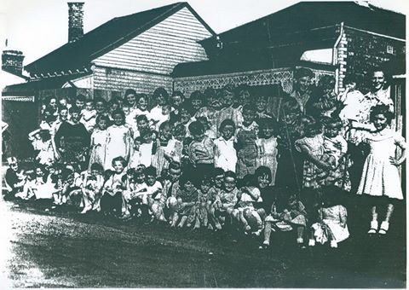
Figure 190 children in 28 houses in Thistlethwaite St, The Argus 1 December 1954

Sport was part of life in Montague. The Wayside Inn fielded a cricket team attracting crowds of 2,000 people while a game involving the Montague Rovers football team could fill the Port Melbourne Football Ground into the 1960s. Boxing was popular. Some waterside workers were renowned for their strength and would go from a full day of lumping coal to a boxing bout. Nappie Ollington, the famous two up king, was an all rounder – boxer, footballer and football coach. He learned the ways of two up from watching play outside the Golden Fleece Hotel.
Waterside workers drank at the Golden Fleece and Rising Sun Hotels. There were also other well-known sly grog places to which police appeared to turn a blind eye.
Montague men offered distinguished service in the war in the Pacific.

Community facilities
Hardship and poverty was part of life in Montague. The conditions became a focus of concern for social and housing reformers in Melbourne. The first free kindergarten in Victoria, Lady Northcote Kindergarten, opened in 1912. It was initiated, funded and run by women from wealthier suburbs. The Melbourne Playground Association, concerned about the number of children playing in the streets, supported the creation of a children’s playground in Montague.
In 1929, Melbourne Rotary and the Council put money towards clearing a site in Carrington Place off Thistlethwaite Street to create a playground. (It was popular with boys, though no girls were recalled ever playing there.) The Presbyterian Mission in Gladstone Street organised regular outings and social events. The Hall on the corner of Montague and Gladstone Street was a club where boys could learn woodwork and other vocational skills to keep them off the streets. Montague School was a treatment centre for influenza after the First World War, and later for victims of the polio epidemic of the 1930s. It became a school for children with special needs in 1928.

Housing
Most people rented, (rather than owned) the small, single fronted timber houses in Montague. The poor housing conditions drew attention of housing reformers. Houses along Gladstone Street next to the Railway line were prone to flooding – especially at the northern end.
The South Melbourne Council and the State Savings Bank of Victoria entered into a housing scheme whereby the Council raised the level of the footpaths and the roads and the Bank took responsibility for the housing and finance. Poor quality housing backing onto lanes were also cleared over time - the named lanes the cue to their former existence. While ‘slum’ houses were mapped and identified, housing was not cleared in large swathes as in the subsequent activities of the Housing Commission.

Flooding and housing
Flooding was part of life in low-lying Montague. When a high tide and heavy rainfall coincided, a lake would form under the Montague Bridge where children would play - paddling and sailing boats. Houses next to the Railway line flooded regularly. In 1935 the South Melbourne Council entered into an arrangement with the State Savings Bank to replace some houses in Gladstone Street with modern but modest homes.
The Council raised the level of the roadway while the Bank managed the construction of the houses and entered into loan and repayment arrangements with purchasers. The houses were intended for workers in steady employment on modest incomes. (Those houses are on the Victorian Heritage Register.)

Transition
The Second World War was a time of peak employment and production in Montague. After the war, heavy industries like Dunlop moved to cheaper land further out of the city to create new facilities. Pressure to make more land available for business and light industry in South Melbourne mounted. Houses were demolished to consolidate lots.
The waterfront was also changing to less labour intensive work practices. Some families took up offers of housing in the Housing Commission’s new estate in Port Melbourne. Others left the area when they married.
Throughout the sixties, housing declined and industry expanded. When Montague Street became the main access route to the Westgate Freeway it was the final blow to any remaining sense of community. Montague entered a phase associated with light industry and businesses focused on motor vehicle auto services. Only isolated houses remain to speak to the former residential nature of Montague.

