Children’s Services in
the City of Port Phillip

Table of Contents

Message from the Mayor 3
Introduction 4
What are the key challenges for children in the City of Port Phillip? 5
What are the future potential opportunities? 7
Childcare 8
What are the benefits of childcare? 8
Childcare in the past 8
Who operates childcare in Port Phillip? 8
How does Council currently support childcare? 9
What changes are occurring to childcare? 9
Playgroups 10
What are the benefits of playgroups? 10
How does Council currently support playgroups? 10
What is the state of playgroups in Port Phillip? 10
Toy Libraries 11
What are the benefits of toy libraries? 11
How does Council currently support toy libraries? 11
Kindergarten 12
What are the benefits of kindergarten? 12
How does Council currently support kindergarten? 12
What is the state of kindergarten in Port Phillip? 12
What changes are occurring to kindergarten? 13
What is Council’s current investment in buildings for children’s services? 14
What buildings does Council provide for children’s services, and how old are they? 14

Message from the Mayor

The City of Port Phillip is facing many challenges for children and families and Council is looking to work with the community to solve them together.
Along with challenges, come opportunities. This is an exciting opportunity for you to shape the future of children’s services in our municipality. The current Childcare Policy was adopted in 2006. This outdated policy does not meet the expectations of our community, the legislative framework, population growth statistics, trends in contemporary practice, or the changing needs of working families. A new Children’s Services Policy is needed to meet community needs and expectations and to ensure compliance with legislation, including the National Competition Policy.
The first stage of community engagement will be the development of high level policy objectives. Later in the year, we will have another round of community engagement when we will invite you to comment on the service response report guided by the agreed policy objectives.
We appreciate that there is rich knowledge, skills and experience in our community and we look forward to drawing on your expertise to develop a forward-thinking, robust policy.

Yours sincerely,
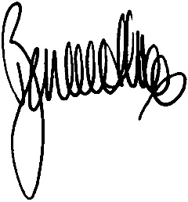
Bernadene Voss
Mayor
City of Port Phillip
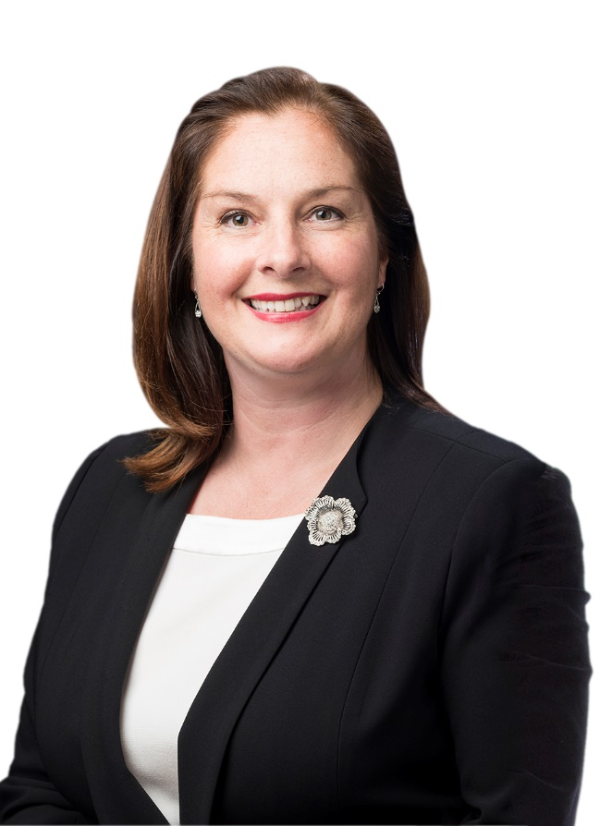

Introduction
Council is providing a range of opportunities for the community to provide ideas about how the City of Port Phillip can deliver services which support the health and wellbeing of children and their families. We encourage you to think about the opportunities and challenges we have in front of us, and to think about how we might create a future which helps all children achieve their full potential.
Your feedback and ideas will be used to identify a range of principles and outcomes which describe the kind of future you want for children in the municipality. We are also interested in your ideas for how we can achieve this future. The principles and outcomes will be reflected in a Stage One report to Council; and your ideas about how we can achieve this future will be reflected in a Stage Two report to Council. These two stages will lead to the development of a Children’s Services Policy.
This Information Pack includes sections on a variety of topics. We invite you to read the challenges and opportunities sections. These sections are designed to stimulate some creative thinking about what kind of City we want for our children, and how we might achieve that City. The other sections describe the range of services that Council currently provides for children to provide context to inform your thinking about what is unique and special about our children’s services, and what you might like to change.
We know that Port Phillip is diverse, eclectic and talented. We want to harness the collective skills and brainpower of our community to think outside the square to inform a Children’s Services Policy that is ready for the future.

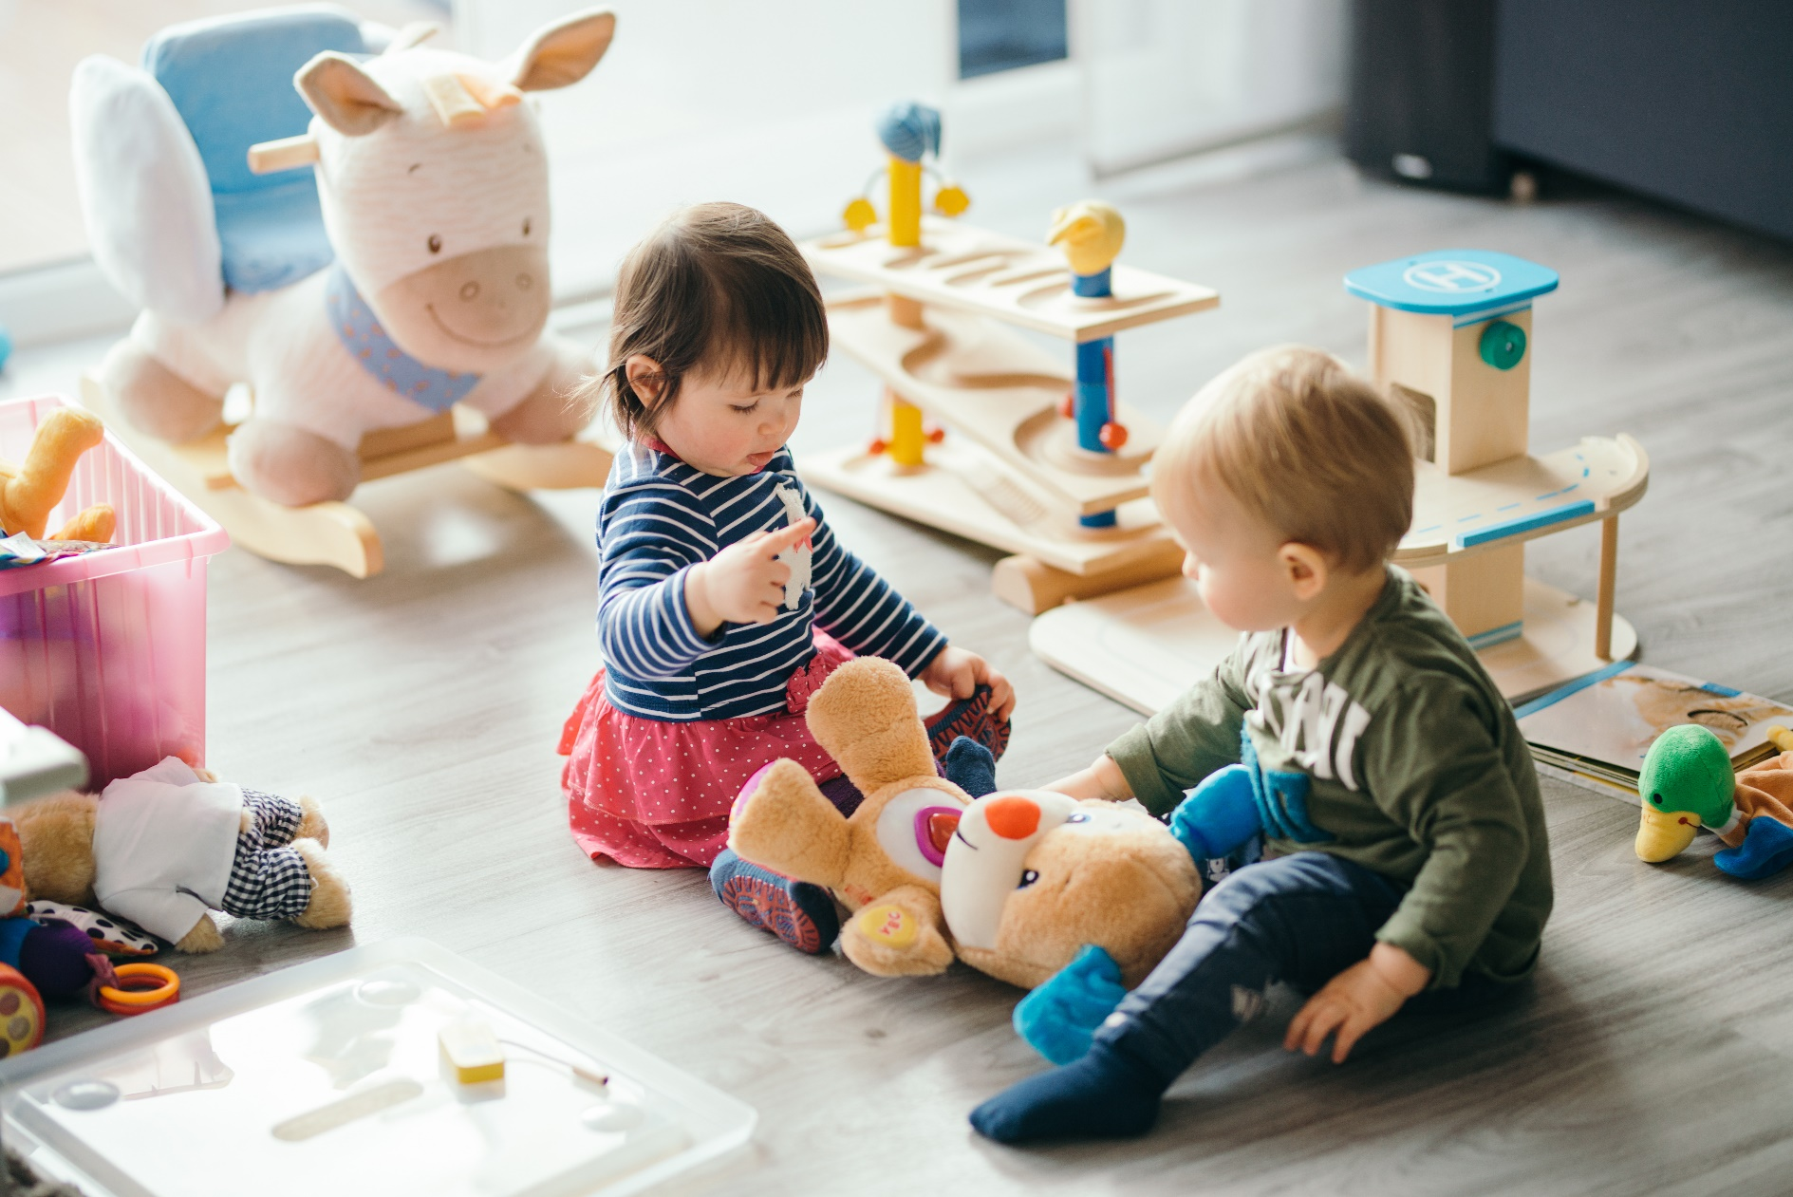

What are the key challenges for children in the City of Port Phillip?
The vast majority of children in Port Phillip are developing very well. However, we do have some challenges.

The key challenges for children in the City of Port Phillip are:
Changing community needs
- Helping families find the services they need – We know that the level of awareness that service providers for children have about each other needs improvement, so that they can refer parents to other services they might need, or find useful for their children.
- Ensuring an adequate supply of childcare for children under the age of three – There is a shortage of places for children under the age of three. This is a common problem across Australia.
- Proficient in English when starting school – 2.2 per cent of children in 2015 were not proficient in English.
- Accessing children’s services if a child has additional needs – The number of children with an additionall need has risen from 2.1 per cent to 3 per cent in 2015. Another 7.9 per cent of children were reported as requiring assessment.
- Supporting children from disadvantaged backgrounds – Compared to other municipalities in our region, Port Phillip has a much higher percentage of people using services for mental illness and alcohol and drug issues.
- Appropriate child developmental rates – Children in South Melbourne and St Kilda have lower rates of development than the state average, despite the number and diversity of children’s services in the municipality.
- Meeting our target for kindergarten participation – Kindergarten participation is reported as much lower than the required Australian target rate of 95 per cent for four-year olds – in 2017 the kindergarten participation rate was 85.6 per cent.
- Supporting families experiencing vulnerability – Families associated with Child Protection and Child First who are using Port Phillip’s childcare centres aren’t adequately supported by state agencies, leaving childcare staff trying to support them without the necessary qualifications and experience of professional social workers.
- Supporting children experiencing vulnerability – Often the Australian Government does not provide ongoing childcare funding to families associated with Child Protection and Child First, despite evidence that shows these children benefit the most from attending childcare. As the Victorian Government shifts the use of public housing more towards transitional use, more children will experience unstable home environments.
- Ensuring children experiencing vulnerability access services – Disadvantaged families are the least likely to use children’s services despite research indicating that they benefit the most.

Population Growth
- Meeting the needs of a population boom – An estimated 80,000 people will move into Fishermans Bend over the next 30 years.
- Other areas within Port Phillip will also experience growth.
- More children’s services will be required for this population growth.
Changes to Australian and Victorian Government legislation
- Reduced access to Australian Government subsidies for childcare for some – Families who don’t meet the childcare Activity Test have reduced eligibility for Australian childcare subsidies than they did in the past.
Ageing buildings
- Most of Council’s buildings which house children’s services were built some time ago. Many of them need updating to provide flexible programs that meet contemporary practice.
Questions:
What other challenges can you identify for children in the
City of Port Phillip?
What ideas could you think of that would help solve these challenges?
What outcomes should we expect for the children who live in the
City of Port Phillip?

What are the future potential opportunities?
The City of Port Phillip is comparatively rich in children’s services and has a long history of Council-supported community involvement and leadership in the provision of children’s services. The potential future opportunities could include:
Changing community needs
- Strengthening the relationship Council has with its community-run children’s services to provide holistic solutions.
- Using long-established community networks to problem-solve how we can approach the challenges for children in the municipality (for example school and kindergarten networks).
- Working together to help families better navigate a sometimes-complex service system.
- Using collaborative planning to address challenges together.
- Council providing leadership and funding to projects which have cross-sector involvement.
- Using and expanding children’s services networks to include all providers of services for children to work together in a coordinated way, and simplifying systems and access to services for families.
Population growth
- Plan for and encourage a range of children’s services into the growth areas, including universal services (for example childcare, kindergarten, maternal child health) and early childhood intervention services (for example services for children with special needs).
Changes to Australian and Victorian Governments
- Capitalising on Victorian Government funding for children’s services hubs.
- Working more closely with the Victorian Government to access resources for children with higher needs, help improve the quality of our kindergarten services, and encourage more children to use Early Start kindergarten.
Ageing buildings
- Reviewing our buildings, looking for opportunities to make our services more accessible, sustainable and low energy.
Questions:
What other potential opportunities are there for improving children’s
lives in Port Phillip?
What’s unique about Port Phillip that we should perhaps have more of?

Childcare
Childcare, otherwise known as long day care, is a service which provides centre-based care provided by professional educators and teachers, where babies and children up to school age can be cared for while their parents work, study or have time for their other commitments.

What are the benefits of childcare?
The Australian Government has traditionally funded childcare because it increases maternal workforce participation. In 2012, the Australian Government recognised the importance of providing quality childcare for longer term positive outcomes for children. The government introduced improved child-staff ratios across Australia, increased the education of childcare workers, and set in place a quality rating and checking system which is governed by state governments.
Poor quality childcare has been shown to have detrimental effects on all children. Quality childcare has been shown to have particularly good impacts on the cognitive and non-cognitive development of children from disadvantaged families. Quality childcare has been shown to provide the same level of outcomes for children as quality care at home. All children need quality care, but disadvantaged children benefit the most from high quality formal childcare, which can produce benefits for cognitive, language and social development (Baxter and Hand 2013). The effects of higher quality childcare on children’s cognitive and behavioural development at school entry are reportedly stronger amongst children from lower income families, which in turn provides evidence that higher quality childcare may be especially important in helping reduce developmental gaps for children from these families (Biddle & Seth-Purdie, 2013; Gialamas et al, 2015; Harrison et al., 2012; Houng et al., 2011; Nicholson et al., 2012).

Childcare in the past
Prior to the 1990s, the majority of childcare in Australia was provided by not-for-profits (NFPs) in direct funding agreements with the Australian Government. A significant change occurred in the sector when the Australian Government began directly funding individual children instead of centres, and allowed for-profits (FPs) to provide childcare services. Now FPs have a majority of the child care market (60 per cent). Government delivered services have always been a minority. Around the same time, childcare centres were allowed to deliver kindergarten funded education within long day care programs. Childcare centres are not mandated to provide kindergarten, but there are financial incentives to do so. Childcare centres are less likely to provide three-year-old kindergarten, for which there is no government funding.

Who operates childcare in Port Phillip?

 | Council-run | Community-run | Private | Independent Not-for-profit
Centres | 5 | 8 | 14 | 1
Places | 362 | 580 | 1148 | 55
Average fees | $125 | $123.75 | $145.33 | $137
Cost to Council | $2.072m | $8,186,658 | $0 | $0

Council also provides a centralised childcare waitlist which costs $145,000, including overheads.

How does Council currently support childcare?
Council’s current approach to childcare has five components:
- Eight community-run childcare centres supporting 580 places.
- Five council-run childcare centres supporting 362 places.
- A 2006 Childcare Policy which provides a Quality Subsidy ($1,034,020 in 2017/18) and an Affordability Subsidy ($592,018 in 2017/18) for the 13 centres. A 2017 Interim Childcare Policy will begin in July 2018.
- Two small pilot programs which provides support to vulnerable families in childcare centres.
- A centralised childcare waitlist which costs $145,000, including overheads.

What changes are occurring to childcare?
There are three changes occurring within childcare now:
Changes | Description
Australian Government reform to funding | The Australian Government has passed legislation that will significantly increase childcare subsidies to lower and middle-income families. It will link childcare more closely to workforce participation hours and replace two subsidy processes (CCB and CCR) with one process (Child Care Subsidy). It takes effect on 2 July 2018. It impacts negatively on families who are not eligible for the Activity Test by changing their access to the Australian Government childcare subsidy, from two days to one day.
Minor change to the role of local government | The Australian Government has recently acknowledged the limits of a purely market approach to delivering childcare which has resulted in oversupply in some areas and undersupply in others. In response, the Australian Government has supported an initiative through the Australian Centre for Excellence in Local Government (ACELG) to provide councils with a guideline on how to plan for, and assist the market (NFPs and FPs), to respond appropriately to demand for childcare.
State reform to support Not for Profits | The Victorian Government has expanded the role of Early Years Management (EYM) organisations to include childcare centres that offer kindergarten education. EYMs are becoming increasingly attractive to community-run childcare centres who want to concentrate on aspects of childcare other than regulation, legislation and the obligations of incorporated associations.

Playgroups
Playgroups were first established in Australia in 1967 by a grassroots movement of parents who had an increasing awareness during the 60’s and 70’s of the value of play in children’s development. By 1975, every state and territory had a Playgroup Association. Over time, three types of playgroups have emerged – community, supported, and rostered. Community playgroups are run by volunteer parents and are the most common form of playgroup. Supported playgroups are funded by federal and/or state governments and run by professionals for children with different needs (for example disability, cultural and linguistically diverse backgrounds, Aboriginal and Torres Strait Islander). Rostered playgroups function more like occasional childcare, with some parents volunteering time to look after children that other parents drop off.

What are the benefits of playgroups?
Playgroups have all the benefits of play outlined in the toy library summary paper. Research in the UK found that participation in playgroups had a positive impact on national curriculum assessments of seven-year olds. Australian research showed that children from disadvantaged families who attended a playgroup from an early age had higher early learning competence compared to those who did not. The research also showed that disadvantaged families are less likely to attend playgroups. In a survey conducted with Port Phillip families, parents talked about the benefits to adults of belonging to a playgroup, almost as much as the benefits to children. One of the most commonly cited benefits was the ability to have adult conversations, and to talk about the challenges of raising children with others.

How does Council currently support playgroups?
Our current approach to play groups has four components:
- Connection to Maternal Child Health (MCH) – Council’s MCH service provides extra assistance to new mothers through parenting sessions, where mothers are encouraged to join a playgroup.
- Playgroup coordination – Council provides advice to new playgroups and assistance with locating a space for new groups. We also provide contact information to anyone wanting to join a playgroup.
- Facilities – Council has three facilities with spaces dedicated to playgroups in St Kilda, Elwood and Port Melbourne. If these locations are not suitable, our Playgroup Coordinator finds a space within one of our other buildings.
- No rent – playgroups do not pay to access our buildings.

What is the state of playgroups in Port Phillip?
Port Phillip has a thriving playgroup scene, with 88 playgroups operating across the municipality. This includes Italian, French, Dutch, Irish, Czech and Greek speaking playgroups and a Rainbow (LGBTIQ) playgroup.

Toy Libraries
Toy libraries are a world-wide phenomenon that emerged from community-based groups interested in providing a shared toy resource. There are 280 toy libraries across Australia, and four within Port Phillip. Families purchase an annual membership which allows them to borrow toys. Port Phillip’s toy libraries cater to families with young children. We provide the four toy libraries with spaces to operate within our buildings.
Councils are the only level of government to provide support to toy libraries.

What are the benefits of toy libraries?
While there has been little research specifically on the value of toy libraries, there is research on the benefit of play for children. Play has been found to:
- allow for the expression of personality and uniqueness
- enhance dispositions such as curiosity and creativity
- enable children to make connections between prior experiences and new learning
- assist children to develop relationships and concepts
- stimulate a sense of wellbeing.
There is a large volume of literature demonstrating that play is associated with the development of language and literacy, sociability, and mathematical ability.
Presidents of toy libraries in Port Phillip said that toy libraries are attractive to families with small apartments or houses with a lack of space for toys, to those who are interested in recycling toys, and to children who love the experience of choosing new toys.

How does Council currently support toy libraries?
Our current approach to toy libraries has three components:
- Facilities – Council provides space for toy libraries in three of our buildings; and the fourth toy library uses a neighbourhood learning centre space (also a Council building).
- Discounted rent – the libraries are supported through a nominal rent.
- Subsidies – the libraries are eligible for three types of subsidies.

Kindergarten
Kindergarten education is provided in kindergarten centres, childcare centres, and kindergarten rooms in family and children hubs. In Australia, kindergarten is provided for four-year olds, for 15 hours per week, 40 weeks of the year, regardless of the setting it’s provided in. There are three types of kindergarten education:
- Integrated kindergarten – full-day, provided in a childcare centre.
- Sessional kindergarten – usually spread over three days in a kindergarten centre or room to a total of 15 hours per week.
- Extended kindergarten – sessional kindergarten (15 hours per week), combined with after-hours childcare in a kindergarten centre or room to create a full-day.

What are the benefits of kindergarten?
Like childcare, the benefits of kindergarten education are well documented. Kindergarten provides young children with the kind of enriching and supportive early learning environments which help develop their brains in healthy ways. While kindergarten is good for assisting all children become ‘school ready’, it has been shown to be particularly effective for disadvantaged children – children who have experienced high levels of adversity, are lacking in rich verbal and other cognitive inputs, and those who have experienced economic hardship and insecurity.
In 2012 Australia introduced 15 hours of universal kindergarten education for four-year olds. This was a significant step for Australia. However, based on research which shows clear links to positive long term educational outcomes, most OECD countries now also provide universal kindergarten education for both three and four-year olds.

How does Council currently support kindergarten?
In Port Phillip there are nine independent kindergarten centres, which are not associated with Council because they are attached to private schools, are ethnic-specific, or offer alternative educational approaches, for example Montessori. Our current approach to kindergarten education has three components:
- Facilities – Council provides standalone kindergarten facilities which are run by the community.
- Discounted rent – centres pay a nominal rent of $10 per year.
- Subsidies – three subsidies totalling $123,000 in 2015/16, including a low-income family subsidy to 10 kindergartens.

What is the state of kindergarten in Port Phillip?
 | Community-run | Independent
Centres | 6 (4 by Council, 2 former Victorian Government) | 9
Places | 408 | 404
Average term fees | $790 | unknown
Cost to Council | $- | $0
* Council provides four centres, the other two are ex-Victorian Government kindergartens

What changes are occurring to kindergarten?
Changes | Description
Universal kindergarten | Kindergarten education experienced significant changes in 2012 when the Australian and state governments agreed to universal kindergarten education for all four-year olds and extended the hours to 15 per week.
Combining kindergarten with childcare | Recently the Australian Government has agreed to financially support kindergartens to provide after-hours care either side of a kindergarten session. Parents can access childcare funding for the after-hours time in the same way that they would with a childcare centre. Only some kindergartens have taken up this offer, but it seems to be increasingly popular.
State reform to support Not-For-Profits | The Victorian Government has expanded the role of EYMs organisations. EYMs are becoming increasingly attractive to community-run childcare centres who want to concentrate on aspects of childcare other than regulation, legislation and the obligations of incorporated associations.
Early Start Kindergarten | The Victorian Government introduced Early Start Kindergarten funding for vulnerable three-year-old children to attend kindergarten – defined as Aboriginal and/or Torres Strait Islander, or where a family has had contact with Child Protection or Child First. The Victorian Government is keen for this service to be used more in the future.
Financial state of kindergarten centres | Another trend noted recently within the industry is the financial precariousness of some community-run kindergarten centres, despite support from councils in the form of nominal rents. The Victorian Government recently provided free financial advice to kindergartens that were financially struggling.

What is Council’s current investment in buildings for children’s services?
Council’s current investment in children’s services infrastructure is significant.
Service | No. of buildings | Building Replacement Value[1]
Childcare | 12 | $24 million
Kindergarten | 4 | $3.96 million
York Street (vacant) | 1 | $500,000
Total | 17 | $28.46 million

What buildings does Council provide for children’s services, and
how old are they?
Council provides a range of dedicated buildings for children’s services. Most of them are quite old, which is not surprising considering the age of the City of Port Phillip. However, the older the building, the more difficult it is to cater for the expectations of a modern service, for example whether or not it can easily accommodate children, parents or educators with a disability.

Centre | Date built
Albert Park Kindergarten | 1890
Eildon Road Childcare Centre | 1900
Civic Kindergarten | 1906
Carter Street Childcare Centre | 1916
The Avenue Childcare Centre | 1920
Elwood Childcare Centre | 1920
Clarendon Childcare Centre | 1928
Lilian Cannam Kindergarten | 1928
York Street Childcare Centre (vacant) | 1970
North St Kilda Childcare Centre | 1970
Clark Street Childcare Centre | 1976
Ada Mary A'Beckett Childcare Centre | 1977
Coventry Street Childcare Centre | 1985
Poets Grove Children's Hub | 2007
Bubup Nairm Family and Children's Centre | 2013
Bubup Womendjeka Family and Children's Centre | 2013
Lady Forster Kindergarten | 1925

Additionally, licences are provided to facilitate access to Council buildings for use of toy libraries and playgroups.

Indicative as of May 2018.
Centres pay for their own utilities. Most of the cost is associated with Quality and Affordability Subsidies. The costings assume that the infrastructure and maintenance levies paid by centres cover council’s costs
Centres pay for their own utilities. Most of the cost is associated with Quality and Affordability Subsidies. The costings assume that the infrastructure and maintenance levies paid by centres cover council’s costs.
[1] Does not include demolishing costs or professional fees.

