Move, Connect, Live
Draft Integrated Transport Strategy 2018-28

Contents

Womin Jeka 4
Mayor's Message 4
Why do we need this strategy? 5
What will be different? 12
Same space - more people 12
Creating a City for people 13
A shift in perspective 13
Movement and Place approach 13
What will we do? 15
Council will deliver with you 15
Council will partner with the Victorian Government to deliver with you 15
Council wants to have a conversation with you about 15
You will need to consider 15
OUTCOME 1 – 16
Our City’s transport network, streets and places cater for our growing community 16
Focus Area: 10-minute walking neighbourhoods Focus Area: Prioritising safety and access 16
Our Priority Actions 16
Measuring progress 17
Focus Area 10-minute walking neighbourhoods 18
Focus Area Prioritising safety and access 19
OUTCOME 2 - 20
Our community is healthier because it has safe, connected and convenient walking and bike riding choices 20
Focus Area: Space for walking, socialising and play Focus Area: Boosting bike riding 20
Our Priority Actions 20
Measuring progress 21
Focus Area Space for walking, socialising and play 22
Focus Area Boosting bike riding 24
OUTCOME 3 – 27
Our community has convenient public transport choices that make it easy to move and connect 27
Focus Area: Partnering to deliver reliable, accessible and more frequent public transport 27
Our Priority Actions 27
Measuring progress 28
Focus Area Partnering to deliver reliable, accessible and more frequent public transport 28
OUTCOME 4 – 30
Our community understands that parking is a limited and shared resource, and works with Council to ensure fairest access 30
Focus Area: Improved parking management 30
Our Priority Actions 30
Measuring progress 30
Focus Area Improved parking management 31
OUTCOME 5 33
Our community benefits from new transport options and technology to move around 33
Focus Area: Harnessing rapid advancements in new technology 33
Our Priority Actions 33
Focus Area Harnessing rapid advancements in new technology 34
Measuring and Reporting 35
Measuring success 36

Womin Jeka
Council respectfully acknowledges the Yalukut Weelam Clan of the Boon Wurrung. We pay our respect to their Elders past and present. We acknowledge and uphold their continuing relationship to this land.

Mayor’s Message
On behalf of the Councillors, I am pleased to invite the community of Port Phillip to provide feedback on the draft Move, Connect Live: Integrated Transport Strategy 2018-2028.
Council is committed to supporting a well-connected transportation future for our city, to make it easy for people to move around and connect with places in a way that suits them as our City grows. This is reflective of both strategic direction two and four of the Council Plan – “We are connected and it’s easy to move around” and “We are growing and keeping our character”.
This draft Strategy includes an action plan to deliver on this commitment over the next ten years, including key priorities such as:
A transport network, streets and places that cater for our growing community
Safe, connected and convenient active transport choices
Public transport choices that make it easy to move and connect
Community understanding that parking is a limited and shared resource, and works with Council to ensure fairest access
New transport options and technology to move around.
This draft Strategy details actions that will deliver on these priorities and allocates a timeline and budget for implementing our long-term commitment. This is to ensure that as a community we can adapt to the increasing number of trips and the challenges associated with increased congestion, while creating travel choices, prioritising effective and equitable access to transport options and ensuring the liveability and safety of our streets.
All members of our community need to move around using our transport network and we have a collective role to play in improving transport accessibility. That is why we are:
Creating 10-minute walkable neighbourhoods
Prioritising safety and access
Providing spaces for walking, socialising and play
Boosting bike riding
Partnering to deliver reliable, accessible and more frequent public transport
Improving parking management, and
Harnessing rapid advancements in new technology.
We are excited to present the draft strategy, and we welcome your feedback.

Why do we need this strategy?
We are connected and it’s easy to move around (Strategic Direction 2, Council Plan 2017-27)
We are growing and keeping our character ( Strategic Direction 4, Council Plan 2017-27)
Port Phillip, with an existing population estimated of 113,512 in 2018, is a popular inner-city area of Melbourne, attracting more than 2.8 million visitors each year. It is the second most visited metropolitan location outside of Melbourne’s central business district. The foreshore that stretches over 11 kilometres, vibrant shopping strips, and vast public open spaces make the City highly desirable to residents, workers and visitors.
We are at a defining moment in Melbourne’s history, with a forecast population growth not seen since the gold rush of the 1880s. Current population is projected to grow by 23 percent to 136,000 people by 2027; this equates to approximately 50 new people a week, or seven new people a day. With its proximity to the Melbourne central business district, Port Phillip will also be affected by growth beyond its own boundaries. This will impact on the liveabilty of all of our community, residents and visitors.
Most notably this change will be felt in our streets. If we continue to travel the same way we do today – 72 per cent of daily movements by private car - our limited street network will have to carry an additional 72,000 private car trips, as well as 21,000 additional trips by other modes (walking, bike riding or public transport) every day. This will dramatically increase traffic congestion, impacting upon the time we spend travelling within and throughout the City and our travel experiences and enjoyment.
We want a city where residents, workers and visitors have lots of travel choices that support Melbourne’s much celebrated liveability, promotes people’s individual health and wellbeing, and contributes to the City’s economy. This is a big challenge for us to take on and it requires us to work together. We are planning and making decisions for our growing City today, to create a city for people and to leave our legacy for future generations.
The MOVE, CONNECT, LIVE Strategy 2018-2028 is a 10-year strategy that includes actions to make it easy for people to move around and connect with places in a way that suits them as the City grows. The Strategy guides how we will work with our key partners in State and Federal governments, developers, bicycle associations and the community, to enhance our transport networks and choices, manage parking, and use new technology to improve accessibility to new and emerging travel modes.
We will know we are successful when:
- our City’s transport network, streets and places cater for our growing community
- our community is healthier because it has safe, connected and convenient active transport choices
- our community has convenient public transport choices that make it easy to move and connect
- our community understands that parking is a limited and shared resource, and works with Council to ensure fairest access
- our community benefits from new transport options and technology

Challenges we face
The City of Port Phillip is currently Melbourne’s most densely populated municipality. It has more than twice the population density of the metropolitan Melbourne average and is experiencing a rapid increase in the number of people living in apartments and units. Port Phillip is unique in comparison to other inner Melbourne Councils as it intersects with both an international freight and recreational port in addition to road, rail, tram, walking and bike riding.
This strategy will deliver a step change in the way we approach some of our most pressing challenges, such as longer peak travel periods, more unreliable and longer travel times throughout the day and week, and impacts on the safety and efficiency of modes such as public transport and bike riding from increased vehicles.
As the population grows in the next 10 years we need to change the way we move and connect to protect Port Phillip's liveability, beauty and places.

Population Growth
Covering an area of 21 square kilometres, Port Phillip are one of the smallest municipalities in Victoria with the highest inner urban population density. It is also home to more than 19,000 businesses that employ over 87,000 people.
The proximity to the city centre, 11 kilometres of bayside foreshore, beautiful tree lined streets and many attractive parks and open spaces make Port Phillip a popular destination for residents, businesses and tourists. We attract 2.8 million visitors a year, second only to the City of Melbourne as the most visited municipality in Victoria.
Our resident population is projected to grow by 25 per cent by 2028, placing considerable strain on our already well used spaces.
Our worker population will also rise dramatically, with the new Fishermans Bend development expected to create additional employment opportunities.

Reliance on Cars
If current car ownership trends continue, over the next decade there will be a 24 per cent increase in the number of cars owned in the City of Port Phillip. Our current supply of on-street car parking spaces is barely enough to meet current demand. Our road network is finite and we have a limited ability to increase car parking capacity – same space, more people, more travel.
Currently 14 percent of our city’s greenhouse gas emissions are due to private vehicle use and a greater reliance on car travel as our City grows will further increase this. With such a big population, ninety-nine per cent of Port Phillip emissions are community generated, and travel choices are a big contributor to these emissions.

Sustainable Transport
A growing city with a road network that is at capacity and cannot be increased, requires a rethink of how more sustainable modes of transport can be used. Integrated transport infrastructure and services can support sustainable and healthy behaviours such as walking, bike riding and the use of public transport. Changing economic conditions mean that more of our community will travel outside the municipality for work, making sustainable travel choices more important than ever.

New Technology
By embracing technology, we can gather data that helps us change the ways we move around our City. New technology, real-time data and connectivity will help us plan our travel better and improve access to alternative modes of transport.
Our City needs to be future ready. We need to work with our partners and the community to plan and deliver an integrated transport network that helps people move throughout the City. Improving access to, and greater turnover of, available parking spaces will maximise the use of our limited spaces and public places. With better and more convenient travel choices, people won’t have to use a car unless it is essential.

The Case for Change
If no changes are made to the way we move around our City in the next 10 years we will experience:
- 72,000 more private car trips on our roads every day, resulting in increased traffic congestion
- 21,000 more trips every day on the already near-capacity public transport network
- 136,000 additional people on our streets and in our public spaces
- 12,000 more cars seeking places to park every day
- Around 50,000 on-street car parks for more than 60,000 local cars and many more additional cars visiting the city for work or leisure.

Big Opportunities
Greater Melbourne is experiencing the biggest investment in the public transport and road network in several decades. This is a once-in-a-generation city shaping program of works that will transform Melbourne, and creates an opportunity for Port Phillip to leverage off this investment to benefit our existing and future communities.
There is an opportunity for Council to enhance this benefit by:
- Doing things with partners – working with others with a focus on better public transport services, cross-council outcomes and upgrades to our public spaces. We rely on the Victorian Government for delivery of key transport infrastructure such as public transport services and management of the arterial road network.
- Doing things differently – shifting our street design priority to the movement of people rather than the movement of vehicles; using technology and new transport options to help people move around; trialling street design changes with our community; and building research partnerships
- Investing in the right things – focusing our effort and investment on those actions that will provide our community with realistic and safe travel choices
- Using what we have better – changing our policies and services to meet changing customer expectations and needs, including improving the value, speed and ease of doing business with Council.
The City of Port Phillip’s response to these opportunities is our Integrated Transport Strategy - Move, Connect, Live 2018-2028.

Where are we now?
Much of Port Phillip is well serviced by public transport in the form of trains, trams and buses. However, as we continue to grow, we need to work with our partners to improve reliability, capacity and frequency of public transport to reduce our reliance on cars.
Port Phillip is relatively flat and easy to navigate on foot and by bike, but only 6 per cent of daily trips are by bike. We have invested in improving safety and amenity for bike riders for many years, but we can make things even better in our City for bike riders and pedestrians.
We have strong and productive relationships with the Victorian Government, state agencies and other local governments. We will leverage these relationships to maximise our impact.
The Victorian Government is planning and constructing significant transport projects in Port Phillip. Most notable is the Melbourne Metro project, which includes Anzac Station and surrounding major transport legacy works, improvements to a number of existing tram stops and a new tram line to Fishermans Bend.
Further assistance is required from the Victorian Government to grow and improve the transport network, including:
- improved tram capacity and a schedule for constructing accessible tram stops
- a comprehensive review of bus services and a plan to improve capacity, operating hours, links to other transport options and frequency
- upgraded bicycle facilities on arterial roads and at key intersections
- pedestrian improvements, particularly in busy areas of activity
- construction of Melbourne Metro 2 train connection to Fishermans Bend.

Listening to our community
During 2017, we spoke to the community about parking, transport, movement and accessibility across Port Phillip. We heard from almost 1,500 people. Views were varied and we have tried to balance the needs and aspirations of our diverse community in developing this strategy. We listened to your feedback and used it to help identify your priorities and concerns. Actions have also been developed, which will be delivered during the life of this strategy.

What we heard
Transport and parking problems have been identified as key issues of concern to you. This led us to seek more detailed information from you on the specific difficulties you are experiencing, and to compare that to what you value the most in your streets and neighbourhoods.
We conducted a community insights online survey in September 2017, resulting in almost 700 responses from people across the City. You told us you want clean and safe streets and footpaths; you want to see vegetation and natural elements; and you want safe streets that encourage walking, bike riding and public transport use.
In response, we developed an Integrated Transport Strategy Position Paper ‘Setting the Direction’ to outline our transport challenges, and consulted you on possible responses to these challenges.
We heard that you are willing to make changes, even if it isn’t always easy. Both the complexity and difficulty of these changes is appreciated by both you and us, including the challenge of balancing individual needs with the needs of the broader community.
Some of the responses we heard during consultation included:
- Population growth is a benefit to the community, but only if the negative impacts can be well managed
- Start by addressing existing problems first, congestion and parking availability are problems now
- Council is expected to be a leader by using technology to benefit the community
- More safe bicycle facilities should be provided to make bike riding a viable and safe option, to encourage bike riding
- Car users are concerned that prioritising other modes and streetscape improvements will lead to car congestion
- Parents of young children are more reliant on their vehicles
- There is support for lower speeds on local streets
- You accept that the future will require moving away from a car-centric lifestyle, but this will be challenging
- Small businesses are concerned about parking changes and how it will affect them
- There is scepticism of Council’s level of influence around public transport
- There are mixed views about redeveloping Council-owned off-street carparks
- Prioritise local residents and people with disabilities for parking over commuters and commercial users
- Residential parking is a concern, with some people wanting free parking permits and others being impacted by neighbours not using their garage to store their vehicles

Our Partners
The key to creating an integrated transport experience in Port Phillip is working in partnership with others. Our community, local and state government partners, transport providers, peak bodies, research organisations and private industry all have a critical role to play.
Our City is affected by Federal and State legislation and policies, the actions of neighbouring councils, the businesses and organisations that operate within our boundaries and everyone who lives, works and visits here.
This context presents both opportunities and challenges for delivering the actions in this strategy. In some instances, we will have direct control over specific actions, especially those relating directly to Council operations. In other cases, we will partner with or advocate to other levels of government for change, and leverage opportunities that benefit our community.
Each of us has a role in creating a future where we can all move, connect and live.

The role of Council
The City of Port Phillip delivers infrastructure projects and manages how the City’s streets and public spaces operate. Our role includes:
Trusted service provider: providing high quality and safe roads, bike paths and footpaths, using technology and parking controls to make parking fairer for everyone, and using planning mechanisms to create better public spaces. Council will commit approximately $37 million over 10 years to deliver the 40 actions in this Strategy (dependent on project co-funding from partners).
Trusted partner and broker: further developing partnerships with Australian, Victorian, and local governments to advocate for and deliver better transport outcomes for our community.
Trusted advisor and agent: making it easier for people to move around our City by creating a connected and integrated transport environment. We’ll do this by giving our community the information it needs and creating incentives for our community to use public and active transport, within the limits of our control and influence.
Trusted steward: being a sector leader in transport and parking management by improving transport choices for our community. This includes a commitment to consulting with our community about changes and making those changes in a careful, considered and timely way.
Monitoring and reporting: monitoring and reporting against the key measures outlined in this strategy, to share our progress and identify opportunities for further improvement.

Our government partners
In Victoria, there are various government agencies, authorities and franchisees that support the planning, operations and delivery of various parts of our road and public transport systems. The Table in Appendix A: ‘City of Port Phillip Transport Partners’ outlines the names and roles of each of these agencies, as well as supporting local councils and community groups.

The role of residents and workers
The choices we make every day have an impact on the travel experience in our municipality, and we all have a role to play in doing things differently. Our City will continue to experience increased congestion, with population growth and travel disruption throughout the next ten years as major public transport, urban developments and road improvement projects are constructed.
There are many things our community can do to minimise the impact of these changes on our lifestyle, including freeing up our roads for people who need to travel by car.
Some changes that may be available for you to consider include working from home, shifting your working hours to travel outside peak travel times, or breaking up your journey by combining travel modes such as public transport, bike riding.
The average person makes 3-4 individual trips a day. If everyone in Port Phillip converted just one of those trips from a vehicle to a sustainable transport trip, we could significantly reduce road congestion.

What will be different?
The City of Port Phillip’s transport challenges are not unique. All major urban areas in Australia and worldwide face population increases that are outpacing the government’s ability to deliver infrastructure. We need to do things differently, but rather than reinvent the wheel, it is important that we learn lessons from other cities and not repeat mistakes of the past.
Council is well-placed to support our community to walk, bike ride and take public transport to work and on short local trips more often. Our City is less than five kilometres from Melbourne city with a mostly flat landscape and an existing public transport network. This strategy will build on these strengths and help make active and public transport choices easier and more enjoyable. We know that private cars will continue to be part of our transport network, but as our City grows unreliable travel times, congestion and pressure on car parking will make driving and parking less convenient and more expensive.

Same space - more people
Council developed a transport model to determine the impact of population growth on the road network by 2028 if current private vehicle rates continue. The model showed that congestion along major roads will increase throughout the day, and this congestion will also spill over into the local street network.
To find out how we can avoid these negative outcomes, we analysed how people travel around on a daily basis. Transport trips can be separated into three main categories:
- Internal - trips within Port Phillip
- To/From - trips to and from Port Phillip
- Through - trips originating and ending outside Port Phillip
Council has the highest level of influence over the first two categories – Internal and To/From – as they involve local residents, workers and visitors and use our local streets. The focus for Council is therefore on local trips (less than 2km) and inner Melbourne connections through neighbouring municipalities.
The impact of the increasing number of trips on our existing street network requires a fundamental rethink of how we get around. The best way to accommodate more people on our streets is to prioritise the creation of safe travel alternatives to owning or driving a car. This will help us achieve our 2028 target of maintaining approximately the same private vehicle trip numbers to 2016.
Council is proposing the following targets by 2028 for daily internal and to/from trips across the municipality.
For all trips taken per day in 2028, we are aiming for a change from 2016 to 2018:
+36% in Walking trips (from 152,000 to 207,000 trips/day)
+151% in Bike Riding trips (from 17,000 to 44,000 Trips/day)
+35% in Public Transport trips (from 42,000 to 56,000 trips/day)
0% increase in Private Car trips (from 128,000 trips/day in 2016 to 2028)
To achieve these targets by 2028 and beyond Council is proposing actions that redesign our streets to provide enough capacity to carry an additional 55,000 walking trips, 27,000 bicycle trips, and 14,000 public transport trips.
Council will pursue initiatives aimed at improving travel choices for our community, that provide a convenient alternative to driving a car. Together, we want to give you the choice to change one car trip a day to an alternative transport option.
Move, Connect, Live will reshape our City and, in doing so, change the way we move around and through the City of Port Phillip.

Creating a City for people
We want a City where residents, workers and visitors have lots of travel choices – a City that is connected and easy to get around – supporting Melbourne’s much celebrated liveability and people’s individual health, wellbeing and contribution to our City’s economy.
If we do nothing - if we do not change the way we travel - everyone will be impacted by transport congestion, longer travel times and lost productivity. Port Phillip’s liveability is critical to Melbourne’s reputation as the world’s most liveable city.
One of the most essential parts of our City are its streets – they are the arteries and the key to shaping our daily experiences. We define a street as inclusive of both the footpath, nature strip and the road space. There is growing global recognition that streets contribute in many ways to economic, environmental and social life, beyond simply moving vehicles from one point to another, and this view supports an integrated transport design approach.
Our City is fundamentally a place for people. When designing streets, we need to shift our thinking from that of prioritising car movement and storage of vehicles (parking), to the movement of people and how we can support a wider range of travel choices. It is about keeping Port Phillip as a fantastic place to live.

A shift in perspective
Streets are traditionally classified by their ability to move traffic and provide access for cars. By embracing a different approach based on the local context, the needs of different users, and positive social, economic and environmental outcomes, we are moving toward designing a City for people.
Internationally, this shift in integrated transport design is framed around a “movement and place” approach, using the local land use context to define priority of use.

Movement and Place approach
We have used a ‘movement and place’ approach to underpin the development of this strategy. Streets (including footpaths) are one of the City’s most valuable assets and we have a limited supply. A movement and place approach will help Council classify our road network based on how each street can serve the local community best. Each street functions as either a part of the transport network (movement) or as part of the neighbourhood for social, goods or services exchange (place).
By assessing streets in terms of the movement or place role to the community, we can prioritise the appropriate users and opportunities for improvement. This could include providing better pedestrian facilities such as wider footpaths, seating or kerb outstands. This could also require removal of some road carriageways.
The key to this process is categorising streets for pedestrian use first, and recognising that local residential streets are different from main streets and major tourist attractions. The process will also help us find out how best to accommodate more than one transport type into one street.
The figures below illustrate:
- the different space requirements for movement of various modes of transport through our streets, the amount of space they require and the different uses of spaces
- various ways a road can provide for different modes.
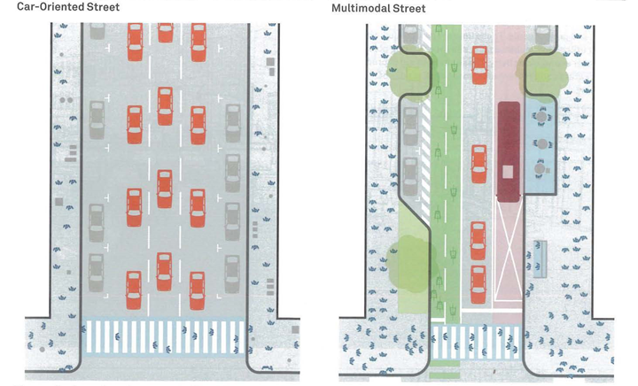

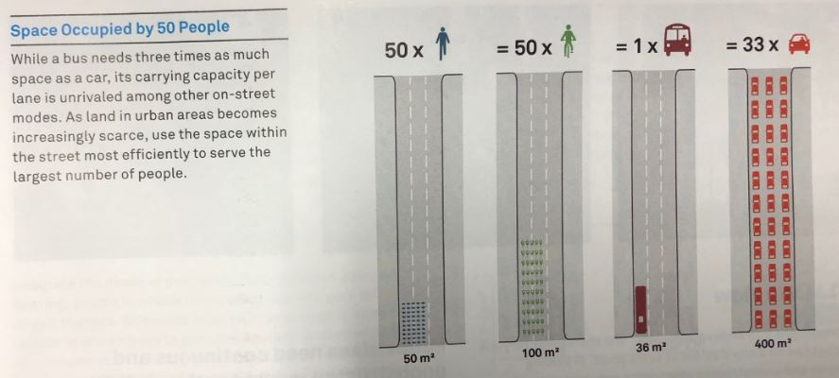

What will we do?

Council will deliver with you
- Safer streets that are great places to walk and play
- Safe separated bike paths so it’s easy to ride to work, to school, to the shops and other destinations in our City
- More travel choices with convenient car share, bike share and electric vehicle charging
- Technology imporvements to find and pay for parking

Council will partner with the Victorian Government to deliver with you
- Reliable acccessible and frequent bus, tram and train transport services – more services, more often

Council wants to have a conversation with you about
- On street parking

You will need to consider
- Changing one car trip a day to car share, public transport or riding a bike or walking

OUTCOME 1 –

Our City’s transport network, streets and places cater for our growing community

Focus Area: 10-minute walking neighbourhoods
Focus Area: Prioritising safety and access

Our Priority Actions | SHORT  18/19 | SHORT  19/20 | MED  21-24 | LONG  25-28
ACTION 1 | Review and update the Port Phillip Planning Scheme and Municipal Strategic Statement to ensure effective integration of land use and transport planning
ACTION 2 | Develop a precinct masterplan for the Domain Precinct (Albert Road and surrounds)
ACTION 3 | Partner with the Victorian Government to ensure the Fishermans Bend Framework and precinct plans maximise local transport connections for both current and future Port Phillip residents and workers
ACTION 4 | Partner with the Victorian Government to fund early delivery of connections to public transport, public space and streetscapes, footpaths and bike lanes in Fishermans Bend
ACTION 5 | Review the Community Bus Services as part of the Aged Care Transition Service review (in response to National Reforms in Aged Care).
ACTION 6 | Develop Movement and Place Precinct Guidelines and delivery plan
ACTION 7 | Deliver blackspot safety improvements at high collision locations (subject to external funding)
ACTION 8 | Ensure our streets and places are inclusive by applying “access for all” standards (upgrading parking for people with disabilities, pedestrian facilities, etc)
ACTION 9 | Support the Victorian Government to develop a vision and plan for St Kilda Junction, and Council to deliver safety and amenity improvements
ACTION 10 | Partner with the Victorian Government and others to minimise the impact of growing freight movements on our community
ACTION 11 | Support the Victorian Ports Corporation (Melbourne) and Victorian Government to manage congestion at Port Melbourne Waterfront precinct
Outcome 1: 10 year Budget $4, 634, 000

Measuring progress
Outcome 1 | Indicator | 2015/16 result | 2021/22 target | 2027/28 target
Our City’s transport network, streets and places cater for our growing community | Number of fatal or serious traffic collisions involving all road users | 78 | ≤119 | ≤96
 | Number of daily passenger vehicle trips (measured by VISTA) | 128,000 | 128,000 | 128,000
 | Performance of ‘traffic management’ in Port Melbourne as part of the Port Phillip Customer Satisfaction Survey | 53% | 55% | 60%

Focus Area
10-minute walking neighbourhoods
To give locals access to shops, community spaces and a strong sense of place that connects homes to workplaces, schools and commercial centres, in areas of highest forecast demand across the City.

What does this mean for you?
- “I feel more connected to the community when I walk and use public transport” - resident
- “The best way to enjoy the beautiful area we live in and take full advantage of it is to get amongst it wherever possible” - resident
Your future experience could be:
I love walking to my local shops and checking out all the beautiful gardens along the way. Everything I need is so close, including the kids school. It’s so easy to cross the road, the streets are cool and shady in summer and the footpaths are wide enough for the kids to scoot ahead”

Why are we doing this?
Population growth and increased housing density across the City will vary significantly between Port Phillip’s neighbourhoods, creating a non-uniform level of localised impact and challenges. There will be extreme change in the north and west, and lesser levels of change in the south and centre.
To achieve the highest level of connectivity for our community, we are aiming to create 10-minute walking neighbourhoods through integration of land use with transport planning. This means locating the increased residential density and jobs growth close to existing (or soon to be completed) high quality pedestrian routes and frequent public transport services that connect to key destinations like schools, employment, shops and community facilities.
The key tool Council has to create walkable neighbourhoods is the Port Phillip Planning Scheme, and supporting zoning and urban design frameworks. This is particularly important in neighbourhoods forecast for rapid population growth such as Fishermans Bend, St Kilda Road precinct, St Kilda, Port Melbourne and South Melbourne. In addition, better links from South Melbourne and Melbourne’s city centre are needed to ensure residents have seamless travel choices.
To support aging in place, Port Phillip delivers a unique community travel service, the community bus, for vulnerable older people and those with disabilities. This is a highly valued and much needed service enables residents to access a reliable and disability enabled travel option to key community facilities and destinations, and maintain regular social connections. A review of this service be will be undertaken as part of the Aged Care Transition Service review in response to national reforms to aged care. The Victorian Government’s Metro Tunnel project will deliver huge benefits to public transport users across Melbourne, particularly for residents close to Anzac Station in the Domain precinct. To maximise the benefits from this major transformation, Council will develop a precinct plan for the area. The precinct plan will detail changes required to local streets and links through private land to accommodate the significant increase in pedestrian numbers generated by a major train station and tram interchange, combined with increasingly densification of this residential and commercial precinct.
The Victorian Government is leading the development of the Fishermans Bend Framework (inclusive of the Fishermans Bend Integrated Transport Plan) in collaboration with the cities of Port Phillip and Melbourne.The key transport and access requirements of Fishermans Bend as it develops into a vibrant neighbourhood will be:
- early delivery of public transport
- high quality bike and pedestrian links
- managing the impact of traffic and parking in the area
- high quality streetscape works.

Focus Area
Prioritising safety and access
Great streets are outcomes of great design. Design of our streets prioritises safety and comfort without compromising the movement of people and goods.

What does this mean for you?
- “Walking and public transport allowed me to get to know my daughter better because all we did was hold hands and chat. Didn't have to focus on driving and parking” – resident
- “We have become so disconnected, we don’t know any of our neighbours, we don’t speak to them now. What the council is proposing would help that.” - Lake Ward resident
Your future experience could be:
- Now we get more frequent and longer pedestrian crossing times, I finally feel I am getting the same level of respect as a car driver on St Kilda Road. It used to take longer to the cross the road than the entire rest of my trip!”

Why are we doing this?
When people feel safer on their local streets they increase their interaction on a personal level with their local environment. This often results in spending more time on the street. The increased sense of ownership for the local community provides wider social benefits for the City.
Council is committed to improving safety of all road users on the transport network with the aim to eliminate fatalities and reduce the risk and severity of injuries on our roads, allowing people of all ages and abilities to travel on our road network safely and with confidence. The number of road injuries, has significantly reduced, with serious injuries to pedestrians in the City having reduced by approximately 50 per cent since 2007.
Increasing safety, or even the perception of safety, can increase the attractiveness of walking and bike riding as an alternative to driving a car. For many people, feeling unsafe on our road network is one of the biggest barriers to making this change.
A location of great community safety concern is the St Kilda Junction, which is a significant physical barrier to biker riders and pedestrians.
Partnering with the Victorian Government to develop a vision for this local area is critical to improving pedestrian and bike rider safety.
Council sets the design quality of our streets via a Design and Technical Standards Manual to ensure both consistent and context responsive physical design outcomes. This includes specifications for increase in street widths, access for all abilities, application of footpath trading guidelines, street furniture placement, drainage and utility provision, opportunities for new technology and green infrastructure (such as shade trees or water sensitive urban design), wayfinding signage, public art and street activation opportunities.
Being next door to the Melbourne CBD and the Port of Melbourne means we can expect an increasing demand of freight travel volumes using multiple modes (trucks, rail). Council recognises the importance of managing the potential impact of an increasing number of through freight movement along our roads and through our growing communities. We will work closely with our State partners to minimise the impact on amenity to the community, through time and route restrictions.

OUTCOME 2 -

Our community is healthier because it has safe, connected and convenient walking and bike riding choices

Focus Area: Space for walking, socialising and play
Focus Area: Boosting bike riding

Our Priority Actions | SHORT  18/19 | SHORT  19/20 | MED  21-24 | LONG  25-28
ACTION 12 | Complete the intersection upgrade of Wellington Street to improve traffic safety, and pedestrian and bike riding facilities
ACTION 13 | Develop criteria to assess change of road space from vehicle-use to public space, to create better links for walking and bike riding
ACTION 14 | Deliver pedestrian projects that create safe, high amenity walking routes and reduce barriers to crossing major roads
ACTION 15 | Work with school communities to support active travel to school as a popular, safe and easy travel option
ACTION 16 | Trial initiatives to increase priority and space for walking, bike riding and play
ACTION 17 | Deliver a network of dedicated and continuous priority bike lanes to create safer routes for all ages and abilities
ACTION 18 | Plan and deliver Kerferd Road safety and streetscape improvements for a better walking and bike riding environment (subject to State funding)
ACTION 19 | Partner with VicRoads to deliver a better walking, bike riding and public transport environment along St Kilda Road
ACTION 20 | Design and deliver high quality bike parking facilities at train and tram hubs to integrate bike riding with public transport
ACTION 21 | Encourage and support the community to ride bikes
Outcome 2: 10 year Budget $18, 235, 000

Measuring progress
Outcome 2 | Indicator | 2015/16 result | 2021/22 target | 2027/28 target
Our City’s transport network, streets and places cater for our growing community | Number of daily walking trips (measured by VISTA) | 153,000 | 180,000  (+18% from base case) | 207,000  (+36% from base case)
 | Number of daily bike riding trips (measured by VISTA) | 17,000 | 30,000  (+75% from base case) | 44,000  (+150% from base case)
 | Growth of bike riders recorded at 7 key intersection in Port Phillip during ‘Super Tuesday Count’ | 4,000 | 7,000 (+75% from base case) | 10,000 (+150% from base case)
 | Speed of vehicles using Wellington Street | <44.8km/hr | 40km/hr | 40km/hr
 | Number of schools (subject to (subject to external funding) each year that Council is working with to improve safety, accessibility and participation | 20/year | 25/year | 41/year
 | ‘Walk to School’ month | 7/year | 9/year | 11/year
 | ‘Ride to School’ | 13/year | 15/year | 18/year
 | ‘Track to School’ infrastructure improvements completed | N/A | 6 | 12
 | Number of bike routes delivered | 0 | 4 | 11
 | Increase in the amount of space on shopping strips and activity centres for pedestrians and civic space | N/A | 10% | 20%

Focus Area
Space for walking, socialising and play
Safe streets and places for walking and play is aligned with designing a City for people, and presents opportunities to allow for a range of activities at different times of the day and week.

What this means for you?
- “I feel more connected to the community when I walk and use public transport” - resident
- “The best way to enjoy the beautiful area we live in and take full advantage of it is to get amongst it wherever possible” - resident
Your future experience could be:
- “Our neighbours got together to apply for one of the new ‘Play Street’ permits from Council, and now we can block off our street twice a month and we all get together to play cricket. The kids love it.”

Why are we doing this?
To achieve streets that support healthy lifestyle choices and provide an enjoyable journey we need to begin by decluttering existing footpaths, widening high pedestrian routes, shortening road crossing times at key locations, trialling new ideas and focusing on school travel safety.
Increased pedestrian trips contribute to outcomes in a number of Council’s other strategies, including the Sustainable Environment Strategy, which has community greenhouse gas emissions reduction goals supported by promoting healthy travel options, the Creative and Prosperous City Strategy through its placemaking initiatives, and the upcoming Public Place Strategy.
Our City is growing in population, but the space we have is not. To meet the needs of a larger community new criteria will be required to identify and prioritise street sections that can be readily converted to public space, such as shared road space with pedestrians and cars, or closed to vehicle traffic completely. This will better service the growing number of residents living in apartments with limited access to nature and social spaces.
Walking is the most basic form of mobility and needs to connect well to other modes of transport. For example, we walk to the car or public transport, and walk our bicycles through high pedestrian traffic areas and across intersections. We can achieve growth in the number of walking trips across our City by swapping short car trips with walking trips.
The majority of streets and roads throughout Port Phillip are well serviced with pedestrian routes. Our focus is on four key actions - increase of footpath width in high pedestrian traffic areas; barriers to crossing at key intersections; safety improvements; and school travel programs. Implementing these actions will make it easier and safer for people to walk to and within activity centres, key public transport stops and other destinations in our City’s neighbourhoods.
Healthy habits for life start early. Investing in active school travel programs is an essential part of encouraging our community to get out and walk more. Council has been delivering walk, scooter and bike to school programs successfully for many years, and now wants to focus on the additional benefits small scale infrastructure improvements can provide. Safety and priority upgrades along the most popular routes to school will be addressed. This will be supported by Council continuing to deliver promotional and behaviour change initiatives in partnership with local schools to grow the level of active travel by parents and children to and from school.
All this change can be disconcerting and daunting, and not necessarily permanent. To support this program of change, Council is proposing a suite of transitional and temporary changes to the design of our City’s streets and laneways, reallocating available space on streets to reflect future demands by people across different times of the day and week. These initiatives include:
- trialling of reallocating car parking lanes on overcrowded pedestrian streets
- temporary street closures for ‘play streets’
- trialling proposed street design changes
- creating low speed shared zones and pedestrian priority crossings
- introduction of traffic calming to improve safety and pedestrian amenity on local streets.
Map 1 illustrates the proposed pedestrian network improvements throughout the municipality. These include improvements to intersections managed by both council and VicRoads, relocation of existing crossings, proposed new crossings on VicRoads managed roads and the three primary schools that will receive safety upgrades to support active travel to school. The map also illustrates the approximate 5 minute and 10 minute walking distances to each of the three schools as a guide for other schools. The walking distances are larger for streets that have less road traffic or pedestrian wait times for safe crossing at intersections.

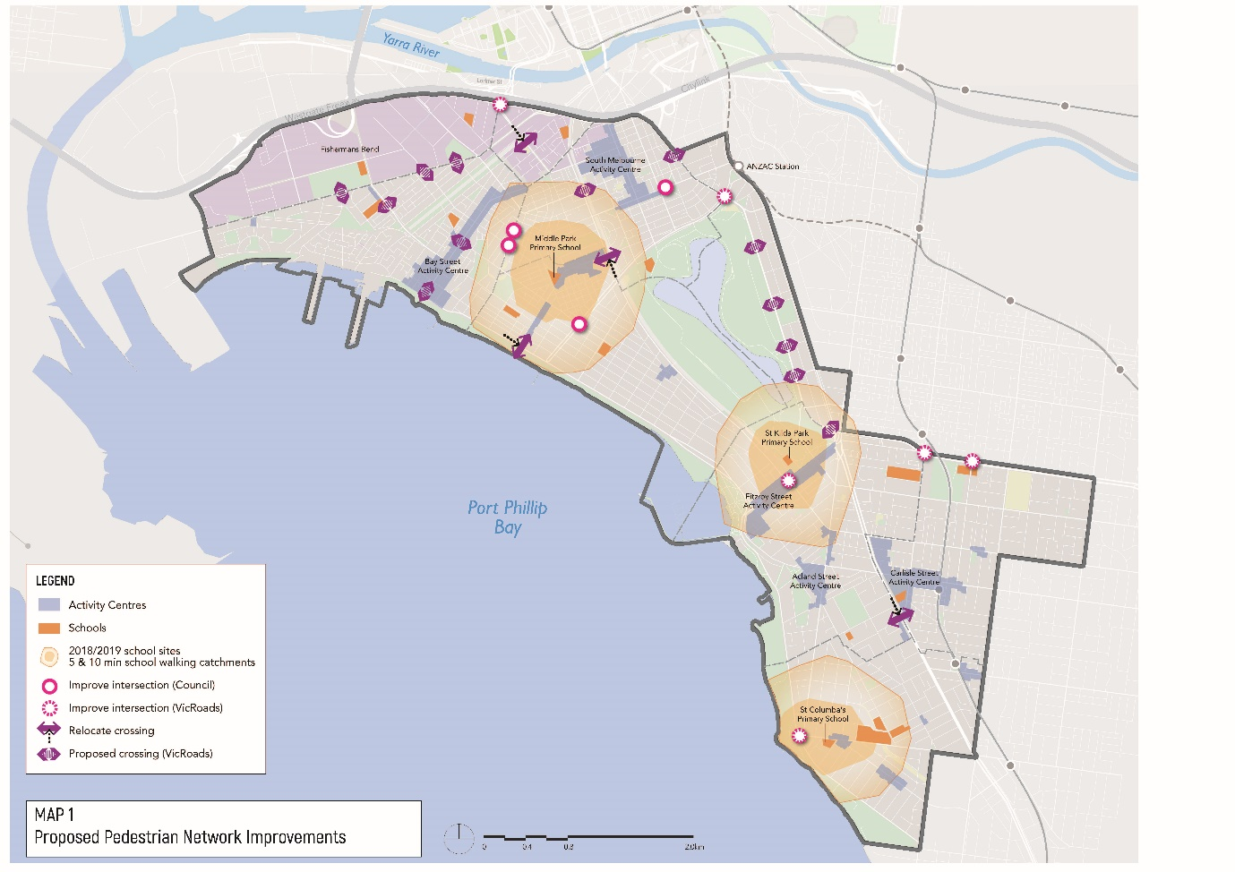

Focus Area
Boosting bike riding
To encourage increased bike riding by prioritising the delivery of comfortable, safe and complete separated bike lanes for local access, commuting and recreational trips throughout the City.

What does this mean for you?
- “I cycle everywhere (I don't own a car), and always encourage my friends to get on a bike!” – resident
- “I call my bicycle my freedom machine because I can go anywhere any time and see smell & hear the world its wonderful” – resident
- “All our friends need for encouragement is to see is the joy on our 2 year olds face when he is in our bike trailer or on the tram.” - resident
Your future experience could be:
- “I always wanted to ride to work but it seemed a bit scary and unsafe. The new bike path has a concrete separation between the cars and bikes and now I ride twice a week. It’s a great way to start the day”
- “We just bought a unit in Montague so we could be close to the city and the beach. Even though I work in Oakleigh, it’s easy to ride my bike to Anzac Station, park my bike and take the train”

Why are we doing this?
Bike riding is healthy, very space efficient, low cost and often the most convenient way to travel short to medium distances (2-10km). Encouraging more people to ride more often in Port Phillip will achieve significant benefits to both general health and the environment.
Previously Council has combined delivery of improvements for bike riding together with walking. While walking is a key priority for our community, it is easier to deliver large improvements for pedestrians than it is for bike riders, especially those who are less confident riders.
We need to invest in a dedicated program of infrastructure improvements for bike riders of all abilities if we are to improve bike rider safety and make it an attractive choice for our community. We know the best outcomes are achieved when we deliver bike lanes that are safely separated from pedestrians and vehicles, and for these lanes to be a continuous route between major destinations.
Bike riding is one of the most efficient ways of moving people in Port Phillip because:
- it is very space efficient, meaning we can move more people through the same space, and when parked needs less space than a car
- the cost to build and operate bike riding facilities is very low compared to public transport and cars
- it provides a healthy and environmentally friendly way of getting around
- bike riding is a quick means of transport for short to medium length trips.
Council will deliver a network of continuous, separated bike lanes linked with intersection upgrades. The following set of criteria was used to identify and prioritise the routes shown in Map 2: Proposed Bike Riding Network Improvements:
- Ease of delivery – minimal conflict with other existing users
- Maximum connectivity – connects the most popular destinations together
- Growth area focus – links to neighbourhoods and precincts with the highest growth in population or land use change
- Ease of uptake – likelihood of attracting the most number of people to bike riding, factoring in other travel options, trip numbers and key destinations.
One of the highest priority separated bike lanes is along Kerferd Road, connecting the beach to Ferrars Street. This project will also deliver additional benefits for pedestrians.
VicRoads is leading a corridor safety project on St Kilda Road in partnership with Council and others, to deliver changes to the design and allocation of space. A key outcome is to reduce the number of injuries, as it is Port Phillip’s busiest tram and bike route and experiences the highest car-dooring injury rate of bike riders in Victoria.
A positive bike riding culture requires high levels of bicycle parking, end-of-trip facilities and behaviour change programs.
Council will deliver and advocate for bike route connections to major transport interchanges and the provision of world class bike parking facilities. This includes both existing and future interchanges such as Ripponlea Station, Balaclava Station, Anzac Station and two locations in Fishermans Bend.
Map 2 illustrates the proposed location of the upgraded bike riding corridors throughout the municipality, proposed bike parking facilities, State government strategic bike riding corridors, major projects to be delivered by the State government and links to adjacent municipalities.
Council is proposing to complete eleven corridors within the next ten years, and an additional three post-2028. In order of priority, the bike corridors are:
- Moray Street to City (with MMRA)
- Kerferd Road (Shrine to Bay - ANZAC Station)
- Albert Road - off-road section (Shrine to Bay - ANZAC Station)
- Garden City - off-road connection to Sandridge Light Rail Trail
- Dorcas St / Nelson Rd / Foote St - Kings Way to Beach
- Inkerman St - Fitzroy Street/ Cantebury Rd to Glen Eira connection
- Sandringham Line/ Westbury St - Ripponlea to Windsor
- Dickens St - Balaclava to St Kilda Beach
- Acland St / Mitford St / Beach St - Fitzroy St to Elwood Beach
- Tennyson St/ Blessington St - Elwood to St Kilda Beach
- Byron St/ Glen Eira Rd - Ripponlea to Elwood
- .Bridge St/ Richardson St/ Loch St - Port Melbourne to St Kilda
- Alexandra St - Prahran to Balaclava
- Armstrong St - Middle Park Beach to Albert Park trail
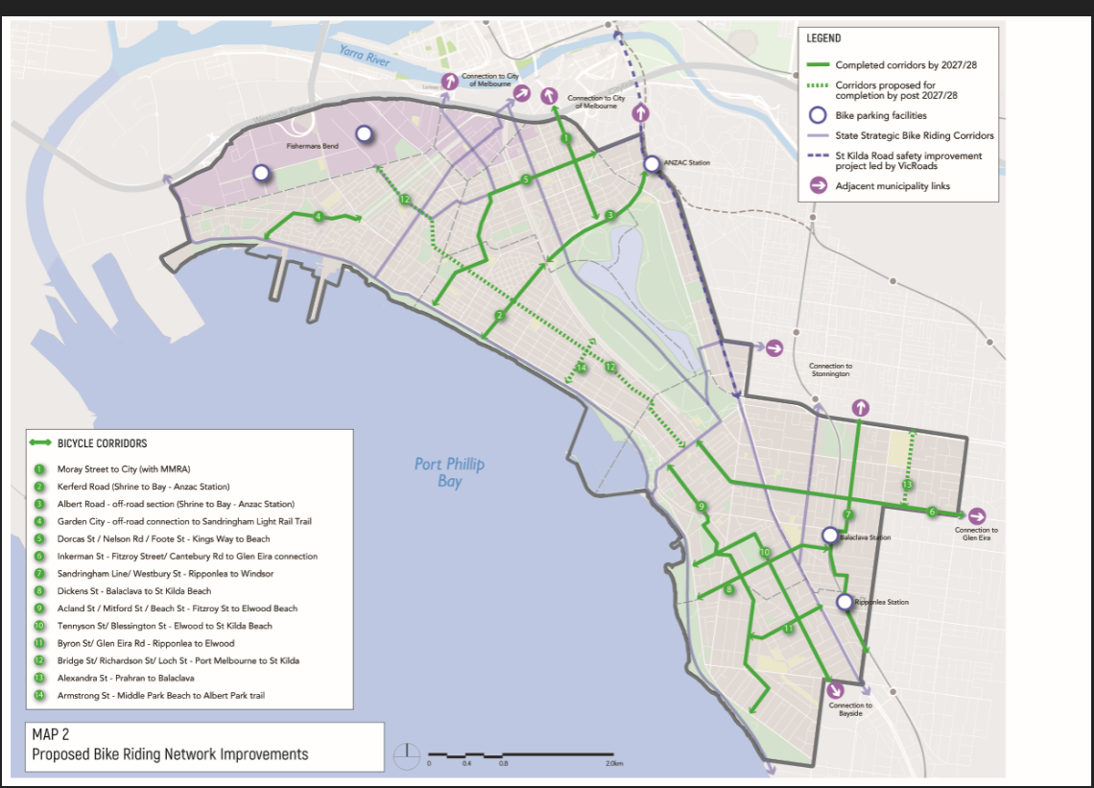

OUTCOME 3 –

Our community has convenient public transport choices that make it easy to move and connect

Focus Area: Partnering to deliver reliable, accessible and more frequent public transport
Our Priority Actions |  | SHORT  18/19 | SHORT  19/20 | MED  21-24 | LONG  25-28
ACTION 22 | Partner with Rail Projects Victoria to design and deliver place, walking, bike riding and public transport improvements around Anzac Station
ACTION 23 | Partner with the Victorian Government and public transport providers to increase the reliability and frequency of both tram and bus services
ACTION 24 | Partner with PTV and Yarra Trams to deliver a pipeline of integrated movement and place tram projects
ACTION 25 | Advocate to State and Federal governments to deliver the Fishermans Bend tram by 2022
ACTION 26 | Advocate to the Victorian Government to commence construction on Metro 2 immediately following completion of the current Metro Tunnel Project in 2025/26
ACTION 27 | Identify and advocate for improvements to missing public transport links and areas of poor public transport connectivity
Outcome 3: 10 year Budget $8,148, 000

Measuring progress
Outcome 3 | Indicator | 2015/16 result | 2021/22 target | 2027/28 target
Our community has convenient public transport choices that make it easy to move and connect | Number of public transport trips (measured by VISTA) | 42,000 | 49,000 (+17% from base case) | 56,000 (+35% from base case)
 | Percentage of upgraded tram stops in shopping and activity centres that include streetscape and placemaking improvements | N/A | 100% | 100%
 | Delivery of dedicated bus or tram only lanes on Council operated streets | 0.5 | 3.5 | 5.5

Focus Area
Partnering to deliver reliable, accessible and more frequent public transport
Council will partner with the Victorian Government and public transport providers to ensure delivery of an attractive and highly competitive travel choice.

What does this mean for you?
- “People like me rely on the roads for our livelihoods. We need frequent public transport to be more reliable. That way, more people will use it and there’s more space on the road for people who really need to drive.”
- “I would catch a bus if there was a quick bus route to the city. Buses are quite slow because while they have the priority lane they make more stops.” - Canal Ward resident
Your future experience could be:
- “Since they separated traffic from trams, the trams are so much more reliable and frequent – which also means less crowded”
- Since Council and PTV have worked together, construction only happens once – a new footpath, a larger area for outdoor dining and an accessible tram stop”

Why are we doing this?
Port Phillip’s inner-city location means it is generally well serviced by public transport services. There are key gaps, however, in both geographical coverage, service speeds and the frequency of services, especially bus and tram services. Improvements to these services will enable better quality travel and accessibility of the network, particularly for less mobile passengers.
Public transport that shares traffic lanes with an increasing number of people driving cars presents challenges to the reliability and speed of services. Prioritising public transport service to move more people faster and more reliably than private vehicle travel is the key aim.
Council will work together with our partners to redesign the network of bus and tram services. We aim to connect key destinations, to serve our growing resident and worker population ready for the benefits of ANZAC Station, including connection times between different modes. This will include a review of existing bus routes, facilitation of a ‘turn up and go’ service, closing current and potential future gaps in the public transport network and reallocation of car parking to provide a network of dedicated lanes for buses and trams separated from cars.
Public Transport Victoria and Yarra Trams are legally obligated to deliver trams stops that are accessible for people with mobility issues. Council’s role is to ensure these works are designed to maximise the benefits to our community, by designing connecting civic spaces and creating more opportunity for events, social activities and footpath trading.
Council will continue to advocate to State and Federal governments, and respective agencies to secure early implementation of tram services into Fishermans Bend so that it truly is a 10-minute neighbourhood for people to live, work and visit.
Council will continue to advocate to State and Federal governments to start planning for Melbourne Metro Rail Project 2 linking Newport to Clifton Hill with two Metro train stations located within Fishermans Bend.
Areas of Port Phillip suffer from poor public transport services including frequency, services hours and connectivity particularly around and between activity centres. Council will identify areas of need and advocate with service providers and the Victorian Government for public transport improvements.

OUTCOME 4 –

Our community understands that parking is a limited and shared resource, and works with Council to ensure fairest access

Focus Area: Improved parking management

Our Priority Actions |  | SHORT  18/19 | SHORT  19/20 | MED  21 - 24 | LONG  25 - 28
ACTION 28 | Develop and implement a new Parking Permit Policy
ACTION 29 | Develop and implement a new Parking Controls Policy (paid and time controlled parking)
ACTION 30 | Develop a new evidence base for parking provision rates for new developments
ACTION 31 | Consider the use of Parking Overlays in the Planning Scheme review process
ACTION 32 | Improve access to parking information to the community via the Council website
Outcome 4: 10 year Budget $950, 000

Measuring progress
Outcome | Indicator | 2015/16 result | 2021/22 target | 2027/28 target
Our community understands that parking is a limited and shared resource, and works with Council to ensure fairest access | Community perception of Council ‘Parking Management’ as part of the Port Phillip Customer Satisfaction Survey | 52% | ≥55% | ≥60%
 | Number of parking precincts that have been reviewed for improvement to parking management | N/A | 10 | 15

Focus Area
Improved parking management
Council will deliver a program of changes to our parking management system to improve equity in car parking while also supporting the economic vitality of the City.

What does this mean for you?
- I’m a ratepayer and pay for 2 parking permits and still can’t get a park in my street! – resident
- My customers need to be able to drive to my shop and know they can get a park – small business owner
- Cost of parking is outrageous and not consistent with other municipalities! - resident
Your future experience could be:
- “More people in my street are parking their cars in their off-street car parks instead of the street, that had really helped create more available spaces for our visitors”
- “I have had some frustrating experiences trying to pay for parking in the past, but the new app allows me to pay easily (no more coins!), and alerts me when my time is nearly up so can extend without leaving the restaurant”

Why are we doing this?
Council currently manages approximately 53,000 on-street car parking spaces across the municipality, as well as around 4,000 spaces in council-managed off-street car parks. This is equivalent to approximately ten Catani Gardens.
These spaces are a mix of paid parking, time restricted or permit parking, and unrestricted parking. Road space comprises 17 percent of the total land area of the municipality and of that 17 percent, 20 percent is dedicated to on-street carparking. Council also plays a role in the supply of private off-street parking through the implementation of the Port Phillip Planning Scheme, which influences the amount of parking that is provided in new developments. These car parks are primarily for private use by residents, workers or visitors, however there are around 2,500 commercial paid parking spaces (mainly in St Kilda Rd and South Melbourne).
Public car parking is a finite resource in Port Phillip. New parking spaces aren’t economical to provide and would take up space that could be used for other modes or other uses such as public space.
Parking controls (time restrictions and paid parking) are a critical tool to support place vibrancy of our streets, to ensure the opportunity to use the street space is equitable and allow more people to use the same space more often. Council’s aim for parking occupancy is ensure that people have the option of finding parking near their destination.

How are we doing this?
Council uses policies to guide our parking management practices. We will review and combine key parking policies to ensure that they meet current and future requirements.
Parking policy reform can support a high quality urban lifestyle, and respond to the trade-offs required to achieve this in an increasingly overcrowded road space.
Council will revise and update the Parking Permit Policy application procedures, online information and enforcement procedures as a priority action. The scope of the proposed changes include:
- introduction of fixed parking precincts for individual permits, changed from street location based
- consolidation and simplification of the existing number of permit policies and types, including the introduction of single-use visitor parking permits
- review of the maximum number of permits allowed per household, taking off-street parking into account
- introduction of tiered pricing structure for permits
- investigation into a transition from paper to electronic permits for some uses to enable a better customer experience.
A new Parking Controls Policy will provide criteria for consistent application of both paid and timed parking controls within the municipality. This will help solve existing issues around inconsistent pricing models, lack of seasonal responsiveness, poor demand management and integration with land uses.
Implementation of the Parking Controls Policy will be undertaken in conjunction with the parking technology program on a progressive basis. Reviewing parking controls in areas of Port Phillip with highest population, congestion and worker growth will be prioritised to address concerns of both existing and new residents. Priority areas include those with high congestion and traffic management requirements such as South Melbourne, St Kilda Road North, Port Melbourne, Balaclava and St Kilda. Community engagement and consultation will help inform parking needs and how we can provide fairer access to parking within our City.
Council will also investigate the development of Parking Overlays. A Parking Overlay is a planning scheme tool that we may use to respond to local car parking issues, both on and off-street, and to manage car parking by precinct rather than on a site-by-site basis.
To prepare for developing Parking Overlays in the planning scheme, Council will gather data on current use of parking supply in existing residential developments.

OUTCOME 5

Our community benefits from new transport options and technology to move around

Focus Area: Harnessing rapid advancements in new technology

Our Priority Actions |  | SHORT  18/19 | SHORT  19/20 | MED  21-24 | LONG  25-28
ACTION 33 | Introduce new technology to make it easier to find and pay for parking
ACTION 34 | Continue to deliver more convenient car share locations with providers and encourage car share provision in new developments
ACTION 35 | Review the car share policy
ACTION 36 | Partner with the Victorian Government and other councils to regulate and manage dockless bike share
ACTION 37 | Invest in transport data capture to evaluate and monitor progress toward mode shift targets
ACTION 38 | Make data available to transport providers and third parties to improve service planning and make it easier to move and connect
ACTION 39 | Establish policy positions on autonomous vehicles, congestion levy expansion, road pricing and emerging new transport options
ACTION 40 | Support the use of electric vehicles, including installation of public charging stations and planning controls requiring charging infrastructure in new developments
Outcome 5: 10 year Budget $4,959,000
Measuring progress
Outcome 5 | Indicator | 2015/16 result | 2021/22 target | 2027/28 target
Our community benefits from new transport options and technology to move around | Residents who are satisfied with the use of pay by phone alternative to pay for parking | NA | >75% | >90%
 | Number of cars owned by Port Phillip residents | 51,200 | 53,400  (+4.3% from base case) | 54,500  (+6.5% from base case)
 | Number of residents who are car share members | 3,300 | 10,800 (+230% from base case) | 16,500 (+400% from base case)
 | Utilisation rate of Bike Share (docked and dockless) | 1 trips/day | 3 trips/day | 4 trips/day

Focus Area
Harnessing rapid advancements in new technology
The way we make our daily travel decisions is set to change dramatically over the next 20 years. Both existing and emerging technologies, particularly the increase of internet enabled, location sensitive mobile devices and the data they produce, will support more options around how and when to travel.

What does this mean for you?
- “[Shared cars] encourage people not to buy a car. I have a friend who did the calculations regarding how much it costs to run a car... and she found that it was much cheaper using the share cars” - Canal Ward resident
Your future experience could be:
- “We tried out the Augmented Reality app at the South Melbourne Market and it really opened up my mind to all the new ways that technology can help you find your war around and discover so much more about my neighbourhood with cool animation”
- Having a car share a few streets away from our house has allowed us to sell our car and save for a holiday. We only need the car for big shops and weekends away, so it gives us everything we need for less”

Why are we doing this?
Australia has entered a period of rapid transport innovation. Smartphone apps to summon rides, self-driving cars, solar power, GPS-connected public bike share schemes and more are changing the way we manage our mobility needs.
Emerging technologies will play a major role in addressing both contemporary challenges and the transport requirements of future generations. The potential role of technology is constantly evolving, and any new long-term strategy needs to be flexible enough to adapt to new innovations and approaches.
One of the first steps Council is making is the introduction of new parking technology to help provide a more efficient and transparent parking service to residents and visitors. Parking ticket machines will be updated to allow modern payment and automated top-up options. Sensor technology will allow for more efficient parking turnover and real-time parking data to point drivers to vacant parking spaces.
Port Phillip is a national leader in the introduction of a car-share policy and has successfully met early targets for car share bays. Council will continue to increase the number of car-share bays across the municipality and continue to collect ongoing data to monitor usage trends across the various operators to ensure greatest community benefit.
The recent introduction of dockless bike share to Melbourne triggered a Council response to ensure providers generate benefit to the community by pursuing better regulation with the Victorian Government and other inner-city councils.
Many changes that will be brought about by technological change will either be delivered by parties other than Council, or in a future beyond the 10-year scope of this strategy. Recent experience with dockless bike share operations prompts Council to be proactive in establishing early thinking around new policy positions for our long-term future. This includes changes such as autonomous vehicles, congestion charges, and emerging transport technologies.
The future of travel choice will be driven by data and Council has the opportunity to work with public and private transport services providers, to offer real-time information and assist innovation across the sector.
To ensure that Council is able to accurately track and report on progress for improvements in the number of people bike riding, walking and using our civic spaces, investment in additional data capture is required.

Measuring and Reporting
The MOVE, CONNECT, LIVE Strategy 2018-2028 is a 10-year strategy supported by a 4-year delivery plan that details the individual projects and methodologies required to achieve the actions in this strategy.
Over the course of the Strategy period (2018-2028), Council will produce two delivery plans. The updated delivery plan will be developed to ensure a periodic review of progress and unforeseen changes are incorporated over a multi-year view. The first year of delivery is outlined in the Council Budget 2018/2019.

- Council Plan 2017-27 and Council Budget 2018/19 (Year 1)
- Delivery Plan 2019-2022
- Delivery Plan 2023-2027

Measuring success
Outcome 1 | Indicator | 2015/16 result | 2021/22 target | 2027/28 target
Our City’s transport network, streets and places cater for our growing community | Number of fatal or serious traffic collisions involving all road users | 78 | ≤119 | ≤96
 | Number of daily passenger vehicle trips (measured by VISTA) | 128,000 | 128,000 | 128,000
 | Performance of ‘traffic management’ in Port Melbourne as part of the Customer Satisfaction Survey – Speak to Sally Horner | 53% | ≥55% | ≥60%
Outcome 2 | Indicator | 2015/16 result | 2021/22 target | 2027/28 target
Our community is healthier because it has safe, connected and convenient walking and bike riding choices | Number of daily walking trips (measured by VISTA) | 153,000 | 180,000  (+18% from base case) | 207,000  (+36% from base case)
 | Number of daily bike riding trips (measured by VISTA) | 17,000 | 30,000  (+75% from base case) | 44,000  (+150% from base case)
 | Growth of cycling users recorded at 7 key intersection in Port Phillip during ‘Super Tuesday Count’ | 4,000 | 7,000  (+75% from base case) | 10,000  (+150% from base case)
 | Speed of vehicles using Wellington Street | >44.8km/hr | ≤40km/hr | ≤40km/hr
 | Number of schools (subject to external funding) each year that Council is working with to improve safety, accessibility and participation
 | ‘Walk to School’ month | 7/year | 9/year | 11/year
 | ‘Ride to School’ | 13/year | 15/year | 18/year
 | ‘Track to School’ infrastructure improvements completed | N/A | 6 | 12
 | Number of bike routes delivered | N/A | 4 | 11
 | Increase in the amount of space on shopping strips and activity centres for pedestrians and civic space | 0% | 10% | 20%
Outcome 3 | Indicator | 2015/16 result | 2021/22 target | 2027/28 target
Our community has convenient public transport choices that make it easy to move and connect | Number of public transport trips (measured by VISTA) | 42,000 | 49,000  (+17% from base case) | 56,000  (+35% from base case)
 | Percentage of upgraded tram stop in shopping and activity centres that include streetscape and placemaking improvements | N/A | 100% | 100%
 | Delivery of dedicated bus or tram only lanes on Council operated streets | 0.5 | 3.5 | 5.5
Outcome 4 | Indicator | 2015/16 result | 2021/22 target | 2027/28 target
Our community understands that parking is a limited and shared resource, and works with Council to ensure fairest access | Community perception of Council ‘Parking Management’ as part of the Customer Satisfaction Survey | 52% | ≥55% | ≥60%
 | Number of parking precincts that have been reviewed for improvement to parking management | N/A | 10 | 15
Outcome 5 | Indicator | 2015/16 result | 2021/22 target | 2027/28 target
Our community benefits from new transport options and technology to move around | Residents who are satisfied with the use of pay by phone alternative to pay for parking | N/A | ≥75% | ≥90%
 | Number of cars owned by Port Phillip residents | 51,200 | 53,400  (+4.3% from base case) | 54,500  (+6.5% from base case)

