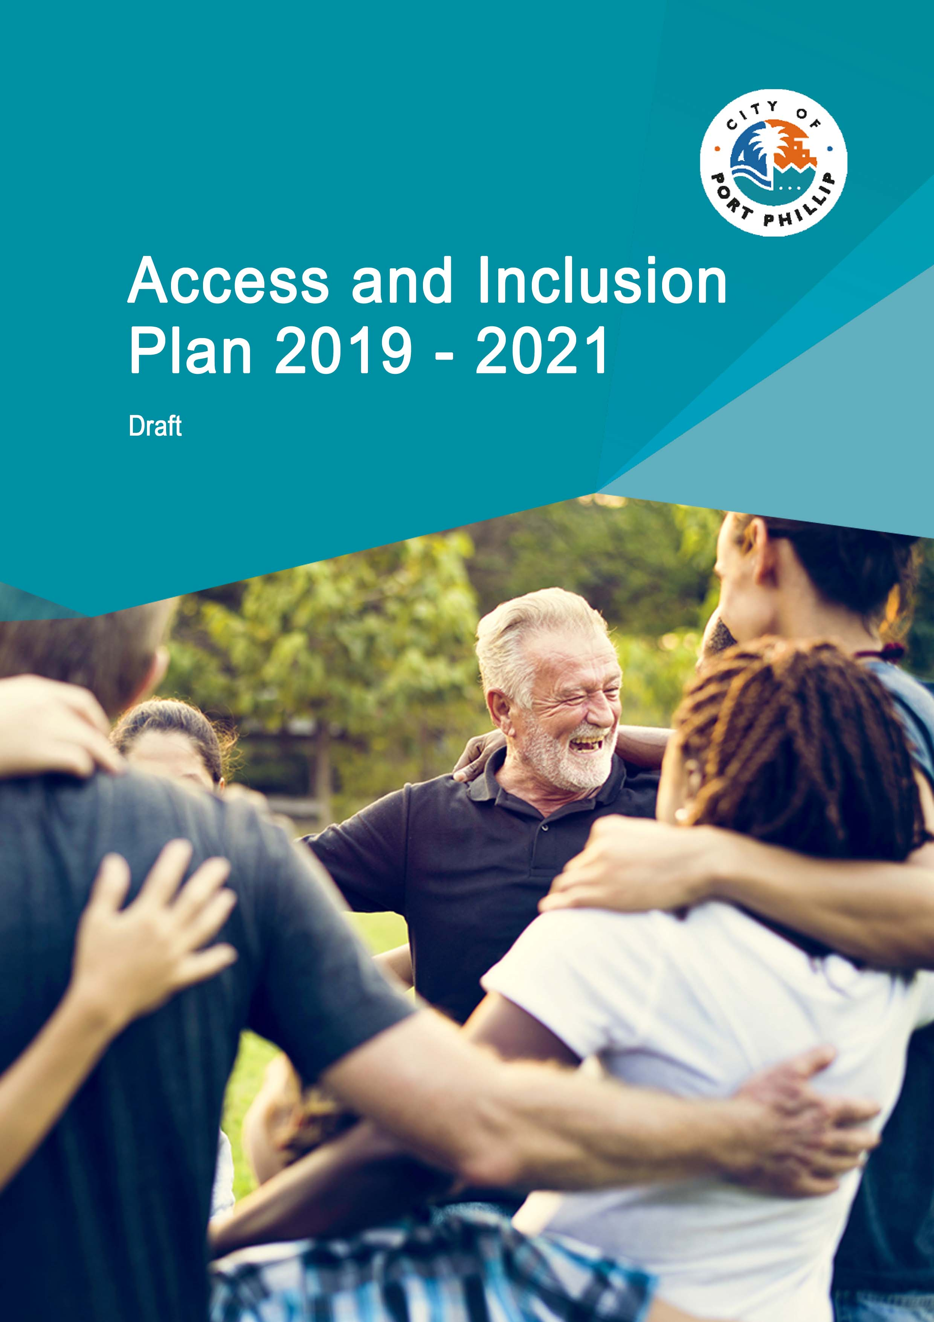
Contents
About this Access and Inclusion Plan 3
Disability - a human rights approach 3
Access and inclusion in the City of Port Phillip 4
Access and Inclusion Plan - Council’s continued focus 5
Framework for achieving our outcomes 6
Access and Inclusion Plan actions 9
1. We are Inclusive 9
2. We are Thriving 10
3. We are Fair 11
4. We are Disability Confident 12
Governance and communications 13
Legislative framework 14
More information 15

Tables
Table 1: Access and Inclusion Plan themes - linking the strategic directions 6
Table 2: Access and Inclusion Plan 2019-21 framework 7
Table 3: We are inclusive 9
Table 4: We are thriving 10
Table 5: We are fair 11
Table 6: We are disability confident 12
Table 7: Governance and communications 13

About this Access and Inclusion Plan
The City of Port Phillip Access and Inclusion Plan 2019-21 is our commitment to improve the equitable participation and inclusion for people with disability within our community. Our vision for this three-year plan is to strengthen the Port Phillip community as a place in which people with disability feel valued and have a positive sense of belonging.
Our purpose is shaped by putting the community first, being inclusive and fair. Our approach for this plan is one of affirmative action to build capability. Capability in the sense of ensuring people with disability can equitably participate in community life, as well as building Council’s disability confidence - applying an accessibility lens to all that we do to advance disability inclusion.

Disability - a human rights approach
Council’s Access and Inclusion Plan is informed by the United Nations Convention on the Rights of Persons with Disabilities, which states:
‘Persons with disabilities include those who have long-term physical, mental, intellectual or sensory impairments which in interaction with various barriers may hinder their full and effective participation in society on an equal basis with others’.
The above statement articulates that an adverse impact of impairment is typically felt when encountering barriers in society. Barriers could be of a social nature, for example, discriminatory attitudes and behaviours towards a person with disability. Barriers could also be environmental, such as a lack of accessibility to premises, goods and services.
By adopting a human rights approach to disability, principles of individual autonomy, dignity and equal opportunity for all are emphasised. This approach is consistent with the recent introduction of the National Disability Insurance Scheme (NDIS). The NDIS aims to equip people with disability with agency and choice to lead a self-determined life.
As a Council, we believe we can make a positive contribution to community strengthening and engagement initiatives for individuals, in partnership with the community, local businesses and services.

Access and inclusion in the
City of Port Phillip
Australian Bureau of Statistics’ data (2015) tells us that almost one in five Australians live with disability. We also know that most disability is acquired as we age and that disability adversely impacts on a person’s ability to earn income. People with disability of working age are approximately 30 per cent less likely to be in employment in comparison to people without disability. In addition, the rates of people with disability participating in social activities decreases for those with more profound impairments.
2016 Census data shows that our City has a lower proportion of residents at post-retirement age in comparison to both Victoria and wider Australia. Furthermore, compared to greater Melbourne, our City has a higher proportion of high income households (those earning $2500 per week or more) and a lower proportion of low income households (those earning less than $650 per week).
We want every Port Phillip resident to feel connected to the wider community and have a positive sense of belonging, whether this is through employment or social participation in the many events and activities our municipality has to offer.

Access and Inclusion Plan
- Council’s continued focus
This is Council’s third disability action plan. Our previous plan, titled Access Plan, was for the period 2013-18. During this time, we focused our efforts on enabling better practice and process within Council with a view to eliminating the potential for disability discrimination.
For the new Access and Inclusion Plan, we aim to move beyond a compliance focus to an organisational culture where access and inclusion is routinely considered as part of ‘the way we do things around here’. The outcomes we want to achieve by 2021 are:
- To have in place an active and engaged network representing the voices of people with disability in our community.
- To demonstrate a significant increase in Council’s organisational disability confidence.
- To be an Employer of Choice for people with disability.
- To be regarded as a valued partner across industry sectors to lead access and inclusion initiatives within the City of Port Phillip.

Framework for achieving our outcomes
The framework for the Access and Inclusion Plan is designed according to four themes. The development of these themes was influenced by the strategic directions in the Council Plan (2017-27), We are Port Phillip, and the focus areas listed within the Victorian Government state disability plan, Absolutely Everyone (2017-20). An outline of this linkage can be found in Table 1:
Table 1: Access and Inclusion Plan themes - linking the strategic directions
Access and Inclusion Plan themes | 1. We Are Inclusive | 2. We Are Thriving | 3. We Are Fair | 4. We Are Disability Confident
Council Plan 2017-27 - 'We are Port Phillip'  Port Phillip today and tomorrow  Strategic directions | Direction 1  We embrace difference, and people belong  Direction 4  We are growing and keeping our character  Direction 5  We thrive by harnessing creativity  Direction 6  Our commitment to you | Direction 1  We embrace difference, and people belong  Direction 2  We are connected and it's easy to move around  Direction 3  We have smart solutions for a sustainable future | Direction 1  We embrace difference, and people belong  Direction 4  We are growing and keeping our character  Direction 5  We thrive by harnessing creativity  Direction 6  Our commitment to you | Direction 1  We embrace difference, and people belong  Direction 6  Our commitment to you
Victorian Government state disability plan ‘Absolutely Everyone’  (2017-20)  Four pillars | Inclusive communities | Health, housing and wellbeing | Fairness and safety | Contributing lives

Each of the four themes in the Access and Inclusion Plan is guided by a set of principles which support the implementation of the actions for the period 2019-21. Furthermore, the Access and Inclusion Plan includes two principles to oversee its governance. The framework containing the principles which guide the actions in the Access and Inclusion Plan can be viewed in Table 2.

Table 2: Access and Inclusion Plan 2019-21 framework
Access and Inclusion Plan themes | 1. We Are Inclusive | 2. We Are Thriving | 3. We Are Fair | 4. We Are Disability Confident
Outcomes | Fostering a community where people with disability belong | Fostering a liveable community | Fostering a respectful and equitable community | Fostering organisational capability and culture
Principles | 1.1  People with disability have a voice in our community  1.2  People with disability can equitably participate in community events and activities  1.3  Our communications are in accessible formats | 2.1  City Strategy and City Design encourages accessible and inclusive design practices  2.2  Accessible transport is optimised across our municipality  2.3  Positively influence the availability of accessible, visitable and adaptable housing  2.4  Transition to the National Disability Insurance Scheme (NDIS) is supported by our council services  2.5  The design of our parks and open spaces considers accessibility for all  2.6  Accessibility is included in our place-making activities | 3.1  Council's customer service is a positive experience for people with disability  3.2  We partner with suppliers who are committed to equitable practices for people with disability  3.3  Access and inclusion awareness is included in the management of community access to council utilised buildings  3.4  Community mental health is strengthened through advocacy and partnerships | 4.1  We are an Employer of Choice for people with disability  4.2  Our employees are disability confident  4.3  Our disability confidence is advanced through informed practices and data  Governance and Communications  - Access and Inclusion is role-modelled by our Leadership  - We commit to transparency and governance

In addition, the actions contained within the City of Port Phillip Access and Inclusion Plan 2019-21 are aligned with current legislative and regulatory requirements. Information on these requirements can be found in the section on the Legislative framework for this Access and Inclusion Plan. One particular piece of legislation warrants a specific mention because of its application to local governments in Victoria: the Disability Act 2006. This Act stipulates that ‘a public sector body must ensure that a disability action plan is prepared for the purpose of:
- reducing barriers to persons with a disability accessing goods, services and facilities;
- reducing barriers to persons with a disability obtaining and maintaining employment;
- promoting inclusion and participation in the community of persons with a disability;
- achieving tangible changes in attitudes and practices which discriminate against persons with a disability’.
The next section in our Access and Inclusion Plan outlines the actions we as a Council commit to for the period 2019-21 to advance access and inclusion within Port Phillip. It includes a component on governance and communications for this action plan.

Access and Inclusion Plan actions

1. We are Inclusive
The table below outlines the principles and actions we commit to with the aim of fostering a community where people with disability belong.
Table 3: We are inclusive
Principle | Action
1.1 People with disability have a voice in our community | 1.1.1 Broaden engagement and consultation with community members with disability (delivery 2019-21)  1.1.2 Provide equitable participation opportunities in civic life for community members with disability (delivery 2019)
1.2 People with disability can equitably participate in community events and activities | 1.2.1 Initiatives and events related to sustainability are routinely assessed to ensure equitable access and inclusion (delivery 2019)  1.2.2 Support sport and recreation providers in facilitating inclusive programs, services and opportunities by increasing their disability confidence (delivery 2020)  1.2.3 Ensure library hosted events are accessible and inclusive (delivery 2019)  1.2.4 Expand access and inclusion support at Council hosted festivals (delivery 2021)  1.2.5 Optimise accessibility and inclusion for our community arts initiatives (delivery 2020-21)  1.2.6 Provide guidelines for accessible and inclusive events held on Council managed public open space (delivery 2020-21)  1.2.7 Increase the disability confidence of library staff (delivery 2020-21)  1.2.8 Improve access to information about the library collection and events (delivery 2020-21)
1.3 Our communications are in accessible formats | 1.3.1 Newly created digital content will meet Web Content Accessibility Guidelines (WCAG) 2.1 AA standard (delivery 2019)  1.3.2 Existing digital content for key Council services information is updated to WCAG 2.1 AA standard (delivery 2020-21)

2. We are Thriving
The table below outlines the principles and actions we commit to with the aim of fostering a liveable community.
Table 4: We are thriving
Principle | Action
2.1 City Strategy and City Design encourages accessible and inclusive design practices | 2.1.1 Review and update key City Strategy documentation, including planning guidelines (delivery 2019-21)
2.2 Accessible transport is optimised across our municipality | 2.2.1 Review and upgrade accessible parking spaces (delivered 2019-20)  2.2.2 Advocate to the Victorian Government and public transport providers to increase the accessibility of tram and bus services (delivery 2019-21)
2.3 Positively influence the availability of accessible, visitable and adaptable housing | 2.3.1 Strengthen advocacy for increasing standards and requirements for accessible, visitable and adaptable housing (delivery 2019-21)
2.4 Transition to the National Disability Insurance Scheme (NDIS) is supported by our council services | 2.4.1 Work with the Brotherhood of St Laurence Local Area Coordinator (NDIS) to enhance community engagement and capacity building within the municipality (delivery 2019-21)
2.5 The design of our parks and open spaces considers accessibility for all | 2.5.1 Identify and implement accessibility improvements for public space and parks (delivery 2019-21)
2.6 Accessibility is included in our place-making activities | 2.6.1 Access and inclusion is considered across all community infrastructure and asset planning projects, including Fishermans Bend Urban Renewal Area (delivery 2019-21)  2.6.2 Accessibility is considered in the review and update of all Council's standard drawings (delivery 2019-21)  2.6.3 Increase the accessibility of footpaths across the municipality (delivery 2019-21)  2.6.4 Promote connection between local business owners and local community members with disability (delivery 2020)  2.6.5 Increase the number of accessible toilets across the municipality (delivery 2021)

3. We are Fair
The table below outlines the principles and actions we commit to with the aim of fostering a respectful and equitable community.
Table 5: We are fair
Principle | Action
3.1 Council's customer service is a positive experience for people with disability | 3.1.1 Increase the disability confidence of Council's ASSIST team (delivery 2019-20)
3.2 We partner with suppliers who are committed to equitable practices for people with disability | 3.2.1 Update our social procurement policy with access and inclusion guidelines for suppliers and partners (delivery 2019)  3.2.2 Include mandatory accessibility and inclusion selection criteria for tenders and panel contracts (delivery 2020)  3.2.3 Update access and inclusion guidelines for grant opportunities (delivery 2019-20)
3.3 Access and inclusion awareness is included in the management of community access to council utilised buildings | 3.3.1 Review our Emergency Management process and practice to enhance accessibility (delivery 2019-20)  3.3.2 Expand the online information provision of the accessibility features for council facilities available to the community (delivery 2019-20)
3.4 Community mental health is strengthened through advocacy and partnerships | 3.4.1 Promote good mental health, accessibility and inclusion for school-aged children (delivery 2019)  3.4.2 Increase community awareness of services that support the wellbeing of carers (delivery 2020)  3.4.3 Strengthen the service development for mental health service provision in our municipality (delivery 2019-21)

4. We are Disability Confident
The table below outlines the principles and actions we commit to with the aim of fostering organisational capability and culture.
Table 6: We are disability confident
Principle | Action
4.1 We are an Employer of Choice for people with disability | 4.1.1 Implement disability confident practices across the employee life-cycle, starting with ensuring accessible and inclusive recruitment practices (delivery 2019-20)  4.1.2 Adopt a centralised workplace adjustment fund (delivery 2019)  4.1.3 Increase work experience opportunities for students with disability (delivery 2020-21)
4.2 Our employees are disability confident | 4.2.1 Increase employee disability confidence through development of  an access and inclusion toolkit (delivery 2019-21)
4.3 Our disability confidence is advanced through informed practices and data | 4.3.1 Implement measures to monitor our level of disability confidence (delivery 2019-20)  4.3.2 Embed Access and Inclusion Key Performance Indicators (KPIs) into departmental plans (delivery 2021)  4.3.3 Council's budget process routinely considers funding to meet accessibility requirements (delivery 2021)

Governance and communications
The table below outlines the principles and actions we commit to with the aim of fostering good governance.
Table 7: Governance and communications
Principle | Action
5.1 Access and Inclusion is role-modelled by our Leadership | 5.1.1 Appointment of an Executive Champion for Access and Inclusion within Council (delivery 2019)  5.1.2 Establish an internal Access and Inclusion project advisory group (delivery 2019)  5.1.3 Explore opportunities to collaborate with other councils on establishing a community of practice for employees with disability to influence organisational best practice (delivery 2019)
5.2 We commit to transparency and governance | 5.2.1 Lodgement of the Access and Inclusion Plan with the Australian Human Rights Commission (delivery 2019)  5.2.2 Our progress is reported in the Council annual report (delivery 2019-21)  5.2.3 Progress on actions is reviewed twice yearly with the Access and Inclusion project advisory group (delivery 2019-21)  5.2.4 Host an annual forum for community members to review progress of our Access and Inclusion Plan (delivery 2019-21)

Legislative framework
Access and Inclusion plans are also known as Disability Action Plans, Accessibility Actions Plans and Access Plans. Council’s Access and Inclusion Plan 2019-21 was developed taking into consideration a range of legislative requirements, as well as guidelines and standards available to advance access and inclusion more broadly. Below is a summary of these considerations.

Victorian Government guidance
- Absolutely Everyone’ state disability plan 2017-20 (VIC)
- Charter of Human Rights and Responsibilities Act 2006 (VIC)
- Disability Act 2006 (VIC)
- Equal Opportunity Act 2010 (VIC)
- Local Government Act 1989 (VIC)

Australian Government guidance
- Disability Discrimination Act 1992
- Fair Work Act 2009
- National Disability Strategy 2010-20

International guidance
- United Nations Convention on the Rights of Persons with Disabilities
- Web Content Accessibility Guidelines (WCAG) 2.1

More information
For more information, please contact us via:
- Online: you can complete a contact form via contact us
- Telephone: ASSIST on (03) 9209 6777
- Postal address: The City of Port Phillip, Private Bag 3, St Kilda, Victoria, Australia, 3182
You can also visit the Port Phillip City Council website for more information.

Alternative formats
If you require this document in an alternative format, please contact our ASSIST team on phone number (03) 9209 6777 or complete the online contact form (webpage address: www.portphillip.vic.gov.au/contact_us.htm).

National Relay Service
If you are deaf, or have a hearing or speech impairment, you can phone us through the National Relay Service (NRS):
- TTY users, dial 133 677, then ask for (03) 9209 6777
- Speak and Listen users, phone 1300 555 727, then ask for (03) 9209 6777
For more information visit the national relay service website.

Language assistance telephone contact numbers
- 廣東話 - (03) 9679 9810
- 普通話 - (03) 9679 9858
- Ελληνικα - (03) 9679 9811
- Polski - (03) 9679 9812
- Русский - (03) 9679 9813

United Nations, ‘Convention on the Rights of Persons with Disabilities’, retrieved 10 January 2019, <https://www.un.org/development/desa/disabilities/convention-on-the-rights-of-persons-with-disabilities.html>.
Australian Bureau of Statistics, ‘4430.0 - Disability, Ageing and Carers, Australia: Summary of Findings, 2015’, retrieved 17 January 2019, <http://www.abs.gov.au/ausstats/abs@.nsf/0/C258C88A7AA5A87ECA2568A9001393E8?Opendocument>.
City of Port Phillip Website, ‘Community Profile’ based on the Australian Bureau of Statistics (ABS) , Census of Population and Housing, 2016, retrieved 17 January 2019, <https://profile.id.com.au/port-phillip/service-age-groups?BMID=50>.
City of Port Phillip Website, ‘Community Profile’ based on the Australian Bureau of Statistics (ABS) , Census of Population and Housing, 2016, retrieved 17 January 2019, <https://profile.id.com.au/port-phillip/household-income?WebID=10>.
Victorian Legislation and Parliamentary Documents, ‘Disability Act 2006’, retrieved 10 January 2019, <http://www.legislation.vic.gov.au/domino/web_notes/ldms/pubstatbook.nsf/f932b66241ecf1b7ca256e92000e23be/0B82C05270E27961CA25717000216104/$FILE/06-023a.pdf>.

