Heritage Design Guidelines

Draft

June 2019

Content
Introduction 3
How to use the Guidelines 7
Design in context 8
Guideline 1 Demolition 11
Guideline 2 Conservation 14
Guideline 3 Additions 19
Guideline 4>New buildings 31
Guideline 5> Car parking 39
Guidelines 6 Fencing 42
Guidelines 6 Signage 44
Guideline 7>Significant trees 47
Guideline 9>Sustainability and services 49
Guideline 10>Subdivision 53
Guideline 11>Public realm and infrastructure 55
Attachment 1>Definitions 57
Attachment 2>Architectural styles 61
Attachment 3>Technical notes 70

Introduction

Purpose
Heritage places in the City of Port Phillip are highly valued by Council and the community for providing a link to the past and for enriching the present environment.
The Port Phillip Heritage Design Guidelines are intended to encourage and support the conservation of heritage places in Port Phillip.
The purpose of the Guidelines is to provide both Council and property owners or occupiers with clear guidance for decision making in relation to the future management and development of heritage places.
The Guidelines follow the philosophy, principles and processes set out in the Australia ICOMOS Charter for Places of Cultural Significance, The Burra Charter (Burra Charter), which is to “do as much as necessary, but as little as possible”. The aim is not to prevent change, but to ensure that change does not diminish the cultural significance of heritage places over time.

Process
Port Phillip City Council strongly encourages property owners and developers to discuss any proposals with Council prior to preparing an application for any new development. The following steps are recommended:

Context analysis
Start your project by understanding the context from the broad surroundings to your own site or building. Chapter 3 Design in Context provides the detailed guidelines on what should be considered and how they would influence your project approach. A site analysis rather than a broad context may be required for more minor works such as repairs or restoration. Attachment 2 can help you to understand the key features of the main architectural styles found within the City of Port Phillip.

Find out planning requirements
Speak to a town planner within the Statutory Planning team about planning permit requirements. They can also advise if there are other planning controls, guidelines or policies that you should consider. For example, Rescode.
Depending on the works, general advice may be provided over the phone 9209 6424 or via email (planhelp@portphillip.vic.gov.au), or in person at the St Kilda Town Hall, 99a Carlisle Street, St Kilda (Monday to Friday, 8.30am – 5pm).Otherwise, you can request pre-application advice (For information, please see Council’s pre-application advice guide).
In some cases, a meeting or site visit with the Heritage Adviser may be necessary. The need for this will be identified as part of the pre-application advice.

Prepare an application
Once an approach has been agreed to, prepare your proposal and an application. (For information about preparing an application, please see Council’s website www.portphillip.vic.gov.au/apply-for-planning-permit

General strategies
The local strategies for heritage set out in Clause 15.03-1L1 are to:
Conserve heritage places in accordance with the principles and procedures set out in the Australia ICOMOS Burra Charter, 2013
Conservation of heritage places and new development are guided by the statement of significance and any relevant documentary or physical evidence.
Encourage new development that respects and complements the heritage place by using a contextual design approach that responds to and reinforces the valued characteristics of heritage places including:
- Building height, scale, massing and form.
- Roof form and materials
- Siting, orientation and setbacks.
- Fenestration and proportion of solid and void features.
- Details, colours materials and finishes.
Encourage new development that respects and complements the heritage place by using a contextual design approach that rotects and conserves views of heritage places.
Maintain the integrity and intactness of heritage places.
Conserve and enhance the significant historic character and intactness of streetscapes within heritage precincts including:
- The layering and diversity of historic styles and character where this contributes to the significance of the precinct, and
- The consistency of historic styles and character where this contributes to the significance of the precinct.
Avoid new development that would result in the incremental or complete loss of significance of a heritage place by:
- Demolishing a building identified as Significant (Individual), Significant (Precinct) or Contributory on the Port Phillip Heritage Policy Map.
- Altering, concealing or removing a feature, detail, material or finish that contributes to the significance of the heritage place.
- Distorting or obscuring the significance of the heritage place, or detracting from its interpretation and appreciation by copying historic styles in detail.
Avoid inadvertent destruction of archaeological remains.

Significance of heritage places in Port Phillip
The Port Phillip Heritage Review contains information about the significance of heritage places in Port Phillip. The amount of information depends on the level of significance:
- Significant (Individual) heritage places have an individual citation in the Port Phillip Heritage Review that explains why the place is significant.
- Significant (Precinct) or Contributory (Places) do not have an individual citation. They form part of heritage precincts, which each have a citation that explains the collective significance of these places.
The citations are available on Council’s website in Volume one of the Port Phillip Heritage review.
When preparing an application:
- Consider the most recent statement of significance if there is more than one statement of significance for the heritage place.
- If there is a statement of significance at both the individual and precinct level for the heritage place then both should be considered.
Citations prepared prior to 1998 sometimes have limited information, or the place may have changed since the citation was originally prepared. For this reason, it may be necessary to obtain expert heritage advice to review the information contained in the citation.

How to use the Guidelines

Application and scope
The Guidelines apply to all properties included within the Heritage Overlay in Port Phillip, except for places and areas included on the Victorian Heritage Register. A permit or permit exemption from Heritage Victoria is required to change any place or object on the Victorian Heritage Register.
All the guidelines apply to places graded Significant (Individual), Significant (Precinct) or Contributory, as shown on Council’s Heritage Policy Maps.
Some guidelines, including Additions, New buildings, Car parking, Fencing, Signage, Sustainability and services and Subdivisions, also apply to Nil grade places.
The Guidelines explain what Council will take into consideration when assessing an application for development or subdivision of land. They will be considered in conjunction with other relevant State and local planning policies and controls contained in the Port Phillip Planning Scheme.
The Guidelines should be considered in conjunction with other heritage controls, policies and guidelines including:
- Clause 15.03 Heritage Conservation and Clause 43.01 Heritage Overlay of the Port Phillip Planning Scheme.
- Dunstan Estate Heritage Guidelines, 2007.
- Fishermans Bend Estate Guidelines, 2010.
- Garden City Estate Guidelines, 2010.
- Specific heritage guidelines for Significant (Individual) heritage places.

How to comply with the guidelines
A development should satisfy all relevant objectives and strategies:
- The objectives provide the overall desired outcomes to be achieved.
- The strategies describe more specific outcomes to be achieved for each guideline.
The guidelines are not exhaustive. Other approaches may be considered, if it can be demonstrated that the outcomes sought by the objectives and strategies will still be achieved.
Many guidelines are mutually informed. A development may not always be able to reach its maximum limit based on one or few criteria alone. Good design will consider all relevant factors comprehensively whereas poor design response focus on box ticking.
The following section, Design in context, provides advice in relation to the preferred approach to developing a sympathetic design response

Design in context
Good design in an historic context links the past to the present and projects into the future by demonstrating an understanding and responding to the context of a place (Office of the Victorian Government Architect, Good Design and Heritage, page 5).
Council encourages a contextual design approach that complement existing heritage places by respecting and understanding historic values and character, and assessing the opportunities and constraints that arise from these.

Managing transitions
An important part of contextual design is managing transitions between old and new. Successful transition between different building styles and forms requires careful consideration of form and details, scale, proportions and massing, setbacks and the distinctive ‘rhythm’ created by traditional fine-grain heritage streetscapes.
For additions, the design response should respect important relationships between the building, its neighbours and its setting and may create new ones. New buildings should complement the existing built form and leave a valuable legacy for the future.

Contemporary design
Contemporary architecture and innovative design is an important part of the contextual approach because well-designed new work can have a positive role in the interpretation of a place. The layering of different styles is a defining feature of Port Phillip’s heritage. 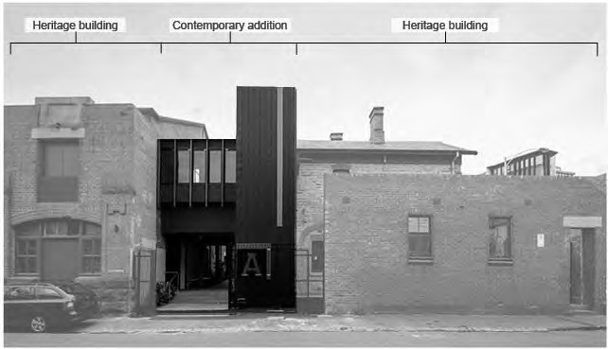

It is a common misunderstanding that contemporary design means a set of stylistic choices completely breaking from the past. What separates contemporary design approach from that of modern era is the significance of context when creating own identity.

Accurate reconstruction
While imitative solutions are generally discouraged, accurate reconstruction may be employed in limited instances where documentary (such as photographs or plans) or physical (e.g., original window frames contained within walls, similar details in adjoining houses) evidence exists. In special cases, accurate reconstruction could be applied to an entire building.

Putting everything together
To inform your design approach you should consider three levels of influence by undertaking context analysis.
A context analysis considers not only your own site but the broader characteristics of the precinct and streets surrounding it. This is particularly important if you site is in a heritage precinct.
The following explains what should be considered at each level of your analysis and how they would influence your design.

Precinct
The historic context of the heritage precinct plays a key role in determining not only the scale and form of additions or new buildings, but also its character and materials. At a precinct level, consider the following:
- Views and skylines. Wiill the proposed development intrude upon views to landmark buildings or landcape within the precinct? What are the characteristics of the historical skylines found within the precinct and how should the proposed development respond to these?
- Urban grain. This describes the layout and scale of the traditional subdivision pattern found within the heritage precinct. What are the characteristics of the ‘urban grain’ within the surrounding heritage precinct. Is it regular or irregular? Are there consistent lot sizes?
- Consistency and repetition. Is the heritage precinct characterised by a consistency of built form or diversity? What are the key features that contribute to the sense of consistency? Or, if diverse, are there any common features such as materials, fenestration patterns, roof forms or otherwise that are repeatedly found in the area?

Street
The primary focus of this level of context is the site and its immediate surroundings which includes the properties within the surrounding streetscape. A site that can be seen or accessed from multiple streets or a public realm will be assessed from all publicly visible sides.
Consider the following:
- Setback and orientation. Do the buildings front the street directly or are they setback from the street? What are the setbacks from the side boundaries and are they consistent within the street?
- Height and roof form. Are the buildings one, two or more than two storeys in height? Do they have a parapet, if so, is it low or high? Are roofs visible, if so, are they steep (high) or shallow (low) in pitch?
- Massing, proportion and rhythm. What is the massing of buildings? Are the building proportions predominantly vertical or horizontal? Is there a regular or an irregular pattern created by elements such as windows and ornamentation? Do the buildings have simple or complex forms following specific rules of order?
- Verandahs. Do the buildings have original, or early, verandahs or awnings? If so, what is their form and detailing?
- Materials and ornamentation. What types of materials are used on external surfaces? What type of ornamentation is applied?
- Front fencing and visual permeability. In residential areas, what are the types of fences traditionally found within the area?
- Driveways and garages. Are they historically found within the area?
- Main entrances. Where are the entrances to buildings located? Do they face toward the front or side, or are they situated on a corner?
For commercial buildings, such as shops, additional considerations could include:
- Shopfronts and entry. Do the buildings have original shopfronts? Are the buildings entered from the front or the side, a central entry or offset? Are they recessed or in line with the building facade?
- Signage. Where is signage located? What form of signage is used?

Site
The story of a building can be read through the manner of its construction and the changes that have been made. Knowing how the building was originally constructed and what changes have happened since (and why) can inform future works. Consider the following:
If your building is graded Significant (Local), Significant (Precinct) or Contributory:
- What are the important features of your building and landscape and how could an addition respond to these? For example, the roof form, materials, colours and details.
- Have any original features been removed or changed? Is there an opportunity to restore or reconstruct these?
- What is the best way to incorporate sustainability features to ensure they have minimal visual impacts. Could these be integrated into the design of a new addition rather than be added to the original house?
If your building is graded Nil:
- What are the important features of buildings on adjoining or nearby sites and how could a new building or addition respond to these? For example, the scale, siting (front and side setbacks), roof form, materials, colours and details.
- If you are undertaking alterations, are there any changes that could make your building sit more comfortably within the streetscape. For example, by changing wall or roof colours or materials, shape or proportions of visible windows or changes to front fencing?
For places that have social significance, additional considerations could include:
- Are there buildings and features that are highly valued by the community? Is the community attachment to the building or feature itself, or associated more with the use of the place?

Guideline 1 Demolition
This section provides guidelines for the complete or part demolition of a heritage place. It applies to all buildings and features that contribute to the significance of a heritage place.

Application
These guidelines apply to Significant (Individual), Significant (Precinct) and Contributory places within the heritage overlay.

Guidelines basis
Good design will protect existing fabric and understand that heritage significance relates to the building as a three-dimensional form. For this reason, these guidelines strongly discourage full demolition or extensive demolition that leads to ‘facadism’ where, for example, only the façade are retained while there are other features contributing to the significance of a place.
Good design also carefully considers the impact of demolition upon internal spatial quality and the relationship between the interior and the façade.
Good design may include part demolition where, for example, the section to be demolished is of no significance or will remove an inappropriate later addition.
Within a heritage precinct, the incremental loss over time of buildings or other features that contribute to the significance of a heritage place can lead to detrimental impacts upon the integrity and historic character.

Specific objectives
Nil.

Demolition guidelines
Strategies | Guidelines
Discourage the complete demolition of any building or feature that contributes to the significance of a heritage place unless:  - The building or feature is structurally unsound and it is demonstrated to the satisfaction of the responsible authority that it cannot feasibly be repaired or adapted for reuse.  The building or feature is in poor condition and it is proposed to deconstruct and accurately rebuild it to the original appearance.  Avoid demolition that results in an incompatible relationship between the new and remaining original fabric.  Allow the demolition of part of a building or feature that contributes to the significance of a heritage place if:  - It will not adversely impact upon the significance of the place, or  - It will remove an addition that detracts from the significance of the place, or  - The part demolition is consistent with specific heritage guidelines prepared for the place.  - It is necessary to ensure that the historic use of the heritage place can continue. | For a Significant (Individual) place conserve all buildings and other features identified as contributing to the significance of the place.  For a Significant (Precinct) or Contributory place, conserve the building to the depth of at least the front two rooms, or more if the building is located on a corner or if there are other publicly visible features beyond the two-room depth. Contributory features such as front fences should also be retained.  If full or extensive demolition is considered appropriate, then consider whether the impacts may be mitigated by:  - Undertaking a visual or documentary record of the building prior to demolition commencing.  - Preparing an interpretation strategy that may include on-site information or other methods.  Conserving any objects or fabric associated with the building that may form part of on-site interpretation, or become part of the historic collection of Council or another organization.
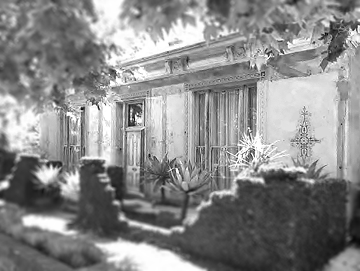 | Photo 2. The removal of a c.1950s addition at the front of this house in Blessington Street, St Kilda revealed the original intact Victorian era façade. Outlines of the removed walls and some of the colour schemes, as well as the lower sections of the walls (now covered in vines) were left as evidence of this change.
Avoid the relocation of a building or feature that contributes to the significance of a heritage place unless:  - The relocation is the only reasonable means of ensuring the continued existence of the building or feature and the option of retaining it in the current location is not feasible, and  - The building or feature has a history of relocation and/or is designed for relocation. | If relocation is considered appropriate, then an appropriately qualified person should:  - Prepare a photographic and documentary record of the building or feature on its current site prior to relocation.  - Provide advice on or oversee the relocation procedure.
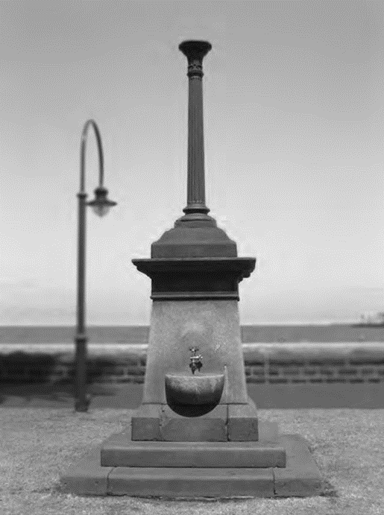 | Photo 2. The Maskell and McNab Memorial was unveiled on 17 July 1890 in memory of two Port Melbourne residents who were killed in the infamous Windsor rail collision of 11 May 1887. Originally located near the Graham Street Railway Station, it has been relocated on three occasions. It now resides on the Bay Trail near the Station Pier in Port Melbourne

Guideline 2 Conservation
This section provides guidelines for the conservation of features, details, materials, and finishes that contribute to the significance of heritage places including:
- Maintenance and preservation.
- Minor repairs.
- Restoration by reinstating original fabric or by the removal of inappropriate additions.
- Reconstruction to a known earlier state using new or introduced material based on historic evidence.
It also provides guidelines for alterations that would change the appearance of a heritage place.

Application
These guidelines apply to Significant (Individual), Significant (Precinct) and Contributory places within the heritage overlay.
For Significant (Individual) places these guidelines apply to all features, details, materials, and finishes that contribute to the significance of the place.
For Significant (Precinct) and Contributory places these guidelines apply to all contributory features, details, materials, and finishes that are visible from the public realm.

Guidelines basis
Designers of buildings during the late nineteenth and early twentieth centuries applied a range of decorative styles to buildings, which reflected the use and function of the building as well as the status of the owner. These styles were expressed by a range of external decorations and finishes such as render, mouldings, cast and wrought iron and timber decoration, tiles, glass, tuck-pointing and paint.
Heritage colour schemes were based on the identification of various parts and elements of the building’s structure and decoration. They employed a limited range of external colours up to World War Two and although new colours became available in the Interwar years (1919 to 1939), tradition resulted in the early colours still being commonly used. Traditional schemes were quite colourful given their limited range, but relied mainly of tonal contrasts rather than changes of hue. Brickwork, stone and render were intended to be naturally finished and were not painted.
Many buildings in Port Phillip are notable for the intactness of many of these features and for the consistency of decorative approaches that have been used. Conservation of these features is therefore essential to maintaining the significance of the heritage places and precincts in Port Phillip.
Regular maintenance is important to conserve the appearance and significance of external finishes and decoration. However, it is important to understand that, in some cases, a special approach may be required to ensure that finishes or decorations are not inadvertently damaged.
Where buildings have been altered, the restoration or reconstruction of contributory features can recover the heritage values of the place and contribute to an improved understanding about its history and significance.
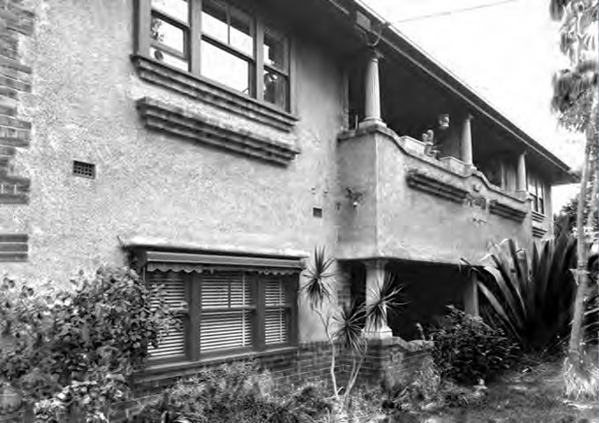
Photo 3 This block of flats in Wimbledon Avenue retains original finishes including the clinker brickwork, which contrasts with the natural (unpainted) render.

Specific objectives
- Alterations do not result in adverse impacts upon significance.
- Features, details, materials and finishes that contribute to the significance of the heritage place are conserved.
- Colour schemes are appropriate to the era and design of the building and the character of the surrounding heritage precinct
- Maintenance does not result in damage to significant fabric.
- Future maintenance problems are avoided.

Conservation guidelines
Strategies | Guidelines
- Encourage the maintenance and repair, rather than replacement of materials, features and details that contribute to the significance of heritage places. | Repairs and maintenance should match the material, colour, texture, composition and pattern of the original.
- Encourage ‘like for like’ replacement of fabric that contributes to the significance of heritage places. | ‘Like for like’ means replacement with new fabric that matches the original in terms of material, colour, texture, pattern, profile, proportions/size, and details.  For example, timber weatherboards should be the same size (width) and have the same profile (square, beaded or round) as the original.  Edwardian houses often have unglazed terracotta tiles with a ‘Marseilles’ profile, and should be replaced with tiles in the same material with an identical profile.  In accordance with Guideline a. the emphasis should be on small scale repair and maintenance, rather than complete replacement wherever possible.
- Except as specified in Guideline d., encourage the accurate restoration or reconstruction of heritage places to a known earlier state, particularly publicly visible features such as:  - Verandahs, balconies and awnings  - Doors and windows  - Wall materials and details (Parapets, stringcourses, corbels, consoles, decorative render etc.)  - Roof materials and details (flues, ventilators, guttering, rainwater heads, fascias, soffits, barges, finials etc.)  - Shopfronts  - Chimneys  - Front fences  - Historic signage  The exception to this rule is where the non- original addition contributes to the significance of the place. See Guideline d. | Restoration or reconstruction should be based on physical or documentary evidence:  - Physical evidence could include remnant fabric within the host building (e.g., an original window frame concealed within a wall) or on an adjoining building if it forms part of a group of related buildings (e.g., original cast iron frieze on an adjoining terrace house).  - Documentary evidence could include building plans, photographs, newspaper articles and the like. Oral history may also be considered.  If there is not enough evidence for an accurate reconstruction, then a simplified design appropriate for the style of the building should be used.  Avoid the incorrect use of traditional details materials or adding a feature that never existed. For example, simple timber Victorian cottages usually did not have ornate cast iron verandahs, and some commercial buildings such as hotels and banks never had a verandah or awning.  For more information see Technical Note 1: Shopfronts.
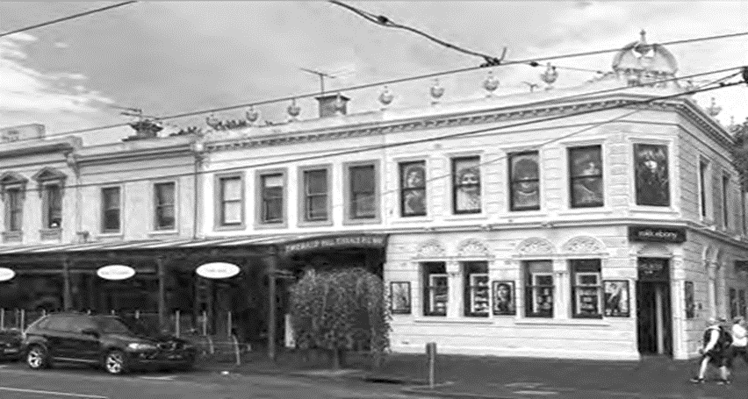 | Photo 4 The reconstruction of historic verandahs in Clarendon Street did not include buildings such as this former bank that never had a verandah
- Encourage the conservation of non-original alterations and additions where they contribute to the significance of the place.  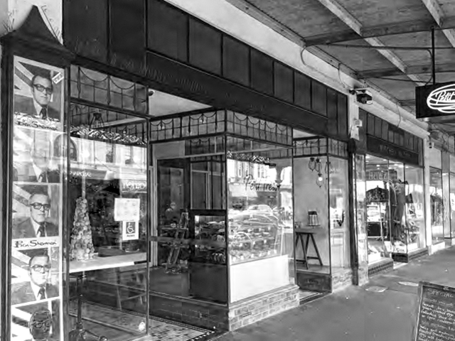  Photo 5 These shopfronts, added during the interwar period, contribute to the historic character of the Victorian era shops in Clarendon Street, South Melbourne. | Sometimes, later additions can contribute to the significance of a heritage place and should be conserved as a record of the historical layers.  Some examples include:  - Interwar shopfronts to Victorian or Edwardian shops.  - Interwar additions to Victorian houses that have been converted to flats.  - Alterations to Victorian era hotels as part of upgrades to meet new liquor licensing laws in the early twentieth century.  An exception could be if a Conservation Management Plan developed specifically for the place concludes that returning the place to its original state is the best conservation outcome.
- Conserve original colour schemes and discourage the painting of originally unpainted surfaces.  - Ensure new colour schemes are appropriate to the architectural style of the building | Original colour schemes should be repainted using the same colours.  Unpainted surfaces should remain unpainted. This includes rendered finishes with original integrated colour.  Carefully remove paint from originally unpainted surfaces (see also Guideline g.).  Where original colour schemes have been lost, authentic colour schemes may be recreated by:  - Undertaking physical analysis such as paint scrapes of key features to determine the original colours used.  - Developing a new scheme based on typical colour schemes for the architectural style and detailing.  For more information see Technical Note 2 Heritage Colour Schemes
- Avoid alterations that would:  - Alter, conceal or remove a feature, detail, material or finish that contributes to the significance of the heritage place.  - Distort or obscure the significance of the heritage place, or detract from its interpretation and appreciation by copying historic styles in detail. | Please refer to Attachment 2, which show typical features, materials and details that contribute to the significance of heritage places.  Avoid alterations to:  - The principal façade, roof or any walls visible from the public realm including a side lane.  - For Significant (Individual) places any feature, detail, finish or material specified in the statement of significance.  Specifically, avoid alterations visible from the public realm that would:  - Enclose original verandahs, balconies or porches.  - Create new openings or enlarge existing ones.  - Result in new floor plates, walls, columns or structural supports cutting through openings.  - Introduce roof decks, balconies or dormer windows.  Avoid techniques such as sandblasting that could damageheritage features, details, materials or finishes.  Seek advice from the Heritage Adviser about the best techniques to avoid damage when carrying out any conservation works.  For techniques such as paint removal or render repair, it may be necessary to carry out tests on a small non-conspicuous area first before proceeding
- For buildings originally used for commercial or industrial purposes, encourage conservation of features such as equipment, machinery or signage that provide evidence of the original use. | Wherever possible, original features should be retained in their original place. If this is not possible, then they may be relocated if this is the only means of conserving the feature. Interpretation may be required.

Guideline 3 Additions
This section provides guidelines for additions to existing buildings.
Guidelines for new development (that is, an entirely new building) are discussed in the following section.

Application
These guidelines apply to all places within the heritage overlay.

Guidelines basis
The heritage places and precincts in Port Phillip illustrate the historic development of the city from the mid-nineteenth century onwards. Some heritage precincts, such as those in Albert Park, Middle Park, Port Melbourne, South Melbourne and parts of Elwood have a more consistent heritage character, while others particularly those in St Kilda and parts of Elwood have a more diverse character, which illustrates successive waves of development.
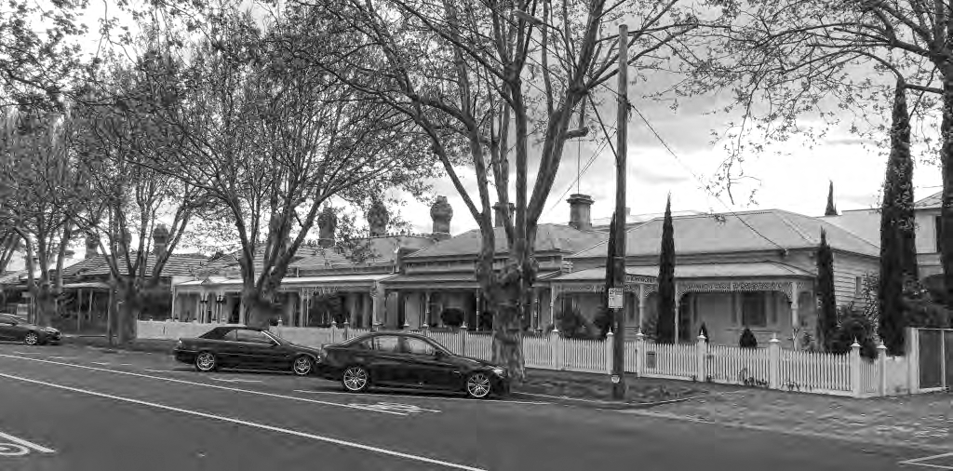
This has created streetscapes that are significant for the high degree of intactness and consistency in terms of style, form, scale and siting such as HO442 Albert Park Residential, as well as those that are have highly diverse streetscapes such as HO5 St Kilda Hill.
The same is true of individual heritage places with some developed in only one period, while the fabric of others show layers of historic development.
Additions to buildings should be guided by significance, and care must be taken with the design and siting and scale to ensure that they do not have an adverse impact upon the historic character of heritage places and precincts. This includes additions to Nil grade buildings within heritage precincts.

Specific objectives
Nil.

Additions guidelines
Strategies | Guidelines
- Except as specified in Guideline b., encourage additions to be:  - Fully concealed if the associated building is within a heritage streetscape with a consistent scale comprised of buildings of the same or similar height, siting, and form, or is graded Significant (Individual), or  - Partially concealed if the associated building is within a heritage streetscape with a diverse scale comprised of buildings with different heights, siting and form and is not graded Significant (Individual). | In deciding whether a streetscape is consistent or diverse consider only the buildings on the same side as the subject building and within the immediate surrounds.  For residential buildings:  - Full concealment may be achieved by containing the addition within a 10 degree sightline as shown in Figure 3.2a or by using across the street sightlines as shown in Figures 3.3, 3.4 or 3.5.  - Partial concealment may be achieved by containing the addition within a sightline of up to 18 degrees as shown in Figure 3.2b.  - For corner sites or houses with complex roofs, additional considerations apply, as shown in Figure 3.6 and 3.8.  For commercial buildings:  - Full concealment may be achieved as shown in Figure 3.3 or 3.8.  - Partial concealment of additions to single storey buildings in diverse streetscapes may be achieved as shown in Figure 3.10.  The top of the concealment zone is measured by the sightline from the street towards the gutter line as shown in Figure 3.7. The context will determine the extent of the variation from 10 up to 18 degrees.  Other considerations include:  - Where the site is elevated above the street.  - Whether the roof of the addition has a sympathetic contextual form (e.g., a hipped form if the original house has a hipped roof or where this is a characteristic of the area).  - Whether oblique views are limited, for example, by higher buildings on adjoining or nearby sites  - Whether the roof form or height or any other feature of the existing house will assist in concealing the addition.  - Whether the addition will be seen within the context of taller buildings visible in the background.  For more information see Technical Note 3 Upper storey additions to single storey dwellings.
- Allow visible additions where:  - The heritage place is situated on a site or within an area where higher density development is encouraged, and/or  - The additions are in accordance with specific development guidelines for the heritage place. | Areas were higher density development is encouraged include those where a Design and Development Overlay applies.  Examples of visible additions are the high- rise apartment buildings constructed behind historic mansions in St Kilda and Queens Roads, and in the adaptive re-use of industrial buildings in South Melbourne and Port Melbourne.
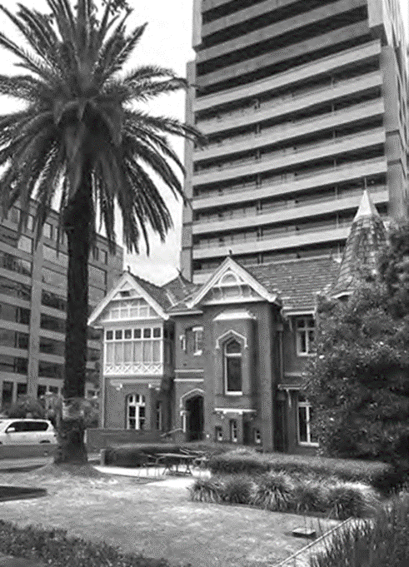  Photo 7 | ‘Warwillah’ in St Kilda Road is typical of the remaining late nineteenth century mansions that now have high-rise additions set behind the original house.
- New development uses a contextual design approach that responds to and reinforces the valued characteristics of heritage places including:  - Building height, scale, massing and form.  - Roof form and materials  - Siting, orientation and setbacks.  - Fenestration and proportion of solid and void features.  - Details, colours materials and finishes.  New development protects and conserves views of heritage places. | For residential and commercial places, the height of the addition and setback from the frontage of the property is guided by the applicable sightline in Guideline a.  Where an addition will be visible from the public realm, a contextual design response is encouraged that:  - Has a roof with a form, pitch and material that is related to the heritage place.  - Uses colours, materials and finishes that complement the heritage place.  - Integrates environmental sustainability features or buildings services.  - Avoids openings in walls facing the frontage of the property.  Where an addition will not be visible from the public realm there is more flexibility and a less contextual response may be considered.  Avoid additions:  - To the facade or visible side walls of a Significant (Precinct), Contributory or Nil.  - That would affect a view to a building or feature that contributes to the significance of a heritage place.
- Avoid additions that would:  - Alter, conceal or destroy/remove features, details materials or finishes that contribute to the significance of the heritage place.  - Distort or obscure the significance of the heritage place, or detract from its interpretation and appreciation by imitating historical styles. | Please refer to Attachment 2, which show typical features, materials and details that contribute to the significance of heritage places.  For Significant (Individual) places, avoid additions that would changes to the contributory features whether or not they are visible from the public realm.  For Significant (Precinct) and Contributory places, avoid additions to the façade or other elevations that are visible from the public realm including a lane if the building is located on a corner.  New work should be distinguishable from old, while being sympathetic with the significant fabric. This can be achieved by:  - Making new material slightly recessed.  - Using a similar material, but with a different texture, or using a similar, but simplified design.  - Avoiding strong contrasts between old and new fabric.  - Avoiding the use of imitation historic detailing such as small paned windows, cast iron decoration, ornate decorations, window glazing etc.  For Nil grade places, alterations that change the appearance of the building are permitted.
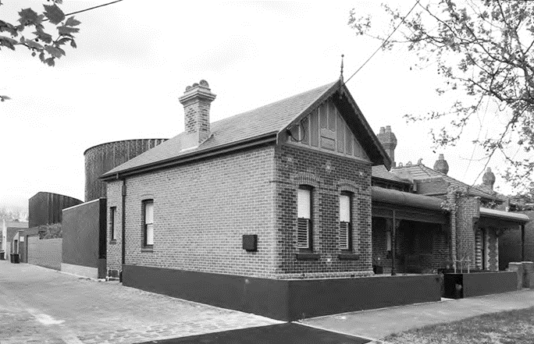 | Photo 8 This approach is demonstrated in the addition at 107 Richardson Street, Albert Park. Although the addition does not have a contextual roof form, the design, siting and form of the addition ensures that it is a recessive element that reads as separate from the original dwelling and does not overwhelm it
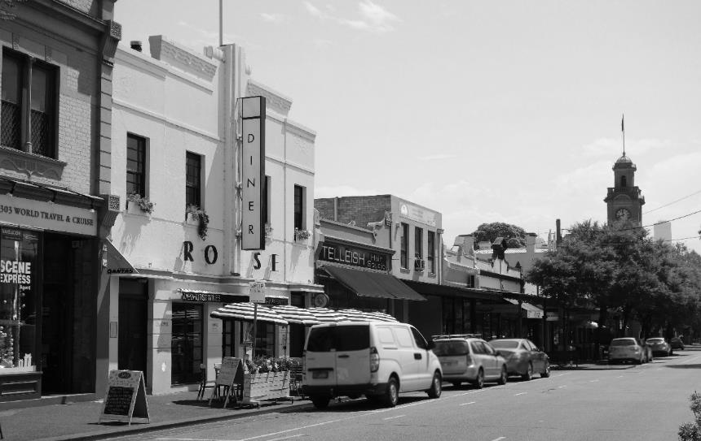
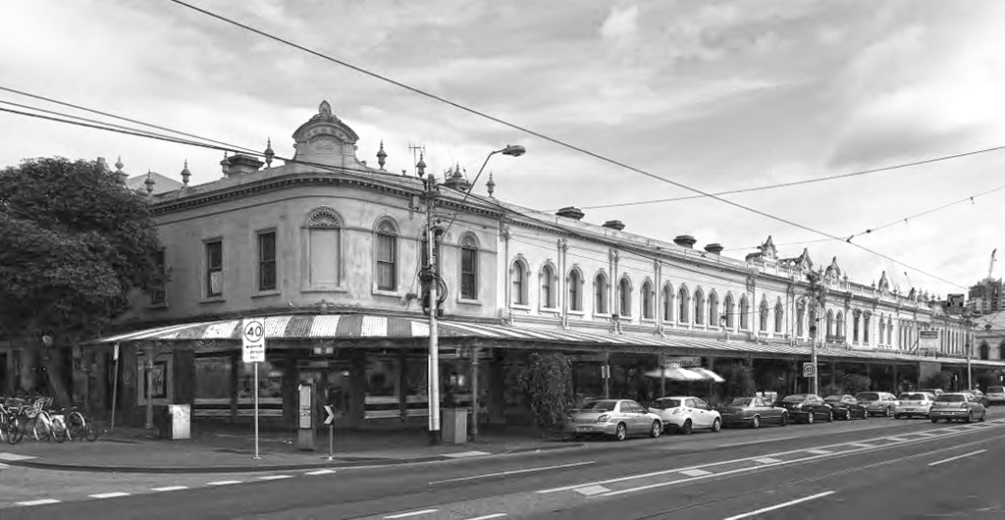

Diagrams
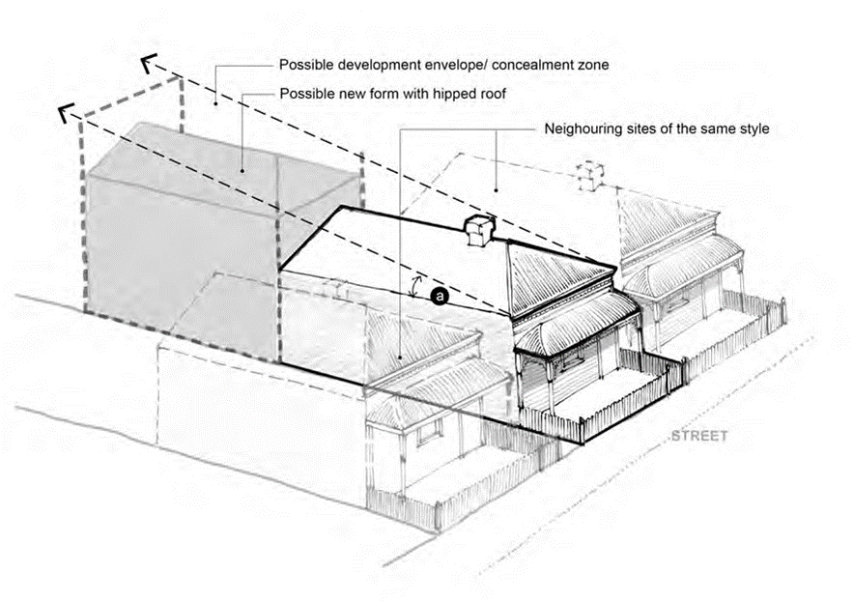

Figure 3.2a.
For additions to middle block residential buildings in a consistent streetscape. Please see Figure 3.7, which shows where the sightline is measured from. 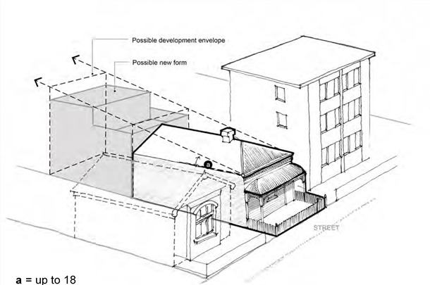
Figure 3.2 b.
For additions to middle block residential buildings in a context of diverse streetscape. As the addition may be visible a similar roof form to the original dwelling should be used.

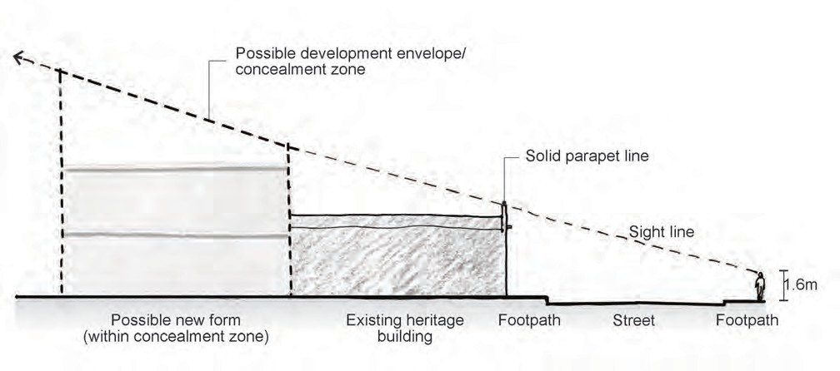

Figure 3.3
Across the street sightline for single storey residential or commercial buildings with a front parapet.
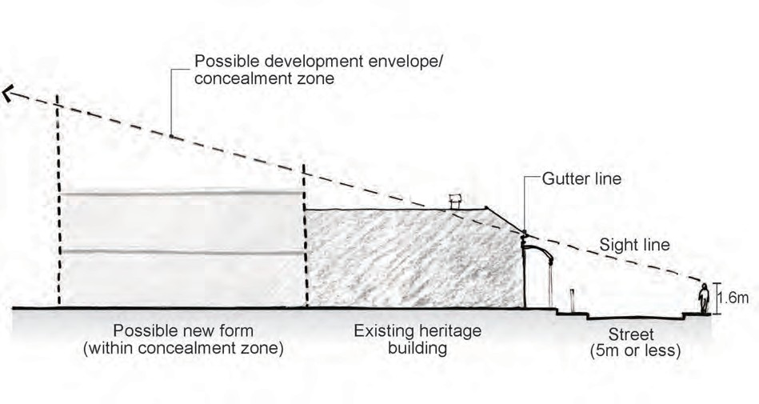

Figure 3.4
Across the street sightline for residential buildings in narrow streets (5 metres or less in width)

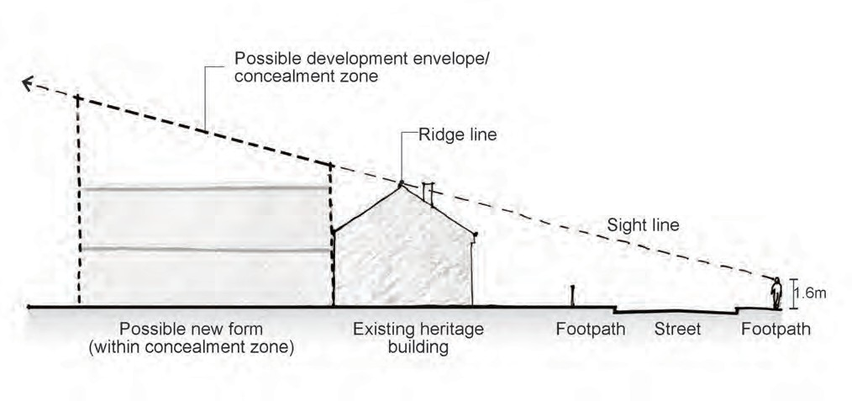

Figure 3.5
Across the street sightline for houses with a ridgeline that is parallel to the street (known as a transverse ridge). 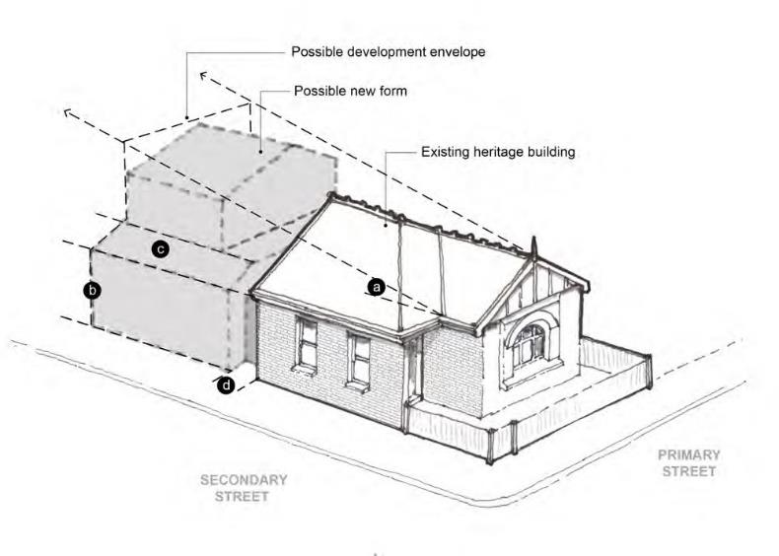
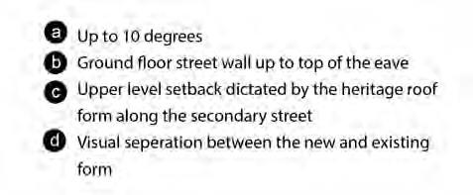
Figure 3.6a Key considerations for rear addition on a corner site in a consistent streetscape
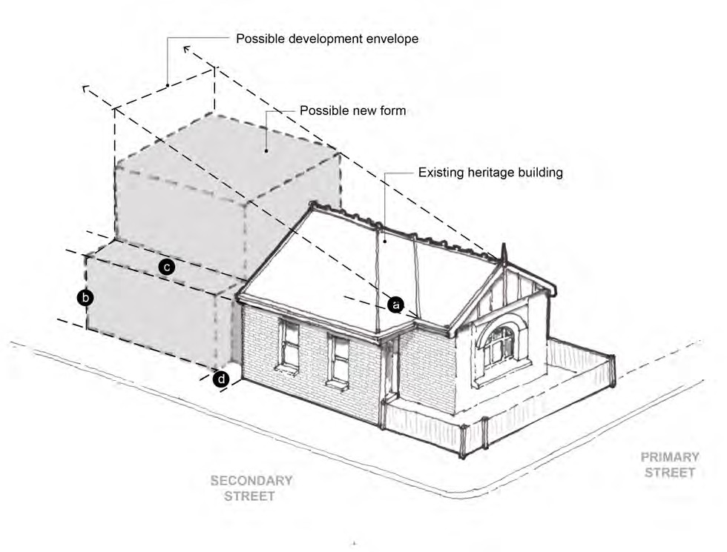

Figure 3.6b
Key considerations for rear addition on a corner site in a diverse streetscape. 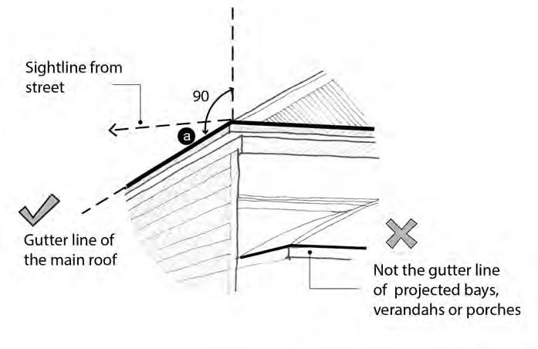

Figure 3.7
Sightlight is measured from the top of the gutter line of the main roof, and not from the projecting front bay, porches or verandahs.

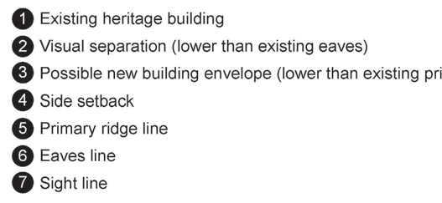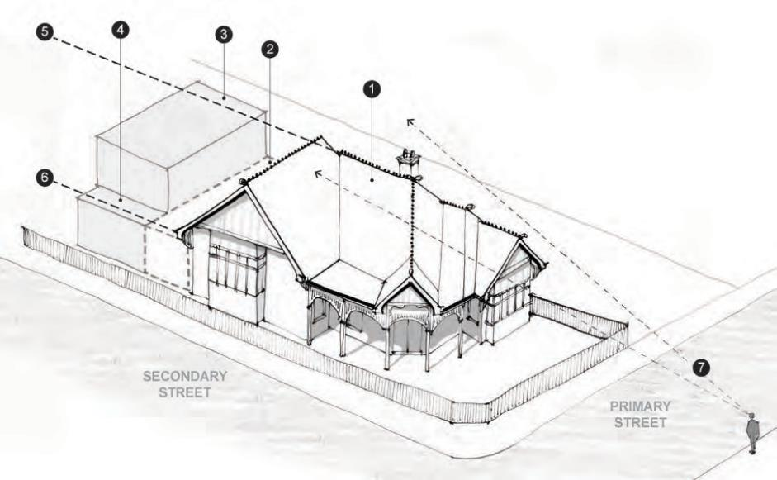
Figure 3.8
For houses with complex roof forms, including on corner sites, additional considerations include the potential need to place the addition behind the silhouette of the main roof, usually lower than the primary ridge line, and a visual separation between old and new, and a setback of the upper level from the side boundary.
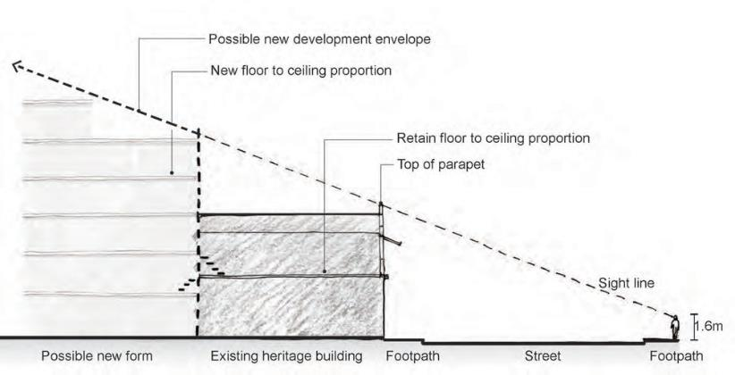

Figure 3.9
For two-storey commercial buildings, the development envelope for the additions is determined by across street sightline and top of parapet.
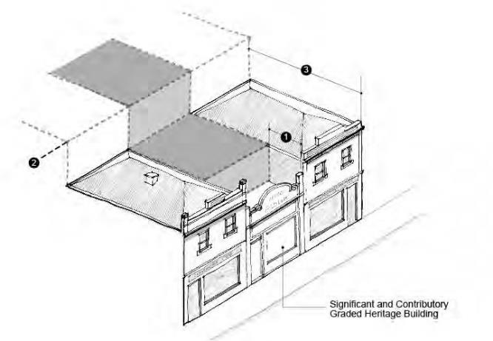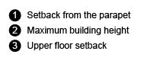
Figure 3.10a For a significant or contributory commercial buildings in a diverse streetscape, a setback from the parapet is still required to provide a visual separation between the old and new but not to the extend of full concealment. The additional considerations include the upper floor setbacks and maximum building height.
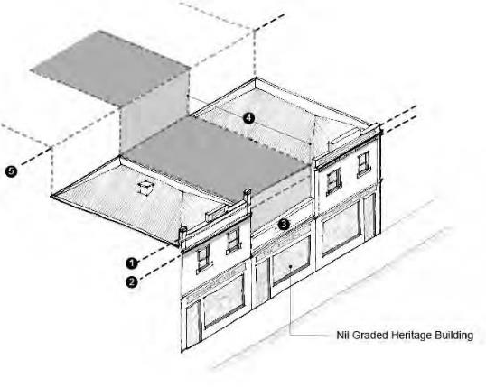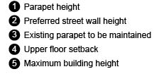
Figure 3.10b For a Nil graded commercial building in a diverse streetscape, it is typically acceptable to allow its addition to fill the gap up to the preferred streetwall height provided that any notable features could still be read clearly in the streetscape.

Guideline 4>New buildings
This section provides guidelines for the construction of new buildings within heritage precincts or on a site containing a heritage place.

Application
These guidelines apply to all places within the heritage overlay.

Guidelines basis
The heritage places and precincts in Port Phillip illustrate the historic development of the city from the mid-nineteenth century onwards. Some heritage precincts, such as those in Albert Park, Middle Park, Port Melbourne, South Melbourne and parts of Elwood have a more consistent heritage character, while others particularly those in St Kilda and parts of Elwood have a more diverse character, which illustrates successive waves of development.
This has created streetscapes that are significant for the high degree of intactness and consistency in terms of style, form, scale and siting such as HO442 Albert Park Residential, as well as those that are have highly diverse streetscapes such as HO5 St Kilda Hill.
The same is true of individual heritage places with some comprised of buildings from only one period, while others show layers of historic development.
New buildings within an historical context should complement the significant heritage character and leave a valuable legacy for the future. They can successfully provide for modern demands within an historic context by respecting and interpreting heritage character without overwhelming it.

Specific objectives
- The consistency or diversity of scale and form is maintained where this is a valued characteristic.
- Front and side setbacks respect and complement the predominant setbacks in the streetscape.
- Materials, colours, textures and finishes respect and complement those evident in the streetscape.
- New development is not visually dominant.

New building guidelines

Strategies | Guidelines
- Encourage a contextual design that respects and complements:  - Building height, scale, massing and form. | - In consistent streetscapes, new buildings should closely reflect the following characteristics:  - Wall height/gutter line.  - Parapet form and height.  - Where visible, roof form, height and complexity.  - Verandah, porch or awning height and form.  - Fence height and form.  - For commercial buildings, the form, proportions and details of nearby original or early shopfronts and verandahs or awnings.  Please refer to Figure 4.1.  If the streetscape is more diverse then there is more flexibility for an interpretive design that responds to characteristics such as overall massing, proportions, materiality and form as shown in Figure 4.2.
- Siting and orientation and setbacks. | In a consistent streetscape, new buildings show have the same siting and orientation as other buildings that contribute to the significance of the precinct.  For example, if houses are detached with consistent side and front setbacks then this should be adopted. See also Guideline b.  In a diverse streetscape, there is more flexibility for an interpretive design. This should have careful regard to the immediate context as shown in Figure 4.2.
- Fenestration and proportion of solid and void features. | New windows should respect and respond to the traditional location, size and proportions of traditional windows on buildings that contribute to the significance of the heritage place.  The design should consider the relationship of solid space (walls, solid) to void space (windows, void). In particular:  - A new building should have about the same (i.e. neither more nor less) void space, such as glazing, than surrounding heritage places.  - Avoid large areas of glass or unrelieved walls.
- Details, colours and materials. | External details, colours, materials and finishes and details should complement not simply copy the finishes and detailing found on heritage places.  Avoid:  - Mock or imitation period detailing.  - bright, reflective or mirrored materials or finishes, or  - Use of many and/or contrasting colours or finishes.
- Encourage new buildings to have similar heights and setbacks to heritage buildings on the same site or in the surrounding heritage precinct, except when:  - The new building is situated on a site or within an area where higher density development is encouraged, and/or  - The new building is in accordance with specific development guidelines for the heritage place. | Building height  In a consistent streetscape, new buildings should not exceed the maximum height of buildings on adjoining lots but may incorporate a higher section at the rear, provided that it is recessive and does not dominate the heritage place as shown in Figure 4.1.  In a diverse street, or where adjoining buildings are of different height, then the average height should be used as the maximum, as shown in Figure 4.3.  Setbacks  In a consistent streetscape the setback should match the setbacks of adjoining buildings.  Where there are heritage places on adjacent sites with differing setbacks, an average setback may be used as shown in Figure 4.3.  In some situations, a greater setback may be required to retain views to a heritage place on an adjoining site, as shown in Figure 4.4.  In commercial areas new buildings should:  - Be constructed to the front boundary and to the side boundaries in line with adjoining buildings.  Incorporate an angled splay on street corners where these are present on adjacent or opposite corners, as shown in Figure 4.5.

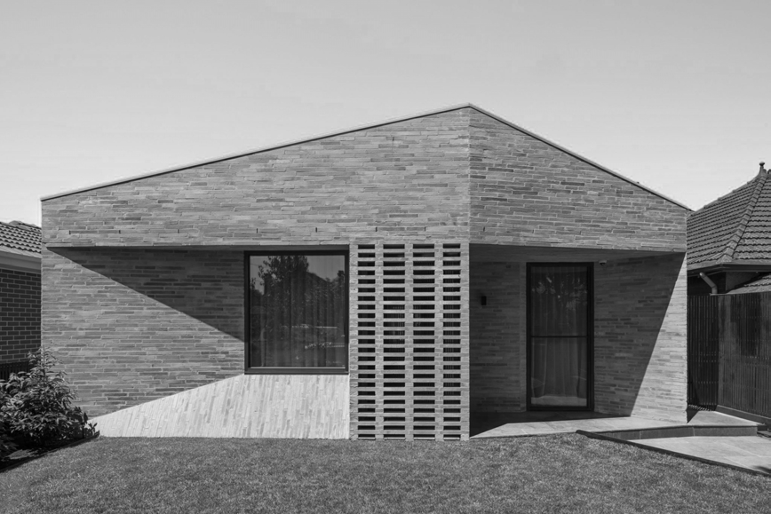
Photo 11 This building by Adam Kane Architect references the Edwardian brick façade in a contemporary manner, taking precedence from its surrounding context. As a new build in the middle of an established heritage setting, the design acts as a contemporary addition to the area whilst also remaining sympathetic to the neighbourhood characteristics.

Diagrams
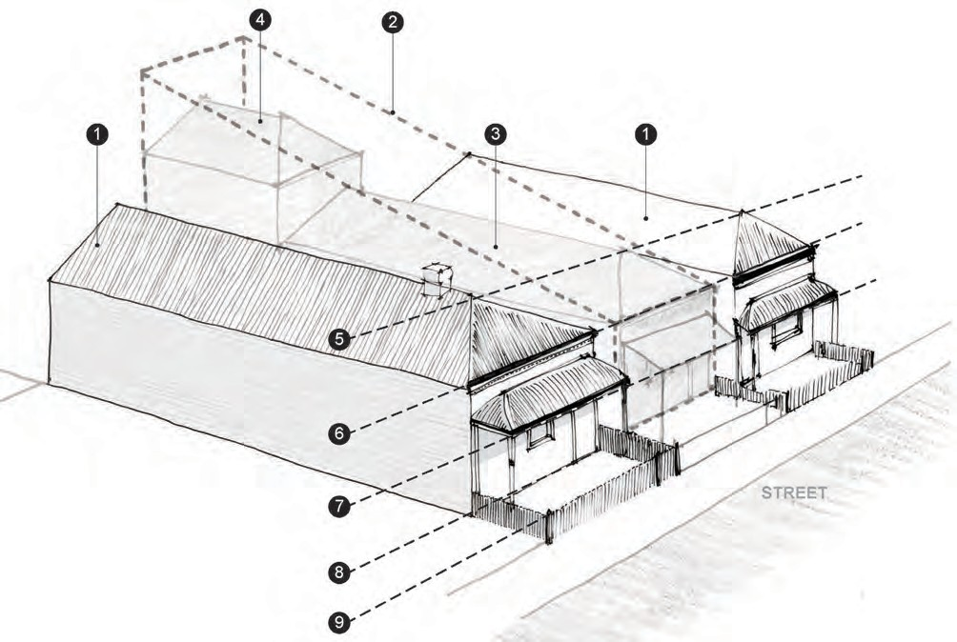
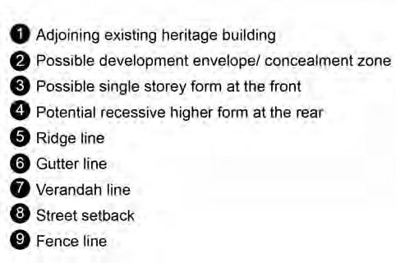

Figure 4.1
Key considerations for residential infill development in a consistent streetscape.

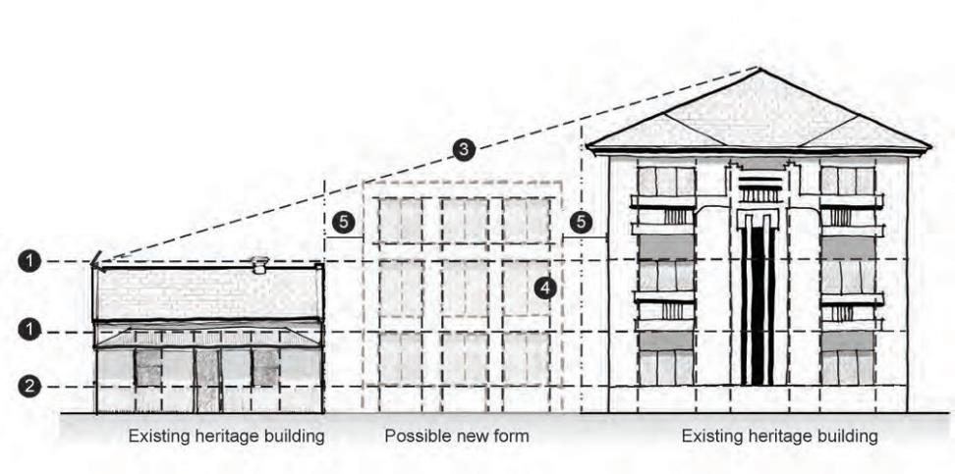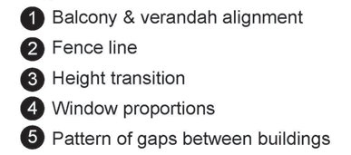

Figure 4.2
An example of a residential infill in a diverse streetscape. The proposal provides a transition between two very different buildings by finding design clues in proportions and alignment.
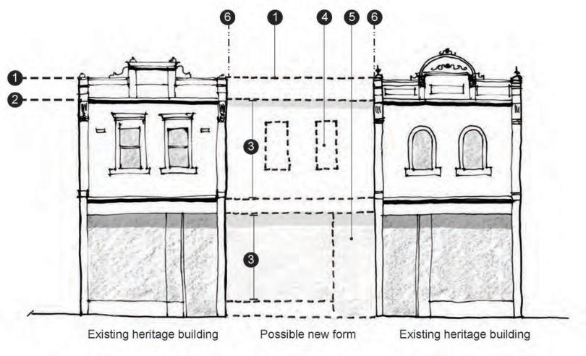

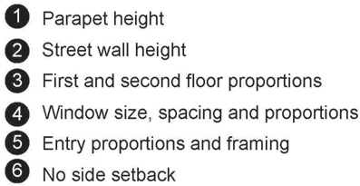

Figure 4.2 Commercial infill in a consistent streetscape.

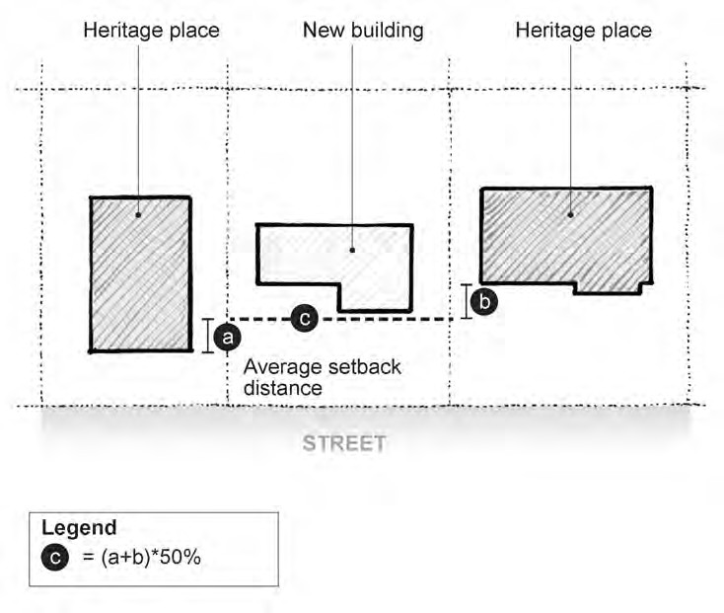

Figure 4.3
Average setback distance between heritage places. 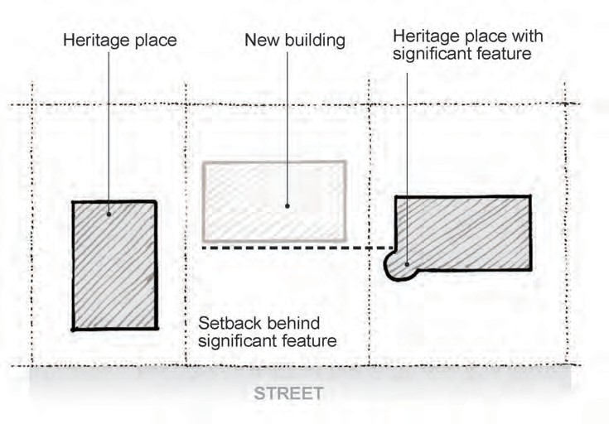

Figure 4.4
Increased setback to maintain view to significant heritage feature such as a corner window or tower.

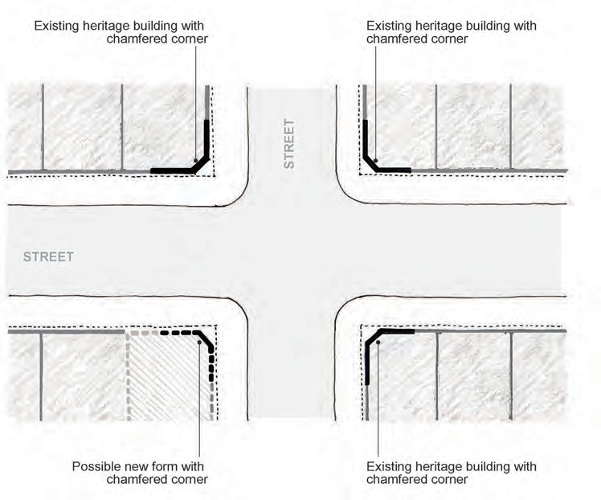
Site

Figure 4.5
Incorporation of corner splay to a commercial building where this is typical of the area.
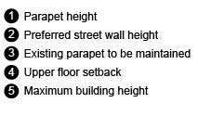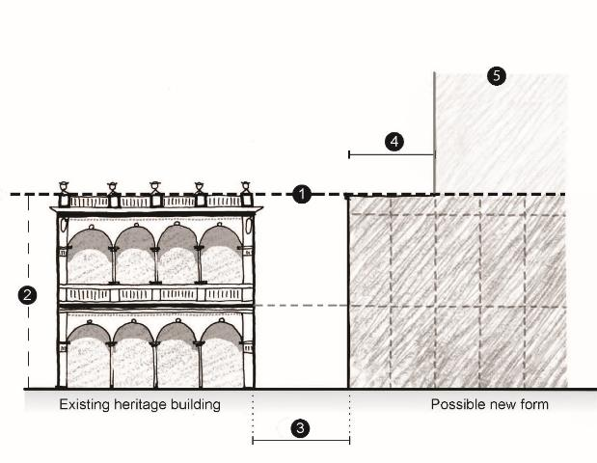

Figure 4.6
Key considerations for new development on a site with an existing heritage building.

Guideline 5> Car parking
This section provides guidelines for the construction of crossovers, driveways and parking areas and structures including car ports and garages.

Application
These guidelines apply to all places within the heritage overlay.

Guidelines basis
In the nineteenth century, stables to accommodate horses were usually only associated with mansions and larger villas. They were always located at the rear of the property and accessed via laneways.
Dedicated car parking areas on residential properties began to appear from the 1920s onwards and by the 1930s had become a common feature within streetscapes.
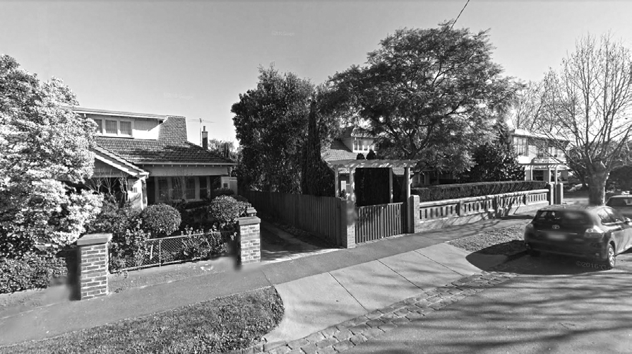

Because of this, features such as crossovers, driveways, parking areas and structures are not found in historic streetscapes dating from prior to the 1920s and introduction of vehicle crossovers, driveways and parking areas and structures will result in adverse impacts by reducing the integrity of historic streetscapes and disrupting the traditional visual relationship between houses and the street.

Specific objectives
- To maintain the integrity of historic streetscapes and the consistency of front setback areas.
- To preserve the traditional visual relationship between houses and the street.
- To ensure that parking structures are not visually intrusive.

Car parking guidelines

Strategies | Guidelines
- Discourage new vehicle crossovers driveways at the front of a heritage place or any property within a heritage precinct. | While new front crossovers and driveways are discouraged, they may be considered in streets comprising predominantly interwar houses where crossovers are part of the historic character of the heritage place and the following conditions can be met:  - There should be no more than one crossover per property.  - The installation of the crossover and driveway should not require the alteration or removal of a feature that contributes to the significance of the heritage place such as a fence or tree.  - Cars can be parked at the side of the house or within the rear yard, and not within the front setback area (see also Guideline d.).
- Encourage vehicle access to be:  - From a rear laneway, or  - For a corner property, from the side street to the rear yard of the property only if rear laneway access is not available. | See Figure 5.1.
- Avoid on-site car parking in locations that would be visible from a street (other than a lane). | As shown on Figure 5.1 new carports or garages for residential heritage places should be freestanding and may be constructed:  - Within rear yards, or  - Within side setback areas provided there is a minimum setback of 1 metre from the front wall of the dwelling.  Consistent with the new building guidelines carports or garages should be simply designed and avoid copying the form or detailing of the house. Roller style doors should be avoided and where possible the  garage door should be integrated into the front wall of the garage.
- Avoid changes to existing crossovers that would impact upon the significance or setting of a heritage place | Avoid widening existing crossovers, particularly when this would require altering a fence that contributes to significance or setting of the heritage place.  An existing crossover may be relocated provided that:  - The width of the crossover is not increased.  - It would not require the alteration of a fence or impact upon a tree that contributes to the significance or setting of the heritage place.

Diagrams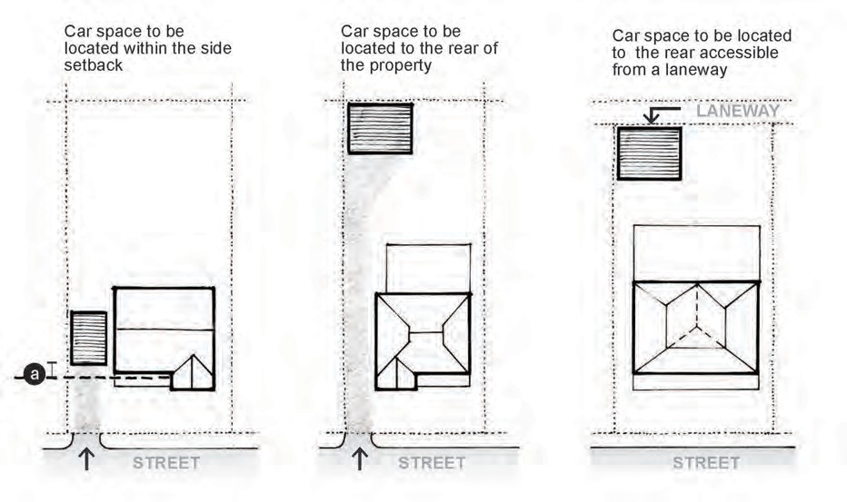

Figure 5.1
Potential locations for garages or carports.

Guidelines 6 Fencing
This section provides guidelines for the construction of fences.

Application
These guidelines apply to all places within the heritage overlay.

Guidelines basis
Front fences and, to a lesser extent, side fences are an integral part of historic streetscapes as they form part of the visual relationship between the private dwelling and the public street. Fences were designed to complement and enhance the setting of houses and fence styles evolved and changed in line with architectural fashions over the years.
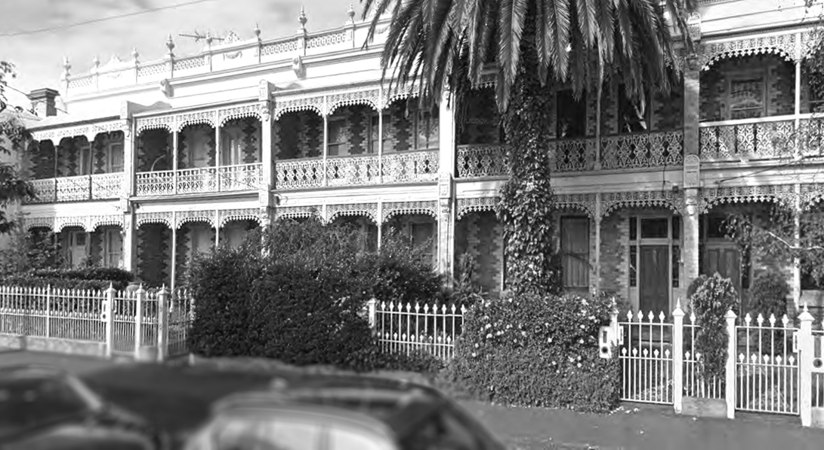
Historic fences where they survive are significant both for their contribution to the setting of heritage places and streetscape and should be preserved. New fences should be sympathetic with historic streetscape character.
Poorly designed fences, particularly high solid fences, or fences in inappropriate styles can have a significant impact upon the setting of buildings and streetscapes.

Specific objectives
- To maintain the integrity of historic streetscapes and the consistency of front setback areas.
- To preserve the traditional visual relationship between houses and the street.

Fencing guidelines

Strategies | Guidelines
- Encourage conservation of fences or gates that contribute to the significance of a heritage place. | Original front fences and gates are conserved and repaired or restored rather than being fully replaced.
- Ensure the height, materials and colours of front fences are appropriate to the architectural style of the heritage place. | Avoid fences that are historically inappropriate. For example, an ornate cast iron fence for a simple Victorian timber cottage, or the use of Victorian style timber picket fences for interwar house.  For more information see Technical Note 4: Fencing
- Encourage a consistent approach for heritage places that form part of a related group of buildings such as an attached pair or terrace row or houses forming part of a consistent streetscape. | If an original fence survives or there is an existing reproduction fence in an appropriate style, then that should be used as the model for new fences.  If no original fences survive, then a fence style appropriate to the building should be chosen and applied consistently.
- Encourage new fences or gates for Nil grade places to be in a simple contemporary style that complements the fences historically found in the heritage precinct. | New fences should have a similar materiality and form.  For example, if situated in a predominantly Victorian or Edwardian precinct, the fence could be a simple plain timber picket or metal palisade, but stripped of any ‘period’ detailing.  In an interwar precinct a low brick or rendered fence may be appropriate.  New fences should have a similar height to the traditional fences in the area. As a guide:  - Within areas that are predominantly Victorian or Federation/Edwardian, between 1.0 and 1.4 metres.  - Within areas that are predominantly interwar, between 0.6 and 1.0  metres.

Guidelines 6 Signage
This section provides guidelines for signage.

Application
These guidelines apply to Significant (Individual), Significant (Precinct) and Contributory places within the heritage overlay.

Guidelines basis
Examples of early or original signage are significant for the ability to illustrate the historic development of shops and retail centres and provide also provide evidence of historically appropriate designs and location of signs.
It is important to strike a balance between the needs of businesses to have adequate exposure, and the need to ensure that new signage does not become a dominant element that detracts from the historic character of shops and retail heritage precincts in Port Phillip.

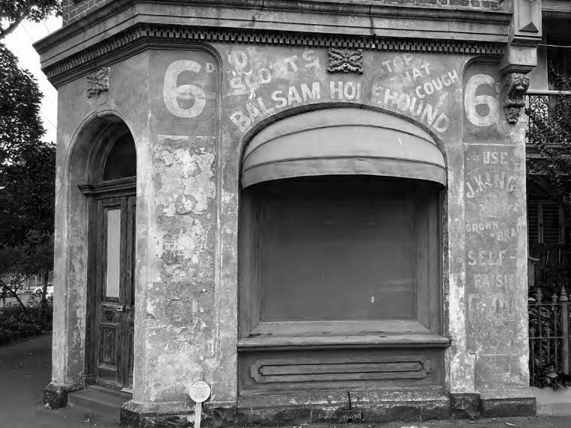
Photo 13 The faded painted signs on this building in South Melbourne provide evidence of its historic use as a corner shop.

Specific objectives
Nil

Signage guidelines
Strategies | Guidelines
- Encourage the conservation of historic signs. | Original signage should be conserved in accordance with the Conservation guidelines.  This may include the restoration or reconstruction of missing in incomplete historic signage based on physical or documentary evidence.  Many original or early signs were painted and have deteriorated over time. In some cases, the action may be to stabilize the sign and prevent further deterioration rather than undertake full restoration.
- Encourage new signage to be in traditional locations on heritage buildings. | Figure 6.1 shows the preferred locations for signage on heritage buildings provided the following conditions are met:  - There should be no more than one above verandah sign per building.  - Above verandah signage should not be not floodlit or internally illuminated.  - Floodlit below verandah signage may be permitted only when:  - The light source is located so that light is directed onto the sign as much as possible to minimise glare.  - Light spillage from the light source is controlled by the use of baffles, shields or reflectors.  - Internally illuminated below verandah signage may be permitted only when the sign is not animated and does not include flashing or running lights.  - Colours, lettering, style and layout of signage respect the character and style of the building.  - External lighting, electrical cables and conduits and any other equipment associated with the signage is concealed from view, unobtrusively located or otherwise treated to minimise visual impacts.
- Avoid signage that would:  - Be visually intrusive or dominant.  - Detract from the setting of a heritage place.  - Alter, damage, conceal or destroy features, details, materials or finishes that contribute to the significance of a heritage place.  - Interfere with views of heritage places. | Avoid the following types of signs:  - Above verandah signs, except as shown in Figure 6.1.  - Animated, Electronic or Floodlit signs.  - Bunting sign.  - High-wall sign.  - Panel sign.  - Pole sign.  - Promotion or Major promotion signs.  - Reflective sign.  - Sky sign.  - Advertising signs attached to street furniture including seating, shelters, phone booths and the like.  Avoid signs that conceal or obscure architectural features and detailing, windows and door openings, or project above verandah or awning fascias.
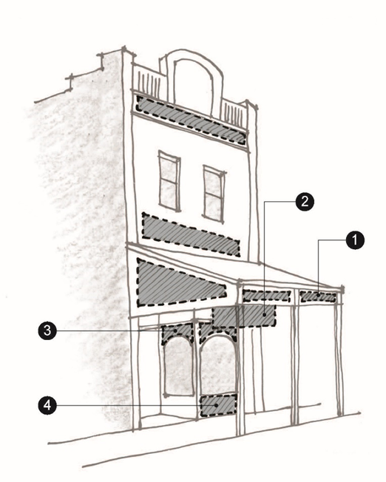 | Figure 6.1 a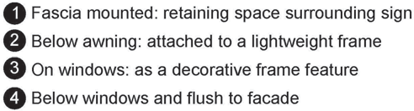
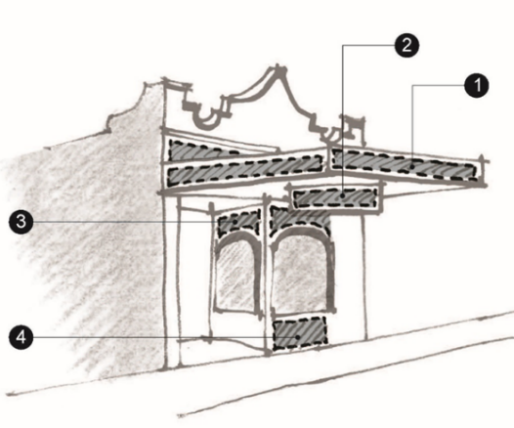 | Figure 6.1 a

Guideline 7>Significant trees
This section provides guidelines for the management and conservation of significant trees on both private and public land

Application
These guidelines apply to Significant (Individual), Significant (Precinct) and Contributory places within the heritage overlay.

Guidelines basis
Mature trees make an important contribution to the historic significance and aesthetic character and setting of heritage places. These include trees forming part of private gardens, as well as trees on public land lining streets and within parks and gardens.
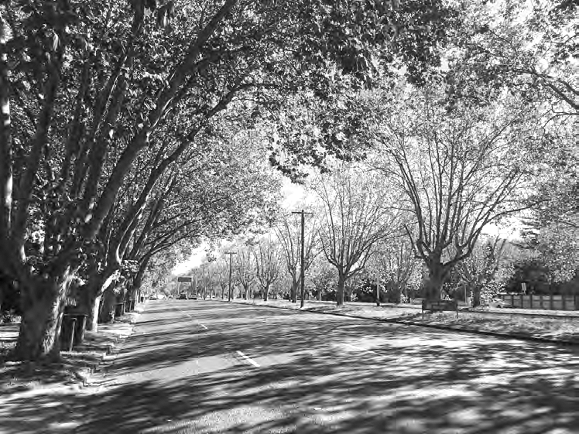
As well as introduced trees, significant trees in Port Phillip also include remnant indigenous trees such as the Ngargee Tree in Albert Park (which has Aboriginal cultural significance) and eucalypts in Alma Park East.

The aim of these guidelines is to encourage the retention of these trees within their normally expected lifespan and to avoid development that could threaten their on-going viability. They also provide guidance for replacement when required.

Specific objectives
- To encourage the retention of trees within their normally expected lifespan.
- To ensure that new development does not adversely impact upon the health or continued viability of significant trees.

Significant tree guidelines
Strategies | Guidelines
Ensure that any future development, or changes in immediate environmental conditions, adjacent to a tree will not have a detrimental impact upon the integrity and condition of the tree. | Any new development in proximity to a significant tree (whether or not it is on the same site) should be accompanied by an arborist’s report that recommends:  - The recommended separation distance and any other measures to avoid detrimental impacts upon the health and viability of the tree.  - Any remedial pruning required.
Where a tree needs to be removed due to poor health or dangerous condition, encourage ‘like for like’ replacement, or an alternative is no longer suitable. | ‘Like for like’ replacement means using a tree of the same species.  An alternative species of tree, or no replacement, may be considered when:  - Changes in the site conditions since the tree was first planted mean that the original species is no longer appropriate, or is no longer suitable (e.g., due to size, form or proximity to buildings or services).  - The original species is inappropriate give the local climate, soils, threat from pest or disease (e.g., Elm leaf beetle), or for other reasons.  - The original species is identified as an environmental weed and cannot be appropriately managed when planted.  Where trees form part of a row, avenue or hedge planting of consistent height, consider whether it would be appropriate to remove  adjoining trees to ensure consistency.

Guideline9>Sustainability and services
This section provides guidelines for the installation of equipment associated with sustainability and building services such as solar panels, water tanks, heating and cooling systems using sustainable energy technologies.

Application
These guidelines apply to all places within the heritage overlay.

Guidelines basis
Heritage buildings are capable of adaptation to include new and upgraded sustainable services and technologies through a sensitive and considered approach.
Through careful balancing between the environmental objectives and the historical and architectural merit, good decisions can be made in the choice of technologies, sitting and design of the sustainable system.
The guidelines here have a particular focus on the roof mounted systems such as solar panels and solar hot water because they become increasingly common and most likely to have cumulative effects on the historical neighborhood character due to their placements on buildings.
Locating Solar System:
For optimum performance a north facing roof is ideal, but power can still be generated in diﬀerent directions away from north.
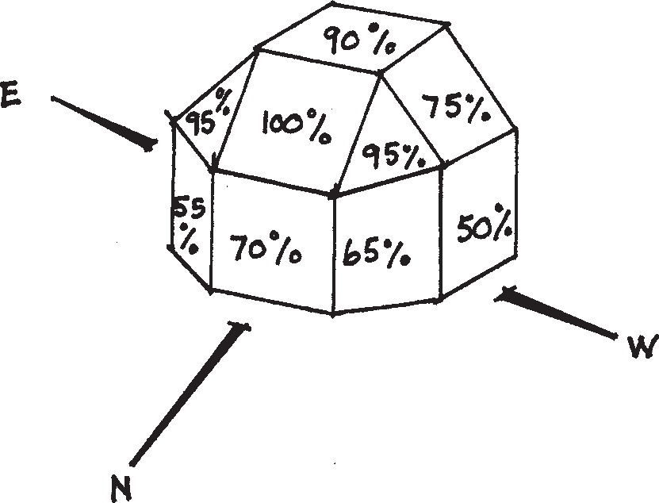
The diagram below shows that solar panels do not have to be facing true north to be an eﬀective solar unit. It also shows the degree that tilt will impact on solar eﬃciency.

Specific objectives
- To improve the environmental sustainability of heritage places without adversely impacting upon heritage significance.
- To ensure that environmental sustainability and building services do not visually dominate a heritage place and cause progressive and gradual changes to the historical neighborhood character.

Sustainability and services guidelines
Strategies | Guidelines
- Except as specified in Guideline b., encourage building services and equipment associated with a heritage place such as air conditioning units, water heaters and the like to be concealed so they are not visible from a street (other than a lane) or public park. | See Figure 9.1, which shows potential locations to ensure concealment from the public realm
- Allow the installation of services and equipment that will support environmental sustainability such as solar panels, solar hot water services water tanks and the like in visible locations when:  - There is no feasible alternative location due to the size or orientation of the lot or building, and  - It is designed and installed in a manner that minimizes potential impacts upon the heritage place and its setting. | NOTE: Environmental sustainability equipment does not require a permit if it is not visible from the public realm.  Potential locations for concealment of environmental sustainability equipment are shown in Figure 9.1 and 9.2.  The key considerations for alternative locations where solar panels would be partially or fully visible are shown in Figure 9.3 and Figure 9.4.  The degree of visibility permitted will be decided on a case-by-case basis having regard to the context and the significance of the heritage place.  Full visibility may not be possible for:  - Significant (Individual) places.  - Buildings within highly intact or consistent streetscapes.  Where roof mounted solar systems  or other services are visible they should:  - Be mounted flush against the roof.  - Not project beyond the edge of the roof plan.  - Have a minimum setback of 1 metre from the edge of the roof.  - Not cover more than 50% of the roof plane being installed on.

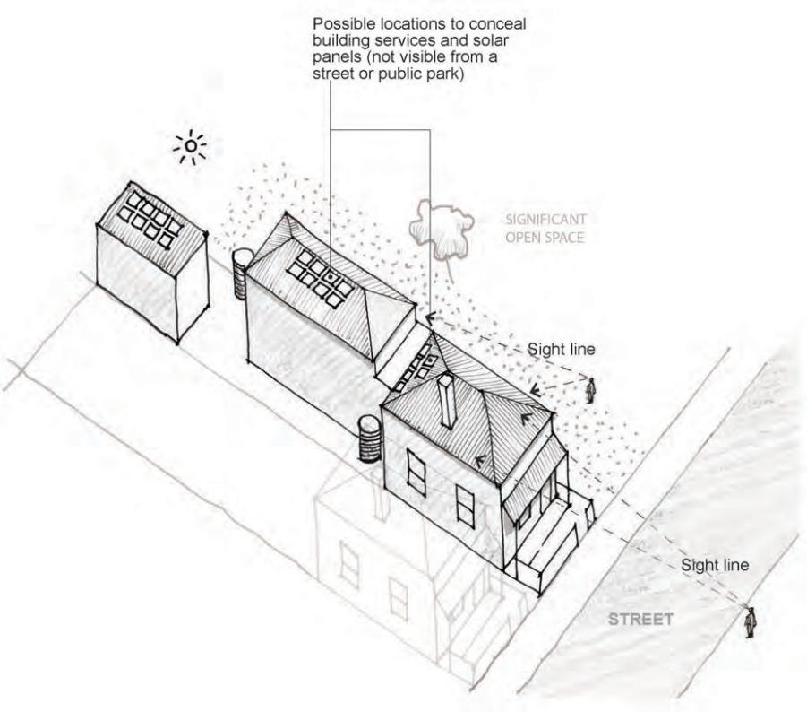
Figure 9.1
Suggested locations to conceal solar panels and water tanks
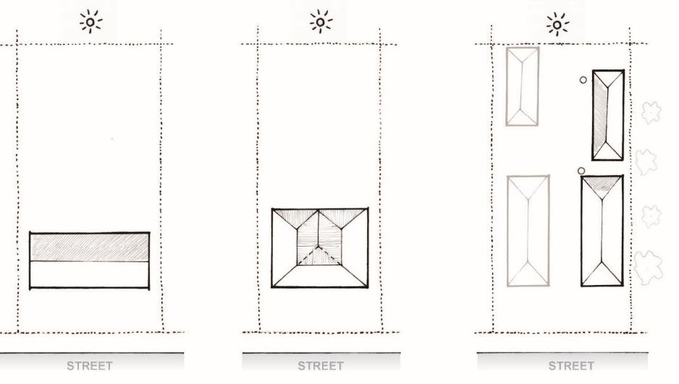
Figure 9.2 Suggested locations (grey area) of solar panels to achieve full concealment from the public realm.

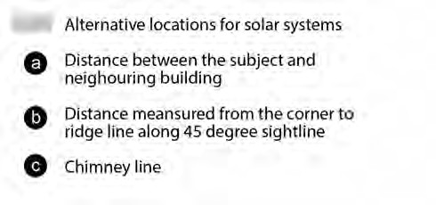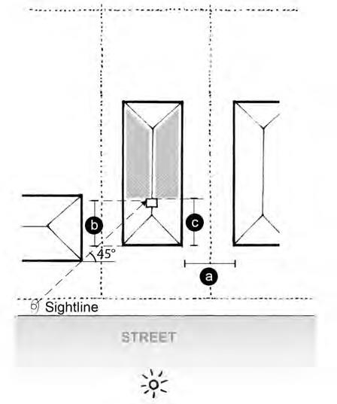
SITE

Figure 9.3 Key considerations for locating solar systems on side roofs to achieve partial concealment if the other roof surfaces not viable.

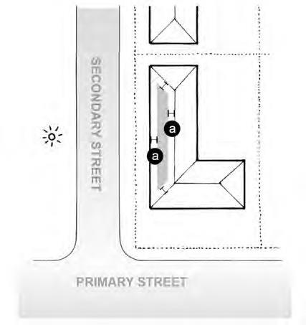If the next building and yours aligns, the solar system should be setback no less than the building gap a. Otherwise, the setback of the solar system should be greater than the distance b (measured from the 45 degree sightline between the corner and ridge line of the two buildings). The additional consideration includes the chimney line and/or other roof features identified as significant.
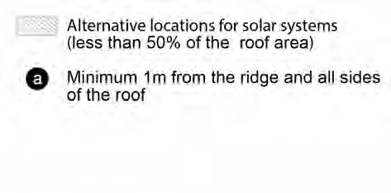
Figure 9.4 Key considerations for locating solar systems on fully visible roofs when the other locations on site not viable.

This diagram shows a corner site example where the solar panels are located on the roof fronting the secondary street rather than the primary one so the key frontage of the heritage building is relatively intact. The additional considerations include the percentage of the roof surface covered as well as the distance between the roof edge and solar systems.

Guideline 10>Subdivision
This section provides guidelines for the subdivision of land.

Application
These guidelines apply to Significant (Individual), Significant (Precinct) and Contributory places within the heritage overlay.
These guidelines do not apply to the subdivision of existing buildings that does not create an additional lot, or the internal subdivision (e.g. strata titling) of existing buildings.

Guidelines basis
The subdivision pattern in much of Port Phillip is typical of late nineteenth century/early twentieth century areas and comprises regularly shaped rectangular lots with consistent dimensions, some with access to rear lanes.
This has created streetscapes that have a consistent ‘urban grain’, which is reflected in the form and siting of buildings creating a distinctive streetscape rhythm and character. Many precincts have a regular ‘fine-grain’ character comprising small consistently shaped allotments situated within a traditional ‘grid’ street network, while others have more irregular layouts that reflect layers of subdivision and re-development.
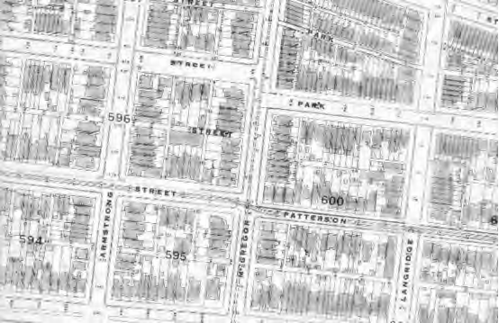
This Melbourne & Metropolitan Board of Works plan, dated 1947, shows the regular subdivision pattern within Middle Park.
It is important to ensure that future subdivision does not disrupt this character and, in addition, does not create the opportunity for inappropriate forms of development. When one large plot or multiple plots are to be developed, Council will assess if the proposed development has been informed by the pattern of the urban grain.

Specific objectives
- The historic ‘urban grain’ created by the pattern and layout of early subdivisions is maintained.
- The subdivision of land to create new lots respects and complements the historic pattern of subdivision.

Subdivision guidelines

Strategies | Guidelines
- Encourage the subdivision of land in a heritage precinct to reflect the historic subdivision pattern. | When large lots are subdivided, ensure lots sizes, proportions and depths are similar to those in the surrounding heritage precinct.  Avoid lots that are larger than or have shapes or proportions that are not found within the heritage precinct.
- Ensure that subdivision maintains an appropriate setting for a heritage place including the retention of contributory features associated with a heritage place on a single lot.  - Avoid the creation of lots that because of their size, location or layout could result in new development that would adversely impact upon the setting of a heritage place. | Avoid creating lots or lot boundaries that would:  - Cut through the middle of buildings, except as part of strata-titling.  - Result in contributory features associated with a heritage place being on separate allotments.  - Result in the loss of views to a heritage place.  - Allow new development between a heritage place and the street frontage.  - Require new buildings to have a lesser front setback than other buildings in the same street.  - Require the creation of a new street crossover to provide access.

Guideline 11>Public realm and infrastructure
This section provides guidelines for the conservation and management of land within the public realm including footpaths, streets and laneways, and features such as memorials, monuments and historic infrastructure associated with utilities (water, gas, electricity, sewerage, drainage).

Application
These guidelines apply to all historic public realm features and infrastructure within the heritage overlay.

Guidelines basis
The public realm (that is, the spaces between private properties including roads, footpaths and laneways) makes an important contribution to the historic character of heritage precincts and the setting of heritage places.
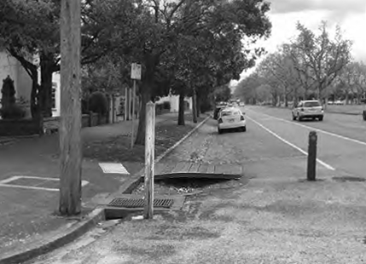
Of key importance is the historic use of bluestone in road construction from the nineteenth until the mid-twentieth centuries for kerbs, channelling and gutters, and laneways. This was often complemented by the use asphalt for footpaths and roads. Historic infrastructure also includes cast iron drainage and sewerage covers and grates, remnant gas lamp poles, electricity substations, horse troughs, and post boxes.

In addition, the public realm contains many important memorials and monuments honouring events and individuals.
It is important that these features are retained, and that missing elements are re-instated where opportunities arise.

Specific objectives
Nil.

Public realm and infrastructure guidelines
Strategies | Guidelines
- Conserve historic public realm infrastructure. | Avoid demolition or removal of contributory features including:  - Bluestone pitchers as kerb and channel and laneways and footpaths.  - Original or early street furniture and lighting.  - Original or early cast iron drain covers and grates, ‘manhole’ covers and the like.  - Early post boxes  - Early electricity substations.  - Monuments and memorials.  - Horse troughs  Avoid the need for complete reconstruction of kerbs, channels and laneways by undertaking regular repair and maintenance.  Reconstruct historic bluestone kerb and channelling only when it is at the end of its useful life.  When full reconstruction is required, this should be carried out in a way that reflects as closely as possible the original appearance.  Reinstate original bluestone kerb and channel or historic street furniture where this is supported by historic evidence.
- Ensure that development, in proximity to a memorial or monument will not have a detrimental impact upon its setting, integrity or condition. | Avoid development that would:  - Obstruct views of a memorial or monument.  - Result in the removal of trees or other features that contribute to its setting.  - Require its removal or relocation  - Potentially impact upon its condition or structural integrity (for example, due to construction being carried out in close proximity).
Photo 16 The installation of this new kerb outstand and associated pedestrian crossing in Bank Street, South Melbourne uses sympathetic materials and also ensures that the historic alignment and layout of the original kerb and channel remains evident. | 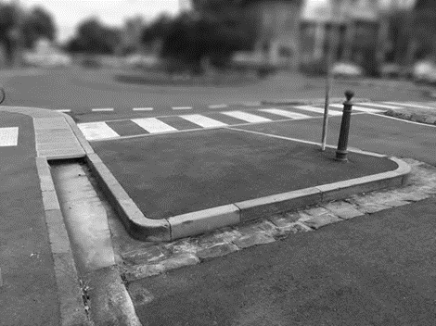

Attachment 1>Definitions

Burra Charter definitions
Adaptation: modifying a place to suit the existing use or a proposed use.
Associations: the special connections that exist between people and a place.
Conservation: all the processes of looking after a place so as to retain its cultural significance.
Cultural significance: aesthetic, historic, scientific, social or spiritual value for past, present or future generations.
Fabric: all the physical material of the place including components, fixtures, contents and objects.
Interpretation: all the way of presenting the cultural significance of a place.
Maintenance: the continuous protective care of the fabric and setting of a place, and is to be distinguished from repair. Repair involves restoration or reconstruction.
Place: site, area, land, landscape, building or other work, group of buildings or other works, and may include components, contents, spaces and views.
Preservation: maintaining the fabric of a place in its existing state and retarding deterioration.
Reconstruction: returning a place to a known earlier state and is distinguished from restoration by the introduction of new material into the fabric.
Restoration: returning the existing fabric of a place to a known earlier state by removing accretions or by reassembling existing components without the introduction of new material.
Setting: the area around a place, which may include the visual catchment.
Use: means the functions of a place, as well as the activities and practices that may occur at that place.

Significance definitions
Heritage place is a place that has identified heritage value and could include a site, area, building, group of buildings, structure, archaeological site, tree, garden, geological formation, fossil site, habitat or other place of natural or cultural significance and its associated land.
Significant (individual) heritage places are places that significant at the local or state level and have a citation in the Port Phillip Heritage Review and/or are included on the Victorian Heritage Register. They are usually significant independent of their context, but may also contribute to the significance of a heritage precinct. They are coloured purple on the City of Port Phillip Heritage Policy Map.
Significant (precinct) heritage places are places that contribute to the significance of a heritage precinct, but are not of individual significance. They are coloured “red” on the City of Port Phillip Heritage Policy Map
Contributory heritage places are places that contribute to the significance of a heritage precinct, but are not of individual significance. They are less intact than Significant (precinct) heritage places but have the potential to be conserved.
They are coloured “green” on the City of Port Phillip Heritage Policy Map. Non-contributory properties are places that not contribute to the significance of a heritage precinct. They have no colour on the City of Port Phillip Heritage Policy.

Architectural definitions
(Based on Apperly et al, A Pictorial Guide to Identifying Australian Architecture, 1989.)
Aedicule: a window or door framed by an architectural arrangement resembling a classical temple.
Arch: usually a curved structure forming the head of an opening and supporting the wall above. Common arches are round, pointed, segmental and flat.
Architrave: The lowest or load-bearing member of a classical entablature. Also, the moulded trim around a doorway or window.
Art Nouveau: an early twentieth century decorative style mostly derived from nature.
Balustrade: a railing of small posts or balusters topped by a coping usually at the edge of stairs or on a roof.
Bi-chromatic, or poly-chromatic: Two or multi-coloured, usually brickwork.
Bracket: a support, often angled, curved or decorative, for a projecting horizontal member.
Building height: Building height is defined in Clause 72 of the Port Phillip Planning Scheme as ‘The vertical distance from natural ground level to the roof or parapet at any point’.
Casement: a window hinged on one of its vertical edges, so as to open either inwards or outwards like a door.
Column: a freestanding load-bearing vertical member, usually circular in plan. In classical architecture it consisted of a base, shaft and capital and supported an entablature.
Double-hung: a window with two vertical sliding sashes, one over the other.
Entablature: in classical architecture, the whole of the horizontal members above a column, including the architrave (top), the frieze (middle) and the cornice (bottom).
Gable: the upper triangular portion of an external wall at the end of a doubly pitched roof. Also, used as a decorative device in a parapet.
Gothic Revival: a late 19th century revival based on the 18th Gothic style in England, characterised by high-pitched roof and gables and pointed arches
Massing: refers to the arrangement of elements within a building such as the proportion of ‘positive’ or solid elements such as walls in relation to ‘negative’ elements such as windows or voids.
Moulding: a contoured band used to embellish a wall or other surface. Each style has its own typical moulding.
Parapet: a wall built up higher than the line of the roof, typically to hide the roof surface.
Pediment: a decorative feature edging the gable and surmounting the entablature of a classical building.
Pier: a solid masonry support more massive than a column, usually square in plan.
Pilaster: a decorative shallow pier attached to or part of a wall as though it were a classical column embedded in the wall.
Pitch: the slope of a roof.
Pointing, tuck pointing: the finished mortar treatment of masonry joints.
Quoining: the external angle or corner of a building, particularly when emphasised or decorated.
Roughcast: plaster, mortar or stucco containing pebbles or coarse gravel to give a rough, knobbly texture to the walls.
Sidelight: windows placed on either side of another window or door that are narrower than the centre opening.
Sill: the lower horizontal part of a window or door opening.
String course: a moulded or projecting band running horizontally across a façade.
Stucco: a thin decorative finish, typically composed of lime, sand and other ingredients, applied to external masonry facades.

Attachment 2> Architectural styles
The heritage houses in the City of Port Phillip represent a wide range of architectural styles from the Victorian era (c.1851 to c.1901) to the present day. This section provides a description of the key features of some of the most common styles:
- Victorian cottage
- Victorian Italianate villa
- Victorian terrace house
- Edwardian
- Queen Anne
- California Bungalow
- Interwar Old English
- Interwar Moderne
For more information about architectural styles please see the following:
- What house is that? A guide to Victoria’s housing styles, prepared by the Heritage Council of Victoria: https://www.heritage.vic.gov.au/ data/assets/pdf_file/0017/61550/What- House-is-That.pdf
- Richard Apperley, Robert Irving, & Peter Reynolds, Identifying Australian architecture. Styles and terms from 1788 to the present
- Peter Cuffley, Australian houses of the twenties and thirties
- Peter Cuffley, Australian house of the forties and fifties

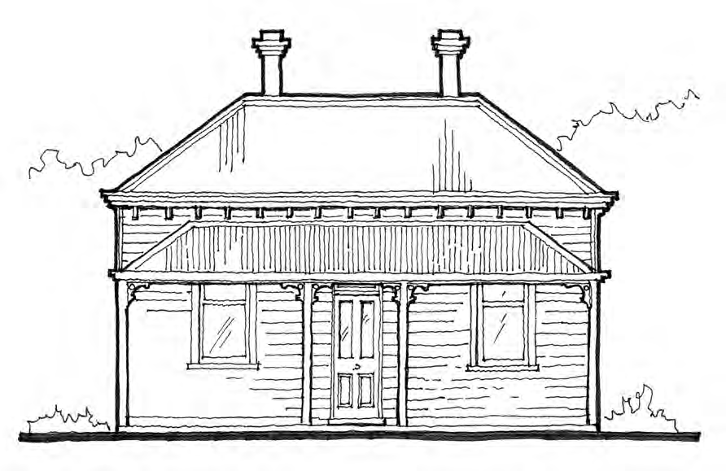Victorian cottage
This is one of the most common house styles in Port Phillip and was typically built during the mid to late nineteenth century, although some examples were built as late as the early 1900s. They can be ‘double- fronted’ as shown (with a room on either side of a central hallway) or ‘single-fronted’ with one room and a side hallway.
Roof | Hipped roof (sometimes gable-fronted in single-fronted examples) clad in slate or galvanised corrugated iron; very early examples may retain timber shingles covered by corrugated iron later.
Walls | Face brick with flush struck lime mortar joints or natural finish cement render, or (as shown) timber weatherboards (usually square edged but sometimes with a beaded edge) with timber stops and corners.
Verandah | Separate skillion or hipped, convex/concave corrugated galvanised iron verandah, which is supported by square or chamfered timber posts. Simple decoration, timber or cast iron brackets. Timber floors for timber houses, or simple terracotta tiles often laid in a diamond pattern for brick houses.
Colours | Walls colours are Light cream, ochre wash, or natural brick, stone or cement render.  Joinery and trim colours are cream, light stone, light brown, rich brown, Indian Red, olive and deep Brunswick Green.
Chimneys | Brick or rendered with cornices.
Eaves | Small or no eaves, often with simple brackets.
Windows | Timber framed double hung sash (sometimes with multi-pane sashes) symmetrically arranged.
Front door | Simple four-panel timber door, sometimes with toplight and narrow sidelights.

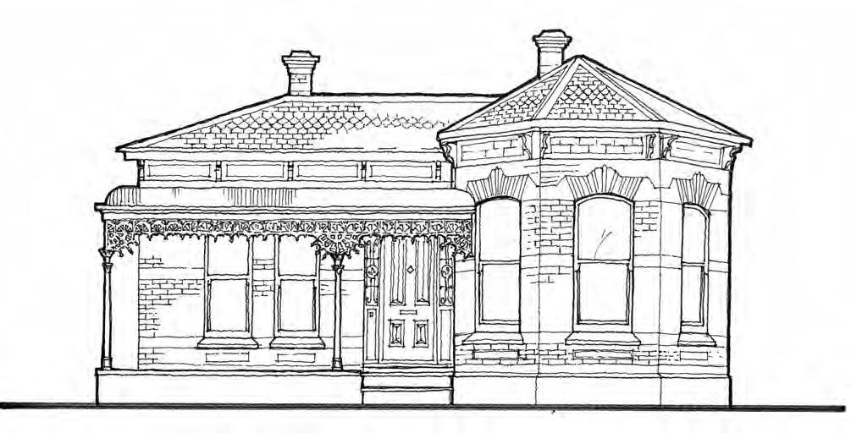

Victorian Italianate villa
During the latter part of the nineteenth century houses became more elaborate and one of the most popular styles was ‘Italianate’. These houses are characterized by the use of coloured brickwork and elaborate stucco (cement render) decoration. They could be asymmetrical with a projecting three-sided bay, as shown above, or symmetrical in appearance.
Roof | Patterned or plain slate or corrugated galvanised iron usually hipped or (in more elaborate ‘Boom style’ examples) concealed behind parapet.
Walls | Tuck pointed bi-chrome (two colours) or polychrome (three or more colours) face brickwork or ruled render to resemble stonework with elaborate cast cement render details. Timber examples have imitation Ashlar timber boards to resemble stonework.
Verandah | Separate convex, concave, or skillion verandah with corrugated galvanized iron roof, cast iron posts and frieze. Terracotta or encaustic tiles or, for more expensive houses, marble edged with bluestone. Timber verandahs for timber houses.
Colours | Rendered walls or timber: Light stone, Salmon Pink, Light Cream, Biscuit, or natural cement render.  Trim and Joinery: Cream, light stone, light and middle browns, rich brown, Indian Red, various greens including Brunswick Green.
Chimneys | Face brick or render, often with cornices. Symmetrically placed.
Eaves | Narrow eaves, usually decorated with brackets and other cement mouldings.
Windows | Timber framed double hung sash (sometimes paired or ‘tripartite’ – wide central sash with narrow side sashes) with square or arched heads, symmetrically arranged.
Front door | Four or six panel doors with deep moulding with basalt threshold and stained or etched glass surrounds.

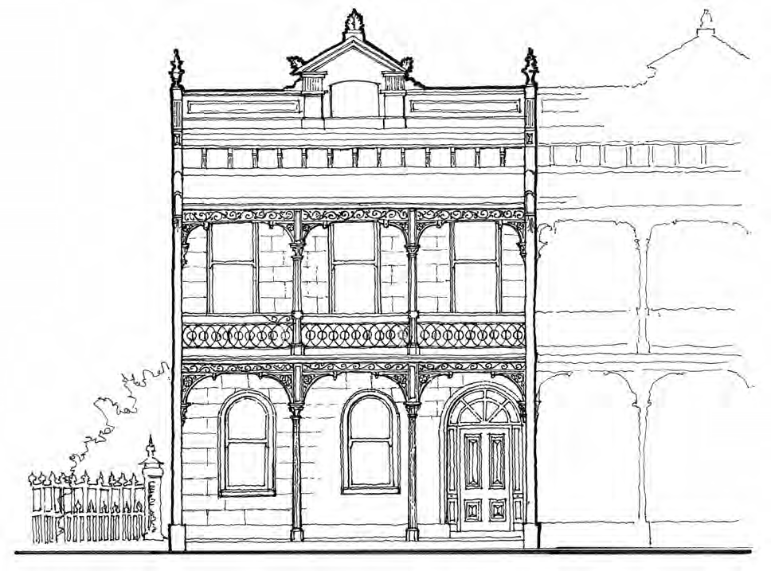

Victorian terrace house
Terrace rows of three or more houses became popular during the late nineteenth century, as they enabled the maximum number of houses per allotment. Terrace houses ranged from simple, single storey cottages to very grand two and sometimes three storey buildings with elaborate decoration.
Roof | Hipped roof usually hidden behind decorative parapet, either solid or an open balustrade above a cornice and a frieze, which was either plain or decorated with a row of brackets (and sometimes additional patterned cement details). Symmetry was often achieved through a central classical inspired pediment or similar architectural feature, balanced by a pair of architectural finial or urns on either side.
Walls | Ruled render walls to imitate Ashlar stone, as shown, or bi-chrome or polychrome brickwork with cast cement details including corbels and masks to party walls. Some single storey examples are constructed of timber.
Verandah | Separate convex, concave or skillion corrugated galvanised iron roof to verandah, usually to both floors on double storey residences. Cast iron frieze, posts and balustrade.
Colours | As for Italianate villa.
Chimneys | Face brick or render, often with cornices.
Eaves | Narrow eaves, usually decorated with brackets and other cement mouldings.
Windows | As for Italianate villa.
Front door | As for Italianate villa.

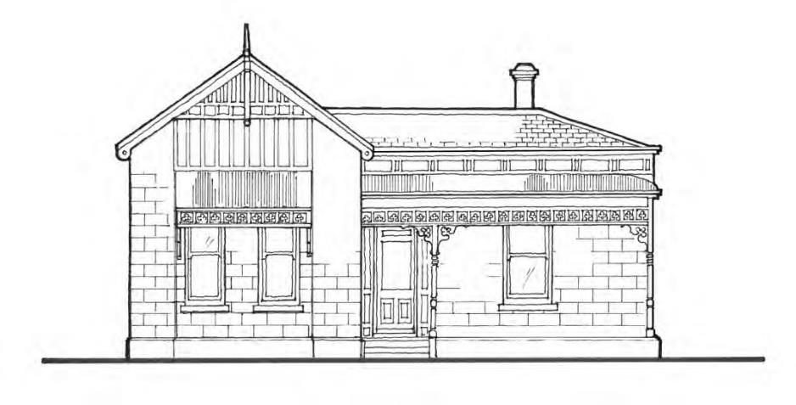
Edwardian
Edwardian houses often have similar form and detailing to Victorian houses, but usually have less elaborate decoration. While the use of cast iron decoration lingered into the early 1900s, the start of the Federation/Edwardian period (c.1901) marked a decline in the use of cast iron for structural and ornamental components of verandahs and an increase in wood for these components.
Roof | Steeply pitched hipped roof clad in slate or corrugated galvanised iron, often with a projecting street-facing gable.
Walls | Imitation Ashlar timber boards (to resemble stone), as shown above, face brick (pressed red) or square edged weatherboards, often with notched patterns to resemble shingles. Gable ends decorated with half-timber, roughcast render, pressed metal, or shingles.
Verandah | Separate skillion or bullnose verandah supported on turned timber posts with simple timber ladder frieze (sometimes with Art Nouveau motifs) or geometric cast iron frieze. Timber verandah floor for timber houses, or tiles for brick.
Colours | Walls: Pale cream, buff, biscuit,  Trim and joinery: deep reds, dark brown, with dark and softer green trims.
Chimneys | Face brickwork (pressed reds), often with render details and terracotta pots
Eaves | Narrow with exposed rafters and lining boards. Often paired timber brackets and timber mouldings.
Windows | Timber double hung sash or casement windows, often with coloured toplights, and sometimes expressed as boxed bays, particularly to projecting rooms.
Front door | Four or six panel doors with deep moulding with basalt threshold and stained or etched glass surrounds.

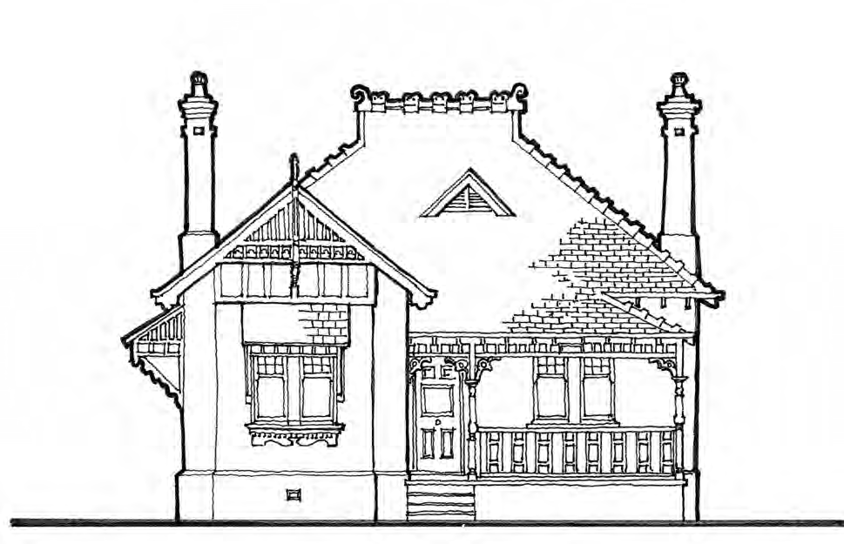

Queen Anne
These picturesque houses became popular during the early 1900s and are well represented in suburbs such as Middle Park, Elwood, West St Kilda and St Kilda East. The often complex terracotta roof is a key feature of these houses.
Roof | Steeply pitched hip and gable roof (usually with a prominent street facing gable) clad in terracotta Marseille tiles or slate with terracotta ridge capping and ram's horn or ball finials. In larger houses roof forms became more complex with the provision of steep roof planes and an array of gables, vents, dormer windows, turrets and spires projecting through the roof.
Walls | Usually pressed tuck pointed red face brick (sometimes with decorative moulded bricks) with rough cast render as bands and to gable ends. Half timber gable ends or square edged timber weather-boards often with notched patterns to resemble shingles.
Verandah | Deep verandas that are usually an extension of the main roof with turned timber post, timber capital moldings, fretted timber bracket, and timber frieze. Often demonstrates Art Nouveau influences
Colours | Walls: Unpainted face brick or if timber light straw, light cream, manila or pale green Trim and joinery: dark brown, brilliant or olive green, deep buff, beige,biscuit, pale cream, off-white.
Chimneys | Tall face brick chimneys often heavily corbelled or with rendered cornices/caps with terracotta pots.
Eaves | Exposed rafters.
Windows | Timber casements with coloured toplights or double hung (often with multi-paned coloured top sash). Rendered brick sills with shaped ‘skirts’. Window hoods with ornate brackets. Feature leadlight windows.
Front door | Three to five-panel half-glazed with coloured or leadlight glass.

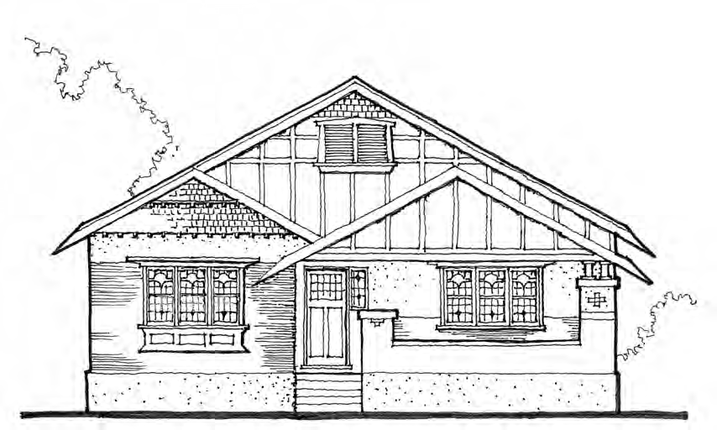

Interwar Californian bungalow
One of the popular housing styles, these simple, rustic dwellings are characterised by natural Arts & Crafts detailing and a dominant, usually gabled roof and a prominent porch.
Roof | Low-pitched gabled roof usually clad in terracotta or coloured concrete tiles, often with street-facing gables and a prominent gabled (or flat-roofed) porch.
Walls | Face brick in pressed reds or clinkers with roughcast render detailing or square or round edged weatherboards. Occasional pebbledash finish to verandah piers. Half-timbered or shingled gable ends with decorative vents.
Verandah or porch | Gabled porch or flat-roofed verandah (separate to roof) supported on square or chunky rendered or brick piers often with a balustrade, or paired timber posts in timber examples.
Colours | Walls: warm grey, pink-beige, brown, buff or light stone.  Trim and Joinery: deep Indian red, dark brown, ivory and medium to dark green
Chimneys | Plain brick chimneys usually placed at the side.
Eaves | Deep overhanging eaves with exposed rafters.
Windows | Casement/double hung. Sometimes a simple bay window to main room. Diamond paneled leadlight on upper sashes of windows
Front door | Often glazed or half glazed.

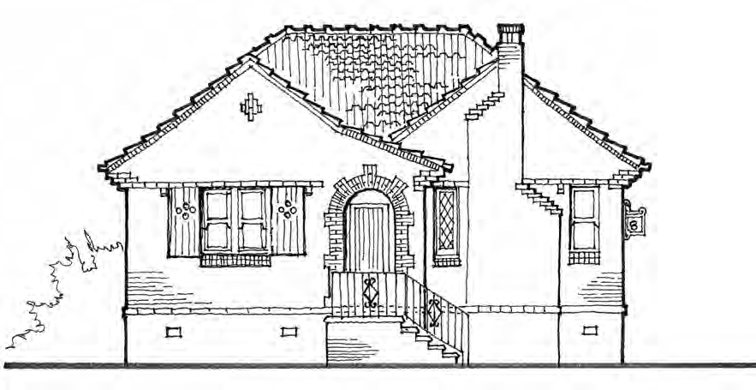

Interwar Old English

Also known as Tudor Revival this popular style emerged during the 1920s and featured Medieval influenced details such as half-timbering, brick nogging, multi-paned timber windows, and picturesque roof profiles. By the 1930s more simplified versions emerged, as shown above.
Roof | Complex hip and gable roof, often clad in terracotta tiles to imitate shingles. Later (1930s) examples often have flush gable ends exposing edges of tiles, as shown above.
Walls | Face brick usually clinker bricks or rendered.
Verandah or porch | Integrated into main roof and usually with Tudor style arched or pointed openings.
Colours | Walls: Unpainted brickwork or natural, cream or buff render  Trim and joinery: Dark stained timber, Light straw, light cream, manila and pale green.
Chimneys | Tall brick chimneys, often stepped with heavy corbelling and terracotta pots.
Eaves | Often corbelled.
Windows | Casement or double hung, often with diamond pattern glazing, sometime with decorative shutters.
Front door | Often dark stained and Tudor style with small coloured glass inserts.

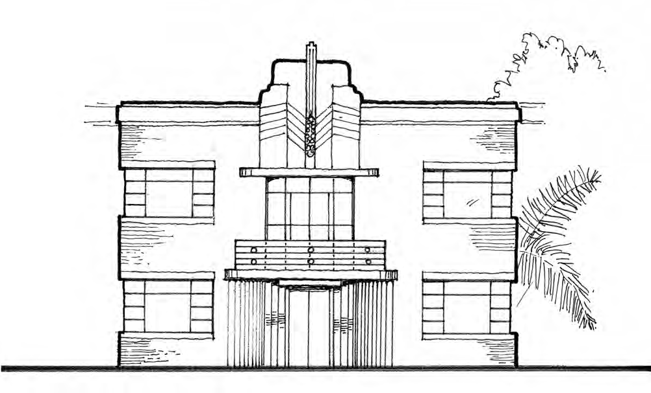

Interwar Moderne (Art deco)
Streamlined Moderne emerged in the early 1930s and quickly became a popular style for flats because of its modern and progressive image. Porches replace verandahs and decoration is stripped back showing the move toward modernism. Streamlined Moderne buildings generally have a horizontal emphasis, sometimes with an emphatic vertical 'anchor' (often stairwells or chimneys) to balance the composition. ‘Jazz’ Moderne is distinguished by applied ‘Art Deco’ style decoration.
Roof | Usually flat or sometimes concealed tiled hipped.
Walls | Smooth render or face brick with square or rounded corners. Jazz Moderne places are enlivened by stepped Art Deco forms and motifs in brick and/or render above and around entrances and to parapets.
Porch & balconies | Simple, cantilevered flat roof or hood. Mild steel balustrades, rounded on corners.
Colours | Walls: White, off white, pale cream, stone  Trim and joinery: apple to forest green, light to dark brown, white, off-white, ivory or tan.
Chimneys | Plain and often concealed or none at all.
Windows | Metal framed with horizontal proportions and often placed at corners with same rounded or square profile as corner. Occasional use of porthole windows as features. Sometimes Art Deco or other design motifs on glass.
Front door | Recessed/stepped brick leading to glazed doors.

Attachment 3> Technical notes

Technical Note 1: Shopfronts

Technical Note 2: Colour schemes

Technical Note 3: Upper Storey additions to single storey dwellings

Technical Note 4: Fencing

The technical notes are under review.

