DRAFT Parking Management Policy
Transport Choices
September 2019

Draft Parking Management Policy

Responsible officer: TBA

Authorised by: Peter Smith, CEO

TRIM folder: 30/09/54

Approval date: TBA

Review date: 1 July 2025

Expiry date: 2028

Version number: TBA

Contents
Draft Parking Management Policy 2
1 Setting the scene 4
1.1 Background 4
1.2 Why we need a Parking Management Policy 5
1.3 Policy context 5
1.4 Outcomes and objectives 6
1.5 Challenges and considerations 6
1.6 Policy scope 7
1.7 Glossary of general terms 7
2 Policy settings 9
2.1 Hierarchy of parking allocation 9
2.2 Parking availability targets 10
2.2.1 Parking tiers and control types 12
2.3 Demand responsive pricing 14
2.4 Parking Permit management 15
2.4.1 Residential Parking Areas 15
2.4.2 Parking Permit types and definitions 17
2.4.3 Parking Permit provisions 24
2.4.4 Parking Permit pricing structure 28
2.4.5 Concession Card holder discounts 30
2.4.6 Applying for permits 30
2.4.7 Permit misuse 31
2.5 Technology 31
3 Policy review 31
3.1 Review of key Policy settings 31
3.2 Review of the Policy 32
3.3 Review of Residential Parking Areas and Parking Permit fees 32
4 Monitoring and evaluation framework 33
4.1 Transparent reporting 33
4.2 Regular reporting 34
5 Responsibilities 34
6 Relevant policy, regulations or legislation 34

1 Setting the scene

1.1 Background
We are at a defining moment in City of Port Phillip history, with our City’s current population projected to grow by 41 per cent to 159,450 people by 2036 (Victoria in Future 2019). This population growth will impact on the whole Port Phillip community, including residents, businesses and their employees, and visitors.
In 2018, Council adopted the Move, Connect Live: Integrated Transport Strategy 2018-28 to address the challenges facing Port Phillip from a transport and liveability perspective, particularly as the population in and around the municipality grows. This strategy also set a clear target for minimising car trips by providing real transport choices for residents, employees and visitors as outlined in Figure 1 below.
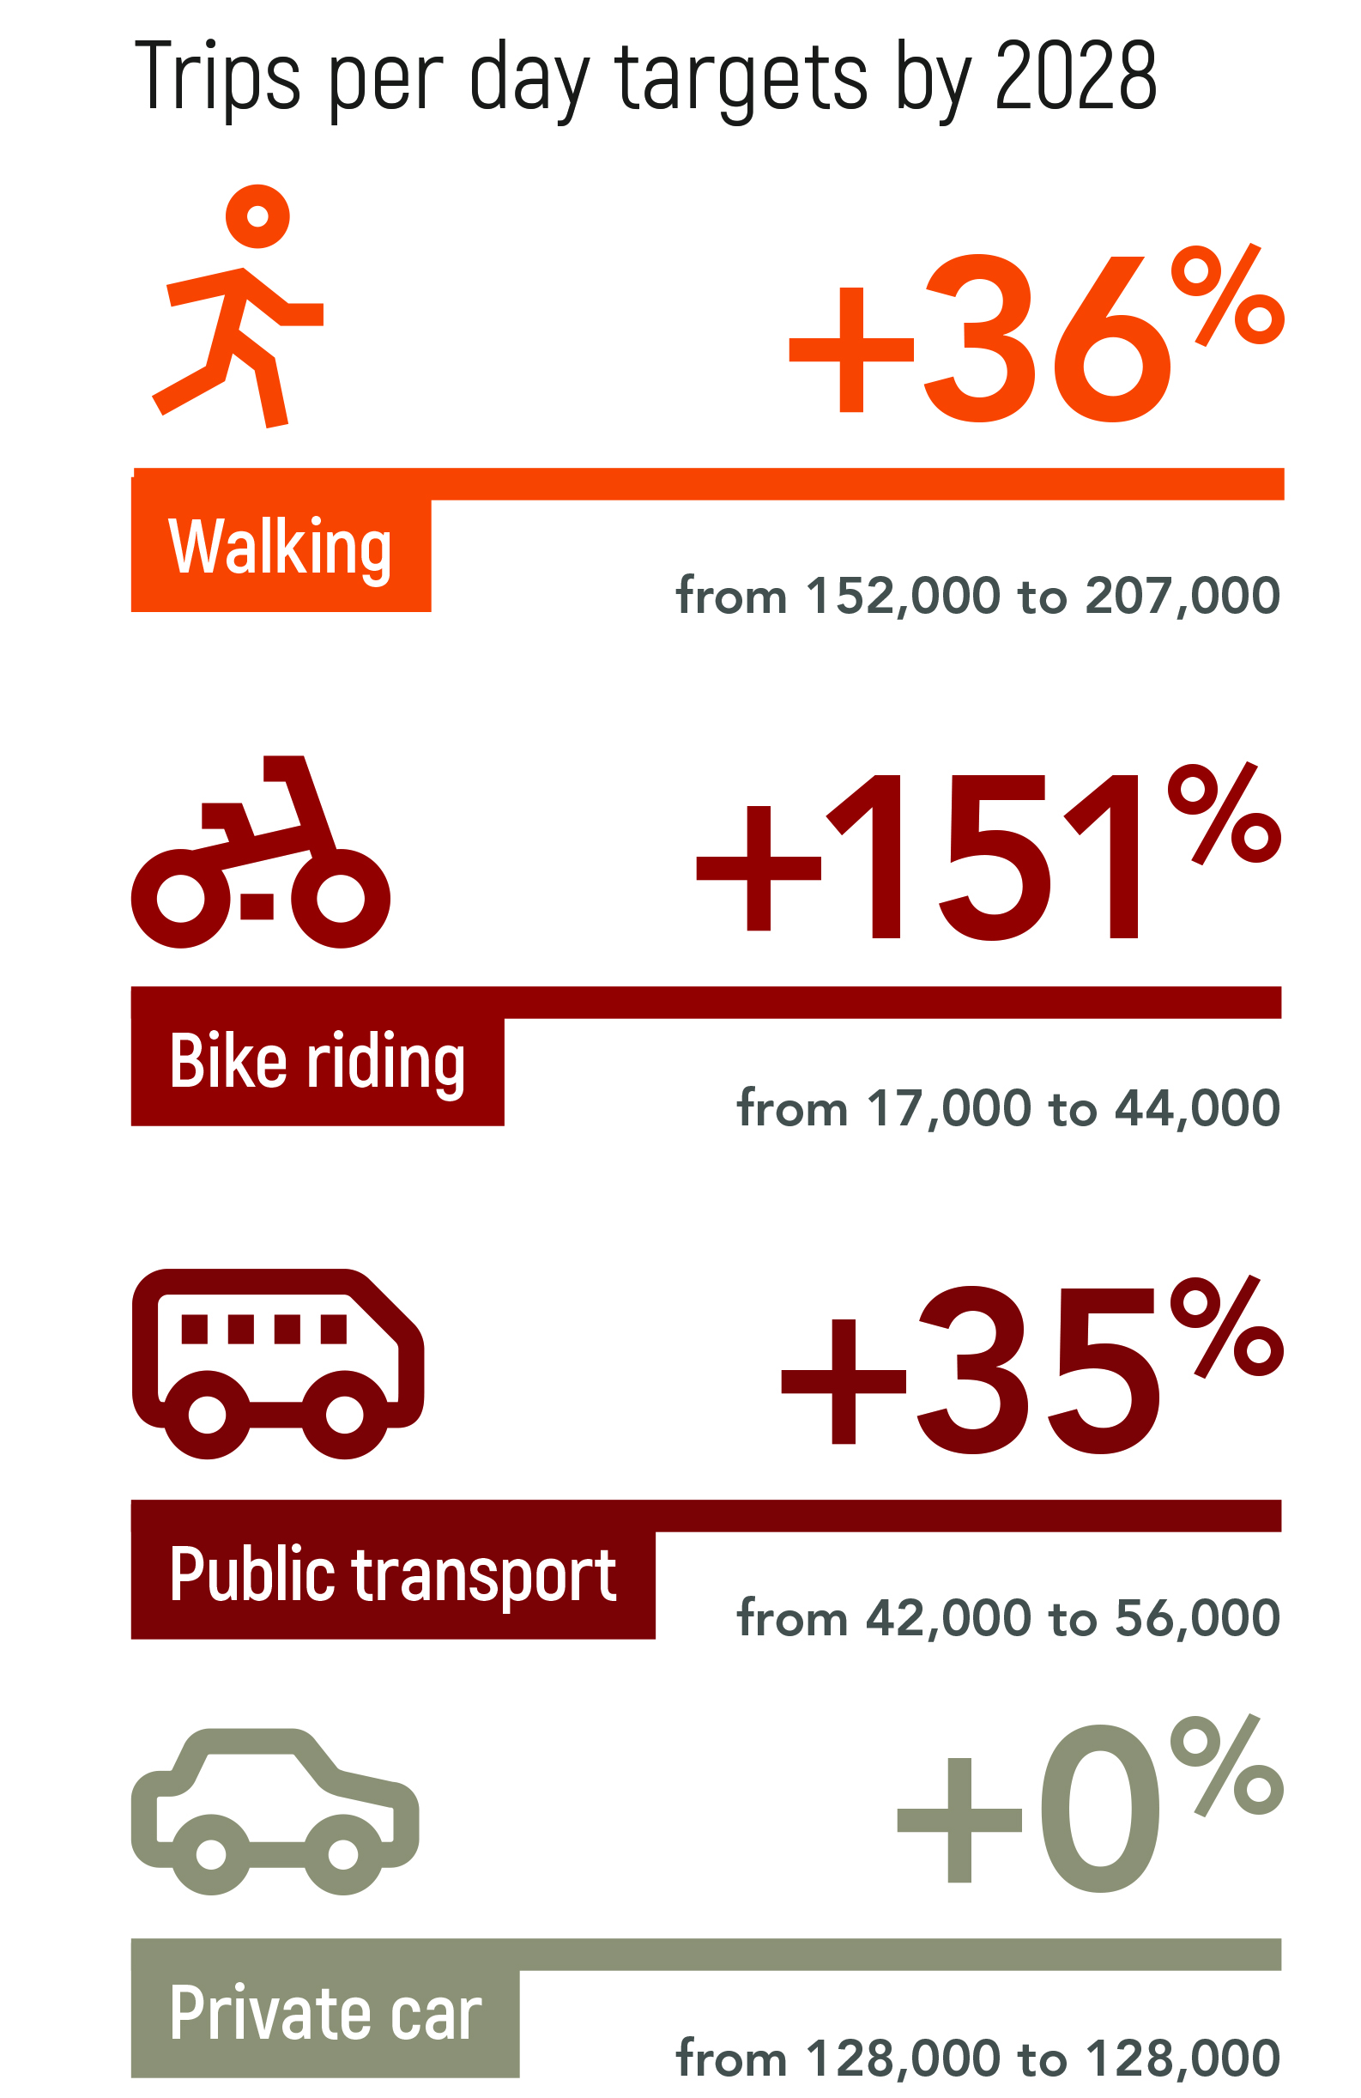
Figure 1: Mode share targets from Move, Connect Live: Integrated Transport Strategy

1.2 Why we need a Parking Management Policy
We want a City where residents, workers and visitors have lots of travel choices that support liveability, promote health and wellbeing, and contribute to the City’s economic vitality.
We know the projected population growth will most notably be felt in our streets; with every additional car residing in our City dramatically increasing traffic congestion and the need for carparking, as well as impacting on the time we spend travelling within and throughout the City.
With the population and number of cars in the City of Port Phillip already rapidly growing as shown in Figure 2 below, now is the time for greater certainty around the ongoing provision, management and availability of carparking. This Policy aims to meet the needs of our City’s residents, employees and visitors, recognising that each person has their own set of needs, and that those needs change over time.
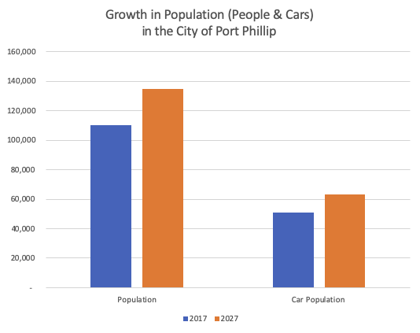
Figure 2: Growth in City of Port Phillip population of cars and people

1.3 Policy context
The Parking Management Policy (the Policy) will contribute to the delivery of the outcome within Council’s Move, Connect Live: Integrated Transport Strategy 2018-28 (the Strategy) specifically related to parking management:
“Our community understands that parking is a limited and shared resource, and works with Council to ensure fairest access. Council will deliver a program of changes to our parking management system to improve equity in carparking while also supporting the economic vitality of the City”.

1.4 Outcomes and objectives
The Policy will provide a framework for the ongoing management of our existing 53,000 on-street and 4,000 Council-owned off-street spaces used for parking and storage of motor vehicles.
The overarching objectives of the Policy are to:
- Address the City’s existing and future growth and transport challenges.
- Provide fairer and more reliable access to parking in all locations and at all times.
These will be delivered via four key settings:
- hierarchy of parking allocation
- parking availability targets
- demand responsive pricing
- Parking Permit management
These settings will allow for ongoing monitoring and evaluation as well as transparent reporting.
The Policy further aims to be:
- Clear and easy for the community and Council officers to interpret and apply.
- Fair and reasonable in both the outcomes it achieves and how it is implemented.
- Flexible to suit different circumstances across Port Phillip, and responsive to changing needs as the City grows.
- Consistent with surrounding and other similar municipalities as far as practicable, while following best practice.
- Realistic and practical to implement, including consideration of Council resources.

1.5 Challenges and considerations
There is a limited amount of public space in the City of Port Phillip and as the population grows, the demand on this space increases. As well as needing space to park and store an increasing number of vehicles, Council also needs to consider the community’s desire to create and maintain a high level of liveability, mitigate the impacts of climate change and provide greater transport choices.
Council recognises that with such a well-established street network, we have limited ability to increase capacity for on-street parking and traffic flow. We also recognise the benefits that other uses of kerb space can bring to the community and as such, some kerb space will need to be converted from parking to accommodate these other uses over time.
In developing this policy, Council has also considered:

Current use of parking spaces

On-street and Council owned off-street car spaces in the City of Port Phillip are used by residents, employees and visitors to our businesses and shopping precincts to park and store vehicles. This policy considers providing equitable use of the on-street car spaces for all users.

Broadening transport choices to better manage congestion

Using alternative transport options eases congestion on our streets and public transport and improves local parking availability for all who need to use their car. This policy complements parallel actions for reallocation of available public space to make alternative modes of transport more efficient and effective in the face of rapid population growth.

Access to parking when – and where - it’s needed most

Ensuring carparking is available to those that need it at the times they need it is critical to making our City liveable, easy to move around, and attractive to visitors. This policy aims to make it easier for all drivers to find suitable parking when and where they need.

1.6 Policy scope
The following aspects are within the scope of this policy:
- All Council-controlled on-street parking spaces, irrespective of whether they are signed, line-marked, regulated or not.
- All Council-owned off-street parking spaces.
- All Council-issued Parking Permits.
- All on-street parking signage and signage in Council-owned off-street carparks.
The following topics are outside of the scope of the Parking Management Policy:
- The reallocation of street spaces to other uses.
- Off-street parking that is commercially operated or privately owned.
- Parking for bicycles (including E-bikes) or shared transport services.
- Victorian Government’s Congestion Levy Act 2005 and its impacts.
- Privately-owned parking
- The Port Phillip Planning Scheme, including the Parking Provisions in Clause 52.06.
- Changes to specific on-street parking controls in response to individual parking issues.
- Developing additional Council-owned off-street parking areas.
- Increasing the total number of on-street parking spaces.
- Reducing the total amount of controlled parking.

1.7 Glossary of general terms
Term | Definition
Carparking | Leaving a car unattended somewhere.
Clearway | A Clearway is a location that cannot be used by any private vehicle for parking and typically only applies at specific times.
Commercial Parking Area | Commercial Parking Areas are typically not designated as specific Parking Areas, but are generally accepted to be an area in which shorter time restrictions apply (typically four hours or less).
Eligible property  Occupants are eligible to apply for Resident Parking Permits | Residential dwellings built before 1 October 2002 with renovations that have taken place before or after 1 October 2002 and have not increased the number of dwellings on the property.
Foreshore Parking Area | Designated paid parking areas along the foreshore where a Foreshore Parking Permit holder can park for the allowable time frame, without purchasing a ticket.
Household | The group of people that together occupy one dwelling.
Ineligible property  Occupants are not eligible to apply for Resident Parking Permits | Residential properties built after 1 October 2002 that have increased the number of properties on a block and all residential properties on a subdivided property where the subdivision has taken place after 1 October 2002.
Non-residential property | A property that is not used predominantly for private residential purposes.
Paid parking | Paid parking requires a fee to be paid to park legally. Often there is a time and paid restriction applied together. If multiple restrictions apply to a space, they must all be complied with to park legally.
Parking Area | A Parking Area is a geographic area within which a single set of controls apply. These are legally applied and enforced in accordance with the Road Safety Road Rules 2017.
Parking availability | The percentage of car spaces available in a Parking Area or Parking Zone at a specific time.
Parking Permit | A Parking Permit provides the permit holder with permission to park in a designated permit holder parking area. Parking Permits have expiry dates. Some Parking Permits are only valid for a specific vehicle while some are transferrable.
Parking space (also parking bay) | Single parking space (or bay), usually line-marked. If unmarked, the exact number of bays within a Parking Zone depends on how close vehicles are parked together.  Parking spaces be restricted to various vehicle type, user groups, time allowances or payment amounts.
Parking Zone | A Parking Zone is one or more parking spaces where the same parking restrictions apply. These are typically adjacent and moving a car within the Parking Zone does not restart the time restriction.
Premium spaces | These are highly sought after convenient carparking spaces that attract high levels of use. In many cases, there is a time of the day or week during which the level of demand makes that space premium and not every premium space will be premium at all times.
Reasonable walking distance | The City of Port Phillip considers 400 metres to be a reasonable walking distance as a car space within 400 metres of a destination can serve that destination just as well as a bus stop, tram stop or train station located the same distance away. At an average pace of 1.2 metres per minute this takes around five minutes to walk.  For other transport modes, reasonable walking distance is typically defined as 800 metres for train stations, and 400 metres from bus and tram stops.  It is important to note that Council consider this reasonable walking distance for able-bodied people conducting most tasks. Specific tasks and different user groups, including people with a disability, will be provided for through accessible parking guidelines and other controls outlined in this policy.
Resident | A person who lives and sleeps at a Port Phillip residence and who provides documentary proof of tenancy or home ownership.
Residential Parking Area | A parking area that is designated as a Resident Parking Permit area.
Residential property | A property that is used predominantly for private residential purposes.
Timed parking | Timed parking can be legally used for the amount of time within the hours of operation displayed on the sign.
Unrestricted parking | Unrestricted parking is a type of Parking Zone that does not have any specific user, time or fee restrictions. An unrestricted parking sign is a plain green ‘P’ on a white background.
User-restricted parking | User-restricted parking is provided solely for use by specific users such as emergency vehicles, vehicles displaying a Disabled Persons Parking Permit, buses, freight vehicles and electric vehicles.
Watch List | The Watch List highlights those Parking Areas experiencing parking availability that is slightly above or below Council’s parking availability target.

2 Policy settings

2.1 Hierarchy of parking allocation
Council allocates available kerb space to types of parking that best reflect the needs of people in a specific street or area. This is a best practice, transparent approach that has been successfully utilised by Council for many years.
Table 1: City of Port Phillip’s hierarchy of parking allocation

User category | Typical types of parking
- Safety for people | Legislation requires no stopping within:  - 20 meters of a signalised intersection; or  - 10 metres of an intersection; or  - One metre of various items such as a fire hydrant; or  - Other locations determined by Council transport engineers (as indicated with signage).  Council sometimes closes (or partially closes) intersections to improve safety for all people using it.
- Public transport stops | Legislation requires no stopping within:  - 20 metres before a bus stop or tram stop  - 10 metres after a bus stop  Public transport stops need to be in specific locations to meet community needs and operational requirements.
- Property access | Legislation requires no stopping in locations that block access to properties unless stopping to drop off passengers (two-minutes only).
- Disabled Persons Parking Permit zones | Disabled Persons Parking Permit zones, sometimes with a time restriction.
- Drop off, pick up and deliveries | Designated ‘drop off or pick up’ zones such as loading zones or taxi zones.
- Customers | A range of time-restricted and paid parking typically:  - Very short-term carparking: P5min – P30min  - Short-term carparking: 1P, 2P, 3P, 4P  - Car storage: Any restriction longer than 4P
- Car share services | Designated spaces for fixed-base car share vehicles, licensed by Council.
- Businesses and local employees | Car storage options (4P+) available two-minute walk from key destinations.  A small number (10-20 spaces) of premium spaces (up to 12P meter) available close to key destinations.
- Residents and their visitors | 2P with Resident Parking Permit holders exempted  4P ticket area with Resident Parking Permit Holders being excepted; area 2P-4P Parking and permit zone all other times
- Commuters | Car storage options (4P+) available 2-10-minute walk from stations or council boundaries where there are few other parking demands.  A small number (10-20 spaces) of premium spaces (up to 12P meter) available close to stations and cross-boundary destinations.

2.2 Parking availability targets
Parking availability targets are used to ensure parking demand is managed across all times of day and to allow as many people as possible to have access to parking when and where they need it. The ideal availability target range will depend upon land uses in the area. Availability targets reflect the different needs people have based on whether they are in a residential, business or recreational area and typical parking restrictions that are applied.
The current parking availability targets are shown in Table 2 below. These targets are to be used by Council as a guide and are not intended to be prescriptive. Note for reference: 20 per cent of car spaces available equates to one in five car spaces available for use.
Table 2: City of Port Phillip parking availability targets
Parking category | Parking availability target range | Example | Reasoning
Premium carparking  (less than 15 minutes) | 25 to 50 per cent of car spaces available | In a typical shopping strip outside a post office, between one in four and two in four of these premium carparking spaces are available across the day. | Premium carparking is required close to key destinations and is typically used for very short time periods like drop off zones. It needs to be more available due to the sporadic nature of peak demands (typically across a day) and the need for additional manoeuvring space.
Short-term carparking  (15 to 30 minutes) | 10 to 25 per cent of car spaces available | In a typical shopping strip outside Coles or a Woolworths, between one in ten and one in four of these spaces are available across the day. | With this average availability, the average walking time from an available car space to any destination will be less than 30 seconds.
Medium-term carparking  (30 minutes to four hours) | Up to 20 per cent of car spaces available | In a typical shopping strip outside an office building, one in five spaces are available across the day. | With this average availability, the average walking time from an available car space to any destination will be less than one minute.
Long-term carparking  (Four hours or more) | Below 10 per cent of car spaces available | In residential areas, one in ten car storage spaces are available across the day. | With this average availability, the average walking time from an available car space to any destination will be less than two minutes.
Premium long-term carparking  (Four hours or more) | 10 to 25 per cent of car spaces available | In residential areas a short distance away from commercial areas, between one in ten to one in four of these premium car storage spaces will be available across the day. | Premium car storage is required close to key destinations and facilities and needs to be more available due to the sporadic nature of peak demands (across the day, week and year).

These targets reflect the community’s expectations about finding a car space within reasonable walking distance of their destination and acknowledge that a person’s willingness to walk from a parking space is significantly influenced by the amount of time the person is expecting to leave the car in the parking space.
Example
Someone using a 15-minute zone to quickly collect something does not want to walk very far to collect the item. By contrast, someone parking for the entire workday is willing to walk further to find a car space that is cheaper or that does not require the car to be moved several times.

2.2.1 Parking tiers and control types
Council typically uses the controls set out in Table 3 below to maximise parking availability by encouraging high turnover of parking spaces in major activity centres (such as main streets and shopping strips) and low turnover in residential areas. As these controls are demand-based, new types of controls may be considered necessary in the future.
Council officers will only apply the next tier if parking availability becomes an ongoing issue at specific times of the day, week or year and the parking demand cannot be managed with the current tier of controls alone.
In Parking Zones where the availability target is exceeded, parking controls can be relaxed. Where parking availability is consistently lower than the target, the controls will need to be tightened.
Each parking tier can only be applied to the extent that it is relevant to the local context, particularly the surrounding land use context. For example, tightening of Tier 3 (timed parking) controls is not appropriate in an area that most or all people need to stay for long periods as tightening of the time limit would just make the parking spaces empty and not useful to anyone.
Table 3: Parking tiers and control types
Tier | Control type | Discussion
1. Unrestricted parking | Unmarked parking  Defined parking without bay definition (but defined by signs at each end of the Parking Zone)  Line-marked parking typically specifies a clear number of parking spaces in each Parking Zone by showing a boundary line for each parking space | The layout of parking spaces is formalised as each parking area gets busier and some drivers have difficulty parking within the rules unless spaces are marked out in some way.
2. User-restricted parking | Disabled Persons Parking Permit zones  Bus stop  Loading zone  Mail zone  Car share zones  Emergency vehicle zone  Residential Parking Area  Foreshore Parking Area | Specific users need to have parking in very specific locations. User restrictions are applied to Parking Zones to provide the necessary availability of space for each user group. Some of these restrictions are governed by commonwealth or state legislation.  It could be appropriate to apply the user-based restrictions for specific times of the day, week or year.
3. Timed parking | 2, 5, 15 and 30-minute parking  1, 2, 4 and 6-hour parking | Time limits typically apply at specific times of the day or week. In some cases, Timed parking controls can apply at all times.
4. Paid parking | Various fees, typically paid per minute or hour | Fees for parking should only apply when and where parking availability is consistently below the target range. Fees are typically not applied to parking that is restricted to less than 15 minutes.  Fees are set by time of day, typically in four specific time bands; morning, afternoon, evening and overnight.

These controls are applied based on variations in demand and availability on specific days. To apply the controls in the most logical and easy to understand way, Council officers use available evidence to select which days of the week and at what times the controls should be applied.
Example
Parking demand around schools typically peak during 45 minutes at the start and end of the school day. Council officers will evaluate each local situation when choosing the specific time periods that parking controls should be applied.
Example
For example, every location starts at Tier 1 (unrestricted parking).
If demand increases such that parking is unavailable for some critical users, then Tier 2 (user-restricted parking) is applied at the location to address the demand.
If parking availability remains tight or is a broader issue for more than a single user group, then Tier 3 (timed parking) is applied.
If parking availability remains tight despite the time-based restrictions that are appropriate to the surrounding land uses, then Tier 4 (paid parking) is applied.
The appropriate fee is the one that balances community access and the demand for the parking location.
Only the controls that apply seven days a week are applicable on public holidays, unless there is a specific note that the control applies on public holidays.
If information indicates that the control applies on a particular day; for example, a parking sign stating that time restrictions apply on a Monday, these time restrictions do not apply on a Monday that is a public holiday unless otherwise stated. When a public holiday falls on a weekend and a day in lieu has been declared by the Victorian Government, Port Phillip City Council will also apply this rule on the day in lieu.

2.3 Demand responsive pricing
In some parts of the City, it is appropriate to charge a fee for parking to provide access to parking on fair terms, as well as producing revenue that can be used for improvements to roads and parking infrastructure.
Paid parking controls are applied based on variations in demand and availability on specific days. To apply paid controls in the most logical and easy to understand way, Council manages and prices on-street parking according to actual demand; that is, the parking availability targets outlined above. This ensures an equitable and consistent pricing structure to maximise parking space turnover and improve parking availability.
If availability is consistently high, fees will be reduced. If availability is consistently more than five per cent above the target range then fees will be increased.
There will be no maximum fee cap per day other than that set by the time limit and hours of operation on each parking sign.
Effective 1 July 2021, any existing all-day parking rates will no longer apply, and people will be required to pay for time used.
All paid parking controls will be reviewed annually. Council officers will proactively publish parking availability data and communicate with the community prior to making annual changes.
There is no upper limit to the tiers, because the upper tiers are only applied if parking availability is consistently low at the previous parking price tier.

2.4 Parking Permit management

2.4.1 Residential Parking Areas
An area based system for Resident Parking Permit holders has replaced the previous ‘surrounding streets’ model, which restricted residential parking to a resident’s street, cross street or adjacent streets. The new parking areas will provide greater parking options for residents around where they live.
There are 35 areas as outlined in Figure 3 below, with each based on reasonable walking distance from a resident’s property to their car as well as adjacent land uses. Where streets form the boundary of a Residential Parking Area, permit holders will be permitted to park on both sides of the street.
A Resident Parking Permit does not guarantee the availability of a parking space to the permit holder. Council officers may declare that demand on specific days is likely to be high. In some instances, (such as during major sporting events) temporary parking restrictions will be applied to some spaces.
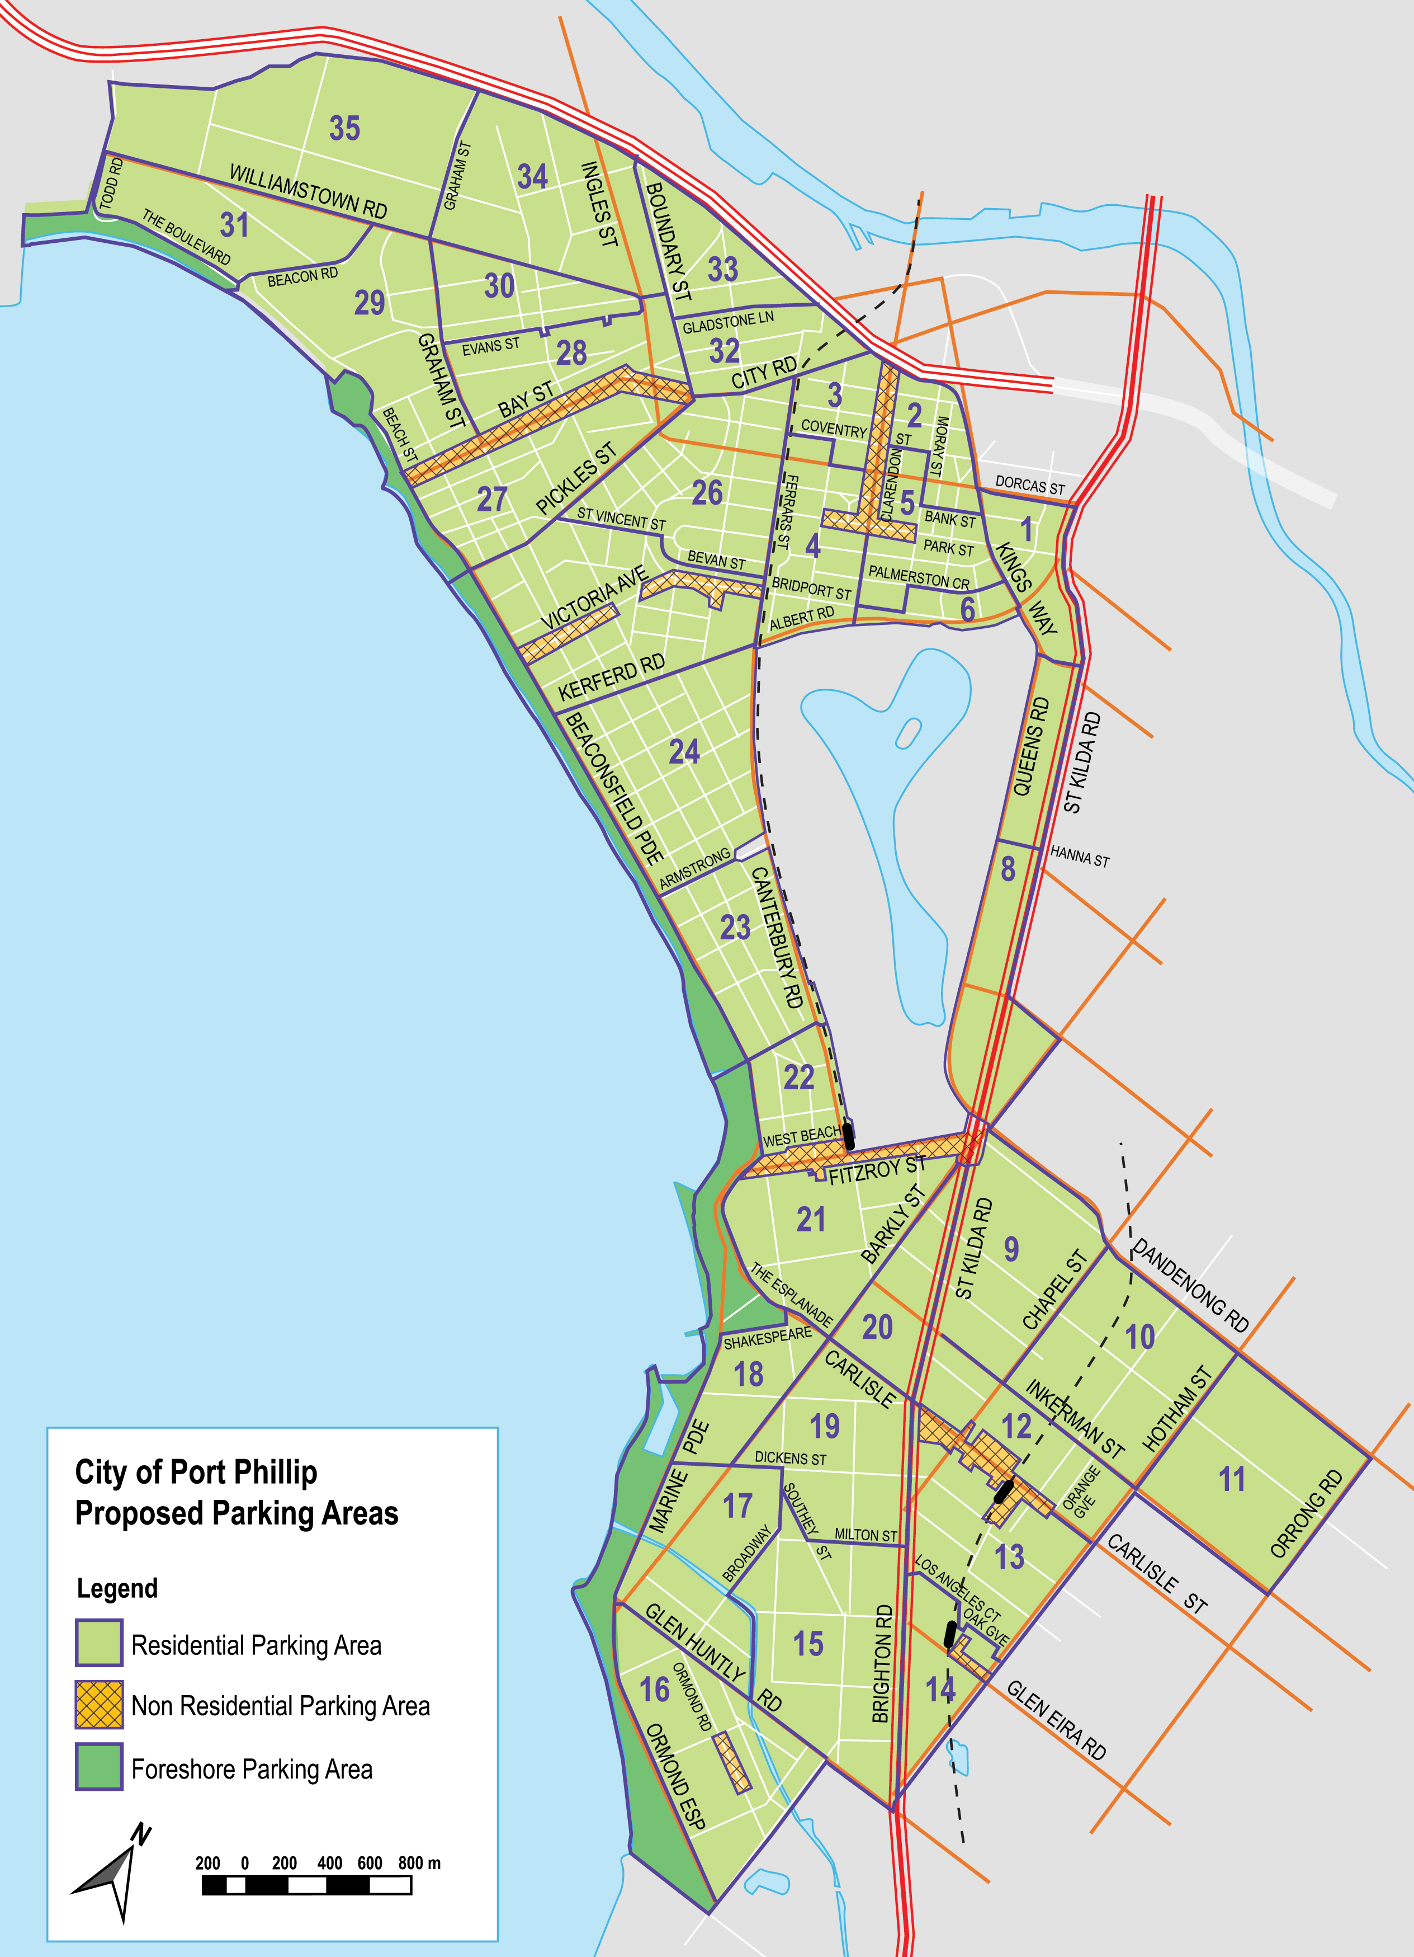
Figure 3: Residential Parking Area map

2.4.2 Parking Permit types and definitions
To simplify Parking Permit options, prioritise residential use in residential areas and legitimate, short-term recreational visitor use in high demand areas, and to reduce misuse of Parking Permits, the following changes have been made to Council’s Parking Permit types and definitions, as outlined in Table 5 below.
Important note
Unless specified in the table below, changes to Parking Permit types and definitions come into effect 1 July 2021 for new applicants and 1 July 2025 for existing permit holders.
Existing permit holders are considered to be eligible residents who held a valid Resident, Visitor and/or Combined Parking Permit prior to the Policy implementation date.
New applicants are eligible residents applying for their first permit after the Policy implementation date.
Table 5: Parking Permit types and definitions
Prior to Policy implementation date |  |  | Effective:  1 July 2021 – new applicants  1 July 2025 – existing permit holders
Permit type | Definition |  | Permit type | Definition
Agency Parking Permit | Allow an eligible worker to visit, by private vehicle, a residential property within the City of Port Phillip during the course of any day on official duties and be exempt from time-controlled and permit zone parking restrictions outside a residential property. |  | Community Non-Profit Parking Permit | No change proposed
Combined Parking Permit  Combined Resident and Foreshore Parking Permit | A vehicle registration-based permit that functions as both a Resident Parking Permit and a Foreshore Parking Permits.  Private vehicles displaying a valid Combined Parking Permit may park in their designated Residential Parking Area and City of Port Phillip Foreshore Parking Areas and be exempt from time-controlled, permit zone, paid parking and 'No Stopping Anytime – Permit Holders Excepted' parking restrictions. |  | No longer available – use Resident Parking Permit (if eligible) and single-use, short-term foreshore parking vouchers  Note: effective 1 July 2021 for new applicants and existing permit holders. | Not applicable
Community Organisation Parking Permit | Allow an eligible worker to visit, by private vehicle, a residential property within the City of Port Phillip during the course of any day on official duties and be exempt from time-controlled and permit zone parking restrictions outside a residential property. |  | Community Non-Profit Parking Permit | No change proposed
Community Service Parking Permit | Allow an eligible worker to visit, by private vehicle, a residential property within the City of Port Phillip during the course of any day on official duties and be exempt from time-controlled and permit zone parking restrictions outside a residential property. |  | Community Non-Profit Parking Permit | No change proposed
Disabled Persons Parking Permit  For individuals; temporary permit | Vehicles displaying a Disabled Persons Parking Permit can park in any designated disabled parking space as per State legislation. Temporary permits are valid for a period of three years. |  | Disabled Persons Parking Permit | No change proposed
Disabled Persons Parking Permit  For individuals; permanent permit | Vehicles displaying a Disabled Persons Parking Permit can park in any designated disabled parking space as per State legislation. Permanent permits do not have an expiration date. |  | Disabled Persons Parking Permit | No change proposed; will be valid for a period of three years from 2022 onwards
Disabled Persons Parking Permit  For organisations; temporary permit | Allow an eligible worker to visit, by private vehicle, a residential property within the City of Port Phillip during the course of any day on official duties and be exempt from time-controlled and permit zone parking restrictions outside a residential property. |  | Community Non-Profit Parking Permit | No change proposed
Foreshore Club Parking Permit | Any resident or member of an approved foreshore club or association shall be eligible to display a Foreshore Club Parking Permit, which exempts the holder from paying the appropriate fee at designated foreshore paid parking areas. Parking time limits must still be obeyed. |  | Foreshore Club Parking Permit | No change proposed
Foreshore Parking Permit | Private vehicles displaying a valid Foreshore Parking Permit are exempt from paying the fee at designated paid Foreshore Parking Areas. Parking time limits must still be obeyed. |  | Foreshore parking vouchers  Note: effective 1 July 2021 for new applicants and existing permit holders. | Total of 360 single-use, short-term foreshore parking vouchers available per household, purchased in smaller booklets.  Each voucher allows vehicles to park in paid parking areas along Beach Road and designated foreshore car parks, for the allowable time frame and without purchasing a ticket.
Foreshore Surf Lifesaving Parking Permit | Any volunteer lifesaver on shift at an approved foreshore club or association shall be eligible to display a Foreshore Surf Lifesaving Parking Permit, which exempts the holder from paying the appropriate fee at designated paid Foreshore Parking Areas. Parking time limits must still be obeyed. |  | Foreshore Surf Lifesaving Parking Permit | No change proposed
Musicians Loading Permit | Allows the permit holder to park in loading zones adjacent to a music venue registered with Music Victoria for the purpose of loading or unloading equipment, exempt from time restrictions and paid parking fees. |  | Musicians Loading Permit | No change proposed
Party Parking Permit | Private vehicles displaying a valid Party Parking Permit are exempt from time-controlled, permit zone, paid parking and 'No Stopping Anytime – Permit Holders Excepted' parking restrictions in the relevant Residential Parking Area. |  | No longer available – use visitor parking vouchers (if eligible) or Reserved Parking Permit | Not applicable
Resident Parking Permit | A vehicle registration-based permit that allows private vehicles displaying a valid Resident Parking Permit to park in their designated Residential Parking Area and be exempt from time-controlled, permit zone, paid parking and 'No Stopping Anytime – Permit Holders Excepted' parking restrictions.  Resident Parking Permit definition and provisions include Visitor and Combined Parking Permits. |  | Resident Parking Permit  Note: effective 1 July 2021 for new applicants and existing permit holders. | A vehicle registration-based permit that allows private vehicles displaying a valid Resident Parking Permit to park in their designated Residential Parking Area and be exempt from time-controlled, permit zone, paid parking and 'No Stopping Anytime – Permit Holders Excepted' parking restrictions.  Resident Parking Permit definition and provisions exclude Visitor and Combined Parking Permits.
Temporary Parking Permit | Allows people or businesses to book parking bays within the City of Port Phillip for their exclusive use, including for:  - Building maintenance  - Events  - Film crews  - Removalists  - School and community groups in buses  - Visiting VIPs  - Weddings.  Reserved Parking Permits can’t be used for non-vehicles, such as skip bins, containers, cranes or scissor lifts. A Reserved Parking Permit allows a vehicle to park and be exempt from time limits and parking fees in an area for the time shown on the permit. If all bays within a signed area are reserved, Council will change the signs or provide a permit to exempt vehicles from parking fees and time limits. |  | Reserved Parking Permit | No change proposed; expanded to include party guests and tradespeople
Tradesperson Parking Permit | Private vehicles displaying a valid Tradesperson Parking Permit are exempt from time-controlled, permit zone, paid parking and 'No Stopping Anytime – Permit Holders Excepted' parking restrictions in the relevant Residential Parking Area. |  | No longer available - use visitor parking vouchers (if eligible) or Reserved Parking Permits | Not applicable
Visitor Parking Permit | A transferrable permit that allows private vehicles displaying a valid Visitor Parking Permit to park in the permit holder’s designated Residential Parking Area and be exempt from time-controlled, permit zone, paid parking and 'No Stopping Anytime – Permit Holders Excepted' parking restrictions. |  | Visitor parking vouchers | Total of 360 single-use, short-term visitor parking vouchers available per household, purchased in smaller booklets  Each voucher allows a vehicle to be parked in the relevant Residential Parking Area for up to 24 hours

2.4.3 Parking Permit provisions
In many locations across our municipality, there are now significantly more Parking Permits issued than there are available spaces.
This has led to residents finding it difficult to find a space where they live and has prompted changes to Parking Permit provisions. These changes are designed to better manage and respond to supply and demand, and to promote use of existing off-street parking resources to reduce pressure on local parking availability.
Parking Permit provisions will be reduced for residents with off-street carparking accessed by a driveway directly from the street to the property, as driveways remove kerb space that could otherwise be utilised for car spaces from the local on-street supply.
Rear access laneways will not be taken into account, as these do not remove kerb space that could otherwise be allocated to on-street carparking. Changes to Parking Permit provisions are outlined in Table 6 for existing permit holders and Table 7 for new applicants below.
Important note
Existing permit holders are considered to be eligible residents who held a valid Resident, Visitor and/or Combined Parking Permit prior to the Policy implementation date.
New applicants are eligible residents applying for their first permit after the Policy implementation date.
Table 6: Parking Permit provisions – existing permit holders
Property type | Provision prior to  30 June 2021 | Provision effective  1 July 2021 | Provision effective  1 July 2025
Higher density developments and single dwellings on a lot built prior to 1 October 2002. | Maximum of three annual Resident Parking Permits (includes Resident, Visitor and Combined Parking Permits), including  Maximum of two annual Visitor Parking Permits, and  Maximum of three annual Foreshore Parking Permits | Maximum of three annual Resident Parking Permits (for existing permit holders with three annual Resident Parking Permits before 1 July 2021; excludes Visitor and Combined Parking Permits) or maximum of two annual Resident Parking Permits (excludes Visitor and Combined Parking Permits), and  One annual Visitor Parking Permit plus up to 360 single-use, short-term visitor parking vouchers per year (for existing permit holders with two annual Visitor Parking Permits before 1 July 2021), or one annual Visitor Parking Permit, or up to 360 single-use, short-term visitor parking vouchers per year, and  Up to 360 single-use, short-term foreshore parking vouchers per year, and  Reserved Parking Permits as needed | Maximum of two annual Resident Parking Permits (excludes Visitor and Combined Parking Permits), and  Up to 360 single-use, short-term visitor parking vouchers per year, and  Up to 360 single-use, short-term foreshore parking vouchers per year, and  Reserved Parking Permits as needed
Single dwelling on a lot with a driveway (crossover) less than or equal to six metres in width.  Removes one on-street car space from local supply. | As above | As above | Maximum of one annual Resident Parking Permit (excludes Visitor and Combined Parking Permits), and  Up to 360 single-use, short-term visitor parking vouchers per year, and  Up to 360 single-use, short-term foreshore parking vouchers per year, and  Reserved Parking Permits as needed
Single dwelling on a lot with a driveway (crossover) more than six metres in width.  Removes two on-street car spaces from local supply. | As above | As above | Zero annual Resident Parking Permits, and  Up to 360 single-use, short-term visitor parking vouchers per year, and  Up to 360 single-use, short-term foreshore parking vouchers per year, and  Reserved Parking Permits as needed
Higher density developments built prior to 1 October 2002 with a driveway (crossover). | As above | As above | Maximum of one annual Resident Parking Permit which excludes Visitor and Combined Parking Permits, and  Up to 360 single-use, short-term visitor parking vouchers per year, and  Up to 360 single-use, short-term foreshore parking vouchers per year, and  Reserved Parking Permits as needed

Table 7: Parking Permit provisions – new applicants
Property type | Provision prior to 30 June 2021 | Provision effective 1 July 2021
Higher density developments and single dwellings on a lot built prior to 1 October 2002. | Maximum of three annual Resident Parking Permits (includes Resident, Visitor and Combined Parking Permits), including  Maximum of two annual Visitor Parking Permits, and  Maximum of three annual Foreshore Parking Permits | Maximum of two annual Resident Parking Permits (excludes Visitor and Combined Parking Permits), and  Up to 360 single-use, short-term visitor parking vouchers per year, and  Up to 360 single-use, short-term foreshore parking vouchers per year, and  Reserved Parking Permits as needed
Single dwelling on a lot with a driveway (crossover) less than or equal to six metres in width.  Removes one on-street car space from local supply. | As above | Maximum of one annual Resident Parking Permit (excludes Visitor and Combined Parking Permits), and  Up to 360 single-use, short-term visitor parking vouchers per year, and  Up to 360 single-use, short-term foreshore parking vouchers per year, and  Reserved Parking Permits as needed
Single dwelling on a lot with a driveway (crossover) more than six metres in width.  Removes two on-street car spaces from local supply. | As above | Zero annual Resident Parking Permits, and  Up to 360 single-use, short-term visitor parking vouchers per year, and  Up to 360 single-use, short-term foreshore parking vouchers per year, and  Reserved Parking Permits as needed
Higher density developments built prior to 1 October 2002 with a driveway (crossover). | As above | Maximum of one annual Resident Parking Permit (excludes Visitor and Combined Parking Permits), and  Up to 360 single-use, short-term visitor parking vouchers per year, and  Up to 360 single-use, short-term foreshore parking vouchers per year, and  Reserved Parking Permits as needed

2.4.4 Parking Permit pricing structure

To encourage understanding of the true value of Resident Parking Permits and further manage increasing demand across the City, a tiered pricing structure for Resident Parking Permits will be utilised.

With this approach, the first Resident Parking Permit can be purchased at a reduced price compared to the second and third permits (while available).
Changes to Parking Permit pricing are outlined in Table 8 below. Parking Permit pricing will be set by Council through the fees and charges as part of the annual budget process.
Important note
Changes to Parking Permit pricing come into effect 1 July 2021 for new applicants and existing permit holders.
Table 8: Parking Permit pricing structure
Prior to Policy implementation date |  |  | Effective 1 July 2021
Permit type | Fee |  | Permit type | Fee
Agency Parking Permit | $0 (free) |  | Community Non-Profit Parking Permit | $0 (free)
Combined Parking Permit  Combined Resident and Foreshore Parking Permit | $122 per annum |  | No longer available | Not applicable
Community Organisation Parking Permit | $0 (free) |  | Community Non-Profit Parking Permit | $0 (free)
Community Service Parking Permit | $0 (free) |  | Community Non-Profit Parking Permit | $0 (free)
Disabled Persons Parking Permit  For individuals; temporary permit | $0 (free) |  | Disabled Persons Parking Permit | $0 (free)
Disabled Persons Parking Permit  For individuals; permanent permit | $0 (free) |  | Disabled Persons Parking Permit | $0 (free)
Disabled Persons Parking Permit  For organisations; temporary permit | $0 (free) |  | Community Non-Profit Parking Permit | $0 (free)
Foreshore Club Parking Permit | $102 per annum |  | Foreshore Club Parking Permit | $110 per annum
Foreshore Parking Permit | $61 per annum |  | Foreshore parking vouchers | $13 per booklet of 30 single-use, short-term vouchers.  $156 for 12 booklets (360 single-use, short-term vouchers in total).
Foreshore Surf Lifesaving Parking Permit | $0 (free) |  | Foreshore Surf Lifesaving Parking Permit | $0 (free)
Musicians Loading Permit | $81 per annum |  | Musicians Loading Permit | $110 per annum
Party Parking Permit | $6 per day |  | No longer available – use visitor parking vouchers (if eligible) or Reserved Parking Permit. | Not applicable
Resident Parking Permit | $83 per annum |  | Resident Parking Permit | $60 - first permit  $120 - second permit  $120 - third permit  Third permit only available for existing permit holders until 30 June 2025.
Temporary Parking Permit | $40 per day plus $92 administration fee |  | Reserved Parking Permit | $120 per day for first parking bay.  $60 per day for each additional bay.  Prices include administration fee.
Tradesperson Parking Permit | $11 per day |  | No longer available - use visitor parking vouchers (if eligible) or Reserved Parking Permits. | Not applicable
Visitor Parking Permit | $112 per annum |  | Visitor parking vouchers | $120 for an annual Visitor Parking Permit (if eligible).  $10 per booklet of 30 single-use, short-term vouchers.  $120 for 12 booklets (360 single-use, short-term vouchers in total).

2.4.5 Concession Card holder discounts
The following Concession Card holders are entitled to receive a 50 per cent discount on the fee for Resident Parking Permits and visitor and foreshore parking vouchers:
- Pensioner Concession Card – issued by Centrelink, Department of Human Services or Department of Veterans’ Affairs
- Health Care Card issued by Centrelink or Department of Human Services
- Commonwealth Seniors Health Card issued by Department of Human Services
- Department of Veterans’ Affairs (DVA) Gold Card – War Widow (WW) or Totally and Permanently Incapacitated (TPI)

2.4.6 Applying for permits
Applications for permits are required to be in writing or online on the prescribed forms. Documentation and payment is required to accompany the application.
If a private vehicle is registered to a company or organisation then a letter, on company letterhead, is to be provided stating that the vehicle is driven primarily by the applicant and parked overnight at a specific City of Port Phillip residential address.
New tenants or owners of a household may be required to complete a Statutory Declaration in instances where permits were held by previous tenants or owners who have now vacated the household. These previously issued permits will need to be cancelled for the current application to be processed within the Resident Parking Permit limit.
Applications for Foreshore Parking Permits must be made on the prescribed form, and for non-resident members of authorised foreshore clubs or associations, include the signature of an office bearer of the club and include the club seal.
Applications for Community Service Organisation Parking Permits must be made in the form of a letter on official letterhead of the organisation in question and include the names and registrations of all applicable vehicles. A clear statement explaining the nature of the request is also required. The request is to be signed off by the Community Service Organisation CEO, General Manager or equivalent.
All applicants will be required to acknowledge acceptance of the rules of this policy by signing the application form and subsequent renewal notices.
A fee may apply to replace an existing permit (same name, address and registration) due to it being destroyed, lost or stolen.
A fee may apply to permit holders who change their vehicle over during a current valid 12-month Parking Permit period. The initial expiry date will however continue to apply.

2.4.7 Permit misuse
Confirmed misuse of Parking Permits, including re-selling permits, may result in the withdrawal of all Parking Permit privileges for the household for a minimum of 24 months, as well as possible prosecution. Any person aggrieved by the withdrawal of their Parking Permit privileges for misuse may appeal in writing to the Manager of Transport Choices. The appeal must be in writing and clearly state the reasons why the decision should be reviewed.

2.5 Technology
The use of technology is being investigated as part of the implementation of the policy to ensure transparent decision making using data and flexibility for our community as customers.
This extends to the use of electronic permits for better customer experience and parking sensors to guide pricing based on demand.

3 Policy review

3.1 Review of key Policy settings
The key Policy settings will be applied consistently across the municipality. Parking control changes will be based on data and evidence, specifically known land use demands and demographic data and parking availability data from surveys and sensors.
Data collection, analysis and monitoring over time will provide Council officers and the community with robust information about parking availability.
This information will then be used to inform future changes to controls including user restrictions, timed parking and paid parking.
Some programs have very specific review triggers and milestones that should be applied. The review triggers for Parking Permits are outlined in Table 9 below.
Table 9: Parking Permit review triggers
Theme | Review trigger | Reasoning
Community Non-Profit Parking Permits | Technology is available at the City of Port Phillip to process permits online. | The online permit system will increase the flexibility and ease with which Community Service Organisations can administer and use these permit types.
Foreshore Club Parking Permits | Technology is available at the City of Port Phillip to process permits online. | The online permit system will increase the flexibility and ease with which clubs can administer and use these permit types.
Visitor parking vouchers | The number of dwellings built after 2002 exceeds the number of dwellings built prior to 2002 within each parking area. | Access to single-use, short-term visitor parking vouchers will improve access and flexibility for more residents and visitors over time.

3.2 Review of the Policy
The review of this policy and its implementation will be conducted by a senior Council officer not responsible for day-to-day management of parking and delegated by the City of Port Phillip CEO.
Implications - why are we doing this?
The Policy seeks to provide a separation of roles and powers regarding parking management, for example:
- Councillors should set the policy, objectives and targets.
- Council officers should be responsible for developing strategies to meet the objectives and targets and reviewing progress towards meeting them.
- Different Council officers should be responsible for day-to-day management and enforcement of parking restrictions, and the evaluation of the Parking Management Policy.
A review of this Policy will be completed one year after its implementation and every five years thereafter.
This timeframe assumes that it often takes six to 12 months to implement many of the policy settings and some additional time to understand how any changes are impacting on the community.

3.3 Review of Residential Parking Areas and Parking Permit fees
Residential Parking Areas and Parking Permit fees will be determined by the City of Port Phillip CEO or as delegated to other council officers through the Instrument of Delegation. Areas will be adjusted over time to meet local community needs. Fees will be reviewed annually.

4 Monitoring and evaluation framework
The parking situation in all parts of the municipality is constantly changing as demand for parking changes. In some locations, the closure of specific venues reduces parking demand.
The opening of new, popular, or regionally significant venues increases parking demand. In other locations, demand changes with the seasons. In all locations, demand is different during the day compared with overnight and varies by day of the week.
Evaluating this policy will be based on how well the policy is able to cope with the variations that occur over time. In some cases, the variations will need to be dealt with through changes to the rules and policy settings.
However, in most cases, it is expected that the foundation provided by the policy will be able to support Council officers to manage the evolution in parking demands a that occur throughout the municipality.
Parking Areas where availability is consistently above or below the target range during a specific time of the day will be the focus of review and the timed restriction or paid parking fee will be changed.
By 2028, the City of Port Phillip will only apply Tier 4 (paid parking) controls to spaces that have sensor technology collecting real time information about availability.
Once paid parking is applied in a location, parking sensors will be installed, and parking availability will be monitored on a regular (typically monthly) basis and over four different time bands as outlined in Table 10 below.
Table 10: Time bands for applying parking controls
Time band | When the control is in effect | Discussion
Morning | 8 AM – 12 Noon | The morning typically has higher availability than afternoon and can have different controls to reflect that variation.
Afternoon | 12 Noon – 6 PM | Afternoon is typically the time of highest demand and controls need to reflect that to ensure parking availability.
Evening | 6 PM – 10 PM | Some areas of Port Phillip experience different demands in the evenings to other times of the day.
Overnight | 10 PM – 8 AM | Overnight parking demand is typically lower in Major Activity Centres and higher in Residential Parking Areas.

4.1 Transparent reporting
The City of Port Phillip will provide transparent reporting of the parking availability data it collects. We recognise that parking availability varies across the day and week, and seek to provide our community with the most accurate picture possible regarding parking availability outcomes.
As more data becomes available and is analysed we will publish annual reports that show how parking is being utilised across the day, days of the week and weeks of the year.

4.2 Regular reporting
Council officers will report to Council on a regular basis with a dashboard of key information that highlights the progress of implementation and the state of parking management in the municipality.
This dashboard will be provided in a written form and cover the following key monitoring information:
- Number of parking spaces managed by City of Port Phillip - any change since previous report.
- Number of active Parking Permits issued by type.
- Parking availability rates in key areas at key times.

5 Responsibilities
The Policy shall be managed by a senior officer delegated by the CEO and administered by authorised officers.
Councillors are responsible for the setting of policy objectives, targets and goals. Council officers are responsible for setting controls or prices for specific locations and reviewing these as part of Council’s annual budget process.

6 Relevant policy, regulations or legislation
This policy is consistent with the following legislation:
- Road Safety Road Rules 2017
- Local Government Act 1989
- Road Safety Act 2009
- Road Management Act 2004
- Transport Integration Act 2010
This policy is consistent with the following strategies:
- Plan Melbourne
- Move, Connect, Live: Integrated Transport Strategy 2018-28
This policy is enacted, in part, through the following:
- Port Phillip Local Law No. 1
- Port Phillip Planning Scheme
The Policy also supports the delivery of other strategic directions contained within the Council Plan 2017-27.

