Engagement Report
Parking Management Policy
Quantitative Research
Version 2
2 October 2019

CONTENTS
Engagement Report 1
Figures 3
Introduction and background 4
Policy objectives 4
Methodology 5
Telephone interviews 5
Face-to-face interviews 5
Survey questions 6
Demographic information 7
Residents 7
Businesses 8
Workers and visitors 9
Engagement results 11
Snapshot of feedback 12
Residents 12
Off-street parking 13
Attitudes towards proposed parking ideas 15
Car share parking 16
Ease of finding street parking 17
Users of parking spaces 18
Road space initiatives 19
Street sweeping effectiveness 19
Businesses 20
Car ownership and use 20
Current parking arrangements 20
Improvement to parking in the area 20
What the council is doing well to manage parking 20
Customer parking 21
Ease of street parking 21
Parking controls principles 22
Uses of road space 27
Parking and permits 27
Workers and visitors 28
Perceptions of current parking 28
Importance of carpark users 30
Uses of road space 30
Road space initiatives 31

Figures
Figure 1 Council parking permits owned by residents 12
Figure 2 How often off-street parking is used by residents 14
Figure 3 Ease of finding a carpark in the streets near the business 21
Figure 4 Availability of parking near main streets and shopping strips 22
Figure 5 Parking spaces for car share vehicles should be prioritised 23
Figure 6 Reduce household permits for those with access to off-street parking 24
Figure 7 Road space should be used to support the broader community 25
Figure 8 A minimum hourly fee should be introduced 26
Figure 9 Ease of finding parking on the street 29
Figure 10 Revenue from permits and paid parking to fund road space initiatives 31
Figure 11 Introduce timed parking restrictions around shopping strips 32
Figure 12 Level of support for introducing a hourly fee to improve parking availability 33
Tables
Table 1 Response reach for telephone interviews methodology 5
Table 2 Response reach for face-to-face interviews methodology 5
Table 3 Suburb of residents surveyed 7
Table 4 Number of businesses surveyed 8
Table 5 Number of workers and visitors surveyed 9
Table 6 Reasons and response rate for residents not owning a car 12
Table 7 Degree residents agree with proposed parking ideas 15
Table 8 Agreement for prioritising car share parking by suburb 16
Table 9 Ease of finding off-street parking for residents 17
Table 10 Importance of road space initiatives 19
Table 11 Importance of uses of road space in the area surrounding the business 27
Table 12 Perceptions of current parking locations 28
Table 13 Most important users of parking spaces 30
Table 14 Average importance of implementing use changes in the area 30

Introduction and background
The City of Port Phillip (CoPP) is one of the geographically smallest municipalities in Victoria, yet it is the most densely populated with twice the population density of the metropolitan Melbourne average. The City is also one of the most visited places in Melbourne. With a foreshore that stretches over 11 kilometres and vast public open spaces, the City is highly desirable to residents and visitors.
Although high population density and growth can bring new life to the City, it also poses significant challenges. The City of Port Phillip’s population is expected to increase 41 per cent by 2036. Managing traffic congestion and on-street parking will continue to be a challenge as our City grows. In many parts of the City, demand for parking outstrips supply.
In September 2018, Council endorsed the Move, Connect, Live: Integrated Transport Strategy 2018-28 (the Strategy). One of the five core outcomes of the Strategy, Outcome 4, is that ‘our community understands that parking is a limited and shared resource, and works with Council to ensure fairest access’.
There has been extensive community consultation conducted over the past four years around parking management, including throughout the development of the Strategy. The City of Port Phillip has recently engaged market research consultancies to further understand community and other stakeholders’ attitudes and behaviours in relation to parking.
Qualitative research through focus groups and in-depth interviewing was conducted in June 2019. To build further on this qualitative research, widespread quantitative research was conducted in July and August 2019 with the results shown in this report.
The information and research gathered as part of this first stage of community engagement was considered in the process of developing a new draft Parking Management Policy.

Policy objectives
Drawn from the Strategy, the objectives for Council’s parking policy are to:
- address the City’s growth and transport challenges and achieve the outcomes identified in the Strategy
- be clear and easy for community and Council officers to interpret and apply
- be fair and equitable in both the outcomes it achieves and how it is implemented
- be adaptable and flexible to suit different circumstances across Port Phillip, and to meet changing needs as the City grows
- be consistent with surrounding and other similar municipalities as far as practicable, while pursuing best practice
- be realistic and practical to implement, including consideration of Council resources.
Council contracted independent market and social research company JWS Research to conduct the qualitative research. The quantitative findings were conducted by independent market research company The Local Government Research Group.

Methodology
The reseach was comprised of three separate but related surveys:
- residents
- businesses
- workers and visitors.
Interviews were conducted with residents and businesses within CoPP via Computer Assisted Telephone Interviewing (CATI).
Surveys were conducted face-to-face with workers and visitors in CoPP, and were completed electronically on tablets.
Interviewing was conducted during July and August 2019.

Telephone interviews
Table 1 Response reach for telephone interviews methodology
Stakeholders | Responses (reach)
Residents | 792
Businesses | 200

Face-to-face interviews
Table 2 Response reach for face-to-face interviews methodology
Stakeholders | Responses (reach)
Workers | 215
Visitors | 212
The margin of error for the residents survey is robust at plus or minus 3.47 per cent indicating a very high level of reliability that the results are indicative of the general community in the municipality of Port Phillip.

Survey questions
The survey instrument was developed in conjunction with CoPP, and covered the following:
- Demographics
- Car ownership – existence and use
- Council permits – frequency and use
- Off-street parking – existence, ease, satisfaction, attitudes (see below for rating scale)
- Importance of different aspects of road space (see below for rating scale)
- Support for various road space initiatives (see below for rating scale)
The survey used a five-point scale to gague feedback in each of the categories.
Off-street parking
Satisfaction:
- 1 = not at all satisfied to 5 = extremely satisfied
Attitudes:
- 1 = strongly disagree
- 2 = disagree
- 3 = neither agree nor disagree
- 4 = agree
- 5 = strongly agree
Confidence:
- 1 = not at all confident to 5 = extremely confident
Ease of parking
- 1 = extremely easy
- 2 = easy
- 3 = neither easy nor difficult
- 4 = difficult
- 5 = extremely difficult
Different aspects of road space
Importance:
- 1 = not at all important to 5 = extremely important
Various road space initiatives
Support:
- 1 = do not support at all to 5 = strongly support

Demographic information

Residents
- The gender split of the sample of residents was 51 per cent female, 49 per cent male.
- The majority of residents (54 per cent) surveyed were aged between 60 and 84 years.
- Residents surveyed were most commonly couples with no children at home (a total of 38 per cent).
- Just under two-thirds of residents surveyed (64 per cent) had been at their current address for 10 years or more.
- Over three-quarters of residents surveyed (78 per cent) claim to own their own home.
- Respondents were able to choose multiple responses when asked how they would describe their connection to The City of Port Phillip. More than half (67 per cent) said they were ratepayers, and 10 per cent of respondents claimed to also work in the area.
The telephone interviews with residents were conducted randomly and resulted in the geographical spread as presented in Table 3. The suburb with the greatest number of residents surveyed was St Kilda (16 per cent). In total, 792 people were surveyed.
Table 3 Suburb of residents surveyed
Suburb | Residents surveyed (per cent)
Albert Park | 10
Balaclava | 5
Elwood | 15
Melbourne (St Kilda Road) | 5
Middle Park | 7
Port Melbourne | 14
Ripponlea | 2
South Melbourne and Southbank | 13
St Kilda | 16
St Kilda East and Windsor | 10
St Kilda West | 4

Businesses
The sample of businesses was randomly selected, and one-third (33 per cent) of those that agreed to participate in the survey were located in South Melbourne as per Table 4. The next most popular locations were St Kilda (21 per cent) and Port Melbourne (16 per cent). In total, 200 businesses were surveyed.
Table 4 Number of businesses surveyed
Suburb | Businesses surveyed (per cent)
Albert Park | 8
Balaclava | 4
Elwood | 4
Melbourne (St Kilda Road) | 7
Middle Park | 3
Port Melbourne | 16
Ripponlea | 2
South Melbourne | 33
Southbank | 2
St Kilda | 21
St Kilda East | 2
St Kilda West | 1
Windsor | 1

The person selected for the business survey interview was screened to confirm that they understood the visitation of workers, customers and clients.
Those people surveyed conisisted of receptionists, administration staff or personal assistants (49 per cent), business owners (29 per cent), and 22 per cent were in another role.
- Almost three-quarters of respondents (73 per cent) were aged between 25 and 59 years.
- Almost two-thirds of the sample (65 per cent) were businesses with one to nine employees.
- Over half of the businesses surveyed (51 per cent) were either a retail premises at street level, or a commercial office space with street level access.
- The majority (70 per cent) of businesses surveyed claimed to have been in business for 10 years or more.
- Most businesses are in a rental lease (59 per cent), with one-third of businesses owning the premises (34 per cent). There were 14 businesses who preferred not to answer this item (seven per cent).

Workers and visitors
Face-to-face interviews were conducted with workers and visitors in various locations as presented in Table 5 below. In total, 427 workers and visitors were surveyed, 212 visitors and 215 workers.
Table 5 Number of workers and visitors surveyed
Location | Number interviewed | Per cent of interviewed | Visitor (per cent) | Worker (per cent)
Bay Street, Port Melbourne | 48 | 11 | 10 | 12
Clarendon Street, South Melbourne | 51 | 12 | 20 | 4
Acland Street, St Kilda | 51 | 12 | 17 | 7
Fitzroy Street, St Kilda | 51 | 12 | 10 | 13
Carlisle Street, Balaclava | 29 | 7 | 5 | 8
Bridport Street and Victoria Avenue, Albert Park | 34 | 8 | 8 | 8
Armstrong Street, Middle Park | 16 | 4 | 1 | 6
Glen Eira Road, Ripponlea | 18 | 4 | 2 | 6
Ormond Road, Elwood | 14 | 3 | 3 | 4
St Kilda Road North (Albert Park side, between St Kilda Junction and Park Street) | 30 | 7 | 8 | 6
Coventry Street, York Street, South Melbourne | 38 | 9 | 11 | 7
Fishermans Bend | 23 | 5 | 2 | 8
St Kilda Road North (Park Street between Kings Way and St Kilda Road) | 24 | 6 | 0 | 11
Total | 427 | 100 | 49.6 | 50.4

Of those workers surveyed:
- Over two-thirds (67 per cent) were aged between 25 and 49 years.
- Not surprisingly, the vast majority (94 per cent) claimed to visit the area where they were interviewed more than once a week.
- Workers were most likely to own a car, with almost three-quarters (72 per cent) claiming to do so.
- The vast majority (81 per cent) planned to spend more than three hours in the area.

Of those visitors surveyed:
- Half (50 per cent) were there for the purpose of eating, drinking or dining.
- Over one-third (35 per cent) claimed to visit the area where they were interviewed more than once a week.
- Almost two-thirds (62 per cent) of visitors claimed to own a car.
- Almost half (45 per cent) of visitors were planning to stay in the area two hours or more.

Combined responses included:
- Close to half of those interviewed (46 per cent) had travelled by car, and almost one in five (19 per cent) had walked, with the same proportion (19 per cent) travelling by tram.
- The most common reasons given for not owning a car were due to economic reasons (22 per cent) and not having a driver licence (21 per cent).
- When asked how much they expected to spend on their outing, amounts ranged from nothing to $350. The most common estimates were $50 (15 per cent), $20 (13 per cent) and $30 (12 per cent). On average, workers anticipated a $30 spend, whereas the average expected spend for visitors was $54.

Engagement results
The margin of error for the resident survey is robust at plus or minus 3.47 per cent, indicating a very high level of reliability that the results are indicative of the general community in the municipality of Port Phillip.
Key insights from the research included:
- A total of 47 per cent of residents agreed that households with off-street parking should be allowed fewer permits, while 32 per cent disagreed.
- Workers and visitors were the most supportive of the introduction of parking restrictions if a portion of revenue from permits and paid parking was going towards initiatives regarding the use of road space.
- Majority (57 per cent) of the residents surveyed that there should be maximum of two permits per household.
- In terms of tiered pricing for permits, 61 per cent agreed that the first permit should be cheaper.
- Of the 456 residents who own a car and have access to off-street parking, 89 per cent use off-street parking either always or sometimes to park their car.
- Residents with Visitor Parking Permits appear to use them frequently, with over one-quarter (27 per cent) of those with visitor permits claiming to use them every day.
- 46 per cent of residents rated finding a carpark on the street near their home difficult or extremely difficult, while 32 per cent found it easy or extremely easy.
- Businesses were the least supportive of introducing timed parking restrictions on or around their business to increase the availability of parking spaces.
- For residents, the most important use of space in main streets and shopping strips were small open spaces, rest areas and footpath dining areas.
- Trees and landscaping, including rain gardens were thought to be important uses of road space across all groups surveyed.
- Residents and businesses showed some level of support for introducing a small hourly fee to increase parking availability and the option to stay for a longer period of four or more hours but further engagement will need to be undertaken to understand objections and concerns.

Quantitative feedback

Residents
The majority (88 per cent) of residents surveyed own or keep a car. Just over half (52 per cent) of residents surveyed were one car households, and just under one-third (31 per cent) had two cars.
Residents of Ripponlea were the least likely to own a car (54 per cent), however the number surveyed was very low (n = 16). Relative to the other suburbs with larger sample sizes, St Kilda (76 per cent), and South Melbourne (80 per cent) had the lowest rates of car ownership.
The most commonly cited reasons for not owning a car are listed in Table 6.
Table 6 Reasons and response rate for residents not owning a car
Reason | Residents (per cent)
Use public transport | 24
I don’t require a car | 22
Do not have a licence | 16
Can’t afford it | 12
Live in a convenient location | 18

Council Parking Permits
Of those residents who own a car, just over one-third (35 per cent) have a Resident Parking Permit. Of those car owners with permits, almost half (48 per cent) had a resident-only permit, and just over one-third (35 per cent) had a combined Resident and Foreshore Parking Permit (Figure 1.) In total, 303 residents who have a Resident Parking Permit were interviewed.
Figure 1 Council parking permits owned by residents
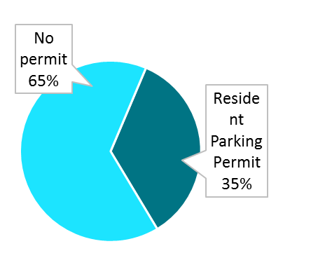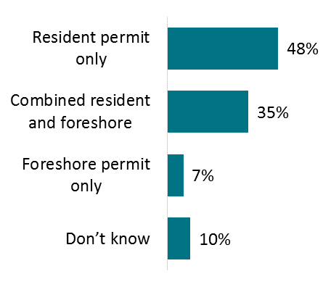
Resident Parking Permit 35%

Resident permits
If the household had one or more cars, residents were asked how many permits including combined permits they had in their household. Only 16 per cent of car owners claimed to have more than one resident permit for their household. Respondents who have permits claimed to be quite confident they know where they can park their car with the permit. Almost three-quarters (72 per cent) gave a confidence rating of four or five out of five (where five is extremely confident).
By far the most commonly cited reason for not being confident about where they can park was that residents were not sure where they are allowed to park or they do not have enough information on where they are able to park (61 per cent). Other reasons given were there are not enough parking spots (16 per cent), and new developments without enough parking (15 per cent).
Residents who live in houses were equally likely to have a Resident Parking Permit than not (50 per cent versus 50 per cent). However, those residing in flats, units or apartments were far less likely to have a Resident Parking Permit (26 per cent).

Visitor Parking Permits
Of all the residents surveyed, 204 indicated that they had a Visitor Parking Permit. These residents were then asked how they used their Visitor Parking Permits. The most common main use for Visitor Parking Permits was for family or friends visiting (65 per cent). For around half of the respondents (49 per cent), this was the last use of their Visitor Parking Permit.
The data suggests that some people may not be using Visitor Parking Permits as intended. Over half (57 per cent) of those who use the permit for their own car do so daily. Over one-quarter (27 per cent) of those with Visitor Parking Permits claim to use them every day, and over one-fifth (22 per cent) use them a couple of times a week.

Foreshore Parking Permits
Foreshore Parking Permits were used less often than Visitor Parking Permits. The most common reported usage for Foreshore Parking Permits was once a week (23 per cent). For almost one-third of those with Foreshore Parking Permits (29 per cent), the last place they used their permit was:
- St Kilda Beach
- The Esplanade
- Luna Park area.
Most commonly, those with a Foreshore Parking Permit claimed to have parked for one to two hours the last time they used it (66 per cent). Just over one-quarter (27 per cent) parked for two to four hours.

Off-street parking
A total of 60 per cent of residents who live in houses claimed to have off-street parking, as compared to 84 per cent of those who live in flats, units or apartments. Figure 2 shows almost three-quarters (73 per cent) of those with access to off-street parking claim to always use it, while 16 per cent use it sometimes and 11 per cent never use off-street parking.
The total of 456 residents who own a car and have access to off-street parking were surveyed.
Figure 2 How often off-street parking is used by residents

For those who do not use their off-street parking, the most common reason was that they use the car space for storage purposes, for example furniture (28 per cent).

Attitudes towards proposed parking ideas
Residents were asked to what extent they agreed with a number of statements regarding off-street parking and council permits (see Table 7). These statements were ideas for change being considered by CoPP.
The statement that was agreed with most is that residents with off-street parking should use their own parking spot (79 per cent rated this as 4 or 5 out of 5, where 5 is strongly agree). In general, respondents disagreed that residents without off-street parking should pay for on-street parking (60 per cent rated this as 1 or 2 out of 5, where 1 is strongly disagree).
In total, 740 to 778 residents were surveyed.
Table 7 Degree residents agree with proposed parking ideas
Proposed idea regarding parking and permits | Agreement
Car share parking should be a priority for easy access | 3.1
Residents with off-street parking should use their own parking spot | 4
Households with off-street parking should be allowed fewer permits | 3.2
Residents without off-street parking should pay for on-street parking | 2.4
There should be a maximum of two permits per household | 3.5
The first permit should be cheaper and increase cost for extra permits per household | 3.5

Car share parking
Residents were asked to what extent they agree with the statement ‘Car share parking should be a priority for easy access’. Overall, the average of 3.1 shows that there was not a particularly high level of agreement. Less than half (44 per cent) gave a rating of four or five out of five (where five is strongly agree)
The results by suburb are presented in Table 8 below.
Table 8 Agreement for prioritising car share parking by suburb
Note, in the table ^ indicates a caution for small sample size.
Suburb | Average
Albert Park (n = 69) | 2.6
Balaclava (n = 34) | 2.7
Elwood (n = 114) | 3.3
Melbourne (n = 36) | 3.3
Middle Park (n = 45) | 2.4
Port Melbourne (n = 99) | 3.0
Ripponlea (n = 16^) | 3.2
South Melbourne and Southbank (n = 97) | 3.6
St Kilda (n = 121) | 3.1
St Kilda East and Windsor (n = 65) | 3.3
St Kilda West (n = 24^) | 2.6
Residents of South Melbourne and Southbank were the most in agreement that car share parking should be a priority for easy access (62 per cent agree or strongly agree). More than half of residents disagreed (disagree or strongly disagree) in St Kilda West (56 per cent), Balaclava (60 per cent) and Albert Park (52 per cent).

Ease of finding street parking
Almost half of residents with a car (46 per cent) claim that it is difficult or extremely difficult to find a carpark on the street near their home (Table 9).
The suburb that appears to be the easiest to find carparks is Middle Park (81 per cent easy and extremely easy), and the most difficult is St Kilda West (62 per cent difficult and extremely difficult).
Table 9 Ease of finding off-street parking for residents
Note, in the table ^ indicates a caution for small sample size.
Suburb | Total surveyed | Extremely easy and easy (per cent) | Neither easy nor difficult (per cent) | Extremely difficult and difficult (per cent) | Don't know (per cent)
Albert Park | 67 | 36 | 26 | 34 | 4
Balaclava | 32 | 49 | 13 | 39 | 0
Elwood | 114 | 23 | 24 | 51 | 1
Melbourne | 37 | 38 | 10 | 47 | 5
Middle Park | 52 | 81 | 3 | 10 | 7
Port Melbourne | 103 | 44 | 20 | 35 | 2
Ripponlea | 13^ | 50 | 20 | 31 | 0
South Melbourne and Southbank | 83 | 33 | 25 | 41 | 1
St Kilda | 103 | 14 | 26 | 58 | 2
St Kilda East and Windsor | 66 | 28 | 10 | 60 | 2
St Kilda West | 27^ | 23 | 15 | 62 | 0
Total | 697 | 32 | 20 | 46 | 2
The vast majority of residents with cars (81 per cent) claim that there are times when it is more difficult to find a carpark on the street near their home.
It was thought that weekday nights (43 per cent) and weekend nights (35 per cent) were the most difficult times.

Users of parking spaces
Respondents were asked who they think are the most important users for parking spaces in a local residential area. They were asked to rank the following in terms of importance:
- residents of the area
- visitors to properties, such as family, friends, tradespeople
- visitors to business or local attractions.
The overwhelming response was that residents of the area were the most important, with 90 per cent of respondents ranking them as number one. Only seven per cent ranked visitors to properties first, and three per cent visitors to business or local attractions.
Visitors to properties were most often ranked second (76 per cent), and visitors to businesses third (79 per cent). The order of importance was very clear in this case, and is in the same order as listed above.
The same question was asked in terms of who residents think are the most important users for parking spaces in a main street or shopping strip. The options they were asked to rank were:
- residents of the area
- visitors to businesses including shoppers and diners
- workers and business owners.
In this case, opinions were more varied. Visitors to businesses were most commonly ranked first with 46 per cent. Just over one-third (36 per cent) of respondents ranked residents of the area first, and only 18 per cent ranked workers and business owners first.
The order of importance was therefore:
- visitors to businesses including shoppers and diners
- residents of the area
- workers and business owners.

Road space initiatives
As our population grows, there are more people sharing our streets and our spaces. Managing the demands of everyone who uses our road space is complex and in urban areas can result in a reduction of on-street parking spaces.
It is therefore useful to determine how important a number of different aspects of road space are to residents, with regard to their local residential area, as well as in main streets and shopping strips.
From the list provided, the results showed that in terms of local residential streets, the most important aspect is trees and landscaping, including rain gardens.
For main streets and shopping strips however, it was small open spaces, rest areas and footpath dining areas that were found to be most important, closely followed by protected on-road bike paths and bike parking.
Residents were asked ‘How would you rate the importance of the following aspects for main streets and shopping strips?’. The results for this are listed in Table 10.
Table 10 Importance of road space initiatives
Initiative | Main streets, shopping strips | Local residential streets
Small open spaces, rest areas | 3.9 | 3.2
Footpath dining areas | 3.9 | 2.7
Protected on road bike paths | 3.8 | 3.1
Bike parking | 3.8 | 2.9
Trees and landscaping, including rain gardens | 3.6 | 3.9
Wider footpaths | 3.5 | 2.9
Motorbike parking | 3.2 | 2.8
Car share parking | 3.1 | 2.7

Street sweeping effectiveness
Residents were asked if they would support parking restrictions at set times in the day to improve street sweeping effectiveness to provide a clear cleaning opportunity. Overall, 60 per cent of residents supported this proposal.

Businesses

Car ownership and use
The majority of workers (95 per cent) owned or kept a car. For those business respondents who have a car, but do not drive to work, the most common reason was that they walk instead (39 per cent).
According to over half of the business respondents surveyed (56 per cent), there are other employees in the business that have cars but do not drive to work. In their opinion, the main reasons for not driving is nowhere to park (30 per cent) or they also walk to work (23 per cent).
Almost half of the businesses surveyed (46 per cent) claimed that more than four cars are used to travel to work by people who work in the business. It is also claimed that 62 per cent do not pay for parking.
When parking for work, the location the employees park in are mainly on the streets nearby (58 per cent) or in a private carpark nearby (34 per cent).

Current parking arrangements
Satisfaction with parking for staff was moderate, at 2.8. Overall, 33 per cent said they were satisfied with staff parking provision.

Improvement to parking in the area
Respondents were asked how they would suggest the City of Port Phillip could improve parking in the area. The most common responses related to increased parking availability:
- The limits are too short or that parking hours should be extended to improve parking in the area (22 per cent).
- More carparks (20 per cent).
- More all-day parking (18 per cent).
- Allocated parking for commercial staff (14 per cent).
- More free parking (11 per cent).
- More business parking or business parking permits (six per cent).

What the council is doing well to manage parking
The business community was largely unsure of how well the City of Port Phillip manages parking (35 per cent ‘don’t know’, 17 per cent ‘none’ or ‘nothing’).
Some praise was given for the following:
- They are vigilant and issue fines (nine per cent).
- Always manage to find a park easily (eight per cent).
- New rules and updated restrictions are an improvement (six per cent).
- We’re allowed permits and it is a good permit system (six per cent).

Customer parking
Business respondents were asked from their experience and feedback from their customers or clients, to the best of their knowledge, what proportion use the following modes of transport to get to their business location. Cars or private transport was seen to be the most common mode of transport (on average used by 76 per cent of customers).
Businesses were asked from their experience and feedback from their customers or clients, to the best of their knowledge, where their customers or clients usually park their cars when they visit the business. The majority (80 per cent) think their customers tend to park on the streets nearby.
Business respondents were asked from their experience and feedback from customers or clients, how they would rate the general satisfaction with the current parking arrangements for their customers out of 5, where 5 is extremely satisfied. Perceived satisfaction with current parking arrangements was found to be moderate at 2.6 out of five overall, with 21 per cent giving a satisfied rating of 4 or 5 out of 5
Those businesses who claimed their customers were dissatisfied with the current parking arrangements were asked for their perceived reasons for dissatisfaction. The main reason given was that there is not enough parking on nearby streets (62 per cent).

Ease of street parking
A total of 62 per cent of businesses find it difficult or extremely difficult to find a carpark near their business.
Overall, six per cent of businesses found it extremely easy to find street parking, 14 per cent easy, 18 per cent neither, 36 per cent difficult, and 26 per cent extremely difficult (Figure 3)
A total of 200 businesses were surveyed.
Figure 3 Ease of finding a carpark in the streets near the business
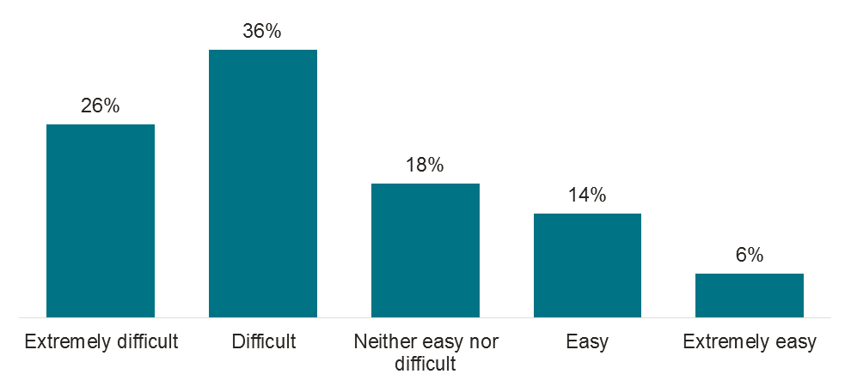
Over three-quarters (76 per cent) of business respondents claimed that there are some times of the day when it is more difficult to find a carpark on the street near their business.
Weekday mornings and weekday afternoons are the most difficult times to find parking near surveyed businesses, with these times nominated by 60 per cent and 61 per cent of those respondents respectively.

Parking controls principles

Availability
When asked about whether they agree or disagree that parking near main streets and shopping strips in Port Phillip is readily available, businesses are divided in their opinion to some extent, with 21 per cent agreeing, but overall 53 per cent disagree or strongly disagree (Figure 4).
Of those surveyed. 22 per cent strongly disagree, 31 per cent disagree, 21 per cent neither agree nor disagree, 21 per cent agree, and four per cent strongly agree.
A total of 200 businesses were surveyed.
Figure 4 Availability of parking near main streets and shopping strips
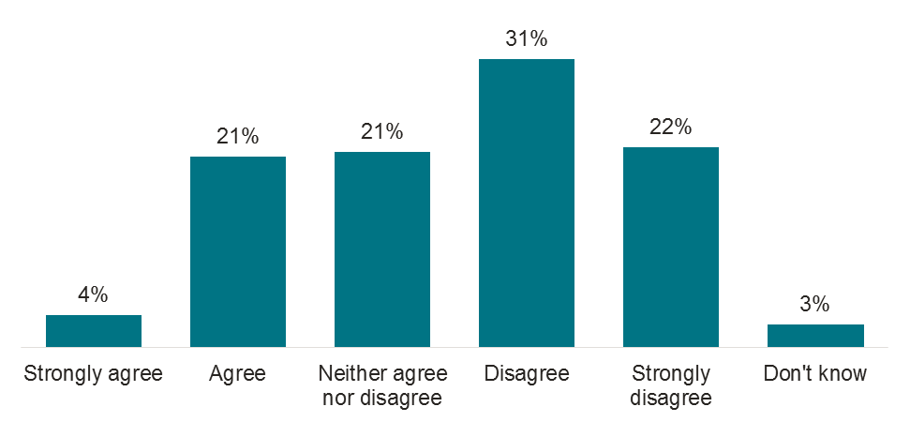

Car share
Businesses are divided about car share parking, however almost half (44 per cent) said they disagree or strongly disagree that parking spaces for car share vehicles should be prioritised, so that people without access to a car can easily use one when they need it.
Of those surveyed, 18 per cent strongly disagree, 26 per cent disagree, 18 per cent neither agree nor disagree, 18 per cent agree, and 11 per cent strongly agree (Figure 5).
A total of 200 businesses were surveyed.
Figure 5 Parking spaces for car share vehicles should be prioritised
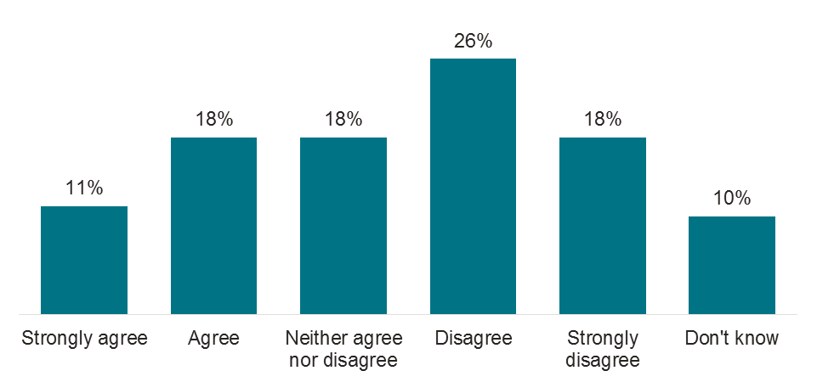

Permit limit
When asked whether households with access to off-street parking should be eligible for fewer Resident Parking Permits, businesses appear to be divided on this issue.
A total of 41 per cent disagree or strongly disagree and 34 per cent agree or strongly agree.
Of those surveyed, 17 per cent strongly disagree, 24 per cent disagree, 19 per cent neither agree nor disagree, 27 per cent agree, and seven per cent strongly agree (Figure 6).
A total of 200 businesses were surveyed.
Figure 6 Reduce household permits for those with access to off-street parking
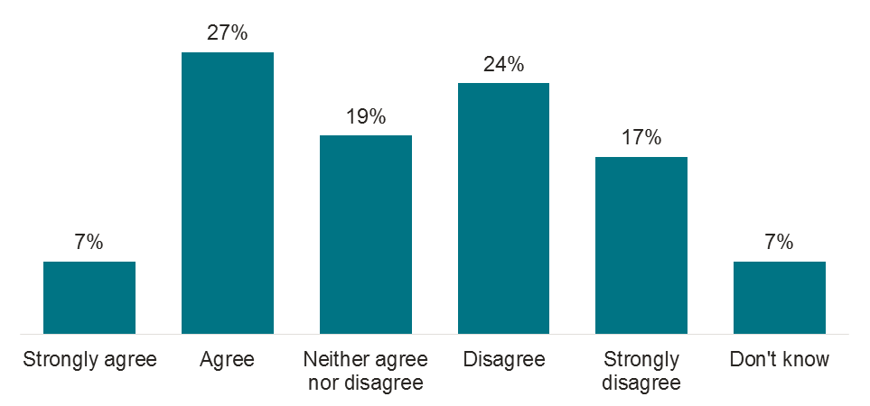

Road space
Businesses mostly support (63 per cent) road space being used to support the broader community, not just some individuals or businesses (Figure 7).
A total of 200 businesses were surveyed.
Figure 7 Road space should be used to support the broader community
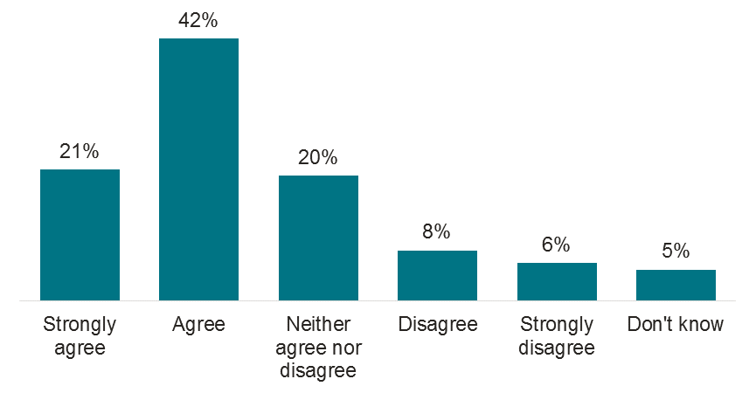

Hourly fee
A total of 58 per cent of business respondents disagree or strongly disagree that the City of Port Phillip should introduce a minimum hourly fee to encourage sufficient parking availability on and near main streets and shopping strips in Port Phillip (Figure 8).
A total of 200 businesses were surveyed.
Figure 8 A minimum hourly fee should be introduced
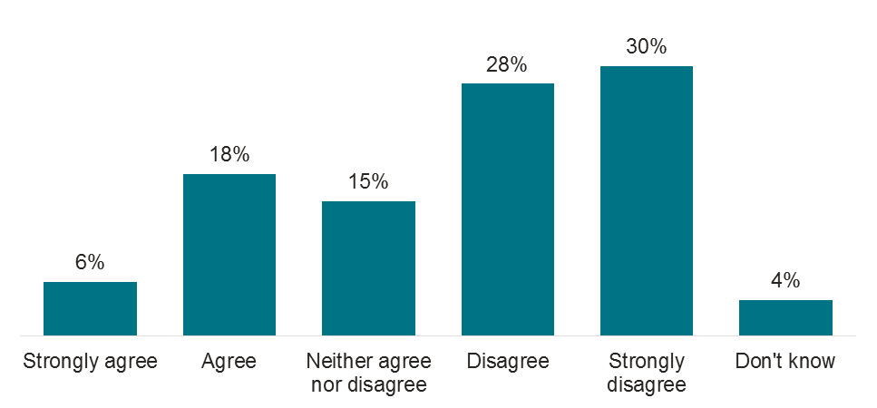

Uses of road space
As our population grows there are more people sharing our streets and our spaces. Managing the demands of everyone who uses our road space is complex, and in urban areas can result in a reduction of parking spaces.
Business respondents were asked to rate the importance of a number of uses of road space in the area surrounding their business.
Greater parking availability, trees and landscaping, and small open spaces were rated as very important initiatives to implement around the surveyed businesses (Table 12).
A total of 200 businesses were surveyed.
Table 11 Importance of uses of road space in the area surrounding the business
Main streets and shopping strips use | Business rating
Greater parking availability | 4.0
Trees and landscaping, including rain gardens | 3.8
Small open spaces, rest areas | 3.5
Protected on road bike paths | 3.3
Bike parking | 3.2
Footpath dining areas | 3.1
Car share parking | 2.7
Wider footpaths | 2.6
Motorbike parking | 2.6
Business respondents were asked to what degree they support the introduction of parking restrictions if a portion of revenue from permits and paid parking went towards these initiatives in their business’ suburb. A higher proportion of business disagreed with this policy (46 per cent) than agreed (36 per cent).

Parking and permits
For business respondents, support for introducing timed parking restrictions on or around shopping strips to increase the availability of parking spaces varied according to location was quite low, with 29 per cent indicating support (rating of four or five out of five where five is strongly support). Almost half (45 per cent) did not support this (rating of one or two out of five, where one means do not support at all).

Workers and visitors
Workers were most likely to own a car, with almost three-quarters (72 per cent) claiming to do so, compared to 62 per cent of visitors.
The most common reasons given for not owning a car were due to economic reasons (22 per cent) and not having a driver licence (21 per cent).

Perceptions of current parking
When asked where they parked their car on the day of interview, the most common response (41 per cent) was on the street near their destination.
A total of 198 workers or visitors who drove to their destination were surveyed.
Table 12 Perceptions of current parking locations
Parking location | Response (per cent)
Off-street parking where you are visiting | 25
On the street near your destination | 41
On the street more than 500 metres away from your destination | 10
Private carpark near your destination | 17
Private carpark more than 500 metres away from your destination | 2
Other | 4
Don’t know | 1
The vast majority of respondents claimed that they did not have to pay for their parking on the day of the interview, workers 89 per cent and visitors 71 per cent.

Opinions regarding whether it was easy or difficult to find parking on the street were varied. A total of 45 per cent claimed it was extremely easy or easy, however, 41 per cent said it was extremely difficult or difficult (Figure 10).
A total of 198 workers and visitors who drove a car were surveyed.
Figure 9 Ease of finding parking on the street
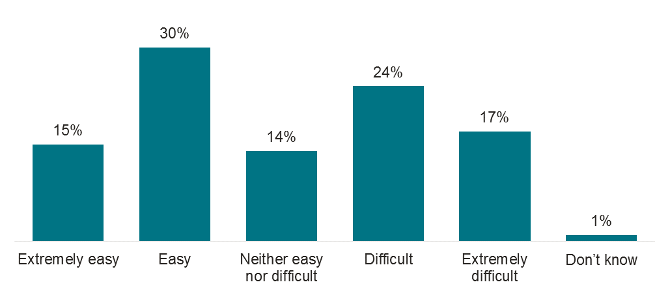
Respondents were asked how satisfied they are with the current parking options in the area. Satisfaction overall was moderate, with an average rating of 3.3, with 45 per cent indicating they were satisfied (rating of 4 or 5 out of 5):
- of 114 workers surveyed, the average response was 3.3
- of 84 visitors surveyed, the average response was 3.4.
The main reason for dissatisfaction across the board was that there was not enough parking available on the streets nearby (53 per cent).
Respondents were asked how they would suggest the City of Port Phillip improve parking management in the area. The most common suggestions were:
- Extended parking hours or limits too short (20 per cent).
- More carparks (18 per cent).
- Multi-level carparks (10 per cent).
- More affordable carparking (eight per cent).
- More free carparking (six per cent).
- Allocated parking for workers, staff or business owners (six per cent).

Importance of carpark users
Respondents were asked to rank users of parking spaces in terms of importance. Both workers (27 per cent) and visitors (32 per cent) ranked residents of the area as the most important (Table 14).
A total of 425 workers or visitors were surveyed.
Table 13 Most important users of parking spaces
Carpark users (ranked) | Workers (per cent)  (n = 213) | Visitors (per cent)  (n = 212) | Total (per cent)  (n = 425)
Residents of the area | 27 | 32 | 29
Shoppers, diners | 23 | 21 | 22
Business visitors | 22 | 17 | 20
Workers | 16 | 13 | 15
Business owners | 12 | 17 | 14

Uses of road space
Respondents were told that ‘as our population grows, managing the demands of everyone who uses our road space is complex and in urban areas can result in a reduction of parking spaces’.
They were then asked to rate the importance of implementing a number of changes in the area.
Table 15 below shows the average importance ratings, and it can be seen that trees and landscaping, including rain gardens, was thought to be the most important change (average 3.7 out of five).
A total of 427 workers and visitors were surveyed.
Table 14 Average importance of implementing use changes in the area
Main streets and shopping strips use | Workers and Visitors
Trees and landscaping, including rain gardens | 3.7
Small open spaces, rest areas | 3.5
Protected on road bike paths | 3.4
Bike parking | 3.4
Car share parking | 3.4
Greater parking availability | 3.4
Footpath dining areas | 3.2
Motorbike parking | 2.9
Wider footpaths | 2.4

Road space initiatives
Respondents were asked to think about the various aspects of important road space initiatives that were mentioned, and whether they would support contribution of a portion of revenue from permits and existing paid parking going towards these initiatives.
Overall 70 per cent of workers and visitors supported with this initative (rating of four or five out of five where five is strongly support). (Figure 10).
In total, 427 people were surveyed.
Figure 10 Revenue from permits and paid parking to fund road space initiatives
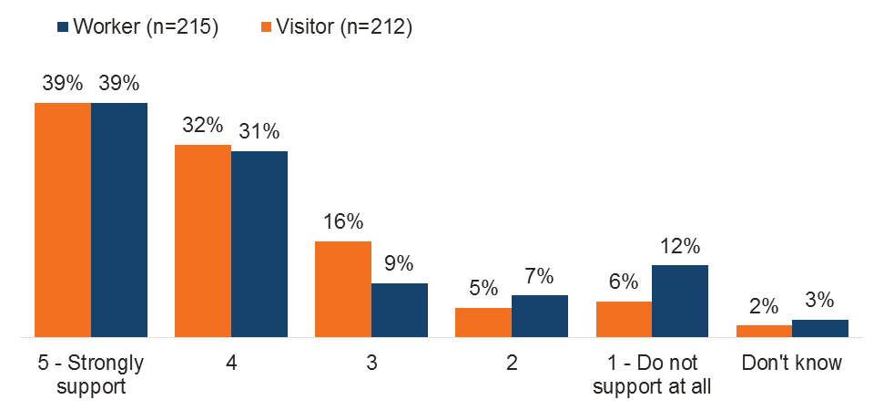

The level of support for introducing timed parking restrictions on or around shopping strips to increase the availability of parking spaces was slightly lower, with 54 per cent of workers and visitors indicating support (rating of four or five out of five where five is strongly support).
A total of 427 people were surveyed.

Figure 11 Introduce timed parking restrictions around shopping strips
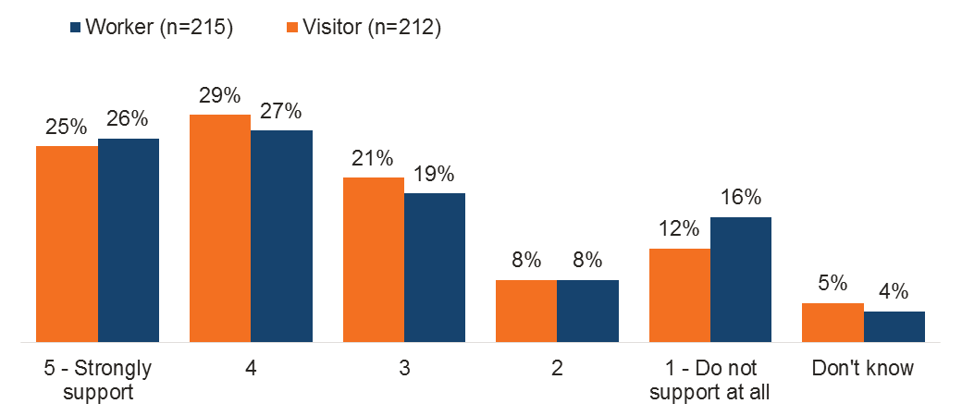

The level of support for introducing a small hourly fee and the option to stay for a longer period of time of four or more hours was similar, with just over half indicating support (53 per cent rated as four or five out of five, where five is strongly support) (Figure 12).
Of the workers surveyed, 26 per cent do not support at all and 36 per cent strongly support.
Of the visitors surveyed, 20 per cent do not support at all and 34 per cent strongly support.
A total of 427 people were surveyed.

Figure 12 Level of support for introducing a hourly fee to improve parking availability
