St Vincent Gardens Playground Upgrade
Community Engagement
Summary Report 2019

Contents
Introduction 3
Executive summary 4
Findings and recommendations 5
Part 1 - Participant profile and demographics 6
Part 2 - Consultation phase one findings 7
Three-phase engagement timeline 7
Part 3 – Consultation phase two responses 13
Response 1 13
Response 2 17
Additional feedback 20
Social media response 23
Email Submissions received 23
National Trust of Australia (Victoria) feedback 23

Figures
Figure 1 Overall engagement participation summary 4
Figure 2 Participant locations within Port Phillip 6
Figure 3 Responses by participant age ranges 6

Tables
Table 1 Phase one timeline 7
Table 2 Phase two timeline 10
Table 3 Phase three timeline 12
Table 4 Phase two consultation: Response 1 themes and responses 13
Table 5 T Phase two consultation: Response 2 themes and responses 17
Table 6 Phase two consultation: additional feedback themes and response 20

Introduction
The City of Port Phillip plans to replace the playground at St Vincent Gardens as part of the Playground Renewal Program with the aim to provide play opportunities across the municipality for children of all ages and abilities. The current playground equipment was installed in 1997 and has reached the end of its useful life.
This document has been compiled following the conclusion of the second phase of a three-phase community engagement program for the St Vincent Gardens playground upgrade (August to September 2019).
In phase one (May to June 2019) 85 participants told us how they engage with the park and how they currently use the playground facility. Participants also provided comments on the current state of the St Vincent Gardens playground, detailed any recommendations they had for the redevelopment moving forward.
In this second phase of engagement, 120 participants provided 310 recommendations captured through the City’s online engagement platform, Have Your Say (HYS) Port Phillip, as well as through social media posts and via direct emails to project officers.
This report has been put together by an independent agency that specialises in community engagement and public open space. The report has been divided into three parts:
- Part 1 - Participant profile and demographics: this section analyses the user groups and specific information relating to survey responses, including their age, where they live, and their relationship to The City of Port Phillip.
- Part 2 – Engagement process: this section outlines the engagement process including what has already been achieved and what will happen next. This section includes a summary of the main findings from phase one, how Council responded to these themes in the Draft Concept Plan, and how these themes have continued into phase two.
- Part 3 - Phase two responses: this section analyses participant feedback gained through the phase two engagement. Responses are categorised into key themes that have been identified through the participant responses to each question.
The information gained from community engagement and comments made from the community will be considered and used to help finalise the design. This report has been commissioned by The City of Port Phillip and completed by The Space Agency, an independent consultancy specialising in stakeholder engagement and placemaking.
The Space Agency was engaged, as an impartial, external consultant, to review and analyse community feedback to identify key themes and recommendations relating to St Vincent Gardens playground upgrades. Every effort has been made by the authors of this document to represent accurately participant feedback and insights.

Executive summary
Following the conclusion of phase one community engagement (May to June 2019) a draft playground concept was shared with the public. Participants were invited to provide feedback on the draft by answering an online questionnaire. Following a review of participant responses, this report has identified the key themes of phase two engagement as:
- Diversity of ages - providing equipment that suits a range of ages (toddler to young teens)
- Pedestrian safety - access from surrounding roads leading to the playground.
- Upgrade of surrounding facilities - expanding project scope to include toilets and waste bins.
- Retaining social spaces for passive recreation - including quieter lawn areas within the park
- Equipment - ensuring there is a variety of good quality equipment, without making the playground too big or noisy that it might disrupt the character of the area.
- Heritage - respecting the heritage of the park and area.
The project page on the City of Port Phillip website ‘Have Your Say’ received 678 visitors. This was the primary engagement tool that enabled participants to share their views on the draft concept plan.
Of the total number of people who viewed the plan, 116 visitors left their comments through the questionnaire. An additional 7 submissions arrived via email. This included 6 emails from residents and one from National Trust of Australia (Victoria).
The combined visitor comments and email submissions generated a total of 314 recommendations for the draft concept plan.
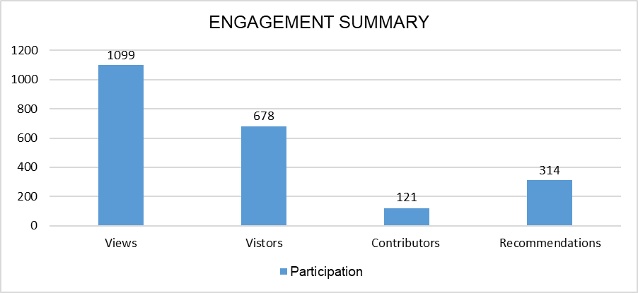
Figure 1 Overall engagement participation summary

Findings and recommendations
- Over 50 per cent of participants were from Albert Park, directly engaging with the park and playground.
- The majority of respondents were aged between 34 and 54 years.
- Similar to phase one outcomes, diversity of offering within the space regarding, accessibility and flexibility were top priorities for participants.
- When asked how they would like this space to be used, safety and diversity was the key factor in most responses. Of these responses, 64 per cent of participants suggested more inclusive facilities that cater to a wider demographic of users, from toddlers and babies to more challenging equipment for older children.
- Overall, participants responded favourably to the proposed design, with over 50 per cent of responses to each question containing positive feedback.
- When asked if there were any elements they would like to keep in the park, 58 per cent of respondents mentioned the play equipment, with strong sentiment to support the large variety of existing equipment and the different ages it catered for.
- A further 35 per cent of respondents included a desire to preserve existing natural landscape, particularly the established trees and open space.
- In response to a question asking what playground equipment the space should consider; the top recommendation was more swings.
- When asked if any further consideration should be made regarding trees and plants in the space, there was no direct feedback. Instead, recommendations were more focused around the retention of existing vegetation and ongoing maintenance.
- Some participants questioned the priority of the park upgrade in comparison to other potential projects within the City of Port Phillip.
- Participants expressed that the park is listed on the Victorian Heritage Register for its aesthetic, historical and social significance to the state of Victoria. As a result, they wanted to see the heritage of the park reflected in the Draft Concept Plan. In particular, through the material choices for the new equipment, the layout for the overall space and retaining space for existing uses of the park including socialising, gatherings and passive recreation.
- Pedestrian safety within the playground and access to and from St Vincent Gardens was also raised as a consideration
- Participants were concerned that the draft plan included upgrades that were not sympathetic to its status as a place of national significance on the Victorian Heritage Register.

Part 1 - Participant profile and demographics
Most participants came from Albert Park, where 67 (58 per cent) of responses said they lived. The next highest response was from South Melbourne with 30 responses. Remaining suburbs included Port Melbourne (8), St Kilda (2), Southbank (3) and 3 participants preferring not to say.
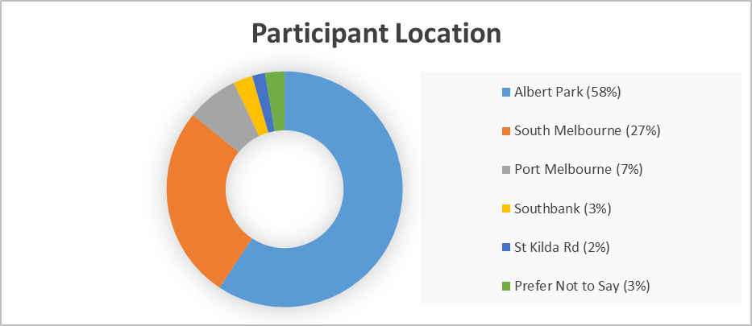
Figure 2 Participant locations within Port Phillip
The engagement was successful in gathering data from diverse age groups with the majority (50 per cent) of participants aged between 35 and 55 years old. Overall, more women took part in the engagement compared to men, with the split 62 per cent to 30 per cent.
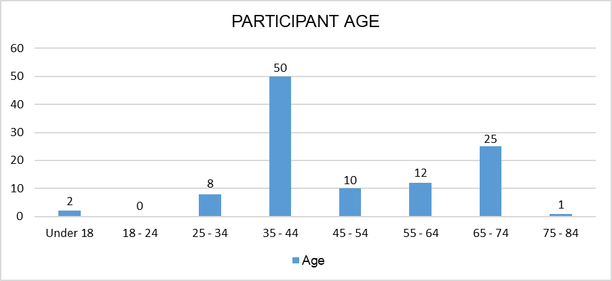
Figure 3 Responses by participant age ranges

Part 2 - Phase one findings
The St Vincent Park playground upgrade is using a three-phase engagement process, of which we are currently in the second phase.
Earlier this year (May to June 2019), the City of Port Phillip held phase one of the community engagement in which they asked the community how they used the park and sought recommendations on how they can improve the playground. The next phase of engagement (phase three) will present back the draft concept plan following a detailed review of participant comments and recommendations.
A timeline outlining the three phases of engagement has been outlined below, including the priority actions and next steps.

Three-phase engagement timeline

Phase one
Table 1 Phase one timeline
Date | Action | Outcomes
6 May to 2 June | HYS online engagement survey open. | 85 Participants
23 May 3 to 5 pm  25 May 10 am to 12 midday | Drop-in sessions held within the park. | 614 Recommendations
2 September | Recommendations and feedback reviewed and shared with the public. | N/A
- Phase one consultation ran from 6 May 2019 and 2 June 2019.
- A total of 85 participants provided 614 recommendations via the Have Your Say online survey.
- Two drop-in session were held within the park on Wednesday 23 June 2019 and Saturday 25 June 2019.
- The concept plan was developed between June and August 2019.
- Recommendations and feedback received in this round of engagement were reviewed and shared with the public in September 2019.
Phase one received 263 page visitors on Council’s HYS which generated 85 responses to the survey. Phase one engagement encouraged participants to respond to eight questions and provide feedback on the design and upgrade of the St Vincent Gardens playground.
- Display final concept plan on Have Your Say for comment.
- Start work on the detail design.
These questions were broken into two sections:
- using the parks and playgrounds
- transforming St Vincent Gardens.
Key responses to each section are outlined below:
- How they use the park
  - recreation and leisure activities
  - the playground and play spaces
  - as a thoroughfare for getting from one place to another.
- Improvements they would like to see
  - Increasing the diversity in playground equipment to cater better to a range of abilities and ages.
  - Maintaining a social function in the space for the local community and improving seating and gathering opportunities.
  - Incorporating nature-based play opportunities.
  - Retaining the existing natural assets of the playground such as the trees and open lawn space.
The responses from these categories were then analysed and grouped into the following key themes:
- Equipment
  - Increasing the diversity in playground equipment to cater better to a range of abilities and ages was important to respondents and was a recurring trend.
  - Of the responses, 56 per cent of participants mentioned the need for new equipment.
  - Of the responses, 35 per cent of participants articulated a desire for more adventurous and challenging equipment.
  - Diversity was a key factor in responses relating to what participants want in a new playground. Of the responses, 26 per cent included suggestions for more inclusive facilities that cater to a wider demographic of users, from toddlers and babies to more challenging equipment for older children.
- Diversity and social connections
  - St Vincent Gardens is a key social space for the local community, not only used for its playground facilities.
  - In detailing how they currently use St Vincent Gardens, 79 per cent of respondents listed the playground, 60 per cent said they use it to meet friends, 59 per cent use it for leisure including activities like relaxing, picnics, reading and connecting to nature, and 49 per cent said spending time with the family.
  - Inclusion of greater amenity facilities was another trend mentioned, with responses including BBQ areas, additional shelter like a gazebo or shaded play area that can provide weather protection.
- Safety
  - Safety and security in and around the playground was mentioned in 33 per cent of the total responses.
  - Participants mentioned the need for a barrier around the playground as they felt the current open access was unsafe for young children.
  - Pedestrian access to and from the playground was mentioned by multiple participants throughout the survey.
- Landscaping
- Of the responses, 68 per cent identified the natural landscape as a special feature, aspect or character important to them at St Vincent Gardens.
- Of the responses, 35 per cent mentioned a desire to preserve the existing natural landscape, particularly the established trees and open space.
- A large number of participants mentioned an appreciation for the tall trees and their ability to provide shade and beauty to the park.

Phase two
Table 2 Phase two timeline
Date | Action | Outcomes
June to August | Concept plan developed. | N/A
30 August | Concept plan shared with the public. | 121 Participants
30 and 29 August | HYS online engagement survey open. | 314 Recommendations
12 September 3 to 5 pm | Drop-in session held within the park. | N/A
- Phase two consultation ran from 30 August to 29 September 2019.
- A total of 121 participants provided 314 recommendations via the Have Your Say online survey.
- One drop in session was held at the park on 12 September 2019.
- Recommendations and feedback from this round of engagement will be reviewed and shared with the public in February 2020.
The feedback received during phase one was taken into consideration by the project team and used to develop a concept plan for the playground upgrade. The elements below have been included as a response to the themes and as a result the phase two draft concept plan includes the following features:
- Equipment – a play area including:
  - Sandpit bound by a play silhouette to the entry path.
  - Active play area including timber style carousel, a double swing and birds nest swing, twin in ground trampolines, monkey bars and balancing logs.
  - Sculpture play acorns.
  - A double swing frame with 'Joey' seat, which allows an adult to swing with a child, and toddler seat.
  - Treehouses:
    - the first treehouse built around an existing Cedar tree trunk
    - the second treehouse is freestanding on 'fan vault' supports to minimise the use of posts under trees.
- Diversity and social connections - a meeting area has been designed to include:
  - Irregular seating walls under existing palm, and twin sets of picnic tables, linked by curved seating walls.
  - Each set of picnic tables are sheltered by bespoke mesh shelter from which pendant stainless steel leaves flutter and give dappled shade.
- Safety and access - the following access around the playground has been upgraded:
  - The entrance from the St Vincent Street end of the Gardens is reinstated through a small incision in the park’s edge wall.
  - New pedestrian ramps make crossing safer and easier and an accessible ramp and stairs sit behind the existing wall and hedge.
  - Improved connections to the Tennis Club building and public toilets.
  - Existing sunken path raised to park level and sealed with surface to match heritage park aesthetic.
- Landscaping - the space has been designed around existing landscaping and includes:
  - Open lawn areas to be retained for activities including running, ball games, sitting, picnicking and free play.
  - New landscaping to be used as barriers and buffers to the space instead of built fences.
Following consultation phase one, project findings and updates were communicated to residents and playground users in the following formats:
- Website - online project updates advising the second phase of consultation.
- Postcard - sent to residents informing them of the concept plan based on feedback from phase one and inviting them to provide feedback on Councils HYS page or attend the face to face session.
- Face-to-face - an in-person engagement session in the park with staff to capture and address feedback from residents.
- Social media - advertising the concept plan is now available for feedback, and a link to HYS.
- Signage - signs in the park showing the concept design, explaining the project and inviting feedback on HYS.
The phase two engagement involved the following processes:
- Phase one findings communicated to local residents from 2 September 2019.
- Draft concept plan circulated to local residents and shared with the public from 30 August 2019.
- One drop-in session held at the playground on Thursday 12 September 2019 at 3 to 5 pm.
- Online survey collecting public responses from 30 and 29 August 2019.
- An online post on the City of Port Phillip’s Facebook page.
The drop-in session was undertaken to disseminate information, answer questions and explain the design on site. Those who attended were directed to the HYS survey to provide their feedback.
Following the completion of phase two, the recommendations and findings will be used to develop the detail design plan for the playground and this will be shared with the public similarly to the recommendations of phase one engagement.

Phase three
Table 3 Phase three timeline
Date | Action | Outcomes
February 2020 | Recommendations and feedback reviewed and shared with the public. | N/A
To be announced | Display final concept plan for comment. | N/A
To be announced | Start work on the detail design. | N/A

Part 3 - Phase two responses

Response 1
Do you have any comments related to the playground and the use of the space that we should consider?
A total of 104 (N) participants responded to this this question, generating 149 recommendations which spanned across 5 key themes:
- equipment and features
- positive responses to the design
- safety and accessibility
- heritage concerns
- appealing to a range of age groups.
10 comments did not fit in to the above themes and were categorised as other.
Table 4 Phase two consultation: Response 1 themes and responses
Theme | Recommendations | % of N | Responses
Equipment and features | 46 | 45 | Diverse and inclusive playground features and equipment was found to be an important factor amongst participants, gaining the most responses for this question. The swings were the most popular recommendation for participants. They would like more included in the upgrade, with one participant commenting:  “Looks good, but two swings are not enough. There are two baby swings now and there is frequently a queue. Plus, there are two older swings that are well used as well.”  Participants also highlighted various amenities as being key to an enjoyable playground experience. The most popular features were waste bins with 9 comments, BBQ facilities with 7 comments and toilet and bathroom facilities with 7 comments. Additionally, the inclusion of water play near the sand pit caused concern for participants, as well as sun protection in the warmer months over the play equipment in particular sand pit.  “Ensure plenty of shade structures over the play equipment- looks like only trees for shade, but in summer it can still be very sunny. Is there shade over the sandpit?”  There was also a focus on protection from the natural elements with 5 responses mentioning shade and a lack of covered areas.
Positive responses | 32 | 31 | Diverse and inclusive playgrounds which catered for all ages and abilities were found to be an important factor amongst participants, making up 47% of the total responses. 12 responses commented on separate play spaces for different ages, with 4 responses specifically highlighting age appropriate equipment especially for toddlers and younger children. One participant wrote:  “The beautiful grounds and feeling like you are outdoors within your community. Play equipment that is engaging for the young ones however having a family that contains older children it is always difficult to find a park that engages all. And this is a downside in many parks. Little kids turn into big kids!”
Safety and accessibility | 32 | 31 | Safety and security in and around the playground was mentioned by a third of all participants in response to this question. Main concerns were around pedestrian access the lack of fencing for the playground. Participants suggested a fence or gate to the playground especially for the safety of toddlers and younger users, with one participant commenting:  “I like new proposal - as mum of twins would be more then happy if the playground has gates on the path and new access (so toddler don't run directly on the road).”  6 comments in this theme directly related to traffic management and vehicle speed on the roads surrounding the playground, with some participants providing detailed responses to the surrounding streets including:  “Cars are driving from southern side of Merton street around to St. Vincent street and driving far too quickly. As the curve in the road prevents a clear line of sight, there could be issues both for people crossing to enter the park and people getting in and out of cars especially on the bottom end of the park nearest to St Vincent street.”
Heritage Concerns | 18 | 19 | The greatest concern within this theme was around the rainbow coloured slide and how it ties in with the rest of the park, generating 12 responses. Participants also focused on the how the materiality should reflect the heritage nature of the park, requesting colours and materials used be as natural as possible. Comments included:  “The current playground design fits in with the heritage precinct because of its colour, the maroon metal is appropriate because it does not intrude into the surroundings. The colours of the rainbow slide and any other bright colours are inappropriate to the surroundings.”  “The brightly-coloured rainbow slide will look shockingly out-of-place in the natural surroundings.”  “Would love to see an emphasis on natural materials. Use of plastic minimised or eliminated.”
Appealing to a range of age groups | 14 | 13 | 64% of the total responses within this theme surrounded the playground appealing to toddlers and younger children, with concerns around the safety of these users within the current design.  “A play structure that is more enclosed (ie no large gaps between levels and stairs or gaping holes) which would be suitable for toddlers to explore with less supervision or risk of falling off would be great.”  Other responses covered providing spaces for the older generations to use the facilities, not only within the playground but also within the open space for socialising and the older children’s play area being separated from infants, with one participant commenting:  “Plans look great, it would be great if there remains a separate area for older and younger children so they can all play confidently. Our 20 month old thrives in the smaller existing park but get overwhelmed when too many bigger kids take over!”
Other | 7 | 6 | 7 responses that fell outside of the above categories included comments which did not address the question and suggested a misunderstanding of the project, as well as a few responses providing feedback on other City of Port Phillip playgrounds and spaces.

Response 2
Is there anything further related to trees and plants in the space that we should consider?
This question received the least number of submissions. 79 recommendations were collected from 63 (N) participants (50 per cent of the total number of participants). Responses have been categorised into the following 6 key themes:
- no change to the space
- ongoing maintenance
- open space and shrubs
- the addition of trees
- native vegetation and planting
- safety and access
Comments that did not fall under these categories have been grouped as ‘other’.
Table 5 T Phase two consultation: Response 2 themes and responses
Theme | Recommendations | % of N | Responses
No change | 21 | 33 | No change to the planting and trees within the space was the most popular response, with 21 responses reflecting that they were either happy with the proposal or wanted the trees and plants in the space to remain as is. Two participants commenting:  “no, the design is lovely.”  And  “Beautiful as it is now.”
Maintenance | 15 | 24 | Rather than specific comments about the trees and plants within the space, 15 responses related to maintenance within the park, both existing and proposed. Comments included budgeting for ongoing maintenance of the trees and general landscaping, after the completion of the upgrade, as well as replating shrubs and bushes that have died over time.  “The gaps in the current hedge around the fence line need restoring to prevent people taking a short cut through the hedge.”
Open space and shrubs | 12 | 19 | 12 comments related to the general landscaping elements within the space. 5 comments mentioned including low shrubs and planting, while an additional 4 comments mentioned the importance of open space within the new design, for passive socialising and informal play. One participant commented:  “Open space needs to be preserved with grass for casual seating and informal playing. The plan seems to promote a rather crowded environment.”
Additional trees | 10 | 15 | 10 Participants commented on the benefit of larger trees within the design, with particular reference made to the retention of the big oak trees within the park. Comments relating to the trees highlighted their benefits including providing shade and how they can blend into the play area for the children. One participant commented:  “The plans to focus the play around the trees is great. Playing under the dappled light is wonderful (now and going forward).”
Native vegetation and planting | 8 | 12 | 8 responses reflected that additional planting should reflect the current vegetation, with one participant commenting that “trees must be sage and in sympathy with the existing exotic trees in the gardens”. 3 participants also expressed favourably how native trees and planting attract native birds and wildlife to the park with one saying:  “Make sure the plants are natives to the area and that they attract wildlife like birds.”  While most responses for this question focused on Native planting that reflected existing trees within the park, it was noted that 4 responses mentioned how they assist in tying the park back to its heritage past and reflects the history of the park through landscaping.
Safety and access | 8 | 12 | 8 responses reflected access and safety to the park, as well as the potential concerns of children climbing the large trees. Comments also included planting being used as a barrier to the road for children within the playground. One participant commenting:  “I think that the existing hedge & wall there provides a safe haven from little ones running off & potentially into the street.”
Other | 5 | 8 | 5 responses were marked as ‘other’ as they did not fall into the above categories. Comments included:  “Suggest ensuring the sandpit is not near the oaks or it will be filled with acorns!”

Additional feedback
Do you have any additional feedback?
A total of 65 (N) participants responded to this this question, generating 84 recommendations. Responses have been categorised into the following five themes:
- those in support of the upgrades
- those who question the priority and necessity of the project
- reflecting the heritage of the gardens
- the furniture and amenities included
- the diversity and accessibility of the new design.
An additional four comments which did not fit into the themes were categorised as ‘other’.
Table 6 Phase two consultation: additional feedback themes and response
Theme | Recommendations | % of N | Responses
In support of the upgrades | 25 | 38 | The majority of responses for this question centred around positive feedback on the overall project with a large number thanking the City of Port Phillip for the upgrades, commenting:  “I am sure you will do a great job on the upgrade park and we look forward to it being one of our favourite parks in the area.”  And;  “Looks great .. fully support the changes.”  It was also noted that participants felt the upgrades were necessary, with some feeling the project was overdue as outlined in one participant’s response shown below:  “this is a park that desperately needs updating and serves a broad and diverse community. The sooner it can be updated the better!”
Amenity and Furniture | 19 | 28 | The most common response for this theme was a request for the toilets to also be upgraded as part of the project, with 38% of comments mentioning the toilet facilities. The second highest response with 27% was a need for more bins or more frequent rubbish collection, with one participant commenting:  “as a user of the park the only thing I would like to add is the rubbish bins, I'm sure this has been addressed, but more bins and more regular emptying in the summer months, would be my suggestion.”  3 responses focused directly on the addition of hand water pumps within the sandpit, raising concerns from previous experiences with a similar set up, as evidenced in the below participant response:  “We would rather not have the water pump in the playground. There is one in the playground at the end of Vic Ave, which is great, but most children leave there wet because of it.”  Other responses in this theme centred around the number of tables and chairs included and the remaining space for additional picnics and socialising.
Diversity and Accessibility | 18 | 27 | Within this theme, comments included making the space accessible to all users, from preschool aged children to teens, as well as accommodating users with a disability. Comments also included the need for adult fitness equipment and spaces that accommodate older users within the playground space. Participant comments included:  “Would love to see toddler age appropriate area.”  And  “I’d love to see area for older kids / play area - soccer posts, football posts?”
Project Priorities | 11 | 16 | 9 of the 11 responses within this theme reflected a concern around the scale of the upgrades and if this was a beneficial use of Council and ratepayer’s money, with one participant commenting:  “In summary, bigger is not necessarily better, and I think this development is too big for the area and an unnecessary expense”  Few participants also mentioned that they felt other assets and projects within the City of Port Phillip required attention and renovations prior to the upgrades of St Vincent Gardens Playground.
Heritage Concerns | 8 | 12 | Eight recommendations focussed on the interpretation of heritage within the new design, with majority focusing on the look and aesthetics of the new design, and if it is sensitive to the heritage past. Other comments included a desire to keep and preserve the existing natural landscape, with some participants feeling the playground upgrades will distract from the open park feel, one commenting:  “The gardens are still fairly true to their original design. It is meant to be a garden not a playground.”
Other | 4 | 6 | 4 responses were marked as ‘other’ as they did not provide further feedback relating to the project or playground upgrades.

Social media response
Information regarding the Have Your Say Survey and Drop in sessions was posted on the City of Port Phillip’s Facebook page on 2 September 2019.
The post reached 5,730 users with 1,176 engaging in certain ways with the page post, for example, by commenting on, liking, sharing or clicking on any element of the post. A total of 12 users shared the post and 13 commented.

Email Submissions received
There were seven email submissions were received during the consultation period. Of these, one came from National Trust of Australia (Victoria) and six were from residents. Of these, three also provided feedback via HYS and are included in the above tables.
Generally, the letters were similar in their comments, with residents reinstating their concerns, and in some cases elaborating in more detail.

National Trust of Australia (Victoria) feedback
As part of the phase two engagement, the proposed upgrades and the concept plan for the playground was submitted to the National Trust of Australia (Victoria). Their website states that:
The National Trust of Australia (Victoria) is the state’s premier community-based heritage advocacy organisation. We actively protect and conserve places of heritage significance for future generations to enjoy.
The feedback from the National Trust states that they support the City of Port Phillip’s intention to make St Vincent Gardens a more accessible space and maintain and enhance its historic role as a community recreation space.
From the concept plan, there were two features that were of concern, and that the National Trust encourage The City of Port Phillip to consider in the final concept design:
- West entrance at St Vincent Street - a western entrance was recommended in 1995 based on the intention to create an east-west axis, however this entrance was never part of the original design of the gardens. The National Trust feel that this inclusion would impact on the integrity of the original design and the ongoing conservation of the Gardens. Furthermore, the western end of the gardens is not level to the street and will therefore require earthworks to produce the entrance.
- Raising the level of paths and walkways - one of the heritage features of the gardens is the sunken paths with hounds-tooth basalt rock edging, which matches the low retaining walls, installed during 1904 to 1910. The National Trust has concerns that raising the path will eliminate this feature from the gardens.

The National Trust supports the balancing of heritage conservation outcomes with the need to make historic places accessible for people of all abilities and so as plans progress, they would like to ensure that the City of Port Phillip’s aspirations for the upgrade can be balanced with the conservation of this important place.
The National Trust also mentioned that, as part of the design process, the provision of play equipment, additional hard surfaces, and proximity of equipment to existing trees should be carefully assessed against identified heritage values.
The National Trust feedback, together with the comments of the community will be reviewed and taken into consideration during the final concept design and shared during phase three engagement.

