Informal Sport and Recreation Facilities
Community Engagement Report

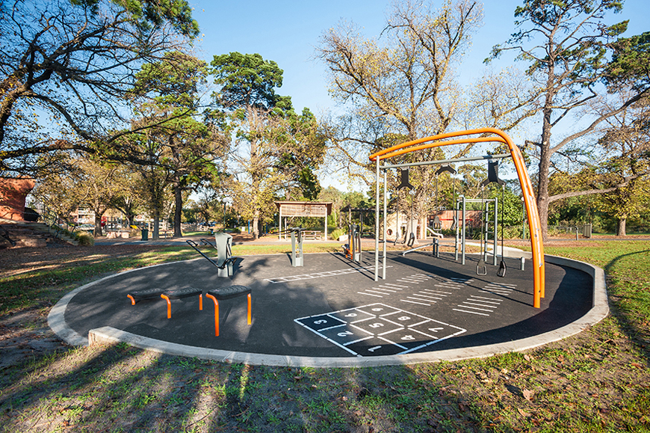

Contents
Contents 2
Background 3
Current state 3
What’s expected in the future? 3
What is Council’s response? 3
Methodology 4
Landscape and context 4
Existing informal recreation facilities 4
Future need and demand 4
Key findings 5
Landscape and context 5
Existing informal recreation facilities 5
Future need and demand 5
Online survey results 6
Face-to-face conversations 8
Recommendations 9
The 5 Rs 9
Renew 9
Refresh 9
Remove / re-purpose 9
Replicate 9
Reimagine 9
What happens next? 9

Background

Current state
The City of Port Phillip is one of the most active municipalities in the state. The local community participate in a diverse range of informal recreational activities in addition to organised sport. In today’s society, people are increasingly time poor and appreciate the opportunity to undertake recreational activities at their own time discretion and in unstructured environments.
To provide for this and ensure the health and wellbeing of residents across all age groups and abilities, Council has installed a range of informal sport and recreation facilities for the community to use at their leisure. These include outdoor fitness stations, skate parks, basketball courts, and outdoor ping pong tables as well as paths for walking, jogging, cycling and other activities along the foreshore and throughout the municipality.

What’s expected in the future?
Existing informal sport and recreation facilities are currently highly utilised by residents and groups. However, for Council to continue to facilitate participation in informal recreation in the future, it needs to plan for the following changes and challenges:
- Projected high population growth combined with a lack of available open space available to be developed for sport and recreation
- Changing trends in sport and recreation participation:
  - Increase in demand for informal opportunities
  - Access and affordability as key determinants for people’s decision not to participate in formal sport
- An ageing population which may alter the types of sport and recreation activities undertaken

What is Council’s response?
To achieve this, Council commissioned a research project with the aim to:
- Review informal sport and recreation opportunities and infrastructure available within the City of Port Phillip, and its current condition and distribution
- Identify current facility gaps and future needs for informal sport and recreation infrastructure
- Set priorities for the upgrade and/or delivery of new informal sport and recreation facilities that will inform a program of works for the next four years (and other potential projects should funds become available).

Methodology
Research was conducted in the following three areas:
- Landscape and context – what are the current state, trends and challenges facing City of Port Phillip?
- Existing informal recreation facilities – what do we currently have and how well is it serving the community?
- Future need and demand – What type, where and how will informal recreation facilities serve the community best in the future?

Landscape and context
To understand the current landscape and the City of Port Phillip, the following documents and information were reviewed and considered:
- City of Port Phillip Council plan and strategies
- City of Port Phillip population profile and projections
- Sport and recreation participation trends in:
  - Victoria
  - City of Port Phillip

Existing informal recreation facilities
To understand what needs to be built in the future and where, it was important to first understand what is currently available to the community and how easy it is for residents to access and use these facilities. Through desktop research and site inspections the following were assessed:
- The quantity of facility types
- The target user for facility types
- The condition of the facilities
- Access to and safety of the facilities
- The supporting infrastructure present at the facility
- The distribution of facilities throughout the municipality

Future need and demand
The future need and demand for informal recreation facility types, supporting infrastructure and locations was determined by:
- A facility gap analysis
- Stakeholder engagement:
  - Place-based consultation
  - Online survey

Key findings
The key facts and findings from the research, which informed future recommendations are summarised below:

Landscape and context
- Sport and recreation participation trends in Victoria clearly show an increased demand for informal opportunities to participate in physical activity
- The suburbs of Middle Park and Albert Park are not forecast to have significant population growth, but will have an ageing population
- The population growth in Elwood, Ripponlea, St Kilda and Fisherman’s Bend will predominantly be in the primary and secondary school age bracket
- There are pockets within the City, particularly around public housing, that have significantly higher levels of disadvantage
- Close to 90% of residents live in medium and high-density housing, with limited private open space
- Nearly three-quarters of the City’s population work within City of Port Phillip or the immediate surrounds and a high percentage walk or cycle for transport

Existing informal recreation facilities
- The City of Port Phillip has 77 informal recreation facilities/sites:
  - 50 are owned or managed by Council
  - 27 are on land owned by other entities (e.g. facilities at Albert Park)
- The most common facility types were basketball/netball rings and courts (25) beach volleyball courts (14) fitness stations (11) and cricket practice nets (10)
- The condition of the facilities was mostly ‘average’ or ‘as new’ (75%) with only 25% considered to be in ‘poor’ condition
- Just over one third (34%) of facilities have public lighting, 50% are considered to have natural surveillance (the placement of infrastructure, activities and people is a way that maximises visibility to ensure safety and positive interaction between users) and the majority (80%) were free from graffiti

Future need and demand
To further understand community need/demand, the thoughts, opinions and behaviours of the community were sought through both (i) face-to-face conversations with users of selected informal sport and recreation facilities and (ii) an online survey to capture the views of the City of Port Phillip residents more broadly.

Online survey results
The community had the opportunity to contribute to this research through the ‘Have Your Say page’ on the City of Port Phillip website. The online survey was open for feedback from 13 March 2019 to 11 April 2019. A total of 316 people completed the survey.

Who answered the survey?
More females than males responded to the survey. Most respondents (78%) were aged between 26 and 55. The younger and older age groups were less represented. The majority (76%) of respondents were City of Port Phillip residents, with most of the other respondents residing in other municipalities, but coming to City of Port Phillip for recreation or to participate in informal sports.

What informal recreation facilities are most used?
Of those who completed the survey, 96% said they have used an informal sport and recreation facility in the City of Port Phillip within the past 12 months. The most highly-used infrastructure were walking/cycling paths (90%) and outdoor fitness stations (55%).

By far the most common reason for not using informal sport and recreation facilities in City of Port Phillip was not knowing what is available, with not having time and the type of facilities available also common reasons for not participating.

What would people like to see more of in the future?
When asked what new activities or facilities they would like to see in the City, respondents had a variety of ideas. The most common were more volleyball courts (with floodlighting), new and improved fitness stations, improvement to bike paths and expansion of the bike path network and more tennis walls and basketball courts.

Face-to-face conversations
Face-to-face conversations were had with users of different informal recreation facilities in the City as well as participants who were involved in physical activity programs managed by Council through participation initiative ‘Sport Phillip’. The key takeout’s from these conversations are summarised below:
- Provision of informal sport and recreation facilities is highly valued by residents, and it was the view of most people consulted that the facilities are generally well used
- Basketball/netball courts, fitness stations, and shared bike/walking paths were the most recognised informal sport and recreation facilities
- Those consulted would like to see increased provision of and access to toilets, seating, and drinking fountains at informal sport and recreation facilities
- People consulted believe that there needs to be increased promotion of the types of informal sport and recreation facilities available, and their locations

Recommendations
Based on information collected, the overarching recommendation is: to create an equitable distribution of informal recreation facilities, ensuring a wide range of facility types, that are appropriate for the location and community needs of the area. This can be achieved through five strategic areas shown below as the 5 Rs.

The 5 Rs

Renew
Improve, expand or replace existing facilities, prioritising those with deficiencies / are in poor condition.

Refresh
Add supporting infrastructure that will encourage the use of informal facilities such as seating, drinking taps, lighting, shade and wayfinding signage.

Remove / re-purpose
Remove facilities that reach the end of their functional life and / or are no longer being used.

Replicate
Install informal sport and recreation facilities that are popular, there is a lack, of or residents want to see more of.
- This could include: Tennis walls, basketball and netball courts, a new skate park or skateable elements and new fitness stations.

Reimagine
Diversify what the City of Port Phillip has to offer in informal recreation facilities.
- Such facilities could include: Parkour facilities, bouldering walls, ‘birdie’ cages (safe golf practice area similar to cricket practice nets), or a formalised running track.
- Consider recreation precincts of varying sizes containing a variety of multi-generational facilities.

What happens next?
- Council will develop a Plan for informal recreation facilities over the next four years based on recommendations from this report.
- Residents can look forward to these projects and more in 2020:
  - Peanut Farm Cricket Net Redevelopment
  - Alma Park Cricket Net Redevelopment
  - JL Murphy Reserve Play space Upgrade (includes a basketball half-court within the scope of works)
  - Elwood Fitness Station

