Parking Management Policy

Residential Parking Areas

Currently, those with Resident Parking Permits are restricted to parking in their street, cross street or adjacent streets.
What we asked*
Do you support the approach to Residential Parking Areas?
What you told us*
62 per cent supported the approach.
*Draft Parking Management Policy Engagement Survey Report October and November 2019.
What is happening
Introduce precinct-based Residential Parking Areas in response to variations in demand and availability on specific days, rather than the current “surrounding streets” model.
Expected outcomes
Create fairer and more flexible Residential Parking Areas based on density, demand and current demographics that will better meet local parking demand, reduce frustration and traffic congestion caused by not being able to find a space, and make parking more accessible to those who need it when and where they need it.
Timeline
Effective 1 July 2021.
Find out more
For more information about Residential Parking Areas, see Figure 3 in Section 2.4.1 of the Parking Management Policy.

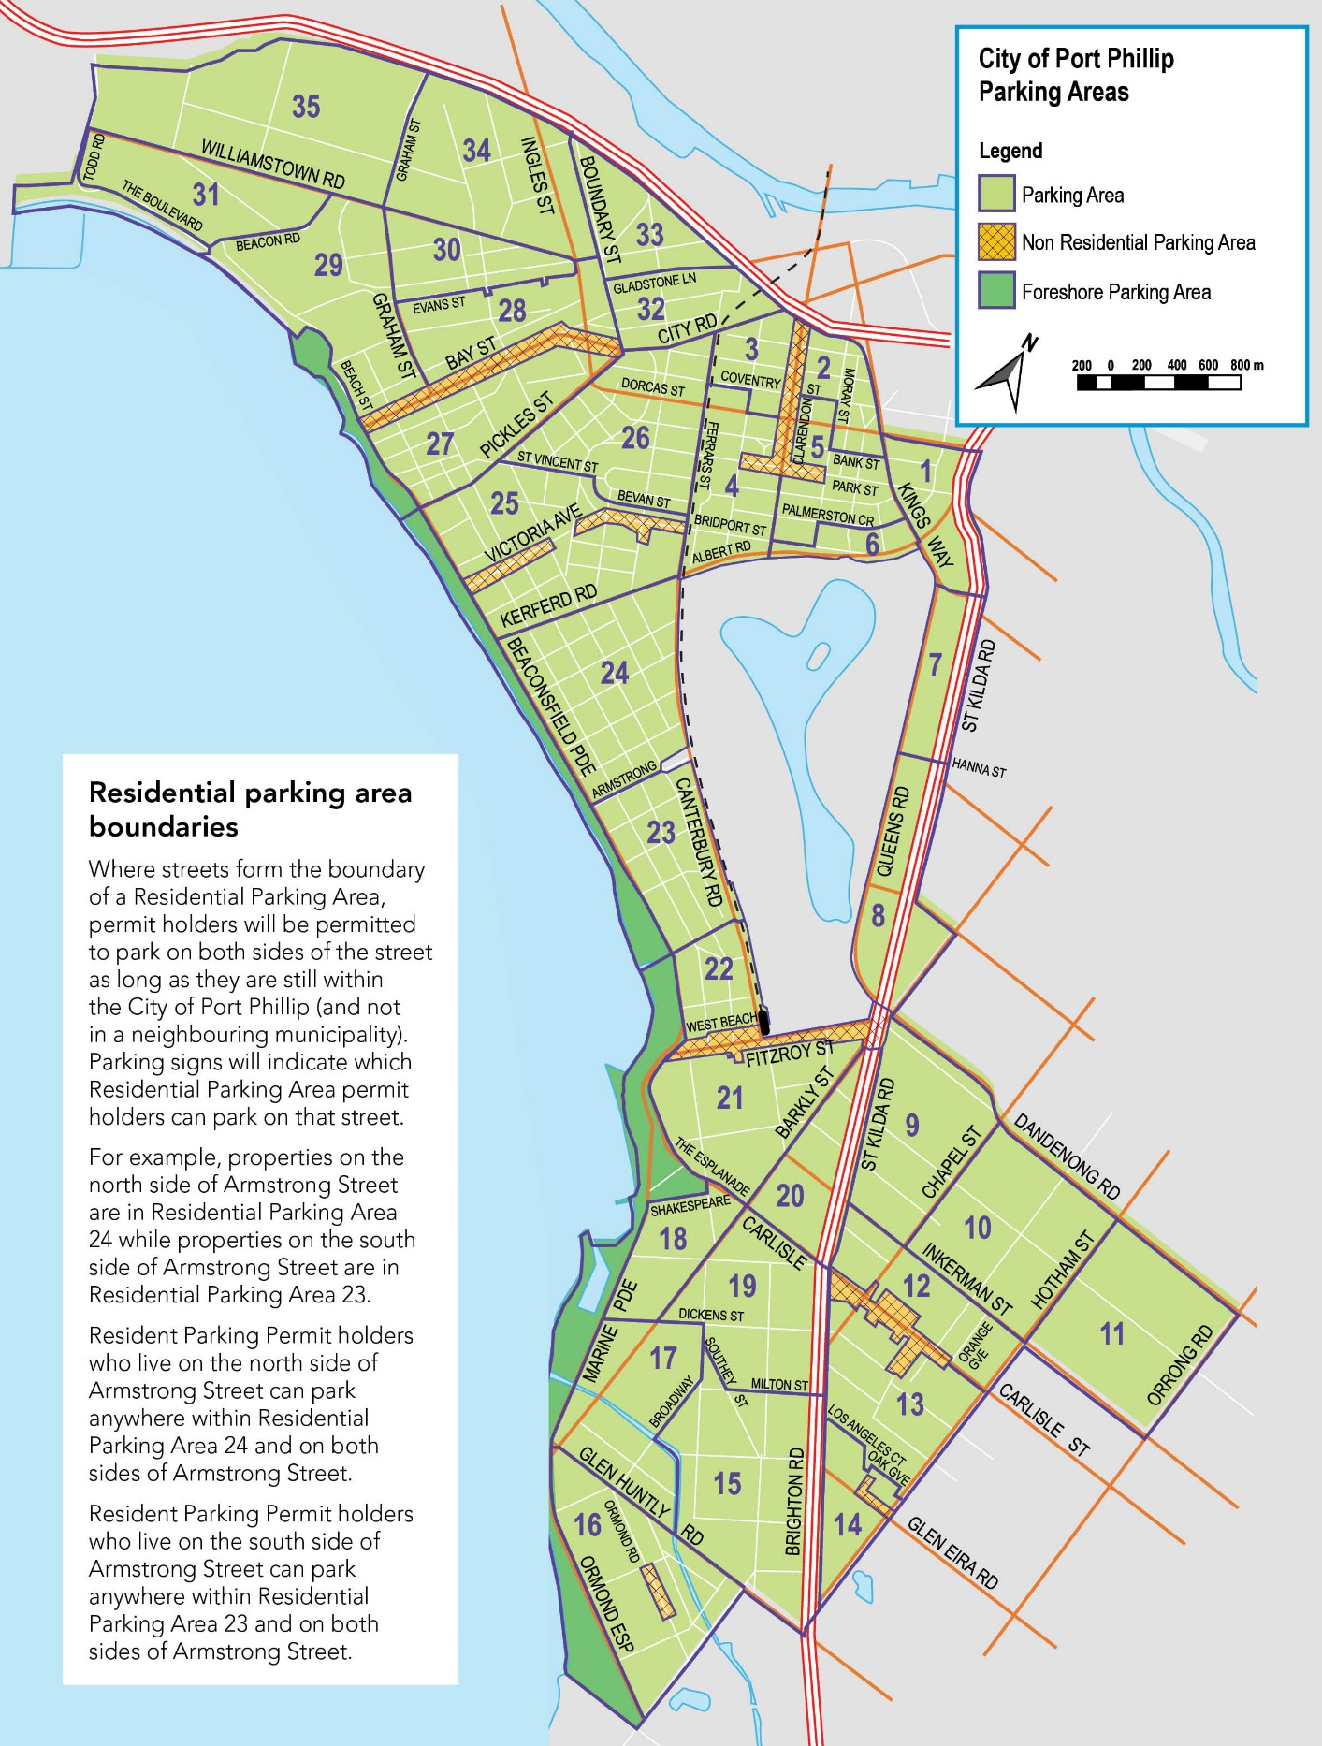
Residential Parking Areas

