Draft Public Space Strategy
August 2020

1

Contents

Womin Djeka 4
Public Space Strategy vision statement 4
Message from the Mayor 4
What is public space and why is it important? 5
Our public space network 5
What is the Public Space Strategy and why do we need it? 7
Listening to our community 10
What is Council’s role in public space? 11
Trusted service provider 11
Trusted advisor and agent 11
Trusted steward 11
Monitoring and reporting 11
Our partners 11
The challenges we face 12
We are growing and changing 12
Responding to pandemics and disruptors 13
Adapting to a changing climate 13
Responding to a different transport future 14
Rapidly evolving technology 14
Changing economic conditions 14
Legislative and policy influence 15
City-wide outcomes 16
Response to COVID-19 16
Places for people 16
Diverse and shared spaces 17
Active spaces 18
Better access to public spaces 18
Sustainable spaces 19
Cultural spaces 19
City-wide Spaces 19
The foreshore 19
Albert Park Reserve 20
Transformative projects 20
Inspiring ideas 24
Our neighbourhoods 27
Public Space 27
Action Plan 28
Neighbourhood Action Plans 29
Albert Park/Middle Park 31
Balaclava/St Kilda East 33
Elwood/Ripponlea 35
Port Melbourne 37
South Melbourne 39
St Kilda Road 41
St Kilda/St Kilda West 43
Montague and Sandridge/Wirraway – Fishermans Bend 45
Future neighbourhood actions 47
Measuring and Reporting 48
Understanding our service levels 48
Measuring our success 48
Appendix A – Actions and financial overview 50
References 68
Council contact details 68

Womin Djeka
[Placeholder]

Public Space Strategy vision statement
[Placeholder]

Message from the Mayor
[Placeholder]

Coronavirus disease (COVID-19)
Port Phillip Council takes the health of our community, staff and visitors very seriously. We are working to keep our community safe during the coronavirus disease (COVID-19) outbreak. We are following advice from the Victorian Government and the Australian Government and doing everything we can to ensure that we can continue to deliver essential services for our community.
During this time, we acknowledge now more than ever the importance of public space to the health and wellbeing of our community. Opportunities to enhance the accessibility, safety and livability of public spaces in the event of a future pandemic and changing social trends because of COVID-19 have been considered and embedded in this strategy. This will enable Council to continue to provide high quality and well-used public spaces into the future.
Whilst the draft Public Space Strategy is primarily intended to provide long term guidance, we need to be agile and flexible in our approach to respond to disruptors such as the current global pandemic or other events which may occur in the future such as extended heatwaves, flood events or other natural disasters.

What is public space and why is it important?
Public space contributes to the liveability of our City and defines our unique sense of identity and place. It is open and accessible to people. It is where we meet our friends, exercise, play sport and relax. It is generally publicly owned and typically includes footpaths, urban plazas, parks, sports fields and beaches .
In this strategy, public space is described in the following ways:
- Public open space (referred to in this strategy as open space) – parks, gardens, reserves, the foreshore and urban spaces
- Shopping strips (activity centres) – destination public spaces which people visit to socialise and relax
- Streetscapes – key streets that link our public spaces and shopping strips
- Contributory public space – other public space such as waterways, civic plazas, forecourts and State owned and managed land (like schools)
- Publicly accessible space on private land – spaces that are linked to major commercial and residential buildings that are privately owned but accessible to the public.
Well-designed public spaces have social, economic and environmental benefits. Research has identified that there are measurable improvements to people’s physical and mental health if they live and work near green public space, and that public space is an essential part of creating sustainable urban communities, particularly as urban density increases (WHO, 2016; Victorian Government, 2012; Deakin University, 2010). Therefore, it is vital that we ensure equitable access to high quality public spaces in our municipality.
The global pandemic COVID-19 has raised new challenges for our community and has directly impacted on the use of public space. We have observed greatly increased demand for the use of public open space for physical exercise, restricted access to playgrounds and some other facilities, changes to community sport as well as a much greater community value placed on the mental health benefits derived from public space. This provides us with opportunities to consider and trial new ways of planning, delivering and managing public spaces.

Our public space network
Port Phillip has an excellent public space network, with approximately 353 hectares of open space distributed over 169 individual open spaces (comprising 17 per cent of our city), as well as some noteworthy public spaces that adjoin our municipality such as Fawkner Park, Kings Domain/Melbourne Royal Botanic Gardens, Ripponlea Gardens and Elsternwick Park. The amount of public space varies in each neighbourhood across our city, ranging from 5 per cent of the total neighbourhood in Balaclava/St Kilda East to 31 per cent in Albert Park/Middle Park.
The foreshore and Albert Park Reserve are by far our largest open spaces, contributing significantly to the public space network and attracts people from across greater Melbourne. We also have a number of medium-sized open spaces (including Alma Park, St Kilda Botanical Gardens, St Vincent Gardens and JL Murphy Reserve).
In addition to open space, each of our neighbourhoods have a range of public spaces in our ‘shopping strips’ (what we call activity centres), other key streets that link public spaces, and the foreshore – our largest open space, as well as contributory public spaces (such as church grounds). St Kilda Road neighbourhood also has publicly accessible private spaces. Map 1 shows our public space network.
Our spaces are generally well-spread across the City, with all our nine neighbourhoods having access to public space.

City of Port Phillip draft Public Space Strategy

Map 1 Port Phillip's public space network
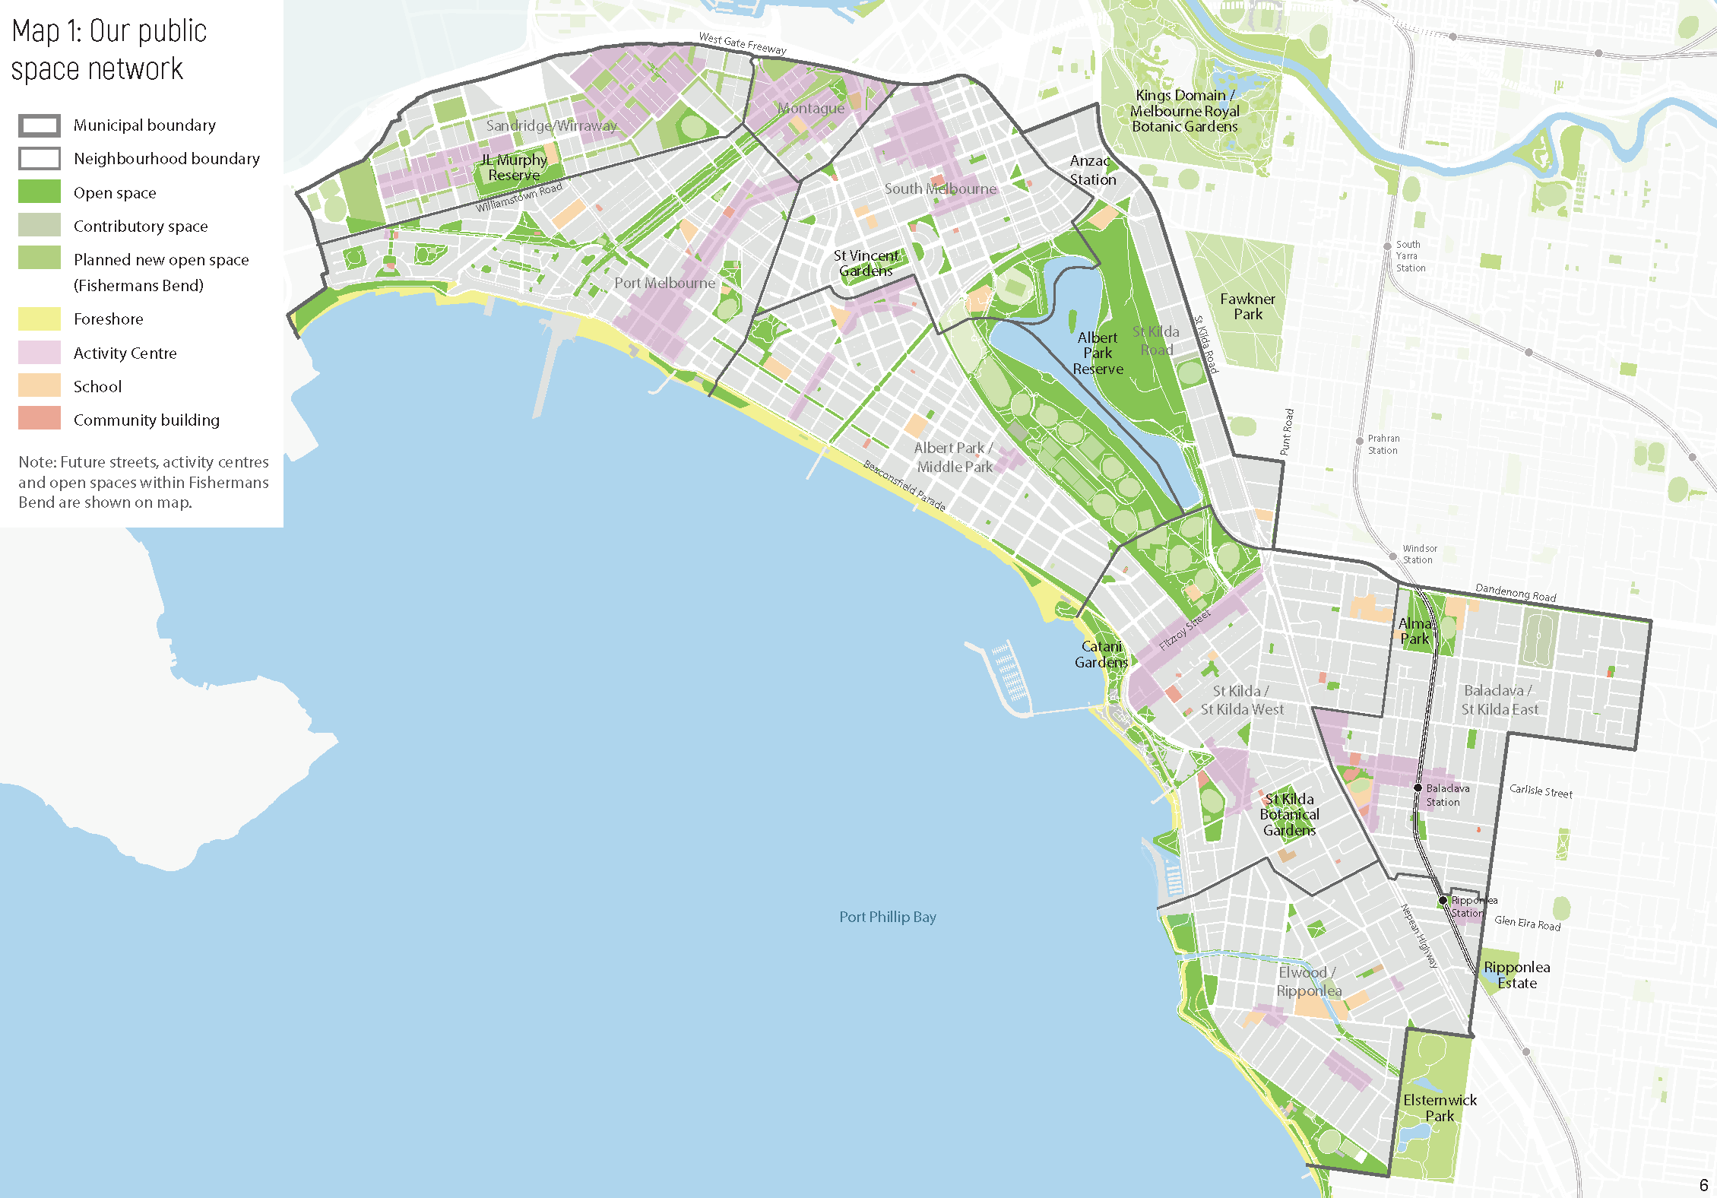

6

What is the Public Space Strategy and why do we need it?
The Public Space Strategy is the vision and blueprint for the future of public spaces in the City of Port Phillip. It is one of Council’s core strategies and delivers on Strategic Direction 4 of the Council Plan 2017-2027 ‘We are growing and keeping our character’ and it informs Council’s ongoing planning and investment in public spaces. It also integrates with and supports the delivery of Council’s vision and other core Council strategies that impact on the public realm (refer to Figure 1 and Table 1).
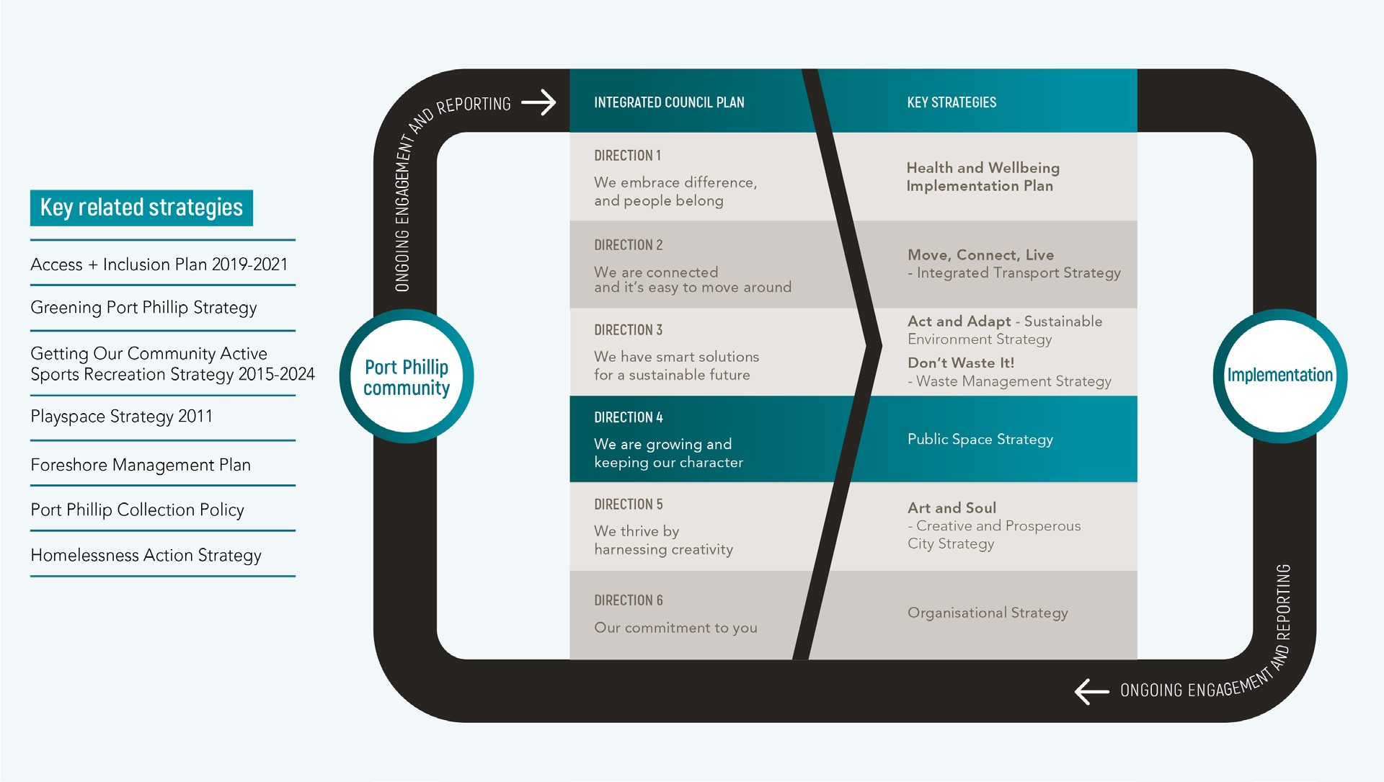
The strategy outlines the challenges, outcomes and actions required to realise the full potential of Port Phillip’s already enviable public space network of parks, gardens, streets, the foreshore, and urban plazas. It is evolutionary, transforming our existing spaces through an integrated action plan that will guide the operation, delivery, upgrade and design of public spaces for each neighbourhood across the City.
Figure 1 Diagram showing links to Council Plan and other related strategies Table 1 How the Public Space Strategy responds to the Council Plan 2017-2027
Council Plan strategic direction | How the strategy responds to Council Plan
Direction 1  We embrace difference, and people belong | The Council Plan says:  - a safe and active community with strong social connections  - community diversity is valued and celebrated. The strategy:  - provides inclusive places for the community to relax, connect and socialise (all ages, cultures and abilities)

7

Council Plan strategic direction | How the strategy responds to Council Plan
- involves the community in the design and creation of public spaces
- provides formal and informal sport and recreation opportunities
- provides direct links to and between public spaces for people of all abilities
- ensures our public spaces are safe, welcoming and inclusive for all
- provides access to nature in all spaces.
Direction 2  We are connected and it’s easy to move around | The Council Plan says:  - our streets and places are designed for people. The strategy:  - recognises the importance of activity centres and streets as public spaces  - creates green links to connect the public space network and enhance accessibility for pedestrians and cyclists  - repurposes our streets temporarily and permanently to create new public space  - improves connections to and along the foreshore for pedestrians and cyclists.
Direction 3  We have smart solutions for a sustainable future | The Council Plan says:  - a greener, cooler and more liveable City  - a City that is adapting and resilient to climate change  - a water sensitive City  - a City with lower carbon emissions  - a sustained reduction in waste. The strategy:  - ensures the effective management and maintenance of our public spaces  - increases access to public space using innovative ideas (e.g. to secure access to ‘restricted’ public space)  - designs our public spaces to contribute to a water sensitive City  - increases the resilience of the foreshore to climate change and sea level rise.
Direction 4  We are growing and keeping our character | The Council Plan says:  - liveability in a high-density City  - a City of diverse and distinctive neighbourhoods and places. The strategy:  - protects and enhances the quality of our existing public space

Council Plan strategic direction | How the strategy responds to Council Plan
- designs and programs our public spaces to be flexible, cater for diverse needs and withstand higher levels of use for a growing community
- recognise that our spaces are used for a variety of purposes and accommodate sharing by a range of user groups
- maintains solar access to key public spaces
- creates a series of destinations along the foreshore
- reflects the cultural significance of the Yaluk-ut Weelam clan of the Boon Wurrung.
Direction 5  We thrive by harnessing creativity | The Council Plan says:  - a City of dynamic and distinctive retail precincts  - a City where arts, culture and creative expression is part of everyday life. The strategy:  - embeds the City’s heritage, art and cultural identity in our public spaces.
Direction 6  Our commitment to you | The Council Plan says:  - a financially sustainable, high performing, well-governed organisation that puts the community first.  The strategy:  - collaborates with strategic partners to improve and manage our public space network  - ensures investment in our public spaces is fair, equitable and financially sustainable.

Listening to our community
Our community is passionate about public space. We recognise the importance of our public spaces to their health and wellbeing, and the overall quality of life for our community. We have committed to working collaboratively with the community to meet our public space challenges head on.
In preparing this strategy we engaged with the community through pop-ups, interactive mapping, an online survey and conversations with key stakeholders to understand their priorities.
You told us:
- our public spaces are well used by the community for a range of activities – 49 per cent of online survey respondents said their enjoyment of public space would be improved by having enclosed space for dogs to safely play off-leash
- our foreshore is the most popular public space in the Port Phillip
- greening our public spaces should be a priority – 90 per cent of neighbourhood pop-up participants were supportive of Council investing more in stormwater harvesting programs to keep our green spaces green without using potable water
- maintenance of our space should be improved
- sharing of our spaces needs to be managed more effectively – 48 per cent of online survey respondents said their enjoyment of public space would be improved by extending the usable hours of public space
- community stewardship of public space is supported
- cultural identity is important
- new public space could be created through repurposing road space – 75 per cent of neighbourhood pop-up participants were supportive of repurposing road space to create new public spaces.
You told us that your favourite spaces are:
- The foreshore because it is great for walking, cycling and casual recreation, and has a good mix of commercial activities and events. It is also culturally significant to the Yaluk-ut Weelam Clan of the Boon Wurrung
- South Melbourne Market because it has a great atmosphere and is vibrant and friendly
- Albert Park Reserve because it is large with lots of open space to play as well as a kids’ playground and formal and informal sports areas
- Elwood Canal because it is a great walking link and has a fantastic habitat corridor that links the area to the foreshore
- St Kilda Botanical Gardens because it is relaxing, peaceful and offers the opportunity to connect with nature
- St Vincent’s Gardens because it’s a beautiful, green oasis in a heavily housed area.

What is Council’s role in public space?

Trusted service provider
Provider of high-quality, community-driven public spaces that form a network of active, vibrant places that contribute to the overall well-being of our City. We work with the community and the State government on the delivery of these spaces.
Ensure that the correct measures and plans are in place to enable us to keep our public spaces open for our community should a future pandemic impact Port Phillip.

Trusted advisor and agent
Work to achieve the Council Plan vision and strategic directions through programs and projects that promote and enhance our public space network.

Trusted steward
Be a sector leader in managing and delivering well-used and high-quality public space.

Monitoring and reporting
Monitor and report against key measures outlined in this strategy to share our progress and identify areas for further improvement.

Our partners
Initiatives outlined in this strategy require significant collaboration between Council and stakeholders including our community, the Victorian Government, public and community sector organisations, and the private sector including developers.

The Victorian Government
Advocate for and develop partnerships with the state government, neighbouring councils and our community (including residents, workers and visitors) to maximise the benefits of our public spaces and public spaces in adjacent municipalities. Advocacy projects are outlined in Appendix A.

Developers
Work with developers to deliver new open space as development occurs, where appropriate and ensure development outcomes enhance adjacent and nearby public spaces.

Our residents and workers
Work with our community to improve the way we use our public spaces, such as establishing community gardens, running community events and encouraging community stewardship of spaces.

The challenges we face
Our city is becoming even more dense, our environment is changing, and technology is shaping our lives in ways that were once unimaginable. This all has an impact on our public spaces: how we provide them, how often they get used, who uses them, how often we need to service them. It makes these places even more important to the well-being of our community. This strategy is our response to those challenges to ensure we maintain our enviable network of public space. The challenges include:

We are growing and changing
Our population is growing to an expected 146,300 people by 2031, an increase of 26,940 people or 23 per cent (Forecast.id., 2020) and as the City’s density increases, the role and demand for public space is changing. Nearly half of this growth comes from Fishermans Bend (over 13,000 residents), which will transform the area from an industrial/employment precinct to a high density residential and mixed-use precinct with approximately 80,000 new residents and 80,000 new jobs by 2050 (DELWP, 2019). Other key areas of growth in Port Phillip are St Kilda Road, St Kilda and South Melbourne.
We are already Victoria’s most densely populated municipality and our resident, worker and visitor population will continue to grow (Port Phillip, 2017). As more people live in apartments, parks are replacing backyards and urban spaces are becoming the ‘living rooms’ where people meet and interact. These spaces are an intrinsic part of the City’s identity and character and they play a major role in creating a sense of connection for people.
Each of our neighbourhoods also has different characteristics. In Albert Park/Middle Park, for example, the population is ageing, and many people live in larger houses with backyards. While other neighbourhoods have a larger population of young families with children, and in others, single person householders are dominant.
Some neighbourhoods have more public space than others, and some parts of some neighbourhoods have historic ‘gaps’ where there is not currently public space within a short, easy and safe walking distance (particularly Balaclava/St Kilda East and South Melbourne). The quality of many of our public spaces is high; however, some spaces are of a lower quality due to things like size, diversity of use and facilities and whether they could be improved.
As the demand for sporting fields and our population both continue to grow, acquiring new land and building additional facilities to meet this demand is not an option available to us due the high cost of land (IMAP, 2019).
For our public space network and Council delivery of services this means:
- new open spaces and sporting fields cannot be provided at the rate of population growth (other than within Fishermans Bend)
- more people will be using our open spaces and there will be limited provision of new open spaces, so our existing spaces will need to work harder and be maintained more frequently (this also includes nature strips and community gardens)
- as usage and amount of open space increases, cost of maintenance will also increase
- our spaces need to be accessible for all people and all abilities
- less people in our community will have a traditional ‘backyard’ and they will be more reliant on public space for leisure and recreation
- as more people live alone, they will rely on our public spaces for social connectedness

- managing public spaces into the future will need to consider the well being and safety of our community should another pandemic impact Port Philip
- forecast growth in Fishermans Bend and greater Melbourne will place pressure on surrounding public spaces.

Responding to pandemics and disruptors
The Coronavirus (COVID-19) pandemic has highlighted how easily our cities can be disrupted by unplanned events. COVID-19 for example has created new and different demands for our public spaces, including a significant increase in the number of people using our spaces at different times of the day and the types of activities being done in our spaces. This has seen community interest in upgrading or changing our spaces rise.
The social and economic recovery during and after the COVID-19 pandemic and other disruptor events is inextricably linked to our public space and impacts local amenity and experience, as well as health and wellbeing, community connection, economic vitality, creative expression and climate change responsiveness. To enable Council to be smarter and to respond to these impacts while being more flexible about public space, we will continue to look at our processes around the use and adaptation of public space during emergencies and crises.
Challenges for our public space network that have emerged through this most recent pandemic include:
- footpaths may need to be widened to make it easier to get around and be socially distant
- temporary or permanent parklets should be created to support local businesses to open and operate safely
- play spaces closer to home may need to be created
- streets will need to be adapted to allow for more active modes of transport such as walking or cycling
- our spaces must feel safe to those who are vulnerable
- low cost, temporary initiatives to activate public spaces will need to be considered in consultation with the community and creative organisations.

Adapting to a changing climate
The City of Port Phillip has declared a climate emergency to recognise the challenges that we are currently facing. As our community adapts to these climate change challenges, local adaptable public spaces that are designed with climate mitigation and adaptation in mind will be increasingly important for our community. Climate change and adaptation will present new challenges for public space outlined in Council’s Act and Adapt Sustainable Environment Strategy 2018-2028.
Challenges for our public space network include:
- lower than average rainfall, changing patterns of rainfall distribution and inconsistent water supply requires future decision-making about irrigating our parks, gardens and reserves
- rising temperatures and heat-related health stress (for humans, animals and trees)
- sea level rise and storm surges make the foreshore vulnerable and long-term (beyond the life of this strategy) may result in areas of the coast being inundated unless proactive measures are taken to prevent this occurring
- more frequent extreme weather events, with increased erosion of the foreshore due to a greater number and intensity of storms

- higher wind speeds
- changing how we manage water in public spaces including stormwater harvesting, water sensitive urban design
- the cost of remediation of contaminated land is expensive and will continue to increase.

Responding to a different transport future
We have a road network that is at capacity and we need to look at innovative solutions. More people and more cars mean that out streets are becoming more congested. Ride sharing, autonomous and electric vehicles may not reduce this demand. Road space makes up approximately 17 per cent of Council controlled land in the municipality, approximately 20 percent of this road space is used just for car parking. In line with the Move, Connect, Live Integrated Transport Strategy 2018-2028, we need to think of new ways to mitigate this increase and rethink the design and use of our streets to be more focused towards people.
Challenges for our public space network include:
- streets may need to be repurposed (temporarily or permanently) to create new public space such as parklets, playstreets, and bike and walking routes, this includes the removal of car parking
- footpaths may need to be widened to allow for social distancing along key walking routes and shopping streets
- some of our streets are not accessible to people of all abilities and often provide little shade or places to rest.

Rapidly evolving technology
The rapid evolution of technology parallels the increasing demand from our community for innovative ways to use and manage our public space. The digital shift will reshape how we deliver services and engage out community in decision making (Port Phillip, 2017).
Challenges for our public space network include:
- changes to technology and the digital environment accelerating faster than we are delivering innovation in our spaces
- lack of technology in our public spaces (such as beacon wayfinding technology, wifi and online booking systems)
- balancing access to new technologies and managing the impact on public spaces (such as dockless e-bikes and scooters)
- being responsive and adaptive to make use of new technologies and solutions.

Changing economic conditions
The rise of online shopping, the sharing economy and more flexible work models are driving an evolution of our places and the experiences people have in our city. The cost of remediating contaminated land also needs to be taken into consideration when planning new or upgrades to spaces
Challenges for our public space network include:
- land values are increasing, making it more expensive to buy land for new public space
- there is an increase in the number of people ‘sleeping rough’ in some of our public spaces

- there are increased vacancies in some of our shopping strips impacting upon vibrancy, making them less appealing as public spaces
- increased use of spaces at all hours.
- there is limited financial flexibility to invest in public spaces due to rate capping
- levels of soil contamination in our public space mean that it is expensive to remediate land.

Legislative and policy influence
At an international level, the United Nations Sustainable Development Goals cover a range of issues including water, energy, climate, oceans, urbanisation, transport, science and technology and aim to build a better world for people and our planet by 2030 (United Nations, 2015). The Victorian Government’s Plan Melbourne is the overarching planning framework for greater Melbourne and sets the direction for metropolitan public space. It highlights its crucial role in contributing to liveable and sustainable neighbourhoods, and to healthy, active and socially connected communities (Plan Melbourne, 2017).
As well as this, the state-led Metropolitan Open Space Strategy will guide strategic investment and the review and alignment of other factors to improve the provision, quality and sustainability of the open-space network. The new Environment Protection Amendment Act 2018 has also changed mechanisms around the management of contaminated land.

City-wide outcomes
The challenges set out above have a key influence on our city’s future and the future of public space within the City of Port Phillip. They will impact how we each use and experience public space. Responses to these challenges need to drive innovative approaches to the future provision and management of open space. We will need to:
- do things differently
- use and improve what we already have
- put effort into the most effective things
- do things with partners.
By doing all of these things we will work toward achieving the following city-wide outcomes, improving our city-wide spaces and delivering transformative projects.

Response to COVID-19
In response to the COVID- 19 pandemic, many cities throughout the world have been re-purposing public space to improve opportunities for physical distancing, facilitate increased active transport and to create additional green space.
Within the City of Port Phillip we have been actively looking at these opportunities. Examples of this include the widening of footpath areas at South Melbourne Market (and using additional road space for market stalls) as well as identifying new routes, wayfinding and safety improvements for our cycling network. We are also activating public space by providing temporary parklets and play spaces. By making our public spaces work harder we can improve community wellbeing, the identity of place and the amenity of our city in response to new demands arising from changed conditions during the pandemic.
This will included initiatives such as:
- supporting the use of our public spaces at all hours rather than peak times
- implementing opportunities to re-purpose underutilised spaces for our community to enjoy
- identifying measures to facilitate easier physical distancing in our shopping areas
- promoting active transport and looking at opportunities for improved bicycle routes and dedicated cycling lanes
- activating public spaces (for example through temporary play spaces)
- establishing new green spaces (for exmple through temporary and permanent parklets)
- improving co-ordination and streamlining the approvals process so we can be agile and responsive.
- working in partnership with local businesses, our community and other levels of government to ensure our public spaces promote these outcomes
- evaluating the success of public space changes and trials, using them as opportunities to accelerate change and embed the ‘new normal’.

Places for people
Our public spaces need to be designed with people and their needs in mind to add to the strong identity of our city.

Key moves:
- involve the community in the design of public spaces
- ensure access to nature and sunlight in all open spaces
- strengthen the community heart of our neighbourhoods by expanding or improving public space in activity centres as part of a structure planning process
- co-locate public spaces and community facilities to encourage shared use
- ensure our spaces are clean, maintained and safe to enable use for people of all abilities, gender, cultural backgrounds and ages
- ensure appropriate amenities in public spaces and key streets including shaded seating where appropriate
- ensure our spaces meet the needs of our community and tourists including active uses, informal and passive recreation
- improve wayfinding to and in our public spaces and different parts of the municipality
- develop a position paper and guidelines on universal design and safety in public spaces.

Diverse and shared spaces
Everyone, no matter their age, gender, ability or background should feel welcome in our public spaces and the spaces should be able to host a variety of uses and users.
Key moves:
- redesign roads, where appropriate, to create more ‘shared zones’ to increase pedestrian amenity and active transport
- design and manage spaces for more than one use to increase appeal and level of use (e.g. sporting facilities, dog-off-leash areas, events, casual and unplanned activities and play etc.)
- prepare a policy to manage shared use of public space and allocation of facilities. This should address structured sport and recreation, unstructured recreation and informal use, festivals and events and management of dogs in public space
- support the use of nature strips for greening in line with Council’s Nature Strip Guideline
- support community gardens on Council owned land in line with policy currently being prepared by Council
- prepare a discussion paper on commercial uses in public spaces (e.g. personal trainers, recreation providers and events.)
- prepare a policy to allow community use of school grounds and manage how schools use our public spaces to ensure net community benefit
- partner with the community and developers to ensure that other spaces such as building forecourts, church grounds and privately-owned public spaces are shared and well-used
- partner with the Victorian Government to activate underutilised spaces for public use (e.g. VicTrack for railway reserves, Department of Health and Human Services for public housing, Department of Transport for rail, tram and road underpasses.)
- develop a position paper to consider the future maintenance of our new and improved spaces

- develop a policy on community gardens on Council owned land and nature strips.

Active spaces
It’s important that our community is active and healthy. Key moves:
- update the Getting our Community Active: Sport and Recreation Strategy 2015-2024 to be consistent with the actions in this strategy and guide the provision of sport and recreation facilities and services in the future
- make our existing sports grounds work harder through extending hours of use by improved lighting, improved programming, licensing, agreements and consideration of different surface types
- provide for informal sport and recreation as an alternative to organized sport to encourage physical exercise in open space
- advocate to Parks Victoria for better use of the sports facilities in Albert Park Reserve and the Department of Education for use of school ovals outside of school hours
- provide for major events and festivals while ensuring ongoing community access to public space
- support and manage community festivals, events and commercial activity in public space through the implementation of the Event Strategy 2018-22, the Outdoor Events Policy and Commercial Recreation Policy
- update the Play Space Strategy 2011 to prioritise play spaces for upgrade and renewal.

Better access to public spaces
Our public spaces should be better connected and by finding ways to create new spaces where they are needed, we can make our public space more effective.
Key moves:
- repurpose road space, where appropriate, to create new public spaces, particuarly in areas where there are gaps in the public space network
- purchase land where necessary to create new public spaces
- activate underutilised parts of our city including vacant lots or parks that need upgrading with temporary, pop-up activities or parks
- use designs such as paint, removal of obstructions, good wayfinding and improved interfaces with surroundings to test more permanent ideas such as road closures and the removal of carparking for playstreets and parklets
- plant more trees on key links to improve shade and amenity
- improve connections to public space for everyone including through a cycling and walking networks designed to link public spaces and key areas through more defined green linkswork with with developers to encourage greening on privately owned public open space
- integrate innovative technology that enhances accessibility and use of public spaces
- repurpose existing restricted open space, where appropriate, to consider a wider range of public uses in the future

- use technology to book facilities in public spaces online.

Sustainable spaces
Our public spaces provide green infrsatructure, biodiversity and high amenity to enhance environmental sustainablity and provide the opportunity to be climate adaptive and can help to mitigate the impacts of climate change. Our public spaces are well maintained so that they can be enjoyed for generatons to come.
Key moves:
- reduce urban heat island effect by encouraging passive cooling principles in public space
- protect and plant long-lived trees in existing and future public space and streetscapes to assist with carbon capture and shade
- integrate water-sensitive measures in the design of public space
- design our public spaces to be long-lasting and constructed of high-quality materials with the whole of life cost considered
- partner with developers to support greening on privately owned public spaces to increase net canopy cover across our city in line with Act and Adapt Sustainable Environment Strategy 2018-28
- update Greening Port Phillip – An Urban Forest Approach, and the Greening Port Phillip street tree planting program 2017-22 to reprioritise key actions based on this strategy
- use more environmentally friendly and sustainable methods to remediate contaminated soil, such as using plants
- develop a framework to guide decision-making on which parks, gardens and reserves should be kept green through irrigation.

Cultural spaces
Our spaces connect people to place and provide the opportunity to celebrate our culture, diversity and creativity.
Key moves:
- support Caring for Country and involve the Yaluk-ut Weelam Clan of the Boon Wurrung
- recognise the heritage significance of public spaces and implement conservation management plans where they exist
- celebrate our diversity by embedding heritage, art and cultural identity into our spaces
- develop guidelines for locating public art and memorials in public space.

City-wide Spaces
The foreshore and Albert Park Reserve are the largest public spaces in our city, and cross multiple neighbourhoods. We must mae sure that they key moves for these spaces are considered with our whole city in mind.

The foreshore
The foreshore is the most popular public space in our City and receives high levels of local and regional visitation.

Key moves:
- work closely with the Victorian Government and other coastal land managers around Port Phillip Bay to implement a best practice approach to adapting to the impacts of sea level rise on the foreshore
- improve accessibility to and the amenity of connections to the foreshore by advocating for improved pedestrian crossings and improving green links between the foreshore and key public spaces (such as Albert Park Reserve and key retail streets)
- upgrade major parks on the foreshore (such as South Beach Reserve, Pier Road, Elwood Park and Point Ormond Reserve)
- plant more shade trees on key sections of the foreshore (such as Pier Road and Pickles Street)
- update Port Phillip’s Foreshore Management Plan to include the above actions and the introduction of the Marine and Coastal Act 2018 and the Coastal Management Plan Guidelines 2020
- ensure foreshore projects accommodate projected sea level rise.
See Albert Park/Middle Park, Elwood/Ripponlea, St Kilda/St Kilda West and Port Melbourne neighbourhoods for specific actions.

Albert Park Reserve
Albert Park Reserve is the largest public space in our City. While it is managed by Parks Victoria, it performs a crucial role in the active and passive recreation of our residents.
Key moves:
- advocate to and partner with Parks Victoria to implement the Albert Park Reserve Master Plan
- advocate to Parks Victoria to improve seating, paths and neighbourhood level unstructured recreation and social facilities within the reserve
- advocate for improved local community access (pedestrian crossings) into the reserve
- improve green links between the reserve and the foreshore
- continue to advocate for better access into the Reserve from the St Kilda Road neighbourhood
- understand the impact of the Australian Grand Prix and the reduction in access to the Reserve when it is closed to local community access during the event, noting that it is a key tourist event and reduced use for approximately three months of the year.
See Albert Park/Middle Park, St Kilda/St Kilda West, South Melbourne and St Kilda neighbourhoods for specific actions.

Transformative projects
Across Port Phillip a series of committed projects will add to and transform public space in the municipality over the coming years. Some of these are Council projects and some are by or with State agencies. They include:
Key moves (committed projects):

- Palais Theatre and Luna Park Forecourt – a partial road closure of Cavell Street will integrate this space and include hostile vehicle management with the public realm to create an accessible, shared public space.
- Activity centres – as we continue to prepare structure plans for activity centres, we help to define where new public spaces could go. In South Melbourne, partnerships may help address gaps in the public space network around the South Melbourne Market, and/or in the north-eastern portion of the neighbourhood. In St Kilda, partnerships may help to deliver a new public space on Carlisle Street.
- Shrine to Sea – support the Victorian government in developing a master plan for and the delivery of the Shrine to Sea corridor.
- Fishermans Bend – a series of new public open spaces to support the future community
- ANZAC Station – support Rail Projects Victoria to deliver a new and improved public realm due to road closures surrounding the Melbourne Metro Station.
- Elsternwick Park Nature Reserve – partner with Melbourne Water to develop a long term, whole-of-catchment management plan to reduce the impact of flooding and improve water quality in the Elster Creek Catchment.

Transforming the foreshore
Over the coming years a number of projects are planned that will reimagine and transform the way we use our foreshore area. These include:
- St Kilda Marina: a new lease for the St Kilda Marina has been awarded, which will unlock the full potential of the site as a working marina and key destination. The net public space within the area will be increased for locals, Melburnians and national and international visitors to enjoy.
- St Kilda Pier: the project, led by Parks Victoria, will rebuild the iconic St Kilda Pier which once complete will provide improved recreational space for more people to enjoy. As part of this, there is an opportunity to transform the landside interface with the pier to reimagine Pier Road and the area surrounding the St Kilda Sea Baths, the Yacht Squadron, and even the connection between the foreshore, Fitzroy Street and the Esplanade Hotel.
- Waterfront Place, Port Melbourne: over the next 10-years Council has the opportunity to enhance the public space around Waterfront Place and the Port Melbourne waterfront to improve what we see as an important visitor gateway to our City. We will continue to work with the Victorian Ports Corporation to achieve this.
- St Kilda Triangle: the St Kilda Triangle site has a rich and varied history and has the potential to be transformed into an exemplary public space for our community to enjoy. Council will continue to work with the community to guide the future planning and development of this site.
- Elwood foreshore: a masterplanned approach to Elwood Foreshore is being considered that will think about the needs for the whole area including both the local community and visitors. It will guide changes to the foreshore buildings, car parking, public realm and sport and recreation facilities.

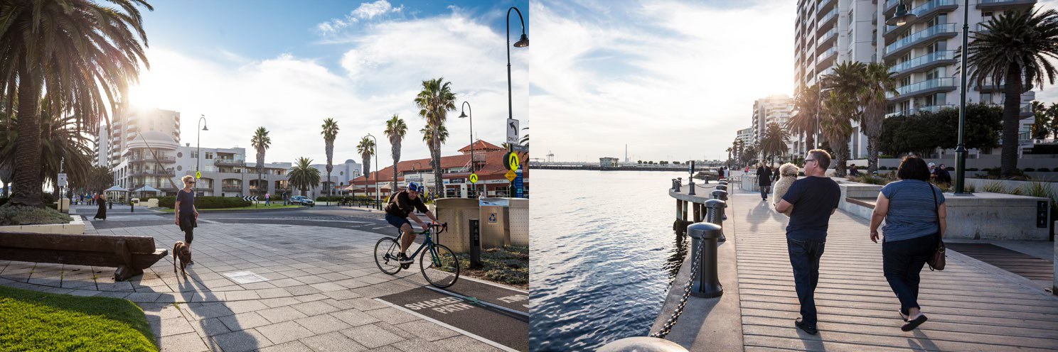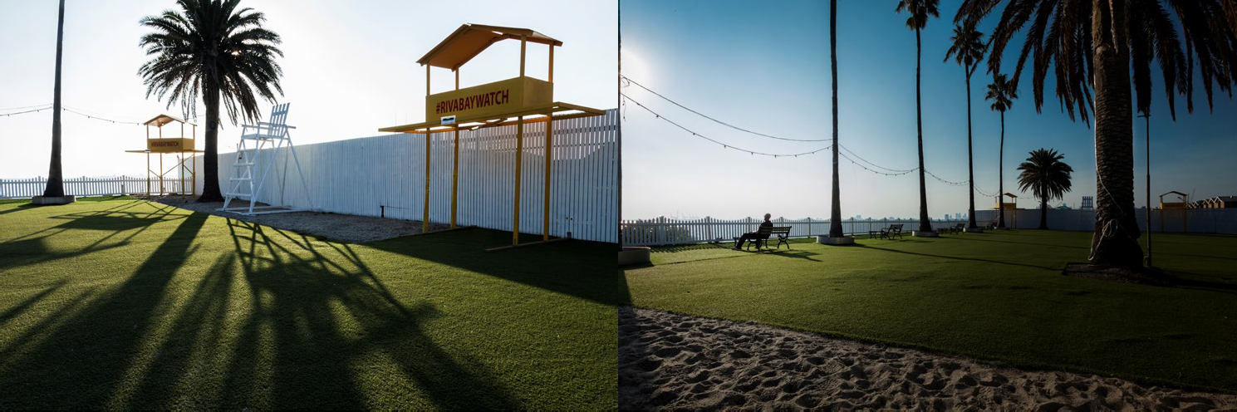
Figure 2 Images of transformative foreshore projects (Top L-R: Waterfront Place, Waterfront Place, bottom L-R: St Kilda Marina, St Kilda Marina). Source: CoPP 2020

Refer to Map 2 for a map showing our transformative projects.

City of Port Phillip draft Public Space Strategy

Map 2 Transformative projects in Port Phillip

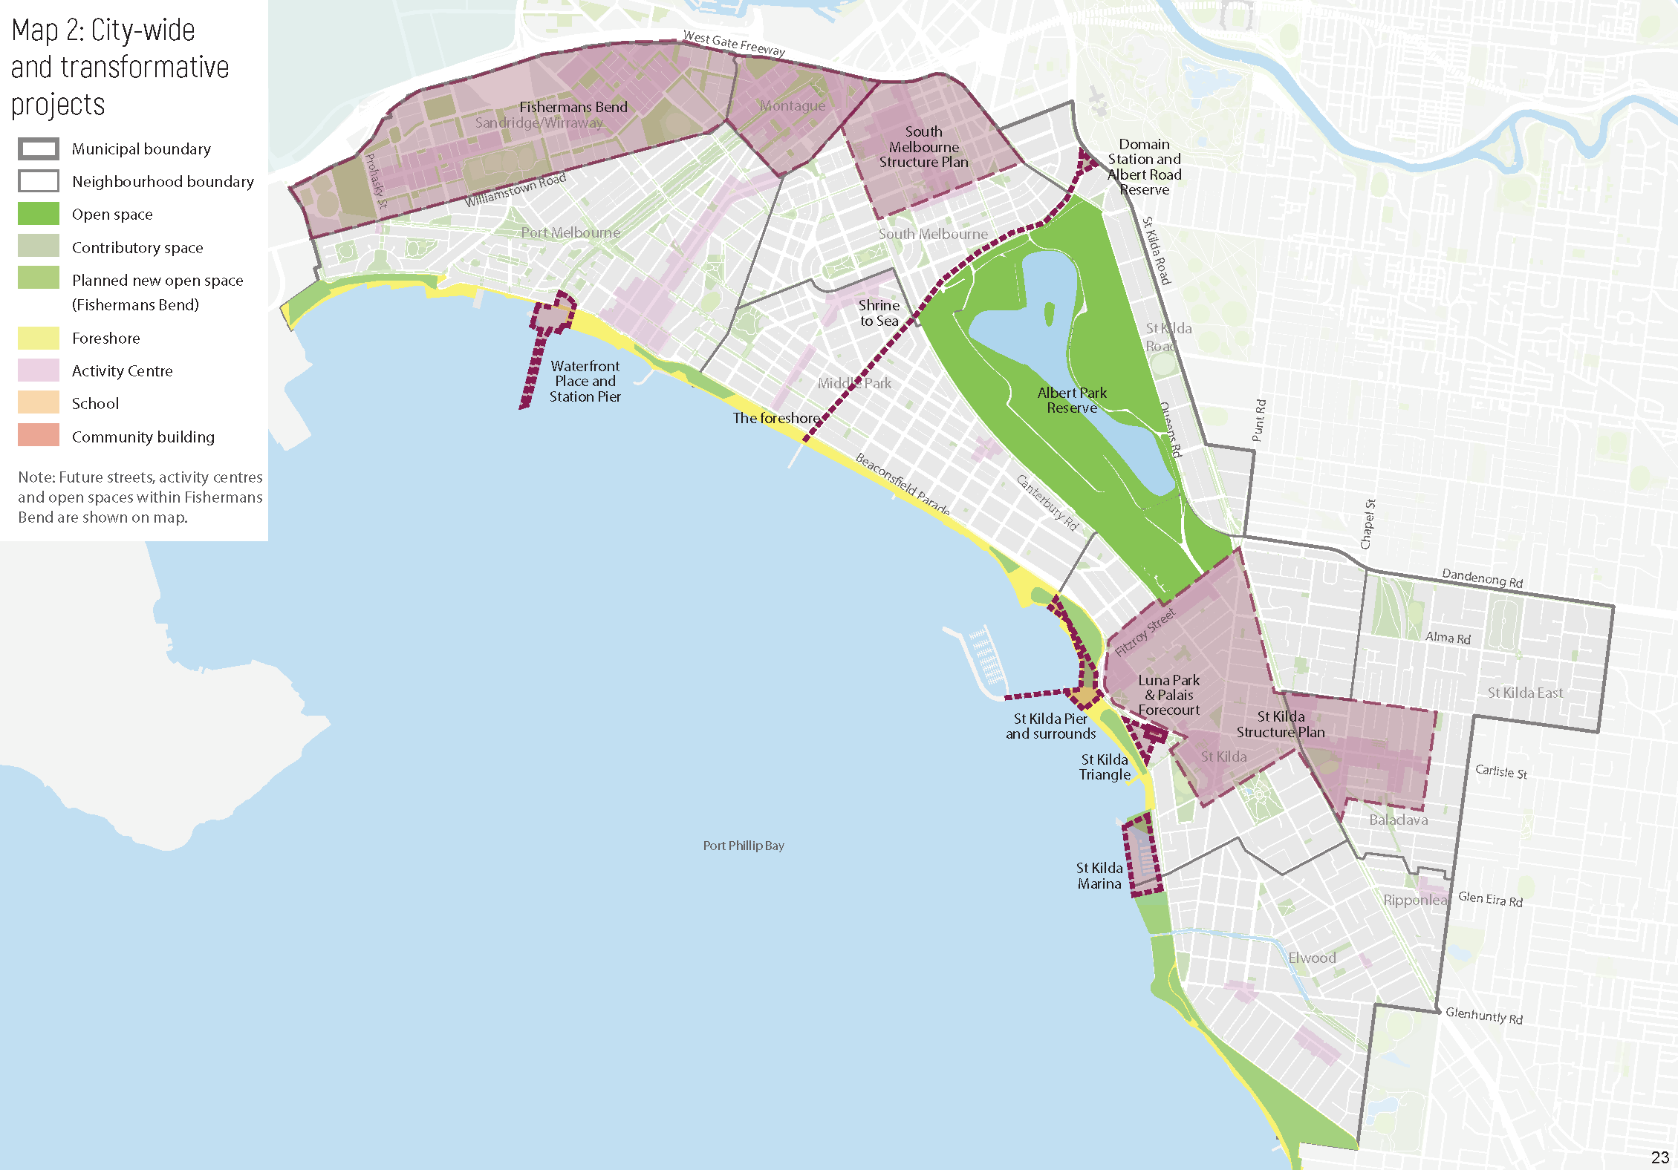
23

Inspiring ideas

Kirrip Park
Kirrip Park is a catalystic investment from Council in partnership with the Victorian Government that has transformed previously underutilised space into a popular park to service an existing and emerging community.
Location: South Melbourne

Key moves:
- working in partnership and leveraging an existing State Government project
- creation of new public space by repurposing road space
- creating a ‘transitional’ space that will be adaptable as the population continues to grow
- increased greening
- sustainable design elements.

Key design characteristics:
- terraced lawn areas for rest and recreation
- LED lighting, seating and footpaths for access through the park
- native garden beds, trees and shrubs
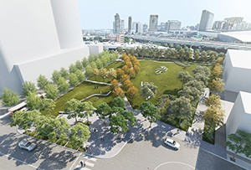
- water sensitive urban design to assist with flood mitigation, filtering and draining water.
Figure 3 Artists impression of Kirrip Park. Source: CoPP 2017

University Square
Location: Carlton, City of Melbourne, Victoria Designer: City of Melbourne’s City Design Studio Key moves:
24

- creation of new public space by removing car parking and traffic lanes
- reducing vehicle traffic
- providing both active and passive spaces.
- making getting around easier and enjoyable through infrastructure provision.

Key design characteristics:
- green lawn allows for both active and passive uses
- ample seating choices encourage use
- low planting promotes views into and out of the site
- retaining existing canopy trees to provide shade
- integrating water sensitive urban design into garden beds
- providing bike parking on the fringe of the site and within the central median of the street.
University Square is a good example of how a site can be revitalised and expanded while providing other functions. The following outcomes could be applied elsewhere: Refer to Figure 2 for photos.
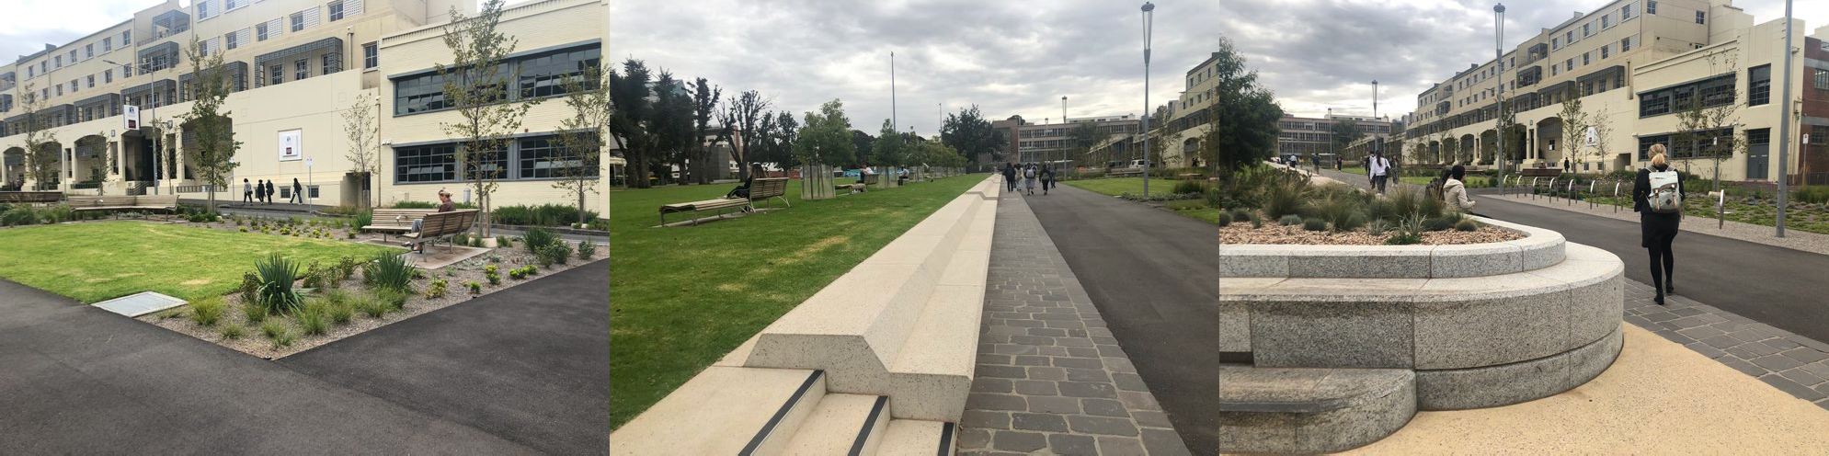
Figure 4 Images of University Square, Carlton designed by City of Melbourne’s City Design Studio. Source: CoPP 2020

RMIT A’Beckett Temporary Urban Square
Location: Corner of A’Beckett Street and Stewart Street, City of Melbourne, Victoria
Designer: Peter Elliott Architecture and Urban Design & TCL

Key moves
- temporarily activates a privately-owned site awaiting redevelopment
- providing active and passive spaces, including dedicated informal recreation spaces

Key design characteristics:
- brightly coloured courts and public art frame the space and tie it together
- oversized and tiered benches places for spectating or socialising
- night-time use is encouraged with bright lighting
- incorporates public art into the design
RMIT’s A’Beckett Square is a high-quality example of a temporary public space in a dense urban setting. Although not all temporary spaces will have RMIT’s funding the following outcomes could be applied elsewhere, such as to:

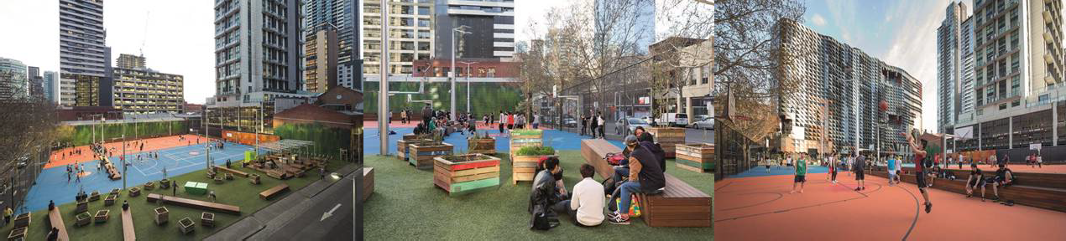

Figure 5 Images showing RMIT A'Beckett Temporary Urban Square designed by Peter Elliot Architecture and Urban Design & TCL. Source: John Gollings, 2019

Balfour Street Pocket Park
Location: Sydney, NSW
Designer: Jane Irwin Landscape Design

Key moves
- partial road closure to provide a transition between two redevelopments
- water sensitive urban design to capture water on site using a brick swale.

Key Design Characteristics:
- brick and natural stone paving echo the brewery buildings that once occupied the site
- day and night interest.
The City of Port Phillip could use this as an example for how to partially close a road to create new public space and make the most of smaller urban spaces.
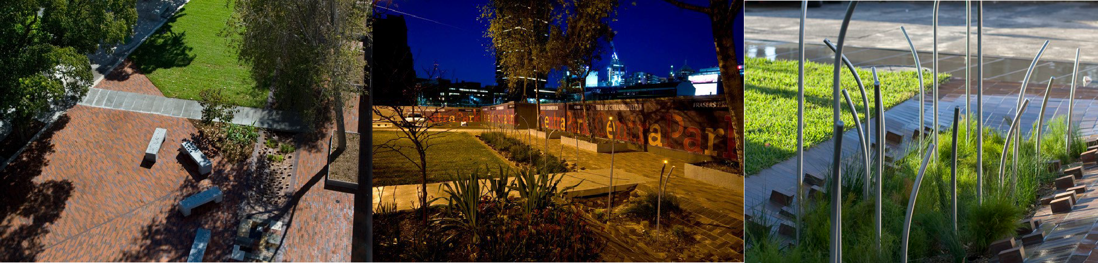
Figure 6 Images showing Balfour Street Pocket Park designed by Jane Irwin Landscape Architecture (JILA). Source: John Platt, City of Sydney, JILA

Our neighbourhoods

Public Space
Port Phillip is made up of nine neighbourhoods, each with their own distinctive character and community (see Map 3 below). While the city-wide spaces (the foreshore and Albert Park Reserve) contribute significantly to the overall network, the public spaces in each of the City’s neighbourhoods are greatly valued by our community.
Overall, we have a great existing public space network; the neighbourhood actions in this strategy seek to respond to the city-wide outcomes and resolve some issues with public space, including filling some gaps in the open space network (particularly in Balaclava/St Kilda East and South Melbourne) so that open space is accessible to everyone, as well as opportunities to improve the quality and diversity of our existing public spaces, and enhance key links and connections to these spaces.
For each neighbourhood, we have considered:
- population changes including forecast growth in residents and workers
- quantity, distribution and quality of existing open spaces
- accessibility of public open space (walking catchment based on the size and function of the space – people generally travel longer distances to larger spaces and shorter distances to smaller spaces)
- future responses to city-wide challenges including the COVID-19 pandemic.

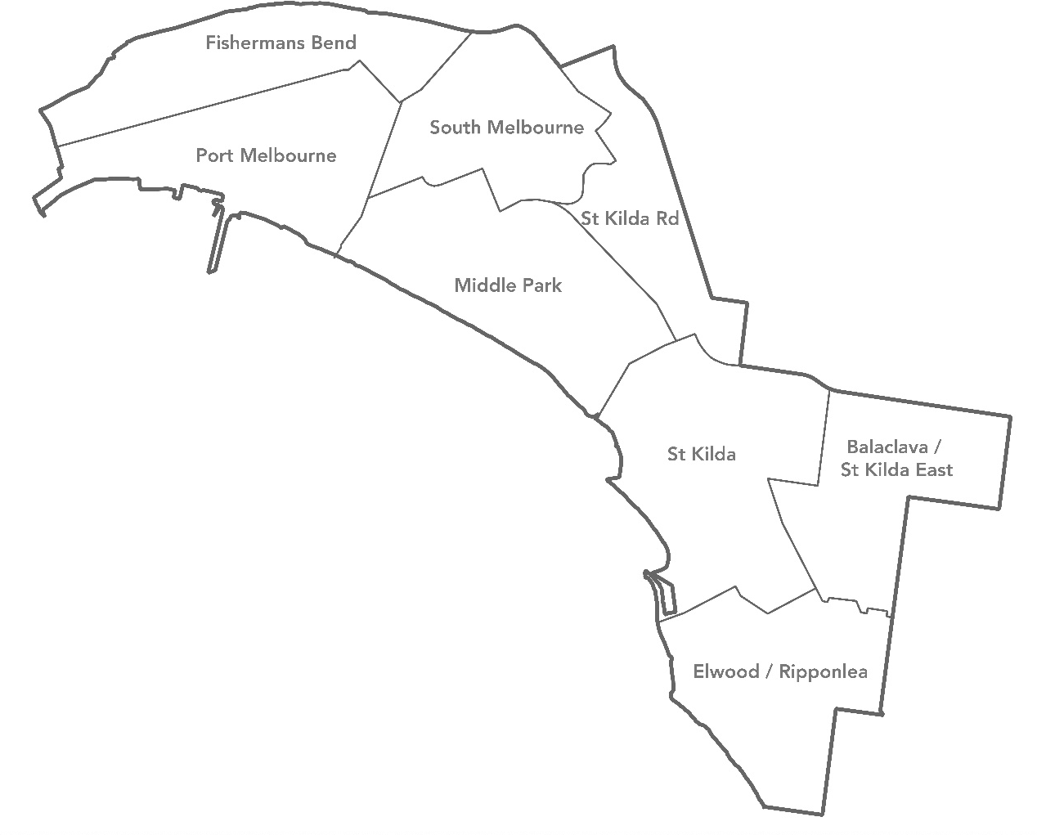
Map 3 Municipal and neighbourhood boundaries of Port Phillip

Action Plan
An action plan has been prepared for our neighbourhoods, except for Montague and Wirraway/Sandridge in Fishermans Bend, to guide investment in our public spaces. The State Government is currently preparing Precinct Plans for Fishermans Bend neighbourhoods, which will outline the role and function of new and existing public spaces in Fishermans Bend.

How have actions been chosen?
The actions in the action plan (excluding advocacy and partnership projects) have been selected to be fundable and deliverable based on available resources to 2031. If Council wants to deliver more
- a list of potential future projects can be found on page 41 – additional resources will be needed.
Priority has been given to public space projects Council has already committed to deliver, and then to actions that address key gaps in the quality, quantity, distribution or accessibility of the public space network. There is limited provision for new open spaces in the action plan – these are prioritised only for the areas with the largest gaps in our open space network.
While consideration has been given to ensuring a spread of projects across all neighbourhoods, some neighbourhoods have more actions than others. For example, neighbourhoods with less open space (such as Balaclava/East St Kilda) have more actions. Neighbourhoods with higher levels of population growth or visitors (such as St Kilda) also have more actions.
Projects have also been aligned to State Government committed projects to ensure we leverage the best outcomes.
Projects will also support Council’s response to the COVID-19 pandemic, through initiatives such as widened footpaths, new parklets and playspaces, street closure trials, improved wayfinding and supporting local businesses and creative organisations.

What types of actions are proposed?
  - provide new open space
  - expansion of existing open space
  - major and minor upgrades to open space
  - street tree planting
  - Structure Plans and strategies
  - pedestrian crossings
  - advocacy and partnerships
  - initiatives responding to the COVID-19 pandemic.

When will actions be delivered?
The action plan has been staged for short (2020-24), medium (2025-28) and long (2029-31) term projects – project timing for each action can be found in Appendix A.
The timeframes for delivery of projects varies and includes design, consultation and construction. Smaller play space renewals could be delivered within a year, while new spaces will likely to take up to six years.
A number of factors can increase the complexity of delivering projects such as the need to remediate contaminated land, heritage values and external approvals, partnership projects reliant on other parties, or land acquisition.

What involvement will the community have?
The identification of actions in this Strategy is the first step. Consultation will be undertaken with the community in the future on specific projects as they commence.

How will actions be funded?
Funding sources identified for Council-delivered projects include Council revenue (such as from rates), grants (such as those from the State Government) and public open space contributions from new development via the Port Philip Planning Scheme. The delivery of projects specified in the action plan will be dependent on annual budget allocations, through Council’s budget process.
The delivery of projects identified in this plan as advocacy and partnership projects are dependent on funding and commitment from other key stakeholders, such as the state government.

What other public space projects will Council deliver?
In addition to the actions identified in this Strategy, other public space projects will be delivered by Council, including:
  - Sport and Recreation facilities (e.g. upgrades to sporting fields and pavilions)
  - ongoing maintenance and renewal (e.g. maintenance and replacement of park and foreshore furniture, paths, lighting, play spaces etc.)
  - public space in Fishermans Bend (delivered by State or Council)
  - streetscape upgrades within activity centres (e.g. these will be determined by future Structure Plans).

Neighbourhood Action Plans
Each neighbourhood section includes an overview of the neighbourhood including the existing public space network and the expected future growth and change and impacts for public space, as well as a map showing the proposed actions. Appendix A has more detail on each action as well as the timing for delivery of the action.
The combined action plans for all neighbourhoods are shown in Map 4.

City of Port Phillip draft Public Space Strategy

Map 4 Neighbourhood actions

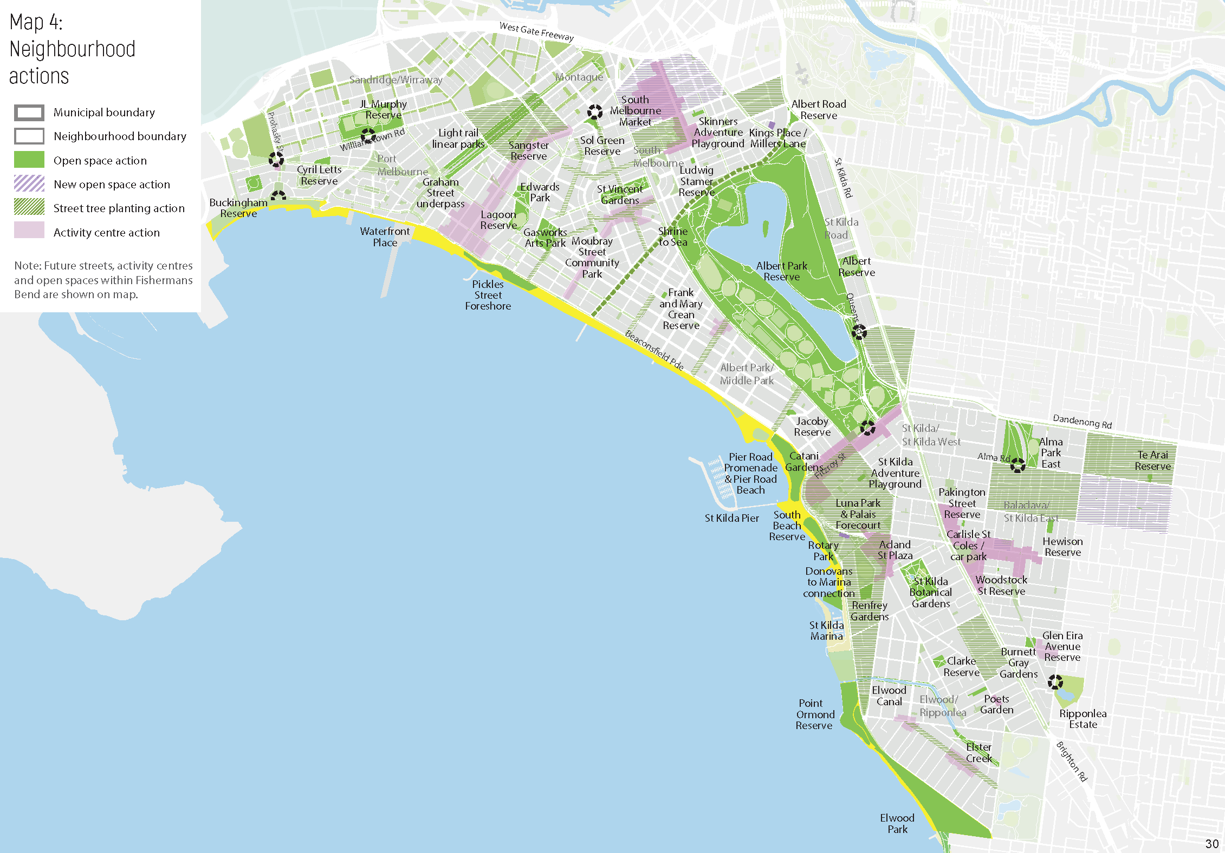

30

City of Port Phillip draft Public Space Strategy

Albert Park/Middle Park
Made up of the suburbs of Albert Park, Middle Park and a small portion of St Kilda West, this area is well known for its heritage character and wide, tree-lined streets.
Albert Park/Middle Park has 26 open spaces, making up 31 per cent of the total neighbourhood, which is significantly higher than the Port Phillip average of 17 per cent. High quality spaces such as the foreshore and Albert Park Reserve as well as smaller spaces provide a diverse range of recreational facilities for the community, and this is our best-serviced neighbourhood with no gaps in the open space network.
Other public spaces include the retail streetscapes of Armstrong Street in Middle Park and Bridport/Victoria Streets in Albert Park as well as contributory spaces including Albert Park College, Albert Park Primary School, Middle Park Primary School and Mary Kehoe Community Centre.
This neighbourhood has an excellent permeable street network with wide road reserves that have space for large canopy trees.
Albert Park/Middle Park is experiencing the least amount of growth of all of our neighbourhoods, with no growth projected by 2031 (staying at around 11,950 residents). Older persons aged 50 or more make up the largest proportion of people, compared to the City average, and most people live in houses with backyards. It is important that public spaces cater to the needs of a diversity of age groups with a focus on ensuring that children and older people are well provided and act as places for exercise, socialising and meeting friends and urban greening.
Map 5 shows the actions in Albert Park/Middle Park. Appendix A includes a more detailed description and timing of actions.

Key moves
  - improve the quality of three existing open spaces (Frank and Mary Crean Resreve, Gasworks Arts Park, Moubray Street Community Park)
  - improve pedestrian amenity in key local streets through increased greening and seating.

31

City of Port Phillip draft Public Space Strategy

Map 5 Neighbourhood actions for Albert Park/Middle Park

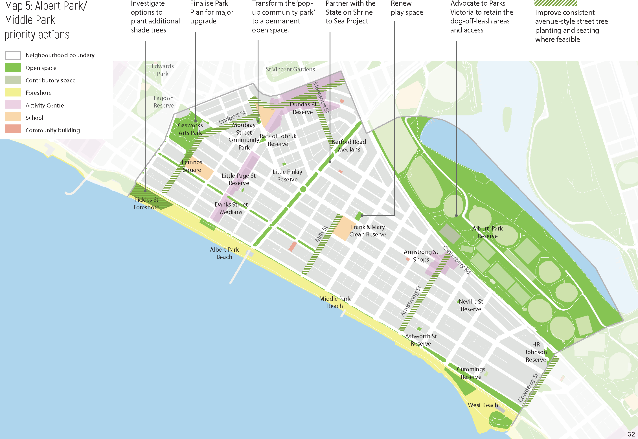
32

City of Port Phillip draft Public Space Strategy

Balaclava/St Kilda East
Made up of the suburbs of Balaclava and St Kilda East, this neighbourhood’s distinctiveness comes from a range of features including a diversity of housing types, the highly valued and well- loved Alma Park, the civic precinct of the St Kilda Town Hall and the unique retail hub of Carlisle Street. There is a prominent Jewish community that adds a vitality and distinctiveness to the area.
Balaclava/St Kilda East has eight open spaces, making up five per cent of the total neighbourhood area. While Alma Park is one of the highest quality spaces in the municipality, Balaclava/St Kilda East has the lowest amount of open space of all our neighbourhoods, significantly lower than the Port Phillip average of 17 per cent and has one of the larger historic gaps in our open space network. As such, it is a focus area for additional open space in the future.
Other public spaces include the retail streetscape of Carlisle Street as well as contributory spaces such as the St Kilda Primary School, St Kilda library forecourt and St Kilda Town Hall Surrounds.
Narrow local streets result in a lack of canopy cover and trees and the relatively poor permeability in the street network makes it harder for people to easily and comfortably walk to public spaces. It is also acknowledged that major roads act as a barrier to safe and easy access to existing open spaces for some in the community, particularly for children, the elderly and those with limited mobility.
Balaclava/East St Kilda is expected to grow by just over four per cent by 2031 (with over 840 additional residents taking the population to around 19,000). This neighbourhood has a diverse community, with a higher proportion of young children and young workers and a lower proportion of older person and persons living on their own, compared to the rest of the City. We need new open spaces in this neighbourhood, and the existing spaces should provide the opportunity for children’s play, as well as a mix of uses for young families and young adults.
Map 6 shows the actions in Balaclava/St Kilda East. Appendix A includes a more detailed description and timing of actions.

Key moves
  - create two new open spaces and increase the size of one existing open space (Pakington Street Reserve), to fill gaps in the open-space network, strengthen the community heart of Carlisle Street and increase the quantity of open space
  - improve the quality of five existing open spaces (Alma Park East, Hewison Reserve, Pakington Street Reserve, Te Arai Reserve, Woodstock Street Reserve)
  - improve the diversity of the local open space network to increase appeal and level of use
  - improve pedestrian amenity in key local streets through increased greening and improve pedestrian crossing to Alma Park.

33

City of Port Phillip draft Public Space Strategy

Map 6 Neighbourhood actions for Balaclava/St Kilda East
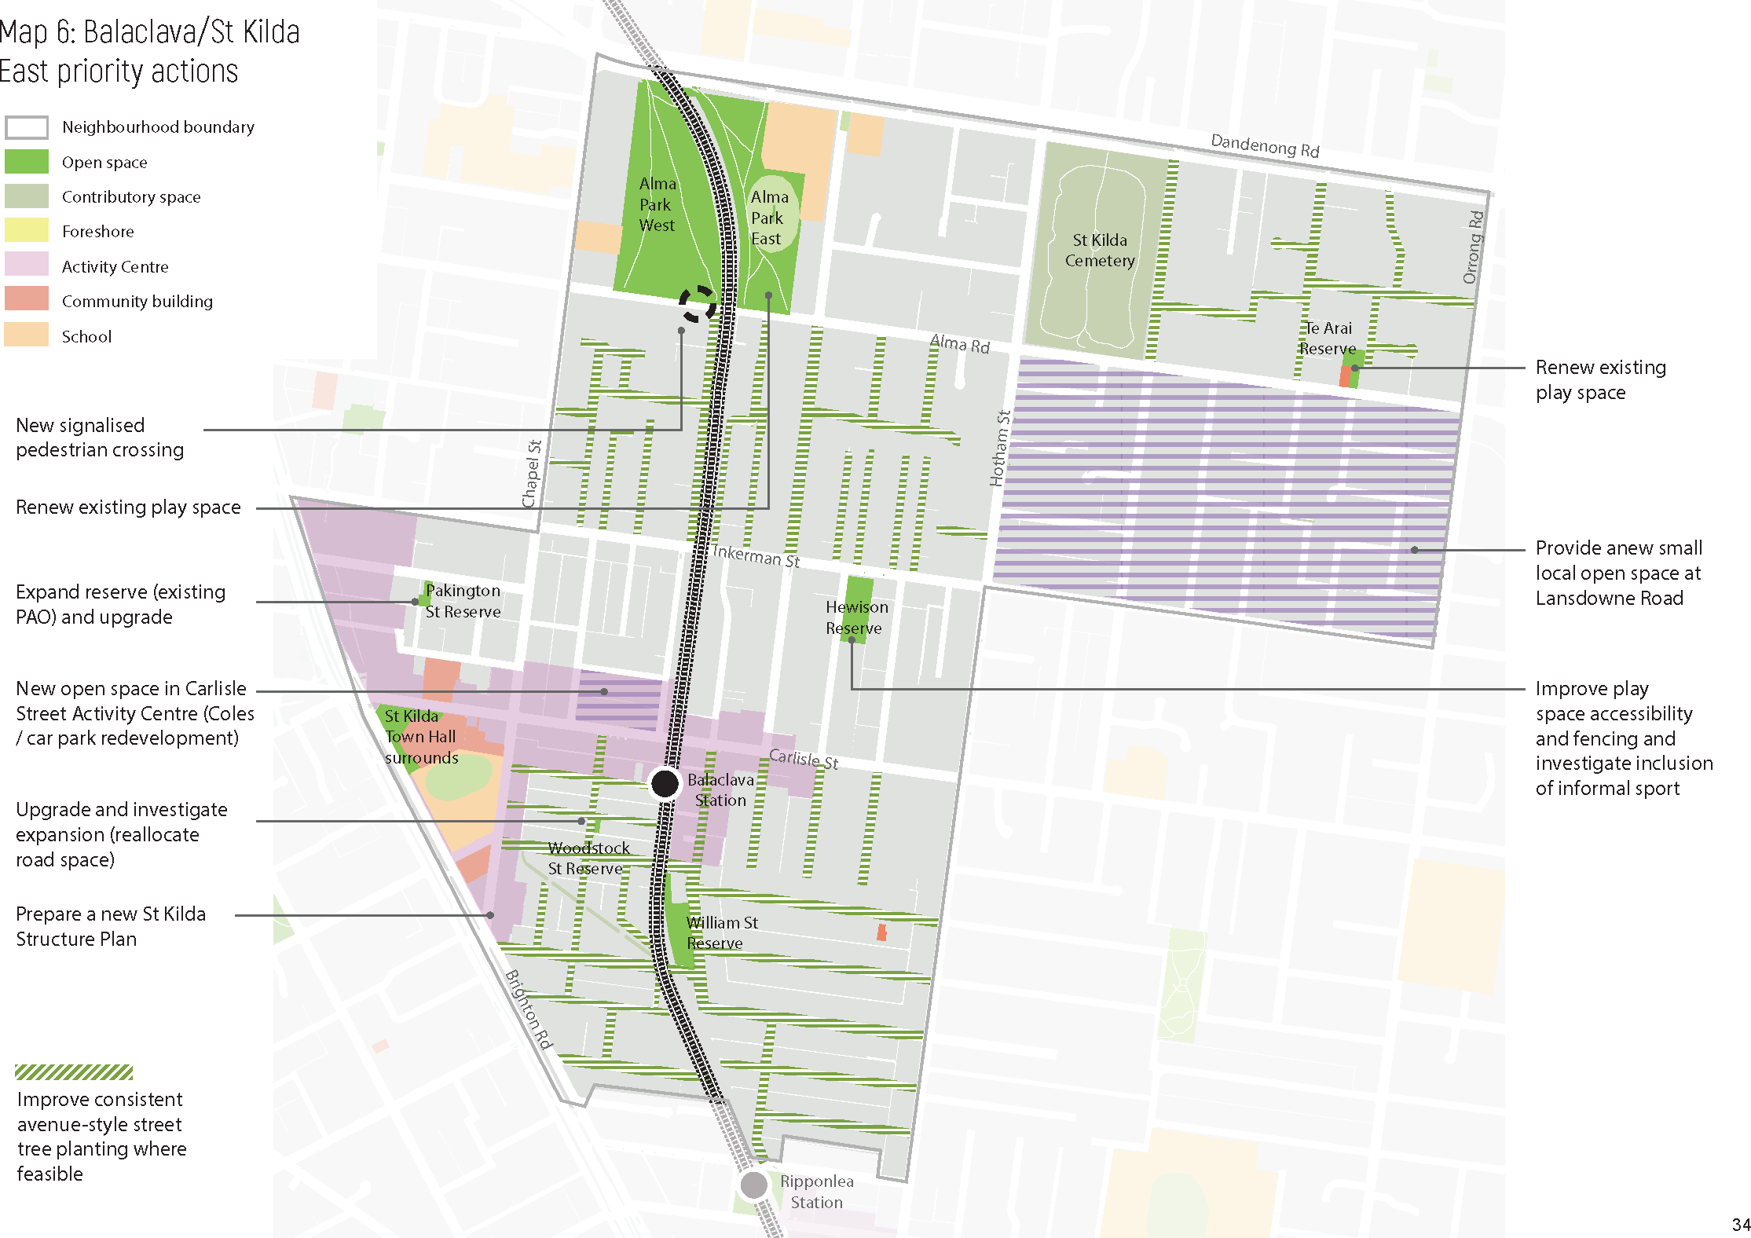

34

City of Port Phillip draft Public Space Strategy

Elwood/Ripponlea
Made up of the suburbs of Elwood and Ripponlea, this neighbourhood is known for its leafy streets and suburban character with lower urban densities than surrounding neighbourhoods. The local shopping streets with vibrant cafes and restaurants combined with Elwood Canal, Elster Creek and the Elwood Foreshore all contribute to its distinctive character.
This neighbourhood has 22 open spaces, making up 13 per cent of the total neighbourhood. This is slightly lower than the Port Phillip average of 17 per cent. There are some smaller gaps within the municipality in the eastern part of this Neighbourhood, and Ripponlea has less open space than Elwood. However, significant open space outside the municipality adjoins this neighbourhood to the east, including Ripponlea Estate and Elsternwick Park.
Other public spaces include the retail streetscapes of Ormond/Glen Huntly Roads and Tennyson Street, as well as contributory spaces including Elwood Primary School, Elwood College and Elwood Neighbourhood Learning Centre.
While Elwood has excellent walkability with wide, tree-lined streets, Ripponlea has relatively narrow streets with limited opportunity for canopy trees. It is acknowledged that crossing major roads is a barrier to safe and easy access to open spaces for some in the community, particularly children, the elderly and those with limited mobility.
This neighbourhood will only experience approximately 1.7 per cent growth by 2031, (over 290 additional residents, taking the population to around 17,300). It has a higher proportion of family households with children, making Elwood School Reserve and Elwood Primary and Secondary schools a central hub for this community. A large number of people in this neighbourhood live in medium- to high-density housing, increasing the demand and need for public space that provides social and green spaces for families, as well for fitness, exercise and sport. Facilities in public space need to continue to cater to a diversity of age groups, specifically children and those aged 35 to 49.
Map 7 shows the actions in Elwood/Ripponlea. Appendix A includes a more detailed description and timing of actions.

Key moves
  - investigate expanding the size of an existing open space in Ripponlea (Glen Eira Avenue Reserve) through reallocation of road space
  - improve the quality and diversity of six existing open spaces including spaces along the foreshore to increase appeal and level of use (Burnett Gray Gardens, Clarke Reserve, Elwood Park and Elwood Foreshore, Glen Eira Avenue Reserve, Poets Garden (Elwood Neighbourhood Community Centre Reserve) and Point Ormond Reserve)
  - investigate the opportunity for a dog-off-leash park at MO Moran Reserve
  - improve pedestrian amenity in key local streets through increased greening and seating, including along the shopping strip on Ormond Road
  - investigate a long-term agreement with Ripponlea Estate for ongoing access for the City of Port Phillip community.

35

City of Port Phillip draft Public Space Strategy

Map 7 Neighbourhood actions for Elwood/Ripponlea

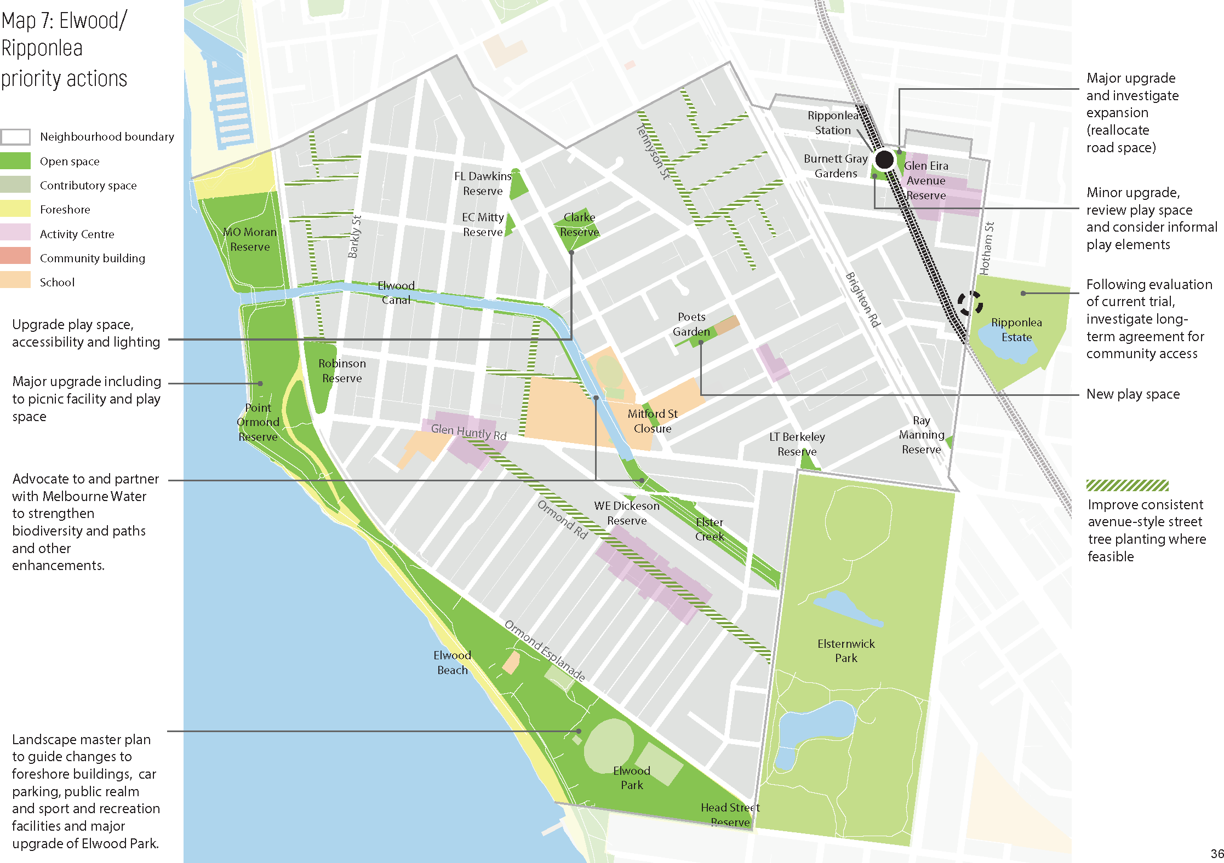

36

City of Port Phillip draft Public Space Strategy

Port Melbourne
Port Melbourne is considered the ‘gateway to Melbourne’ via Station Pier, where cruise ships and the Spirit of Tasmania dock, making it a major access point. Port Melbourne’s waterfront precinct brings many visitors, attracted to foreshore promenade and beaches, and the retail strip along Bay Street.
Port Melbourne has 56 open spaces – the highest number of all our neighbourhoods – making up 17 per cent of the total neighbourhood. This is on par with the City average of 17 per cent. Almost everyone in this neighbourhood lives and works within a safe and easy walk of open space, due to the diverse and well distributed open space network that includes access to the foreshore Two existing major sporting facilities adjoin the northern boundary of the neighbourhood – JL Murphy Reserve and North Port Oval – and more new spaces are planned in Fishermans Bend in the future. Access to these spaces across major roads is currently poor due to a lack of pedestrian crossings.
Other public spaces include the retail streetscapes of Bay Street and Centre Avenue, as well as contributory spaces including Port Melbourne Primary School and Port Philip Specialist School as well as three publicly accessible private church grounds.
The street network is well connected, however the consistency of large broad spreading canopy shade trees could be improved, as could the amenity on some of the major and arterial roads.
Growth in Port Melbourne will be relatively low, with an expected 1.3 per cent increase by 2031 (over 400 additional residents, taking the population to around 18,000). Forecast growth in Fishermans Bend (to the north of this neighbourhood) is high, however, and will likely result in an increased level of use of public space within Port Melbourne. There is a higher proportion of families with young children and older people in this neighbourhood when compared to the City average. In the future, it will be important to ensure that the network is diverse and caters to a wide range of uses from play to informal sport to passive enjoyment.
Map 8 shows the actions in Port Melbourne. Appendix A includes a more detailed description and timing of actions.

Key moves
  - improve the quality and diversity of eight existing open spaces to increase appeal and level of use (Buckingham Reserve, Cyril Letts Reserve, Edwards Park, Graham Street Underpass, JL Murphy Reserve, Lagoon Reserve, Port Melbourne Light Rail Corridor (landscape masterplan), Sangster Reserve)
  - investigate the opportunity for a dog-off-leash park
  - improve pedestrian amenity in key local streets through increased greening
  - advocate for improved pedestrian crossings across Williamstown Road to Fishermans Bend
  - advocate/partner with the Victorian Government for improved public space at Waterfront Place, integrated with a future Station Pier upgrade.

37

City of Port Phillip draft Public Space Strategy

Map 8 Neighbourhood actions for Port Melbourne

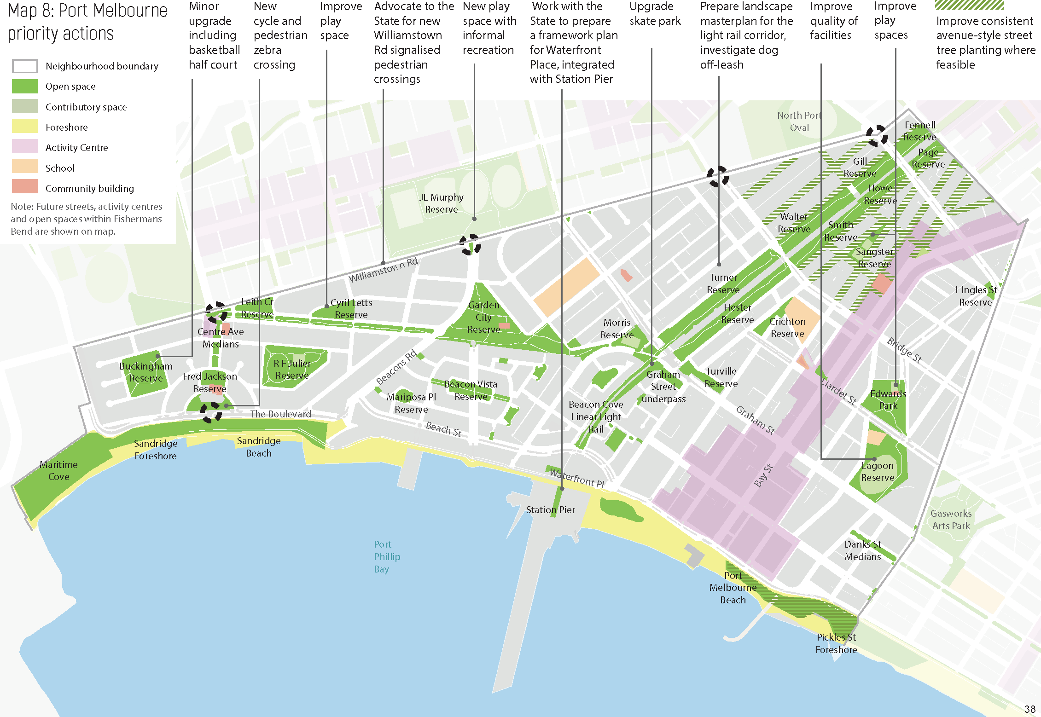

38

City of Port Phillip draft Public Space Strategy

South Melbourne
South Melbourne is one of the oldest neighbourhoods in our City. Clarendon Street, Coventry Street and South Melbourne Market attract both locals and visitors and the neighbourhood has a mix of both residential and business uses. The area also includes a significant cluster of creative industries and their workers.
South Melbourne has 18 open spaces, making up 14 per cent of the total neighbourhood. This is lower than the Port Phillip average of 17 per cent. While this neighbourhood has a diversity of open spaces, including Skinners Adventure Playground, and Albert Park Reserve and St Vincent’s Gardens, one of the larger historical gaps in our open space network is located in the north-east of this neighbourhood within the South Melbourne Major Activity Centre.
Other public spaces include the retail streetscape of Clarendon Street as well as contributory spaces including South Melbourne Market, South Melbourne Park Primary School, South Melbourne Town Hall and Park Towers. Publicly accessible private spaces include two church grounds.
The street layout is made up of wide, well connected streets, many with excellent canopy cover and greening. Laneways also contribute to the pedestrian permeability.
South Melbourne is expected to experience 5.7 per cent growth by 2031 (over 660 additional residents, taking the population to around 12,170 residents). It is also likely that the number of workers in this neighbourhood will increase, and the use of public space in South Melbourne may also increase due to the projected growth in Fishermans Bend. This neighbourhood has a higher than average proportion of older people and family households with children, and lower proportion of residents aged between 18 and 34, compared to the rest of our City. This means that the existing excellent access to sporting and recreation facilities should be retained and the diversity of facilities for families and social facilities improved.
Map 9 shows the actions in South Melbourne. Appendix A includes a more detailed description and timing of actions.

Key moves
  - investigate the opportunity for two new open spaces to fill gaps in the open space network and strengthen the community heart of the South Melbourne central activity centre
  - investigate expanding the size of an existing open space through reallocation of road space (Sol Green Reserve)
  - improve the quality and diversity of three existing open spaces (Ludwig Stamer Reserve, , Sol Green Reserve and St Vincent Gardens)
  - improve pedestrian amenity in local streets through increased greening
  - improve pedestrian access to South Melbourne Market and advocate for improved connectivity to Fishermans Bend
  - advocate to Parks Victoria for a seamless connection between Albert Road Reserve and Albert Park Reserve as part of the Shrine to Sea project.

39

City of Port Phillip draft Public Space Strategy

Map 9 Neighbourhood actions for South Melbourne

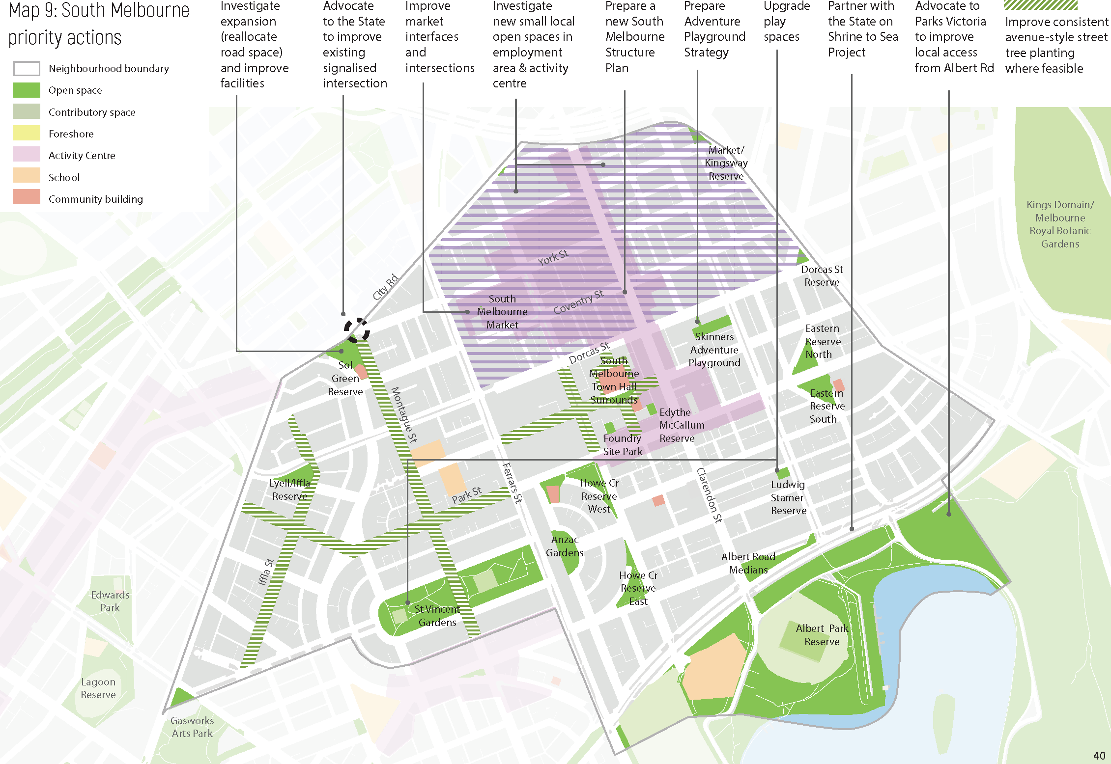
40

City of Port Phillip draft Public Space Strategy

St Kilda Road
Made up of parts of the suburbs of Melbourne, Windsor, Albert Park and South Melbourne, St Kilda Road is one of Melbourne’s most famous streets. Its role as a premier office location supporting Melbourne’s Central Activities District will be boosted by the new Anzac Station for the Metro Tunnel in the Domain Precinct.
St Kilda Road has four open spaces, making up 12 per cent of the total neighbourhood. This is lower than the Port Phillip Average of 17 per cent. This neighbourhood has three large parklands within close proximity – Albert Park Reserve within the municipality, and Fawkner Park and Kings Domain/Melbourne Royal Botanic Gardens located nearby but outside the municipality.
Other public spaces include the contributory space of Mac Robertson Girls High School within Albert Reserve. Unique to St Kilda Road are the publicly accessible private forecourts that form an entry to many of the office buildings in the area.

While the heritage listed tree lined boulevard of St Kilda Road significantly contributes to the character of this neighbourhood, the long narrow nature of the urban layout, which is contained between two major arterial roads, restricts pedestrian access and permeability. It is acknowledged that crossing arterial and major roads is necessary to access open spaces is a challenge for some in the community, particularly children, the elderly and those with limited mobility.

St Kilda Road is our second fastest growing neighbourhood with expected growth of 37 per cent by 2031 (over 5,530 additional residents, taking the population to around 20,500 residents), and a significant employment hub with the number of workers also expected to increase. There is a much higher proportion of young people aged 18 to 34 years and a much smaller proportion of parents and young children, compared to the city average. The vast majority of people (97 per cent) live in high-density housing – large, multi-story apartment buildings – with significant levels of growth and development to continue. This means more people rely on public open space for outdoor recreation, access to nature and social connectedness.
Map 10 shows the actions in St Kilda Road. Appendix A includes a more detailed description and timing of actions.

Key moves
  - create a new public plaza in the Domain Precinct through reallocation of road space (Kings Place/Millers Lane)
  - improve pedestrian amenity in local streets through increased greening
  - advocate to Parks Victoria for public access to Albert Reserve and improved pedestrian connections and access into Albert Park Reserve.

41

City of Port Phillip draft Public Space Strategy

Map 10 Neighbourhood actions for St Kilda Road

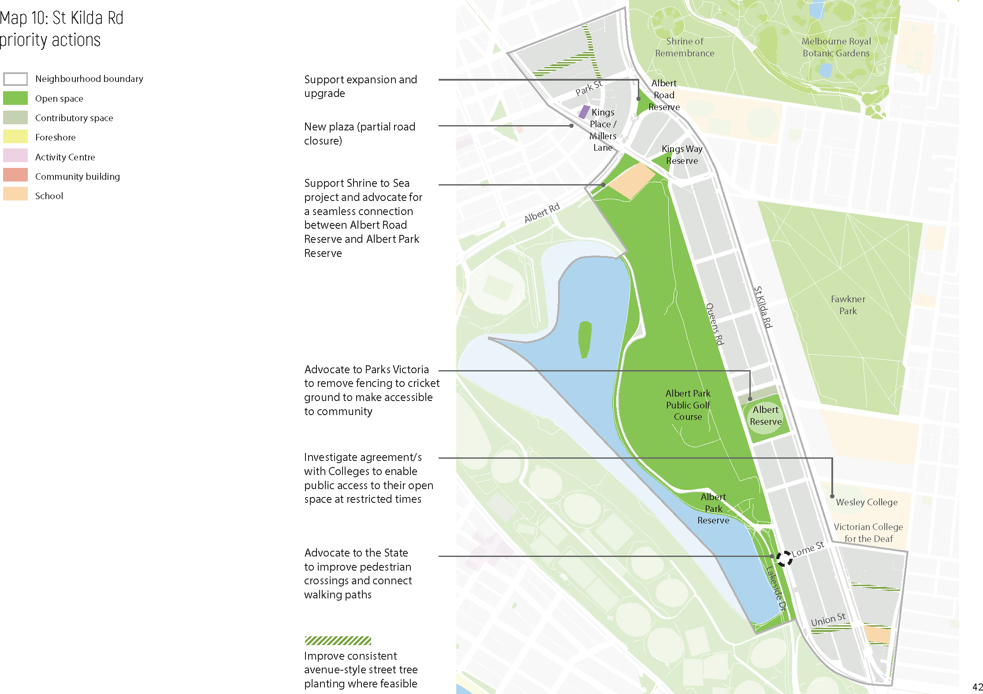

42

City of Port Phillip draft Public Space Strategy

St Kilda/St Kilda West
Made up of most of St Kilda, a small part of Elwood and most of St Kilda West, this neighbourhood is known for its iconic retail strips, significant open spaces and the foreshore. St Kilda attracts over a million visitors a year and is home to many of Melbourne’s famous attractions including Luna Park, St Kilda Beach and Acland Street. St Kilda also hosts major events including St Kilda Festival and Pride March.
St Kilda/St Kilda West has 35 open spaces, making up 17 per cent of this neighbourhood. This is the same as the Port Phillip average. There is generally a good distribution of open spaces within a short walking distance of everyone.
Other public spaces include the retail streetscapes of Fitzroy and Acland Streets, St Kilda Park Primary School (contributory public space) and Christ Church on Acland Street (publicly accessible private space).
This neighbourhood has an excellent walking network, wide road reserves with large broad- spreading canopy trees and access to high quality spaces such as the foreshore, Albert Park Reserve and St Kilda Botanical Gardens.
St Kilda/St Kilda West is forecast to experience 10 per cent growth by 2031 (over 2,620 additional residents, taking the population to around 28,500 residents. There is a smaller proportion of younger people (under 17 years) living in this neighbourhood, with a higher proportion of people aged 18 to 34 years and prominence of young couples, singles and group households, compared to the City average. There is a lower proportion of families with young children compared to the rest of our City. Most people live in terrace housing, ‘walk up’ flats or newer apartments suggesting a high reliance on public spaces for access to nature, recreation and socialising.
Map 11 shows the actions in St Kilda/St Kilda West. Appendix A includes a more detailed description and timing of actions.

Key moves
  - create a new Palais/Luna Park forecourt through reallocation of road space
  - improve the quality and diversity of eight existing open spaces, including those along the foreshore (Acland Street Plaza, Catani Gardens, Jacoby Reserve, Pier Road Beach and Promenade, Renfrey Gardens, Rotatry Park, South Beach Reserve and St Kilda Botanical Gardens)
  - improve pedestrian amenity in key local streets through increased greening
  - engage in advocacy and partnership projects for the foreshore, including Station Pier and St Kilda Marina.

43

City of Port Phillip draft Public Space Strategy

Map 11 Neighbourhood actions for St Kilda/St Kilda West

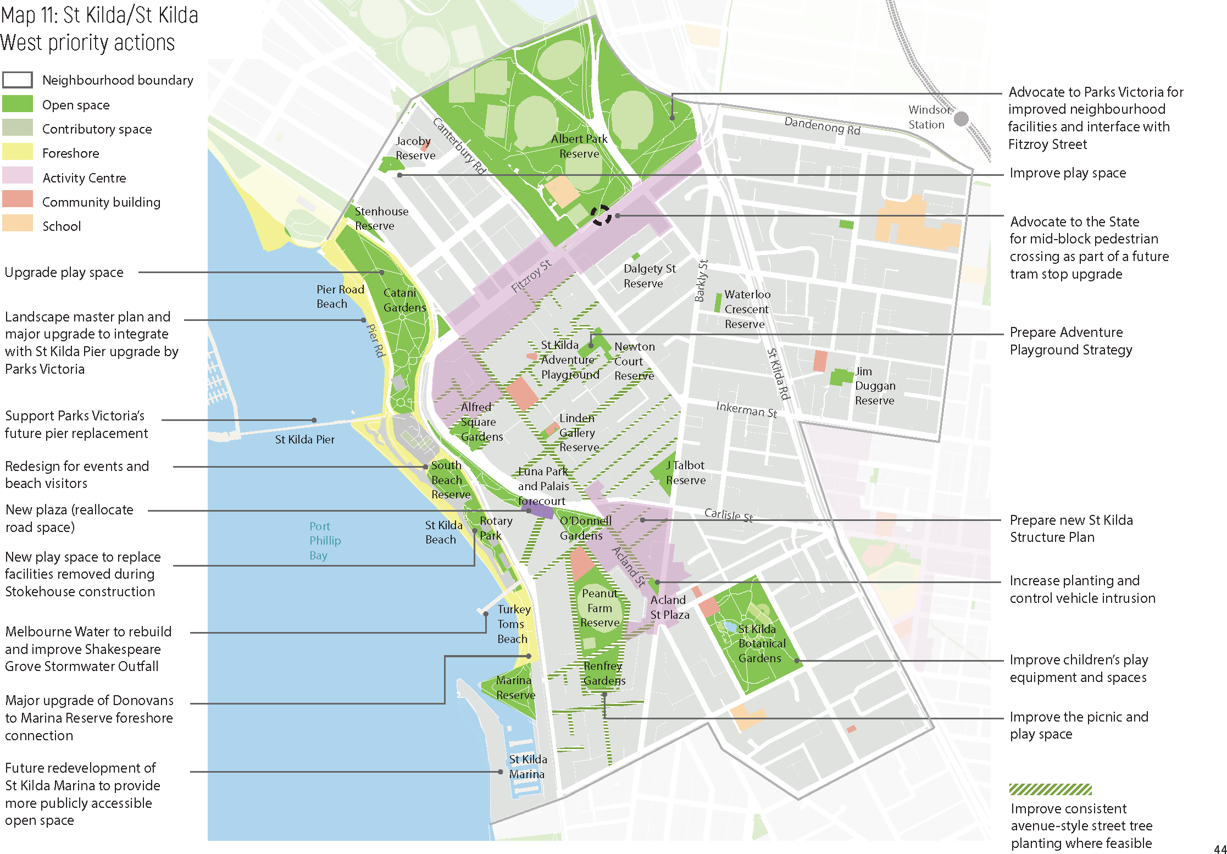

44

City of Port Phillip draft Public Space Strategy

Montague and Sandridge/Wirraway – Fishermans Bend
Three out of four precincts within Fishermans Bend are located within the City of Port Phillip, comprising two of our neighbourhoods – Montague and Sandridge/Wirraway. Lorimer is located within City of Melbourne.
Montague and Sandridge/Wirraway have four existing open spaces as well as a network of planned new open spaces, which once delivered will make up 21 per cent of these neighbourhoods (see Map 12). Once delivered, this will be higher than the Port Phillip average, however it is noted that the density in Fishermans Bend will also be substantially higher than much of the rest of the municipality. JL Murphy Reserve and North Port Oval are two existing major sporting facilities within this neighbourhood. The proposed open spaces will generally provide a good distribution of open spaces within a short walking distance of everyone.
Other public spaces will include retail streetscapes in each neighbourhood, existing schools (Montague Continuing Education Centre and South Melbourne Primary School) as well as additional spaces in the future such as new schools and forecourts to new community hubs.
While the permeability and quality of the existing street network is poor, in the future once fully developed, these neighbourhoods will have an excellent walking network with a permeable street network.
Montague and Sandridge/Wirraway are expected to be Port Phillip’s fastest growing neighbourhoods, forecast to experience 705 per cent growth by 2031 (over 13,000 additional residents, taking the population to around 14,850). These neighbourhoods are projected to keep growing and accommodate 68,000 people and 34,000 jobs by 2050. It is expected that this new population will also use existing public space in South Melbourne and Port Melbourne.
Map 12 shows the existing and planned new public space network in Fishermans Bend. The State Government is preparing Precinct Plans for Fishermans Bend which will determine the role and function of open spaces in this neighbourhood and a funding and finance strategy (including an Infrastructure Contributions Plan) to deliver these works. Because of this, there is no detailed action plan for the Fishermans Bend neighbourhoods in this Strategy.
We will continue to work with the State in planning for Fishermans Bend, and advocate for:
  - early delivery of key open spaces within Fishermans Bend, to keep up with population growth
  - improved connectivity between public space in Fishermans Bend and South Melbourne and Port Melbourne
  - high quality public spaces with a range of uses and functions to meet the needs of the future community.

45

City of Port Phillip draft Public Space Strategy

Map 12 Existing and new public space network in Fishermans Bend

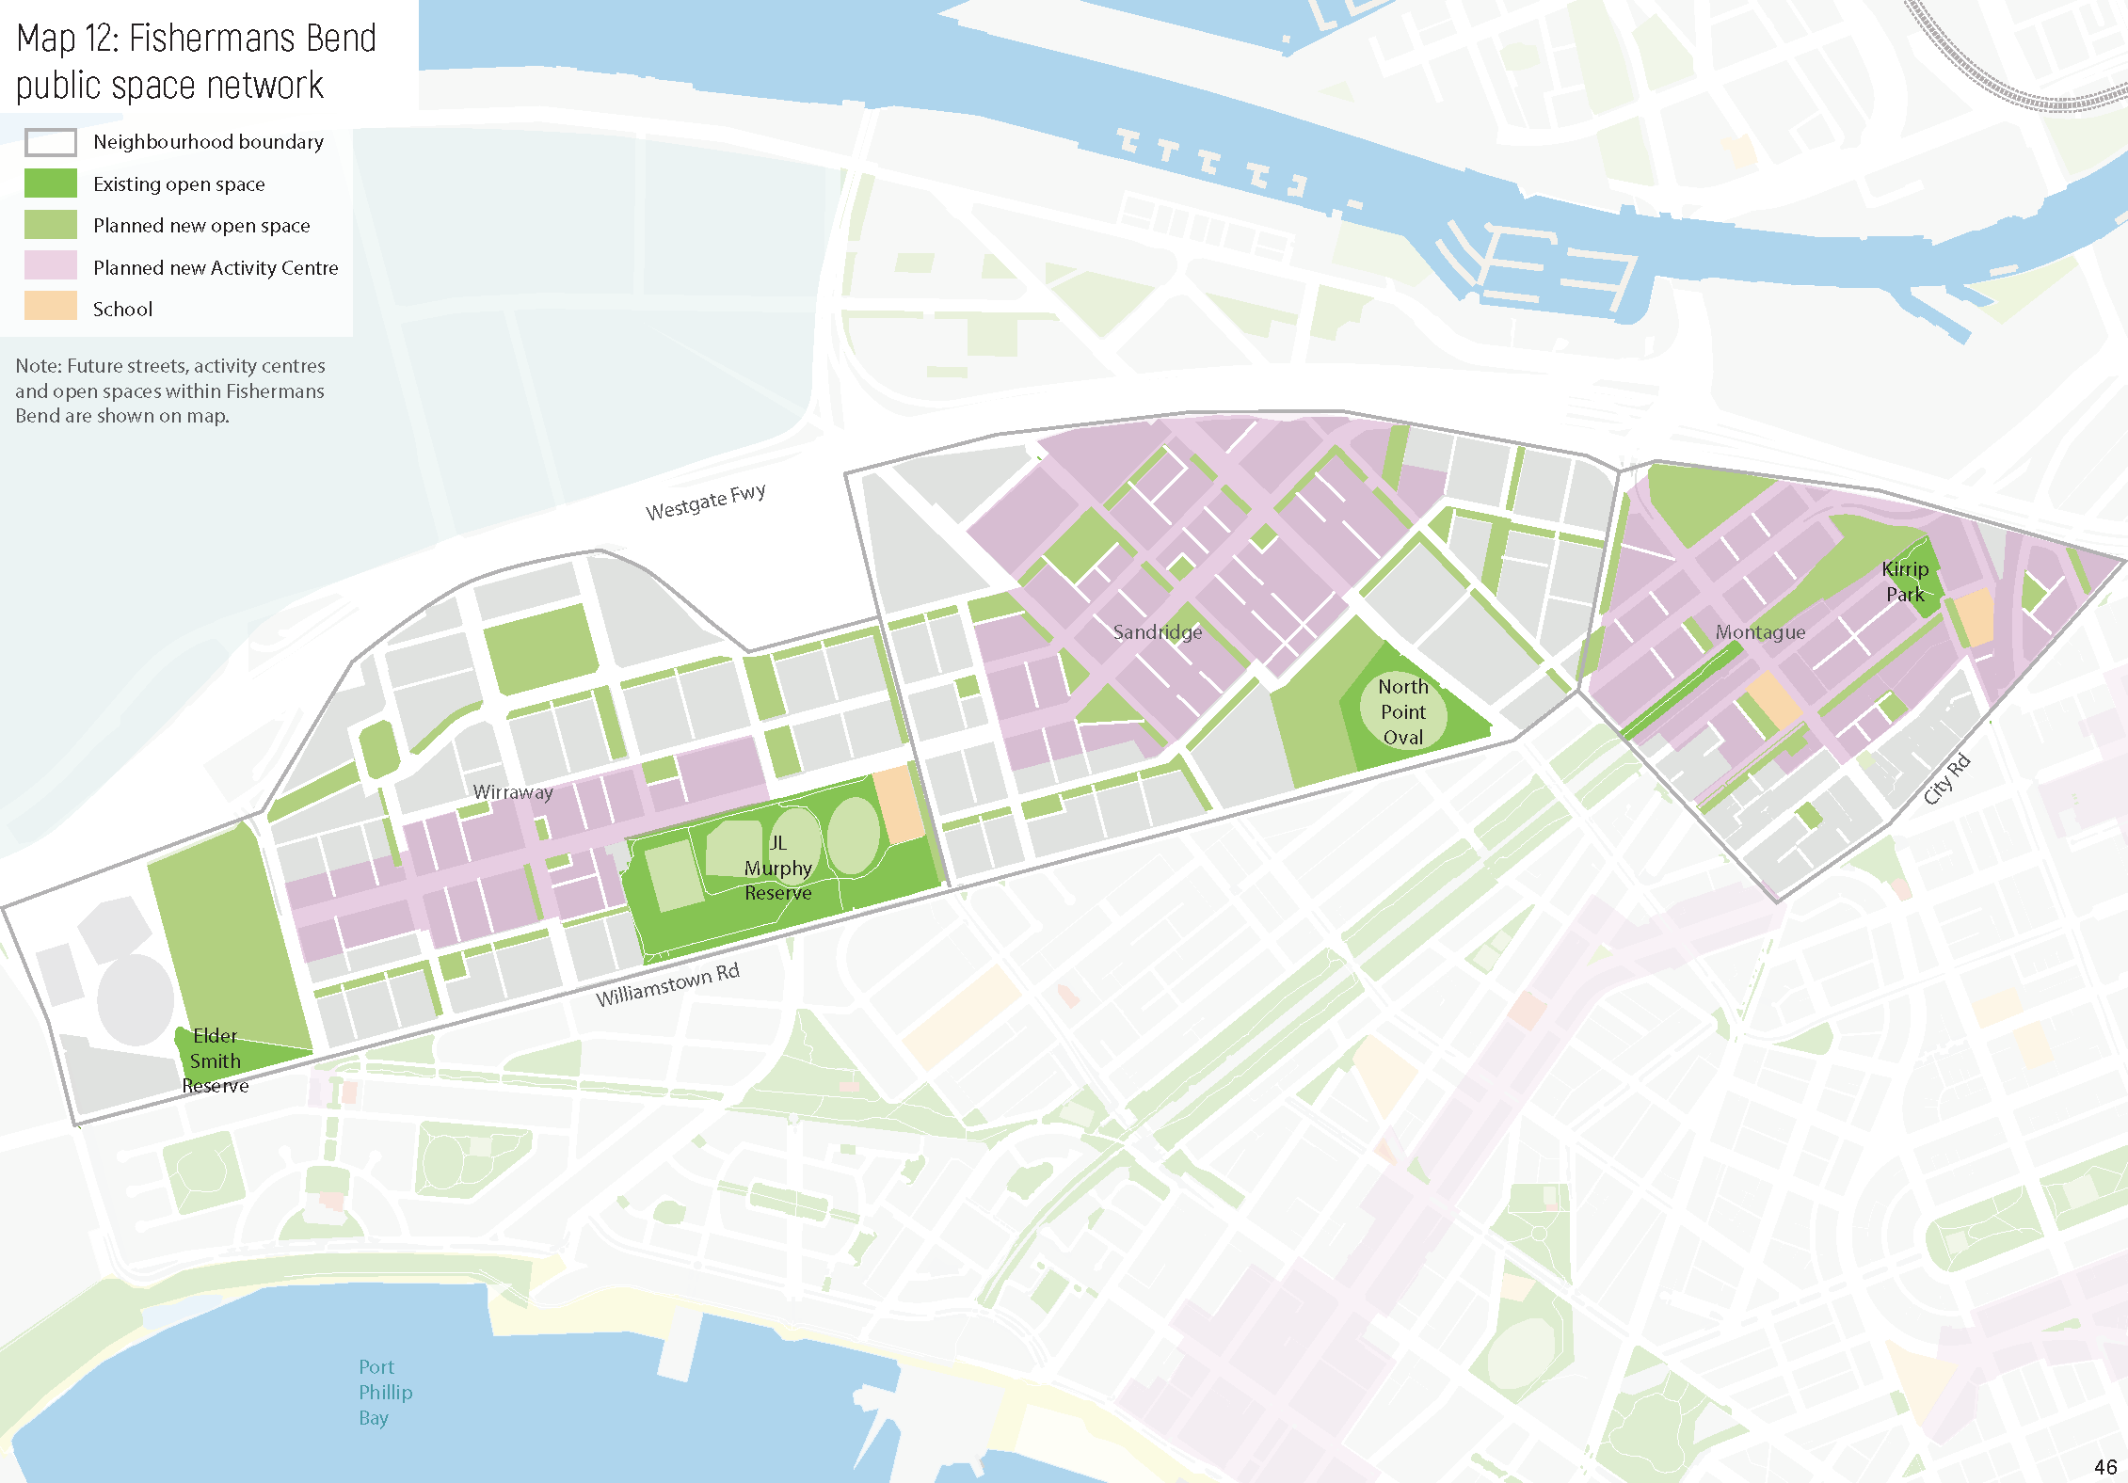
46

Future neighbourhood actions
The list of projects in the Action Plan are those that can be funded and resourced at Council’s current capacity. Future council’s may want to go further to deliver additional actions to improve the public space network even further. Additional actions include:
  - Alfred Square Gardens – major upgrade (St Kilda/St Kilda West)
  - Beach Street Foreshore upgrade associated with the Station Pier upgrade (Port Melbourne)
  - Catani Gardens - minor upgrade (St Kilda/St Kilda West)
  - Centre Ave Medians/Fred Jackson Reserve – green link between Fishermans Bend and Sandridge Foreshore (Port Melbourne)
  - Dalgety Street Reserve - minor upgrade (St Kilda/St Kilda West)
  - Eastern Reserve North – expansion and major upgrade (South Melbourne)
  - E C Mitty Reserve – explore expansion through reallocation of road space (Elwood/Ripponlea)
  - Kerferd Road Medians – improved activation and access associated with the Shrine to Sea project (Albert Park/Middle Park)
  - Kings Way Reserve – major upgrade (St Kilda Road)
  - investigate a new small local open space in Balaclava, south of Carlisle Street (Balaclava/St Kilda East)
  - investigate a new small local open space St Kilda Road North – this could be via a developer contribution (St Kilda Road).
Note these actions are subject to additional funding and resourcing.

47

Measuring and Reporting
The Public Space Strategy will be reviewed after five years and updated if needed.

Understanding our service levels
What happens if we keep doing the same thing (if we don't change things will get worse)?
  - more people will be using our public spaces and they may not be fit-for-purpose
  - some people will not be within a short walk to public space
  - many public spaces will be limited to single-use activities
  - our lesser-quality spaces will not be used to their full potential
  - our spaces will be more sensitive to the impacts of climate change. What happens if we make a change (doing things differently)?
  - our public spaces will be able to cater to higher use from more people
  - nearly everyone will be within a short walk of public spaces
  - our public spaces will be used for a range of active and passive activities
  - more of our public spaces will be used to their full potential
  - our public spaces will be more resilient to climate change.

Measuring our success
We will be reporting our progress each year through Council’s annual report (unless otherwise stated).

Category | Indicator | 2019  result | 2026  target | 2031  target
Strategy Actions | Percentage of Strategy actions on-track | N/A | 50% | 90%
 | Delivery of new open spaces achieved | N/A | 50% | 90%
 | Percentage of municipality within a safe walking distance of open space | 85% | 85% | 90%
 | Number of open spaces rated good or high quality | 75% | 80% | 85%
Effectiveness measures | Contracted maintenance standard delivered for open spaces | 95% | 95% | 95%
 | Public space community requests resolved on time | 85% | 85% | 85%
 | Participation per capita in sport and recreation across formal and informal activities | 20% | 25% | 30%
Customer satisfaction measures | Resident satisfaction with open space | 90% | 90% | 90%
 | Community rating of Council’s recreational facility performance | 75% | 75% | 80%

In addition to the above measures, the Public Space Strategy will help to support reaching targets in Council’s other core strategies:

Move, Connect, Live - Integrated Transport Strategy 2018-28:
  - increase in pedestrian and civic space on shopping strips in activity centres to 20% by 2027/28
  - streetscape improvements are delivered as part of tram stop upgrade projects in shopping and activity centres per year to 100% by 2027/28.

Act and Adapt – Sustainable Environment Strategy 2018-28:
  - street tree canopy cover 10% increase on baseline (to 21%) by 2027/28.

City of Port Phillip draft Public Space Strategy

Appendix A – Actions and financial overview
This is a multi-year action plan which includes city wide and neighbourhood actions.
The total budget for delivery of neighbourhood open space actions is $52 million. The Action Plan has been developed on preliminary cost estimates and more detailed work will be required to establish the cost of remediating contaminated land, land acquisition and detailed design and construction.
The Strategy also includes a range of actions funded via other means:
  - public space projects delivered by others
  - street tree planting and renewal works (via existing Council Budget)
  - development of strategies (via existing Council Budget)
  - additional maintenance cost impacts to the budget.

Our Priority Actions |  |  |  | Short 20-24 | Medium 25-28 | Long 29-31
City-wide
Advocacy and partnerships
1 | Albert Park Reserve | Advocacy | Advocate for the implementation Albert Park Reserve Masterplan.
2 | Elwood Canal and Elster Creek | Partnership | Continue partnership with Melbourne Water to enhance Elwood Canal and Elster Creek.
3 | Developer delivered public open space | Advocacy | Advocate to developers to provide public open space as part of their development.
4 | Foreshore – climate change | Advocacy/ partnership | Advocate for the preparation and implementation a coordinated plan to manage the impacts of climate change along the foreshore.
5 | Foreshore – key infrastructure projects | Advocacy/ partnership | Leverage opportunities and advocate for high-quality public space outcomes associated with key
50

City of Port Phillip draft Public Space Strategy
Our Priority Actions |  |  |  | Short 20-24 | Medium 25-28 | Long 29-31
 |  |  | infrastructure projects on the foreshore (such as Waterfront Place/Station Pier, St Kilda Pier, St Kilda Marina) and connecting to the foreshore (such as Shrine to Sea).
6 | Fishermans Bend | Advocacy/ partnership | Ensure the Fishermans Bend Framework and precinct plans maximise public open space outcomes for the current and future Port Phillip community, including by reducing the impact of a higher population in Port Melbourne and South Melbourne.
7 | Metropolitan Open Space Strategy | Partnership | Partner with DELWP to implement the Metropolitan Open Space Strategy and the management of Crown land.
8 | School grounds | Advocacy | Advocate to the Department of Education to facilitate the reciprocal sharing of Council’s public spaces and public spaces within school grounds.
9 | Shrine to Sea | Advocacy/ partnership | Support DELWP developing a masterplan for the Shrine to Sea corridor. Also see action 5.
Strategies
10 | Foreshore Management Plan | Strategy | Update Port Phillip’s Foreshore Management Plan to include the above actions and the introduction of the Marine and Coastal Act 2018 and the Coastal Management Plan Guidelines 2020.
11 | Play Space Strategy | Strategy | Update the Play Space Strategy 2011 to set the vision, policy context and framework for future development of play spaces and prioritise play spaces for upgrade and renewal in the City.
12 | Getting our Community Active: Sport and Recreation Strategy 2015-2024 | Strategy | Update the Getting our Community Active: Sport and Recreation Strategy 2015-2024 to be consistent with the actions in this strategy where appropriate.

City of Port Phillip draft Public Space Strategy
Our Priority Actions |  |  |  | Short 20-24 | Medium 25-28 | Long 29-31
13 | Greening Port Phillip – An Urban Forest Approach | Strategy | Update Greening Port Phillip – An Urban Forest Approach, and the Greening Port Phillip street tree planting program 2017-22 to reprioritise key actions based on this strategy.
14 | Open Space Water Management Plan 2010 | Strategy | Supersede the Open Space Water Management Plan 2010 with a new irrigation strategy to guide decision- making on which parks, gardens and reserves should be kept green.
15 | Reactivation of Public Space 2020-21 | Strategy | Support the implementation of the Reactivation of Public Space 2020-21 to reactivate public space in response to the COVID-19 pandemic, through initiatives such as widened footpaths, new parklets and playspaces, street closure trials, improved wayfinding and supporting local businesses and creative organisations.
Albert Park/Middle Park
Existing public open spaces
16 | Frank and Mary Crean Reserve | Play space renewal | Renew the existing play space to improve safety and enhance community experience.
17 | Gasworks Arts Park | Major upgrade | Finalise Park Plan in compliance with the Contamination Management Action Plan. Improve lawn areas, garden beds, paths, play equipment, lighting, seats, picnic tables, drinking fountains and bins.
18 | Moubray Street Community Park | Minor upgrade | Transform the ‘pop-up community park’ to a permanent open space. Improve access and community use and increase greening and tree planting.
Streetscapes and other public spaces

City of Port Phillip draft Public Space Strategy
Our Priority Actions |  |  |  | Short 20-24 | Medium 25-28 | Long 29-31
19 | Armstrong Street | Tree planting and seats | Improve consistent avenue-style street-tree planting and seating, to link the foreshore, Armstrong Street Shops and Albert Park Reserve.
20 | Bridport Street | Tree planting and seats | Improve consistent avenue-style street-tree planting and seating, to link the activity centre to Gasworks Arts Park, Lemnos Square and the foreshore.
21 | Cowderoy Street | Tree planting and seats | Improve consistent avenue-style street-tree planting and seating, to link the foreshore, Cummings Reserve, Jacoby Reserve, HR Johnson Reserve and Albert Park Reserve.
22 | Mills Street | Tree planting and seats | Improve consistent avenue-style street-tree planting and seating, to link the foreshore and Middle Park Primary School.
23 | Montague Street | Tree planting and seats | Improve consistent avenue-style street-tree planting and seating, to link St Vincent Gardens with Dundas Place Reserve/Bridport Street, Victoria Avenue Activity Centre and Kerferd Road medians.
24 | Pickles Street Foreshore | Tree planting | Investigate options to plant additional shade trees to improve the useability of the foreshore reserve.
Advocacy and partnerships
25 | Albert Park Reserve | Advocacy | See action 1. In addition, continue to advocate to Parks Victoria to retain the dog-off-leash areas and  access within Albert Park Reserve.
26 | Albert Park, Middle Park and St Kilda West Foreshore | Advocacy | See action 4.
27 | Shrine to Sea Project | Advocacy/ partnership | See action 9.
Balaclava/St Kilda East

City of Port Phillip draft Public Space Strategy
Our Priority Actions |  |  |  | Short 20-24 | Medium 25-28 | Long 29-31
New public open space
28 | St Kilda East | New small local open space | Provide a new small local open space in Lansdowne Road to fill the gap in the area bound by Alma Road, Inkerman Street, Hotham Street and Orrong Road.
29 | Carlisle Street Activity Centre, Balaclava | New small local open space | As part of any future redevelopment of the Coles Supermarket site and adjacent car park, investigate options to provide a new open space to fill the gap in this area and create a community heart in the Carlisle Street Activity Centre, consistent with the Carlisle Street Activity Centre Structure Plan, 2009.
Existing public open space
30 | Alma Park East | Play space renewal | Renew the existing play space to improve safety and enhance community experience.
31 | Hewison Reserve | Minor upgrade | Improve play space, accessibility and fencing and investigate the opportunities for inclusion of informal sport.
32 | Pakington Street Reserve | Renewal | Improve paths, seating, lighting and planting and include a new small community garden.
33 | Pakington Street Reserve | Expansion and major upgrade | Acquire the site adjoining Pakington Street Reserve with the existing Public Acquisition Overlay to expand and upgrade this open space.
34 | Te Arai Reserve | Play space renewal | Renew the existing play space to improve safety and enhance community experience.
35 | Woodstock Street Reserve | Upgrade and investigate expansion | Investigate opportunities to enlarge the reserve through reallocation of road space and undertake an upgrade.
Streetscapes and other public spaces

City of Port Phillip draft Public Space Strategy
Our Priority Actions |  |  |  | Short 20-24 | Medium 25-28 | Long 29-31
36 | Streets in the area bound by Alma Road, Inkerman Street, Chapel Street and Hotham Street | Tree planting | Plant additional street trees where feasible to increase canopy cover and improve pedestrian amenity.
37 | Streets in the area bound by Dandenong Road, Alma Road, Orrong Road and Hotham Street | Tree planting | Plant additional street trees where feasible, to increase urban greening and shading to improve the pedestrian experience and connections from Balaclava Walk.
38 | Streets in the area bound by Carlisle Street, Albion Street/Oak Ave, Brighton Road and Hotham Street | Tree planting | Plant additional street trees where feasible, to increase canopy cover and improve pedestrian amenity.
39 | Alma Road | Pedestrian crossing | Provide a new signalised pedestrian crossing over Alma Road to Alma Park East and Alma Park West.
40 | Carlisle Street Major Activity Centre | Structure Plan | Prepare a new St Kilda Structure Plan, which includes consideration of the proposed new open space in the Carlisle Street Major Activity Centre and public realm outcomes. In the meantime, continue to implement the recommendations in the Carlisle Street Activity Centre Structure Plan 2009, including improvements to the pedestrian pavements and crossing points.
Elwood/Ripponlea
Existing public open space
41 | Burnett Gray Gardens | Minor upgrade | Improve the character and useability of this space, retaining the heritage and planted, green character.

City of Port Phillip draft Public Space Strategy
Our Priority Actions |  |  |  | Short 20-24 | Medium 25-28 | Long 29-31
 |  |  | Review the play space and consider informal play elements.
42 | Clarke Reserve | Minor upgrade | Upgrade play space, accessibility and lighting and consider better delineation between play and other activities.
43 | Poets Garden (Elwood St Kilda Neighbourhood Learning Centre) | New play space | New play space to improve safety and enhanced community experience, informed by the Playground Safety Audit.
44 | Elwood Park and Elwood Foreshore | Landscape masterplan and major upgrade | Guide changes to foreshore buildings, car parking, public realm and sport and recreation facilities (consistent with directions provided in Getting Our Community Active Sport and Recreation Strategy 2015-2024).
45 | Glen Eira Avenue Reserve | Major upgrade and investigate expansion | Investigate options to reallocate road space to expand the reserve and improve integration with Glen Eira Avenue. Upgrade may integrate a future events space to complement the adjoining commercial interface, while retaining the residential interface and green character to Burnett Grey Gardens.
46 | Point Ormond Reserve and Moran Reserve | Major upgrade, dog-off leash | Implement the existing landscape concept plan for Point Ormond Reserve including upgrades to the picnic facility, play area and paths. Support dog-off- leash area in Moran Reserve.
Streetscapes and other public spaces
47 | Streets in the north east part of the area bound by Southey and Milton Streets,  Glenhuntly Road, | Tree planting | Plant additional street trees where feasible to increase canopy cover and improve pedestrian amenity.

City of Port Phillip draft Public Space Strategy
Our Priority Actions |  |  |  | Short 20-24 | Medium 25-28 | Long 29-31
 | Broadway and Brighton Road
48 | Ormond Road retail street | Tree planting and passive irrigation | Integrate passive irrigation and additional street tree planting where feasible, to improve urban greening and cooling in the heart of this neighbourhood activity centre.
49 | Streets in the area bound by Dickens Street, Glenhuntly Road, Marine Parade and Barkly Street | Tree planting | Plant additional street trees where feasible, to increase canopy cover and improve pedestrian amenity
Advocacy and partnerships
50 | Elster Creek and Elwood Canal | Partnership | Continue to strengthen the biodiversity values, balanced with providing for linear path and recreational access including clear sightlines to maintain view corridors for safety. Additionally, review the ongoing safety of shared trail and vehicle access across and along the canal in the context of the flood management in consultation with Melbourne Water.  Advocate to Melbourne Water for continued partnership to enhance the channel.
51 | Elwood Foreshore | Advocacy | See action 4.
52 | Ripponlea Estate (City of Glen Eira) | Partnership | Following evaluation of the current six-month trial, investigate a long-term agreement with Ripponlea Estate for access for the City of Port Phillip community to this open space.
53 | Hotham Street, between Glen Eira Road and Nepean Highway | Advocacy | Advocate to the Department of Transport for a new signalised pedestrian crossing on Hotham Street, to improve access to Ripponlea Estate.

City of Port Phillip draft Public Space Strategy
Our Priority Actions |  |  |  | Short 20-24 | Medium 25-28 | Long 29-31
Port Melbourne
Existing public open space
54 | Buckingham Reserve | Minor upgrade | Improve the quality, appeal and role of this open space, including incorporating a basketball half court as part of the play space.
55 | Cyril Letts Reserve | Play space renewal | Improve play space and edge interface through planting and seating.
56 | Edwards Park | Play space renewal | Improve play space to improve integration with the park.
57 | Graham Street Underpass | Major upgrade | Upgrade the existing skate facility and improve connectivity between this and Hester Reserve, Turville Reserve and Cook Reserve.
58 | JL Murphy Reserve | New play space | A new play space with some informal recreation elements to implement the JL Murphy Reserve Masterplan.
59 | Lagoon Reserve | Major upgrade | Improve the quality of the facilities and determine the appropriate levels of use of the sports field in the future.
60 | Port Melbourne light rail linear parks | Landscape masterplan, investigate dog off-leash | Prepare a Landscape masterplan for Cook, Fennell, Gill, Hester, Howe, Page, Smith, Turner and Walter Reserves to increase the diversity of unstructured recreation and social facilities, investigate if fenced dog off-leash can be supported, protect mature trees and strengthen the indigenous vegetation values along the light rail corridor. Note: the delivery of this space is not funded via this strategy – delivery will be considered subject to the outcomes of the masterplan.

City of Port Phillip draft Public Space Strategy
Our Priority Actions |  |  |  | Short 20-24 | Medium 25-28 | Long 29-31
61 | Sangster Reserve | Play space renewal | Renew play space, consider better use of old substation and ensure integration with Bowls Club strategy.
Streetscapes and other public spaces
62 | Streets in the area bound by Williamstown Road, Ingles Street, Bridge Street and Bay Street | Tree planting | Plant additional street trees where feasible, to increase canopy cover and improve pedestrian amenity.
63 | Streets in the area bound by Williamstown Road, Boundary Street, Ingles Street and Crockford Street | Tree planting | Plant additional street trees where feasible, to increase canopy cover and improve pedestrian amenity.
64 | The Boulevard | Pedestrian zebra crossing | Provide a new cycle and pedestrian zebra crossing between Fred Jackson Reserve and Sandridge Foreshore, subject to warrants.
Advocacy and partnerships
65 | Port Melbourne Foreshore | Advocacy | See action 4.
66 | Williamstown Road – Prohasky Street/Centre Avenue, Beacon Road, Northport Oval and Bridge Street | New pedestrian crossings | Advocate to the Fishermans Bend Taskforce and the Department of Transport for new signalised pedestrian crossings at Williamstown Road and Prohasky Street/Centre Avenue, Beacon Road, Northport Oval and Bridge Street, to improve access between open space in Fishemans Bend and Garden City, consistent with Council’s Move, Connect, Live Sustainable Transport Plan. This will improve access  to Centre Road Medians and Sandridge Foreshore, and connect J L Murphy Reserve, Garden City

City of Port Phillip draft Public Space Strategy
Our Priority Actions |  |  |  | Short 20-24 | Medium 25-28 | Long 29-31
 |  |  | Reserve and the Beacon Vista to Beacon Cove Promenade.
67 | Waterfront Place | Partnership | Work with Development Victoria and Ports Victoria to prepare an overall framework plan to guide the future use and design of Waterfront Place, integrated with the Station Pier upgrade. This includes consideration of the connectivity to and future use of Station Pier, Waterfront Place, Station Pier Linear Park and Beach Street Foreshore. Also see action 5.
South Melbourne
New public open space
68 | New small local open space in South Melbourne Activity Centre | New small local open space | As part of the development of the South Melbourne structure plan, investigate options to create a new small local open space to provide for residents and workers in this area and fill the gap in the area bounded by Dorcas Street, Clarendon Street, City Road and Ferrars Street. There are opportunities to consider repurposing parts of existing public land adjoining South Melbourne Market.
69 | New Small Local open space in South Melbourne employment area | New small local open space | As part of the development of the South Melbourne Structure Plan, investigate location options for a new small local open space in the heart of the employment area to fill the gap in the area bounded by Clarendon Street, Dorcas Street, Kings Way and West Gate Freeway. The open space should be located away from major arterial roads and provide a protected and peaceful green open space that encourages people outdoors as a break from work.  Note: the delivery of this space is not funded via this
 |  |  | strategy – delivery will be considered subject to the outcomes of the Structure Plan.

City of Port Phillip draft Public Space Strategy
Our Priority Actions |  |  |  | Short 20-24 | Medium 25-28 | Long 29-31
Existing public open space
70 | Ludwig Stamer Reserve | Play space upgrade | Upgrade the play space to improve its condition and enhance the play experience, informed by the Playground Safety Audit.
71 | Skinners Adventure Playground | Adventure Playground Strategy | Prepare Adventure Playground Strategy to determine the scope of a future upgrade and consider increased public access. Note: the delivery of this space is not funded via this strategy – delivery will be considered subject to the outcomes of the strategy.
72 | Sol Green Reserve | Major upgrade and investigate expansion | Improve the character and quality of facilities to strengthen its role as a local community space. Investigate opportunities to enlarge the reserve through reallocation of road space.
73 | St Vincent Gardens | Play space upgrade | Upgrade the play space to improve the quality and role of this open space in line with Council’s Play Space Strategy and the park’s heritage values.
Streetscapes and other public spaces
74 | Iffla Street, Park Street and Montague Street | Tree planting | Plant additional street trees where feasible, to increase canopy cover and improve pedestrian amenity.
75 | Streets in the area bound by Dorcas Street, Park Street, Ferrars Street and Clarendon Street | Tree planting | Plant additional street trees where feasible, to increase canopy cover and improve pedestrian amenity.
76 | South Melbourne Market interfaces and intersections | Pedestrian crossings | Investigate opportunities to improve pedestrian safety and priority at the Cecil Street, York Street and Coventry Street intersections and widen footpaths as

City of Port Phillip draft Public Space Strategy
Our Priority Actions |  |  |  | Short 20-24 | Medium 25-28 | Long 29-31
 |  |  | part of a future masterplan for South Melbourne Market.
77 | South Melbourne Activity Centre | Structure Plan | Prepare new South Melbourne Structure Plan, which includes consideration of the new public spaces outlined above and public realm outcomes including changes to tram infrastructure on Clarendon Street and Park Street.
Advocacy and partnerships
78 | City Road / Montague Street intersection | Advocacy | Advocate to the Department of Transport to improve this intersection as part of a green link between the Montague Precinct of Fishermans Bend, Sol Green Reserve and St Vincent Gardens.
79 | Albert Park Reserve | Advocacy | See action 1. In addition, advocate to Parks Victoria to improve local access into the Reserve from Albert Road.
80 | Shrine to Sea Project | Advocacy/ partnership | See action 9.
St Kilda Road
New public open space
81 | Kings Place Plaza/Millers Lane plaza | New plaza | Provide a new gathering place for pedestrians through a shared zone on Kings Place and Millers Lane as well as the new plaza created through partial road closure of Cobden Street. Plaza to include landscaping, tree planting, bike parking, seating and drinking fountains.
Streetscapes and other public spaces
82 | Streets in the area bound by Dorcas  Street, Park Street, | Tree planting | Plant additional street trees where feasible to maximise canopy, increase summer shade and

City of Port Phillip draft Public Space Strategy
Our Priority Actions |  |  |  | Short 20-24 | Medium 25-28 | Long 29-31
 | Kings Way and St Kilda Road |  | improve pedestrian amenity, consistent with the Domain Precinct Public Realm Masterplan.
83 | Streets in the area bound by Lorne Street/High Street, Queens Road and Punt Road (excluding Queens Lane and St Kilda Road) | Tree planting | Plant additional street trees where feasible, to increase canopy cover and improve pedestrian amenity.
Advocacy and partnerships
84 | Albert Park Reserve | Advocacy | See action 1. Advocate to Parks Victoria and Department of Transport to improve access into Albert Park Reserve from Queens Road. This includes improving the existing signalised pedestrian crossing at Lorne Street/Queens Road, connect the existing footpath network to the trail network in Albert Park Reserve and create a potential new pedestrian crossing over Lakeside Drive.
85 | Albert Reserve | Advocacy | Advocate to Parks Victoria to remove the fencing to at least the cricket ground to make this accessible to the community and for other fencing to be upgraded to improve visual access to the reserve.
86 | Albert Road Reserve | Advocacy/ partnership | Support the expansion and upgrade of this open space by reallocating part of Albert Road to public open space, as proposed by the Victorian Government. Advocate for the inclusion of unstructured recreation facilities in locations with excellent winter sunlight access.
87 | Contributory Public Space | Partnership | Investigate agreement/s with Wesley College and the Victorian College for the Deaf to enable public access

City of Port Phillip draft Public Space Strategy
Our Priority Actions |  |  |  | Short 20-24 | Medium 25-28 | Long 29-31
 |  |  | to their open space at restricted times, increasing access to public space in this neighbourhood.
88 | Shrine to Sea project | Advocacy/ partnership | See Action 9. In addition, advocate to state agencies to ensure a seamless connection between Albert Road Reserve and Albert Park Reserve. Consider improvements to path connections, landscaping and amenities.
St Kilda/St Kilda West
New public open space
89 | Luna Park and Palais forecourt | New plaza | Create a new plaza outside the Palais Theatre through reallocation of part of Lower Esplanade, and control vehicle intrusion outside Luna Park and the Palais Theatre.
Existing public open space
90 | Acland Street Plaza | Minor upgrade | Increase planting to improve urban heat island effect and control vehicle intrusion.
91 | Catani Gardens | Minor upgrade | Improve the quality and character of the playground and picnic facilities.
92 | Jacoby Reserve | Play space renewal | Renewal of the play space in line with Council’s Play Space Strategy and Playground Safety Audit.
93 | Pier Road Promenade and Pier Road beach, St Kilda Foreshore | Landscape masterplan and major upgrade | Guide the future of Pier Road Promenade and Pier Road Beach to ensure integration with the St Kilda Pier upgrade being undertaken by Parks Victoria. Improve cycle and pedestrian connections, arrival and access to St Kilda Pier, the Yacht Squadron and St Kilda Pier Reserve, increase urban greening with large shade trees, incorporate seating areas and unstructured recreation facilities and identify opportunities to improve all-ability beach access.

City of Port Phillip draft Public Space Strategy
Our Priority Actions |  |  |  | Short 20-24 | Medium 25-28 | Long 29-31
94 | Renfrey Gardens | Minor upgrade | Improve the picnic and play area to complement the recent upgrades to Peanut Farm Reserve.
95 | Rotary Park, St Kilda Foreshore | New play space | New play space to replace the previous facilities removed during the construction of the Stokehouse.
96 | St Kilda Adventure Playground | Adventure Playground Strategy | Prepare Adventure Playground Strategy to determine the scope of a future upgrade and consider increased public access. Note: the delivery of this space is not funded via this strategy – delivery will be considered subject to the outcomes of the strategy.
97 | St Kilda Botanical Gardens | Play space upgrade | Improve the children's play equipment and spaces, informed by the Playground Safety Audit.
98 | Donovans to Marina Reserve connection, St Kilda Foreshore | Major upgrade | Improve foreshore paths and cross-overs, lighting, vegetation and shade, upgrade the seawall between Donovans and Marina Reserve and control vehicle intrusion.
99 | South Beach Reserve, St Kilda Foreshore | Major upgrade | Redesign for events and beach visitors, to better manage the large number of people who use this space, particularly on hot days.
Streetscapes and other public spaces
100 | Streets in the area bound by Upper Esplanade, Fitzroy Street, Grey Street and Barkly Street | Tree planting | Plant additional street trees where feasible, to increase canopy cover and improve pedestrian amenity.
101 | Streets in the area bound by Upper Esplanade, Marine Parade, Barkly Street and Dickens Street | Tree planting | Plant additional street trees where feasible, to increase canopy cover and improve pedestrian amenity.

City of Port Phillip draft Public Space Strategy
Our Priority Actions |  |  |  | Short 20-24 | Medium 25-28 | Long 29-31
102 | Fitzroy Street and Acland Street – St Kilda Structure Plan | Structure Plan | Prepare new St Kilda Structure Plan, which includes consideration of public spaces and public realm outcomes in St Kilda. Investigate options to encourage activation of the commercial interface along Chaucer Street and improve pedestrian links and access between Acland Street and Peanut Farm Reserve.
Advocacy and partnerships
103 | Albert Park Reserve | Advocacy | See action 1. In addition, advocate to Parks Victoria to provide improved neighbourhood level open-space facilities to encourage unstructured recreation and social connectedness east of Lakeside Drive, improve paths west of Lakeside Drive, and retain the existing mature trees and the natural features as a contrast to the urban character of the wide pavements on the south side of Fitzroy Street.
104 | Brooks Jetty (Shakespeare Grove Stormwater Outfall) | Advocacy | Melbourne Water is currently reviewing options for the Shakespeare Grove Stormwater Outfall including the opportunity to incorporate improved public access and design.
105 | St Kilda Foreshore | Advocacy | See action 4.
106 | Fitzroy Street, between Princes Street and Grey Street/Canterbury Road | Advocacy | Advocate to Department of Transport for a mid-block pedestrian crossing over Fitzroy Street as part of a future tram stop upgrade to improve access to Albert Park Reserve.
107 | St Kilda Marina | Partnership | Require the future redevelopment of the St Kilda Marina to provide increased publicly accessible open space, including a new civic plaza and additional greening. Also see action 5.

City of Port Phillip draft Public Space Strategy
Our Priority Actions |  |  |  | Short 20-24 | Medium 25-28 | Long 29-31
108 | St Kilda Pier | Partnership | Continue to work with Parks Victoria regarding the future replacement of the St Kilda Pier to ensure quality environmental, public realm and visitor outcomes. Also see action 5.

References
City of Port Phillip (2019) Council Plan 2017-27 Year 3 – Revised June 2019
Deakin University Australia, Townsend, M and Weerasuriya, R prepared for Beyond Blue, Beyond (2010) Blue to Green: The benefits of contact with nature for mental health and well=being
DELWP (2019) Fishermans Bend Framework
DELWP (2017) Plan Melbourne 2017-2050 Metropolitan Planning Strategy Prepared by the Inner Melbourne Action Plan
Forecast i.d. community (2019) City of Port Phillip population forecast
Parks Victoria (2019) Albert Park Masterplan, prepared by Hansen Partnership et al for Parks Victoria
SGS Economics Planning (2019) IMAP Regional Sport and Recreation Strategy Prepared for State Government of Victoria, Department of Environment, Land, Water and Planning
United Nations (2015) United Nations Sustainable Development Goals
Victorian Parliamentary Legislative Council (2012) Inquiry into Environmental Design and Public Health in Victoria
World Health Organisation Europe (2016) Urban green spaces and health, A review of evidence

Council contact details
For more information, please contact us via: www.portphillip.vic.gov.au/contact_us.htm
Phone: | 03 9209 6777
Facsimile: | 03 9536 2722
SMS: | 0432 005 405

You can also visit our website: www.portphillip.vic.gov.au

[insert infographic of national relay service here]

68

