Community Gardens Assessment Guidelines

May 2020
Contents

Purpose 3
Sources of Influence 4
Licenced Community Gardens on Council Owned or Managed Land 5
Productive Gardening in Port Phillip: Other Types of Gardens Not Covered by these Guidelines 5
Principles for Licenced Community Gardens 7
Licenced Community Garden Approval Process 9
Responsibilities for Licenced Community Gardens 10
Council 10
Community Garden Groups 10
Flowchart 12
Definitions 13
Relevant Policy, Regulations or Legislation 14

Purpose

Community Gardens provide much more than just the opportunity to grow food locally. They sustain community spirit and foster community connections in a public space that residents share and collectively care for.

With population growth and growing demands for existing open space in our municipality, the use of land for a Community Garden must be considered against a number of other land use options.

Council recognises the value that Community Gardens provide across the city, however it is important to ensure gardens are safe, risks are mitigated and that there is equitable community access to these valued resources.

Further to this, Council understands that establishing a Community Garden requires community members to undertake considerable planning, collaboration and engagement. It is important to ensure this commitment is strong enough so that the long-term benefits are realised.

The Community Garden Assessment Guidelines assists community groups to understand from the onset the responsibilities of all stakeholders involved in Licenced Community Garden projects on Council Owned or Managed Land.

Responsibilities include obtaining adequate funding and resources along with the management of risks. The guidelines also indicate the types of governance structures required to support the ongoing management of Licenced Gardens.

The Guidelines provide a clear process for residents who want to establish a community garden and establishes two gateways through which Council will consider and determine:

- Whether the site is suitable for use as a Licenced Community Garden, and
- If the site is suitable, whether the proposal is well considered, able to be managed and an appropriate use of the community’s resources.
The principles outlined in the assessment guidelines will inform the ongoing management of a Licenced Community Garden, and where required, an approach for a garden’s cessation.

Sources of Influence
In developing these guidelines, the City of Port Phillip acknowledge and draws influence from the City of Melbourne Community Gardens Policy, The City of Darebin Communal Food Garden (Community Garden) Assessment Guidelines and the City of Bayside Community Gardens Policy.

These guidelines will support the implementation of Council’s pending Public Space Strategy. Directions are further provided from Council’s Act and Adapt, Don’t Waste It, the Property, Asset Management and Community Funding policies.

Licenced Community Gardens on Council Owned or Managed Land
Across the municipality, licenced or leased Community Gardens are generally provided as shared community space, but in some settings may provide gated access for members. Generally, such gardens contain a series of plots that may be both allocated or shared amongst users.

Each garden within the network will be:

- Managed by an incorporated group (Community Garden Groups)
- Auspiced by a community group, or
- Attached to a leased community facility.

Groups or auspicing organisation may manage more than one site.

Productive Gardening in Port Phillip: Other Types of Gardens Not Covered by these Guidelines

Licenced Community Gardens are one type of food production residents can participate in across our municipality. Council manages and licences a range of gardens across the City including:

- Street and Laneway Gardens

Street and laneway gardens are on nature strips, footpaths or within road reserves. They may be managed by an individual or an informal group of residents through voluntary community stewardship. Verge gardens are fully accessible to the broader community and have no restrictions or controls around access to or gathering of their produce.

Street and laneway gardens provide community with a local neighbourhood option for gardening and in some circumstances composting infrastructure.

Council provides Nature Strip Guidelines, which support the community stewardship of public spaces. People who choose to garden on verges must comply with these guidelines and have a duty of care to the broader community in considering and managing risks including health risk from contaminants, trip hazards and maintaining public safety.

- Garden Plots within Public Open Space

There are a number of raised garden beds in Council’s parks and reserves. These are not licenced or fenced and are fully accessible to the broader community.

These gardens are generally managed by a group of volunteers and interested parties through informal Garden Groups and are installed as part of Council’s Parks and Open Space upgrades. Requests for garden plots within public open space are considered through community consultation and on a case by case basis, when undertaking upgrades or redevelopment of public spaces. Council considers such installations where there has been an identified recreational need in the local area through Council’s ‘Public Space Strategy’ or park planning processes.

- Gardens on Private Land / Land Owned and Managed by Other Authorities
Some gardens are on land owned by private individuals, organisations or authorities.

Within Port Phillip a number of gardens operate on church, school or on housing estates. Applications are also made for sites that are privately owned, such as vacant land, that may be waiting on another use.

In these circumstances, agreements must be directly negotiated between gardeners and landowners.

Gardeners should also check with Council’s Planning Department to confirm if a permit is required.

- Commercial Footpath Trading
Businesses such as cafés or restaurants that install planter boxes as part of an outdoor area, must follow the guidelines for plants and planter boxes in the City of Port Phillip Footpath Trading Guidelines.

Council recognises the value of productive Gardens in providing a sustainable city. To encourage you to participate, we are developing a series of Edible Garden
Guidelines. To obtain more information on how you can be involved through any of the other garden types above, or to obtain a copy of relevant guidelines, visit Council’s website or phone 9209 6777.

Principles for Licenced Community Gardens

The following principles provide the framework for how Council will manage and consider future requests for all Licenced Community Gardens. These principles support the objectives of the draft ‘Public Space Strategy’.

Places for People

- Community Garden Groups will foster inclusiveness and the building of local community connections
- Community Garden planning and establishment must consider appropriate application of crime preventative design to create a safe environment for all users
- Community Gardens are effectively governed and self-supporting
- There are clear roles & responsibilities between Council and Community Garden Groups
- Community Garden Groups are responsible for the proactive consideration and management of risk.

Public Spaces for a Higher Density City

- A network of Community Gardens will be equitably distributed across all neighbourhoods within the municipality subject to the availability of appropriate space.
- Council will consider the proximity of existing Community Gardens when considering the establishment of any new garden requests
- The establishment of new gardens are encouraged in neighbourhoods where there is a high level of urban density or future growth
- Sites should be deemed suitable for use as a Community Garden
- Council does not have other requirements for that area of land.

Sharing, Inclusive and Diverse Spaces

- Community Gardens are welcoming, accessible and inclusive of the broader Port Phillip community
- Community Garden Groups will promote a broader use and purpose for Community Garden site, as a multi-purpose facility and gathering place. This includes reporting on activities hosted for the neighbourhood which promote broader social inclusion
- Gardens are not for the exclusive access of a limited membership group.

Sustainable Spaces

- Gardens will improve sustainability outcomes
- Gardens will be places where the community can participate and learn how to reduce waste through examples of community composting and on-site management of waste.
- Sites will have access to adequate and sustainable water supply and sufficient sunlight
- Community Garden Groups will outline how risks associated with soil contamination will be identified and managed.

Licenced Community Garden Approval Process

Approvals for a Licenced Community Garden will be considered through two “gateways”:

- Gateway One: Assessment of the suitability of a proposed site, including consideration of other Council or community usage priorities, location and the perceived demand for the proposed.

- Gateway Two: Assessment of an implementation plan, including:
- Determined need
- Governance and management
- Fair and transparent plot allocation
- Plans to encourage community engagement and social connection
- Plans for reducing green waste and composting on site
- Risk plan
- Sustainability plan, and
- Associated licences and permits.

Only an application that has met the expectations of gateways 1 & 2 will proceed to Council for consideration.

Responsibilities for Licenced Community Gardens

Council will not allocate funds to acquire land or build new Licenced Community Gardens.
Community groups are able to apply for grants, through Council’s Grants programs, if they are able to meet the criteria of those grant programs.

Council
Council will:

- Establish, review and where necessary update, procedures and information on how to apply for a Licenced Community Garden within the City of Port Phillip
- Provide information and advice to residents on how to apply for a Community Garden, including advice on the suitability of potential sites
- Consider and assess proposals for the development of new gardens
- Consider improvements to existing facilities
- Provide advice on whether planning permits are required in relation to proposals on private land
- Develop user agreements that consider applications on a case by case basis, specific user needs, site considerations and constraints
- Undertake the development and ongoing management of a tenancy agreement for Community Gardens on Council managed land to ensure they are operating in accordance with the principles of this guide and the policies of Council
- Provide advanced notification to users in circumstances where a redevelopment was to occur that would impact on the operation of the garden
- Conduct a fair and transparent process to revoke licences or remove gardens, when disused, not adequately maintained or abandoned.

Community Garden Groups
Community gardeners or groups that may be operating one or more Licenced Community Gardens on Council owned or managed land will:

- Be incorporated or be auspiced by an established incorporation.
- Take legal and financial responsibility for the establishment and ongoing operation of a Community Garden
- Identify potential sites, and provide applications to Council to determine a site’s suitability
- Lead consultation and engagement with all members of the community including adjacent residents and, where required, authorities in the design and management of the proposed garden
- Obtain any formal permits, such as planning permits and approvals where required
- Enter into tenancy agreements with Council for the use of any site on Council owned or managed land
- Obtain and maintain Public Liability Insurance with a minimum cover as required by Council and insurance for any of the group’s improvements, buildings or works, and contents within the Council property
- Build the garden, carry out ongoing maintenance and ensure the upkeep and replacement of infrastructure as required, including the management of composting
- Undertake the management and governance of formal groups which will include:
- the fair and transparent allocation of new spaces to community gardeners
- providing opportunities for residents not directly involved in the gardens to be provided with access
- undertake conflict resolution
- report on numbers of events hosted to foster social inclusion for the neighbourhood
- acknowledge Council’s contribution through communications and media as opportunities arise
- Maintain signage and up to date contact details
- Be responsible for the removal of the garden when it is no longer in use or at the end of tenancy
- Identify and manage risks associated with the ongoing operation of Community Gardens.

Flowchart

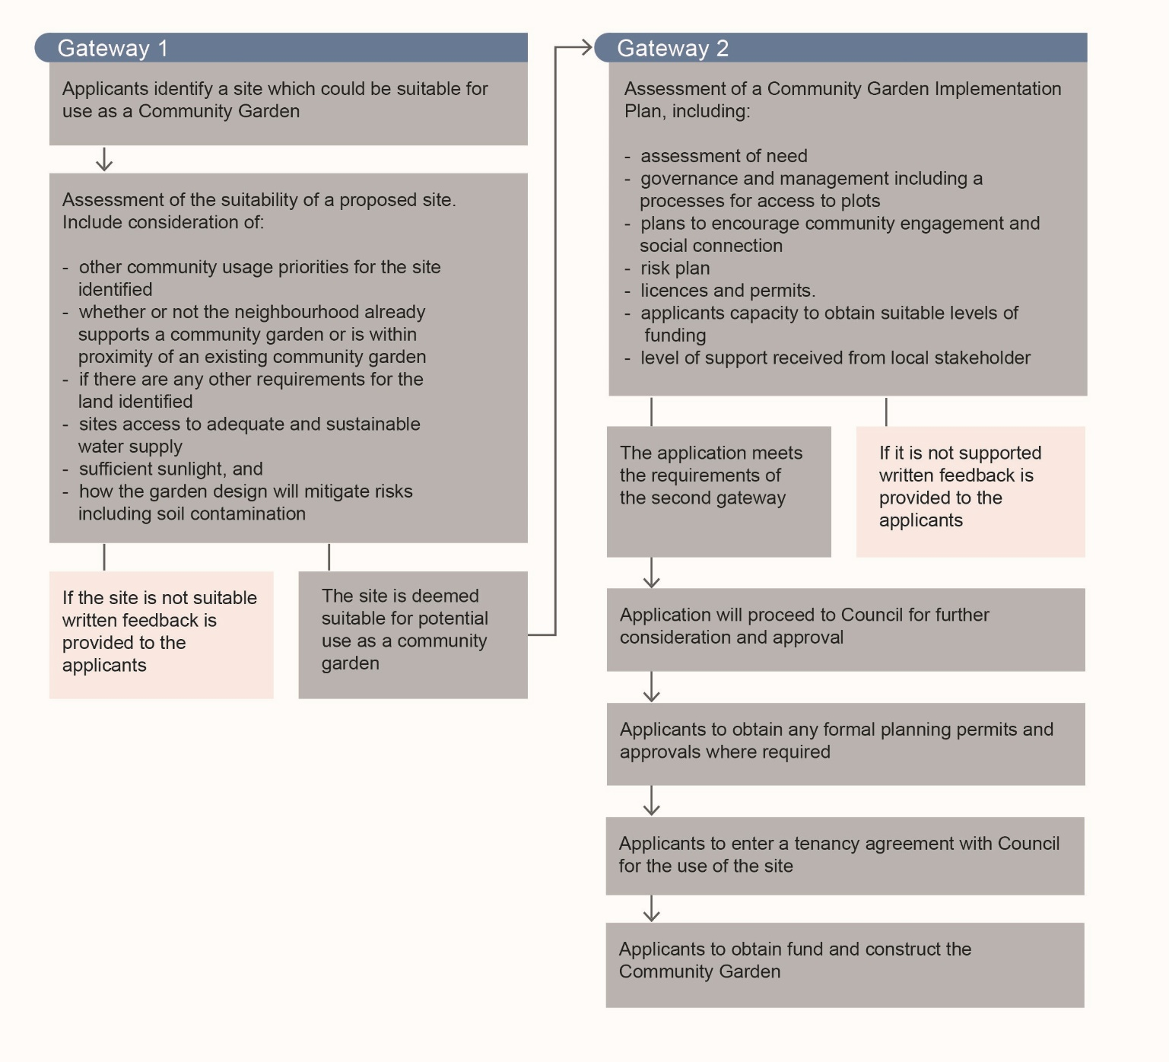

Definitions

Auspice | An auspice is an organisation who may manage a fund, licence or lease on behalf of a smaller community groups that may not have the resources to do so. In the case of community gardening in Port Phillip, an established incorporated group (gardening or community) may manage any funding, licences or leases with the smaller group that might undertake the actual community gardening projects.
Council Owned or managed Crown Land | Land which is in the care, control and management of Council.
Incorporated Community Garden Groups (Community Garden Group) | Community Garden Groups collectively manage plots on private or public land to produce plants grown for food or recreation. Incorporated groups are registered as an association and must refer to the requirements of the Associations Incorporation Reform Act 2012.
Informal Garden Groups | Effectively run by a small number of people (3+) that are not formed into a legal corporation.
Land Owned or Managed by other authorities | Land may be owned or managed by the State Government and may include sites under the Department of Education, VicTrack, or Melbourne Water.
Lease | A lease grants a tenant exclusive possession and use of property for a specified period of time, subject to certain terms and conditions
Licence | A licence grants the licensee non-exclusive use of Council land / property for a specific period of time and subject to certain terms and conditions.
Memorandum of Understanding | Provides an outline of objectives, responsibilities and management arrangements between parties.
Private Land | Any land owned by an individual or organisation that is not publicly accessible / may not be entered or remained on without permission. This may include privately owned sites, or land vested in a church.

Relevant Policy, Regulations or Legislation

City of Port Phillip, DRAFT Public Space Strategy February 2020
City of Port Phillip, Act and Adapt: Sustainable Environment Strategy 2018-28
City of Port Phillip, Don’t Waste It: Waste Management Strategy 2018 - 2028
City of Port Phillip, Property Policy, September 2019
City of Port Phillip, Asset Management Policy 2017
City of Port Phillip, Community Funding Policy, September 2019

Associations Incorporation Reform Act 2012

