Move, Connect, Live

Integrated Transport Strategy 2018-28

Contents
Contents 2
Womin djeka 6
Message from the Mayor 7
Why we need this strategy 9
Challenges we face 12
Population growth 12
Reliance on cars 12
Sustainable transport 13
New technology 13
The case for change 14
Peak traffic congestion (AM) 14
2016 14
2027 16
Big opportunities 18
Where are we now? 19
Listening to our community 20
What we heard 20
Our partners 22
The role of Council 22
Our government partners 23
The role of residents and workers 26
Where do we work? 26
How did we travel to work? 26
What will be different 28
Same space – more people 28
Creating a city for people 30
A shift in perspective 30
Movement and place approach 30
Typical street types in Port Phillip 33
Typical street elements in a movement street 34
Typical elements in a place street 35
Outcome 1 36
Focus areas 36
10-minute walking neighbourhoods. 36
Prioritising safety and access 38
Why are we doing this? 38
Priority Actions 40
Measuring Progress 41
Case study - Cycling without Age 41
Outcome 2 43
Focus areas 43
Space for walking, socialising and play 43
Boosting bike riding 47
Priority Actions 53
Measuring Progress 54
Outcome 3 55
Focus area 55
Partnering to deliver reliable, accessible and more frequent public transport 55
Priority Actions 57
Measuring Progress 58
Outcome 4 59
Focus area 59
Improved parking management 59
Priority Actions 62
Measuring Progress 62
Outcome 5 63
Focus area 63
Harnessing rapid advancements in new technology 63
Priority Actions 65
Measuring Progress 66
Measuring and reporting 67
Outcome 1 67
Outcome 2 68
Outcome 3 69
Outcome 4 69
Outcome 5 70
Appendix A: City of Port Phillip transport partners 71
Victorian Government 71
Transport operators 72
Local government 72
Peak bodies 73
Local community 73
Appendix B: 10 Year Implementation Plan 74
Outcome 1 74
Outcome 2 76
Outcome 3 77
Outcome 4 78
Outcome 5 79

Womin djeka
Council respectfully acknowledges the Yaluk-ut Weelam Clan of the Boon Wurrung.
We pay our respect to their Elders, both past and present.
We acknowledge and uphold their continuing relationship to this land and water on which we rely.
We recognise the intrinsic connection of the Traditional Owners to Country and acknowledge their contribution in the management of land, water and resources.

Message from the Mayor
On behalf of the Councillors, I am pleased to publicly release Council’s Move, Connect Live: Integrated Transport Strategy 2018-28.
Council is committed to supporting a well-connected transportation future for our City, to make it easy for people to move around and connect with places in a way that suits them as our City grows. This is reflective of both strategic directions two and four of the Council Plan - “We are connected and it’s easy to move around” and “We are growing and keeping our character”.
This Strategy will deliver on this commitment over the next 10 years, including key priorities such as:
- a transport network, streets and places that cater for our growing community
- safe, connected and convenient active transport choices
- public transport choices that make it easy to move and connect
- community understanding that parking is a limited and shared resource, and opportunities to work with Council to ensure fairest access
- new transport options and technology to move around.
This Strategy is a long-term plan to ensuring that as a community we can adapt to the increasing number of trips and the challenges associated with increased congestion, while creating travel choices, prioritising effective and equitable access to transport options, and ensuring the liveability and safety of our streets.
All members of our community need to move around using our transport network and we have a collective role to play in improving transport accessibility.
That is why we are:
- creating 10-minute walkable neighbourhoods
- prioritising safety and access
- providing spaces for walking, socialising and play
- boosting bike riding
- partnering to deliver reliable, accessible and more frequent public transport
- improving parking management, and
- harnessing rapid advancements in new technology.
Cr Bernadene Voss
Mayor

Why we need this strategy
The City of Port Phillip, with an estimated population of 113,512 in 2018, is a popular inner-city area of Melbourne, attracting more than 2.8 million visitors each year. It is the second most visited metropolitan location outside of Melbourne’s central business district.
A foreshore that stretches over 11 kilometres, vibrant shopping strips, and vast public open spaces make our City highly desirable to residents, workers and visitors.
We are at a defining moment in Melbourne’s history, with a forecast population growth not seen since the gold rush of the 1880s. Current population is projected to grow by 23 per cent to 136,000 people by 2027; this equates to approximately 50 new people a week, or seven new people a day. With its proximity to the Melbourne central business district, Port Phillip will also be affected by growth beyond its own boundaries. This will impact on the liveability for all of our community, residents and visitors.
Most notably, this change will be felt in our streets. Modelling has shown that if we continue to travel the same way we do today - 72 per cent of daily movements by private car - our limited street network will have to carry an additional 72,000 private car trips, as well as 21,000 additional trips by other modes (walking, bike riding or public transport) every day. This will dramatically increase traffic congestion, impacting upon the time we spend travelling within and throughout the City, and our travel experiences and enjoyment.
We want a city where residents, workers and visitors have lots of travel choices that support Melbourne’s much celebrated liveability, promotes people’s individual health and wellbeing, and contributes to the City’s economy. This is a big challenge for us to take on and it requires us to work together. We are planning and making decisions for our growing City today, to create a city for people and to leave a legacy for future generations.
We will know we are successful when:
- our City’s transport network, streets and places cater for our growing community
- our community is healthier because it has safe, connected and convenient active transport choices
- our community has convenient public transport choices that make it easy to move and connect
- our community understands that parking is a limited and shared resource, and works with Council to ensure fairest access
- our community benefits from new transport options and technology.
To support the delivery of the Strategy, Council will produce two four-year plans (2019-2023 and 2023-2027) that detail the individual projects and methodologies required to achieve the actions.
The first year of delivery is outlined in the Council Budget 2018/19.
Key related strategies:
- Customer Experience Program
- Information, Communication, Technology Strategic Plan
- Placemaking Program
- Greening Port Phillip Strategy
- Asset Management Strategy
- Public Space Strategy
The table below lists the six strategic directions contained in the Council Plan and the strategies developed by Council to outline how each will be achieved.
Integrated Council Plan | Key Strategies
DIRECTION 1 - We embrace difference, and people belong. | Health and Wellbeing Implementation Plan
DIRECTION 2 - We are connected and it’s easy to move around. | Move, Connect, Live - Integrated Transport Strategy
DIRECTION 3 - We have smart solutions for a sustainable future. | Act and Adapt – Sustainable Environment Strategy  Don’t Waste It! - Waste Management Strategy
DIRECTION 4 - We are growing and keeping our character. | Public Space Strategy
DIRECTION 5 - We thrive by harnessing creativity. | Art and Soul - Creative and Prosperous City Strategy
DIRECTION 6 - Our commitment to you. | Organisational Strategy
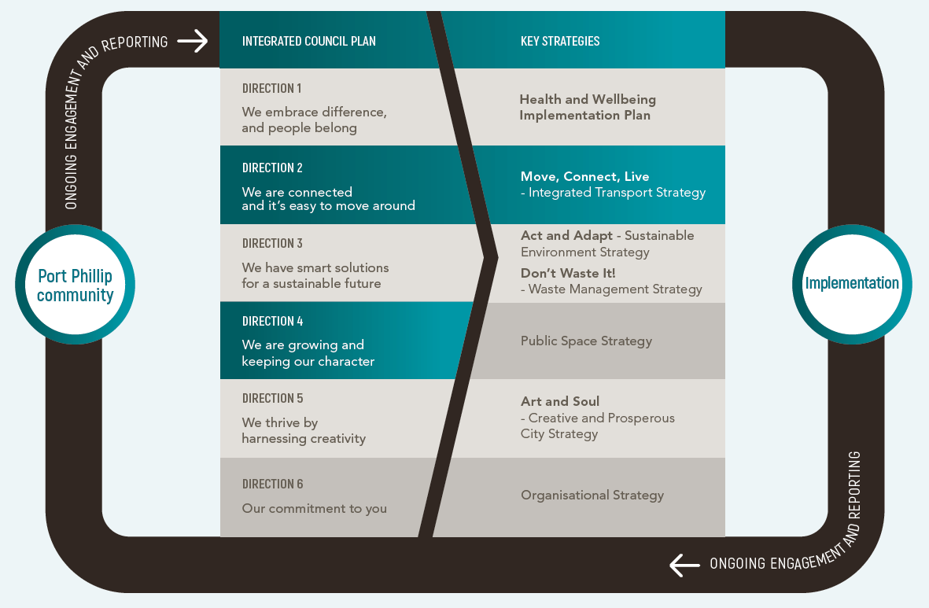

Challenges we face
The City of Port Phillip is currently Melbourne’s most densely populated municipality. It has more than twice the population density of the metropolitan Melbourne average
and is experiencing a rapid increase in the number of people living in apartments and units.
Port Phillip is unique in comparison to other inner Melbourne council as it includes both an international freight and recreational port in addition to other travel modes.
This Strategy will deliver a step change in the way we approach some of our most pressing challenges, such as longer peak travel periods, more unreliable and longer travel times throughout the day and week, and impacts on the safety and efficiency of modes such as public transport and bike riding, from increased vehicles.

Population growth
Covering an area of 21 square kilometres, the City of Port Phillip is one of the smallest municipalities in Victoria with the highest inner urban population density. It is also home to more than 19,000 businesses that employ over 87,000 people.
Our resident population is projected to grow by 23 per cent by 2027, placing considerable strain on our already well used spaces. Our current density equates
to one person per 186 square metres.
The increased population is likely to be housed in apartments that have little access to private open space. This will require our streets and public spaces to cater more to individual connection to nature and social connection need.
Our worker population will also rise dramatically, with over 40,000 workers based within the new Fishermans Bend area.

Reliance on cars
If current car ownership trends continue, over the next decade there will be a 24 per cent increase in the number of cars owned in the City of Port Phillip. Our current supply of on-street car parking spaces is barely enough to meet current demand.
Our road network is finite and we have a limited ability to increase on-street car parking capacity and vehicle movement - same space, more people, more congestion.
Ninety nine per cent of Port Phillip emissions are community generated, and travel choices are a big contributor to these emissions. Currently 14 per cent of our City’s greenhouse gas emissions are due to private vehicle use, and a greater reliance on car travel will further increase this.

Sustainable transport
A growing City with a road network that is at capacity and cannot be increased, requires a rethink of how more sustainable modes of transport can be used.
Integrated transport infrastructure and services can support sustainable and healthy behaviours such as walking, bike riding and the use of public transport.
Changing economic conditions mean that more of our community will travel outside the municipality for work, making sustainable travel choices more important than ever.

New technology
By embracing technology, we can gather data about transport user decisions, gaps and use. New technology, real-time data and connectivity will help us plan our travel better and improve access to alternative modes of transport.
Our City needs to be future ready. We need to work with our partners and the community to plan and deliver an integrated transport network that helps people move. Improving access to, and greater turnover of, available parking spaces will maximise the use of our limited spaces and public places. With better and more convenient travel choices, people won’t have to use a car unless it is essential.

The case for change
If no changes are made to how we move around our City in the next 10 years we will experience:
- 72,000 more private car trips on our roads every day, including through travel, resulting in increased traffic congestion, as illustrated in map showing projected traffic congestion in 2027.
- 21,000 more trips every day on already overcrowded public transport services, and unsafe and fragmented bike riding and walking routes.
- 136,000 additional people on our streets and in our public spaces.
- 12,000 more drivers seeking places to park every day.
- 50,000 on-street car parks for approximately 60,000 local cars and many more additional cars visiting the City for work or leisure.

Peak traffic congestion (AM)

2016
Currently, there are several locations within the City where the traffic demand exceeds the capacity of the road corridor, resulting in congestion and severe delays. This usually occurs in the peak morning and afternoon commute times. Queens Road, Fitzroy Street intersections and Canterbury Road are such locations. The map below shows peak morning traffic congestion in the City of Port Phillip, including areas of high congestion (low traffic flow) and extreme congestions (low traffic flow) based on the Victorian Integrated Traffic Model (VITM).
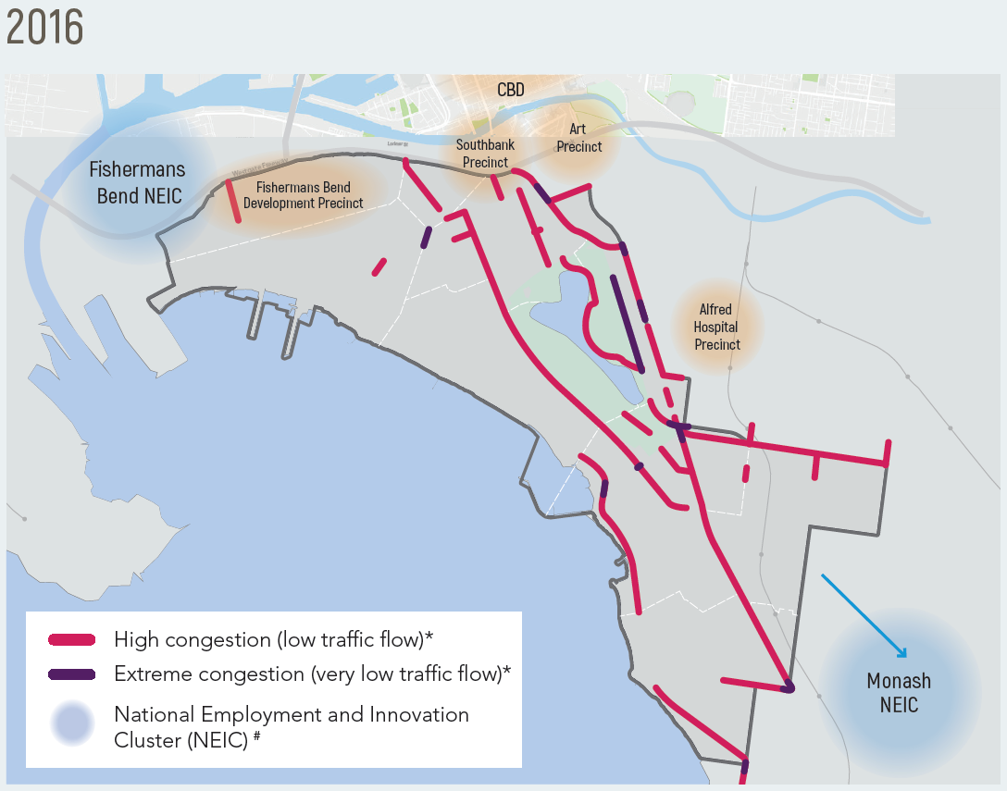

2027
Based on the current population projection and way people travel, a model of what future traffic congestion would look like in 2027 is illustrated in the map below. It shows areas of high congestion (low traffic flow) and extreme congestions (low traffic flow) based on the Victorian Integrated Traffic Model (VITM). The neighbourhoods of highest population growth have also been identified based on data from the ABS 2016 Census of Population and Housing. If the levels of vehicle travel continue like today, there will be major increases in congestion along Beach Road, Jacka Boulevard, Grey Street, Queens Road, Salmon Street and Ormond Esplanade.
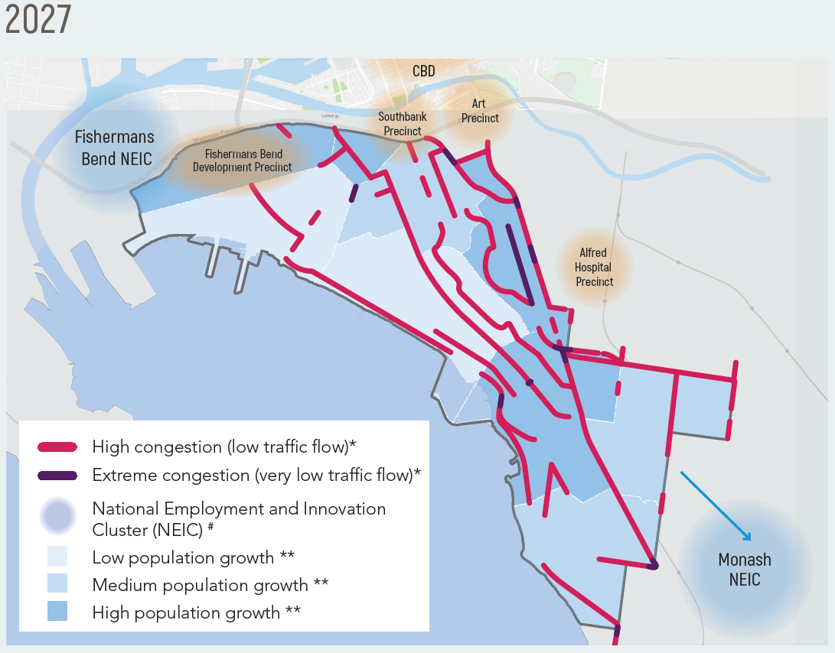

Big opportunities
Greater Melbourne is experiencing the biggest investment in its public transport and road network in several decades. This is a once-in-a-generation city shaping program of works that will transform Melbourne, and creates an opportunity for Port Phillip to leverage off this investment to benefit our existing and future communities.
- Doing things with partners - A focus on working with others to develop better public transport services across neighbouring council boundaries, and upgrades to our public spaces. We rely on the Victorian Government for delivery of key transport infrastructure such as public transport services and management of the arterial road network.
- Doing things differently - Shifting our street design priority to the movement of people rather than the movement of vehicles; using technology and new transport options to increase transport choices; trialling street design changes with our community; and building research partnerships.
- Investing in the right things - Focusing our effort and investment on those actions that will provide our community with realistic and safe travel choices.
- Using what we have better - Changing our policies and services to meet changing customer expectations and needs, including improving the value, speed and ease of doing business with Council.

Where are we now?
Much of Port Phillip is well serviced by public transport in the form of trains, trams and buses. However, as we continue to grow, we need to work with our partners to improve reliability, capacity and frequency of public transport to reduce our reliance on cars.
We have strong and productive relationships with the Victorian Government, state agencies and other local governments. We will leverage these relationships to maximise our collective impact.
The Victorian Government is planning and constructing significant transport projects in Port Phillip. Most notable is the Melbourne Metro project, which includes Anzac Station and surrounding major transport legacy works, improvements to a number of existing tram stops and a new tram line to Fishermans Bend.
Port Phillip is relatively flat and easy to navigate on foot and by bike, but currently only six per cent of daily trips are by bike. We have invested in improving safety and amenity for bike riders for many years, but we can make things even better in our City for bike riders and pedestrians.
Further assistance is required from the Victorian Government to grow and improve the transport network, including:
- improved tram capacity and a schedule for constructing accessible tram stops
- a comprehensive review of bus services and a plan to improve capacity, operating hours, links to other transport options and frequency
- upgraded bicycle facilities on arterial roads and at key intersections
- pedestrian improvements, particularly in busy areas of activity
- construction of Melbourne Metro 2 train connection to Fishermans Bend.

Listening to our community
Views were varied and we have tried to balance the needs and aspirations of our diverse community in developing this strategy. We listened to your feedback and used it to help identify your priorities and concerns.

What we heard
Transport and parking problems have been identified in the Council Plan 2017-18 as key issues of concern to you. This led us to seek more detailed information from you on the specific difficulties you are experiencing, and to compare that to what you value the most in your streets and neighbourhoods.
We conducted a staged community engagement process in 2017 to both establish and respond to the Integrated Transport Strategy Position Paper ‘Setting the Direction’, reaching approximately 1,200 people in various ways.
This input was used to develop the draft Move, Connect Live Strategy released in June 2018. An additional 520 community members - residents, workers and visitors - provided feedback on this draft and shaped the final strategy.
We heard that you are already making changes, even if it isn’t always easy. Both the complexity and difficulty of these changes is appreciated by both you and us, including the challenge of balancing individual needs with the needs of the broader community.
Some of the responses we heard during consultation included:
- Population growth is a benefit to the community, but only if the negative impacts can be well managed.
- There is strong support to improve bike lane infrastructure for safe bike riding experiences, work together with the Victorian government to achieve improvements faster, and continue to focus on safety for pedestrians and bike riders as a priority.
- Council is expected to be a leader by using technology to benefit the community.
- There is significant support for researching and developing an evidence base for parking provision rates in new developments for both new residents and existing residents.
- Car users are concerned that prioritising other modes and streetscape improvements will lead to car congestion.
- Parents of young children are more reliant on their vehicles.
- There is support for lower speeds on local streets.
- You accept that the future will require moving away from a car-centric lifestyle, but this will be challenging.
- Small businesses are concerned about parking changes and how it will affect them.
- There is scepticism of Council’s level of influence around public transport.
- There are mixed views about whether to redevelop Council-owned off-street carparks.
- There is strong interest in being further involved in the development of the new parking policies for parking controls and parking permits.
- Residential parking is a concern, with some people wanting free parking permits and others being impacted by neighbours not using their garage to store their vehicles.

Our partners
The key to creating an integrated transport experience in Port Phillip is working in partnership with others. Our community, local and state government partners, transport providers, peak bodies, research organisations and private industry all have a critical role to play.
Our City is affected by Federal and State legislation and policies, the actions of neighbouring councils, the businesses and organisations that operate within our boundaries and everyone who lives, works and visits here.
This context presents both opportunities and challenges for delivering the actions in this Strategy. In some instances, we will have direct control over specific actions, especially those relating directly to Council operations. In other cases, we will partner with or advocate to other levels of government for change, and leverage opportunities that benefit our community.
Each of us has a role in creating a future where we can all move, connect and live.

The role of Council
The City of Port Phillip delivers infrastructure projects and manages how the City’s streets and public spaces operate. Our role includes:
- Trusted service provider - Providing high quality and safe roads, bike lanes and footpaths, using technology and parking controls to make parking fairer for everyone, and using planning mechanisms to create better public spaces. Council will commit approximately $37 million over 10 years to deliver the actions contained in this Strategy (dependent on project co-funding from partners).
- Trusted partner and broker - Further developing partnerships with Australian, Victorian, and local governments to advocate for and deliver better transport outcomes for our community.
- Trusted advisor and agent - Making it easier for people to move around our City by creating a connected and integrated transport environment. We’ll do this by giving our community the information it needs and creating incentives for our community to use public and active transport, within the limits of our control and influence.
- Trusted steward - Being a sector leader in transport and parking management by improving transport choices for our community. This includes a commitment to consulting with our community about changes and making those changes in a careful, considered and timely way.
- Monitoring and reporting - Monitoring and reporting against the key measures outlined in this Strategy, to share our progress and identify opportunities for further improvement.

Our government partners
In Victoria, there are various government agencies, authorities and franchisees that support the planning, operations and delivery of various parts of our road and public transport systems. The Table in Appendix A: ‘City of Port Phillip Transport Partners’ outlines the names and roles of each of these agencies, as well as supporting local councils and community groups.
The partnership responsibilities diagram below illustrates the level of control to deliver respective outcomes in Port Phillip by Council, government partners and industry. This information is also contained in the table below.
Outcome Number | Focus Area | Funding source | Delivery responsibility | Policy and regulation
1 | Ten minute walking neighbourhoods | - Developers | - Developers | - Council  - State
1 | Prioritising safety and accessibility | - Council  - State | - Council | - N/A
2 | Space for walking, specialising and play | - Council  - State | - Council  - State | - State
2 | Boosting bike riding | - Council  - State | - Council  - State | - State
3 | Partnering to deliver reliable, accessible and more frequent public transport | - Council  - State  - Operators | - Council  - State  - Operators | - State
4 | Improved parking management | - Council  - Private industry | - Council  - Private industry | - Council  - State
5 | Harnessing rapid advancements in new technology | - Council  - Private industry | - Council  - Private industry | - Council  - State
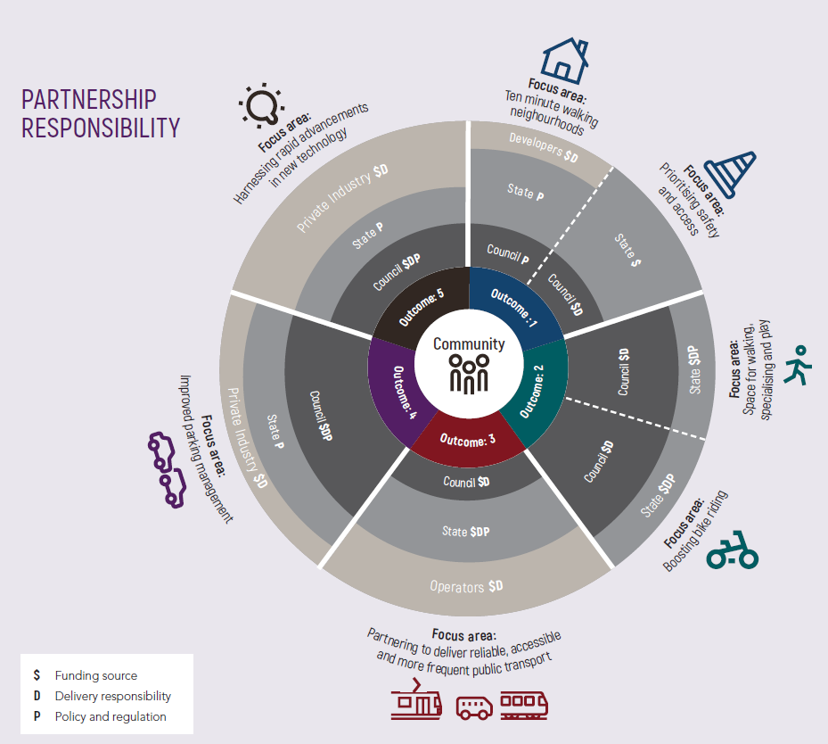

The role of residents and workers
The choices we make every day have an impact on the travel experience in our municipality, and we all have a role to play in doing things differently.
Our City will continue to experience increased congestion, with population growth and travel disruption throughout the next 10 years as major public transport, urban developments and road improvement projects are constructed.
There are many things our community is already doing around making changes to their travel choices, which frees up our roads for people who need to travel by car.
Some additional changes that may be available for you to consider include working from home, shifting your working hours to travel outside peak travel times, or breaking up your journey by combining travel modes such as public transport, bike riding and walking.
The average person makes three to four individual trips a day. If everyone in Port Phillip converted just one of those trips from a vehicle to a sustainable transport trip, we could significantly reduce road congestion.
The majority of workers in Port Phillip currently come from outside the municipality, and some from long distances. The investment in connections to public transport improvements and bike links will assist some in choosing to combine modes of transport to get to work and reduce road congestion.

Where do we work?
- 82 per cent of Port Phillip workers commute from outside the municipality, travelling for longer and from further away than local residents. Commuters come from as far north as Whittlesea, south from Mornington Peninsula, west from Greater Geelong (but predominantly Wyndham), and east from Yarra Ranges.
- 73 per cent of local residents commute outside the municipality. Largely to the CBD, south to Kingston and east to Greater Dandenong.

How did we travel to work?
The following statistics are based on data from the ABS 2016 Cesus of Population and Housing:
- 45 per cent by car
- 16 per cent by tram
- 9 per cent by train
- 2 per cent by bus
- 8 per cent by walking
- 5 per cent by bike
- 6 per cent worked from home
- 9 per cent by other mode

What will be different
The City of Port Phillip’s transport challenges are not unique. All major urban areas in Australia and worldwide face population increases that are outpacing the government’s ability to deliver infrastructure.
We need to do things differently, but rather than reinvent the wheel, it is important that we learn lessons from other cities and not repeat mistakes of the past.
Council is well placed to support our community to walk, bike ride and take public transport to work and on short local trips more often. Our City is less than five kilometres from Melbourne’s CBD with a mostly flat landscape and an existing public
transport network. This Strategy will build on these strengths and help make active and public transport choices easier and more enjoyable. We know that private cars will continue to be part of our transport network, but as our City grows unreliable travel times, congestion and pressure on car parking will make driving and parking less convenient and more expensive.

Same space – more people
Council commissioned transport modelling to better understand the impact of population growth on the road network by 2028, based on current private vehicle use. This modelling showed that congestion along major roads will increase throughout the day, and that congestion will also spill over into the local street network, as illustrated in the maps for 2016 and 2027 peak traffic congestion included earlier in this document.
To find out how we can avoid these negative outcomes, we analysed how people travel around on a daily basis. Transport trips can be separated into three main categories:
1. Internal trips within Port Phillip
2. To / from trips to and from Port Phillip
3. Through trips originating and ending outside Port Phillip
Council has the highest level of influence over the first two categories - Internal and To / From - as they involve local residents, workers and visitors, and use our local streets. The focus for Council is therefore on local trips (less than two kilometres) and inner Melbourne connections through neighbouring municipalities.
However, through-trips make up the highest percentage of daily trips on our road network. The increase in these will also have an impact on the surrounding local street network, particuarly neighbourhoods closest to major roads.
The impact of the increasing number of trips on our existing street network requires a fundamental rethink of how we get around. The best way to accommodate more people on our streets is to prioritise the creation of safe travel alternatives to owning or driving a car, as cars take up the most amount of road space per person. This will help us achieve our 2028 target of maintaining the current levels of congestion, with approximately the same private vehicle trip numbers as 2016.
Council is proposing the following targets by 2028 for daily internal and to/from trips across (not through) the municipality.
We are aiming for:
- 36 per cent increase in walking trips per day, from 152,000 in 2016 to 207,000 in 2028
- 151 per cent increase in bike riding trips per day, from 17,000 in 2016 to 44,000 in 2028
- 35 per cent increase in public transport trips per day, from 42,000 in 2016 to 56,000 in 2028
- 0 per cent increase in private car trips per day, from 128,000 in 2016 to 128,000 in 2028
The source of the 2016 figures is the 2016 Victorian Integrated Survey of Travel and Activity (VISTA).
To achieve these targets by 2028 and beyond, Council is proposing actions that redesign a number of our streets to provide enough capacity to carry an additional 55,000 walking trips, 27,000 bicycle trips, and 14,000 public transport trips.
Council will pursue initiatives aimed at improving travel choices for our community, that provide a convenient alternative to driving a car. Together, we want to give you the choice to change one car trip a day to an alternative transport option.
Move, Connect, Live will reshape our City to optimise the way we move around the City of Port Phillip.

Creating a city for people
We want a City where residents, workers and visitors have lots of travel choices - a City that is connected and easy to get around – supporting Melbourne’s much celebrated liveability and people’s individual health, wellbeing and contribution to our City’s economy.
If we do nothing - if we do not change the way we travel - everyone will be impacted by transport congestion, longer travel times and lost productivity. Port Phillip’s liveability is critical to Melbourne’s reputation as one the world’s most liveable cities.
One of the most essential parts of our City is its streets - they are the arteries and the key to shaping our daily experiences. We define a street as inclusive of both the footpath, nature strip and the road space. There is growing global recognition that streets contribute in many ways to economic, environmental and social life, beyond simply moving vehicles from one point to another, and this view supports an integrated transport design approach.
Our City is fundamentally a place for people. When designing streets, we need to shift our thinking away from prioritising car movement and storage of vehicles (parking), to the movement of people and how we can support a wider range of travel choices. It is about keeping Port Phillip as a fantastic place to live.

A shift in perspective
Streets are traditionally classified by their ability to move traffic and provide access for cars. By embracing a different approach based on the local context, the needs of different users, and positive social, economic and environmental outcomes, we are moving toward designing a City for people.
Internationally, this shift in integrated transport design is framed around a “movement and place” approach, using the local land use context to define priority of use.

Movement and place approach
We have used a ‘movement and place’ approach to underpin the development of this Strategy. A movement and place approach will help Council classify our road network based on how each street can serve the local community best. Each street functions as either a part of the transport network (movement) or as part of the neighbourhood for social, goods or services exchange (place).
This could include providing better pedestrian facilities such as wider footpaths, seating or kerb extensions. This could require removal of some parking.
The key to this process is categorising streets for pedestrian use first, and
recognising that local residential streets are different from main streets and major tourist attractions. The process will also help us find out how best to accommodate more than one transport type into one street.
The diagram below is drawn from the new draft Movement and Place Framework of Victoria recently developed by VicRoads and Transport for Victoria, and outlines six general street types – city hubs, city streets, city places, connectors, activity streets and boulevards, and local streets - that capture the range of different movement and place combinations. These movement and place combinations are contained in the table below.
Council will adapt this approach to align with the specific conditions of Port Phillip as part of the delivery of this Strategy.
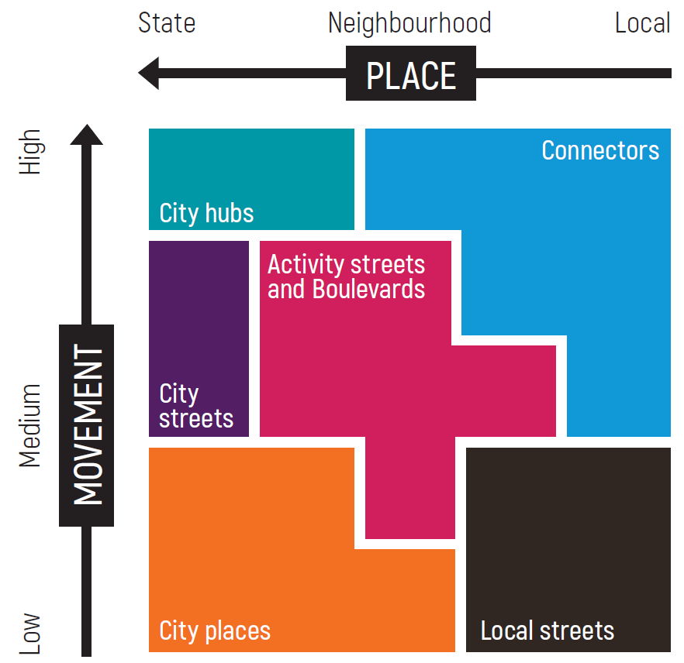
Neighbourhood element | Level of movement | Place Experience
Connectors | Medium to High | Local to Neighbourhood
City hubs | High | State to Neighbourhood
City streets | Medium | State
Activity streets and boulevards | Medium | Neighbourhood
City places | Low to Medium | State to Neighbourhood
Local streets | Low to Medium | Local to Neighbourhood

Typical street types in Port Phillip

City Hubs
- St Kilda Junction
- Domain Precinct

City streets
- Barkly Street
- Inkerman Street
- Carlisle Street

City places
- Acland Street
- Armstrong Street
- Ormond Road

Connectors
- Beach Road
- Brighton Road
- Canterbury Road
- Queens Road

Activity streets and boulevards
- Clarendon Street
- Bay Street
- Fitzroy Street
- Kerferd Road to Albert Road (Shrine to Sea)

Local streets
- Residential streets across all neighbourhoods

Typical street elements in a movement street

Walking
- Clear space on foothpaths for all to pass.

Bike riding
- Protected lanes for bike riders separated from other modes including parked cars.

Public transport
- Dedicated lanes for buses and trams, including facilities.

Vehicles
- Dedicated space for motorised vehicles to move people and goods.

Parking
- Space for vehicle parking, stopping and unloading.

Typical elements in a place street

Outdoor dining
- Permitted space for outdoor dining.

Public plaza
- Hard paved public areas that can be used for events and activities.

Street furniture
- Physical objects in the street including light poles, bins, parking machines, seats and new technology.

Green infrastructure
- Trees, planting beds, nature strips, vertical planting and water sensitive urban design.

Footpath trading
- Permitted space for business signs, goods displays and food vendors.

Building edges
- Building frontages including façade treatment, windows, setbacks, signs and awnings for shelter.

Outcome 1
Outcome 1 is: Our City’s transport network, streets and places cater for our growing community.

Focus areas
The focus areas of Outcome 1 are:
- 10-minute walking neighbourhoods.
- Prioritising safety and access

10-minute walking neighbourhoods.
In areas of highest forecast demand across the City we aim to deliver access to key services within a 10-minute walk. Close local access to shops and community spaces creates a strong sense of place and connects homes to workplaces, schools and commercial centres.

What this means for you
- “I feel more connected to the community when I walk and use public transport” – resident.
- “The best way to enjoy the beautiful area we live in and take full advantage of it is to get amongst it wherever possible” – resident.
Your future experience could be:
“I love walking to my local shops and checking out all the beautiful gardens along the way. Everything I need is so close, including the kids’ school. It’s so easy to cross the road, the streets are cool and shady in summer and the footpaths are wide enough for the kids to scoot ahead.”

Why are we doing this?
Population growth and increased housing density across the City will vary significantly between Port Phillip’s neighbourhoods, creating a non-uniform level of localised impact and challenges. There will be extreme change in the north and west, and less change in the south and centre.
To achieve the highest level of connectivity for our community, we are aiming to create 10-minute walking neighbourhoods through integration of land use with transport planning. This means locating the increased residential density and jobs growth close to existing (or soon to be completed) high quality pedestrian routes and frequent public transport services that connect to key destinations like schools, employment, shops and community facilities.
The key tool Council has to create walkable neighbourhoods is the Port Phillip Planning Scheme, and supporting zoning and urban design frameworks. This is particularly important in neighbourhoods forecast for rapid population growth such as
Fishermans Bend, St Kilda Road precinct, St Kilda, Port Melbourne and South Melbourne. In addition, better transport links from South Melbourne and Melbourne’s city centre are needed to ensure residents have seamless travel choices.
To support ageing in place, Port Phillip delivers a unique community travel service, the community bus, for vulnerable older people and those with disabilities. This highly valued and much needed service enables residents to access a reliable and disability enabled travel option to key community facilities and destinations, plus maintain regular social connections. A review of this service will be undertaken as part of the Aged Care Transition Service review in response to national reforms to aged care.
The Victorian Government’s Metro Tunnel project will deliver huge benefits to public transport users across Melbourne, particularly for residents close to Anzac Station in the Domain precinct. To maximise the benefits from this major transformation, Council is developing a precinct plan for the area. The precinct plan will detail changes required to local streets and links through private land to accommodate the significant increase in pedestrian numbers generated by a major train station and tram interchange, combined with increasing densification of this residential and commercial precinct.
The Victorian Government is finalising the completion of the Fishermans Bend Framework (inclusive of theFishermans Bend Integrated Transport Plan and Precinct Plan) in collaboration with the cities of Port Phillip and Melbourne. The key transport and access requirements of Fishermans Bend as it develops into a vibrant neighbourhood will be:
- early delivery of public transport
- high quality bike and pedestrian links
- managing the impact of traffic and parking in the area
- high quality streetscape works.

Prioritising safety and access
Great streets are outcomes of great design. Design of our streets prioritises safety and comfort without compromising the movement of people and goods.

What this means for you
“Walking and public transport allowed me to get to know my daughter better because all we did was hold hands and chat. Didn’t have to focus on driving and parking” - resident.
“We have become so disconnected, we don’t know any of our neighbours, we don’t speak to them now. What the council is proposing would help that.” - resident
Your future experience could be:
“Now we get more frequent and longer pedestrian crossing times, I finally feel I am getting the same level of respect as a car driver on St Kilda Road. It used to take longer to cross the road than the entire rest of my trip!”

Why are we doing this?
When people feel safer on their local streets they increase their interaction on a personal level with their local environment. This often results in spending more time on the street. The increased sense of ownership for the local community provides wider social benefits for the City.
Council is committed to improving safety of all road users on the transport network with the aim to eliminate fatalities and reduce the risk and severity of injuries on our roads, allowing people of all ages and abilities to travel on our road network safely and with confidence. The number of road injuries has significantly reduced, with serious injuries to pedestrians in the City having reduced by approximately 50 per cent since 2007.
The predicted increased number of trips and growth in through-traffic from surrounding areas means that our local community will increasingly experience more cars travelling on their streets, as drivers travelling through the municipality look for shorter routes to bypass slow points on VicRoads’ controlled arterial roads. Council seeks to manage this by implementing Local Area Traffic Management treatments on local streets and shopping strips as part of discouraging through-traffic onto them and maintaining safer vehicle speeds.
Increasing safety, or even the perception of safety, can increase the attractiveness of walking and bike riding as an alternative to driving a car. For many people, feeling unsafe on our road network is one of the biggest barriers to making this change.
A location of great community safety concern is the St Kilda Junction, which is a significant physical barrier to biker riders and pedestrians.
Partnering with the Victorian Government to develop a movement and place vision for this local area is critical to improving pedestrian and bike rider safety.
Council sets the design quality of our streets via a Design and Technical Standards Manual to ensure both consistent and context responsive physical design outcomes. This program will be led by a Movement and Place Precinct approach and includes
specifications for increase in street widths, access for all abilities, application of footpath trading guidelines, street furniture placement, drainage and utility provision, opportunities for new technology and green infrastructure (such as shade trees or water sensitive urban design), wayfinding signage, public art and street activation opportunities.
Being next door to the Melbourne CBD and the Port of Melbourne means we can expect an increasing demand of freight travel volumes using multiple modes (trucks, rail). Council recognises the importance of managing the potential impact of an increasing number of through freight movement along our roads and through our growing communities. We will work closely with our partners to minimise the impact on amenity to the community, through securing time and route restrictions.
Freight requirements in areas of increasing residential density will also need an updated approach to ensure that resident needs are being catered for within their buildings as much as possible. This relates to some of the following:
- waste and recycling services
- service van parking
- loading - small goods delivery
- loading - removal vans and large goods delivery

Priority Actions
Our priority actions for Outcome 1 | Timing for action
- Review and update the Port Phillip Planning Scheme and Municipal Strategic Statement to ensure effective integration of land use and transport planning. | 2018/19, 2019/20 and 2021-24.
- Develop a precinct masterplan for the Domain Precinct(Albert Road and surrounds). | 2018/19.
- Partner with the Victorian Government to ensure the Fishermans Bend Framework and precinct plans optimise wider transport connections for both current and future Port Phillip residents and workers. | 2018/19 and 2019/20.
- Partner with the Victorian Government to fund early delivery of connections to public transport, public space and streetscapes, footpaths and bike lanes in Fishermans Bend. | 2019/20, 2021-24 and 2025-28.
- Review the Community Bus service as part of the Aged Care Transition Service review (in response to national reforms in aged care). | 2019/20 and 2021-24.
- Develop Movement and Place guidelines that include green infrastructure. | 2019/20 and 2021-24.
- Deliver blackspot safety improvements at high collision locations (subject to external funding). | 2019/20, 2021-24 and 2025-28.
- Deliver Local Area Traffic Management (LATM) treatments to deter through traffic and maintain safe vehicle speeds on local streets. | 2018/19, 2019/20, 2021-24 and 2025-28.
- Ensure our streets and places are safe and inclusive, including accessible parking, pedestrian facilities, lighting and security. | 2018/19, 2019/20, 2021-24 and 2025-28.
- Support the Victorian Government to develop a Movement and Place Strategy for St Kilda Junction and Council to deliver safety and amenity improvements. | 2018/19 and 2019/20
- Partner with the Victorian Government and others to manage the impact of growing freight and goods delivery movements on our community. | 2018/19, 2019/20, 2021-24 and 2025-28.
- Support the Victorian Ports Corporation (Melbourne) and Victorian Government to manage congestion at Port Melbourne Waterfront precinct. | 2018/19, 2019/20, 2021-24 and 2025-28.

Measuring Progress
The indicators for measuring the progress of Outcome 1 - Our City’s transport network, streets and places cater for our growing community - are contained in the table below.
Indicator for Outcome 1 | 2016/17 Result | 2020/21 Target | 2027/28 Target
Number of fatal or serious traffic collisions involving all road users. | 78 (Reduction in crashes achieved is higher than the original target set) | Less than 119 (Calculated as 20% reduction of 2007-11 average). | Less than 96
Number of daily private passenger vehicle trips (measured by VISTA) | 128,000 | 128,000 | 128,000
Community perceptions of Council’s ‘traffic management’ as part of the Port Phillip Customer Satisfaction Survey | 53% | 55% | 60%

Case study - Cycling without Age
Common anxieties associated with ageing includes social isolation, the need for functional assistance, and the loss of independent mobility. Wintringham Specialist Aged Care is a Victoria-based not-forprofit welfare company specialising in the housing and care of older people who are experiencing homelessness or are vulnerable to homelessness.One of their residential accommodation locations is in Port Melbourne.
For nine years, Wintringham has been taking their Port Melbourne residents out and about in the neighbourhood on bicycle rickshaws.
Through the international program Cycling without Age, Wintringham has been able to partner with the software organisation, Zendesk, which offers its employees time off work to volunteer as riders. The Wintringham team know that by getting their clients active, outdoors and involved in conversations, their emotional wellbeing and cognitive function will improve.
Council was also able to partner with Wintringham and Zendesk as part of the community engagement activities for the development of this Strategy.
Benefits of the rickshaw rides include:
- a reduction in feelings of isolation and loneliness
- connection with community
- physical benefits associated with being outdoors, including vitamin D from sunshine and fresh air
- opportunity for mental stimulation leading to
- improved cognitive function
- emotional benefits.

Outcome 2
Outcome 2 is: Our community is healthier because it has safe, connected and convenient walking and bike riding choices

Focus areas
The focus areas for Outcome 2 are:
- Space for walking, socialising and play
- Boosting bike riding

Space for walking, socialising and play
Safe streets and places for walking and play is aligned with designing a City for people, and presents opportunities to allow for a range of activities at different times of the day and week.

What this means for you
- “I feel more connected to the community when I walk and use public transport” – resident.
- “The best way to enjoy the beautiful area we live in and take full advantage of it is to get amongst it wherever possible” – resident.
Your future experience could be:
- “Our neighbours got together to apply for one of the new ‘Play Street’ permits from Council, and now we can block off our street twice a month and we all get together to play cricket. The kids love it.”

Why are we doing this
To achieve streets that support healthy lifestyle choices and provide an enjoyable journey we need to begin by decluttering existing footpaths, widening high pedestrian routes, shortening road crossing times at key locations, trialling new ideas and focusing on school travel safety.
Increased pedestrian trips contribute to outcomes in a number of Council’s other strategies, including the Sustainable Environment Strategy, which has community greenhouse gas emissions reduction goals supported by promoting healthy travel options, the Creative and Prosperous City Strategy through its placemaking initiatives, and the upcoming Public Place Strategy.
Our City is growing in population, but the space we have is not. To meet the needs of a larger community new criteria will be required to identify and prioritise street sections that can be readily converted to public space, such as road space shared with pedestrians and cars, or closed to vehicle traffic completely. This will better service the growing number of residents living in apartments with limited access to nature and social spaces.
Walking is the most basic form of mobility and needs to connect well to other modes of transport. For example, we walk to the car or public transport, and walk our bicycles through high pedestrian traffic areas and across intersections. We can achieve growth
in the number of walking trips across our City by swapping short car trips with walking trips.
Most of our City’s streets have footpaths. Our focus is therefore not on creating more whole routes but on the following five actions:
- increase footpath widths in high pedestrian traffic areas
- reduce barriers to crossing at key intersections
- improve pedestrian safety
- implement walking priority and safety improvements on routes to schools (alongside)
- delivery of Council’s school travel program.
Implementing these actions will make it easier and safer for people to walk to and around activity centres, key public transport stops and other destinations in our City’s neighbourhoods.
Healthy habits for life start early. Investing in active school travel programs is an essential part of encouraging our community to get out and walk more. Council has been delivering walk, scooter and bike to school programs successfully for many years, and now wants to focus on the additional benefits small scale infrastructure improvements can provide. Safety and priority upgrades along the most popular routes to school will be addressed. This will be supported by Council continuing to deliver promotional and behaviour change initiatives in partnership with local schools, to grow the level of active travel by parents and children to and from school.
All this change can be disconcerting and daunting, and not necessarily permanent. To support this program of change, Council is proposing a suite of transitional and temporary changes to the design of our City’s streets and laneways, reallocating available
space on streets to reflect future demands by people across different times of the day, week and year. These initiatives include:
- trialling proposed street design changes
- trialling ‘pedestrian clearways’ on overcrowded pedestrian streets by using car parking lanes for pedestrians during peak hour
- temporary street closures for ‘play streets’
- creating creatively-painted low speed shared zones and pedestrian priority crossings
- introducing traffic calming to improve safety and pedestrian amenity on local streets.

Pedestrian network improvement

Map 1 illustrates proposed pedestrian network improvements throughout the municipality. These include:
- improvements to intersections managed by both Council and VicRoads
- better located crossings
- proposed new crossings on VicRoads managed roads
- three primary schools that will launch the Healthy Tracks to School safety upgrade program to support active travel to school.
Map 1 illustrates the approximate five and 10-minute walking distances to the three schools and a guide for walking distances for other schools. Walkers are able to travel further in a given time when streets have less road traffic and shorter wait times for safe crossing at intersections.
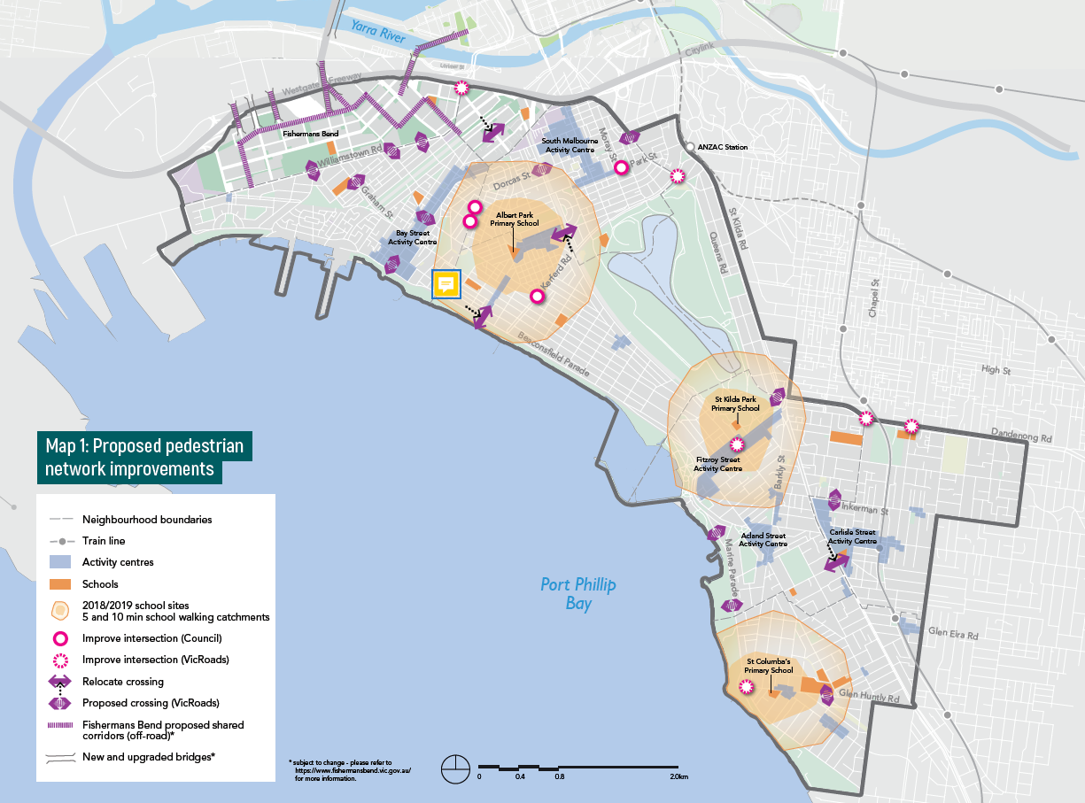

Best practice research - Cities Alive
In 2017 Arup Pty Ltd published a report Designing for urban childhoods to showcase new thinking from around the world. Their research reinforces that a child-friendly approach to urban planning is essential for the creation of inclusive cities that work better for everyone, but is often overlooked as an urban concept.
Traffic hinders children’s independent mobility and affects their physical and mental development. The amount of time children spend playing outdoors, their ability to get around independently, and their level of contact with nature are strong indicators of how a city is performing, not just for children but for all generations of city dwellers.
The report suggests ways of tackling this including pedestrian priority and play streets:
- Green infrastructure - safe urban water play in both flooded and dry conditions
- intergenerational spaces - for both old and young
- pedestrian priority - a safe environment for everyday street play and socialising
- multi-use community spaces - smart use of spaces around schools and other community facilities to enable out of hours use
- Play streets - temporarily closed to traffic to allow danger free outdoor play
- Road treatment – colourful crossings and shared spaces to improve pedestrian awareness
- Playful encounters - public art, bus stops and tram stops that invite creative interaction as part of the journey.

Boosting bike riding
To encourage increased bike riding by prioritising the delivery of comfortable, safe and continuous protected bike lanes for local access, commuting and recreational trips throughout the City.

What this means for you
- “I cycle everywhere (I don’t own a car), and always encourage my friends to get on a bike!” – resident.
- “I call my bicycle my freedom machine because I can go anywhere any time and see smell and hear the world it’s wonderful” – resident.
- “All our friends need for encouragement, is to see the joy on our two year olds face when he is in our bike trailer or on the tram.” – resident.
Your future experience could be:
- “I always wanted to ride to work but it seemed a bit scary and unsafe. The new bike path has a concrete separation between the cars and bikes and now I ride twice a week. It’s a great way to start the day”.
- “We just bought a unit in Montague so we could be close to the city and the beach. Even though I work in Oakleigh, it’s easy to ride my bike to Anzac Station, park my bike and take the train”.

Why are we doing this?
Bike riding is healthy, very space efficient, low cost and often the most convenient way to travel short to medium distances (two to 10 kilometres). Encouraging more people to ride more often in Port Phillip will achieve significant benefits to both general health and the environment.
Previously Council has combined delivery of improvements for bike riding together with walking.
We need to invest in a dedicated program of infrastructure improvements for bike riders of all abilities if we are to improve bike
rider safety and make it an attractive choice for our community. We know the best outcomes are achieved when we deliver bike lanes that are safely separated from pedestrians parked and moving vehicles, and for these lanes to be a continuous route
between major destinations.
Bike riding is one of the most efficient ways of moving people in Port Phillip because:
- it is very space efficient, meaning we can move more people through the same space, and when parked needs less space than a car
- the cost to build and operate bike riding facilities is very low compared to public transport and cars
- it provides a healthy and environmentally friendly way of getting around
- it is an easy and convenient means of transport for short to medium length trips.
Council will deliver a network of continuous, protected bike lanes linked with intersection upgrades.
One of the highest priority corridors is along Kerferd Road. Council will partner with ParksVictoria to deliver protected bike lanes as part of the Victorian Government’s Shrine to Sea project connecting Anzac Station and St Kilda Road to the Bay Trail. This project will also deliver benefits for pedestrians.
VicRoads is leading a corridor safety project on St Kilda Road in partnership with Council and other organisations and agencies, to deliver changes to the design and allocation of space. A key outcome is to reduce the number of injuries, as it is Port Phillip’s busiest tram and bike route and experiences the highest car-dooring injury rate of bike riders in Victoria. Council can help grow a bike riding culture by providing bicycle parking, end-of-trip facilities and targeted behaviour change programs.
Council will deliver and advocate for bike route connections to major transport interchanges and the provision of world class bike parking facilities. This includes both existing and future interchanges such as Ripponlea Station, Balaclava Station, Anzac Station and two locations in Fishermans Bend.

Case study - Inclusive City Cycling
A city that is designed for cycling is successful when its bike riding population reflects the wider population of residents living in that
city. A report focusing on women and bike riding in the United Kingdom, from a 2017 Bike Life survey, explored different factors
relating to how bike riding can make cities more liveable.
A key factor stopping women from bike riding is not feeling safe (men consistently ranked existing facilities as safer than women).
Women were most represented (79 per cent) in supporting the investment in protected bike lanes, even if this meant less space for
road traffic, as a means of creating a safer environment. Nearly a third of women living in Bike Life cities do not currently bike ride but would like to begin.

Case study - City of Sydney - Cycling Strategy and Action Plan 2018-2030
The evidence of the past decade is that if you deliver safe cycling facilities, Sydneysiders will get on their bikes and ride. The numbers speak for themselves. Thousands of people now travel by bike in Sydney and surrounding areas. The efficient and safe movement of people and goods is essential for economic growth, and is a hallmark of a globally competitive city.
In the last decade - from 2007 to 2017 - City of Sydney has achieved an overall 100 per cent increase in bike rider numbers. A key part of this success has been due to their commitment to protected bike lanes, resulting in a boom in bike rider numbers. These increases range from a 281 per cent increase in George Street, Redfern, to a 580 per cent increase in Kent Street.

Bike riding network improvement map
The following criteria was used to identify and prioritise the routes shown in Map 2:
- Ease of delivery - Selecting local streets gives Council greatest control over delivery, and avoiding key traffic and public transport routes to allow greatest flexibility, protection and other streetscape improvements in designing the corridors.
- Maximum connectivity - Connecting the most popular destinations together.
- Growth area focus - Linking to neighbourhoods and precincts with the highest growth in population or land use change and in neighbouring municipalities.
- Ease of uptake - Likelihood of attracting the most number of people to bike riding, factoring in other travel options, trip numbers and key destinations.
Council is proposing to complete 11 corridors within the next 10 years, and an additional two after 2028. The Victorian Government will also deliver two corridors. The total of 15 bicycle corridors are:
1. Moray Street to City (with MMRA)
2. Albert Road to Kerferd Road (Shrine to Sea - delivered by State Government)
3. Park Street link
4. Garden City - off-road connection to Sandringham Light Rail Trail
5. Dorcas St / Nelson Rd / Foote St - Kings Way to Beach
6. Inkerman Street - Fitzroy Street/ Cantebury Road to Glen Eira connection
7. Sandringham Line/ Westbury Street - Ripponlea to Windsor
8. Dickens Street - Balaclava to St Kilda Beach
9. Acland Street / Mitford Street / Beach Street - Fitzroy Street to Elwood Beach
10. Tennyson Street/ Blessington Street - Elwood to St Kilda Beach
11. Byron Street/ Glen Eira Road - Ripponlea to Elwood
12. Bridge Street/ Richardson Street/ Loch Street - Port Melbourne to St Kilda
13. Alexandra Street - Prahran to Balaclava
14. Armstrong Street - Middle Park Beach to Albert Park trail
15. St Kilda Road safety improvement project - delivered by State Government
These bike corridors are also included in Map 2.
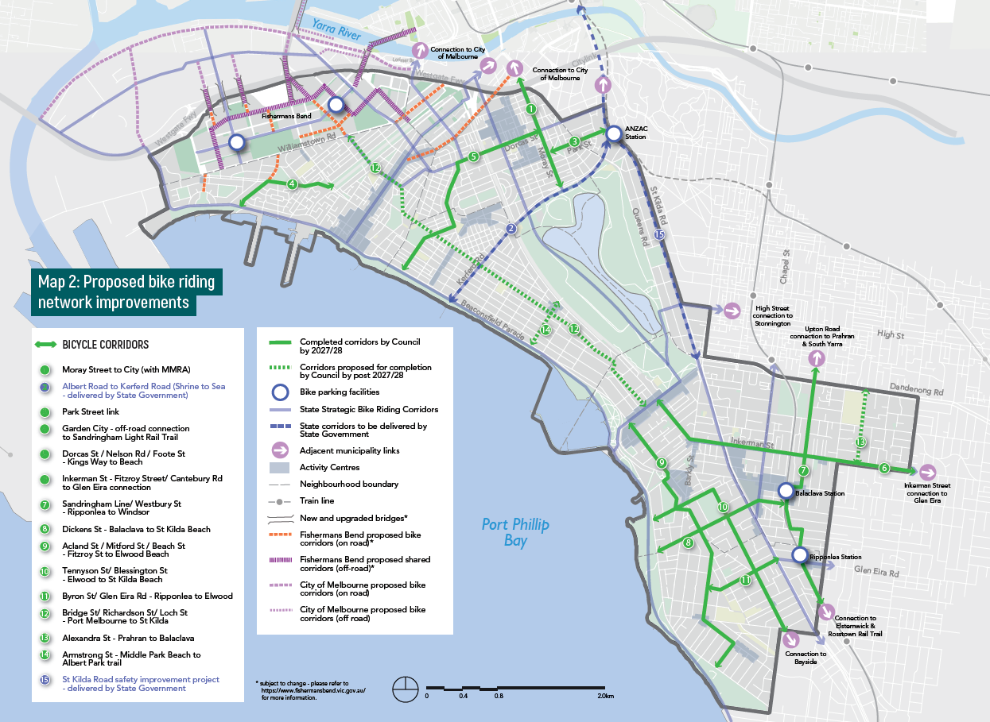

Priority Actions
Our priority actions for Outcome 2 | Timing for action
- Complete the intersection upgrade of Wellington Street to improve traffic safety, and pedestrian and bike riding facilities. | 2018/19.
- Develop criteria to assess change of road space from vehicle use to create space for social connection, trade, and walking and bike riding links. | 2018/19 and 2019/20.
- Deliver pedestrian projects that create safe, high amenity walking routes and reduce barriers to crossing major roads. | 2018/19, 2019/20, 2021-24 and 2025-28.
- Work with school communities to support active travel to school as a popular, safe and easy travel option. | 2018/19, 2019/20, 2021-24 and 2025-28.
- Trial initiatives to increase priority and space for walking, bike riding and play. | 2019/20, 2021-24 and 2025-28.
- Deliver a network of dedicated and continuous protected bike corridors to create safer routes for all ages and abilities. | 2018/19, 2019/20, 2021-24 and 2025-28.
- Partner with Parks Victoria to plan and deliver the Shrine to Sea boulevard to deliver safety and streetscape improvements for walking and bike riding (subject to State funding). | 2018/19, 2019/20 and 2021-24.
- Partner with VicRoads to deliver a better walking, bike riding and public transport environment along St Kilda Road. | 2018/19, 2019/20 and 2021-24.
- Partner with Victorian Government to design and deliver high quality bike parking facilities at train and tram hubs to integrate bike riding with public transport. | 2021-24 and 2025-28.
- Encourage and support the community to ride bikes | 2018/19, 2019/20, 2021-24 and 2025-28.

Measuring Progress
The indicators for measuring the progress of Outcome 2 – Our community is healthier because it has safe, connected and convenient walking and bike riding choices - are contained in the table below.
Indicator for Outcome 2 | 2016/17 Result | 2020/21 Target | 2027/28 Target
Number of daily walking trips (measured by VISTA) | 153,000 | 120,000 (18% increase from base case) | 207,000 (36% increase from base case)
Number of daily bike riding trips (measured by VISTA) | 17,000 | 30,000 (75% increase from base case) | 44,000 (151% increase from base case)
Speed of vehicles using Wellington Street | Greater than 44.8km per hour | Less than or equal to 40km per hour | Less than or equal to 40km per hour
Number of schools participating in ‘Walk to School’ month | 7 per year | 9 per year | 11 per year
Number of schools participating in ‘Ride to School’ day | 13 per year | 15 per year | 18 per year
Number of ‘Healthy Tracks to School’ - infrastructure improvements for safer walking routes to schools completed | N/A | 6 | 12
Number of protected bike corridors delivered | N/A | 4 | 11
Increase in pedestrian and civic space in shopping strips and in activity centres | N/A | 10% | 20%

Outcome 3
Outcome 3 is: Our community has convenient public transport choices that make it easier to move and connect.

Focus area
The focus area for Outcome 3 is: Partnering to deliver reliable, accessible and more frequent public transport
Council will partner with the Victorian Government and public transport providers to ensure delivery of an attractive and highly competitive travel choice.

Partnering to deliver reliable, accessible and more frequent public transport

What this means for you
- “People like me rely on the roads for our livelihoods. We need frequent public transport to be more reliable. That way, more people will use it and there’s more space on the road for people who really need to drive.” - Business owner.
- “I would catch a bus if there was a quick bus route to the city. Buses are quite slow because while they have the priority lane they make more stops.” – resident.
- Your future experience could be:
- “Since they separated traffic from trams, the trams are so much more reliable and frequent - which also means less crowded.”
- “Since Council and PTV have worked together, construction only happens once - a new footpath, a larger area for outdoor dining and an accessible tram stop.”

Why are we doing this?
Port Phillip’s inner-city location means it is generally well serviced by public transport services. There are key gaps, however, in both geographical coverage, service speeds and the frequency of services, especially bus and tram services. Improvements to
these services will enable better quality travel and accessibility of the network, particularly for less mobile passengers.
Public transport that shares traffic lanes with an increasing number of people driving cars presents challenges to the reliability and speed of services. Prioritising public transport service to move more people faster and more reliably than private vehicle travel is the key aim.
Council will work together with our partners to redesign the network of bus and tram services. We aim to connect key destinations, to serve our growing resident and worker population ready for the benefits of Anzac Station, including connection times between
different modes. This will include a review of existing bus routes, facilitation of a ‘turn up and go’ service, closing current and potential future gaps in the public transport network and reallocation of car parking to provide a network of dedicated lanes for buses and trams separated from cars.
Public Transport Victoria and Yarra Trams are legally obligated to deliver trams stops that are accessible for people with mobility issues. Council’s role is to ensure these works are designed to maximise the benefits to our community, by designing connecting civic spaces and creating more opportunity for events, social activities and footpath trading.
Council will continue to advocate to State and Federal governments, and respective agencies to secure early implementation of tram services into Fishermans Bend so that it truly is a 10-minute neighbourhood for people to live, work and visit.
Council will continue to advocate to State and Federal governments to start planning for Melbourne Metro Rail Project 2 linking Newport to Clifton Hill, with two Metro train stations located within Fishermans Bend.
Areas of Port Phillip suffer from poor public transport services including frequency, services hours and connectivity, particularly around and between activity centres. Council will identify areas of need and advocate to service providers and the Victorian
Government for public transport improvements.
When the Metro Tunnel is complete it will create 48 per cent more passenger capacity on the Sandringham Line and 60 per cent more capacity on the Sunbury Line (accessed by the new Anzac Station) Trams along St Kilda Road carry more people per hour than the Westgate Bridge.
Map 3: Council’s Proposed Public Transport Network 2028
This map of the City of Port Phillip and surrounding Councils shows existing and proposed train, tram and bus routes . There are new bus, tram and train routes shown for Fishermans Bend. The proposed Park Street tram link closes the 400m gap between tram lines in South Melbourne. There are potential relocated or discontinued bus routes in Elwood and Port Melbourne. It also shows potential tram/bus priority signals or locations.

The map includes the following disclaimers: For discussion purposes only and subject to change. (a) This proposal is not endorsed by the Department of Transport (b) The proposals contained in this map are subject to state funding.

Priority Actions
Our priority actions for Outcome 3 | Timing for action
- Partner with Rail Projects Victoria to design and deliver place, walking, bike riding and public transport improvements around Anzac Station. | 2018/19, 2019/20, 2021-24 and 2025-28.
- Partner with the Victorian Government and public transport providers to increase the reliability and frequency of both tram and bus services. | 2018/19, 2019/20, 2021-24 and 2025-28.
- Partner with PTV and Yarra Trams to deliver a pipeline of integrated movement and place tram projects. | 2018/19, 2019/20, 2021-24 and 2025-28.
- Advocate to State and Federal governments to deliver the Fishermans Bend tram by 2022. | 2018/19, 2019/20 and 2021-24.
- Advocate to the Victorian Government to commence construction on Metro 2 immediately following completion of the current Metro Tunnel Project in 2025/26. | 2018/19, 2019/20 and 2021-24.
- Identify and advocate for improvements to missing public transport links and areas of poor public transport connectivity. | 2018/19, 2019/20 and 2021-24.
- Investigate the opportunity to pilot transport services to improve connections within Elwood and from Port Melbourne to St Kilda. | 2019/20, 2021-24 and 2025-28.

Measuring Progress
The indicators for measuring the progress of Outcome 3 - Our community has convenient public transport choices that
make it easy to move and connect - are contained in the table below.
Indicator for Outcome 3 | 2016/17 Result | 2020/21 Target | 2027/28 Target
Number of public transport trips (measured by VISTA) | 42,000 | 49,000 (17% increase from  base case) | 56,000 (35% increase from base case)
Streetscape improvements are delivered as part of tram stop upgrade projects in shopping and activity centres per year | N/A | 100% | 100%
Delivery of dedicated bus or tram only lanes on Council controlled streets (kilometres) | 0.5km | 3.5km | 5.5km

Outcome 4
Outcome 4 is: Our community understands that parking is a limited and shared resource, and works with Council to ensure fairest access.

Focus area
The focus area for Outcome 4 is:
- Improved parking management

Improved parking management
Council will deliver a program of changes to our parking management system to improve equity in car parking while also supporting the economic vitality of the City.

What this means for you
- “I’m a ratepayer and pay for two parking permits and still can’t get a park in my street!” – resident.
- “My customers need to be able to drive to my shop and know they can get a park.” - small business owner.
- Your future experience could be:
- “More people in my street are parking their cars in their off-street car parks instead of the street, that has really helped create more available spaces for our visitors.”
- “I have had some frustrating experiences trying to pay for parking in the past, but the new app allows me to pay easily (no more coins!), and alerts me when my time is nearly up so can extend without leaving the restaurant.”

Why are we doing this?
Council currently manages approximately 53,000 on-street car parking spaces across the municipality, as well as around 4,000 spaces in council-managed off-street car parks. This is equivalent to the area of approximately 10 Catani Gardens.
These spaces are a mix of paid parking, time restricted or permit parking, and unrestricted parking. Road space comprises 17 per cent of the total land area of the municipality and of that 17 per cent, 20 per cent is dedicated to on-street car parking. Council also plays a role in the supply of private off-street parking through the implementation of the Port Phillip Planning Scheme, which influences the amount of parking that is provided in new developments. These car parks are primarily for private use by residents,
workers or visitors; however, there are around 2,500 commercial paid parking spaces (mainly in St Kilda Road and South Melbourne).
Public car parking is a finite resource in Port Phillip. New parking spaces aren’t economical to provide and would take up space that could be used for other modes or other uses such as public space.
Parking controls (time restrictions and paid parking) are a critical tool to support place vibrancy of our streets, to ensure the opportunity to use the street space is equitable and allow more people to use the same space more often. Council’s aim for parking
occupancy is to ensure that people have the option of finding parking near their destination.

How are we doing this?
Council uses policies to guide our parking management practices. We will review and combine key parking policies to ensure that they meet current and future requirements.
Parking policy reform can support a high quality urban lifestyle, and respond to the trade-offs required to achieve this in an increasingly overcrowded road space.
Council will revise and update the Parking Permit Policy application procedures, online information and enforcement procedures as a priority action. The scope of the proposed changes include:
- introduction of fixed parking precincts for individual permits, changed from street location based
- consolidation and simplification of the existing number of permit policies and types, including the introduction of single-use visitor parking permits
- review of the maximum number of permits allowed per household, taking off-street parking into account
- introduction of tiered pricing structure for permits
- investigation into a transition from paper to electronic permits for some uses to enable a better customer experience.
A new Parking Controls Policy will provide criteria for consistent application of both paid and timed parking controls within the municipality. This will help solve existing issues around inconsistent pricing models, lack of seasonal responsiveness, poor demand management and integration with land uses.
Implementation of the Parking Controls Policy will be undertaken in conjunction with the parking technology program on a progressive basis. Reviewing parking controls in areas of Port Phillip with highest population, congestion and worker growth will be
prioritised to address concerns of both existing and new residents. Priority areas include those with high congestion and traffic management requirements such as South Melbourne, St Kilda Road North, Port Melbourne, Balaclava and St Kilda. Community
engagement will help inform parking needs and how we can provide fairer access to parking within our City.
Council will also investigate the development of Parking Overlays. A Parking Overlay is a planning scheme tool that we may use to respond to local car parking issues, both on and off-street, and to manage car parking by precinct rather than on a site-by-site basis.
To prepare for developing Parking Overlays in the planning scheme, Council will gather data on current use of parking supply in existing residential developments.

Best practive research - Parking supply in residential apartments
Increasing residential densities and urban consolidation are viewed as critical to the development of more sustainable urban transport and land use systems.
Residential apartment buildings now account for a substantial proportion of new developments, particularly in inner city areas. Planning provisions specify the requirements for on-site car parking in those developments. Car ownership levels are now being impacted by a range of factors including better access to public transport, declining youth licensing rates and availability of options to have access to a car without owning one.
International research has found that planning provisions that specify the amount of car parking required in apartment evelopments are resulting in excess parking availability. This comes at a cost to developers and reduces housing affordability.
Data from the Australian census was used to examine car ownership and parking supply in residential apartments in Melbourne, Australia. Consistent with the findings of international studies, excess parking availability is apparent in Melbourne’s apartment developments. The parking requirements for larger apartments containing three or more bedrooms had the highest level of excess parking. Changes in the way parking requirements are specified have the potential to reduce parking oversupply.

Priority Actions
Our priority actions for Outcome 4 | Timing for action
- Develop and implement a new Parking Permit Policy | 2018/19 and 2019/20.
- Develop and implement a new Parking Controls Policy (paid and time controlled parking) | 2018/19, 2019/20, 2021-24 and 2025-28.
- Develop a new evidence base for parking provision rates for new developments | 2019/20 and 2021-24.
- Consider the use of Parking Overlays in the Planning Scheme review process | 2018/19, 2019/20 and 2021-24.
- Improve access to parking information to the community via the Council website | 2019/20 and 2021-24.

Measuring Progress
The indicators for measuring the progress of Outcome 4 - Our community understands that parking is a limited and shared resource, and works with Council to ensure fairest access - are contained in the table below.
Indicator for Outcome 4 | 2016/17 Result | 2020/21 Target | 2027/28 Target
Community perception of Council ‘Parking Management’ as part of the Port Phillip Customer Satisfaction Survey | 52% | Equal to or greater than 55% | Equal to or greater than 60%
Number of precincts that have been reviewed for improvement to parking management | N/A | 6 | 15

Outcome 5
Outcome 5 is: Our community benefits from new transport options and technology to move around.

Focus area
The focus area for Outcome 5 is:
- Harnessing rapid advancements in new technology

Harnessing rapid advancements in new technology
The way we make our daily travel decisions is set to change dramatically over the next 20 years. Both existing and emerging technologies, particularly the increase of internet enabled, location sensitive mobile devices and the data they produce, will support more options around how and when to travel.

What this means for you
- “[Shared cars] encourage people not to buy a car. I have a friend who did the calculations regarding how much it costs to run a car... and she found that it was much cheaper using the share cars.” – resident.
Your future experience could be:
- “Having a car share a few streets away from our house has allowed us to sell our car and save for a holiday. We only need the car for big shops and weekends away, so it gives us everything we need for less.”
Why are we doing this?
Australia has entered a period of rapid transport innovation. Smartphone apps to summon rides, self-driving cars, solar power, GPS-connected public bike share schemes and more are changing the way we manage our mobility needs.
Emerging technologies will play a major role in addressing both contemporary challenges and the transport requirements of future generations. The potential role of technology is constantly evolving, and any new long-term strategy needs to be flexible enough to adapt to new innovations and approaches.
One of the first steps Council is making is the introduction of new parking technology to help provide a more efficient and transparent parking service to residents and visitors. Parking ticket machines will be updated to allow modern payment and automated top-up options. Sensor technology will allow for more efficient parking turnover and real-time parking data to point drivers to vacant parking spaces.
Port Phillip is a national leader in the introduction of a car-share policy and has successfully met early targets for car share bays. Council will continue to increase the number of car-share bays across the municipality and continue to collect ongoing data to monitor usage trends across the various operators to ensure greatest community benefit.
The recent introduction of dockless bike share to Melbourne triggered a Council response to ensure providers generate benefit to the community by pursuing better regulation with the Victorian Government and other innercity councils.
Many changes that will be brought about by technological change will either be delivered by parties other than Council, or in a future beyond the 10-year scope of this strategy. Recent experience with dockless bike share operations prompts Council to be proactive in establishing early thinking around new policy positions for our long-term future.
This includes changes such as autonomous vehicles, congestion charges, and emerging transport technologies.
The future of travel choice will be driven by data and Council has the opportunity to work with public and private transport services providers to offer real-time information and assist innovation across the sector.
To ensure that Council is able to accurately track and report on progress for improvements in the number of people bike riding, walking and using our civic spaces, investment in additional data capture is required.
Three per cent of our residents are already registered car share members - that’s over 3,000 people.

Best practice research - Mobility as a Service (MaaS)
Mobility as a Service (MaaS) is a transport system approach that promotes and facilitates multi modal, centralised and flexible choices, combined with purchase options. MaaS models use a digital platform to bring all modes of travel into a single on-demand service, and is currently receiving great attention and research interest. Different business models have emerged in which travellers can either pre-pay for their mobility services bundled into a MaaS plan, or pay-as-they-go using a smart app linked to the service.
A recent study by ITS Australia and iMOVE Co-operative Research Centre (based in Port Melbourne), focused on an evidence base required to prepare for the major changes anticipated that cleverly builds on existing assets and delivers user-centric services that match the increasing expectations of customers.

Priority Actions
Our priority actions for Outcome 5 | Timing for action
- Introduce new technology to make it easier to find and pay for parking | 2018/19, 2019/20, 2021-24 and 2025-28.
- Continue to deliver more convenient car share locations with providers and encourage car share provision in new developments | 2018/19, 2019/20, 2021-24 and 2025-28.
- Review the car share policy 2016-2021 | 2018/19 and 2021-24.
- Partner with the Victorian Government and other councils to regulate and promote shared transport services and manage disruptive shared transport technologies | 2018/19, 2019/20, 2021-24 and 2025-28.
- Invest in transport data capture to evaluate and monitor progress toward mode shift targets | 2018/19, 2019/20, 2021-24 and 2025-28.
- Make data available to transport providers and third parties to improve service planning and make it easier to move and connect | 2019/20, 2021-24 and 2025-28.
- Establish policy positions on autonomous vehicles, congestion levy expansion, road pricing and emerging new transport options | 2019/20 and 2021-24.
- Support the use of electric vehicles through a variety of measures including the investigation of options to use the planning scheme to facilitate electric vehicle charging infrastructure in new developments | 2021-24 and 2025-28.

Measuring Progress
The indicators for measuring the progress of Outcome 5 - Our community benefits from new transport options and technology to move around - are contained in the table below.
Indicator for Outcome 5 | 2016/17 Result | 2020/21 Target | 2027/28 Target
Residents who are satisfied with the use of pay-by-phone option to pay for parking | N/A | More than 75% | More than 90%
Number of cars owned by Port Phillip residents | 51,200 | 51,200 | 53,500
Number of residents who are car share members | 2,500 | 12,500 | 13,500
Utilisation rate of share bikes (docked and dockless) - trips / day | 1 | 2 | 3

Measuring and reporting
The Move, Connect, Live Strategy 2018-28 is a 10-year strategy.
The Strategy will be reviewed after four years and updated if needed. We will be reporting our progress each year through Council’s annual report (unless otherwise stated).

Outcome 1
The indicators for measuring the progress of Outcome 1 - Our City’s transport network, streets and places cater for our growing community - are contained in the table below.
Indicator for Outcome 1 | 2016/17 Result | 2020/21 Target | 2027/28 Target
Number of fatal or serious traffic collisions involving all road users. (Note - Targets reflect increased population in Port Phillip and Metropolitan Melbourne and resulting increase in trips within, to/from and through our City). | 78 (Reduction in crashes achieved is higher than the original target set). | Less than 119 (Calculated as 20% reduction of 2007-11 average). | Less than 96
Number of daily private passenger vehicle trips (measured by VISTA, annually, subject to funding). | 128,000 | 128,000 | 128,000
Community perceptions of Council’s ‘traffic management’ as part of the Port Phillip Customer Satisfaction Survey | 53 per cent | 55 per cent | 60 per cent

Outcome 2
The indicators for measuring the progress of Outcome 2 – Our community is healthier because it has safe, connected and convenient walking and bike riding choices - are contained in the table below.
Indicator for Outcome 2 | 2016/17 Result | 2020/21 Target | 2027/28 Target
Number of daily walking trips (measured by VISTA, annually, subject to funding) | 153,000 | 120,000 (18% increase from base case) | 207,000 (36% increase from base case)
Number of daily bike riding trips (measured by VISTA, annually, subject to funding) | 17,000 | 30,000 (75% increase from base case) | 44,000 (151% increase from base case)
Speed of vehicles using Wellington Street | Greater than 44.8km per hour | Less than or equal to 40km per hour | Less than or equal to 40km per hour
Number of schools participating in ‘Walk to School’ month | 7 per year | 9 per year | 11 per year
Number of schools participating in ‘Ride to School’ day | 13 per year | 15 per year | 18 per year
Number of ‘Healthy Tracks to School’ - infrastructure improvements for safer walking routes to schools completed | N/A | 6 | 12
Number of protected bike corridors delivered | N/A | 4 | 11
Increase in pedestrian and civic space in shopping strips and in activity centres (measured as square meature increase). | N/A | 10% | 20%

Outcome 3
The indicators for measuring the progress of Outcome 3 - Our community has convenient public transport choices that make it easy to move and connect - are contained in the table below.
Indicator for Outcome 3 | 2016/17 Result | 2020/21 Target | 2027/28 Target
Number of public transport trips (measured by VISTA, annually, subject to funding) | 42,000 | 49,000 (17% increase from  base case) | 56,000 (35% increase from  base case)
Streetscape improvements are delivered as part of tram stop upgrade projects in shopping and activity centres per year | N/A | 100% | 100%
Delivery of dedicated bus or tram only lanes on Council controlled streets (kilometres) | 0.5km | 3.5km | 5.5km

Outcome 4
The indicators for measuring the progress of Outcome 4 - Our community understands that parking is a limited and shared resource, and works with Council to ensure fairest access - are contained in the table below.
Indicator for Outcome 4 | 2016/17 Result | 2020/21 Target | 2027/28 Target
Community perception of Council ‘Parking Management’ as part of the Port Phillip Customer Satisfaction Survey | 52% | Equal to or greater than 55% | Equal to or greater than 60%
Number of precincts that have been reviewed for improvement to parking management | N/A | 6 | 15

Outcome 5
The indicators for measuring the progress of Outcome 5 - Our community benefits from new transport options and technology to move around - are contained in the table below.
Indicator for Outcome 5 | 2016/17 Result | 2020/21 Target | 2027/28 Target
Residents who are satisfied with the use of pay-by-phone option to pay for parking | N/A | More than 75% | More than 90%
Number of cars owned by Port Phillip residents (Note - Car Share Policy target identifies a 5% increase by 2027/28 based on current car use, congestion from through traffic and improved travel choices). | 51,200 | 51,200 | 53,500
Number of residents who are car share members (Target of 10% of residential population identified in Car Share Policy). | 2,500 | 12,500 | 13,500
Utilisation rate of share bikes (docked and dockless) - trips / day | 1 | 2 | 3

Appendix A: City of Port Phillip transport partners

Victorian Government
Victorian Government organisation / agency | Transport role
Transport for Victoria (TfV) | Responsible for the planning and coordination of all transport systems in Victoria. It acts as an umbrella agency for Public Transport Victoria, Active Transport Victoria (ATV), VPC and VicRoads.
Public Transport Victoria (PTV) | Statutory authority responsible for providing, coordinating and promoting public transport services in Victoria. Manages the contracts for Yarra Trams, Metro and bus operators.
VicRoads | Road and traffic authority responsible for planning, development and management of the arterial road network and delivering road safety initiatives. Approval authority for Council road upgrade projects.
Rail Projects Victoria (RPV) | Formerly Melbourne Metro Rail Authority (MMRA), responsible for the delivery of Metro Tunnel including a new station at Domain.
Port of Melbourne Corporation (PMC) | The Port of Melbourne is Australasia’s largest maritime hub for containerised, automotive and general cargo. It is a key economic asset for businesses and people across Victoria and south-eastern Australia.
Victorian Ports Corporation (VPC) | Manages Station Pier services for trade and tourism including the Spirit of Tasmania, shipping to Tasmania, and cruise passenger berth
Transport Accident Commission (TAC) | Road injury insurance agency that provides funding to improve safety at areas of high injuries.

Transport operators
Transport operators | Transport role
Yarra Trams (YT) | Operates Melbourne tram network and delivers tram upgrade construction projects.
Bus operators | A number of independent bus operators run the Victorian Metropolitan bus network
Metro Trains | Operates Melbourne metropolitan train network.

Local government
Local government | Transport role
Adjacent local councils | City of Melbourne, Stonnington City Council, City of Glen Eira, Bayside City Council
Inner Melbourne Action Plan  (IMAP) | The Inner Melbourne Action Plan (IMAP) brings key government stakeholders together to develop and deliver regionally based actions.
Inner South Metropolitan  Mayors Forum (ISMMF) | Bayside, Boroondara, Glen Eira, Kingston, Port Phillip, Stonnington and Yarra councils state advocacy group focused on shared transport priorities including reducing the cost of delays due to ineffective transport.
Melbourne Transport Forum  (MTF) | A local government interest group that works towards effective, efficient and equitable transport in metropolitan Melbourne by providing a forum for debate, research and policy development.

Peak bodies
Peak body | Transport role
Bicycle Network (BN) | Promotes community health through prevention and control of disease by “more people bike riding more often”
Public Transport Users  Association (PTUA) | Lobby group representing passenger interests on public transport throughout Victoria
Victoria Walks | A walking health promotion charity, managed by an independent voluntary board

Local community
Local community | Transport role
Bicycle User Group (BUG) | Represents the views and needs of local bike riders including lobbying for better cycling conditions in and around Port Phillip.

Appendix B: 10 Year Implementation Plan

Outcome 1
The 10 year budget for implementing priority actions for Outcome 1 is $4.634 million.
Our priority actions for Outcome 1 | Timing for action
- Review and update the Port Phillip Planning Scheme and Municipal Strategic Statement to ensure effective integration of land use and transport planning. | 2018/19, 2019/20 and 2021-24.
- Develop a precinct masterplan for the Domain Precinct(Albert Road and surrounds). | 2018/19.
- Partner with the Victorian Government to ensure the Fishermans Bend Framework and precinct plans optimise wider transport connections for both current and future Port Phillip residents and workers. | 2018/19 and 2019/20.
- Partner with the Victorian Government to fund early delivery of connections to public transport, public space and streetscapes, footpaths and bike lanes in Fishermans Bend. | 2019/20, 2021-24 and 2025-28.
- Review the Community Bus service as part of the Aged Care Transition Service review (in response to national reforms in aged care). | 2019/20 and 2021-24.
- Develop Movement and Place guidelines that include green infrastructure. | 2019/20 and 2021-24.
- Deliver blackspot safety improvements at high collision locations (subject to external funding). | 2019/20, 2021-24 and 2025-28.
- Deliver Local Area Traffic Management (LATM) treatments to deter through traffic and maintain safe vehicle speeds on local streets. | 2018/19, 2019/20, 2021-24 and 2025-28.
- Ensure our streets and places are safe and inclusive, including accessible parking, pedestrian facilities, lighting and security. | 2018/19, 2019/20, 2021-24 and 2025-28.
- Support the Victorian Government to develop a Movement and Place Strategy for St Kilda Junction and Council to deliver safety and amenity improvements. | 2018/19 and 2019/20
- Partner with the Victorian Government and others to manage the impact of growing freight and goods delivery movements on our community. | 2018/19, 2019/20, 2021-24 and 2025-28.
- Support the Victorian Ports Corporation (Melbourne) and Victorian Government to manage congestion at Port Melbourne Waterfront precinct. | 2018/19, 2019/20, 2021-24 and 2025-28.

Outcome 2
The 10 year budget for implementing priority actions for Outcome 2 is $18.235 million.
Our priority actions for Outcome 2 | Timing for action
- Complete the intersection upgrade of Wellington Street to improve traffic safety, and pedestrian and bike riding facilities. | 2018/19.
- Develop criteria to assess change of road space from vehicle use to create space for social connection, trade, and walking and bike riding links. | 2018/19 and 2019/20.
- Deliver pedestrian projects that create safe, high amenity walking routes and reduce barriers to crossing major roads. | 2018/19, 2019/20, 2021-24 and 2025-28.
- Work with school communities to support active travel to school as a popular, safe and easy travel option. | 2018/19, 2019/20, 2021-24 and 2025-28.
- Trial initiatives to increase priority and space for walking, bike riding and play. | 2019/20, 2021-24 and 2025-28.
- Deliver a network of dedicated and continuous protected bike corridors to create safer routes for all ages and abilities. | 2018/19, 2019/20, 2021-24 and 2025-28.
- Partner with Parks Victoria to plan and deliver the Shrine to Sea boulevard to deliver safety and streetscape improvements for walking and bike riding (subject to State funding). | 2018/19, 2019/20 and 2021-24.
- Partner with VicRoads to deliver a better walking, bike riding and public transport environment along St Kilda Road. | 2018/19, 2019/20 and 2021-24.
- Partner with Victorian Government to design and deliver high quality bike parking facilities at train and tram hubs to integrate bike riding with public transport. | 2021-24 and 2025-28.
- Encourage and support the community to ride bikes | 2018/19, 2019/20, 2021-24 and 2025-28.

Outcome 3
The 10 year budget for implementing priority actions for Outcome 3 is $8.148 million.
Our priority actions for Outcome 3 | Timing for action
- Partner with Rail Projects Victoria to design and deliver place, walking, bike riding and public transport improvements around Anzac Station. | 2018/19, 2019/20, 2021-24 and 2025-28.
- Partner with the Victorian Government and public transport providers to increase the reliability and frequency of both tram and bus services. | 2018/19, 2019/20, 2021-24 and 2025-28.
- Partner with PTV and Yarra Trams to deliver a pipeline of integrated movement and place tram projects. | 2018/19, 2019/20, 2021-24 and 2025-28.
- Advocate to State and Federal governments to deliver the Fishermans Bend tram by 2022. | 2018/19, 2019/20 and 2021-24.
- Advocate to the Victorian Government to commence construction on Metro 2 immediately following completion of the current Metro Tunnel Project in 2025/26. | 2018/19, 2019/20 and 2021-24.
- Identify and advocate for improvements to missing public transport links and areas of poor public transport connectivity. | 2018/19, 2019/20 and 2021-24.
- Investigate the opportunity to pilot transport services to improve connections within Elwood and from Port Melbourne to St Kilda. | 2019/20, 2021-24 and 2025-28.

Outcome 4
The 10 year budget for implementing priority actions for Outcome 4 is $950,000.
Our priority actions for Outcome 4 | Timing for action
- Develop and implement a new Parking Permit Policy | 2018/19 and 2019/20.
- Develop and implement a new Parking Controls Policy (paid and time controlled parking) | 2018/19, 2019/20, 2021-24 and 2025-28.
- Develop a new evidence base for parking provision rates for new developments | 2019/20 and 2021-24.
- Consider the use of Parking Overlays in the Planning Scheme review process | 2018/19, 2019/20 and 2021-24.
- Improve access to parking information to the community via the Council website | 2019/20 and 2021-24.

Outcome 5
The 10 year budget for implementing priority actions for Outcome 5 is $4.959 million.
Our priority actions for Outcome 5 | Timing for action
- Introduce new technology to make it easier to find and pay for parking | 2018/19, 2019/20, 2021-24 and 2025-28.
- Continue to deliver more convenient car share locations with providers and encourage car share provision in new developments | 2018/19, 2019/20, 2021-24 and 2025-28.
- Review the car share policy 2016-2021 | 2018/19 and 2021-24.
- Partner with the Victorian Government and other councils to regulate and promote shared transport services and manage disruptive shared transport technologies | 2018/19, 2019/20, 2021-24 and 2025-28.
- Invest in transport data capture to evaluate and monitor progress toward mode shift targets | 2018/19, 2019/20, 2021-24 and 2025-28.
- Make data available to transport providers and third parties to improve service planning and make it easier to move and connect | 2019/20, 2021-24 and 2025-28.
- Establish policy positions on autonomous vehicles, congestion levy expansion,road pricing and emerging new transport options | 2019/20 and 2021-24.
- Support the use of electric vehicles through a variety of measures including the investigation of options to use the planning scheme to facilitate electric vehicle charging infrastructure in new developments | 2021-24 and 2025-28.

For more information please contact us via:
www.portphillip.vic.gov.au/contact_us.htm
Phone: 03 9209 6777
Facsimile: 03 9536 2722
SMS: 0432 005 405
You can also visit our website: www.portphillip.vic.gov.au
Postal address:
City of Port Phillip, Private Bag 3, St Kilda, Victoria, Australia,3182
National Relay Service
If you are deaf or have a hearing or speech impairment, you can phone us through the National Relay Service (NRS):
TTY users dial 133677, then ask for 03 9209 6777
Speak & Listen users phone 1300 555 727, then ask for 03 9209 6777
For more information visit: www.relayservice.gov.au
Please contact ASSIST on 03 9209 6777 if you require a large print version.
Language assistance
廣東話 – 03 9679 9810
普通話 – 03 9679 9858
Ελληνικα – 03 9679 9811
Polski – 03 9679 9812
Русский – 03 9679 9813
Other – 9679 9814

