Draft South Melbourne Market Strategic Plan
Engagement summary report

How we engaged

Earlier this year we asked for feedback from our community and traders on the plan’s draft strategic priorities to help inform the draft South Melbourne Market Strategic Plan.
The draft South Melbourne Market Strategic Plan was released for community consultation from 7 May to 23 May 2021. The engagement program was hosted on Council’s Have Your Say online engagement portal and feedback was channelled primarily through a survey seeking feedback on the draft plan. Sixty-eight survey responses were received.
Feedback was also captured through three pop-up sessions where community and traders were invited to provide feedback on the draft plan’s key strategic initiatives. At these sessions on the 15 and 16 May the Market team spoke to approximately 100 people and received high quality feedback through this engagement activity.
Feedback was also gathered at the Trader meeting held on Wednesday 19 May with approximately 24 traders in attendance.

The consultation was promoted via Council and the Market’s communications channels, including Divercity, social media and e-newsletters.

Who we engaged
The survey was completed by 68 people. Fifty-eight of the survey respondents indicated they shopped at the Market, nine worked at the Market and 27 lived near the Market.
The following provides a brief snapshot of who we engaged through the survey.
- Sixty-six per cent found out about the survey via the Market’s e-news.
- The majority of respondents lived in City of Port Phillip (71%); 21 per cent lived in South Melbourne; 16 per cent in Port Melbourne.
- Seventy-one per cent of respondents were female.
- Sixty-three per cent were aged between 35 and 59.

Engagement findings

Key insights
- Sixty-four per cent of responses indicated they were supportive of the draft strategic plan overall.
- Seventy-two per cent indicated they were comfortable with the Vision and Mission statements.
- Respondents indicated the highest level of comfort (59%) for the key initiatives in the strategic priority - Curate a differentiated retail offer.
- Support for environmental sustainability initiatives and want them to be front and centre.
- Technology – Important to embrace technology.
- Understand and support the need to be financially sustainable.
- It is important to remain accessible – physically and financially.
- Keep talking to and surveying the customers and traders.
- Focus on local vs tourism.
- Retail mix – Stalls need to remain a good mix of old and new, affordable and artisanal.
- Value – this remains a key driver with fresh produce and is at the core of why people shop at the Market.
Those who indicated they were uncomfortable with some of the strategic key initiatives noted:
- Don’t change – Some respondents did not want to see gentrification.
- Prices – Increased rents may mean increased costs of goods which will affect affordability.
- Sustainability – not enough of a focus and no KPIs.
- Carparking – parking and roundabout congestion came up as a constant issue.
- Profitability – many were surprised the Market hasn’t been making a profit.
- Congestion – many are interested in how congestion will be managed into the future.
- Language – some respondents were critical of the language used in the draft Plan referencing it as ‘jargon’, ‘gobbledygook’ and using ‘clichés’.

Survey
The survey asked for feedback on the draft South Melbourne Market Strategic Plan 2021-2025. This included feedback on the draft plan’s outcomes, vision and mission statements, key strategic initiatives and the four key strategic priorities.
Vision and mission
Seventy-two per cent indicated they were comfortable with the Vision and Mission statements. Seven per cent indicated they were neutral and 20 per cent indicated they were not comfortable.
Very uncomfortable | Not really comfortable | Neutral | Somewhat comfortable | Very comfortable
10.45% | 10.45% | 7.46% | 28.36% | 43.28%

Respondents were then asked to provide feedback on why they were / were not comfortable with the vision and mission statements.
Survey respondents most commonly expressed positive feedback for the vision statement and mission, key and repeating comments have been summarised below:
- The Market should remain a much-loved part of the community
- Fresh produce be the first key point in the Vision
- Need to keep meeting and exceeding customers’ expectations
- The Market needs to remain a unique shopping experience
- Need to focus on local
Those who expressed negative feedback for the vision and mission noted concerns around:
- No mention of sustainability in the Vision
- Keep the pricing down, continue to attract locals
- One-stop-shop sounds like a supermarket
Key Strategic Outcomes
Respondents were asked to provide feedback on the outcomes that the Market aspires to achieve by 2025.
52 of the 68 survey respondents contributed to this open text question. Key or repeating comments are presented below:
- Profitability is important
- Range of choice should not be at the expense of existing retailers
- Online accessibility important to futureproof the retail offer
- Focus on the importance of supporting the local community
- Mix of stalls needs to be balanced
- Supportive of more sustainable practices
- Stay a ‘market’ and remain affordable
- The wording is quite vague and hard to measure

Key strategic initiatives
The draft Plan includes four strategic priorities that will secure the brightest and most prosperous future for the Market, its traders, and the local economy. To achieve these strategic priorities a series of key strategic initiatives have been outlined.
Survey respondents were asked to what extent they were comfortable that the key strategic initiatives would help achieve each of the strategic priorities.
Respondents were then asked to provide feedback on why they were / were not comfortable with the key strategic initiatives.
In summary most respondents responded positively, being somewhat or very comfortable with the key strategic initiatives.
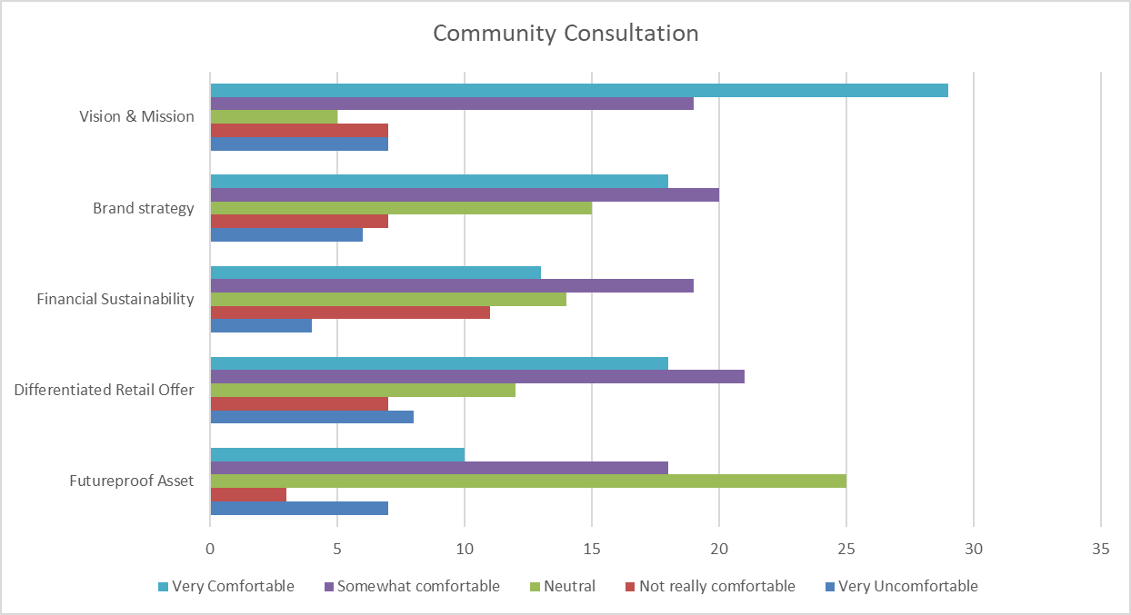

Enhance the South Melbourne Market Brand: This strategic initiative includes a combination of a brand strategy, sustainability strategy, customer experience strategy and digital solutions strategy.
Fifty-eight per cent indicated that they were comfortable that these key initiatives would help enhance the Market’s popularity in the community. While twenty-three per cent indicated they were neutral and 20 per cent indicated uncomfortable.
Very uncomfortable | Not really comfortable | Neutral | Somewhat comfortable | Very comfortable
9.09% | 10.61% | 22.73% | 30.30% | 27.27%

The respondents who indicated they were comfortable with these key initiatives noted:
- Technology is key to the future
- Need to stay a step ahead and set the trends
- Would like more of a Sustainability focus
- Support the community focus
Those who indicated they were uncomfortable with the key initiatives noted concerns about the following:
- Why is branding important if the Market is already busy
- No KPIs for sustainability
- There were no actual initiatives to comment on, just plans
- Too much marketing jargon

Build Financial Sustainability
Fifty-three per cent indicated they were comfortable that these key initiatives would help the Market to build financial sustainability, while 23 per cent indicated they were neutral and 24 per cent indicated they were not comfortable.
Very uncomfortable | Not really comfortable | Neutral | Somewhat comfortable | Very comfortable
6.56% | 18.03% | 22.95% | 31.15% | 21.31%

The respondents who indicated they were comfortable with these key initiatives noted:
- The Market needs to be profitable and improve efficiency
- Multifaceted revenue model would support diversity in offer
- Retain value for money for customers
- The Market needs to be around for ever
- Any sponsorship should be consistent with community expectations
Those who indicated they were uncomfortable with the key initiatives noted concerns about the following:
- Is Council equipped to run a retail Market?
- No guarantee that good quality, reasonably priced produce will be retained
- Hope the profit is not coming from small stallholders and affordable rent continues
- Continue to support the smaller and older stalls
- Reads privatisation and not supportive of this

Differentiated retail offer
Fifty-nine per cent indicated they were comfortable that these key initiatives would help curate a differentiated retail offer, while 18 per cent indicated they were neutral and 22 per cent indicated they were not comfortable.
Very uncomfortable | Not really comfortable | Neutral | Somewhat comfortable | Very comfortable
12.12% | 10.61% | 18.18% | 31.82% | 27.27%

The respondents who indicated they were comfortable with these key initiatives noted:
- As long as existing retailers are not driven out
- Consult with existing businesses on the retail offer and conduct regular market research
- Open the Market out onto York Street
- Keep supporting start-ups in SO:ME Space
- Diversity and uniqueness are key to success
- Keep the standard offers such as grocer, bottle shop, key cutter, books, newsagency, massage.
- Need variety in offer, including messy stalls, helpful salespeople and sole traders, along with more fancy shops
The respondents who indicated they were uncomfortable with the key strategic initiatives noted concerns about the following:
- It’s not broken so why fix it?
- Curate the Market hand-in-hand with the traders
- This does not guarantee basic services will continue
- Main aim should be good value, high quality food
- Focus on food, fresh produce is the main reason people shop at the Market
Improve South Melbourne Market Asset
Forty-four per cent indicated were comfortable that the key initiatives would improve the Market’s asset, while with 40 per cent indicated they were neutral and 15 per cent indicated they were uncomfortable.
Very uncomfortable | Not really comfortable | Neutral | Somewhat comfortable | Very comfortable
11.11% | 4.76% | 39.68% | 28.57% | 15.87%

The respondents who indicated they were comfortable that key initiatives to noted:
- Toilets need to be improved
- The Market should be safe and comfortable
- This will secure the future of the Market
- There should be an Asset plan
- Solid foundations are important
- It would be good to focus on traffic congestion
Those respondents who indicated neutral (neither comfortable or uncomfortable) feedback included:
- Improved amenities and facilities
- Increased cleaning with more people attending takeaway outlets
- Assess the Market as a community asset, not just for commercial gain
- The Market needs some attention in heating / cooling / painting / refreshing
- Extend the operating hours
- Ensure sustainable construction material
Those respondents who indicated they were uncomfortable with the key initiatives noted:
- Profit should cover costs of improvements to the facility
- NEXT will change the purpose and ambience of the Market
- NEXT not needed, focus on some other areas in CoPP
- Asset improvement might see death of smaller traders
Overall support for the draft plan

Survey respondents were asked to indicate their level of support overall for the draft plan using a five-point scale from Strongly supportive to Not supportive at all.
Sixty-four percent of respondents indicated they were supportive of the plan overall, while 13 per cent were not sure and 22 per cent were not supportive at all.
1.Not supportive at all | 2 | 3.Not sure | 4 | 5.Strongly supportive
4.44% | 17.78% | 13.33% | 40.00% | 24.44%

Pop up sessions
Feedback was also captured through three pop-up engagements in May. Two sessions were hosted for the community and one session for traders.
At these sessions we hosted an interactive engagement activity where we asked the community and traders to provide feedback on the draft plan’s key strategic initiatives and overall general feedback on the Market.
Key or repeating comments have been summarised below.
Community:
Sustainability:
  - Would like more recycling opportunities at the Market for the community such as clothing drop off bins and soft plastics recycling.
  - Push traders harder to become more sustainable
Events:
  - Love the events and want more
  - More busking and cooking demos
Brand:
  - So much love for the Market
  - Remain authentic and don’t lose the focus on locals
  - The Market is all about the traders, relationship and history
  - Don’t market to the tourists, keep it local
  - It’s a great experience, don’t lose that
Asset:
  - Improve toilet facilities
  - Clearing Deli Aisle has been fantastic
  - Improve disability access into stalls
  - More seating required
  - Cecil street closure should be permanent
Retail Mix:
  - Many customers stated that gentrification is a real concern
    - Too commercialised
    - More expensive
    - Lacking affordable options
  - Don’t lose the older stalls
  - Food is the focus and fresh produce in particular
  - More local / regional food focus
  - Policies: Happy to hear about fur, indigenous and egg policies
Opening Hours: Many customers want the Market open more often
Parking: Parking was a common complaint by customers
Traders:
Brand:
- Don’t lose the essence of the Market – the Village DNA
- Support the digital / ecommerce direction
- Customer experience is important and they all love creating memorable experiences.
- Events – shouldn’t impact the Market brand
- Want to understand the customers better, supportive of digital tech to do this
Sustainability:
- We’re not leaders anymore and need to do more
- Recycling hub for the traders and community
- Develop framework to know what we’re striving for
- Align traders with what we are striving for
Asset:
- Improve toilet facilities and amenities for traders
- Heating and cooling to be improved
- Supportive of compliance plan
- Retain the heritage of the Market
- Renewable energy
- NEXT Project: keen to be involved and provide feedback
- Risk & Safety – would like more training
- Improve parking in any improvements
Financial sustainability:
- Agree Market should make a profit
- Happy with support provided in 2020
- Thought events would make money (like QVM) but they often don’t
- Rental Model:
  - Understand need for change
  - Appreciate it will be on individual case by case basis
  - Appreciate it will be industry based
Differentiated Retail:
- Traders would like to be involved in the mix, precincting and pipeline work
- Concerned precinct work may shuffle traders around
- Agree that the retail mix is a balancing act
- Work needs to be done on managing congested stalls (Agathe Patisserie / Aptus) that impact other stalls.
- Need to cater for locals first and foremost.

Next steps
In summary, all this feedback will be presented to the SMM Committee and Market Management to ensure that they are aware of the sentiment of the community and traders when planning and working on the key strategic priorities.
Changes to the Strategic Plan, as a result of the community consultation, will include:
- Page 10: Vision and Mission: We will move point 4 – being a trusted destination for quality, value, fresh and extensive offer – to point 1. This appears to be the most important aspect of the Market to the community. We will also remove the reference to ‘one-stop-shop’.

- Page 15: Develop Sustainability Strategy: We will include a reference to setting KPI’s for sustainability that are measurable and reported annually.

- Page 17: The addition of an Asset Plan to the ‘Improve South Melbourne Market Asset’ Strategic Priority. The initiatives currently include delivering on a Compliance Plan, developing and implementing a Risk & Safety Plan and exploring opportunities in the NEXT Project. What is not featured is a 5-year Asset Plan that incorporates general improvements not covered under compliance or NEXT. This is actually currently being developed with the CoPP Assets team. The Asset Plan will assess assets of the Market and plan for future required upgrades.

Market Management and the Market Committee wish to thank the community members and traders that read the Strategic Plan and took time to provide some incredibly valuable feedback. We would like to assure all respondents that their feedback will be constantly referred to by Market Committee and Market Management to ensure we continue to deliver the best market experience for all.

