Community Engagement
Policy
February 2021

Policy governance

Responsible Service/Department:
Strategic Engagement
Adoption authorised:
Council
Date of adoption:
February 2021
Date effective from:
February 2021
Content Manager folder:

Content Manager file #:

Endorsed CEO or ELT member or department manager to make or approve document editorial amendments:
Chief Executive Officer (or delegate)
Annual desktop review date:
December 2022
Review date:
December 2023
Completion date:
February 2025
Version number:
1
Relevant Legislation:
Local Government Act 2020
Associated Strategic Direction #:
Strategic Direction 6
Associated instruments:
City of Port Phillip Public Transparency Policy
City of Port Phillip Governance Rules
Review History:
Name | Content Manager File Reference | Date | Description of Edits
Community Engagement Policy
geor

Contents

Policy governance 2
Contents 4
Tables 4
Purpose 5
Outcomes 5
Definitions 6
Responsibilities 7
Scope 8
Policy 8
What is community engagement? 8
Local Government Act 2020 8
Council’s promise to the community 8
Who we engage 9
Levels of engagement 10
Evaluating our engagement 12
Closing the loop 12
Relevant policy, regulations or legislation 13
Attachments 13
Attachment 1: Criteria for deliberative engagement 14
Attachment 2: Community engagement principles 15
Attachment 3: Community stakeholder groups 16
Attachment 4: Types of community engagement 17

Tables
Table 1: Definitions of terms 7
Table 2: Responsibilities of roles 8

Purpose
The purpose of this Community Engagement Policy is to demonstrate the City of Port Phillip’s commitment and approach to community engagement, and to meet its legislative obligations under the Local Government Act 2020. It outlines how Council will facilitate genuine and transparent opportunities for the community to provide feedback and inform the decisions made by Council. Where the problem is complex and challenging, the policy addresses how Council will draw upon expertise and collective intelligence to co-design solutions and build shared ownership and responsibility for outcomes with the community.
This policy applies to our Councillors, staff, contractors and consultants. It will act as a guide to community members to know what to expect in our planning for community engagement and what role they can play in our decision-making.

Outcomes
The outcomes of this policy are to:
- ensure our community and stakeholders have the opportunity to provide their views and aspirations for our City, to inform the decision making of Council
- provide genuine opportunities for the community to provide feedback that will assist Council to deliver public value through its projects, strategies and services
- build community and stakeholder trust and confidence in the Council, as the Council is aware of and actively considers the lived experience and feedback of the community as part of its decision-making process
- create opportunities for the community and stakeholders to build knowledge of Council activities to enhance their ability to engage with Council from an informed position
- raise awareness of the different ways our community and stakeholders can be involved in Council decision making, ranging from sharing information about a matter to coming together to co-create a solution
- ensure community engagement is as representative as possible by removing barriers to participation
- ensure an environment is created where diversity of view and thought is encouraged and safe to express, and that all participants, including Councillors and staff are treated respectfully
- ensure Council resources are applied effectively and efficiently when planning anhd delivering community engagement activities.

Definitions
Table 1: Definitions of terms
Term | Definition
Community | Community is a flexible term used to define groups of connected people. We use it to describe people of a municipality generally, including individuals or groups who live, work, play, study, visit, invest in or pass through the municipality.  More specifically, it can refer to everyone affiliated with the municipality, or smaller groups defined by interest, identity or location, and not necessarily homogenous in composition or views. Different types of communities often overlap and extend beyond municipal boundaries. Communities may be structured, as in clubs or associations, or unstructured, such as young people. Communities are flexible and temporary, subject to individual identity and location.
Community engagement | A process to support decision making that provides community members with meaningful opportunities to have a say on matters that are important to them or that they are impacted by.
Community engagement principles | The five community engagement principles outlined in section 56 of the Local Government Act 2020.
Consultation | The process of seeking input or feedback on a matter.
Deliberation | The process of presenting and considering relevant facts and information from multiple points of view, discussing possible options and reaching a group (majority or consensus) recommendation.
Deliberative engagement | Deliberative engagement is an engagement process that enables individuals to draw on collective wisdom and expert advice to work through issues and explore potential solutions together to reach a shared recommendation.  Deliberative engagement can be scaled to a project depending on factors such as community impact, interest, complexity and polarised views.  A guide to when deliberative engagement should be considered is provided as Attachment 1 to this policy.
IAP2 | International Association of Public Participation
Public | General term used to broadly describe community and other external stakeholders or groups.
Participation | Public participation encompasses a range of public involvement, from simply informing people about what council is doing, involving the public in the decision-making process, and community activity addressing the common good.
Stakeholder | An individual or group with an interest in or ability to influence the outcomes of a project or initiative and are directly involved in or impacted by a decision. They may also be a group that Council is actively partnering with or make seek to partner with in the future.
Transparency | A lack of hidden agendas or conditions, and the availability of all information needed to collaborate, cooperate and make decisions effectively.

Responsibilities
Table 2: Responsibilities of roles
Role | Responsibility
Council | Champion the commitment and principles for community engagement through leadership, modelling practice and decision making.
Executive Leadership Team | Champion behaviours that foster transparent and meaningful community engagement practice and drive the principles through policy, process and leadership.  Monitor implementation of this policy.
Leadership Network | Manage areas of responsibility to ensure community engagement practice is consistent with this policy.
All staff | Plan and deliver community engagement in line with this policy is the responsibility of all employees as appropriate to their role and function.
Strategic Engagement | Implement processes and tools to support this policy.  Monitor implementation of this policy and conduct periodic reviews to ensure continuous improvement.

Scope
This policy applies to our Councillors, staff, contractors and consultants. It will act as a guide to community members to know what to expect in planning for community engagement and what role they can play in our decision making.
This policy supports Strategic Direction 6 in the Council Plan 2017-21, which outlines the organisation’s aspiration to be a financially sustainable, high performing and well governed organisation that puts the community first.

Policy

What is community engagement?
We are lucky to have an engaged and passionate community, and greatly value their feedback and insights. Our community has a deep well of knowledge and lived experience, and feedback allows Council to have a greater understanding of diverse points of view, values, concerns and priorities. It is a fundamental element of council decision making and essential in ensuring good governance.
At its simplest, community engagement involves having conversations and working with people in the community who are interested in or may be affected by Council’s decision-making. Additionally, it provides opportunities for our community and Council to learn together and build shared knowledge through experiences, actions and learnings.
While community engagement does not replace the final decision-making power of Council, it plays an invaluable role in enhancing Council’s capacity to make well-informed, acceptable and sustainable decisions on behalf of the community it represents.

Local Government Act 2020
Section 56 of the Local Government Act 2020 (the Act) outlines a set of community engagement principles. Council adopts these principles that guide how we will implement all community engagement processes undertaken by Council. Our commitment to the community builds on these principles and outlines our promise and expectations against the principles.
The five community engagement principles in the Local Government Act 2020 are included as Attachment 2 to this policy.

Council’s promise to the community
When engaging with community and stakeholders, Council promises to the best of its ability to:
- seek out and encourage contributions from people, including those who may be affected by or interested in a decision
- provide clear, relevant, timely and balanced information for people to meaningfully contribute
- select a level and scale of engagement that appropriately reflects the issue at hand and opportunities for collaboration with our community
- explore and implement new and emerging technologies that support greater, more interactive and engaging ways to contribute through different channels
- provide a variety of appropriate and accessible ways for people to have their say and speak honestly
- actively listen so that people’s ideas and input assist in making the final decision
- consider the needs and interests of all people in the decision-making process, and actively remove barriers to engagement
- acknowledge and give appropriate consideration to input from those who may be more impacted than others by a decision
- conduct engagement activities in ways that make efficient and effective use of Council’s available resources
- share the final decision, and how community input was considered in making that decision.
While noting these promises, on some occasions, Council may agree to take a slightly different approach to engagement by trialling an initiative and seeking feedback through temporary use, initiatives or activations. Community feedback about what works and what doesn’t through these temporary approaches will then be used to inform longer-term policy outcomes.
There may also be occasions where Council is not able to engage with the community; for example, where Council is legislatively required to take a particular course of action on a matter. On these occasions Council will clearly communicate the action being taken and why Council was not able to undertake community engagement on this matter.

Who we engage
We are committed to ensuring all interested and impacted members of our community have the opportunity to participate in our community engagement processes. For Council to make better decisions, it needs to understand the views, priorities and concerns of its community. As part of this commitment, we will identify stakeholders, people and communities that may be affected by a decision being considered in addition to encouraging broad contributions from our wider community.
At times there are decisions to be made that impact the entire municipality such as when we develop our Council Plan and Budget. We also understand and are aware there are decisions that may affect some people more than others. We will work with our community to identify who our stakeholders are and how they are affected, and design and deliver an engagement approach that appropriately reflects their level of impact and ability to influence the decision to be made.
We are also committed to hearing from our community about the things they are passionate about and listening to their ideas. As part of this commitment, we will take a neighbourhood approach to actively reach out to our community in the places they live, work, play and visit.
Some examples of our community stakeholder groups are provided as Attachment 3 to this policy.

Levels of engagement
Our approach to community engagement is based on the International Association for Public Participation’s (IAP2) Public Participation Spectrum, which is designed to help determine an appropriate level of engagement based on the public’s role in the decision-making process.
The spectrum shows how differing levels of participation are appropriate dependent upon the goals, timeframes, resources and levels of concern around the decision to be made, and states the promise being made to the public at each level. At each level we strive to provide all relevant information required to our community to enable them to be active participants, in line with Council’s Public Transparency Policy.
The table below represents the five levels of engagement based on the IAP2 Spectrum of Public Participation. The spectrum specifically identifies the public participation goal and the promise to the public. We have built upon this and included the types of engagement undertaken and when we would use these types of engagement, and provided examples of the form of engagement.
 | Inform | Consult | Involve | Collaborate | Empower
Public participation goal | To provide the public with balanced and objective information to assist them in understanding the problem, alternatives, opportunities and/or solutions. | To obtain public feedback on analysis, alternatives and/or decisions. | To work directly with the public throughout the process to ensure concerns and aspirations are understood and considered. | To partner with the public in each aspect of the decision including the development of alternatives and the identification of a preferred solution. | To place the final decision making in the hands of the public.
Promise to the public | We will keep you informed. | We will keep you informed, listen to and acknowledge concerns and aspirations, and provide feedback on how public input influenced the decision. | We will work with you to ensure that your concerns and aspirations are directly reflected in the alternatives developed and provide feedback on how public input influenced the decision. | We will look to you for advice and innovation in formulating solutions and incorporate your advice and recommendations into the decisions to the maximum extent possible. | We will implement what you decide.
Type of engagement undertaken | Communicate | Seek feedback | Deliberative engagement | Deliberative engagement | Deliberative engagement
When we use this form of engagement | At particular points in a lifecycle of any matter (e.g. the early stages, key points or conclusion)  To meet a legislative requirement or meet safety requirements / standards | When seeking ideas / input to inform development of a concept, seeking feedback on a draft concept / document or checking back in with our community that we have adequately captured and interpreted their ideas / concerns | To meet legislative requirements under the Local Government Act 2020  When seeking deeper input from the community in finding solutions to challenging issues or where specific sectors of the community may be more deeply impacted by a decision than others (e.g. complex local issues or strategies that impact particular communities of interest) | To meet legislative requirements under the Local Government Act 2020  When a complex problem requires deeper understanding of the challenges and a more informed community input is sought to work collaboratively towards a solution. | When Council is willing to accept and implement the recommendations made to them.
Examples of form | Factsheets  Drop-in sessions / information sessions  Web pages  Newsletters  Technology (e.g. virtual / augmented reality)  Participation by the public at Council meetings | Participation by the public at Council meetings  Focus groups  Technology (e.g. virtual / augmented reality, gamification)  Temporary installations / pop-ups / activations | Advisory groups  Focus groups  Workshops  Technology (e.g. virtual / augmented reality, gamification)  Temporary installations / pop-ups / activations | Co-design workshops  Community panels  Engaging through action (e.g. action learning / placemaking approach)  Technology (e.g. virtual / augmented reality, gamification)  Temporary installations / pop-ups / activations | Citizen’s juries  Council election
In deciding which level of engagement is appropriate, Council will strive to deliver a level of engagement that most accurately reflects the community’s ability to influence the decision to be made.
An overview of community engagement types is provided as Attachment 4 to this policy.

Evaluating our engagement
Measuring our community engagement performance is an important part of the engagement process. It allows us to understand our successes, our challenges and how we can improve our engagement practice in the future. It assists us in identifying whether we achieved our intended outcomes and if not, that we need to do to ensure we meet those outcomes going forward.
When evaluating our engagement, we will consider both the engagement process and the outcomes to determine its effectiveness. This may be done by measuring the level of input or interactions with the community and the representative nature of this, such as:
- surveys completed
- number of attendees at engagement events
- social media reach and engagements
- visits to Council’s Have Your Say online engagement portal.
We will also measure the outcomes of participation. This may be done by responding to questions such as:
- Did we achieve our community engagement objectives?
- Were those who may be affected by a decision, given sufficient materials to meaningfully engage in the process?
- To what extent were those engaged in the process representative of those affected by the decision and of the broader community?
- How did the engagement and community contribution influence the decision-making process?
- What learnings from the engagement process can be applied to future projects?
When designing our community engagement, we will establish an engagement evaluation process that reviews outcomes to ensure learnings are incorporated into future engagement processes for continuous improvement. We will use community feedback on the engagement experience to identify and implement improvements to our engagement practice.

Closing the loop
We will close the loop with our community and inform participants how their feedback was considered in the decision-making process and the final decision. Reporting of outcomes and updates will be available online through Council’s Have Your Say online engagement portal, and in some instances through Council meetings. We will also provide information directly to those who ask to be kept informed of the project.

Relevant policy, regulations or legislation
Local Government Act 2020
City of Port Phillip Public Transparency Policy
City of Port Phillip Governance Rules

Attachments
Attachment 1: Criteria for using deliberative engagement
Attachment 2: Community engagement principles
Attachment 3: Community stakeholder groups
Attachment 4: Types of community engagement

Attachment 1: Criteria for deliberative engagement

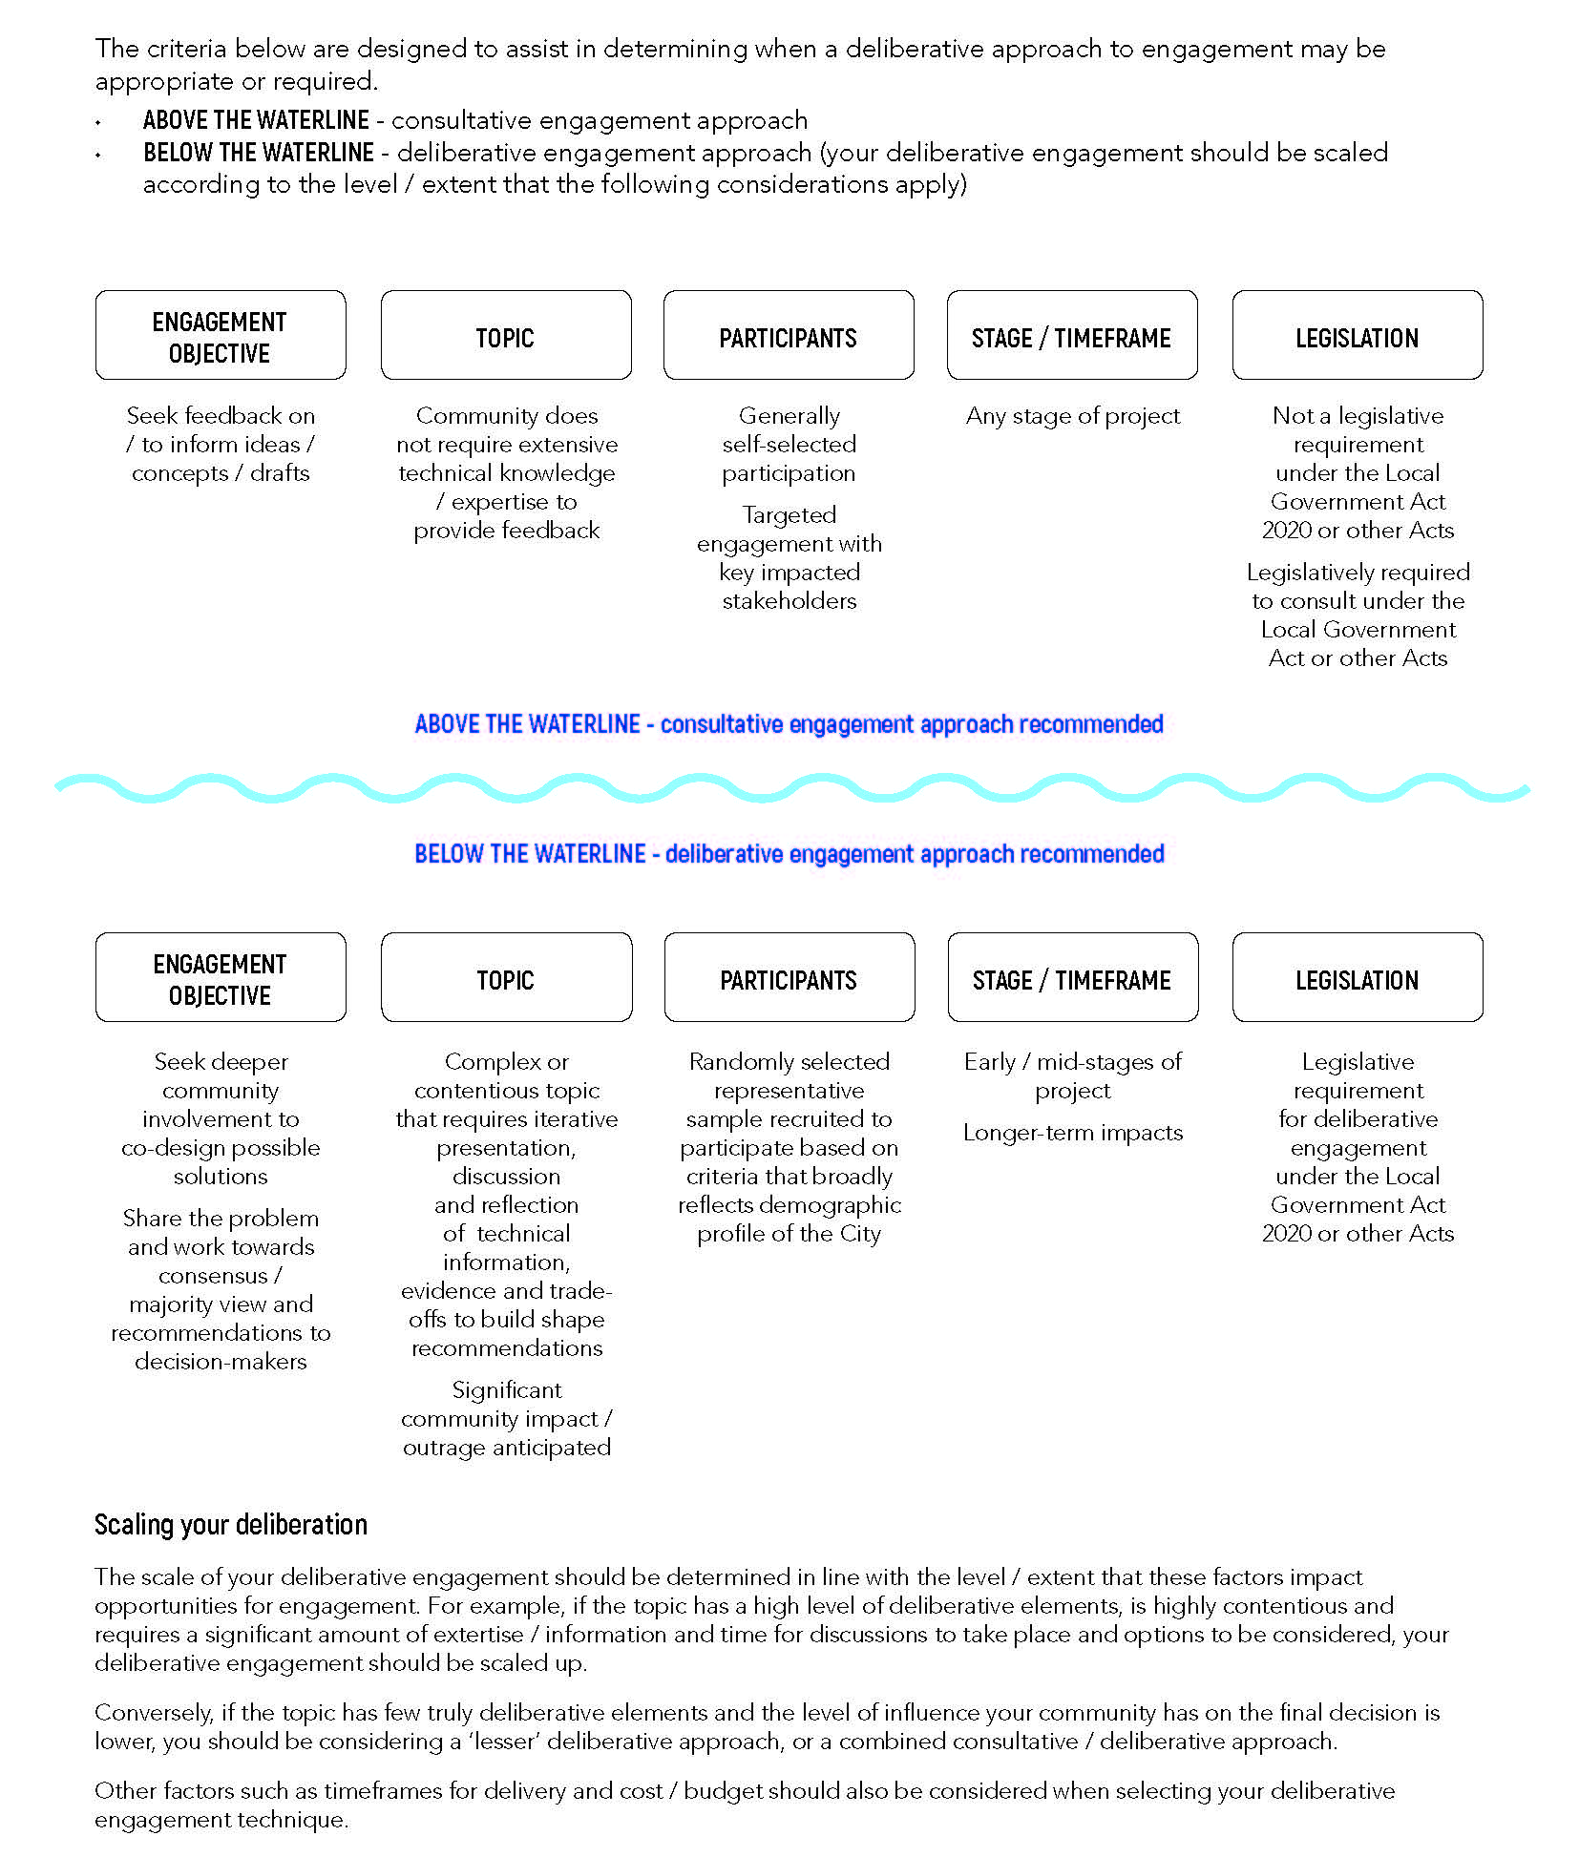

Attachment 2: Community engagement principles
Section 56 of the Local Government Act 2020 outlines a set of community engagement principles. Council adopts these principles and commitments that guide how we will implement all community engagement processes undertaken by Council. Our commitment to the community builds on these principles and outlines our promise and expectations against the principles.
The five community engagement principles are:
- The community engagement process has a clearly defined objective and scope.
- Participants in community engagement will have access to objective, relevant and timely information to inform their participation.
- Participants in community engagement will be representative of the persons and groups affected by the matter.
- Participants in community engagement are entitled to reasonable support to enable meaningful and informed engagement.
- Participants in community engagement are informed of the ways in which the community engagement process will influence Council decision making.

Attachment 3: Community stakeholder groups
The table below shows an example of some of our community stakeholder groups.
Residents | Ratepayers | Businesses, traders and commercial groups
Owner/occupiers | Students | Visitors
Workers | Children and young people | Older people
People with disabilities | LGBTIQ community | Multicultural and faith-based groups
People from culturally and linguistically diverse backgrounds | Indigenous people/groups | Advisory committees
Community groups | Service groups | Advocacy groups
Heritage and history interest groups | Arts and cultural interest groups | Sports and recreation clubs
Environment and sustainability interest groups | Special interest groups | Schools, kindergarten, childcare centres
Park users | Shoppers and diners | Pedestrians
Public transport users | Bike riders | Car users
Neighbouring councils | Other government agencies and other tiers of government | Unions

Attachment 4: Types of community engagement
Deliberative engagement
Deliberative engagement is a form of democracy where deliberation is at the heart of the decision-making process. This can take place at the three highest levels of influence on the IAP2 Spectrum: ‘Involve’, ‘Collaborate’ and ‘Empower’.
Deliberative engagement processes can often recommend solutions to a challenging problem, often one that has been difficult to solve in the past, thus improving strategy or policy outcomes. The process enables the individuals participating to draw on collective wisdom and expert advice to not only create a shared outcome but also have shared responsibility in the process. Having shared responsibility can result in wider community support for both the process and the outcome.
Deliberative engagement can be scaled to a project depending on the community impact, interest, complexity and polarised views. This will be determined during the engagement planning process. Some projects may require a skilled facilitator to ensure an impartial and equitable process.
Some examples of deliberative engagement practices are:
- a representative, random selection of the community that meets over several sessions exchanging information to come to a consensus on a solution/decision
- community members workshopping ideas, concepts and proposals, and providing recommendations.
Consultative engagement
Consultative engagement occurs at the second level of influence on the IAP2 Spectrum, which is ‘Consult’. At this level of engagement, Council is seeking community input or feedback on a project. This type of engagement is appropriate when seeking early input or ideas towards shaping a concept, or when seeking feedback on draft documents such as policies and plans.
Examples of consultative engagement include:
- ideation
- surveys
- submissions
- polls
- online forums.
Communications
When Council makes a decision it is important to communicate the decision and the reasons behind it with our community. Communications occurs at the first level of engagement, “Inform’, on the IAP2 Spectrum. Any good engagement process needs to be supported by informative communications. We are committed to providing clear, relevant, timely and balanced information to those people impacted or interested in a decision. Understanding the problem, the opportunities the decision to be made and how the community can influence this through the engagement process ensures our community can engage in a meaningful way.

