DRAFT Business Parklet guidelines
Version 1, June 2021

Guideline Governance
Responsible Service / Department:
City Growth and Culture
Safety and Amenity
City Strategy, Design and Sustainability
Adoption authorised:
Council
Date of adoption:
[Insert Text]
Date effective from:
[Insert Text]
Content Manager folder:
[Insert Text]
Content Manager file:
[Insert Text]
Endorsed CEO or ELT member or department manager to make and approve document editorial amendments:
General Manager of City Growth and Organisational Capability
Manager City Growth and Culture
Annual desktop review date:
Review date:
Completion date:
2025
Version number:
[Insert Text]
Stakeholder review and engagement:
Community Building and Inclusion, Strategy, Design and Sustainability, City Growth and Culture, Governance and Organisational Performance, Safety and Amenity, Construction, Contracts and Operations, Property and Assets; Open Space, Recreation and Community Resilience
Relevant Legislation:
[Insert Text]
Associated Strategic Direction #:
Strategy 4 – Vibrant Port Phillip
Associated instruments:
Business Parklet Policy
Supersedes:
N/A
Review history:
Name | Content Manager File Reference | Date | Description of Edits
Name of document | # | DD/MM/YYYY | Description of changes

Contents
Guideline Governance 2
Contents 4
Tables 5
Purpose 6
Outcomes 6
Who is this document for? 7
Eligibility 7
What is a parklet? 8
Definitions 9
How to set up a parklet 10
Before you apply 10
Business parklet process 11
Apply 11
Review process 11
Permit issued 11
Installation 11
Operation 11
Remove infrastructure 11
Types of permits available 12
Annual permits 12
Seasonal permits 13
Amendments to an existing permit 14
Removal 14
Display of permit registration 14
Considerations prior to making an application 15
Will your premises have enough toilet and sanitary conveniences? 15
Will you need to relocate any public infrastructure? 15
Will access to any services be compromised? 15
Will you include any advertising? 15
Will you display any goods? 16
Taking care of your business parklet 17
Daily management 17
Safety and accessibility 17
Community amenity 18
COVIDSafe Plan and patron limits in outdoor spaces 18
Hygiene and cleanliness 19
Queuing 19
Where can parklets be located? 20
Location 20
Occupying an adjacent parking bay 21
Maximum number of parklets within areas 22
Designing your parklet 23
All Parklets should include: 23
What can go in your parklet? 31
Movable furniture 31
Fixed furniture 33
Required information with application 34
Decision making 36
The Council’s priorities 39
Council assessment 39
Appeal process 39
Council responsibilities 40
Maintenance of the carriageway and footpath 40
Compensation and loss of trade 40
Monitor compliance with approved permit 40
Relevant policy, regulations or legislation 40
Attachments 40

Tables
Table 1 Definition of terms 9
Table 2 Approval process 11
Table 3 Types of permits 13
Table 4 Recommended maximum number of parklets 22
Table 5 Decision making matrix 37
Table 6 Council’s Business Parklet Priorities 38

Purpose
This document set outs how businesses can apply to establish a parklet that supports their business and adds to the vibrancy of our city. It also sets out what traders should consider if they want to establish and maintain a business parklet and how Council officers will consider applications.
This document provides guidance under the City of Port Philip Local Law 1 and supports the Business Parklet Policy.

Outcomes
The desired outcomes of these Guideline are to:
- Encourage activation and vibrancy in our neighbourhoods and activity centres, which makes them more enjoyable and safer for our community.
- Encourage a sense of community through the creation of safe gathering spaces.
- Support our local businesses and economy to be more resilient to future economic challenges and changes to operating regulations (made by other levels of Government).
- Balance the activation of public space with amenity requirements of surrounding businesses and the community.
- Ensure activation of public space adds to the character, heritage and overall design of our city and meets accessibility, public safety and sustainability requirements.
- Provide additional public space for people to walk, dwell and enjoy our city.
- Ensure businesses that benefit from use of public space make a fair contribution for this use through appropriate fees and charges.
- Provide certainty to businesses, community, Councillors and officers on the way requests to use public space in new ways will be managed (and any fees, charges and engagement required) to ensure applications can be considered efficiently, effectively and with speed.
- Ensure appropriate oversight and compliance measures are established to provide our community and Councillors with confidence that legislative and road safety requirements are being achieved and the policy objectives described above are being met.
- Test and trial new uses of public space, which could inform longer-term public space priorities, projects and investment by Council.

Who is this document for?
This document is for:
- Businesses who wish to utilise existing on-street parking spaces, either for hospitality or other uses with a public benefit to apply to establish a parklet.
- Surrounding businesses and community members who are interested to understand how business parklets are managed by Council.
- Council Officers who are assessing applications for business parklets.

Eligibility
All hospitality businesses based in the City of Port Phillip are eligible to apply to participate in the Business Parklet Program. The exceptions are stand-alone bottle shops, tobacco shops, venues with an electronic gaming machine or other gambling component.
Community, not-for-profit organisations or businesses outside of hospitality can apply to Council separately on an as-needs basis and these will be assessed on their merits for decision.

What is a parklet?
A parklet is a car parking space, or in some limited instances a part of a public road, that has been transformed into a place that the whole community can enjoy.
Two types of parklets are supported by the City of Port Phillip. The first is a community parklet built and managed by Council that is publicly accessible for anyone to visit and enjoy. The second is a business parklet which is managed by and in association with a business to expand their services, who has obtained a permit from Council. A common example is an outdoor dining area associated with a nearby café. This document applies to the second type of parklet.
Parklets:
- Encourage people to spend more time enjoying our streets.
- Activate our streets and transform them into places for people rather than cars
- Add greenery which improves the look and feel of our streets
- Create opportunities for people to spend time outside and meet new people, which can reduce the risk of social isolation and mental health problems
- Allow more people to observe and participate in the life of the street, which can improve the overall feeling of safety in the neighbourhood.

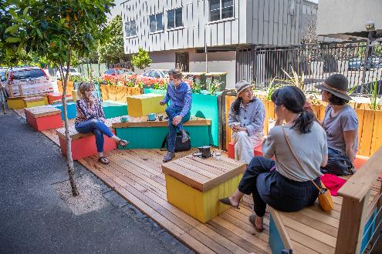 | 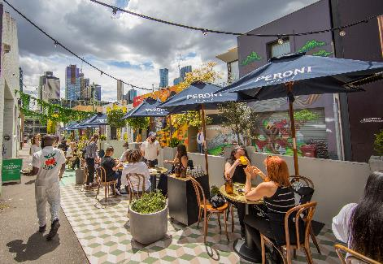
Figure 1: Parklet with fixed seating | Figure 2: Business parklet with removable furniture

Definitions
Table 1 Definition of terms
Term | Definition
Council | City of Port Phillip
Expression of Interest | An opportunity to demonstrate your business or organisation’s interest, suitability and plans to host a business parklet.
Parklet | Re-purposed on-street parking spaces which are designed to extend public space to provide an additional place for congregation, accessible public seating, street greening and additional pedestrian space.
Business parklet | Parklet used for commercial purposes and is the subject of this Guideline.
Community parklet | Parklet used by the general community without the expectation of having to purchase anything. These are Council owned and managed.
On-street parking | Designated parking spaces located on public roads that may be occupied by a vehicle for a specified period.
Parklet Panel | A decision-making body within Council consisting of subject matter experts that make decisions on Business Parklet permits
Permit | Refers to an approval issued under City of Port Phillip Local Law No. 1 (Community Amenity) 2013 (amended November 2017) that authorises a use or activity.
Permit holder | Refers to the person or business who has been issued a Permit.
Trading zone | The permitted area that the City of Port Phillip allows for commercial activity.

How to set up a parklet
Prospective applicants should use these Guidelines to assist them make an application for and subsequently manage a business parklet. This will ensure they understand the design, legal, costs and other responsibilities associated with having a business parklet.
The key steps in how to set up a parklet are explained below.

Before you apply
Before you apply, read through these guidelines to make sure you understand what you will need to do. Provide as much information as you can.

If you need help, contact us through our Business enquiries portal: https://www.portphillip.vic.gov.au/council-services/business-in-port-phillip/business-enquiries.

It’s also important to consider whether your needs would be met by a footpath trading permit or expanded footpath trading. Further information on footpath trading can be found on the Footpath Trading permit web page at https://www.portphillip.vic.gov.au/council-services/business-in-port-phillip/business-permits/footpath-trading-permit.
Be aware that not all applicants will be granted a permit, as there are a number of criteria and requirements which will be considered and some locations have limitations on the number of parklets permitted.

Business parklet process
Table 2 Approval process

Expression of Interest period
Businesses are invited to apply for a Business Parklet during the Expression of Interest period. Expressions of Interest for a business parklet can be made online by visiting the City of Port Phillip outdoor dining webpage at https://www.portphillip.vic.gov.au/

Apply
Complete an application form and submit it with supporting documentation.

Review process
Once the EOI period closes, Council will review your application within 1-8 weeks. Applicants may be contacted to discuss aspects of their application or to seek further information. Should your application meet the criteria, Council will work with you to finalise Parklet designs to ensure compliance.

Permit issued
If your application is successful, Council will aim to issue your permit within 14 days.

Installation
Council will contact you to arrange the installation of parklet infrastructure.

Operation
Manage parklet in accordance with permit conditions.

Remove infrastructure
At the expiry of the permit, all infrastructure must be removed by the permit holder.

Types of permits available
Two permit types are available:
- Seasonal (during summer months) Permits allow activations that run in the high season from 1st October to 30th April each year.
- Annual Permits allow for year-round activation.
Both Seasonal and Annual Permits can be applied for each year during an Expression of Interest period.
All Annual Permits will expire 30th September. Seasonal Permits expiry dates may vary. Should a Seasonal Permit holder wish to transfer to an Annual Permit they must contact Council prior to the expiry of their Seasonal Permit to inquire (refer to ‘Renewal of an existing permit’, below).

Annual permits
Annual permits will be granted for a maximum of twelve months. Depending on site-specific constraints such as access, traffic and parking conditions, permits may be issued for a shorter duration.
Permits may be subject to change at any time during the permit period to ensure that safety and amenity is not compromised during any period of this extended outdoor dining initiative.
Renewal of an annual permit
Permits are required to be renewed annually and can be renewed up to two times unless:
- non-payment of fees - permit revoked
- neighbour withdraws consent - revoked or amended
- streetscape works require access to permit location
- there is a waiting list of parklet requests.
A renewal notice will be issued for all Annual Permit holders. It is the responsibility of the permit holder to ensure all permit renewal details including public liability details, amendments and fees are forwarded to the Council by 31 August. Failure to provide all renewal documentation and fees may result in the cancellation of the permit.
The Council reserves the right to reassess and amend permit conditions at any time.

Seasonal permits
Seasonal permits will be granted for a maximum of six months. Depending on site-specific constraints such as access, traffic and parking conditions, permits may be issued for a shorter duration from three to six months.
Table 3 Types of permits
 | Seasonal Permit | Annual Permit
Duration | 1st October though to 30th April | Twelve months, expiring 30 September
Renewal option | Not renewable  Option to apply for annual permit at end of seasonal permit – conditions apply | Permits may be renewed annually up to two times unless:  - non-payment of fees - permit revoked  - neighbour withdraws consent - revoked or amended  - streetscape works require access to permit location  - there is a waiting list of parklet requests.
Average investment | $5-15K | $20-30K
Access requirement | Minimum requirement is a ramp to carriageway or platform level with footpath; platforms level with the footpath may be constructed instead | Platform level with footpath
Expression of Interest period | June – August | June - August
Example | 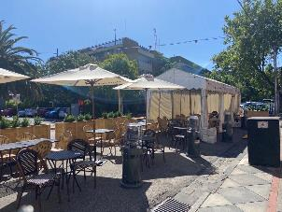 | 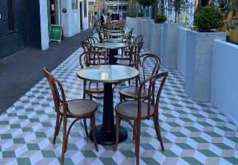

Amendments to an existing permit
Permit-holders can submit an Expression of Interest application form for any amendments to an existing permit. Amendments may include changing furniture design, adding furniture or increasing advertising. Council reserves the right to amend permit conditions at any time. An amendment fee is payable for officer assessment and liaison.
Transfer of ownership
A permit applies only to the specific premises and business for which it is issued and is not transferable on the sale or transfer of ownership. There is no legal attachment to the sale or transfer of ownership of a business.
A permit-holder or new proprietor can apply to transfer the ownership of the existing permit within 28 days of sale so that the permit remains valid.
A transfer of ownership fee is required for officer assessment and liaison. In considering the transfer of ownership request, the Council can reassess and amend permit conditions to ensure compliance with the Guidelines and to respond to any changes to the parklet design or operation.
It is the responsibility of the existing proprietor to include the balance of the remaining permit fee in the sale of the business.

Removal
All public infrastructure must be made good and returned in clean condition at the end of the permit period.

Display of permit registration
Permit holders must display the current Parklet Permit registration sticker clearly and legibly on the shop-front window.

Considerations prior to making an application

Will your premises have enough toilet and sanitary conveniences?
The addition of an outdoor area to an existing restaurant/café may lead to an increase in overall seating capacity. As such, you must have adequate toilet facilities available for customers and staff. Council will assess the appropriate provision of toilet facilities on a case-by-case basis and in line with any relevant building regulations.
Where the introduction of an outdoor area increases the total seating capacity beyond 20 seats it may be necessary to upgrade existing toilet facilities or retain the overall number of seats to 20.

Will you need to relocate any public infrastructure?
If you need to relocate any public infrastructure, such as seats, bins or bicycle stands, you can make a request to Council to relocate that infrastructure. The new location must be a good outcome for the community.
If you want to relocate the infrastructure to the front of another premises, you should obtain written consent from the owner of the other building and the owner of the other business and attach this with your request.
You will need to pay for all costs associated with the relocation of any public infrastructure, including the reinstatement of the pavement.

Will access to any services be compromised?
When thinking about how you will set up your parklet, it’s important that services such as sewers, gas, water, telecommunications and electricity conduits should not be obstructed by any structures that won’t be moved for the duration of the permit (such as platforms, barriers, planters and bench seating). Movable furniture such as tables, chairs, umbrellas, and heaters may be placed on top of underground service pits. However, in an emergency, immediate access will be required.
Council and other service authorities endeavour to provide notice of upcoming works, however access to any services within the permitted area must be provided at any time, without notice to the permit holder.

Will you include any advertising?
If you propose to include any advertising, you need to include details about this in your permit application. It will be subject to approval by the Council.
You may feature the name of your business or relevant product name/s on umbrellas and barriers only. Advertising on screens is not permitted, apart from the business/company logo displayed on every second panel and on the two end returns closest to the kerb edge (refer figures 3 and 4 below).

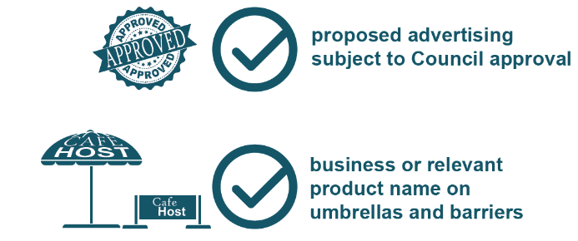 | Figure 3: Advertising and furniture require approval by Council.
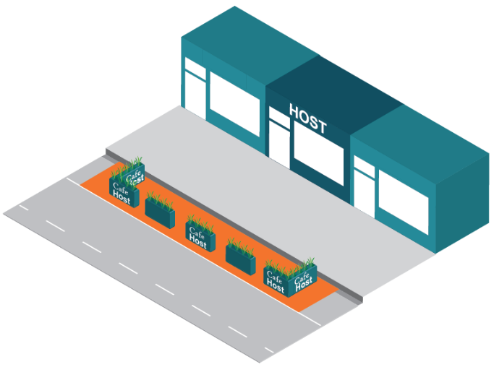 | Figure 4: Only the business/company logo can be displayed on every second panel and on the two end returns closest to the kerb edge.

Will you display any goods?
Parklets may not be used for the display or sale of goods sold within the premises.

Taking care of your business parklet

Daily management
As the permit-holder, you will be responsible for the management of your parklet and will need to:
- Operate in accordance with any conditions of the permit, endorsed plans and requirements outlined in these Guidelines.
- Actively monitor the parklet, for example, by observing patrons during hours of operation and managing any behaviour that may interfere with the use, enjoyment and personal comfort of others.
- Observe all local law provisions relating to footpath trading, including noise, responsible serving of liquor, health and amenity.
- Maintain access for all users in and around the footpath at all times, including repositioning furniture when moved outside the trading zone by patrons.
- Keep the area clean, including by ensuring tables and chairs are kept clean and litter is removed and deposited in bins kept inside the premises.
- All moveable furniture must be removed at the end of trading hours. In cases where the business operates after street trading hours finish, the Council will allow outdoor furniture to be securely stacked in the trading zone until the close of business at which time furniture must be removed.
- Actively monitor patronage to report on average usage if/when requesting a new permit or renewal.

Safety and accessibility
As the permit-holder you will be responsible for ensuring safe and unobstructed access to the footpath and parklet area is available by:
- Providing continuous accessible paths of travel along the building line.
- Ensuring any parklet in close proximity to an intersection does not obscure driver’s line of vision or traffic signs (as approved by Council’s traffic engineer).
- Maintaining any required clearances and setbacks from traffic lanes, public assets and other street infrastructure.
- Ensuring the permitted area remains an inviting, clean and safe place.
- Ensuring that patrons and clients do not unreasonably impede the flow of pedestrian, bicycle or vehicle traffic.
- Complying with the Disability Discriminating Act 1993 (DDA) at all times, unless otherwise approved.

Community amenity
As the permit-holder you will be responsible for ensuring the amenity of the footpath, parklet and adjacent areas are protected and enhanced by:
- Removing all unfixed furniture and signage from the permitted area as per permit conditions at the end of operations each day.
- Complying with the earlier close of business times in the event that business hours of the permit conflict with business hours stipulated in a relevant planning permit, Liquor Licensing permit or other permit.
- Complying with Environment Protection Authority requirements in respect of noise and having no externally amplified speakers (refer also to www.epa.vic.gov.au).
- Preventing adverse impacts on the amenity of the neighbourhood from the emission of noise, smell or appearance of the premises in accordance with the City of Port Phillip Local Law No. 1 (Community Amenity) September 2013 (amended November 2017).
- Avoiding obstructive furniture and excessive signage which create a hazard for users, including people with physical or vision impairments.
- Ceasing Outdoor trading in activity centres at 11:00pm.

COVIDSafe Plan and patron limits in outdoor spaces
As the permit-holder you will be responsible for ensuring that table service in outdoor dining areas is in accordance with a COVIDSafe Plan and any patron limits designated for outdoor spaces in accordance with Victorian government requirements. Visit https://www.dhhs.vic.gov.au/victorias-restriction-levels-covid-19 for the latest information on COVID-19 business restrictions.
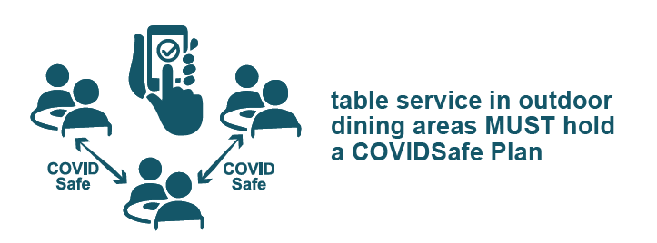

Hygiene and cleanliness
As the permit-holder you will be responsible for maintaining the hygiene and cleanliness of the permitted area by:
- Clearing litter from the trading area and vicinity.
- Removing any food scraps, cigarette litter and other waste within the immediate area and depositing them within their own bins kept within the premises.
- Litter generated by trading must not be swept into the street gutter or adjacent footpath areas.
- Not placing trade waste in public street bins.
- Ensuring the preparation, handling and serving of food and drinks to patrons located on the permitted area is conducted in accordance with the Food Safety Regulations, www.health.vic.gov.au/foodsafety. For information on food safety education and training programs contact the Council’s Health Services Unit at healthservicesunit@portphillip.vic.gov.au

Queuing
As the permit-holder you will be responsible for ensuring that your patrons or clients do not impede the flow of pedestrian traffic in the pedestrian zone. Businesses that attract large numbers of patrons who queue outside the premises or parklet must accommodate these patrons in an orderly fashion within the trading zone.
As the permit holder you will be responsible for ensuring the safe management of patrons queuing at venues. Queues of patrons are to be contained within the venue where practical.

Where can parklets be located?

Location
Parklets can be located in designated on-street parking bays that:
- Are on Council owned or managed roads.
- Are on a road with 40km/h speed limit or less.
- Are not designated for specific purposes (e.g. accessible, loading zone, car share).
- Do not obstruct view lines for pedestrians, cyclists and drivers (as considered by Council’s Transport Engineering Officer).
- Have a minimum area of 6 metres x 2.5 metres and retain a 3-3.5m travel lane width.
- Are located either directly adjacent to the host building, at either primary or secondary frontage/s.
- Maintain direct access to the footpath.
- Do not impact the ability of a person with disabilities to access a public service such as a medical service or similar.
Do not obstruct drains or service hatches.
Wherever possible, preference will be given to non-metred parking bays.

Roads that are VicRoads managed are subject to approval by the Victorian Government. Council can support you in the process of seeking this approval.

Designated clearways will not be considered.

Intersections – line of sight
To ensure adequate sight lines for pedestrians, bike riders, motor cyclists, and vehicles, trading within 10m of an unsignalised intersection or within 20m of a signalised intersection will not be permitted.
Unsignalised intersections: Low structures (that do not obstruct the driver’s line of vision) may be acceptable. An on-site assessment by Council’s Traffic Engineer may be required.
Signalised intersections:
Views of traffic signals must be keep clear. An assessment by the Council’s traffic engineer will ensure proposed placement and height of structures will not cause a traffic hazard.
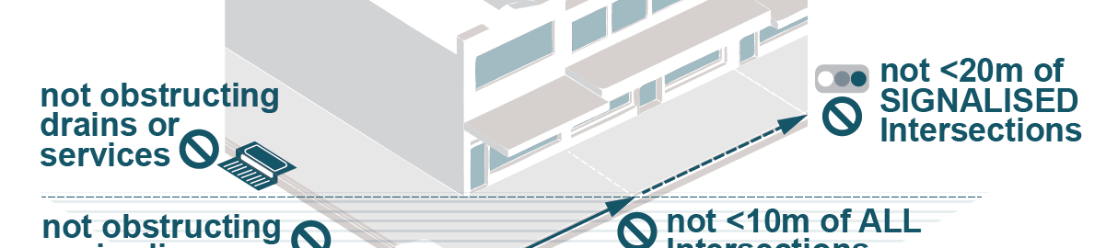
Figure 5: Business Parklets need to be placed 10m from a unsignalised intersection and 20m from a signalised intersection

Occupying an adjacent parking bay
The permit applicant should obtain and submit written consent of the owner, body corporate and/or occupier of the adjacent premises when applying to occupy a parking bay in front of an adjacent premises.
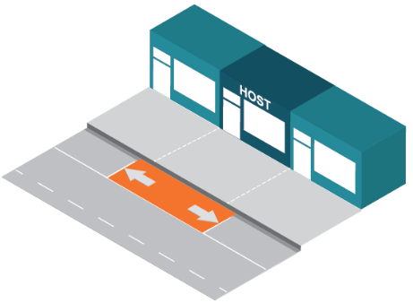
Figure 6: A host may apply for a business parklet in front of their premises.
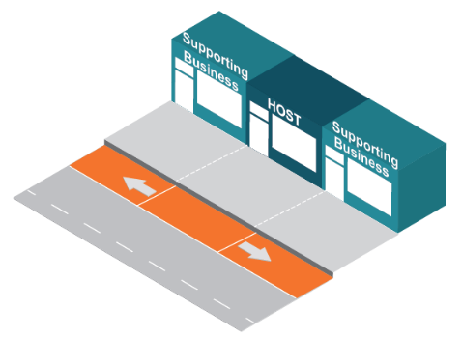
Figure 7: A host may apply for a business parklet in front of neighbouring premises with their written consent.

The letters of consent should be provided on the third party’s official letterhead. If the neighbouring premises is sold or occupied by a new tenant, the existing permit will remain valid until it expires. However, when applying for a new permit or renewal, a new letter of support must be submitted to Council from the new owner, body corporate and/or occupier.
If the adjoining owner, body corporator and/or occupier withdraws consent during the permit period, depending on the circumstances the permit holder may be permitted to trade in front of the adjacent premises until the permit expiry date.
Where an applicant proposes using a parking space that is not adjacent to a business, Council may use its discretion to approve a permit if the outcome would benefit the streetscape and general community. Council will assess such applications on a case-by-case basis and reserves the right to approve or refuse any application with reference to streetscape and community outcomes.

Maximum number of parklets within areas
To minimise potential impacts to on-street car parking, and ensure an appropriate balance of outcomes within local areas, the following recommended maximum number of parklets within each area has been calculated. The calculations were based on a number of factors including the total number of publicly available on-street car parking spaces, the number of spaces allocated to other uses (such as loading, etc), public transport connections, feedback and experiences through the trial period and community consultation, other locational factors and physical attributes such as footpath widths. These numbers are a recommendation only and may be varied at officer discretion as part of the overall consideration of each proposed parklet. This will also include consideration of the concentration of parklets in any one part of particular activity centres. Requests outside of these activity centres will be considered on a case by case basis.

Table 4 Recommended maximum number of parklets
Location | Recommended maximum
Acland St Activity Centre | 15
Ormond Road Activity Centre | 10
Glen Huntly Road Activity Centre | 5
Glen Eira Road Activity Centre | 8
Tennyson St Activity Centre | 3
Carlisle St Activity Centre | 15
Inkerman St Activity Centre | 4
Fitzroy St Activity Centre | 9
Victoria Ave Activity Centre | 15
Bridport St Activity Centre | 20
Bay St Activity Centre | 20
Armstrong St Activity Centre | 14
Clarendon St Activity Centre | 27

Designing your parklet
City of Port Phillip Activity Centres each have their own distinct character. Business Parklets have potential to enhance the local character of each street. The design and appearance of business parklets and furniture should be high quality, robust and structurally sound to withstand prolonged exposure to various climatic conditions.

All Parklets should include:
Safety elements
- A buffer setback space of 0.45m must be provided around the perimeter of the parklet, from adjacent traffic/bicycle lanes and adjacent parked cars
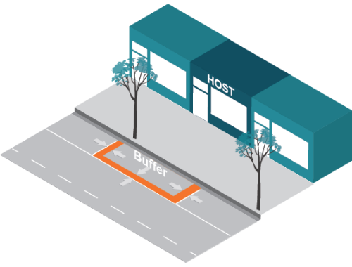 | 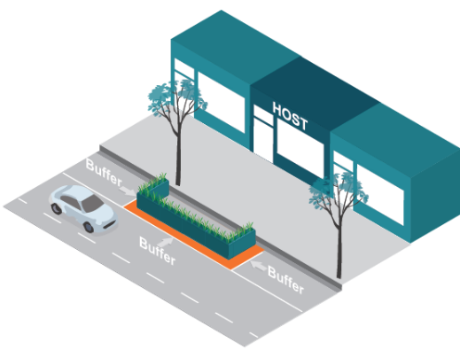
Figure 8: Business Parklets need to have a least a 0.4m buffer between any traffic lane, including bicycle lanes, and the structure.
- 0.4 x 0.4m barriers must be provided at all four corners and at regular 4m intervals
- The total height of the parklet barriers may not exceed 0.9m above carriageway level
- Barriers must be:
  - Collapsible
  - Weighted with 300mm crushed rock
  - Soil filled to at least 0.3m depth for planting
  - Treated pine sleepers
  - Or equivalent, as approved by Council
- Between the barriers, a 0.2m deep buffer must be provided that spans the gaps between the barriers at all four corners and every 4m. Examples of acceptable barriers are shown below.
- Reflective tape must be placed along the top edge of the platform and at 0.75m height.
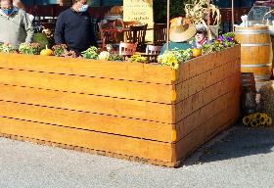 | 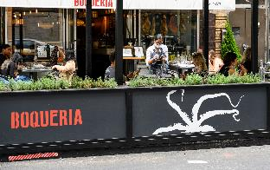 | 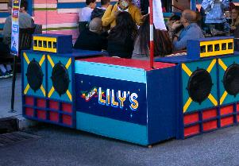
Figure 9: Natural wood materials should appear finished and well maintained. | Figure 10: Business or other relevant product name may only appear on every other barrier; artwork may fill remaining spaces. | Figure 11: Creative patterns, designs or artwork that enhance the streetscape are encouraged.
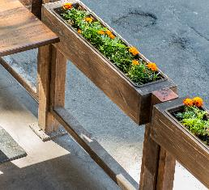 | 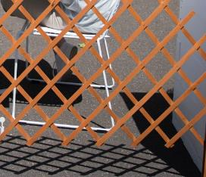 | 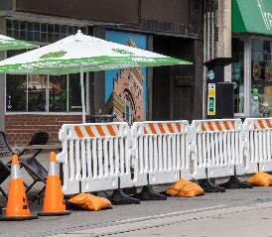
Figure 12: Barriers must fully enclose the space. No gaps are permitted. | Figure 13: Flimsy materials like lattice should not be used. | Figure 14: Temporary barriers and other rented materials must be wrapped and finished.

Accessible paths of travel
- Accessible paths of travel must be made available for persons utilising mobility devices such as wheelchairs, prams, and walkers. This may require the removal of existing footpath trading, particularly where footpaths are narrow.
- There must be at least one entrance in an unobstructed area, with a minimum width of 1.5m, preferred 2m.
- There must be an accessible path of travel into the parklet, connected to the accessible entrance, wheelchair turning area and resting space.

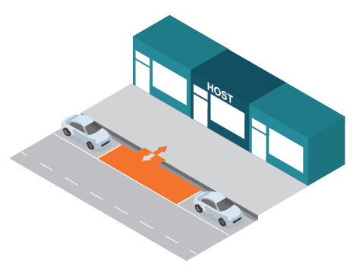

Figure 15: Business Parklets must have at least one unobstructed entrance, with a minimum width of 1.5m, preferrably 2m.
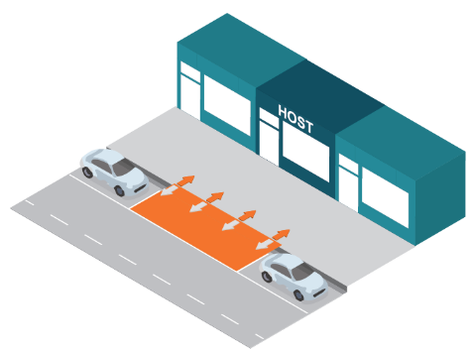
Figure 16: It is preferred that the entire frontage of the Business Parklet is accessible from the footpath.

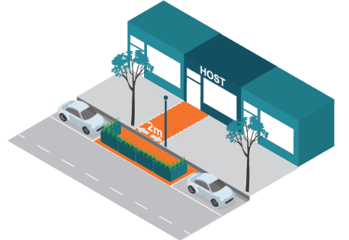
Figure 17: The design of the entrance to the Business Parklet needs to take into account fixed objects in the footpath such as trees and lighting.

Wheelchair turning space and resting space
- A wheelchair turning space must be provided and must allow for a wheelchair to make a 180° turn, with a minimum diameter of 1.5m.
- A wheelchair resting space should be provided and have a 0.8m minimum width and 1.3m minimum length. The wheelchair resting space should have companion seating located nearby if there is fixed seating in the design.

Accessible amenities
- At least one table, counter and/or shelter must be wheelchair accessible.
- A table or counter should be 0.7-0.85m above the platform height and have an unobstructed knee clearance area of 0.43-0.44m underneath the table or counter.

Ramps, stairs and raised levels
Those applying for an Annual Permit must include a raised platform that is level with the footpath. Those applying for Seasonal Permits may utilise either a platform or a ramp that transitions down to the carriageway level.
- Steps should be avoided as a general principle. However, any step must have a warning strip at the nose of the step.
- Any ramps should not exceed a 5% gradient slope.
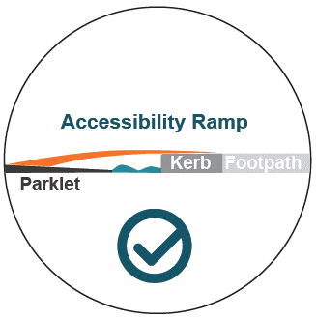
Figure 18: Seasonal Business Parklets are not required to have a platform that is level with the footpath and may therefore use a ramp onto the carriageway.

Raised platform
All Annual Parklet permit holders must include a raised platform that is level with the footpath. Seasonal Parklet permit holders may also install raised platforms, however it is not mandatory. Any platform should address the following:
- A platform that raises the area to meet the level of the kerb flush (±0<6mm difference is acceptable).
- The maximum gap that is allowed is 1cm. A bridging platform can be used if there is a gap larger than 1cm between the platform and the kerb or if the parklet height doesn’t not match the height of the kerb (refer diagram below)
- Any structures must ensure stormwater flow is not obstructed. Cleaning of leaves or debris is the responsibility of the permit holder.
- Any structures including decking in proximity of stormwater entry pits must be designed to enable access and maintenance to occur.
- The entire structure should be built to allow for easy removal.
- Where a Business Parklet would be built at a different level from the kerb upstand, a bridging or leveling platform can be utilised to create a smooth transition and prevent tripping hazards.
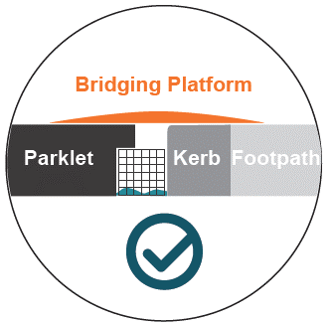 | 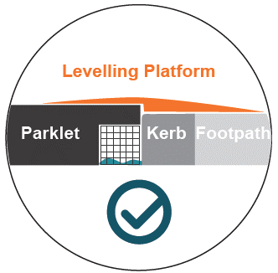
Figure 19: Bridging platform covers a gap between the platform and the kerb upstand. | Figure 20: Levelling platform creates a smooth transition and prevents tripping hazards.

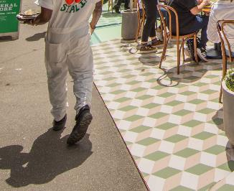 | 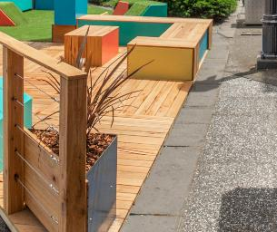
Figure 21: A mat creates a flush transition from the platform to the footpath. | Figure 22: The platform has been constructed at the level of the footpath.
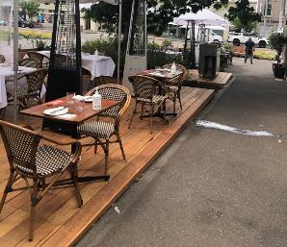 | 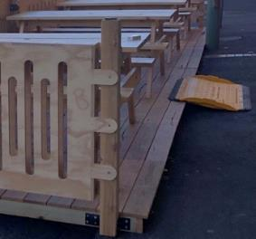
Figure 23: Platform is not flush with surround footpaths. | Figure 24: Ramp is used to gain access to a platform.

Drainage
- A gap of 0.2m between the kerb and the base of the frame will need to be included to allow for water to run along the drain as usual
- A rubbish grate should be placed along the edge of the kerb to prevent debris from collecting under the parklet
- An inspection lid must be included where a stormwater side entry pit is located underneath a deck structure
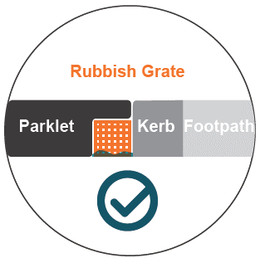
Figure 25: A rubbish grate will prevent litter from being trapped under the platform.
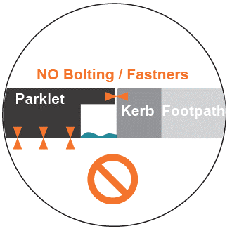
Figure 26: Structures must not be fixed to the pavement or the kerb upstands.
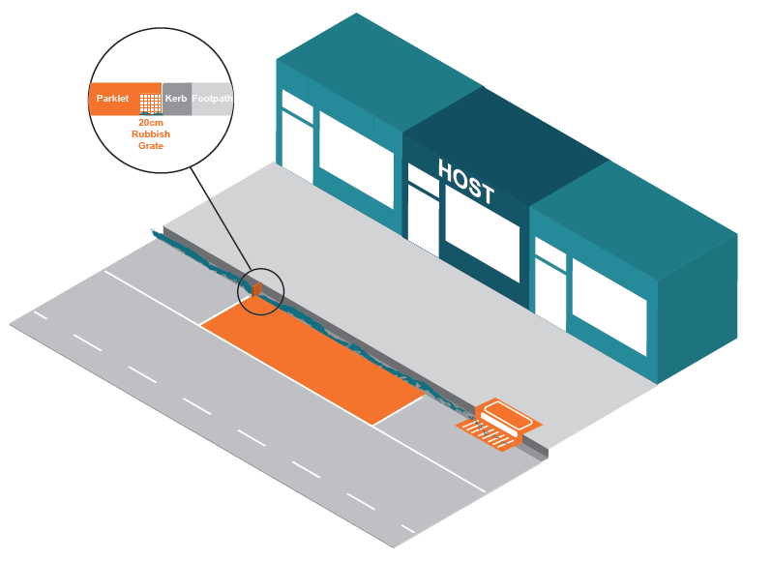
Figure 27: A rubbish grate located at the edge of a parklet.

Materiality and design quality
- Parklets should not contain loose material that can overflow onto surrounding footpaths and roads.
- Materials should be of a high quality, cleanable, enduring and environmentally friendly.
- Low quality plastic materials are discouraged.
- Low emission, recycled, sustainably sourced and/or locally sourced products are encouraged.
- Natural materials and muted finishes are encouraged, including steel, aluminium, wood, recycled content concrete, etc.
- A precinct approach to provide consistent colour and selection of large furniture items is encouraged through consultation with other traders within the street section.

Planting
- Planting should be provided where practicable in the barrier and buffers.
- Upkeep of planting is the responsibility of the permit holder.
- Low (under 0.3 m in height) plants should be selected to limit impacts on lines of sight.
- Some taller plants may be used where they would not be planted densely and would maintain lines of sight.
- Artificial plants are discouraged.
- Plants should be contained within the parklet and not overhang the barriers.
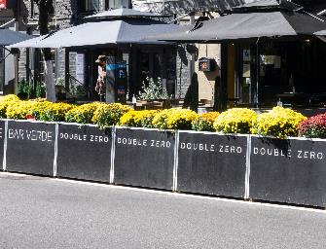 | 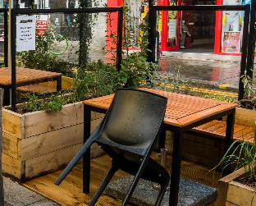 | 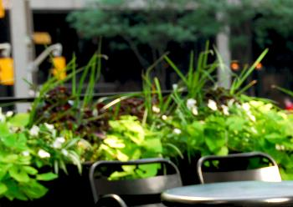
Figure 28: Planting is low to maintain lines of sight. | Figure 29: Vines are tall but not dense to maintain lines of sight. | Figure 30: Some taller plant species are not dense to maintain lines of sight.
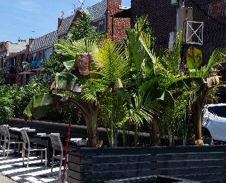 | 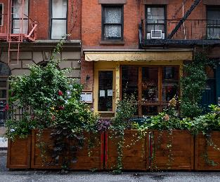 | 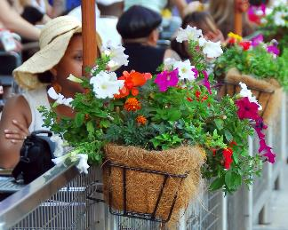
Figure 31: Planting is high and obstructs lines of sight. | Figure 32: Planting is high and obstructs lines of sight. | Figure 33: Planting structure is hanging outside the parklet.

What can go in your parklet?
Permit holders that have limited hours of operation will be asked to install fixed furniture elements to allow the parklet to be used by the community when the business is not in operation. Therefore, not all furniture housed within the parklet will be moveable. This will ensure that parklets will contribute to the activation and life of the street when the business is not in operation.

Movable furniture
The following guidelines apply to moveable items of furniture:
- Furniture in an outdoor area must be of an outdoor design style.
- Furniture should be hardy, sturdy and portable.
- Furniture must be solid enough to resist wind gusts.
- Furniture must be constructed of materials that do not deteriorate quickly.
- Furniture must be easy to clean.
- All chairs and tables must have a minimum 30mm diameter rubber pad on their legs to protect the parklet surface. It is the business owner’s responsibility to maintain the base of all items and to ensure items placed on the footpath do not cause damage to their parklet or other public infrastructure such as the carriageway or footpath. The cost of repairing any damage caused will be borne by the applicant.
- Furniture must be stackable for ease of storage and readily removed and stored within the indoor (private) part of the café as stipulated on the permit.
- Bar-style furniture is discouraged. A table should be between 0.7 to 0.8metres in height and a chair or seat must be between 0.4 to 0.5metres in height.
- No advertising is permitted on tables and chairs.
- Council will approve all furniture before it is installed. All furniture designs will be considered on a case-by-case basis.
Placement and storage of movable furniture
The number of tables and chairs permitted on the parklet is determined by the size and number of the available car parking spaces directly in front of the applicant’s premises. The following guidelines will determine the placement and storage of the furniture:
- No more than the maximum number of tables and chairs specified on the permit can be used in the footpath trading area.
- Furniture must be set back from existing infrastructure, including street trees, lights and public furniture.
- No furniture is permitted on grassed areas or nature strips.
- Furniture must be removed and stored inside the premises outside of hours of operation unless otherwise stipulated by the permit.
- The applicant must ensure that adequate storage is provided within the premises for all approved outdoor trading furniture. If the business operates beyond the hours approved on the permit, the applicant must indicate on plans where items will be stored. If there is insufficient internal storage area, the Council may allow outdoor furniture to be securely stacked within the trading zone until the close of business. Approval will only be given if the applicant can demonstrate that the furniture will remain securely stacked and the relocation of the outdoor furniture into the premises can be carried out without causing unreasonable noise and disturbance to nearby residents.
- The number of tables and chairs placed within the parklet trading area must allow unobstructed access and circulation for patrons and staff.
- A minimum space of four-square metres is typical for a table and four chairs (2m x 2m) and a distance of 0.5metres should be allowed between adjoining settings.
  - 2-person table requires a minimum of 2m² (unless a narrow footpath)
  - 3-person table requires a minimum of 3m²
  - 4-person table requires a minimum of 4m²
- Bench-style furniture is permitted for use in outdoor areas. However, it must be constructed of lightweight material to ensure it can easily be removed and stored within the premises in accordance with the hours of operation on the permit.
- Bench-style furniture must have a gap of 0.5metres between each table setting to allow unobstructed access and circulation for patrons and staff.

Fixed furniture
The following guidelines apply to fixed items of furniture:
- Should be hardy, sturdy and fixed in place
- Should be easy to clean and dry
- Must be constructed of materials that do not deteriorate quickly.
- No form of advertising is permitted on fixed furniture.
- Council must approve all furniture before located in the parklet. All furniture designs will be considered on a case-by-case basis.
- Fixed seating should be integrated into the design in a creative way that utilises the space efficiently but also maintains a space for sitting when moveable seating is packed away (particularly in cases where the parklet is only in operation for part of the day and where the parklet is not being shared by a neighbouring business)
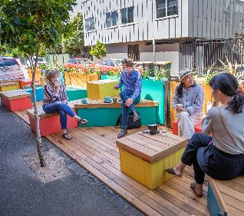 | 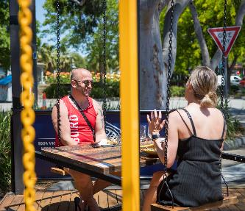 | 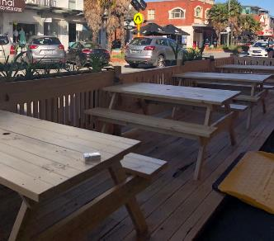
Figure 34: Fixed seating can be part of the structure and never removed | Figure 35: Get creative with fixed seating; these swing seats sit out day and night | Figure 36: A classic picnic table never gets old but be sure to provide accessible seating

Required information with application
Permit applicants should submit the following information when applying for a Parklet Permit:
- Completed application form
- A copy of any planning permit for the business or written advice from Council’s Statutory Planning Unit indicating that a planning permit is not required for the business to which the outdoor area relates.
- Where relevant, a copy of the approved Liquor Licence for the premises to which the activation area relates.
- Proof of the company and business registration certificates; showing the company name, ACN, ABN and business name.
- A site plan of existing conditions to scale 1:100 accurately showing the following:
  - width of the building frontage.
  - the abutting properties – (business names).
  - existing infrastructure, including existing trees, light poles, rubbish bins, street furniture, fire hydrants and pits. Car parking and parking restrictions and other relevant features
  - all dimensions associated with the footpath area must be shown.
- A site plan of the proposed activation on a fully dimensioned plan at scale 1:100, accurately showing the area and layout of the proposed activation clearly showing compliance with the requirements of these Guidelines. This includes the proposed location of chairs, tables, screens, heaters, umbrellas, advertising signs, and the required zone dimensions.
- Photographs of the site clearly showing the proposed footpath activity zone relative to buildings and existing features in the footpath area.
- Details of furniture including colour photographs or detailed design drawings scaled at 1:100 of the proposed furniture, including any screens, planter boxes, heaters and umbrellas.
- Details of any advertising including a colour photograph or detailed design drawings to scale of any proposed advertising logo, and clear indication of its size and location on screens and umbrellas. If total advertising area exceeds 8.0m² a planning permit is required first.
- Public liability insurance. The Council requires the insurance policy to note Council’s interest and be for the amount of no less than $10,000,000 in respect of any single occurrence. Public liability insurance must remain current and valid for the life of the permit.
- Form of indemnity to indemnify the Council against all claims of any kind arising from any negligent act either by the permit holder or the permit holder’s agents and users.
- Application fee payable to the City of Port Phillip (non-refundable), being the fee for on-site meeting, review and assessment of the application.
- Records or letters of support from surrounding businesses and clientele.
- A letter of consent must be supplied, if you wish to occupy car parking spaces in front of neighbouring businesses or residents.
Failure to submit all the above details may result in delays in processing the application or rejection of the application.

Decision making
Where applications meet all the requirements of the Guidelines and it is within the maximum number of parklets for an activity centre, Council will normally grant a permit. In cases where an application does not clearly meet the Guidelines, where there are special circumstances or where there are more applications received than the maximum number of parklets for an activity centre, the application will be referred to the Council’s Parklet Panel for further consideration.
The Panel will provide its recommendation to the authorised officer who will approve or refuse the permit application. The Panel will assess all applications using Council’s Parklet Priorities, the Permit holders responsibilities and the City of Port Phillip Local Law No. 1 (Community Amenity) September 2013 (amended November 2017). The Panel will consider the following when making a decision:
- The effect on traffic flows and safety for all modes
- The effect on local car parking
- The effect on pedestrian flows and safety
- The impact on neighbouring businesses
- The impact on the appearance of the street and its surroundings
- The impact on residential amenity
- The duration of use
- Compatibility with other uses in the street
- The number of other existing or proposed parklets within the area
- Whether it is complementary to the primary adjoining use
- Whether it is less intensive than the primary adjoining use
- The applicant’s previous record of compliance
- Any relevant policies of the Council
- Any other matter relevant to the application
In some cases a variation to these Guidelines may be granted if the priority objectives can be met and there are extenuating circumstances. Each case will be decided on its merits.
Extenuating or special circumstances could include factors such as the following:
- Demonstrated hardship in conforming to new standards
- Established precedent
- Existence of mitigating factors
- Supports the achievement of the parklet trading priorities

Table 5 Decision making matrix
Category | Category weighting | Element
Transport Engineering | Must satisfy all conditions | - Meets location criteria  - Proposed number of car parking spaces  - Uninhibited view lines  - Speeds 40km/h or less  - Located adjacent to host building  - Direct access to footpath  - Clear from existing infrastructure  - Does not impact the ability of a person with disabilities to access a public service such as a medical service or similar
Community Support | Must satisfy all conditions | - Provide letters of support from neighbouring businesses  - Demonstrate community support  - Consider the needs of all people including age, gender, cultural background, ability
Enforcement | Must satisfy all conditions | - Neighbourhood disputes  - History of enforcement action  - Would not result in maximum number of parklets for the area being exceeded
Risk management | Must satisfy all conditions | - Meets safety criteria
Design and general aesthetic | 50% | - Planting  - Accessibility/DDA  - Meets Design criteria  - Aesthetically pleasing
Neighbourhood Context | 25% | - Activity Centre vs residential  - Local demand and restrictions on car parking  - Local retail vacancy rates
Community benefit | 25% | - Hours of operation  - Permanent seating  - Artwork or creative contribution  - Public facilities for example bicycle stands

In addition to the above, the Parklet Panel will also provide advice on any issues in relation to serious or ongoing breaches of permit conditions.

Table 6 Council’s Business Parklet Priorities
Priority | Objectives
Public safety | - Streets are safe and have unobstructed passage on the carriageway and on the footpath  - Streets have clear views for all modes of transport  - Streets are safe and unobstructed passage for those who may be physically or visually impaired
Accessibility for all | - Any third-party assets are inclusive so that anyone with an impairment will be able to access public space activations  - People who are pushing prams or using mobility devices will be able to access the facility
Function | - Streets are easily navigated by all transport modes  - Allow appropriate traffic flow by all transport modes  - Support public transport  - Support preservation of loading zones, disabled bays, bus zones and car share bays  - Support access to local businesses and residences
Balancing a prosperous local economy with local amenity | - Supporting a prosperous local economy is balanced with ensuring that a public space activation (and any associated off-site impacts) do not cause any significant impacts on the function and amenity of surrounding areas in relation to nuisance, noise, and other amenity considerations.
Vibrant street life | - Streets are vibrant and lively  - Streets contribute positively to an area’s sense of place and character.
Attractive streetscape | - Streets are attractive, clean and pleasant  - Any heritage significance is not diminished
Leisure opportunities | - Public space activations support social interaction, alfresco dining and drinking as enjoyable leisure activities

The Council’s priorities
Table 5 outlines the order of Council’s priorities for parklets. It is a principle-based rule-of-thumb for all decisions relating to public space activations. For example, Council’s highest priority is public safety, although this is not the only concern. Public safety can be addressed while also creating a vibrant street life, ensuring accessibility for all and balancing a prosperous local economy with residential amenity. Indeed, achieving all these priorities is Council’s goal.
There are times when this is not possible and so Council must favour one over another. For example, public space activations give streets a vibrancy and liveliness but they must be limited (in amount and location) to ensure that the streets can be used safely by all members of our community. Council has used this order of priority to determine these Guidelines and will use it when making decisions on permit applications.

Council assessment
On receiving an application, Council will:
- Check that all relevant information has been received
- Check that the use is legally established under the Planning and Environment Act 1987
- Check the application to ensure it meets the intent and requirements of the City of Port Phillip Local Law No. 1 (Community Amenity) September 2013 (amended November 2017), and the Parklet Guidelines
- Refer the application to relevant Council departments for advice and comment as necessary
- Check the application against the assessment criteria
- Inspect the site and check the accuracy of submitted application plans
- Assess the application against other outstanding matters that may relate to the premises
- Advise the applicant of any changes that need to be made to the submitted.
Council will invoice the applicant for the remaining costs associated with a successful application. Once payment has been made and the permit has been issued, operation within the permit zone can commence.
Fees paid are according to the application type, Seasonal or Annual. Permit application fees are non-refundable.

Appeal process
Appeals regarding the Business Parklet permitting process are to be addressed in writing to either the Coordinator, City Permits or the Senior Public Space Coordinator. Appeals will be assessed against the Business Parklet Policy, these Guidelines and the Business Parklet Procedure. Appeals will be considered by a Parklet Panel and where applicable with the input of external regulatory bodies. The outcome will be issued in writing.

Council responsibilities

Maintenance of the carriageway and footpath
The Council is responsible for managing the maintenance of the carriageway and footpath and reserves the right to access the carriageway or footpath and remove all third-party assets at any time.

Compensation and loss of trade
Council are not responsible for providing any compensation for the removal of footpath trading furniture or any loss of trade when service authorities or others are required to carry out works within the road reserve. The permit-holder is responsible for reinstating any fittings or fixtures, not the person, service authority or contractor executing the works.
Council are not responsible for providing any for any problems, inconvenience or loss of trade resulting from activities or works carried out by Council or its contractors at, or adjacent to, a permit holder’s footpath trading area.

Monitor compliance with approved permit
Council’s authorised officers will monitor the operation of permits and ensure the conditions of the permit are met.
Following a complaint or observation of a breach of a permit, a Council officer will contact the permit holder and take appropriate enforcement action. This may be in the form of verbal instructions, a written notice or an infringement notice.
In the case of a serious breach, an officer may act immediately to resolve the situation. A serious breach is one where the officer considers there is an immediate public safety risk. This may include instances where access is impeded to an extent that it would be difficult or impossible to walk freely through the pedestrian zone or drive freely in the adjacent carriageway.
Each breach will receive a warning or an infringement notice depending on the gravity of the offence. Cases where there are three breaches within a twelve-month period will be referred to the Parklet Panel for determination of whether the permit should be cancelled or amended.

Relevant policy, regulations or legislation
City of Port Phillip Local Law No. 1 (Community Amenity) September 2013 (amended November 2017)

Attachments
Nil

