Engagement summary report
Draft Library Action Plan
April 2021
CONTENTS
Executive Summary 3
Developing the Library Action Plan 3
Engagement approach 3
Introduction 4
Purpose of this report 4
Purpose of engagement 4
Communications 4
Limitations 5
Engagement approach 5
Who we engaged 6
How we engaged 10
Engagement findings 10
Key insights 10
Survey results 12
Library Vision 12
Goal areas 13
Email submissions 27
Postcards 30
Neighborhood Conversations 30
Meetings 32
Next steps 33
Appendices 34
Appendix A: Targeted consultation with young people and parents 34
Library Vision 35
Goal areas 35
Appendix B: Verbatim responses to open text survey 38
Library vision 38
Appendix C: Verbatim postcard responses 81
Appendix D: Verbatim responses to post-it note activity at Neighborhood Conversations 82
Appendix E: Submissions received 86

Executive Summary

Developing the Library Action Plan
Port Phillip’s five library branches, online services and outreach programs reach more than 55,000 people, one of the highest library membership rates in Victoria.
Council is developing a Library Action Plan that aims to ensure libraries contribute to our creative ecosystem and respond to current and future community needs for spaces and services, programming, collections and resources and emerging technology.
The Library Action Plan will act as a reference point for both the library service and Council, providing a strategic basis for more informed planning and decision making, and clearly articulating Council’s vision and future aspirations for libraries. It will also provide some context and background for why libraries are a vital part of Council’s cultural and community infrastructure, identify possible gaps and areas for future service development, and outline the steps and actions required to best position the library service to respond to both current and emerging community needs.

Engagement approach
A comprehensive engagement program took place from May to the end of October 2019 with more than 500 people providing feedback on libraries. This involved a wide range of consultation and engagement activities, involving input from both staff and the community to collect views and feedback about future opportunities for development of the library service.
This feedback was incorporated into the draft Library Action Plan, which was released for consultation from 5 February to the 7 March 2021. The primary feedback tool was a survey, hosted online and available in hard copy. One-hundred and six responses were received, with the majority of respondents being Port Phillip residents (84 per cent). An engagement activity was also run at our Neighbourhood Conversations sessions and received 104 post-it note pieces of feedback in response to the draft plan’s goals. Three submissions were also received via email and discussion occurred in the Person consultative committee.
To ensure engagement reflected feedback from younger members of our community supplementary consultation activities with young people/parents with children were undertaken. We received an additional 26 survey responses and gathered feedback from the Youth Advisory Committee through this targeted approach. This feedback has not been incorporated into the report findings, but a summary has been provided as Appendix A of this report.
The consultation was promoted via Council and Library’s communications channels, including Divercity, social media and e-newsletters. Posters and corflutes were displayed at Council’s libraries and Summer Rangers also visited local activity centres to promote the consultation and encourage people to participate in the consultation online.

Introduction
Council is developing a Library Action Plan that aims to ensure libraries contribute to our creative ecosystem and respond to current and future community needs for spaces and services, programming, collections and resources and emerging technology.
A comprehensive engagement program took place for the draft Library Action Plan from May to the end of October 2019 with more than 500 people providing feedback on libraries. This involved a wide range of consultation and engagement activities, involving input from both staff and the community to collect views and feedback about future opportunities for development of the library service.
This feedback was incorporated into the draft Library Action Plan, which was released for consultation from 5 February to 7 March 2021. This phase of engagement focused on whether we’ve got the draft Action Plan right in terms of how our community understands our challenges, whether we have the right actions and outcomes for libraries and the right priorities for each of the branches.
The primary consultation tool was an online survey, hosted on our online consultation platform ‘Have Your Say’. Feedback was also captured through a series of neighbourhood-based pop-up engagements throughout February and March.
The consultation was promoted via Council and Library’s communications channels, including Divercity, social media and newsletters. Posters were displayed at Council’s libraries and Summer Rangers also visited local activity centres to promote the consultation and encourage people to participate in the consultation online.

Purpose of this report
The purpose of this report is to provide a summary of community engagement on the draft Library Action Plan. It details the engagement techniques used and presents the findings from this engagement program.

Purpose of engagement
The purpose of this engagement program was to inform the community of the development of the Library Action Plan and to provide feedback on the draft plan prior to finalisation.

Communications
We communicated with our community about this engagement via Library’s website and the Have Your Say site, and via Council’s online Divercity newsletter.
Emails were distributed to the Have Your Say and Library’s database and information about the draft plan and how to provide feedback was also promoted via Council and Library social media channels (Facebook, Instagram, LinkedIn). Posters were displayed at Council libraries alongside corflutes display which provided information about the draft plan and how to provide feedback.
The consultation was also advertised and promoted alongside our Neighbourhood Conversations sessions this was done via Council social media channels and through various Council and community e-newsletters.
As part of our Neighbourhood Conversation sessions intercept surveyors also visited key activity centres to promote the engagement.

Limitations
Limitations to the community engagement process include:
- Due to the five-day snap lockdown no consultation promotion within the library branches could happen during this period.
- Due to increased COVID-19 safety measures we could not undertake onsite intercept surveying as part of our Neighbourhood Conversations sessions.
- Informed feedback is dependent on people having read the draft documents.
- Contributions to this engagement program do not necessarily constitute a wholly representative snapshot of our community as people self-selected to participate.

Engagement approach
This section details the community engagement approach in developing and consulting on the draft Library Action Plan.
A comprehensive engagement program took place from May to the end of October 2019 with more than 500 people providing feedback on libraries. This involved a wide range of consultation and engagement activities, involving input from both staff and the community to collect views and feedback about future opportunities for development of the library service.
Some of the key themes identified for future service development were:
- Fabulous Spaces
- Responsive Programming
- A Contemporary Collection
- Engagement and Connection
This feedback was incorporated into the draft Library Action Plan, which was released for consultation from 5 February to the 7 March 2021. This phase of engagement focused on whether we’ve got the draft Action Plan right in terms of how our community understands our challenges, whether we have the right actions and outcomes for libraries and the right priorities for each of the branches.

Who we engaged
Our survey was completed by 106 people, more than 84 per cent of whom were residents. Survey respondents also represented business owners, ratepayers, workers, and students, with some respondents representing more than one group.
A series of demographic questions were asked as part of the survey. The following provides a brief snapshot of who we engaged through the survey.
- Albert Park was the most visited branch at 43 per cent followed by St Kilda at 37 per cent and then Emerald Hill at 33 per cent.
- Seventy-nine per cent of respondents were residents
- Twenty-three per cent of responses were aged between 70 and 84
- Fifty-seven percent of responses were female

Connection to Port Phillip
Q: What is your connection to Port Phillip?
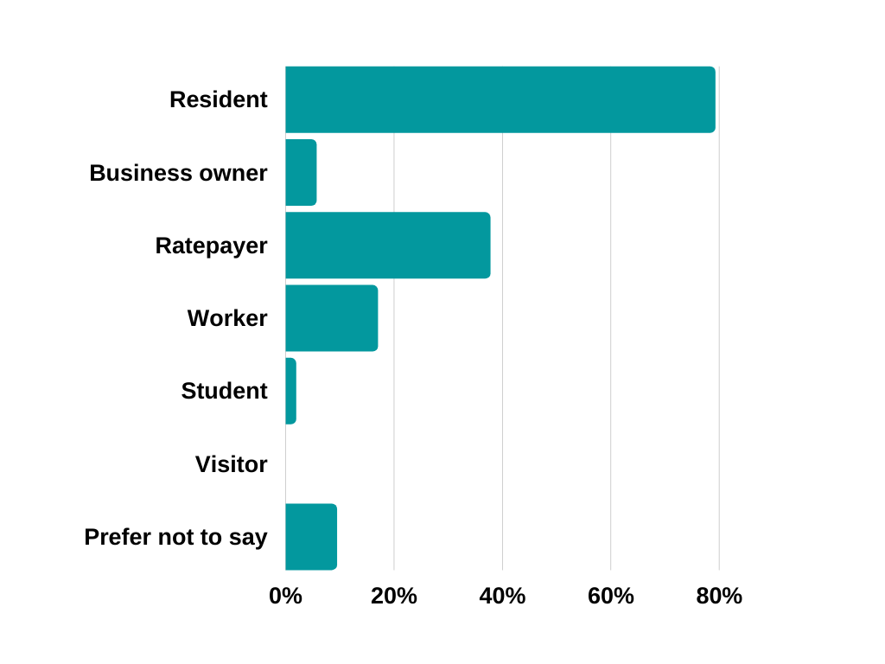
Our survey was completed by 106 people, more than 79% of whom were residents. Survey respondents also represented business owners, ratepayers, workers, and students, with some respondents representing more than one group.
Resident | 79.25%
Business owner | 5.66%
Ratepayer | 37.74%
Worker | 16.98%
Student | 1.89%
Visitor | 0.00%
Prefer not to say | 9.43%

Library branch users
Q: Which of the following library branches to you use?
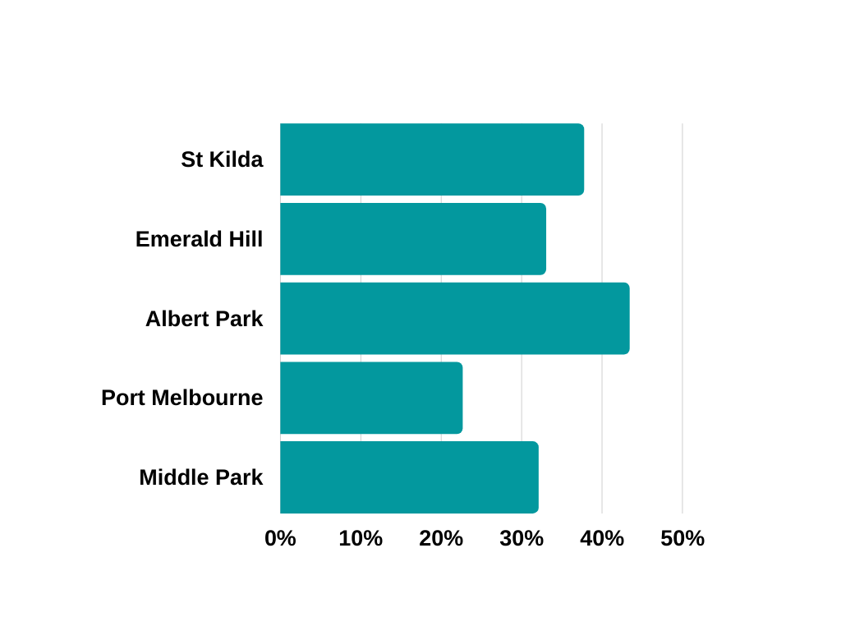
Survey respondents were able to select more than one branch.
Library branch | Survey respondents
St Kilda | 37.74%
Emerald Hill | 33.02%
Albert Park | 43.40%
Port Melbourne | 22.64%
Middle Park | 32.08%

Age range of survey respondents
Q: Which age group do you belong to?
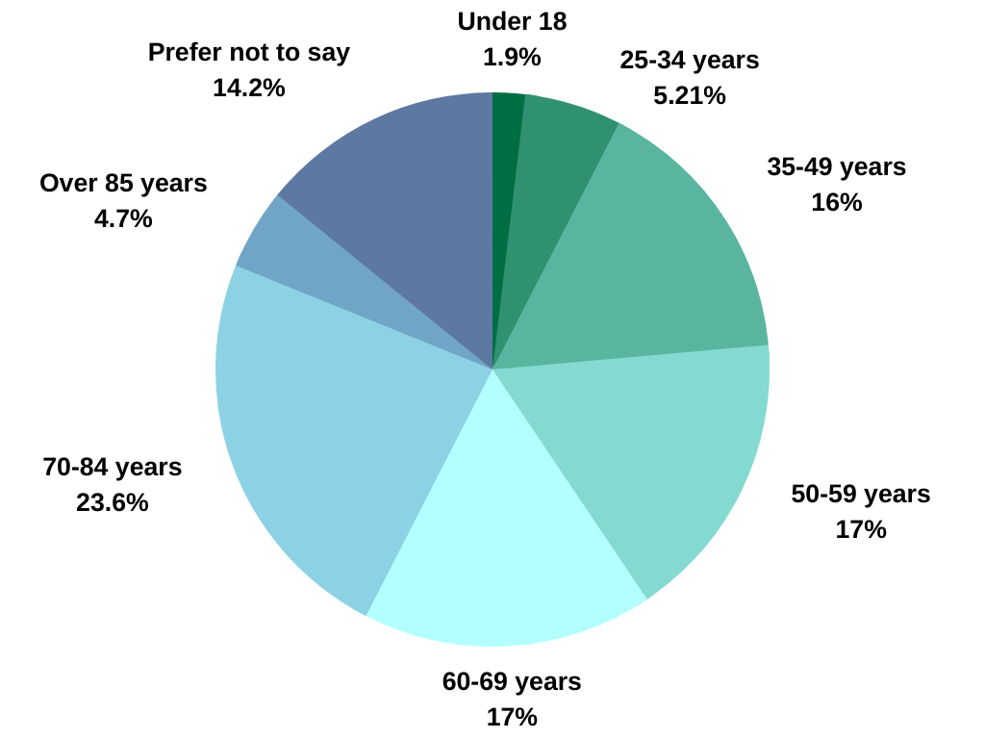

Under 18 | 1.89%
18-24 | 0.00%
25-34 | 5.66%
35-49 | 16.04%
50-59 | 16.98%
60-69 | 16.98%
70-84 | 23.58%
Over 85 | 4.72%
Prefer not to say | 14.15%
Other | 0.00%

Gender of survey respondents
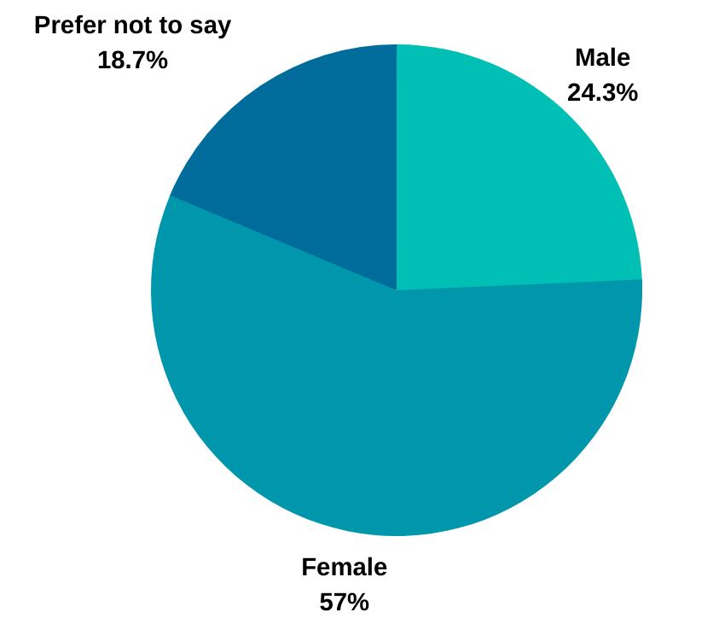
Q: Which gender do you identify with?
Male | 24.53%
Female | 57.55%
Other | 0.00%
Prefer not to say | 18.87%

How respondents found out about the consultation
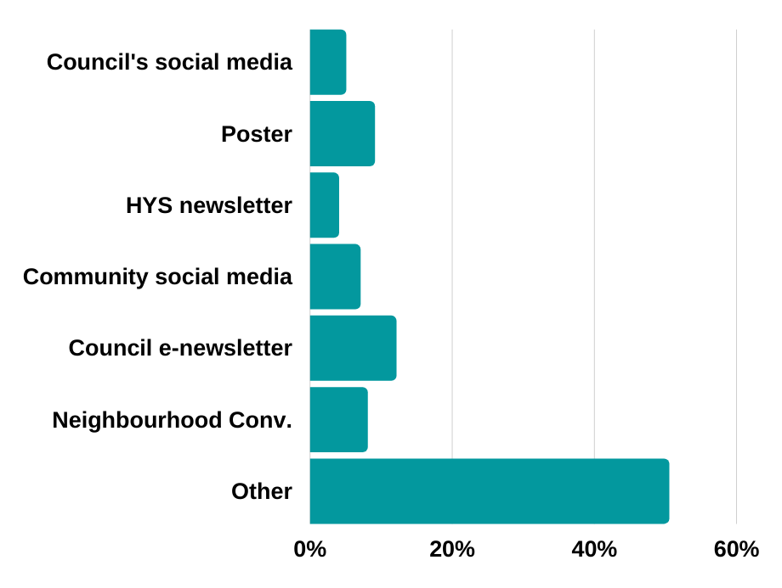
Q: How did you hear about this consultation?
Council's social media | 5.05%
Poster | 9.09%
HYS newsletter | 4.04%
Community social media | 7.07%
Council e-newsletter | 12.12%
Neighbourhood Conversations pop-up | 8.08%
Other | 50.51%
‘Other’ included: word of mouth, library staff members, Council website, Next door app, Linking Neighbours program, brochure in the library, This Week in St Kilda (TWiSK).

Residential suburb of survey respondents
Q: What is your residential suburb?
Albert Park | 6.60%
Balaclava | 3.77%
Elwood | 4.72%
Melbourne | 0.94%
Middle Park | 19.81%
Port Melbourne | 12.26%
Ripponlea | 0.00%
South Melbourne | 18.87%
Southbank | 0.94%
St Kilda | 8.49%
St Kilda East | 5.66%
St Kilda West | 0.94%
Windsor | 0.00%
Prefer not to say | 12.26%
Other | 2.83%

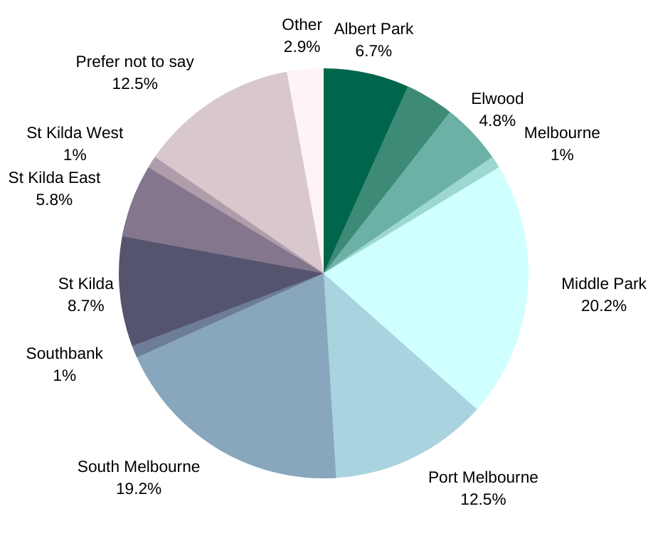

How we engaged
The engagement program was hosted on Council’s Have Your Say online engagement portal and feedback was channelled primarily through a survey seeking feedback on the draft plan’s vision, actions within the goal areas, library branch, outreach and online services statements and service outcomes. One hundred and six responses were received, including 39 hardcopy surveys. There was also the opportunity to provide feedback on the draft Plan via paid for reply postcard, which were available at library branches and the Neighbourhood Conversations sessions.
Feedback was also captured through our Neighbourhood Conversations sessions throughout February and early March, where the community were asked for feedback on the plan’s draft goals. We received 104 post-it not responses through this engagement activity.
While there was no formal (statutory) requirement to undertake a submissions process, two email submissions were made on behalf of community groups and the third was an individual submission by a community member.

Engagement findings

Key insights
Almost 200 community members were engaged across four different formats in this second phase of engagement, which sought feedback from the community on the draft Library Action Plan. Key insights from their feedback are outlined below.

24/7 Library
A lot of feedback was received regarding the 24/7 Library proposed for Middle Park library. Many people requested further information and clarity about how this would be implemented, including staffing hours, how books and resources would be accessed, whether other locations would be considered or piloted, how much it would cost and whether this would match demand. Many respondents were opposed to the idea, questioning the need, and had concerns about safety for staff and customers. Some respondents supported the idea due to the greater access to resources it would provide.

The scope of library services
The community provided feedback that some of the proposed actions of the draft Library Action Plan were outside the scope of library services. In particular, respondents thought that some of the activities proposed under the goal Create (such as expanding creative activities at the library including live music), were in conflict with what they thought is the core purpose of the library: books, reading and literacy. The proposed climate emergency relief centre was also thought to be outside the scope of library services by many respondents. Respondents wanted to see core library services prioritised over new initiatives.

Library infrastructure redevelopment
Maintaining the physical infrastructure to keep up with demand and growth was a recurring theme throughout the engagement. Many respondents agreed that library buildings were in need of refurbishment to ensure they were light, bright and welcoming. Some respondents supported the proposed refurbishment of St Kilda library, particularly to maintain the facilities and respect its heritage status. Some respondents would like to see investment in refurbishing all libraries, not just St Kilda. The need to support library access for the growing population in the north of the City was also recognised by community members.

Diversity and inclusion
Many of the community members who provided feedback supported the library's proposed actions of promoting diversity and inclusion of all the community, such as offering digital literacy programs, children’s programs, and providing safe community spaces that are accessible to all. Suggestions were made to further promote the library as an inclusive safe place, such as; more diverse programming that reflects the broader community, support for CALD and LOTE communities through book resourcing, support for disability access through a specialist librarian, and support for disadvantaged groups within the community.

Details about actions and implementation
Some commonly occurring feedback received through phase two engagement was a request for the Plan to provide greater detail about the proposed actions and timelines to implement the Plan and achieve the Vision.

Communication and engagement
Many respondents supported the Plan’s proposed action for greater community engagement and communication. Community members thought better communication of the library services available was important for accessibility, and that more proactive communication with the community was needed. It was suggested in the feedback that the library could provide more opportunities for engagement with the community and promote a greater level of communication between libraries and the community.

Books
A recurring theme across the engagement was the community's love of books, and the desire to see a greater emphasis on books and reading in the Plan. Many would like to see commitments to increasing the physical book collection and to maintaining book clubs included in the Plan. Respondents liked the provision of digital media such as e-books, particularly for the greater accessibility they allow, but did not want to see e-books replace the physical collection. Many people liked the idea of partnering with local bookshops to promote literary events.

Staff
Many respondents highlighted how much they love and value the staff at CoPP libraries, stating they were one of the library’s greatest assets, and wanted to see Staff supported in the Plan. Community members thought staff were important to make libraries welcoming and inclusive. The proposed volunteer program was divisive among respondents with many respondents loving the idea, but some members of the community were concerned volunteers would replace experienced and trained staff, particularly for supporting vulnerable populations.

Survey results

Library Vision
Australia’s best inner urban network of neighbourhood libraries, helping to make Port Phillip a creative, liveable, prosperous and socially connected city for everyone who lives and works here.
Culture… Creativity… Connection…
Respondents were asked to provide any feedback on the draft Plan’s vision. Eighty-eight out of the 106 respondents contributed to this question.
Q: Do you have any feedback on this vision?
Survey respondents most commonly expressed positive feedback for the vision statement, with many respondents stating that it was an admirable vision.
- In particular, respondents liked that it was aspirational, and noted the importance of having an ambitious vision statement.
- Many respondents recognised the significant commitment and investment that will be needed to achieve this aspirational vision through implementation of the Plan.
- Some respondents also suggested the inclusion of the words ‘informed’ and ‘educational’ to reflect the important role of the library as a resource for knowledge and learning, and ‘safe’ and ‘tolerant’ to reflect the inclusive and diverse nature of the City of Port Phillip community.
“I like the vision. It is very aspirational. … Because it is so aspirational, CoPP will need to be careful not to lose its focus along the way if we want to have a chance to make progress towards this vision.” – online survey respondent
However, some respondents expressed negative feedback for the vision.
- Specifically, some respondents did not like the ‘vague’ nature of the language in statements that did not offer a ‘concrete’ vision for the libraries.
- Respondents also expressed a dislike for the term ‘best’, stating that competition with others should not be the aim, but rather providing better services for the community.
- Many respondents also stated that they thought the vision statement should have more emphasis on books, learning and literacy, believing that this is the core purpose of a library.
“No one is wanting the libraries to be the best. We are wanting you to do better in every possible way.” – online survey respondent

Goal areas
The Library Action Plan 2021-2026 identifies five goals. Within each of these goals are a series of actions which will be implemented over the next five years to give effect to the libraries’ vision for the future.
Survey respondents were asked to indicate their level of support for the proposed actions within each of the plan’s goals using a five-point scale from Very supportive to Not supportive at all.
Respondents were then given the opportunity to provide feedback on why they were/ were not supportive of these actions.
Level of support for each goal area was mostly high, with every goal receiving a majority (more than 50%) positive response of ‘Very supportive’, except for Create. The differences in community opinions for each goal area was exposed through the open-ended follow up question, which is outlined in the following pages. The breakdown of responses for each goal area is shown through the graph below.
Goal area | Average level of support  (1: Very supportive, 5: Not supportive at all)
Belong | 1.94
Connect | 1.57
Grow | 1.54
Create | 2.11
Sustain | 1.90
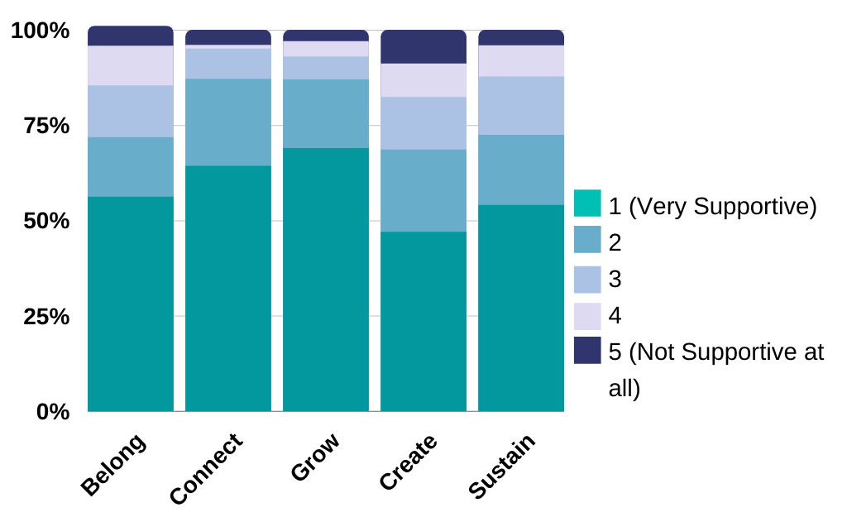

Figure: Visual representation of the breakdown of responses for feedback for each Goal Area

Belong
Goal: Help people to participate in Port Phillip life, with a focus on the vulnerable and disadvantaged
Seventy-one per cent of respondents indicated they were supportive of the proposed actions for this goal, with 56 per cent very supportive. Thirteen per cent of respondents were unsure, while 15 per cent indicated lack of support.
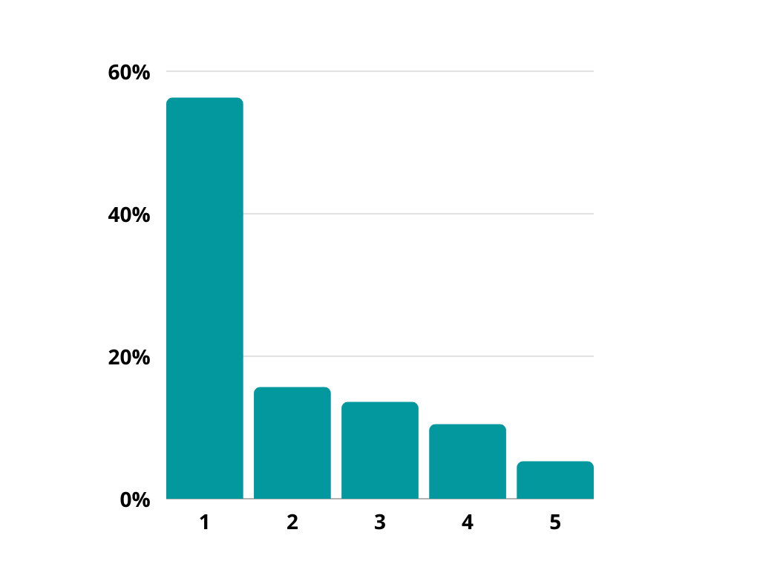
Snapshot of quantitative feedback
Average | 1.94
1 (Very Supportive) | 56.25%
2 | 15.63%
3. Unsure | 13.54%
4 | 10.42%
5 (Not supportive at all) | 5.21%
Figure: Breakdown of responses to quantitative feedback (1: Very supportive, 5: Not supportive at all)

Key themes from open-ended responses
Q: Please tell us why you chose that answer?
Ninety-two out of the 106 respondents contributed to this open text question.
There were many opposing opinions for the actions within the goal Belong coming through in the community feedback, these include:
- Libraries where books and learning are the core purpose vs. libraries as a service and activity hub for the community;
- Libraries as needing to hold onto physical books and media vs. libraries needing to transition to digital media to keep up with the times;
- 24/7 libraries enable greater access vs. 24/7 libraries are unnecessary and unwanted.
The key themes that emerged from the feedback are included below in order of frequency:
- 24/7 library
- Infrastructure development and its distribution
- Diversity and inclusion
- Resourcing
- Actions and implementation
24/7 Library | There were conflicting views on the 24/7 library, with many respondents supporting the idea, rejecting it, and many expressing confusion about how this would work in practice.  Those supporting the idea liked the greater access it would provide due to extended hours.  Some of those rejecting the idea did not support any 24/7 library, while others did not support Middle Park as the choice for the library. Some suggested Middle Park was not the best choice for the 24/7 library due to its location and demographics, and that a location with access to public transport would be preferable. Some questioned the need and desire of the Middle Park community for a 24/7 library. Some respondents expressed in particular they wanted Middle Park to remain a consistently staffed library.  It was suggested different locations could be piloted to ensure greatest success. Others suggested extending hours of all branches instead of one branch 24/7.  Many raised questions and concerns about security and safety of the community and staff, and the costs of running the library.  Many did not know what the 24/7 library would mean for library users and how it would run, including questions about when the library would be staffed and when library users would be able to browse books.
Infrastructure development and its distribution | Some respondents agree with the dire need to redevelop St Kilda to support greater ‘capacity and flexibility’, while others stated that the refurbishment of all libraries is needed, including new community spaces.  Some respondents disagreed with the focus on St Kilda for redevelopment, highlighting investment should be spread across all services in the City. Some respondents highlighted that St Kilda Library was not easily accessible to/from the northern areas of the City and were of the view that it had received redevelopment recently.  In particular, people questioned the redevelopment of St Kilda Library instead of Port Melbourne and/or Emerald Hill, due to the proximity to the Fishermans Bend growth area, which is geographically far from the St Kilda Library.
Diversity and inclusion | For the libraries to be inclusive and welcoming to CoPP’s diverse population, respondents suggested:  - Libraries be co-located with other services to support access by disadvantaged populations  - Support CALD and LOTE communities through appropriate book resourcing and library services  - Support for digital services for older community members  “Libraries are at the heart of community - equal access and shared space/resources supports equity and belonging.”  Some respondents liked that the Plan was “shift[ing] away from the traditional view of a library of purely the lending of physical books and other reading materials” and like the “emerging role of libraries as social connectors”  - Some respondents requested diverse programming to reflect the broader needs of the community  - Some respondents were unhappy with the focus on disadvantaged groups, instead of population as a whole, and wanted all groups to be included in the focus of library activities  Recognise the unique heritage of St Kilda  - One respondent wanted the St Kilda Library maintained as it is a community heritage building  - Another respondent questioned the absence of recognition of local Indigenous heritage in the Plan
Resourcing | Many respondents stated they thought there should be more emphasis placed on maintaining and increasing books and hard copy resources at the libraries, particularly as ambitious other activities are proposed in the Plan.  Some respondents supported the additional activities proposed, such as greater support for vulnerable communities and creative workshops, but stated it should not be at the expense of funding the book collection and programs:  - A number of respondents thought that these additional activities divert resources from core library services  - It was noted that book resources have been decreasing in previous years  - Respondents suggested that other Council buildings could be used for these activities instead of the libraries.
Actions and implementation | Many respondents liked the ambitious ideas presented but were unclear or doubtful about how they would be achieved, especially given the current funding levels.

Connect
Goal: Connect people with; each other, services and resources, and the world around them
Eighty-seven per cent of respondents indicated they were supportive of the proposed actions for this goal, with 64 per cent very supportive. Seven per cent of respondents were unsure, while four per cent indicated lack of support.
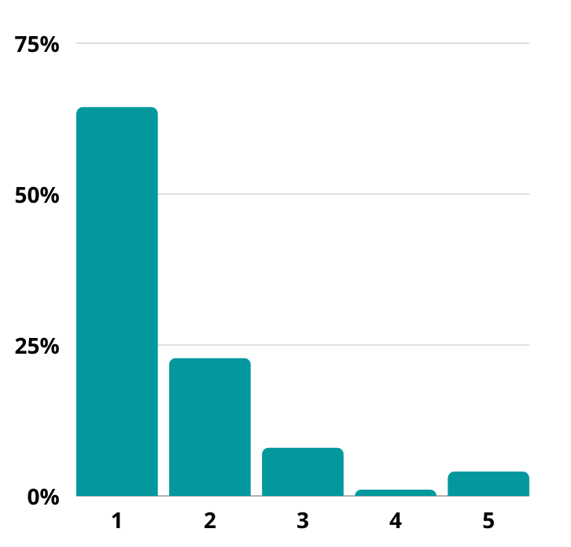
Snapshot of quantitative feedback
Average | 1.57
1 (Very supportive) | 64.36%
2 | 22.77%
3. Unsure | 7.92%
4 | 0.99%
5 (Not supportive at all) | 3.96%
Figure: Breakdown of responses to quantitative feedback (1: Very supportive, 5: Not supportive at all)

Key themes from open-ended responses
Q: Please tell us why you chose that answer?
Eighty-one out of the 106 respondents contributed to this open text question.
The key themes that emerged from the feedback are included below in order of frequency:
- Technology and digital literacy
- Books

Technology and digital literacy | Many respondents supported the need to transition to more online and digital services for greater accessibility. Some respondents suggested that these technological upgrades were well overdue.  - There were mixed opinions about whether a website upgrade was needed, with a request that the needs of LOTE groups be considered in website content.  - One respondent suggested to digital app could be more user friendly  - Many respondents supported the suggested digital literacy programs, especially for older residents, as well as CALD communities.
Books | Many respondents were concerned about the potential for the technological and digital upgrades to result in the replacement of books with e-books  - There was support for upgrades to digital services as long as the physical collection is not impacted, with more tangible targets about increasing book collection requested in the Plan.
Other feedback
- There were some concerns about the cost of providing these services, with some doubting whether they would be funded
- Respondents like the inter-library loans resource-sharing program, with one respondent concerned about the recent price increase of the service.

Grow
Goal: Support people of all ages, backgrounds and circumstances to read, learn and enrich their lives
Eighty-seven per cent of respondents indicated they were supportive of the proposed actions for this goal, with 69 per cent very supportive. Six per cent of respondents were unsure, while three per cent indicated lack of support.

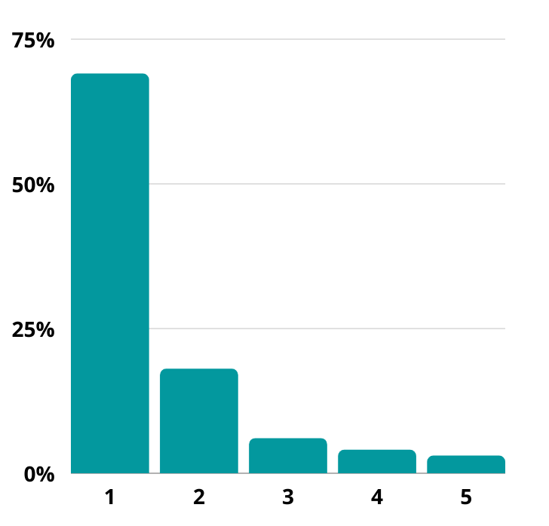
Snapshot of quantitative feedback
Average | 1.54
1 (Very Supportive) | 69.00%
2 | 18.00%
3. Unsure | 6.00%
4 | 4.00%
5 (Not supportive at all) | 3.00%
Figure: Breakdown of responses to quantitative feedback (1: Very supportive, 5: Not supportive at all)

Key themes from open-ended responses
Q: Please tell us why you chose that answer?
Seventy-eight out of the 106 respondents contributed to this open text question
Of the five goals, Grow was the most strongly supported. However, some of the suggested actions of this goal were divisive. The feedback for Grow fell into the following key areas, in order of frequency:
- Volunteer program and staff
- Partnership with bookshops
- Managing growth
- Children’s programming
- Communication

Volunteer program and staff | Support for the suggested volunteer program was divided among respondents, with more respondents ultimately supporting the idea than rejecting it  - A lot of respondents loved the idea, especially for extending access to vulnerable populations  - However, many of respondents were concerned with using volunteers instead of experienced, trained staff to support vulnerable populations  - Concerns regarding volunteers replacing experienced paid staff, thereby devaluing the work of paid staff  - Some respondents did not agree with the suggestion to remove barriers between staff and customers, highlighting staff were not social workers  - Name tags for staff were suggested to decrease barriers between staff and the community.
Partnership with bookshops | Many people strongly supported the idea of partnering with local bookshops  - Some were concerned with the potential cost, especially if the library were to shift responsibility for book clubs to bookshops.
Managing growth | Some respondents were concerned with investment in a library in the Fishermens Bend growth zone would come at the expense of other libraries  - Some respondents acknowledged the need to support access to libraries in growth areas  - Many highlighted that the libraries in the northern part of the City could service this population, in particular Port Melbourne.
Children’s programs | There was support for the proposed early years and youth programs  - Greater integration with local schools was suggested.
Communication | Respondents agreed with the proposed communication strategy, indicating that they thought better communication was needed to make libraries more accessible.  - Some respondents thought this communication strategy was well overdue, and that much more proactive communication with the community is needed.

Other feedback
- A few respondents would like more focus on inclusion of disabled persons and older members of the community
- There was support for more services, such as homework clubs for school students, and events, such as author readings and workshops
- It was suggested the library provides guidance for establishing book clubs to best support them.

Create
Goal: Inspire people to be creative, turn their ideas into reality, and participate in a prosperous creative ecosystem.
Sixty-eight per cent of respondents indicated they were supportive of the proposed actions for this goal, with 47 per cent very supportive. Thirteen per cent of respondents were unsure, while 17 per cent indicated lack of support.
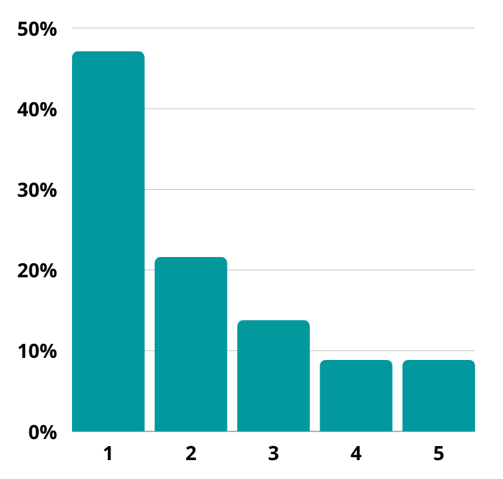
Snapshot of quantitative feedback
Average | 2.11
1 (Very Supportive) | 47.06%
2 | 21.57%
3. Unsure | 13.73%
4 | 8.82%
5 (Not supportive at all) | 8.82%

Figure: Breakdown of responses to quantitative feedback (1: Very supportive, 5: Not supportive at all)

Key themes from open-ended responses
Q: Please tell us why you chose that answer?
Eighty-two out of the 106 respondents contributed to this open text question
Of the five goals, Create was the least supported on average. This is due to the critical responses in one key area:
- Resourcing and scope of library services.
Resourcing and scope of library services | Many respondents liked the ideas for expanding creative activities such as live music at the library, but viewed these activities to be irrelevant and out of the scope of library services  - Many found the proposed activities to be in conflict with what they believe to be the core purpose of the library: books, reading, and literacy  - Respondents stated that they thought it was important to maintain the core purpose of the library as a place for reading and literacy, as there are no other dedicated public spaces for these activities, unlike live music  “Libraries represent a love of books, the art enjoyment of reading and knowledge/learning. Unlike live music there are no other public spaces dedicated to this.”- online survey respondent  - Many were concerned with the cost and the redirection of resources away from core library services related to learning and literacy  “Don't try and be an expert in everything, just do the primary role really really well and not water it down with other engagements.”- online survey respondent  - In particular, respondents mostly did not support the suggested inclusion of spaces and resources for gaming
Other feedback
- A few expressed support for the idea of storyteller/writer/artist in residence and supporting local creatives, with one respondent stating the importance of creativity for individual’s wellbeing and mental health
- It was suggested that other Council buildings could be used to support the creative activities suggested in the Plan.

Sustain
Goal: Respond to the needs and aspirations of our diverse and growing community
Seventy-two per cent of respondents indicated they were supportive of the proposed actions for this goal, with 54 per cent very supportive. Fifteen per cent of respondents were unsure, while 12 per cent indicated lack of support.
Snapshot of quantitative feedback
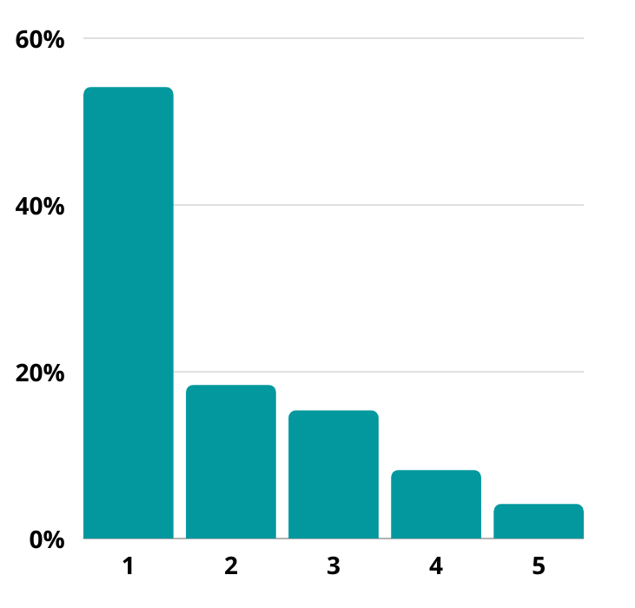
Average | 1.90
1 (Very Supportive) | 54.08%
2 | 18.37%
3. Unsure | 15.31%
4 | 8.16%
5 (Not supportive at all) | 4.08%
Figure: Breakdown of responses to quantitative feedback (1: Very supportive, 5: Not supportive at all)

Key themes from open-ended responses
Q: Please tell us why you chose that answer?
Seventy-two out of the 106 respondents contributed to this open text question.
The feedback on the goal Sustain fell into the following key areas, included below in order of frequency:
- climate change
- staff
- community engagement
Climate change | While many respondents agreed with the urgent need to address climate change, most respondents thought acting as a “climate emergency relief centre” was out of the scope of the library.  They did support the library providing public seminars around climate change for education, as a way of improving awareness and action around the issue in the community.
Staff | Many respondents highlighted how much they love and value the staff at CoPP libraries  - In particular, respondents questioned staff reductions in the past year, and would like to see the workforce grow in the future  - Hiring staff from local diverse CALD groups was suggested, for greater representation of the community across staff.
Community engagement | Many respondents supported greater community engagement and regular involvement in library planning and decision making  - A library advisory committee was suggested, as well as including local business representation in discussions  - To ensure that any engagement is inclusive and representative of CoPP’s diverse community, engagement should include multicultural groups, LGBQTI groups, First Nations, disadvantaged and vulnerable groups.
Other feedback:
- Respondents questioned whether a comprehensive children’s education program was the role of the library, as opposed to a state government responsibility.

Library branches, online and outreach services
Respondents were asked to provide feedback on statements that outlined what you can expect from library branches, online and outreach statements in 2026.
Seventy-six out of the 106 survey respondents contributed to this open text question. Key or repeating comments are presented below, and verbatim responses are provided as Appendix B to this report.
Q: Do you have any feedback on these?
The feedback from the open-ended questions fell into the following key areas:
- Middle Park as a 24/7 library
- Changes in library services
- Resourcing
- Books

Middle Park as a 24/7 library | The most common response was related to Middle Park becoming a 24/7 library  - Many were confused about what this would mean  - Many did not support this if it means losing staffed hours and/or physical books.  Some respondents supported the 24/7 library due to the greater access and extended hours it would provide.  One respondent suggested: “St Kilda would be a more appropriate place for the 24/7 library as it has better access to public transport and a younger demographic which would utilise the service more than Middle Park residents”
Changes in library services | Many respondents questioned the new directions of the library services and whether they are within the scope of the library.  A couple of respondents liked the idea of differentiating the services that each library provides as a way of allowing a greater diversity of services without reducing quality.  More respondents wanted services to be distributed evenly between the libraries.
Resourcing | Respondents were concerned with how the new suggested library services would be funded without reducing core library services  It was suggested existing council buildings could be used for creative activities instead of building new spaces at the libraries
Books | Respondents wanted continued investment and commitment to providing books and book clubs.

What you value from your library
In earlier feedback from the community when developing the draft plan, we heard that some of the key things people valued from their library were beautiful spaces, responsive programming, a contemporary collection, engagement and connection and future-oriented technology.
Sixty-six of the 106 survey respondents contributed to this open text question. Key or repeating comments are presented below, and verbatim responses are provided as Appendix B to this report.
Q: Is there anything missing?”
Many respondents indicated support for the Plan and its contents, saying they did not think anything was missing.
“If 80% of what you have said here gets off the ground them Port Phillip will be leaders in creating healthy diverse connected communities.”- online survey respondent
Respondents who thought something was missing from the Plan gave feedback that relates to the following key themes:
- Books and book clubs
- Inclusive safe community spaces
- Staff
Books and book clubs | The most common response was related to a lack of emphasis on books, including increasing the collection of hard copy books.  - Respondents recognised a contemporary collection was needed respondents also valued the access to out of print books that libraries can provide  Greater support for book clubs was mentioned by some respondents, asking they not be discontinued.  - More book clubs (including a non-fiction book club) was suggested due to slow turnover of existing book clubs
Inclusive safe community spaces | Some respondents said they wanted libraries to be welcoming, safe spaces for all the community. A quiet, peaceful space that is a refuge from the outside world.  Diverse members of the community should feel welcome and safe at the library.  - A specialist disability access librarian was suggested  One respondent questioned if hiring security guards could enable increased safety for staff and community.
Staff | Respondents said that they really value the staff at CoPP, that they are one of the library's greatest assets, and that they want to see staff supported in the Plan.  - It was noted that the staff are important to libraries being welcoming and inclusive.  Respondents thought that libraries should be adequately staffed, and that diverse, well-trained and loyal staff should be supported through recognition and respect in the Plan.

Other comments
Q: Please share any other feedback or suggestions on the draft Library Action Plan.
Fifty out of the 106 survey respondents contributed to this open text question. Key or repeating comments are presented below, and verbatim responses are provided as Appendix C to this report.
The most common response received was support for the plan and its directions.
“It makes me happy that the City of Port Phillip takes their libraries so seriously and that they are being kept up to date and evolving with the times.” - online survey respondent
Feedback and comments that were not in direct support for the Plan relate to the following key themes:
- Details about actions and implementation
- Service prioritisation and resourcing
- Access and opening hours, 24/7 library
Details about actions and implementation | Many respondents requested more details about how the Plan would be implemented and the vision achieved, including transparency around timelines and how milestones would be measured.
Service prioritisation and resourcing | Respondents were concerned ‘core library services’ were not being prioritised, especially after decreased staff and book resources last year. They would like to see a focus on re-establishing and growing core library services before expanding to other services.
Access and opening hours, 24/7 library | Respondents requested extended hours, especially on the weekend, to enable access for more of the community.  Respondents did not support that hours be extended in the form of a 24/7 library, especially if this meant the library would not be staffed.

Email submissions
While there was no formal (statutory) requirement to undertake a submissions process, two email submissions were made on behalf of community groups and the third was an individual submission by a community member.
Each of the submissions have been summarised below, and verbatim responses are provided as Appendix E to this report.
Community Alliance of Port Phillip (CAPP)
CAPP would like to see a clear statement in the Plan that details the libraries’ focus, so that the libraries are accessible and offer an equitable service for all.
- To ensure this is achieved, an assessment of current users, their needs and experience of the library needs to be established in the Plan.
- Demographic data provides a tool to plan for future trends and provide equitable distribution of services, particularly for those with greater needs or who are from disadvantaged groups.
- While not providing services such as accommodation or community support, libraries should be tolerant and open to all.
- Staff training and capability development is one way in which libraries can reach new users and promote the libraries.
There should be in the Plan a focus on books and reading.
- Providing literature, educational resources and information using a variety of media should also be included.
Engagement between library staff, users and the broader community is seen to be essential, including
- Greater opportunities for engagement through use of spaces to meet
- Support with written engagement (such as submissions or work-related activities).
To set priorities for the short, medium and long-term, the plan must take into account:
- The current use for each library
- Opportunities for reaching new users/user groups (e.g. creative industries and gaming, access points during instances of climate extremes),
- The needs of each geographical area.
  - For example, the smaller South Melbourne libraries may provide specialised services based on the local population profile, while the larger St Kilda Library can continue to be used by a number of groups, with the opportunity to develop new contacts and services.
- The expected population growth of Fishermans Bend and the changes that the opening of the Melbourne Metro will bring to the area around the Domain.
CAPP is critical of the Plan’s expectations for libraries in 2026; the services and roles of each library needs to be stated clearly and accessible to residents across Port Phillip.
To support the issues raised, preferred models of other libraries were provided, including the Boyd Community Centre and Southbank Library and Greater Dandenong libraries.
St Kilda Historical Society
The Society stated that it has provided input to the submission made by CAPP, this submission more specifically relates to the St Kilda Library.
- The Society notes a long history of a relationship with this library branch in particular, and continuing relationship through its use of areas in the library.
The Society seeks reassurance that the facilities at the St Kilda Library are maintained, and that the Plan acknowledges the importance and central role of the St Kilda Library in the City of Port Phillip.
- The Society calls for a place where they can meet regularly, expand the available historical books and other resources.
Ensuring a welcoming library through design and maintenance is noted as an important considerations for the Plan, including;
- Expanding and linking to open spaces
- Providing meeting spaces
- Clean facilities
- Shelves that do not act as barriers and staff training.
Expert advice and community views should be included when considering the future direction of the library.
Community member
This submission from a community member notes the feedback provided is based on conversations they have had with their book group, neighbours, friends and community group contacts.
Concerns were raised about:
- The Plan being too broad, and that priorities need to be clearer, including funding priorities
- The opportunity to participate: the document was too big, promotion of the survey was limited, the survey was open for two weeks, library staff were unable to provide further information
- The quality of the responses provided, difficult to provide feedback due to survey design and size.
Improvements to communication by library management with library staff, borrowers and local community organisations was noted as an area in need of improvement and, as such, should be addressed in the Plan.
A late additional submission from a community member was received. Key points include:
- not making the library 24/7
- more social services in St Kilda Library and an onsite Housing Officer, social worker and domestic violence referral system
- St Kilda Library to become a one stop assistance centre essential high-quality communication and co-operative links to agencies.
- build a purpose-built library in Fishermans Bend that includes theatres, auditoriums, rooms for study, practice and teaching.
- introduce fines for overdue library books to fund the activities in plan.

Postcards
Four postcard responses were received in response to the draft Library Action Plan.
- Increased support for younger and older members of the community to access the library
  - provide appropriate reading material for different age groups
  - redeveloping infrastructure to ensure there are appropriate spaces for different demographics to enjoy the library
- Suggestion to re-introduce fines for late and lost books.

Neighborhood Conversations
Feedback was also captured through seven neighbourhood-based pop-up engagements throughout February and early March 2021.
At these sessions we hosted an interactive engagement activity where we asked the community to provide feedback on the draft plans goals through a post it note activity. As part of this the community were also encouraged to fill out a hardcopy survey or provide feedback online.
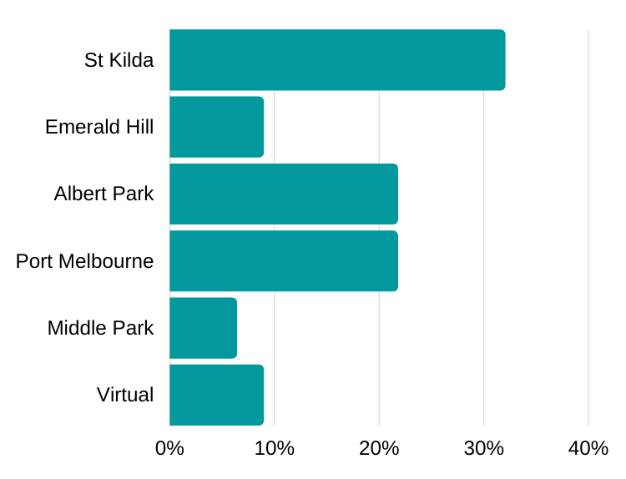
We received 104 post-it responses from 78 participants.
Library branch | Post-it note respondents
St Kilda | 32.05%
Emerald Hill | 8.97%
Albert Park | 21.79%
Port Melbourne | 21.79%
Middle Park | 6.41%
Virtual | 8.97%

Key insights
Feedback from the post-it notes was mostly general in nature, and fell into the following key areas:
- Inclusive and welcome
- Programming
- Physical spaces
- Digital and online
- Resources
Inclusive and welcoming | - Space and programming for children and mothers, young people  - Support for older people through appropriate media such as talking books, help with digital literacy  - Support for disadvantaged populations including children, such as study zones at Port Melbourne Library  - Love the friendly and helpful staff for creating a welcoming environment
Programming | - Writer talks and presentations  - Community activities  - Online programming to connect community less able to access the library in person  - Programs are important for building community connections  - Literacy courses with a vocational focus for disadvantaged and CALD groups  - Free events and workshops to get an exposure to different ideas and experiences  - Programs in LOTE to support migrant communities
Physical spaces | - Quiet spaces provided, but some spaces for talk and activity too  - More study and workspaces  - Spaces for different groups in the community such as children, families and disadvantaged groups  - More meeting rooms available for free for the community  - Space to display, recognise and celebrate local heritage  - Refurbishment of spaces needed, to increase lightness and brightness
Digital and online | - Like the self-service technology  - Online services and portal provided useful  - Enjoy using computers, could have more available
Resources | - Love the inter-library loan service, some say the service has worsened recently  - Like the variety of books (including children’s and young adult) and magazines available  - A couple of respondents mentioned the long wait time for popular book titles

Meetings
Officers were invited to attend the March 2021 meetings of the Older Person Advisory Committee and the Multifaith Forum. Key points raised at these meetings included:
Multifaith Forum
- Activities to tie in with Cultural Diversity week
- Libraries and potential support options for new arrivals
- Festivals for specific cultural groups or events in the calendar, e.g. Diwali etc
- Appropriate signage in branches
- Collections – e.g. Hindi, Urdu, Spanish (Polish collection is outdated)
- Bi-lingual Storytime activities
- Adult programming that is culturally appropriate
- Telling stories in language – how to involve families in the library, e.g. Children could
help to produce learning resources
- Libraries can act as a ‘window to the world’
- Singapore libraries model – e.g. libraries as active community centres
- What role could volunteers help play?
- Good to foster the idea of library ‘champions’ in the community
Older Persons’ Consultative Committee
- Libraries were one of the most loved and exciting Council services and would like to advocate for the library to be well resources into the future and would like to advocate for more of them.
- Digital literacy is an issue for older/vulnerable residents and that other Councils have been running digital literacy training and could this be considered for our libraries.
- Enjoyed the live music sessions that the library has been putting on.
- Libraries are an important space where community can connect with one another and would like the spaces to be used in this way.
- Liked the way the draft Action Plan was written. She said she felt the document was speaking to her directly.
- Social isolation and mental health are issues experienced by older residents and would like to see how this is married up in the action plan.
- Home library service is a fantastic service.
- Enjoyed reading the document, and said it was easy to read.
- Audiobooks in other languages, Braille etc. as felt audiobooks are beneficial also for people who illiterate.
- Consider options for storytelling and digitization of stories.
- Concerned about minority communities who are ageing.
- Gap in Library Services in Elwood.
- Partnerships that the library service could explore and mentioned Vision Australia to be considered.

- Library Service could consider partnering with schools to do storytelling for students, particularly schools that are teaching languages.
- Making it easier process for older people to register with the home library service.

Next steps
This report and the updated draft Library Action Plan will be presented to Council at the 16 June 2021 Ordinary Council Meeting, where Council will consider adopting the Plan.

Appendices

Appendix A: Targeted consultation with young people and parents

Youth Advisory Committee
We attended a Youth Advisory Committee meeting in April to seek feedback on the plan’s goal areas and actions related to each of these. Feedback has been summarised below.
- Create spaces and opportunities for young people to meet and connect that aren’t just based around books.
- Library spaces to accommodate different needs at different times.
- Not just focussed on books – create online and interactive opportunities.
- Support for education and learning opportunities such as academic skills learning modules, game design programs and career focussed events.
- Events - themed/topic nights.
- Host youth worker sessions.
- Languages other than English (LOTE) books and services for migrant populations
- Support for artist, writer residence programs, with the suggestion to include career in residence as part of this.
- Support to create opportunities to investigate, share and learn about what other people are doing.
- ‘Human Library’- access to diversity of knowledge and experience. Idea is to ‘borrow’ or book time with a person to share in their lived experience.
Parents with young children
We promoted the consultation to parents with young children through our Council childcare centres and e-newsletters for Family, Youth and Children, Libraries school holiday programmes and children’s immunisation sessions. We received an additional 26 survey responses from these engagement activities.
Who we heard from:
- Eighty-four per cent were aged between 35-49 years old, followed by 7 per cent at 25 – 34 years old.
- St Kilda Library was the most visited branch at 29 per cent, followed by Albert Park and Middle Park Libraries both at 25 per cent.
- 75 per cent were residents.
- Over 90 per cent were female.

Library Vision
Survey respondents all expressed positive feedback for the vision statement, with many respondents referencing the social connection that libraries foster.
Suggestions included:
- referencing a way for people to give back.
- The educational element that it brings to children.
- how it brings all different parts of the community together.
“I think this vision reflects accurately on the local community's values and Port Phillip libraries are a wonderful hub for people to connect, interact and take part in activities.”

Goal areas
In general, most respondents were supportive overall of the actions within each goal area.
Feedback from open text responses to each goal area has been summarised below:

Belong
- Support for expanding libraries programs to support vulnerable and disadvantaged people.
- Support for programs and activities for children and youth.
- Suggestion for library programs to evolve and expand into beyond books to toy libraries, tool libraries, skills exchanges.
“Investment in libraries is so important for all. In particular recognising new ways to support and connect and engage with vulnerable and disadvantaged people.”

Connect
- The library is a place of learning and staff should have the tools to provide this.
- More modern digital services across the library.
- Suggestion for a greater focus on connecting people with each other, not just services.
“Connection for me is about bringing the community together. Storytime was wonderful example of this because it bought lots of young parents together. They could make new friends and their children could socialise too. Helped make these connections, it was and is the most important part of our libraries to me.”

Grow
- Support for the proposed early years and youth programs and suggestions to include more linguistically diverse programs as part of this.
- More learning services, resources, and space for primary school children.
“As a parent (migrant) of a five year old, the local library has been such a safe and enriching space for us. They've given me confidence as an adult, inspired my son and helped me feel connected with the community.”

Create
- Suggestion for community groups to partner with the library.
- Support for creative art and music programs and spaces.
“Love this. Programming should be diverse and define learning/education broadly.”

Sustain
- Some participants supported libraries becoming a community hub for climate change education. However, one participant noted they didn’t understand what a ‘climate emergency relief centre’ is.
- Support for the development of children and youth programs. One participant suggested increasing support and programming for kids transitioning to school and throughout to continue to foster a love of literacy.
“I don’t understand what a ‘climate emergency relief centre’ is. Agree and support the children’s education program – my children are all prolific readers and believe this is large part due to programs such as Storytime, also the exposure to the library through holiday program.”
Where there was little/ no support for the actions, key feedback included:
- Not supportive of the library moving away from its core functions and would not support rates increasing to pay for optional activities.

Branches
In general, there was support for the library branch statements. Some suggestions included:
- create more ‘hubs’ and breakout rooms at Albert Park to provide community with place to meet and study.
- One participant noted they felt St Kilda Library in its current state does not represent a benchmark for urban libraires.

What you value from your library
In general, there was support for the library service outcomes. When asked if there was anything missing, suggestions included:
- Consider offering educational opportunities for teens and parents on technology.
- Partnerships with schools.
- Provide a social service staffed by trained professionals.
- Focus on the core services that libraires offer.

Appendix B: Verbatim responses to open text survey
All references to staff, specific businesses or individuals have been removed.

Library vision
Q: Do you have any feedback on this vision?
I think that what is proposed is excellent
Bit pompous
I love it! Maybe some other adjectives to reconsider the "safe", "thriving", "educational"
Very hard to measure success with such a broad vision who would not agree with this.
I attend the Middle Park Library, have done for so many years. It is an integral part of our community. Please don't close it or turn it into a computer centre. The children at Middle Park - and adults - all have access at home.
Libraries are for quiet activities, reading. Please don't turn them into noisy activity centres, more suited to neighbourhood houses.
Great vision! COPP libraries are a very important part of our community.
Open longer hours 24x7 will be best or close to it!
Yes - fantastic. It's all about creative, energized communities + your role in this.
I would add resourced - as the provision of free and accessible resources supports the growth and development of community and its members wisdom and potential.
Excellent vision, and working so far.
As per the library action plan 2021-26 I support enthusiastically the mission statement.
Only that library is an important and loved of our community.
Too involved but library has always been important part of our community for 50 years I have lived here & still!
Keep all 5 existing branches operating. Increase the hours particularly at Middle Park and increase the ways in which library staff interact with users.
Exhibition space for "non" established artists - book market.
This vision is admirable.
Yes I agree with this statement!
everyone who …. Implies, excludes visitors?
I appreciate that you are planning to take up all the technology you need to anticipate demand for this, however I would like to see emphasis on the only things we can depend on when the power goes OFF - i.e. BOOKS! Please think of the many residents and St Kilda who can't move around much and be sure to keep up the home delivery trucks, your small branches and keep sitting places that make libraries.
I suggest more operating computers. How to improve the capacity using the floor space efficiently and more flexibility.
I am in support at whatever makes Port Phillip liveable and socially connect in this, these it will help bring the community together I believe.
There is no mention of books or resources.
I love the idea. I have to say I don’t think it is there. I know I probably don't use the main library but I do feel library sercie was bigger at my previous locations - both at library & digitally
Very commendable and wishing you well on the implementation. However long it takes.
N/A
It’s fine – see comments just add a focus on people with disability.
Sounds wonderful
I love the idea. I have to say I don’t think it is there. I know I probably don't use the main library but I do feel library sercie was bigger at my previous locations - both at library & digitally
Great concept - it's all pretty good at present
Libraries have moved beyond being "bricks and mortar" building with a collection of physical items for borrowing. They have become information resources mixed with aspects of delivering neighbourhood and community services.
This is too my vision!
- concern that the older demographic is being left out of the grand plan
- books hardly mentioned, the collections the library holds are important to keep as it can be the only place to obtain an out of print book for research or other purposes
- more comfortable physical space to accommodate reading of books or newspapers, research, study is required
- a lot of jargon used in the document
- would like to read a proper analysis of the genre system vs the dewey decimal system - what evidence is there that one works better than the other, using what criteria? Evidence?
- Yes the St Kilda library needs a huge amount of work to revitalise the space,
First impression: it sounds very general, vague, maybe a bit too "airy-fairy".
And why the competitive edge? Why does it have to be "the best"? And how would that be evaluated anyway?
I disagree that being the best is a good motivation. Rather being the best for our community is a more valuable goal
I like it, thank you. Very pleased with the work you've done.
I feel the vision has some good points but you have outlined no specifics for instance I would not like to see some bookshelves replaced with technology no matter what the library is mainly about books and reading
Good , but it should include making Port Phillip an "informed" City as well.
Yes. We need an emphasis on books. More books on shelves, more new books and activities centred around books, such as the book clubs.
I think the council should stick to providing library services at the present level, and not increase the current cost per capita so the burden on ratepayers is not increased.
Council already tried to 'refocus' Middle Park Library in 2017 without resident consultation, and needs to be mindful of what the core purpose of the Library service is before turning it into some sort of themepark for other 'progressive' agendas. The covid crisis made very clear just how many people rely on the libraries in their day-to-day lives, and yet Port Phillip Libraries lagged behind other municipalities (particularly City of Hume Libraries) in terms of deliveries and implementing click-and-collect services. Not everyone wants digital service, or can get access to it, and/or what they want to see is not available in that format.
Yes, the libraries are chronically underfunded, they've been woefully run down and neglected for years on end (particularly when compared to other councils) - libraries should be your flagship service, they're the friendly face of council to the community - how the staff have managed to maintain such a profoundly professional, kind, generous and inclusive service in the face of such blatant disregard from council in general is actually quite astounding. It's visibly clear that at the current level of funding and support from council that the stated goals of the council's 'vision for libraries' has no possible chance of becoming reality.
Council needs to recognise that their libraries are uniquely placed to meet (and indeed exceed) the goals of the vision but must be adequately supported to do so.
My comments should not be taken as an attack on the service delivery of the libraries, as the staff are quite obviously your most valuable asset, whose professional insight and acumen needs to be not only recognised but encouraged and allowed to flourish.
It's time the council becomes more inclusive of the diverse voices within the community - those that are currently being stifled by the 'we need more books' cries from the middle-aged white, wealthy minority. Your libraries are openly accepting of all and should be allowed to pursue their vision that libraries are not just about books, and that libraries interact with users in a whole spectrum of ways - from eBooks, to games, to creative spaces, events, places to study - a community building environment.
I like the first phrase.
However the vision statement does not mention books, reading, literacy, literate, research, reading.....
Key words that should be included in a library vision.
Nice words but more action needed to achieve this. I think the library needs to send out regular newsletters to members so we know what is going on. I only heard about this survey from a friend. I also belong to the Mornington Peninsula library and they are much better at keeping members informed.
These are (largely meaningless) platitudes.
Sounds good!
The "vision" does not mention books or reading or literature or literacy or access to anything tangible.
Such a wishy-washy, motherhood-statement start point offers no vision worth the name. It could mean anything.
By all means try to improve the library service but do not stuff up what is a library's most important function - access to books.
I like the vision. It is very aspirational. In my view libraries in CoPP are significantly below what I have experienced in inner city libraries, especially when living in the City of Yarra for five years. Because it is so aspirational, CoPP will need to be careful not to lose its focus along the way if we want to have a chance to make progress towards this vision.
CoPP needs to consider ALL residents, not just those that are the most vocal (wealthy retirees) or most top-of-mind for government (low income, migrants, etc.). There are many working families in CoPP, including single parent working families, who make significant sacrifices to live in the municipality and deserve some attention. They are time and often relatively cash-poor (as they are not entitled to subsidies) and may lack the connections with local groups.
no
No, I like it, it excites me
Dont try to be the best. Who are you competing with? No one other than yourself. Try to be the most effective at the services you offer, try to be most engaging with all the communities within the city, try to be the most inclusive- offering a plethora of books in a variety of appropriate languages including First Peoples. Don't set the bar too high with some tokenistic slogan of being the best. It doesn't say much at all. No one is wanting the libraries to be the best. We are wanting you to do better in every possible way. Keep on improving and engaging regularly w communities to understand their needs.
What is it to be liveable? I think you should unpack that more to understand what you're really trying to say.
It should state "..helping to make Port Phillip an inclusive..." Should led with your strengths. CoPP is a diverse and inclusive city, recognise that and make it a strengthen and core aspect of your programming.
The suggestion that we increase our LOTE (language other than English) collection, large print books and talking books for older people that were in the 2020-2025 version of the Plan, have disappeared from the new Plan. These are vital parts of a library's function in the community. Bring them back into the plan.
And what about books, we need many more in our libraries, on the shelves.
It is great to have vision statements - but it is more important to explain how you are going to get there
Great vision. Some way of making videos/books on lower racks more easily accessible might help access. . Automated racks that could be turned to rotate lower racks to top would be nice. Notice a lot off older people using library sure they would appreciate this. Login is good idea. Scanner at entrance that reads library card might be simpler. Dedicated help on using digital and online services might increase use of these services. Self study/video areas at St Kilda could be even better with a bit of a spruce up
Expand not contract
For me key aspects of the library service are the physical collection for older and out-of-print books, and the fantastic access to research software. Although my general reading habits are using eBooks and audiobooks, CoPP has an enviable range of older books, especially Australian literature, some of which cannot be found in any other format. Protecting these works seems to me as important as moving more of the collection online. In terms of research, the access to online research archives has been immensely helpful, combined with the access provided by the State and National Libraries.
I also strongly support the artist/writer program aspects of the plan, as the area has played a role in the lives of so many artists over the years, and the nurturing and protection of artists and storytellers will seem vital in the coming years, when support at other levels of government can prove unreliable.
sounds good
Yes! I want a local viable library that has reading material as it's main focus. I wish for it not to be closed at the drop of a hat. I do not want to have to go to St. Kilda as it's the only Library open most of the time. If funding the library is an issue, our library needs books, magazines, not a gallery and performing space in St Kilda Library, and as St Kilda is already a big library I don't think it should be bigger. Our area has a greatly expanding population.
No problem with the vision, but unclear as to how it will be achieved.
..
Clarity required on the suggestion of a 24/7 branch as it doesn't go into any detail on what this could look like in the draft plan. There could be security risk for staff in attendance, additional running costs, and what are the statistics on demand and request for 24/7 opening hours?
Question why the smallest and quietest library branch of the network is the one selected for 24/7 operation?
An admirable vision. Libraries because of their nature, form a central 'hub' especially for people new to the area. It is important that they are sufficiently staffed and funded to enable them to respond to changes - which inevitably happen in any community.
Amazing that this has taken so long. I moved from Yarra where libraries take pride of place in communities. There is ample light, study and reading space, private meeting rooms and even an outdoor reading and meditation space at North Fitzroy library
COMPLETELY WRONG FOCUS!
Nothing on book collections or core library functions , mistakes the primary function of a library it houses information it is not the point of creating it.
Vague description of future state of branches makes me think no Middle Park is to closed, Emerald Hill emptied , and of course the only clear action , expand St Kilda ehich does not need it.
I think that libraries still need to be first and foremost about books. With an ever increasing number of people, including children, spending an ever increasing amount of time on their devices, public availability books for actually reading becomes even more important.
It's incredibly important
The vision seems sound but there is no mention of the little book libraries that are located around the neighbourhood that allow people to drop used books off for others to read.
Keep libraries sacred, a place for lovers of books for the community to enjoy. Keep good old fashioned service with quality experienced staffed librarians. Maintain free and equal access to knowledge. The primary function of a library should be to provide the community with a building containing collections of books, periodicals, and sometimes films and recorded music for use or borrowing by the public. Any new ideas must not impede on it's primary function. Any additional activities are welcome but not to the deteriment of its primary function.
Great.
This is a pretty "soft" statement and provides little in the way of concrete offerings - what facilities and services will libraries provide to achieve this?
This is a great vision.
I had to tick one box in the first question to move on to the next question which is push polling but I rarely use libraries. There should be a box " I dont/rarely use libraries" in the question above.
As an older resident in CoPP, the library has been a haven during 2020.
Belong - it is important the library is available for isolated people and easily accessed as our local Port Melbourne library.
Connect - I have learned to use and appreciate the large range of electronic resources when the library was closed. Providing access to technology for older, isolated residents will become increasingly important. The library provides an important hub for our community.
Grow - I am an active volunteer in CoPP and would be keen to volunteer and assist the community in using our library.
Sustain - the library staff are wonderful and it is important that they have time to provide support for us to maximise use of the library and all of its' resources and to connect our community.
At first read seems a good overview of assessed needs. The proof is in the implementation of the plan. One of the challenges I see is keeping access to libraries while upgrading & improvements take place. Also it is always important to keep the community informed & have a plan to reach those who do not see libraries as places for them. An integrated marketing approach to all community sectors will be needed, for example a flowchart exhibition in front public spaces of community centres, town halls, at markets etc & venues such as Gasworks, Theatreworks etc. Any place that the local community might attend, maybe even street stalls.
I want to know what this means?
Middle Park Library operates as a 24/7 branch providing the local community with increased access to collections and spaces. It is also the key attractor in a vibrant community hub supporting local community learning, health and well-being.
Are you changing the library? Will there be staff on duty? Will there be physical books on display. Will I be able to come in and relax and use the internet or read the newspaper? This library is a true local library and essential for many older patrons who don't have the capability of getting to other libraries. Please don't change Middle Park library.
The vision is great, but given the diversity of our community, I would also include the word tolerant.
The vision looks great, and the creative, liveable and socially connected all talk directly to the Plan's aspirations. Prosperous, while a broad and admirable goal for any community, feels a bit out of place in this vision. I think a library has a greater role in helping a community be informed, which seems to be missing from the vision.
No, sounds good
Admirable ambition. Buta as it is clearly the worst and most poorly funded library service it has a long way to go.
That's admirable
The vision sounds like lots of "weasel" words with not a lot of substance - sorry.
Satisfactory vision as far as it goes
Iâ€™d really like to see opportunities for language classes to improve community interaction, to learn skills that directly nourish community and understanding, and enable social interaction. It also provides work opportunities to qualified language teachers from various cultures. Iâ€™d also love to see a broader magazine collection digitally
Agree to the vision
This is incredibly ambitious given the innovative libraries that exist. Itâ€™s great aspiration but council needs to invest heavily in all the libraries but particularly St Kilda. Make it great
This sounds good, though I'd add civic-minded, but does it have to be 'the best'?
Not sure how the above statement relates to a library? Please explain how a library makes Port Phillip creative, livable, prosperous and socially connected? A library is a font of knowledge to inform, enlighten, and entertain people that live and work here
It seems good
I am not going to answer for every aspect of the report. There is plenty of discussion in the document about what is wanted, but it seems to me a lot is 'motherhood' stuff - better access, more resources, more services. And of course we all want that. But I do think (and maybe that was not intended to be in the scope of this document) that there is a shortage of HOW this will be achieved. The Libraries for example should be hosting community and social gatherings like book clubs (I understand that there have been cut-backs in this area). I can find only one reference to informing the community abut the services of the libraries (and the word marketing isn't used - but we really need pro-active communication telling us what's available and encouraging groups to participate). I note that there are proud boasts about the numbers of titles and the borrowing rates. But I note also that Booroondara has a much higher borrowing rate and one of the reasons for that would be that it has so many more titles per head! The more you offer the more use you will get - assuming people are aware of what's on offer. I will flick through the rest of the survey but may not add anything. It is quite hard to comment without having the document open beside me.
I think that what is proposed is excellent
Bit pompous
I love it! Maybe some other adjectives to reconsider the "safe", "thriving", "educational"
Very hard to measure success with such a broad vision who would not agree with this.
I attend the Middle Park Library, have done for so many years. It is an integral part of our community. Please don't close it or turn it into a computer centre. The children at Middle Park - and adults - all have access at home.
Libraries are for quiet activities, reading. Please don't turn them into noisy activity centres, more suited to neighbourhood houses.
Great vision! COPP libraries are a very important part of our community.
Open longer hours 24x7 will be best or close to it!
Yes - fantastic. It's all about creative, energized communities + your role in this.
I would add resourced - as the provision of free and accessible resources supports the growth and development of community and its members wisdom and potential.
Excellent vision, and working so far.
As per the library action plan 2021-26 I support enthusiastically the mission statement.
Only that library is an important and loved of our community.
Too involved but library has always been important part of our community for 50 years I have lived here & still!
Keep all 5 existing branches operating. Increase the hours particularly at Middle Park and increase the ways in which library staff interact with users.
Exhibition space for "non" established artists - book market.
This vision is admirable.
Yes I agree with this statement!
everyone who …. Implies, excludes visitors?
I appreciate that you are planning to take up all the technology you need to anticipate demand for this, however I would like to see emphasis on the only things we can depend on when the power goes OFF - i.e. BOOKS! Please think of the many residents and St Kilda who can't move around much and be sure to keep up the home delivery trucks, your small branches and keep sitting places that make libraries.
I suggest more operating computers. How to improve the capacity using the floor space efficiently and more flexibility.
I am in support at whatever makes Port Phillip liveable and socially connect in this, these it will help bring the community together I believe.
There is no mention of books or resources.

BELONG
See previous comments on the excellent service at South Melbourne.
Would have been 5 but only saw things specific to St Kilda not anything for others
They are all very proactive positive suggestions. The cost of 25/7 service may not be met with demand.
I don’t know what 24/7 branch means. Is it different to library pick up and drop off - NO. We want our books - Books are imperative.
St Kilda centric vision as outlines in the section "Our libraries in 2026". The Action plan "Belong" must be given measurable outcomes! Only "point 1" ("implementation a 10 year asset renewal..") is currently measurable. How do you measure a successful implementation for example "point 2" "increase literacy"? - Concerned that libraries will become too noisy if the social activities are not sufficiently separated from the (quiet) reading spaces. - Should 'gaming' really be promoted in a library?
Looks like a good balance between renewal and new developments.
See previous comments on the excellent service at South Melbourne.
Its about broadening the view of libraries to not just be about books - or holder of books. Its about - learning environment - building capacity - broading role to include literacy written world of digital.
Libraires are at the heart of community - equals access and shared space/resources supports equity and belonging.
They all seem relevant to the community needs and proactive to ensure City of Port Phillip has good facilities.
The 24/7 branch proposed at Middle Park would not work at that specific branch - love the idea of the library being accessible at extended hours but it would not work with the community there, plus it raises concerns around staffing and safety. St Kilda is in dire need of refurbishment but this will be a massive job. An arts focus is a big tick for that community. Programs are often held at St Kilda and a better space for
The vulnerable and disadvantaged are at a higher risk, by definition. Any efforts to support them and enhance their quality of life, and therefore also their carers and family, is a targeted and significant approach to creating a happier and more cohesive society and a compassionate culture.
Very supportive but just how will realistic are they? 24/7 branch @ middle park? Has there been any consultation ? How will you resource this? What about indigenous local heritage? Where and when can we see a timeline of these actions? Do we have any architectural plans to view these refurbishments?
But no mention of books!!! WHY? As a significant demographic of Port Phillip and ratepayers I share the benefits of the library (E Hill). We have many disadvantaged and vulnerable in our community and I think the library has the opportunity to welcome and share books with these groups. Books are accessible not I.T.
Libraries can play a much more active role in the community. Support the underline text (actions 1 - renew and refurbish /2/4). Action 2 - provide information and support to dyslexic users. Reading programs for elderly learners who are dyslexic. 24/7 branch what does this mean?
Anything that enhances peoples experience of the library is important to the community.
It all sounds very exciting!
Agree with the goals, especially 4 and 1 that develops interactive children's areas!
"belong" statements ambiguous
Obviously you need to plan and 10 years is a good time span to cover but I don’t see any emphasis on reading and literature. Now the government is charging more for degrees, which cover these fields, our main purpose should be in those areas. I enjoy going to concerts and other events at St Kilda library (but you could let other groups do drama etc).I still want BOOKS!
Redevelop St Kilda Library to improve capacity and flexibility. Because the use of digital technology like iPhone and computer use the space to use that technology. Use space multipurpose (for public presentation).
There is no mention of books or resources in the library. The focus on gaming, e-resources, programming is misplaced. The community want to be able to get to the library and borrow books not e-books or electronic resources. There is no mention of budgeting to build up the supply of books in libraries these have diminished significantly in Middle Park.
No response
All 4 points are essential to meet the vision.
I assume low cost/no cost
All the actions sound great
I think the role of library is to engage/be the heart of a community. Most of all it should be inclusive for all
Supportive overall of these actions but quiestion the need for a 24/7 access - this may not create a safe environment. Suggest exteded hours to, for example, 10pm
Already pretty well catered for
1. Any new libraries should be situated where possible close to a neighbouhood house or community centre to optimise the use and sharing of common goals and activities. The draft action plan reaffirms the shift away from the traditional view of a library of purely the lending of physical books and other reading materials.
2. Supporting and offering digital programs would greatly benefit older people and help retain and renew connections in an evolving technological space.
3. A 24/7 library would be fantastic, depending on where it is located, hopefully close to public transport. The would give access to people who do not work the traditional daylight 8-5pm jobs. however it would probably not be as realistic for night shift workers.
A 24/7 library would be great in the area. And I love the idea of strengthening children's connection to the library and therefore their parents too. Very supportive of these ideas.
Point 1 supportive of most of these
Point 2, 3 4 supportive of these
However disagree that the focus should be on the vulnerable and disadvantaged, I think all residents should benefit, and not just one group be singled out as this will create disharmony. All groups should be advantaged to some degree. Advice should be sought from a person experienced community development
The actions sound promising but I am unsure about how they would be implemented
Insufficient detail.
And probably too much emphasis on everything...other than BOOKS.
I agree with all of the goals and aspirations for development. Especially the need for refurbishment, redevelopment of the physical libraries and seeking potential for adding new libraries.
I strongly disagree with Middle Park as 24/7 library. In fact any 24/7 libray
One thing I like about living in St Kilda is the diverse group of people living in the community. Your plan for Belong is all about that
as again you do not give enough specifics I do agree with all of the community being able to access the library services but I feel all the libraries should be basically what they are mainly for books and reading I am not against technology and know it is necessary for the younger people in the community I use technology but I do not want to see the library becoming what it is not at the expensive of the book collections no matter what people do enjoy books
Point 1 , strongly disagree need to "redevelop" St Kilda. It is the least of the "least advantaged" as that is where the bulk of spend, staff, collection and services is focused.
Point 4, should specifical call out working with advocates of the branches, that is working with Friends of library groups like those in Middle Park and Emerald Hill.
To address disadvantage need to spread: development funds across the city ; invest more in collections, the is less than 50% of the printed collection in Emerald Hill as there was 15 years ago, yet it catchment population has doubled and it has nearly more than a thousand residents in state and social housing within 400 m!
I think the emphasis should be on books. Not gaming, not computers, not eBooks. Keep the library as a library. Middle Park library needs to remain a library with books and be expanded to serve the growing community.
These goals will increase the burden on ratepayers, and much of this duplicates the role of the State Govt.
Some of these goals are sound, but I don't think servicing creative industries or community meetings/workshops belongs in the library (1.1 and 4). They are separate issues that need designated spaces that don't disturb/interrupt other patrons in educational/learning/work-related activities for which they would like some quiet and privacy.
Multi-purpose spaces for wider work or group activities should be placed where they are not going to cause noise or disruption. Council would be better re-purposing buildings it owns, or making a separate site for these activities rather than tagging them on to existing spaces already at capacity.
Whilst I'm very supportive of these aims, I see absolutely no way that these will be achieved given current funding levels.
As far as St. Kilda library is concerned, you need to understand that the community are the custodians of an architecturally unique heritage building (including the internal original furnishings), this is a landmark building within the community, and you have an obligation to preserve and celebrate it. Yes, expand it, but do so with sensitivity to the current structure and uses.
The current programming is innovative and reflects the creativity of the municipality - it's unique amongst all councils and it's essential that it be recognised that programming is not simply children's story-time or literary author talks, but must reflect the broader demands and needs of the community - music, arts and crafts, heritage, mental health, community capacity building, technology, support for vulnerable communities - these are the things that are being done, but need to be built on and expanded, not side-lined for story-times!
24/7 branch is a great idea - but the location you've chosen is, put simply, stupid. A minority voice of older, wealthy users with a limited vision is drowning out the majority - this library should, by all rights, be converted to a children's library as that clearly meets the needs of the area in which it is situated. If I were wanting to disprove the concept of a 24/7 library I would pick Middle Park (which I understand is the location under consideration for this use) as a test bed and sit back and watch the train wreck ensue. It is entirely the wrong demographic for this use case.
Agree wholeheartedly with actions 2-4.
Re action 1:
Only strongly agree with last 2 dot points.
Disagree strongly with 24/7 pilot - insufficient detail given, on the surface, appears to totally change current library service, which is not good option for local community
Disagree strongly with gaming and tech, etc as this a library not a gaming centre
Libraries are an integral part of the community and developing hubs sounds like a good plan. Better access to research material such as journals would also help.
Part 1:
- St Kilda Library has been upgraded every two years or so for decades. How many more times does it need to be done?
- The renovations at St Kilda are done while the other branches get little if any improvement - as is seen from the endless flood problems at Middle Park. PPLS (and CoPP) need to realise that Port Phillip does contain places other than St Kilda.
- There is no explanation of what a '24/7 branch' is, or how it would operate.
Parts 2, 3 and 4: all very worthy, but without any estimate of what is to be done, how much it will cost, and what resources it will divert from core business (i.e., running a library with books on the shelves), it is impossible to evaluate.
Sound like the st kilda library is going to get the lions share of attention --AGAIN
Because Middle Park Library has historically been a constant target for closure as a functioning, staffed point of access to real books for the local community.
The communities of Albert Park, South Melbourne and Port Melbourne are super-served by three libraries, all within less than a 2km radius of each other. St Kilda library is 5km distant and on the far side of the busy Nepean Highway. Middle Park Library fills the gap for residents of Middle Park and St Kilda West, many of them elderly or young families.
But it is clear from this proposal that, once again, a half-baked idea has been hatched as a means of closing the library. This has repeatedly been rejected by Middle Park and St Kilda West residents.
While I support the planned actions, I find the overall goal does not match the actions and am concerned with the goalâ€™s focus on â€œvulnerable and disadvantagedâ€. Focusing on these segments of the population is good, however once again, the vast majority of people â€œin the middleâ€ - those working and making sacrifices to live in Port Phillip, as opposed to the wealthy few and disadvantaged few, are forgotten.
I feel that we need more community spaces where people gather and get to know each other and these initiatives work towards that
The desire for cultural heritage and working with non profits makes its sound like port Phillip aim to have this bustling diverse and educated character
Collaborate with local organisations that are already doing what you've outlined. This helps foster goodwill and spreads the message of the library and it's programming to a cohort that not may know of it's existence.
#2. Engage with multicultural groups to ensure this cohort is not being left behind. Make these programs available to people w a range of english language skills.
#4. Pop ups at housing estates. Park St housing estate has a newly developed community hub at the base of the towers. Utilising these spaces to promote libraries and respective programming would be targeting the fringe community groups that often only see libraries as a space for internet usage.
24/7 library is a great idea, we should pilot in several areas to get a good view of the outcome
A 24/7 library isn't all that useful if you don't live near it.
I'd prefer to see better hours at all the branches
eg longer hours over the weekends. Evening hours. I'd be happy to trade daytime hours - I'm at work and the kids are at school. Even if I wan;t at work I could still come in the evenings
Sounds like you are covering a lot of bases.
The elderly need support
Continuing book groups is vital
I understand that Middle Park Library could not be closed due to a small but ideologically focused community opposition, but I think this is a shame. The pilfering of resources for such a tiny building within a small community deprives the four other libraries of that element of funding.
I wonder what the budget might be for the St Kilda redevelopment and whether Port Melb, which will be experiencing a large Fishermans bend influx of readers, should perhaps have a significant budget to expand
Am concerned that business es such as bookshops shouldn't take over book clubs role, making that form of social connection un affordable for some, especially older people.
Generally though, sounds great.
Reads well, but interested to see how it is realised.
Not sure what you mean by 24/7. Will it be staffed 24/7?
Middle Park library lends itself to be a place for parents/carers to come together, with childcare and infant welfare facilities being part of the same building. Council could give some thought to taking over some of the car-parking spaces in Nimmo street, building a platform as has occurred elsewhere, and setting up umbrellas, tables and chairs and maybe a coffee machine somewhere. Carers/parents dropping their children off, or using the toy library could meet and catch up.
many elderly people not digitally literate
A library is not a place to encourage gaming. It should be a place to encourage reading, curiosity, and creativity.
Disagree with the proposal of a 24/7 library due to additional running costs, security risk to staff, and no clear understanding of community need for this.
A central place is vital for a cohesive community. Even more could be made of our libraries by building strong community partnerships as outlined.
I have been a member of the Port Melbourne Book Club and it is great for meeting community people through books
Because I love libraries and want to see decent facilities
No more nedds to be invested in st Kilda,
No clarity what a 25.7 branch means , likely withdrawl of all staff?
I don't know what a 24/7 branch actually means ...
I don't want the focus to be on St Kilda - it always seems to be the focus but it's not accessible to everyone. All libraries in the COPP need to be treated equally.
All of the 5 items are a necessity in providing a great library service to the community
The list is so exhaustive it is impossible to rate. Each point should be independently evaluated for feedback. For example, I would not be supportive at all of a 24/7 branch however I would be be very supportive of identifying new library builds; the points are completely unrelated.
I believe that libraries play a very important role in modern, democratic societies.
The goals as stated are admirable - I'm reserving strong approval until I see concrete practical activities and improvements that will achieve them
I'm excited by the 24/7 trial as I find the reduced weekend hours a little restrictive. Refurbishing branches and assets over time is important.
PPCC have sent to much money on library building that have been upgrade already.
Our local library is an important community resource and needs upgraded facilities to act as a community hub
Plan includes broad sectors of the population & acknowledges different needs.
Because I don't understand what you are planning to do with the Middle Park Library. It sounds like you are turning it into an ATM!
It aligns with my own values and visions for our community.
The emerging role of libraries as social connectors is important, particularly in relation to how they contribute to the broader wellbeing of vulnerable residents.
But maybe you could have something better involving the elderly?
None of these activities should take place at the expense of the book collection. Encouraging literacy and reading should be the core activity of the library service. Many of these extra curricular activities would be better locate din the many under-used community centres, theate spaces and art galleries already owned by the City of Port Phillip
About time
Belong to me is about all people "belonging" including older and existing library users. It seems there is very little about belonging for those people who have lived here all their lives, supported libraries and the community and are facing huge changes to their suburbs feel, look and pressures put on due to increased population. How about including these people in belong section. Libraries need to be for all in the community and I don't belive this is reflected in your policy.
Again sounds good but letâ€™s see how it will be made â€œon the groundâ€ to successfully happen in real terms
Parents and children have many dedicated spaces already. The library is a quiet, peaceful place for many, not a child minding service. Especially St Kilda, it should focus on arts and adult community classes and exhibitions, workshops and book launches and readings, not childrenâ€™s activities
This is only a strategy without commitments or measurable outcomes.
Yes to 1 to 3. We need to infrastructure right first.
Because this expands social and cultural capital
Generally good, but I donâ€™t support the inclusion of Gaming nor the idea of a 24x7 branch. Iâ€™d like to see space made available at PM, AP, EH and StK branches for students to do homework there afternoons or evenings, perhaps until 8PM.
Why are council officers trying to reinvent the wheel ? Firstly what is the significance on focusing on the vulnerable and disadvantaged? Surely a library is for all the citizens within our community. To single out a minority smacks of a political bias. This should not be coming from our public servants. This socialist mantra should not be tolerated as all community services should be for the equal benefit of all citizens. This opening statement dismisses the fact that ratepayers are the ones paying for any library improvements (and the wages of council employees) The focus should be on fairness for the total community.
Point one singles out St Kilda library as an arts and creative focus? Please explain why it is just for the St Kilda library and not equally the others?
Gaming... ? What. Next council officers will suggest a casino in libraries with profits going to the vulnerable and disadvantaged. You have to be kidding. Who comes up with this stuff.
24/7 - Happy with this but security is an issue
I do not think council should consider any new builds but consider building a better online system so citizens can get better service remotely.
Happy with the last point but how is it different than what we already have. Letâ€™s not reinvent the wheel and claim some innovation has happened.
Is a library really a social magnet SHHHHH? A coffee shop down the road for the book club seems to be a better place to bring people together. And our schools are where literacy and numeracy lesson are taught- which is under the state government domain. It should not be the council domain to entertain people but simply to provide services. Port Phillip is not and should not become the entertain capital of Victoria
Point 3 I sort of agree with but again feel like council are reinventing and creating work that doesnâ€™t need to be created
Point 4 Not sure we need this as it seems to focus on minorities and not the greater good of the community. All this reaching out partnership stuff sounds too hard. Is there a business case that I can see as to the value v costs to achieve this pie in the sky utopia. Council should focus its efforts on on line and sticking to their knitting. Whoever is heading this project seems to be looking to create work for themselves.
It is what is needed
Generally, this is good stuff. I'm not sure that gaming is an important service to be offering. Maybe in St Kilda, but in Albert and Middle Parks, people have their own computers - this is middle class affluence. And is there really a need for 24/7 service? I detected somewhere in the draft document, that it is planned for Middle Park. Middle Park certainly needs resources - chiefly in my view the services of a dedicated person who can build relationships with the community and its members and understand their needs. We must have consistent staffing who can work with say Middle Park Primary School and host events for the school - junior bookclubs for example. So consistent staffing, open longer hours, more titles and much more sales effort. But 24/7? I suggest that is probably over the top. The only likely customers at 4.00 in the morning are the homeless. And whilst they certainly need support, the Library is not the place for them at 4.00 in the morning.
See previous comments on the excellent service at South Melbourne.
Would have been 5 but only saw things specific to St Kilda not anything for others
They are all very proactive positive suggestions. The cost of 25/7 service may not be met with demand.
I don’t know what 24/7 branch means. Is it different to library pick up and drop off - NO. We want our books - Books are imperative.
St Kilda centric vision as outlines in the section "Our libraries in 2026". The Action plan "Belong" must be given measurable outcomes! Only "point 1" ("implementation a 10 year asset renewal..") is currently measurable. How do you measure a successful implementation for example "point 2" "increase literacy"? - Concerned that libraries will become too noisy if the social activities are not sufficiently separated from the (quiet) reading spaces. - Should 'gaming' really be promoted in a library?
Looks like a good balance between renewal and new developments.
Its about broadening the view of libraries to not just be about books - or holder of books. Its about - learning environment - building capacity - broading role to include literacy written world of digital.
Libraires are at the heart of community - equals access and shared space/resources supports equity and belonging.
They all seem relevant to the community needs and proactive to ensure City of Port Phillip has good facilities.
The 24/7 branch proposed at Middle Park would not work at that specific branch - love the idea of the library being accessible at extended hours but it would not work with the community there, plus it raises concerns around staffing and safety. St Kilda is in dire need of refurbishment but this will be a massive job. An arts focus is a big tick for that community. Programs are often held at St Kilda and a better space for
The vulnerable and disadvantaged are at a higher risk, by definition. Any efforts to support them and enhance their quality of life, and therefore also their carers and family, is a targeted and significant approach to creating a happier and more cohesive society and a compassionate culture.
Very supportive but just how will realistic are they? 24/7 branch @ middle park? Has there been any consultation ? How will you resource this? What about indigenous local heritage? Where and when can we see a timeline of these actions? Do we have any architectural plans to view these refurbishments?
But no mention of books!!! WHY? As a significant demographic of Port Phillip and ratepayers I share the benefits of the library (E Hill). We have many disadvantaged and vulnerable in our community and I think the library has the opportunity to welcome and share books with these groups. Books are accessible not I.T.
Libraries can play a much more active role in the community. Support the underline text (actions 1 - renew and refurbish /2/4). Action 2 - provide information and support to dyslexic users. Reading programs for elderly learners who are dyslexic. 24/7 branch what does this mean?
Anything that enhances peoples experience of the library is important to the community.
It all sounds very exciting!
Agree with the goals, especially 4 and 1 that develops interactive children's areas!
"belong" statements ambiguous
Obviously you need to plan and 10 years is a good time span to cover but I don’t see any emphasis on reading and literature. Now the government is charging more for degrees, which cover these fields, our main purpose should be in those areas. I enjoy going to concerts and other events at St Kilda library (but you could let other groups do drama etc).I still want BOOKS!
Redevelop St Kilda Library to improve capacity and flexibility. Because the use of digital technology like iPhone and computer use the space to use that technology. Use space multipurpose (for public presentation).
There is no mention of books or resources in the library. The focus on gaming, e-resources, programming is misplaced. The community want to be able to get to the library and borrow books not e-books or electronic resources. There is no mention of budgeting to build up the supply of books in libraries these have diminished significantly in Middle Park.

CONNECT
Sounds great! Improving online experience would be great
See my notes - I believe library without books is not a library.
"Very supportive" of worthwhile aims but must state timeframes and measurable outcomes clearly. Libraries do not need to connect people with each other, must focus on strengthen services and resources.
COPP librarians have been most helpful to me in developing digital literacy. For older and unemployed people could be one of the few sources of technology support our digital literacy programs.
Because its up to date responses to these times.
As before comments.
I particularly like no.3 as sometimes this library doesn't have the books I'm after. I also love no.5
Community needs are so diverse and if we can continue to update our collection to meet those needs that would be great. Resources - sharing is a big tick. Technology support would be hugely beneficial for a growing number of patrons.
Our society is becoming more fragmented and less connected. Social isolation is a serious issue across all demographics and a structural approach may reach many for when opportunities and networks are limited or not appropriate to their needs and personalities.
Because it is what the community needs, especially number 5. Can we also see a timeline for these actions? Please.
Really need more support for people (Elderly, migrants etc) with structure to use technology and computers.
Only indicates digital advantages. Physical books are a basis for community coming together sharing discussing experiencing different opinions face to face. Physical community sharing books are free!!
Could more Australian authors be considered in the resources.
Don't reply too much on digital everything! Need more personal interaction.
I love contemporary writers and prefer hard copy rather than the constant gazing at a screen. So keep it up and yes helping and upskilling languages for refugees.
Being over 70 I get into trouble at times when using the computer - the staff are always helpful but it would be great to have classes to move beyond the basics.
Especially for and 5. Would be sorry if the digital collection overtook hardcopy - in availability. Many of us with kindles etc still vastly prefer books.
A minority of services no longer wishes/needs to 'connect' naturally/normally youth is the percoid for this.
Yes, a good collection of library materials is essential! Just don't throw out all the good books, please. You will have to be clever to actually get the people who lack skills to want to acquire them.
I support a computer system for people with port computer skills to use computers. A Port Phillip website that is set out easy to use, not too much information.
Focus seems to be on electronic resources and not books. Very poor book resources in Middle Park library - these continue to decrease.
I am particularly interested in No. 5 aim.
No response
All dimensions seem sensible/needed
All the aims sound good
I like to borrow via the digital app. I don't find it to be the most user friendly (too much scrolling to find genre etc) I also don’t find digital range as good. Anything to enhance would be great
Great to see digital literacy and access prominent in this plan
Don't over do the technology side at the expense of standard books and magazines etc
Agree with all items as they address ways and means to engage with community and provide access beyond the resources of local libraries.
When developing new interactive websites please take into account that not everyone has the latest super computer able to load and run complex websites/webpages.
Please also take into account the diversity of the community with varying levels of English proficiency required to navigate websites/webpages
The libraries in Port Phillip do need more resources, so this sounds great. This vision keeps content contemporary and relevant.
Yes basically support these ideas as long the library collection is impacted on negatively
Actions are positive. I particularly support no. 1 with emphasis on "building ..contemporary hardcopy library collection".
The St Kilda library urgently needs new books - contemporary fiction and non fiction in greater numbers.
Supportive, providing that none of these services come at the expense of providing hard copy library books.
I support all of these points but I am concerned with the constant use of contemporary.in relation to the
the hard copy collection. A rich, varied and strong collection in a library should have depth and breadth. Just because it isn't shiny it is still valuable. Often more so if out if print!
again as long as books do not dwindle not everyone has access to Ebooks
1. There needs to actual targets for collection, the collection budget was reduced by a nearly a third last year, no mention to correct that. Lack of physical collection
4. I do not support spending on the website - it is less than 10 years old, looks like many other services libraries' websites, even those with newer sites. Very unlikely to see any return on the investment.
Sounds good! As long as electronic resources donâ€™t replace books...
Fine, as long as the costs are controled
These are core library activities and what should be the focus- not trying to graft other initiatives and activities onto that. The Inter-library loan service (Library Link Victoria) has been discontinued for nearly a year now (3), and we were told just prior to lockdown that the cost of borrowing from university libraries was set to increase to a fee level beyond the means of most patrons. Please keep in mind many patrons don't have a home computer or constant digital access, hard-copy resources should still be prioritised.
1. Currently the collections are embarrassingly old when compared to other services and, unfortunately, take up too much physical space. It needs to be recognised that books are only part of how the library supports the community and how people engage with the service - such as meeting rooms, study space, techlabs and programs facilities.
2. Port Phillip has been a leading library in flexible, empathetic and user-friendly policies and practices and this should be continued without change. I would be very, very concerned to see any change to free use of services - accessibility is the heart and soul of the public library ethos.
3. Inter-library loans are an amazing and vastly appreciated service, I am concerned about the recent price hike and feel this should be capped.
4. Yes - more online events for accessibility for those who face barriers physically attending library buildings.
5. Incredibly important - it's obvious to me as a library user that you're understaffed and push the current physical resources to breaking point - this point is so very important, but I fail to see how you'll deliver given current resource (physical and human) levels.
Agreed.
Plus, for improvement:
Library collection etc in point 1 should also include words such as reading, books, literacy, literate....
This survey is too verbose to reach people who have literacy needs.
Again, this section consists largely of unarguable platitudes and very little detail.
1. There are no numbers - what size the collection should be, how many should be hard copies ('books'), or even how many books there should be per capita.
2. This would be a fundamental task of any library, and should have been for decades.
3. Like what? Does this mean merger with another library services?
4. See 2. above.
5. Good idea.
A revamp to bring the service up to date with technology is important.
All of this is admirable, especially committing to a hardcopy collection that responds to diverse community needs - which I assume includes elderly residents, residents with mobility problems and young families.
It is precisely because of this that it is important to our local community that actual hardcopy books are accessible via a staffed library in Middle Park.
that was written in such corporate jargon, I have no idea what any of it means. Try writing it in accessible language if you want community input
#4. Ensure you can provide training around accessing and using any interactive features. Some community groups will need instruction or guidance in their local language/simple english. Have library website available in other languages/translate the page option.
#1 Updating the non-english component is long overdue
A high concentration on digital, technology. What about helping people to read from a book.
I'd like to see a greater on-line resource
Good luck getting the money for all this. oughimproved efficiencies .....
It would be good to allow people to request book purchases
Very appreciative of Inter Library Loan services and eResearch, and hope that the Library continues to expand these programs and access opportunities.
Loving digital literacy programs, statewide resource sharing, more high quality contemporary books, and freshened policies to aid our utilisation of and access to resources
A long time ago, students from the Housing Commission towers and others were able to meet at Emerald Hill library after school to do their homework. As I recall they also received a glass of lemonade and a biscuit. With computer tutoring programs now available and homework still required, it might be worthwhile considering establishing a space in some of our libraries for students to go, have access to computers and do their homework.
assits elderly people
Absolutely support the progression to improved technology including digital library, and computer training for the ageing population.
Whenever I move to a new area, which I have done many times in my life, one of my first ports of call is the library. I feel, as I said previously, a library is a centre of community.
And yes, as digital technology rapidly changes, customers need to be supported to learn how to use it efficiently.
It is. Bringing library services into the 21st century
Based on last 5 years the collection has shrunk so have no cofidence you can or will deliver !
I think that libraries need to focus on public availability of books.
Each of these dot points is important. Both hardcopy and digital are necessary. Resource sharing is also important - not all libraries need to have everything, but an easy sharing system is important.
Allows for a more diverse use of libraries and their facilities
We need a library app.
A new and more interactive library website would improve the user experience.
I am not interest in this.
For me during 2020, the library has been extremely valuable with its large variety of electronic resources. For isolated or elderly people the library is very important in assisting with use of technology, which is increasingly required in daily life.
Sharing resources is sensible, such as the current ILL system. But on call experts, shared s/ware devpt, shared staff training activities wld also be good, as a start. Much can be done to share access to tech resources, for staff & for library users.
To maintain access to all, programs for users in what's available & how to get to it, are essential. These should be brief, targeted, & offered on a rolling basis thro the year, as population moves & new users will be wanting this.
Because there isn't enough detail for me to understand what is actually going to happen with each library
There is an urgent need to review and update all services provided by our libraries, as they have fallen behind.
support the recognition of technology as playing a major role in the future of the library service.
It's good
This is the most important activity of any public library. Unfortunately for the last twenty years the council has not funded this activity when compared to other inner Melbourne councils.
About time
Great ideas and initiatives but how will it be achieved?
How will all the above be achieved?
Digital literacy is enabling. Making technology accessible and educating girls people in cutting edge technology would help reach the vision.
Digital scope and literacy are vital today
Iâ€™d like to see more outreach into our local schools as well.
At last stating what is needed without the BS talk
Excellent ideas
Where is the actual connecting in all this? Surely this needs an extra heading of Promotion of Services. No point in building a better web face if you don't tell anyone about it. You can have the best collection in the world, but the world will not make a beaten path to your door unless you tell them about it. This is really important in my view.
As before comments.
Sounds great! Improving online experience would be great
See my notes - I believe library without books is not a library.
"Very supportive" of worthwhile aims but must state timeframes and measurable outcomes clearly. Libraries do not need to connect people with each other, must focus on strengthen services and resources.
COPP librarians have been most helpful to me in developing digital literacy. For older and unemployed people could be one of the few sources of technology support our digital literacy programs.
Because its up to date responses to these times.
I particularly like no.3 as sometimes this library doesn't have the books I'm after. I also love no.5
Community needs are so diverse and if we can continue to update our collection to meet those needs that would be great. Resources - sharing is a big tick. Technology support would be hugely beneficial for a growing number of patrons.
Our society is becoming more fragmented and less connected. Social isolation is a serious issue across all demographics and a structural approach may reach many for when opportunities and networks are limited or not appropriate to their needs and personalities.
Because it is what the community needs, especially number 5. Can we also see a timeline for these actions? Please.
Really need more support for people (Elderly, migrants etc) with structure to use technology and computers.
Only indicates digital advantages. Physical books are a basis for community coming together sharing discussing experiencing different opinions face to face. Physical community sharing books are free!!
Could more Australian authors be considered in the resources.
Don't reply too much on digital everything! Need more personal interaction.
I love contemporary writers and prefer hard copy rather than the constant gazing at a screen. So keep it up and yes helping and upskilling languages for refugees.
Being over 70 I get into trouble at times when using the computer - the staff are always helpful but it would be great to have classes to move beyond the basics.
Especially for and 5. Would be sorry if the digital collection overtook hardcopy - in availability. Many of us with kindles etc still vastly prefer books.
A minority of services no longer wishes/needs to 'connect' naturally/normally youth is the percoid for this.
Yes, a good collection of library materials is essential! Just don't throw out all the good books, please. You will have to be clever to actually get the people who lack skills to want to acquire them.
I support a computer system for people with port computer skills to use computers. A Port Phillip website that is set out easy to use, not too much information.
Focus seems to be on electronic resources and not books. Very poor book resources in Middle Park library - these continue to decrease.

GROW
See previous comments.
(Actions 4 and 5 circled) with awesome
I think items 1-4 are very costly. I hope there would be cost/benefit analysis done before undertaking such major spending.
New suburbs need new library services.
Barriers before customers and staff? What barriers? - Why a volunteer program to extend library services, Why not create jobs and pay people to do this? There are plenty of financially vulnerable people in Port Phillip who would love to be paid for purposeful work.
Great to see planning for new developments in our area. Volunteer program sounds good.
Yes, a very inclusive approach. -Engage young, vulnerable, elderly + work with these associates who support these groups to align + co-operate with them.
A library in Fisherman's bens would be a great idea. Early years + youth resources are a big tick - having space increased services for children and young adults is SO important. Partnerships are always good + a volunteer program would be so beneficial.
Vulnerable groups such as homeless, children at risk and the elderly definitely need to be reached out and warmly invited. These groups are often invisible so special efforts to reach them and listen to them, especially as these people are often introverted/less outgoing for sensitive reasons.
1 *STK, Albert Park, Port Melbourne libraries all need maintaining so it would be fair to ask they need not be forgotten. 4 - inclusive to indigenous community - more artwork + programming + awareness. 5 - volunteering needs resourcing well. 6 - Fantastic. Can we do a literacy festival in St Kilda? with music.
Critical that everyone knows what their libraries can provide and promote this to the wider community.
These are definitely my idea of a library. Extending a hand of welcome to community. (Not a tick on a screen). An automation does not provide enjoyment, contentment, reassurance, confident cheer, welcoming warmth.
No. 6 - introduce author talks at different libraries and various venues.
Yes - interact with users by actively running programs more. Action 2 - homework clubs, book groups etc. Action 4 - clear name tags on library staff. Action 5 - home deliveries.
Just do it!
I love being in the library when "cuck go the shears' is coming forth at high volumes and they look as though they could use more space. Promotion with book shops sounds great - I have been to St Kilda for authors promoting books and its very good.
Agree with all 6 of these aims and objectives.
Libraries provide sources and materials for "growing' which remains the responsibility of parents, adults and schools.
Please don't most of resources go into Fisherman's Bend. South Melba yes try to get children into libraries - lots of good picture books. Train volunteers to be help 'vulnerable' to choose right tape, audiobooks, print before you put them up on the bus. Yes, yes mix it with local bookshops.
Help the local communities. Working with local independent bookshop does that include undisclosed fee.
No mention of the needs of Middle Park library. No mention of improving supply of books.
In spite of google ect. There is nothing better than a good book!
As a past educator I appreciate the importance of reading and learning.
requires a stronger focus on disabled persons and the aged in our community.
All aims are very good
I work in education. I think a big issue is for young people to know how to actually effectively research and then actually evaluate the reliability. Anything that can build upon that is important
Volunteer program would be wonderful
Great ideas and easy to implement
Very supportive particularly for services for pre-school age children and children in primary school.
Item 5 for the volunteer program, tends to indicate that in order to deliver these services, there needs to be a library that is physically situated in those proposed catchment areas. Or multiple small facilities strategically located that will enable easy access to the target audience.
Basically support these ideas, point 5 is of concern, volunteers should not replace experienced paid staff. So agree as long experienced staff are involved in the programs as well asn volunteers are not used a replacement of paid staff.
All good ideas for actions especially number 5. That would be a great program for St Kilda.
Again, there's too little detail, and I can't be sure of implications or actual plans.
I consider (5) to be a good idea.
(6) is also a good idea, but was already a feature back in pre-Covid days.
No. 5 is a potential worry.
How would the volunteers be used? Organised? Report to? Be managed and checked? Volunteers for children at risk?
This all sounds very flabby.
The existing home library service run and coordinated by library staff who oversee the volunteers who does deliveries is a proven model and success.
Literacy is the a skill that everyone needs; it makes all the difference to our options and choices.
yes the above all sounds ok but I feel if you are to incorporate every aspect detailed you will have to increase the library spaces Ie with the proposed amount of residents moving in to the area especially Fishermans bend which will be full of apartments there will be more rate revenue to put into our libraries staffing and library hours we pay our rates for this service it is a community service and a necessity
Item 6 needs to include Friends of library groups specifically.
Item 4 , seems inappropriate for the past year and couple years ahead.
basically OK, but a lot of motherhood stuff in these goals-need to see the costings
(2) It's fair enough for the library to have programs that enhance educational and literacy options, but libraries are not schools/kindergartens/adult education centres, and should not be expected to pick up the slack for other services that have their own dedicated staffs/cost centres.
(4) I'm not sure what is implied by 'removing barriers between customers and staff', but please keep in mind that library staff are not social workers! They already put up with quite a lot of unsuitable behaviour from patrons (that I have witnessed at my branch), and are already expected to deal with some difficult situations/circumstances that go beyond their responsibility.
(5) volunteer programs are problematic because of OH&S requirements. Port Phillip Libraries already runs HLS, and Council should tread carefully when trying to implement 'social services' within a library framework
(6) why just 'independent bookshops'? Dymocks already has in place a children's literary fund that they promote. It's problematic for Council to be asking more from small business owners it already doesn't support/promote given the whopping rates they pay!!
A lot of this sounds very much like privatisation. I am diametrically opposed to any form of privatisation - we've seen it before in the state and federal governments and it has always been a failure - once profit drivers are introduced the service delivery drops.
Partnerships should be with community services and cultural organisations - not businesses. If you want to seed a flourishing service that is world class, partnering with businesses is NOT the way to do so.
Volunteers may sound like a good idea, but it does two things: 1. it undermines the fact that library staff are highly qualified, trained and experienced PROFESSIONALS. The use of volunteers should be limited to VERY specific circumstances. It suggests to me that the council is either failing to recognise the value in their human resource and has no real understanding of the work that library staff do or are simply penny-pinching. If I were looking to ruin staff moral, I would introduce volunteers en-mass and watch the services wither.
Given that you were one of the only services in Victoria to stand down staff during COVID, I think it clearly demonstrates the lack of understanding by council of what a library is, what library staff do and how critical they are to the cohesion of our community. It's beyond time that the professionalism of library staff is understood and respected by council.
Very supportive of the growth header statement.
Re dot point 2:
Early years is a critical period in life. Libraries can support childrenâ€™s literacy development and love of reading, books, storytelling in a community setting that also has reach into early learning centres such as kinder next door, schools and peopleâ€™s homes.
EG. mP library is right next door to MCH and kinder - stronger connections should be established and according to community consultations, parents would value this.
Better communication is definitely needed.
1. South Melbourne? Where would this be? Is it a replacement for Emerald Hill?
2. Good idea. Should already be underway. So long as it doesn't result in conversion of Middle Park to some 'hub', as was attempted a couple of years ago.
3. A basic duty of the library. It is disturbing that this is included, as it implies that PPLS has not been doing it.
4. There is a long way to go here. Port Melbourne seems to have been designed to be noisy, while the lighting in the non-fiction section of Emerald Hill is abysmal, even after an 'upgrade'.
5. Extending services is good, but why volunteers? Self check out should have freed enough librarians for the PPLS to do it with paid staff.
6. No objection.
Again, all very admirable. But investing in new library services for new ratepayers in Fisherman's Bend, or for the already well-served community in South Melbourne should not come at the expense of the diverse community in Middle Park and St Kilda West. We need a staffed book library.
We also need better connection with local schools and supporting local schools. Their own libraries are under a lot of pressure as they have limited space and have had to re-allocate what was the library to other â€œmore pressingâ€ educational needs in order to accommodate all their students. Most schools in the municipality are within easy walking distance to libraries making libraries a logical partner to support literacy programs and generally education.
I like the connection between the library and growth in the community as well as volunteer opportunities
#1 Do you do this well? Maybe not. Why not engage with community engagement specialists to do some of the work
#2 Ensure these spaces are diverse and showcase multicultural aspects that reflect the city
#3 long over due. Time to think outside the box.
#4 need to do a lot of work to address the uptight, constipated librarian image
Partnering with local independent bookshops is a great initiatives
I think this is critical. But I think it needs better availability (opening hours) to realise
I am sceptical of bookshop partnerships, being concerned that it may entail libraries divesting themselves of the book club service.
Have always experienced most staff as very accessible and obliging and think a low key physical barrier as exists now, is functional for staff and library user alike
Other strategies are terrific
I want to see the schoolies night continued at EHL as well as bookclubs and author nights at EHL
Again, love the sentiment, await the action.
Implementing a volunteer program to extend library services, particularly to vulnerable groups such as the homeless, children at risk and the elderly
Libraries should be part of every child's life, including story time, information sessions and community groups.
Yes - more communication strategies that make libraries more accessible. Too many people are 'scared' of books, libraries and librarians - there is a long way to go to lift the stereotype of a library as a silent space, overseen by a strict, straight laced, librarian who demands SILENCE! A library card should be viewed as a key - a key which opens up the treasure trove of information, fun and opportunity when you walk through the library door.
Love no 5
Spportive of all of the above especially nos. 5 & 6
Again failure to do this in past 5 years makes me sure a failure to deliiver on this . also really , services to homeless? They already hangout out in library, no need to reach out theh come to you!
I think the aim sounds positive as it is about reading and learning but I'm not sure that the points below support this aim.
All sounds good although I believe our current libraries are doing all this already, although the increased growth in Fisherman's Bend will need to be factored in.
Allows for a wider use of library resources to all groups within the community
Point no. 4 - we have seen in modern interior public space design a complete lack of thoughfulness in regard to how people move through a space that is predictive. For example, K-mart implemented a new point of sale system where they moved their point of sale registers to the centre of the store as it was perceived to be a 'more friendly' experience. It is well documented that the traditional register at the entrance to the store is the most efficient. K-marts re-invention of this convention causes massive confusion and is a complete failure. Another example is the interior design of the South Melbourne Primary school; they have done away with closed classrooms and have open spaces for up to 5-6 classes to run simultaneously on the one level thereby 'removing barriers'. In my view this is a complete failure. Removing the barriers removes the structure and actually impedes on the teachers ability to gain control of their class and their attention. I guarantee teachers have to factor in rotating classes to find 'quiet' spaces within that school. There is nothing wrong with modernisation and making spaces brighter and lighter but be very careful about removing normal boundaries so the public actually understands where to check out material without having to try and re-navigate the built world we live in, it can be over whelming and confusing.
I assume that the actions in Points2,4 will make spaces available for customers to meet to discuss/explore material or have input from or interaction with writers
I believe trained staff should be used to extend library services, not volunteers.
I don't believe barriers between customers and staff is a bad thing. Not sure if this plan means physical barriers or otherwise. This part of the plan isn't clear so I don't support it.
Let the light in through the windows !! Citizens can visit the PPCC website to get information on the libraries, We have 3 libraries already in the northern part of the municipality. We don't need more of them. Fisherman's Bend folk can visit the large Port Melbourne library.
Growing the library is very important to ensure our community can utilise and benefit. I think a volunteer program is an excellent idea to further build the library community and would be happy to be involved.
Volunteer involvement, local business involvement, sharing literary events all good things & will be more attractive within refurbished spaces.
This is a no brainer.
Strongly support the opening up of our library services to everyone in the community, particularly those who can get the greatest benefit from these services. How will we partner with the community to reach marginalised communities will be important.
It's good
Excellent objectives. It is the execution that is the hard part.
As long as it is achieved with new resources rather than re-allocating existing ones
Love some of these initiatives especially 3 & 6
Love to see more author readings, workshops and events
Early years and youth services are critical. Help young people build skills that will make a difference to creative industries and learning. Libraries should be places that welcome everyone. We need to build capability of staff and also have comm7nity organisations come into the library to deliver their services.
Creation of a volunteer program
I believe that this is happening but it could be updated but is the wheel being recreated . Nothing new here so donâ€™t waste too much ratepayer money giving the community what it already has.
Having said that Fishermanâ€™s Bend is a whole new library? Or can a virtual library be the solution. Letâ€™s move forward
Needed to cater for growth areas
No 3. here is the one. I wonder though if communications is enough? We need a real sales effort - that means going out into the community and approaching target groups. You can tell the whole world in the Council newsletter and you will reach probably only the already converted. This needs much more proactive effort. Not necessarily advertising, but community engagement at a personal level. Reach out to community leaders (teachers, youth groups, aged care providers) and 'sell' the services. Your volunteer program (5.) is an excellent idea. If the product is right (that means getting all the other things right) and people try it, they will return and they will tell others.
You really do have an opportunity with book clubs (with provision of tea making facilities and encouraging them to bring their home-made cakes or whatever). Promoting local writers by encouraging clubs to read them, and then getting the author along to address the group or answer questions...
And there is an opportunity to help new book clubs form by offering a template in how to run and organise a book club.
See previous comments.
(Actions 4 and 5 circled) with awesome
I think items 1-4 are very costly. I hope there would be cost/benefit analysis done before undertaking such major spending.
New suburbs need new library services.
Barriers before customers and staff? What barriers? - Why a volunteer program to extend library services, Why not create jobs and pay people to do this? There are plenty of financially vulnerable people in Port Phillip who would love to be paid for purposeful work.
Great to see planning for new developments in our area. Volunteer program sounds good.
Yes, a very inclusive approach. -Engage young, vulnerable, elderly + work with these associates who support these groups to align + co-operate with them.
A library in Fisherman's bens would be a great idea. Early years + youth resources are a big tick - having space increased services for children and young adults is SO important. Partnerships are always good + a volunteer program would be so beneficial.
Vulnerable groups such as homeless, children at risk and the elderly definitely need to be reached out and warmly invited. These groups are often invisible so special efforts to reach them and listen to them, especially as these people are often introverted/less outgoing for sensitive reasons.
1 *STK, Albert Park, Port Melbourne libraries all need maintaining so it would be fair to ask they need not be forgotten. 4 - inclusive to indigenous community - more artwork + programming + awareness. 5 - volunteering needs resourcing well. 6 - Fantastic. Can we do a literacy festival in St Kilda? with music.
Critical that everyone knows what their libraries can provide and promote this to the wider community.
These are definitely my idea of a library. Extending a hand of welcome to community. (Not a tick on a screen). An automation does not provide enjoyment, contentment, reassurance, confident cheer, welcoming warmth.
No. 6 - introduce author talks at different libraries and various venues.
Yes - interact with users by actively running programs more. Action 2 - homework clubs, book groups etc. Action 4 - clear name tags on library staff. Action 5 - home deliveries.
Just do it!
I love being in the library when "cuck go the shears' is coming forth at high volumes and they look as though they could use more space. Promotion with book shops sounds great - I have been to St Kilda for authors promoting books and its very good.
Agree with all 6 of these aims and objectives.
Libraries provide sources and materials for "growing' which remains the responsibility of parents, adults and schools.
Please don't most of resources go into Fisherman's Bend. South Melba yes try to get children into libraries - lots of good picture books. Train volunteers to be help 'vulnerable' to choose right tape, audiobooks, print before you put them up on the bus. Yes, yes mix it with local bookshops.
Help the local communities. Working with local independent bookshop does that include undisclosed fee.
No mention of the needs of Middle Park library. No mention of improving supply of books.

CREATE
Sounds so great
I am wondering if this is the role of local libraries.
All good ideas, but do they necessarily belong in a library? What is the role of neighbourhood houses/ neighbourhood centres alongside libraries like this
Wonderful to see libraries enhancing their role as community hubs.
Big agenda, you'll need to prioritise but go for it.
The kids workshops in school holidays have provided many enriching opportunities.
Currently none of these initiatives are of interest to me but I see no benefit.
Live music + artist/writes/storyteller in residence would work so well in St Kilda especially. Maybe something like our own writers festival which other libraries have. Unsure about what the Game Action Plan is - how do we access that?
I still have a great love for notion of any library, including a community library, being a welcoming quiet place for quiet people to follow their quiet, but important, passions.
1. Where you hold this? 2. Excellent can this include indigenous stories as well? Couldn't accommodate this at present. 4. Are you buying or having this purpose built 6. Not everyone is into gaming.
seems a bit peripheral! Fine as long as libraries can still focus and sustain their core focus.
But where are book clubs in this view?
Other organisations (+schools) will already be doing a lot of this very well. Library budget needs to be used for more good reading material. 1 - what does this mean? 2 - council does this? 3.Author talks? 5 - expensive! Schools do this better. 6 - if this means things like Lego workshops? yes
This is a no brainier and should be a part of the library policies throughout the planet!
music - would be great. The piano at the city library is a joy to hear being played.
would like number 3 to be established help people create histories.
Leave creating to galleries for inspiration.
Help creative groups.
Great idea to use resources like books, computers to create written work
Don’t like emphasis on e-resources, no mention of books. The emphasis seems to be on other things rather than building a good resource of books, which should be the basis of any library.
All worthy aims
Creativity is so important for individuals for individuals to move forward and can be a means for supporting mental health.
Because I assume all based on inclusive/ inclusion/inclusivity values
I think this makes people more connected to their community and this is important
Perhaps a bit of overkill
Based on my limited reading of the Draft Action Plan, and having done nil further research into libraries and the evolving nature of libraries both in Australia and overseas, I feel that these items are secondary and may need to be discussed in reviews of community centers and neighbourhood houses.
These ideas are great, however, I'm not sure that they are relevant for our library branches. I think a separate building like a Community Centre would more suit these ideas. Points 2 and 3 could work well but not to the detriment of other library services. It is hard to see how this could all fit into any of the current library branches. Gas Works would be a suitable venue for such ideas.
Good ideas
It's too vague.
Yes, with infinite physical space and finance, everything would be very nice. But that situation doesn't exist, so what would be given priority, and what would suffer as a result?
None of this is listed in the survey/consultations that were held. Surely the spaces for meeting rooms and library program spaces that were asked for would be in conflict with this usage.
Creativity is great but the buzz words,
Creative eco system are not
I need more creativity in my life
again to incorporate all these facilities more space will be required as I do not want to see bookshelves diminish
This is a fundamentally not focusing oi what only libraries can deliver, access to a broad group collections of information resources , printed, recorded, and digital. The core purpose is a place and collection, not production to add to a collection ( local history recording for example a worthy task, but should be funded in it own write, author festivals another, but again a festival not a core library service).
Points 1 and 3 in particular are misplaced - the libraries are not resourced to do this.
The libraries core functions, would have to be sacrificed, specifically the goals: "creating space for performance, rehearsal, exhibition and creative development". The Council has provided other spaces in the city and other mechanisms to support live music - supporting St Kilda Festival and ANAM are two high cost examples.
These goals are written as if the Port Phillip library service has an inexhaustible source of finances , which it does not! So what is to no longer be funded by PPLS?
What is the â€œGame Action Planâ€? Sounds unclear. We need spaces for people to read and study books - not for gaming!!
1. Not actions that a 'library' should be doing-more Kindy and school based= state govt responsibility
2. opening a can of worms on copyright issues.
3. Seriously? another $100,000 p.a. job?-that's what schools are for!
4. The council must have numerous better spaces that St Kilda Library for that!
5. Not an X-box central? again not a council responsibility-will distract from proper schooling.
(1) why do we need a 'creative production and education program'. This sounds like a matter for the school curriculum.
(2) this is problematic from an ethics/copywrite point of view. What would be its purpose, how would it be stored/administered/selected? Sounds like Council overreach and not a core function.
(3) to do what? and service what age-group?
(4) I really don't know why Council even has a 'Live Music Action Plan', when many residents already complain about disturbance and lack of amenity caused by noise and anti-social behaviour around designated venues for live music. I'm particularly opposed to this concept within a library environment, it's inappropriate and unsuitable. If Council wants to move into the performing/creative arts area, it should partner with designated venues/spaces, or re-purpose ones it owns, for that elsewhere and not force it upon the library environment. These are two separate issues and it will inevitably please no one.
(5) admirable idea, but local business in Port Phillip have enough on their plate without Council pestering them for more time/money! Local businesses tend to have a pretty negative view of Council's interference/lack of responsiveness at the best of times, and this is not their role.
(6) what the hell is a 'Game Action Plan'? Again, sounds like something of limited use/interest to the bulk of library patrons and should be dealt with as a separate issue. If, in fact, it's worthy of attention anyway.
In general - YES! Programs are now a central part of library services, but it should be recognised (from what I've seen) that they're already doing (or attempting to do) so much in these spaces. The answer is: more funding.
As a rate payer, this is exactly where I would like to see my libraries getting more recognition and support. I've personally attended some fantastic, creative and innovative (and inclusive) events there that were way more exciting than the traditional, trite literary talks.
It should be noted that council appears to be under the misapprehension that only the newly bred and nearly dead should be catered for - this is woefully inaccurate at a 'boots on the ground' community level - there is huge and diverse demand for events at ALL levels. The libraries should be supported in giving voice to those who are traditionally voiceless - it's obvious from a user perspective that a minority of users control the majority of outcomes for council and this must not be allowed to continue - the libraries cater for so many, many more.
Libraries are not creative spaces in the ways listed above.
E.g. music, creative production only where adjacent community spaces exist.
Libraries are a community resource, fostering creativity of the mind, not community houses.
Libraries have a unique contribution and point of difference- NOT provided by any other council service - in promoting and supporting literacy, reading, research. This is also creativity.
Great aims.
I have no particular objection other than to:
3. How much is this going to cost? And what useful function does said 'storyteller in residence' have? How is this evaluated?
4. Live music is irrelevant and has no place in a library.
The major issue with this is that all this diverts resources from core business, that is, books / ebooks. In moderation, it can be useful to attract people. Overdone, it detracts from the library.
Excellent creating community. Must cater for diversity of population.
Point-by-point
1) If resources for core-library services - lending books - are already tight, it is a waste to expand into providing services that are already available elsewhere.
2) The world is awash with podcasts which are readily available to anyone. This a waste of money.
3) This looks like an expensive drain on library resources. If you want to run artist/writer/storyteller classes - I can't see any other way that this would be useful - then do so out of the Live and Lear3n budget.
4) This is already well catered for outside the library system. Waste of library resources.
5) Completely irrelevant. The pace of technological change is now so rapid that by the time you get this off the ground, purchase equipment etc, it will either be already obsolete, and a terrible drain on resources if you try to keep up.
6) How about spaces for for people to access books, to be inspired by reading and guided into new reading experiences by well-informed and dedicated staff.
I'd like to see much more opportunities to gather and learn new skills, hobbies and activities through workshops so that local people can meet and connect with other locals and build more connections and community in real life, and not online
Over the years I've seen the importance of storytelling in personal life, and business so to keep that skill accessible is key in the modern world so is a very supportive attribute
Artist/writer/storyteller in residence is a gem of an idea. Yes.
I love the idea that libraries support creative endevor and activity. But I think it should support already existing facilities and programs. Perhaps if some of the underutalised community space in PP was turned over
Some of this already done by library
Artists in residence not really library
It sounds very lively and fun esp. artist in residence aspect.
I'm iffy about the Game Action Plan. If it is about terribly exciting gaming plays , that could result in a noisy adolescent space takeover. I am sounding mean and old I know but with each addon event and experience there can be a trade off in the peaceful calm library ambience, which is a great attractor itself.
as it stands now as a local place to meet there is not enough space in our library for the general public to organise events directly related to writing, I think the town hall should be used for music and gallery space perhaps not the library
It is essential that the community knows what is on offer at our libraries outside of the obvious. To date Council does not have a good track record of keeping the community informed as to what's on across the whole municipality, but in this case libraries themselves can inform users.
Developing partnerships with local businesses, schools and creative industries to establish Port Phillip libraries as centres of excellence in digital technology resources and education
Really like the suggestion of supporting local talent
Our future depends on the creativity of the next generations - let's give them plenty of space to explore and expand their creativity.
We need to attract the teenagers into our libraries so supportive but need to extent advertising
Completely mistakes purpose of library.
Libraries should focus on books and reading. I fully support book-related activities.
To me, this is the bonus stuff above what a library should provide. If funding is an issue, some of this should be put on the back burner, such as 3, 4, 6 above. COPP already does a lots of arts based stuff, it doesn't need to include it in the basic library program.
Involves the entire community from business, to creativity and to the community
Point 4. leave the creative sapace for performance to the organisations that specialise in this like the National Gallery, performaing arts centre etc. Redirect these resouces back to the primary focus of a library, access to learning material - books, audio, media for borrowing etc. Don't try and be an expert in everything, just do the primary role really really well and not water it down with other engagements.
I don't agree that libraries are the best places for live music.
Having said that, I do support item No. 5 developing partnerships with local businesses and schools.
Not interested in this.
Not sure what these ideas would look like.
Again, integration into existing community programmes is excellent. There is so much emphasis in Port Phillip on events for the general public & encouraging tourist incomers, libraries could provide a much needed balance with emphasis on community created & experienced events.
I would like to know more about what we are going to lose by all this "creation".
Our libraries could and should be far more integrated into our community than they are.
Fostering creativity is particularly apt for a library service in our municipality. Very excited by the connections outlined here to the creative community.
It's good
These activities may have merit but not at the expense of the books and literacy. The council has already cut $200,000 out of the book purchasing budget. There are plenty of under used facilities in Coincil owned propertis, community centres, theatres, and art galleries that could accomodate these activities.
All these things should be done with expanded resources and spaces not squeezing them into existing spaces
Support the first three. Not sure about the 4th as there is so many spaces and so much council support for live music. Libraries represent a a love of books, the art enjoyment of reading of reading and knowledge/ learning. Unlike live music there are no other public spaces dedicated to this. A reduction in focus or services/ access to libraries for live music would be a terrible thing. Libraries obvioulsy need to develop with community expectations but there are also other spaces for gaming etc Most gamers appear to want to play by themselves anyway.
Hmm such key words but if you would just add â€œ by doing .......â€
Ok if all can be delivered, also reliant on support from councillors.
We will need skilled people to facilitate this. Create spaces that enable people to develop their ideas. Provide space for new creatives to bring their ideas to life. How will we do this without significant investment? Investment in the future is necessary.
Ecosystem is the key word.
I think these efforts push to expand beyond the traditional role of libraries. Until you have more solid and stronger â€œbasicâ€ library offerings I donâ€™t support this expansion. I would prefer to see the Live Music efforts incorporated at Gasworks and other performance spaces.
Lost me with this one. Council is creating an entertainment precinct WTF. Council needs to focus on delivering SERVICES. Council is not an entertainment company and should stick to delivering traditional council services to the people that pay their wages. Not waste it on creating LIVE MUSIC venues. Stop trying to reinvent the wheel. Our libraries arenâ€™t broken but need to be maintained and brought in line with modern technology. If the community want to set up a historical society itâ€™s up to them Itâ€™s not the councils job to do this or second guess what people want. A lot of money can be spent on little results . Is there a business case that supports these proposed initiatives?
Good for the community
Not sure that No 4. fits in a library. Council has other spaces that are suitable. But beware imposing musical events that interfere with the routine enjoyment of the libraries everyday activities. If you've got an auditorium or performance area that is separate, fair enough, but many library users want relative peace! No idea what no 6. means. Is this about computer games? Fair enough I suppose in libraries where your demographic needs it, but South Melbourne? Albert Park? Middle Park? Maybe in St Kilda...
See previous comments.
Sounds so great
I am wondering if this is the role of local libraries.
All good ideas, but do they necessarily belong in a library? What is the role of neighbourhood houses/ neighbourhood centres alongside libraries like this
Wonderful to see libraries enhancing their role as community hubs.
Big agenda, you'll need to prioritise but go for it.
The kids workshops in school holidays have provided many enriching opportunities.
Currently none of these initiatives are of interest to me but I see no benefit.
Live music + artist/writes/storyteller in residence would work so well in St Kilda especially. Maybe something like our own writers festival which other libraries have. Unsure about what the Game Action Plan is - how do we access that?
I still have a great love for notion of any library, including a community library, being a welcoming quiet place for quiet people to follow their quiet, but important, passions.
1. Where you hold this? 2. Excellent can this include indigenous stories as well? Couldn't accommodate this at present. 4. Are you buying or having this purpose built 6. Not everyone is into gaming.
seems a bit peripheral! Fine as long as libraries can still focus and sustain their core focus.
But where are book clubs in this view?
Other organisations (+schools) will already be doing a lot of this very well. Library budget needs to be used for more good reading material. 1 - what does this mean? 2 - council does this? 3.Author talks? 5 - expensive! Schools do this better. 6 - if this means things like Lego workshops? yes
This is a no brainier and should be a part of the library policies throughout the planet!
music - would be great. The piano at the city library is a joy to hear being played.
would like number 3 to be established help people create histories.
Leave creating to galleries for inspiration.
Help creative groups.
Great idea to use resources like books, computers to create written work
Don’t like emphasis on e-resources, no mention of books. The emphasis seems to be on other things rather than building a good resource of books, which should be the basis of any library.

SUSTAIN
All of the above are excellent goals.
"Sustain" is the most important ad relevant section and should be put in early in the action plan, not last. Council should be supporting its library staff they seem to be undervalued, despite being trained and dedicated staff. (Actions 5,6 and 7 circled).
Sounds like a good way at implementing plan for libraries to become comprehensive community hubs.
Yes support your staff to ensure they can deliver. Most people I've dealt with in your service are very customer focussed. + So out of all ways to assist so they should have help to maintain this.
No 2 and no.3 are especially relevant to me.
Libraries are a discussion forum on hot topics - huge tick. Feedback from community is so important to improve staff rostering - what does this mean exactly? 5 year tech plan - can you provide specifics?
Nothing is more important than saving our planet and delivering climate stabilisation and recovery. Without this we have nothing.
Can we see an established timeline and budget on when and how this is going to happen? We are all well into 2021 now - what stage is this at? 3. What about adult literacy? And helping people who have come out of incarceration.
Hope these will be funded properly!
But where are the book clubs?
No. 4 - Could a local resident literacy advisory be considered. No. 7 - Name tags for librarians. Librarians encouraged to discuss authors and to welcome people into the library.
As we move into eco-side! As much information regarding mass extinction - rivers/forest/pollution should be accessible, taught and advice for communities to slow the process - not all this carbon footprint b/s - its multinational companies time to address this.
Belonging to PPLAC and PPOSA I am sure both groups could make better use of the library.
Longevity does not imply success.
we live in an area so subject to climate changes in rising seas, important to help with this. Good intelligent staff always needed! Nice to get to know your local librarian - don't switch them around too much.
I support reviewing evaluating and building well set out floor areas and spaces.
no mention of books and building up the supply of books in all libraries. The focus on e resources is misplaced.
Libraries are more than just a place for booking things in and out. 1 - use library space for meeting venues not necessarily climate topics. 2 - is this possible? Technology changes quickly. 3 - MP works with kindergarten. 4 - A library advisory committee which is listened to. 5 - foster initiative amongst staff. 6 - A motivated librarian responsible for running MP. 7 - staff interaction with borrowers, than standing behind the desk. See feedback from patrons.
A library is a very safe and useful place for an old person who lives alone to visit.
In order to meet the vision staff and participants need to be involved fully.
Becoming local knowledge centres and support for local people is increasingly essential as percentage of annual ‘crisis’ such as Covid and Environmental collapses occur and new responses at local level required.
Goes without saying a library should be responding to the needs of the community
would like to see children's education program prioritised
Stay out of politics and action group bias
Agree with all items, but it would be great if future library builds could be aligned with community centres and/or neighbourhood houses to optimise item 1.
These items re-affirm the need to integrate with the diverse community and draw staff and leaders from these multicutural communities
Supportive of points 2 to 7.
Point 1, not sure what a relief centre would be, but to host public education, discussions and forums on climate change and sustainability would be feasible if there was suitable space at the library. Again these sorts of activities could be carried out at other venues
All these actions are necessary for our community and I see the library as having an essential role in these types of programs and actions.
All above is good.
However I'm not sure how good a fit libraries will be as climate emergency relief centres.
Sustainability, our future needs it.
yes it is a diverse and growing community so more space will be needed for instance there is no meeting room space in Albert park library so how will you incorporate these new ideas into the existing branches only st Kilda seems to have that sort of space and emerald hill a small meeting room now even smaller with social distancing
Scored 4 as some of these items make not a lot of sense to be included, in LAP, and others gesturing, rather than serious:
Item 1 , including " libraries as climate emergency relief centres" is on the face of it absurb or gross over commitment. What is meant by this, having Emerald Hill Library, or other brances open when they are not scheduled to be during heat waves, so residents without aircon get relief, town halls would be much more effective.
Item 3 "children education program" is serious overreach, the school system does this.
1. No way-this is a Federal and State issue-I have been here for 40 years, and the level of the Bay has not risen by the 3 m I was promised in 1982!
2. So vague!
3. That's what schools are for -duplication of State Govt responsibilties
4-6 OK in theory but need to control costs
(1) absolutely opposed to this. It is not the core job of Port Phillip Libraries to serve as 'relief centres'. This is pure political overreach and very much pushing Council's agenda on this issue. Quite disgraceful actually.
(3) this is a kindergarten/school issue. Your own draft says (p.14) "...dominated by 25 to 39-year olds, but with an increasing number of older people... More than two-thirds of households will be single person or couples without children". So why is this required??
(4) should already be the top priority, but I didn't see notification of this survey sent as an e-mail/text to everyone with a library card, or publicised on your social media!
(5) I have been told on more than one occasion that St. Kilda branch is 'under-staffed' on a weekend, and still isn't back to weekend operating hours. City of Port Phillip already has a massive roster of employees, then Council wastes more of our rates on lawyers and expensive consultants! I'm all more more library staff, they're at the coal face of service, how about you make some cut-backs in other departments????
(6) see above
(7) see above
Again with the focus on children. Yes, literacy and early childhood development are a critical function of libraries, but your demographic needs are far, far more diverse and simply must be addressed. This continued focus on children comes off as an utter failure by council to understand the fundamental needs of those you claim to represent.
I would be very, very cautious about anything that relies on 'friends' groups or library advisory committees - they're traditionally stacked with conservatives with limited vision and personal agendas. This process should be done by libraries reaching out to representatives of all community sectors to ask how the library can best support them - such as: GLBQTI+, multicultural groups, First Peoples, the disadvantaged and vulnerable, mental health organisations, people with a disability, new migrants - the list goes on. I can see the services event programming already goes a long way to being inclusive, and this ethos should inform the rest of councils decisions.
6. As long as this includes employing more staff, yes - your staff are your greatest assets and are, in very real terms, the only consistently friendly face of council.
7. YES - clearly this is an area that should be expanded as the job currently being done is exceptional, and adding more resources can only improve on what is a great offering. Love to see more of it!
Sustain is about identifying and acknowledging critical and unique role of local libraries,
In promoting and making available opportunities for reading, books, literacy, research.
Sustain is about being proactive in promoting key objectives of reading, books, literacy, research and thus community connection.
Note: cannot comment on staff rostering etc.
I don't know what a climate emergency relief centre is.
1. I appreciate that climate change is an issue, but the library is hardly the first line of defence. Are survivors of climate-related disasters expected to shelter in the library / 'relief centre'?
2 and 3 should have been done years ago.
4, 5, 6 and 7 are basic operating procedures of any competently run service-providing organisation. It is mildly alarming that they seem novel to PPLS.
Team = Diversity. Rostering - great Smaller librarys to be open for more hours not just for people who are not working.
Again, point-by-point, there are some good ideas and some terrible ones:
1) Seriously? Port Phillip is not in the bush, it will not suffer bushfires. Neither will the sea levels rise in the next 10 years. Don't put scarce library resources into this - come back in 2030 and discuss again.
2) Yep. A plan is definitely needed but it should be flexible because of the pace of technological advancement.
3) There are schools for this, Partner with schools by all means but don't use ratepayers' money to reinvent that wheel.
4) This should be, in fact should have been, the very first initiative. Why isn't it already in place?
5) Honestly? You don't already have library workforce recruitment and development policies?
6) This takes the biscuit. This is what a manager should do as a matter of course. If your current manager isn't doing it, sack them and get somebody in who knows what they are doing.
7) This should already be general council policy, it should not be established at the cost of library resources.
#3 that includes CALD children
#4 focus groups- over a meal
#5 ensuring that recruitment has a diversity recruitment policy. Employing people w local language skills would be useful.
#7 ensure team has representation from majority of communities within COpP
Climate emergency relief center? Surely, this should be a relief center for all/any emergency in the area. Public education on climate change, why this issue and not a dozen others. This is cherry picking and is not a whole of society issue. The library service should stick with reading.
Not just people who live and work here. If there is sufficient resource people would visit and bring creativity and $ with them
Ensure the elderly are included- they are very unlikely to respond to this questionnaire
Very sensible esp climate emergency relief centre concept
Not sure how or why libraries need to offer a comprehensive education program, then again, what education program is intended?
Thinking of schools, some use volunteers to act as 'mentors' to some of their students. Council could also think of ways to use volunteers in their library service. There are many retirees looking for something constructive to do.
Implementing a library workforce recruitment and development plan to ensure staff resourcing, skills, capacity and commitment meet or exceed emerging community needs and service demands.
Anything that improves operational efficiency has to be a positive move
Adequate staff, with adequate training is essential. And yes, the community needs to be involved as much as possible, every step of the way.
We all need to work together and strengthen our sense of community.
Extent 4 to include local business
More interested in the libraries actually being modern, light, well-resourced spaces than political ideologies
Complete mistake of purpose of library,.
'climate relief' really?
Since you have laid off a 1 in 3 staff, point 5 is very ironic.
Again, all good stuff but not critical to what a library should be providing.
Creates an environment of growth within the library environment
Point 1. there are already established avenues for the public to engage on political and environemental issues.
Because of my strong backing of points4and 5.
Yawn - still not interested in this.
Supporting staff to meet current and future community needs is essential to sustaining our wonderful library service.
Already people are advised to seek out libraries as a place of refuge on hot days. These demands can only increase. Active involvement in community, again an integration into existing networks seems entirely logical. Staff involvement in such varied programmes offers greater job diversity & cld attract a high quality of motivated staff.
What have libraries got to do with climate emergency relief centres? Surely the council has properties that would be more suitable for this type of function.
It's good
Points 2-7 are sensible.Turning St Kilda Library into a "Climate Emergency Relief Centre" is laughable if it was not serious.
Not sure if libraries are an ideal climate emergency relief centres. Do you envisage the books insulating us against fires?
Except p[lease don't preach to me in the library - I agree with climate change and do what ever I can to reduce my impact but I HATE being told what to think in a condescending manner as often happens with this type of messaging.
How how how?
These actions are required
Better more responsive workforce will be necessary. New staff with really diverse skills.
Libraries are crucial in community development
While a strong supporter of aggressive climate action, Iâ€™m not supportive of action #1 specifically targeting only climate and sustainability. Why wouldnâ€™t our libraries also focus on immigration, homelessness, joblessness, domestic violence, drug addiction, etc. we should foster discussion on more subjects relevant to life in CoPP.
Not sure about a childrenâ€™s education program. This is a state schools domain and local council doesnâ€™t need to replicate.
Also what is a climate emergency relief center? I think we already have an ECO CENTRE which to my discussed I visited the other day. If council is suggesting getting rid of this eyesore and creating a program within libraries I would support it As clearly we are not getting value from the privately run, publicly funded EcoCentre.
The rest of the proposal is just Housekeeping Stuff that should be ongoing. Again this is trying to reinvent stuff that is mostly not broken
Need to adapt to community needs
Involve the customers in decision making about content of services, opening hours etc. Great stuff! You really need a 'Friends of the Library' group for each library.
All of the above are excellent goals.
"Sustain" is the most important ad relevant section and should be put in early in the action plan, not last. Council should be supporting its library staff they seem to be undervalued, despite being trained and dedicated staff. (Actions 5,6 and 7 circled).
Sounds like a good way at implementing plan for libraries to become comprehensive community hubs.
Yes support your staff to ensure they can deliver. Most people I've dealt with in your service are very customer focussed. + So out of all ways to assist so they should have help to maintain this.
No 2 and no.3 are especially relevant to me.
Libraries are a discussion forum on hot topics - huge tick. Feedback from community is so important to improve staff rostering - what does this mean exactly? 5 year tech plan - can you provide specifics?
Nothing is more important than saving our planet and delivering climate stabilisation and recovery. Without this we have nothing.
Can we see an established timeline and budget on when and how this is going to happen? We are all well into 2021 now - what stage is this at? 3. What about adult literacy? And helping people who have come out of incarceration.
Hope these will be funded properly!
But where are the book clubs?
No. 4 - Could a local resident literacy advisory be considered. No. 7 - Name tags for librarians. Librarians encouraged to discuss authors and to welcome people into the library.
Libraries are more than just a place for booking things in and out. 1 - use library space for meeting venues not necessarily climate topics. 2 - is this possible? Technology changes quickly. 3 - MP works with kindergarten. 4 - A library advisory committee which is listened to. 5 - foster initiative amongst staff. 6 - A motivated librarian responsible for running MP. 7 - staff interaction with borrowers, than standing behind the desk. See feedback from patrons.
As we move into ecoside! As much information regarding mass extinction - rivers/forest/pollution should be accessible, taught and advice for communities to slow the process - not all this carbon footprint b/s - its multinational companies time to address this.
Belonging to PPLAC and PPOSA I am sure both groups could make better use of the library.
Longevity does not imply success.
we live in an area so subject to climate changes in rising seas, important to help with this. Good intelligent staff always needed! Nice to get to know your local librarian - don't switch them around too much.
I support reviewing evaluating and building well set out floor areas and spaces.
no mention of books and building up the supply of books in all libraries. The focus on e resources is misplaced.

Library branch online and outreach services statements
Q. Do you have any feedback on these statements?
Emerald Hill (ticked) has always reached its goals in providing excellent services.
Emerald Hill - the gaming doesn't resonate with me personally but I know its big. Virtual library - the audio collection could use improvement
St Kilda and Albert Park statements ticked. 24/7 library is circled with 'not sure this is necessary'
Why the need to develop the St Kilda Library into an "iconic benchmark?!" - Too much emphasis on St Kilda. The libraries in Albert Park and Port Melbourne transformed into "the poor cousins' which will run a far greater risk of closure when Council finances become stretched. Rotate the 24/7 responsibilities between all libraries.
What does this mean - will you open to public for book selection NOT CLEAR
Sounds wonderful!
Sounds great!
Interesting idea to have a focus in each branch. You could extend this + make more overt to help with resourcing.
Stk - creative production capacity such as creative labs - what is this referring to? Also recording at rehearsal space? Middle Park as a 24/7 branch - as stated earlier this would be the wrong community for a 24/7 branch + would prove quite problematic. 24/7 Virtual library perhaps?
Invaluable, diverse and central to a good humane quality of life.
St Kilda - you have to fix the public toilets to a standard that can accommodate the population growth. Are you building up like North Fitzroy library? Can we see architectural plans yet? Albert Park - same there with toilets, will you build up? Port Melbourne needs more study spaces + rooms + marketing because no one knows it is there from the Bay Street. Emerald Hill - would not know it is rich in indigenous history because it is not visible or promoted currently. Middle Park - 24/7 is this where the community has access through a library card or are staff there? Outreach: staff?
24/7 at Middle Park - how can this be done safely and securely?
My experience at E.Hill leads me to assume that book clubs will be abandoned.
Middle Park library or operate as 24/7 is there an understanding on how this is done?? Will a librarian be present 24/7? I would like to have greater turnover of books at Middle Park.
Middle Park - continued availability is important.
Keep all 5 branches operating sufficient hours + expand the activities with them. Use for more community programs. Albert Park - why wasn't albert park open on a sat in Feb. Emerald Hill - because staff there know what to do well. Middle Park - better use of this M.P centre. Virtual library - worked well during covid (As did other libraries.
It all sounds really good!
My experience is as these statements are expressed. My needs are generally not complex - but may have attended to when time required something more difficult to find.
Middle Park library is a wonderful children's library with lots of picture books - most important in early education. Lots of older people who depend on books - id like more of them. A good place to be a 'community hub' as you put in your local news.
From a big supporter of the Emerald Hill library centre.
no mention about books! Unclear what 24/7 Middle Park branch entails - needs to provide books not e-resources and downloadable books - must be physical books and reflect the need of the community.
Middle Park has very limited opening.
No response.
RE: Albert Park – It seeks to be inclusive and foster increased diverse community knowledge.
Is it much different to now?
Outreach program will be critical for promoting all library services to the community in an increasingly digital age
All sounds good - pretty much a progression of the current situation
The Vision for St Kilda Library
As described is a radical shift from what we know and love. Such a new emphasis on creative production doesn't even sound like a library. People love this library and they have not asked for this direction. The library's physical space will need to be hugely expanded and redeveloped to accommodate these and all the other services and functions we expect. Perhaps a different venue fort these services is a possibility.
Measuring success of any of these changes will be important e.g. as stated in the Plan page 13: "a library service that has a positive impact on people's lives (told through case studies and stories)
There's already an exhibition gallery in St. Kilda Town Hall. Why replicate something? This is economically and environmentally irresponsible...especially when the present library service sometimes struggles to provide basic services.
The vision for St Kilda library is a radical shift from what we know and love it as now. Such new emphasis on creative production as described doesn't even sound like a library. People love this library. Have they asked for this direction?
It will need to be hugely expanded and redeveloped to accommodate these and all the other services and functions we expect.
Middle Park library was very recently thought to be so unused that the library and Council thought to close it down. Now it is desired to be the pilot for a 24/7 library? Hard to understand. What about the security in place for staff and how many staff will be present?
Makes me realise that I should make more use of the local services. There is so much available (and to be made available as a result of these plans).
Thank you
with the growing community and technology will these spaces really be large enough to accommodate all your proposals we do have community centres for some activities but for voluntary groups there is a charge.
libraries of course should always be free no matter what services are provided the one thing about a library is you do not need money or social status to use it .
in my opinion books still remain an integral part of the library service
Need details on what it means for delivery of existing services specifically EHL and MPL.
For Emerald Hill, the statement "this library has a strong relationship with local makers, creators and gamers" is not accurate and needs to be corrected.
It needs to include a place for meeting , as it at least has a public meeting space, and it needs to include recognition of active groups in the community working to preserve and enhance the EHL, that is Friends of EHL.
The inclusion of gaming makes little to no sense, most gaming is online, and therefore not tied to place for consumption, not for creation !!!
As long as Middle Park library keeps its books.
The council needs to be cogniscent that the 'Bank of Ratepayer' is not bottomless, and should restricct Capital expenditure to a minimum to contunue current services.
Absolutely opposed to "creative production capacity such as creative labs, an exhibition gallery and recoding [sic.] and rehearsal spaces". Port Phillip Council has the CSAS, which is hardly ever used or showing anything of any wider public interest that I can tell: I don't even know where at Town Hall it is situated! The Council funds Linden and other spaces already, and should not be imposing some sort of performance art space/development on the library environment!
You're a holistic service, act like one. Restricting activities and services to specific locals does not represent community character, it fractures it and is a distinctly odd way of celebrating it.
The whole Middle Park 24/7 thing is inane - at a place where you can't get a coffee after 3pm, why would council ever entertain this as a valid option? Albert Park is literally a 10 minute walk away and is located in an area that has far greater amenities available at a hugely expanded timeframe. It's time council stopped pandering to the minority voices of special interest groups - honestly, rate payers aren't stupid and we're sick of seeing this going on.
What do you mean specifically for MP library?
Not enough details are provided.
MP library is a valued community resource with staff the community value.
It has great potential for increased links with early learning programs, kinder, MCH.
Fundamental to these early years services and libraries is supporting literacy development and creating lifelong readers and users of public libraries.
Quiet spaces are also necessary.
St Kilda: as usual, the vast bulk of expenditure is at St Kilda. St Kilda gets everything it wants, usually at 2-yearly intervals.
Albert Park: this simply says what it is, and contains no aspirations, plans or spending commitments. I interpret this as meaning that nothing will be done at Albert Park.
Port Melbourne: sounds very modern, but detail is lacking.
Emerald Hill: storytelling? There is no explanation of how these lofty but vague goals are to be achieved. Or whether it will mean the extinction of a lending library.
Middle Park: how does a library operate 24/7? If Middle Park is a 'key attractor' to the local hub, then said 'hub' must be near dead. MP's operating hours are pathetic, it is grossly under-resourced and (even before Covid) was closed repeatedly for extended periods.
Virtual: I don't use it much, but this seems a reasonable description of the virtual library. What is going to be improved?
Outreach: again, I don't use it, but this seems reasonable.
The plan for Middle Park Library is an absolute betrayal of the needs of the local community.
We don't need "24/7" access to the library - 10 to 6, four days a week plus Saturdays would be perfect. We need daytime access to a library with books and staff to help us. Where is the mention of "books" in this idiotic scheme?
The rest of the Middle Park outline - "vibrant community hub" - is pure jargonistic flim-flam, the thinnest of veneers for a plan to leave the community with an empty room with wi-fi.
I also note the already super-served communities of Albert Park, Port Melbourne and South Melbourne will see major development - do they pay higher rates than the residents of Middle Park and St Kilda West?
Statements are ok. All libraries, but in particular Albert Park and Middle Park, need some refurbishment. The spaces look uninviting and dirty, very old fashioned shelving system, difficult to search, dark spaces.
All of these libraries (besides middle park, which I haven't visited) are uncomfortable and unwelcoming spaces. Albert Park is dark and univiting, nowhere nice to just sit and read. Port Melbourne is so modern, it is also cold and unwelcoming. Like a university library, just functional, but not somewhere you want to go and relax and meet others. They just feel like research centres.The only library I've ever been to that is warm, inviting and relaxing is Toorak library on Toorak Rd, South Yarra. Port Phillip should model all their libraries on that one, if they want to create environments that welcome people
With Albert park being the library I use, I feel it's more than just a hub amongst restaurnats. Maybe just a renwording to give it more credit. "Cultural centre of Albert park strip"
The Emerald Hill library seems to have sporadic hours, and not long enough. We need longer hours every day. And let the public know that it is open, put out a sign of some sort that can be seen if we circle around trying to find a car park. And more signs to show where the entrance is would be good. First time users can get frustrated and just keep going past!
St Kilda library isn't that handy for people who don't live near there. I'd like to see a similar facility north of St K
Middle park needs to remain an active library space and not be closed and made into a pseudo- â€œspaceâ€
The iconic destination status of St Kilda library does nothing for me, and other residents both now and new, down this end of town. More St Kilda centrism from CoPP and perhaps reflecting a self serving desire for executives to be known as a high status 'design fashion forward' council.
I am wondering whether the vision for Port Melbourne library means that the service would manage the whole building in the future. Would like a clearer idea.
St.Kilda is the most popular library! It is open more and better supplied with reading material, of course it is more popular.
Reality is that prior to amalgamation, Port Melbourne Council decided to build one big library, as did St Kilda. South Melbourne Council built three to provide greater access for its community. These are the library structures currently in existence and thought needs to be given as to how best to utilise the different spaces, now that so much access can be done online.
The idea of taking the library out into the community, is a good one as our population ages.As far as I am aware, there is a library delivery service to Southport etc. and for those incapacitated at home. More volunteers could be used to expand this for the elderly.
The description for Albert Park library is vague and sounds like a real estate description. On the face of it, it appears there are no plans for Albert Park Library at all based on the description.
The description for Middle Park library is concerning at best. Why would you select the smallest and quietest library of the network for a 24/7 operation that appears to have no basis for having such hours. The council needs to present some research statistics to support the proposal for such a change in hours.
I like the idea that each library has its own 'character'.
Personally I often use the virtual library.
What an interesting idea to have Middle Park Library as a 24/7 branch - I will have to think more about that as a viable proposition.
But adapting to change is essential especially in our rapidly changing times.
I am a member of a book club at the port Melbourne Library. Great program
Terrible for ratepayers regards St kilda library, no need for crewtive production capacity , plus that ixx provided at Gasworks already.
Emerald hill , what does that mean?
Middle park , obviously you intend to drive it to closing.
I don't know what is meant by 24/7 branch - staffed? access to the entire collection?
As long as there are no cut backs in the services I currently get from the Port Melbourne library service. I like to borrow books, use the ebooks services (are there are providers beyond Borrow Box & Libby which could be investigated), I use the interlibrary loan system frequently and would like to see this continue and I hope it will be reinstigated once Covid restrictions are lifted. This is a practical use of resources.
Covers the broad spectrum of the City of Port Phillip.
We do not want or need a 24/7 access library in Middle Park. This branch should have a dedicated librarian staffing the library.
Good to see proposed extension to Middle Park opening hours and the implied increase in physical size, together with new offerings involving speakers, forums exhibitions etc
Virtual Library: I've wasn't aware of the 'chat' function or educational videos mentioned here.
24 hour serve will waste staff time and may be a security risk late at night too. Nice physical description but so what.
I am not sure how an exhibition space wld be used in St Kilda Lib, there is already the Town Hall space opposite. Interested to know how the space wld be used, as it wld probably be large area. Presumably it wld double as a venue for events? Middle Park seems an odd choice for a 24/7 pilot as it is out of the way, in a quiet residential area. Virtual library collections shld not be at the expense of hard copy mtls. A balance within budgeting shld reflect this.
Middle Park Library
Middle Park Library operates as a 24 hours 7 days a week branch providing the local community with increased access to collections and spaces. It is also the key attractor in a vibrant community hub supporting local community learning, health and well-being.
I don't understand what this means
As a user of the St Kilda library, this sounds exciting. Iâ€™m also excited by and supportive of improvements to our virtual library & outreach, which will increase access and modernise library services.
Nope
What is meant by a 24/7 library? Is it staffed eight hours a day and open via a swipe card for the rest of the day? Or is it merely a drop off and collection station accessible 24 hours a day?
Why is St KIlda Library to be the "largest and most popular library" when it is furthest away from the bulk of the existing population and the growth areas of the city in Fisherman's Bend and South Melbourne?
If only - hope the implementation is as inspirational as the verbiage
Port Melbourne is also a place to enhance a love of books - please don't take that away from us - please!
StKilda would be a more appropriate place for the 24/7 library as it has better access to public transport ans a younger demographic which would utilise the service more than Middle park residents.
For St Kilda - what does that last sentence really mean??
Agree
Do we need 5 libraries in Port Phillip? Port Melbourne it to small to keep.
Outreach is to be commended.
Generally supportive. I live in Middle Park and I think the library is too small to justify the staffing required to operate. Iâ€™d advocate it becoming a pick-up/return hub using lockers such as those used by Australia Post and activated by scanning a library card. Perhaps maintain a small childrenâ€™s collection and reading space. The rest of the collection is too small to justify the space and we can easily access AP library.
Stkilda - a recording studio? Rehearsal space. Stick to library services not trying to become an ENTERTAINMENT council.
Emerald Hill - gaming? You are kidding people can do this at home.And letâ€™s not forget what schools are for and stop doubling up.
Virtual library-100% support this as itâ€™s the real future.
Outreach - please explain parks and festivals? No one is going to read let alone borrow a book at a festival unless itâ€™s a writers festival
No
Looking at Middle Park, I am always wary of this 'well-being' concept. It needs careful defining if we are to avoid snake-oil rogues and abuse of vulnerable people. Do we see yoga or pilates classes as within the library function? Maybe, but be careful.
I do think there is an opportunity for the libraries to take on the role of the local museums - foster the local history societies, act as a repository for local artefacts and photographs. Many of the older people who have lived in the area all their lives will have photograph collections and will be delighted no doubt if some of their photos can be useful. A lot of the work cataloguing and display can be done by volunteers, but the framework and storage can be provided by the local libraries.
Emerald Hill (ticked) has always reached its goals in providing excellent services.
Emerald Hill - the gaming doesn't resonate with me personally but I know its big. Virtual library - the audio collection could use improvement
St Kilda and Albert Park statements ticked. 24/7 library is circled with 'not sure this is necessary'
What does this mean - will you open to public for book selection NOT CLEAR
Why the need to develop the St Kilda Library into an "iconic benchmark?!" - Too much emphasis on St Kilda. The libraries in Albert Park and Port Melbourne transformed into "the poor cousins' which will run a far greater risk of closure when Council finances become stretched. Rotate the 24/7 responsibilities between all libraries.
Sounds wonderful!
Sounds great!
Interesting idea to have a focus in each branch. You could extend this + make more overt to help with resourcing.
Stk - creative production capacity such as creative labs - what is this referring to? Also recording at rehearsal space? Middle Park as a 24/7 branch - as stated earlier this would be the wrong community for a 24/7 branch + would prove quite problematic. 24/7 Virtual library perhaps?
Invaluable, diverse and central to a good humane quality of life.
St Kilda - you have to fix the public toilets to a standard that can accommodate the population growth. Are you building up like North Fitzroy library? Can we see architectural plans yet? Albert Park - same there with toilets, will you build up? Port Melbourne needs more study spaces + rooms + marketing because no one knows it is there from the Bay Street. Emerald Hill - would not know it is rich in indigenous history because it is not visible or promoted currently. Middle Park - 24/7 is this where the community has access through a library card or are staff there? Outreach: staff?
24/7 at Middle Park - how can this be done safely and securely?
My experience at E.Hill leads me to assume that book clubs will be abandoned.
Middle Park library or operate as 24/7 is there an understanding on how this is done?? Will a librarian be present 24/7? I would like to have greater turnover of books at Middle Park.
Middle Park - continued availability is important.
Keep all 5 branches operating sufficient hours + expand the activities with them. Use for more community programs. Albert Park - why wasn't albert park open on a sat in Feb. Emerald Hill - because staff there know what to do well. Middle Park - better use of this M.P centre. Virtual library - worked well during covid (As did other libraries.
It all sounds really good!
My experience is as these statements are expressed. My needs are generally not complex - but may have attended to when time required something more difficult to find.
Middle Park library is a wonderful children's library with lots of picture books - most important in early education. Lots of older people who depend on books - id like more of them. A good place to be a 'community hub' as you put in your local news.
From a big supporter of the Emerald Hill library centre.
no mention about books! Unclear what 24/7 Middle Park branch entails - needs to provide books not e-resources and downloadable books - must be physical books and reflect the need of the community.

Service outcomes
Q: Is there anything missing?
All of the above are very important and well worth the initative.
Responsive programming - perhaps focus on upskilling and employment
I think the library service currently is outstanding!
Each of these groups of questions is repetitive. You would have achieved responses with 5 questions in total. Very confusing for elderly and young to fill in.
Yes, "Engagement and Connection" paragraph 1 appears to turn libraries into neighbourhood centres: What is the definition of a library? - How can Neighbourhood houses be used better to support libraries?
I would be very pleased if a space in one of the libraries could be made available to a person/group interested in repairing electrical goods for a cost so they don't end up in landfill.
Contemporary' - what does this mean exactly? In reference to collection? A celebration of multiculturalism + inclusion (reflected in collection, programs). A pathway to resources + services i.e. for families, parents, youth, and marginalised communities. A hub to connect people to support.
A prefer to think of the collection as rich and diverse, including classical materials.
This all sounds wonderful. What about safety - will there be security guards on all shifts like there are for other library services?
All the above are essential for a good library service.
But nothing mentioned about book clubs!! Emerald Hill is only open 20 hours a week!! Where is the concern for disadvantaged and vulnerable. Libraries should be welcoming safe space for the community.
A contemporary collection - with infrastructure authors recent books, well represented. Engagement and connection - language clearer where people can practice English speaking (esp for families). Don't spend on expensive software packages. Educational training happens elsewhere.
All of the above sounds very good! I find the libraries best asset is THE STAFF - THEY ARE FABULOUS!
no - it all seems to be covered!
A self help coffee for?
Have computer opportunities at the St Kilda Library.
Availability – when are they open.
No response.
More focus on Disability awareness particularly books – tech assistance for people who are blind/vision impaired. A specialist disability access librarian.
Pro-active author talks program at the Albert Park library.
Emphasis on books is missing
Thank you for the opportunity to respond the the very interesting Draft Action Plan. I had not realised how much libraries had changes and evolved.
Agree with all these things but actually carrying out these key ideas rather than just talking about them would be good.
Programs have been cancelled because of library staff lack of interest so would like a clearer pathway to engage with Library staff and senior management.
More community rooms where people can meet.
Yes these are the key things I value in my library with a particular emphasis on continuing to value hard copy books as well as digital resources.
There is too little mention of books. Not digital, but paper.
Please don't impoverish our society by reducing an emphasis on books, and promoting gaming and digital representation already so prevalent and easily accessible elsewhere.
I have a very young grandson, who already loves being read to from a growing number of books - the feel and look of the pages; the turning of pages, each revealing new text and illustration; the flow and rhythm of language. It's something that will help shape his future life.
With the advent of Kindle and such, it was predicted that bookshops wouldn't survive. Not true. The community loves books. Please don't forget that.
Provides a safe space, a equalising space.
you mention technology but I do not see the retention of a good hardcover books mentioned above.
you cannot replace everthing with technology
Lack of recognition of two major factors and a recent issue that highlights disconnect between PPLS leadership and library users:
1) Impacts of COVID19 , you reduced the PPLS staff and collection budget by >30% in 2020!!! No details on how this is to be recovered.
2) The collection has shrunk, in particular the written collection. This is not a good trend, for a city whose population has grown consistently and is forecast to significantly grow further.
The recent action to wind down book clubs, shows that there is a lack of appreciation by PPLS leadership of the core of libraries function books and specifically readers!!
Yes - an emphasis on books. New books need to be continually added
all good words but at what cost?
Adequate and timely inter-library loan access. I'm told it might recommence next week (9 March) at a far reduced capacity of two requests per-fortnight. This is a poor option for resources that Port Phillip Libraries do not hold.
Also, why does it take Port Phillip Libraries' designated supplier months on end to process books, CDs, DVD/BluRay?? 'In process at our supplier' was constantly exceeding the expected date of delivery, and this was before covid made that almost an impossibility. They have one job they get paid a lot to discharge? Why does this process take so long?
Sure, all great ideas and things that should be implemented. Now all you have to do is adequately resources it and value the staff you have - honestly, every interaction I've ever had, over 30 years, with library staff has been wonderful. I can see how hard they work, how skilled they are, how much they care for their community and how difficult their roles can be. If I can see that, surely council should too?
Council has failed in its leadership in this area and someone needs to step up and advocate - the community shouldn't be the only people who can see their evident value.
Beautiful spaces - include hard copy books, etc
Responsive programming - also book groups, author talks, childrenâ€™s storytelling
Contemporary collection - still needs focus on hardcopy material, libraries are unique in offering this on a community basis
Engagement and connection - focussed on reading, research, literacy...
Connection in the form of book clubs for all ages, especially adults/older people, (Could be community led), author talks, rather than increased focus on gaming, etc.
ALSO
- Specific information re MP library required
- increased collection of LOTE books, audiobooks.
- specific strategies to link with local MCH, early learning and schools
- increased respect for value of library staff and their contribution - Iâ€™m not sure that their expertise is valued in this plan?
How do people give feedback when this survey was not made widely available? Does the library run book clubs for example? How do I learn about author talks?
The 'contemporary collection' sounds like the death of hard copy books.
Most of this sounds eminently sensible. Probably because it is from library users, not management or consultants.
If 80% of what you have said here gets off the ground them Port Phillip will be leaders in greating healthly diverse connected communities.
Really? And nobody mentioned books? What does this council have against books?
Thatâ€™s a good summary of what people look for in 21st century libraries.
Contemporary spaces have always been interpreted in the existing libraries as cold and austere. Contemporary can also be warm and cosy, with warm woods and fabrics instead of steel, plastic and glass everywhere. I don't feel like visiting or staying in a space that thinks natural building materials and warm earthy colours means a space isn't up to date. I wish the council would stop using municipal architects and instead use someone who gets that the future is about nature and not cold white buildings
Well ventilated spaces with natural light and good use of natural light. Creating spaces that act as a refuge from the busy outside, that are serene and peaceful.
on-line service. As libraries were shut so much of last year it would be great to see non-building functionality considered
Also - it would have been great to see the PP libraries adopt the same level of creativity and customer service/ outreach that shops did
Book groups need to continue
The contemporary collection is important but I think that access to rarer, out-of-print, or historically important titles needs to remain as part of the Library's values, especially in regard to Australian literature, which already struggles to break through in a crowded cultural environment.
Libraries are oases of calm and purposeful focus.
Just the fact that the emphasis in the draft plan is weighted to redevelopment including exhibition spaces, recording studios, etc. It is important to remember the core function of a library. Satisfy that successfully then add the trimmings.
Also the plan places little detail on plans to cater for the mix of cultures in our community and how libraries can provide and encourage those, particularly those where English is not their first language, to be part of the library and the community.
None of the feedback above incorporates a community looking for a 24/7 library. Strongly disagree to this proposal.
Cleanliness: Toilets in such a busy place need to be really well plumbed so that toilets don't block. And they need to be really really well ventilated so that they don't smell. It is all very well having wonderful welcoming spaces for the public, but then dreadful public loos - which will discourage many people.
Staff: Libraries are notoriously demanding places to work [e.g. I'm looking for a book, it has a blue cover]. There needs to be adequate staff for the services offered, and the staff need to feel that they are heard and supported when they can see a need for big, or small, changes. Interaction with staff can make or break a visit, especially for someone visiting for the first time. Therefore staff need to feel supported enough, and have enough time, to look after visitors.
Any mention in increasing collection.
Working with those community members passionate about good library services.
Not closing bookclubs!
Keep up the good work and don't let libraries be regarded as something that is past its useby date. I moved to the COPP over thirty years ago and was impressed with the library system on offer then and the changes which have been made over the years. Don't reduce staffing - the human interaction and knowledge is critical - if you don't have a librarian to ask, the service cannot be as functional as it should be.
Only the addition of the book loan libraries located around the neighbourhood.
An app. It should give me the details of my account and allow me to search the catalogues etc.
I'd like to see better variety in the provision of ebooks and audiobooks in the future.
No interest.
Friendly staff with time to explain how to use the library's resources and engage with the community
Welcoming & well-trained staff with a diversity of skills & interests. Job satisfaction goals shld aim for excellence in developing a diverse & loyal workforce. Visiting a branch is enhanced by recognising staff & being recognised, as in "my other home" idea. Staff who are eager & able to help with queries are a boon to the user.
Not that occurs to me.
No
Books, Books and more books. It is extraordinary that a library plan can be developed and the words literacy and books virtually ignored.
Contemporary collections are fine but the libraries should also be a repository of literary and historical heritage.
I would love to see more ( are there any now?) Activities specifically related to reading/ listening/ watching areas of interest like for example non fiction with topics like War History, Philosophical topics related to culture- keeping away from politics. Guest speakers talking about relevant topics for the older users.
Outdoor area for dog owners
Just do it
No all this is great and we should invest to a achieve it
Designated quiet spaces
No, but I donâ€™t think these should all be presented as of equal importance.
1/ stop pushing our community as a artsie one there are many other professions
2/ please stop pushing for Port Phillip to be the Entertainment capital of Victoria
3/ Council employees should stop creating the agenda and doing the community response afterwards. Get diverse community involvement from the start and some of the wacky ideas floated in this document wouldnâ€™t have seen the light of day
4/ council need to stick to providing council services and go no further.
5/ for all their good intentions council workers do not know how to run a business and need to put forward a business case that shows profit as ratepayers are not a bottomless pit
6/ lastly our libraries are not broken and the initiatives presented are not new. Libraries need some rejuvenation not reinvention. Please donâ€™t waste our money on things that are superfluous. Work for the greater good of our community please.
No
I sense that all this is a little reactive. It should be more proactive. Under Engagement and Connection, "providing opportunities" is not outgoing enough. We should be actively seeking such community participation, not just saying to enquirers "Yes, we've got a room upstairs that you can use for that". Identify individuals and encourage group participation - particularly with elderly people. Council has support services already and the people who provide them can be fired up to sell the group idea to their customers. Let's get proactive!
All of the above are very important and well worth the initative.
Responsive programming - perhaps focus on upskilling and employment
I think the library service currently is outstanding!
Each of these groups of questions is repetitive. You would have achieved responses with 5 questions in total. Very confusing for elderly and young to fill in.
Yes, "Engagement and Connection" paragraph 1 appears to turn libraries into neighbourhood centres: What is the definition of a library? - How can Neighbourhood houses be used better to support libraries?
I would be very pleased if a space in one of the libraries could be made available to a person/group interested in repairing electrical goods for a cost so they don't end up in landfill.
Contemporary' - what does this mean exactly? In reference to collection? A celebration of multiculturalism + inclusion (reflected in collection, programs). A pathway to resources + services i.e. for families, parents, youth, and marginalised communities. A hub to connect people to support.
A prefer to think of the collection as rich and diverse, including classical materials.
This all sounds wonderful. What about safety - will there be security guards on all shifts like there are for other library services?
All the above are essential for a good library service.
But nothing mentioned about book clubs!! Emerald Hill is only open 20 hours a week!! Where is the concern for disadvantaged and vulnerable. Libraries should be welcoming safe space for the community.
A contemporary collection - with infrastructure authors recent books, well represented. Engagement and connection - language clearer where people can practice English speaking (esp for families). Don't spend on expensive software packages. Educational training happens elsewhere.
All of the above sounds very good! I find the libraries best asset is THE STAFF - THEY ARE FABULOUS!
no - it all seems to be covered!
A self help coffee for?
Have computer opportunities at the St Kilda Library.

Q. Any other feedback or suggestions on the draft Library Action Plan?
(edited to remove identify references of businesses, individuals and staff} at South Melbourne Library is so helpful friendly and accommodating it is a pleasure to go to the library.
I love the library and so do my children.
The plans seem incredibly expensive and I hope cost/benefits analysis is done before major expenses are undertaken. This Council seems to be acquiring a growing debt. Libraries are critical community hubs. Thank you.
1. Middle Park library hours have been severely reduced 2. Most residents don't know you have reopened. 3. When I got online - it showed M/Park open 6 days a week - when you are only open 3 days - total 12 hours. Very very confusing. Please update the online info and also increase hours.
There is no reason for St Kilda Library to become an "iconic benchmark". Develop all current Port Phillip libraries to best serve their neighbourhoods rather than splurging funds on one library (St Kilda) and "tweaking" the other libraries in Poor Phillip. Residents want to have amenity in their neighbourhoods rather than an "iconic benchmark" library in a distant part of Port Phillip (where parking problems already exist).
Thanks very much for this opportunity. The librarians make the COPP library a fantastic service. Looking forward to the new development.
Open for longer hours and also on Sat/Sun/public holidays. 24/7 will be best to close to it.
Great job. Look forward to the detailed action plan with key milestones. It’s a big agenda. But I'm very confident you can deliver + always thankful for your help in my own literacy with writing projects. Sorry on Tram and very bumpy! Thank you and good luck.
I support all the proposals, however absent is the provision of silent study spaces - a core need in all these libraries that is currently being neglected.
This is an excellent plan for an excellent group of librarians. Keep up the great work! Much appreciated.
There is also no mention of putting social workers into the library services. Melbourne Council has one. Or looking at other ways to help the homeless in our services.
Seems very ambitious and will need lots of new funding to make it happen.
I have read the library action plan 2021-26.
It is an exciting projection to expand the functionality and access to our local library. But the reality is this is the omission of providing space and support to local books clubs.
I would have thought that libraries and book clubs were metonyms.
My experience at Emerald Hill has shown a distain for books clubs from the library.
We have been bombarded with odd reasons to say that the space we occupy is difficult to provide beyond 2021.
We have been told that the high demand for members to book clubs (that have been received throughout the community) cannot be realised because we (E.Hill book club) occupies too much space???
We have on many occasions aske the library to make it known that we would welcome many new members!! Always ignored!! Never happens!!
I find the categories of the plan repetitive however ambitious and encouraging for me as a I am a user of the libraries.
This is all too much involving an amenity that we have become so dependant on.
The plan is very broad and is a lot for people to read and digest. But doesn't really say how a lot of this can actually happen. A lot of local, older residents particularly have found it very overwhelming. Libraries should a). Should provide good number of recently released books and rework the shelf displays. b). open hours that suit users. c). have community programs e.g. book groups, discussions, author talks, homework help. d). communicate well about events, books, surveys etc. Some library staff appeared to know very little about the Library Action Plan and the survey so little was done to draw attention to taking and completing this. The a5 version was not mentioned at all! It would have been very good to have suggested that library staff actively seeks feedback.
No response.
No response.
Can we please do something about extending book clubs? We have no turnover at Albert Park – people stay together for years. Can we have NON-fiction book club and one that provides for vision impaired/blind.
More online resources, focus on children's activities, build community through inclusive activities, welcoming spaces, volunteer opportunities
I welcome the action plan.
There was talk of book clubs in the draft plan, page 4, as one example of engaging with the community and meeting increasing community demand.The library/council should be mindful of the mental health crisis that we are currently facing and will face for years to come.
We would like to submit this following letter for the consultation process:
3 February 2021
Dear Mayor and Councillors,
We write to make you aware of an email that we received from Alistair Baird, Team Leader Library Branch/Community Services, dated 21 /01/21 (see attached email), stating that our library supported book club is to cease to function at the end of 2021. We have requested further details and have received no reply to date.
The rationale mentioned in the email from Alistair Baird is that our book club group has been operating for many years and resources need to be diverted elsewhere to give others a chance to participate in this program. Our book club is in its 13th year this year and we have three original members from that time. Since that time there have been many members come and go over the years, and new members have joined as vacancies become available. We welcomed two new members in 2019 including one just before the pandemic.
Now we are to understand (but not accept) that the enduring success and stability of our group, is the cause of our being denied access to this library service along with the resources that allow our group to operate from the end of 2021.
Our group is composed of all women, virtually all retired and on fixed incomes and mostly single and/or living alone. We have a wide range of ages ranging from 40 years old to over 80 years old and to quote from the draft Library Action Plan this cohort is expected to almost double by 2041
The book club has been the social connection for many especially during times of stress such as bereavement, and especially during this unprecedented time of the current pandemic. We have managed to maintain our connection and continue throughout on zoom during the lockdowns of 2020. We can state unreservedly that book clubs are beneficial for the health and wellbeing of our members. There is a plethora of research evidence to support this and not to mention the community building, community engagement, well-being and inclusion, all values at the front and centre of the draft Library Action Plan 2021 to 2026.
We have had no consultation on this matter beyond one email informing us that we will have reached our use-by date by the end of the year. We believe that this decision is not taking the well being of the group members â€“ and CoPP residents into account. We believe that this decision is discriminatory. We would like to have an input into this decision and in the light of the CoPPâ€™s draft Library Action Plan it seems rather precipitous to remove book clubs from the libraries before any wide-ranging consultation.
We call upon the council to unreservedly overrule this decision presumably made by the library and explore supporting an expansion of the library book club program for the benefit of others who may wish to participate in this program. The story of the success of our book club should be taken as a model for future book clubs in the City of Port Phillip.
signed
First Tuesday of the month book club at the St Kilda Library
The smaller footprint of the hard copy collection that is envisaged through culling will be undermined by the lower shelving and the face out displays. While I think these are good ideas I strongly disagree with the notion of the books needing to be new and contemporary. Bookshops exist to sell and promote the latest titles and libraries also should be well stocked with these. However a big difference with a library is it is frequently the only place to find that out of print but fantastic book that you really need/want to read. Library collections are just that, collections of books, resources that are deemed worthy to remain on the shelf despite the year of publication. Of course they also need to be holding up in good shape.
The stack at St Kinda library and the Classics collection in the Children's area are two examples if the library understanding this.
Much of this LAP is refocusing on services provided by other functions, of council, state, and the private sector, and not what is core to libraries, and in addition a failure to recognize the constraints that PPCC's budget is under.
Also the consultation mechanism should include , the Friends groups, and outreach to the library users. There were not even hard copies of the survey in EHL (disadvantages the housing commission residents) , which itself is currently barely open now and has not been for most of 2020 !!
I think the council is overreaching at a time when its population is suffering from post-covid issues, and is short of cash-particularly local busineses crushed by repeated lockdowns. My view is not to increase spending on vague motherhood goals but to put what money is available in direct ssupport of locals for the Libray or anything else!
It was pretty clear that Port Phillip Libraries were not a priority for Council last year, and reactivating services lagged behind other municipalities. Then St. Kilda branch was closed for another week due to flooding! The staff are under considerable strain, not helped by a lack of resources/options for patrons. Council should prioritise core library services and get that right before imposing their social engineering/political aspirations.
I think I've said enough.
please Note:
During COVID-19 lockdown months, an exceedingly popular street library was established by the community outside the MP library,.
Books, magazines and CDs were regularly donated and taken for reading/ listening.
Turnover was significant and users comprised all age groups.
This demonstrated a significant valuing of the local mP library, providing opportunities for:
- enjoying reading and music
- community connection
- community literacy development
- community learning
- valuing of the location.
All feedback demonstrated a sense of loss of the physical library space and service.
Therefore it is imperative that the Draft Action Plan makes very clear what the intentions for MP library may be, so that people may make useful and authentic comments.
There is significant local interest in maintaining the library space and increasing opportunities for community connection around reading.
Most of this 'Library Action Plan' (a misnomer - there is almost nothing on how the aims are to be achieved) is vague, nebulous and almost meaningless. Without numerical figures, details the of means to achieve them and evaluation of whether the goals have been achieved, it is virtually worthless.
As a broad aspirational plan to improve services this plan has some fairly obvious and laudable ideas.
But as an "action plan" it is so empty of specifics and hopelessly off the mark as to the main function of libraries and what communities actually value.
It so relegates the essential service that libraries deliver, so undermines the foundation of giving people access to the inspiring universe of books and literature, that the word 'library" in the context of this plan is utterly meaningless.
It actually seems like a plan to destroy beyond recognition Port Phillip's incredibly valuable library service.
Itâ€™s good (and long overdue!) that CoPP is looking at improving libraries across the municipality. I hope this focus is sustainable and the plan doesnâ€™t lose council support after 18 months or when next budget is voted. It will take time to turn around our local libraries but it is well worth it.
Looks good
Maintain the book groups!!!!
Council should provide evidence of why it proposes a 24/7 library by way of survey results and community consultation. We strongly disagree with this proposal.
It makes me happy that the City of Port Phillip takes their libraries so seriously and that they are being kept up to date and evolving with the times.
A library is an essential community resource and we could promote them even more.
Great work. Hope it can all be implemented
I noted that very rarely is the word ""book" used. For me personally as ""elderly" I would strongly wish to see Middle Park library continued as it is with staff and pick and and drop down available in its current format.
Needs more transparency on the actual time frame for libraries - especially St Kilda - to be renovated and ready to use
Full of waffle.
Make sure whatever is done enhances, or at the very least, maintains the current system and doesn't reduce it any ANY way.
I find the existing hours at the Albert Park library on weekends quite restrictive. If these hours were increased, I've have more opportunity to attend and pick up books for collection.
I'd like to commend the library on the competition for kids to design bookmarks. I'm a bookmark collector and was very excited when I saw the launch of the collection on the Facebook site. Such a terrific initiative, I hope the library continues this program in the future.
We have 5 libraries and that is two libraries to many. Middle Park and Emerald Hill should close. Port Melbourne, Emerald Hill and Albert Park libraries are all within walking distance of each other. I live in Middle Park and Middle Park library closing will be no loss as Albert Park library is close by. After council amalgamation there was no rationalization of the buildings were needed, which should go or if a new building is needed, say in Elwood, where there is nothing. Post amalgamation the old councillor's who were re-elected were still clinging to their former municipality "empires".
As a 40yr resident in the area, the libraries have been a mainstay of my connection to local community, with their display of local events, leaflets of performance org'ns etc. There have been many changes over that time & I look forward to many more. It is high time that St Kilda Library was refurbished, as I have sat next to a bucket on quite a few occasions!! A move into the future in design & usage is long overdue. Good luck with it all!
It's all good
1.Middle Park Library must be restored to being a fully-operating library with the lending of books for children and adults as its core purpose.
2. 50% of stock must be rotated from other libraries every two months as at Greythorn Library.
3. A dedicated manager responsible for the library in attendance three days a week as at Fairfield Library
4 .Open eight hours a day six days a week as at Greythorn Library
5. Refresh the presentation of stock every day. as at Newport Library
6. Visit all the child care centres and primary schools at least once a term.as at North Melborne Library
7 Weekly Storytime in the upstairs community centre as at Kathleen Syme Community Centre and Library
8 Monthly community liaison meeting with a local library support group as at Darebin Libraries
Sounds great. Let's see if the Council can follow through and make it a reality without introducing needless and counter productive bureaucracy
Please protect our libraries - what Council tried to do to Middle Park a few years ago was criminal. It has left many of us very suspicious about Councils motives with regards to this plan. My family and i love the libraries and use them all the time. The staff are wonderful and helpful.
Its okay to have quiet spaces for people in our busy municipality and libraries provide this. They don't need to be 100% utilised all the time and full of noise and activities. One of the true joys of a library is that it is a space to sit quietly and contemplate what you are reading/ learning. You can enjoy the magic that books etc provide. The quiet is so healing. There are no other places that provide quiet as the parks are full, the beach is full, the streets are full. All public areas are noisy and bustling which is great but libraries don't need to be like this as well and can offer that alternative to residents.
Great ideas and prettily put but how will you convert them to ACTIONS to follow ?
So often in my long life and career I have heard, read & had presented to me many well articulated â€œ ACTION PLANSâ€ that sound so good and look so nice (in the folders) but never actually come to fruition for many reasons : inability to convert the WORDS TO ACTIONS, lack of actual knowledge and abilities, lack of imagination, initiative and understanding to make things as stated actually happen.
Light and welcoming, very important!
I am providing my time and expertise in answering this Action Plan Document so I would appreciate some acknowledgment that it has been read. Thank you
An excellent plan
Well done. I hope the consultation produces workable ideas and directions for you. Good luck.
Peter at South Melbourne Library is so helpful friendly and accommodating it is a pleasure to go to the library.
I love the library and so do my children.
The plans seem incredibly expensive and I hope cost/benefits analysis is done before major expenses are undertaken. This Council seems to be acquiring a growing debt. Libraries are critical community hubs. Thank you.
1. Middle Park library hours have been severely reduced 2. Most residents don't know you have reopened. 3. When I got online - it showed M/Park open 6 days a week - when you are only open 3 days - total 12 hours. Very very confusing. Please update the online info and also increase hours.
There is no reason for St Kilda Library to become an "iconic benchmark". Develop all current Port Phillip libraries to best serve their neighbourhoods rather than splurging funds on one library (St Kilda) and "tweaking" the other libraries in Poor Phillip. Residents want to have amenity in their neighbourhoods rather than an "iconic benchmark" library in a distant part of Port Phillip (where parking problems already exist).
Thanks very much for this opportunity. The librarians make the COPP library a fantastic service. Looking forward to the new development.
Open for longer hours and also on Sat/Sun/public holidays. 24/7 will be best to close to it.
Great job. Look forward to the detailed action plan with key milestones. It’s a big agenda. But I'm very confident you can deliver + always thankful for your help in my own literacy with writing projects. Sorry on Tram and very bumpy! Thank you and good luck.
I support all the proposals, however absent is the provision of silent study spaces - a core need in all these libraries that is currently being neglected.
The plan is very broad and is a lot for people to read and digest. But doesn't really say how a lot of this can actually happen. A lot of local, older residents particularly have found it very overwhelming. Libraries should a). Should provide good number of recently released books and rework the shelf displays. b). open hours that suit users. c). have community programs e.g. book groups, discussions, author talks, homework help. d). communicate well about events, books, surveys etc. Some library staff appeared to know very little about the Library Action Plan and the survey so little was done to draw attention to taking and completing this. The a5 version was not mentioned at all! It would have been very good to have suggested that library staff actively seeks feedback.
This is an excellent plan for an excellent group of librarians. Keep up the great work! Much appreciated.
There is also no mention of putting social workers into the library services. Melbourne Council has one. Or looking at other ways to help the homeless in our services.
Seems very ambitious and will need lots of new funding to make it happen.
I have read the library action plan 2021-26.
It is an exciting projection to expand the functionality and access to our local library. But the reality is this is the omission of providing space and support to local books clubs.
I would have thought that libraries and book clubs were metonyms.
My experience at Emerald Hill has shown a distain for books clubs from the library.
We have been bombarded with odd reasons to say that the space we occupy is difficult to provide beyond 2021.
We have been told that the high demand for members to book clubs (that have been received throughout the community) cannot be realised because we (E.Hill book club) occupies too much space???
We have on many occasions aske the library to make it known that we would welcome many new members!! Always ignored!! Never happens!!
I find the categories of the plan repetitive however ambitious and encouraging for me as a I am a user of the libraries.
This is all too much involving an amenity that we have become so dependant on.

Appendix C: Verbatim postcard responses
Middle Park Library services a mixed community library available for young members to learn to use the library and also see the variety of reading.
The older members of our community need access to books also being able to read the newspapers and computer etc.
It would be sad to think the Middle Park community lost the library which has always been available for over 60 years.
Albert Park has had a explosion of young families and new seniors - we desperately need more space in the library and a community facility – their is simply not enough room for student – extend into our carpark or go up another floor – increase the internal space – develop further the infrastructure.
think Port Phillip council should re-introduce fines for borrowers who return items to their library excessively late (say 2 months) and if they ‘lose’ an item, for whatever reason, insist they pay the cost of replacing said item, one reminder to return the item and if it is not returned within two weeks a foreshadowed fine be levied.
Please keep Middle Park as a book collection for children – most important – and adults of all ages who like the physical act of reading, turning the pages, working the paper, typeface, even smell when it’s a new book. Keep the technology down to requests so it doesn’t have to take up a lot of room. I know space is limited and that will be hard to manage but it doesn’t need to be 24/7 open with no staff – like a burring child with its mother absent

Appendix D: Verbatim responses to post-it note activity at Neighborhood Conversations
Council does libraires well, never had any issues
Storytime and kids activities to help in literacy. Diverse groups using the library.
Older people and assistance using things like talking books
Study space
Talking books, prefer CD not downloads
Inter library loans helpful
Need to engage kids very young
Variety of magazines available
Manage spaces so good balance between noisy and quiet areas. Acknowledge that there will be both.
Concern reduce library staff
Brighten space up, looks a bit run down.
Not all digital, some of everything.
Space for board games.
Local history tours.
Digital literacy courses for seniors e.g shopping, bills, mygov, forms, medical apps and warranties. Free short regular modules. Humiliated not knowing and having to rely on children. Seniors and migrants - need for these skills.
Helpful to have familiar staff.
Would like more support for disadvantaged kids at Port Melbourne library
Sees particular role in supporting those children who are struggling as a result of their education being disrupted by COVID
Love library
Library - use ebooks, great selection and chosen well
Use empty shops as pop up libraries
Like the chapter books and toys at Port Melbourne
Port Melbourne library
Children’s books! So handy – we’ve borrowed 100s – which we simply wouldn’t be able to afford
Storytimes only run once a week – so limited opportunity to attend. Great to have additional sessions
The cookbooks are so handy – expensive items
Free service!
Good range of programs for adults
The library has such great links to the community
Love library’s online portal – to renew and reserve
You’re fabulous – love the library
If I had to find a weakness long wait lists for popular titles – not a complaint but nice if there was a shorter waitlist
Don’t visit library to use it as a space that much
Love Emerald Hill
Take library and make it more digital
Would like more diversity of voices to be represented
Sits in library to read
Lovely as a space – particularly for those who don’t have access to heating or cooling
Collection meets my needs
Opportunity to Inter Library Loan or purchase is great!
Would like to see online programming that could bring the housebound together and create connections

Staff are good – friendly
Would like more money spent on physical collection
Age of collection a concern – compared to other libraries
Great programs – particularly the Baby Rhyme Time for new parents
People [staff] helpful and nice
Would like more copies of books to support non-library run book clubs
Good when the same staff are based at local branches – familiar faces
Library staff are amazing and knowledgeable "Spoke to Kate'
Space for different groups in the community, kids, families, disadvantaged groups
More Boonwurrung art and signage
I like the library
Family focus across generations, great way to engage kids and study
Like the range of the collection
Programs and activities for different audience.
Libraries are fantastic - very pleased!
Libraries give kids good experience early on through story time.
Virtual resources – wish they were a bit more user friendly but love the idea of them. Online is good but libraries are uniquely placed to create connections in the community.
Use internet in the library when I want to be around people. Love book talks, craft program for grandkids. Keep up the good work
I use St Kilda Library for the space, for study really, accounting work. Needs more power points. Integrated in virtual Library and tutorials.
I use St Kilda Library for the space, for study really, accounting work. Needs more power points. Integrated in virtual Library and tutorials.
I use St Kilda Library for the space, for study really, accounting work. Needs more power points. Integrated in virtual Library and tutorials.
St Kilda Library is amazing use it all the time as a new mum, attend storey time. It’s a good place to meet people and have a chat. It’s a nice space to find some friends when your are a parent. The Library has great amenities, which is important when you have a young child. It’s a good representation of the community, when you go into the library you can see lots of different cohorts of society using it. The Library is useful at all stages of life. It’s really awesome!
Keep the libraries going, they’re a haven for homeless people. They’re a centre of knowledge. Nothing beats a good book. People need to access to free, in-depth information. The community needs libraries!
Not going to cut funding?
Libraries are great for our community. Important for all ages. Young children, study, older – all ages.
Community connections created through programs and smaller environment.
Not going to close up?
Give Libraries lots of money!
Give High rental population so lots of people don’t know libraries exist.
Really appreciate library lots of really good humans makes the difference, great people can access library in different ways. I go to the library to work – Library as a space is good for students.
Energy has moved Northside, St Kilda buildings are falling apart, I hate seeing them rundown. Deeply worried, there is no attempt to recruit new Library members. Letterbox drop to drive people into the library.
Use library for a place to study and to be around people and have no distractions. I focus when I am in the library.
Any money spent on libraries is great. Use them a lot good things for kids.
Homeless at Libraries, deface them with their presence and use as a toilet. But library could offer literacy courses with vocational focus. Mental health talks would be appreciated.
Should have mental health talks.

Appreciate Libraries as a hub for community - not for books. Thank you for all you’ve done during Covid.
More resources for bookclubs.
2.5 year old – “I love the library”
Used to bring grandson tot the library for activities or just to play or read a book. Have books at home but going to library a special activity and provides connections to other parents. More storey times but limit quantity, better outcome with smaller group lose interaction with bigger group, Could have different ages and different languages.
Politicians don’t see the point in paying for libraries.
Libraries are important when growing up. Love libraries. The community does think the libraries equal books. But knows so much more now. Events, space, support.
Love as a space, Nice to know these places exist. Books! Nice to have even if only for elderly and young. Changing demographic, but remembering older involved as kids and then come back and go into the library.
Fantastic Libraries there for people to read and express themselves.
Mainly borrowing kids stuff, fantastic storey times.
Use to learn computer literacy skills.
Bike park not moved in six years outside day-care centre on Avenue. Needs kids betakes, more bike stacks, security and shelter. Not enough bike space for all ages.
Try to do research and have own collection for people. Benefit for space hard to get from Council would like to have more space to show their collection of books.
Loves programs – would like more support for them: libraries are more than just books. Particularly like programs around topical issues, gardening, psychology, music (love the small acoustic multicultural groups). Important that they are FREE events – to try things out. Love the exposure to different ideas and experiences. Enjoy and value programs. Small, frequent library events are better than the larger festivals as they allow communities to interact with each other in the library environment.
Live in Balaclava so have used the library for study as at uni. Has studied here a lot. Sees library as a meeting place. Uses the study rooms. Would like larger meeting spaces – free. Is with a local not-for-profit so this would support them to work in the community.
Uses e-books. Would like explanation on website as to difference between e-book vendors / services (eg. One has greater Australian content) Didn’t understand why the collections were separate.
Uses City library because of the lovely study spaces and online resources. Oh, you have the same online resources? PPLS needs to better promote its service offer.
Haven’t used library a lot for books – use it for the internet and computer workspaces, and borrowing dvds. Going to the library to study or work sets and defines my worktime – I could do it from home, but going to the library gives me structure. Have a friend who does the same – comes to the library to study and work. Likes to work around other people and have space away from distractions. Access to public toilets very important – so nice compared to Coles! Very important for the community, particularly the elderly, to have access to safe public toilets – these still need work though.
Member of St Kilda Historical Society – we try do research on behalf of people about their houses and local matters. We have our own collection. We benefit from the space – but it was very hard to get from council. Would like to have space in library to show their collection.
Loves programs – would love more on active transport and bikes. Would like multilingual programs – those delivered IN a community language. Grew up in public housing and there would be very popular events in a community language (Russian bingo!). It can be hard to find your community if you are from a migrant background. The library has a strength in this area to help create connections.
Why current COVID-restricted opening hours? Other councils have their libraries open
Space for groups to meet in library spaces or in Council spaces
Make it easy for people to borrow. Better visual displays.
Continuity of services is really good.
Good job connecting heritage with Emerald Hill Library

Full service at middle park library
Inter-Library loan service is not as good as it used to be – less functional
Difficult to find what I was looking for – books
Good option for accessibility and for older users.
More computers available & training to use.
More opening hours.
Children and family services & resources
Promoting what’s now in the libraries. ie: new books ect.
Develop branches and services in line with changing demographics
Look at services and infrastructure around the St Kilda road precinct
Ipods available for loan – process like at the docklands library.
Need to wait to borrow, primarily books.
Each village has its own personality tapping into that & having libraries take on the identity and diversity is important.

Appendix E: Submissions received
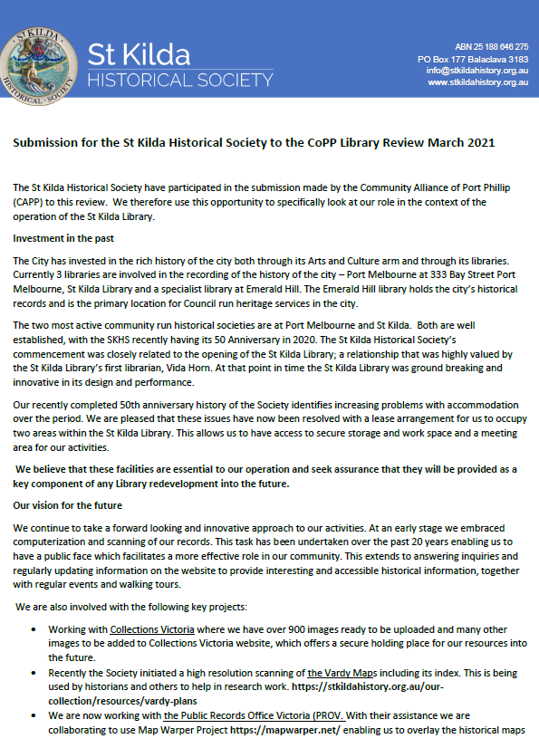
St Kilda Historical Society
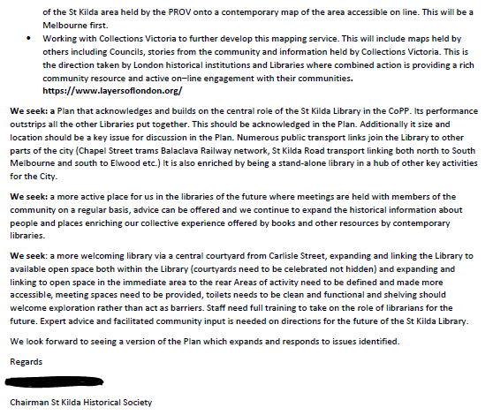

CAPP
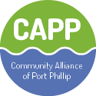
CITY OF PORT PHILLIP DRAFT LIBRARY ACTION PLAN MARCH 2021
RESPONSE FROM THE COMMUNITY ALLIANCE OF PORT PHILLIP (CAPP)
PO Box 1105, St Kilda South, VIC 3182
Email: info@capp.org.au
Website: www.capp.org.au

Introduction
In its Library Plan (“the Plan”) for the future, we would like to see Council making a clear statement about the primary focus for its libraries including recognition of the fact that libraries offer a universal service for all – both residents and workers and needs to:
- be delivered in an equitable way across the municipality,
- respond to population density and specific demographic groups,
- consider levels of accessibility regarding hours of operation/staffing levels and the quality and quantity of books on offer,
- consider the needs in the particular area of service delivery, and
- invest in inclusion.
The statement should recognize that the central and unique role of libraries is in providing access to literature and information and encouraging reading for its own worth and value. The focus must/should be on books, reading and literacy and how our many and varied communities can access and enjoy our libraries. The distinct value of reading – the engagement with the author – needs to be stated. It stimulates the imagination, broadens the mind, opens one to ideas, promotes compassion and empathy, and can take one into other worlds or reaffirm one’s own world and experiences.
Modern libraries also provide literature and information in a variety of forms including digital, audio, journals, newspapers, film and most centrally, books. Libraries offer meeting rooms for events and lectures as well as space for smaller group discussions, children’s story telling and book clubs.
Active engagement between staff, library users and the community is essential. New provisions in the Local Government Act specify a higher standard of engagement than was required in the past. Modern Libraries provide the place where this information sharing and engagement can take place – e.g., offering assistance with submissions, doing resumes and work-related activities, including information sessions on a range of issues including work opportunities in the area.
A greater focus on educational resources particularly the expansion of data bases is needed to foster an educated society.
Assessment of Current Libraries
The Plan needs to clearly establish whether Council’s five libraries are meeting community needs and expectations. The Plan needs to detail what each library currently provides including its performance and relevance to the population it serves. We need to know what each library does not do and why. Comparative information on Library performance over time is essential for a considered assessment of library need. We have sought this information from Council, and it is supplied in Attachment 1. But number of loans and visitors is only one part of the picture. Which demographic groups are being reached? What services do visitors use? Are visitors surveyed about their library expectations and needs?
The Plan also needs to identify more clearly what its libraries should/could provide. The Plan suggests a very broad role for Council’s libraries including creative industries, gaming, innovation, recording and rehearsal spaces, access to new technologies, access points in instances of climate extremes and support locations for lonely and disadvantaged members of the community in addition to its primary focus of providing books and information. If these ideas were to be embraced, then extensive redevelopment and expansion would be needed.
Each library needs to be assessed against its best use within its community, its current assets, its relationship to other services and its capacity to adapt to meet contemporary library expectations. This would enable priority setting in the Plan for the short term, medium term and long term and includes the following questions:
- How much is council prepared to invest in new and /or extended buildings?
- How much is council prepared to invest in the wide range of resources needed to deliver a wider range of services?
- How can Council build collaborative arrangements with adjoining councils to jointly deliver library services particularly in high growth areas?
- How does Council intend to link its libraries with the development of other service providers in each area?
A key thing to remember is that each library cannot be everything to everyone.
The Plan states that most people should be/are within walking distance of a library. This is not realistic, and it would be better to relate distance to libraries to transport options and aim for a ten-minute commute.
Demographic Analysis and Projections of Population Growth.
Key demographic information by area is readily available on CoPP ID Community and should be used in the Library analysis. https://atlas.id.com.au/port-phillip
This analysis clarifies key parameters requiring attention in service delivery considerations. It shows the area north of Fitzroy Street with very high incomes but pockets of acute disadvantage around the social and public housing areas, high numbers of children per household and high levels of home ownership. The area south of Fitzroy Street by contrast overall falls into the median income bracket with high proportional levels of younger people and low levels of home ownership. It is unfortunate that the demographic analysis in the report relies on generalities rather than specifics in considering where libraries are situated and what they should do for their communities.
The Plan gives some general information on future trends in population growth. However more detailed information and analysis is required and should be provided at the outset to guide where (and if) investment and growth is needed, what library models will be most likely to deliver for most citizens, and how individual groups (children, youth, older citizens, immigrant families, non-English speaking residents etc.) could be reached and engaged with the library services.
The Plan suggests but does not analyze two possible scenarios for City growth – low growth and high growth.
Low Growth Areas
Areas identified in the Plan as low growth have substantial differences in service options and accessibility. Using the Council’s current demographic information laid out against existing library services it is clear that some areas are better served than others, whilst some are not serviced at all.
Differences in service models between the previous Council areas of St Kilda, Port Melbourne and South Melbourne have also led to very different service outcomes – none of which offers a comprehensive and accessible library service aligned with best practice for all.
For residents of East St Kilda and Elwood access to their closest library – St Kilda Library – is difficult and transport options are limited. Whereas the Middle Park, Albert Park and Emerald Hill libraries are , neighbourhood in scale and character, but lack the economies of scale and capacity to expand of the two bigger libraries – St Kilda and Port Melbourne.
The three libraries in the South Melbourne area would need to be substantially upgraded to provide even some of the additional services that are anticipated in the Plan. However, there is also an opportunity for greater specialization at these libraries to meet the population profile of the area. The demographic analysis should provide guidance on this question.
St Kilda Library is a stand-alone library facility within a full range of other services within the St Kilda hub. Nearby it has multiple other buildings that could meet service gaps if required beyond the core library activities we describe earlier in this submission. It therefore seems inefficient and perhaps counter-productive for the library, as represented solely by the building, to be re-envisaged to meet a wide variety of social needs as described in the Plan.
The proposed redevelopment of the Library building is however welcome. By modern standards it lacks associated facilities such as meeting spaces, a coffee shop and the capacity to separate key activities. It also lacks/does not use the indoor-outdoor opportunities that are a feature of libraries of the future and has little connection with allied services such as the St Kilda Historical Society (SKHS) which is accommodated there. Linkages are important for widening contacts and developing new services and perspectives. Council should explore these opportunities.
There is a concern that long term social problems that the Library currently confronts can or should be addressed elsewhere. The library cannot be a substitute for accommodation and community support, but it can be a welcoming place for lonely people seeking social interaction with others if suitable facilities for rest and support are built into the redeveloped library. Suitably qualified staff are needed to manage this in the future. At the forefront of our consideration is the clear principle that libraries are public spaces, tolerant and open to all.
The redevelopment of St Kilda Library (and indeed all libraries) needs to include substantial upgrades to information systems and improvement to customer experience programs such as scanning facilities and user payment systems.
High Growth Areas
Fishermans Bend –
A more nuanced analysis of population growth in Fishermans Bend is needed. For example, five-, ten- and twenty-year projections would assist in developing short and medium term plans. The Port Melbourne Library would need to be expanded to deal with need in the short term but is in close proximity to Montague and possibly Sandridge. The City of Melbourne (COM) has 2 libraries in close proximity to parts of Fishermans Bend (The Docklands state of the art library, and the Southbank library in the Boyd Community Hub in City Road). These libraries provide some short-term solutions by collaborating with COM.
The Southbank Library and community hub offer a model for the Port Melbourne Library expansion of its functions over time.
Profiling of future or longer term need suggests the use of multipurpose hubs in Fishermans Bend itself. State Government and Council negotiations will be essential around funding, locations and extent of service delivery.

The Domain –
This is already a rapidly growing area that will be further accelerated with the opening up of the Domain Metro. An analysis is needed of what library services are currently used by these residents with local consultation about planning urgently required. The population density of this area may, in time, justify the development of a community hub including a large library within the South Melbourne area
We believe that there is a great need to recognize and reconcile the different service delivery models currently in use to gain an understanding of and respond to the needs of the future
How Can Our Libraries Reach Out?
The plan needs to specify how it will identify those most in need and develop a strategy to engage with those groups. Outreach services from all the libraries will be central to achieving this.
Library Workforce
CAPP strongly urges Council to invest in its library workforce. New buildings and expanded resourcing will only deliver to our expectations if the staffing capability is improved: qualified experienced professional librarians; professional community outreach workers; technical and digital professionals; teachers; community development workers are just some of the people that will be needed to achieve the goals identified in the Plan.
We support the plan’s identification of the skill mix required: ‘to include people with expertise in education, community engagement, social work and youth work, digital, program development, marketing, and program and partnership development.’
What consultation and input have been received from staff and their industrial representatives?
The outreach role of experienced staff will be particularly important to engage a wider participation in our libraries; to identify the needs of particular groups and how best they can access libraries. For example:
- Schools, kindergartens, childcare services
- Aged care service providers
- Immigrant service providers
- Youth and Sporting groups
- Community and public housing groups
- Arts organizations
The Plan’s Expectations for Libraries in 2026
This section of the report is unsatisfactory. Each library is described, and in some instances, their roles stated. But the report contains no analysis that explains how these decisions have been reached.

In one instance there is nothing to ‘expect’ e.g. “Albert Park Library is nestled in the heart of the local shopping strip – close to shops, cafes, restaurants and bars. Albert Park is a community hub for Albert Park and neighboring Middle Park residents.’ How does this reflect strategic considerations, identification of the potential role of that venue, and what it will do?
In another instance, the Port Melbourne Library is presented as being ‘focused on creativity and programs that are delivered across the whole Town Hall building’s venues – literature, music, art, design and new technologies – this is the place to connect, collaborate and create. Whilst this seems a valuable role for the plan it contains no discussion about why these roles are proposed nor why in that location.
This is a problem across the proposed roles of each library. In another example, Emerald Hill is proposed as a hub for children’s reading. Again this is an important and valuable role but there is no rationale provided to inform why that venue was chosen for this role. Further, the plan does not detail how a specialist service such as this will be available across the city. For example, how do the children of migrant families living in cramped accommodation in the St Kilda East apartment blocks access these services?
This demonstrates the need for the Plan to ensure that the services and roles of specific libraries are known and accessible to residents across the city.
CAPP’s Vision for Libraries in 2026
CAPP envisages that the Libraries of the future will understand their communities and respond to their needs bearing in mind our stated and prime purpose for Libraries as centres for the exploration of our inner and outer worlds.
Looking at Library excellence, there are some great libraries to look at. Stand-alone libraries such as Docklands are nearby and are state of the art. The Boyd Community Centre and Southbank Library offer another model combining a library and community facilities. Dandenong Council offers another model for its service delivery with seamless service delivery and great interaction with its community as its key focus. Each of these should be analyzed against the opportunities we should be seeking for our community. Depending on overall analysis and ensuring equitable delivery of services is key and is an important building block for a more cohesive community.

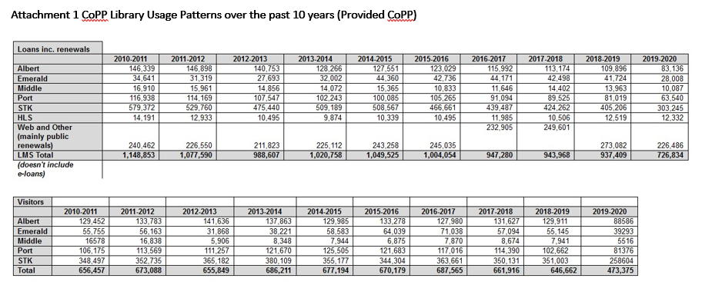
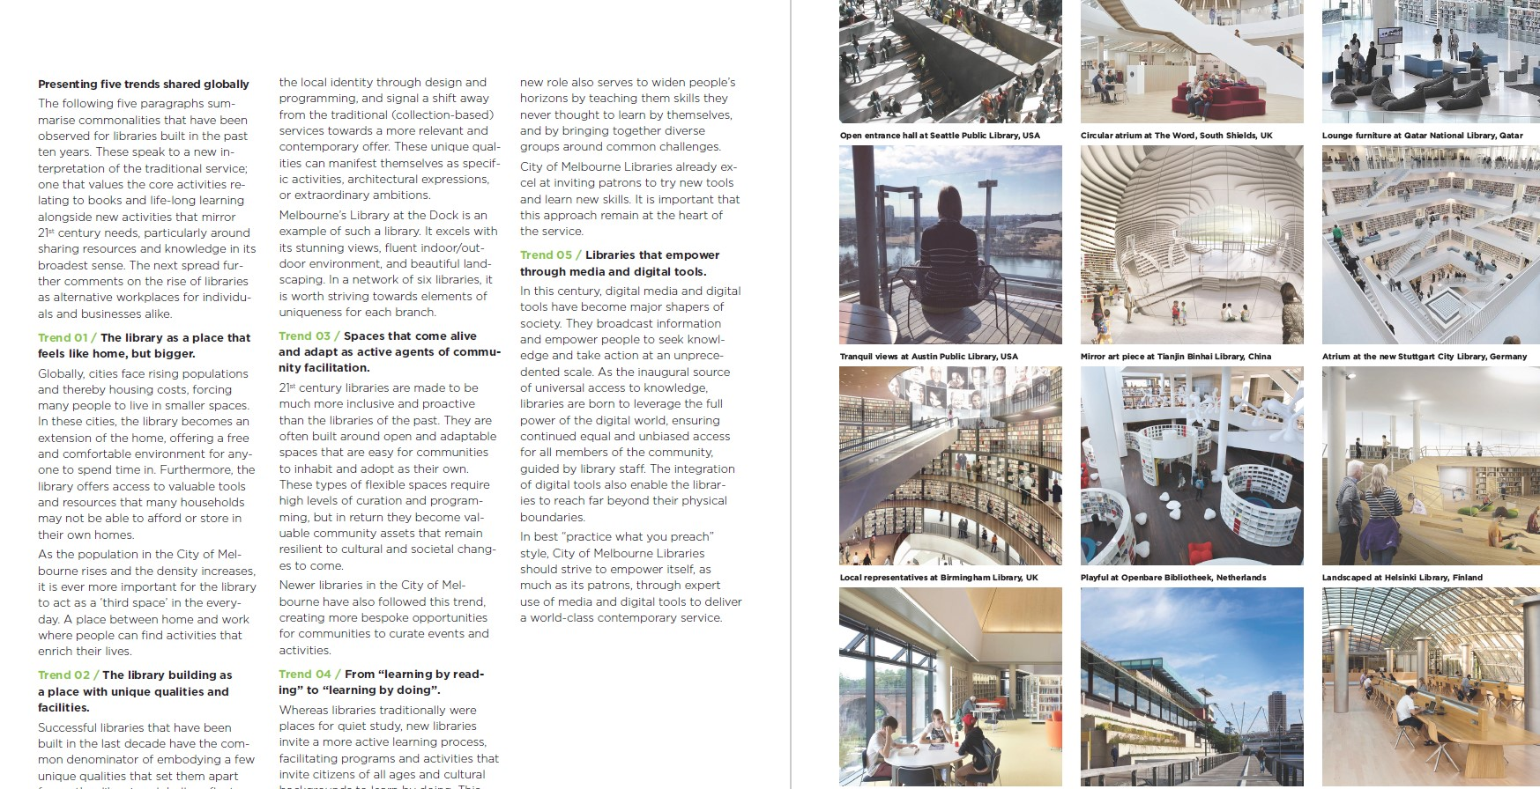

COMMUNITY MEMBER
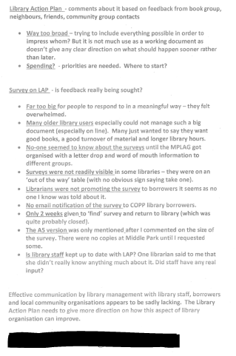

See An Ode to The Public Library, the Gateway to an Educated Society Geoff Gallop 5.8.2019 https://www.themandarin.com.au/113122-an-ode-to-the-public-library-the-gateway-to-an-educated-society/

