Domestic Animal Management Plan
Engagement summary report – phase 1
July 2021
Contents

Executive summary 3
Developing a Domestic Animal Management Plan 3
Engagement Approach 3
Engagement findings 4
Introduction 7
Purpose of the report 7
Purpose of engagement 7
Communications 7
Limitations 7
How we engaged 8
Who we engaged 8
Engagement findings 10
Who we heard from 10
Summary of key results 14
Survey results 18
Desexing pets 19
Registering pets 21
Dogs in apartments 22
Suggestions for supporting cat/dogs owners 23
Issues related to dogs 26
Reporting incidents to Council 28
Dog waste collection and disposal 30
Balancing use of public space for all 34
Issues related to cats 38
Council services for better animal management 40
Signage 43
Contact with Council 45
Improving animal management services 47
Neighbourhood Conversations 49
Appendices 51
Appendix A: Survey questions 51
Appendix B: Breakdown of responses from Neighbourhood Conversation sessions 58

Executive summary

Developing a Domestic Animal Management Plan

Under the Domestic Animals Act 1994, every Victorian local government must prepare a Domestic Animal Management Plan (DAMP) outlining how it will manage dogs and cats within its municipal boundaries. This Plan is renewed every four years.

The City of Port Phillip’s Domestic Animal Management Plan provides Council with a strategic approach towards promotion of responsible pet ownership, the welfare of dogs and cats in the community and the protection of the community and the environment from nuisance dogs and cats. The plan also outlines how Council will enforce all legislative requirements and compliance with our local laws.

Engagement Approach

The engagement approach includes two rounds of community engagement: consultation to inform development of the draft plan (May 2021); and consultation gather feedback on the draft plan (scheduled for August 2021).
As part of the first round of engagement to inform the draft plan we wanted to understand from our community what they perceive as the most prevalent animal issues and what aspects of animal management are working well, as well as what could be improved.
This engagement ran from 30 April to 30 May 2021. A total of 1,717 community members were engaged primarily via an online survey, as well as hardcopy surveys, face-to-face pop ups, and email responses.
There were 1,624 survey responses received, with the majority of respondents being Port Phillip residents (1424; 87.8%) and /or being pet owners (1421; 87.7%).
Eighty-nine people also participated in an engagement activity at our Neighbourhood Conversation sessions, where we asked people to indicate how frequently they had noticed a range of issues relating to cats and dogs in Port Phillip.
As part of the Neighbourhood Conversation sessions, officers also promoted the consultation throughout our local activity centres, encouraging people to participate in the consultation online.
The engagement was promoted via Council’s communications channels, including Divercity Online, social media and e-newsletters. Corflute signage advertising the consultation was displayed in areas such as parks and local activity centres throughout the municipality. Emails were also distributed to all registered per owners as well as a range of key stakeholders within animal organisations, inviting them to provide feedback.

Engagement findings
In April and May 2021, the City of Port Phillip undertook a consultation with the local community to inform development of its new Domestic Animal Management Plan. A total of 1,717 community members were engaged primarily via an online survey, as well as hardcopy surveys, face-to-face pop ups, and email responses.
A total of 1618 valid survey responses were received through Council’s Have Your Say online platform. This represents a statistically significant sample of the population with a standard error of +/- 2.5% with a confidence interval of 95% (based on an approximate City of Port Phillip population of 113,200, with a minimum of 597 responses required, assuming random sampling).
The results of the consultation process were analysed, with key themes identified as they emerged from the responses. The consultation revealed a community passionate about their pets, with lots to say about how the City of Port Phillip could best support both pet and non-pet owners.
Some key findings of the engagement were:
- High engagement in the survey from pet-owners demonstrates a high level of interest in animal management and commitment to responsible pet ownership in the City of Port Phillip.
- Many community members are satisfied with Council animal management services, in particular the friendly and responsive communication with Council about animal related issues was noted.
- The need for increased compliance with and enforcement of leash rules, off-leash areas and dog prohibited areas.
- Concerns around the high cost pet registration fees, and a lack of transparency around how the fee is used to serve the needs of pets and pet owners.
- The need for new solutions to address the problem of dog waste which is not disposed of properly.
- The need for more off-leash areas, including more fenced and enclosed areas, particularly in light of the increase in dog ownership which has occurred since the start of the COVID-19 pandemic.
- Increased awareness of the process and ease with which incidents involving pets (e.g dog attack) can be reported.
- Consideration of public education and awareness campaigns to increase the level of compliance with local laws regarding pets, including encouraging the community to call-out fellow community members if they see the wrong thing happening.

Satisfaction with current Council services
Respondents indicated a high level of satisfaction with many of the Council services related to pet ownership and animal management examined in this engagement. More than two thirds of those who had contacted Council with an animal-related query were satisfied with the service, with the friendly and helpful staff and quick response and resolution noted. Additionally, when asked for suggestions as to how Council could improve its services related to animal management, around a quarter of respondents indicated they were happy with current services and had no further suggestions (the second most frequent response).
Greater enforcement of current rules and regulations
Across all responses there was a desire for more enforcement of rules and regulations. Many respondents thought that existing rules were satisfactory but a lack of enforcement by Council was the reason for low compliance, creating issues for both pet owners and non-pet owners. A suggestion was made relating to exploring opportunities for greater community self-enforcement, including an awareness campaign based around calling out other members of the community if they see something wrong.
Value for money from registration fees
Many respondents expressed their concerns with the high cost of Port Phillip’s pet registration fees, particularly as there is a perceived lack of value for money received from them. Respondents wanted more transparency around how registration fees are used and would like to see this revenue spent specifically on pet-related services and support. The provision of dog waste bags in public spaces and more regular emptying of dog waste bins were suggested as services that should be covered by current registration fees.
Dog waste
Dog waste that is not cleaned up by the owner was identified as a frequent issue (noticed ‘always’ or ‘often’) by 39% of respondents, with 37 specific sites identified where dog waste is regularly sighted. A range of suggestions were offered as to for how the problem might be reduced, including increased provision of dog waste bags/bins, public awareness campaigns, and greater enforcement by Council staff.
Fenced and enclosed off-leash areas
A common suggestion or request from respondents was more fully fenced off-leash areas. Interestingly, this was suggested by those who wanted more off-leash areas, but also those who would like to see greater compliance for leash-rules and those who would like more-dog prohibited areas. Responses indicated creating a proper separation between off-leash dogs, and dogs on-leash and other public open space users would help all users use spaces more safely. In addition, there is a preference among some dog owners for separate fenced areas for small dogs and large dogs.
Off-leash areas and compliance
One of the most common themes across all responses was a desire for increased off-leash areas for dogs. It was pointed out that while the number of dogs in the Port Phillip has increased since COVID-19, the number of off-leash areas has not increased in response. While many respondents stated there was low compliance of on-leash rules in on-leash areas, some thought that access to more off-leash areas would result in greater compliance in on-leash areas.

Reporting incidents to Council
More than one in three respondents (34.6%) had witnessed or experienced a dog-related incident which were reportable to Council. Of those who witnessed or experienced an incident, only two-thirds of respondents actually reported it to Council. Those who did not report the incident cited a range of reasons including inability to identify the dog and/or owner; lack of awareness of the reporting process; a perception that Council would be unable or unwilling to act on the information; and, owner intimidation or concern about any repercussions from making a reporting.
Education and awareness initiatives
Along with enforcement, there was a strong interest across most responses in greater education and awareness initiatives. In particular, education and awareness of current rules and restrictions and good pet ownership were mentioned. It was suggested this could increase compliance with rules and restrictions, as well as reduce the issue of pet nuisances such as barking.
Differing views of pet owners compared to non-pet owners
When asked about whether current restrictions relating to dogs provide good balance for all public open space users, 41.2% of pet-owners thought they did provide balance, compared to 33.6% of non-pet owners. Pet owners and non-pet owners who did not think current restrictions provided a balance tended to have different reasons for this; in general, pet-owners because they would like to see more off leash areas (42.0%), while non-pet owners because they would like to see more dog prohibited areas (30.1%). Pet owners are also much more supportive of Council providing dog waste bags, than non-pet owners, however, are only marginally more willing to pay.

Introduction

Purpose of the report
The purpose of this report is to provide a summary of community engagement to inform the draft Animal Management Plan. It details the engagement techniques used and presents the findings from this engagement program.

Purpose of engagement
The purpose of this engagement program was to inform the community of the development of the draft Animal Management Plan and to provide feedback to inform the draft plan.

Communications
We communicated with our community about this engagement using a range of online and offline channels. Emails with information about the consultation were distributed to all registered pet owners, and through Divercity Online and Have Your Say newsletters.

A project page was published on Have Your Say with information about the process, FAQs and the online survey.

Information about the consultation process and opportunities to be involved were promoted via Council’s social media channels (Facebook, Twitter, Instagram).
To promote the consultation to a wider audience, a social media advertisement was created on Facebook and Instagram, targeting the Port Phillip area.

Corflute signage with QR codes advertising the engagement were displayed throughout the municipality in trader precincts, reserves and along the foreshore.

Posters advertising a series of neighbourhood-based pop-up sessions were also distributed and displayed at Council-managed facilities, and in shop fronts at local activity centres where possible. Signage on site was also displayed a few days in advance of a pop-up to further promote these neighbourhood-based sessions. As part of our Neighbourhood Conversation sessions Council Officers also visited key activity centres to promote the engagement and encourage people to fill out the survey online.

Limitations
- Consultative engagement provides only a high-level snapshot of community sentiment and does not reflect any deeper deliberation of issues and challenges.
- Contributions to this engagement program do not necessarily constitute a wholly representative snapshot of our community as people self-selected to participate.
- Non-pet owners accounted for only 12.3% of respondents, therefore findings may not provide a balanced perspective on the competing needs of pet owners and non-pet owners.
Engagement approach

How we engaged
This section details the community engagement approach in developing the draft Domestic Animal Management Plan.
A total of 1,717 community members were engaged primarily via an online survey, as well as hardcopy surveys, face-to-face pop ups, and email responses.
The engagement program was hosted on Council’s Have Your Say online engagement portal and feedback was channelled primarily through a survey seeking feedback on a range on animal related topics and issues, and suggestions for improvement.

Feedback was also captured through a series of neighbourhood-based pop-up sessions throughout May, where the community were asked to indicate to indicate how frequently they had noticed the following cat and dog related issues in Port Phillip.
Engagement activity | Responses
Online Have Your Say survey responses | 1618
Hardcopy survey responses | 6
Face-to-face pop-up engagement responses | 89
Email responses | 4

The online and hardcopy surveys were identical and were analysed and presented together. Due to the low number of email responses, results are presented alongside themes emerging from the survey, where appropriate.

Who we engaged
A series of demographic questions were asked as part of the survey.
A high proportion of respondents (87.7%) identified as being pet owners - indicating a high level of interest and engagement in relation to responsible pet ownership. While respondents’ gender profile and suburb of residency is not representative of the wider Port Phillip population, the high proportion of pet owners among respondents provides useful insights for policy development.
Survey respondents were also predominantly female (72.9%) and overwhelmingly pet owners (87.7%). The high proportion of female respondents reflects the Australian average of 82.5% of pet owners being female (PetPlan Australian Pet Census, 2016). The high level of respondents who are pet owners suggests a commitment to responsible pet ownership and a high level of interest in the outcomes of the Domestic Animal Management Plan.

The following provides a brief snapshot of who we engaged through the survey.
- The majority of respondents identified as residents (1424; 87.8%) and/or dog/cat owners (1421; 87.7%)
- Over 70% of respondents were female (1183; 72.9%).
- Over one third of respondents were aged between 35 to 49 years old (38.98%).
- The most common suburbs that respondents resided in were Port Melbourne (427, 26.31%), followed by Elwood (299; 18.42%) and then St Kilda (292; 17.99%).

Engagement findings

Who we heard from

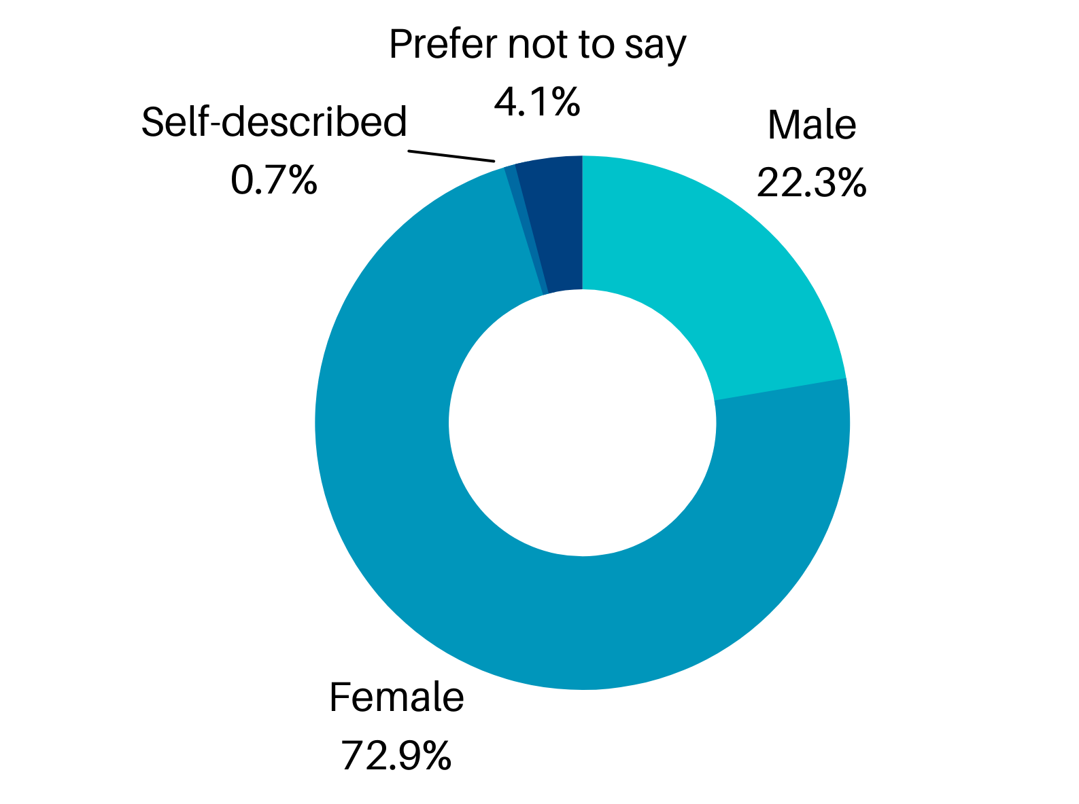
Gender identification
Gender identification | Proportion of respondents (1624)
Male | 22.3%
Female | 72.9%
Self-described | 0.7%
Prefer not to say | 4.1%

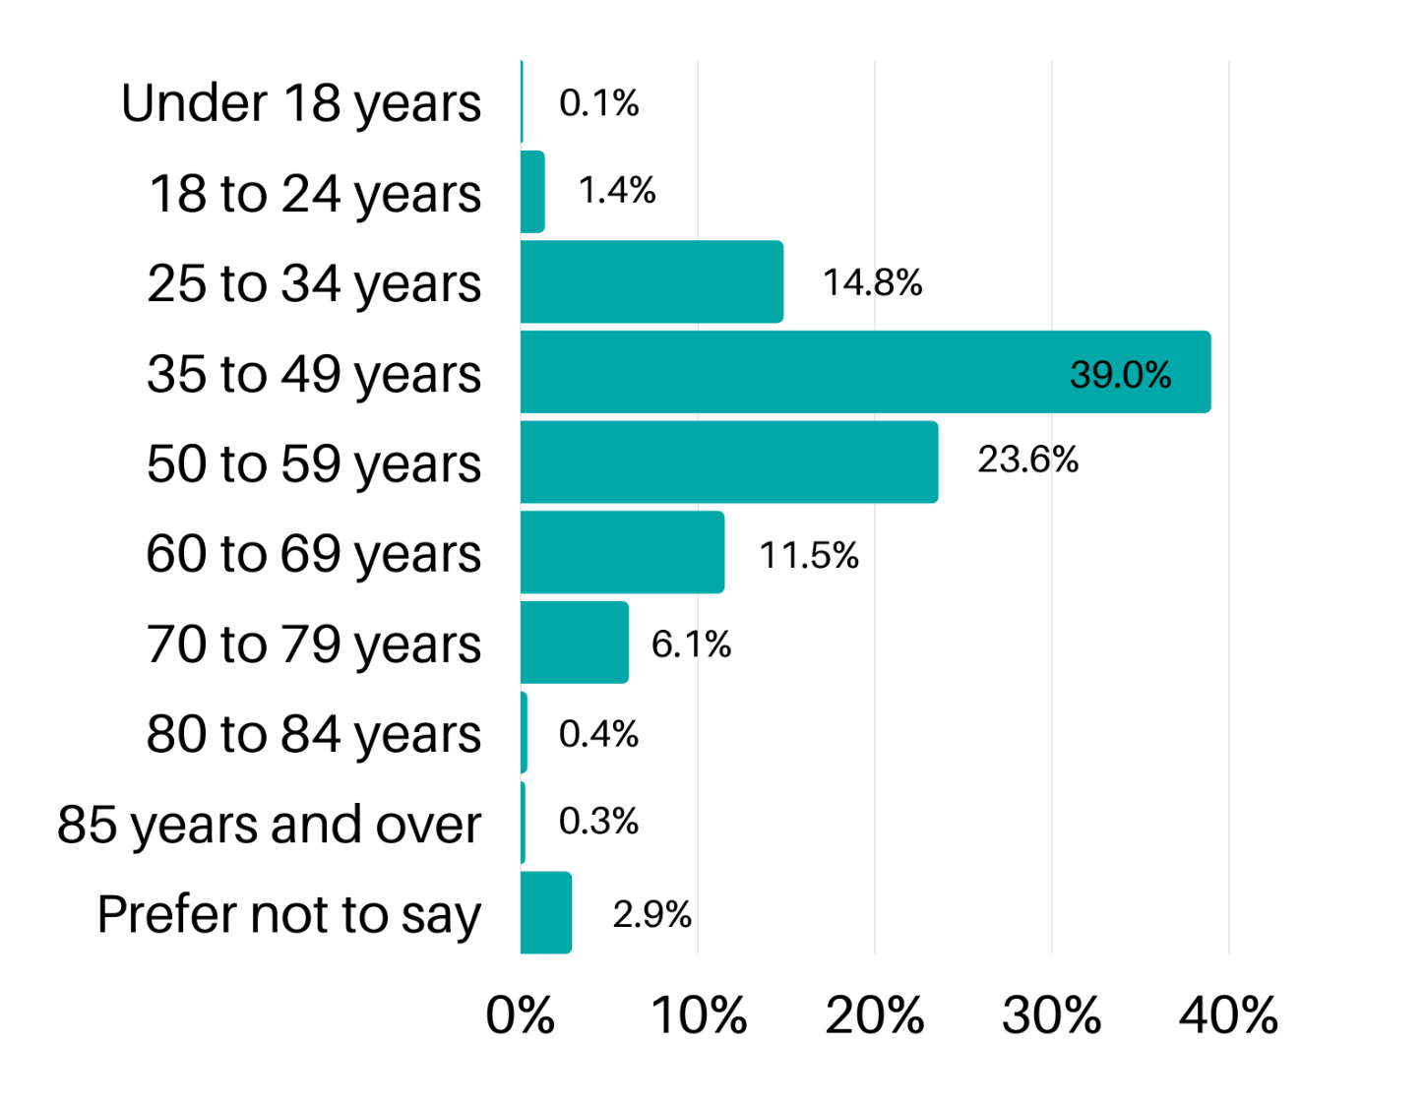
Age-group

Age group | Proportion of respondents (1624) | Proportion of demographic in City of Port Phillip population*
Under 18 years | 0.1% | 13%
18 to 24 years | 1.4% | 8%
25 to 34 years | 14.8% | 26%
35 to 49 years | 39.0% | 25%
50 to 59 years | 23.6% | 12%
60 to 69 years | 11.5% | 9%
70 to 79 years | 6.1% | 6%
80 to 84 years | 0.4%
85 years and over | 0.2% | 1%
Prefer not to say | 2.9% | -
*Australian Bureau of Statistics, Census of Population and Housing 2016

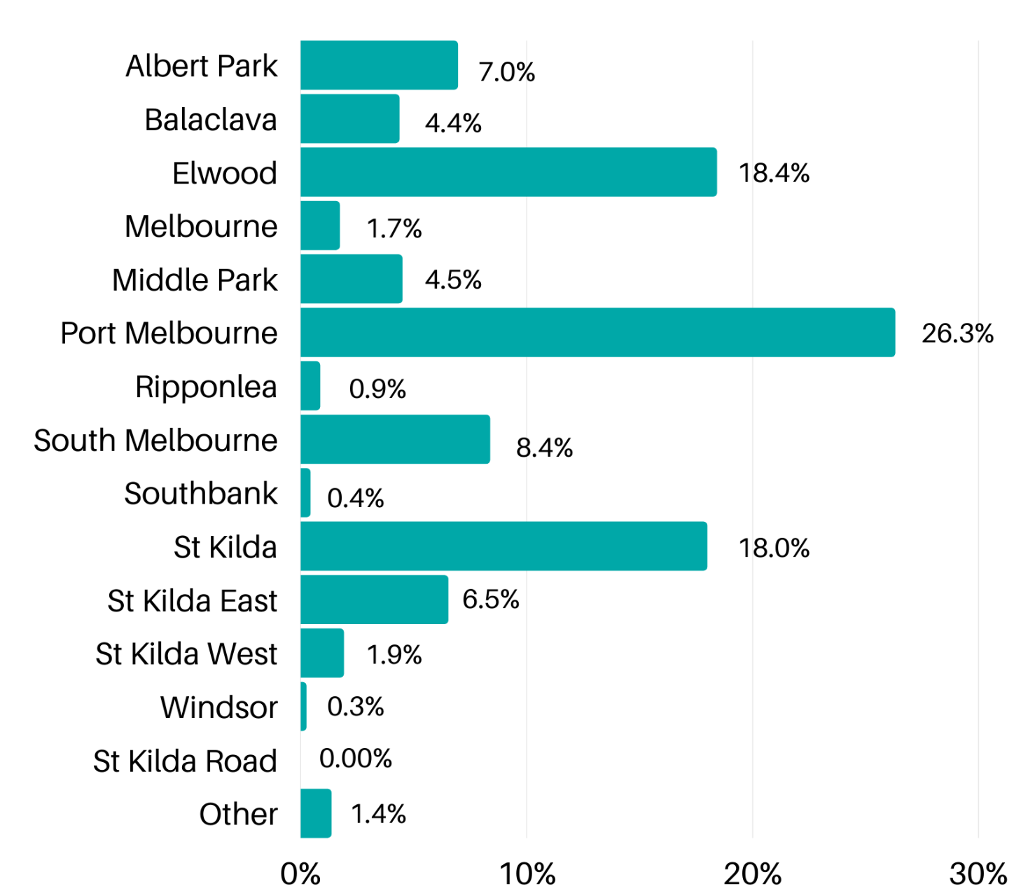
Residential suburb
Suburb | Proportion of respondents (1624) | Suburb proportion of City of Port Phillip population*
Albert Park | 7.0% | 6.4%
Balaclava | 4.4% | 5.2%
Elwood | 18.4% | 14.6%
Melbourne | 1.7% | N/A
Middle Park | 4.5% | 4.0%
Port Melbourne | 26.3% | 15.8%
Ripponlea | 0.9% | 1.5%
South Melbourne | 8.4% | 11.1%
Southbank | 0.4% | N/A
St Kilda | 18.0% | 20.7%
St Kilda East | 6.5% | 8.8%
St Kilda West | 1.9% | 3.2%
Windsor | 0.2% | N/A
St Kilda Road | 0.0% | 8.5%
Other | 1.4% | N/A
*Australian Bureau of Statistics, 2020 Estimated Resident Population.

How survey respondents heard about the consultation

Communication channel | Proportion of respondents (1624)
Have Your Say e-newsletter | 26.5%
Other Council email / e-newsletter | 26.6%
Divercity Online | 3.4%
Poster / display at a Council facility | 1.1%
Poster at local shop / cafe | 0.8%
Council's social media channels | 11.7%
Council staff at a pop-up session | 2.0%
Signage | 1.6%
Word of mouth | 12.4%
Other | 13.8%

Responses in ‘Other’ include: Facebook and social media (10.5% of responses), in particular community Facebook groups (6.8% of responses) such as Elwood 3184, Port Phillip Pooches, Residents in St Kilda, and Port Melbourne Focus; email, Councillors or Council staff, farmers market, public posters, Linking Neighbours.

Summary of key results
Each question is presented with the total number of responses received. Results for questions are presented as a proportion of responses (percent) to allow for comparability across questions.
We asked | You said
Relationship with domestic animals in the City of Port Phillip (1621 responses) | - 87.7% are a dog/cat owner  - 87.8% are a resident in Port Phillip
Desexed status of pets (1234 responses) | - 76.6% have dogs that are desexed  - 4.0% have dogs that are not desexed  - 28.2% have cats that are desexed  - 0.2% have cats that are not desexed
Reasons for not desexing (51 responses) | Top reasons for not desexing:  - 58.8% said their pet is too young or that their vet recommends not to desex  - 13.7% are planning to breed their pet  - 11.8% prefer not to desex their pets  - 11.8% have other reasons for not desexing such as pet on a breeding contract, or pet health issues
Registration status of pets (1233 responses) | - 78.8% of respondents have dogs registered with Port Phillip Council.  - 25.7% of respondents have cats registered with Port Phillip Council.  - 2.0% of respondents have pets that aren’t registered.
Reason for non-registration (32 responses) | Top reasons for not registering:  - 28.1% deem it unnecessary as the pet is too young, or lives inside only  - 25% think the cost of registration is too high, and/or value of registration is low  - 18.7% do not register as a matter of opinion
Living in an apartment with a dog (1232 responses) | - 36.3% live in an apartment with their dog  - 47.2% live in a non-apartment dwelling with their dog
Better supporting dog/cat owners - suggestions (1012 responses) | Top suggestions:  - 11.1% wanted Council to provide dog waste bags and dispensers  - 10.9% would like to see greater enforcement of rules and regulations  - 9.9% would like to see enclosed and fenced off dog parks and off-leash areas
Issues related to dogs | Most frequent issues:  - 15.3% ‘always’ notice uncollected dog waste, and 31% ‘often’ notice it (1620 responses)  - 11.8% ‘always’ notice dogs off leash where they shouldn’t be, and 20.9% ‘often notice it (1622 responses)  - 8.9% ‘always’ notice owners not watching their dogs in off-leash areas, and 20.3% ‘often’ notice it (1622 responses)
Reporting incidents with a dog (1620 responses) | - 65.4% haven’t had a reason to report an incident with a dog  - 23.6% had experienced an incident but did not report it  - 11% had experienced an incident and reported
Reasons for not reporting (367 responses) | Top comments:  - 23.4% couldn’t identify the owner or dog to report  - 20.3% believed nothing would be done by Council as a result of reporting  - 15.3% did not know how to report or were not aware they should report
Improving dog waste collection and disposal - suggestions (1520 responses) | Top suggestions:  - 58% suggested Council should provide dog waste bags and dispensers  - 33.7% suggested Council should provide more bins and empty bins more regularly  - Greater enforcement by patrols (11.8%) and fines (19.4%) was suggested
Particular locations of uncollected dog waste (1231 responses) | Top general locations:  - local streets - 30.4%  - parks and gardens - 15.1%  - everywhere - 14.2%  Top specific locations:  - Albert Park Reserve, Albert Park - 5.1%  - Alma Park, St Kilda East - 4.1%  - Gasworks Arts Park, Albert Park - 4.0%
Balancing public space use - dog restrictions (1619 responses) | - 42.9% think current restrictions on dogs provide a good balance for all public space users  - 40.6% do not think restrictions provide a good balance, as they would like more dog off-leash areas.  Cross tabulation of data shows that 41.2% of dog/cat owners think current restrictions provide balance, while only 33.7% of non-dog/cat owners think so.  Respondents were given an opportunity to explain their answer (747 responses). Top comments:  - 22.5% think there are too few off-leash areas, and would like more  - 21.8% would like less restricted beach access for dogs  - 19.1% would like to see more fenced dog areas
Issues related to cats | Most frequent issue was that 8.2% ‘always’ notice trespassing or wandering cats, and 11.3% ‘often’ notice it (1621 responses).  Other issues infrequently noticed.
Initiatives to manage nuisance cats | 70.1% support a night time cat curfew (1621 responses)  79.7% support mandatory cat desexing (1621 responses)  80.3% support discounted cat desexing (1619 responses)
Council services - dog waste bags (1620 responses) | 78.4% strongly support Council providing dog waste bags in parks and beaches.  Cross-tabulation shows 81.31% of dog/cat-owners strongly support dog waste bag provision, while only 57.9% of non-dog/cat-owners do.
Dog waste bags - willingness to pay (1595 responses) | 41.8% were willing to consider paying extra for Council to provide dog waste bags, 58.2% were not  Cross-tabulation shows 42.8% of dog/cat owners were willing to pay for dog waste bags, while only 33.9% of non-dog/cat owners were.
Signage - on and off-leash areas (1618 responses) | 62.2% thought current signage clearly displayed on and off leash areas.  Respondents who did not were invited to give suggestions to improve it (576 responses). Top suggestions:  - 16.8% thought signage could be made easier to understand  - 14.6% thought signage design could be improved, including colour and size  - 9.8% thought there could be more signage
Contact with Council - animal management query (1624 responses) | - 32% had contacted Council with an animal related query  - 68% had not contacted Council
Contact with Council - satisfaction with experience (526 responses) | Those who had contacted Council were asked to rate their experience.  67.7% were satisfied with the service provided.  Respondents were asked to elaborate (440 responses). Top comments:  - Council staff were friendly and helpful (27.5%)  - Not helpful in answering query (23.0%)  - Quick response and/or resolution (20.2%)
Improving animal management services - suggestions (820 responses) | Top suggestions:  - Greater enforcement through increased patrolling by Council staff (25.1%)  - No further suggestion, happy with current services (23.4%)  - Greater enforcement by increased fines (7%)

Survey results

Relationship with domestic animals in the City of Port Phillip
Survey respondents were asked about their association with animals and the City of Port Phillip, to gain a perspective of the different groups interested in the City’s Domestic Animal Management Plan.
Survey respondents were asked to select all categories that applied to them: (1621 responses)
Relationship with domestic animals | Proportion of respondents (1621)
Dog/cat owner | 87.7%
Resident in Port Phillip | 87.8%
Visitor to Port Phillip | 1.8%
Employee in the animal care industry | 2.2%
Member of animal advocacy/rescue group | 3.1%
Member of a wildlife/environmental group | 2.8%
Other | 1.4%

Those who selected ‘Other’ included: Dog-related business worker: walker, groomer, trainer, carer; Other animal owner or non animal owner; Ratepayer; CoPP Business owner or worker; Member of clubs in CoPP; Occasional dog owner.
Respondents were also asked which group/organisation do you belong to? (74 responses)
Top comments:
Most frequent responses were pet rescue organisations (47.3% of responses) including the RSPCA (14.9% of responses), Lort Smith Animal Hospital (5.4 % of responses), Lost Dogs Home (4.1% of responses), Victorian Dog Rescue Group (4.1% of responses ) and greyhound rescue organisations (4.1% of responses).
Next frequent were wildlife rescue organisations (23.0% of responses), including Wildlife Victoria (5.4% off responses), World Wildlife Fund (4.1% of responses), and bird rescue organisations (4.1% of responses); followed by environmental groups (18.9% of responses) including local environmental groups such as Elsternwick Park Association and Landcare, and general environmental organisations. Other types of organisations represented were animal justice organisations, conservation organisations, political organisations, and animal charities.

Desexing pets

Survey respondents were asked about whether their pets were desexed. (1234 responses)

Responses in ‘Other’ included: Too young to be desexed, other pets desexed, non-pet owner.
Pet desex status | Proportion of respondents (1234)
My dog(s) are desexed | 76.6%
My dog(s) are not desexed | 4.0%
My cat(s) are desexed | 28.2%
My cat(s) are not desexed | 0.2%
Some of my dogs are desexed | 1.5%
Some of my cats are desexed | 0.2%
Other | 1.0%

Respondents were asked for their reason for not desexing. (51 responses)
Responses in ‘Other’ included: Pet on breeding contract or license, pet health issues.

Reason for not desexing | Proportion of respondents (51)
My dog(s)/cat(s) are too young to be desexed / veterinary recommendation | 58.8%
I prefer not to desex my dog(s)/cat(s) | 11.8%
I can't afford the procedure | 3.9%
I plan to breed my dog(s)/cat(s) | 13.7%
Other | 11.8%

Registering pets

Survey respondents were asked about the registration status of their pets. (1233 responses)
Responses in ‘Other’ included: Pet registered elsewhere, not currently pet owner.
Pet registration status | Proportion of respondents (1233)
Yes, my dog(s) are registered with Port Phillip Council. | 78.8%
Yes, my cat(s) are registered with Port Phillip Council. | 25.7%
Some of my pets are registered. | 0.6%
None of my pets are registered. | 2.0%
I'm not sure if my pets are registered. | 1.0%
Other | 0.7%

Responses in ‘Other’ included: Pet registered elsewhere, not currently pet owner.
Respondents who indicated their pets were not registered were asked for the reason for not registering them. (32 responses)
Top comments:
Unnecessary: too young, inside pet | The most common reason for non-registering pets was that it was deemed to be unnecessary by the owner, due to the pet being too young, or being an inside cat only (28.1%).
Cost / value | The second most common reason for not registering pets was stated to be the perceived high cost of registration in the City of Port Phillip, and the perceived lack of value received from registration (25%). Lack of dog waste bags provided was highlighted as a particular service they would like to see provided as part of registration fees.  “Port Phillip charges significantly more for registration than many other councils, and it's hard to see what pet owners get in return for the high cost.”
Opinion / ideological | A number of respondents stated they did not register their pet as they did not believe it was necessary as a general rule (18.7%).
Registered elsewhere / recently moved | A few respondents had registered their pets elsewhere and, having recently moved or other reasons, had not registered their pet in the City of Port Phillip (15.6%)
Forgot / didn’t know | Some respondents stated they weren’t aware they had to register their pet, or simply forgot (12.5%).

Dogs in apartments

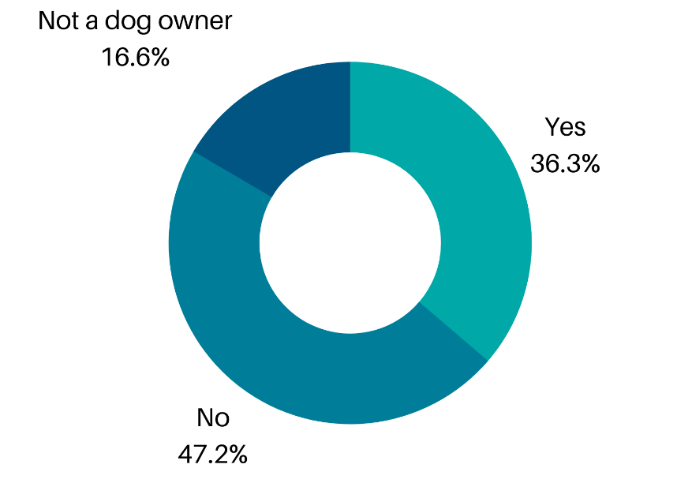
Respondents were asked whether they lived in an apartment with their dog.
(1232 responses)
Dog owners living in apartments | Proportion of respondents (1232) | Number of respondents
Yes | 36.3% | 447
No | 47.2% | 581
Not a dog owner | 16.6% | 204

Suggestions for supporting cat/dogs owners

Respondents were asked for suggestions for how Council could better support dog / cat owners. (1012 responses)
Top suggestions:
Provide dog waste bags / waste bag dispensers | Respondents most frequently stated that Council could better support pet owners by providing dog waste bags and dispensers in parks and on beaches (11.1 %). Some community members who provided feedback via email also supported this.  “Visiting other shared off-leash and recreational areas, the parks that offer free dog bag dispensers and more bins are much cleaner.”  “provide dog bags you are the only council that doesn’t”
Enforcement - general | Many respondents would like to see rules and regulations enforced, through a visible presence from rangers and more patrols from animal management staff (10.9%). Some respondents (3.5%) would like to see more fines issued to pet owners who do not follow the rules.  “More presence in the dog parks at the peak times. In 12 years, I have only encountered a ranger once and it was at a time when the dog beach was almost empty. If (friendly) rangers cruised through a couple of times per week, stopped for a short chat and 'got to know' each dog park, then the bad apples would feel more pressured to address their lack of control”  “Responsible pet owners get pets and know that they have to adhere to local laws for the sake of the community. Irresponsible pet owners get pets and allow their pets to affect the community in a negative way (not picking up their waste, walking them unrestrained) which impacts those responsible pet owners. Which in my opinion is unfair and needs to be stopped.”
Enclosed / fenced dog parks | Some respondents (9.9%) stated they would like Council to provide fenced dog parks and off-leash areas, to allow for greater safety of dogs and the public. This was also stated as needed to create separation between on-leash and off-leash areas to suit the needs of both users.  “Provide at least one fully fenced closed park for dogs per suburb to be off leash for their safety and tranquility of owners as many dogs are getting run over and car circulation keeps increasing. It also provides those who don’t like dogs to go close and know they are contained”  “Airlock/double gated off leash dog parks. These allow members of the community who don’t want to mingle with dogs a space for dog owners to take their pets away from public spaces. Also allows dog owners to meet each other and form tighter community bonds. Also allows a safe space for dogs”
Registration - cost and value | A number of respondents (5.9%) thought that the cost of registration in the City of Port Phillip was too high, and expressed they did not see the value obtained from it. Some respondents highlighted they would like more transparency around how registration fees are used.  There were a number of suggested changes to registration costs and processes, including:  - registrations longer than annual  - discounted registration for: pensioners, greyhounds who aren’t allowed off lead, puppies who are not yet desexed, and inside cats  - lower/ higher fees for multiple animal owners  - financial incentives to pay on time.  “The cost of registration for my dog is $210 per year. Other than signage I am not sure what value I get from this fee. Speaking to other owners many do not register their animals for the same reason. I would like to see greater transparency around the $ collected and the $ spent on animal management.”
More off-leash areas | Some respondents (8.8%) would like to see an increased number of off-leash dog areas. A suggestion was also made by a number of respondents to create additional separate off-leash areas for small and larger dogs, to increase safety.
Education / awareness initiatives (good pet ownership) | Education and awareness initiatives to encourage responsible pet ownership (8.2%) and more generally (3.5%) were suggested as a way for Council to better support pet owners.
More pet-friendly infrastructure | Respondents would like to see more pet friendly infrastructure around the City, such as water bowls and safe places to tie up dogs outside shops (4.9%). Some respondents would also like to see greater support for local businesses, cafes and restaurants to be pet-friendly.
Mandatory desexing or incentives to desex | Desexing promoted through incentives and discounts was also mentioned by some respondents (5%) Some respondents also supported mandatory desexing of pets.
Restricting cat movement | Some respondents (3.9%) would like to see a night-time cat curfew enforced, while other respondents would like to see cat movement restricted at all times (4.1%).
Information | A number of respondents would like more information provided from Council about current laws (1.9%), about on-leash and off-leash areas (2.1%), and in general more information provided (1.1%).  “It might be helpful if owners received an information packet when registering their pets (or renewing registration) that included local vets, emergency after hours care providers, pet friendly locations, etc.”

Other suggestions included:
- Increased lighting at dog parks for improved safety, and visibility of dog waste (3.0%)
- Improved reporting processes for nuisance dogs and their owners (1.6%)
- Providing better quality registration tags, for example metal ones (1.1%). This was also suggested in a response received via email.
- Providing or assisting with access to services for low-income pet owners (1.0%)
- Higher levels of maintenance of dog parks, particularly of grassed areas (1.0%)
- More surveys and consultation around animal issues and management (0.6%)

Issues related to dogs
Survey respondents were asked for frequency with which they had noticed various issues related to dogs: ‘always’, ‘often’, ‘sometimes’, ‘rarely’ and ‘never’. Those who indicated ‘always’ or ‘often’ are reported below as noticing issues frequently.

46.3% frequently noticed uncollected dog waste

32.7% frequently noticed dogs off leash where they shouldn’t be

29.2% frequently noticed dog owners not watching their dogs in off-leash areas

11.5% frequently noticed dogs bothering, worrying or interfering with other people

13.4% frequently noticed dogs bothering, worrying or interfering with other dogs

18.0% frequently noticed dogs not returning to their owners when called / not responding to commands

6.8% frequently noticed too many dogs being walked at once and not under control

2.2% frequently noticed dogs being disruptive at sporting events

All responses received for the frequency of dog issues noticed are represented in the graph and table below. The number of responses received for each issue is noted in the table.

Issue related to dogs | Always | Often | Sometimes | Rarely | Never
Uncollected dog waste (1620) | 15.3% | 31.0% | 38.0% | 14.1% | 1.7%
Dogs off leash where they shouldn’t be (1622) | 11.8% | 20.9% | 34.2% | 27.6% | 5.5%
Dog owners not watching their dogs in off-leash areas (1622) | 8.9% | 20.3% | 30.5% | 29.6% | 10.7%
Dogs bothering, worrying or interfering with other people (1622) | 3.3% | 8.2% | 20.7% | 43.4% | 24.5%
Dogs bothering, worrying or interfering with other dogs (1622) | 3.7% | 9.7% | 31.1% | 42.4% | 13.0%
Dogs not returning to their owners when called / not responding to commands (1622) | 4.0% | 14.0% | 37.5% | 34.5% | 10.0%
Too many dogs being walked at once and not under control (1621) | 2.3% | 4.6% | 11.9% | 35.0% | 46.3%
Dogs being disruptive at sporting events (1616) | 0.9% | 1.3% | 5.5% | 21.0% | 71.3%

Reporting incidents to Council

Survey respondents were asked about whether they ever had a reason to report an incident with a dog (for example, dog attack, dog rushing, dog not under effective control)? (1620 responses)
Reporting a dog-related issue | Proportion of respondents (1620)
Yes, and I reported it to Council | 11.0%
No | 65.4%
Yes, but I did not report it to Council | 23.6%

Respondents who indicated they did not report to Council were asked to explain why they did not. (367 responses)
Top comments:
Couldn’t identify the owner or dog | The most common reason respondents did not report an incident to Council was because they couldn’t identify the owner or the dog after the incident (24.3%).  “Because how do you identify the owner and dog? It's not like you can grab their dog registration details off the dogs collar if the dog and owner are unfriendly and vicious”
Perceived lack of action by Council | Many respondents did not report as there was a perceived lack of action or follow up by Council, with many stating they did not think anything would be done as a result of reporting (20.2%).  “I didn’t feel as though anything could be or would be done about it”
Not aware or didn’t know how to report | A number of respondents were not aware they could or should report, or didn’t not know how (15.3%). A response received via email suggested signage explaining what to do when an incident occurs.  “I have no idea to report it to the Council”
Owner intimidation | Some described they had experienced aggression and intimidation from the owner of the dog following the incident, causing them to not report the incident (11.4%).  “Aggressive dogs often have aggressive owners”
Effort or difficulty reporting | 10.1% of respondents stated that it was too difficult to report, or the effort required to report was too great.
Saw no point (magnitude of the incident) | The incident was perceived to be not worth reporting due to size of the incident in the case of 8.7% of respondents. Many stated the injuries received were not serious enough to warrant reporting.
Self-resolved | The issue was resolved between the dog owner and the respondent so didn’t need to be reported (8.7%).
Repercussions of reporting | Some respondents didn’t want to create issues for the owner, or didn’t want to see the dog destroyed as a consequence (3.8%).  “I didn't know the process, and I did not know what would happen to the dog/owner.”

Dog waste collection and disposal

Survey respondents were asked for suggestions for how Council could improve dog waste collection and disposal by dog owners. (1520 responses)
Top suggestions:
Provide dog waste bags and dispensers | Over half of respondents (58%) stated that they thought Council providing dog waste bags and dispensers would improve dog waste collection by owners. Environmental ‘plastic-free’ dog bags were suggested by a number of people.  “Provide poo bags at dog parks and more bins. I’ve seen this at other councils and don’t know why we don’t have it. It’s handy for when owners may run out and accidentally get caught out!”
Providing more bins and emptying bins more regularly | Providing bins in parks alongside dog waste bags was suggested by 33.7% of respondents as a way to improve dog waste collection and disposal. More regular collection was also suggested, with some respondents stating they were frequently full.  “Bins at dog off leash areas need to be emptied more regularly. Clarke Reserve bin is often full to overflowing.”
Enforcement and fines | Many respondents would like to see stronger policing of dog owners picking up after their dogs, with more visible patrols and enforcement (11.8%) and fines given to those breaking the rules (19.4%).
More signage | Some respondents thought more signage reminding people of the laws to collect their dog’s waste would increase compliance (8.8%).
Education and awareness initiatives | 6.1% of respondents thought owners needed to be made aware of their responsibilities as dog owners and reminded to stay aware of their dogs when off-leash. The issue of the impact of dog waste on health and the environment were also stated as education opportunities.
Community self-enforcement | It was suggested by 4.1% of respondents that the dog-owning community should be encouraged to take greater responsibility for reminding people to pick up after their dogs if they see non-compliance. Calling out owners who did not follow the rules publicly was suggested as a potentially effective strategy.  “Vigilance by everyone. If you see something, let the owner know if you can. I don’t want to lose access to anywhere because of others not paying attention.”
People ignore rules regardless | Some respondents stated they thought owners would ignore the rules regardless of initiatives to improve compliance.

Other suggestions received:
- More lighting at off-leash areas so there is no excuse for not seeing a dog littering (1.2%)
- More street cleaning by Council
- Greater incentives to follow the rules

Survey respondents were asked for particular locations where they have noticed uncollected dog waste. (1231 responses)
General areas where dog waste was noticed around the City
General area | Proportion of respondents (1231)
Local streets | 30.4%
Parks and gardens | 15.1%
Everywhere | 14.2%
Naturestrips | 10.9%
Streets (general) | 6.5%
Dog beach / dog park | 5.5%
Beaches | 4.1%

Specific locations where dog waste was dog waste was noticed around the City
All locations mentioned more than five times are included. The large number of locations where dog waste has been noticed is indicative of the prevalence of this issue. Port Melbourne in particular seems to have a number of problem areas for dog waste. This could be reflective of the higher proportion of respondents who took part in the are from Port Melbourne, compared to the rest of the City.

Top five parks in the City where respondents have noticed dog waste
City of Port Phillip-managed park | Proportion of respondents (1231)
Alma Park, St Kilda East | 4.1%
Gasworks Arts Park, Albert Park | 4.0%
Lagoon Reserve, Port Melbourne | 3.4%
Peanut Farm Reserve, St Kilda | 2.7%
Garden City Reserve, Port Melbourne | 1.2%

Other locations where respondents have noticed dog waste
Location dog waste was noticed | Proportion of responses (1231)
Albert Park Reserve, Albert Park* | 5.1%
Bay St, Port Melbourne | 3.4%
Elsternwick Park, Brighton* | 2.9%
Ormond Rd, Elwood | 2.4%
Elwood Canal, Elwood | 1.9%
Port Melbourne Boardwalk/Pier, Port Melbourne | 1.9%
Nott St, Port Melbourne | 1.9%
Fitzroy St, St Kilda | 1.6%
Elwood Beach, Elwood | 1.5%
Alma Rd, St Kilda and St Kilda East | 1.5%
Graham St, Port Melbourne | 1.5%
Beacon Cove Promenade, Port Melbourne | 1.3%
Rouse St, Port Melbourne | 1.3%
Acland St, St Kilda | 1.2%
Pickles St, Port Melbourne | 1.2%
St Kilda Botanical Gardens, St Kilda | 1.2%
Barkly St, St Kilda | 1.0%
Beach St, Port Melbourne | 1.0%
Edwards Park, Port Melbourne | 1.0%
St Kilda Rd, Albert Park & St Kilda | 1.0%
Beaconsfield Pde, Albert Park & Middle Park | 0.9%
Inkerman St, St Kilda | 0.9%
Port Melbourne Beach, Port Melbourne | 0.8%
St Kilda Beach, St Kilda | 0.8%
Turner Reserve, Port Melbourne | 0.6%
Blessington St, St Kilda | 0.6%
Danks St, Port Melbourne & Middle Park | 0.6%
Raglan St, St Kilda east | 0.5%
Elwood Primary School, Elwood | 0.3%
Fawkner Park, South Yarra* | 0.3%
South Melbourne Beach, South Melbourne | 0.3%
Middle Park Beach, Middle Park | 0.2%
*Locations not in City of Port Phillip or not managed by City of Port Phillip

Balancing use of public space for all

Survey respondents were asked whether they thought current restrictions relating to dogs provide a good balance for all users of public spaces in Port Phillip? (1619 responses)

Balance for all public open space users | Proportion of respondents (1619)
Yes, I think its balanced. | 42.9%
No, I would like more dog off-leash areas. | 40.6%
No, I would like more dog prohibited areas. | 6.9%
No, I would like more dog on-leash areas. | 10.1%
I'm not aware what the restrictions are. | 6.2%

The data was cross-tabulated for dog/cat owners and non-dog/cat owners to gain a greater understanding of different perspectives on the restrictions relating to dogs.

Pet ownership status | Yes, its balanced | No, more dog off-leash areas | No, more dog prohibited areas | No, more dog on-leash areas | Not aware of the restrictions
Dog/cat owner (1501) | 41.2% | 42.0% | 2.9% | 8.2% | 5.7%
Non-dog/cat owner (226) | 33.6% | 12.0% | 30.1% | 17.7% | 6.6%

Results show a higher proportion of dog/cat owners think current restrictions are balanced compared to non dog/cat owners. A much higher proportion of dog/cat owners would like to see more off-leash areas, while a higher proportion of non-dog/cat owners would like to see more dog prohibited areas.

Survey respondents were asked to elaborate on their answer relating to current dog restrictions and balancing use of public space for all. (747 responses)
Top comments:
Currently too few off leash areas / more needed | The most frequent response was related to a desire for more off-leash dog parks (22.5%), with many respondents stating there are currently too few. Issues people had with existing off-leash areas was that they were too small (29 responses), too crowded (28 responses) or too far from the home (29 responses). It was noted by some respondents (28) that there has been an increase in dog ownership, particularly since COVID-19 lockdowns last year, so there needed to be increased off-leash areas to reflect this.  “The more dogs are socialised and have space to run - the more well rounded dogs there are. Given the amount of dogs that have been purchased by residents through Covid there are in certain areas not enough off leash areas.”
Less dog restrictions of the beach | Many respondents would like to see less restrictions on the beach for dogs (21.8%). Some respondents in particular indicated their desire for beach access in the morning in summer, to be consistent with other beaches in the City.  “The restriction over the summer period on the beaches is excessive. The beaches should remain open to dogs, at least in the early hours of the morning/evening when there are not a lot of people around. Not allowing dogs on the beaches at all disadvantages those who love those beach walks and are responsible dog owners”
Fenced dog parks | Many respondents stated they would like to see existing and new dog parks, particularly off-leash areas, fully fenced off (19.1%). This is to increase safety and prevent dogs running on the roads. This was also stated as being best for both on-leash and off-leash dog walkers, as it creates proper separation between the two.
More dog free zones | Some respondents felt there needed to be more zones where there were no dogs, particularly on beaches and in parks (10.8%). Many stated that there needed to be greater enforcement at designated dog-free zones such as beaches and children’s playgrounds.
More on-leash restrictions | 6% of respondents thought there should be greater restrictions and enforcement for dogs to be on-leash in some areas. This includes streets and pathways, as well as beaches.  “I have a greyhound and he is not allowed off leash and it is distressing to him when dogs get in his personal space- this happens very frequently even in on-leash only areas”
More owner responsibility required | Some respondents thought more owner responsibility was required, with many owners distracted while their dogs are off-leash, resulting in restrictions not being followed (4.9%).

Other suggestions received:
- Many respondents highlighted that there is competition at many off-leash areas which are mixed-use, such as sports fields and beaches, and would like to be better informed about when it is scheduled to be used (3.2%).
- More signage (3.2%) and signage that is easier to understand (1.8%) was suggested to promote more compliance of restrictions.
- Education and awareness initiatives around restrictions in place, particularly at beaches and off-leash areas.
- Some would like the social benefits of dog ownership and dog parks acknowledged and supported by Council.

Issues related to cats

Survey respondents were asked for frequency with which they had noticed various issues related to cats: ‘always’, ‘often’, ‘sometimes’, ‘rarely’ and ‘never’. Those who indicated ‘always’ or ‘often’ are reported below as noticing issues frequently.

19.5% frequently noticed trespassing or wandering cats

4.4% frequently noticed stray or feral cats
6.8% frequently noticed cats preying on wildlife

6.3% frequently noticed cats fighting or causing noise nuisance
All responses received for the frequency of cat-related issues noticed are represented in the graph and table below. The number of responses received for each issue is noted in the table.

Cat-related issue | Always | Often | Sometimes | Rarely | Never
Trespassing or wandering cats (1621) | 8.2% | 11.3% | 24.9% | 28.1% | 27.5%
Stray or feral cats (1620) | 1.9% | 2.6% | 9.1% | 19.2% | 67.2%
Cats preying on wildlife (1620) | 2.0% | 4.8% | 9.8% | 16.0% | 67.5%
Cats fighting or causing noise nuisance (1620) | 2.0% | 4.3% | 13.0% | 24.6% | 56.1%

Survey respondents were asked for their level of support for initiatives to manage nuisance cats.
Issue related to cats | Strongly support | Somewhat support | Not sure | Somewhat oppose | Strongly oppose
Night time cat curfew (1621) | 53.4% | 16.7% | 17.1% | 6.2% | 6.5%
Mandatory cat desexing (1621) | 64.7% | 15.0% | 14.5% | 3.8% | 2.0%
Discounted cat desexing (1619) | 64.6% | 15.7% | 14.6% | 2.3% | 2.7%

Council services for better animal management

Dog waste bags

91.8% of respondents support Council providing dog waste bags in parks and beaches

All responses of the level of support for Council providing dog waste bags in parks and beaches are indicated in the figure and table below. 1620 responses
Level of support | Proportion of respondents (1620)
Strongly support | 78.4%
Somewhat support | 13.4%
Not sure | 4.1%
Somewhat oppose | 2.6%
Strongly oppose | 1.5%

Survey respondents were asked if they were willing to pay extra for the Council to provide dog waste bags. (1595 responses)

indicated they would be willing to pay extra for dog waste bags to be provided

“I don't think we should have to pay extra for poo bag dispenses when we already pay to register our dog and rates on our property. What does the dog registration fee cover if not poo bags?”
The data was cross-tabulated by dog/cat owners and non-pet owners to gain a greater understanding of different perspectives related to dog waste bag provision.
of dog/cat owners support Council providing dog waste bags
of non-dog/cat support Council providing dog waste bags

Pet ownership status | Strongly support | Somewhat support | Not sure | Somewhat oppose | Strongly oppose
Dog/cat owner (1418) | 81.31% | 12.27% | 3.31% | 2.33% | 0.78%
Non-dog/cat owner (202) | 57.92% | 21.29% | 9.90% | 4.46% | 6.44%

Dog/cat owners are much more supportive of Council providing dog waste bags, compared to non-dog/cat owners.
Willingness of dog/cat owners vs non-dog/cat owners to pay extra for dog waste bags to be provided

of dog/cat owners are willing to consider paying extra for dog waste bags

of non-dog/cat owners are willing to consider paying extra for dog waste bags

Pet ownership status | Willing to consider paying | Not willing to consider paying
Dog/cat owner (1406) | 42.82% | 57.18%
Non-dog/cat owner (189) | 33.86% | 66.14%

Dog/cat owners are slightly more willing to pay extra for dog waste bags to be provided, compared to non-dog/cat owners.

Signage

Survey respondents were asked whether they thought signage in public spaces (parks and beaches) clearly displays whether an area is on-leash or off-leash. (1618 responses)

indicated they thought on/off leash signage in public spaces was clear

Those who did not think signage was clear were asked to give suggestions for how this could be improved. (576 responses)
Top suggestions:
Signage adequate as is | The most frequent response related to signage was that it was OK as it is currently (33.6%).
Signage clarity (easy to understand) | The most common critique of existing signage is that it could be easier to understand (16.8%). Respondents thought signage needed to be clearer on the beach especially, indicating which beaches were OK for dogs and which were not, including on the beaches themselves. Signs including maps of dog on and off leash areas were also suggested.
Signage design (size, colour, height etc.) | Many respondents thought signage could be made clearer through design (14.6%). Making signs larger was a common suggestion, as well as the use of pictures and colour coding to indicate dog on/off leash areas and dog prohibited areas. Using stencils on paths to communicate rules were also suggested.
More signage | Some respondents thought there could be increased numbers of signs in public areas (9.8%).

Other suggestions made:
- Many respondents thought that people ignore rules regardless of signage (11.0%)
- Greater enforcement (4.5%) and fines (2.1%) was suggested as a way to increase compliance, rather than signage.
- Some respondents stated that if there was more off-leash dog areas, there would be greater compliance in on-leash zones (3.3%)

Respondents were also asked where signage could be clearer

Top locations:
Entrances of parks | The most common suggestion for where signage should be clearer was at every entrance to all parks (7.30%).
Beaches | Many respondents thought signage needed to be clearer on beaches (7.0%), particularly to mark when and where access is limited to dogs.
Parks and gardens | Some respondents thought more signage was needed in all parks and gardens (5.04%), including both larger and smaller green spaces.

Other suggestions made:
- More signage needed where restrictions for dogs occur: playgrounds, beaches, sports fields.
- Busy streets such as Bay St were suggested as locations for signage about leash restrictions and reminding to pick up waste.

Contact with Council

Survey respondents were asked if they had ever contacted Council with an animal management query. (1624 responses)

Contact with Council | Proportion of respondents (1624)
Yes | 32.0%
No | 68.0%

Those who had contacted Council were asked how satisfied they were with the service provided. 526 responses
of those who had made contact with Council were satisfied with the service provided

Satisfaction levels of all 526 responses are presented in the figure and table below.

Satisfaction with contact with Council | Proportion of responses (526)
Very satisfied | 39.4%
Somewhat satisfied | 28.3%
Not really satisfied | 18.6%
Very unsatisfied | 13.7%

Respondents were asked to elaborate on their experience of contacting Council. (440 responses)
Analysis of responses shows that 33.4% had a generally positive experience and 33.6% had a generally negative experience.
Top comments:
Council was friendly and helpful | The most common experience of respondents contacting Council was that they found Council staff to be friendly and helpful (27.5%).
Not helpful | Many respondents found that their interaction with Council was not helpful in answering their query (23.0%).
Quick response or resolution | 20.2% of respondents stated their query was responded to and resolved quickly.
Slow or unresponsive | A number of respondents indicated their query went unanswered, or was only answered after some time (17.5%).

Other comments made:
- Respondents would like to see greater enforcement and more patrols to reduce the need for reporting.

Improving animal management services

Survey respondents were asked for suggestions for how Council could improve its animal management services. (820 responses)
Top suggestions:
Enforcement - general | The most frequent response was that respondents would like to see more enforcement of rules and regulations, with more physical presence and patrols from rangers and animal management officers (25.1%). Many noted that while existing rules were sufficient, lack of enforcement meant they were not followed. Particular issues identified as requiring greater enforcement are compliance in on-leash areas and dog waste. Collecting DNA of samples to identify repeat offenders was suggested by a few respondents. Particular locations people identified as needing more patrols and enforcement are beaches in summer, on-leash parks on weekends and evenings, off-leash parks (for waste collection).  “I've never seen anyone get in trouble for having a pet off-leash in an on-leash area. I think this issue is not policed enough.”
No suggestion | Many respondents highlighted they have no further suggestions for how animal management services could be improved (23.4%), with many respondents stating they were happy with current services.
Enforcement - fines | As well as increasing enforcement of rules through patrols, some respondents would also like to see an increase in fines given (7.0%). This was suggested as a way to increase compliance with rules, particularly at on-leash areas where dogs are off-leash, and for those not picking up their dogs' waste.
Education and awareness initiatives | Many respondents would like to see education and awareness initiatives put in place surrounding existing rules and regulations, as well as responsible pet ownership (5.6%). This includes the provision of clear and concise information about animal management rules to the community. Education and awareness initiatives were suggested as a way for the council to be proactive about addressing issues surrounding pets without the need for punitive approaches. Pet-friendly public events were suggested as an opportunity for these initiatives. Awareness initiatives for non-dog owning public surrounding dog off-leash areas was suggested also.
Fenced dog parks | 5.3% of respondents would like to see existing and new dog parks fenced off, to increase safety of off leash areas and to increase division between on-leash and off-leash areas.
Providing dog poo bags and bins | Some respondents would like to see dog waste bags provided by Council along with adequate bins for dog waste, particularly at off-leash areas (4.6%). Plastic-free dog bags were suggested by a few people.
More off leash areas and improving off leash areas | Increasing the number of off-leash areas was a fairly common response (3.2%). Some respondents would also like to see separate areas for small and large dogs created. The creation of an agility park and specific greyhound off-leash areas was suggested, as well as more off-leash time at Peanut Reserve was also suggested.
Improve signage | Improving current signage was mentioned frequently, particularly at the beach and on-leash parks. It was suggested there should be more signage (2.9%), clearer signage that is easy to understand (2.0%). People also the signage be larger, repainted where necessary, and include maps of off-leash areas.

Other suggestions made:
- More continued communication and engagement between the community and Council (2.2%)
- Improve reporting processes and management for nuisance barking (1.8%)
- More 'pet friendly' council attitude including a less punitive approach more generally (1.7%)
- Improved maintenance (1.4%) and lighting (1.5%) at parks, including off-leash areas.
- Improve processes for lost animals: including reducing animals going to the pound by allowing vets to scan microchip, continued communication about lost animal with person who reported, particularly before an animal is euthanised (1.3%)
- Council-run events and activities for pets and their owners (1.1%)
- Manage other nuisance animals in the City like foxes and possums (1.1%)

Neighbourhood Conversations
Seven neighbourhood-based pop-up sessions were held throughout May, seeking feedback on a range of topics, including animal management in Port Phillip.

At these sessions participants were asked to indicate thorough a sticker dot activity how frequently they had noticed a range of cat and dog related issues in Port Phillip. In total, 353 people engaged with Council officers at these sessions and 89 people took part in the engagement activity.
As part of this the community were also encouraged to fill out a hardcopy survey or provide feedback online.
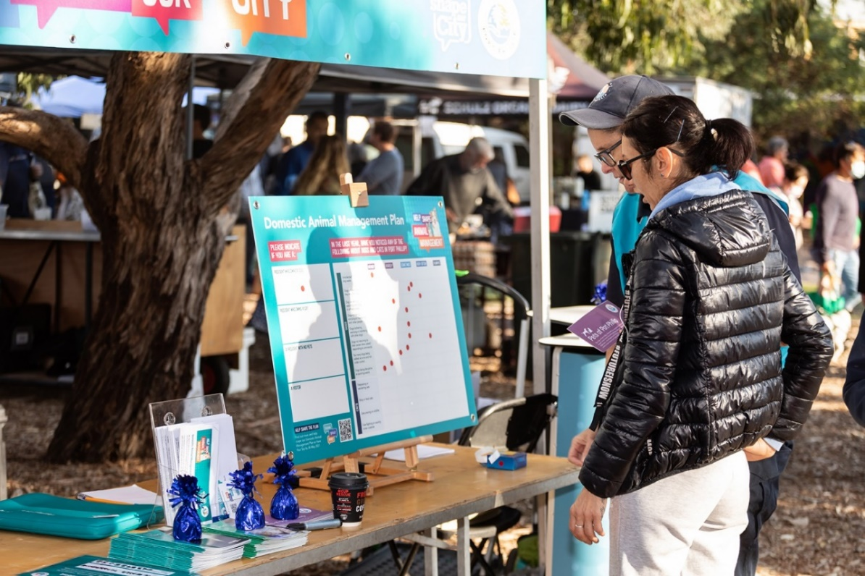
Image: St Kilda pop-up session, Vege Out Farmers’ Market
Pet ownership of face-to-face engagement participants (89 responses)
Resident who owns a dog | 43.82%
Resident who owns a cat | 15.73%
Resident with no pets | 32.58%
Visitor | 7.87%

Participants in the face-to-face pop engagements were asked about the frequency with which they have noticed various issues related to dogs and cats.
Average from 89 responses across all pop-up engagements. For a breakdown of responses at each pop-up engagement location, please see Appendix B.
 | Never | Rarely | Sometimes | Very often | Always
Uncollected dog waste | 8.51% | 19.68% | 39.90% | 28.63% | 10.43%
Dogs off leash where they shouldn't be | 13.63% | 24.58% | 42.20% | 12.14% | 10.03%
Dog owners not watching their dogs in off-leash areas | 18.84% | 26.91% | 37.55% | 12.24% | 6.43%
Dogs bothering, worrying or interfering with other people | 24.57% | 45.62% | 22.23% | 8.62% | 0.00%
Dogs bothering, worrying or interfering with other dogs | 14.85% | 57.70% | 14.02% | 5.44% | 1.59%
Dogs not returning to their owner when called/ responding to commands | 16.08% | 34.90% | 31.18% | 13.41% | 5.70%
Too many dogs being walked at once and not under control | 50.06% | 22.38% | 17.12% | 3.01% | 0.00%
Dogs being disruptive at sporting events | 70.69% | 7.95% | 1.59% | 0.00% | 0.00%
Frequency of issues noticed was generally lower in face-to-face engagements compared to the survey, however were largely similar.
 | Never | Rarely | Sometimes | Very often | Always
Trespassing or wandering cats | 44.1% | 14.7% | 12.7% | 11.0% | 9.1%
Stray or feral cats | 53.5% | 6.2% | 7.0% | 2.9% | 4.1%
Cats preying on wildlife | 62.7% | 4.3% | 8.0% | 6.8% | 6.2%
Cats fighting or causing noise nuisance | 64.3% | 16.8% | 4.2% | 2.5% | 0.6%

The results from the survey and face-to-face engagements show similar frequency of issues related to cats.

Appendices

Appendix A: Survey questions

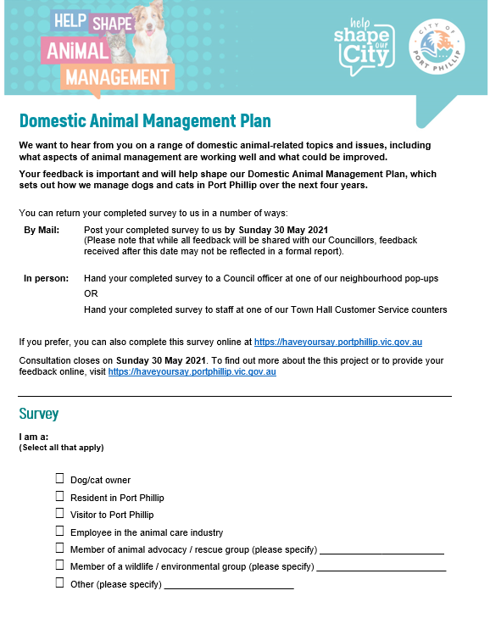

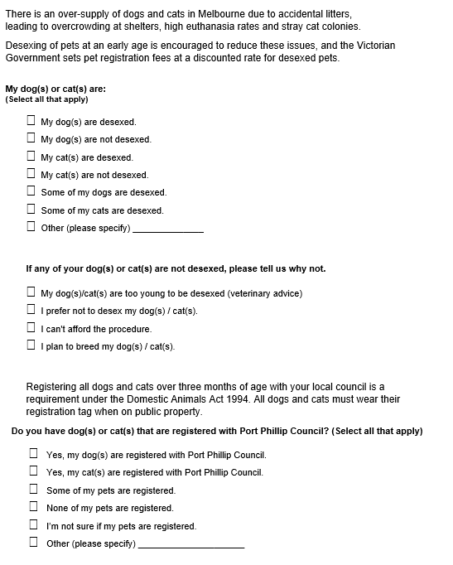
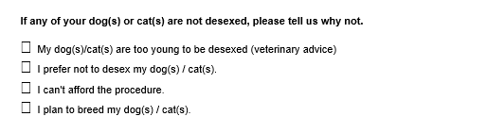

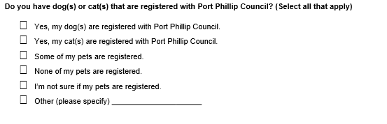
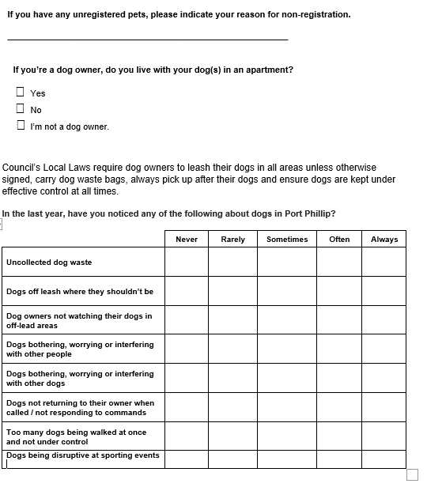

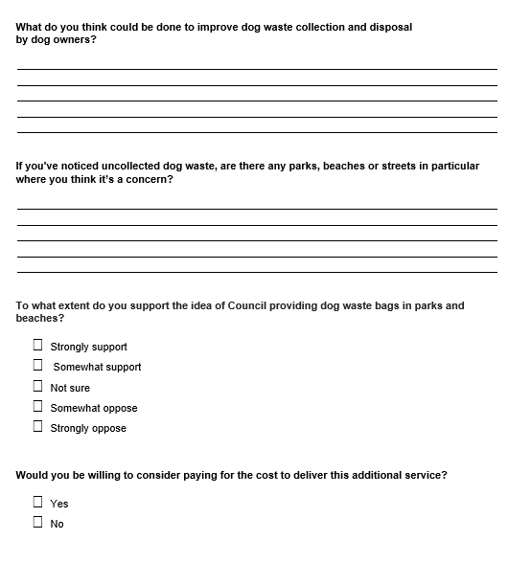
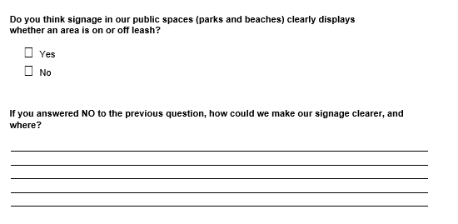

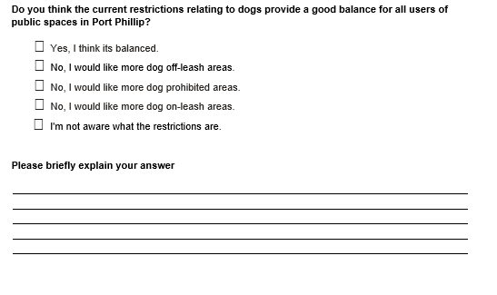
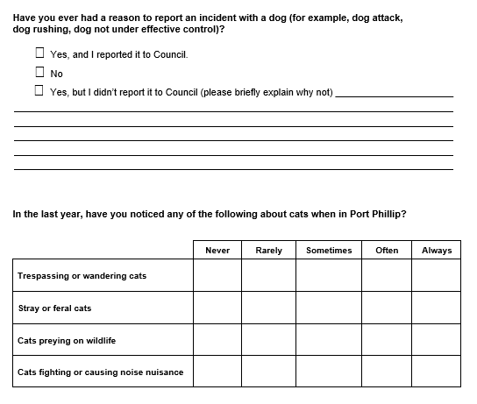

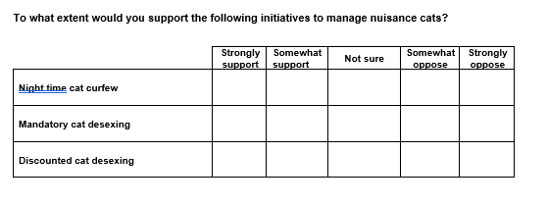
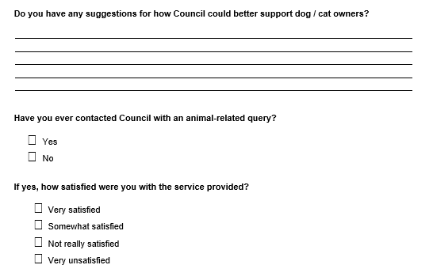
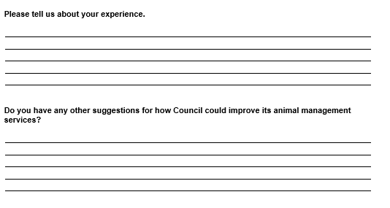
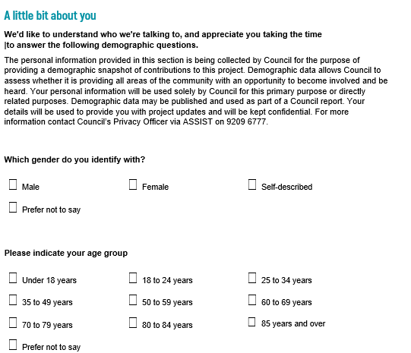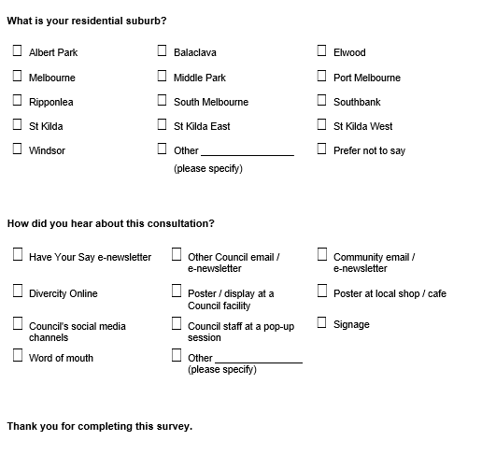

Appendix B: Breakdown of responses from Neighbourhood Conversation sessions

Face-to-face engagement location | Uncollected dog waste
 | Never | Rarely | Sometimes | Very often | Always
St Kilda | 8.0% | 4.0% | 28.0% | 20.0% | 16.0%
Port Melbourne | 0.0% | 0.0% | 55.6% | 44.4% | 11.1%
Middle Park | 7.1% | 42.9% | 0.0% | 14.3% | 28.6%
St Kilda Rd | 0.0% | 40.0% | 60.0% | 0.0% | 0.0%
Elwood | 0.0% | 12.5% | 12.5% | 81.3% | 6.3%
Balaclava | 0.0% | 27.3% | 45.5% | 18.2% | 0.0%
South Melbourne | 44.4% | 11.1% | 77.8% | 22.2% | 11.1%

Face-to-face engagement location | Dogs off leash where they shouldn't be
 | Never | Rarely | Sometimes | Very often | Always
St Kilda | 0.0% | 20.0% | 40.0% | 4.0% | 48.0%
Port Melbourne | 11.1% | 22.2% | 55.6% | 0.0% | 11.1%
Middle Park | 7.1% | 42.9% | 35.7% | 7.1% | 0.0%
St Kilda Rd | 0.0% | 0.0% | 80.0% | 0.0% | 0.0%
Elwood | 12.5% | 37.5% | 43.8% | 37.5% | 0.0%
Balaclava | 9.1% | 27.3% | 18.2% | 36.4% | 0.0%
South Melbourne | 55.6% | 22.2% | 22.2% | 0.0% | 11.1%

Face-to-face engagement location | Dog owners not watching their dogs in off-leash areas
 | Never | Rarely | Sometimes | Very often | Always
St Kilda | 4.0% | 20.0% | 24.0% | 16.0% | 8.0%
Port Melbourne | 22.2% | 33.3% | 44.4% | 11.1% | 0.0%
Middle Park | 7.1% | 35.7% | 35.7% | 7.1% | 7.1%
St Kilda Rd | 20.0% | 20.0% | 80.0% | 0.0% | 0.0%
Elwood | 25.0% | 18.8% | 31.3% | 31.3% | 18.8%
Balaclava | 9.1% | 27.3% | 36.4% | 9.1% | 0.0%
South Melbourne | 44.4% | 33.3% | 11.1% | 11.1% | 11.1%

Face-to-face engagement location | Dogs bothering, worrying or interfering with other people
 | Never | Rarely | Sometimes | Very often | Always
St Kilda | 8.0% | 28.0% | 36.0% | 4.0% | 0.0%
Port Melbourne | 0.0% | 77.8% | 22.2% | 0.0% | 0.0%
Middle Park | 21.4% | 28.6% | 28.6% | 0.0% | 0.0%
St Kilda Rd | 0.0% | 100.0% | 0.0% | 0.0% | 0.0%
Elwood | 37.5% | 37.5% | 37.5% | 25.0% | 0.0%
Balaclava | 27.3% | 36.4% | 9.1% | 9.1% | 0.0%
South Melbourne | 77.8% | 11.1% | 22.2% | 22.2% | 0.0%

Face-to-face engagement location | Dogs bothering, worrying or interfering with other dogs
 | Never | Rarely | Sometimes | Very often | Always
St Kilda | 12.0% | 24.0% | 32.0% | 4.0% | 0.0%
Port Melbourne | 0.0% | 88.9% | 22.2% | 0.0% | 0.0%
Middle Park | 7.1% | 42.9% | 28.6% | 0.0% | 0.0%
St Kilda Rd | 0.0% | 100.0% | 0.0% | 0.0% | 0.0%
Elwood | 31.3% | 56.3% | 6.3% | 25.0% | 0.0%
Balaclava | 9.1% | 36.4% | 9.1% | 9.1% | 0.0%
South Melbourne | 44.4% | 55.6% | 0.0% | 0.0% | 11.1%

Face-to-face engagement location | Dogs not returning to their owner when called/ responding to commands
 | Never | Rarely | Sometimes | Very often | Always
St Kilda | 4.0% | 24.0% | 40.0% | 12.0% | 0.0%
Port Melbourne | 0.0% | 33.3% | 55.6% | 0.0% | 0.0%
Middle Park | 0.0% | 35.7% | 42.9% | 0.0% | 0.0%
St Kilda Rd | 20.0% | 40.0% | 40.0% | 0.0% | 0.0%
Elwood | 18.8% | 50.0% | 25.0% | 6.3% | 6.3%
Balaclava | 0.0% | 36.4% | 36.4% | 9.1% | 0.0%
South Melbourne | 55.6% | 0.0% | 33.3% | 11.1% | 0.0%

Face-to-face engagement location | Too many dogs being walked at once and not under control
 | Never | Rarely | Sometimes | Very often | Always
St Kilda | 4.0% | 24.0% | 40.0% | 12.0% | 0.0%
Port Melbourne | 66.7% | 22.2% | 0.0% | 0.0% | 0.0%
Middle Park | 28.6% | 42.9% | 7.1% | 0.0% | 0.0%
St Kilda Rd | 60.0% | 0.0% | 40.0% | 0.0% | 0.0%
Elwood | 75.0% | 31.3% | 12.5% | 0.0% | 0.0%
Balaclava | 27.3% | 36.4% | 9.1% | 9.1% | 0.0%
South Melbourne | 88.9% | 0.0% | 11.1% | 0.0% | 0.0%

Face-to-face engagement location | Dogs being disruptive at sporting events
 | Never | Rarely | Sometimes | Very often | Always
St Kilda | 68.0% | 0.0% | 4.0% | 0.0% | 0.0%
Port Melbourne | 55.6% | 22.2% | 0.0% | 0.0% | 0.0%
Middle Park | 71.4% | 7.1% | 7.1% | 0.0% | 0.0%
St Kilda Rd | 80.0% | 20.0% | 0.0% | 0.0% | 0.0%
Elwood | 87.5% | 6.3% | 0.0% | 0.0% | 0.0%
Balaclava | 54.5% | 0.0% | 0.0% | 0.0% | 0.0%
South Melbourne | 77.8% | 0.0% | 0.0% | 0.0% | 0.0%

Face-to-face engagement location | Trespassing or wandering cats
 | Never | Rarely | Sometimes | Very often | Always
St Kilda | 28.0% | 8.0% | 12.0% | 4.0% | 12.0%
Port Melbourne | 33.3% | 33.3% | 11.1% | 11.1% | 22.2%
Middle Park | 28.6% | 28.6% | 21.4% | 0.0% | 7.1%
St Kilda Rd | 80.0% | 0.0% | 0.0% | 20.0% | 0.0%
Elwood | 87.5% | 12.5% | 6.3% | 12.5% | 0.0%
Balaclava | 18.2% | 9.1% | 27.3% | 18.2% | 0.0%
South Melbourne | 33.3% | 11.1% | 11.1% | 11.1% | 22.2%

Face-to-face engagement location | Stray or feral cats
 | Never | Rarely | Sometimes | Very often | Always
St Kilda | 36.0% | 8.0% | 4.0% | 0.0% | 4.0%
Port Melbourne | 55.6% | 11.1% | 22.2% | 11.1% | 0.0%
Middle Park | 0.0% | 7.1% | 7.1% | 0.0% | 7.1%
St Kilda Rd | 100.0% | 0.0% | 0.0% | 0.0% | 0.0%
Elwood | 75.0% | 6.3% | 6.3% | 0.0% | 6.3%
Balaclava | 63.6% | 0.0% | 9.1% | 9.1% | 0.0%
South Melbourne | 44.4% | 11.1% | 0.0% | 0.0% | 11.1%

Face-to-face engagement location | Cats preying on wildlife
 | Never | Rarely | Sometimes | Very often | Always
St Kilda | 28.0% | 4.0% | 12.0% | 0.0% | 20.0%
Port Melbourne | 77.8% | 0.0% | 0.0% | 11.1% | 0.0%
Middle Park | 78.6% | 0.0% | 7.1% | 7.1% | 0.0%
St Kilda Rd | 80.0% | 20.0% | 0.0% | 0.0% | 0.0%
Elwood | 62.5% | 6.3% | 18.8% | 0.0% | 12.5%
Balaclava | 45.5% | 0.0% | 18.2% | 18.2% | 0.0%
South Melbourne | 66.7% | 0.0% | 0.0% | 11.1% | 11.1%

Face-to-face engagement location | Cats fighting or causing noise nuisance
 | Never | Rarely | Sometimes | Very often | Always
St Kilda | 40.0% | 12.0% | 0.0% | 0.0% | 4.0%
Port Melbourne | 77.8% | 22.2% | 0.0% | 11.1% | 0.0%
Middle Park | 50.0% | 21.4% | 14.3% | 0.0% | 0.0%
St Kilda Rd | 100.0% | 0.0% | 0.0% | 0.0% | 0.0%
Elwood | 81.3% | 12.5% | 6.3% | 6.3% | 0.0%
Balaclava | 45.5% | 27.3% | 9.1% | 0.0% | 0.0%
South Melbourne | 55.6% | 22.2% | 0.0% | 0.0% | 0.0%

it should be noted that participants in the face-to-face engagements were given the option of ‘very often’, rather than ‘often’ used in the survey.

