Business Parklet guidelines
Version 2, October 2021

Guideline Governance
Responsible Service / Department:
City Growth and Culture
Safety and Amenity
City Strategy, Design and Sustainability
Adoption authorised:
Council
Date of adoption:
[Insert Text]
Date effective from:
[Insert Text]
Content Manager folder:
[Insert Text]
Content Manager file:
[Insert Text]
Endorsed CEO or ELT member or department manager to make and approve document editorial amendments:
General Manager of City Growth and Organisational Capability
Manager City Growth and Culture
Annual desktop review date:
Review date:
Completion date:
2025
Version number:
1
Stakeholder review and engagement:
Community Building and Inclusion, Strategy, Design and Sustainability, City Growth and Culture, Governance and Organisational Performance, Safety and Amenity, Construction, Contracts and Operations, Property and Assets; Open Space, Recreation and Community Resilience
Relevant Legislation:
[Insert Text]
Associated Strategic Direction #:
Strategy 4 – Vibrant Port Phillip
Associated instruments:
Business Parklet Policy
Supersedes:
N/A
Review history:
Name | Content Manager File Reference | Date | Description of Edits
Name of document | # | DD/MM/YYYY | Description of changes

Contents
Guideline Governance 2
Contents 4
Tables 5
Purpose 6
Outcomes 6
Who is this document for? 7
Eligibility 7
What is a business parklet? 8
Definitions 9
How to set up a business parklet 10
Before you apply 10
Business parklet process 11
Advertising period 11
Apply 11
Review process 11
Permit issued 11
Installation 11
Operation 11
Remove infrastructure 11
Types of permits available 12
Annual permits 12
Seasonal permits 12
Amendments to an existing permit 13
Transfer of business ownership 13
Removal 14
Considerations prior to making an application 15
Will your premises have enough toilet facilities? 15
Will you need to relocate any public infrastructure? 15
Will access to any services be compromised? 15
Will you include any advertising? 15
Display or sale of goods 16
Taking care of your business parklet 17
Daily management 17
Safety and accessibility 17
Community amenity 18
COVIDSafe Plan and patron limits 18
Hygiene and cleanliness 19
Queuing and waiting 19
Where can business parklets be located? 20
Location 20
Occupying an adjacent parking bay 21
Maximum number of business parklets within areas 21
Designing your business parklet 23
All business parklets must include: 23
What can go in your business parklet? 31
Removable furniture 31
Fixed furniture 32
Weather protection 32
Information required with application 35
Decision making 37
Business parklet priorities 37
Assessment process 39
Decision-making on applications 39
Review of decisions 40
Council responsibilities 41
Maintenance of the footpath and carriageway 41
Compensation and loss of trade 41
Monitor compliance with approved permit 41
Relevant policy, regulations or legislation 41
Business Parklet Standard Conditions 42

Tables
Table 1 Definition of terms 9
Table 2 Approval process 11
Table 3 Types of permits 13
Table 4 Recommended maximum number of parking bays to be used as business parklets 22
Table 5 Council’s business parklet priorities and objectives 38

Purpose
This document set outs how businesses can apply to establish a parklet that supports their business and adds to the vibrancy of our city. It also sets out what traders should consider if they want to establish and maintain a business parklet and how Council officers will consider applications.
This document is in line with the Council’s Plan and the Municipal Health and Wellbeing Plan 2017-27. The Council’s Business Parklet Policy Objectives are in line with the City of Port Philip Community Amenity Local Law 1 and other relevant Council policies.

Outcomes
The desired outcomes of these Guidelines are to:
- Encourage activation and vibrancy in our neighbourhoods and activity centres, which makes them more enjoyable and safer for our community.
- Encourage a sense of community through the creation of safe gathering spaces.
- Support our local businesses and economy to be more resilient to future economic challenges and changes to operating regulations (made by other levels of Government).
- Balance the activation of public space with amenity of the surrounding community.
- Ensure activation of public space adds to the character, heritage and overall design of our city and meets accessibility, public safety and sustainability requirements.
- Provide additional public space for people to walk, socialise and enjoy our city.
- Ensure businesses that benefit from the commercial use of public space make a fair contribution through appropriate fees and charges.
- Provide a framework for businesses, community, and Council to balance competing interests to ensure decision making is fair and consistent, with compliance measures.
- Supports trailing short-term commercial use of on-street parking bays, which could inform longer-term public space priorities, projects and investment by Council.

Who is this document for?
- Businesses who wish to utilise existing on-street parking spaces, either for hospitality or other uses that benefit the community to apply to establish a parklet.
- Surrounding businesses and community members who are interested to understand how business parklets are managed by Council.
- Council Officers who are assessing applications for business parklets.

Eligibility
All hospitality businesses based in the City of Port Phillip are eligible to apply for a Business Parklet. The exceptions are stand-alone bottle shops, tobacco shops, venues with an electronic gaming machine or other gambling components.
Community, not-for-profit organisations or businesses outside of hospitality can apply to Council separately on an as-needs basis and these will be assessed on their merits.

What is a business parklet?
A business parklet is a car parking space, or in some limited instances a part of a public road, that has been transformed by a commercial business into a place that the whole community can enjoy.
A business parklet is managed by and in association with a business to expand their services.
Benefits:
- Encourage people to spend more time enjoying our streets.
- Reimagine the use of car parking bays to transform them into places for people rather than cars
- Provide greening opportunities which can improve the look and feel of our streets
- Support local businesses by extending their floor space
- Allow more people to observe and participate in the life of the street, which can improve the overall feeling of safety in the neighbourhood.

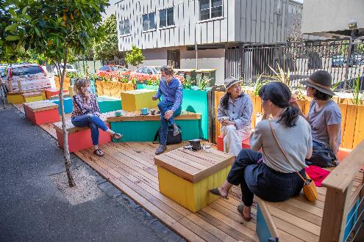 | 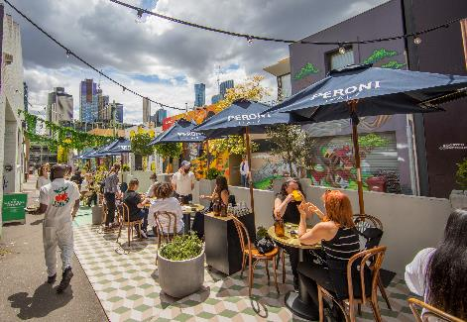
Figure 1: Parklet with fixed seating | Figure 2: Business parklet with removable furniture

Definitions
Table 1 Definition of terms
Term | Definition
Council | City of Port Phillip
Parklet | Re-purposed on-street parking spaces which are designed to extend public space to provide an additional place for congregation, accessible public seating, street greening and additional pedestrian space.
Business parklet | Parklet used for commercial purposes and is the subject of this Guideline.
On-street parking | Designated parking spaces located on public roads that may be occupied by a vehicle for a specified period.
City Permits Panel | The Panel considers:  - applications that do not meet the requirements of the Footpath Trading Guidelines, Mobile Food Vehicle Guidelines, or Business Parklet Guidelines, but the officer recommends support, or  - the permit applicant seeks a review of the Council officer decision  - any matters in relation to serious or ongoing breaches of permit conditions, and  - any matters to assist the objectives and implementation of the Footpath Trading Guidelines,  Mobile Food Vehicles Guidelines, or Business Parklet Guidelines.
Permit | Refers to an approval issued under City of Port Phillip Local Law that authorises a use or activity.
Permit holder | Permit has the same meaning as the definition under City of Port Phillip’s Local Law

How to set up a business parklet
Applicants must use these Guidelines to assist with their application and to manage a business parklet. This will ensure they understand the design, requirements, assessment, responsibilities and costs associated with business parklets.
The key steps in how to set up a business parklet are explained below.

Before you apply
It’s also important to consider whether your needs could be met by a footpath trading permit, or an extension to existing footpath trading.
Be aware that not all applicants will be granted a permit, as there are a number of criteria and requirements which will be considered. Some locations have limitations on the number of business parklets that can be permitted.
Read through these Guidelines to make sure you understand what you will need to do.

For additional help visit:

https://www.portphillip.vic.gov.au/council-services/business-in-port-phillip/business-enquiries

Business parklet process
Table 2 Approval process

Advertising period
Traders are invited to apply for a Business Parklet during the advertised period.

Apply
Applications with supporting documentation can be made online at: https://www.portphillip.vic.gov.au/ .

Review process
Applicants may be contacted to discuss aspects of their application or to provide further information. Council will work with you to finalise Business Parklet designs and achieve compliance.

Permit issued
If your application is supported Council will issue you with a permit with conditions and an approved plan.

Installation
The permit holder can install the Business Parklet and permitted structures and furniture.

Operation
The permit holder will manage the business parklet in accordance with the permit conditions and approved plan.
Council officers will periodically inspect the business parklet structure and its use. Feedback will be provided to the permit-holder to address any matters.

Remove infrastructure
At the expiry of the permit, all infrastructure must be removed by the permit holder and the land returned to its original condition.

Types of permits available

Annual permits
Annual permits allow for year-round activation, granted for a maximum of twelve months and expire 30th September. Permits may be subject to change at any time during the permit period.
Renewal of an annual permit
Permits are required to be renewed annually, up to two times unless:
- non-payment of fees - permit revoked
- neighbour withdraws consent - revoked or amended
- streetscape works require access to business parklet location
- there is a waiting list of business parklet requests in your precinct.
A renewal notice will be issued for all eligible Annual Permit holders. It is the responsibility of the permit holder to ensure all details have been updated, including public liability insurance, letters of consent. Failure to provide all documentation and/or payment of fees may result in the cancellation of the permit.
The Council reserves the right to reassess and amend permit conditions at any time.

Seasonal permits
Seasonal permits allow for business parklets for up to six months, from 1 October to 30 April each year.
Seasonal permits expiry dates may vary. If a seasonal permit holder applies to transfer to an annual permit, they must contact Council prior to the expiry of their seasonal Permit, to inquire (refer to ‘Renewal of an existing permit’, below).

Table 3 Types of permits
 | Seasonal Permit | Annual Permit
Duration | 1 October to 30 April | Expires annually on 30 September
Renewal option | Not renewable  Option to apply for annual permit at end of seasonal permit – conditions apply | Permits may be renewed annually up to two times unless:  - non-payment of fees - permit cancelled  - neighbour withdraws consent – amended permit or not renewed  - streetscape works require access to permit location  - there is a waiting list of parklet requests.
Average investment | Low-Medium | Medium-High
Access requirement | Minimum requirement is a ramp to parking bay or platforms level with the footpath may be constructed instead | Platform level with footpath
Example | 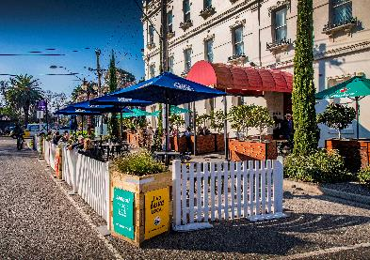 | 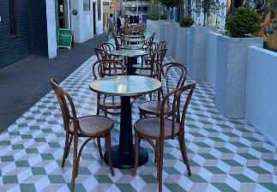

Amendments to an existing permit
Permit-holders can apply to amend a business parklet permit at any time. Examples include amending the size of a business parklet, changing furniture design, or increasing advertising. An amendment fee is payable for officer assessment and liaison.

Transfer of business ownership
A new proprietor must apply to take over an existing business parklet within 28 days of the sale. There is no legal attachment to the sale or transfer of ownership of a business.
An application fee is required for officer assessment and liaison. In considering the transfer of ownership request, the Council may reassess and amend permit conditions to ensure compliance with the Guidelines to respond to any changes in the business parklet design or operation.
It is the responsibility of the existing proprietor to include the balance of any remaining permit fees in the sale of the business.

Removal
All business parklet furniture, platforms and associated materials must be removed at the expiry or cancellation of a permit, or if a business ceases trading. Council assets including kerbing, footpath and road surfaces etc must be made good and returned in clean condition.

Considerations prior to making an application

Will your premises have enough toilet facilities?
The addition of an outdoor area to an existing restaurant/café may lead to an increase in overall seating capacity. You must have adequate toilet facilities available for customers and staff in line with any relevant building regulations.
Where overall capacity exceeds twenty seats it may be necessary to upgrade existing toilet facilities.

Will you need to relocate any public infrastructure?
If you need to relocate items such as seats, litter bins or bicycle stands, you can make a request to Council to relocate that infrastructure.

The relocation of public infrastructure may sometimes be possible, but this must result in an equal, if not a better outcome for the community.

If the infrastructure is to be relocated in front of other premises, you must then obtain the written consent(s) of the owner and occupant of the premises where the items will be relocated.

All costs associated with the approved relocation of any public infrastructure, including any reinstatement must be paid by the person/business requesting the change.

Will access to any services be compromised?
When thinking about how you will set up your parklet, it’s important that services such as sewers, gas, water, telecommunications and electricity conduits should not be obstructed by business parklet structures, you may need to demonstrate how access could be maintained during the lifetime of business parklet, by including inspection lids in your design.
Removable furniture such as tables, chairs, umbrellas, and heaters may be placed on top of underground service pits. Access to services may be required at any time.

Will you include any advertising?
If you propose advertising, include this in your application for consideration.
You may feature the name of your business or relevant product name/s on umbrellas and barriers only. The business/company logo can be displayed on every second panel and on the two end returns closest to the kerb edge. Refer to Figures 3 and 4.

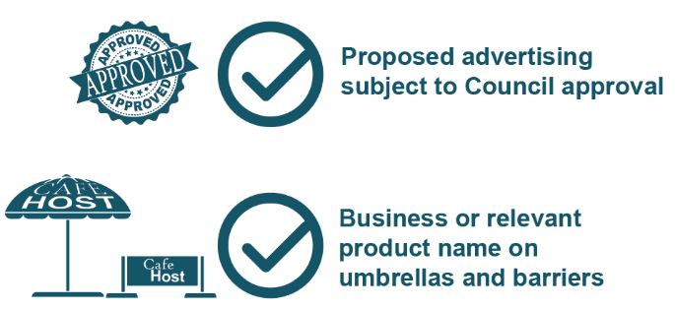 | Figure 3: Advertising and furniture require approval by Council.
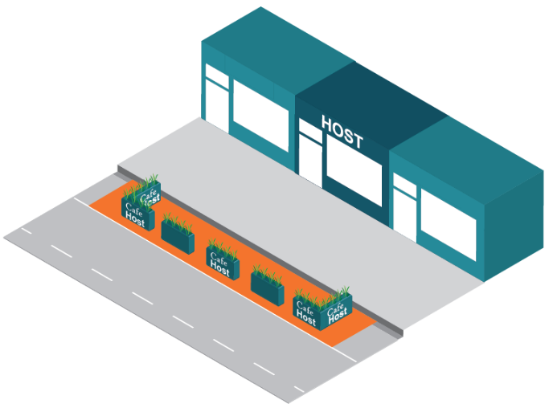 | Figure 4: Only the business/company logo can be displayed on every second panel and on the two end returns closest to the kerb edge.

Display or sale of goods
Business parklets must not be used for the display or sale of goods sold within the premises.

Taking care of your business parklet

Daily management
As the permit-holder, you will be responsible for the management of your parklet and will need to:
- Operate in accordance with any conditions of the permit, endorsed plans and requirements outlined in these Guidelines.
- Actively monitor the use of the business parklet, for example, ensuring patrons consuming food and drinks are seated and managing any behaviour that may interfere with the use, enjoyment and personal comfort of others, including nearby residents.
- Observe all relevant Acts and Regulations, including Council’s Local Law, liquor licencing and Health.
- Maintain access for all users in and around the footpath, without encroaching into areas beyond the approved business parklet area.
- Keep the area clean, including tables, chairs and surrounding areas, with any litter removed and deposited in bins kept inside the premises.
- Ensure any planters are watered and maintained.
- All non-fixed items must be removed at the end of trading hours. Where a business continues to operate internally after outdoor licencing hours have ceased, you may request to stack and store these items within the business parklet.
- Actively monitor patronage to report on its use if/when requesting a new permit or renewal.

Safety and accessibility
As the permit-holder you would be responsible for ensuring safe and unobstructed access to the footpath and business parklet area by:
- Providing a continuous accessible footpath.
- Ensuring any business parklet in close proximity to an intersection does not obscure a driver’s line of vision, or traffic signs.
- Maintaining any required clearances and setbacks from traffic lanes, public assets and other street infrastructure.
- Ensuring the permitted area remains an inviting, clean and safe place.
- Ensuring that patrons and clients do not unreasonably impede the flow of pedestrian, bicycle or vehicle traffic.
- Achieving the intent of the Disability Discrimination Act 1993 (DDA).

Community amenity
As the permit-holder you would be responsible for ensuring the amenity of the immediate areas are protected and enhanced by:
- Complying with the permitted use, hours and conditions of any relevant Planning Permit, Liquor Licence or other permit.
- Complying with Environment Protection Authority (EPA), requirements in respect of noise, and no external address system, or sound amplification equipment, (refer to www.epa.vic.gov.au).
- Preventing adverse impacts on the amenity of the area from the emission of noise, smell or appearance of the premises in accordance with Council’s Local Law.
- Avoiding visual clutter of repetitive, inappropriately scaled signage.
- The prompt removal of graffiti and rectification of any damage.

COVIDSafe Plan and patron limits
The permit-holder will be responsible for ensuring that the use of the business parklet is in accordance with a COVIDSafe Plan, any patron limits in accordance with Victorian government requirements.
Visit https://www.dhhs.vic.gov.au for the latest information on COVID-19 business restrictions.
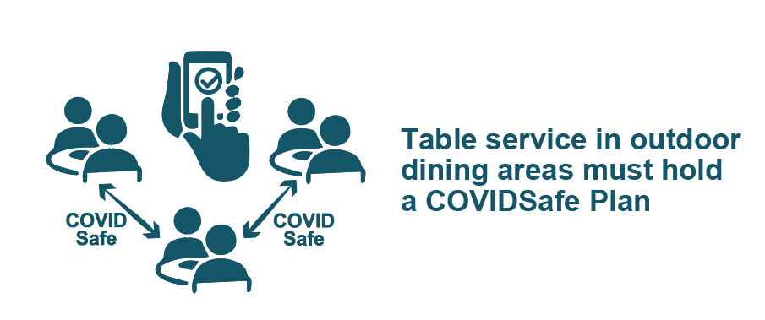

Hygiene and cleanliness
As the permit-holder you will be responsible for maintaining the hygiene and cleanliness of the permitted area by:
- Clearing litter from the business parklet and immediate area.
- Removing any food scraps, cigarette litter and other waste within the immediate area and depositing them within their own bins kept within the premises.
- Litter generated by trading must not be swept into the street gutter or adjacent footpath areas.
- Not placing trade waste in public street bins.
- Ensuring the preparation, handling and serving of food and drinks to patrons is conducted in accordance with the Food Safety Regulations, www.health.vic.gov.au/foodsafety. For information on food safety education and training programs contact the Council’s Health Services Unit at healthservicesunit@portphillip.vic.gov.au

Queuing and waiting
As the permit-holder you will be responsible for ensuring that your patrons do not impede the flow of pedestrian traffic. Businesses that attract large numbers of patrons who queue outside the premises or business parklet must ensure the pedestrian zone remains clear. Queuing must be contained inside the venue where practical.

Where can business parklets be located?

Location
Business parklets may be considered in on-street parking bays that:
- are on Council owned or managed roads.
- are on a road with 40km/h speed limit or less.
- are not clearways, disabled, loading zone, car share, etc.
- do not obstruct sightlines for pedestrians, cyclists and drivers.
- provide a minimum area of 6 metres x 2.5 metres and retain a 3-3.5m wide trafficable lane.
- are located either directly adjacent to the host business, on either the primary or secondary frontage/s.
- maintains direct access to the footpath.
- do not impact the ability of a person with disabilities to access a public service such as a medical service or similar.
- do not obstruct access to Council and utility/telecommunication assets.

When possible, preference will be given to non-metred parking bays.

Department of Transport (VicRoads) managed roads are subject to approval by the Victorian Government. Council can support you in the process of seeking this approval.

Intersections – line of sight
To ensure adequate sightlines for pedestrians, bike riders, motor cyclists, and vehicles, trading within 10m of an un-signalised intersection, or within 20m of a signalised intersection will be subject to assessment on a case-by-case basis.

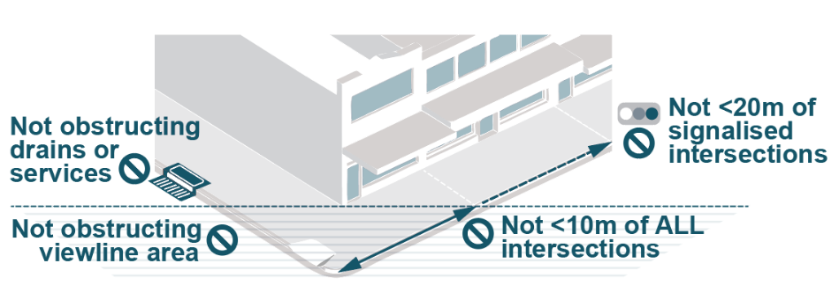
Figure 5: Business Parklets need to be placed 10m from a unsignalised intersection and 20m from a signalised intersection

Occupying an adjacent parking bay
The permit applicant must obtain and submit the consent of the owner, body corporate and/or occupier when applying to occupy a parking bay in front of an adjacent premises.
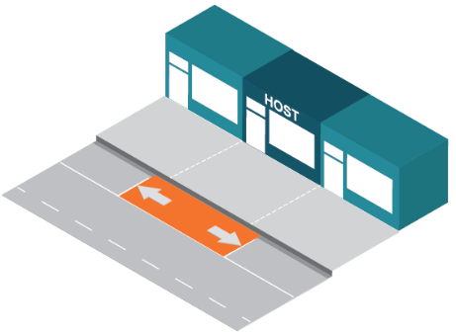 | 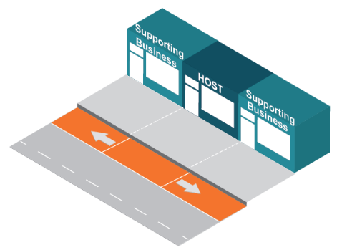
Figure 6: A business may apply for a business parklet in front of their premises. | Figure 7: A business may apply for a business parklet in front of neighbouring premises with their written consent.

If the neighbouring premises is sold or occupied by a new tenant, the existing permit will remain valid until it expires. When applying for a new permit or renewal, a new consent must be submitted from the new owner, body corporate and/or occupier.
If the adjoining owner, body corporate and/or occupier withdraws consent during the permit period, depending on the circumstances the permit holder may be permitted to trade in front of the adjacent premises until the permit expires.
Where an applicant proposes using an on-street parking bay that is not adjacent to anther business and/or occupier, Council may consider if the outcome would benefit the streetscape and general community. Council will consider on a case-by-case basis.

Maximum number of business parklets within areas
To minimise potential impacts to on-street parking and ensure an appropriate balance of outcomes within each activity centre, recommended maximum number of parklets within each area has been calculated. Refer to Table 4.
Activity centres are defined by the Commercial 1 (C1Z) overlay of the Planning Scheme. Calculations are based on a number of factors, including the total number of publicly available on-street car parking spaces, the number of spaces allocated to other uses (such as loading, etc), public transport connections, community feedback and experiences through the trial period, physical attributes such as footpath widths and other location factors.
The recommended maximum number of business parklets in each activity centre may be varied at officer discretion, taking into consideration the density of business parklets in any one part of an activity centre and any other relevant matters.
Requests for business parklets outside of identified activity centres will be considered on a case-by -case basis.

Table 4 Recommended maximum number of parking bays to be used as business parklets
Location | Recommended maximum parking bays used
Acland St Activity Centre | 15
Ormond Road Activity Centre | 10
Glen Huntly Road Activity Centre | 5
Glen Eira Road Activity Centre | 8
Tennyson St Activity Centre | 3
Carlisle St Activity Centre | 15
Inkerman St Activity Centre | 4
Fitzroy St Activity Centre | 9
Victoria Ave Activity Centre | 15
Bridport St Activity Centre | 20
Bay St Activity Centre | 20
Armstrong St Activity Centre | 14
Clarendon St Activity Centre | 27

Designing your business parklet
Activity centres each have their own character, that can be enhanced through the design of business parklets. The design and appearance of business parklets and furniture must be of high quality, robust and structurally sound to withstand prolonged exposure to all weather conditions.

All business parklets must include:
Safety elements
- A buffer setback of 0.45m must be provided around the perimeter of the parklet, from all adjacent traffic/bicycle lanes and adjacent parking bays
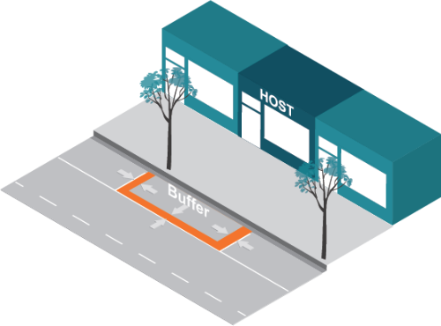 | 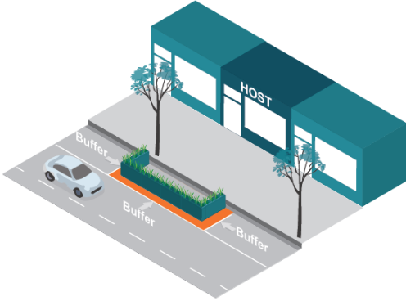
Figure 8: Business Parklets need to have a least a 0.45m buffer between any traffic lane, including bicycle lanes, and the structure.
- 0.45m x 0.45m barriers must be provided at all four corners and at regular 4m intervals
- The total height of the business parklet barriers must not exceed 0.9m above carriageway level
- Barriers must be:
  - collapsible
  - weighted with 0.3m depth crushed rock
  - soil filled to at least 0.3m depth for planting
  - treated pine sleepers
  - or equivalent, as approved by Council
- Between barriers, a 0.3m deep buffer must be provided that spans the gaps between the barriers at all four corners and every 4m. Examples of acceptable barriers are shown in Figures 9 to 11
- Reflective tape must be placed along the top edge of the platform and at 0.75m height.

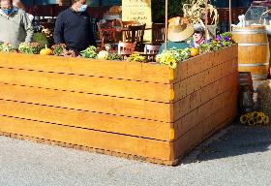 | 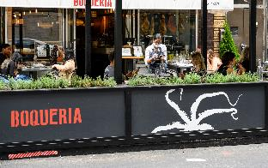 | 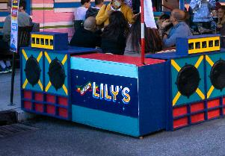
Figure 9: Natural wood materials should appear finished and well maintained. | Figure 10: Business or other relevant product name may only appear on every other barrier; artwork may fill remaining spaces. | Figure 11: Creative patterns, designs or artwork that enhance the streetscape are encouraged.
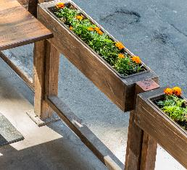 | 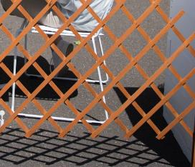 | 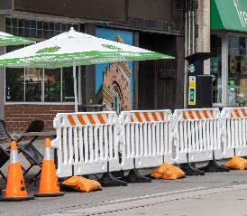
Figure 12: Barriers must fully enclose the space. No gaps are permitted. | Figure 13: Flimsy materials like lattice should not be used. | Figure 14: Temporary barriers and other rented materials must be wrapped and finished.

Accessible paths of travel
- Un-obstructed paths of travel must be provided for persons utilising mobility devices such as wheelchairs, prams, and walkers including those who may be visually impaired community members.
- To achieve a business parklet may require the removal of outdoor dining on the footpath, particularly where a footpath is narrow.
- A business parklet must provide at least one accessible access point, with a minimum width of 1.5m, preferred 2m.
- A business parklet should provide a wheelchair turning area and resting space.
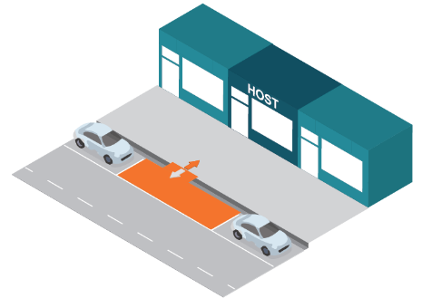 | 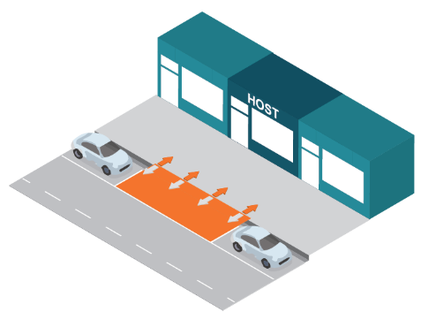
Figure 15: Business Parklets must have at least one unobstructed entrance, with a minimum width of 1.5m, preferably 2m. | Figure 16: It is preferred that the entire frontage of the Business Parklet is accessible from the footpath.

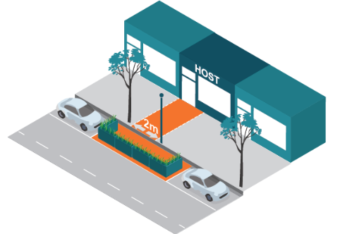
Figure 17: The design of the entrance to the Business Parklet needs to take into account fixed objects in the footpath such as trees and lighting.

Wheelchair turning area and resting space
- A wheelchair turning area should be provided, to make a 180° turn, with a minimum diameter of 1.5m.
- A wheelchair resting space should be provided and have a 0.8m minimum width and 1.3m minimum length. The wheelchair resting space should incorporate companion seating.

Accessible tables and chairs
- At least 50% of all outdoor dining tables should be wheelchair accessible.
- A table must be 0.7m to 0.8m above the platform height, with an unobstructed knee clearance height of 0.43m to 0.44m underneath the table.

Raised platform
Annual business parklets must include a raised platform that is level with the kerb. Seasonal business parklets may also include raised platforms.
- The difference in height between a kerb and raised platform should be no more than 6mm.
- The maximum gap between the kerb and raised platform is 1cm. A bridging platform can be used if a gap is more than 1cm, or if the raised platform does not match the height of the kerb. Refer diagram below.
- Any raised platform must ensure stormwater flow is not obstructed. The removal of leaves and litter is the responsibility of the permit holder.
- Any structure including a platform in proximity of stormwater entry pits must be designed to enable access and maintenance to occur.
- Where a Business Parklet would be built at a different level from the kerb upstand, a bridging or leveling platform can be utilised to create a smooth transition and prevent tripping hazards.
- Steps should be avoided. Any step must have a warning strip at the nose of the step.
- Any ramp should not exceed a 5% gradient slope.
- A parklet structure 100m² or greater may also be subject to a Building permit.
- Must allow for easy removal.
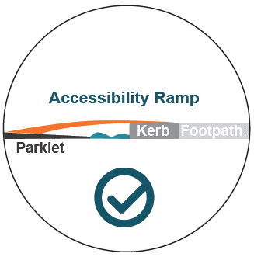
Figure 18: Seasonal Business Parklets are not required to have a platform that is level with the footpath and may therefore use a ramp onto the carriageway.

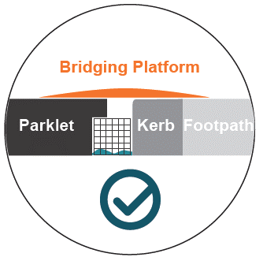 | 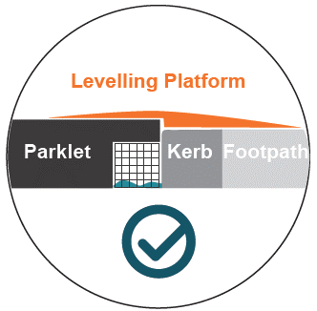
Figure 19: Bridging platform covers a gap between the platform and the kerb upstand. | Figure 20: Levelling platform creates a smooth transition and prevents tripping hazards.

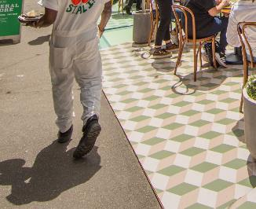 | 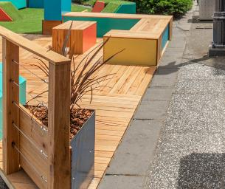
Figure 21: A mat creates a flush transition from the platform to the footpath. | Figure 22: The platform has been constructed at the level of the footpath.
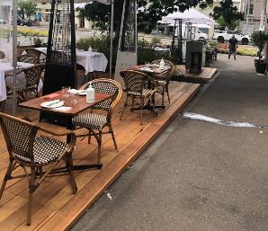 | 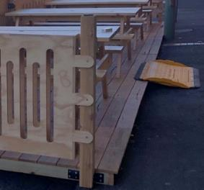
Figure 23: Platform is not flush with surround footpaths. | Figure 24: Ramp is used to gain access to a platform.

Drainage
- A gap of 0.2m between the kerb and the base of the platform frame must be included for storm water drainage
- A rubbish grate should be placed along the edge of the kerb to prevent debris from collecting under a platform
- An inspection lid must be included where a stormwater pit is located underneath a platform
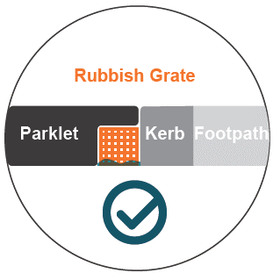 | 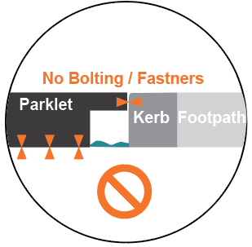
Figure 25: A rubbish grate will prevent litter from being trapped under the platform. | Figure 26: Structures must not be fixed to the pavement or the kerb upstands.
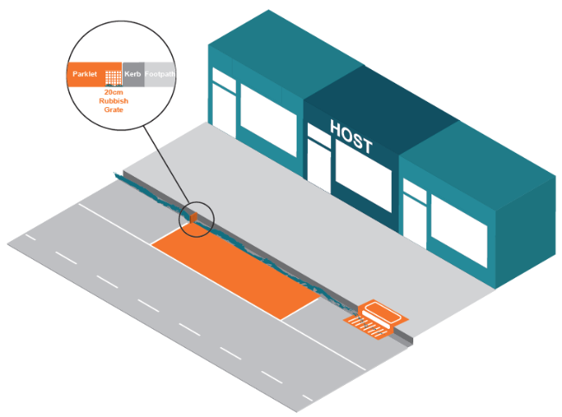
Figure 27: A rubbish grate located at the edge of a parklet.

Materials and design quality
- Business parklets must not be constructed of loose materials that can overflow into surrounding areas (i.e. hay bales).
- Materials used must not deteriorate quickly and be easy to clean.
- Low quality plastic materials are discouraged.
- Low emission, recycled, sustainably sourced and/or locally sourced products are encouraged.
- Natural materials and muted finishes are encouraged, including steel, aluminium, wood and recycled content concrete.
- A ‘neighbourhood character’ approach is encouraged, to provide consistent design outcomes. This can be achieved by traders engaging with others within activity centres.
Planting
- Planting should be provided where practicable in the barrier and buffers but must not overhang.
- Plants under 0.3m in height, should be selected to maintain sightlines.
- The permit-holder must ensure plants are watered and maintained.
- Artificial plants are discouraged.
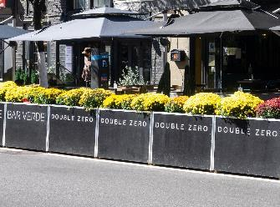 | 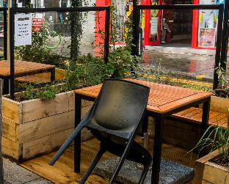 | 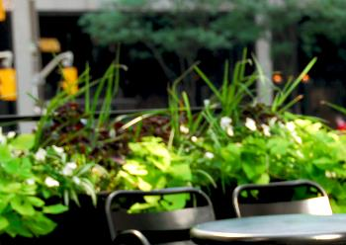
Figure 28: Planting is low to maintain lines of sight. | Figure 29: Vines are tall but not dense to maintain lines of sight. | Figure 30: Some taller plant species are not dense to maintain lines of sight.
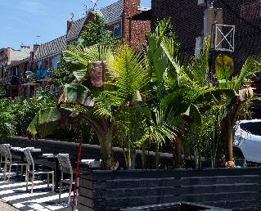 | 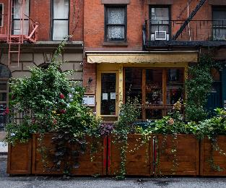 | 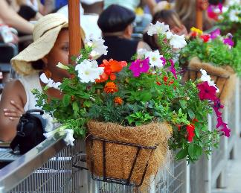
Figure 31: Planting is high and obstructs lines of sight. | Figure 32: Planting is high and obstructs lines of sight. | Figure 33: Planting structure is hanging outside the parklet.

What can go in your business parklet?
Traders that have limited hours of operation will be asked to install fixed furniture elements, to allow the parklet to be used by the community when the business is not in operation.

Removable furniture
- Must be of an outdoor design style.
- Must be hardy, sturdy and portable.
- Must be solid enough to resist wind gusts.
- Must be constructed of materials that do not deteriorate quickly.
- Must be easy to clean.
- Tables and chairs must have a minimum 30mm diameter rubber pad at their base to protect the parklet surface. It is the business owner’s responsibility to maintain the base of all items and ensure items placed on the parklet surface do not cause damage. The cost of repairing any damage will be borne by the permit-holder.
- Must be stackable and readily removable for storage within premises.
- Bar-style furniture is not supported. A table must be between 0.7 to 0.8m in height and a chair or seat between 0.4 to 0.5m in height.
- No advertising is permitted on tables and chairs.
- Council officers must assess all furniture before it is purchased and installed. Furniture designs will be considered on a case-by-case basis.
Placement and storage of removable furniture
- The number of tables and chairs placed within a business parklet must allow for unobstructed access and circulation for all patrons and staff.
- A minimum space of four-square metres is typical for a table and four chairs (2m x 2m) and a distance of 0.5m should be allowed between adjoining settings.
  - 2-person table requires a minimum of 2m² (unless a narrow footpath)
  - 3-person table requires a minimum of 3m²
  - 4-person table requires a minimum of 4m²
- Bench-style furniture is permitted for use in business parklets but must be constructed of lightweight material to ensure easy removal and storage.
- Bench-style furniture must have a gap of 0.5m between each setting to allow unobstructed access and circulation for patrons and staff.
- All furniture must be removed and stored inside the premises outside the of permitted hours of operation, unless otherwise stipulated by the permit.
- The permit-holder must ensure that adequate storage is provided for all furniture. If the business operates beyond the hours approved on the permit, the applicant must indicate how furniture will be securely stacked and/or stored to be rendered unusable.
- Furniture removal must occur without causing unreasonable noise and disturbance to nearby residents.

Fixed furniture
- Must be hardy, sturdy and fixed in place.
- Must be easy to clean.
- Must be constructed of materials that do not deteriorate quickly.
- Furniture should be integrated into the design that uses the space efficiently and maintains seating for community use when removeable furniture is removed.
- No advertising is permitted on fixed furniture.
- Council officers must assess all furniture before it is purchased and installed. Furniture designs will be considered on a case-by-case basis.
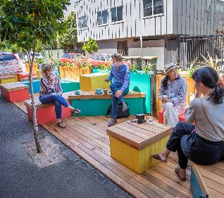 | 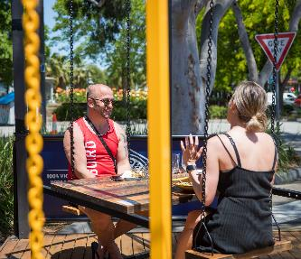 | 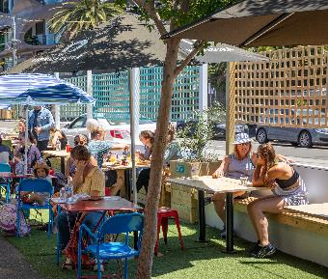
Figure 34: Fixed seating can be part of the structure and never removed | Figure 35: Get creative with fixed seating; these swing seats sit out day and night | Figure 36: Bench seating is used along the permitter and moveable furniture is added each day

Weather protection
Umbrellas
The following design standards apply:
- Must not obstruct traffic signals.
- Must be suitable for use in a commercial, outdoor setting.
- Must not protrude into the buffer causing a hazard to passing people or vehicles.
- May overhang into the footpath area provided there is a minimum clearance of 2.2 metres.
- The colour of umbrellas should be sympathetic to the heritage values and the streetscape.
- Must be adequately weighted or bolted to the parklet structure and lowered during high winds.
Marquees and awnings
Annual business parklet applicants may request structures to provide additional weather protection.
- Plans scaled 1:100 must be submitted, including detail of materials and the written approval obtained prior to construction.
- Must not obstruct traffic signals.
- Must not protrude into the buffer causing a hazard to passing people or vehicles.
- These must be constructed of sturdy materials, able to resist the relevant wind rating and be easy to clean.
- Council does not support the use of temporary marquees, or transparent drop-down blinds.
- A parklet structure 100m² or greater may also require a Building permit.
- Design must also allow for easy removal.
Festoon lighting
Lighting may be used to contribute to the ambience of a business parklet.
- Must be stable (not flashing) and secured to avoid swaying and driver distraction.
- Must be waterproof and suitable for outdoor use.
- Must not be attached to any street tree or public infrastructure without the written approval of Council.
- Should be energy efficient, solar powered, with an automatic timer.
Freestanding patio heaters
Gas heaters are commonly used to heat outdoor dining areas. Due to the potential fire and explosion risks associated with gas heaters it is important that they are properly managed and maintained. Applicants will be required to submit a signed management plan for freestanding heaters to ensure the following:
- An outdoor gas heater must be installed and operated in accordance with the manufacturer’s instructions, such as required clearances from combustibles, maintenance and replacement requirements, performance of safety checks.
- Regular safety checks must be conducted on the gas heater to check for leaks.
- Gas heaters must comply with relevant Australian standards and regulations (AS/NZS 1596:2008 Storage and Handling of LP Gas) and be certified by the Australian Gas Association or equivalent body (e.g., SAI Global).
- A member of staff should be assigned the role of gas supervisor to monitor the safe use and storage of gas heaters and cylinders. All staff should be trained in operating the gas heater, in hazards of using gas and in relevant safety procedures. The gas supervisor should be fully conversant with the manufacturer’s instructions, clearances requirements, safety checks for holes and leaks and how to safely store and handle gas cylinders.
- Preventative maintenance should be scheduled and conducted on all outdoor gas heaters, with records of all maintenance performed.
- The applicant must ensure that they are covered under their insurance policy for the use of gas heaters.
- The business parklet area should be supervised to prevent unauthorised relocation and operation of gas heaters by patrons.
- Gas heaters should be checked by a licensed gasfitter every 12 months, or sooner if required.
- Gas cylinders must be stored in an external and secure location after hours, but not within the business parklet. Gas cylinders must not be stored inside premises.
- Gas heaters should only be switched on at a patron’s request. Staff should monitor the usage of heaters within the business parklet and switch heaters off when the area is not is use.
- The transfer of gas between cylinders must not be conducted at a business premises.

Information required with application
- Complete application form with business name, ACN and ABN.
- Copy of any relevant Planning Permit for the business.
- Copy of any relevant Liquor Licence including red-line plan.
- Copy of internal floor plan, including sanitary facilities available.
- Consent of owner, body corporate and/or occupier neighbouring premises, if proposing to occupy space in front of a neighbouring premises.
- Plan of existing conditions to scale 1:100 and fully dimensioned to show:
  - building frontage, and footpath
  - abutting properties with business names
  - infrastructure - trees, light poles, litter bins, public seats, bicycle stands,
fire hydrants, stormwater pits, utility or telecommunication assets
  - parking bays and parking restrictions
  - any adjacent footpath outdoor dining or advertising boards
  - any other relevant features.
- Proposed site plan of the business parklet to scale 1:100 and fully dimensioned to show:
  - barriers, planters, platforms, and any other structures, with buffer setbacks from adjacent traffic/bicycle lanes and adjacent parking bays
  - any inspection lids to stormwater pits, utility or telecommunication assets
  - layout of removal and fixed table, chairs, screens, heaters, umbrellas, waiter stations or other items
  - any adjacent footpath outdoor dining or advertising boards
- Proposed elevation plans of the business parklet to scale 1:100 and fully dimensioned to show:
  - barriers, planters, platforms, and any other structures, with buffer setbacks from adjacent traffic/bicycle lanes and adjacent parking bays
  - cross-section to show a gap of 0.2m between the kerb and the base of the platform frame
  - advertising/business logos
  - any other structures
- Proposed furniture and plants including photographs, design specifications and materials to show compliance with the Guidelines.
- Photographs showing the proposed area of occupation and immediate surrounds.
- Advertising details, including a colour photograph or detailed design drawings to scale of any proposed advertising logo, and clear indication of its size and location on barriers and umbrellas. Note: If total advertising area exceeds 8m² a planning permit is required.
- Public liability insurance noting Council’s interest and for no less than $20M in respect of any single occurrence.
- Form of indemnity to indemnify the Council against all claims of any kind arising from any negligent act either by the permit holder or the permit holder’s agents and users.
- Payment of application fee
Failure to submit all required information will result in delays in considering the application.

Decision making

Business parklet priorities
The diagram below shows the order of Council’s priorities for business parklets. It is a principle‐based rule‐of‐thumb for all decisions relating to business parklets.
For example, Council’s highest priority at all times is public safety, although this is not the only concern. Public safety can be addressed while also creating a vibrant street life, ensuring accessibility for all and balancing a prosperous local economy with residential amenity. Indeed, achieving all these priorities is Council’s goal.
There are times when this is not possible and Council must favour one over another. For example, business parklets gives streets a vibrancy and liveliness but it must be limited (in amount and location), to ensure that footpaths and carriageways can be safely used by all members of our community.

Figure 37: Council’s business parklet priorities
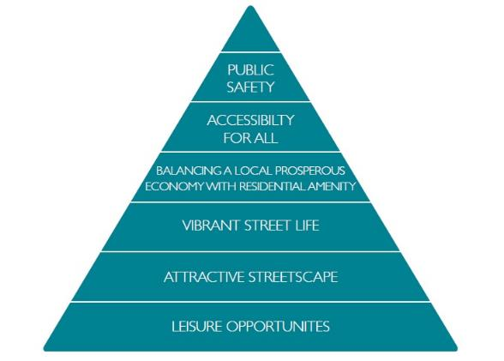

Table 5 Council’s business parklet priorities and objectives
Priority | Objectives
Public safety | - Streets are safe and have unobstructed passage on the carriageway and on the footpath  - Streets have clear views for all modes of transport  - Streets are safe and unobstructed passage for those who may be physically or visually impaired
Accessibility for all | - Streets are inclusive so that anyone with an impairment will be able to access public space activations  - People who are pushing prams or using mobility devices will be able to access the facility  - Streets are easily navigated by all transport modes  - Support public transport  - Retention of loading zones, disabled bays, bus zones and car share bays  - Support access to local businesses and residences
Balancing a prosperous local economy with local amenity | - Supporting a prosperous local economy is balanced with ensuring that a public space activation (and any associated off-site impacts) do not cause any significant impacts on the function and amenity of surrounding areas in relation to nuisance, noise, and other amenity considerations.
Vibrant street life | - Streets are vibrant and lively  - Streets contribute positively to an area’s sense of place and character.
Attractive streetscape | - Streets are attractive, clean and pleasant  - Heritage significance is not diminished
Leisure opportunities | - Public space activations support social interaction, alfresco dining and drinking as enjoyable leisure activities

Assessment process
On receiving an application, the authorised officer will:
- Check that all relevant information has been received
- Check that the use is legally established under the Planning and Environment Act 1987
- Check the application to ensure it meets the intent and requirements of the Local Law and the Business Parklet Guidelines
- Inspect the site and checks the accuracy of submitted plans
- Refer the application to relevant Council departments for advice
- Assess the application against the Business Parklet Guidelines
- Assess the application against any outstanding matters that may relate to the premises
- Advise the applicant of any changes that need to be made to the submission.
- Approve with conditions or refuse the permit application.
Council will invoice the applicant for the fees payable with the business parklet. Fees are not refundable. Once payment has been made and the permit has been issued, installation and use of business parklet may commence in accordance with the permit and conditions.

Decision-making on applications
Where applications meet all the Guidelines, the Council will normally grant a permit. In cases where an application does not clearly meet the Guidelines or where there are special circumstances, the application will be referred to the Council’s City Permits Panel for further consideration. The Panel will provide its recommendation to the authorised officer who will approve or refuse the permit application. The Panel is comprised of senior officers from across the Council.
In some cases, a variation to these Guidelines may be granted if the priority objectives can be met and there are extenuating circumstances. Each decision will be decided on its merits including:
- the number and location of business parklets within an activity centre
- the length of previous business parklet occupation and any waiting list
- consent of owner, body corporate and/or occupier neighbouring premises, if occupying space in front of a neighbouring premises
- the effect on vehicular traffic flows and safety;
- the impact on residential amenity;
- the impact on the appearance of the street and its surroundings;
- the duration of use;
- compatibility with other uses in the street;
- whether it is complementary to the primary adjoining use;
- whether it is less intensive than the primary adjoining use;
- the ability to provide adequate sanitary facilities;
- the applicant’s previous record of compliance;
- any relevant policies of the Council; and
- any other matter relevant to the application.
In situations where demand outstrips availability preference will be given to applications that demonstrate:
- shared use between multiple traders
- likely high usage from community (including hours of activation)
- positive contribution to amenity and vibrancy of location

Review of decisions
An applicant may seek a review of an officer’s decision by submitting their request within 28 days of the decision, including all information to be taken into consideration, for review by the City Permits Panel.
In cases where an application does not meet the Guidelines, or where there are special circumstances, the officer may refer the matter to the City Permits Panel, to provide their recommendation to the authorised officer.
In some cases, a variation to these Guidelines may be granted if the priority objectives can be met and there are extenuating circumstances.
The City Permits Panel will also provide advice on any issues in relation to serious or ongoing breaches of permit conditions.
The Panel will consider applications using the Business Parklet Guidelines and City of Port Phillip’s Community Amenity Local Law.

Council responsibilities

Maintenance of the footpath and carriageway
Council is responsible for managing the maintenance of the footpath and carriageway and reserves the right to access the footpath and carriageway or remove business parklet infrastructure at any time.

Compensation and loss of trade
Council is not responsible for providing any compensation for the removal of a business parklet or for any loss of trade when Council and other service authorities are required to carry out works within the footpath or carriageway. The permit-holder is responsible for reinstating any fittings or fixtures, not the person, service authority or contractor executing the works.
No compensation is provided for any problems, inconvenience or loss of trade resulting from activities or works carried out by the Council, service authority or its contractors at, or adjacent to, a permit holder’s business parklet.

Monitor compliance with approved permit
Council’s authorised officers will monitor the operation of permits and ensure the conditions of the permit are met.
Following a complaint or observation of a breach of a permit, a Council officer will contact the permit holder and take appropriate enforcement action. This may be in the form of verbal instructions, a written notice or an infringement notice.
In the case of a serious breach, an officer may act immediately to resolve the situation. A serious breach is one where the officer considers there is an immediate public safety risk. This may include instances where access is impeded to an extent that it would be difficult or impossible to walk freely through the pedestrian zone or drive freely through the adjacent carriageway.
Each breach will receive a warning or an infringement notice depending on the gravity of the offence. Where three breaches have occurred within a twelve-month period, these will be referred to the City Permits Panel to consider if the permit should be amended or cancelled.

Relevant policy, regulations or legislation
City of Port Phillip Local Law No. 1 (Community Amenity) September 2013 (amended November 2017)

Attachments
- Business Parklet Standard Conditions
- Maps of activity centres

Business Parklet Standard Conditions

In addition to complying with any relevant requirements in the Community Amenity Local Law No.1, the following conditions apply to the activity or use:

- The layout and use must not be altered without the written consent of the Council.
- All clearances from traffic/bicycle lanes, adjacent parking bays, public seating, litter bins and any other public infrastructure must be maintained.
- The occupation of the business parklet must have a limited impact on residential amenity and the neighbourhood.
- The use and operation of the business parklet must be in accordance with the hours of use detailed in the permit. If the hours are not stipulated, the use and operation must cease by 11pm every day.
- Council reserves the right to reclaim access to the land at any time for maintenance purposes. Should any fittings fixed within the business parklet need to be removed temporarily due to the nature of the maintenance, Council will reinstate them accordingly and to the best of its abilities.
- Council and other service authorities reserve the right to access all underground services within the business parklet at any time, without notice to the permit-holder.
- No compensation will be payable for any removal of fittings or fixtures associated with the business parklet, or for the loss of trade experienced due to these works.
- The maintenance of the business parklet, including sanitation, graffiti, litter removal and damage is the responsibility of the permit-holder.
- A copy of permit must be kept on-site and presented to an authorised officer upon request.
- The City of Port Phillip reserves the right to amend or revoke the permit at any time.

Parklet Design
- The business parklets must not be constructed of loose materials.
- Platforms must be no more than 6mm difference in height than the adjacent kerb.
- Platforms, ramps and structures must ensure stormwater flow is not obstructed.
- Platforms and structures in proximity of stormwater entry pits must be designed to enable access and maintenance to occur.
- Platforms and structures must include inspection lids to allow unobstructed access to all Council and service authorities assets.
- Furniture design must consider any camber of the road surface and be of safe, sturdy construction.
- Outdoor dining tables must not exceed 800mm in height and chairs 500mm in height.
- Removal furniture must be stored inside the premises outside the of permitted hours of use, unless otherwise approved by Council.
- Marquees and other structures are not permitted unless approved by Council.
- The design of ramped access must include a clear path of travel in accordance with Australian Standard
AS 1428.1-2009.
- Reflective tape must be placed along the top edge of the platform, at 0.75m height and on each top corner and opposite ends of the business parklet.
- All business parklet furniture and structures must be easily removed at the expiry or cancellation of a permit, or if a business ceases trading. Council assets including kerbing, footpath and road surfaces must be made good and reinstated to its original condition.

Health
- The preparation, handling and serving of food and drinks to patrons must be conducted in accordance with the requirements of the Food Act 1984 (Vic), National Food Safety Standards and Council’s Health Services Unit.
- The use and activity within the business parklet must be in accordance with the venues COVIDSafe Plan and the directions of the Department of Health & Human Services (DHHS).

Venue Management
- All patrons must be seated within the business parklet.
- Patron numbers must not exceed the maximum permitted by Council and the Department of Health & Human Services (DHHS).
- Liquor must not to be sold, consumed or served within the business parklet unless the area is covered by a current valid liquor license.
- Venue management must ensure that the pedestrian zone is kept clear of patrons and any items unless approved by Council.

Waste Management
- Litter generated from the business parklet must not be swept into the gutter or adjacent areas and must be deposited within the operator’s own bins kept within the premises.
- The stormwater channel must be maintained daily to remove any litter.
- Where smoking is permitted under the Tobacco Act 1987, windproof ashtrays must be provided for patrons wishing to smoke within the business parklet.
- Tables must be cleared of all bottles, glass and tableware and be kept clean to ensure safety and cleanliness for other patrons.

Noise
- No form of external public-address system or sound amplification equipment shall be used outside the premises.
- The use of the business parklet must not cause nuisance and shall not have an impact on the residential amenity of the neighbourhood by the emission of excessive noise.

Risk management
- Public liability insurance of $20 Million must remain current, extend to include the whole area as detailed in the business parklet permit and be valid for the life of the permit with a copy forwarded to Council upon renewal.
- The permit-holder will be held responsible for any damage caused to Council assets.
- No compensation will be payable for any flood related damage, as the carriageway is part of the stormwater overland flow.
- The permit-holder indemnifies and releases the City of Port Phillip from all liability arising from the use of the business parklet, including any claims made by any person for injury, loss or damage, howsoever caused.
- Council must be notified immediately of any damage to public assets, as well as any other condition that creates a hazard to the public.

Planters
- Planters must be regularly watered and maintained by the permit-holder.
- Plants must be under 0.3m in height, unless approved by Council.

Umbrellas
- Any permitted umbrellas must maintain a minimum of 2.2 metres from the underside of the umbrella to the finished floor level of the business parklet.
- Any permitted umbrellas must not protrude beyond the business parklet.
- Any permitted umbrellas must be adequately weighted or bolted to the business parklet structure and lowered during high winds.

Heaters
- Stand‐alone heaters must comply with Australian Standard AS 1596 and be certified by the Australian Gas Association.
- The use and operation of gas heaters must be in accordance with the requirements of Energy Safe Victoria (ESV).

Signage
- Council reserves the right to install and maintain promotional and advertising signage to the exterior of the business parklet structure.
- Advertising within or on the business parklet structure must not contain political messaging or promote tobacco, gambling, alcohol, violence or illegal activities.

Major events
- During major events such as New Year’s Eve, additional conditions apply. This includes no glass bottles or glassware permitted within the business parklet unless expressly permitted.

Compliance
- A breach of any of the conditions of the business parklet permit may result in enforcement action being taken against the permit-holder and/or the organisation responsible for the permit. This action may include the issuing of a Notice to Comply, fines, cancellation of the permit and/or impounding of items.
- Any enforcement action that is required in relation to the permit may affect future requests for business parklets or footpath trading.

