Draft Domestic Animal Management Plan
Engagement summary report – phase 2
October 2021

Contents
Executive summary 3
Developing the draft Animal Management Plan 3
Engagement approach 3
Engagement findings 4
Introduction 7
Purpose of this report 7
Purpose of engagement 7
Communications 7
Limitations 8
Engagement Approach 9
Who we engaged 9
How we engaged 10
Engagement findings 11
Summary of key results from the survey 11
Survey results 16
Theme 1: Responsible pet ownership through information, education and services 18
Theme 2: Balancing the need for dog friendly areas with other open space uses 22
Theme 3: Partnerships 25
Theme 4: Pet regulation and compliance 27
Theme 5: Minimising overpopulation and animal euthanasia 30
Overall satisfaction with the draft Plan 33
Online forum responses 36
Email responses 37
Engagement experience 38
Appendix A: Survey demographic data 42
Appendix B: Forum comments 47
Appendix C: Email feedback 55

Executive summary

Developing the draft Animal Management Plan
Under the Domestic Animals Act 1994, every Victorian local government must prepare a Domestic Animal Management Plan (DAMP) outlining how it will manage dogs and cats within its municipal boundaries. This Plan is renewed every four years.

The City of Port Phillip’s Domestic Animal Management Plan provides Council with a strategic approach towards promotion of responsible pet ownership, the welfare of dogs and cats in the community and the protection of the community and the environment from nuisance dogs and cats. The plan also outlines how Council will enforce all legislative requirements and compliance with our local laws.

Engagement approach
The engagement approach included two rounds of community engagement: consultation to inform development of the draft plan (May 2021); and consultation to gather feedback on the draft plan (August 2021).

As part of the first round of engagement to inform the draft plan we wanted to understand from our community what they perceive as the most prevalent animal issues and what aspects of animal management are working well, along with what could be improved.

This feedback was used to develop our draft plan, which was released for community feedback from 6 August to 5 September 2021. A total of 561 people were engaged primarily via an online survey, online forum and email.

There were 537 survey responses received, with the majority of respondents being Port Phillip residents (476; 89%) and / or being pet owners (470; 88.5%)

An online forum was set up with Council officers available at set times to respond in real time to any questions from the community about the draft plan. Twenty-seven responses were received from 14 community members through this channel.

The engagement was promoted via Council’s online communications channels, including Divercity, social media and e-newsletters. Emails were also distributed to all registered pet owners as well as a range of key stakeholders within animal organisations and sporting clubs, inviting them to provide feedback.

Engagement findings
In August and September 2021, the City of Port Phillip consulted the community on the draft Domestic Animal Management Plan. A total of 561 community members were engaged, primarily via an online survey on Council’s Have Your Say platform. Feedback was also received through an online forum on Council’s Have Your Say platform, and by email.
Survey respondents were predominantly Port Phillip residents (89%) and overwhelmingly pet owners (88.5%), in particular dog owners. The large number of respondents, and in particular the large number of respondents who were pet owners, suggests a high level of interest in responsible pet ownership and the outcomes of the Domestic Animal Management Plan in the City of Port Phillip.
Some key findings of the engagement were:
Elements of the draft Plan supported by community members:
- There was generally a high level of satisfaction across all themes for the draft Plan
- The proposed fenced dog off-leash areas were supported
- The proposed actions to support businesses to be dog friendly was liked by respondents
- Implementing a cat curfew was generally supported
- Actions proposed to minimise overpopulation and animal euthanasia were strongly supported.
Elements of the draft Plan less supported by community members
- Balancing the needs of sporting clubs and dog owners through a 20 metre on-leash rule around sports games and trainings was not widely supported
- The proposed permit system for walking more than six dogs was generally not supported.

There is generally a high level of satisfaction for the draft Plan
There was generally a high level of satisfaction across the five Themes, with more than 60% of respondents indicating some level of satisfaction with the proposed actions for most themes. In particular, the actions proposed for Theme 5: minimising over-population and animal euthanasia which were supported by 81.9% of respondents. Theme 4: regulation and compliance, however, received the least amount of support, with a satisfaction level of 58.8%.

Participants supported investigating more fenced dog off-leash areas in City of Port Phillip
Many respondents (57) were happy to see the proposed actions in the draft Plan to investigate fenced dog off-leash areas at Clarke Reserve in Elwood and along the light rail line in Port Melbourne. Respondents would also like to see other parks around the municipality considered for fenced off-leash areas, such as Peanut Farm, Hester Reserve and Lagoon Reserve, as well as at the proposed new off-leash area for MO Moran Reserve. Some respondents would like to see a greater commitment to delivering fenced off-leash areas than the ‘investigation’ proposed.

Strong support for actions promoting local businesses becoming dog friendly
Respondents liked the idea of supporting local businesses to be dog friendly, with 36 respondents indicating they supported this action. This action was the most supported of all proposed actions for Theme 3. The proposed door stickers to indicate dog friendly businesses were generally thought to be a good way to communicate this.

Respondents had diverse opinions on the proposed action to balance the use of sporting fields
A new Council Order was proposed in the draft Plan for dogs to be on-leash within 20 metres of sports fields when in use for training and games, as well as being prohibited from entering the ground during these times. The feedback indicated that there is diverse community opinion on this action, with a number of respondents (23) expressing they were against the proposed Order, and several respondents (7) referencing they were in support of the proposed Order. There was some confusion as to when and where the rule would be applicable.

Strong support for actions proposed to minimise over-population and animal euthanasia
The actions proposed to minimise over-population and animal euthanasia were strongly supported, with respondents (50) expressing they were happy with the proposed actions within Theme 5. In particular, the proposed desexing measures of mandatory cat desexing (30), and free desexing services (26) were supported. Some respondents thought mandatory desexing should be extended to include dogs as well (20).

The proposed cat curfew garnered both support and opposition
There were divided opinions on the proposed cat curfew, with 75 respondents to Theme 4 supportive of a cat curfew of some kind. Of these, 48 respondents supported the proposed night-time cat curfew to stop cats roaming and killing local wildlife. A further 27 respondents thought the curfew could be stricter, with cats confined to their property at all times of the day. Conversely, some respondents (42) did not support the proposed cat curfew. Several respondents (9) would like greater clarity about how the cat curfew would be implemented and enforced.

Enforcement of the proposed actions was supported to ensure effectiveness
The proposed actions in Theme 1 to increase Authorised Officer patrols to increase compliance with dog waste collection around the municipality were supported, with respondents (38) commenting on the need for greater enforcement. Respondents also stated they would also like to see an increased focus on enforcement for other issues, such as increasing dog leash regulation compliance, and addressing out of control dogs. Across themes, respondents indicated they thought enforcement was key to the success of the actions proposed.

The proposed actions could do more to address some key issues, such as dog waste management
Across themes, respondents highlighted they thought dog waste and compliance with dog off-leash regulations were issues across the municipality. Respondents would like to see the proposed actions better address these issues, in particular, by Council providing dog waste bags which was suggested by 44 respondents to Theme 1.

Diverse opinions of the proposed permits for walking more than six dogs
There were diverse opinions between respondents who commented on the proposed actions to require a permit to walk more than six dogs at a time, with 25 respondents stating they were against the proposed permit system, and 15 respondents stated they were in support of the idea. Respondents who indicated they were against the idea would like to see professional dog walkers better supported, and felt the permit system would negatively impact their small businesses. Some respondents who supported the permit system thought a lower number of dogs would be appropriate.

Introduction

Purpose of this report
The purpose of this report is to provide a summary of community engagement on the draft Animal Management Plan. It details the engagement techniques used and presents the findings from this engagement program.

Purpose of engagement
The purpose of this engagement was to inform the community on the development of the Domestic Animal Management Plan and to provide feedback on the draft plan prior to finalisation.

Communications
We communicated with our community about this engagement using a range of online methods via our Have Your Say site, emails, social media channels and Council’s online Divercity newsletter.

Due to the closure of most Council facilities and COVID-19 restrictions, several distribution channels were unavailable, and promotion relied predominantly on online methods. Emails with information about the consultation were distributed to all registered pet owners, and through Divercity Online and Have Your Say newsletters.

The project page was updated on Have Your Say with information about the consultation process, FAQs and online forum and survey.

Information about the consultation process and opportunities to be involved were promoted via Council’s social media channels (Facebook and Instagram). To promote the consultation to a wider audience, a social media advertisement was created on Facebook and Instagram, targeting the Port Phillip area.

Limitations
Limitations to the community engagement process include:
- Consultative engagement provides only a high-level snapshot of community sentiment and does not reflect any deeper deliberation of issues and challenges.
- Contributions to this consultation do not necessarily constitute a representative snapshot of our community, as people self-selected to participate.
- Due to COVID-19 restrictions and lockdown there were limited opportunities for face-to-face engagement activities during the consultation period and digital engagement was the main delivery mode.
- A high proportion of respondents were pet owners (88.5%, 470 respondents). Dog owners in particular have high levels of representation, with 314 respondents owning a dog. Consequently, the survey may not provide a balanced perspective on the competing needs of pet owners and non-pet owners, particularly when it comes to balancing use of public open space.
- A low number of responses were received from members of sporting clubs (1.9%, 10 respondents) compared to dog owners (314 respondents). The survey therefore may not provide a balanced perspective on the competing needs of dog owners and other sporting facilities users.

Engagement Approach
This section details the community engagement approach in developing and consulting on the draft Domestic Animal Management Plan.
In May 2021 we asked our community through a series of neighbourhood-based pop up engagements and survey what they perceive as the most prevalent animal issues and what aspects of animal management are working well, along with what could be improved.
This feedback was used to inform the draft Domestic Animal Management Plan, which was released for consultation from 6 August to 5 September 2021.

Who we engaged
A series of demographic questions were asked as part of the survey. The following provides a brief snapshot of who we engaged through the survey. Detailed demographic data is provided as Appendix A to this report.
- The majority of respondents were Port Phillip residents (476; 89%) and / or being pet owners (470; 88.5%)
- Survey respondents were predominantly female (69.1%)
- Over half of respondents were aged between 35 to 49 years old (336; 62.60%)
- The most common suburbs that respondents resided in were Port Melbourne (128; 23.8%), followed by Elwood (98; 23.8%) and then St Kilda (89; 16.6%).

How we engaged
The engagement program was hosted on Council’s Have Your Say online engagement portal and feedback was channelled primarily through an online survey seeking feedback on the proposed actions in the draft Plan. Five hundred and thirty-seven responses were received.

An online forum was also hosted on Have Your Say, to provide a space for the community members to provide feedback and have questions answered by Council’s Animal Management team.

The following table provides a summary of the activities and tools used to promote the engagement and seek feedback.

Channel | Reach / Participants
Advertising
Emails to Have Your Say newsletter subscribers | Approximately 3,600 emails  - Sent on 5 August – open rate 70%  - Sent on 20 August – open rate 49%
Divercity Online | Approximately 4,200 emails  - Sent on 12 August – open rate 55%
Council’s social media – Facebook, Instagram, LinkedIn | Facebook  - Three organic posts – 8,364 people reached  - One advert targeting those in the Port Phillip area - 11,517 people reached  - Posts shared to 10 community Facebook groups  Instagram  - Three organic posts – people reached 2,134
Email to registered pet owners | Approximately 9,675  - Sent on 12 August - open rate 60%
Emails to stakeholders | 25 emails
Responses
Online responses via Have Your Say | 3,181 visitors to the Have Your Say page  - 537 survey responses  - 27 posts to the forum
Other responses  Written emails, phone calls and  social media comments | 10 emails received.

Engagement findings

Summary of key results from the survey

We asked | You said
Relationship with domestic animals in the City of Port Phillip  (531 respondents) | - 88.5% (470) pet owners  - 10.7% (57) non-pet owners
Pet ownership status  (470 respondents) | 66.8% (314) dog owners  23.8% (112) cat owners  9.4% (44) owners of dogs and cats
Satisfaction with Theme 1: Responsible pet ownership through information, education and services  (537 respondents) | 62.2% (326) were satisfied or very satisfied with the proposed actions  21% (113) were neutral about the proposed actions  16.8% (90) were dissatisfied or very dissatisfied with the proposed actions  300 respondents provided a reason for their level of satisfaction. Top responses:  - 44 respondents would like to see Council providing dog waste bags to promote responsible pet ownership  - 38 respondents support increased patrols for enforcement of dog waste collection  - 37 respondents are happy with the proposed actions as they currently stand
Satisfaction with Theme 2: Balancing the need for dog friendly areas with other open space uses  (537 respondents) | 60.7% (326) were satisfied or very satisfied with the proposed actions  19.4% (104) were neutral about the proposed actions  19.9% (107) were dissatisfied or very dissatisfied with the proposed actions  273 respondents provided a reason for their level of satisfaction.  Top responses:  - 57 respondents support investigating fenced dog off-leash areas  - 25 respondents are against the proposed dog walking permits for more than 6 dogs, while 15 respondents support this proposed action  - 24 respondents support the proposal to investigate opportunities for increased dog off-leash areas  - 23 respondents are against the proposed Council Order for dogs to be on leash within 20m of sports grounds in use, while 7 respondents support it.
Satisfaction with Theme 3: Partnerships  (536 respondents) | 68.8% (369) were satisfied or very satisfied with the proposed actions  20.3% (109) were neutral about the proposed actions  10.8% (58) were dissatisfied or very dissatisfied with the proposed actions  177 respondents provided a reason for their level of satisfaction. Top responses:  - 36 respondents like the idea of supporting businesses to be dog friendly  - 34 respondents are happy with the proposed actions as they currently stand  - 22 respondents found some of the proposed actions unnecessary  - 20 respondents gave suggestions for other partnerships to be explored by Council
Satisfaction with Theme 4: Pet regulation and compliance  (536 respondents) | 58.8% (315) were satisfied or very satisfied with the proposed actions  19.8% (106) were neutral about the proposed actions  21.5% (115) were dissatisfied or very dissatisfied with the proposed actions  266 respondents provided a reason for their level of satisfaction.  Top responses:  - 75 respondents support a cat curfew, with 48 respondents supporting the night time cat curfew proposed and a further 27 supporting a stricter curfew  - 32 respondents found the proposed actions to be unnecessary over-regulation  - 23 respondents supported increased enforcement through patrols
Satisfaction with Theme 5: Minimising overpopulation and animal euthanasia  (537 respondents) | 81.9% (440) were satisfied or very satisfied with the proposed actions  10.4% (56) were neutral about the proposed actions  7.6% (41) were dissatisfied or very dissatisfied with the proposed actions  162 respondents provided a reason for their level of satisfaction  Top responses:  - 50 respondents are happy with the proposed actions as they stand  - 30 respondents support mandatory cat desexing  - 27 respondents support free or discounted desexing services
Overall satisfaction with the draft Plan  (537 respondents) | 60.0% (322) were satisfied or very satisfied with the draft Plan  20.5% (110) were neutral about the draft Plan  19.6% (105) were dissatisfied or very dissatisfied with the draft Plan  291 respondents provided a reason for their level of satisfaction.  Top responses:  - 24 respondents believe enforcement of the proposed actions will be key to its success  - 23 respondents would like to see Council provide dog waste bags  - 22 respondents are happy with the Plan as it currently stands

Summary of key results from other engagements

Online forum responses (27 responses by 14 respondents) | Top responses received:  - 9 responses were related to reviewing the current beach restrictions for dogs  - 4 responses were related to fenced dog off-leash areas
Email responses (10 responses) | Top responses received:  - 5 email responses received were in opposition of the proposed Council Order for dogs to be on-leash within 20m on sports games and training

Summary of satisfaction with the draft Plan
were satisfied or very satisfied with Theme 1: Responsible pet ownership through information, education and services
were satisfied or very satisfied with Theme 2: Balancing the need for dog friendly areas with other open space uses
were satisfied or very satisfied with Theme 3: Partnerships
were satisfied or very satisfied with Theme 4: Pet regulation and compliance
were satisfied or very satisfied with Theme 5: Minimising overpopulation and animal euthanasia

were satisfied or very satisfied overall with the draft Plan

Survey results

Relationship to domestic animals in the City of Port Phillip

I am a: (select all that apply) (531 respondents)
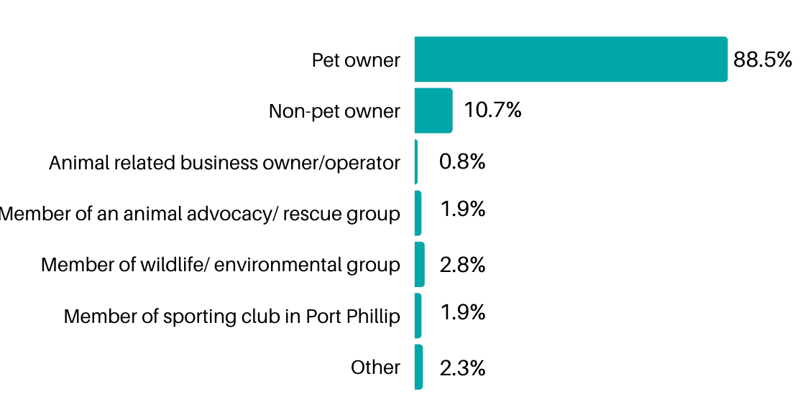

Relationship to domestic animals | Number of respondents (531 total) | Proportion of respondents
Pet owner | 470 | 88.5%
Non-pet owner | 57 | 10.7%
Animal related business owner/operator | 4 | 0.8%
Member of an animal advocacy/ rescue group | 10 | 1.9%
Member of wildlife/ environmental group | 15 | 2.8%
Member of sporting club in Port Phillip | 10 | 1.9%
Other | 12 | 2.3%

‘Other’ including: past pet owner, resident, person interested in domestic animal management, domestic animal services employee, and prospective pet owner.

Which group or organisation do you belong to? (25 respondents)

- Sporting groups (36%, 9 responses) including: Surf lifesaving, Elwood Cricket Club, Touch Football Victoria, Albert Park Bowls Club, Port Melbourne Netball Club, Royal Melbourne Yacht Squadron, St Kilda Baseball
- Animal rescue organisations (32%, 8 responses) including: RSPCA, Lort Smith, Lost Dogs Home
- Local environmental organisations (28%, 7 responses) including: Elsternwick Park Association, Earthcare St Kilda
- Environmental organisations (24%, 6 responses) including: WWF; Animal welfare groups (20%, 5 responses) including the Animal Justice Party, Wildlife conservation organisations (16%, 4 responses) including Wildlife Victoria,

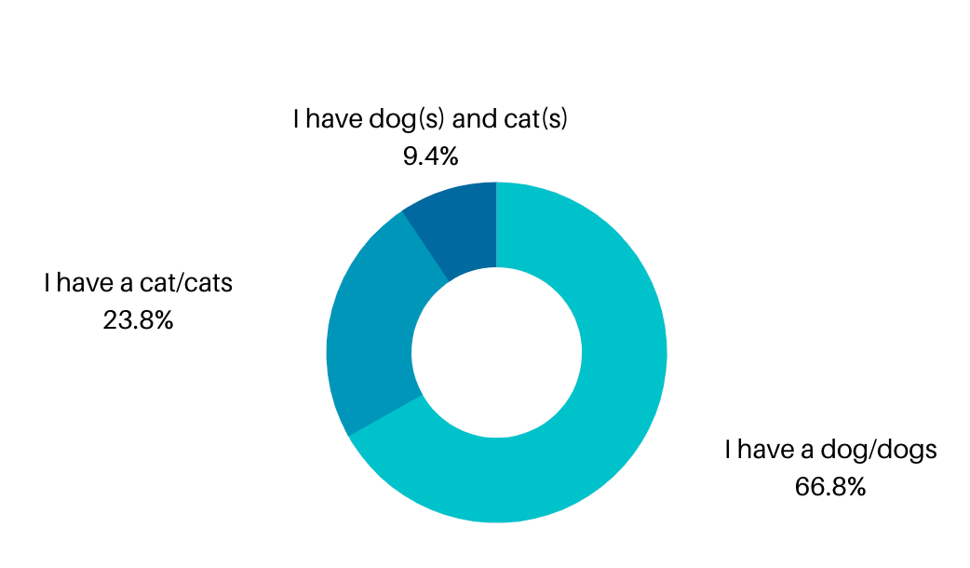
Pet ownership status (470 respondents)
Q. Which of the following describes your pet ownership? Choose only one option.

Pet ownership | Number of respondents (470 total) | Proportion of respondents
I have a dog/ dogs | 314 | 66.8%
I have a cat/ cats | 112 | 23.8%
I have a dog(s) and cat(s) | 44 | 9.4%

Theme 1: Responsible pet ownership through information, education and services

of respondents were satisfied or very satisfied with the proposed actions for Theme 1

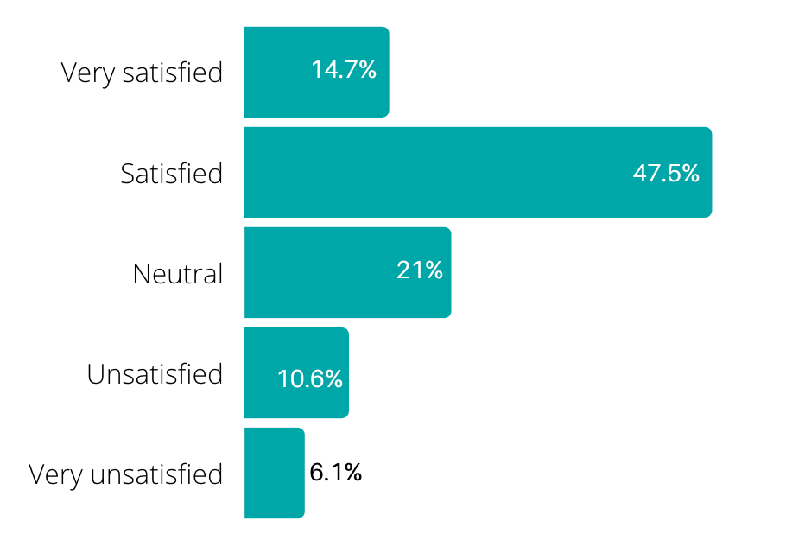
Level of satisfaction with proposed actions | Response count (537 total) | Proportion of responses
Very satisfied | 79 | 14.7%
Satisfied | 255 | 47.5%
Neutral | 113 | 21.0%
Unsatisfied | 57 | 10.6%
Very unsatisfied | 33 | 6.1%

Respondents were given the opportunity to provide a reason for their level of satisfaction. Three hundred of the 537 survey respondents provided an answer to this open-ended question.

General comments about the proposed actions in the draft Plan:

Happy with the actions as is | A number of respondents (37) indicated they were happy with the draft Plan. Of these, 16 respondents thought the actions were thorough and covered everything, while 10 respondents thought the actions proposed were reasonable.
Actions may not be enough to be effective | Some respondents (19) thought the actions may not be enough to be effective to promote responsible pet ownership, particularly around the issues of owners picking up their dogs' waste and dogs walking off-leash when they shouldn’t.  “...the actions are fine but insufficient. additional actions are required to provide a reasonable balance of rights and protections for people from the dogs of irresponsible dog owners.”
Greater balance needed in actions for dogs and cats | Some respondents (18) thought the proposed actions were heavily weighted towards dogs. Respondents pointed out that responsible pet ownership should also include cats, and would like to see more done to promote responsible pet ownership with regards to limiting cats roaming to protect wildlife. Some respondents would also like to see actions related to cats due to perceived lack of value obtained from cat registration fees.
Some actions are unnecessary | Some respondents (15) expressed they felt the proposed actions to be unnecessary, with most concerned about the cost.  “Many of these initiatives seem to be a waste of council resources and finances.”

Feedback on specific proposed actions in the draft Plan:

Enforcement | A number of respondents (38) commented on the need for greater enforcement, agreeing with the proposed action to increase patrols for compliance on dog waste collection. Respondents stated they would also like to see an increased focus on enforcement for other issues, such as increasing dog leash rule compliance, and addressing out of control dogs. Several respondents (11) stated they would like to see fines given by patrolling officers to increase the effectiveness of enforcement.
Education and awareness raising | Some respondents (14) generally supported the education and awareness initiative proposed for dog owners regarding dog waste, but would also like to see education and awareness raising initiatives for responsible dog management in off-leash parks, as well as care and safety around pets for both pet and non-pet owners.  “More education needs to be done on teaching dog owners to be more responsible when walking dogs.”
Increased signage | Some respondents (14) supported the proposed increased signage, particularly the footpath stencils, to enable dog restrictions to be clearly communicated.  “I would like to be able to walk with my dog off-leash (as opposed to just having him leash in a fenced dog park), and being able to identify permitted and appropriate areas would be wonderful.”  A small number of respondents (3) were not in support of the footpath stencils, citing cost as the reason.
Protection of wildlife | Some respondents (13) were concerned with the protection of wildlife, and thought that the education and awareness initiatives proposed to inform pet owners about the risk to wildlife would be insufficient, particularly for cat owners. To address this, 9 respondents supported a cat curfew and another 6 respondents thought containment of cats within properties should be required at all times.
Pet registration fees and process | Respondents were generally supportive of the proposed actions related to pet registration, in particular the SMS reminder was noted by 10 respondents.  The proposed infographic was mentioned by 5 respondents, with most strongly supporting the idea, and a couple of respondents indicated it was unnecessary.  Several respondents (9) would like to see more value obtained from their registration fees, particularly cat-owning respondents who stated that the proposed actions were largely directed towards dog owners, and felt the cost of cat registration was too high considering this.
Information and communication | Respondents (6) who referenced the proposed use of the QR code to communicate information related to off-leash areas were mostly supportive of the idea. However, some respondents supported the idea but doubted its effectiveness, and did not want to see it replace regular signage.  “I think the use of QR codes and footpath stencils is great”  Respondents appreciated the proposed actions that promoted increased information provided and communication with pet owners.  “Most of the proposed actions are increased communication with pet owners (mainly dog owners) about responsible dog ownership/guardianship so that is great.”
Clarity needed for dog attack kit | The dog attack kit proposed to facilitate dog attack reporting processes was mentioned by 6 respondents, who indicated clarification was needed about what this contained and its purpose.

Additional actions suggested:

Council providing dog waste bags and bins | A number of respondents (44) would like to see dog waste bags provided by Council to promote responsible pet ownership. An increase in the number of bins provided was also requested by some respondents (11).
Addressing the issue of off-leash dogs | Some respondents (25) noted they would like to see more action taken to address the issue of dogs off-leash outside of off-leash zones, with the areas around St Kilda Botanical Gardens and Elwood beach mentioned as problem areas. The promotion of self-regulation and owner responsibility for this issue was suggested by several respondents (7).  “I think some of these initiatives are good, but I don't believe any of these address people who have their dogs off-lead, when they are not adequately able to control their dog; this could be at an off-leash park or anywhere. It is a huge issue”
Beach regulations | Several respondents (9) would like to see the beach regulations for dogs reviewed, to give greater access to dogs, particularly in summer.
off-leash areas | Some respondents (7) would like more actions to address the need for more off-leash areas. An additional 7 respondents would like to see more fenced dog off-leash areas to be included to facilitate responsible pet ownership, with Alma Park and Albert Park suggested as possible locations.

Theme 2: Balancing the need for dog friendly areas with other open space uses

of respondents were satisfied or very satisfied with the proposed actions for Theme 2
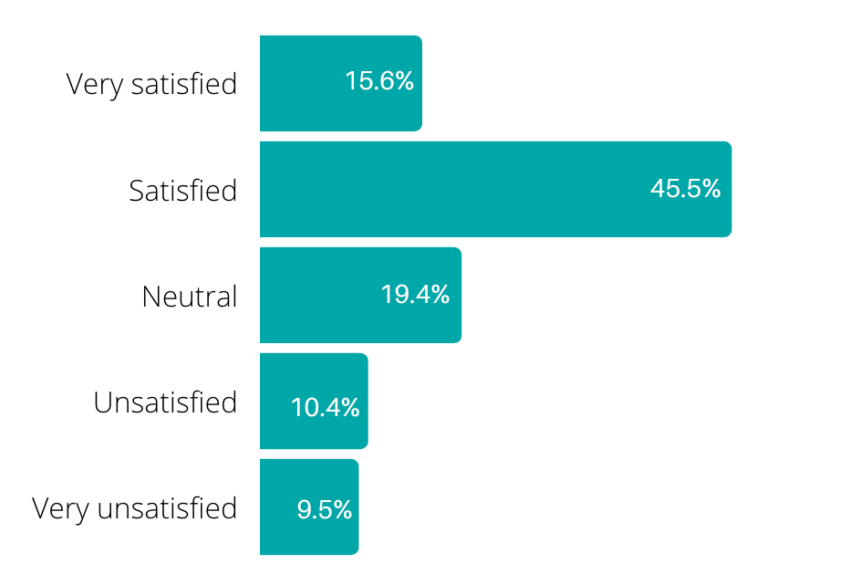

Level of satisfaction with proposed actions | Response count (537 total) | Proportion of responses
Very satisfied | 82 | 15.3%
Satisfied | 244 | 45.4%
Neutral | 104 | 19.4%
Unsatisfied | 56 | 10.4%
Very unsatisfied | 51 | 9.5%

Respondents were given the opportunity to provide a reason for their level of satisfaction.
Two hundred and seventy-three of the of the 537 survey respondents provided an answer to this open-ended question.

General comments about the proposed actions in the draft Plan:

Satisfied with the Plan as is | A number of respondents (26) indicated they were happy with the proposed actions as they currently stand.  “Considerable thought seems to have gone into these recommendations, which appear fair and logical.”

Feedback on specific proposed actions in the draft Plan:

Fenced dog off-leash areas | The proposed actions to investigate fenced off-leash areas for Clarke Reserve and along the light rail line in Port Melbourne were strongly supported by respondents, with 57 respondents indicating they liked the idea. Suggestions were made to improve the action, such as having gates that do not face pedestrian/cycle paths and roads for safety when exiting. Suggestions were also made for fenced areas at Peanut Farm, Hester Reserve, Lagoon Reserve, Albert Park, Alma Park, as well as in the suburbs of St Kilda and Middle Park. Some respondents mentioned they would like to see the proposed MO Moran Reserve dog park fully fenced too. Some respondents would like to see a greater commitment to delivering fenced off-leash areas than the ‘investigation’ proposed.  “Fenced off lead areas specifically for dogs are an excellent way of alleviating problems as the areas are clearly defined.”  Several respondents (9) indicated they did not support the proposed fenced dog off-leash areas due to a perceived loss of amenity and open space.  The proposed action to explore opportunities to provide separated fenced areas for small and big dogs received mixed feedback, with 15 respondents supporting the idea, and 10 respondents disliking the idea, feeling it is unnecessary.  “I love the idea of small / large dog areas. My dog is a small dog but is intimidated by the larger dogs at the dog park in Alma Park.”
Permits for walking more than six dogs | A number of respondents (25) indicated they did not support the proposed introduction of permits for walking over six dogs at a time. Several respondents (6 ) expressed empathy for dog walkers, and would like to see them supported as small businesses.  “Leave dog walkers alone they have suffered inordinately through the pandemic and its impact on their businesses.”  Several respondents (15) supported the proposed permit system for walking more than 6 dogs, with some suggesting 6 dogs was too many, and 4 was more appropriate.
More off-leash dog areas | The proposed action to investigate opportunities for increased off-leash dog areas was supported by respondents (24), indicating they would like to see more off-leash areas.  “More off-leash areas would be great or growing the existing areas.”
Balancing sports and dogs | Some respondents (23) indicated they were against the proposed Council Order requiring dogs to be on lead within 20 metres of organised sports games and training. Many pointed out the coexistence between sports teams and dog owners that occurs at present, particularly at Peanut Farm. Some respondents would like clarity as to when the rule would apply, with some confusion about whether dogs were required to be on-leash or whether they were prohibited from being within 20m.  “Dog owners and footy players share the Peanut Farm in harmony and respect the space for both training and dog playing. Please note that we would like to continue to share the space during these times.”  Several respondents (7) supported the proposed Council Order to limit dogs off-leash within 20m of sports games and training.  “These initiatives also strikes a good balance between sporting clubs and dog owners to maximise use of space.”
Lighting | Some respondents (12) indicated their support for the proposed action to provide lighting in popular dog walking areas, with many highlighting the increased safety this would provide, as well as greater visibility of dog waste.  “having better lighting in popular dog walking areas would be great and would make me feel safer when walking my dog after work in winter time.”

Additional actions suggested:

Dog waste | Several respondents (10) would like to see more actions to reduce dog waste, particularly in off-leash areas. DNA testing of dog faeces to track repeat offenders was suggested by some respondents.

Theme 3: Partnerships

of respondents were satisfied or very satisfied with the proposed actions for Theme 3
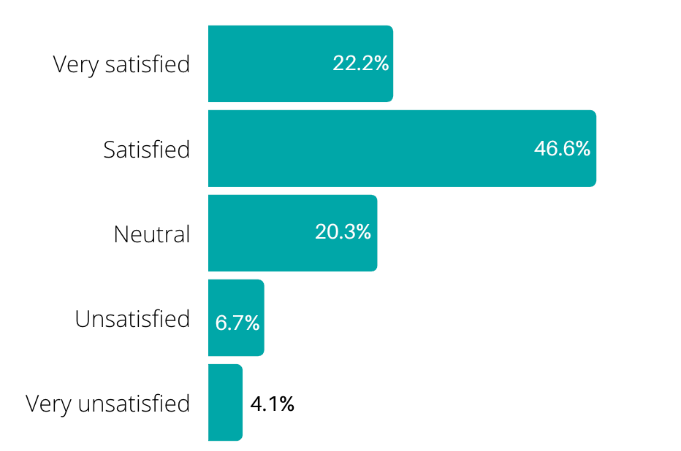

Level of satisfaction with proposed actions | Response count (536 total) | Proportion of responses
Very satisfied | 119 | 22.2%
Satisfied | 250 | 46.6%
Neutral | 109 | 20.3%
Unsatisfied | 36 | 6.7%
Very unsatisfied | 22 | 4.1%

Respondents were given the opportunity to provide a reason for their level of satisfaction.
One hundred and seventy-seven of the 537 survey respondents provided an answer to this open-ended question.

General comments about the proposed actions in the draft Plan:

Satisfied with the proposed actions as they are | A number of respondents (34) indicated they were happy with the proposed actions, expressing they were great, proactive ideas.  “No explanation needed. You have nailed it.”
Unnecessary | Some respondents (22) found some of the proposed actions to be unnecessary, expressing that they felt there were a waste of time, money, or just not needed.  “Mostly unnecessary”

Feedback on specific proposed actions in the draft Plan:

Dog friendly businesses | Respondents (36) liked the idea of supporting local businesses to be dog friendly, with 23 respondents calling out the dog friendly ‘door sticker’ as a good way to do this: “Door stickers on shops stick out as something worthwhile.”  “We love it when we find dog-friendly shops that we can enter with our well-behaved pets. It would be great to aim to make a regenerated Fitzroy St - the most dog friendly place in Melbourne!”  Several respondents (4) did not like the idea, stating this could negatively affect customers who might be allergic or afraid of dogs.
Australia post partnership | Several respondents (6) were generally not supportive of the proposed partnership with Australia post, with an additional 5 respondents questioning the reason for doing this.
Partnership with other Councils | Some respondents (6) supported the proposed action for collaboration and information sharing across Councils, highlighting that more consistent regulations across Councils benefits everyone.

Additional actions suggested:

Other partnerships to consider | A number of respondents (20) suggested other partnerships Council could consider developing including:  - Partnerships with other pet rescue organisations to increase rehoming, particularly cat rescue organisations to avoid cat high euthanasia rates at the Lost Dogs Home (4)  - Partnerships with local obedience and training organisations such as the Hobsons Bay Obedience Dog Club (3)  - Partnerships with schools, dog walking organisations, organisations providing support to vulnerable groups such as Pets of the Homeless, and local wildlife organisations to promote responsible pet ownership for wildlife protection were also mentioned.

Theme 4: Pet regulation and compliance

of respondents were satisfied or very satisfied with the proposed actions for Theme 4

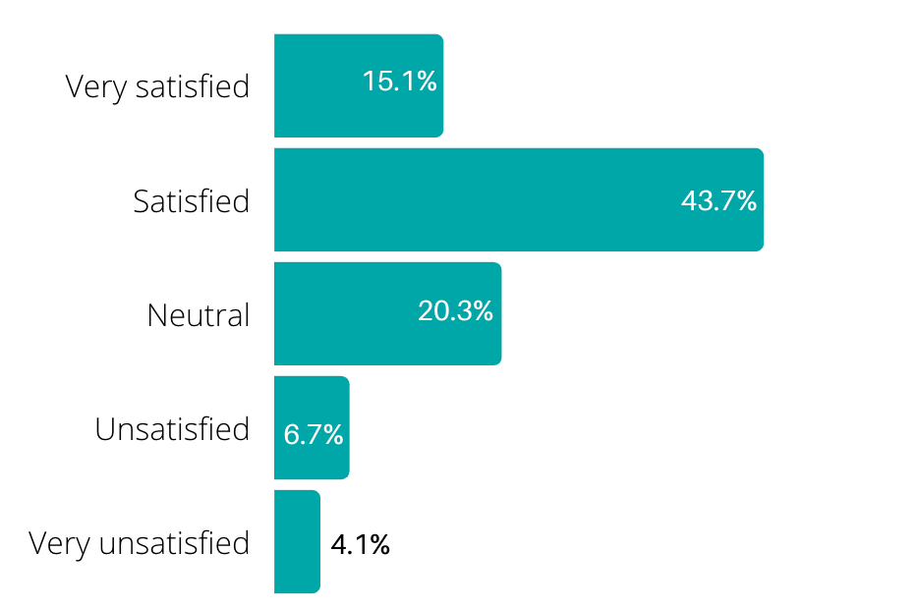

Level of satisfaction with proposed actions | Response count (536 total) | Proportion of responses
Very satisfied | 81 | 15.1%
Satisfied | 234 | 43.7%
Neutral | 106 | 19.8%
Unsatisfied | 49 | 9.1%
Very unsatisfied | 66 | 12.3%

Respondents were given the opportunity to provide a reason for their level of satisfaction.
Two hundred and sixty-six of the 537 survey respondents provided an answer to this open-ended question.

General comments about the proposed actions in the draft Plan:

Some actions are unnecessary | A number of respondents (32) felt that the actions outlined in the draft Plan regarding regulations and compliance were unnecessary, stating the regulations were overreaching and a waste of money.  Some respondents referenced the cat curfew in particular as unnecessary, as well as annual dog property inspections. Many respondents said that this action was ‘ridiculous’ and an invasion of privacy.  “Too intrusive on privacy”
Satisfied with the actions as they are | Some respondents (24) indicated they were satisfied with the actions as they are now.  “These all seem like purposeful and positive initiatives. I would encourage the council to consider supportive rather than punitive actions when enforcing them.”

Feedback on specific proposed actions in the draft Plan:

Cat curfew | A number of respondents (48) agreed with the current cat curfew action outlined in the draft.  The rationale behind this pro cat curfew stance was to stop cats roaming and killing local wildlife. Over half of respondents (26) in support of the cat curfew referenced the protection of wildlife as the reasoning backing their statement.  “It is essential that a cat curfew be introduced as they wreak havoc on native bird life”  “Restricting cat movements outside is critical for cats’ health and for protecting wildlife”  A further 27 respondents stated that the cat curfew should be more restrictive. Most of these comments suggested cats should remain indoors all hours of the day.  “Cat curfews should be 24hrs. Owners should not be allowed to have cats outdoors when they leave the premises.”  In total, 75 respondents supported a cat curfew in some form, either the current cat curfew outlined in the draft Plan or a stricter cat curfew.  On the other hand, 42 respondents disagreed with the proposed cat curfew. Many responses highlighted the unreasonable nature of the action and referenced the wasted resources needed to enforce this. Other comments stated that the argument suggesting cats are killing the local wildlife lacks evidence.  “A cat curfew is not supported. This is too challenging to implement if a cat is used to going outside at night time.”  Several respondents (9) said that more clarity regarding the cat curfew was needed, more specifically, around how it would be enforced.  “Cat curfew - unsure on how this would work”
Increased enforcement through patrolling | A number of respondents agreed (23) that there should be an increased presence of Authorised Officers to enforce the rules. Many of the respondents stated that they had never seen patrols and this action is long overdue.  “I would be really pleased if you do increase the patrols. It would make the on-lead area safe for those who feel vulnerable when walking their dog.”
Dangerous dog breeds | Some respondents (12) mentioned the proposed processes for managing dangerous dog breeds. However, this issue was divisive where 5 respondents opposed the process of declaring dangerous dog breeds restrictions and 7 respondents were in favor of breed specific restrictions.  “I do not believe in breed restrictions, sorry.”  “For me, control of dangerous dogs is priority no 1. Focus on dangerous breeds.”
Business and property inspections | Several respondents (8) acknowledged the action calling for annual property and business inspections for compliance with the Domestic Animal Act. Of these respondents most (7) were not in favor, some stating that the action seemed ‘authoritarian’.

Additional actions suggested:

Additional actions to promote pet regulation and compliance | Respondents indicated they would also like to see actions to address:  - Better incident reporting process (4)  - Support for enforcing fines (3)  - Issues with barking nuisance (3)

Theme 5: Minimising overpopulation and animal euthanasia

of respondents were satisfied or very with the proposed actions for Theme 5

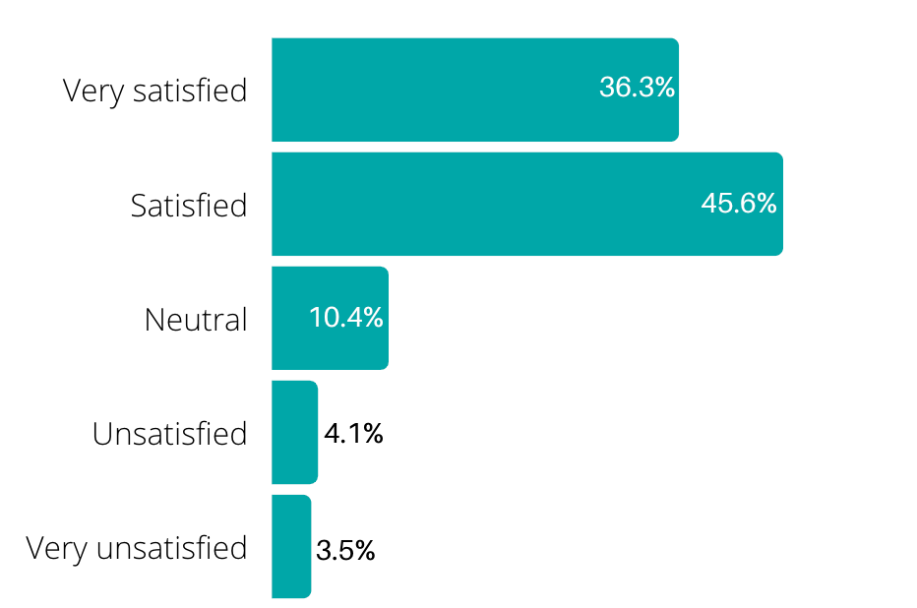

Level of satisfaction with proposed actions | Response count (537 total) | Proportion of responses
Very satisfied | 195 | 36.3%
Satisfied | 245 | 45.6%
Neutral | 56 | 10.4%
Unsatisfied | 22 | 4.1%
Very unsatisfied | 19 | 3.5%

Respondents were given the opportunity to provide a reason for their level of satisfaction.
One hundred and sixty-two of the 537 survey respondents provided an answer to this open-ended question.

General comments about the proposed actions in the draft Plan:

Happy with the proposed actions as they are | A number of respondents (50) indicated they were happy with the actions proposed under this theme, with one respondent stating the actions showed “Great initiative for justice of animals”.
Some actions are unbalanced | Some respondents (13) stated the actions were unbalanced either favouring or penalising one community group. Mostly, these comments agreed with mandatory desexing for cats but suggested that this action should be extended to dogs as well.  “Should also introduce mandatory desexing of dogs except for registered breeders”  “Mandatory desexing is an absolutely fantastic idea but if you applied this to dogs as well it would be perfect.”

Feedback on specific proposed actions in the draft Plan:

Mandatory desexing for cats | A number of respondents (30) indicated they were in favour of mandating cat desexing.  A minority (11) disagreed with the action mandating desexing of all cats. Some respondents (8) commented further, stating that all pet desexing should be at the discretion of the owner.  “If you have a pet, desexing should be a choice…”
Free or discounted desexing | Some respondents (27) supported the action to introduce free desexing to encourage pet ownership without the costs involved. Some believe that this action will encourage owners who cannot afford desexing to do so, and also spreads awareness about how important it is to desex pets.  “Offering free desexing is an excellent idea as there would be many people in Port Phillip who can't afford to desex their cats. Offering it free also sends a message to people as to how important this is.”
Mandatory desexing for dogs | Some respondents (20) believed mandatory desexing should also be extended to dogs.  “All pet dogs and cats [to be] neutered. Not just cats”
Partnering with Lost Dogs Home and other animal welfare organisations | Several respondents (13) agreed with the proposed action to partner with Lost Dogs Home, veterinary clinics and animal rescue organisations to optimise rehousing opportunities.  “Very happy to see that you are collaborating with shelters and hopefully will encourage residents to adopt.”  However, several respondents (7) were concerned about the potential partnership with Lost Dogs Home due to their high kill rate, instead encouraging Council to partner with other no-kill shelters.  “I would rather you didn’t partner with the Lost Dogs Home LDH their history with excessive euthanasia is well documented.”

Additional actions suggested:

More education and awareness | A few respondents (3) suggested that more education, especially targeting new pet owners, would reduce the number of pets that end up in pounds and euthanised.  “Missing the steps after adoption /purchase for owners to have the best connections they can - suggest support for education /orientation for new pet owners esp. rescues.”  “With strong education this [euthanasia] really should be a rare occurence.”

Overall satisfaction with the draft Plan

of respondents were satisfied or very satisfied with the draft Plan overall

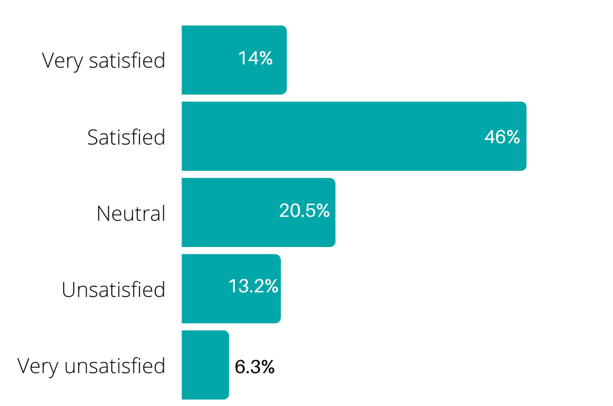
Level of satisfaction with proposed actions | Response count (537 total) | Proportion of responses
Very satisfied | 75 | 14.0%
Satisfied | 247 | 46.0%
Neutral | 110 | 20.5%
Unsatisfied | 71 | 13.2%
Very unsatisfied | 34 | 6.3%

Respondents were given the opportunity to provide any additional comments about the draft Domestic Animal Management Plan.

Two hundred and ninety-one of the 537 survey respondents provided an answer to this open-ended question.

General comments about the draft Plan:

Suggestions for improving the draft Plan | Nearly half of respondents (130) had a suggestion on how to improve the draft Plan, or stated they felt that something was missing from the draft Plan. These are outlined in the top responses below.
Satisfied with the draft Plan as is | A number of respondents (22) indicated they were satisfied with the current draft Plan.

Top responses on specific themes:

Enforcement | Some respondents (24) stated that enforcement was key to the success and longevity of the actions outlined in the Plan. Respondents were mainly concerned with the lack of enforcement imposed on owners who fail to clean up after their dog.  “Please ensure greater enforcement of dog owners cleaning up after their dogs. The amount of dog waste on the footpaths over the last 6 months has been very concerning.”  Also, some respondents noted that better enforcement needed to be imposed around the municipality to deter owners from letting their dog off-leash outside dedicated off-leash areas.  “Dogs need to be on a lead in the streets for their own protection. Too many dogs are walked without a leash. It’s very dangerous for the dog and upsetting for dogs on a lead and people generally. This law needs to be more closely enforced.”
Dog waste bags | It was suggested by some respondents (23) that Council should provide dog waste bags at parks to increase compliance with dog waste collection around the municipality.  “...installing more biodegradable animal bags at more locations across the council area to ensure people pick up after their dog.”
Education and awareness | A number of respondents (21) noted that education and awareness needed to be improved for both pet and non-pet owners. A range of ideas circulated on how education and awareness could be improved. These were:  - Importance of mandatory desexing  - Importance of seeing eye dogs - special considerations  - Dog urination  - Dog training  - Spread of disease between pets  - General rules and regulations  - Regulations on dogs at kids playgrounds  - On and off-leash zones
Increase ownership limit | Some respondents (20) believed the pet ownership limit should be increased in units and townhouses. In some instances, respondents noted that townhouses in Port Phillip are often larger than houses, and therefore concluded the ownership limits imposed on townhouse residents should align closer with house owners/tenants rather than those occupying apartments.  “I think that having only 1 animal in a townhouse or unit is too few. Maybe increase it to 2?”  “Many townhouses or apartments are just as spacious as some houses in this area.”  Some respondents stated that many pets need a companion, so limiting ownership in apartments and townhouses to 1 pet was not supported.  “For apartments there should be a limit of 2 as it’s unfair to apartment owners and their dog to deprive them from having a companion dog.”
Against the cat curfew | A number of respondents (18) expressed that they did not support the proposed cat curfew, with many respondents stating the cat curfew was unreasonable and unnecessary.  “I have no problems with the plan with the exception of the proposed cat curfew. It is unjustified and unreasonable. Cat curfews are only required in rare instances where cats are a demonstrated nuisance.”  Conversely, 5 respondents were in support of the cat curfew and a further 6 respondents stated there should be stricter regulations regarding the cat curfew.
Beach restrictions | Some respondents (15) added they would like to see reduced restrictions on dogs at the beach. Of these respondents (8) noted that they wanted more dog access during the summer months, some suggesting dogs could have access at quieter times in the morning and evenings.  “To ban local dog owners who are residents and ratepayers from most of the beaches for all of summer is disproportionate. One simple compromise could be dogs allowed before 08:00am and after 08:00pm assuming that this is about the amenity of beachgoers.”

Online forum responses
The online forum was hosted on Council’s Have Your Say platform to provide community members the opportunity to provide feedback and receive responses from Council officers. There were 27 posts to the online forum by 14 community members with 35 responses to feedback submitted.

Feedback received through the forum related to the following themes:

Beach restrictions for dogs | Nine contributions related to the current beach restrictions for dogs, with five respondents indicating they would like to see the summer restrictions in particular reviewed. One respondent indicated they were not supportive of increasing beach access for dogs.
Fenced dog off-leash areas | Four contributions were related to fenced dog off-leash areas, with two in favour of the proposed actions for increased fenced off-leash areas. The other comments were requesting fenced areas at specific locations: Lagoon Reserve and Alma Park.

Other responses related to the following topics:
- Education and awareness of existing rules and regulations (2)
- The issue of dogs off-leash in on-leash areas (2)
- Cat curfew: in support of (1) and against (1)

Email submissions

Community members were also given the opportunity to provide feedback via email. Ten email responses were received. Email submissions are attached Appendix C to this report.

Feedback received via email related to the following themes:

Balancing sports fields and off-leash dogs | Half of the email responses received (5 emails) were in opposition of the proposed Council Order for dogs to be on-leash within 20m on sports games and training. Email respondents would like to see the sportsgrounds continued to be shared between sports teams and dog owners.

Other responses received related to the following topics:
- The issue of dogs off-leash in on-leash areas (2)
- Support for the proposed free cat desexing program, with suggestions for education and awareness initiatives to promote the program (2)
- Opposition to the proposed night time cat curfew (2)
- Suggestion for incentivising registration by offering free registration for the first year or ownership, or discounted registration for desexed animals (2)
- Opposition to the proposed limit on pet ownership, with suggestions to increase this to 2 cats, 2 small dogs, or 1 large dog (2)
- Opposition for mandatory desexing, due to disproportionate impacts of disadvantaged communities (2)
- Support for professional dog walkers (1)
- Addressing the issue of dog waste around the municipality (1)
- Dog attack reporting processes, stating the process is too difficult (1)
- A review of summer beach restrictions to allow dogs in the morning (1)
- Suggestion for partnering with Hobson’s Bay Obedience Dog Club over Lost Dogs Home for training events (1)
- Support for promoting dog friendly businesses (1)
- Support for proposed increased lighting in dog-walking areas (1)

Engagement experience

Respondents were asked to share feedback on how they found the consultation experience and were asked to what extent they agreed/ disagreed with two statements:

- Council provided me with access to information to enable me to meaningfully participate in this process
- Council actively supports community involvement in decision making

Council provided me with access to information to enable me to meaningfully participate in this process

of respondents agreed or strongly agreed with the statement

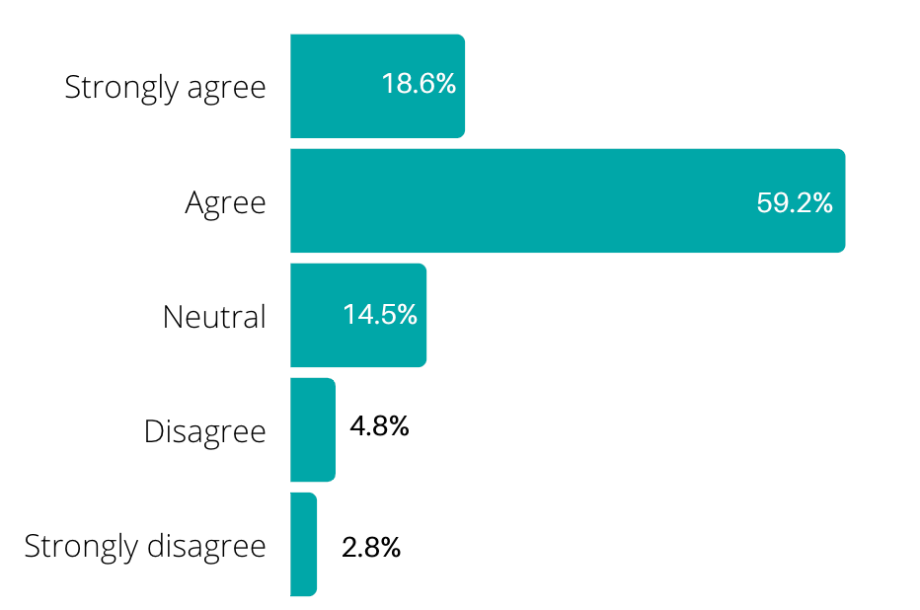

Level of agreement with statement | Response count (537 total) | Proportion of responses
Strongly agree | 100 | 18.6%
Agree | 318 | 59.2%
Neutral | 78 | 14.5%
Disagree | 26 | 4.8%
Strongly disagree | 15 | 2.8%

Council actively supports community involvement in decision-making

of respondents agreed or strongly with the statement

Level of agreement with statement | Response count (537 total) | Proportion of responses
Strongly agree | 59 | 11.0%
Agree | 262 | 48.8%
Neutral | 152 | 28.3%
Disagree | 39 | 7.3%
Strongly disagree | 25 | 4.7%
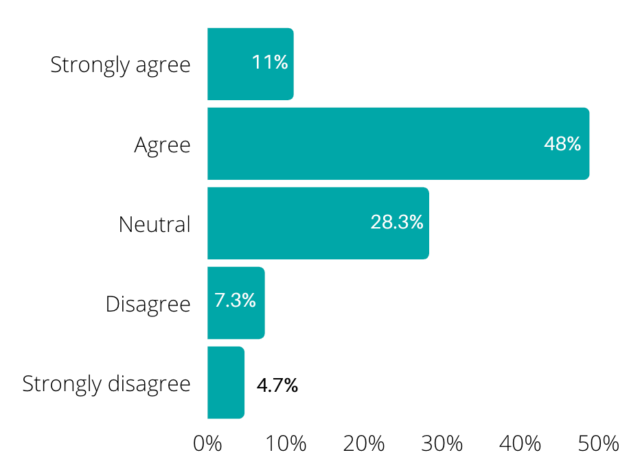

Respondents were given the opportunity to explain how the experience could be made better.

Top responses from 127 respondents:

Positive experience | Overall, 24 respondents had a positive experience with the survey. Of these, 14 respondents did not mention specific aspects of the process but concluded their experience was positive.  “I think this process has been handled well.” and “I do not think you could have made my experience better.”  Of the positive comments, respondents also said the survey was ‘clear’ (3), “informative” (2), and the process was ‘unbiased’ (1).
Better community outreach | A number of respondents (21) questioned Council’s effort to reach the community and promote this survey, referencing more extensive outreach as something that would better their experience. The main concern was that some respondents were only finding out about the survey through a friend or by accident.  “I shouldn't have had to find out about this through a friend. As a rate payer we should be sent correspondence on such issues.”  Several respondents (7) furthered this point stating the lack of outreach may have led to a lack of representation from all community groups in the municipality.  “I somehow missed the original consultation period yet I’m signed up for Divercity and am a pet owner - was that my fault or could the initial consultation have been better publicised? Also, I would suspect that pet owners are disproportionately represented in the survey; as much as I selfishly like this, I feel that we pet owners might be overly influential.”  A few respondents (4) disagreed that there was a lack of outreach stating “it was great to get email prompts about these surveys…”.  Suggestions  “Perhaps announce these processes in dog parks. I was lucky to see this email but if I hadn't, I wouldn't have been able to get involved due to no knowledge.
Meaningful impact on the Domestic Animal Management Plan | A number of respondents (16) referenced they hope that Council will consider this feedback when revising the plan and enforce proposed actions to bring meaningful change to the community. Some respondents expressed they would like to see how the feedback from this survey has been used to influence the plan in the future.  “Ideally, I would like to have feedback on how my points can be / or not considered and the reasons. In the same way you are looking for feedback, it should be a duty of reply back to those participants who provide comprehensive feedback.”  Some referenced previous community involvement efforts stating they “generally see no feedback nor any form of acknowledgement”.  A further 10 respondents implied that this survey was a “tick the box” exercise, although they hoped this was not the case.  “I was happy to be part of a different community consultation regarding the council budget earlier this year. I do feel however having been part of THAT (not this) process, perhaps it was just a formality - that boxes need to be ticked by council to ask for input & go through the motions. I really hope that this is not the case here.”

All feedback and suggestions for improving the engagement experience are welcome and have been gratefully received are being considered by Council’s Strategic Engagement team, and will be considered by Council as part of its commitment to improving its community engagement practices and including the community in its decision-making processes

Appendix A: Survey demographic data
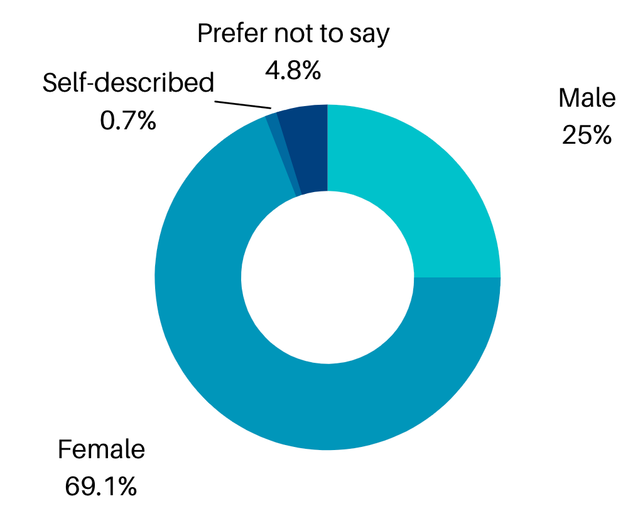
Gender identification (537 respondents)

Gender identification | Number of respondents (537 total) | Proportion of respondents
Male | 134 | 25.0%
Female | 371 | 69.1%
Self-described | 6 | 1.1%
Prefer not to say | 26 | 4.8%

Age group (537 respondents)

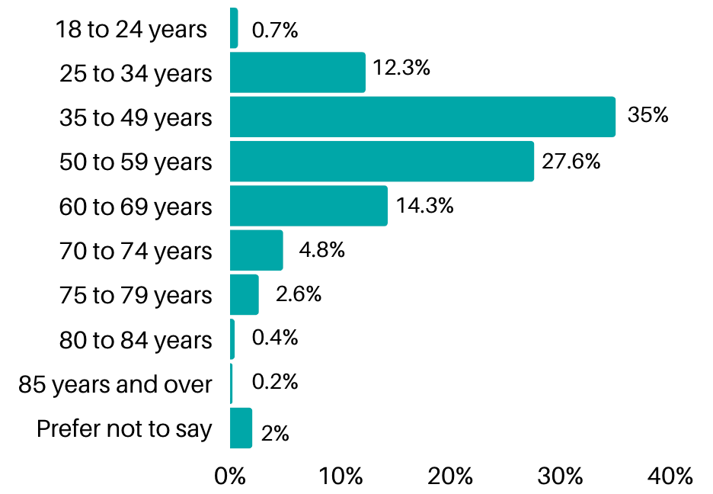

Age group | Number of respondents (537 total) | Proportion of respondents | Proportion of demographic in City of Port Phillip population*
18 to 24 years | 4 | 0.7% | 13%
25 to 34 years | 66 | 12.3% | 8%
35 to 49 years | 188 | 35.0% | 26%
50 to 59 years | 148 | 27.6% | 25%
60 to 69 years | 77 | 14.3% | 12%
70 to 74 years | 26 | 4.8% | 9%
75 to 79 years | 14 | 2.6% | 6%
80 to 84 years | 2 | 0.4%
85 years and over | 1 | 0.2% | 1%
Prefer not to say | 11 | 2.0% | -
*Australian Bureau of Statistics, Census of Population and Housing 2016

Residential suburb (537 respondents)

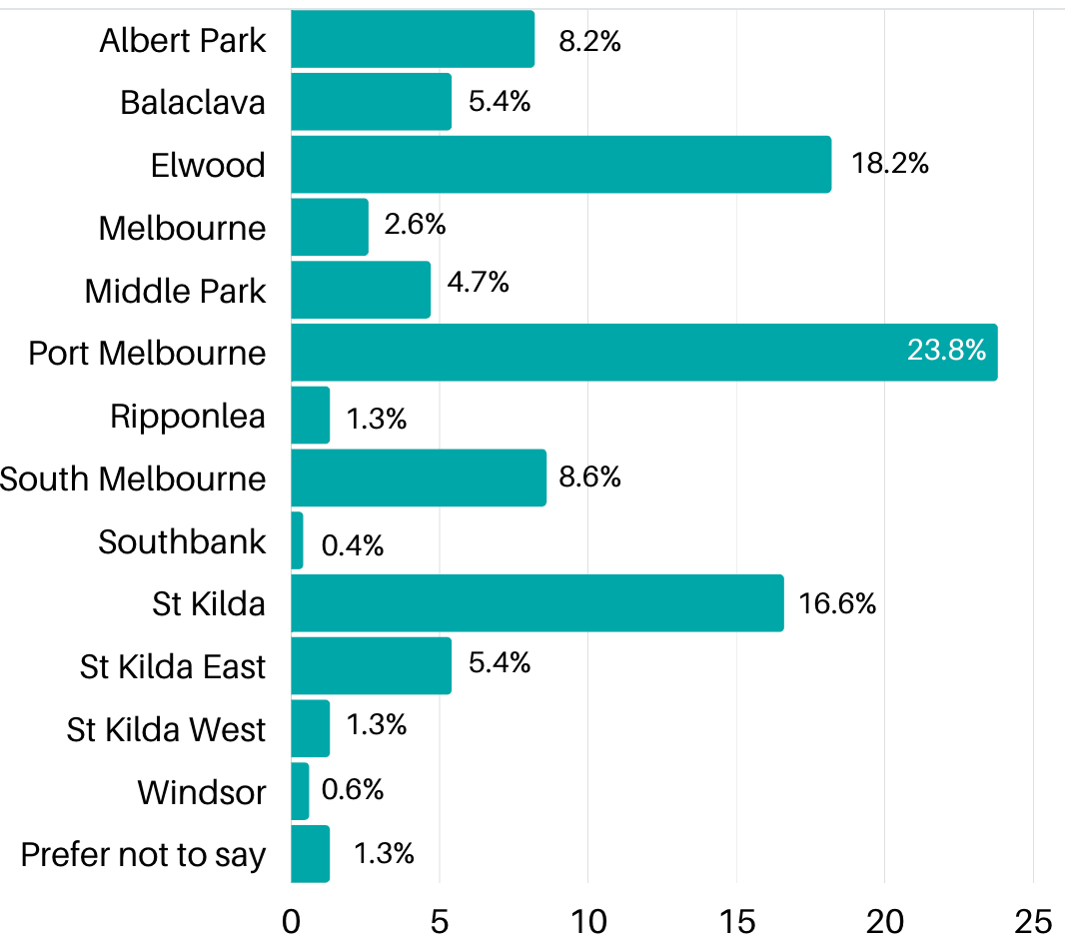

Residential suburb | Number of respondents (537 total) | Proportion of respondents | Proportion of City of Port Phillip population*
Albert Park | 44 | 8.2% | 6.4%
Balaclava | 29 | 5.4% | 5.2%
Elwood | 98 | 18.2% | 14.6%
Melbourne | 14 | 2.6% | N/A
Middle Park | 25 | 4.7% | 4.0%
Port Melbourne | 128 | 23.8% | 15.8%
Ripponlea | 7 | 1.3% | 1.5%
South Melbourne | 46 | 8.6% | 11.1%
Southbank | 2 | 0.4% | N/A
St Kilda | 89 | 16.6% | 20.7%
St Kilda East | 29 | 5.4% | 8.8%
St Kilda West | 7 | 1.3% | 3.2%
Windsor | 3 | 0.6% | N/A
St Kilda Road | 0 | 0.0% | 8.5%
Prefer not to say | 7 | 1.3% | N/A
Other | 0 | 0.0% | N/A
*Australian Bureau of Statistics, 2020 Estimated Resident Population

How survey respondents heard about the consultation (487 respondents)
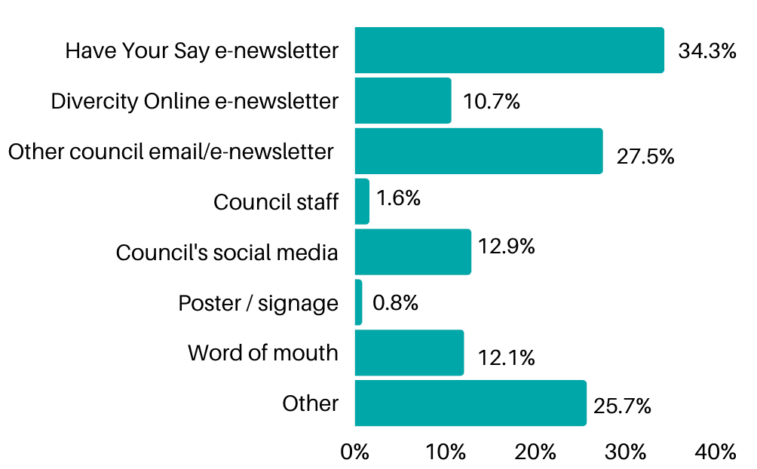

Communication channel | Number of respondents (487 total) | Proportion of respondents
Have Your Say e-newsletter | 167 | 34.3%
Divercity Online e-newsletter | 52 | 10.7%
Other Council email/e-newsletter | 134 | 27.5%
Council Staff | 8 | 1.6%
Council Social Media | 63 | 12.9%
Poster / signage | 4 | 0.8%
Word of mouth | 59 | 12.1%
Prefer not to say | 0 | 0.0%
Other | 125 | 25.7%

‘Other’ including: Social media including Facebook, Instagram, and local Facebook groups (27 responses); Council emails (9 responses), and political groups (4 responses)

Connection to City of Port Phillip (535 respondents)
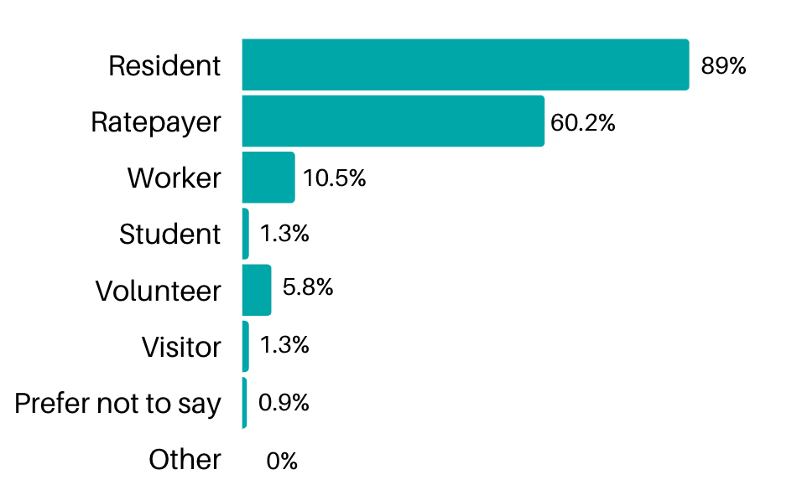

Connection to City of Port Phillip | Number of respondents (535 total) | Proportion of respondents
Resident | 476 | 89.0%
Ratepayer | 322 | 60.2%
Worker | 56 | 10.5%
Student | 7 | 1.3%
Volunteer | 31 | 5.8%
Visitor | 7 | 1.3%
Prefer not to say | 5 | 0.9%
Other | 0 | 0.0%

Appendix B: Forum comments
I'm signing off now! Thank you to everyone who has provided feedback and comments so far. Our survey is open until 5 September 2021. We look forward to going through your responses!
I have had an issue with nuisance cats at night (reported to council) and am in full support of the cat curfew. I work as a veterinarian and see the effect that they have on wildlife, other owned cats and themselves. Thankyou for considering it.
Hi Courtney, thank you for your comments. All feedback received from this consultation will be presented to Council for consideration to ensure the final DAMP reflects the needs of our community and continues to promote responsible pet ownership.
I would like to see a fenced off leash dog park in the Port Phillip community. Other councils and cities have them but we don't seen to have them here. My friend vsent me photos of their fenced off leash area with tunnels lots of trees bushes and things to investigate for the dogs.
Hi Beverley, thank you for your comments. We welcome all feedback including any feedback around the fencing of dog parks. All feedback from this consultation including comments in this forum will be presented to Councillors for consideration, prior to finalisation of the DAMP.
Good morning, I’m Dirk and I am the Local Laws and Animal Management Coordinator at Port Phillip, and the Project Manager for our Domestic Animal Management Plan. We’ve also got online Skye, our Animal Management Team Leader. We’ll both be online for the next hour for a chat and to answer any questions you might have about our draft Plan. We've had a lot of great comments and feedback so far!
Skye and I are signing off now, thanks to everyone who has provided feedback and comments so far. We’ll be back online again on Tuesday between 7 pm and 8 pm. We're looking forward to having a conversation with you then. You can also provide feedback through our survey which is open until 5 September 2021. Have a great Sunday!
I am a cat owner. I am not supportive of the night-time 9pm - 6am cat curfew. I note that cat nuisance was not reported as a primary issue or concern by the community in the report. Education material should be provided to owners rather than a mandated curfew being brought in.
Hi Samantha, Thank you for your feedback. Another proposed action in the draft Plan is to develop a targeted campaign to increase education and awareness amongst pet owners on the potential impacts their pets can have upon wildlife. We hope that the proposed cat curfew will also assist in minimising cat fights, reducing the transmission of diseases such as FIV, and reduce instances of cats being hit by cars. Cats confined on their own property live, on average, three times longer than cats that are allowed to wander
I see there are a few plans for fenced parks and the idea to incorporate small and large dog areas. Has Alma park been considered?
Hi Pebbles, We welcome all feedback including any feedback around the fencing of dog parks. All feedback from this consultation including comments in this forum will be presented to Councillors for consideration, prior to finalisation of the DAMP.
I have experienced many issues with out of control off lead dogs with oblivious or dismissive owners. I’m not sure what can be done about this but I feel it’s a significant issue.
Hi Belinda. Thank you for your feedback. Off lead dogs, and dogs not under effective control, are the most reported issue to our Animal Management team, and as such we are proposing a number of actions in the DAMP to address these issues, including:- Engagement with Lost Dogs Home to provide two “Dogs in the Park” training events per annum- The provision of dog training providers register on Council’s website.- Development of a dog attack reporting kit, outlining the investigation process.- Fostering relationships with other Councils and Government departments to share ideas, data and information on responsible pet ownership.- Exploring the use of QR codes to provide ease of access to online maps, dog restrictions and other relevant locational information.- Consideration given to the installation of footpath stencils in high traffic areas (parks and streets) to depict dog regulations.- Auditing of existing signage and the investigation of options to better communicate dog regulations.
I am a dog owner and I support the Domestic Animal Management Plan in its current format. I don’t support increased access to public open space, including the beach for dogs, as I think we need to achieve a balance between dog and human needs.
Hi Belinda, thank you for your feedback. The draft plan aims to provide a balance
between the needs for dog friendly areas and other open public space users.
Thank you to everyone for your feedback and comments, it's been great to have a conversation with you about our draft Plan. Dirk and I will be back online on Sunday between 10 am and 11 am and again on Tuesday 7 pm to 8 pm. You can also join other our online chat forums on business parklets and accessibility in our City which you can find out more about here: https://haveyoursay.portphillip.vic.gov.au/neighbourhood-conversations
The majority of this plan seems sensible & will make engagement out in the community a better experience. My only concern is the number of "legal" cats in an aparment is set at 1. Many owners have 2 cats & some apartments are the size of a small house anyway. I believe this should be amended (understand dogs due to their sheer size)
Hi Becstartilly, Thank you for your feedback around the limit of cats that can be kept in an apartment under the local law. Your feedback and all comments in this forum will be presented to Councillors for consideration prior to finalisation of the DAMP.
Thank you to everyone who has provided comments and questions. We are still working through all of your responses. Thank you for your patience.
I also feel all dog attacks and dog rush ought to be assessed by a specialist animal behaviourist, prior to animal being declared dangerous. Filing reports and lodging complaints only creates a larger divide amongst dog owners and those who do not like dogs. We need to have an assessment and understanding (as much as possible) of an adverse event and consider it a learning opportunity, presented in a non-judgemental and unbiased way.
Hi Anupam, thank you for your suggestion. As authorised officers, the Animal Management team assess each case based on evidence and gather statements made by all parties to make an unbiased decision. We use this evidence to then make a fair assessment on if there has been a breach in the state legislation that we operate under (The Domestic Animals Act 1994). Animal management officers undertake training all year round regarding behavioural assessments of dogs. We encourage the owners to take responsibility to ensure their dog has had adequate training and socialisation to reduce the risk of dog rush and attack. Declaring a dog menacing or dangerous is not taken lightly, and it is centred on a risk assessment of public safety and the seriousness of the breach that has been thoroughly investigated. The draft Plan proposes to develop a dog attack reporting kit to help the community better understand this process, and reduce the chance of repeat offences.
Also, would it be possible for us to have an agility park open to all. Thank you.
Hi Anupam, our draft plan proposes that when developing landscape master plans to consider the feasibility of incorporating dog agility equipment in our
existing public off-lead parks, which would be open to all members of the public.
Along with Barking Dog Management Kit, I feel it would be prudent to include in your annual registration and social media campaigns things such as dog behaviour, training, information on local trainers, etc.
Hi Anupam, thank you for your suggestion. All new and renewed pet registrations have a Pets of Port Phillip flyer posted out to them which contains information about responsible pet ownership. A proposed action in the draft plan is to provide a list of dog trainers on our Council website. We will also have targeted social media campaigns to provide information for pet owners, and we can look at including information about dog training in our campaign.
With regards to 9pm to 6am Cat Curfew, do you have data to suggest that this does in fact protect wildlife in the short and long run? Anecdotally I find there is no difference in whether a cat is outdoors during the day or night. Some hunt, some don't, and they often hunt rodents (as opposed to possums).
Hi Anupam, thank you for your question.The question of whether cats prey on wildlife (both native and introduced species) is an area of great debate, but the general consensus is that they do hunt (day and night, if permitted) due to their strong hunting instincts. It is difficult to accurately assess the exact amount of cat predation, particularly at night, other than conducting thorough research (e.g. putting tracking devices on cats). Without this, we cannot know the extent of cat hunting prey at night. The proposed cat curfew could also assist in minimising cat fights, reducing the transmission of diseases such as FIV, and reduce instances of cats being hit by cars. Cats confined on their own property live, on average, three times longer than cats that are allowed to wander.
1. Do you also have an education plan for the general public on how to/not to approach dogs? 2. "Minimise potential for dogs and cats to create a nuisance” Define nuisance. 3. More bins on neighbourhood streets please. 4. If you start a Port Phillip Dog Squad I would be happy to head it. Aim would be to teach dog owners and otherwise about dog behaviour, which I understand you are hoping to do via LDH however 2 visits per annum are not enough, and a constant source of information would be more beneficial in the long run. 5. It would be wonderful if the council could reach out to Port Phillip Pooches Facebook page and work with us. 6. We also really need to alter the conversation slightly and discuss safety of the dogs from people, as much as we do vice versa. Poisonings, complaints, and negative attitudes towards dog owners is fairly commonplace. All of us really need to come together on this and build a bridge. The sole responsibility need not lie purely with dog owners. 7. I think it is also important to stress upon “dog haters” that dog owners do live in this area, and are very involved in doing what is right for everyone. We would appreciate your support in moving forward and creating a healthy inclusive community in Port Phillip.
Hi Anupam, thank you for questions and feedback. Council’s draft DAMP has a number of actions proposed around education initiatives which we will develop over the four years of the plan. This will be based around the needs in the community and arising issues. We hope both dog owners and non-dog owners will benefit from these initiatives. Our Plan also proposes to develop and strengthen partnerships with vets, domestic animal businesses, owner’s corps, real estate agents and public housing providers to promote responsible pet ownership. Nuisance is any thing or circumstance that causes an annoyance or inconvenience. In the context of the Domestic Animals Act, nuisance dogs and cats are those that injure or endanger the health of any person, or creates a noise disturbance. Thank you for your suggestion to provide more bins. The installation of additional street bins sits within the scope of Council’s waste management division, and we will continue to communicate with them about this matter. Thank you for your feedback, all feedback from this consultation, including comments in this forum, will be presented to Councillors for consideration prior to finalisation of the DAMP. If you would like to discuss anything in more detail, please contact us via ASSIST on 9209 6777.
hi & thanks for the opportunity - many of us that have commented are asking about things that might be actually mentioned in the plan but will they happen? I personally want to see changes as per my earlier post to the beach access times in summer. I cannot see what logic has been applied to the sequence of off lead vs no access at all.
Hi Liz. In accordance with the Domestic Animals Act, we are required to submit our DAMP to the Secretary of the Department of Jobs, Precincts and Regions and provide annual updates. We are committed to the proposed actions and meeting the time frames outlined
Given there is some infrastructure already present at Lagoon reserve, would it be possible to fence it completely fro safety of the dogs and children that play there? Thank you.
Hi Anupam, thanks for your question. We welcome all feedback including any feedback around the fencing of dog parks. All feedback from this consultation including comments in this forum will be presented to Councillors for consideration, prior to finalisation of the DAMP.
Is this purely in writing? Just want to make sure there isn't a live video link I am missing. Thank you
Hi Anupam, yes, this is an online chat forum for you to post comments and reply to others’ comments.
Good afternoon, I’m Dirk and I am the Local Laws and Animal Management Coordinator at Port Phillip, and the Project Manager for our Domestic Animal Management Plan. We’ve also got online Skye, our Animal Management Team Leader. We’ll both be online for the next hour for a chat and to answer any questions you might have about our draft Plan.
I'm keen to see access changed to some beaches over the summer period so that we can walk dogs offlead along a continuous stretch. Currently Port Melbourne Beach & one of the Beaches at Sandridge are full off lead beaches all day long but the beaches adjacent to them have restrictions that don't make sense (& my dog can't read the signs at Sandridge). I think we are really lucky to have all the dog access that we do love & don't take it for granted. In my last home we had to drive to anywhere decent for our dog to have a good run
Hi Liz, thanks for your question. In considering our off leash restrictions, we note that our current DAMP 2017-2021 required a review into all dog off-leash restrictions along our foreshore and the St Kilda Botanical Gardens to protect and balance the needs of the whole community. During November and December 2018, Council commissioned Metropolis Research to undertake a study in the form of two survey methods; a resident (door to door) visit where 600 residents were surveyed; and a face to face survey conducted along Port Phillip’s beaches and the St Kilda Botanical Gardens where 871 randomly selected visitors/residents participated. Participants included a mix of dog and non-dog owners to ensure a fair and balanced approach. The survey demonstrated that generally over 80% of respondents consider the current dog off-leash beach provisions provide a good balance for all users and Council . These findings were presented at a Council Meeting in April 2019 where Council resolved to retain the current restrictions.
thanks for replying to this. I wasn't able to stay online. I don't dispute that the current dog off-leash provisions provide a good balance - 2 things thoa) I'm questioning the logic behind what is allowed in summer time - there are beaches adjacent to one another with no true break except for rocks at Sandridge where one beach is allowed 24/7 & the other is no dogs allowed at all in summerb) that perhaps some of the beaches where no dogs are allowed at all in summer be reviewed so dogs area allowed in restricted times - particularly where they are adjacent to beaches that are accessible.it had been suggested to me by your department that I contact my local councillors - this was pre election time last year - I did so & some suggested a petition - I reverted back to your department to find that this current process might instead be a better forum for me to achieve a result. Although surveys were done & seem fair - it might well be that what I'm proposing is also fair. I would just like to be able to have a continuous walk along a beach in summer time as I can in wintertime. I cannot understand the logic of why a beach that I can usual walk along in winter is not available with restrictions in summer.
Hi Liz! The restrictions strive to achieve that important balance between allowing enough space for dog owners while also providing beaches that people can use in summer knowing that its free from dogs. While the current summer restrictions do not allow you to walk your dog continuously along sections of the beach, for every beach that’s restricted a dog friendly beach can be accessed directly next to it. We hope this provides residents with either a dog friendly beach or dog free beach within walking distance. If you would like to discuss this further please contact me through Council’s ASSIST on 9209 6777.
The plan is balanced in what's said. What doesn't happen is awareness (people hear only what they wish to) and any adequate presence so by-laws are respected. It means huge numbers of off lead dogs with owners on phone or not controlling. These days. Impossible if you have a well managed dog who you know to be reactive. Despite trying to avoid everyone purposefully ignoring your plan in the street, or disregarding polite requests because 'their dog offload is fine', (what's wrong with you?) your unenforced plan is being studiously ignored by 3/4 of people out on the local streets.Please turn your attention and any resourcing possible to educating people not to disregard the need for use of leads on most streets and nature strips. It is extremely hard to do the right thing politely and apply constant avoidance 100% of contant street encounters when so many disregard your sensible statements and dump their onlead responsibilities onto the well behaving owner. Walking when busy becomes nightmarish regarding off lead dogs approaching, unsupervised. It needs a change.
Hi Peter, Thank you for your feedback on our draft DAMP. We recognise there are opportunities that exist to provide clearer guidance to the community on dog regulations, and the promotion of dog friendly and dog prohibited spaces is important in increasing community awareness of where and when you are able to walk your dog. With responsible pet ownership at the forefront in development of the Draft DAMP, additional activities have been added in this area including: Engagement with Lost Dogs Home to provide two “Dogs in the Park” training events per annum.The provision of dog training providers register on Council’s website.Development of a dog attack kit, outlining the investigation process.Fostering relationships with other Councils and Government Departments to share ideas, data and information on responsible pet ownership.Exploring the use of QR codes to provide ease of access to online maps, dog restrictions and other relevant locational information.Consideration given to the installation of footpath stencils in high traffic areas (parks and streets) to depict dog regulations.Auditing of existing signage and the investigation of options to better communicate dog regulations.Increased patrols to identify breaches The DAMP and the activities listed above, provide Council with a strategic, balanced approach towards promotion of responsible pet ownership, the welfare of pets in the community and the protection of the community and the environment from nuisance pets. The Plan also outlines how Council will enforce all legislative requirements and compliance with our local laws. Knowing where we are heading and what we want to achieve are crucial to providing the best possible outcomes for our City and community, both now and over the longer-term.
Could we have dog access before 10am to the beaches in summer please. They are empty before this time. Can we have an answer as to why the Council is ignoring this popular request. Also, could Lagoon Reserve be dog fenced. Thank you
Thank you Sue. I am with you there.
Hi Sue, thanks for your question. In considering our off-leash restrictions, we note that our current DAMP 2017-2021 required a review into all dog off-leash restrictions along our foreshore and the St Kilda Botanical Gardens to protect and balance the needs of the whole community. During November and December 2018, Council commissioned Metropolis Research to undertake a study in the form of two survey methods; a resident (door to door) visit where 600 residents were surveyed; and a face to face survey conducted along Port Phillip’s beaches and the St Kilda Botanical Gardens where 871 randomly selected visitors/residents participated. Participants included a mix of dog and non-dog owners to ensure a fair and balanced approach. The survey demonstrated that generally over 80% of respondents consider the current dog off-leash beach provisions provide a good balance for all users and Council. These findings were presented at a Council Meeting in April 2019 where Council resolved to retain the current restrictions. While no changes to beach access or fencing to Lagoon Reserve have been proposed in the draft DAMP, we welcome all feedback including any feedback around beach access for dogs and Lagoon Reserve. All feedback from this consultation including comments in this forum will be presented to Councillors for consideration, prior to finalisation of the DAMP.
The report says more than 20 percent of respondents asked for more access to Beaches in summer. Many respondents asked if we could use the beaches before 10 am when they are empty. Why then are there no actions to enable this to happen? The beaches are our largest open spaces and this initiative will cost the council nothing. I feel this feedback has been ignored. Can an action be included please
Hi Rachel, thanks for your question. In considering our off leash restrictions, we note that our current DAMP 2017-2021 required a review into all dog off-leash restrictions along our foreshore and the St Kilda Botanical Gardens to protect and balance the needs of the whole community. During November and December 2018, Council commissioned Metropolis Research to undertake a study in the form of two survey methods; a resident (door to door) visit where 600 residents were surveyed; and a face to face survey conducted along Port Phillip’s beaches and the St Kilda Botanical Gardens where 871 randomly selected visitors/residents participated. Participants included a mix of dog and non-dog owners to ensure a fair and balanced approach. The survey demonstrated that generally over 80% of respondents consider the current dog off-leash beach provisions provide a good balance for all users and Council . These findings were presented at a Council Meeting in April 2019 where Council resolved to retain the current restrictions.
Dog access to beaches in Port Phillip is very variable and some suburbs already have good access. Many of us would like more beach access in summer in the mornings for Port Melbourne. How can we take this forward?
Hi Rachel,
While no changes to beach access have been proposed in the draft DAMP following an extensive review of beach restrictions in 2019, we welcome all feedback including any feedback around beach access for dogs. All feedback from this consultation including comments in this forum will be presented to Councillors for consideration, prior to finalisation of the DAMP.
Are you saying council won’t review beach access?
I think my comments are getting lost. Are you saying that the council will not review beach access for Port Melbourne
Hi Rachel, While no changes to beach access have been proposed in the draft DAMP following an extensive review of beach restrictions in 2019, we welcome all feedback including any feedback around beach access for dogs. All feedback from this consultation including comments in this forum will be presented to Councillors for consideration, prior to finalisation of the DAMP.
I do not understand why the Council has granted a MUltiple Animal Permit to someone in the neighbouring small apartment. The Council has a rule of ONE DOG OR CAT PER UNIT, but breaks its own rule on payment of $70.In the large courtyard garden which is our Common Property, we need to balance the rights of both pet-owners and birdlovers. My neighbour's three cats are scaring away the birds that we previously enjoyed here. Where apartment-dwellers share Common Property, I consider that Multiple Animal Permits are inappropriate. Can you please tell me if any Councillors might be interested in protecting our area's birdlife?
Thank-you for your enquiry in response to the current community consultation for City of Port Phillip’s Draft DAMP. The City of Port Phillip Local Law No. 1 Clause 23 specifies how many animals can live on a property without a permit. The number is different for different types of dwelling. A resident must apply for a multiple animal permit if that number exceeds those specified in Council’s Local Law No. 1. Authorised Officers must ensure that the applicant adheres to policies and procedures when reviewing applications, such as registration, housing, hygiene, noise and smell. Council has the jurisdiction to revoke any excess animal permit at any time if the applicant is not adhering to regulations, policies, requirements and legislation of the permit. We understand how important animals are in our lives, and every effort will be made with pet owners to assist them to reduce any nuisance their animals may be causing to neighbours. Our draft DAMP is proposing mandatory cat desexing, as well as a cat curfew from 9am to 6pm. Both of these requirements will aid in the challenges of unwanted and excessive cat reproduction and roaming cats, and reduce the instances
Good evening, I'm Skye, the Animal Management Team Leader. I'll be online for the next hour for a chat and to answer any questions you might have about our draft Plan.
We’ve received some queries around what happens with dogs off lead on Peanut Farm Oval if a scheduled sporting event is cancelled, so we’d like to provide some clarification. Introduce a Council Order requiring dogs within 20 metres of an organised sporting event or training to be on lead; and prohibited from entering the ground/playing surface/training space while the sporting event or training is taking place, and; Publish scheduled sporting events and games on website and via QR codes (where feasible) to assist the community to understand dog controls. During a sporting event or training session, dogs within 20 metres of the event or training session will need to be on a lead and are not allowed on the playing surface. These restrictions will only apply when the event is taking place to minimise disruption to the participants. If scheduled events are cancelled or don’t go ahead for any other reason, then these restrictions would no longer apply for that scheduled time and the event / training space would revert back to an off-lead area. These actions have been proposed to provide a better balance for users of our public spaces, in particular areas that are off-lead and are also utilised by sporting clubs. To help dog owners plan their walks and avoid times when these spaces are not available, we propose to publish scheduled events and games on our website and via QR codes. We understand and appreciate that many of our sporting ovals such as Peanut Farm Reserve are well-used spaces and that most dogs are well controlled around sporting events. We hope that these changes will minimise the chances of dogs running through and interrupting games and reduce any potential tension between sporting groups and dog owners.

Appendix C: Email submissions
To the animal management team of Port Phillip,
I would like to respond to the Port Phillip Draft Domestic Animal Management Plan2022-25; mainly item 2.2 on page 11 of the draft:
"Introduce a Council Order requiring dogs within 20 meters of an organised sporting event or training to be on lead; and prohibited from entering the ground/playing surface/training space while the sporting event or training is taking place. Publish scheduled sporting events and games on website and via QR codes (where feasible) to assist the community to understand dog controls."
Being a member of the Dog Owners Group in St Kilda (DOGISK) for many years, as well as a rate paying resident of Port Phillip for just under 20 years, I share the same concerns of DOGISK, being based on the premise that recreation grounds are a precious and limited resource and that by being shared with all user groups fully utilise this resource and benefit the community more effectively.
These grounds should be promoted to be used and enjoyed as much as possible by the diverse community.
On a personal note, it has been an invaluable resource when we rescued our dogs, being a safe place to socialise, rehabilitate and train our dogs to be well adjusted pets.
DOGISK represent a social group of dog owners who started in the Peanut Farm Reserve in St Kilda.
Approximately 780 group members regularly use the park daily, with many more joining us infrequently.
This group is a forum for our Dog related news and social interaction.
Our highly socialised dogs provide a safe and supportive environment for introducing new dogs and puppies, helping them become balanced and happy animals when around others.
Highly socialised, trained and well balanced animals make pet ownership a joy and also improve the St Kilda and Port Phillip areas attracting increased use of dog friendly cafes and community facilities.
Our regular group of dog owners are friendly, inclusive and from a diverse background.
We welcome new locals and new pet owners to join our group, happy to offer them advice, company and a few laughs during our daily walks.
The group has been a great benefit during Covid times giving support and reassurance to all dog owners and non dog owner companion visitors.
We represent the concerns of many of the 7,900 dogs and their owners registered in the 21 sq km of Port Phillip area.
We want to ensure the council continues to support fair access to the facilities and services currently provided for our pets.
We are growing stronger in numbers every day and now have Friday evenings 16.30 to 19.30 as a regular formalised meeting time for dogs, owners, and friends in all seasons.
Dogs and their owners are present all days in large numbers mornings and evenings as well spread during the day.
There would be few times when there is not a dog in the Peanut Farm Reserve.
Our expanded diverse numbers (780) justify our members to be able to formally use the Council amenities at the Peanut Reserve.
The Dog Owners Group of St Kilda is by far the biggest user group of the Peanut Farm oval.
Total man hours of Dog Owners Group members using the oval per year, conservatively 71,905 man hours per year not including other dog walkers; far exceeds that of all the sporting clubs using the oval combined.
We are concerned that the draft states that Port Phillip Shire -Introduce a Council Order requiring dogs within 20 meters of an organised sporting event or training to be on lead; and prohibited from entering the ground/playing surface/training space while the sporting event or training is taking place.
Publish scheduled sporting events and games on website and via QR codes (where feasible) to assist the community to understand dog controls.
-Going on past experience at the Peanut Farm we have noticed blanket bookings for the oval by sporting clubs but the actual use by them bears little resemblance to the booking times and dates.
If other user groups were denied use of the oval based on sport club bookings the Peanut Farm oval would spend a vast amount of time empty.
The Peanut Farm is a valuable resource to the Community and to be under utilised in the way described is unacceptable.
I can only assume this booking and under utilisation situation would apply at other Port Phillip sporting grounds.
Council Officers have stated in reports that bookings show the Peanut Farm is heavily utilised by sports clubs in winter months, Mon 4pm to 6 pm and Tue-Fri 4pm to 8 pm for training and all weekend for competition.
Group members who have attended the Peanut Farm for years confirm they have rarely seen the oval used by sporting clubs more than two days during the week.
Weekends are heavily used for matches and used by dogwalkers after matches are well finished.
Some weekends the oval is not used at all by sporting clubs when teams play away. Dog owners use this time effectively.
The statement that the oval is used by sporting clubs every day during winter months is absurd. It is simply not true. Dogwalkers spend more time on the oval during the times stated than sporting clubs do.
Most often the sport club training is a small number of participants not doing match training but being coached.
The sports group occupy about one quarter of the oval space and have coexisted safely with the dog walkers at the other end of the oval.
If match training is happening, the dog walkers exit the oval completely when training begins.
Of course when a full match is on the oval is not available for other uses.
This system has functioned with consideration, respect, and in a cooperative manner utilising the oval to its fullest potential for years.
With the Peanut Farm oval lighting now on for approx 3 hours every week day from 5.00pm winter and 6.00pm summer dog owner’s numbers and others using the oval have increased dramatically.
The oval has become a brilliant demonstration of a Council resource being fully utilised with noticeable community Well-Being benefits.
People from near and far often quote the success of the Peanut Farm oval being used by dog owners and the outwardly positive community spirit.
So in summary the Dog Owners Group of St Kilda requests that Port Phillip Draft Domestic Animal Management Plan2022-25; item 2.2 on page 11 of the draft is reworded to the effect that Sporting Groups have priority of using sporting grounds when the shared use by other groups is impracticable.
This would be sporting matches and match training.
It doesn't necessarily mean coaching and minor training.
Cooperation and coordination between sporting coaches and other user groups should continue as in the past with the aim of utilising the oval to its fullest, and sharing the oval for the betterment of all user groups and the community.
In the case of the Peanut Farm oval common sense has prevailed and all user groups have coexisted in a cooperative manner over the years.
All users of the oval are on site at the time and can judge the situation and make decisions in consultation with each other and with good will make decisions that will enable the status quo to remain for the betterment of the whole community and utilising scarce resources to the full.
Coaches and dog owners know that not showing good will or being uncooperative would have a negative impact on all users within the community.
The dog owning community would not tolerate a dog owner being prosecuted for having an unleashed dog on an empty Peanut Farm oval at a time a sporting event was advertised but did not eventuate, as often the case; or not being allowed to unleash a controlled dog at the oval with a few sporting members being coached in a small fraction of the oval.
I hope the above is taken into serious consideration when finalising the Council Order as the Dog Owner community in St Kilda has proven, as a whole to be conscientous, welcoming, courteous and responsible citizens.
Hi
I really appreciate all the work but you make too hard.
People are busy. This is a ridiculously verbose and onerous document. Most people give up the minute they look at it.
The reason your numbers are so low for dog attacks
No-one bothers to report because it is a all so onerous
We have an enormous issue in Elwood with dogs off lead and not under control both in man in streets and at the beach and park areas.
A massive amount if attacks or near missed from inexperienced owners or just owners who know it all
Someone is going to get serious hurt and dogs already are.
You need to make this easier. Or nothing will change. It's just another council thing that only people too much time bother with
Dear Port Phillip Council,
The Dog Owners Group of St Kilda members would like to respond to the Port Phillip Draft Domestic Animal Management Plan2022-25; mainly item 2.2 on page 11 of the draft
(Introduce a Council Order requiring dogs within 20 meters of an organised sporting event or training to be on lead; and prohibited from entering the ground/playing surface/training space while the sporting event or training is taking place. Publish scheduled sporting events and games on website and via QR codes (where feasible) to assist the community to understand dog controls.)
Our Groups concerns are based on the premise that recreation grounds are a precious and limited resource and that by being shared with all user groups fully utilise this resource and benefit the community more effectively.
These grounds should be promoted to be used and enjoyed as much as possible by the diverse community. We represent a social group of dog owners who started in the Peanut Farm Reserve in St Kilda. Approximately 780 group members regularly use the park daily, with many more joining us infrequently. This group is a forum for our Dog related news and social interaction. Our highly socialised dogs provide a safe and supportive environment for introducing new dogs and puppies, helping them become balanced and happy animals when around others. Highly socialised, trained and well balanced animals make pet ownership a joy and also improve the St Kilda and Port Phillip areas attracting increased use of dog friendly cafes and community facilities.
Our regular group of dog owners are friendly, inclusive and from a diverse background. We welcome new locals and new pet owners to join our group, happy to offer them advice, company and a few laughs during our daily walks. The group has been a great benefit during Covid times giving support and reassurance to all dog owners and non dog owner companion visitors. We represent the concerns of many of the 7,900 dogs and their owners registered in the 21 sq km of Port Phillip area.
We want to ensure the council continues to support fair access to the facilities and services currently provided for our pets. We are growing stronger in numbers every day and now have Friday evenings 16.30 to 19.30 as a regular formalised meeting time for dogs, owners, and friends in all seasons. Dogs and their owners are present all days in large numbers mornings and evenings as well spread during the day. There would be few times when there is not a dog in the Peanut Farm Reserve. Our expanded diverse numbers ( 780) justify our members to be able to formally use the Council amenities at the Peanut Reserve. The Dog Owners Group of St Kilda is by far the biggest user group of the Peanut Farm oval. Total man hours of Dog Owners Group members using the oval per year, conservatively 71,905 man hours per year not including other dog walkers; far exceeds that of all the sporting clubs using the oval combined.
We are concerned that the draft states that Port Phillip Shire -Introduce a Council Order requiring dogs within 20 meters of an organised sporting event or training to be on lead; and prohibited from entering the ground/playing surface/training space while the sporting event or training is taking place. Publish scheduled sporting events and games on website and via QR codes (where feasible) to assist the community to understand dog controls.
Going on past experience at the Peanut Farm we have noticed blanket bookings for the oval by sporting clubs but the actual use by them bears little resemblance to the booking times and dates. If other user groups were denied use of the oval based on sport club bookings the Peanut Farm oval would spend a vast amount of time empty. The Peanut Farm is a valuable resource to the Community and to be under utilised in the way described is unacceptable. I can only assume this booking and under utilisation situation would apply at other Port Phillip sporting grounds. Council Officers have stated in reports that bookings show the Peanut Farm is heavily utilised by sports clubs in winter months, Mon 4pm to 6 pm and Tue-Fri 4pm to 8 pm for training and all weekend for competition.
Group members who have attended the Peanut Farm for years confirm they have rarely seen the oval used by sporting clubs more than two days during the week. Weekends are heavily used for matches and used by dogwalkers after matches are well finished.
Some weekends the oval is not used at all by sporting clubs when teams play away. Dog owners use this time effectively.
The statement that the oval is used by sporting clubs every day during winter months is absurd. It is simply not true. Dogwalkers spend more time on the oval during the times stated than sporting clubs do. Most often the sport club training is a small number of participants not doing match training but being coached. The sports group occupy about one quarter of the oval space and have coexisted safely with the dog walkers at the other end of the oval. If match training is happening, the dog walkers exit the oval completely when training begins. Of course when a full match is on the oval is not available for other uses. This system has functioned with consideration, respect, and in a cooperative manner utilising the oval to its fullest potential for years.
With the Peanut Farm oval lighting now on for approx 3 hours every week day from 5.00pm winter and 6.00pm summer dog owner’s numbers and others using the oval have increased dramatically. The oval has become a brilliant demonstration of a Council resource being fully utilised with noticeable community Well-Being benefits. People from near and far often quote the success of the Peanut Farm oval being used by dog owners and the outwardly positive community spirit.
So in summary the Dog Owners Group of St Kilda requests that Port Phillip Draft Domestic Animal Management Plan2022-25; item 2.2 on page 11 of the draft. is reworded to the effect that Sporting Groups have priority of using sporting grounds when the shared use by other groups is impracticable.
This would be sporting matches and match training. It doesn't necessarily mean coaching and minor training. Cooperation and coordination between sporting coaches and other user groups should continue as in the past with the aim of utilising the oval to its fullest, and sharing the oval for the betterment of all user groups and the community.
In the case of the Peanut Farm oval common sense has prevailed and all user groups have coexisted in a cooperative manner over the years. All users of the oval are on site at the time and can judge the situation and make decisions in consultation with each other and with good will make decisions that will enable the status quo to remain for the betterment of the whole community and utilising scarce resources to the full.
Coaches and dog owners know that not showing good will or being uncooperative would have a negative impact on all users within the community.
The dog owning community would not tolerate a dog owner being prosecuted for having a unleashed dog on an empty Peanut Farm oval at a time a sporting event was advertised but did not eventuate, as often the case; or not being allowed to unleash a controlled dog at the oval with a few sporting members being coached in a small fraction of the oval.
Kind regards,
The Dog Owners Group of St Kilda members would like to respond to the Port Phillip Draft Domestic Animal Management Plan2022-25; mainly item 2.2 on page 11 of the draft
(Introduce a Council Order requiring dogs within 20 meters of an organised sporting event or training to be on lead; and prohibited from entering the ground/playing surface/training space while the sporting event or training is taking place. Publish scheduled sporting events and games on website and via QR codes (where feasible) to assist the community to understand dog controls.)
Our Groups concerns are based on the premise that recreation grounds are a precious and limited resource and that by being shared with all user groups fully utilise this resource and benefit the community more effectively. These grounds should be promoted to be used and enjoyed as much as possible by the diverse community. We represent a social group of dog owners who started in the Peanut Farm Reserve in St Kilda. Approximately 780 group members regularly use the park daily, with many more joining us infrequently. This group is a forum for our Dog related news and social interaction. Our highly socialised dogs provide a safe and supportive environment for introducing new dogs and puppies, helping them become balanced and happy animals when around others. Highly socialised, trained and well balanced animals make pet ownership a joy and also improve the St Kilda and Port Phillip areas attracting increased use of dog friendly cafes and community facilities. Our regular group of dog owners are friendly, inclusive and from a diverse background. We welcome new locals and new pet owners to join our group, happy to offer them advice, company and a few laughs during our daily walks. The group has been a great benefit during Covid times giving support and reassurance to all dog owners and non dog owner companion visitors. We represent the concerns of many of the 7,900 dogs and their owners registered in the 21 sq km of Port Phillip area. We want to ensure the council continues to support fair access to the facilities and services currently provided for our pets. We are growing stronger in numbers every day and now have Friday evenings 16.30 to 19.30 as a regular formalised meeting time for dogs, owners, and friends in all seasons. Dogs and their owners are present all days in large numbers mornings and evenings as well spread during the day. There would be few times when there is not a dog in the Peanut Farm Reserve. Our expanded diverse numbers ( 780) justify our members to be able to formally use the Council amenities at the Peanut Reserve. The Dog Owners Group of St Kilda is by far the biggest user group of the Peanut Farm oval. Total man hours of Dog Owners Group members using the oval per year, conservatively 71,905 man hours per year not including other dog walkers; far exceeds that of all the sporting clubs using the oval combined. We are concerned that the draft states that Port Phillip Shire -Introduce a Council Order requiring dogs within 20 meters of an organised sporting event or training to be on lead; and prohibited from entering the ground/playing surface/training space while the sporting event or training is taking place. Publish scheduled sporting events and games on website and via QR codes (where feasible) to assist the community to understand dog controls.-Going on past experience at the Peanut Farm we have noticed blanket bookings for the oval by sporting clubs but the actual use by them bears little resemblance to the booking times and dates. If other user groups were denied use of the oval based on sport club bookings the Peanut Farm oval would spend a vast amount of time empty. The Peanut Farm is a valuable resource to the Community and to be under utilised in the way described is unacceptable. I can only assume this booking and under utilisation situation would apply at other Port Phillip sporting grounds. Council Officers have stated in reports that bookings show the Peanut Farm is heavily utilised by sports clubs in winter months, Mon 4pm to 6 pm and Tue-Fri 4pm to 8 pm for training and all weekend for competition. Group members who have attended the Peanut Farm for years confirm they have rarely seen the oval used by sporting clubs more than two days during the week. Weekends are heavily used for matches and used by dogwalkers after matches are well finished. Some weekends the oval is not used at all by sporting clubs when teams play away. Dog owners use this time effectively. The statement that the oval is used by sporting clubs every day during winter months is absurd. It is simply not true. Dogwalkers spend more time on the oval during the times stated than sporting clubs do. Most often the sport club training is a small number of participants not doing match training but being coached. The sports group occupy about one quarter of the oval space and have coexisted safely with the dog walkers at the other end of the oval. If match training is happening, the dog walkers exit the oval completely when training begins. Of course when a full match is on the oval is not available for other uses. This system has functioned with consideration, respect, and in a cooperative manner utilising the oval to its fullest potential for years. With the Peanut Farm oval lighting now on for approx 3 hours every week day from 5.00pm winter and 6.00pm summer dog owner’s numbers and others using the oval have increased dramatically. The oval has become a brilliant demonstration of a Council resource being fully utilised with noticeable community Well-Being benefits. People from near and far often quote the success of the Peanut Farm oval being used by dog owners and the outwardly positive community spirit. So in summary the Dog Owners Group of St Kilda requests that Port Phillip Draft Domestic Animal Management Plan2022-25; item 2.2 on page 11 of the draft. is reworded to the effect that Sporting Groups have priority of using sporting grounds when the shared use by other groups is impracticable. This would be sporting matches and match training. It doesn't necessarily mean coaching and minor training. Cooperation and coordination between sporting coaches and other user groups should continue as in the past with the aim of utilising the oval to its fullest, and sharing the oval for the betterment of all user groups and the community. In the case of the Peanut Farm oval common sense has prevailed and all user groups have coexisted in a cooperative manner over the years. All users of the oval are on site at the time and can judge the situation and make decisions in consultation with each other and with good will make decisions that will enable the status quo to remain for the betterment of the whole community and utilising scarce resources to the full. Coaches and dog owners know that not showing good will or being uncooperative would have a negative impact on all users within the community.
The dog owning community would not tolerate a dog owner being prosecuted for having a unleashed dog on an empty Peanut Farm oval at a time a sporting event was advertised but did not eventuate, as often the case; or not being allowed to unleash a controlled dog at the oval with a few sporting members being coached in a small fraction of the oval.
I have read with interest the above document.
I am aware that many dog owners are very frustrated with the fact that we are unable to walk on our dogs on the beach for six (6) months of the year March – November.
This has been known by the Council for years and has been totally ignored in the new plan.
There are different rules for different parts of OUR beach.
For example, from Kerford Road towards St Kilda you are allowed on the beach until 10 am or 10.30 am during summer.
From the Port Melbourne dog beach, you are unable to walk the beach to Kerford Road.
It is difficult to understand why different times are allocated to different parts of the beach.
Surely, it would be much easier for all concerned to be able to have the beach all year around until 10 am in the morning.
Most of the time there is no one on the beach only dedicated dog owners, owing to the weather and most families are not on the beach early in the morning.
This change would certainly make dog owners much happier and more like to be supportive of other Council actions.
I also wish to comment on:
Engage with Lost Dogs Home to provide two “Dogs in the Park” training
events per annum
I am uncertain what this would a achieve, it may be a fun day for some but there is plenty of dog training available. Perhaps supporting Hobsons’s Bay Obedience Dog Club would be of more benefit to the community.
Provision of lighting of popular dog walking areas
Please include additional light in parks.
Footpath Stencils
These will probably be ignored, people are too busy looking at their phones, talking, or drinking coffee.
This plans seems to be more about enforcement than co-operation.
I would also like to point out that during last summer our very small dog beach was taken over by the Exchange’s beach bar, which is a wonderful idea but NOT on the dog beach.
I look forward to your response.
I have read the document and think that it is reasonable, as a cat owner I do realise that others may see them as pests. However, my cat has been desexed, chipped and looked after in respect to times he’s allowed out. Yet still he is persecuted by two neighbours who threaten to poison him.
I’m not sure how one protects pets from that kind of threat.
Thank-you for the opportunity to comment on the DRAFT plan. My comments are as follows and I would appreciate an acknowledgement and response in due course:
1. Dog poo on the footpath outside the high-rise beachfront apartment buildings in Beacon Cove continues to be a common problem for pedestrians and is not addressed in the draft plan. It’s only likely to get worse as the CoPP population increases. Recommendation: Charge the relevant Body Corporate immediately for cleaning the footpath (every day if necessary). That would incentivise the building’s residents to identify the offending dogs’ owners. Anecdotal stories suggest that some owners stand at the door and let their dogs out in the morning to foul wherever they will, while the owners simply stand at the door to let the animals back inside, especially in winter, with no intention of cleaning up after them.
2. Extendable dog leads are a tripping hazard for pedestrians when used on residential street footpaths and also not addressed in the draft plan. On one occasion, I was walking along the wide asphalt footpath in Victoria Ave, Albert Park towards evening with a dog on a lead coming towards me. Suddenly, the dog took off across the footpath for no apparent reason, leaving a dark-coloured tripwire at shin height right in front of me. Fortunately I saw it and was able to stop in time to avoid a very nasty fall onto the asphalt path. Recommendation: education of dog owners on the risks of extendable leads outside park areas and consideration of regulation if necessary.
3. Need for awareness of dog owners that some people are afraid of dogs and the owner calling out “he/she won’t hurt you” as their dog runs up to such a person is not enough. Also not covered in the draft plan, and will get worse as populations of both people and dogs increase. My late elderly neighbour refused to walk through Gasworks Park (ever) and if I walked in the street with her and we saw a dog coming, I had to place myself between her and the dog, even if it was on a lead, while reassuring her. Apparently she’d had a bad experience with a dog as a young child. Recommendation: Increased occasional presence of Animal Management staff in off leash dog parks to monitor behaviour, and consider the need for a test of owners’ voice control of their dogs at some future time. I live about 100m from Gasworks Park and once had a stray dog appear in my front garden, having crawled under my gate apparently chasing my cat. I looked up and down the street and towards the park and no owner was in sight. So, I rang the phone number on the dog’s collar. The owner was at least 100m away and had no idea whatsoever where their dog was or in which street.
Dear Port Phillip Council,
The fact that the City of Port Phillip council is considering favouring the few who participate in casual sporting commitments over the rest of the community members that live in the area and utilise the space that our fees pay for is appalling and i trust that the council members will look to find a compromised solution rather than folding to the pressure from a loud minority group.
The Dog Owners Group of St Kilda members would like to respond to the Port Phillip Draft Domestic Animal Management Plan2022-25; mainly item 2.2 on page 11 of the draft
(Introduce a Council Order requiring dogs within 20 meters of an organised sporting event or training to be on lead; and prohibited from entering the ground/playing surface/training space while the sporting event or training is taking place. Publish scheduled sporting events and games on website and via QR codes (where feasible) to assist the community to understand dog controls.)
Our Groups concerns are based on the premise that recreation grounds are a precious and limited resource and that by being shared with all user groups fully utilise this resource and benefit the community more effectively.
These grounds should be promoted to be used and enjoyed as much as possible by the diverse community. We represent a social group of dog owners who started in the Peanut Farm Reserve in St Kilda. Approximately 780 group members regularly use the park daily, with many more joining us infrequently. This group is a forum for our Dog related news and social interaction. Our highly socialised dogs provide a safe and supportive environment for introducing new dogs and puppies, helping them become balanced and happy animals when around others. Highly socialised, trained and well balanced animals make pet ownership a joy and also improve the St Kilda and Port Phillip areas attracting increased use of dog friendly cafes and community facilities.
Our regular group of dog owners are friendly, inclusive and from a diverse background. We welcome new locals and new pet owners to join our group, happy to offer them advice, company and a few laughs during our daily walks. The group has been a great benefit during Covid times giving support and reassurance to all dog owners and non dog owner companion visitors. We represent the concerns of many of the 7,900 dogs and their owners registered in the 21 sq km of Port Phillip area.
We want to ensure the council continues to support fair access to the facilities and services currently provided for our pets. We are growing stronger in numbers every day and now have Friday evenings 16.30 to 19.30 as a regular formalised meeting time for dogs, owners, and friends in all seasons. Dogs and their owners are present all days in large numbers mornings and evenings as well spread during the day. There would be few times when there is not a dog in the Peanut Farm Reserve. Our expanded diverse numbers ( 780) justify our members to be able to formally use the Council amenities at the Peanut Reserve. The Dog Owners Group of St Kilda is by far the biggest user group of the Peanut Farm oval. Total man hours of Dog Owners Group members using the oval per year, conservatively 71,905 man hours per year not including other dog walkers; far exceeds that of all the sporting clubs using the oval combined.

We are concerned that the draft states that Port Phillip Shire -Introduce a Council Order requiring dogs within 20 meters of an organised sporting event or training to be on lead; and prohibited from entering the ground/playing surface/training space while the sporting event or training is taking place. Publish scheduled sporting events and games on website and via QR codes (where feasible) to assist the community to understand dog controls.
Going on past experience at the Peanut Farm we have noticed blanket bookings for the oval by sporting clubs but the actual use by them bears little resemblance to the booking times and dates. If other user groups were denied use of the oval based on sport club bookings the Peanut Farm oval would spend a vast amount of time empty. The Peanut Farm is a valuable resource to the Community and to be under utilised in the way described is unacceptable. I can only assume this booking and under utilisation situation would apply at other Port Phillip sporting grounds. Council Officers have stated in reports that bookings show the Peanut Farm is heavily utilised by sports clubs in winter months, Mon 4pm to 6 pm and Tue-Fri 4pm to 8 pm for training and all weekend for competition.
Group members who have attended the Peanut Farm for years confirm they have rarely seen the oval used by sporting clubs more than two days during the week. Weekends are heavily used for matches and used by dog walkers after matches are well finished.
Some weekends the oval is not used at all by sporting clubs when teams play away. Dog owners use this time effectively.
The statement that the oval is used by sporting clubs every day during winter months is absurd. It is simply not true. Dog Walkers spend more time on the oval during the times stated than sporting clubs do. Most often the sport club training is a small number of participants not doing match training but being coached. The sports group occupy about one quarter of the oval space and have coexisted safely with the dog walkers at the other end of the oval. If match training is happening, the dog walkers exit the oval completely when training begins. Of course when a full match is on the oval is not available for other uses. This system has functioned with consideration, respect, and in a cooperative manner utilising the oval to its fullest potential for years.
With the Peanut Farm oval lighting now on for approx 3 hours every week day from 5.00pm winter and 6.00pm summer dog owner’s numbers and others using the oval have increased dramatically. The oval has become a brilliant demonstration of a Council resource being fully utilised with noticeable community Well-Being benefits. People from near and far often quote the success of the Peanut Farm oval being used by dog owners and the outwardly positive community spirit.
So in summary the Dog Owners Group of St Kilda requests that Port Phillip Draft Domestic Animal Management Plan 2022-25; item 2.2 on page 11 of the draft. is reworded to the effect that Sporting Groups have priority of using sporting grounds when the shared use by other groups is impracticable.
This would be sporting matches and match training. It doesn't necessarily mean coaching and minor training. Cooperation and coordination between sporting coaches and other user groups should continue as in the past with the aim of utilising the oval to its fullest, and sharing the oval for the betterment of all user groups and the community.
In the case of the Peanut Farm oval common sense has prevailed and all user groups have coexisted in a cooperative manner over the years. All users of the oval are on site at the time and can judge the situation and make decisions in consultation with each other and with good will make decisions that will enable the status quo to remain for the betterment of the whole community and utilising scarce resources to the full.
Coaches and dog owners know that not showing good will or being uncooperative would have a negative impact on all users within the community.
The dog owning community would not tolerate a dog owner being prosecuted for having a unleashed dog on an empty Peanut Farm oval at a time a sporting event was advertised but did not eventuate, as often the case; or not being allowed to unleash a controlled dog at the oval with a few sporting members being coached in a small fraction of the oval.

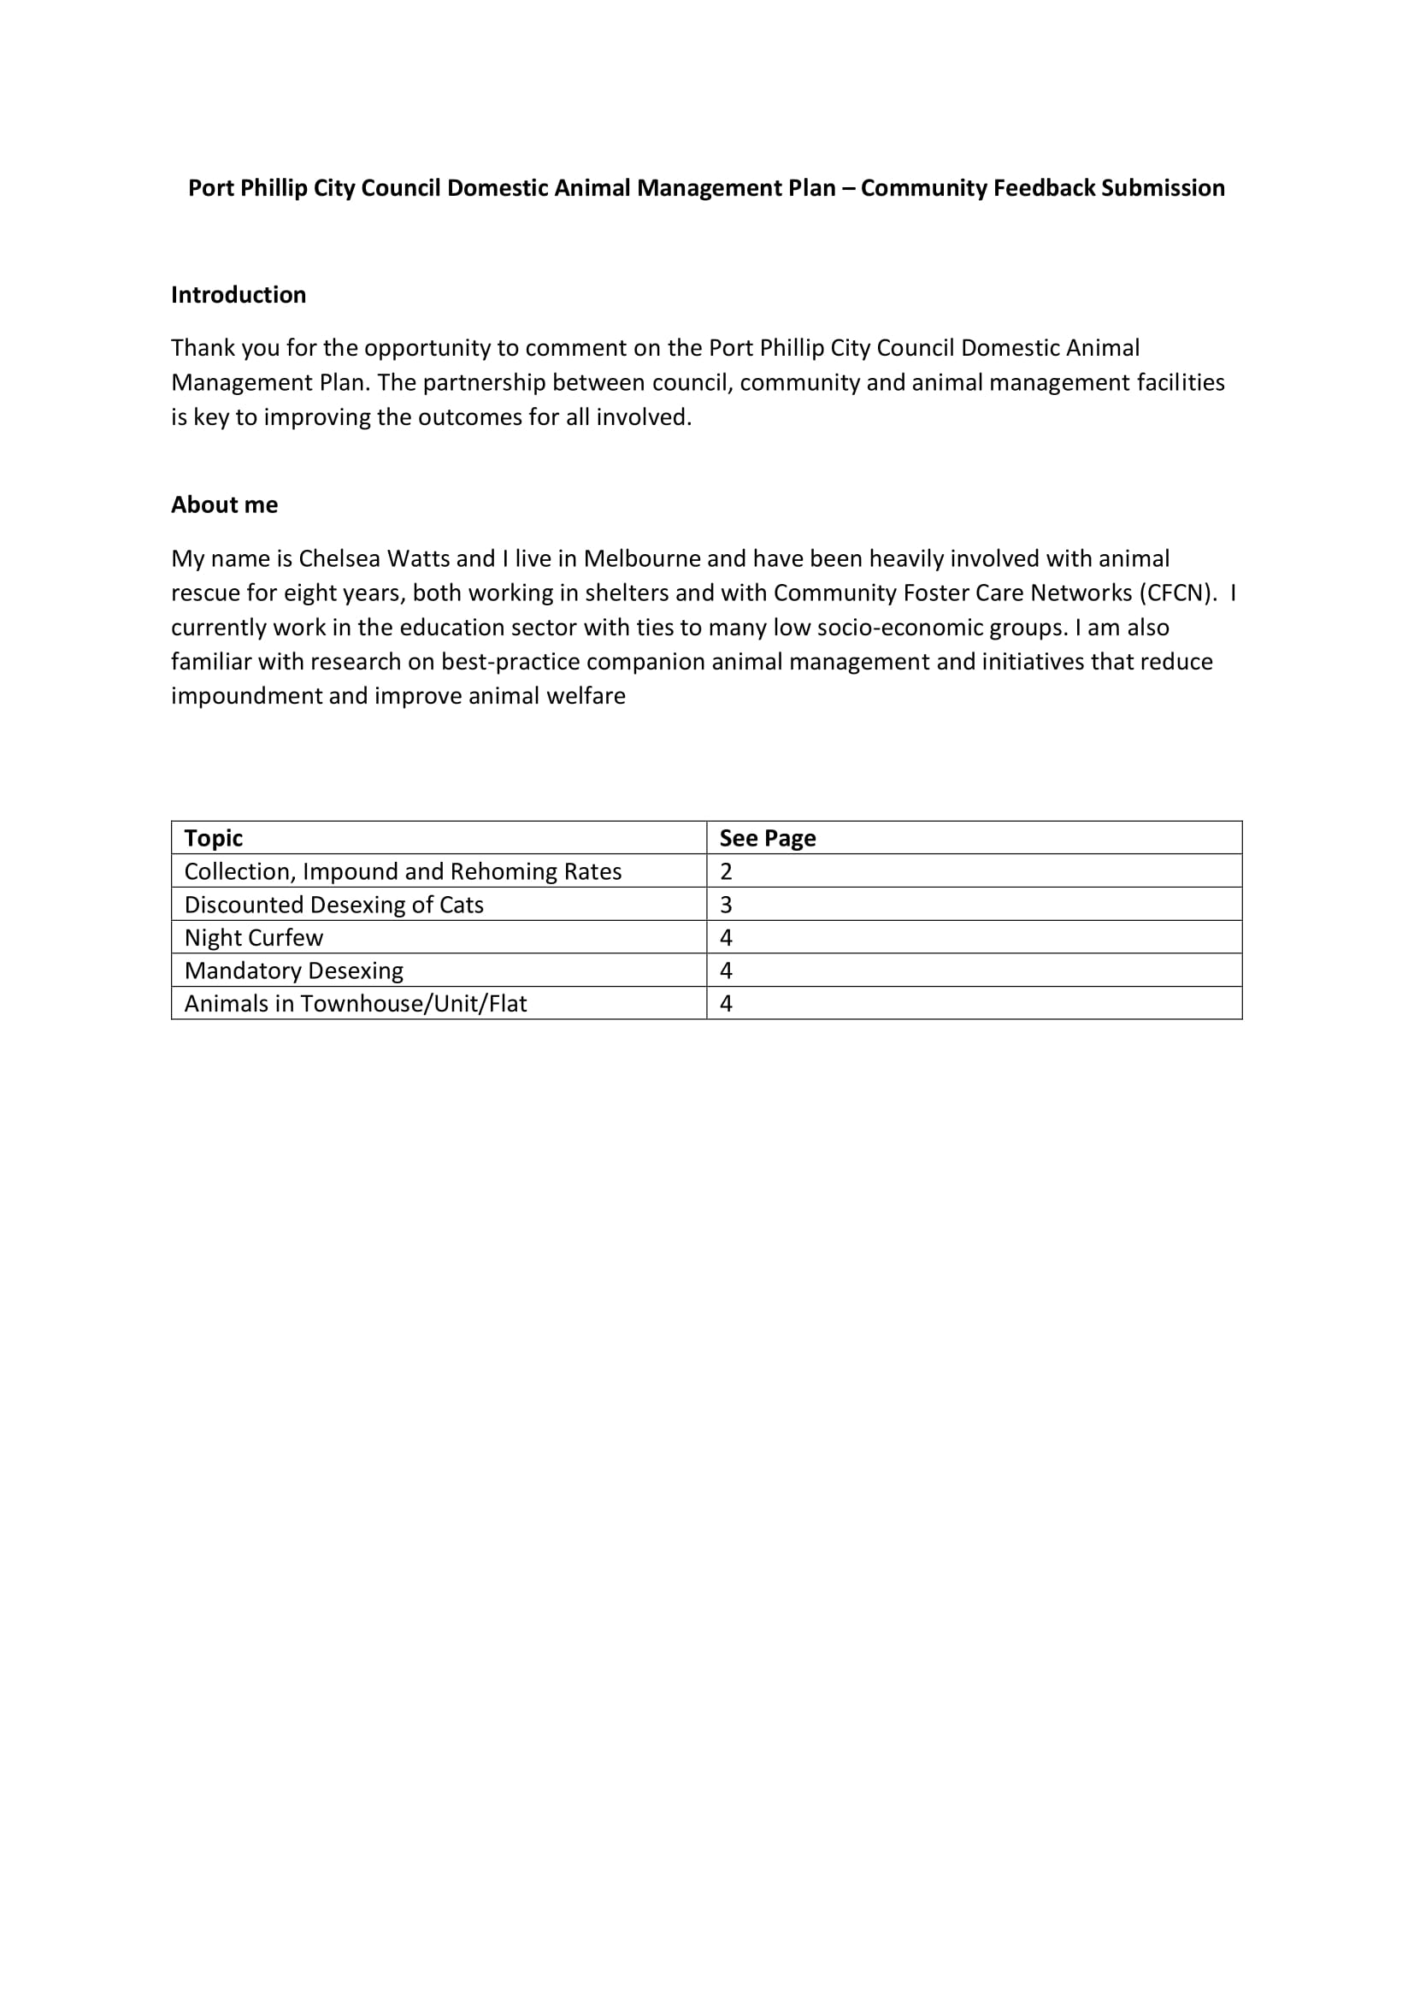

Email 2:

