Sports Surfaces Operating Guidelines
Version 1, July 2021

Guideline Governance

Responsible Service / Department:
Open Space, Recreation and Community Resilience
Adoption authorised:
Council
Date of adoption:
21 July 2021
Date effective from:
21 July 2021
Content Manager folder:
76/04/105
Content Manager file:
E105799/21
Endorsed CEO or ELT member or department manager to make and approve document editorial amendments:
CEO
Annual desktop review date:
31 July
Review date
July 2023
Completion date:
July 2025
Version number:
1
Stakeholder review and engagement:
As required
Relevant Legislation:
NA
Associated Strategic Direction 1:
Inclusive Port Phillip
Associated instruments:
Sport and Recreation Strategy 2015-2024
Supersedes:
NA
Review history:
Name | Content Manager File Reference | Date | Description of Edits

Contents
Sports Surfaces Operating Guidelines 1
Guideline Governance 2
Contents 4
Purpose 5
Outcomes 5
Definitions 6
Scope 8
Operating Guidelines 9
Context 9
Guidelines 10
Decision making matrix 12
How the guidelines contribute to achieving the desired outcomes 15
Relevant Policies, Regulations or Legislation 18
Attachment 1 19
Suite of options to address the ground surface condition and carrying capacity challenge 19
Attachment 2 21
Detail and research of environmental and health issues addressed in the guidelines 21
Health and safety 22
Attachment 3 25
Benefits and drawbacks of synthetic and hybrid surfaces 25
Attachment 4 26
Comparison of potential hours of use between surface types 26
Attachment 5 28
Synthetic sports grounds for community use in inner Melbourne 28
Attachment 6 29
Auckland Council Hybrid Surface Case Study 29

Purpose
The purpose of this document is to help guide decision making and provide clear information on the types and quality of surfaces that will be considered for existing and new sports grounds in the municipality.
High quality turf surfaces and alternate sports ground surfaces contribute to addressing the increasing demand for sports facilities with our increasing population but noting the shortage of supply as an inner metropolitan Council. The choice of sports ground surfaces contributes to playability, safety, longevity and can increase the carrying capacity of sports grounds through providing harder wearing surfaces that can withstand more hours of use without surface deterioration.

Outcomes
- Make our existing sports grounds work harder through extending hours of use with improved lighting, programming, licensing, agreements and consideration of different surface types to increase the carrying capacity to meet demands
- Improve the playability and safety of sports grounds year-round
- Future-proof the City (for population and participation growth and climate change) through appropriate innovation and best practice in sports ground surfaces

Definitions
Term | Definition
CoPP, Council and City | Refers to the City of Port Phillip
Sport Ground / Field | An outdoor rectangular or oval shaped piece of land, with a natural or artificial turf surface, used predominantly for field sport training and matches  Nb. The terms ‘ground’ and ‘field’ are used interchangeably
Carrying Capacity | The amount of use a sports ground can withstand without significant wear and tear, typically expressed as hours per week
Turf/Surface Profile | Refers to the makeup of the turf system including the top playing surface and various levels underneath, including drainage
Synthetic Surface | A sports ground (or part thereof), with a playing surface comprised of 100% synthetic turf, made from synthetic fibres created to look like natural turf
Hybrid Surface | A sports ground (or part thereof), with a playing surface comprised of natural turf with a small percentage (5-10%) of synthetic fibres
Leaching | Is the draining of soluble chemicals or minerals away from soil by the action of percolating liquid, particularly rainwater
Infill | The material that is used to fill the gaps between synthetic fibres in synthetic systems, typically made from recycled rubber and sand.
Microplastics | Small pieces of plastic debris (less than five millimetres long) that are present in the environment, resulting from the disposal and breakdown of consumer products and industrial waste
Carcinogen | A substance capable of causing cancer in living tissue
Polycyclic Aromatic Hydrocarbons (PAH’s) | A class of environmental pollutants produced when coal, oil, gas, garbage, tobacco, meat, and other substances are burned, which can have adverse health effects with high or prolonged exposure
Heritage Overlay | Refers to places of heritage significance (local or state) that are protected by the Victorian State Government
Green Engineering | The design, commercialisation, and use of processes and products that minimise pollution, promote sustainability, and protect human health without sacrificing economic viability and efficiency
Flood-Zone | Refers to a geographical area that is at risk of flooding (low to high depending on the estimated flood risk)
Annual Exceedance Probability (AEP) | The likelihood of occurrence of a flood of given size or larger occurring in any one year. AEP is expressed as a percentage (%)
Top Planting | The removal of the top layer of natural turf in a hybrid turf system
Water Harvesting | The process of capturing rainwater where it falls and taking measures to keep it clean so it can be used for other purposes
Gmax | A measurement used to indicate surface hardness, calculated as the ratio of maximum negative acceleration on impact in units of gravities to the acceleration due to gravity
First (1st) Generation | Refers to the initial iteration of artificial turf surfaces commonly known as ‘AstroTurf’
Second (2nd) Generation | Refers to a version of artificial turf named ‘shag turf’ made from polypropylene fibres that addressed some of the issues with 1st generation, including a less abrasive surface and more flattering appearance
Third (3rd) Generation | Refers to the synthetic turf systems that are used today, with further improvements including softer fibres made from polyethylene, a more stable surface and the addition of infill which has a cushioning effect
Waste Pyramid | A waste management hierarchy that indicates an order of preference for actions to reduce and manage waste, presented diagrammatically in the form of a pyramid. The aim of the waste hierarchy is to extract the maximum practical benefits from products and to generate the minimum amount of waste
Carbon Sequestration | A process by which carbon dioxide is removed from the atmosphere and held in solid or liquid form
IMAP | Stands for the Inner Melbourne Action Plan, which is a collaborative partnership between the Cities of Yarra, Melbourne, Port Phillip, Stonnington and Maribyrnong

Scope
This document only applies to current and future, Council owned, managed or joint use outdoor sports grounds that facilitate field-based sports, such as football, soccer and cricket. The guidelines do not apply to any other public open space, informal recreation sites, hard surfaces such netball or basketball courts, exclusive use sports such as bowling greens and tennis courts, or playgrounds in the City of Port Phillip.

Operating Guidelines

Context
There are currently 15 full-size sporting fields and ovals in the City of Port Phillip (CoPP) on Council owned or managed land, all of which have natural turf surfaces. Many of these grounds have patches of synthetic or hybrid turf in high traffic areas such as in centre square, goal mouths and around cricket pitches. There is also a small sided synthetic soccer pitch at Elwood Primary School, which Council has access to outside of school hours.
Many of these sports grounds experience significant wear through high levels of use, resulting in poor and unsafe playing surfaces. Changing weather conditions and an increasing population create further challenges for the City’s natural turf fields. Council has identified that sports fields and ovals need to be harder wearing and able to withstand high levels of use from multiple groups for both organised sport and informal recreation.
Council’s Sport and Recreation Strategy 2015-2024 identifies alternate sports ground surfaces as a significant opportunity to increase the hours of use of sports ground and facilitate multiple usage types; as well as the need to ensure natural turf surfaces are of high quality and more durable.
The guidelines below aim to inform decision making for the type and quality of sports ground surfaces in the municipality, achieve the three key outcomes listed above and align with Council’s strategic objectives for the community in the Council Plan 2017-27, the Sport and Recreation Strategy 2015-2024 and Draft Public Space Strategy 2020.

Guidelines
Sports ground surface types
Best Practice and Innovation | The City of Port Phillip is striving for best practice and innovation in sports ground surfaces and will consider new technologies that increase the carrying capacity and quality of grounds  * See attachment 4 for the potential increase in carrying capcity of different surface types
Multifaceted Approach | The City of Port Phillip will adopt a multi-faceted approach to optimising sports ground surfaces to facilitate increased use, including:  - Club education and training practices  - Better understanding and monitoring of (i) amount and (ii) intensity of use to enable more effective ground management and programming  - Improving the performance of natural turf grounds (including irrigation, drainage, profile and turf type considerations)  - Artificial solutions for high traffic areas of sports grounds  - Alternate surfaces such as full synthetic and hybrid systems  * See attachment 1 for further detail
Balance of Surface Types | Alternate surface installations will be used to complement natural turf pitches to ensure an appropriate balance of surface types (natural and artificial) in the municipality’s sport ground portfolio
Municipal Context | Sport ground surface decisions will be considered through a municipal lens, recognising that what has worked in other places may not be our optimal solution. Municipal considerations include:  - Geographic context (Southern hemisphere, country and location within the municipality)  - Climate and weather patterns (level of rainfall, drought etc)  - Municipal issues (limited open space and desire/need for public spaces to be multiuse)
Site Specificity | The most appropriate solution (or combination), will be specific to the site and based on a needs analysis and cost/benefit analysis including factors as:  - Types of current and potential future use (formal and informal)  - Frequency of use and estimated future demandBenefits and drawbacks of the surface type (* See attachment 3 for further detail)  - Ability to facilitate multiple uses  - Council priorities  - Budget allocation
Environmental Impacts | The environmental impacts of any surface (including articifical) will be rigorously investigated and carefully considered in all sports ground surface decisions through a ‘green engineering’ lens including:  - Materials effect on the environment  - Re-use/recyclability of materials at end of life  - Maintenance requirements (including water use, machinery energy requirements and chemicals used)  * See attachment 2 for further detail
Health Impacts | The health impacts of any artificial surfaces will be carefully considered in all sports ground surface decisions, including:  - Health to players and users  - Particpant safety and injury  - Heat and UV management  * See attachment 2 for further detail
Maintenance Considerations | The maintenance and renovation requirements of each solution (including time, cost, testing and specialist equipment required) will be considered prior to a new surface installation to ensure it is achievable, so that:  - The ongoing benefits of the new surface are fully realised  - The life span of the product is maximised  - The surface meets ongoing safety and quality requirements
Supporting Infrastructure | The City of Port Phillip recognises that any proposed changes to sports ground surfaces must consider the impacts on other aspects of the facility, including:  - Sports ground lighting  - Pavilion size and capacity for increased use  - Impact of increased use on surrounding amenity and required supporting infrastructure e.g. parking and improved greening  - Maintenance regimes
Agility | The first installation of a full synthetic or hybrid sports ground in the City will be a pilot, with data collected on the environmental and health impacts of the surface change to inform future sports ground surface decisions.  * See attachment 5 and 6 for examples of synthetic and hybrid installations

Decision Making Matrix
Table 1: Features of Different Surface Types
* Over a 10-year period, based on maximum carrying capacity usage per week, taking into consideration both installation and
maintenance costs
* Capital investment such as surface type is subject to Council budget process approval

Suitability factor | Synthetic | Hybrid | Natural Turf
Carrying Capacity (Average) | 60+ hours per week | 30-35 hours per week | 20-25 hours per week
Life Span | 10-20 years | 7-10 years | 10-15 years
Synthetic Fibres | 100% | 5-10% | 0%
Heat | Increased surface temperature, due to UV reflection off the surface | Surface temperature is only higher if the natural grass is worn away (unlikely with appropriate management of ground usage) | Positive role in heat regulation - absorbs the sun’s heat during the day and slowly releases it in the evening
Water Use (Average) | Minimal (assuming water cooling is not required frequently) | 175-375 KL/week depending on site use, desired quality and management practices | 175-375 KL/week depending on site use, desired quality and management practices
Sports and Usage Types | Can be multi-purpose for training, but some sports have different requirements for competition | Can be used in the same way as natural turf | Can be used for all grass sports, both training and matches
Suitable for Dog Walking | No | Yes | Yes
Fence Required | Preferable | No | No
Installation Cost ($) | High | Medium | Low
Maintenance Cost / Requirements | Low | Medium/high | Medium
Cost $ Per Hour of Use * | $47 | $94 | $146
Table 1: Features of different surface types
 | Synthetic | Hybrid | Natural Turf
Attributes of Preferable / Ideal Sites
Location Context | Located in a reserve with multiple sports grounds OR A single sports ground with substantial nearby greenspace | A single sports ground without substantial surrounding greenspace | Suitable for single or multiple sport ground reserves
Site Context | Part of a sporting precinct with adequate parking or recognised as a place for organised sport within the community | Competing demand from different groups | Important greenspace within the community or sport requires natural turf
Open Space Character Classification | Primary: Sporting or restricted sporting/recreation  Secondary: None | Primary: Sporting  Secondary: Passive/ play/ other | Primary: Sporting  Secondary: Passive/ play/ other
Heritage Overlay | No | Yes | Yes
Required Uses | Predominantly organised formal sport and recreation and informal recreation use | - Sport  - Dog walking  - Informal recreation  - Passive community use  - Events | Suitable for all usage types:  - Sport  - Dog walking  - Informal recreation  - Passive community use
Current Use of Sports Ground (Demand) | Above capacity | At or above capacity | At or within carrying capacity
Future Use (Forecast Demand) | Greatly exceeds carrying capacity of natural turf | Exceeds carrying capacity of natural turf | Falls within carrying capacity of natural turf
Flood Risk | Low to moderate risk flood zones (1-2% AEP) | Low to moderate risk flood zones (1-2% AEP) | N/A
Number of Synthetic Fields in Municipality | Low | Medium | High
Funding Available for Installation | High | Medium | Low
Climate Prediction for Useable Life | Extreme (can tolerate drought and heavy rain, does not require any resting between seasons) | Moderate (can tolerate dry periods and wet periods with a safe playable surface) | Moderate (can tolerate short dry periods, doesn’t tolerate heavy rain or drought)
Role of the surface type in the sports ground portfolio
Purpose 1 | Utilise the synthetic field within the reserve for sport training and junior games, allowing the neighbouring turf fields time to rest and maintain surface quality | Carefully manage the use and maintenance of these grounds in line with the intended purpose:  - If ground is predominantly for high levels of community use, can program significantly more hours of use and play even if natural grass is worn  - If ground is to be considered for higher level competition, limit the number of programmed hours and preserve the green aesthetics | Utilise for organised and informal sport and recreation
Purpose 2 | Program competition for sports where the surface is appropriate/desired, notably soccer |  | Utilise as green space that provides health and well-being benefits for users and the community
Purpose 3 | Use the synthetic field as a bookable space that Council can receive a return on e.g. school use during the day | Ensure equity and sharing of space amongst multiple user groups | The option of moving some sport to synthetic fields when required to avoid blowouts of natural turf grounds (rather than cancelling sport, or playing on unsafe grounds)

How the Guidelines Contribute to Achieving the Desired Outcomes
Outcome 1: Increase the carrying capacity of sports grounds to meet demand from sports clubs and other users, through surfaces changes and enhancements, while considering environmental and other impacts
There is increasing demand for the use of sports grounds in the City of Port Phillip. Participation in organised sport is growing, particularly by female and juniors in traditional winter field sports (previously dominated by male participants), which have the greatest impact on ground condition due to training loads and weather conditions in this season. There is also greater demand for sports ground use from schools and the wider community, including dog walking. This increase in demand, combined with a limited number of Council owned or managed sports grounds, limited opportunities to purchase land for new public space, and similar issues throughout the Inner Melbourne Action Plan (IMAP) Council region, creates a capacity challenge within the municipality. CoPP needs to look at how it can maximise the use of the existing grounds, while taking into consideration the effect that changes may have on the environment and community.
Increasing carrying capacity
Finding an appropriate balance between Council’s priorities to make our existing sports grounds work harder through extending hours of use with improved lighting and programming, licensing, agreements and consideration of different surface types. To achieve this balance, Council will adopt a suite of options, with solutions individualised for each site. This includes;
(1) Club education and training practices,
(2) Getter understanding and monitoring of (a) amount and (b) intensity of use,
(3) Improved irrigation, drainage, profile and turf types for natural turf surfaces,
(4) Artificial solutions for high wear areas of sports grounds and,
(5) Artificial surfaces including full synthetic and hybrid turf fields.
Further detail of the suite of options is provided in attachment 1.
Environmental impacts
There are many environmental impacts that need to be considered when choosing a sports ground surface for community use. Factors such as;
(1) the maintenance requirements of the surface, including water usage and frequency of
maintenance,
(2) the effect of artificial materials on the environment, such as microplastics leaving the synthetic
system and potential leaching from infill,
(3) the urban heat island effect when converting a natural turf field to a synthetic or hybrid field,
(4) The carbon footprint of different surface types,
(5) the overall sustainability of the solution, including end of life reuse and recycling options,
(6) the element of soil contamination and how this is managed and mitigated.
Further detail and environmental research is provided in attachment 2.
Other Impacts
Council must also consider the impact that changing the type of sports ground surfaces may have on the site and its surrounds, especially if the goal is increased use of the ground. Such impacts must be considered in the planning stage of any new surface installation, including:
- Provision and quality of sports ground lighting
- Facility/pavilion quality and capacity for increased use
- Supporting infrastructure requirements, such as fencing
- Impact on surrounding amenity, from increased traffic, parking requirements and noise
- Multiple uses of the site, including if it is utilised as a community green space
- Maintenance requirements (expertise, time, testing and equipment)
It is important to note that with any emerging technology, the long-term effects cannot be fully realised until the product has gone through a full lifecycle. While hybrid and synthetic technology has been utilised for a long time in Europe and the USA, it is much newer in Australia (particularly hybrid). The predominant use for hybrid has been for stadia and elite purposes, not as commonly for community use. A new environment and different nature of use may present different challenges. For these reasons, the first installation of a full synthetic or hybrid field in CoPP will be a pilot, with learnings to inform future installations.
Outcome 2: Improve the playability and safety of sports grounds year-round
Many sports ground surfaces in the City of Port Phillip and the IMAP region are less than optimal at times during the year with the current level and type of use they experience, and this is only set to increase. Surface quality is a common complaint from users and is also a safety concern, which has potential ramifications for individuals, Clubs/Associations and Council. Artificial surfaces can improve both playability and safety outcomes for users and some sporting bodies are pushing for full synthetic surfaces for their community leagues. However, there is a community perception that synthetic surfaces are less safe, with concerns around the hardness of the ground and surface temperature. It is important to address these concerns and that Council remain diligent in installing and maintaining surfaces to a high level to ensure player safety and reduce the risk of any incidents that may further fuel these perceptions.
Playability and safety (less ground issues and a smoother playing surface)
High use of sports grounds and playing on waterlogged grounds causes damage and destruction of the natural grass. This can lead to both (i) bare/worn or (ii) muddy surfaces underfoot, both of which are problematic for playability of the ground. Most grasses go dormant in winter months, which when combined with wet weather, high use, and poor growing conditions, results in significant surface deterioration. This also means that the time and maintenance work required to bring the grass back after the winter season is significantly greater, which can also negatively impact summer sports, if the grounds aren’t in suitable condition at commencement of the season. The use of synthetic fibres on sports grounds can help the ground to withstand higher levels of use, which can also combat the programming challenges of preseason training, and the drainage systems used in conjunction with these surfaces reduce the likelihood of water pooling.
User health and safety considerations
There are over 100 independent studies that have been completed worldwide on the safety of the materials used in artificial sports surfaces and the potential impacts on user health. A major focus of the research has been on the potential toxicity of recycled rubber, which can be used as infill for many synthetic systems. Research studies generally show that infill rubber does not pose a serious health risk to players and users (Sport and Recreation Victoria, Artificial Grass for Sport Guide). Concerns about increased heat and incidence of injury have also been raised in the community. Research on the type of synthetic and hybrid systems installed today (3rd generation) shows that there is no increased risk of injury when playing on synthetic turf compared to natural turf. While temperature of synthetic surfaces can be significantly higher than natural turf surfaces, there are several ways to reduce the heat impact for users and ensure a safe environment for participation in sport and recreation. For further detail and research on the impacts on player physical health, heat and UV and user injury see attachment 2.
Outcome 3: Future-proof the City (for population growth and climate change) through appropriate innovation and best practice in sports ground surfaces
Council is committed to creating a City that is future ready and providing infrastructure that allows agility in responding to the needs of our rapidly growing and changing community. Using only natural turf for sports ground surfaces moving forward will not provide sufficient carrying capacity and may inhibit Council’s ability to facilitate a safe and active community.
Developing a portfolio of sports grounds with multiple surface types that are specific to the nature and demands of the site is likely to produce the best overall result for Council and the community. There are many different types of hybrid and synthetic systems, which can support multiple uses, and enable our spaces to work harder and carry more load. The intended type and intensity of use for the site, safety and environmental factors, geographical context and economic factors including cost of maintenance and rental opportunity, should all be considered when choosing the most suitable surface type for each site.
Council should be guided by experienced contractors and/or feasibility studies in conjunction with green engineering principles when making decisions about sports ground surfaces. Green engineering provides a holistic framework that recognises the need to consider the planet, people and profit, which is especially applicable in a local government context. It is defined as the ‘design, commercialisation, and use of processes and products that minimise pollution, promote sustainability, and protect human health without sacrificing economic viability and efficiency’ (United States Environmental Protection Agency). It is also important that Council consult with key stakeholders, particularly sports ground users, as learnings from benchmarking and consultation with other Council’s suggests that while some groups embrace new surface types, other groups may be resistant to change.
There is also an opportunity for Council to embrace innovation and be an early adopter of hybrid technology across a full-size sports ground for predominantly community use. The City of Port Phillip (and many other Councils) are already utilising hybrid technology for high traffic areas of sports grounds, including locations at Elwood Park, Peanut Farm and JL Murphy Reserve. However, due to limited installations of full hybrid surfaces (i) in an Australian context (ii) for community use, a hybrid full ground trial at an appropriate site should be considered. This allows for performance of this surface type in the City of Port Phillip to be monitored and assessed and maintenance regimes to be optimised, to ensure efficient and effective full hybrid surfaces in the future (see attachment 6 for a hybrid case study in Auckland, New Zealand).

Relevant Policies, Regulations or Legislation
- Act and Adapt: Sustainable Environment Strategy 2018-28
- Public Space Strategy 2021 (Estimated endorsement December 2021)
- Sport and Recreation Strategy 2015-2024

Attachment 1

Suite of Options to Address the Ground Surface Condition and Carrying Capacity Challenge
Club Education and Changing Training Practices
There are higher traffic areas of natural turf fields, which are more susceptible to ground deterioration. These typically include goal squares, centre squares, the centre corridor and bench dug outs. While higher use of these areas cannot be avoided during matches, it can be addressed during training by changing sports club practices. Sports clubs will be educated and encouraged to use lower traffic areas of the ground where possible during training, to help alleviate commonly faced issues, including poor ground condition. To facilitate this, Council will endeavour to provide safe playing surfaces on all sporting reserves that is consistent across the entire field so all areas can be used equally for evening training. This may be achieved through resting sections of reserves when required, rotating club allocations to ensure the nest condition of the playing surfaces.
Better Understanding and Monitoring of (I) Amount and (Ii) Intensity of Use
While ground surface types are assigned a certain number of hours of use, they can withstand without significant deterioration, in practice surface quality is highly influenced by the intensity and type of use. Council understands that each hour of use can vary significantly in terms of impact on the ground surface. For example, one hour of use by three senior football teams training will likely impact ground condition significantly more than one hour of use by one junior football team training. When calculating the number of hours of sport to program to grounds, Council will also consider the amount of community use outside of sport allocation, which may also impact on ground condition, such as school children and dog walking. Council will explore ways of monitoring the intensity of use to better understand the use of Council’s sports grounds and program more effectively.
Improved Irrigation, Drainage, Profile and Turf Types for Natural Turf Surfaces
Using efficient and suitable irrigation, drainage and turf profiles (such as sand carpeting, rootzone sand, and sub-soil drainage systems) for existing natural turf pitches, can increase the carrying capacity of grounds without the need for full artificial surfaces and potentially costly and disruptive major works. Similarly, using harder wearing turf types, such as couch grass, or supporting different grass types in the different seasons, can improve the hardiness of the field (with appropriate maintenance) and is the preferred turf option where possible. These improvements may be an appropriate solution to increase the carrying capacity and quality of the surface by a small amount.
Artificial Solutions for High Wear Areas of Sports Grounds
To enable sports grounds to withstand current use with less surface deterioration, installing synthetic or hybrid surfaces on high traffic areas such as the goal mouths, player benches and entrance points, helps to alleviate stress on the area’s most prone to damage. This is also a way to familiarise the community with these surface types before full synthetic or hybrid surface installations may occur in the future.
Artificial Surfaces (Full Synthetic and Hybrid Turf Fields)
Full synthetic and hybrid turf fields have the potential to greatly increase the number of hours per week a sports ground can be used and are a long-term solution to relieve ground capacity pressures. The benefits, drawbacks and suitability of these options are explored further in attachment 3. Case studies and examples of synthetic sports ground are provided in attachment 5 and a hybrid case study is detailed in attachment 6.

Attachment 2

Detail and Research of Environmental and Health Issues Addressed in the Guidelines

Environmental
Water Usage
Synthetic surfaces have a much lower water requirement than both natural turf and hybrid surfaces, which is beneficial to meeting Council’s potable water use targets (203 ML/y by the year 2028). Hybrid surfaces have no greater water requirement than natural turf surfaces, which is ‘current state’ for CoPP. Synthetic and hybrid systems can also be designed to capture water and re-use for other purposes (water harvesting).
Leaching from Infill (Run-Off into Waterways)
Full synthetic surfaces contain infill, which typically consists of rubber particles, that sit between the synthetic blades of grass. A large study commissioned in Auckland, New Zealand investigated the quality of water draining from several synthetic fields over a multi-year period. The study concluded that there were no issues with water quality, with all substances/potential contaminants within acceptable levels. The water was cleaner than run off from normal soil, as the irrigation system for the synthetic surface included a sand filter. There is also a lesser need for herbicide and pesticide use with synthetic fields, compared to fields that contain natural turf.
Microplastics
The technology used for synthetic and hybrid fields is continually evolving and improving. Synthetic systems are now made to ‘contain the field’ (ensure that all elements of the field stay within the system) and drainage is designed to catch microplastics. Microplastics are any plastic debris measuring 5mm or smaller in size. This means that rubber infill and tips of yarn can be filtered out and have less chance of entering water ways.
Heat Dissipation and Carbon Footprint
Synthetic turf may contribute to the urban heat island effect. Urban heat islands are created in dense urban environments, when significant amounts of natural grass and trees are replaced by impervious surfaces which absorb heat. Urban heat islands increase demand for energy (particularly air conditioning), intensify air pollution, and increase heat-related health problems. While converting a few natural turf sports grounds to synthetic surfaces is unlikely to have a significant effect, it is important to understand it can be an issue with mass conversion or in conjunction with other surface changes in the municipality.
When comparing the carbon footprint of natural turf and synthetic turf, the whole life cycle of the product needs to be considered. While the installation and maintenance of natural turf emits more carbon dioxide than artificial surfaces, the production, transportation and disposal of synthetic surfaces emits more carbon dioxide than natural surfaces. Natural turf also helps to remove carbon dioxide from the atmosphere through photosynthesis and stores it as organic carbon in soil, making natural turf fields important “carbon sinks”.
Both above factors highlight the need to carefully balance the number of synthetic fields and natural turf fields in the municipality, particularly if converting a natural turf field to a synthetic field. If significant conversion of natural turf to synthetic materials is planned, Council should also consider proactive strategies to offset/counteract the effects of removing green space, such as additional tree planting.
Waste Pyramid
Council will consider the waste pyramid in the creation, operation and end of life options for sports ground surfaces. The ideal solution is prevention and Council will endeavour to use high quality materials that are suitable for the location and type of use and employ maintenance practices that extend the life of the product. The quality of materials can be assessed using the ‘Fiber performance Index’, which provides a score between 0-100, that considers durability, resilience and friction of the product. At end-of-life, Council will explore ways to re-purpose/re-use the materials, such as use in residential gardens and sports ground viewing areas, before considering recycling options. This prolongs the life of the materials before recycling is required and decreases/delays the manufacturing of new products. Finally, if recycling is not a viable option, energy recovery is a more favourable option than disposal into landfill.
End of Life Challenge
While the materials used in many synthetic and hybrid systems have the potential to be recycled, there are several challenges that may prohibit this from occurring:
- The technology needed to recycle these products is not readily available in Australia
- There is little upstream demand for the recycled product, which has resulted in stockpiling in European countries (where the technology is available)
- The end supplier often is not willing to pay more for a recyclable solution
- However, the industry moves quickly and there is a lot of work being done in this space:
- There are approximately 50 synthetic sports grounds in Australia that will soon reach end of life, which experts say will prompt the technology to come to Australia in the next 2-3 years
Turf companies are investing heavily in creating sustainable and innovative solutions, which include (i) re-use options and opportunities (ii) materials that are more easily recycled and (iii) products derived from the recycling of synthetic systems that there is demand for upstream.

Health and Safety
Player Physical Health
Recycled rubber infill: Recycled rubber contains substances that are potentially hazardous in their natural state, such as Styrene and Butadiene (which are known carcinogens). However, in recycled rubber they are combined with other chemicals to form polymers, which lock the hazardous chemicals in the polymer chain and therefore present little risk to humans. These polymers are even present in products, which are approved for human consumption, such as chewing gum. However, there has been community concern that these polymers may break down to their raw components and then pose a safety risk to players, which has prompted much research:
- Multiple studies have looked at exposure to rubber infill and the potential toxicity if inhaled, ingested or with skin contact and none have found harmful health effects (National Institute for Public Health and the Environment, Ministry of Health, Welfare and Sport, Netherlands, ‘Playing sports on synthetic turf fields with rubber granules’ 2012-2016)
- However, just because research to date hasn’t found any ill health effects, doesn’t mean none exist. Due to the known hazard of these chemicals in their raw form, Europe has enforced comprehensive regulations that restrict the presence of polymers that contain these chemicals in all products, including car tyres. Registration, Evaluation, Authorisation and Restrictions of Chemicals (REACH) has identified 8 key Polycyclic Aromatic Hydrocarbons (PAH’s) which cannot sum more than 10mg/kg in any product.
- To mitigate any risk Council will ensure that if recycled rubber infill is to be used, it will be sourced from tyres that are manufactured under these standards. Alternatively, there are other types of infill that can be used that don’t contain toxic substances.
Heat and UV
The temperature of synthetic surfaces can be significantly higher than natural turf surfaces. This is largely a result of direct sunlight (i) reflecting off the synthetic fibres and (ii) being absorbed and radiating from the infill, not high air temperatures. Therefore, the heating effect of synthetic surfaces is significantly less if there is cloud cover or wind.
The main concern with hot conditions for sports participation is it can lead to heat stress, particularly for children and the elderly. Heat stress is two-fold, impacted by both external conditions (the environment) and internal conditions (the body). Sport governing bodies have heat policies and guidelines addressing both, such as shorter playing times and more drink breaks in hot weather and changing playing times to earlier or later in the day. The practical implementation of such guidelines reduces both the likelihood of heat stress and the need to cancel sport.
However, the parameters around ‘hot weather’ in these policies typically include measures of ambient temperature and relative humidity - few address surface temperatures. As synthetic surfaces become more prevalent it is important to consider the impact that surface temperature may have on heat stress and heat-related illnesses. Further research needs to be done in this area in an Australian context.
- While the external and internal conditions mentioned above are still applicable with synthetic surfaces, Council may consider specific methods to reduce the surface temperature of synthetic surfaces if it becomes problematic (particularly in the future with climate change) including:
- Permanent solutions, such as: Cool grass technology and alternate infill materials
- Temporary solutions in hot conditions with little wind or cloud cover, such as: Watering the surface and using grass Wetting agents
- Alternate sport programming (time of day) in heat waves.
However, as the ground carrying capacity pressures (mentioned earlier in this document), are most prevalent in winter, Council will first consider converting fields that have predominant use in winter (such as soccer pitches), which would largely eliminate the potential issue of heat with synthetic surfaces.
User Injury
Synthetic and hybrid grounds provide consistent and smooth surfaces underfoot. This is an advantage to natural turf grounds, which can be highly variable (particularly with overuse, or if not appropriately maintained). There has been concern that synthetic surfaces may increase injury risk as there is a perception that the surface is harder. However, research to date shows no consistent increases in injury when playing on 3rd generation synthetic surfaces, which are the type that are installed today (Risk of Injury on Artificial Turf vs Natural Grass, British Journal of Sports Medicine, 2006). There is evidence that older systems installed in the past, such as 1st and 2nd generation may have increased injury risk when compared to natural turf, but these are no longer installed. A potential downside is that full synthetic surfaces can be more abrasive and therefore increase the severity of ‘turf burns’. However, incidence of this is low and most sports are accepting of synthetic surfaces for participation.
Hardness
Ground hardness needs to be managed carefully regardless of surface type, natural or artificial. Compacting of the surface is the main factor that leads to increased ground hardness. This can occur through overuse, heavy rainfall and drought for natural turf, and low infill levels for synthetic surfaces. It is important to ensure that grounds are properly maintained and tested at least once per year to ensure grounds are an appropriate hardness at all locations across the ground (less than 120 Gmax when using a Clegg impact tester and less than 164 Gmax when using an ASTM F355 device). There is no evidence to suggest that synthetic fields increase the incidence or severity of surface contact injuries, but more research needs to be done in this area.

Attachment 3

Benefits and Drawbacks of Synthetic and Hybrid Surfaces
Full Synthetic | Benefits | - Significantly increased carrying capacity: 60+ hours of use per week  - Can support multipurpose activities  - Consistent, safe, playable surface all year around  - Surface not affected by drought or heavy rainfall  - Increased sustainability of sports clubs (meet participation demands, less training/game cancellations)  - Decreased maintenance and renovation requirements (but still must be diligent with maintenance regimes)  - Less water use than natural turf and hybrid surfaces  - Surface does not require rest and regeneration time
 | Drawbacks | - Higher initial installation and disposal costs  - Community perception around health impacts and safety of synthetic grounds  - Synthetic surfaces heat up more than natural turf (some types of infill heat up more than others)  - Some infill may decrease in performance with the harsh UV conditions in Australia  - Not all synthetic surfaces are recyclable at end of life and the technology to recycle the newer surfaces is not readily available in Australia
Hybrid | Benefits | - Increased carrying capacity: 30-35 hour of use per week  - A 'greener' solution:  - Facilitates varied uses such as dog walking (unlike synthetic)  - Better aesthetics when natural grass is worn (compared to full natural turf field)  - Has some heat and carbon sequestration benefits due to large percentage of natural grass still present (unlike synthetic)  - Increased sustainability of sports clubs (meet participation demands, less training/game cancellations)  - Lower initial installation and disposal costs (compared to synthetic)  - Does not require infill, which has negative perceptions in the community around health and environmental impacts  - Ground is still safe and playable even when the natural turf has worn through  - Increased stability of the surface and root zone creating a more level playing surface. The synthetic fibres also protect and increase the durability of the natural grass
 | Drawbacks | - Surfaces still need rest to allow natural turf to rejuvenate  - Maintenance requirements are no less than natural turf and ideal maintenance regimes are still being optimised:  - Thatch build-up needs to be managed  - Must be diligent with maintenance to retain the benefits of a hybrid surface  - Irrigation repairs are slightly more complicated than natural turf as there is a need to cut through the backing mat  - No Australian case studies detailing performance or whole of life impacts for full ground surfaces  - The technology to recycle the synthetic backing of a hybrid surface is not readily available in Australia

Attachment 4

Comparison of Potential Hours of use Between Surface Types
The chart below shows the total hours of use that would be available if all 15 sports grounds in the City were a particular surface type. This is based on a conservative estimate, assuming 20 hours of use per week for a natural turf field, 30 hours of use for a hybrid surface and 60 hours of use for a synthetic surface. To achieve an appropriate balance of surface types in the City, it is likely that a combination of surface types will be used across the 15 sports grounds, resulting in between 300 and 900 hours of available use per week. If just 2 natural turf fields were transitioned, 1 to a synthetic ground and 1 to a hybrid ground, this would increase the total potential hours of use hours from 300 to a minimum of 350 hours per week.

Scenario: Transitioning a Natural Turf Soccer Ground to an Alternate Surface Type
Current state: Many soccer grounds in Melbourne currently have natural turf surfaces. It is common for surface condition to be poor for significant periods of the year, due to damage to the natural grass, from high participation, cooler climates and use in wet conditions. This results in the requirement for ground use to be reduced, with only an average of 15 hours able to be programmed to the ground each week.
Solution 1: Hybrid
- The initial installation cost of a hybrid surface is approximately $140 metres squared vs natural turf of $9 metres squared
- This would increase ground use to 30 hours per week (an increase of 15 hours of use per week) which equates to an additional 720 hours of use per year
- This would enable provision for an additional 150 people to participate in sport each week, based on one training session and one match each week (3 hours of use a week per participant)
- A hybrid surface is a greener option that is suitable for passive community recreation and dog walking
Solution 2: Synthetic
- The initial installation cost of a synthetic surface is higher: approx. $2.5M+
  - This figure includes costing based on the forecasted Council 2021/22 Budget for the JL Murphy Synthetic the includes sub surface works, park integration, and supporting infrastructure
- This would increase ground use to 60+ hours per week (a significant increase of 45 hours of use per week), which equates to an additional 2,160 hours of use per year
- This would enable provision for an additional 450 people to participate in sport each week, based on one training and one match a week each (3 hours of use a week per participant)
- Synthetic surfaces can be multi-lined and used for a variety of activity types for training purposes. Some sports have a desire for singular line markings and surface type for competition, which is needs to be challenged to maximise overall participation in sport and recreation
- Synthetic surfaces are ideally fenced
The recommended primary use for synthetic surfaces is sport participation.

Attachment 5

Synthetic Sports Grounds for Community Use in Inner Melbourne
Case study 1: Gardiner Park, Glen Iris
- The City of Stonnington, opened Gardiner Park synthetic sports ground in July 2019.  - It is a multi-sport ground with line markings for AFL, Soccer and Rugby  - The City of Stonnington noted that it ‘offers much-needed increased capacity to accommodate the growing number of adults and children participating in local sport, and supports Council’s commitment to providing quality recreation and sporting facilities for the community’ | 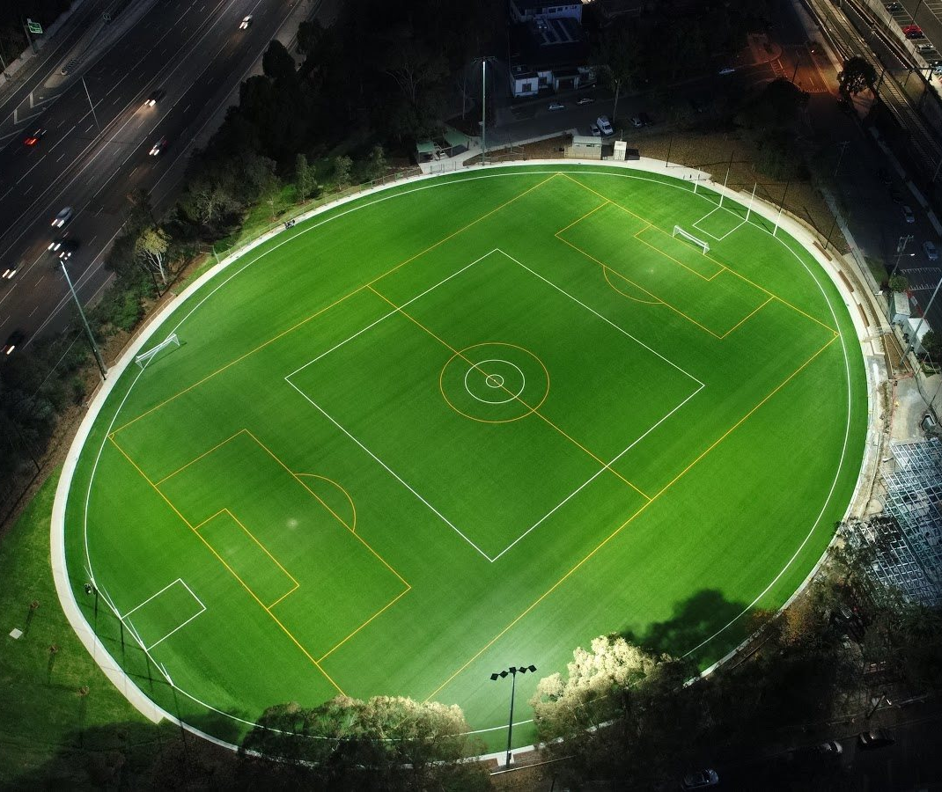
Case study 2: JJ Holland Park, Kensington
- The City of Melbourne installed a multipurpose synthetic sports ground at one of its four sport precincts in 2010.  - The City of Melbourne noted the importance of this field to address participation pressures: in winter 2009 sporting clubs requested 620 hours of use per week, however, only 350 hours could be allocated at this site.  - The master plan for Princes Park recommends a synthetic field installation, with the aim to have 1 synthetic field in each of the City’s 4 sport precincts. | 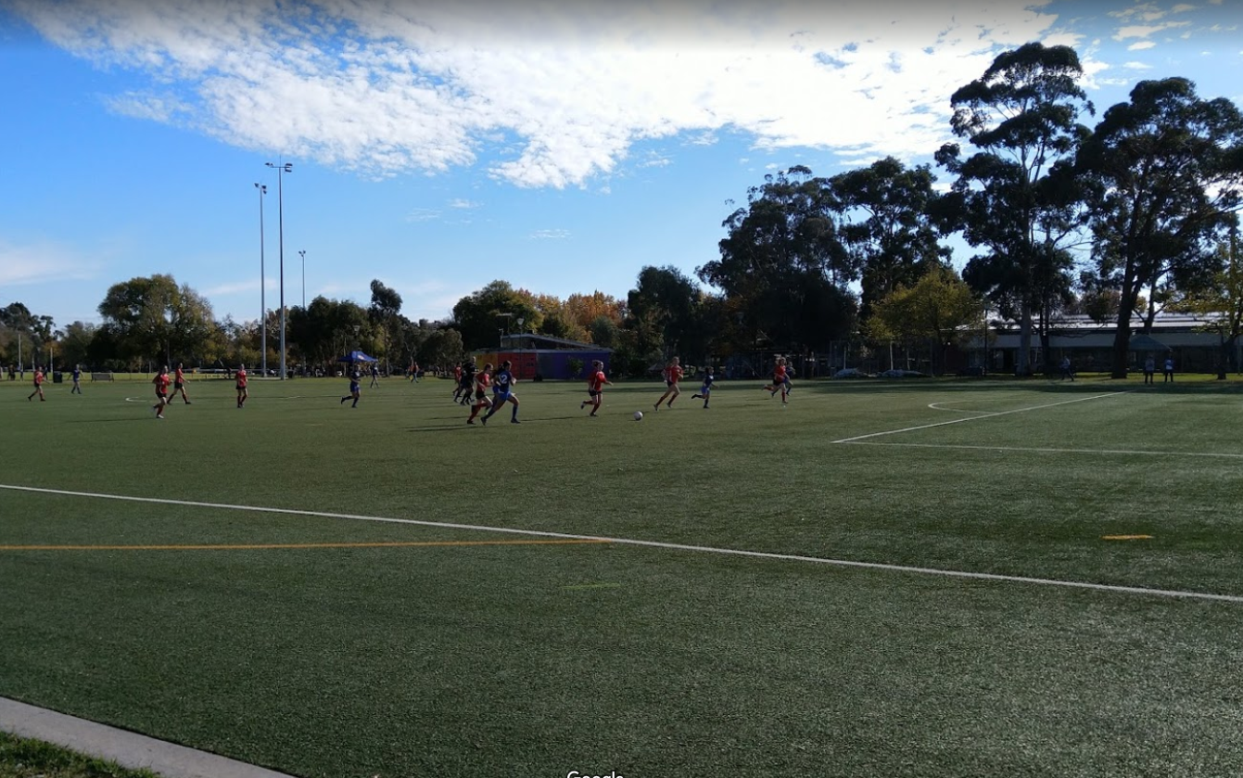

Attachment 6

Auckland Council Hybrid Surface Case Study
Happy Medium: A case for Hybrid  “It’s a combination of the benefits of synthetic and natural turf, at a good cost point, to address playing capacity issues” |  | 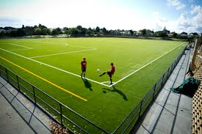
Background | Gribblehirst Park and Nixon Park (opened April 2017) became the first community full-hybrid pitches to be installed in Australasia. While synthetic surfaces were the initial preference, hybrids emerged as more appropriate choice. XtraGrass (hybrid) was the product used.
Problem to be Solved | - Sports field playing capacity  - Significant wear causing inconsistent and unsafe playing surface  - Blow outs resulting in field closures and decreased availability of the ground for sport
Approach | Auckland Council developed a suite of options and applied a programmatic approach to ensure the most suitable solution for each ground:  - Sand carpeting over the soil  - Hybrid surface  - Synthetic surface  - Drainage improvements (sub-soil drainage system)  - Adding training lights
Benefits of Hybrid Surfaces for Council | - Lower installation cost than a synthetic pitch  - Higher carrying capacity than natural turf (30-35 hrs compared to 20-25 hrs)  - Amenity advantages – looks like a natural field, no fences  - Better solution in heritage areas as less disruption during installation  - Quality playing surface  - Multi-use, including casual community recreation and dog walking  - “Greener” outcome as much of field is still natural turf  - The synthetic element of the hybrid alone is a FIFA-rated product, so even if the natural turf is completely worn, the surface can still be played on in winter
Challenges / Concerns for Council | - Establishing rye grass in the heat of summer  - Disease caused high mortality of the rye due to the warm moist conditions  - Organic matter/thatch build up  - Problematic as it lowers the fields drainage potential, creates a harbour for disease, buries synthetic fibres and creates stability issues underfoot  - Annual ‘top planning’  - Requires an eight-week closure over Christmas for the natural grass component to regenerate (similar requirement to full natural turf fields)  - Best practice maintenance regimes and renovations are still being refined
Response from Different Groups | Community: While synthetic pitches have been highly contentious in certain cases, there have been no community issues with full hybrid pitch installations  Clubs: Love playing on the hybrid pitches as they provide greater playability and less ground closures  Council: Site selection is important due to previously contaminated landfill sites and low-lying grounds that are prone to flooding
Maintenance | Maintenance requirements are higher for hybrid than synthetic surfaces, but like natural turf:  - Need to keep the synthetic fibres upright and maintain the natural turf  - Higher agronomic expertise is required for hybrid surfaces  Maintenance requirements: Mowing (for natural grass) and raking out organic matter and lifting fibres (for synthetic fibres)  Annual renovation: Top planning (removing the top level of the natural surface)
Environmental Concerns | The main environmental concerns are around the infill materials used for synthetic surfaces. Hybrid systems don’t require infill. The synthetic blades themselves (present in both synthetic and hybrid systems) pose little risk to the environment:  - The fibres are designed to hold together  - Synthetic fibres are below mowing height so aren't removed when mowing
End of Life | The machinery/equipment needed to recycle hybrid and synthetic surfaces is not readily available in New Zealand or Australia yet. The technology exists in America and Europe. Auckland’s main aim is to ensure materials don’t go to landfill at end of life.
Cost | Average total per sports ground (transition from natural turf to hybrid) $1.1M:  - $400,000 sand carpet  - $700,000 hybrid surface
Performance | The Performance of hybrid grounds depends on the nature of use:  - Nixon Park withstands 35+ hours of booked use plus additional community casual use. The natural turf cover has worn off, so field is not ‘high-presentation’, but still playable  - Gribblehurst Park is used for Premiere Rugby, so hours of use are monitored (limited to 30-35 hours) to ensure higher quality presentation and natural turf cover is maintained
Overall Comment | There have been learnings about maintenance and renovation regimes over the past 3 years, that should not be underestimated. In general, the hybrid surfaces are performing well, and have been well received. Auckland Council will likely install more hybrids rather than full synthetic pitches in the future.

