Draft Don’t Waste It!
Waste Management Strategy
2022-25
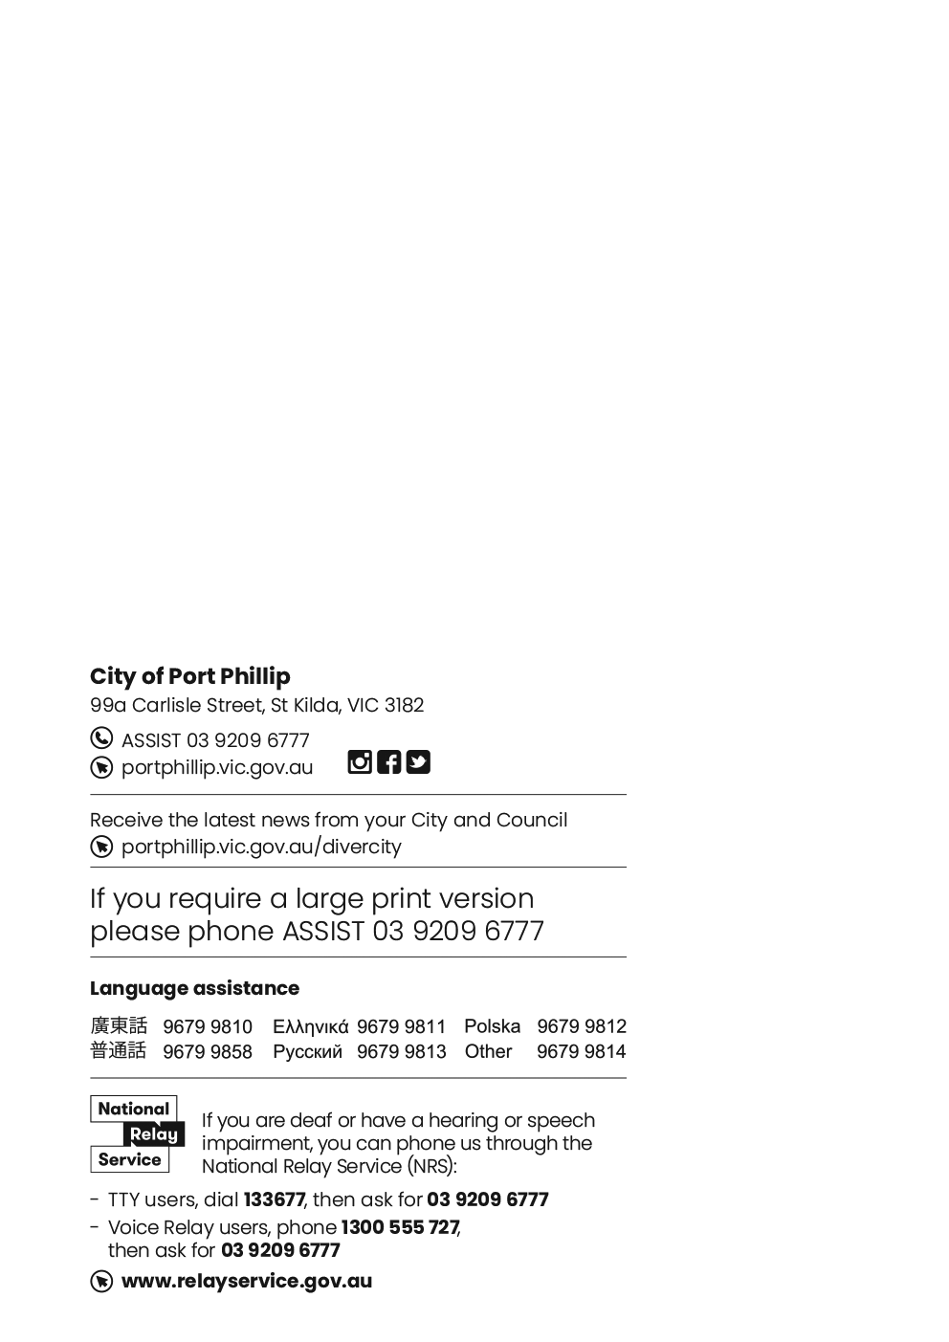

Acknowledgement
Council respectfully acknowledges the Traditional Owners of this land, the people of the Kulin Nations. We pay our respect to their Elders, past and present. We acknowledge and uphold their continuing relationship to this land.

Contents
Message from the Mayor 6
Strategy Overview 7
A changing landscape for waste 10
In review: Don’t Waste It! 2018-28 - Years 1-4 12
Our roadmap to transition 14
Food organics and garden organics (FOGO) 17
Separated glass recycling 23
Mixed recycling 27
Garbage 30
Public place waste 34
Collaboration and advocacy 38
Advocacy 39
Appendix 1 – Circular economy actions 40
Appendix 2: Summary of key waste targets 41
Appendix 3 – Houses/townhouses receiving a FOGO bin 47
Appendix 4 - Apartments/units receiving a kerbside FOGO bin 48
Appendix 5 - Locations of communal FOGO and glass hubs 49

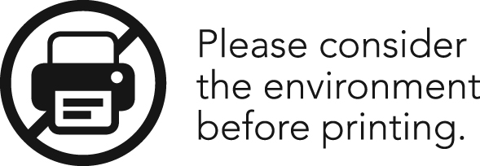
This Strategy provides reflection on the first four years of the Don’t Waste It! Waste Management Strategy 2018-28 and provides direction for the future of our waste and recycling services within Port Phillip to ensure we are creating a sustainable and innovative waste and recycling system for our community.

Message from the Mayor

Strategy Overview
The revised Don’t Waste It! Waste Management Strategy 2022-2025 sets out how we will transform our current waste and recycling services over the next four years to best serve our diverse and expanding community.
The strategy is a roadmap that sets out how we will introduce new recycling services, reduce the overall quantity of materials we are sending to landfill and integrate circular economy principles to our waste and recycling streams. These changes will also help Council meet our legislative requirements under the Victorian Government’s Recycling Victoria policy.

The strategy had five priority areas:
- Food organics and garden organics (FOGO).
- Separated glass recycling.
- Mixed recycling.
- Garbage.
- Public place waste

Across the five priority areas we will deliver the following:
FOGO | Introduction of a weekly kerbside FOGO service for eligible houses/ townhouses in January 2023.  Introduction of a weekly kerbside FOGO service for eligible apartments/units in July 2023  Expansion of the communal food organics hubs across the city (80 sites) in July 2023.
Separated glass recycling | Expansion of the communal glass hubs across the city (80 sites) in January 2023.
Mixed recycling | Reduction in mixed recycling contamination levels.
Garbage | Diversion of waste from landfill, through FOGO services, changes to collection frequency and exploring alternatives to landfill.
Public place waste | Increase recycling and divert waste from landfill from our public place waste bins.  Increase in satisfaction with public place waste and recycling bins.  Reduction in dumped rubbish issues.

Background
On 17 October 2018 Council adopted the ‘Don’t Waste It!’ Waste Management Strategy 2018-2028 (Don’t Waste It! 2018-28) after a period of community consultation. Don’t Waste It! 2018-28 provided the blueprint for how Council and the community would work together to create a more sustainable future for Port Phillip, through the way we managed our waste.
Don’t Waste It! 2018-28 set out to deliver 25 actions across four outcome areas:​
- A City that reduces waste
- A City that maximises reuse and recycling
- A City that has clean streets, parks and foreshore areas
- A City that uses technology to process waste better and reduce environmental impacts

Draft Don’t Waste It! 2022-25
Since the release of Don’t Waste It! 2018-28 the Victorian waste and recycling sector has undergone significant changes. As a result, we need to acknowledge these changes by evolving our approach to waste and recycling and setting new targets and priority areas for the coming years.
This Strategy is our revised roadmap to transitioning our current waste and recycling services into those which drive, support and promote a circular economy. It builds on the findings of the first four years of Don’t Waste It! 2018-28 to help create a sustainable and innovative waste and recycling system for our community.

What is a circular economy?
A circular economy is one in which moves us away from a linear mindset – take, use and through away and instead focuses on opportunities to reduce the environmental impacts of production and consumption through promoting reuse, recovery and recycling of our materials.
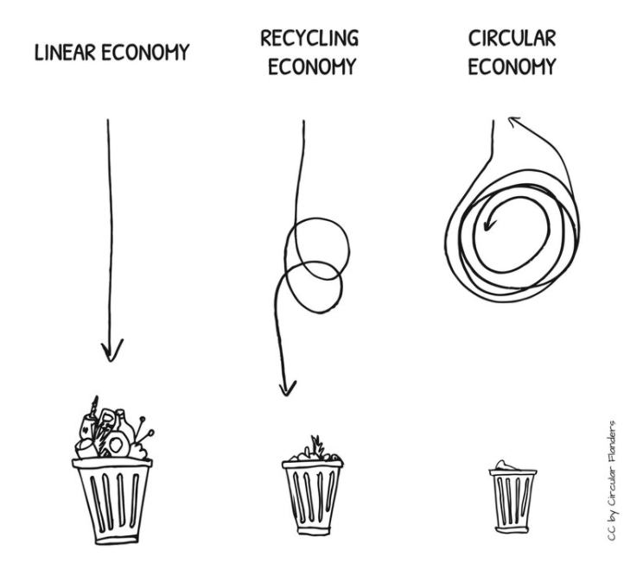

This strategy also works to support broader waste initiatives that have or will be implemented within Victoria over the coming years, including the Victorian Plastic Bag Ban (2019) and the upcoming Single Use Plastic Ban (2023).
While this strategy is specifically focused on landfill diversion through increased recycling opportunities it is important that Council and our community continue to follow the waste hierarchy by prioritising waste avoidance and minimisation to reduce the quantity of materials that we are generating, consuming and ultimately discarding.
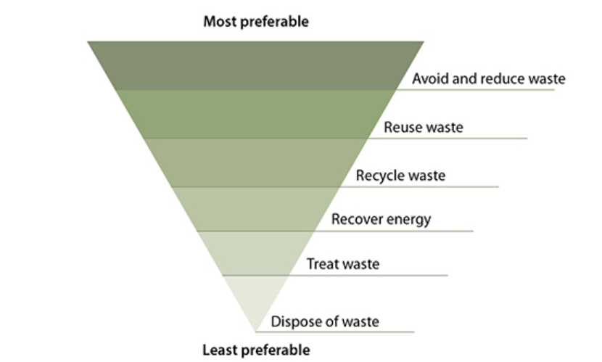

This Strategy contributes to our organisation vision ‘Proudly Port Phillip: A liveable and vibrant City that enhances the wellbeing of our community’ by delivering on the Strategic Direction, ‘Sustainable Port Phillip - Port Phillip manages waste well, maximises reuse and recycling opportunities and supports the circular economy’ contained within our Council Plan 2021-2031.

A changing landscape for waste
The Victorian waste and resource recovery sector has undergone several significant challenges and changes since Council first adopted Don’t’ Waste It! 2018-28.

National Sword Policy
In 2017, China announced the implementation of strong contamination thresholds on the import of recyclable materials from other countries, including Australia. When this announcement was made Victoria was selling and exporting approximately 30% of our recycling materials to overseas markets, including China. On 1 January 2018, the new contamination thresholds were enforced, resulting in a significant disruption to the Victorian recycling sector. The value of our recyclable materials dramatically decreased and end markets for the products couldn’t be sourced. This resulted in the cost of recycling Council materials significantly increasing. These factors led to the collapse and ultimate closure of City of Port Phillip’s previous recycling processor, SKM.

Federal waste export bans
In December 2020, the federal government announced a national ban on the export of waste plastic, paper, glass and tyres. The ban is part of the Recycling and Waste Reduction Act which aims to invest in building Australia’s recycling industry to contribute to a circular economy by building onshore markets for recycled products.

Release of ‘Recycling Victoria: a new economy’.
In June 2021 the Victorian Government released ‘Recycling Victoria: a new economy’ (Recycling Victoria). Recycling Victoria’s is the state’s action plan to reform Victoria’s waste and recycling. Recycling Victoria outlines 4 key goals with associated targets to help drive the state towards a circular economy and help shape the future of waste within City of Port Phillip:
Goal 1 - Design to last, repair and recycle
Goal 2 - Use products to create more value
Goal 3 - Recycle more resources
Goal 4 - Reduce harm from waste and pollution
Household recycling reforms will also be mandated through Recycling Victoria, which will mean changes to the way we separate our waste and recycling at home. Access to four core waste and recycling services will be introduced resulting in households having access to the following four services:
- Food organics and garden organics (FOGO) - NEW
- Separated glass recycling - NEW
- Mixed recycling (paper, plastic and metal) - EXISTING
- Garbage - EXISITING
All Victorian Council’s must comply with the requirements of Recycling Victoria. Council is currently waiting for additional guidance from State government regarding service specifications to ensure our proposed waste and recycling service delivery is compliant.

Increasing costs of waste services
In addition to the impacts of China’s National Sword Policy, local factors also impact our waste management costs, resulting in rising costs to process our waste and recycling each year.

Victoria’s landfill levy
Victoria’s landfill levy, which is part of the price we pay to dispose of our garbage to landfill, continues to increase. On 1 July 2021, the Victorian landfill levy, the price we pay to take our garbage to landfill, increased from $75.90 per tonne to $105.90 per tonne. This price will increase again from 1 July 2022 to $125.90 per tonne.
The landfill levy is designed to fund improvements to Victoria’s waste and recycling sector along with in incentivising reductions in garbage generation.

Recycling contamination levels
Contamination occurs when items that aren’t recyclable are placed into our various recycling bins. When contamination occurs, we are changed additional fees to process the materials or, if contamination is severe, divert the materials to landfill. Our contamination levels are consistently above the accepted levels which impacts on our costs to process our recycling.

Recycling Victoria
The Victorian Government requires all councils to have glass recycling services in place by 2027 and food organics and garden organics (FOGO) in place by 2030. We are planning for an earlier transition to these new services, however new waste services incur additional costs as council will need to pay for the collection and processing of these streams.

In review: Don’t Waste It! 2018-28 - Years 1-4
The first four years of Don’t Waste It! 18-28 provided an opportunity to work with the community to deliver programs to trial new approaches to recycling and waste management. These programs allowed us to gain an understanding about how the community utilised each program and the requirements for a broader rollout throughout the municipality. Don’t Waste It! 2018-28 set out to achieve five targets by 2022:
- 20% reduction in waste per house/apartment and per Council employee
- Landfill diversions of 43% for houses, 29% for apartments, 58% for council buildings and 85% for public bins.
- 50% reduction in contamination levels in recycling bins.
- 50% reduction in recyclable items in waste bins.
- Maintain community satisfaction levels of 90% for waste services.
Don’t Waste It! 2018-28 also included a key target for 2028:
- 50% reduction in food waste food waste diversion from landfill within house/apartment, Council and commercial buildings

Key deliverables
In response to the 2022 targets and the changes in the Victorian waste and recycling sector City of Port Phillip delivered several key programs and trials targeting separation of glass and food organics and garden organics (FOGO) materials from the garbage stream.

FOGO initiatives
- Elwood FOGO trial
- Communal food organics recycling hubs
- Multi-unit development food organics trial
- Composting with Community: home composting system subsidy

Glass initiatives:
- Communal glass recycling trial
- Garden city kerbside glass recycling trial
The trials and programs tested the effectiveness and uptake of each initiative to assess if a broader rollout throughout the community would enable us to reach our 2022 targets.

Reflecting on our targets
Don’t Waste It! 2018-28 set ambitious targets to reach by 2022. Though the first four years delivered some terrific trials with our community we saw that the reduced scale that the trials were delivered in, along with changes to the waste and recycling industry and the COVID-19 pandemic didn’t allow us to reach our targets.
Areas of Don’t Waste It! 2018-28 such as Advance Waste Processing (AWP) also have not progressed in Victoria to the extent that was anticipated when the strategy was adopted. Although we still believe AWP will form part of Council’s future waste management options, and we are continuing to review this technology and consider alternatives to landfilling.
The revised strategy is an opportunity to refine our targets and incorporate feedback and learnings from each trial.
Due to the outcomes and community feedback received from each of the trials the revised strategy will prioritise our spending on the following:
- New recycling systems: Introducing new recycling streams and infrastructure
- Education: Supporting our residents to by updating our waste and recycling information
- Waste and recycling auditing: Conducting regular auditing of our waste and recycling bins to ensure we are monitoring our progress and allowing us to be proactive in addressing issues as they arise.

Our roadmap to transition
Our roadmap to transition brings together what we have learned over the past four years of Don’t Waste It! 2018-28 through our trials, programs and services and synthesises this into an actionable and measurable plan.
This roadmap defines how we will transform our current waste and recycling services over the next four years to best serve our diverse and expanding community. The roadmap aims to reduce the overall quantity of materials we are sending to landfill and integrate processes to bring in a circular economy to our waste and recycling streams. These changes will also help Council meet our legislative requirements under the Victorian Government’s Recycling Victoria policy.
The roadmap to transition has five priority areas:
- Food organics and garden organics (FOGO)
- Separated glass recycling
- Mixed recycling
- Garbage
- Public place bins

Our hybrid approach to waste and recycling: kerbside bins and communal hubs.
The needs of the Port Phillip community are diverse, particularly when it comes to our waste and recycling services. Our previous trials have shown that the standard kerbside service approach isn’t suitable for our expanding recycling streams. As a result, we will be incorporating a hybrid approach for our new recycling services using kerbside bins and communal hubs. Our hybrid approach is flexible and will evolve to ensure our waste and recycling service delivery is compliant with Recycling Victoria.

Communal hubs
City of Port Phillip has a unique housing demographic, with approximately 90% of our dwellings being medium or high density compared to 33% for Greater Melbourne. In addition to this, many of our standalone houses have limited outdoor and garden space. This poses a challenge when introducing new waste and recycling streams as additional kerbside bins are not suitable for every household and do not offer a cost-effective solution to introducing new FOGO and glass recycling services.

Our previous trials for glass recycling, FOGO and communal food organics provided valuable insight into how our community could use and access new waste services. This has helped to shape our broader communal hub service offering. We have seen that for some high-rise apartments having dedicated bins for food organics doesn’t actively promote diversion of food waste from the garbage stream. We have also seen that many households don’t generate enough glass to make a kerbside service viable. We also know that the waste generated between property types differs with houses / townhouses generating 50% more garden organics than apartments / units.
Our communal hubs have been designed allow all households access to the new FOGO and glass services without having to accommodate an additional kerbside bin within their property.
Our communal glass and food organics hubs trials demonstrated that our community strongly support communal hubs and that including a communal service is an important aspect of our future waste service delivery.

Planning our communal hubs
Our communal hubs will be implemented with the goal of providing a glass and FOGO service within 300m of properties, except for households accessing a kerbside bin for FOGO.
The locations will be determined based on specific criteria including public safety and accessibility as well as community consultation. Factors including proximity to housing and public transport, accessibility for collection vehicles and a gender impact assessment will be considered when selecting locations.
The location and designs of the hubs will be developed using the Prevention Through Environmental Design (CPTED) principle to maximise community uptake and safety and minimise any amenity issues.
Passive surveillance, including auditing by Council officers, will be conducted to maintain the safety of the community and the amenity of the hubs.

Timeline to transition
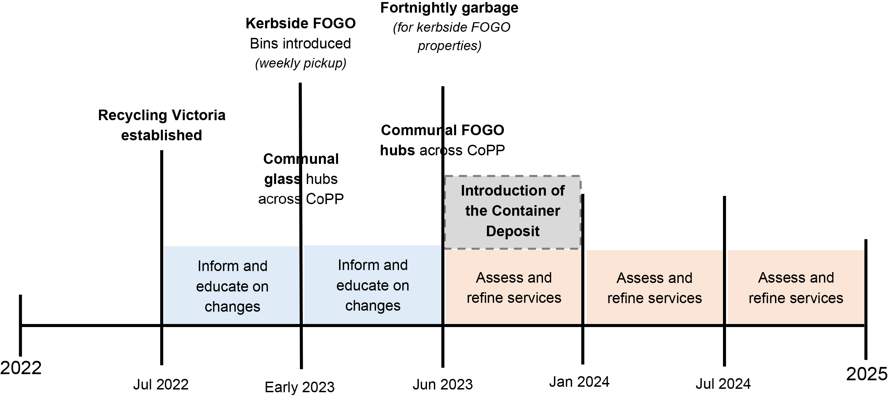

Recycling Victoria interim targets
- Divert 72% of waste from landfill by 2025
- Cut the volume of organic material going to landfill by 20% by 2025

POST 2025
- Transition to fortnightly garbage (all properties)

Food organics and garden organics (FOGO)
Historically, City of Port Phillip hasn’t had a kerbside green waste service because of the high proportion of apartments and units which generate little to no garden waste. We have previously offered a free drop-off service for garden organics at the Port Phillip Resource Recovery Centre and booked green waste collections for residents to dispose of their garden organics.
We acknowledge that this approach isn’t sustainable as all households generate food organics waste. Our FOGO materials are a valuable resource that can be recovered and when collected through a FOGO service, can be processed and used to rehabilitate Victorian land rather than going into landfill.
As a result, are taking significant steps to expand on our current FOGO services to ensure that all households are able to divert their FOGO materials from the garbage stream.

Where are we now

Standard kerbside service
 | Contamination rate | % of the garbage stream
Households | N/A | 56.0%
Apartments | N/A | 43.1%
St Kilda Town Hall | TBA | TBA

Properties participating in trials targeting FOGO diversion
 | Contamination rate | % of the garbage stream
Elwood FOGO service | <1% | 42.9 %
High-rise apartments food organics trial | <1% | 32.70%
Communal FOGO hubs | <5% | N/A

What will this new FOGO service look like?
The FOGO service will involve two separate services to offer adaptable solutions for our diverse households; opt-out kerbside FOGO bins and access to communal FOGO hubs.

Kerbside FOGO
- Eligible houses / townhouses will receive a 120L FOGO lime-green lidded kerbside bin by early 2023, with the option to get a free upsize to a 240L bin
- Eligible apartments and unit blocks will receive 120L lime-green lidded kerbside FOGO bins by July 2023. The quantity of bins provided will be based on the number of individual households and be tailored to each building
- The kerbside FOGO service will be collected weekly with no change to the existing weekly kerbside garbage bin collection frequency
- From mid-2023 we will have advanced the kerbside FOGO service to a fortnightly garbage collection for households with a kerbside FOGO bin. This will maximise food waste diversion and promote increased use of the FOGO bin for food waste
- Households can collect one kitchen caddy and one roll of compostable caddy liners from designated Council buildings to help collect their food scraps as part of the service

Communal FOGO hubs
- We will expand our small number of existing communal FOGO hubs to increase the accessibility for households that don’t receive a kerbside FOGO bin by July 2023
- We will monitor the uptake of the communal FOGO hubs and we will consider a move to a fortnightly garbage collection for all households when communal FOGO hub volumes indicate that the city is ready for this change
- Households can collect one kitchen caddy and one roll of compostable caddy liners to help collect their food scraps as part of the service
- The number of communal FOGO bins at each site will vary based on the size of the location
- Communal FOGO bins will be emptied 2-3 times a week to and regularly cleaned to maintain amenity and minimise odour. This frequency may be adjusted seasonably to accommodate increased temperatures in Spring / Summer
- The locations and structure of the communal FOGO hubs will be established using Crime Prevention Through Environmental Design (CPTED) principles and community consultation to maximise community uptake and safety and minimise any amenity issues.
- Hub locations will be agile and are designed to be adjusted in the initial rollout stage to ensure all hubs are positioned in the optimal location.

Getting a bin upsized
We understand that some households may struggle with a fortnightly garbage collection. Households can request a free bin upsize if they meet the following criteria:
- Six or more people residing in one house
- Children in nappies
- A person with a medical condition which results in additional waste.

Targets:
- 20-30% reduction in FOGO materials in the garbage stream for properties using a kerbside service by 2025
- 10-15% reduction in FOGO materials in the garbage stream for properties using a communal service by 2025
- 80-90% of kerbside FOGO bins visually inspected through Council audits contain contamination within a level accepted by our FOGO processor (~<5%) in the first 6 months post-implementation
- Kerbside FOGO bins achieve a <5% contamination rate during the first post-implementation municipal waste audit in 2023 and then and then continue to maintain these contamination levels until 2025
- 80-90% of communal FOGO bins visually inspected through Council audits contain contamination within a level accepted by our FOGO processor (~<5%) 6 months post-implementation
- Communal FOGO bins achieve a <5% contamination rate during the first post-implementation municipal waste audit in 2024 and then continue to maintain these contamination levels until 2025
- 30-40% reduction in FOGO materials in Council building garbage stream by 2025*
- 70% - 80% of households are satisfied with the FOGO services 6 – 12 months post implementation.

Priority actions:
- We will introduce a weekly kerbside FOGO service for eligible houses / townhouses that generate garden organics and can accommodate an additional bin
- We will offer a weekly kerbside FOGO service for eligible apartments / units that demonstrate support from residents and building management
- We will transition the Elwood FOGO area to a fortnightly garbage collection in 2022
- We will expand our communal food organics recycling hubs so that a majority of households that are ineligible for a kerbside bin are within 300m of a hub
- We will expand our St Kilda Town Hall FOGO service to additional Council buildings
- We will provide targeted educational materials to support the diversion of food waste through the kerbside and communal FOGO services and then transition to fortnightly garbage collection for residents with a kerbside FOGO service
- We will establish the locations and structure of the communal FOGO hubs using Crime Prevention Through Environmental Design (CPTED) principles and community consultation to maximise community uptake and safety and minimise any amenity issues
- We will explore opportunities to with our FOGO processor to utilise processed FOGO materials within CoPP public spaces and gardens
- We will explore opportunities to divert our foreshore seaweed from landfill

Progress monitoring and evaluation
- We will conduct regular audits of the kerbside FOGO bins and provide targeted feedback to households to monitor contamination within the first 12 months of implementation.
- We will conduct regular audits of the communal FOGO bins and provide updates to the community via the Council website and social media platforms within the first 6 months of implementation
- We will review the data collected in the annual municipal waste audits to understand the FOGO volumes generated and the garbage volume reductions.
- We will conduct a community satisfaction survey for the communal and kerbside FOGO services 6 – 12 months post implementation to assess uptake and make necessary adjustments to the services

Don’t Waste It! 2018-2028 programs that informed the FOGO service offering
- Elwood FOGO trial (August 2020 - ongoing service)
Trialling a kerbside FOGO bin for households in Elwood
- Communal food organics recycling hubs (May 2021 – ongoing service)
Trialling 3 communal hubs for food organics in high-density areas (Rats of Tobruk Reserve, HJ Johnson Reserve, Lagoon Reserve)
- High-rise apartment food organics trial (July 2021 – November 2021)
Trialling approaches to communal food organics bins in 3 high-rise apartment buildings

Circular economy insight

South Melbourne Market’s food dehydrator
The South Melbourne Market currently operates an onsite food dehydrator to capture food waste from retailers and visitors. The dehydrator enables the market to process food waste from retailer and patrons including coffee grounds, fish offal, deli waste meal leftovers.

How does it work?
Inside the dehydrator food waste is heated and shredded, turning the materials into a dry product called SoilFoodTM.
Not only does the dehydrator reduce emissions that would result from transporting the food waste offsite for processing, but it also allows the South Melbourne Marker to process up to 5.5 tonnes of food waste each week.

Closing the loop
Visitors to the South Melbourne Market can purchase SoilFoodTM directly form the market to use as a nutrient-rich soil additive for their gardens.

Case study

Elwood FOGO trial
In August 2020 City of Port Phillip launched the Elwood FOGO trial, our first kerbside trial for food organics and garden organics. The trial was implemented understand the impact of a kerbside FOGO service and how households utilise the service. These findings were utilised to inform our broader rollout of the FOGO service throughout the municipality, including bin sizing, collection frequency and educational requirements. Participating households received a 240L FOGO bin that was collected on a fortnightly basis along with a kitchen caddy to help collect food scraps within the home.
Fortnightly bin audits were conducted to continually monitor how the service was being utilised by households and to provide targeted education to households that were found to be putting the wrong materials in their FOGO bins. The FOGO trial was championed by the community, with Council utilising feedback gained through surveys and online consultation sessions to adjust the trial and to inform the service

The results?
The Elwood FOGO trial diverted approximately 115 tonnes of food and garden organics from landfill throughout the 10-month trial period and achieved an overall contamination rate of <1%.
Due to the low contamination rates and overwhelming support from the Elwood community the trial moved to an ongoing service for participating households in July 2021.

How can you get involved?
The Elwood FOGO trial evaluation showed that 36% of participating household’s garbage bins still contain food waste that could be diverted into the FOGO bins.
To utilise your kerbside FOGO bin to its full potential, try the tips below to help reduce any bin odours:
- Use a certified compostable liner to collect food waste in your caddy. Look for the AS4736 logo to ensure that are certified compostable
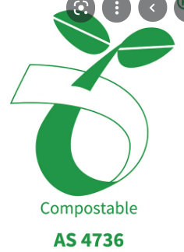
- Wrap your food waste in newspaper before putting it in the kerbside bin
- Cover your food organics with some garden organics once you place it in your kerbside bin
- If you have room in your freezer, try freezing your food and place in it you bin the night before your collection
- Store your FOGO bin out of direct sunlight

Separated glass recycling
Our 2021 municipal waste audits showed that 38.5% of our residential mixed recycling bins consisted of glass materials including bottles and jars.
Separating out glass from our mixed recycling bins is an important process to ensure that we are maximising the value and recyclability of our mixed recycling bin.
The recycling industry is also continuing to evolve, and Council is anticipating that by 2025 Victorian recycling processors will no longer accept glass in the mixed recycling stream. This will mean that glass will be considered a contaminant in the mixed recycling stream and will result in increased processing costs and the potential for our mixed recycling to be sent to landfill (due to contamination).

Why do we need to separate glass from our recycling bins?
Glass items can get broken when placed in our recycling bins or when tipped into our recycling trucks. This becomes a contaminant in our recycling bins and can reduce the valuable of other recyclable materials in the bin including paper, cardboard and plastic.

What will the new glass service look like?
Findings from our 2020 glass recycling trials (both kerbside and communal bins) showed that communal bins were the preferred service with strong uptake from the community and low contamination rates.
Our Garden City kerbside glass trial showed that providing a third bin for glass recycling was not a cost-effective option for our community. In addition to the space related issues of storing an additional bin, the trial saw low bin presentation rates and the majority of bins being less than 25% full at the time of collection.

Communal glass hubs
As a result of the glass trials, we will provide a glass recycling service to the community in the form of communal glass hubs. This will involve:
- Expanding our communal glass hubs across Council to increase the accessibility for households and apartments to separate and recycle their glass materials
- Optimising the number and size of communal glass bins at each site
- Optimising the collection frequency of the communal glass bins. Bins will be emptied weekly, or as needed and regularly cleaned

Targets:
- 10-20% reduction in glass materials in the kerbside recycling stream by 2024
- 40-50% reduction in glass materials in the kerbside recycling stream for houses / townhouses by 2025.
- 30-40% reduction of glass in the kerbside mixed recycling stream for apartments / units by 2025.
- Communal Glass bins achieve a <5% contamination rate during the first post-implementation municipal waste audit in 2023 and then continue to maintain these contamination levels until 2025
- 80-90% of audited communal glass bins contain contamination within a level accepted by our glass processor (~<5%) 6 months post-implementation
- 80-90% of households are satisfied with the communal glass services 6 – 12 months post implementation.

Priority actions:
- We will expand our communal glass hubs so that a majority of households and apartment buildings live within 300m of a hub
- We will work towards increasing the permanency of our glass hubs through design and prioritise materials that use recycled content
- We will establish the locations and structure of the communal glass hubs using Crime Prevention Through Environmental Design (CPTED) principles and community consultation to maximise community uptake and safety and minimise any amenity issues
- We will increase the use of recycled glass in Port Phillip construction and infrastructure projects, including road resurfacing
- We will explore opportunities to use the glass collected through our communal hubs within Port Phillip construction and infrastructure projects, including road resurfacing

Progress monitoring
- We will conduct regular glass bin audits to monitor contamination within the first 6 months of implementation
- We will monitor the glass material volumes collected from the communal hubs.
- We will monitor the reduction of glass in the Kerbside recycling stream via annual municipal waste audits.
- We will increase our auditing and educational campaign materials for glass separation in the lead up to glass no longer being accepted in our mixed recycling stream.

Don’t Waste It! 2018-2028 programs that informed the glass service offering
- Garden City kerbside glass trial (March 2020 – October 2020)
Trialling a kerbside glass bin for households in Garden City
- Communal food organics recycling hubs (March 2020 – ongoing)
Trialling 3 communal hubs for glass recycling in high-density areas of South Melbourne and Albert Park

Victoria’s Container Deposit Scheme
The Victorian Government is in the process of establishing Victoria’s Container Deposit Scheme (CDS), which provides a cash reward for the return of select glass, cans and plastic beverage containers. The container deposit scheme will run independently from Council’s kerbside and communal recycling services.
The CDS has 3 main targets:
- Increase the recycling of eligible CDS containers within Victoria
- Reduce litter from CDS containers by up to 50%
- Support Victoria’s circular economy by turning old containers into new ones

How does the CDS work?
- Empty eligible containers are collected
- The containers are returned to a dedicated CDS recycling point
- You select a refund option: cash refund per container to person who returns it and/or nominated charity, community and sports groups.
- Containers are then collected by a nominated contactor and recycled

When will the CDS be operational?
The CDS is scheduled to be implemented in 2023.

Case study

Glass recycling trials – Communal vs kerbside collections
In March 2020 City of Port Phillip ran a trial of kerbside and communal glass recycling bins. The trials were and important step in understanding how our community utilised both types of bins to help provided a roadmap for Council to deliver on the Recycling Victoria target of implementing a glass recycling service to our community by 2027.
Households participating in the kerbside trial were provided a 120L glass bin, with a fortnightly collection. The mixed recycling bin collection was also decreased to fortnightly as part of the trial. Fortnightly bin audits were conducted for both the glass and mixed recycling bins to monitor how the service was being utilised, contamination of both recycling bins and the impact of the glass trial on the fullness of the mixed recycling bin.
The trials were promoted through Council’s website and social media pages in addition to Divercity. Letters informing residents about the trials were delivered to all households living in proximity of a communal glass hub and an additional information pack was given out to households receiving the kerbside service.

The results?
The trials found that a dedicated kerbside bin wasn’t effective, with only 42% of bins placed out for collection each fortnight. Bins that were placed out for collection were only ¼ full. In comparison, the communal glass bins were very popular with the community, with Council expanding the number of communal hubs from 2 to 7 sites to keep up with the uptake from the community.
During the 8-month trial, more than 50 tonnes of glass was recycled, with 70% of the total volume collected through the communal bins. Due to the success of the communal bins the hubs were made ongoing in August 2020. These sites have provided the blueprint for the broader rollout of City of Port Phillip’s glass service as part of the Revised Don’t Waste It! Strategy 2022-25.

How can you get involved?
The success of the communal glass trial showed that City of Port Phillip residents are passionate about recycling and are willing to take extra steps to maximise their recycling!
Our expanded communal glass recycling hubs will help us maximise our recycling and free up valuable space in our recycling bins.
The communal glass bins are easy to use by following these simple steps:
- Locate your nearest glass collection point on the Council website
- Separate your glass recyclables from your yellow recycling bin
- Remove any lids from your glass containers / bottles and place them in your yellow recycling bin
- Empty your glass into the communal bins, making sure your items are loose, and free from any plastic bags

Mixed recycling
2020-21 proved to be challenging years for recycling. With industry changes to our recycling acceptance list and COVID-19 restrictions resulting in more waste being generated at home we saw our kerbside recycling bin contamination rates increase, reaching 25% in April 2020. A contamination rate of approximately 10% is permitted by our processor.
When our mixed recycling bins are heavily contaminated not only do our processing costs increase but there is a possibility that an entire truckload of recycling will be sent to landfill.
The expansion of our communal glass recycling hubs will help to minimise contamination from glass materials and prepare for glass to become a contaminant in our recycling bin. In addition to diverting glass we need to keep our mixed recycling free from plastics bags, soft plastic packaging and e-waste ensure our recycling stream can be processed and not sent to landfill.

Where are we now
 | Contamination rate | % of the garbage stream
Households | 8.8% | 11.0%
Apartments | 23.4% | 22.8%
Council buildings | 12.8% | 23.5%

What does this service look like?
Households have access to a weekly kerbside mixed recycling collection and can choose from either a 120L or 240L bin.
Previously, there has been a lot of confusion about how to use this stream correctly. With the expansion of the communal glass hubs, we will be able to simplify the recycling requirements for this service to keep help get our recycling right and focus on the basics: paper, cardboard, hard plastic and metals.

Targets:
- ≤5% contamination rate in the kerbside mixed recycling stream for houses / townhouses by 2025
- 10-15% contamination rate in the kerbside mixed recycling stream for apartments / units by 2025
- ≤5% contamination rate in Council building mixed recycling bins by 2025

Priority actions:
- We will revise and update our waste education material to reflect industry changes and simplify our disposal information to reduce contamination
- We will develop targeted educational material for residents of units/ apartments to minimise contamination
- We will provide targeted educational materials to support the diversion of glass to our hubs
- We will work with apartment building managers to minimise the contamination of our apartment buildings, specifically high-rise apartments
- We will explore opportunities to implement initiatives and infrastructure to target incorrect waste disposal and litter
- We will work with apartment buildings to increase the number of buildings that offer a mixed recycling stream to residents
- We will provide targeted educational materials to Council staff to ensure Council buildings are leading by example by maximising our recycling and reducing contamination

Progress monitoring
- We will conduct annual municipal waste audits and use the audit findings to monitor contamination progress and adjust our educational initiatives accordingly
- We will continue to conduct flip top kerbside mixed recycling bin audits to monitor contamination and deliver targeted household education with a focused effort in 2024 to deliver the glass recycling diversion targets

Case study

Recycling Reset contamination management campaign
In April 2020 bin audits identified that 25% of our kerbside recycling bins consisted of contamination. With residents forced to spend an increased amount of time at home due to COVID-19 restrictions City of Port Phillip developed our Recycling Reset campaign to provide some direct education about what is allowed in our recycling bins.
Recycling bins were inspected by trained Council staff to look for visual contamination and bins with incorrect items were tagged to help raise awareness for the household. Over 14,500 recycling bin inspections were conducted throughout the six-month campaign.

The results?
Through Recycling Reset’s direct engagement, residents achieved a 25% reduction in recycling bin contamination from items including plastic bags, soft plastics, garden organics and e-waste (electrical items).

Garbage
Based on our 2021 municipal waste audits each week we are generating approximately 11.5kg of garbage per house / townhouse and 5.7kg per individual apartment / unit. The changes to our recycling services will be implemented to significantly reduce the quantity of garbage we generate and keep our waste disposal costs low. This will be achieved by increasing the accessibility of recycling streams and taking the confusion out of recycling.
Each year it is costing us more to dispose of our garbage. On 1 July 2021, the Victorian landfill levy, the price we pay to take our garbage to landfill, increased from $75.90 per tonne to $105.90 per tonne. This price will increase again from 1 July 2022 to $125.90 per tonne.
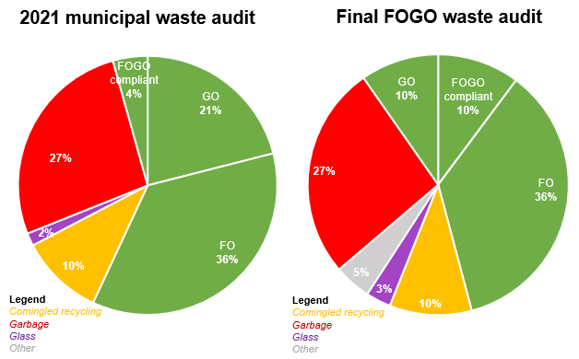
Our Elwood FOGO trial showed that having a weekly garbage collection didn’t encourage residents to use their FOGO bin for food scraps. At the end of the trial, 36% of the garbage bin still consisted of food waste that could’ve gone in the FOGO bin.

Targets:
- 20-30% reduction in the kerbside garbage stream for houses and townhouses by 2025
- 10-15% reduction in the garbage stream for apartments and units by 2025
- 20-30% reduction in the garbage stream for Council buildings by 2025

Transitioning to fortnightly garbage collections
A key area of our revised garbage services will be the transition from weekly to fortnightly garbage collections. The transition be implemented to promote the increased diversion of food waste from the garbage stream into the FOGO bin.
We understand that some households may struggle with a fortnightly garbage service so households can request a free bin upsize if they meet the following criteria:
- Six or more people residing in one house
- Children in nappies
- A person with a medical condition which results in additional waste
The transition aims to:
- Promote the uptake of new recycling services
- Increase food waste disposal into the FOGO bin
- Reduce reliance on landfill
- Reduce annual landfill costs.
The transition for properties with a kerbside FOGO service will occur over a 6-month period. We will monitor the uptake of the communal FOGO hubs and we will consider a move to fortnightly garbage collection for all households when communal FOGO hub volumes indicate that the city is ready for this change.
Council will continue to explore opportunities for alternatives to landfilling for the garbage stream, including advanced waste treatment technology, comparing the benefits and costs of different technologies to inform our decisions.
The findings from the Elwood FOGO trial identified that providing residents access to a FOGO service wasn’t enough to divert food waste from landfill. Only 11 per cent of the food waste generated by participating households was diverted into the FOGO bins from the garbage stream.
Changes to the garbage bin collection frequency are required to encourage households to rethink how they use their garbage bin to start diverting food waste into the FOGO and communal food organics hubs

Priority actions:
- We will commence the transition to a fortnightly kerbside garbage collection for households with a kerbside FOGO bin by July 2023
- We will transition the Elwood FOGO area to a fortnightly garbage collection in 2022
- We will monitor the communal FOGO hub volumes to plan for a future transition to a fortnightly kerbside garbage collection for all remaining properties
- We will transition to the standardised red lid for all kerbside garbage bins by mid to late 2024
- We will transition to the standardised red lid for all public garbage bins by mid to late 2025
- We will develop and implement a reusable nappy program for families to help minimise nappy waste and ease the transition to weekly garbage collections for families in early 2023
- We will focus on the diversion of FOGO materials into council building FOGO service
- We will undertake audits of the council garbage stream and develop targeted educational materials and initiatives based on audit findings
- We will work with community groups and community members to deliver zero waste workshops to promote reusable alternatives for common household items

Progress monitoring
- We will conduct annual waste audits to monitor progress towards our garbage stream reduction targets
- We will review our customer request and complaints data to understand how the community have responded to the change in waste services

Circular economy insight

South Melbourne Market’s ‘Shuck Don’t Chuck’ initiative
The South Melbourne Market has partnered with The Nature Conservatory to recycling oyster, mussel and scallop shells that are generated by retailers and patrons.
Shells are used by The Nature Conservatory to restore marine environments, including Port Phillip Bay that have been impacted by historic dredging.

How does it work?
- Oyster shells are collected in dedicated bins around the market
- The shells are collected and ‘cured’ which is a process that kills off any diseases within the shells
- Cured shells are taken out to reef restoration sites including Port Phillip Bay
- Recycled shells are placed on the seabed in areas that have been prepared by The Nature Conservatory to enable new oysters to grow!
Not only does the ‘Shuck Don’t Chuck’ initiative help to restore City of Port Phillip’s marine ecosystems it also helps to divert a significant quantity of shellfish waste from landfill!

St Kilda Repair Café
Since November 2017 the St Kilda Repair has been tackling our throwaway culture by proving a free repair service to the Port Phillip community. Their motto is simple, to provide a place where you can bring along your things that need fixing or mending.
The St Kilda Repair Café is a collaboration between the Jewish Climate Network and the Port Phillip Eco Centre and is run by a dedicated group of passionate volunteers. At each repair day, 15-20 volunteers offer their repair services to the community, with anywhere between 20 – 40 items repaired. The range of items that have been repaired is vast including small electrical appliances, clothing, jewellery and toys.
Since it first began, the St Kilda Repair café has fixed over 500 items, with an additional 140+ items partially fixed (they just require a few extra parts!).
The St Kilda Repair Café operates on the second Sunday of each month (except during January) at The Port Phillip Eco Centre.
More information can be found at www.stkildarepaircafe.org.au

Public place waste
Port Phillip’s public spaces are popular with residents and visitors, particularly in the summer months, therefore access to waste disposal points is important in keeping the public spaces clean and well kept. Throughout Port Phillip there is currently a disproportional number of public place garbage bins compared to recycling bins. On the foreshore alone we have 87% more garbage bins than recycling bins.
While we have a roadmap to achieving significant changes to our residential recycling services, we need to work toward making sure the Port Phillip community is equipped to support our vision to maximise reuse and recycling opportunities by accessing public place recycling bins.

Where are we now
 | Contamination rate | % of the garbage stream
Public Place Recycling | 27.2% | 25.6%

Business kerbside services
Council currently operates a free cardboard collection service for traders on our main shopping strips and centres. This service operates in addition to a garbage and mixed recycling service, which mirrors our kerbside service. Each business is entitled to one garbage and one mixed recycling bin. The collection occurs on the same day as the garbage collection.
A significant quantity of cardboard is placed out for collection by our traders on non-collection days. This disposal method is classified as littering and is reported to our rapid response crew who collect it along with other dumped rubbish around Port Phillip.
This cardboard is not collected by our recycling truck and is sent to landfill along with the other dumped rubbish.

Public place bins at events
All large events held within City of Port Phillip are required to submit a Waste Management Plan (WMP) outlining how they will manage waste and recycling during the event. As part of this process Council includes minimum requirements for events, including the provision of 2 streams, mixed recycling and garbage and comprehensive bin signage. The WMP is submitted back to Council and reviewed by Council officers prior to the event.

Impact of the Container Deposit Scheme (CDS) and single use plastic ban on public place bins
Currently 40.8% of our public place recycling bins contain CDS-eligible materials, with an additional 5.5% found in our public place garbage bins. The introduction of the CDS in 2023 has the potential to divert a significant quantity of materials from our public place recycling stream. The placement of our public place recycling bins will be reviewed once the CDS had been operational for 6-12 months to allow us to understand the impact the CDS has had on the capacity and use of our public place bins.
The introduction of the single use plastic ban means that single-use straws, cutlery, plates, drink-stirrers, expanded polystyrene food and drink containers, and cotton bud sticks will be banned from sale or supply in Victoria by February 2023. It is expected that single use plastic ban will also impact on the volumes of waste disposed in our public place garbage bins.

Hard waste and dumped rubbish
Between July 2020 and June 2021, Council received approximately 13,000 online requests for booked hard waste collections and over 9,700 reports of dumped rubbish requiring removal. With approximately 54% of Port Phillip residents living in rental properties, an increasing number of dumped rubbish reports are the result of end-of-lease dumping of unwanted household goods.
Along with the amenity issues caused by dumped rubbish there is a significant cost associated with its removal, with costs continuing to increase as the Victorian landfill levy continues to rise.
In early 2022 Council implemented new process for managing our hard waste bookings and dumped rubbish reports, aimed at streamlining the reporting and included upgrading our online booking system. In addition to our booked hard waste services, properties will receive a sticker to place on their unwanted items to inform the community that it is part of a booked service and isn’t dumped rubbish.
To tackle the issues of dumped rubbish we will implement a dumped rubbish action plan which will include both proactive and reactive approaches. We will continue to monitor hotspot areas and we will collect dumped rubbish within 48-72 hours of when it is reported. We will continue to work closely with local laws to investigate dumped rubbish issues and deliver targeted education to prevent them from occurring. We will work with building managers of large apartment blocks to ensure residents are aware of hard waste pick up options and to explore other actions that will help to minimize hard waste generation from apartments. We will promote swap and share platforms so that hard waste pick-ups/ illegal dumping issues are avoided. We will also work with other agencies to tackle larger industrial scale illegal dumping issues.

Targets
- 20% increase in community satisfaction with our public place garbage and mixed recycling bins by 2025.
- 10- 20% reduction in reported dumped rubbish issues by 2025
- 20-30% reduction in the garbage stream for public place bins by 2025
- 60% of all our hard rubbish is recycled or recovered

Priority actions
- We will expand the placement of our public place recycling bins by early 2023 to areas of the community generating increased quantities of waste
- We will monitor the impact of the CDS through annual municipal waste audits to identify the quantity of CDS-eligible materials that remain in our public place garbage and recycling bins. This information will be used to review the placement of public place mixed recycling bins to optimise locations.
- We will revise and update our public place bin signage to provide clearer guidance around correct disposal processes for each waste stream
- We will monitor the quantity of eligible CDS materials that are diverted through drop off points, assuming data is made available
- We will review our cardboard collection service offering and determine if there are more effective ways to offer cardboard/ paper recycling options for businesses that also support public place recycling
- We will review the feasibility of expanding our solar compactor bins to additional locations to assist with reducing the frequency of collection in specific public areas
- We will review the current placement of public place bins and work towards reducing the quantity of public place garbage bins by optimizing bin sizes and placement and expanding our recycling alternatives
- Waste services at Council-organised events will include garbage, mixed recycling and FOGO bins
- We will update our waste processes for independent events to support and encourage the inclusion of garbage, mixed recycling and FOGO bins

Progress monitoring
- We will monitor the community satisfaction with our public place garbage and mixed recycling bins annually
- We will conduct annual municipal waste audits and use the audit findings to monitor the contamination rates of our public place recycling bins and adjust our educational initiatives accordingly
- We will monitor the reported and collected dumped rubbish
- We will review the reports from our waste contractor to monitor the recycling rates of our hard rubbish collections.

Collaboration and advocacy
To achieve a sustainable reduction in waste, to deliver on the state government targets for waste reduction and to deliver on the key actions of this strategy we need to work in partnership with others.
Council’s partners include:
- Our community – residents, visitors and businesses.
- Victorian Government and its agencies, particularly Sustainability Victoria and the newly established Recycling Victoria.
- Melbourne 9 (M9) and neighbouring Councils.

Community
Our community has a major role to play in reducing, reusing and recycling waste.
Residents – through what they buy, how they reuse, how they dispose of their waste, including separating their waste into the correct waste streams and using kerbside or communal services.
Businesses – through how they package goods and how they dispose of their waste
Visitors – through minimising litter on our streets and foreshore and separating their waste into the correct waste streams and accessing local recycling options like container deposit return points.

Government
Sustainability Victoria and Recycling Victoria are the two major Victorian Government agencies involved in waste and will be key partners.
Sustainability Victoria – is the government agency that supports Victorians through advice and support to tackle climate change, use our resources wisely and be more sustainable in our everyday lives.
Recycling Victoria – will oversee and provide strategic leadership for the waste and recycling sector and will be established on the 1 July 2022.
We will also work in partnership with other local councils to:
- Share information and experiences with waste and recycling services and issues
- Explore opportunities to collaborate with other councils within the waste and recycling sector as we know that opportunities increase, and we when we aggregate our waste and recycling tonnes collected with others
- Explore opportunities to collaborate with other councils on alternatives to landfilling, including advanced waste treatment technologies.

Advocacy
Council has an important role to deliver waste services, however, there are many circular economy and waste related issues that are not in the direct control of council. Council advocates to the state and federal governments on a range of issues to get better outcomes.
Our priority advocacy actions in relation to waste and the circular economy are:
We will advocate to government to:
- Ban the use of non-recyclable items and packaging through the Product Stewardship Scheme and other policy opportunities.
- Ban the import and production of hard-to-recycle materials (except for essential needs such as some medical uses).
- Fund technology and research that leads to an advanced domestic circular economy sector and positions Australia as a leading expert in this new economic sector
- Partner with Local Government to help guide and inform Federal policy and investment decisions around supporting circular economy, recycling, product packaging and waste reform opportunities
- Reinvest the funds collected from local governments via the Municipal and Industrial Waste Levy to support the rollout of the Circular Economy Policy, with a focus on the rollout of the four-service model.
- Develop targeted engagement programs and initiatives to address waste reduction, resource recovery and recycling contamination aligned with inner metropolitan settings and communities, particularly regarding multi-unit developments

Appendix 1 – Circular economy actions
We are looking at opportunities within our waste streams to deliver circular economy outcomes to ensure that we can recover and reuse as much of our waste as possible. Key actions we will undertake are:
- Working with our FOGO processor to use processed FOGO materials within CoPP public spaces and gardens.
- Increasing the use of recycled glass in Port Phillip construction and infrastructure projects, including road resurfacing.
- Working with our separated glass processor to use the glass collected through our communal hubs within Port Phillip construction and infrastructure projects, including road resurfacing.
- Working with our separated glass processor to identify other local uses for the glass collected through our communal hubs.

Appendix 2: Summary of key waste targets
 |  | Monitoring and reporting
Stream | Target | 2023 | 2024 | 2025
FOGO | 20-30% reduction in FOGO materials in the garbage stream for properties using a kerbside service by 2025 | Annual reporting - monitoring via annual municipal waste audit data | Annual reporting - monitoring via annual municipal waste audit data | Target Date  Final report - monitoring via annual municipal waste audit data
FOGO | 10-15% reduction in FOGO materials in the garbage stream for properties using a communal service by 2025 | N/A | Annual reporting - monitoring via annual municipal waste audit data | Target Date  Final report - monitoring via annual municipal waste audit data
FOGO | 30-40% reduction in FOGO materials in Council building garbage stream by 2025 | Annual reporting - monitoring via annual municipal waste audit data | Annual reporting - monitoring via annual municipal waste audit data | Target Date  Final report - monitoring via annual municipal waste audit data
FOGO | Kerbside FOGO bins achieve a <5% contamination rate during the first post-implementation municipal waste audit in 2023 and then continue to maintain these contamination levels until 2025 | Target Date  Report - monitoring via annual municipal waste audit data  Regular monitoring via flip top audits  (**80-90% of kerbside FOGO bins visually inspected through Council audits contain contamination within a level accepted by our FOGO processor (~<5%) in the first 6 months post-implementation) | Annual reporting - monitoring via annual municipal waste audit data | Target Date  Report - monitoring via annual municipal waste audit data
FOGO | Communal FOGO bins achieve a <5% contamination rate during the first post-implementation municipal waste audit in 2024 and then continue to maintain these contamination levels until 2025 | Regular monitoring via flip top audits  (**80-90% of communal FOGO bins visually inspected through Council audits contain contamination within a level accepted by our FOGO processor (~<5%) 6 months post-implementation) | Target Date  Report - monitoring via annual municipal waste audit data | Target Date  Report - monitoring via annual municipal waste audit data
FOGO | 70 - 80% of households are satisfied with the FOGO services 6 – 12 months post implementation. | Monitor results via satisfaction survey | Target Date  Report via satisfaction survey results
Glass / mixed recycling | 10-20% reduction in glass materials in the kerbside recycling stream by 2024 | Annual reporting - monitoring via annual municipal waste audit data | Target Date  Final report - monitoring via annual municipal waste audit data
Glass / mixed recycling | 40-50% reduction in glass materials in the kerbside recycling stream by 2025 | Annual reporting - monitoring via annual municipal waste audit data | Annual reporting - monitoring via annual municipal waste audit data | Target Date  Final report - monitoring via annual municipal waste audit data
Glass / mixed recycling | 30-40% reduction of glass in the kerbside mixed recycling stream for apartments / units by 2025. | Annual reporting - monitoring via annual municipal waste audit data | Annual reporting - monitoring via annual municipal waste audit data | Target Date  Final report - monitoring via annual municipal waste audit data
Glass | Communal Glass bins achieve a <5% contamination rate during the first post-implementation municipal waste audit in 2023 and then continue to maintain these contamination levels until 2025 | Target Date  Report - monitoring via annual municipal waste audit data  Regular monitoring via flip top audits  **80-90% of audited communal glass bins contain contamination within a level accepted by our glass processor (~<5%) 6 months post-implementation | Annual reporting - monitoring via annual municipal waste audit data | Target Date  Report - monitoring via annual municipal waste audit data
Glass | 80-90% of households are satisfied with the communal glass services 6 – 12 months post implementation. | Monitor results via satisfaction survey | Target Date  Report via satisfaction survey results
Mixed recycling | ≤5% contamination rate in the kerbside mixed recycling stream for houses / townhouses by 2025 | Annual reporting - monitoring via annual municipal waste audit data | Annual reporting - monitoring via annual municipal waste audit data | Target Date  Final report - monitoring via annual municipal waste audit data
Mixed recycling | 10-15% contamination rate in the kerbside mixed recycling stream for apartments / units by 2025 | Annual reporting - monitoring via annual municipal waste audit data | Annual reporting - monitoring via annual municipal waste audit data | Target Date  Final report - monitoring via annual municipal waste audit data
Mixed recycling | ≤5% contamination rate in Council building mixed recycling bins by 2025 | Annual reporting - monitoring via annual municipal waste audit data | Annual reporting - monitoring via annual municipal waste audit data | Target Date  Final report - monitoring via annual municipal waste audit data
Garbage | 20-30% reduction in the kerbside garbage stream for houses and townhouses by 2025 | Annual reporting - monitoring via annual municipal waste audit data | Annual reporting - monitoring via annual municipal waste audit data | Target Date  Final report - monitoring via annual municipal waste audit data
Garbage | 10-15% reduction in the garbage stream for apartments and units by 2025 | Annual reporting - monitoring via annual municipal waste audit data | Annual reporting - monitoring via annual municipal waste audit data | Target Date  Final report - monitoring via annual municipal waste audit data
Garbage | 20-30% reduction in the garbage stream for Council buildings by 2025 | Annual reporting - monitoring via annual municipal waste audit data | Annual reporting - monitoring via annual municipal waste audit data | Target Date  Final report - monitoring via annual municipal waste audit data
Public place waste | 20% increase in community satisfaction with our public place garbage and mixed recycling bins by 2025. |  |  | Target Date  Report via satisfaction survey results
Public place waste | 10-20% reduction in reported dumped rubbish issues by 2025 | Annual reporting – monitoring via dumped rubbish reports to Council | Annual reporting – monitoring via dumped rubbish reports to Council | Target Date  Report via data from dumped rubbish reports to council
Public place waste | 60% of our hard rubbish is recycled or recovered | Annual reporting – monitoring via reporting from waste contractor | Annual reporting – monitoring via reporting from waste contractor | Target Date  Report via data from waste contractor
Public place waste | 20-30% reduction in the garbage stream for public place bins by 2025 | Annual reporting - monitoring via annual municipal waste audit data and reporting from waste contractor | Annual reporting - monitoring via annual municipal waste audit data and reporting from waste contractor | Target Date  Final report - monitoring via annual municipal waste audit data

Appendix 3 – Apartments/units receiving a FOGO bin 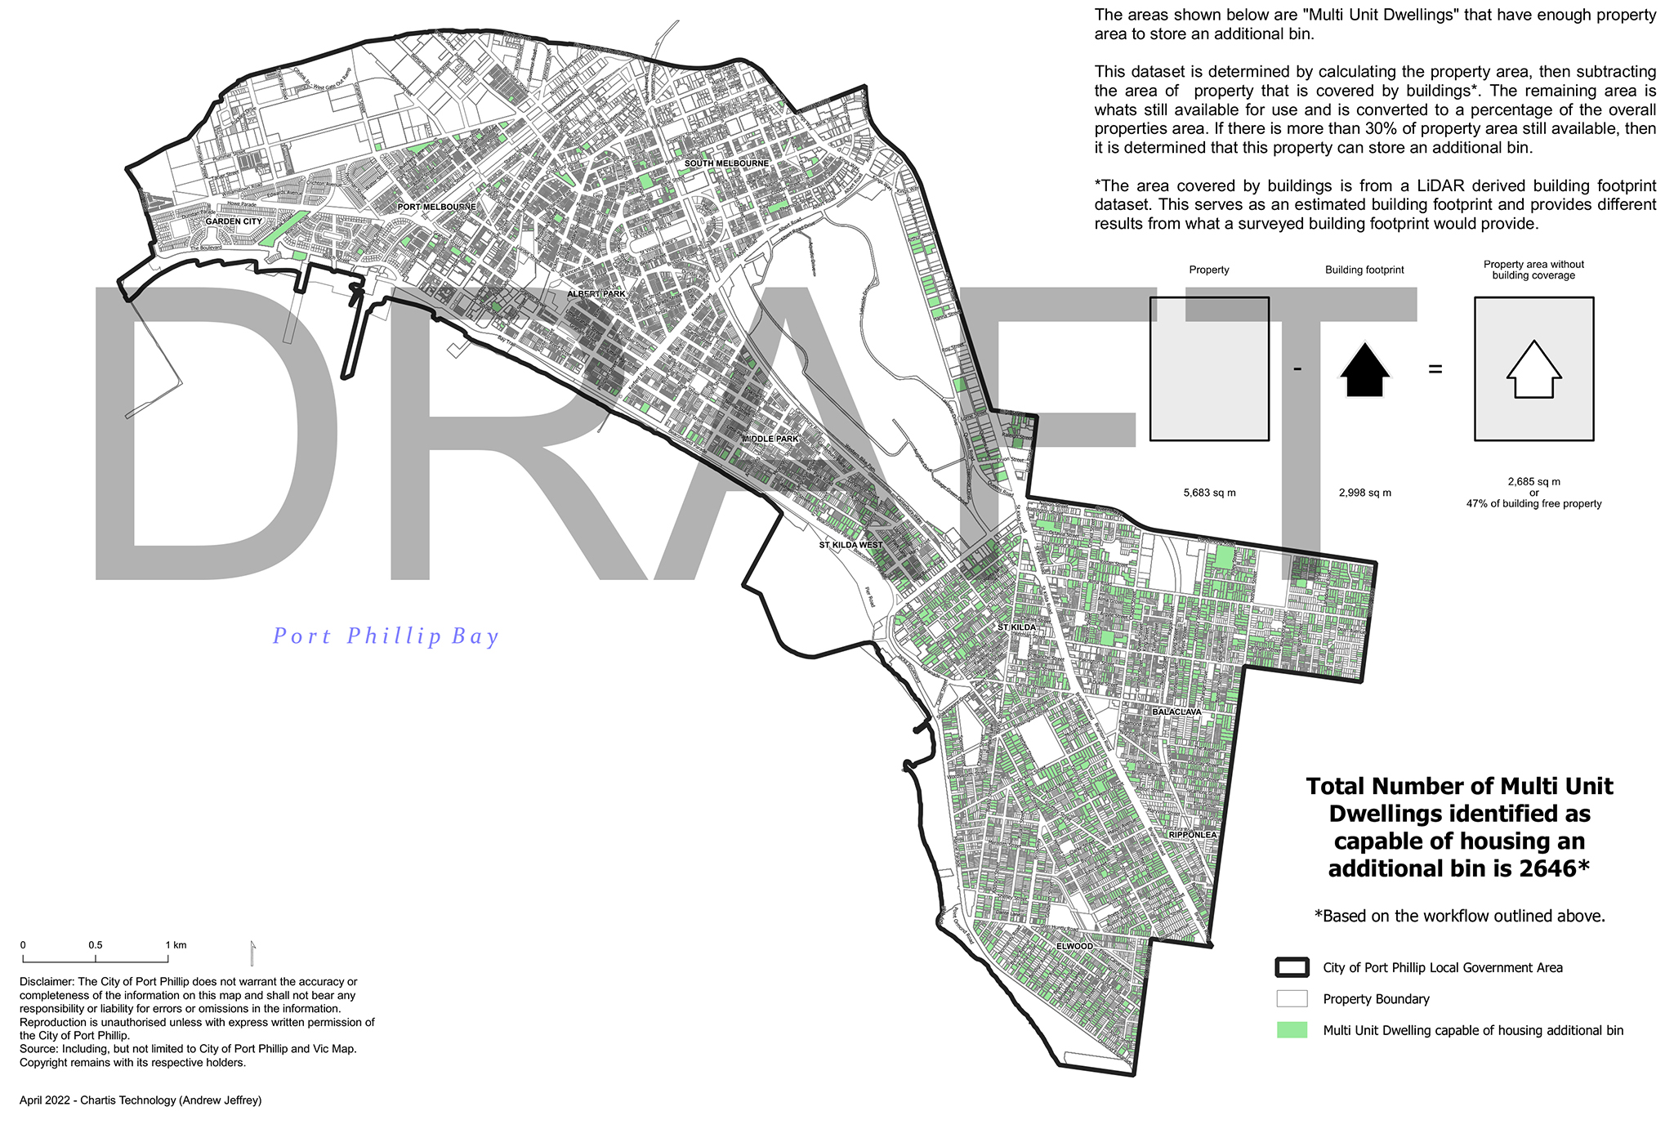

Appendix 4 - Houses/townhouses receiving a kerbside FOGO bin
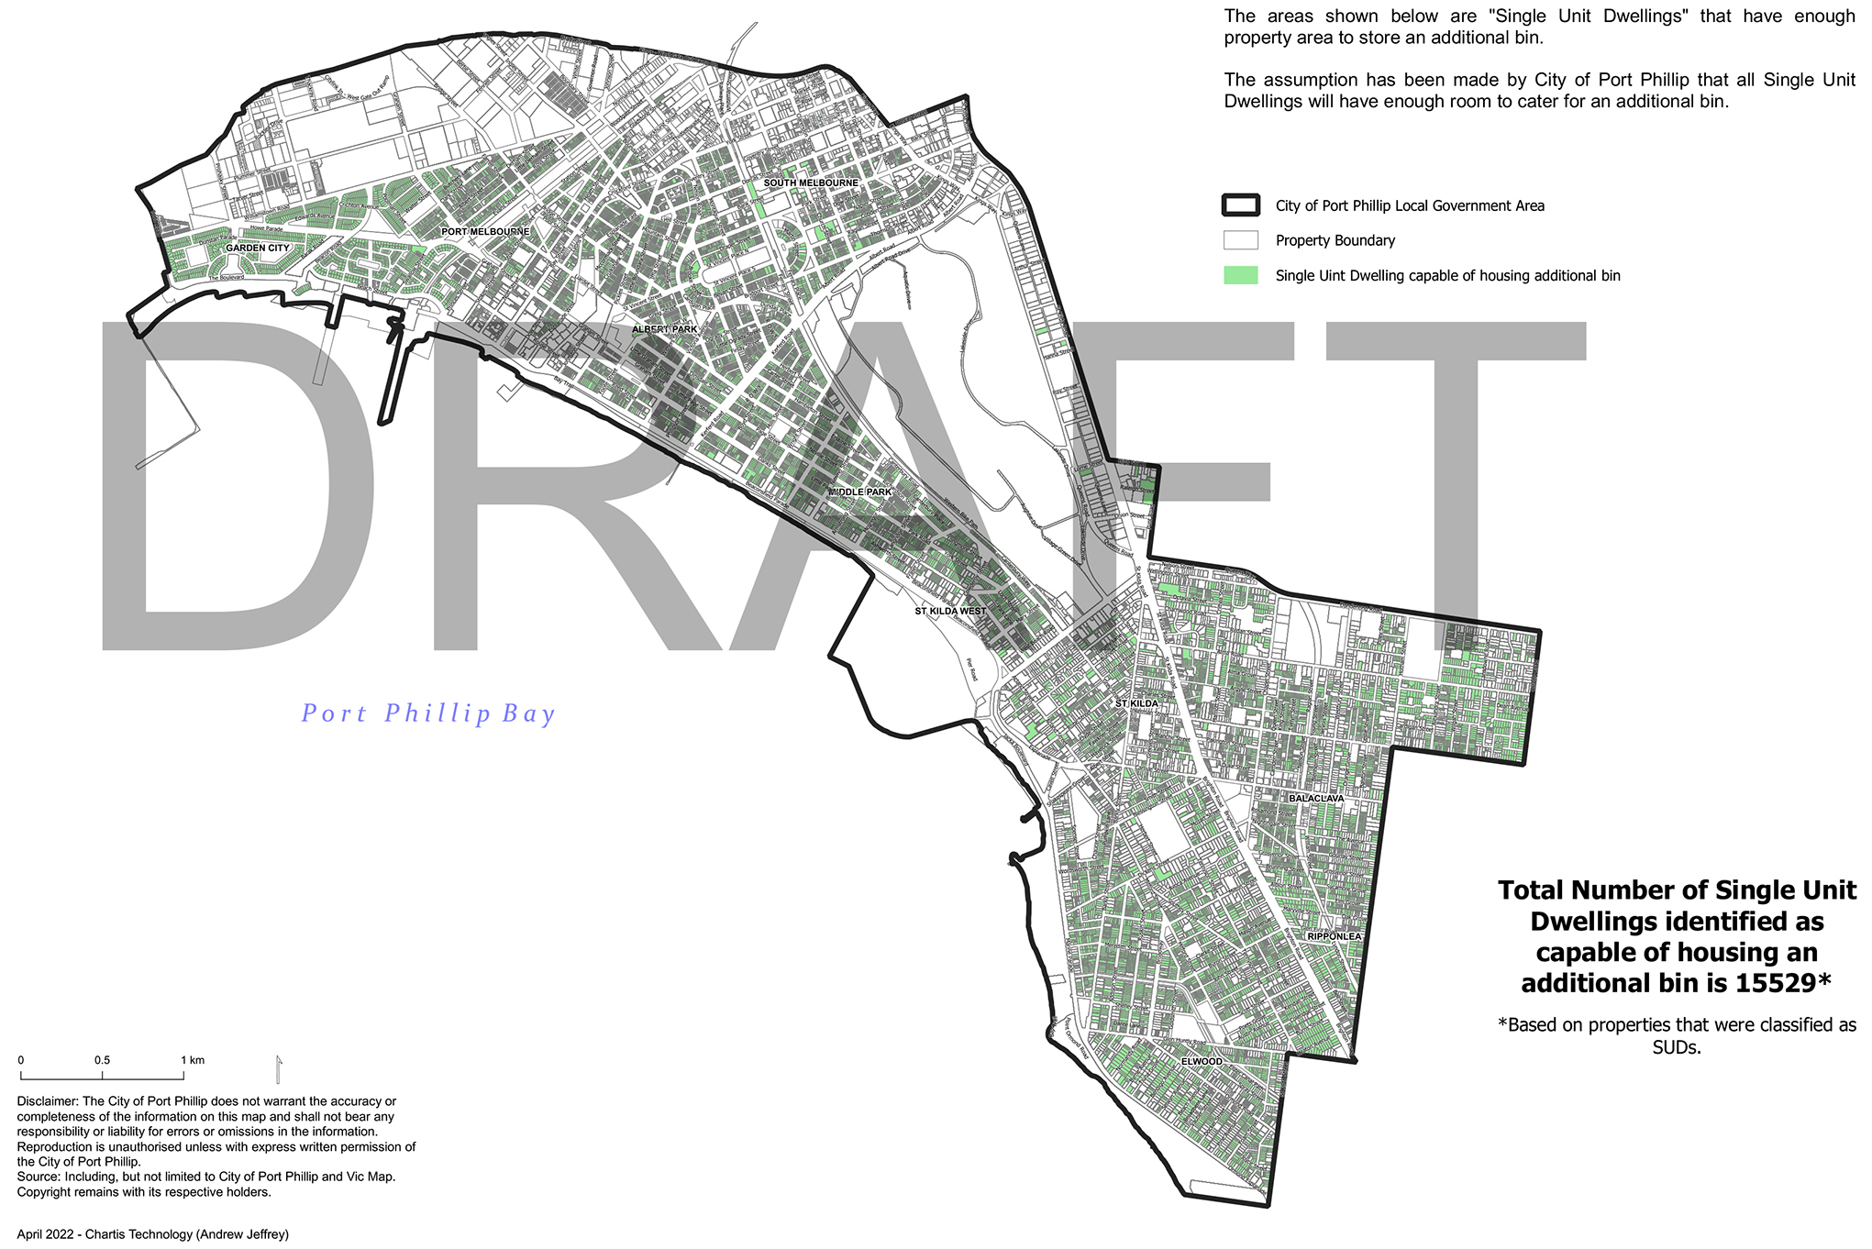

Appendix 5 - Locations of communal FOGO and glass hubs
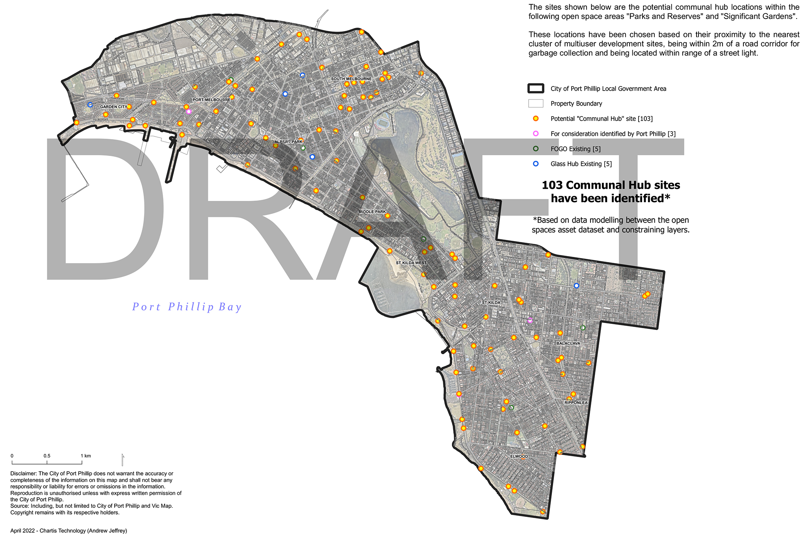

* From 2019 audit levels

