DRAFT COUNCIL

PLAN 2021-31
  - Year Two – April 2022
Volume 3

City of Port Phillip

Council Plan 2021-31
Local Government Performance Reporting Framework and service profiles

The Council Plan is divided across three volumes:
Volume One introduces the Plan, including background information, development approach and details on the inputs that informed the Plan. Importantly, it outlines the vision our community has for our City over the next 10 years and presents our strategic directions (including the services provided and performance indicators for each), an overview of our financial strategy and a list of proposed capital works projects by neighbourhood.
Volume Two contains the detailed financial information for the Plan, including our 10-year Financial Plan. It includes information on our financial strategy, financial position, risks and sustainability. It also contains asset management information including Council’s Asset Management Framework, a detailed asset plan, and detailed financial information about our services provided in each strategic direction.
Volume Three provides information on the 28 services we provide to our community.

Council respectfully acknowledges the Traditional Owners of this land, the people of the Kulin Nation. We pay our respect to their Elders, past and present. We acknowledge and uphold their continuing relationship to this land.
Table of Contents
City of Port Phillip 3
Council Plan 2021-31 3
Local Government Performance Reporting Framework measures 6
Service measures 6
Financial performance measures 8
City of Port Phillip service profiles 10
All services overview 11
Inclusive services 17
Affordable housing and homelessness 17
Ageing and accessibility 21
Children 25
Community programs and facilities 30
Families and young people 34
Recreation 37
Liveable services 40
City planning and urban design 40
Development approvals and compliance 43
Health 46
Local laws and animal management 49
Municipal emergency management 52
Public space 54
Transport and parking management 59
Sustainability services 64
Amenity 64
Sustainability 68
Waste management 72
Vibrant services 75
Arts, culture and heritage 75
Economic development and tourism 78
Festivals 81
Libraries 84
South Melbourne Market 87
Well-Governed services 90
Asset and property management 90
Communications and engagement 94
Customer experience 97
Finance and project management 101
Governance, risk and policy 104
People, culture and safety 107
Technology 110

Local Government Performance Reporting Framework measures
Each year Port Phillip collects Local Government Performance Reporting Framework measures so we can compare like services across the sector. These measures are reported regularly in the CEO Report. For further information on performance reporting and to view the current CEO Report please visit our website portphillip.vic.gov.au

Service measures
Service measure | 2018/19 | 2019/20 | 2020/21
Animal management
Time taken to action animal management requests | 1 day | 1 day | 1 day
Animals reclaimed | 56 % | 51 % | 50 %
Animals rehomed | No data | 11 % | 18 %
Cost of animal management service per population | $5.54 | $7.55 | $7.61
Animal management prosecutions | No data | 100 % | 100 %
Food safety
Time taken to action food complaints | 1.74 days | 1.68 days | 1.79 days
Percentage of required food safety assessments undertaken | 100 % | 100 % | 97 %
Cost of food safety service per premises | $591 | $638.11 | $637.36
Percentage of critical and major non-compliance outcome notifications followed up in the calendar year | 100 % | 100 % | 100 %
Governance
Council decisions made at meetings closed to the public | 9.1 % | 6.62 % | 7.38 %
Community satisfaction with community consultation and engagement* | 61 | 59 | 58
Councillor attendance at Council meetings | 94 % | 94 % | 99 %
Cost of governance per Councillor | $56,441 | $52,239 | $44,132
Community satisfaction with Council decisions* | 59 | 58 | 60
*Rating out of 100
Libraries
Physical library collection usage (loans per item) | 4.33 | 3.73 | 3.82
Proportion of library resources less than five years old | 49 % | 51 % | 49 %
Active library borrowers in municipality | 18.6 % | 18.5 % | 17.6 %
Cost of library service per population | $37.42 | $35.48 | $30.30
Maternal and child health (MCH)
Infant enrolments in the MCH service | 100.95 % | 101.03 % | 100.83 %
Cost of the MCH service | $75.54 | $84.67 | $88.86
Participation in the MCH service | 74.28 % | 87.38 % | 83.49 %
Participation in the MCH service by Aboriginal children | 80 % | 95 % | 94.29 %
Participation in four-week key age and stage visit | 93.8 % | 95.87 % | 93.53 %
Roads
Sealed local road requests per 100 km of sealed road | 57 | 50 | 51.13
Sealed local roads maintained to condition standards | 97 % | 97 % | 94 %
Cost of sealed local road reconstruction per square metre | $91.10 | $65.31 | $79.08
Cost of sealed local road resealing per square metre | $31.12 | $28.07 | $56.29
Community satisfaction with sealed local roads* | 68 | 69 | 67
*Rating out of 100
Statutory planning
Time taken to decide planning applications | 78 days | 88 days | 93 days
Planning applications decided within required timeframes | 57 % | 68 % | 68 %
Cost of statutory planning service per planning application | $2,617.25 | $2,791.06 | $2,674.48
Planning decisions upheld at VCAT | 72 % | 77 % | 75 %
Waste collection
Kerbside bin collection requests per 1,000 households | 29.31 | 26 | 24.14
Kerbside collection bins missed per 10,000 households | 3.4 | 3.07 | 2.05
Cost of kerbside garbage bin collection service per bin | $53.07 | $50.49 | $50.07
Cost of kerbside recyclables collection service per bin | $46.55 | $51.38 | $50.07
Kerbside collection waste diverted from landfill | 29 % | 33 % | 32 %

Financial performance measures
Measure | 2018/19 | 2019/20 | 2020/21
Efficiency
Average residential rate per residential property assessment | No data | $1,754.55 | $1,773.54
Expenses per property assessment | $3,072.16 | $3,142.99 | $2,865.36
Liquidity
Current assets compared to current liabilities (YTD result) | 267.53 % | 360.39 % | 309.49 %
Unrestricted cash compared to current liabilities (YTD result) | -85.93 % | -207.81 % | -104.41 %
Obligations
Asset renewal compared to depreciation | No data | 72.23 % | 75.37 %
Loans and borrowings compared to rates | 7.15 % | 5.81 % | 5.61 %
Loans and borrowings repayments compared to rates | 0.67 % | 0.27 % | 0.26 %
Non-current liabilities compared to own source revenue | 5.29 % | 5.52 % | 1.46 %
Operating position
Adjusted underlying surplus (or deficit) | -3.37 % | -2.89 % | 3.5 %
Stability
Rates compared to adjusted underlying revenue | 57.56 % | 57.73 % | 60.46 %
Rates compared to property values | 0.19 % | 0.19 % | 0.19 %
Sustainable Capacity Indicators
Expenses per head of municipal population | $1,977.99 | $1,989.31 | $1,831.72
Infrastructure per head of municipal population | $6,287.75 | $6,175.51 | $6,070.61
Population density per length of road (kilometres) | 425.56 | 436.23 | 437.88
Own-source revenue per head of municipal population | $1,805.92 | $1,827.14 | $1,728.81
Recurrent grants per head of municipal population | $97.92 | $93.40 | $83.12
Relative Socio-Economic Disadvantage | 10/10 | 10/10 | 10/10
Resignations and terminations compared to average staff | 18.04 % | 14.2 % | 14.9 %

City of Port Phillip service profiles
Under the Local Government Act 2020 a Council must plan and deliver services to the municipal community based on the following performance principles:
- services should be provided in an equitable manner and be responsive to the diverse needs of the municipal community
- services should be accessible to the members of the municipal community for whom the services are intended
- quality and costs standards for services set by the Council should provide good value to the municipal community
- a Council should seek to continuously improve service delivery to the municipal community in response to performance monitoring
- service delivery must include a fair and effective process for considering and responding to complaints about service provision.
In addition, a Council must provide a description of services and initiatives to be funded in their Budget. Service profiles are one output of service planning. The primary purpose of the following 28 service profiles is to clearly demonstrate:
- the value to the community in providing the service
- why we provide the service
- what we provide
- how we provide the service
- how much it costs
- how it is funded
- the priority areas.

All services overview
Inclusive Port Phillip
Service | Description | Total Cost  ($,000s) | Proportion of all rates received spent | Proportion of other income funding
Affordable housing and homelessness | Increase affordable housing for eligible people experiencing housing stress or loss, homelessness and sleeping rough. Create partnerships that work collectively to increase affordable housing and reduce homelessness. | $2,002 | 1.15 % | 0 %
Ageing and accessibility | Facilitate independence and promote social connectedness for older people and those with a disability through the provision of high-quality support services and community building initiatives. | $7,132 | 0.76 % | 71 %
Children | Create healthy starts to life for all children born and living in our City, support parents and children to be healthy and connected, and offer programs to promote optimal development for children. | $16,921 | 1.3 % | 64 %
Community programs and facilities | Create opportunities that build social connections, value diversity and address health and wellbeing inequities in our communities, including a commitment to reconciliation and support for the Aboriginal and Torres Strait Islander Community. | $3,626 | 1.97 % | 5 %
Families and young people | Create opportunities for all children, young people and families to be healthy and connected, to reach their full potential. | $4,746 | 3 % | 15 %
Recreation | Plan, deliver and activate sport, recreation and open space facilities and services to create community health and wellbeing. | $7,595 | 4.56 % | 21 %

Liveable Port Phillip
Service | Description | Total Cost  ($,000s) | Proportion of all rates received spent | Proportion of other income funding
City planning and urban design | Deliver strategic planning, controls and urban design outcomes to enhance Port Phillip’s character and create a liveable, attractive and sustainable City. | $4,119 | 2.28 % | 0 %
Development approvals and compliance | Support well-designed, sustainable, safe development that protects heritage and neighbourhood character and maximises community benefit. Support outdoor dining to enhance our City’s liveability and vibrancy. | $7,642 | (1.74 %) | 100 %
Health | Maintain, improve and protect public health in the community, through education and inspection services. | $1,864 | 0.5 % | 49 %
Local laws and animal management | Protect Council assets, the environment and health and safety of our community, and ensure responsible pet ownership. | $2,071 | 0.66 % | 34 %
Municipal emergency management | Provide operational and strategic emergency management services across preparedness, response and recovery. | $604 | 0.38 % | 0 %
Public space | High quality and unique parks, open spaces and foreshore for the enjoyment of our community and visitors. | $24,327 | 9.97 % | 15 %
Transport and parking management | Support a reliable, well-connected transport system and enable people to more easily move around, connect with and get to places within our growing City. | $31,705 | 16.74 % | 100 %

Sustainable Port Phillip
Service | Description | Total Cost  ($,000s) | Proportion of all rates received spent | Proportion of other income funding
Sustainability | Improve the sustainability of our City by reducing carbon emissions, water use and waste generation; increasing trees, vegetation and biodiversity; improving water quality and our resilience to the impacts of climate change, including flooding and heat. | $6,371 | 3.67 % | 16 %
Waste Management | Maintain a clean and healthy City by keeping our streets, parks and foreshores clean and protecting the environment. | $16,164 | 11.94 % | 2 %
Amenity | Provide a clean, safe and enjoyable environment that enhances how our community and visitors experience our City. | $14,475 | 7.72 % | 2 %

Vibrant Port Phillip
Service | Description | Total Cost  ($,000s) | Proportion of all rates received spent | Proportion of other income funding
Arts, culture and heritage | Foster creative, diverse, inclusive participation in our arts and cultural sectors while preserving the heritage and unique identity of Port Phillip. | $9,258 | 5.25 % | 3 %
Economic development and tourism | Promote our City to support residents, visitors and industry to achieve stronger economic outcomes. | $1,395 | 0.37 % | 0 %
Festivals | Create festivals and events that deliver tangible benefits to our community, from improved health and wellbeing to economic development, while supporting cultural vibrancy and social engagement. | $4,272 | 1.77 % | 42 %
Libraries | Support learning, social engagement and community connectedness. | $6,580 | 3.79 % | 15 %
South Melbourne Market | Operate an engaging and entertaining market environment where our community and visitors spend time shopping, dining and supporting local business. | $9,399 | 0.32 % | 85 %

Well-Governed Port Phillip
Service | Description | Total Cost  ($,000s) | Proportion of all rates received spent | Proportion of other income funding
Asset and property management | Ensure Council has the right assets at the right time for the right cost to support service delivery now and in the future. | $22,152 | 9.47 % | 24 %
Communications and engagement | Inform the community about Council decisions and activity and facilitate opportunities for the community to inform Council projects, initiatives, policies and strategies. | $2,363 | 1.48 % | 0 %
Customer experience | Ensure that customers receive services that meet their needs and expectations and can achieve their goals with greater ease and satisfaction. | $5,678 | 3.16 % | 0 %
Finance and project management | Ensure the financial sustainability and transparency of Council and that investments in projects deliver value for ratepayers. | $16,977 | (4.25 %) | 100 %
Governance, risk and policy | Support sound decision-making through transparency, accountability, community participation, risk management and compliance. Undertake advocacy to influence the delivery of community priorities. | $6,592 | 3.93 % | 5 %
People culture and capacity | Enable a safe workplace and a high performing workforce. | $5,042 | 3.08 % | 0 %
Technology | Support Council operations and efficient, effective service delivery through the delivery of high-quality information, communication and technology services. | $11,660 | 6.79 % | 0 %

Inclusive services

Affordable housing and homelessness
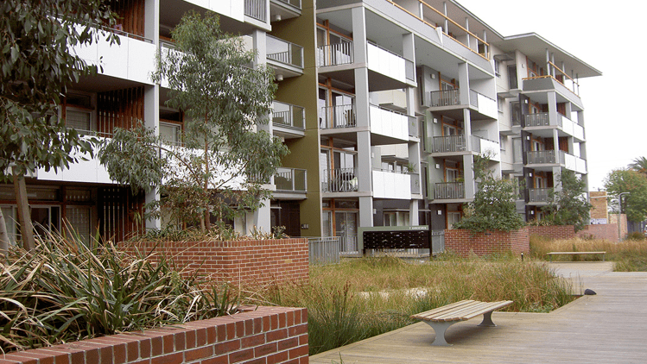
The value we provide
- Increased affordable housing for very low, low and moderate-income households in housing stress, including supported housing for persons who are experiencing homelessness and sleeping rough.
- Prevention of homelessness, or reduced time spent without a secure home, for older Port Phillip residents facing housing stress or loss.
- Creation of partnerships that work collectively to increase affordable housing and reduce homelessness.
What we do
- Provide direct assessment, referral and interim case management support services for older persons in housing stress, at risk of housing loss or homelessness.
- Coordinate an integrated multi-agency response to public homelessness, through the Port Phillip Zero project, and to rooming house closures.
- Align the affordable housing program to respond to homelessness, through provision of supported social housing using Housing First principles.
- Directly invest (via cash and property contributions) to grow affordable housing.
- Facilitate and broker partnerships and projects by others that deliver affordable housing.
- Negotiate voluntary housing agreements with private developers to meet the six per cent affordable housing target in Fishermans Bend.
- Undertake research into housing need and the impact of homelessness.
- Undertake projects and events to enhance the community’s understanding of homelessness and housing stress, including community engagement and the involvement of people with a lived experience of homelessness.
- Align community grants and service agreements to assist people in housing stress or facing homelessness.
Why we do it
- To respond to declining housing affordability, which results in increasing housing stress, poverty, homelessness, and dislocation of residents from Port Phillip.
- To provide alternative social housing in response to the loss of private rooming houses.
- To foster a community that is socially diverse and inclusive, recognising the importance of attachment and belonging to this community.
- Recognising that one of the key social determinants of health of individuals, families and communities is secure, safe and accessible housing.
Activities that support this service
- Affordable and community housing
- Housing and homelessness service
Our service at a glance
Service statistics | 2018/19 | 2019/20 | 2020/21
Affordable and community housing
People living in rental housing stress (SGS, 2018) | 5,700+ | - | 4,912
Number of social (public and community) housing units in Port Phillip (DHHS, 2019) | 3,999 | 4,043 | 4,154
Beds in the 99 registered private and community rooming houses in Port Phillip (Prescribed Accommodation Register and Victorian Government Gazette 2020) | - | 1,800+ | 1,104
Housing and homelessness service
Requests for Council to assist people sleeping rough | 424 | 327 | 177
Direct hours of housing assistance | 638 | 576 | 549
Number of clients | 220 | 187 | 177
Number of older local persons housed | 104 | 44 | 51
How much it costs to provide the service
Budget 2022/23
Operating costs $000  Employee costs 632  Contracts 55  Materials and other expenses 377  Operating projects 1,110  Total operating expenses 2,175  Capital projects 0  Total expenses 2,175  Expenses include management overhead allocation and exclude depreciation. | How the service is funded $000  Rates 1,404  Parking revenue 284  Reserves 486  Fees and charges (incl. statutory) 0  Grants 0  Other income 0  Total funding 2,175  Revenue from parking fees and fines is allocated on a proportionate basis across all service categories.
$0.87 is spent on this service out of every $100 of rates we receive
35% of costs are funded from fees and charges, grants or other income
Major contracts (annualised expense) $000
- None
Major property leases Most recent market Rent per year rental estimate ($000) ($ excl GST)
- None
Major financial contributions $000
- None
Major assets
Council assets (June 2021) Written Down Value $000
- Community housing 1,288
Our projects (* means 100% grant and contribution funding and ** means partial grant and contribution funding)
Capital projects $000 2022/23 2023/24 2024/25
None
Total Capital projects (excluding Fleet Renewal allocation) 0 0 0
Operating projects $000 2022/23 2023/24 2024/25
In Our Backyard Strategy Implementation 1,000 1,000 0
Rough Sleeping Assertive Outreach 110 0 0
Total operating projects 1,110 110 0
Note: asset information will be updated in the final version

Ageing and accessibility
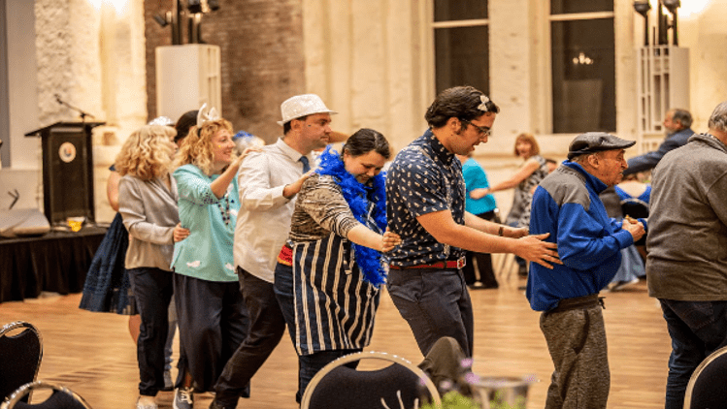
The value we provide
- Facilitate independence and promote social connectedness for older people and those with a disability, through the provision of high-quality support services and community building initiatives.
What we do
- Deliver government-funded services, including:
  - Regional Assessment Services to determine client needs
  - in-home support services and social support programs
  - accessible and supported community transport as an aged care and disability access service.
- Deliver positive and healthy ageing initiatives.
- Fund community groups and service providers, through grants and funding deeds, to deliver a range of support programs and community building initiatives.
- Implement the Access and Inclusion Plan as required by the Local Government Act 2020.
- Consult with Advisory Committees and community networks, such as Older Person’s Consultative Committee (OPCC) and City of Port Phillip Access Network (COPPAN).

Why we do it
- To promote social connectedness and foster a community that is socially diverse and inclusive.
- To support older residents and those with disability to remain living independently at home and in the community.
Activities that support this service
- Access planning
- Commonwealth assessment and intake
- Independent living (home, respite and personal care)
- Social inclusion (support)
- Access and support
- Community transport
- Community meals
- Positive and healthy ageing - Seniors Festival, Seniors Register and Linking Neighbours.

Our service at a glance
Service statistics | 2018/19 | 2019/20 | 2020/21
Home care
Home care clients | 1,570 | 1,561 | 1,419
Hours of general home care | 19,430 | 16,689 | 14,643
Hours of meal preparation | 1,428 | 710 | 235
Hours of personal care | 5,578 | 4,761 | 3,544
Hours of home maintenance service | 2,662 | 2,020 | 1,687
Hours of respite care | 4,689 | 896 | 398
Hours of shopping services | 8,518 | 6,899 | 5,399
Social inclusion
Hours of core social report | 11,412 | 8,082 | 5,633
Hours of high priority social support | 16,635 | 7,051 | -
Social inclusion volunteers | 10 | 11 | 0
Community meals
Community meals delivered | 16,448 | 18,009 | 25,361
Community meals provided at centres | 1,938 | n/a | n/a*
Community meals subsidised | 187,464 | 807,755 | 557,122
Community transport
Community bus trips | 1,981 | 1,981 | n/a**
Passengers who used the Community Bus service | 34,455 | 26,735 | 8,232
Positive and healthy ageing
Linking Neighbours Program participant numbers | 6,789 | 5,221 | 6,268
Seniors register | 800+ | 780 | 720
Seniors Festival participants | 4,537 | 2,916 | 2,905
*This activity ceased in 2020 due to COVID-19 and will not be reopening
**We no longer offer a route service – Council decision 2021
Note: some service statistic data has not been available at the time of preparing this report. Where possible, data will be included for the final version.

How much it costs to provide the service
Budget 2022/23
Operating costs $000  Employee costs 4,710  Contracts 656  Materials and other expenses 1,248  Operating projects 0  Total operating expenses 6,613  Capital projects 110  Total expenses 6,723  Expenses include management overhead allocation and exclude depreciation. | How the service is funded $000  Rates 850  Parking revenue 879  Reserves 58  Fees and charges (incl. statutory) 499  Grants 4,438  Other income 0  Total funding 6,723  Revenue from parking fees and fines is allocated on a proportionate basis across all service categories.
$0.51 is spent on this service out of every $100 of rates we receive
87% of costs are funded from fees and charges, grants, reserves and other income
Major contracts (annualised expense) $000
- Delivered Meals Service 396
Major property leases Most recent market Rent per year rental estimate ($000) ($ excl GST)
- Department of Health and Human Services -
Office of Housing 351 1
- Napier Street Aged Care 750 0
- Southport Community Residential Home 550 1
Major financial contributions $000
- Food services and social support grants 200
- Social Meals Program 102
- South Point Day Links 52
- Sacred Heart Mission 30
Major assets
Council assets (June 2021) Written Down Value $000
- Aged care facilities (1) 6,889
Note: asset information will be updated in the final version
Our projects (* means 100% grant and contribution funding and ** means partial grant and contribution funding)
Capital projects $000 2022/23 2023/24 2024/25
None
Total Capital projects 0 0 0
Operating projects $000 2022/23 2023/24 2024/25
None
Total operating projects 0 0 0

Children
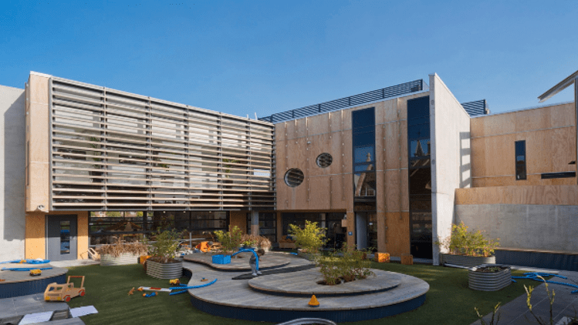

The value we provide
- Create healthy starts to life for children born and living in the City.
- Support guardians and children to be healthy and connected.
- Provide programs, services or connection to services that promote optimal development for children and their families.
What we do
- Provide quality early childhood education and care for children aged 0-6 years, including operating and managing children’s services, and support for community-managed children’s services and toy libraries.
- Support early access to maternal child health service for all families to support families.
- Provide parent education and support to families.
- Monitor child’s growth and development.
- Provide accessible and affordable programs for children from families experiencing vulnerability, including families who do not meet criteria of the Additional Child Care Subsidy.
- Manage enrolment for Council and community services that meet DET Priority of Access principles.
- Provide subsidies for community managed childcare and kindergartens.
Why we do it
- Council has a vision for Children’s Services: ‘A children’s services environment that honours diversity, builds creativity and social connections and encourages all children and families to maximise their development outcomes now and in the future.’
- Recreation, engagement and child-friendly cities are a priority deliverable to ensure services are reaching diverse community cohorts.
- Children’s Services is seeking to achieve three outcomes:
  - All children living in Port Phillip are supported to develop their full potential.
  - Families are supported across various stages of their child’s development, families feel connected, part of a welcoming community and are afforded opportunities to increase their capacity and capability.
  - The effects of disadvantage on children’s development are minimised.

Activities that support this service
- across various stages of their child’s development, families feel connected, part of a welcoming community and are afforded opportunities
- community-managed childcare and other children’s services
- allied professional agencies and services including maternal and child health.

Our service at a glance
Service statistics | 2018/19 | 2019/20 | 2020/21
Childcare
Total places across the City | 2,186 | 2,213 | 2,574
Council-managed places | 362 | 362 | 362
Bubup Nairm Family and Children’s Centre | 116 | 116 | 116
Clark Street Children’s Centre | 65 | 65 | 65
Coventry Children’s Centre | 60 | 60 | 60
North St Kilda Children’s Centre | 77 | 77 | 77
Barring Djinang Kindergarten | 44 | 44 | 44
Community-managed places | 568 | 568 | 523
Commercially managed places | 1,125 | 1,327 | 1,415
Maternal and child health
Birth notifications received | 1,270 | 1,259 | 1,204
Community immunisation sessions held | 81 | 81 | 78
Infants and children attending immunisation sessions | 2,658 | 2,422 | 1,361
Kindergarten programs
Playgroups | 70 | 70 | -
Note: some service statistic data has not been available at the time of preparing this report. Where possible, data will be included for the final version
How much it costs to provide the service
Budget 2022/23
Operating costs $000  Employee costs 11,793  Contracts 293  Materials and other expenses 4,032  Operating projects 181  Total operating expenses 16,299  Capital projects 1,010  Total expenses 17,309  Expenses include management overhead allocation and exclude depreciation. | How the service is funded $000  Rates 3,108  Parking revenue 2,263  Reserves 45  Fees and charges (incl. statutory) 9,630  Grants 1,322  Other income 2,263  Total funding 17,309  Revenue from parking fees and fines is allocated on a proportionate basis across all service categories.

$1.55 is spent on this service out of every $100 of rates we receive
82% of costs are funded from fees and charges, grants, reserves and other income
Major contracts (annualised expense) $000
- None
Major property leases Most recent market Rent per year rental estimate ($000) ($ excl GST)
- Ada Mary A’Beckett Children’s Centre 350 10
- Albert Park Kindergarten 122.5 10
- Clarendon Children’s Centre 130 10
- Civic Kindergarten 197.5 10
- Eildon Road Children’s Centre 150 10
- Lady Forster Kindergarten 225 104
- Lillian Cannam Kindergarten 205 10
- Poets Grove Family and Children’s Centre 380 10
- South Melbourne Community Child Care
Cooperative 212.5 10
- The Avenue Children’s Centre 100 10
- Elwood Children’s Centre 117.5 10
- Bubup Womenjeka Family and Children’s Centre 420 104
Major financial contributions $000
- Childcare subsidies (Council and community managed centres) 576
- Kindergarten grants 118
- Family Services (Early Education Grants) 156
Major assets
Council assets (June 2021) Written Down Value $000
- Council and community managed childcare centres (12) 23,283
- Maternal and child health centres (7) Not separately valued
Our projects (* means 100% grant and contribution funding and ** means partial grant and contribution funding)
Capital projects $000 2022/23 2023/24 2024/25
Childcare Centres Building Asset Renewals | 200 | 200 | 200
Children's Centres Improvement Program | 810 | 3,150 | 3,425
Total Capital projects (excluding Fleet Renewal allocation) 1,010 3,350 3,625

Operating projects $000 2022/23 2023/24 2024/25
Kinder Central Registration & Enrolment 181 0 0
Total operating projects 181 0 0
Note: asset information will be updated in the final version

Community programs and facilities
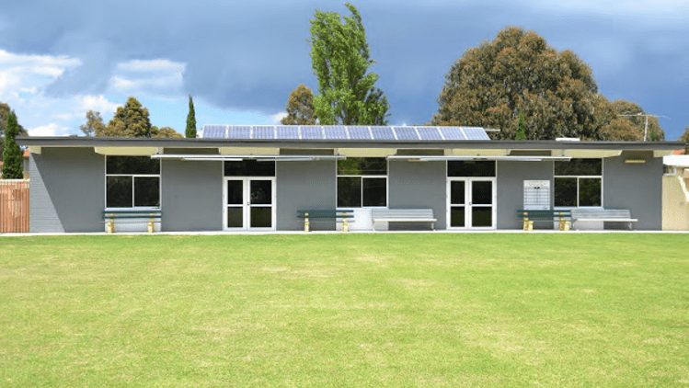
The value we provide
- Create opportunities that build social connections, value diversity and address health and wellbeing inequities in our communities.
- Build the capacity of the local community sector to support vulnerable and disadvantaged community members.
- Commitment to reconciliation and support for the Aboriginal and Torres Strait Islander Community.
What we do
- Provide community facilities for general community use, and leases and licences for local community organisations that provide services to residents.
- Provide well managed community facilities where people can learn, connect and engage with others in programs and activities.
- Implement initiatives to address health and wellbeing inequities for particular population groups (including indigenous, multicultural, LGBTIQA+).
- Strengthen and build local community capacity, including providing funding and training opportunities for our local community sector and volunteers.
- Work with Traditional Owners, the local Aboriginal and Torres Strait Islander community, and Indigenous service providers to advance Council’s commitment to Reconciliation in a culturally safe environment, through implementing the City of Port Phillip Reconciliation Action Plan.
- Outreach to Aboriginal and Torres Strait Islander (ATSI) community and leadership of the ATSI working group.
- Work in partnership with the multicultural, multifaith and LGBTIQA+ communities to facilitate inclusion and a stronger voice in planning and decision making.
Why we do it
- To reduce health and wellbeing inequities in the local community.
- To foster a community that is socially diverse, inclusive and connected.
- To foster a community that has a strong understanding and respect for its First People.
Activities that support this service
- Community capacity building and volunteer management
- Community facilities management
- Community service planning
- Community strengthening, including diversity
- Grants and community sector funding deeds
- Reconciliation, Aboriginal and Torres Strait Islander Gathering.

Our service at a glance
Service statistics | 2018/19 | 2019/20 | 2020/21
Community Centres
Bookings | 13,476 | 14,004 | 1,809*
Casual hires | 1,428 | 710 | 149*
Grants and community sector funding deeds
Community Grants funded | 61 | 46 | 45
Volunteer hours | 25,839 | 22,481 | 20,713
People benefited from annual community grants | 13,057 | 6,801 | 18,212
Visits per capita to community facilities | 1.7 | N/A | N/A**
*Significantly impacted by lockdowns as our venues were closed
**It is not possible to get a visits per capita ratio
How much it costs to provide the service
Budget 2022/23
Operating costs $000  Employee costs 2,149  Contracts 966  Materials and other expenses 1,056  Operating projects 0  Total operating expenses 4,170  Capital projects 0  Total expenses 4,170  Expenses include management overhead allocation and exclude depreciation. | How the service is funded $000  Rates 3,269  Parking revenue 545  Reserves 78  Fees and charges (incl. statutory) 248  Grants 0  Other income 30  Total funding 4,170  Revenue from parking fees and fines is allocated on a proportionate basis across all service categories.
$2.31 is spent on this service out of every $100 of rates we receive
22% of costs are funded from fees and charges, grants, reserves and other income
Major contracts (annualised expense) $000
- None
Major property leases Most recent market Rent per year rental estimate ($000) ($ excl GST)
- Hellenic RSL 230 104
Major leases Market rental estimate Rent per year (excl GST)
- None
Major financial contributions (including funding deeds) $000
- Port Phillip Community Group 608
- Community grants 285
- South Port Community Centre 132
- Town Hall hire subsidy 105
- South Port Legal Service 67
- Friends of Suai 30
Major assets
Council assets (June 2021) Written Down Value $000
- Community centres (12) 9,834
Our projects (* means 100% grant and contribution funding and ** means partial grant and contribution funding)
Capital projects $000 2022/23 2023/24 2024/25
None
Total Capital projects (excluding Fleet Renewal allocation) 0 0 0

Operating projects $000 2022/23 2023/24 2024/25
None
Total operating projects 0 0 0
Note: asset information will be updated in the final version

Families and young people
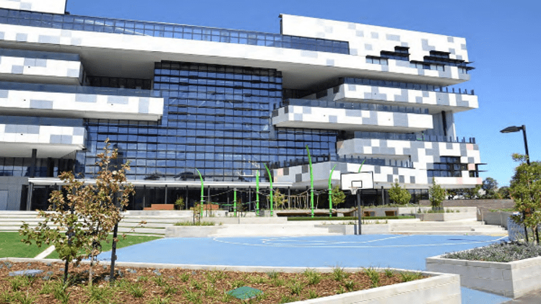
The value we provide
- Opportunities for all children, young people and families to be healthy and connected to reach their full potential.
What we do
- Provide leadership, recreation and engagement programs for children, families, and young people.
- Provide generalist youth support and referral pathways.
- Provide intensive formal support for whole families.
- Work with families to access financial assistance for early education engagement.
- Provide support to victims and survivors of family violence, and their children.
- Provide programming within the Adventure Playgrounds for children aged 5 to 12 years at St Kilda and South Melbourne.
- Provide access to universal access to brief support services for parents with young children.
- Fund local service providers to maximise support to families and children.
Why we do it
- To deliver on Council’s vision to create - ‘A children’s services environment that honours diversity, builds creativity and social connections and encourages all children and families to maximise their development outcomes now and in the future.’
- The outcomes sought to be achieved are:
  - All children and young people living in Port Phillip are supported to develop their full potential.
  - Parents, carers and families are supported to increase their capacity and capability.
  - The effects of disadvantage on children’s development are minimised.
Activities that support this service
- Family services and support
- Middle years services (including Adventure Playgrounds)
- Youth services.

Our service at a glance
Service statistics | 2018/19 | 2019/20 | 2020/21
Family support
Received in government grants | $273,047 | $392,142 | 360,949
Family support hours provided | 3,370 | 3,837 | 3,250
Number of high-risk families supported | 64 | 83 | 118*
Young people
Young people (aged 8 to 11 years) accessing programs that are run or funded by Council | 31,732 | 25,631 | 12,498
Young people (aged 12 to 25 years) accessing programs that are run or funded by Council | 10,009 | 15,532 | 10,662
*“High risk” is open to interpretation and the program has changed over the years. For our purposes, ’High risk’ is interpreted as anyone needing support beyond what’s available in universal services, i.e. services we provide are referral-based and screened.

How much it costs to provide the service
Budget 2022/23
Operating costs $000  Employee costs 2,549  Contracts 379  Materials and other expenses 1,793  Operating projects 0  Total operating expenses 4,721  Capital projects 490  Total expenses 5,211  Expenses include management overhead allocation and exclude depreciation. | How the service is funded $000  Rates 3,859  Parking revenue 681  Reserves (14)  Fees and charges (incl. statutory) 1  Grants 528  Other income 156  Total funding 5,211  Revenue from parking fees and fines is allocated on a proportionate basis across all service categories.
$2.86 is spent on this service out of every $100 of rates we receive
26% of costs are funded from fees and charges, grants, reserves and other income
Major contracts (annualised expense) $000
None
Major property leases Most recent market Rent per year rental estimate ($000) ($ excl GST)
None
Major financial contributions $000
Youth Grants 112
Star Health Natal Support 202
Major assets
Council assets (June 2021) Value $000
Adventure playgrounds (2) Not separately valued
Our projects (* means 100% grant and contribution funding and ** means partial grant and contribution funding)
Capital projects $000 2022/23 2023/24 2024/25
Adventure Playgrounds Upgrade 490 935 2,170
Total Capital projects (excluding Fleet Renewal allocation) 490 935 2,170

Operating projects $000 2022/23 2023/24 2024/25
None
Total operating projects 0 0 0

Recreation
The value we provide
- Plan, deliver and activate sport, recreation and open space facilities and services to create community health and wellbeing.
What we do
- Work with local sporting clubs and the community to facilitate participation in recreation and leisure activities.
- Provide infrastructure and facilities to support organised sport and active and passive recreation.
- Plan, implement and guide strategic open space planning across Council.
Why we do it
- To support our community to be healthy and active and promote social connectedness.
Activities that support this service
- Sport and recreation

Our service at a glance
Service statistics | 2018/19 | 2019/20 | 2020/21
Sports club members | 20,000+ | - | No data*
Sport club buildings | 20 | - | 14 leased sports clubs  8 pavilions
Bookings across 15 sporting reserves (2017/18) | 4,801 | - | No data*
*Due to COVID-19 sports clubs were not operational. We therefore did not conduct our annual survey requesting participation numbers to sports club as a result, and no bookings were issued.
How much it costs to provide the service
Budget 2022/23
Operating costs $000  Employee costs 1,031  Contracts 188  Materials and other expenses 2,575  Operating projects 0  Total operating expenses 3,793  Capital projects 6,911  Total expenses 10,705  Expenses include management overhead allocation and exclude depreciation. | How the service is funded $000  Rates 4,103  Parking revenue 1,399  Reserves 3,546  Fees and charges (incl. statutory) 237  Grants 1,324  Other income 95  Total funding 10,705  Revenue from parking fees and fines is allocated on a proportionate basis across all service categories.
$4.07 is spent on this service out of every $100 of rates we receive
62% of costs are funded from fees and charges, grants, reserves and other income
Major contracts (annualised expense) $000
- None
Major property leases Most recent market Rent per year rental estimate ($000) ($ excl GST)
- Albert Park Bowls Club 150 465.75
- Port Melbourne Bowling Club 340 5,193
- Port Melbourne Football Club 257.5 104
- Port Melbourne Lifesaving Club 220 553.5
- Port Melbourne Tennis Club 152.5 1,223
- Port Melbourne Yacht Club PMYC 275 8,200
- Royal Melbourne Yacht Squadron RMYS 200 40,880
- Sandbar Beach Cafe - -
- South Melbourne Lifesaving Club 145 104
- St Kilda Lifesaving Club 180 104
Major financial contributions $000
None
Major assets
Council owned/managed assets (June 2021) Written Down Value $000
Lifesaving clubs (3) and sports club buildings (20) 39,627
Our projects (* means 100% grant and contribution funding and ** means partial grant and contribution funding)
Capital projects $000 2022/23 2023/24 2024/25
Albert Park Bowls Club Pavilion Upgrade 50 260 -
Elder Smith Netball Courts and Pavilion 1,324 3,556 -
Graham St Overpass Skatepark and Carpark 828 70 -
J Talbot Reserve Basketball Upgrade 170 - -
JL Murphy Comm Pitch Synthetic Field 2,500 - -
Lagoon Reserve Pavilion & Sports Field 1,726 4,400 -
North Port Oval Upgrade (Council) 46 680 -
North Port Oval Works (Election) 38 - -
Sport & Recreation Program 160 600 400
Sports Fields Lighting Program 30 450 1,000
Sports Playing Field Program 40 - 1,500 Total Capital projects (excluding Fleet Renewal allocation) 6,912 10,016 2,900

Operating projects $000 2022/23 2023/24 2024/25
None
Total operating projects 0 0 0

Note: asset information will be updated in the final version

Liveable services

City planning and urban design
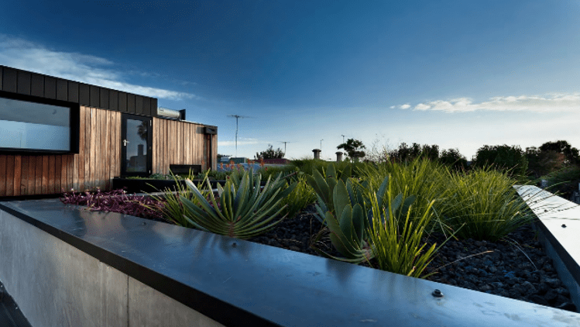
The value we provide
- Strategic planning, controls and urban design outcomes to enhance Port Phillip’s character and create a liveable, attractive and sustainable City.
What we do
- Manage Port Phillip Planning Scheme including the Local Planning Policy Framework.
- Develop and engage on integrated urban spatial policies and projects.
- Develop municipal-wide and place-based urban strategy and land use policies.
- Contribute to advocacy for state planning policy and regulation reform.
- Provide urban design, landscape, architecture and heritage advice on public realm projects.
- Advocate for investment and design improvements on state public realm and transport projects.
Why we do it
- To ensure our City is liveable, sustainable and vibrant, retaining our diverse and distinctive neighbourhoods as the City continues to grow.
Activities that support this service
- City design
- City policy
- City strategy
- Fishermans Bend Program
- Urban economics
- Heritage.

Our service at a glance
Service statistics | 2018/19 | 2019/20 | 2020/21
None

How much it costs to provide the service
Budget 2022/23
Operating costs $000  Employee costs 2,914  Contracts 0  Materials and other expenses 37  Operating projects 1,123  Total operating expenses 4,073  Capital projects 0  Total expenses 4,073  (expenses include management overhead allocation, exclude depreciation and project expenditure) | How the service is funded $000  Rates 3,436  Parking revenue 532  Reserves 105  Fees and charges (incl. statutory) 0  Grants – operating 0  Other income 0  Total funding 4,073  Revenue from parking fees and fines is allocated on a proportionate basis across all service categories.
$2.31 is spent on this service out of every $100 of rates we receive
16% of costs are funded from fees and charges, grants, reserves and other income
Major contracts (annualised expense) $000
None
Major property leases Market rental Rent per year
($000) estimate ($ excl GST)
None
Major financial contributions $000
None
Major assets
Council assets (June 2021) Value $000
Historical and heritage sites (31) -
Our projects (* means 100% and ** means partial grant and contribution funding)
Capital projects $000 2022/23 2023/24 2024/25
None
Total Capital projects (excluding Fleet Renewal allocation) 0 0 0

Operating projects $000 2022/23 2023/24 2024/25
Fishermans Bend Program 300 300 300
Heritage Program Implementation 330 390 90
Housing Strategy 200 130 0
Planning Scheme Amendments 165 260 260
South Melbourne Structure Plan 128 0 0
St Kilda Catalyst Sites Investing 0 60 0
Total operating projects 995 1,080 650

Note:
- some service statistic data has not been available at the time of preparing this report. Where possible, data will be included for the final version.
- asset information will be updated in the final version.

Development approvals and compliance
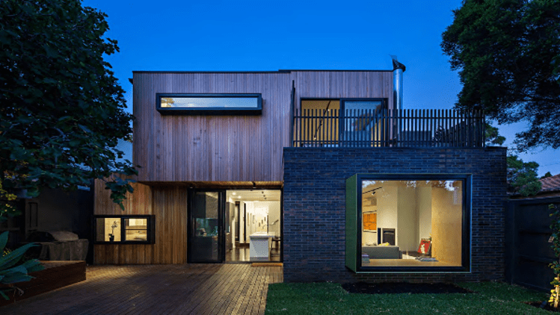
The value we provide
- Support well designed, sustainable and safe development that protects heritage and neighbourhood character, maximises community benefit.
- Support outdoor dining to enhance our City’s liveability and vibrancy.
What we do
- Make statutory planning decisions on planning permit and subdivision applications.
- Provide heritage and urban design advice relating to the planning scheme and policies.
- Provide frontline customer service.
- Issue permits and enforce the building regulations including prosecutions, siting provisions and public safety.
- Register and inspect domestic swimming pools and spas.
- Administer local laws permits for construction activities and commercial uses, including footpath trading.
- Investigate and enforce alleged breaches of the Planning and Environment Act, the Port Phillip Planning Scheme and the Building Act.
- Proactively monitor development sites for compliance with Planning Permits.
Why we do it
- To ensure our City is liveable, sustainable and prosperous, retaining our diverse and distinctive neighbourhoods as the City continues to grow.
Activities that support this service
- Building control
- Business support
- City permits
- Fishermans Bend planning
- Planning compliance
- Statutory planning
- Economic Development & Activation.

Our service at a glance
Service statistics | 2018/19 | 2019/20 | 2020/21
Planning applications received | 1,224 | 1,041 | 1,146
Planning applications decisions made | 1,204 | 1,080 | 1,005
How much it costs to provide the service
Budget 2022/23
Operating costs $000  Employee costs 7,174  Contracts 8  Materials and other expenses 590  Operating projects 0  Total operating expenses 7,772  Capital projects 148  Total expenses 7,920  (expenses include management overhead allocation, exclude depreciation and project expenditure) | How the service is funded $000  Rates (2,212)  Parking revenue 1,035  Reserves (14)  Fees and charges (incl. statutory) 9,110  Grants 0  Other income 0  Total funding 7,920  Revenue from parking fees and fines is allocated on a proportionate basis across all service categories.
$1.74 is returned by this service out of every $100 of rates we receive
128% of costs are funded from fees and charges, grants, reserves and other income
Major contracts (annualised expense) $000
None
Major property leases Market rental Rent per year
($000) estimate ($ excl GST)
None
Major financial contributions $000
None
Major assets
Council assets (June 2021) Value $000
None
Note: asset information will be updated in the final version
Our projects (* means 100% and ** means partial grant and contribution funding)
Capital projects $000 2022/23 2023/24 2024/25
None
Total Capital projects (excluding Fleet Renewal allocation) 0 0 0

Operating projects $000 2022/23 2023/24 2024/25
None
Total operating projects 0 0 0

Health
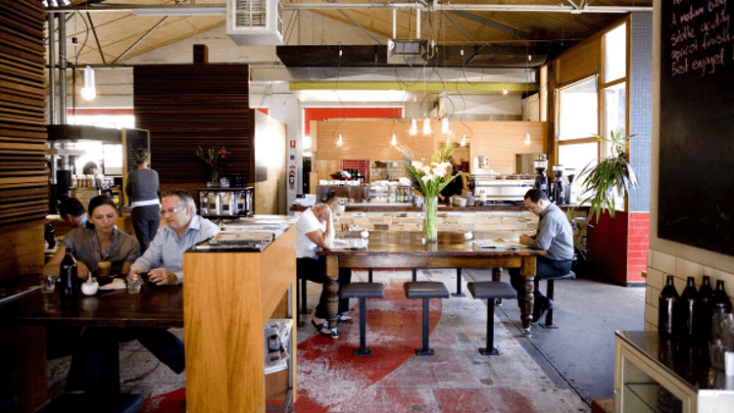
The value we provide
- Maintain, improve and protect public health in the community, through education and inspection services.
What we do
- Reduce the incidence of infectious disease by monitoring standards for registered food premises.
- Support the production of safe and secure food for consumption from restaurants, cafes and all registered food premises.
- Monitor health standards of accommodation properties, registered tattooists and beauty services.
- Provide an immunisation program for infants, children and adults.
- Investigate public health nuisance complaints.
- Monitor the use and sale of tobacco.
Why we do it
- To support a healthy and safe community, where the incidence of infectious disease is minimised.
- To fulfil mandatory duties described in the Victorian Food Act 1984, the Public Health and Wellbeing Act 2008 and the Tobacco Act 1987.
Activities that support this service
- Health services
- Immunisation program and infectious waste.

Our service at a glance
Service statistics | 2018/19 | 2019/20 | 2020/21
Health services
Prescribed accommodation inspections conducted | 149 | 109 | 135
Hairdresser, tattooist and beauty services inspections conducted | 95 | 173 | 39
Syringes collected and discarded through syringe disposal | 19,122 | 22,434 | 14,529
Public health nuisances reviewed | 245 | 262 | 248
Food safety
Inspections of registered premises | 2,801 | 2,584 | 1,950
Food premises complaints | 205 | 251 | 271
Food samples analysed | 238 | 230 | 146
How much it costs to provide the service
Budget 2022/23
Operating costs $000  Employee costs 1,660  Contracts 89  Materials and other expenses 234  Operating projects 0  Total operating expenses 1,983  Capital projects 0  Total expenses 1,983  (expenses include management overhead allocation, exclude depreciation and project expenditure) | How the service is funded $000  Rates 783  Parking revenue 259  Reserves (14)  Fees and charges (incl. statutory) 844  Grants 71  Other income 0  Total funding 1,983  Revenue from parking fees and fines is allocated on a proportionate basis across all service categories.
$0.55 is spent on this service out of every $100 of rates we receive
61% of costs are funded from fees and charges, grants, reserves and other income
Major contracts (annualised expense) $000
None
Major property leases Market rental Rent per year
($000) estimate ($ excl GST)
None
Major financial contributions $000
None
Major assets
Council assets (June 2021) Value $000
Immunisation centres (6) Not separately valued
Note: asset information will be updated in the final version
Our projects (* means 100% and ** means partial grant and contribution funding)
Capital projects $000 2022/23 2023/24 2024/25
None
Total Capital projects (excluding Fleet Renewal allocation) 0 0 0

Operating projects $000 2022/23 2023/24 2024/25
None
Total operating projects 0 0 0

Local laws and animal management
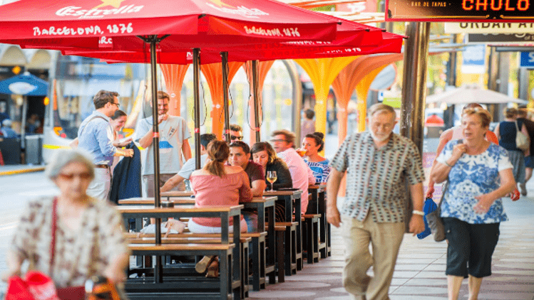
The value we provide
- Protect Council assets, the environment and the health and safety of the community.
- Ensure responsible pet ownership.
What we do
- Enforce Local Law No 1 (use, occupation and behaviour on Council land, commercial activities, illegal advertising, dumped rubbish and illegal camping).
- Monitor building development compliance with asset protection permits.
- Proactive patrols and investigation of customer requests to ensure compliance with laws.
- Manage the impacts of increased visitation on our public spaces during the peak summer period through the delivery of a Summer Management program.
- Encourage responsible pet ownership through education and registration, respond to complaints about animals, and patrol parks and beaches.
- Implement the Domestic Animal Management Plan.
Why we do it
- To support a healthy and safe community, one that enjoys high levels of amenity and responsibly manages pet ownership.
- To fulfil mandatory duties described in the Local Government Act 2000 and Domestic Animals Act 1995.
Activities that support this service
- Animal management
- Local laws enforcement.

Our service at a glance
Service statistics | 2018/19 | 2019/20 | 2020/21
Local laws
Customer requests for local laws investigation | 5,208 | 4,054 | 3,023
Asset protection permit inspections | 1,095 | 1,851 | 1,344
Proactive building site inspections | 4,260 | 4,530 | 5,742
Proactive patrols on shared open space and foreshore areas | 275+ | - | -
Animal management
Customer requests for animal management | 3,134 | 2,980 | 2,665
Pet registrations | 9,474 | 10,936 | 11,560
Note: some service statistic data has not been available at the time of preparing this report. Where possible, data will be included for the final version.

How much it costs to provide the service
Budget 2022/23
Operating costs $000  Employee costs 1,782  Contracts 75  Materials and other expenses 225  Operating projects 300  Total operating expenses 2,382  Capital projects 150  Total expenses 2,532  (expenses include management overhead allocation, exclude depreciation and project expenditure) | How the service is funded $000  Rates 1,175  Parking revenue 331  Reserves (14)  Fees and charges (incl. statutory) 1,027  Grants 0  Other income 12  Total funding 2,532  Revenue from parking fees and fines is allocated on a proportionate basis across all service categories.
$0.62 is spent on this service out of every $100 of rates we receive
54% of costs are funded from fees and charges, grants, reserves and other income
Major contracts (annualised expense) $000
- None
Major property leases Market rental Rent per year
($000) estimate ($ excl GST)
- None
Major financial contributions $000
- None
Major assets
Council assets (June 2021) Value $000
- None
Note: asset information will be updated in the final version
Our projects (* means 100% and ** means partial grant and contribution funding)
Capital projects $000 2022/23 2023/24 2024/25
None
Total Capital projects (excluding Fleet Renewal allocation) 0 0 0
Operating projects $000 2022/23 2023/24 2024/25
Local Law Review 300 17 0
Total operating projects 300 17 0

Municipal emergency management
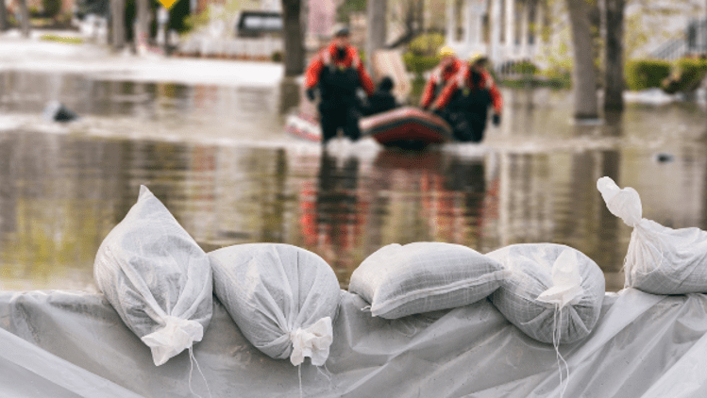
The value we provide
- Operational and strategic emergency management services across preparedness, response and recovery.
What we do
- Operational and strategic emergency management services across preparedness, response and recovery.
Why we do it
- To support a healthy and safe community if an emergency.
Activities that support this service
- COVID-19 response
- Emergency management and safety.

Our service at a glance
Service statistics 2018/19 2019/20
- None

How much it costs to provide the service
Budget 2022/23
Operating costs $000  Employee costs 383  Contracts 26  Materials and other expenses 98  Operating projects 0  Total operating expenses 507  Capital projects 0  Total expenses 507  (expenses include management overhead allocation, exclude depreciation and project expenditure) | How the service is funded $000  Rates 454  Parking revenue 66  Reserves (14)  Fees and charges (incl. statutory) 0  Grants 0  Other income – property income 0  Total funding 507  Revenue from parking fees and fines is allocated on a proportionate basis across all service categories.
$0.31 is spent on this service out of every $100 of rates we receive
10% of costs are funded from fees and charges, grants, reserves and other income
Major contracts (annualised expense) $000
- None
Major property leases Market rental Rent per year
($000) estimate ($ excl GST)
- None
Major financial contributions $000
- None
Major assets
Council assets (June 2021) Value $000
- None

Our projects (* means 100% and ** means partial grant and contribution funding)
Capital projects $000 2022/23 2023/24 2024/25
None
Total Capital projects (excluding Fleet Renewal allocation) 0 0 0
Operating projects $000 2022/23 2023/24 2024/25
None
Total operating projects 0 0 0

Public space
The value we provide
- High quality and unique parks, open spaces and foreshore for the enjoyment of our community and visitors.
What we do
- Oversee all planning and strategy for public space within the municipality, including parks, gardens, reserves, foreshore, streetscapes, playgrounds and urban spaces.
- Plan for future uses of public spaces; developing new, enhancing current and designing spaces that can be used by the whole community.
- Develop the 10-year plan and oversee the capital projects portfolio for open space and recreation.
- Deliver greening outcomes across our City, increasing canopy cover, biodiversity, trees and vegetation.
- Operational and strategic emergency management services across preparedness, response and recovery.
- Deliver the Summer Management Program to address the impacts of large crowds visiting our iconic spaces.
Why we do it
- To support our community to be healthy and active and promote social connectedness.
- To provide social, economic and environmental benefits to our community through well-designed and maintained public spaces.
- To enhance the liveability and character of our City and define our unique sense of identity and place.
- To provide equitable access for the community to high quality public open spaces across the municipality.
- To provide environmental outcomes, minimise the impact of the heat island effect, enhance wildlife habitat and strengthen biodiversity within our City’s highly urbanised environment.
- To minimise harm and negative impacts created by large crowds during the summer period (Summer Management Program).
- To support our community to be healthy and active and promote social connectedness.
- Emergency management and community safety.
Activities that support this service
- Development, review and delivery of the Public Space Strategy, Foreshore Management Plan, Recreation Strategy and Greening Port Phillip
- Delivery of the Summer Management Program
- Delivery of the Open Space and Recreation Capital Portfolio Implementation of the Emergency Management Program.

Our service at a glance
Service statistics | 2018/19 | 2019/20 | 2020/21
Ovals mowed (hectares per week) | 14 | 14 | 14
Reserves and gardens maintained (hectares per week) | 177.6 | 177.6 | 177.6
Playground inspections conducted | 2,088 | 2,629 | 2,808
Additional trees planted | 1,325 | 1,337 | 894
Street Tree Canopy Cover (Reordered every 3 years) | 19 % | 19.2 % | 19.2 %
Percentage of municipality within a safe walking distance of open space | 85 % | 85 % | 85 %
How much it costs to provide the service
Budget 2022/23
Operating costs $000  Employee costs 2,531  Contracts 10,963  Materials and other expenses 2,112  Operating projects 1,753  Total operating expenses 17,359  Capital projects 11,560  Total expenses 28,919  (expenses include management overhead allocation, exclude depreciation and project expenditure) | How the service is funded $000  Rates 16,252  Parking revenue 3,780  Reserves 815  Fees and charges (incl. statutory) 627  Grants 6,980  Other income 465  Total funding 28,919  Revenue from parking fees and fines is allocated on a proportionate basis across all service categories.
$13.12 is spent on this service out of every $100 of rates we receive
44% of costs are funded from fees and charges, grants, reserves and other income
Major contracts (annualised expense) $000
- Parks and open space maintenance 5,713
- Tree maintenance 3,728
- Street lighting electricity 1,232
- Civil infrastructure and maintenance 3,071
- Signs and street furniture 643
Major property leases Market rental Rent per year
($000) estimate ($ excl GST)
None
Major financial contributions $000
None
Major assets
Council assets (June 2021) Written Down Value $000
- Park structures 649
- Water irrigation 4,715
- Reserves and gardens (176 ha) Not separately valued
- Playgrounds and sportsfields (75) Not separately valued

Our projects (* means 100% and ** means partial grant and contribution funding)
Capital projects $000 2022/23 2023/24 2024/25
Acland Street Plaza Planting and HVM | 900 | 0 | 0
Alma Park Play Space Upgrade | 497 | 0 | 0
Bay Trail Safety Upgrades | 250 | 0 | 0
Bowen Crescent Reserve | 0 | 0 | 0
Carlisle Street New Small Local Space | 0 | 0 | 0
Clarke Reserve Play Space Upgrade | 0 | 0 | 50
Cobden Place Pocket Park | 0 | 0 | 0
Dog Parks (locations not specified) | 0 | 50 | 450
Elwood Foreshore Facilities Development Stage 1 | 727 | 877 | 12,268
Expand the size of Eastern Reserve North | 0 | 0 | 0
Foreshore Summer Management CCTV | 25 | 0 | 0
Gasworks Arts Park Reinstatement | 700 | 3,535 | 0
Glen Eira Avenue Reserve | 0 | 0 | 0
Hewison Reserve - Upgrade | 350 | 0- | 0
Land Acquisition in St Kilda East | 0 | 0 | 250
Lansdowne Road New Small Local Open Space | 0 | 250 | 500
Ludwig Stamer Reserve Play Space Upgrade | 350 | 0 | 0
Maritime Infrastructure Program | 325 | 450 | 650
Moubray Street Community Park | 1,200 | 0 | 0
Pakington Street Reserve | 0 | 0 | 0
Palais Theatre and Luna Park Precinct | 3,708 | 0 | 0
Port Melbourne Light Rail Linear Parks | 0 | 30 | 100
Public Space Lighting Program | 0 | 0 | 0
Public Space Minor Capital Works | 1,050 | 1,200 | 1,200
Sol Green Reserve Upgrade | 25 | 150 | 1,800
South Beach Reserve, St Kilda Foreshore | 0 | 0 | 0
South Melbourne Activity Centre New Small Location | 0 | 0 | 0
South Melbourne Employment Area New Small Location | 0 | 0 | 0
St Kilda Botanical Gardens Play Space | 0 | 0 | 0
St Kilda Pier Landside Works Upgrade | 70 | 1,500 | 2,080
St Kilda Promenade Safety Upgrade | 220 | 3,300 | 0
St Vincent Gardens Playground | 50 | 730 | 0
Station Pier Linear Park | 0 | 0 | 0
Waterfront Place | 0 | 0 | 0
West Beach Boardwalk Accessibility | 350 | 0 | 0
Woodstock Street Reserve | 0 | 0 | 0
Total Capital projects (excluding Fleet Renewal allocation) 10,797 12,072 19,348

Operating projects $000 2022/23 2023/24 2024/25
Blessington Street Temporary Road Closure - - 100
Coastal Planning 50 180 20
Coles Car Park Balaclava Temporary Park 10 90 -
Dickens Street Temporary Park 80 - -
Dogs Off-Leash Guideline 226 - -
Glen Eira Avenue Reserve Trial - - -
Green Line Trial Upgrade 10 110 -
Site Contamination Management Program 322 50 50
St Kilda Marina Project 955 2,845 2,000
Temporary Park Gibbs St - 100 -
Temporary Park Lansdowne Road 100 - -
Total operating projects 1,753 3,375 2,170
Note: asset information will be updated in the final version

Transport and parking management
The value we provide
- Support a reliable, safe and well-connected transport system.
- Enable people to more easily move around, connect and get to places as the City grows.
What we do
- Manage parking policy, on-street parking controls and enforcement.
- Maintain our roads, medians and footpaths.
- Plan for and deliver changes to our City’s transport network, streets and places to cater for our growing community.
- Increase the range of healthy, safe, connected and convenient walking and bike riding choices.
- Partner with the Victorian Government to provide more convenient, reliable, accessible and frequent public transport choices.
- Work with the community to ensure fairest access to parking as a limited and shared resource.
- Harness new technologies and transport options for our community to get around and pay for parking.
- School Crossing Program for the safe and efficient movement of school children.
Why we do it
- To provide residents, workers and visitors with different travel options that respond to Melbourne’s population growth, support Melbourne’s much celebrated liveability, promote people’s individual health and wellbeing, and contribute to the City’s economy.
- To respond to our limited ability to increase on-street carparking capacity and vehicle movement.
- To act to reduce the safety risk to our community on our streets.

Activities that support this service
- Appeals review administration
- Domain Major Transport Projects
- Maintenance and operations – road transport
- Parking services
- Strategic transport
- Transport safety engineering.

Our service at a glance
Service statistics | 2018/19 | 2019/20 | 2020/21
Parking management
Abandoned vehicles | 1,646 | 1,249 | 1,153
Disabled parking permits issues – Blue | 1,737 | 1,582 | 1,206
Disabled parking permits issued – Green | 174 | 160 | 107
Resident parking permits issued | 8,041 | 7,639 | 7,286
Foreshore permits issued | 2,504 | 2,291 | 2,244
Combined permits issued | 6,726 | 6,106 | 4,395
Community service permits issued | 1,237 | 1,317 | 1,550
Visitor parking permits issued | 12,400 | 11,984 | 8,983
Parking enforcement infringements issued | 153,069 | 138,718 | 108,479
Parking complaints (officer) | 47 | 43 | 31
Number of parking permits issued per year | 34,519 | 32,718 | 25,769

How much it costs to provide the service
Budget 2022/23
Operating costs $000  Employee costs 7,820  Contracts 9,005  Materials and other expenses 6,287  Operating projects 985  Total operating expenses 24,097  Capital projects 9,594  Total expenses 33,691  (expenses include management overhead allocation, exclude depreciation and project expenditure) | How the service is funded $000  Rates 24,128  Parking revenue 4,404  Reserves 987  Fees and charges (incl. statutory) 1,044  Grants 2,858  Other income 270  Total funding 33,691  Revenue from parking fees and fines is allocated on a proportionate basis across all service categories.
$17.24 is spent on this service out of every $100 of rates we receive
28% of costs are funded from fees and charges, grants, reserves and other income
Major contracts (annualised expense) $000
- Parking administration services 1,950
- Vehicle towing 697
- Parking sensors and online payment system 541
- Parking machine maintenance 335
Major leases Market rental estimate Rent per year (excl GST)
- None
Major financial contributions $000
- None
Major assets
Council assets (June 2021) Value $000
- Streets and laneways (265 km) (a)
- Kerb and channel (455 km) 63,161
- Road pavement 188,703
- Road surface 76,251
- Footpaths and cycleways
(473 km footpaths and 59 km bike network lanes and paths) 63,188
- Bridges (13) 4,715
- Street furniture (such as seats and bike racks) 13,339
- Traffic control devices (2,123 parking machines) 2,786
- Off street carparks 11,285
- Lights on road 2,374
- On street parking (52,000 spaces) Not separately valued
- In-ground parking sensors (1,571) Not separately valued
- Signs, speed humps, roundabouts and other traffic management
devices to improve road safety Not separately valued
Our projects (* means 100% and ** means partial grant and contribution funding)
Capital projects $000 2022/23 2023/24 2024/25
Bike Infrastructure Program 2,052 370 6,845
Blackspot Safety Improvements* 173 400 400
Footpath Renewal Program 940 1,345 1,600
Kerb and Gutter Renewal Program 870 920 920
Laneway Renewal and Upgrade Program 660 615 535
Local Area Traffic Management** 465 406 400
Parking Technology Program 360 400 400
Pedestrian Infrastructure Delivery Program 864 770 560
Road Renewal Program** 2,960 8,735 2,000
Pier Road and Bay Trail Safety Upgrade 250 0 3,310
Total Capital projects (excluding Fleet Renewal allocation) 9,594 13,961 16,430

Operating projects $000 2022/23 2023/24 2024/25
Car Share Policy Review and Development 30 0 0
Domain Precinct - Metro Tunnel Project* 490 490 0
Parking Provision Rates Investigation 100 0 0
Parking Policy E-Permit Implementation 365 310 0
Total operating projects 985 800 0
- From 1 July 2008, Council recognises any material land under roads that comes in Council’s control within the Financial Report at fair value.
- Note: asset information will be updated in the final version

Sustainability services

Amenity
The value we provide
- A clean, safe and enjoyable environment that improves the ways our community and visitors experience the City.
What we do
- Clean our streets, beaches and the foreshore.
- Maintain our drains, trade commercial areas and public toilets.
- Respond to graffiti complaints and remove graffiti.
Why we do it
- To maintain hygienic, safe and enjoyable natural and built environments that encourage residents and visitors to enjoy Port Phillip.
Activities that support this service
- Infrastructure maintenance services (including drainage and graffiti removal)
- Street and beach services.

Our service at a glance
Service statistics | 2018/19 | 2019/20 | 2020/21
Square metres of graffiti removed | 23,000 | 19,037 | 24,810
Customer requests (street and beach cleaning, infrastructure maintenance and development) | 5,550 | - | -
Assets maintained (buildings, public toilets, park lighting, foreshore and car park lighting, BBQs) | 240 | - | -
Kilometres of streets swept – Km per month | 237 | 237 | 237
Tonnage of street sweepings collected | 2,124 | 3,435 | 2,687
Square metres of beach cleaned - metres per week | 2,348,732 | 2,348,732 | 2,348,732
Kilometres of footpath cleaned | 414 | 414 | 414
Tonnage of seaweed collected | 1,713 | 1,297 | 1,685
Kilometres of stormwater pipe cleaned | 32 | 42 | 45
Number of stormwater drainage pits cleaned | 8,360 | 10,476 | 14,105
Kilometres of laneways cleaned | 56 | 56 | 56
Number of biohazards removed | 3,758 | 3,040 | -
Note:
- monthly reporting of several service statistics will be available from 1 July 2021 after the introduction of the Mobile Resource Management System;
- some service statistic data has not been available at the time of preparing this report. Where possible, data will be included for the final version.

How much it costs to provide the service
Budget 2022/23
Operating costs $000  Employee costs 6,195  Contracts 3,255  Materials and other expenses 809  Operating projects 0  Total operating expenses 10,259  Capital projects 1,660  Total expenses 11,919  (expenses include management overhead allocation, exclude depreciation and project expenditure) | How the service is funded $000  Rates 9,838  Parking revenue 1,558  Reserves 154  Fees and charges (incl. statutory) 0  Grants 240  Other income 129  Total funding 11,919  Revenue from parking fees and fines is allocated on a proportionate basis across all service categories.
$6.85 is spent on this service out of every $100 of rates we receive
17% of costs are funded from fees and charges, grants, reserves and other income
Major contracts (annualised expense) $000
- Drainage management 1,300
- Street waste 766
- Road line remarking program 377
Major property leases Market rental estimate Rent per year (excl GST)
- None
Major financial contributions $000
- None
Major assets
Council assets (June 2021) Written Down Value $000
- Stormwater pits (13,901) 31,512
- Stormwater pipes (11,900km) 100,519
- Public toilets 3,370
- Road and footpaths (please refer to Transport and parking management)
Note: asset information will be updated in the final version
Our projects (* means 100% and ** means partial grant and contribution funding)
Capital projects $000 2022/23 2023/24 2024/25
Public Toilet Plan Implementation Program 460 870 450
Stormwater Management Program 1,200 1,000 1,000
Total Capital projects (excluding Fleet Renewal allocation) 1,660 1,870 1,450

Operating projects $000 2022/23 2023/24 2024/25
None
Total operating projects 0 0 0

Sustainability
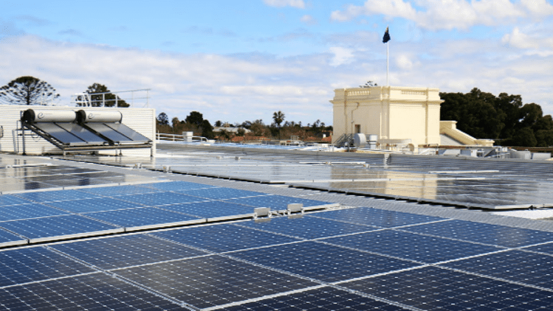
The value we provide
- Improve the sustainability of our City and respond to the Climate Emergency by reducing carbon emissions, water use and waste generation, increasing trees, vegetation and biodiversity, improving water quality and ensuring we are adapting and resilient to the impacts of climate change, including flooding and heat.
What we do
- Develop and implement environmental strategy, policy and action plans for Council and the community.
- Plan and design infrastructure that has an environmental benefit.
- Deliver environmental programs, educational campaigns advice and support to our community.
- Provide advice and support to embed sustainability into Council strategic planning, project and service delivery.
- Develop and implement requirements for new developments to reduce their environmental impacts and increase resilience to climate change.
- Partner with Victorian and other local governments, education and not-for-profit agencies to develop and deliver projects that improve environmental outcomes.
- Advocate to the Victorian and Australian Governments for stronger commitments and increased investment in sustainability projects and initiatives.
Why we do it
- To respond to the Climate Emergency.
- To reduce Council’s environmental impact and help the community reduce their own environmental impacts.
- To reduce carbon emissions and mitigate our impact on climate change.
- To improve how we manage water to reduce the impacts of flooding, decrease potable water use and improve water quality in the bay.
Activities that support this service
- Sustainable policy
- Sustainable programs.

Our service at a glance
Service statistics | 2018/19 | 2019/20 | 2020/21
Sustainability
Community participants in Council-run sustainability programs | 7,839 | 12,313 | 9,945
Environmentally Sustainable Design review of planning applications | 212 | 228 | 389
Community participants in EcoCentre-run sustainability programs | 17,549 | 15,035 | 16,410
Trees planted | 1,325 | 1,337 | 894
How much it costs to provide the service
Budget 2022/23
Operating costs $000  Employee costs 1,588  Contracts 391  Materials and other expenses 155  Operating projects 4,023  Total operating expenses 6,157  Capital projects 6,428  Total expenses 12,585  (expenses include management overhead allocation, exclude depreciation and project expenditure) | How the service is funded $000  Rates 6,166  Parking revenue 1,645  Reserves 2,729  Fees and charges (incl. statutory) 0  Grants 2,045  Other income 0  Total funding 12,585  Revenue from parking fees and fines is allocated on a proportionate basis across all service categories.
$3.96 is spent on this service out of every $100 of rates we receive
51% of costs are funded from fees and charges, grants, reserves and other income
Major contracts (annualised expense) $000
- None
Major property leases Most recent market Rent per year
($000) rental estimate ($ excl GST)
- Port Phillip EcoCentre 62 0
- Bili Nursery 32 0
Major financial contributions $000
- EcoCentre contribution and funding for education programs 322
Major assets
Council assets (June 2021) Value $000
- Trees (46,166 trees) 43,984
- Councillors will be briefed in February about deferral of funds due to absence of partnership funding.
Our projects (* means 100% and ** means partial grant and contribution funding)
Capital projects $000 2022/23 2023/24 2024/25
Catani Gardens Irrigation Upgrade 349 0 0
EcoCentre Redevelopment** 4,756 143 0
HVAC, Air and Energy Improvement Program 400 900 250
Open Space Irrigation Renewal Upgrade 0 350 350
Stormwater Harvesting Development 160 590 1,750
Water Sensitive Urban Design Program 763 740 740
Total Capital projects (excluding Fleet Renewal allocation) 6,428 2,723 3,090

Operating projects $000 2022/23 2023/24 2024/25
Climate Emergency Plan Development 125 0 0
Coastal Hazard Assessment Implementation 60 0 0
Community Electric Vehicle Charging Program 100 100 100
Elster Creek Catchment and Elsternwick Park 430 600 0
Energy Efficient Street Lighting Upgrade 1,743 0 0
Greening Port Phillip Program 1,340 1,240 1,240
Permeability Assessment 150 0 0
South Melbourne Market Sustainability Initiative 75 75 75
Sustainable Environment Strategy 0 65 0
Total operating projects 3,798 2,080 1,415

Note: asset information will be updated in the final version

Waste management
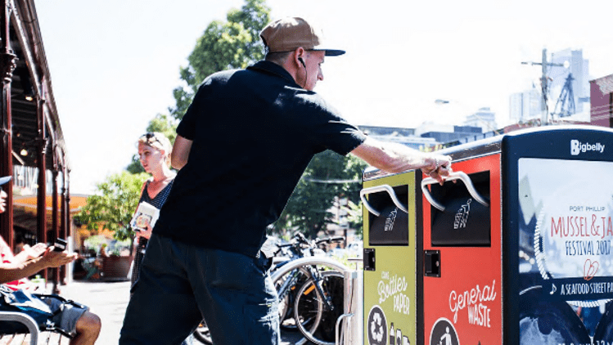
The value we provide
- A clean and safe City by keeping our streets, parks and foreshores clean and protecting the environment.
What we do
- Reduce waste going to landfill through kerbside and public place recycling, hard waste and green waste collection, operating the Resource Recovery Centre and providing waste education.
- Provide additional waste management services through kerbside refuse services and removal of waste from street litter bins.
Why we do it
- To maintain hygienic, safe and enjoyable natural and built environments that encourage residents and visitors to enjoy Port Phillip.
- To create a more sustainable future for Port Phillip by reducing the amount of waste we dispose.
Activities that support this service
- Hard and green waste, dumped and mattress collection
- Litter bin clearances and repairs
- Refuse and recycling household collections
- Resource Recovery Centre
- Waste management and minimisation services.

Our service at a glance
Service statistics | 2018/19 | 2019/20 | 2020/21
Waste Management
Kerbside waste bins collected each week | 39,115 | 39,252 | 39,406
Kerbside recycling bins collected each week | 35,601 | 35,861 | 36,152
Hard and green waste collections | 18,779 | 20,220 | 21,678
Public litter bins emptied (per annum) | - | 57,000 | -
Resource Recovery Centre participants (per annum) |  | 19,800 | -
Note: some service statistic data has not been available at the time of preparing this report. Where possible, data will be included for the final version.

How much it costs to provide the service
Budget 2022/23
Operating costs $000  Employee costs 2,535  Contracts 14,990  Materials and other expenses 147  Operating projects 1,550  Total operating expenses 19,222  Capital projects 600  Total expenses 19,822  (expenses include management overhead allocation, exclude depreciation and project expenditure) | How the service is funded $000  Rates 16,592  Parking revenue 2,591  Reserves (14)  Fees and charges (incl. statutory) 370  Grants 250  Other income 33  Total funding 19,822  Revenue from parking fees and fines is allocated on a proportionate basis across all service categories.

$12.05 is spent on this service out of every $100 of rates we receive
16% of costs are funded from fees and charges, grants, reserves and other income
Major contracts (annualised expense) $000
- Residential kerbside recycling collection 4,548
- Regional landfill 3,659
- Residential kerbside waste collection 3,048
- Hard waste and dumped rubbish collection 1,586
- Resource Recovery Centre 564
- Mobile waste and recycling bins 210
Major leases Market rental estimate Rent per year (excl GST)
- None
Major financial contributions $000
- None
Major assets
Council assets (June 2021) Value $000
- Street and park litter bins (1,212) Not separately valued
Note: asset information will be updated in the final version

Our projects (* means 100% and ** means partial grant and contribution funding)
Capital projects $000 2022/23 2023/24 2024/25
Waste Transformation Bin Purchases 600 600 0
Total Capital projects (excluding Fleet Renewal allocation) 600 600 0

Operating projects $000 2022/23 2023/24 2024/25
Waste Transformation Program 1,550 530 0
Total operating projects 1,550 530 0

Vibrant services

Arts, culture and heritage
The value we provide
- Foster creative, diverse and inclusive participation in our arts and culture sectors while supporting the heritage and unique identity of Port Phillip.
What we do
- Deliver programs, services and spaces and promote community participation and engagement in arts, culture and heritage.
- Provide funding support for artists and cultural organisations.
- Manage and develop the Port Phillip City Collection.
- Plan, develop and support new and existing creative industries.
Why we do it
- To foster a community that is socially diverse and inclusive, one that protects heritage, and brings arts, culture and creative expression to everyday life.
Activities that support this service
- Arts (Filming approvals and Shakespeare Grove)
- Arts collection and program
- Arts funding.

Our service at a glance
Service statistics | 2018/19 | 2019/20 | 2020/21
Arts, culture and heritage
Filming permits issued | 316 | 201 | 160

How much it costs to provide the service
Budget 2022/23
Operating costs $000  Employee costs 2,156  Contracts 1,133  Materials and other expenses 2,348  Operating projects 215  Total operating expenses 5,851  Capital projects 5,325  Total expenses 11,176  (expenses include management overhead allocation, exclude depreciation and project expenditure) | How the service is funded $000  Rates 4,170  Parking revenue 1,461  Reserves 5,395  Fees and charges (incl. statutory) 79  Grants 0  Other income 70  Total funding 11,176  Revenue from parking fees and fines is allocated on a proportionate basis across all service categories.
$4.54 is spent on this service out of every $100 of rates we receive
63% of costs are funded from fees and charges, grants, reserves and other income
Major contracts (annualised expense) $000
- None
Major property leases Most recent market Rent per year rental estimate ($000) ($ excl GST)
- Australian National Academy of Music (ANAM) 450 1,022 +
capital contribution
- Arts Access Victoria 105 36,958
- Gasworks Arts Inc. 653 104
- Linden New Art 380 104
Major financial contributions $000
- Gasworks Arts Park management and programming 617
- Linden New Art management and programming 358
- Cultural Development Fund Projects 187
- Cultural Development Fund – Key Organisations 180
- Cultural Development Fund – Festivals & Events 135
- Pride March/Midsumma 94
- Arts Programming 40
- Indigenous Arts and Events 37
Major assets
Council assets (June 2021) Written Down Value $000
- Art facilities (4) 6,696
- Art and heritage collection 16,800
Note: asset information will be updated in the final version
Our projects (* means 100% and ** means partial grant and contribution funding)
Capital projects $000 2022/23 2023/24 2024/25
Art Acquisition, Preservation and Exhibition 0 30 0
Palais Theatre Concrete Spalling 665 0 0
Palais Theatre Tunnels Rectification 1,455 0 0
South Melbourne Town Hall Renewal and Upgrade 3,205 11,025 0
Total Capital projects (excluding Fleet Renewal allocation) 5,325 11,055 0

Operating projects $000 2022/23 2023/24 2024/25
Deliver Live Music Action Plan 190 75 0
Art Collection public programming and engagement 25 0 0
Total operating projects 215 75 0

Economic development and tourism
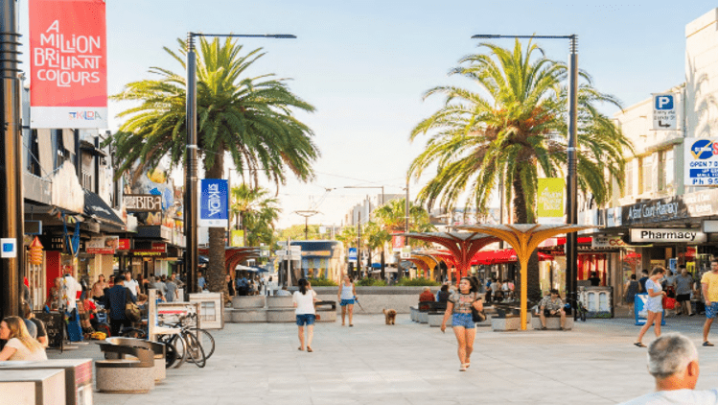
The value we provide
- Local, domestic and international promotion to support residents, visitors and industry achieve stronger economic outcomes.
What we do
- Support local business and enable activity centres in our community that contribute to a high standard of living.
- Provide business mentoring training and support for new and existing businesses to help them develop and grow in partnership with the Victorian Government.
- Work with local co-working spaces to grow the start-up ecosystem in Port Phillip.
- Operate three Special Rates in activities centres.
- Support local Traders’ Associations achieve economic objectives.
Why we do it
- To support local businesses responding to increasing challenges facing the retail and hospitality industries.
- To support retention of creative industries in the South Melbourne precinct.
- To maximise the social and economic benefits to residents and businesses by having Port Phillip as a destination for tourists.
- By encouraging local residents to support their local shopping strips.
Activities that support this service
- Economic growth and activation.

Our service at a glance
Service statistics | 2018/19 | 2019/20 | 2020/21
None
How much it costs to provide the service
Budget 2022/23
Operating costs $000  Employee costs 857  Contracts 0  Materials and other expenses 99  Operating projects 875  Total operating expenses 1,831  Capital projects 0  Total expenses 1,831  (expenses include management overhead allocation, exclude depreciation and project expenditure) | How the service is funded $000  Rates 1,506  Parking revenue 239  Reserves 86  Fees and charges (incl. statutory) 0  Grants – operating 0  Other income 0  Total funding 1,831  Revenue from parking fees and fines is allocated on a proportionate basis across all service categories.
$0.90 is spent on this service out of every $100 of rates we receive
18% of costs are funded from fees and charges, grants, reserves and other income
Major contracts (annualised expense) $000
- None
Major property leases Most recent market Rent per year rental estimate ($000) ($ excl GST)
- None
Major financial contributions $000
- None
Major assets
Council assets (June 2021) Value $000
- None

Our projects (* means 100% and ** means partial grant and contribution funding)
Capital projects $000 2022/23 2023/24 2024/25
None
Total Capital projects (excluding Fleet Renewal allocation) 0 0 0

Operating projects $000 2022/23 2023/24 2024/25
Games Action Plan Implementation 75 75 0
Social and Economic Recovery 800 650 650
Total operating projects 875 725 650

Festivals
The value we provide
- Bring a wealth of benefits to the community including health and wellbeing of residents, economic development for local businesses, cultural vibrancy and social engagement.
What we do
- Provide the St Kilda Festival, St Kilda Film Festival and Indigenous arts programs, including the Yalukut Weelam Ngargee event.
- Ensure that events activate neighbourhoods across all parts of our City and grow local businesses and industries.
- Support, partner or leverage large events in the local area and within wider Melbourne to bring or retain visitors to the municipality.
- Operate and promote the St Kilda Esplanade Market.
- Attract, advise, permit and support producers of quality events.
Why we do it
- To foster a community that is socially diverse and inclusive, one that brings arts, culture and creative expression to everyday life.
- To maximise the social and economic benefits to residents and businesses by having Port Phillip as a destination for tourists.
Activities that support this service
- Esplanade Market
- Festivals management
- Major events, permits and promotion.
Our service at a glance
Service statistics | 2018/19 | 2019/20 | 2020/21
Festivals
Attendance at St Kilda Festival | 460,000 | 400,000 | No data*
*Did not happen due to COVID-19

How much it costs to provide the service
Budget 2022/23
Operating costs $000  Employee costs 1,249  Contracts 2,089  Materials and other expenses 622  Operating projects 0  Total operating expenses 3,960  Capital projects 0  Total expenses 3,960  (expenses include management overhead allocation, exclude depreciation and project expenditure) | How the service is funded $000  Rates 2,410  Parking revenue 518  Reserves (14)  Fees and charges (incl. statutory) 506  Grants 80  Other income 459  Total funding 3,960  Revenue from parking fees and fines is allocated on a proportionate basis across all service categories.
$1.66 is spent on this service out of every $100 of rates we receive
42% of costs are funded from fees and charges, grants, reserves and other income
Major contracts (annualised expense) $000
- None
Major property leases Most recent market Rent per year rental estimate ($000) ($ excl GST)
- None
Major financial contributions $000
- St Kilda Festival 1,821
- St Kilda Film Festival 252
- Yalukut Weelam Ngargee 94
Major assets
Council assets (June 2021) Value $000
- Council’s open spaces Valuation included within total land

Our projects (* means 100% and ** means partial grant and contribution funding)
Capital projects $000 2022/23 2023/24 2024/25
None
Total Capital projects (excluding Fleet Renewal allocation) 0 0 0

Operating projects $000 2022/23 2023/24 2024/25
None
Total operating projects 0 0 0

Libraries
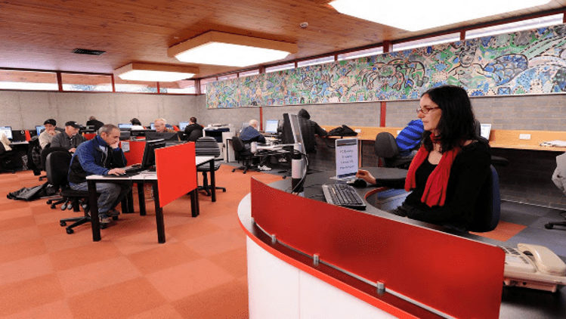
The value we provide
- Support learning, social engagement and community connectedness.
What we do
- Operate five libraries across Port Phillip.
- Provide branch-based, online and in-home library and information services, including access to technology, free Wi-Fi and skilled staff.
- Provide flexible, safe and welcoming community spaces for all age groups.
- Present a range of literacy and life-long learning programs and events that encourage participation and support individuals and community.
- Provide children’s learning and play activities.
Why we do it
- To promote social connectedness.
- To foster inclusiveness in a community that is socially diverse.
- To bring arts, culture and creative expression to everyday life.
- To support life-long learning and literacy.
Activities that support this service
- Library collections maintenance
- Library operations.

Our service at a glance
Service statistics | 2018/19 | 2019/20 | 2020/21
Libraries
Loans made at our five library branches | 937,409 | 726,834 | 590,527
Inter-library loans | 5,267 | 3,809 | 507
Total library visits | 626,662 | 473,375 | 229,659
Programs run | 468 | 284 | 101
Attendees at our programs | 30,899 | 17,314 | 4,025
Library hard copy resource | 211,000 | 195,000 | 189,374
New collection items | 19,000 | 19,000 | 18,214
Library homepage sessions | 190,000 | 188,000 | 155,243
Unique website users | - | 116,000 | 86,729
Loans (excluding online renewals and home library) | 553,125 | 414,949 | 291,151
Public internet bookings | 84,000 | 58,000 | 10,847
Online resources accessed | 214,700 | 278,220 | 308,152
How much it costs to provide the service
Budget 2022/23
Operating costs $000  Employee costs 4,326  Contracts 52  Materials and other expenses 1,014  Operating projects 60  Total operating expenses 5,452  Capital projects 972  Total expenses 6,424  (expenses include management overhead allocation, exclude depreciation and project expenditure) | How the service is funded $000  Rates 4,802  Parking revenue 840  Reserves (14)  Fees and charges (incl. statutory) 42  Grants 755  Other income 0  Total funding 6,424  Revenue from parking fees and fines is allocated on a proportionate basis across all service categories.
$4.83 is spent on this service out of every $100 of rates we receive
25% of costs are funded from fees and charges, grants, reserves and other income
Major contracts (annualised expense) $000
- None
Major property leases Market rental Rent per year
($000) estimate ($ excl GST)
- None
Major financial contributions $000
- None
Major assets
Council assets (June 2021) Written Down Value $000
- Libraries (5) 3,026 (3 libraries)
- Library books (206,749)
Our projects (* means 100% and ** means partial grant and contribution funding)
Capital projects $000 2022/23 2023/24 2024/25
Library Collection Purchases 952 852 852
St Kilda Library Redevelopment 20 600 2,500
Total Capital projects (excluding Fleet Renewal allocation) 972 1,452 3,352

Operating projects $000 2022/23 2023/24 2024/25
Library Action Plan Implementation 60 60 60
Total operating projects 60 60 60
Note: asset information will be updated in the final version

South Melbourne Market
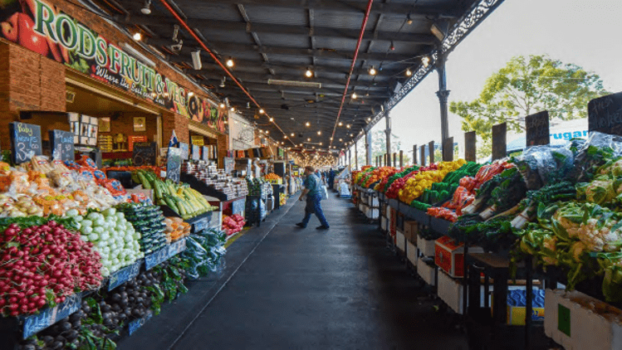
The value we provide
- South Melbourne Market is the quintessential village market. A prosperous, authentic destination that is home to fresh, artisanal and cultural products, creative and joyful experiences, celebrates local, is a leader in sustainability, is loved, trusted and connects our customers and community.
What we do
- Ensure the market operates in a sustainable and economically viable manner.
- Manage a safe and family friendly market for all ages and abilities to enjoy.
- Provide special events and services such as the Mussel Festival and South Melbourne Market Direct.
- Provide a friendly, accessible meeting place where people can feel part of a community.
Why we do it
- To foster and support small businesses and traders.
- To encourage tourism and visitation and to provide a unique shopping experience for the community.
Activities that support this service
- South Melbourne Market
- South Melbourne Market Mussel Festival
- South Melbourne Market Direct.

Our service at a glance
Service statistics | 2018/19 | 2019/20 | 2020/21
Visitors to South Melbourne Market | 5,567,704 | 5,151,854 | 3,969,340
South Melbourne Market stall holders | 144 | 144 | 145
How much it costs to provide the service
Budget 2022/23
Operating costs $000  Employee costs 1,881  Contracts 2,140  Materials and other expenses 3,930  Operating projects 0  Total operating expenses 7,950  Capital projects 2,572  Total expenses 10,522  (expenses include management overhead allocation, exclude depreciation and project expenditure) | How the service is funded $000  Rates 1,217  Parking revenue 1,376  Reserves 478  Fees and charges (incl. statutory) 633  Grants 0  Other income 6,818  Total funding 10,522  Revenue from parking fees and fines is allocated on a proportionate basis across all service categories.
$1.24 is spent on this service out of every $100 of rates we receive
88% of costs* are funded from fees and charges, grants or other income
* Includes depreciation and excludes capital expenditure
Major contracts (annualised expense) $000
- South Melbourne Market cleaning and waste collection 1,448
- South Melbourne Market Security 711
Major property leases Market rental Rent per year
($000) estimate ($ excl GST)
- None
Major financial contributions $000
- None
Major assets
Council assets (June 2021) Written Down Value $000
- South Melbourne Market (building only) 20,200
Our projects (* means 100% and ** means partial grant and contribution funding)
Capital projects $000 2022/23 2023/24 2024/25
South Melbourne Market Cecil Street Essential
Services Connections 207 0 0
South Melbourne Market Compliance Works 2,040 3,840 2,480
South Melbourne Market Renewal Works 200 200 450
South Melbourne Market Stall Changeover Refits 125 125 125
Total Capital projects (excluding Fleet Renewal allocation) 2,572 4,165 3,055
Operating projects $000 2022/23 2023/24 2024/25
None 0 0 0
Total operating projects 0 0 0

Well-Governed services

Asset and property management
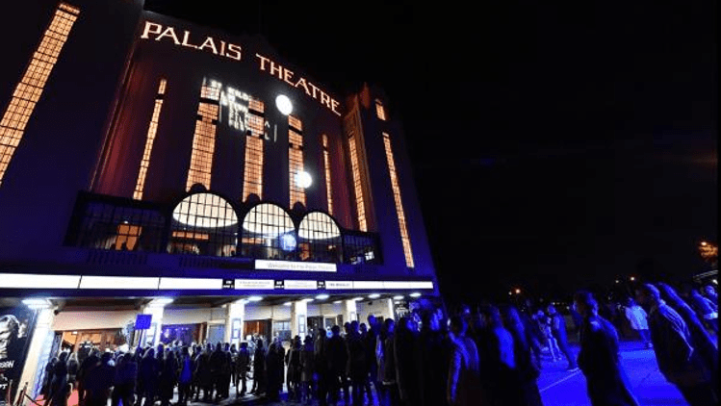
The value we provide
- Ensure Council has the right assets at the right time for the right cost to support service delivery now and in the future.
What we do
- Delivery of support services to the organisation and community, integrating people, place and process within Council buildings including improving the safety, wellbeing and productivity of the core business.
- As trusted stewards of Council’s assets on behalf of the community, we ensure that the right assets are in the right place at the right time to support delivery of community services for current and future generations.
- We translate organisational strategy into property strategy and lead the development and transactions of Council’s property portfolio.
- Sponsorship and coordinating delivery of the annual programmed capital renewal and upgrade program for all asset classes and reactive renewal and upgrade works as required.
Why we do it
- To ensure that the property and asset portfolio efficiently and effectively meets:
  - strategic and operational needs
  - current standards and expectations
  - our contractual commitments
  - our obligation as Committee of Management of Crown Land
  - legislation and regulations (for example building codes, disability discrimination legislation, the Local Government Act 2020).
Activities that support this service
- Asset planning
- Events and corporate facilities management
- Property leases and licences management
- Road discontinuances administration.

Our service at a glance
Service statistics | 2018/19 | 2019/20 | 2020/21
Property management
Leases and licences managed by Council | 195 | 195 | 210
Building maintenance requests processed | 4,855 | 5,733 | 2,924

How much it costs to provide the service
Budget 2022/23
Operating costs $000  Employee costs 5,169  Contracts 5,068  Materials and other expenses 4,154  Operating projects 0  Total operating expenses 14,390  Capital projects 6,700  Total expenses 21,090  (expenses include management overhead allocation, exclude depreciation and project expenditure) | How the service is funded $000  Rates 12,770  Parking revenue 2,757  Reserves 103  Fees and charges (incl. statutory) 493  Grants 0  Other income (incl. property rental) 4,968  Total funding 21,090  Revenue from parking fees and fines is allocated on a proportionate basis across all service categories.
$6.24 is spent on this service out of every $100 of rates we receive
39% of costs are funded from fees and charges, grants, reserves and other income
Major contracts (annualised expense) $000
- Cleaning of Council Buildings 1,564
- Electricity 881
- Graffiti removal 153
- Security services 379
Major property leases Most recent market Rent per year
($000) rental estimate ($ excl GST)
- Access Arts Victoria 230 65
- Brewsters 229 229
- Café Watersedge 170 65
- Decanters by The Bay N/A 107
- Elwood Bathers 350 233
- Foreshore Providore Pty Ltd 119 80
- Palais Theatre Live Nation 694 912
- Pier Warehouse Station Pier 170 65
- Redside 205 41
- Saltwater Studio - 73
- Sandbar Beach Café 127 127
- Schiavello Group 219 64
- Shorething Donovans 305 319
- St Kilda Marina 410 134 +7% gross receipts
- St Kilda Sea Baths Car Park 275 272
- Stokegroup 815 243
- The Reject Shop Limited - 220
- The Vineyard 236 243
- West Beach Bathing Pavilion 350 1 +5% turnover
Major financial contributions $000
- None
Major assets
Council assets (June 2021) Value $000
- Commercial buildings (36) 141,795
- Corporate buildings (25) 140,085
- Council corporate fleet cars (136) -
Note: some service statistic data has not been available at the time of preparing this report. Where possible, data will be included for the final version.
Note: asset information will be updated in the final version
Our projects (* means 100% and ** means partial grant and contribution funding)
Capital projects $000 2022/23 2023/24 2024/25
Building Renewal and Upgrade Program 2,450 2,560 2,480
Building Safety and Accessibility Program 1,370 1,500 1,500
Council Fleet Renewal Program 1,780 1,754 1,954
Workplace Plan Implementation 1,100 1,890 140
Total Capital projects (excluding Fleet Renewal allocation) 6,700 7,704 6,074

Operating projects $000 2022/23 2023/24 2024/25
None
Total operating projects 0 0 0

Communications and engagement
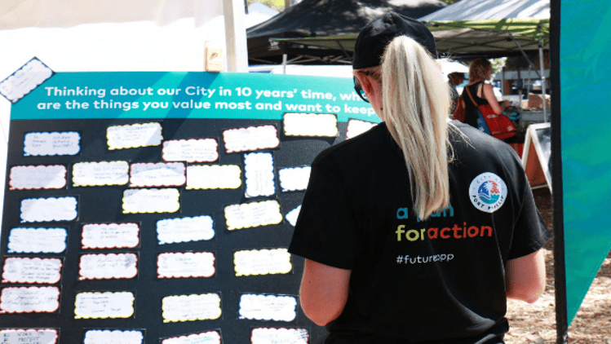
The value we provide
- Inform the community about Council and facilitate opportunities for the community to inform Council projects, initiatives, policies and strategies.
What we do
- Enable two-way communication between Council and the community.
- Communicate accessible information for the community on Council’s services, programs, projects, corporate governance and key initiatives.
- Promote Council’s decisions, advocacy, events and activities through proactive media and communications.
- Inform and engage our workforce with internal communications.
Why we do it
- To support transparency and enable community participation to ensure Council understands the current and future needs of our customers.
Activities that support this service
- Communications and brand
- Digital communications and design
- Media relations
- Strategic engagement.

Our service at a glance
Service statistics | 2018/19 | 2019/20 | 2020/21
Communications and engagement
Number of projects/initiatives that we engaged  the community on | 43 | 28 | 17
Number of pieces of feedback on the Council Plan and Budget | 662 | 400 | 929
Number of Twitter followers | 7,718 | 7,980 | 7,968
Visitors to the Council’s website | 885,153 (2017/18 | 900,129 | 874,618
Facebook followers | 5,455 (2017/18) | 11,722 | -
LinkedIn followers | 3,051 (2017/18) | 8,945 | -
Instagram followers | 1,671 (2017/18) | 4,220 | -
Online consultations designed and managed | 28 | - | -
Note: some service statistic data has not been available at the time of preparing this report. Where possible, data will be included for the final version.

How much it costs to provide the service
Budget 2022/23
Operating costs $000  Employee costs 2,282  Contracts 60  Materials and other expenses 130  Operating projects 0  Total operating expenses 2,472  Capital projects 0  Total expenses 2,472  (expenses include management overhead allocation, exclude depreciation and project expenditure) | How the service is funded $000  Rates 2,163  Parking revenue 323  Reserves (14)  Fees and charges (incl. statutory) 0  Grants 0  Other income 0  Total funding 2,472  Revenue from parking fees and fines is allocated on a proportionate basis across all service categories.
$1.51 is spent on this service out of every $100 of rates we receive
13% of costs are funded from fees and charges, grants, reserves and other income
Major contracts (annualised expense) $000
- None
Major leases Most recent market Rent per year
($000) rental estimate ($ excl GST)
- None
Major financial contributions $000
- None
Major assets
Council assets (June 2021) Value $000
- None

Our projects (* means 100% and ** means partial grant and contribution funding)
Capital projects $000 2022/23 2023/24 2024/25
None
Total Capital projects (excluding Fleet Renewal allocation) 0 0 0

Operating projects $000 2022/23 2023/24 2024/25
Council Plan 2021-31 Years 1-4 program 70 70 70
Total operating projects 70 70 70

Customer experience
The value we provide
- Customers receive services that meet their needs and expectations and they achieve their goals with greater ease and satisfaction.
What we do
- Develop the customer experience strategy and policy.
- Manage the Customer Experience Improvement Program, which includes improving customer service processes and systems, provision of customer experience tools, training, advice and support.
- Customer insights.
- Customer experience measurement and performance.
- Provide customer service through service counters at Council town halls, a customer call centre, and online services.
- Service management including service design and quality assurance.
Why we do it
- To ensure Council understands the current and future needs of our customers.
- To ensure customers and the community have good experiences with Council staff and services.
- To ensure service delivery and customer experience meet customer needs and expectations.
Activities that support this service
- ASSIST – service centre.
- Customer experience management.
- Customer experience culture and capability uplift including enterprise change.
- Service Management Strategy, Policy and Processes.

Our service at a glance
Service statistics | 2018/19 | 2019/20 | 2020/21
ASSIST customer service
Number of customer interactions | 162,677 | 166,874 | 158,373
Face to face interactions at Council service Centres | 32,164 | 22,298 | 19,372
Phone calls answered by ASSIST | 94,677 | 73,360 | 80,165
Administration tasks handled by ASSIST | 35,836 | 71,216 | 58,836
ASSIST phone calls answered within 30 seconds | 77 % | 67 % | 60.17 %

How much it costs to provide the service
Budget 2022/23
Operating costs $000  Employee costs 1,945  Contracts 67  Materials and other expenses 60  Operating projects 0  Total operating expenses 2,072  Capital projects 0  Total expenses 2,072  (expenses include management overhead allocation, exclude depreciation and project expenditure) | How the service is funded $000  Rates 1,815  Parking revenue 271  Reserves (14)  Fees and charges (incl. statutory) 0  Grants 0  Other income 0  Total funding 2,072  Revenue from parking fees and fines is allocated on a proportionate basis across all service categories.
$1.27 is spent on this service out of every $100 of rates we receive
12% of costs are funded from fees and charges, grants, reserves and other income
Further revenue and expense information on the service
Activity Expenses $000 Revenue $000
ASSIST – service centre 1,655 0
Customer experience program management incl. enterprise change 455 0
Customer experience management 296 0
Service advisory and evaluation 133 0
Operating projects (Customer Experience Program) 9,649 0
Management expenses 359 0
Total 12,555 0
Expenses exclude depreciation. Management expenses consist of apportioned costs for the Executive Leadership Team (CEO and general managers) and all department managers.
Major contracts (annualised expense) $000
- None
Major property leases Most recent market Rent per year
($000) rental estimate ($ excl GST)
- None
Major financial contributions $000
- None
Major assets
Council assets (June 2021) Value $000
- None

Our projects (* means 100% and ** means partial grant and contribution funding)
projects $000 2022/23 2023/24 2024/25
None
Total Capital projects (excluding Fleet Renewal allocation) 0 0 0

Operating projects $000 2022/23 2023/24 2024/25
None
Total operating projects 0 0 0

Finance and project management
The value we provide
- Ensure the financial sustainability and transparency of Council and that investments in projects deliver value for ratepayers.
What we do
- Develop financial strategy, policies and plans including the 10-year financial plan, annual budget, and 10-year project portfolio.
- Financial, procurement, contract management and project management advice, training and support.
- Fleet management, payroll, rating and property valuation services.
- Reporting on financial, procurement and project delivery performance including through the annual report and monthly CEO report.
Why we do it
- To fulfil mandatory duties described in the Local Government Act 2020.
- To deliver projects that support Council services.
Activities that support this service
- Contracts, procurement and fleet
- Financial services, compliance and systems
- Management accounting and financial analysis
- Project governance
- Project delivery
- Rates and valuations.

Our service at a glance
Service statistics | 2018/19 | 2019/20 | 2020/21
Capital expenditure | $34.8 million | $22.3 million | -
Value of operating projects | Not available | $10.6 million | -
How much it costs to provide the service
Budget 2022/23
Operating costs $000  Employee costs 7,748  Contracts 1,808  Materials and other expenses 1,379  Operating projects 0  Total operating expenses 10,934  Capital projects 0  Total expenses 10,934  (expenses include management overhead allocation, exclude depreciation and project expenditure) | How the service is funded $000  Rates (5,016)  Parking revenue 1,429  Reserves (1,772)  Fees and charges (incl. statutory) 191  Grants 2,994  Other income (incl. interest income) 13,107  Total funding 10,934  Revenue from parking fees and fines is allocated on a proportionate basis across all service categories.
$5.05 is returned by this service out of every $100 of rates we receive
146% of costs are funded from fees and charges, grants, reserves and other income
Major contracts (annualised expense) $000
Banking and bill payment services 560
Valuation services 179
Major leases Most recent market Rent per year
($000) rental estimate ($ excl GST)
None
Major financial contributions $000
None
Major assets
Council assets (June 2021) Value $000
Financial assets - current 116,634
Council corporate fleet cars (123) Not separately valued
Our projects (* means 100% and ** means partial grant and contribution funding)
Capital projects $000 2022/23 2023/24 2024/25
None 0 0 0
Total Capital projects 0 0 0
Operating projects $000 2022/23 2023/24 2024/25
None
Total operating projects 0 0 0
Note: some service statistic data has not been available at the time of preparing this report. Where possible, data will be included for the final version.
Note: asset information will be updated in the final version

Governance, risk and policy
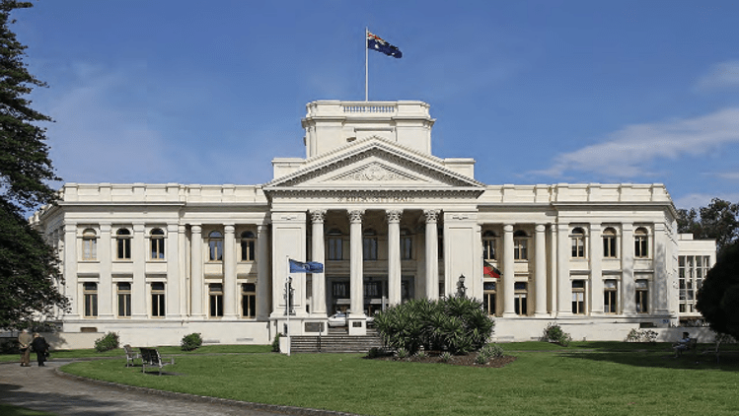
The value we provide
- Support sound decision-making through transparency, accountability, community participation, risk management and compliance.
- Advocacy through partnerships with stakeholders to deliver on community priorities, co-create solutions to community challenges, and contribute to shared visions for the City.
- Enable a safe workplace and a high performing workforce.
What we do
- Support Councillors to make well-informed decisions.
- Manage Council’s obligations in privacy and information management.
- Ensure risk management is integrated into strategic and decision-making processes.
- Ensure robust planning, reporting, and risk and claims management.
- Maintain Council’s insurance policies, respond to claims and assess damage to our assets.
- Coordinate independent assessment of Council compliance and performance through the Audit and Risk Committee.
- Develop policies and strategic documents to support Council activities.
Why we do it
- Good decision-making processes underpin democratic governments.
- To fulfil mandatory duties described in the Local Government Act 2020.
Activities that support this service
- Council planning and performance
- Councillor support and expenses
- Governance
- Records management and mail services
- Risk, assurance and insurance
- Strategic policy and partnerships.

Our service at a glance
Service statistics | 2018/19 | 2019/20 | 2020/21
None

How much it costs to provide the service
Budget 2022/23
Operating costs $000  Employee costs 3,184  Contracts 201  Materials and other expenses 3,554  Operating projects 70  Total operating expenses 7,009  Capital projects 0  Total expenses 7,009  (expenses include management overhead allocation, exclude depreciation and project expenditure) | How the service is funded $000  Rates 5,798  Parking revenue 916  Reserves (14)  Fees and charges (incl. statutory) 8  Grants (a) 0  Other income 301  Total funding 7,009  Revenue from parking fees and fines is allocated on a proportionate basis across all service categories.  (a) originally held under strategic partnerships, this has since been allocated to fund the Rotary Park project under Public Space.
$4.10 is spent on this service out of every $100 of rates we receive
17% of costs are funded from fees and charges, grants, reserves and other income
Major contracts (annualised expense) $000
- Insurance services 2,051
- Internal audit and core assurance services 173
Major property leases Most recent market Rent per year
($000) rental estimate ($ excl GST)
- None
Major financial contributions $000
- M9 42

Major assets
Council assets (June 2021) Written Down Value $000
- Town Halls (3) 54,561
Note: asset information will be updated in the final version
Our projects (* means 100% and ** means partial grant and contribution funding)
Capital projects $000 2022/23 2023/24 2024/25
None
Total Capital projects (excluding Fleet Renewal allocation) 0 0 0

Operating projects $000 2022/23 2023/24 2024/25
None
Total operating projects 0 0 0

People, culture and safety
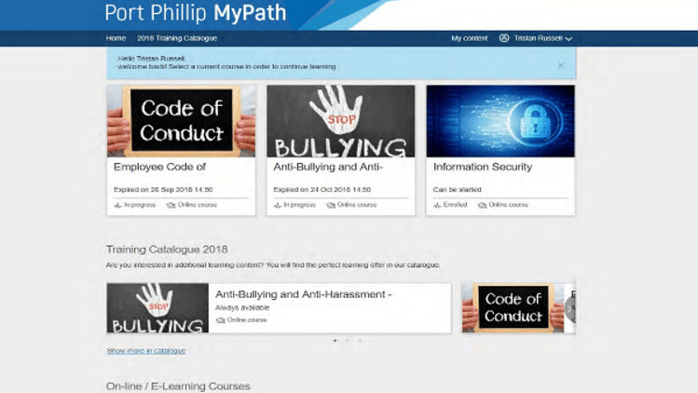
The value we provide
- Enable a safe and inclusive workplace and a high performing workforce.
What we do
- Develop people and culture, and workplace health and safety strategies and policies.
- Provide human resource management processes, systems, training, advice and support.
- Advise and support on workplace relations, industrial relations and change management.
- Provide Safety and Wellbeing processes, systems, training and advice including management of Workcover and return to work.
- Manage staff recruitment and selection including pre-employment screening.
- Organisational capability and development, including leadership development.
Why we do it
- To support delivery of Council priorities through the employment of an agile, values-driven, engaged and high-performing workforce.
- To build a safe and inclusive workplace culture.
- To fulfil mandatory duties described in Occupational Health and Safety (OHS), Equal Employment Opportunity (EEO), Fair Work and Local Government Legislation and Council’s Enterprise Agreement.
- To position Council as an employer of choice and support the attraction and retention of diverse talent.
Activities that support this service
- Human resources (including HR business partnering, recruitment and employee relations)
- Organisational capability
- HR systems and analytics
- Safety and wellbeing.
Our service at a glance
Service statistics | 2018/19 | 2019/20 | 2020/21
None
How much it costs to provide the service
Budget 2022/23
Operating costs $000  Employee costs 3,677  Contracts 31  Materials and other expenses 1,340  Operating projects 0  Total operating expenses 5048  Capital projects 0  Total expenses 5,048  (expenses include management overhead allocation, exclude depreciation and project expenditure) | How the service is funded $000  Rates 4,402  Parking revenue 660  Reserves (14)  Fees and charges (incl. statutory) 0  Grants 0  Other income 0  Total funding 5,048  Revenue from parking fees and fines is allocated on a proportionate basis across all service categories.
$3.05 is spent on this service out of every $100 of rates we receive
13% of costs are funded from fees and charges, grants, reserves and other income
Major contracts (annualised expense) $000
None
Major leases Most recent market Rent per year
($000) rental estimate ($ excl GST)
None
Major financial contributions $000
None
Major assets
Council assets (June 2021) Value $000
None
Our projects (* means 100% and ** means partial grant and contribution funding)
Capital projects $000 2022/23 2023/24 2024/25
None
Total Capital projects (excluding Fleet Renewal allocation) 0 0 0

Operating projects $000 2022/23 2023/24 2024/25
None
Total operating projects 0 0 0

Technology
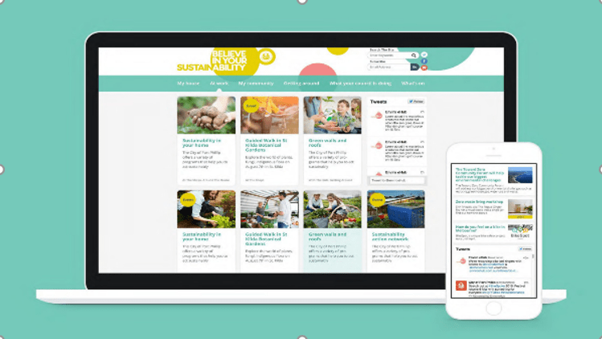
The value we provide
- Support Council operations including efficient and effective service delivery through information, communication and technology services.
What we do
- Develop information, communication and technology strategy and policy.
- Design and deliver process and system improvements to support service delivery.
- Provide technology, continuous improvement and records management training, advice and support.
- Manage Council’s technology assets, records, data and information.
- Provide data analysis and reporting and process and system improvement services.
Why we do it
- To ensure customers and the community have good experiences with Council staff and services by easily accessing Council data, information and services.
- To support staff to deliver on Council activities and provide good customer experience.
Activities that support this service
- Operational information technology.
- Digital and technology services.
Our service at a glance
Service statistics | 2018/19 | 2019/20 | 2020/21
Number of published open datasets biannually | - | 29 | No data
How much it costs to provide the service
Budget 2022/23
Operating costs $000  Employee costs 5,750  Contracts 12  Materials and other expenses 6,257  Operating projects 1,220  Total operating expenses 13,239  Capital projects 800  Total expenses 14,039  (expenses include management overhead allocation, exclude depreciation and project expenditure) | How the service is funded $000  Rates 11,666  Parking revenue 1,835  Reserves 536  Fees and charges (incl. statutory) 0  Grants 0  Other income 2  Total funding 14,039  Revenue from parking fees and fines is allocated on a proportionate basis across all service categories.
$8.30 is spent on this service out of every $100 of rates we receive
17% of costs are funded from fees and charges, grants, reserves and other income
Major contracts (annualised expense) $000
- OneCouncil system 1,131
- Microsoft licencing agreements 850
- Internet network services 460
- Printing services 256
- Adobe 185
- Dell Boomi 190
Major property leases Most recent market Rent per year
($000) rental estimate ($ excl GST)
- None
Major financial contributions $000
- None
Major assets
Council assets (June 2021) Value $000
- Computers (2,177) Not separately valued
- Mobile phones (614) Not separately valued
Our projects (* means 100% and ** means partial grant and contribution funding)

Capital projects $000 2022/23 2023/24 2024/25
Core IT Infrastructure Renewal and Upgrade Program 800 800 650
Total Capital projects (excluding Fleet Renewal allocation) 500 800 650

Operating projects $000 2022/23 2023/24 2024/25
Clever Council Program 1,220 1,380 1,380
Total operating projects 1,220 1,380 1,380
Note: asset information will be updated in the final version

