Nature Strip Guidelines
Draft 02, June 2022

Guideline Governance
Responsible Service / Department:
Public Space and Planning
Adoption authorised:
Council
Date of adoption:
TBC
Date effective from:
TBC
Content Manager folder:
[Insert Text]
Content Manager file:
[Insert Text]
Endorsed department manager to make and approve document editorial amendments:
Dana Pritchard
Annual desktop review date:
2023
Review date:
2023
Completion date:
2025
Version number:
01
Stakeholder review and engagement:
Community Consultation
Sustainability, Local Laws, Parks, City Permits & Public Space Teams
Relevant Legislation:
Road Safety Act 1986 (Victoria)
Road Management Act 2004 (Victoria)
Local Law No 1 (Community Amenity) 2013 (City Of Port Phillip)
Associated Strategic Direction #:
Liveable Port Phillip, Sustainable Port Phillip
Associated instruments:
Public Space Strategy 2021
Supersedes:
Nature Strip Guidelines 2013
Review history:
Name | Content Manager File Reference | Date | Description of Edits
Nature Strip Guidelines | # | TBC | Adoption

What is a nature strip?
A nature strip is the public land between the property boundary and the road kerb but does not include the paved footpath area. Nature strips are important green spaces that support street trees, provide permeable surfaces and can improve biodiversity if planted with a variety of plants, including local indigenous species.
When planted with a garden, nature strips can:
- improve biodiversity
- improve permeability
- reduce the urban heat island effect
- contribute to streetscape attractiveness
- provide opportunities to meet community
- provide activity through gardening
- reduce the need for mowing.
Nature strips include essential above and below-ground public services including water, sewerage, gas, electricity and communications infrastructure. They also provide space for rubbish collection.
Some streets in Port Phillip are fully paved and do not have nature strips. If you do not have a nature strip in front of your home and want to garden, there are other public gardening opportunities available here.
Nature strip gardening in Port Phillip is guided by the following three principles:

Nature strips are for greening and biodiversity, community connection and contribute to aesthetics and spirit of neighbourhoods.

Streets are safe and accessible for everyone.

Tread lightly.

This brochure sets out how to plan, plant and maintain the nature strip outside your home or business in line with these principles. You do not need approval or a permit to plant on your nature strip if you garden in accordance with these guidelines.

Nature strips are for greening and biodiversity, community connection and contribute to aesthetics and spirit of neighbourhoods

Planning your nature strip garden
- Talk to your neighbours. Let them know what you are planning, ask if they would like to join in and talk through any concerns.
- Consider planting indigenous plants to promote biodiversity and improve habitat for rare and threatened species.
- Consider planting drought tolerant species and group plants with similar water needs together to reduce water use.
More information about suitable plant species is available on our webpage or in the gardening section at local libraries.

Streets are safe and accessible for everyone
You must maintain your nature strip garden to be safe and tidy for everyone.

Footpaths
Footpaths need to be kept free of vegetation so everyone can use them. Footpaths widths vary throughout the city, generally a 1.2 m wide path is the minimum required to enable access for people using prams, wheelchairs, scooters and people needing assistance to use a footpath safely. In many areas, footpaths are wider to enable greater accessibility and to provide more pedestrian space. A 30 cm offset is required beside the footpath. You can grow grass, a low ground cover or have mulch in the offset area ensuring any plant is always trimmed back from the path edge.

Kerbs and parking
If there is parallel parking in the area, keep a 50 cm offset beside the kerb clear. Consider keeping some sections with a 1 m offset to allow for car doors to be opened and for people to access the footpath with ease. You can grow grass or a grass replacement ground cover or have mulch in the offset area ensuring any plant is always trimmed back from the kerb edge.

In areas with angled parking you can plant to the kerb, keeping plants below 50 cm in height within a 50 cm offset. You must keep an area 1.2 m wide clear every 5.5 m (or every two car spaces) to allow people to access the footpath from the kerb. You can grow grass or a grass-replacement ground cover in this area.
Keep an area suitable and accessible for rubbish bin collection.

Plant heights
Plants grown on nature strips need to be kept under 1 m high to ensure visibility for everyone walking, cycling and driving. Plants should be under 50 cm high in the following circumstances:
- When they are within 2 m from a driveway.
- When they are within 10 m from a corner, pedestrian crossing or intersection.

Offset area diagrams

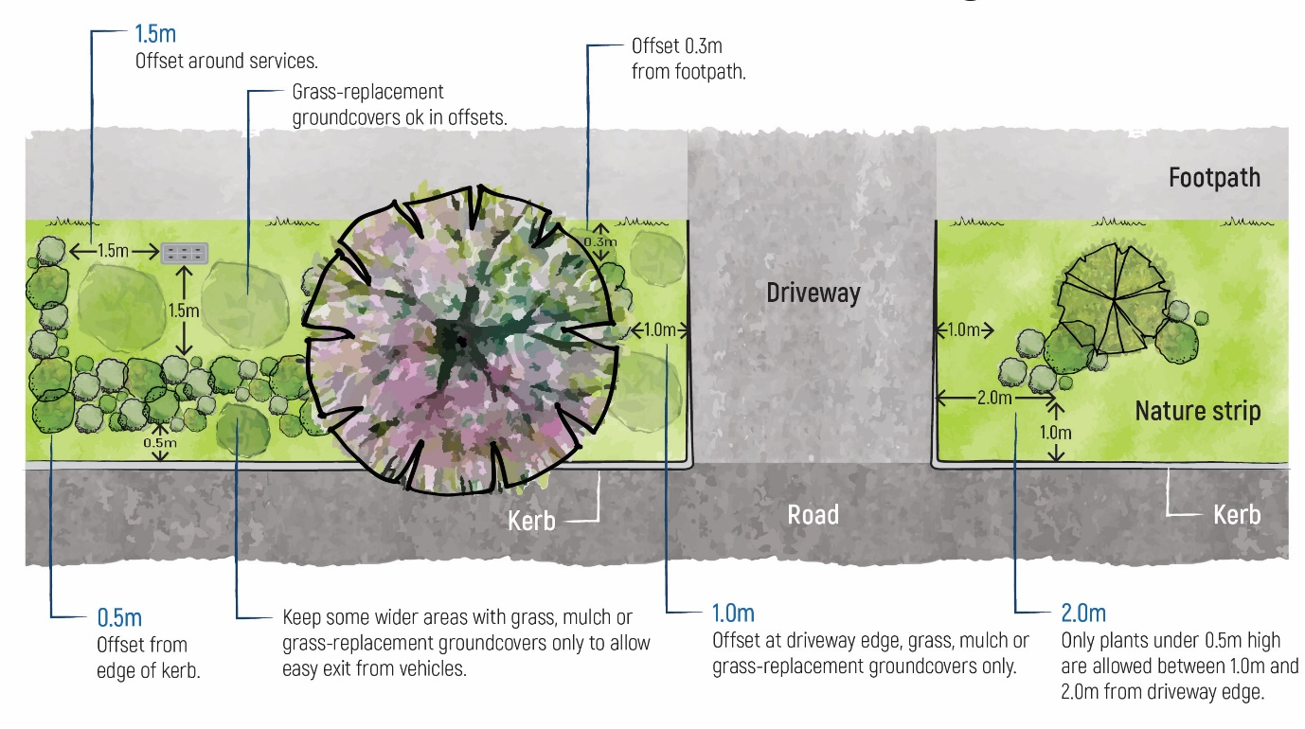
Figure 1 Offsets from driveways, kerbs, footpaths and service pits. Clearances from kerb on streets with parallel parking

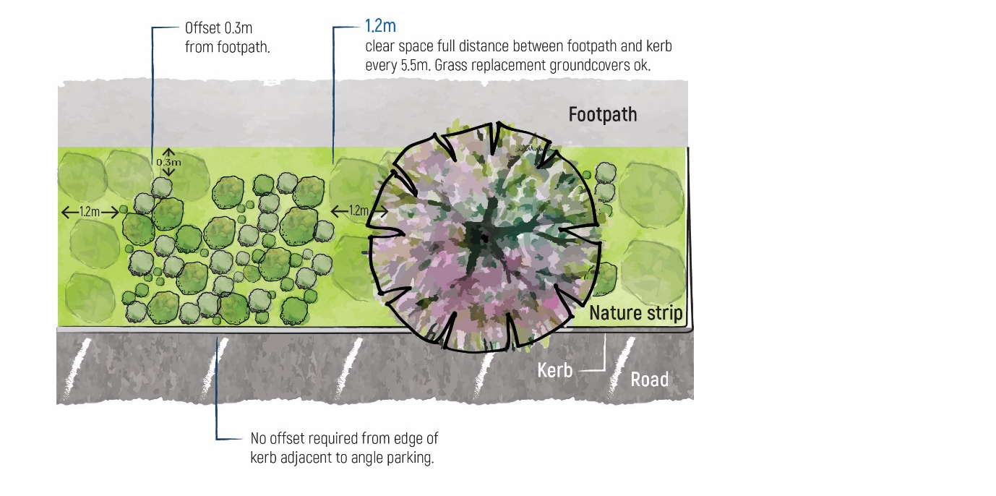
Figure 2 Offsets from kerb and path and clear space for footpath access on streets with parallel parking

Tread lightly
Essential services
Prior to planting or digging, check any underground services by contacting Dial Before You Dig on 1100 or apply online at www.1100.com.au. If nature strip gardening activities cause damage to public utility services, you must report the damage to the appropriate authority.
Service pits, storm water pits, power poles, fire hydrants and service pillars require a 1.5 m radius of clear space. You can grow grass or a grass replacement ground cover or have mulch in this area. Utility companies may access their infrastructure for upgrades or repairs at any time. Utility companies are required to reinstate grass on the nature strip following maintenance work, but are not required to reinstate nature strips that have been modified and landscaped with anything other than grass.

Soil contamination
Soil contamination is common across Port Phillip (and all of inner-Melbourne). Humans may be exposed to these contaminants when gardening, via direct skin contact or by inhaling airborne dust when digging. These contaminants can also transfer to edible plants. For this reason, Council recommends that you do not eat plants grown directly in your nature strip. You should grow plants you intend to eat in a raised planter box with clean soil purchased from a nursery. Find out more about planter boxes or soil contamination.
Trees
Street trees provide shade and shelter for people walking and cycling and cool streets and surrounding properties in hot weather. Trees contribute to the aesthetics and character of the street and accommodate urban wildlife.

As trees in urban areas are growing in harsher conditions, it is important to protect their growing space. Street trees require an area to be kept free of planting to protect their root zone. This provides trees access to available water and nutrients, allowing roots to breathe and helping protect tree roots from disease. To keep trees healthy:
- keep a radius of 1.5 m or 3 times the trunk diameter (whichever is greater) free of planting surrounding the tree trunk. This means that small tree plots, pits and grates with a gravel surface will not be suitable for a nature strip garden
- keep the soil level the same below the tree canopy. You can mulch the area around the tree, keeping the mulch away from the base. Do not mound soil, mulch or grass clippings against the tree trunk.

Planting around trees diagrams

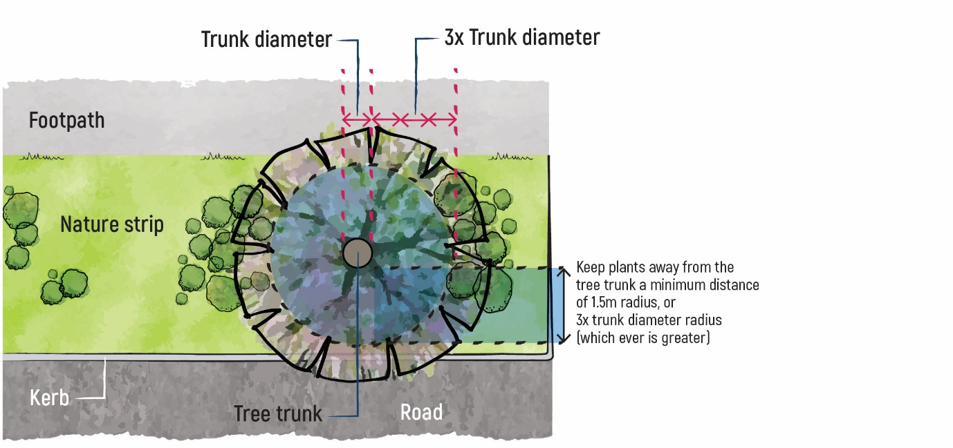
Figure 3 Keep a radius of 1.5 m or 3 times the trunk diameter (whichever is greater) free of planting surrounding the tree trunk

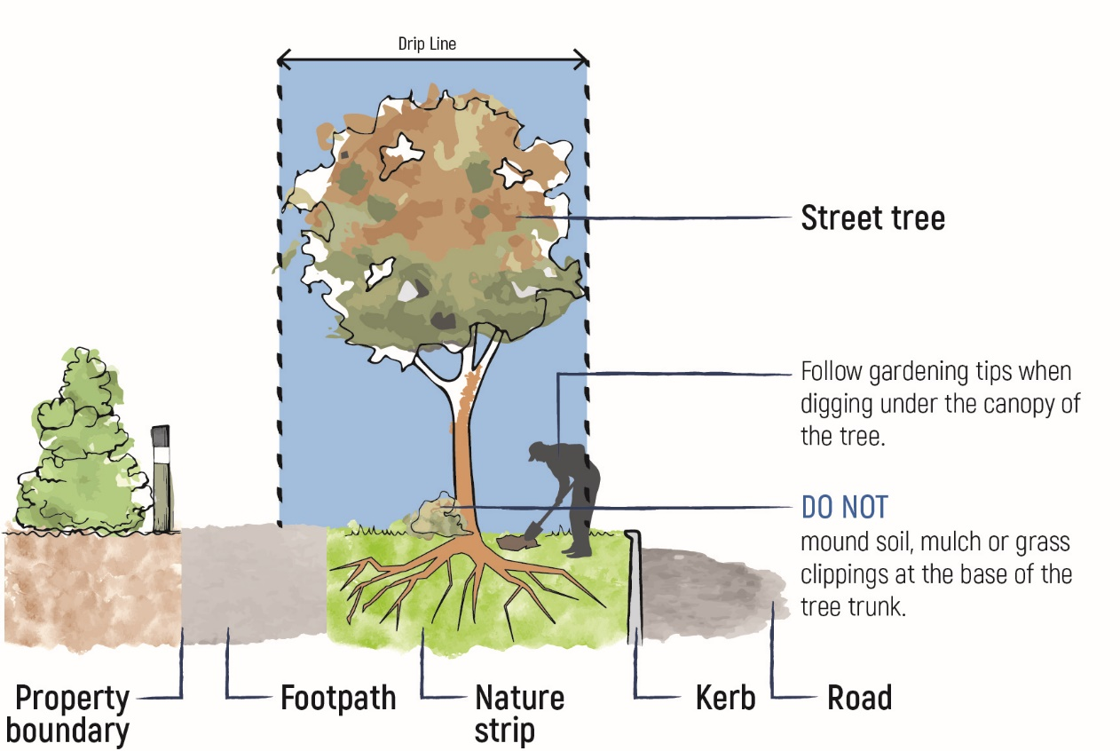
Figure 4 Extra care is required in the drip line (under the tree canopy) of trees

Planting your nature strip garden
The following provides some guidance for the removal of grass and preparing the garden bed:
- Shovels, hoes or trowels are all suitable for grass removal. Do not use mechanical tools.
- If you uncover tree roots, do not cut, scrape or damage them, particularly if the roots are greater than 30 mm in diameter. Any roots that are uncovered during the process can be buried with mulch or new topsoil to keep them healthy.
- Herbicides should not be used.
- Dig 50 to 100 mm deep to make sure you remove all the grass (roots and all).
- If an area is hard to dig, don’t force it. A small tree root may be lying under that section of turf.
- Once you’ve removed the grass, apply 50 to 75 mm depth of woodchip mulch in the area where turf has been removed.
- Water the mulch thoroughly.
- Use plants in small pots (tube stock or 100 mm pots) to minimise digging.

Materials and structures
Nature strip gardening is for planting, biodiversity and beautifying the area. It is important to keep public space safe and accessible. Please do not use:
- any materials or structures which are unsafe, loose, slippery, sharp, pointy, impermeable, block sight lines, attach to trees, can be a trip hazard or have negative environmental outcomes. This includes any raised edging, synthetic turf, irrigation, garden stakes, fencing, walls, furniture, signs, rocks and letter boxes
- sharp, prickly or poisonous plants
- weed species.

Existing nature strip and street gardens
Many valued, biodiverse and beautiful nature strip gardens are planted in Port Phillip. There is no expectation that these gardens be removed, even if they don’t fully comply with the new guidelines.
Council is sometimes requested to investigate nature strip gardens where a safety concern has been raised. In these instances, Council works with affected residents to modify and maintain the gardens and ensure public safety. In rare situations where there is a continued conflict between the garden and safety, Council has the option to utilise the Local Law to issue orders and penalties.

Standards and Guides informing these guidelines:
AS1428.1 2009 Australian Standards for Access and Mobility
AS4970 2009 Australian Standards for Tree Protection on Development Sites
AusRoads Guide to Traffic Management Part 10 https://austroads.com.au/publications/traffic-management/agtm10
Urban Design Guidelines for Victoria https://www.urban-design-guidelines.planning.vic.gov.au/home

