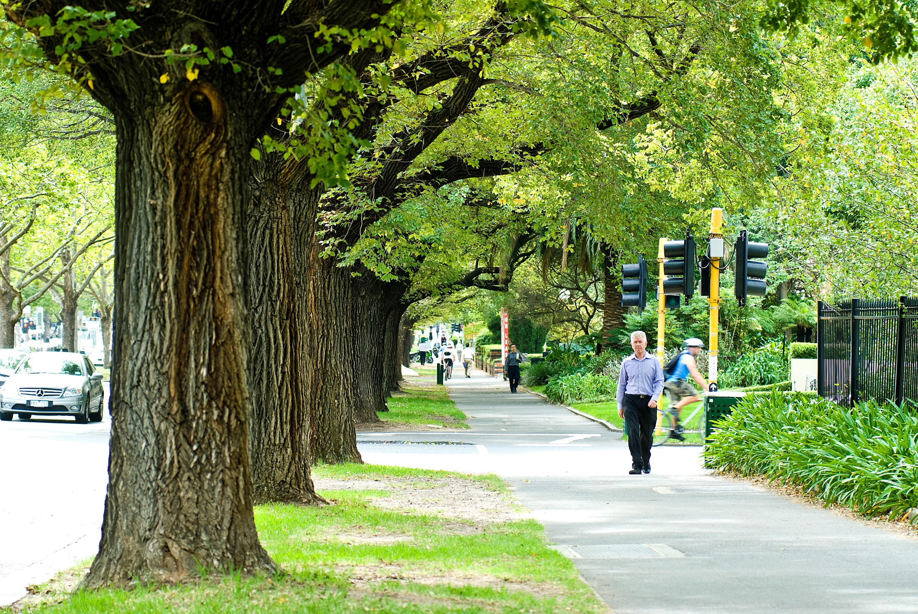

Nature Strip Guidelines
ANALYSIS OF PHASE ONE COMMUNITY ENGAGEMENT RESULTS
SUMMARY REPORT

JUNE 2022

Prepared by

Global Research Ltd

For the City of Port Phillip

Contents
Executive summary 2
Key insights 4
Summary of findings for each survey question 7
Q&A sessions and email submissions 8
Analysis of written comments 9
What do you like about the nature strip guidelines? 10
Is there anything you’d like us to consider adding to the guidelines? 11
Is there any part of the guidelines you disagree with? 15
The consultation process 18
Longform submissions from groups 21
Petition 24
Demographics – Respondent Characteristics 25
Survey respondent characteristics 26
Analysis method and results presentation 28

Executive summary

The City of Port Phillip is undertaking a review of its existing Nature Strip Guidelines, which were prepared in 2013. The purpose of the NSG is to provide clear direction on how the community can safely garden on nature strips within the municipality, while ensuring nature strips remain safe and functional.  This report contains analysis of the first phase of community engagement. Feedback from the community will inform the next iteration of the draft Nature Strip Guidelines, which will be open for consultation in June 2022.  The first consultation period ran from December 2021 to February 2021 and included an online survey and an open question forum on the Council’s Have Your Say website, two online ‘live’ sessions, and targeted meetings with external stakeholders. The survey garnered 578 responses, and Council also received 36 email submissions, 64 questions in the forum, and a petition with almost 6000 signatures.  This is a summary report presenting the major themes from the community’s feedback. Similar ideas were raised across all forms of feedback, with key themes from the survey responses echoed in the Q+A sessions, long-form submissions, and the petition. | 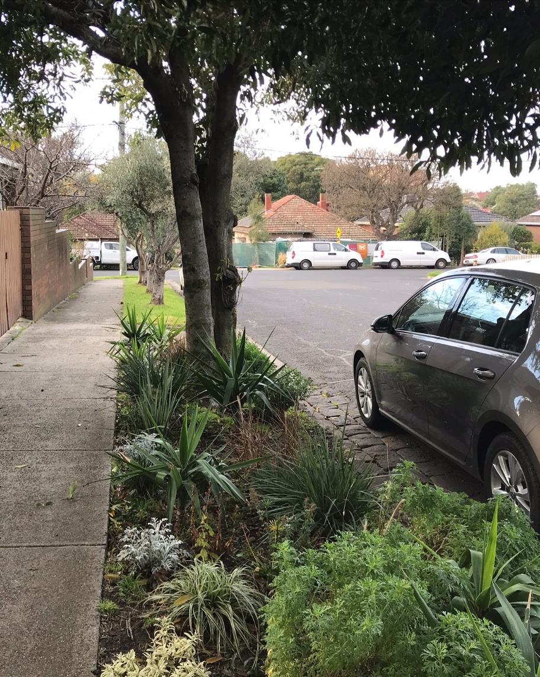

Engagement Overview
Stage one  The first stage of community engagement on the draft NSG occurred from December 2021 to 13 February 2022. As a result of COVID-19 restrictions, all engagement was undertaken virtually and included:  - A survey on Council’s Have Your Say website with four open-ended questions:  - What do you like about the draft guidelines?  - Is there anything you’d like us to consider adding to the guidelines?  - Is there any part of the guidelines you disagree with?  - How could we have made your experience with the consultation process better?  - An open question forum on Council’s Have Your Say website  - Two online ‘live’ sessions with presentations from Council officers, typed questions and live answers (these replaced planned in-person sessions due to COVID-19 restrictions). These sessions were recorded.  - Targeted meetings with external stakeholders.  - A meeting between Council staff and Traditional Owners. | Engagement reach  During the first stage of public consultation on the draft NSG, Council received:  - 6,628 views and 3,691 visitors to Council’s Have Your Say website  - 578 responses to the survey on Council’s Have Your Say website  - 64 questions asked in the open question forum on Council’s Have Your Say website  - 36 email submissions  - 12 full-session attendees at the two online Q&A sessions, with others popping in and out  - 5,936 signatures to a community petition to ‘Keep street gardening growing in City of Port Phillip’  Additionally, the process generated significant media interest with the draft NSG featuring in several news publications and radio segments.  As a result of the extensive feedback received, Council has decided to hold a second engagement which is planned for June 2022, with the intention to include in-person sessions as well as the Have Your Say page and paper surveys. The community will be able to give their views on a revised draft of the NSG, which will be informed by feedback received during the first stage of consultation.  Feedback from the second stage will be considered and the draft finalised. After this, the draft NSG will go to an open Council meeting for consideration by Councillors. Community members can register to speak at this meeting.

Key insights
1. | There is support for nature strip plantings and greening of the city  Nature strip planting was overwhelmingly supported by respondents as a cherished aspect of urban life in the City of Port Phillip and people wanted this to be encouraged.  - People highlighted the benefits of nature strip gardens – the enhanced visual appeal of streetscapes, a cooler, greener city with thriving biodiversity, and the enhanced sense of neighbourhood connection. |  | RECOMMENDATIONS  - Clarify that CoPP supports nature strip gardening and is not intending to remove, destroy, or prohibit this.  - Communicate CoPP’s broader plans to de-pave areas of the city and increase tree canopy to convey to the community that Council is committed to greening Port Phillip via means other than nature strips.  - Offer more information and tips through various channels (online, interactive sessions and workshops, having a council liaison person) to promote biodiversity and support people in planting their nature strips. This could include information regarding suitable flora for specific conditions, water harvesting and management, composting, planting ideas, and suggestions as to how to connect neighbours and the wider community.
2. | There are concerns about rules being too restrictive  The guidelines were commonly perceived as discouraging or negatively framed. People feared that the current rules, which were often described as too restrictive and “one-size fits all”, would both deter new gardens and result in the removal of beloved established gardens. |  | RECOMMENDATIONS  - Adopt positive language and framing that supports nature strip gardening, emphasise the value CoPP places on the efforts of the residents to green their city, and promote the social, environmental and community benefits of street gardens.  - Clearly communicate how issues of non-compliance will be addressed, particularly regarding existing gardens, to reassure the community that gardens will not be summarily removed.  - Clarify routes to resolve issues, complaints, and disputes.
3. |  | Calls for a more nuanced approach to guidelines  Respondents felt the guidelines did not account for the varied characteristics of specific locations and wanted more discretion over nature strip planting in their streets.  - People noted various situations in which the safety aspects of the guidelines could be upheld while still allowing nature strip planting to occur. They urged that specifics be taken into account such as: footpath width, whether streets have angle or parallel parking, and the health of existing trees. | RECOMMENDATIONS  - Consider how clearance requirements can be more granular to enable more widespread planting in different contexts, for example, smaller nature strips or laneways with no vehicle access, and how plant height restrictions can be used to circumvent issues of visibility.  - Use the knowledge of the community and initiatives such as the Heart Garden Project to understand how accessibility and safety have been managed around already established gardens, and consider how other councils are addressing this.
4. |  | Calls for a more evidence-based approach  Respondents questioned the scientific basis for some of the guidelines and wanted to see that approaches are evidence-based.  - Restrictions around tree planting and clearance requirements were notable areas where people wanted to see the evidence behind the guidelines. |  | RECOMMENDATION  - Provide more evidence and justification to support final decisions, particularly around topics of contention.

5. | People want to have input and be heard  The consultation process was felt to be inadequate by participants, many of whom were frustrated that they had not heard directly from CoPP about this issue.  - Respondents, although in the act of participating in community consultation, felt they were not being consulted. They felt excluded from decision making and feared that the guidelines were a foregone conclusion. | RECOMMENDATIONS  - Reiterate that the Nature Strip Guidelines are in their draft form and reassure the community that their feedback is both sought and heard.  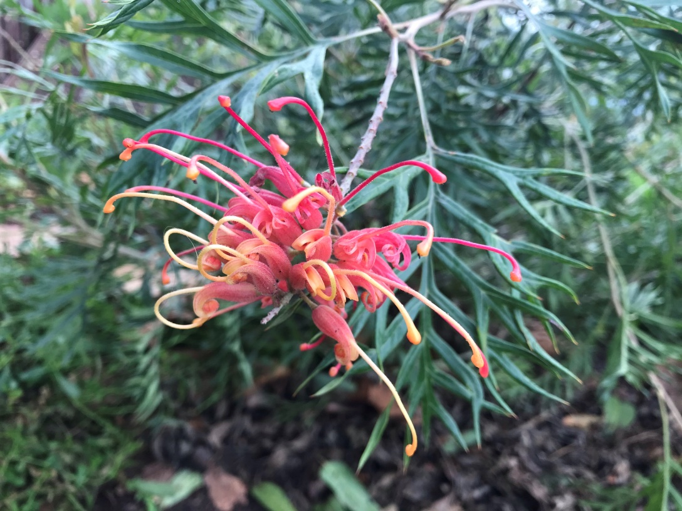  - Incorporate community feedback as much as possible and explain the justification behind decisions when outcomes do not align with community sentiment.

Summary of findings for each survey question
578 people completed the survey.

 | What do you like about the draft guidelines?  - Respondents liked the following aspects of the draft guidelines in relatively equal proportions:  - They will ensure verge planting is done well or correctly;  - They offer clear, concise, straightforward advice;  - The guidelines show that Council recognises the significance and importance of verge planting;  - They will enable safe access and egress for pedestrians and drivers;  - They encourage nature strip planting.  - Respondents offering a positive comment when asked what they like about the guidelines were double that of those who offered a negative comment.  “My recommendation would be to begin with looking at what exists and building a rough set of guidelines around that – that isn’t too prescriptive as all of our nature strips are so different and one set of regimented rules simply doesn’t work.” | Is there anything you’d like us to consider adding to the guidelines?  - Respondents frequently used this question to state their overall disagreement with the guidelines. People expressed disapproval of the “one size fits all” approach, calling for more flexibility in clearance requirements to allow people with smaller areas to plant their nature strips. People wanted the guidelines to be simple, outcome-focused, and less about “what you can’t do”.  - The guidelines were felt to disincentivise nature strip planting. People wished to see the document reframed with more positive language to encourage street gardening, and wanted more emphasis on the environmental, social, and aesthetic benefits of street gardens.  - Respondents sought to ensure that current gardens would not be removed, suggesting exemptions for established gardens or Council discretion in handling these. More generally, people wanted compliance issues to be dealt with constructively and respectfully, and for community views to be taken into account.  - Comments around safety and accessibility most commonly called for the clearance areas to be reduced, with people suggesting accessibility could still be achieved with a more nuanced approach to risk. On the other hand, some respondents highlighted that accessibility and safety should be prioritised, with particular consideration given to groups who have heightened access needs such as people with disabilities.
Is there any part of the guidelines you disagree with?  - Disagreement with the guidelines was largely based on clearance areas. Respondents argued that in many places clearances were so large as to prevent any planting from occurring.  - Relatedly, a large number of respondents deemed the guidelines too prescriptive or restrictive.  - Limits around planting under trees (e.g., in tree squares) were argued to preclude the possibility of any planting occurring, and some respondents disagreed that under-tree planting would negatively impact on tree health.  - A substantial number of respondents expressed distress at the thought that existing and much-loved gardens would be removed once guidelines come into effect. |  |  | The consultation process  - Quantitative results indicated an overall sense that respondents wish to be more involved in the decision-making process and feel this process can be improved.  - Just over a quarter of respondents agreed (21%) or strongly agreed (5%) that Council actively supports community involvement in decision-making;  - Just under half of respondents (48%) agreed that Council provided them with access to information to enable them to meaningfully participate in this process, while 37% of respondents disagreed.  - Free text responses indicated objection to finding out about the consultation via informal means; respondents would have liked to have been informed directly by CoPP.  - There were a substantial number of respondents who considered the consultation insufficient; they argued there was not enough advertisement of the issues, that too few residents were able to give feedback, and that timeframes were too short.  - A considerable number of comments were made conveying scepticism about the consultation process; people were concerned that they were not being heard, and that their opinions would not be incorporated into the guidelines.  - There was a thread of anti-Council sentiment in comments, with several opportunities taken to criticise Council operations more broadly, and expressions of distrust and animosity towards Council.

Q&A sessions and email submissions
- Questions and comments from the online Q&A sessions and the email submissions from groups echoed concerns raised in survey responses. The overall sentiment was that people wanted the rules to be more enabling to support the environmental and social effects of nature strip gardens and to align with broader goals of greening the City of Port Phillip. It was generally felt that the current draft guidelines will not achieve this, and that they are at odds with the Council’s position on other aspects of sustainability and liveability.
- Questions from the Q&A sessions conveyed that people wanted more clarification around the effects of planting on trees, desired more flexibility in clearance requirements, and wanted to know community opinions were accounted for in the development of the guidelines.

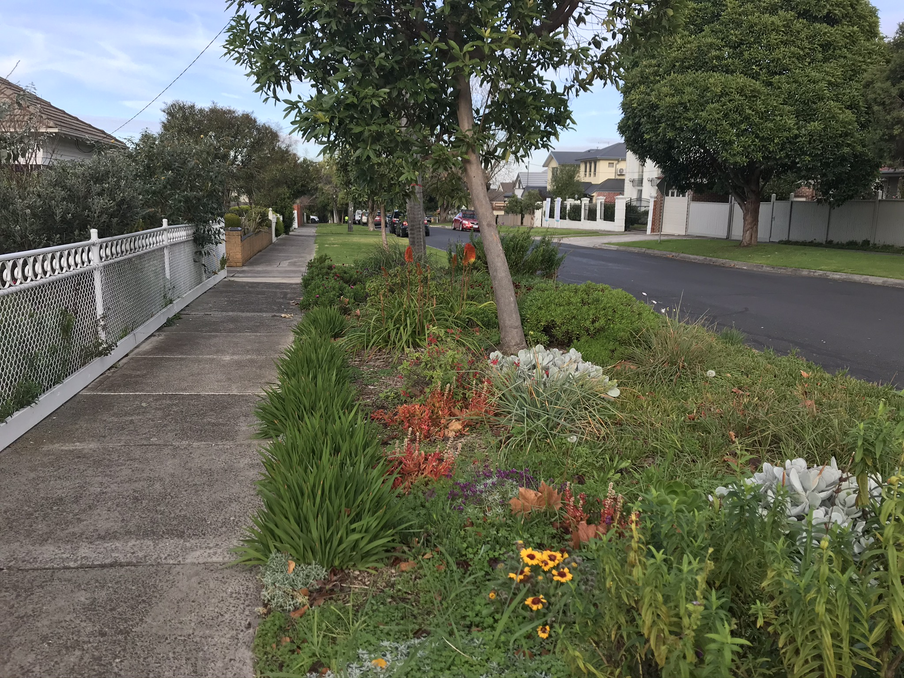

Analysis of written comments

What do you like about the nature strip guidelines?

Guidelines will provide clarity and encourage gardening  People felt the guidelines will provide guidance and clarity around nature strip gardening and will generally encourage or allow nature strip planting. They also saw them as showing that Council recognises the importance of verge planting to residents and indicate that they encourage nature strip gardens.  It acknowledges that the community and visitors enjoy street gardening and see it as a value add to living in this highly populated municipality. | There are benefits to nature strip gardening  The guidelines allow for the benefits of nature strip planting – particularly environmental and biodiversity benefits that contribute to a green, cool city where bird and insect life can flourish. Respondents also raised social and community benefits, including the willingness of residents to improve their neighbourhoods, and the enhanced community connection and spirit the gardens bring.  I am glad that nature strip gardens are allowed as they play a significant and important role in biodiversity, and people engaging with nature.
Guidelines encourage a unified streetscape  The guidelines will promote uniformity on planted nature strips and create an aesthetically pleasing streetscape. Some people expressed admiration that the guidelines represent a good balance between “gardens and accessibility”, “community engagement and safety”, and “encouraging” planting within the revised framework.  I see that these guidelines are an improvement to the existing ones and hopefully create a more unified landscape architecture within this lovely city. | They will result in safe and accessible footpaths and roads  The guidelines address safety and accessibility, particularly footpath obstruction and access for vehicles and those entering or exiting vehicles. Respondents who discussed clearance areas agreed that footpaths, laneways, and driveways must remain accessible, while others felt that the guidelines for the height limit on plants would increase safety.  Completely agree this needs to be done in a safe way. I like the considerations of visibility of Bicycles, as well as vehicles.
*A large number of negative comments were also made on the topic, with people taking the opportunity to state what they didn’t like, or saying they liked nothing about the guidelines. To avoid repetition, these themes have been discussed under “Is there any part of the guidelines you disagree with” on p. 15.

Is there anything you’d like us to consider adding to the guidelines?

More flexibility and acknowledgement of different contexts and streetscapes  People wanted the guidelines to be more flexible and less “one size fits all”, especially regarding clearance requirements. It was also suggested these present an equity issue due to the more affluent areas tending to have larger verges. People wanted the guidelines to consider different contexts and how people could beautify smaller streets, or to be recommendations rather than rules.  Less what you can’t do and more this is how we can help facilitate your plans, as an example when you say no to narrow streets instead give examples of variations that CAN be done if the local residents are keen |  | Positive framing and more emphasis on the benefits of nature strip planting  People felt that the document should be framed more positively and encourage people to garden, describing the current tone as prohibitive and disempowering. They called for the guidelines to highlight the many environmental, aesthetic and social benefits of street gardening.  Start again for a complete rewrite so that they are inclusive, empowering, researched properly, thought through and not only celebrate current street gardeners (who are out making our city more beautiful) but also encourage others to make a safe, informed and positive difference to their community and their planet.

Provisions for existing gardens to be exempt from new requirements  Comments suggested softening the guideline’s restrictions or including “grandfather clauses” to protect beloved established gardens, which people feared would be removed when the guidelines come into effect.  Please be more realistic about clearances given the small areas available in many, many CoPP streets, consider the effect on the community that has lovingly created and maintained planting areas that would now be deemed non-compliant - don't make the compliance retrospective!! |  | A respectful process for non-compliant gardens  More clarity was requested around how non-compliant gardens would be addressed, asking for Council to consult and work with residents “respectfully and constructively” to remedy unsafe elements. People suggested there should be space for discretion and negotiation and an appeals process, and that the clause that allows CoPP to remove gardens or issue fines should be deleted.  Community consultation before any existing and loved plantings are removed. Please do not be heavy handed in removing existing gardens. We love them and care for them.
Evidence and research underpinning decisions  Respondents wanted to see a clear scientific rationale for decisions and were in some cases sceptical about the extent of the restrictions around tree planting and clearances. They requested more research (and for this to be made available), including issues with current gardens and data collection around safety and risk, an impact assessment of the new guidelines, more social and environmental research and consideration of best-practice case studies from Australia and around the world.  More risk-based approach to the dimensions on planter boxes and garden beds. I didn’t see any research suggesting existing plantings are a problem. |  | Allowances for planting around trees  Calls were made for more flexible restrictions to allow planting around trees dependent on the tree’s type/age or garden size, and people argued that thoughtful planting could actually benefit trees and enrich soils.  The evidence for desired distance from trees for planting of ground shrubs is possibly a highly contested situation. Not all trees are the same and the possibility of Collar Rot being initiated is not a case of "one size fits all".

A review of the clearance requirements for safety and accessibility
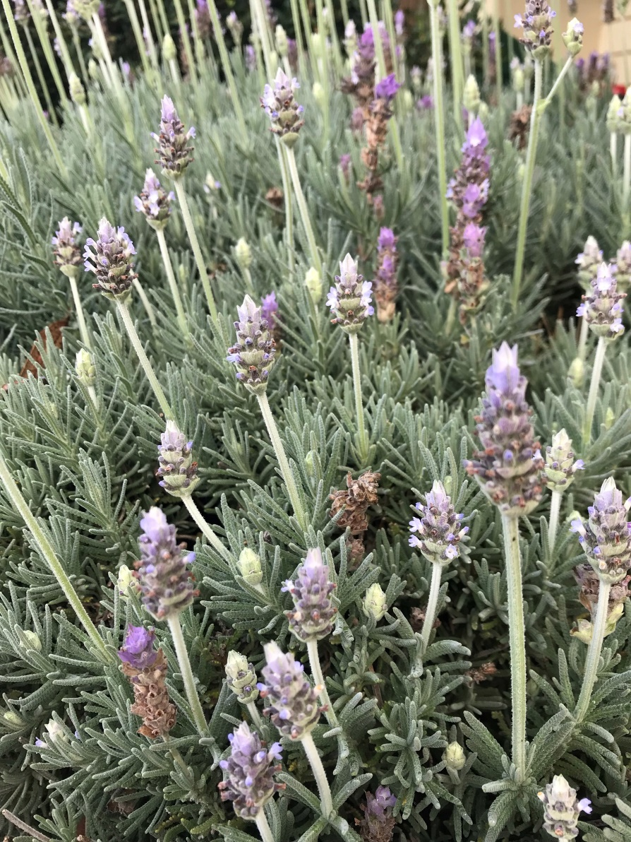
People commonly called for the requirements to be reduced or removed to allow more planting, or argued that the guidelines prioritised car transport over planting. It was suggested a more nuanced approach to risk could be taken to reach a balance between planting and access. People also suggested plant heights limits could be extended, or that more variation could circumvent visibility issues, e.g., having low plants around intersections.
On the other hand, others wanted greater consideration of access needs, especially for those with disabilities or people walking with prams, suggesting more restrictions for planter boxes, compulsory paths across nature strips, and ensuring unhindered footpath and car access.
Remove the requirement that tree squares cannot be planted and reduce the size of the clearance areas to create a reasonable balance.
There are many community members who live with medical conditions and disability. These members of our community are rate payers and should be able to live a safe and functional life within their own community.

Planting tips and ways to promote biodiversity  It was suggested that the Nature Strip Guidelines place a greater emphasis on promoting biodiversity. This was envisioned by way of more information around planting suitable natives, especially drought-tolerant natives, and plants or ground cover that supports birds and insects. Other ideas including planning biodiversity corridors across neighbourhoods, and gardening and composting tips and ideas.  I personally would love to see a guideline that suggests some local flora that would be suitable to plant, some instructions on how to compost, some diagrams on where to plant and what time of the year and some suggestions about starting a social group around gardening. |  | Reconsideration of “what is permitted”  Elements such as bird houses were argued to enhance community and biodiversity values, and people felt these should be permitted as long as they did not harm trees or present a hazard. Some people argued that there should be additional restrictions, for example on exotic species or spiky plants.  The guidelines will mean the removal of all child-friendly fairy trees and other artistic ‘installations’ which raise the human spirit and nurture community well-being.
Consideration of where else planting might be appropriate  It was felt that some laneways and wide median strips were suitable for planting, especially wall plantings which did not impact on laneway access. People also wanted the Council to consider opportunities for removing asphalt and adding nature strips to green the city.  In our area there are lots of 'dead end' laneways which people have turned into beautiful garden oasis' which are shared by all the residents. Please encourage these, as they help to turn otherwise quite bleak laneways into a community. |  | How council can support people to establish gardens  Ways for Council to support gardeners were suggested, such as funding or providing plants and materials, regularly interacting with the community to educate and support them, and linking up with other initiatives and organisations to leverage their expertise and volunteer capacity.

Is there any part of the guidelines you disagree with?

Clearances are excessive and will prevent or diminish planting opportunities  Clearance areas were described as too large, not logical, and unnecessary, and people felt they would effectively prohibit planting or that gardens would be unfairly limited to the few areas where strips were large enough to keep planting within the rules.  2.5m away from an established tree and 1.5m away from smaller trees and any services would result in tiny "plantable" areas on many nature strips, with some unable to be planted at all. |  | Guidelines are too prescriptive and discouraging  People felt that the current framing and requirements were negative, restrictive, and rigid, and argued that they would dramatically curtail planting and actually disincentivise people from making the effort to garden on their nature strip.  These new guidelines deny residents the many benefits that come from street gardening, including cross generational engagement, community cohesion, ability to create beauty for the enjoyment of all and also respond to climate change and declining urban biodiversity.
Restrictions around tree planting are too strict  The restrictions around tree planting were frequently questioned or disagreed with. People did not want to see tree square planting removed, neither did they want to see bare tree squares. They questioned the rationale for a blanket ban under trees.  Tree squares are lovely, and plentiful in the area. If you ban them then you will be digging up and concreting over many streets that are made attractive and much more climate friendly by the gardens. |  | Compliance and consequences for existing gardens  There was an outcry against the potential removal of established gardens that do not comply with the new guidelines, with people often expressing distress at this prospect. People were especially worried gardens would be abruptly removed without consultation. A few suggested including a “grandfather clause” to prevent this.  There are several great creations that the guidelines could give the council a mandate to destroy.

Environment and climate change – there is a disconnect between guidelines and sustainability goals  The manifold environmental benefits of nature strip gardening were raised, especially regarding biodiversity and cooling of the city. There was a sense that the guidelines did not currently reflect and prioritise these benefits, and that this was out of alignment with Council’s general “green” position and its other strategies and documents.  Given we are in a climate crisis I would have thought CoPP would have completed a transparent research analysis on how we as a community can do the best we can for our natural environment and ourselves…I don't understand the rigidity of the draft nor the reasoning behind it. |  | What is not permitted  People protested the exclusion of additions to nature strips such as bird baths, letterboxes, play equipment, little libraries, rocks, swings, bird boxes, seats, and furniture, praising the community and aesthetic benefits they provide.  Plant types were also discussed, with some calling for a greater variety of plants to be permitted and others advocating for drought-resistant natives to be prioritised.  A better option re the erection of signs, community libraries, fairy trees on trees could also be discussed with locals as to how to achieve a mutually agreeable result. A blanket guideline is not helpful.  …guide residents to indigenous species; species that can survive in what are often harsh environments and others that are more protected.
Registration process and barriers  People wanted there to be as few barriers to verge planting as possible. Comments either disagreed with the idea of registering gardens in general or specified that requirements were onerous for business owners and renters.  Renters and business owners have to jump through many more hoops to create a garden (if they can plant a garden at all). |  | Raised planter boxes  The requirement that edible gardens be restricted to planter boxes was a point of contention with people arguing this was too limiting. People also objected to the requirement for boxes to be completely sealed, or argued against the clearance requirements regarding their placement which were felt to be too restrictive.  Yes, so many plants can be edibles. I object to them only being compliant in planter boxes.

Evidence base for guidelines  People disagreed with the guidelines on the basis that not enough evidence is provided to justify some aspects of its rules. They wanted to see research and a clear rationale for decisions, especially regarding tree health and clearances.  There’s no context for the guidelines e.g., what problems have arisen / increased following the burst of nature strip gardening (has there been an increase in trees dying and / or falling over, and is it DIRECTLY RELATED to the gardens)? And what’s the evidence? |  | Plant heights  More commonly, people anticipated that plant height restrictions would be difficult to comply with or described them as unrealistic, though some agreed they were necessary for safety. There were calls for more variation or discretion in the plant height limits.  The limits to heights and number of plants. It's too simplistic.  Limited height to plantings for no good reason.
Restrictions on laneways  It was felt planting should be allowed in laneways to beautify them, especially laneways not used for vehicle access.  Urban eyesores (such as laneways that are not fit for vehicle traffic) should be available for street gardening. |  | Approach to accessibility  Comments about accessibility were varied, with some people feeling that disability access had not been sufficiently addressed in the guidelines, while others noting that the approach was too simplistic and that gardens are not a major inconvenience.  Nor do they [the guidelines] address accessibility for those with disabilities or those using wheelchairs, prams, or other mobility devices.

The consultation process

Respondents were asked to indicate their agreement with two statements regarding CoPP’s approach to consultation and were able to answer a free-text question about how the consultation process could have been improved.  While answering other free-text questions about their views on the guidelines, people frequently offered feedback on the consultation process. To minimise repetition, all comments regarding the consultation process have been discussed in this section. |  | 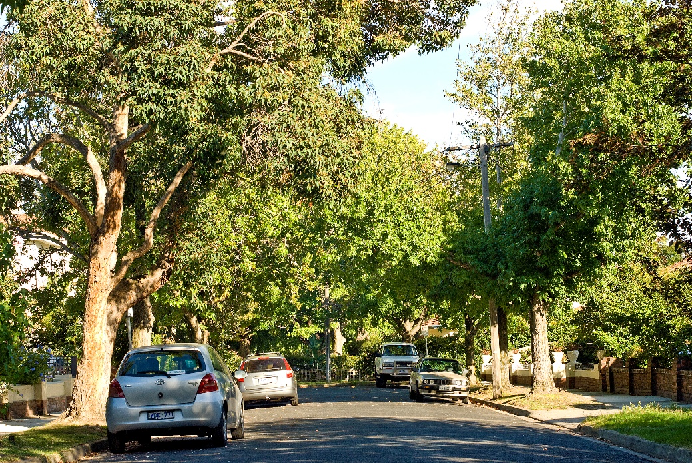

Assessment of Council’s approach to consultation  Respondents were asked to indicate their level of agreement with the following two statements:  - Council provided me with access to information to enable me to meaningfully participate in this process  - Council actively supports community involvement in decision-making  Results are presented in the chart below. Note that only 520 respondents answered the first question, and 517 answered the second, therefore percentages do not add to 100%. |  | Findings  - These results indicate an overall sense that respondents wish to be more involved in the decision-making process regarding changes to their community, with just over a quarter of respondents agreeing (21%) or strongly agreeing (5%) that Council actively supports community involvement in decision-making.  - Just under half of respondents (48%) agreed that Council provided them with access to information to enable them to meaningfully participate in this process, while 37% of respondents disagreed.

How could we have made your experience with the consultation process better?
People want to hear directly from Council  People were often displeased that they learned of the consultation through sources other than the Council, e.g., by word of mouth, community newsletters, or seeing it shared on social media by friends or community groups. People stated they would prefer to have been informed via a newsletter, letter drop, poster, or other advertising in their neighbourhood, and some wanted more opportunities to engage in-person, such as through community meetings or focus groups.  People also noted that this was especially important given the timeframe, which was described as too short or at an inconvenient time (pre-Christmas) for people to give considered feedback.  I was disappointed to find out about this via community social media/newspaper/notes. As a very long-term resident I feel greening our environment is crucial, particularly now we see such residential growth. That there is a proposal that addresses this, that I found out about indirectly is disappointing. | More active and deliberative engagement with communities  People felt Council should have talked to people in the community before they developed the guidelines and called for more in-depth engagement to ensure the guidelines reflected community values and needs.  Some were sceptical that the consultation was in good faith, worrying that outcomes were predetermined and community voices would not be taken into account.  Recommend that council engages with community representatives (such as the heart gardening project) to understand community values prior to releasing proposals.  Ensure information is clear and survey is easy to navigate  People raised issues they had experienced navigating the online pages and filling out the survey, or pointed out that the consultation excluded people who were not digitally competent. They also wanted language in the guidelines to be clear and straightforward, with images and illustrations to back them up.  The survey assumes an in-depth knowledge of the guidelines. A plain English explanation or questions that provide context/details would be beneficial  Make it easier to find online pages like this! And include the 'have your say' in the other online Port Phillip account I already have.

Longform submissions from groups

Several long submissions were received from various groups. These have been read by Council staff as well as summarised below.
*Note submissions from individuals have been analysed in the same framework as the online survey.
Submissions were received from:
- Australian Institute of Landscape Architects;
- The Heart Gardening Project (Emma Cutting);
- Port Phillip Emergency Climate Action Network;
- Protect our Planes;
- Westgate Biodiversity.

Group name | General position | Key points
Australian Institute of Landscape Architects  Representing over 3500  members, we champion quality design for public open spaces, stronger communities, and  greater environmental stewardship. | The draft guidelines are inconsistent with other Council documents and should be edited to increase discretion and encourage urban gardening. | - Draft guidelines are inconsistent with directions identified in Move Connect Live Integrated Transport Strategy 2018-2028; Places for People: Public Space Strategy 2022-32; and tree protection zones outlined in AS4970.  - Planter boxes do not allow for stormwater management.  - Guidelines should enhance urban biodiversity and resident participation.  - Overly prescriptive setback requirements result in inequitable access.  - Suggest more discretion on setbacks and short-term use of guidelines.  - See the guidelines as standard defensive rules to be used only in cases of dispute or damage to existing trees or public risk.  - Recommend highlighting benefits of nature strips re cooling and canopy increase.  - Recommend a precinct-based street master-planning and design process with resident involvement to meet Council’s various social and sustainability outcomes.  - Consider how the guidelines can assist in the understanding and assessment of landscape performance.
The Heart Gardening Project (Emma Cutting)  The Heart Gardening Project’s purpose is to “heal humankind by creating biodiversity in our cities.” Since 2020, the project has created over 70 street gardens, and worked with volunteers, households and organisations to plant over 5000 plants and cover over 454 square metres with indigenous-focused gardens as part of the Melbourne Pollinator corridor. | The comprehensive submission opposes the draft guidelines, which are seen as at odds with Council’s strategic direction and as reducing opportunities for street gardening. | - Draft guidelines don’t align with other Council objectives.  - Emphasises social amenity and biodiversity/climate benefits of street gardens.  - Commends Council’s emphasis on safety, accessibility, and tree maintenance but views current approach as unnecessarily conservative, with supporting evidence.  - Suggests that safety and accessibility can be achieved through more flexible guidelines.  - Suggests that draft guidelines will result in the removal of many current gardens and that they will deter gardeners or result in non-conformance due to being overly complex and inflexible, especially regarding clearance requirements.  - Raises consultation and evidence issues regarding lack of consultation with Traditional Owners and other stakeholders, and lack of spatial analysis and socio-economic research.  - Tone is negative and disempowering.  - Recommends rewriting the guidelines with community input and aligning them with community desires.  - Offers a range of suggestions around guidelines for planting height, planting around trees and tree squares.  - An extensive array of supporting documents accompanied the submission. These included:  - Multiple statements of support from various experts and locals highlighting the overwhelming biodiversity benefits of street gardening, particularly the Heart Garden’s concept of a connected corridor, as well as the aesthetic and wellbeing benefits.  - A letter of support from Sir David Attenborough praising the Heart Gardening Project’s work.  - Various NSGs from across Australia were offered as positive examples to emulate, alongside possible initiatives inspired by other councils.  - New suggested guidelines for specific types of street contexts.  - Research around tree safety in support of more lenient guidelines for planting around trees.  - Results of a Connection and Safety survey carried out by the Heart Gardening Project which highlighted support for street gardening and its social and wellbeing benefits.  - A biodiversity report detailing the species present at 3 street garden sites (all of which would be deemed non-compliant).  - Reference to the 5890+ signatures on the “Keep street gardening growing in City of Port Phillip” petition, which reads: “We are asking Mayor Marcus Pearl and the Councillors of City of Port Phillip Council to arrange a rewrite of the new draft nature strip guidelines so that they are inclusive, empowering, researched properly, thought through and not only celebrate current street gardeners (who are out making our city more beautiful) but also encourage others to make a safe, informed and positive difference to their community and their planet.”
Port Phillip Emergency Climate Action Network | Oppose draft guidelines as they currently stand due to disconnection from Council’s other sustainability objectives and concern that draft guidelines disincentivise gardening and detract from environmental benefits. | - Draft guidelines are unnecessarily restrictive, and at odds with Council’s wider greening, open space and climate strategies.  - Removal of existing gardens due to non-compliance will result in substantial loss of biodiversity, amenity and social capital.  - More flexible Guidelines need to be developed through a co-design process and must align with Council’s public space and greening policies.  - More broadly, consider how policy can be integrated across all sustainability initiatives and how community and stakeholders can be involved in design and implementation.
Protect our Planes | Concerned that draft guidelines are a risk to plane tree health. | - Unclear whether 2.5m minimum will allow planting in the drip line and affect tree health.  - Suggests the document should state problem being addressed, Council objectives, and offer different pathways to meet these.
Westgate Biodiversity | Opposes current guidelines based on concerns that their restrictive nature will deter street gardening and result in removal of current gardens, with subsequent losses in biodiversity. | - Describes the guidelines as unnecessarily risk-averse and as not taking different contexts into account.  - Considers the restrictions as likely to lead to non-compliance and conflict between Council and community.  - Contends the guidelines disconnect major reserves and will result in significant biodiversity loss, and edible plants rules will lead to various indigenous plants being disallowed.  - Views draft guidelines as inequitable due to clearance requirements meaning nature strips would only be viable in wealthy areas.  - Urges Council to take an encouraging rather than a compliance approach.

Petition
A “Keep street gardening growing in City of Port Phillip” petition was started by Emma Cutting of The Heart Gardening Project. The petition was signed by 5,935 supporters and was received by Councillors (Heather Cunsolo, Peter Martina and Rhonda Clark) at a meeting on March 2nd.
We are asking Mayor Marcus Pearl and the Councillors of City of Port Phillip Council to arrange a rewrite of the new draft nature strip guidelines so that they are inclusive, empowering, researched properly, thought through and not only celebrate current street gardeners (who are out making our city more beautiful) but also encourage others to make a safe, informed, and positive difference to their community and their planet.
The full petition can be found at https://www.change.org/p/mayor-marcus-pearl-keep-street-gardening-growing-in-city-of-port-phillip

Demographics – Respondent Characteristics

Survey respondent characteristics
The demographic information discussed in this section represent only the respondents who completed the survey, either online or in paper format. Demographic information was not collected from those who engaged via email or other platforms.
578 people completed the survey, but not all respondents answered all demographic questions.

Connection to City of Port Phillip  - The majority of respondents (92%) live in the City of Port Phillip area.  - Ratepayers in City of Port Phillip were the second largest group amongst respondents (41%).  - Other response options were all selected by less than 10% of respondents. | Gender  - The gender split amongst survey respondents was uneven with almost two-thirds of respondents (60%) identifying as a woman.  - Less than a third of respondents (29%) stated they were a man.

Age  - The most widely represented age group among respondents was the 35-49 year age group, which made up almost one third of all respondents (30%).  - The 50-59 year age group was the second largest (22%), closely followed by the 60-69 year age group (19%).  - All other age groups were selected by less than 10% of respondents. | Residential suburb (where respondents live)  - The three most common suburbs of residence among respondents were South Melbourne (39%), Port Melbourne (18%), and Albert Park (12%).  - All other response options were selected by less than 10% of respondents.  How respondents heard about the project  - Over half of respondents selected ‘other’ when asked how they heard about this project. Common responses in ‘other’ included word of mouth (through neighbours, friends, and fellow gardeners); social media; social media posts shared via other groups (non-Council); an email through groups such as Compost Revolution or the Heart Gardening project; and, newspapers or radio.  - Of the options presented, the most common answer was ‘Council social media’ (11%).  - This was closely followed by ‘Have Your Say newsletter’ (10%) and ‘Poster/signage’ (9%).

Analysis method and results presentation

Qualitative analysis description  Four questions were asked of survey respondents. Additional emails were analysed within the same framework as the survey. Comments from the two online Q&A sessions have been summarised in their own section.  Global Research analysts read each comment received from the community and coded them into themes and topics, which have informed the discussion in this report.  Comments from respondents have been included in this report verbatim. However, obvious spelling or grammatical errors have been amended for clarity. | Quantitative analysis description  Respondent characteristics and demographic information are presented in charts after the discussion section of this report. Frequency analysis has been completed and percentages are shown, as well as the actual number of those who selected each option. Note that these charts represent only those who responded to the survey as these were the only respondents who were asked to provide demographic information.

This report has been prepared by:
Global Research
150 Office Rd
Merivale
Christchurch 8014
New Zealand
+64 3 355 4562
www.globalresearch.nz

