Skinners Adventure Playground

Stage 1 Upgrade

Engagement one (play-styles) summary report – November 2022

Contents
Executive summary 3
Project background 4
Engagement approach 6
Engagement findings 7

Executive summary
This Engagement Report has been compiled following the conclusion of the first phase of community engagement for the Skinners Adventure Playground Stage 1 Upgrade (10 October – 22 November 2022). The engagement included face-to-face consultation with the playground users, supervising staff, and online consultation with interested community members.

During the engagement period, children who use the playground had the opportunity to provide their feedback on different a variety of play-styles. They were shown a number of different images and were able to vote on their preferred play-styles and elements and provided comments directly on the images. In addition to feedback from the playground users, twelve (12) responses were received from members of the community through the City’s online engagement platform - Have Your Say Port Phillip. Respondents provided their ideas of what they would like to see at Skinners Adventure Playground in the future. A local preschool who regularly attend Skinners was invited to contribute to the face-to-face engagement, however they cancelled their visit during the engagement period, and did not contribute.

The information received during the engagement period will be used to develop a concept plan for the new play equipment. The concept plan will be circulated in the second phase of engagement, with Skinners Adventure Playground users, supervision staff and the local community to provide feedback, and to confirm the final plan.

Every effort has been made by the authors of this document to represent accurately participant feedback and insights.

Project background
Adventure Playgrounds:
Two Adventure Playgrounds are located within the City of Port Phillip, Skinners Adventure Playground, South Melbourne, and the St Kilda Adventure Playground. They are special purpose, staffed facilities that have restricted opening hours and have been designed as big 'backyards' for the local children in public housing. For many families, the playgrounds are more than just a 'backyard'. While primarily an exciting place to play, adventure playgrounds are a place where vulnerable families can access service information and referral to a broader wellbeing support network within the community. Adventure playgrounds are unique environments that provide a recreation space for children to explore, use their imagination, and play in a space that encourages risk taking within safe boundaries.
Adventure playgrounds differ from public playgrounds for the following reasons:
- They are only open at certain times.
- Children are supervised at all times the playground is open.
- Generally, there is less emphasis on the provision of manufactured play equipment.
- There is a greater emphasis on creative, social, and cognitive play types. This could be through unstructured experimental play or through the delivery of structured activities.
- Activities with greater elements of risk are acceptable and encouraged within the boundaries of a safe community space.
- They provide an increased level of engagement with the community and family.
- They are often referred to as communal backyards.
- They often have a haphazard, uncoordinated appearance.
- Adventure Playgrounds often incorporate nature, water features, community buildings and informal landscapes.

Skinners Adventure Playground:
The City of Port Phillip has managed Skinners Adventure Playground from 1981 and has fully funded the operations of the site since federal funding ceased in 2014. The vast majority of the play equipment at Skinners had been built by adventure playground staff, volunteers and community groups over the past decades, with the majority of materials being donated from hard rubbish, construction sites and community groups. In a changing risk environment, much of the equipment no longer aligns with Council’s risk mitigation process, due to the lack of structural information, compliance documentation and adherence to the relevant Australian standards.
In November 2021, Council engaged an independent OH&S consultant to undertake a comprehensive audit of the compliance and associated risk related to the play equipment and operational procedures at the site. A carpentry contractor was also engaged to undertake a review of the existing play equipment focusing on the structural integrity, to provide recommendations for remediation and/or removal. Upon completion of the reports any equipment that was identified as unsafe and at the end of its life was removed from the site in mid-2022.
Council has committed to a complete upgrade of the site in the 10-year financial plan. To ensure the continuation of play services at the site and to increase the safety and compliance of equipment, Council will undertake ‘Stage 1’ works while a long-term Adventure Playground strategy is undertaken. The Stage 1 works are aimed at ensuring that the site is usable in the short-term and replacing the play equipment that was removed at the Moray Street end of the site. Wherever possible, works implemented as part of Stage 1 should be re-used and/or incorporated into the future complete site upgrade.

Adventure Playground Vision and Design Principles:
As part of Council’s commitment to Adventure Playgrounds, a specific Vision and Design Principles have been adopted, and must be considered for this project:
VISION
Adventure Playgrounds provide safe and welcoming spaces that honour diversity, build resilience and creativity, provide social connections, and encourage all children and families to maximise their development outcomes
DESIGN PRINCIPLES
- Facilitate risky (but safe play)
- Be accessible, safe, and welcoming for all; meeting DDA and CPTED best practice
- Provide connection with nature and the natural environment
- Place children and young people at the heart of design
- Provide a unique aesthetic that recognises the past and is delivered for the future.

Engagement approach
- Playground users were asked to provide feedback via:
- Morning and afternoon face-to-face engagement sessions held over a two-week period at Skinners Adventure Playground, which were facilitated by the supervising staff.

- Playground supervising staff were asked to provide feedback via:
- One face-to-face engagement session with the Project Manager; and
- An email to their Coordinator.

- Community stakeholders were asked to provide feedback via:
- Morning and afternoon face-to face engagement sessions at Skinners Adventure Playground run by the supervising staff;
- Council’s ‘Have Your Say’ webpage – survey and questions; and
- Council’s social media pages - Facebook and Instagram.

Stakeholders were informed about the engagement in the following way:
- Signage displayed at Skinners Adventure Playground;
- Email notification to followers of the previous Adventure Playground projects on Council’s Have Your Say webpage;
- Personalised email from the Executive Manager Family, Youth & Children and Divisional Performance to key stakeholders, advising them of the consultation and inviting and encouraging them to participate; and
- Social media posts on Council’s Facebook and Instagram pages.

Engagement findings
Face-to-face engagement (playground users):
The children who use the playground had the opportunity to provide their feedback on a variety of different play-styles at nine (9) face-to-face engagement session facilitated by the supervising staff over a two-week period from 10 October to 23 October. Approximately sixty (60) children were involved in the engagement sessions.

The children were shown a number of different images for a range of play-styles and provided feedback on their preferred play-styles and elements. All responses from the face-to-face engagement sessions are shown in the table below, ranked in order of most popular to least popular:

Ranking | Play style | Item | Responses
=1 | Multi-play unit styles | 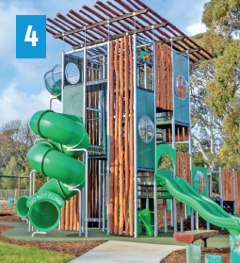 | TOTAL RESPONSES: 12  LIKES: 11  - “So many slides”  - “Really tall”  - “Lots of sticks and things to do”  - “Looks like you can have a lot of fun”  - “Looks cool”  - “It’s got lots of thing to do on it”  - “Looks fun”  - “Because it’s big”  - “Lots of places, lots of slides”  - “It’s big with multiple slides”  - “Lots of different levels is great. Good to have lots of different slides/ways to get up and down. It’s good that it’s big and high and lots of lookouts”  DISLIKES: 0  OTHER: 1  - “Would like secret underground base, maybe with a tunnel”
=1 | Rocking & Spinning | 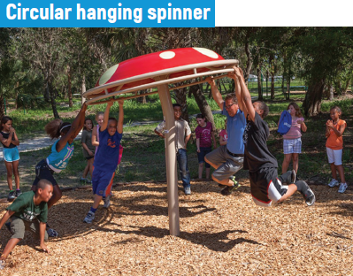 | TOTAL RESPONSES: 12  LIKES: 11  - “Looks fun” x 3  - “I love swinging” x 2  - “Looks like Mario Kart and spinning”  - “It’s more risky + you can fit more kids”  - “I love hanging with friends”  - “Fun – hold & spin”  - “This looks like awesome fun with friends”  - “Looks really fun +we get to spin around”  DISLIKES: 1  - “Little kids can’t play on it; it will be unfair”
2 | Swinging | 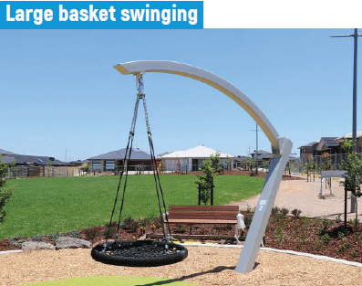 | TOTAL RESPONSES: 10  LIKES: 10  - “My favourite thing to do is swinging”  - “I like swinging and relaxing”  - “I like this because it’s bigger and more people can fit”  - “Relaxing”  - “It can swing in all directions”  - “I like this one because more people can play at a time”  - “You can spin really high”  - “I love swinging and it’s big so I can go on it with friends”  - “I can swing with my friends”  DISLIKES: 0
3 | Multi-play unit styles | 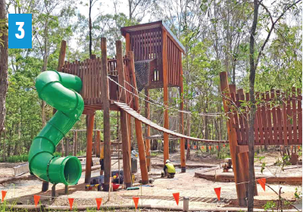 | TOTAL RESPONSES: 9  LIKES: 9  - “I like how it’s super tall!”  - “I like climbing”  - “Looks more like a jungle”  - “Reminds me of an Xmas workshop”  - “Reminds me of the old cubbies”  - “Lots of stuff on it, the bridge, different levels and fun”  DISLIKES: 0
4 | Rocking & Spinning | 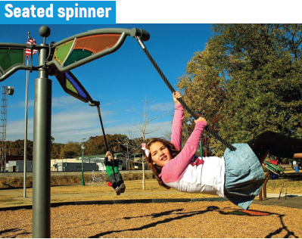 | TOTAL RESPONSES: 8  LIKES: 8  - “It looks the funnest”  - “I like this the most”  - “I like the spinning and it looks comfy”  - “I love spinning”  - “This could be a present launching machine for Xmas”  - “You can spin around while sitting”  - “You can sit down + relax”  DISLIKES: 0
5 | Water Play | 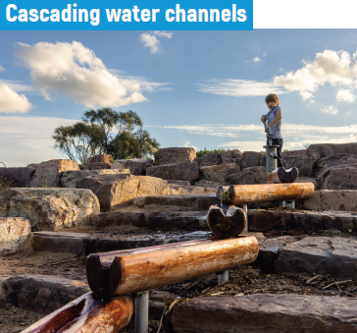 | TOTAL RESPONSES: 9  LIKES: 8  - “It looks like the outback”  - “I love the water and good for summer”  - “You can drink the water instead of going home and drinking”  - “It reminds me of a coal mine”  - “I like the logs!”  - “I really like this one – versatile (multiple ways) not many playgrounds have it”  - “I love the water coming down the logs”  DISLIKES: 0  OTHER: 1  - “Could be similar to the playground next to the Children’s Hospital – Kids build a dam then it floods”
6 | Sliding | 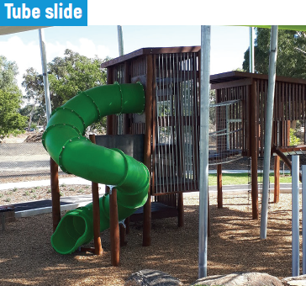 | TOTAL RESPONSES: 7  LIKES: 7  - “I like the slide and when we play police we can put people in the gaol”  - “I like this one because it’s smooth and safer”  - “I like the slide”  - “It’s the most interesting – tunnel slides are good”  - “I like the big green slide”  DISLIKES: 0
=7 | Swinging | 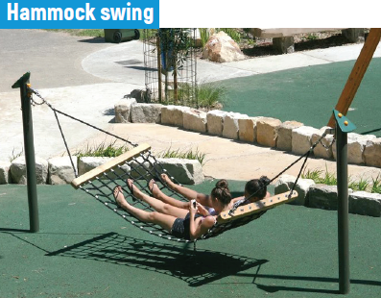 | TOTAL RESPONSES: 7  LIKES: 7  - “I wanna swing”  - “Relaxing”  - “It looks relaxing after a big day at school”  - “I like that you can lay on it”  - “You can relax on sunny days”  - “I can take a nap”  - “I can chill out on it”  DISLIKES: 0
=7 | Nature Play | 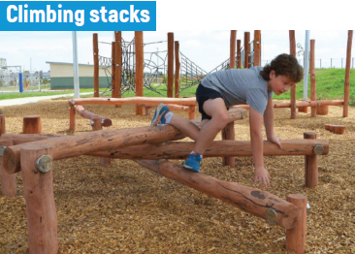 | TOTAL RESPONSES: 7  LIKES: 7  - “I love climbing”  - “You have to balance or you will fall”  - “I like climbing”  - “We get to do lots of climbing + that is fun”  - “Looks a lot more fun”  DISLIKES: 0  OTHER: 1  - “Getting a really big version of this like the Children’s Hospital would be better”
8 | Climbing | 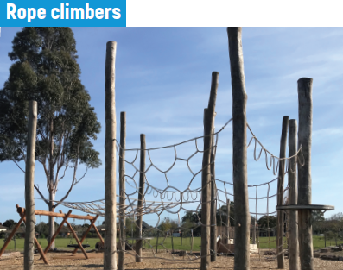 | TOTAL RESPONSES: 7  LIKES: 6  - “It’s sick and really big, so it’s more fun”  - “I like to climb”  - “Multiple games you could play & looks fun to play on!”  - “Being able to play floor is lava and not touch the ground & tiggy off the ground”  - “High ropes course is cool”  - “Good for climbing”  - “We get to do lots of climbing”  DISLIKES: 1  - “I’m scared of this because it’s so high”
9 | Cubbies | 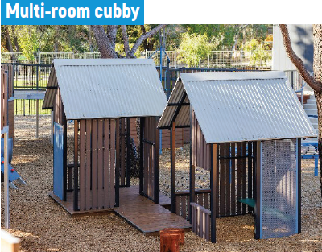 | TOTAL RESPONSES: 5  LIKES: 5  - “Because there is more than one room”  - “You can put animals in it”  - “You can hide in it”  - “This could be the list checking room for Santa”  - “Looks fun”  DISLIKES: 0  OTHER: 0
10 | Multi-play unit styles | 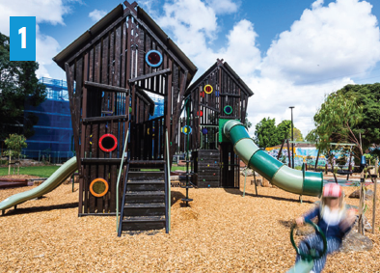 | TOTAL RESPONSES: 6  LIKES: 5  - “Lots of stuff to do on it”  - “The slide looks like the old cubbies”  - “Lots of stuff to do”  - “I like the coloured windows”  DISLIKES: 1  - “Too boring, not good for hiding (see through)”
11 | Climbing | 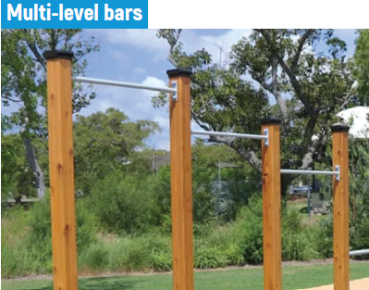 | TOTAL RESPONSES: 8  LIKES: 5  - “I can do flips on it and climb on it”  - “I like monkey bars”  - “We can do cool tricks on it”  - “Monkey bars”  DISLIKES: 2  - “It looks too plain”  - “I don’t like this one”  OTHER: 1  - “I want AFL goals”
=12 | Multi-play unit styles | 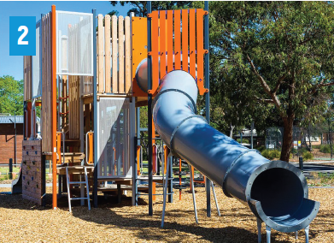 | TOTAL RESPONSES: 4  LIKES: 4  - “Climbing & sliding”  - “Big slide”  - “Lots of elements”  - “I like the slide and climbing”  DISLIKES: 0
=12 | Nature Play | 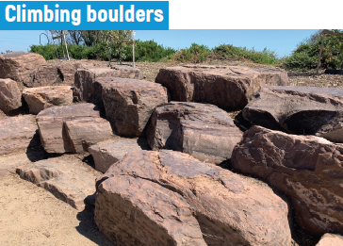 | TOTAL RESPONSES: 4  LIKES: 4  - “I want this because we can play zombies on it”  - “It’s like the floor is lava”  - “I like these – we can pretend it’s mountains. It would be good to have challenging big rocks to do parkour”  DISLIKES: 0
13 | Climbing | 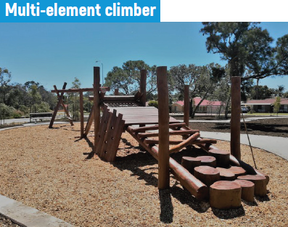 | TOTAL RESPONSES: 3  LIKES: 3  - “I like this because it looks like you can do parkour”  - “You can do lots on it”  - “multiple stuff to do”  DISLIKES: 0
=14 | Water Play | 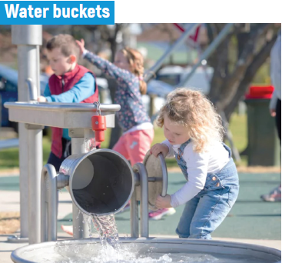 | TOTAL RESPONSES: 3  LIKES: 3  - “I like to play with water”  - “You can pop a cup under it”  DISLIKES: 0
=14 | Swinging | 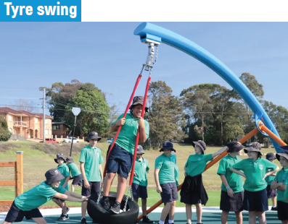 | TOTAL RESPONSES: 3  LIKES: 3  - “This is ting ”  - “It’s different because you can stand and swing”  - “I like the tyre”  DISLIKES: 0
=15 | Cubbies | 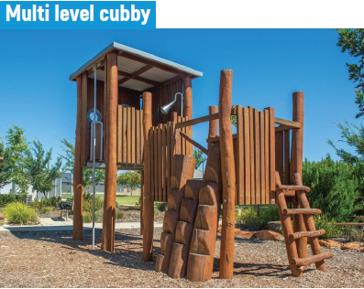 | TOTAL RESPONSES: 4  LIKES: 3  - “You can climb it and it has more things to do”  - “Multi-level cubbies are awesome. Having more than 1 or 2 means a group(s) of kids can have a base each and not fight over the 1 or 2”  - “Tall and not boring like the others”  DISLIKES: 0  OTHER: 1  - “It has to be a proper shelter to be able to hide from rain”
=15 | Sliding | 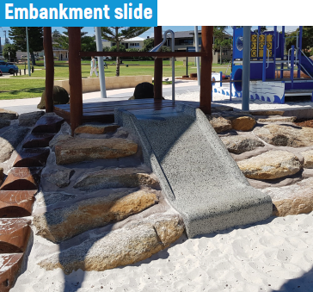 | TOTAL RESPONSES: 4  LIKES: 3  - “Slide to sandpit is cool”  - “Good to have one little one with sand so the little kids are away from the big kids”  - “This could be the candy cane conveyer belt”  DISLIKES: 0  OTHER: 1  - “I like the cubby in the background”
16 | Sliding | 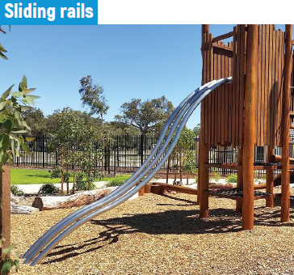 | TOTAL RESPONSES: 6  LIKES: 3  - “I like that it’s risky”  - “It’s got a metal slide”  DISLIKES: 3  - “This one looks uncomfortable”  - “Worst one in the world”  - “Looks like you can break your head open”
=17 | Rocking & Spinning | 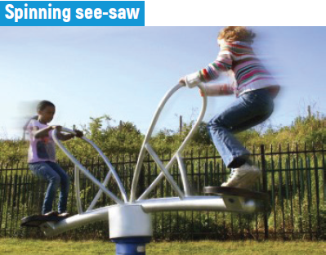 | TOTAL RESPONSES: 2  LIKES: 2  - “I like it because you get dizzy”  - “I like how you bounce”  DISLIKES: 0
=17 | Rocking & Spinning | 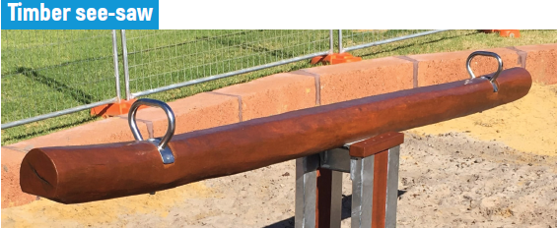 | TOTAL RESPONSES: 2  LIKES: 2  - “My sister would love this, good for little kids”  DISLIKES: 0
18 | Nature Play | 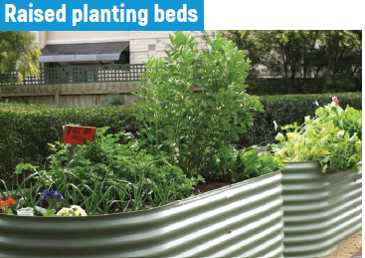 | TOTAL RESPONSES: 3  LIKES: 2  - “I get to water the plants”  DISLIKES: 1  - “I don’t like any of these because they are boring”
=19 | Climbing | 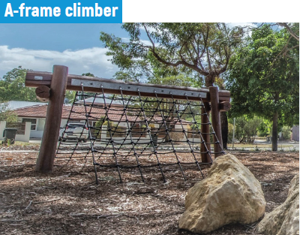 | TOTAL RESPONSES: 1  LIKES: 1  - “Fun to race with friends climbing”  DISLIKES: 0
=19 | Nature Play | 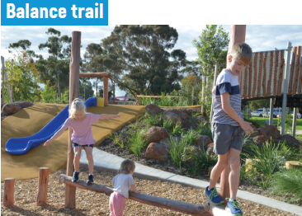 | TOTAL RESPONSES: 1  LIKES: 1  - “Because it’s fun”  DISLIKES: 0
=19 | Sliding | 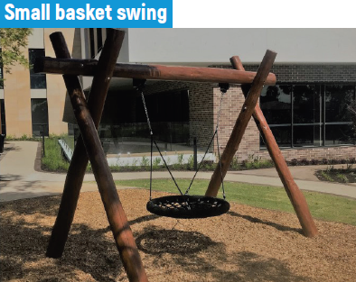 | TOTAL RESPONSES: 1  LIKES: 1  - “I like swinging”  DISLIKES: 0
20 | Water Play | 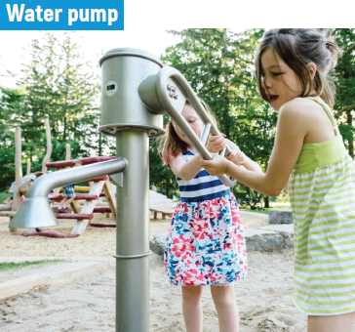 | TOTAL RESPONSES: 2  LIKES: 1  - “Great for summer”  DISLIKES: 1  - “A bit boring for me”
=21 | Cubbies | 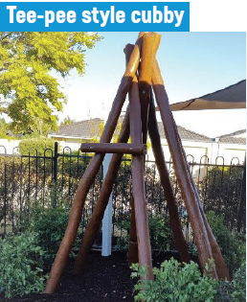 | TOTAL RESPONSES: 3  LIKES: 1  - “I like to hide and play games”  DISLIKES: 2  - “This looks small, boring and non-waterproof!”  - “If it had a cover over it would be much better”
=21 | Cubbies | 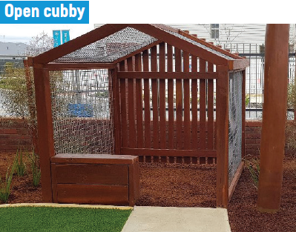 | TOTAL RESPONSES: 3  LIKES: 1  - “I like”  DISLIKES: 2  - “Not proper shelter”  - “This sucks”
=22 | Nature Play | 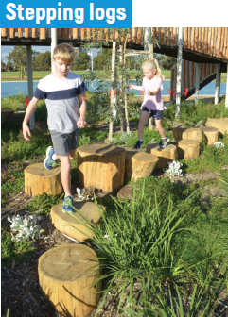 | TOTAL RESPONSES: 1  LIKES: 0  DISLIKES: 1  “Looks a bit plain”
=22 | Nature Play | 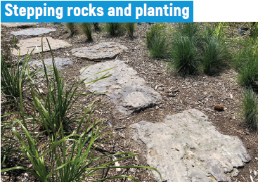 | TOTAL RESPONSES: 1  LIKES: 0  DISLIKES: 1  - “Everything here can be found in local parks, with nothing unique to Skinners Adventure Playground which has been a large part of the attraction to the park here!”
 | Other |  | Some playground users also submitted ‘wish lists’ of items that they would like to see included in the playground, including:  - A tree house (5)  - Trampolines (5)  - A camping area (2)  - A dancing stage (2)  - A pool/hot tub (2)  - A silver & gold area (2)  - A zip line (3)  - Bigger monkey bars (2)  - Bumper cars (2)  - Electric scooters (2)  - Go karts (3)  - Swings (2)  - Twisty cups (2)  - An art room (1)  - A face painting area (1)  - A helicopter (1)  - A pirate ship (1)  - A rock wall for climbing (1)  - A salon area (1)  - A seesaw (1)  - A sky playground (1)  - A water gun area (1)  - Bigger/taller slides (1)  - Giant Jenga (1)  - Lots of little hiding places for hide and seek (1)  - Pillows (1)  - Twisty slides (1)  - Wissy dissy (1)

Face-to-face engagement and email correspondence (Supervising staff):
After facilitating the consultation sessions with the playground users, and reviewing the draft version of this report, the Skinners Adventure Playground supervising staff had the opportunity to provide their feedback via email, and at a face-to-face engagement session on 22 November 2022.
Feedback at the face-to-face session was provided from three (3) supervising staff members, and email feedback was received from one (1) additional staff member.
The main themes that arose from their feedback were:
- Equipment colours, materials and shapes
- Opportunities for art/personalisation of the equipment
- Number of equipment pieces and mix of spaces
- User age range
- Shade and water
- Other play equipment to be considered
Specific comments about the equipment or use of the playground included:
Theme | Feedback
Equipment colours, materials and shapes | - Like that the equipment will be made from treated timber and that it will be Australian made.  - It would be great to be able to incorporate colour into the equipment - the staff and children would like to have input into the colours  - Use different shapes of equipment i.e., spheres, pyramids, cubes etc. Three items of different shapes were suggested.  - I would love to see more areas for climbing using the natural surroundings (climbing rope on trees) etc.  - Wooden fort / cubby structure with lots of different elements on it, such as slides, swings, flying fox, moving bridges, climbing wall and a maze  - Creative, man-made, reflect St Kilda, different, quirky, fun, sustainability, reference to its history, recycled wood, colourful
Opportunities for art/personalisation of the equipment | - Most of the options looked like equipment that you can find in any other playground  - It would be great to have opportunities to incorporate art to personalise
Number of equipment pieces and mix of spaces | - It would be good to have one big piece of equipment and some smaller equipment pieces so smaller groups can play away from the larger unit  - A large basket swing or hammock swing would be useful for calming a child who might need some time alone  - Having a combination of play and chillout spaces  - Need to have the equipment targeted at the core user group; 5- to 12-year-olds as opposed to catering for much younger children  - I would love to have a sensory chill out area, an area that was multi-tactile with the objective to calm children that are over regulated
Shade and water | - A water play element would be good as it was something the children enjoyed at Skinners when the ponds existed  - A water play area is a great idea for summer  - Shaded spaces would be good to enable play all year round
Other things to be considered | - Flying fox activity incorporated into the activity – a short distance, not too high off the ground.  - An open space for sport – football/soccer goal posts etc. Some children are more sport oriented and would rather kick a ball around than play on equipment  - Not really interested in garden beds as they already exist, and the children aren’t really interested in gardening  - Sheltered chill out area for parents to sit and chat  - Play equipment at the following playgrounds:  - Play equipment at Northcote Arts school (High Street)  - Fitzroy towers playground  - Alma Park slug  - MpPA: Museum of Play and Art

Online engagement – Have Your Say webpage (Community):

The survey on Council’s Have Your Say consultation platform was open from 10 October to 23 October 2022. During this time the page received One hundred and fifty-eight (158) views and a total of twelve (12) responses to the survey.
Of these respondents, ten (10) had visited the playground and two (2) lived close to the playground.
- One (1) visited daily
- Two (2) visited a few times a week
- One (1) visited every few months
- Four (4) visited a few times a year
- Three (3) didn’t visit the playground
The play-styles question was answered by one person who was aged under ten (10) years of age. This respondent identified that swinging, sliding, climbing, cubbies and the trampoline are their favourite things to do in a playground.
The remaining respondents were aged 25 to 69 years of age and they provided their comments on what they would like to see at Skinners Adventure Playground in the future.
The main themes that arose from their feedback were:
- Maintain risky/adventurous play (4)
- Maintain natural setting/recycled feel of equipment (4)
- Maintain supervised play (3)
- Update equipment to make it safer (2)
- Concerns about safety of surrounding area (2)
- Have consistent opening hours (1)
Specific comments about the equipment or use of the playground included:
- Create separate areas for younger and older children
- Provide cubby houses and swings for younger children
- Create a family space with a BBQ, toilets, and area for teenagers
- Liked that the trampoline was a feature and equipment was made of everyday objects such as a wheelie bin tunnel.
The feedback received for this consultation can be found in Appendix 1 of this document

Online engagement – Council social media pages (Community):

Information relating to the engagement was posted on Council’s Facebook and Instagram accounts. The Facebook post reached the 14,000 people following Council’s Facebook page, with a total of 5 users reacting to the post, and 1 user sharing the post. No comments were received.
The Instagram post reached Council’s 6,260 followers and received 11 ‘likes’ and 1 comment was received which provided play suggestions for the upgrade project, including a new trampoline area, staircases and cubbyhouses, an art wall and a maze.

Appendix 1 – Feedback received via Have Your Say:

Response | Comment | Connection to the playground | Age group
 | Swinging, sliding, climbing, cubbies and the trampoline are favourite things to do in a playground. | Visits a few times a year | Under 10
 | Better play equipment, but please keep the trees / natural setting. | Visits a few times a year | 25 to 34 years
 | Ongoing opportunity for kids to take calculated risks in a creative and adventurous space | Visits every few months | 35 to 49 years
 | Workers on-site, ongoing programs. For Skinners to retain its 'Personality' for future generations. New installations with the creativity and recycled nature of the existing equipment and the return of resources like tires & planks for kids to explore build and create themselves. Risk taking play! | Visits a few times a week | 35 to 49 years
 | I have a toddler daughter and we live across the street. I love Skinners and hope the staffed hours will continue, perhaps with even more reliability (sometimes when I think the playground will be open it is closed and I'm not sure why.). | Visits a few times a week | 35 to 49 years
 | Safer adventure and nature play equipment. It’s a great playground but needs to be more inviting, with separate areas for little kids and big kids. | Visits a few times a year | 35 to 49 years
 | I am concerned about safety, criminality, drug dealing, and the proximity to the walk-up flats windows, as well as the close proximity to brothels on the street: how can this all be made safe and open to the best standard in Australia? This is what the kids and families need. | Lives nearby but doesn’t visit | 50 to 59 years
 | I would like this playground to be wonderful and a completely safe place for children and families...I am very concerned about the drug dealing and criminal activity, which is constant threat to everyone's safety here, including children, and needs to be addressed. | Lives nearby but doesn’t visit | 50 to 59 years
 | I would like to see a chubby house and a swing set for the young ones to play on | Visits daily | 35 to 49 years
 | A different and more adventurous experience to the usual "cookie-cutter" style playgrounds, and one that incorporates copious large canopy trees and plants to give a more natural bush-like environment. Materials should be natural and organic, rather than plastic. Staff presence is a must for safety. | Visits a few times a year | 60 to 69 years
 | A place for families to gather with picnic tables, BBQ, toilet facilities and an area for teenagers | Don’t visit the playground | 50 to 59 years
 | Keep the adventure side of the playground. My son absolutely loved to see how the playground was built using “every day” objects like the tunnel made of wheelie bins. Also loved the trampolines. There was no other playground that had them and we simply don’t have the space to have one at home. | Was a regular visitor but their child has outgrown the equipment | 50 to 59 years

