Sandridge Bay Trail Safety Project, Port Melbourne - Community Engagement Summary Report
June 2023

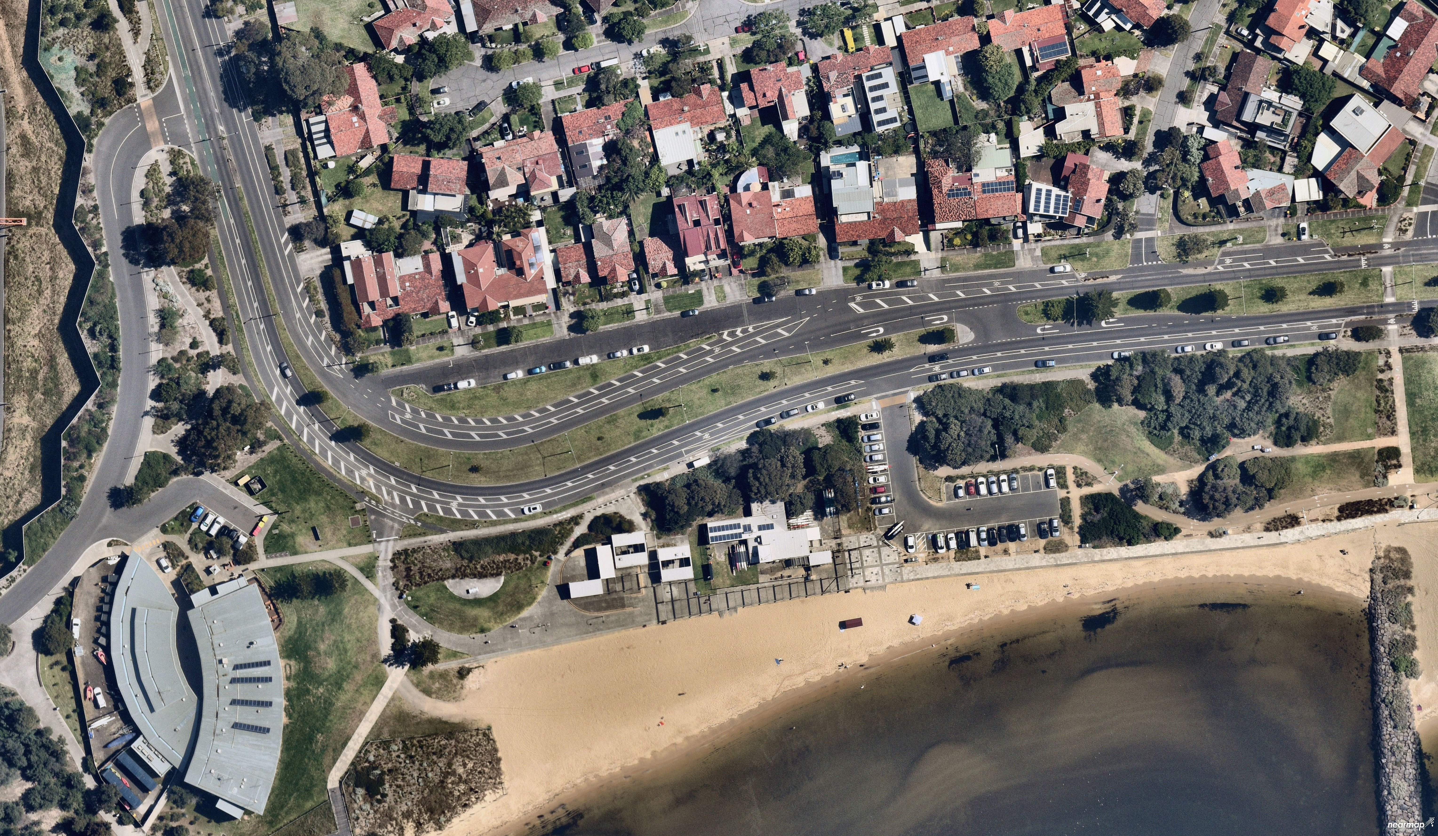

Executive Summary
There is an opportunity to make Sandridge Bay Trail (at Sandridge Life Saving Club) safer for all.
From Tuesday 14 March to Sunday 16 April 2023, the City of Port Phillip asked for community feedback on existing safety concerns including how pedestrians, cyclists and cars move around the space and interact with each other.
Participants were asked to review the list of safety concerns Council had already identified and aimed to address and to identify if there were any additional safety concerns that had been missed.
These issues already identified by Council included:
- Cyclists riding on pedestrian only paths
- Bus stop shelter creating a visual and physical barrier for path users
- Pedestrians and bike riders sharing narrow paths along The Boulevard creating congestion and collision risk
- Conflict between drivers, bike riders and pedestrians at Sandridge Life Saving Club carpark entrance
- Intersecting pedestrian and bike rider path risks
- Overgrown shrubs impacting sightlines and safety for path users
- Inadequate lighting along the bike path
- Vehicles illegally accessing the foreshore reserve and beach (often with jet ski/PWC trailers)
A total of 34 people provided feedback via the online Have Your Say page, with an additional one by direct email. There was an overall positive response from respondents in support for the project. Majority of the issues raised by respondents were issues Council had already identified.
Of the additional issues raised, some have been referred onto the relevant departments within Council.
- 23 of respondents agree with the items listed or reiterate issues identified by Council
- 22 of respondents were concerned with cyclist safety and
- 14 being concerned with pedestrian safety
- 15 respondents reiterated their concerns with the bus shelter
- 4 respondents raised issues which have been forwarded to relevant teams within Council for response.

Information received from the community during this consultation period will be considered to assist with progressing the design.

Introduction

Project background
The Bay Trail runs the length of the 11km of the municipality’s foreshore. It is heavily used and caters for pedestrians and cyclists (recreational and commuter).
Council heard from the community about the existing safety concerns including how pedestrians, cyclists and cars move around the space and interact with each other.
Council is undertaking an upgrade to the area around the Bay Trail at Sandridge beach to create a safer area for all to enjoy.
Whilst we have been able to address some of these concerns with smaller safety works already, there is now an opportunity to make more comprehensive improvements to resolve the community’s concerns with safety.
The safety concerns already identified by Council are:
- Cyclists riding on pedestrian only paths
- Bus stop shelter creating a visual and physical barrier for path users
- Pedestrians and bike riders sharing narrow paths along The Boulevard creating congestion and collision risk
- Conflict between drivers, bike riders and pedestrians at Sandridge Life Saving Club carpark entrance
- Intersecting pedestrian and bike rider path risks
- Overgrown shrubs impacting sightlines and safety for path users
- Inadequate lighting along the bike path
- Vehicles illegally accessing the foreshore reserve and beach (often with jet ski/PWC trailers)
Community consultation seeking feedback on the concept design was held over March/ April 2023. Information received from the community during this consultation period is presented below and will be considered to assist with progressing the design.
Every effort has been made by the authors of this document to represent accurately participant feedback and insights.

What we set out to achieve
The purpose of the community engagement was to:
- Understand if the issues identified by Council were accurate and correct
- Understand if there were further issues Council had missed

Engagement questions
Participants were asked the following questions:
- Please review the list of safety concerns (above) we've already identified and aim to address. Is there anything that we've missed?
- How do you use this area?
- Which of the following describes your connection to the City of Port Phillip?
Participants were also asked to respond to a range of demographic questions, including:
- Age bracket
- Gender; and
- Residential suburb

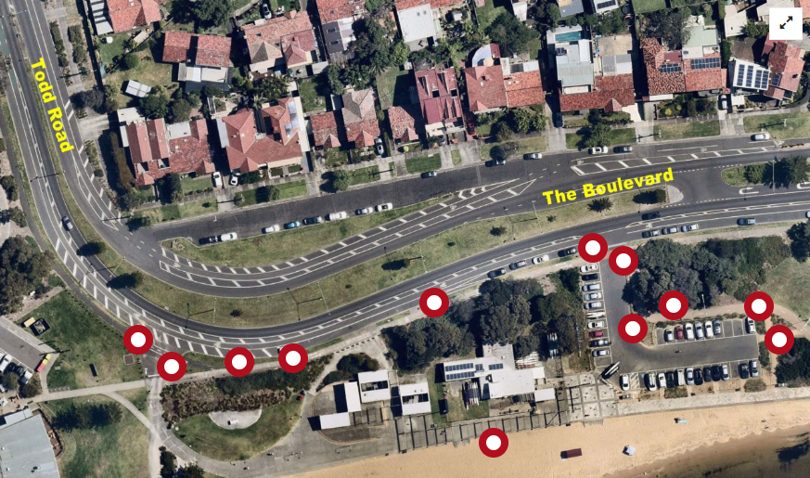 Figure 1: Sandridge Bay Trail – markers indicate areas that require solutions to address safety concerns ©nearmap

What we did

Engagement activities
The following engagement activities were undertaken during this project:
- An online survey hosted on Council’s Have your Say project page
- On site posters/ letter drops and emails to relevant parties.
- Emails sent to Life Saving Victoria, Sandridge Life Saving Club, Bicycle Network, Beacon Cove Neighbourhood Association

Participation
Participation snapshot:
- 378 views of the Have Your Say page
- 34 contributions to the survey
- 11 people followed the project page
- Bicycle Network promoted the consultation to their website
- 1 letter received via email

Strategies to support participation
Community participation was supported through the following initiatives:
- Dedicated Project Page: a dedicated project page was created on Council’s Have Your Say (HYS), a central online location for community to access information and participate in the survey.
- HYS posters: in key areas around the site.
- Letterbox drop: to residents facing The Boulevard opposite the site area.
- Emails: to directly impacted associations: Life Saving Victoria, Sandridge Life Saving Club, Bicycle Network, Beacon Cove Neighbourhood Association.

Who we heard from

Age of participants
The highest represented age group of participants was 35 – 49 years, 12 participants or 34% of total participants. The second highest represented age group were 50 – 59 years, with 7 participants or 20% of total participants.
A breakdown of participants’ age groups can be seen in the chart below.

Figure 2: Participant age groups

Gender of participants
97% of participants identified their gender. Of those participants who identified their gender, 51% (18 participants) reported to identify as a man or male and 46% (16 participants) identified as a woman or female. 3% (1 participant) preferred not to say.
A breakdown of participants’ gender can be seen in the chart below.

Figure 3: Participant gender

Participants by suburb
Participants were asked which suburb they lived in, with the majority of participants (57%, 20 participants) identifying that they lived in Port Melbourne. Five (5) other suburbs within the City of Port Phillip were represented, with these numbers shown in the chart below. Two (2) suburbs outside the City of Port Phillip were identified, Prahran and Carlton.

Figure 4: Participants’ suburbs

Participant connection to the City of Port Phillip
Participants were asked to describe their connection to the City of Port Phillip. The highest reported response (86%, 30 responses) being a resident, followed by ratepayer (43%, 15 responses). 5 (14%) of responses identified as a volunteer or a worker within the municipality.

Figure 5: Participants’ connection to City of Port Phillip

What we heard
Participants were asked to: Please review the list of safety concerns (above) we've already identified and aim to address. Is there anything that we've missed? The key themes that arose from this question are tabulated below including extracts from comments received.
Table 1: Consultation themes
Theme | Number of Responses | Feedback
Agree with the items listed or reiterate issues identified by Council | 23 | “Thank you for addressing these issues especially the ones about pedestrian safety and the interface with cyclists (and e- scooters).”  “I agree with the items in your list.”  “Your list looks very thorough.”  “No, I share these concerns.”  “Agree with the list.”  Of the 35 comments received, 4 respondents chose to provide no additional comments.
The main concerns from the community were around Cyclist and Pedestrian safety:
Cyclist Safety | 22 | ISSUES  - Provide separate bicycle lane  - Improve cyclist safety at bus shelter  - Improve cyclist safety at carpark crossing and speed trap  - Improve maintenance along cycle paths  - Improve signage and navigation throughout the area  - Pedestrians on cycle paths  - Sand build up on paths  “Separate delineated safe bike lane should be built on the road”  “Improve cyclists safety at bus shelter: currenty shared path is really narrow and puts cyclists at risk....”  “There need to be a proper bike path that leads all the way to Sandridge lookout alongside the walking path...”  “Please create separated bike lanes, by concrete bollards on the ground as an example. The Netherlands do this so well, it encourages more active transport and relies on the principal that no traffic, such as foot or car and cycle traffic, should be competing...”  “Sometimes there is sand build up on the bike paths which can cause loss of control and accidents. This could be build up from wind, or other vehicles crossing the path.”
Pedestrian Safety | 14 | ISSUES  - Improve pedestrian safety at bus shelter  - Improve pedestrian safety at carpark crossing  - Improve safety for pedestrians crossing the boulevard to Sandridge Beach  - Consider path materiality  - Consider pedestrian safety when crossing the cycle path to the BBQ area  - Consider fencing along carpark (foreshore side)  - Provide separated bicycle lane  “Pedestrian crossing on The Boulevard, near Sandridge beach. I live on the service road coming off Todd road along The Boulevard, with small children. Crossing to access Sandridge beach is hard given the amount of people that speed around that bend. Speed bumps on Todd road and The Boulevard, up to Batman St would slow drivers down. Also a pedestrian crossing with lights would make it safer for people to access the beach. It’s hard to get to a safe spot to cross the road given views of both directions at this particular spot. I’ve seen so many families nearly collected by cars at this spot. There is nowhere safe for pedestrians to cross to Sandridge beach without walking up Todd Rd to the traffic lights.”  “For safety of the users of the Sandridge Beach Facilities, there must be a separation of mechanized (Cycles, e Scooters, skating Boards, etc) and the pedestrians.”  “The area at the end of the provided photo, and just east (right) off the photo is frequently used by large family groups during summer days (typically with large sun awnings). Care is needed when riding through the area as both adults and kids often have little awareness that there is a bike path straight in front of their tent. I have no desire to stop people using the area, but wonder whether thought can be given to how, at least, the adults can be made aware of the pinch point.”  “Have pathway surfaces been considered? Concrete and paving stones are both very hard on foot tread and for an aging population not a favoured surface. Bitumen paths offer a much easier and safer walking surface for long term body health - knees and hips.”
Across the themes of Cyclist and Pedestrian safety, the bus shelter was of common concern:
Bus Shelter | 15 | “Bus shelters on footpath is major issue, impacting pedestrian visibility, the shelters need to be repositioned off the footpath, thank you.”  “The bus shelter creates more than an inability to see oncoming traffic - it creates countless opportunities for collisions and injuries. It is the easily the most dangerous aspect of the cycle path in this area in my opinion. I am thankful that council will be addressing this.”  “The bus shelter is a particularly dangerous obstacle on the path and consideration needs to be given to its relocation...”  “The bus stop shelter is the main one. Plus no crossing at the beach car park entrance.”  “I am a regular bike rider along this route, and agree it is poorly laid out and dangerous. However I am concerned that you already appear to have decided that the bus shelter needs to remain, albeit with some change in layout.  I submit that there is no need for the bus shelter at all, and that it should be removed completely.  - This shelter is barely 500m from the end of the bus route. I have never seen anyone catch a bus there.  - Shelter is not needed for people alighting at this stop, when the Life Saving Club and toilets are within 20 m.  - It is dangerous, and fails to conform with safety standards - it should never have been built in its current form.”
There were also a number of new issues identified that have been referred to the correct teams within council:
Other | 4 | ISSUES  - Jet skis entering beach  - eScooters speeding  - eScooters and e-bikes left often blocking paths  - Lack of maintenance in the area  - Lack of bicycle parking  “Jet ski riders consistently invading swimming beach area, not obeying speed laws on water - has ruined all enjoyment of swimming in Sandridge and Port Melb beaches. should be banned.”  “It would be great to have some bike parking by the toilet block (or some other obvious location). There isn’t really a good place to secure your bike when you need to take a comfort break or when you are combining a ride and walk”  “Parts of the shrubbery in The Boulevard from Beacon Rd to Todd Rd has been left to be overgrown, unsightly and unsafe to walk past, especially at night...”

Next Steps
Thank you to everyone who provided their feedback on the Sandridge Bay Trail Safety Upgrade. Your feedback will help Council in the decision making around how to improve the safety of the Bay Trail at Sandridge Life Saving Club.
Next steps for this project:
- Using the themes and issues identified to inform the development of a concept plan
- Seek further community input to confirm the concept plan responds to the issues identified
- Incorporating the further community feedback to then inform the detailed designs, State Government Coastal Act consent and competitive public tender for construction in mid to late 2024.

