Skinners Adventure Playground

Stage 1 Upgrade

Engagement two (concept plan) summary report – April 2023

Contents
Executive summary 3
Project background 4
Engagement approach 6
Engagement findings 7

Executive summary
Following consultation with the children who use Skinners Adventure Playground, the Adventure Playground supervising staff, and members of the local community (10 October – 22 November 2022), a Concept Plan was developed for new play equipment to be located at the Moray Street end of Skinners Adventure Playground to replace the equipment removed in July 2022.

The engagement period for the Concept Plan commenced on the 17 March 2023 and concluded on the 10 April 2023. During this time, the same stakeholder groups from the first phase of consultation had the opportunity to provide their feedback on the proposed play equipment items, colours (where possible) and the proposed play equipment layout.

The information received during this second phase of consultation for the Concept Plan will be used to confirm the Final Plan for the Stage 1 works.

Every effort has been made by the authors of this document to represent accurately participant feedback and insights.

Project background
Adventure Playgrounds:
Two Adventure Playgrounds are located within the City of Port Phillip, Skinners Adventure Playground, South Melbourne, and the St Kilda Adventure Playground. They are special purpose, staffed facilities that have restricted opening hours and have been designed as big 'backyards' for the local children in public housing. For many families, the playgrounds are more than just a 'backyard'. While primarily an exciting place to play, adventure playgrounds are a place where vulnerable families can access service information and referral to a broader wellbeing support network within the community. Adventure playgrounds are unique environments that provide a recreation space for children to explore, use their imagination, and play in a space that encourages risk taking within safe boundaries.
Adventure playgrounds differ from public playgrounds for the following reasons:
- They are only open at certain times.
- Children are supervised at all times the playground is open.
- Generally, there is less emphasis on the provision of manufactured play equipment.
- There is a greater emphasis on creative, social, and cognitive play types. This could be through unstructured experimental play or through the delivery of structured activities.
- Activities with greater elements of risk are acceptable and encouraged within the boundaries of a safe community space.
- They provide an increased level of engagement with the community and family.
- They are often referred to as communal backyards.
- They often have a haphazard, uncoordinated appearance.
- Adventure Playgrounds often incorporate nature, water features, community buildings and informal landscapes.

Skinners Adventure Playground:
The City of Port Phillip has managed Skinners Adventure Playground from 1981 and has fully funded the operations of the site since federal funding ceased in 2014. The vast majority of the play equipment at Skinners had been built by adventure playground staff, volunteers, and community groups over the past decades, with the majority of materials being donated from hard rubbish, construction sites and community groups. In a changing risk environment, much of the equipment no longer aligns with Council’s risk mitigation process, due to the lack of structural information, compliance documentation and adherence to the relevant Australian standards.
In November 2021, Council engaged an independent OH&S consultant to undertake a comprehensive audit of the compliance and associated risk related to the play equipment and operational procedures at the site. A carpentry contractor was also engaged to undertake a review of the existing play equipment focusing on the structural integrity, to provide recommendations for remediation and/or removal. Upon completion of the reports any equipment that was identified as unsafe and at the end of its life was removed from the site in mid-2022.
Council has committed to a complete upgrade of the site in the 10-year financial plan. To ensure the continuation of play services at the site and to increase the safety and compliance of equipment, Council will undertake ‘Stage 1’ works while a long-term Adventure Playground strategy is undertaken.
Skinners Adventure Playground - Stage 1 Upgrade:
The Stage 1 upgrade works are aimed at replacing the play equipment that was removed at the Moray Street end of the site and ensuring that the site is usable in the short-term. Works implemented as part of Stage 1 should be re-used and/or incorporated into the future complete site upgrade.
The first phase of community engagement for Stage 1 was undertaken from 10 October to 22 November 2022. The engagement included face-to-face consultation with the playground users, supervising staff, and online consultation with interested community members.

During the engagement period, the children who use the playground and the supervising staff had the opportunity to provide their feedback on a variety of play-styles. They were shown a number of different images and were able to vote on their preferred play-styles and elements and provided comments directly on the images. In addition to feedback from the playground users, twelve (12) responses were received from members of the community through the City’s online engagement platform - Have Your Say Port Phillip. Respondents provided their ideas of what they would like to see at Skinners Adventure Playground in the future.

The information received during the engagement period was compiled and used to develop the Concept Plan for the new play equipment and layout for the Stage 1 works area.

Adventure Playground Vision and Design Principles:
As part of Council’s commitment to Adventure Playgrounds, specific Vision and Design Principles have been adopted, and must be considered for this project:
VISION
Adventure Playgrounds provide safe and welcoming spaces that honour diversity, build resilience and creativity, provide social connections, and encourage all children and families to maximise their development outcomes
DESIGN PRINCIPLES
- Facilitate risky (but safe play)
- Be accessible, safe, and welcoming for all; meeting DDA and CPTED best practice
- Provide connection with nature and the natural environment
- Place children and young people at the heart of design
- Provide a unique aesthetic that recognises the past and is delivered for the future.

Engagement approach
Stakeholders were informed about the engagement in the following ways:
- Signage displayed at Skinners Adventure Playground (on the Moray Street playground fence and at the Dorcas Street entry);
- Project fact sheets delivered to residents living in properties surrounding the Adventure Playground; and
- Text message notification to parents and carers of registered Adventure Playground users, advising them of the consultation and inviting them to participate.

Feedback was gathered in the following way:
- Playground users were asked to provide feedback via:
- Morning and afternoon face-to-face engagement sessions held over a three-week period at Skinners Adventure Playground, which were facilitated by the supervising staff.

- Playground supervising staff were asked to provide feedback via:
- One face-to-face engagement session with the Project Manager and Council’s Have Your Say webpage

- Community stakeholders were asked to provide feedback and ask questions about the project via:
- Council’s Have Your Say webpage.

Engagement findings
Face-to-face engagement (playground users):
The children who use the playground had the opportunity to provide their feedback on the Concept Plan at face-to-face engagement sessions facilitated by the supervising staff over a three-week period from 17 March to 10 April 2023. Approximately sixty-six (66) children visited Skinners during the engagement period and were asked to provide feedback on the Concept Plan.

The children were shown the concept plan indicating the proposed play equipment layout and images of each proposed play equipment item. They were asked:
- “Do you like where the equipment is placed in the playground?”
- “Would you enjoy playing on this” (shown next to images of each proposed equipment item).
They could tick yes or no next to each and leave feedback.

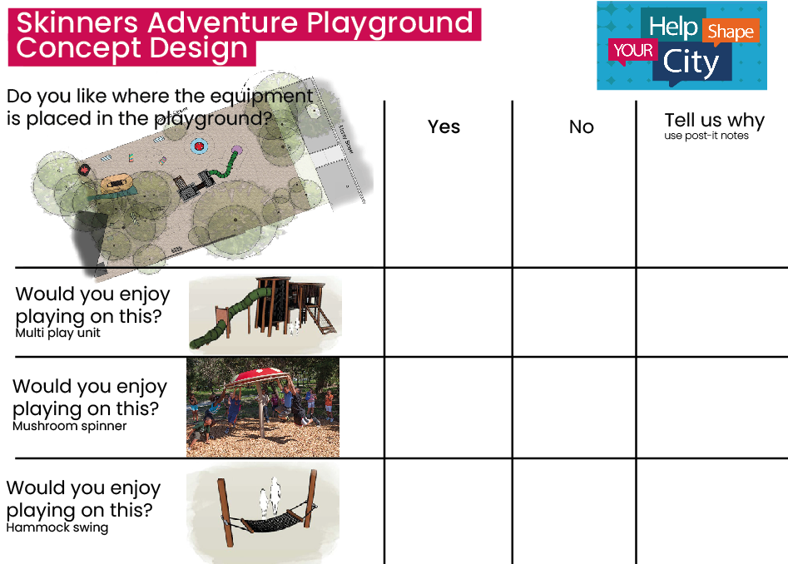

All responses from the face-to-face engagement sessions are shown in the table below (Every effort has been made by the authors of this document to represent accurately participant feedback and insights).

Question | Yes | No | Tell us why
Do you like where the play equipment is placed in the playground?  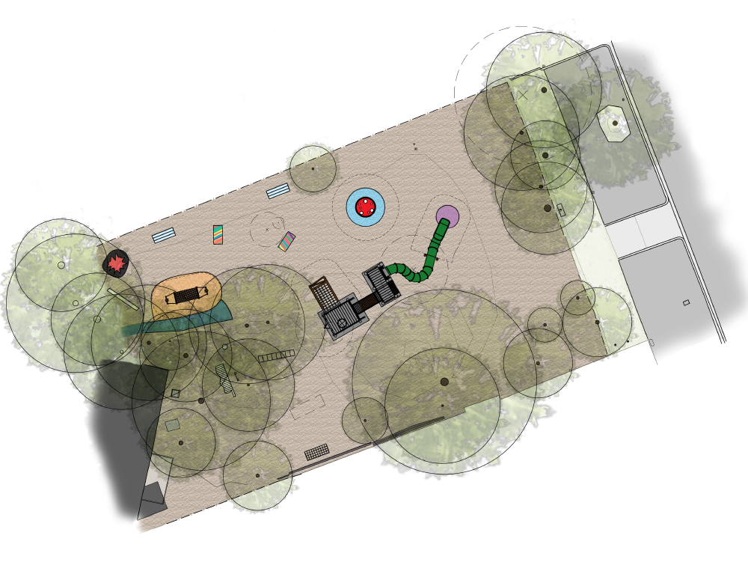 | 8 responses | 0 responses | YES  NO  OTHER  - “Where is the rest?”  - “Waterslide with motor that turns on & off with remote”
Would you enjoy playing on this?  Multi-play unit  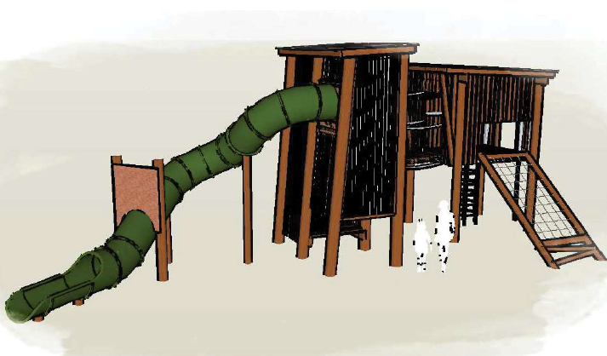 | 14 responses | 1 responses | YES  - “So cute ”  - “Favourite, so much fun”  NO  - “Want it higher”  OTHER  - “Slide colour with flames”  - “Can we get 2 (slides)?”
Would you enjoy playing on this?  Spinning mushroom  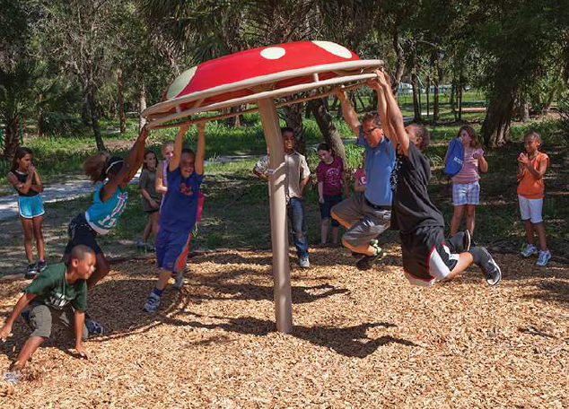 | 11 responses | 0 responses | YES  - “Because it’s fun!”  - “Playing & fun”  NO  -  OTHER  - “”
Would you enjoy playing on this?  Hammock swing  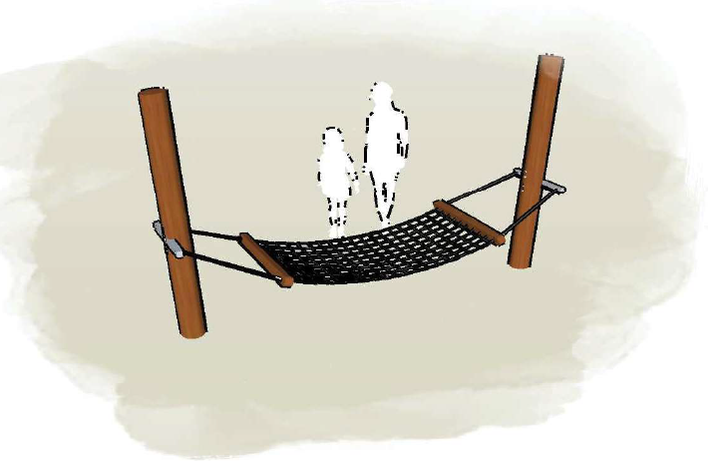 | 11 responses | 2 responses | YES  - “When it’s hot I can lie to dry out”  - “A bit fun & scary”  NO  - “People will get hurt”  OTHER

If you could choose the colour of the slide what would you choose?  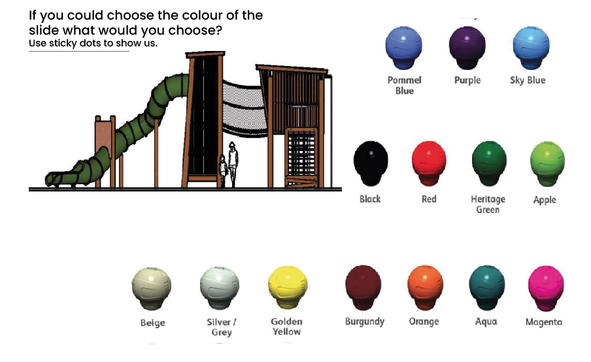 | - ‘Pommel Blue’ received six (6) votes  - ‘Heritage Green’ received one (1) vote

Face-to-face engagement (Supervising staff):
Skinners Adventure Playground supervising staff had the opportunity to provide their feedback at a face-to-face engagement session on 17 March 2023.
Feedback at the face-to-face session was provided from four (4) supervising staff members. The main feedback included:
- The proposed multi-play equipment unit was not supported (does not suit the Skinners Adventure Playground principles of risky play or unique aesthetic)
- The proposed spinning mushroom play item was supported
- The proposed hammock swing was generally supported (a larger version preferred)
- The proposed seating was not supported. Would prefer to move existing loose seating around.
- There are other play equipment items which should be considered (separate cubbies, waterplay)
Specific comments about the equipment or use of the playground included below (Every effort has been made by the authors of this document to represent accurately participant feedback and insights):
Theme | Feedback
Multi-play equipment unit | - It doesn’t look like ‘Skinners’. It’s too cookie-cutter/generic. Looks like equipment you would find in a regular playground, not Skinners.  - It looks claustrophobic  - The cubby spaces are very small. The playground used to have a lot more cubbies and hiding spaces.  - It is not risky enough – all the elements are enclosed with bars and mesh (e.g., the bridge, slide).  - Instead of an enclosed structure and enclosed slide, what about a an open 3m high slide with an open ladder for more risky play - A single element instead of combined structure.  - The high, open swinging bridge shown in the previous round of consultation is the type of risky equipment envisioned. Can this be incorporated?
Spinning mushroom | - Like the spinning mushroom
Hammock swing | - Skinners used to have a hammock swing, but it was larger. This would be preferred?
Seating | - The proposed seating is ugly and doesn’t suit Skinners  - We don’t need fixed seating – prefer moveable seating and already have enough.
Other play equipment suggestions | - Separate cubbies spaced apart so they can be used as ‘bases’ for running/hiding games, and other imagination play like shops.  - A raised cubby on stilts  - Waterplay elements  - Soccer and football are popular there should be space for these games.
Other – General | - The options to vote on in the previous round of consultation that informed the concept plan were not risky enough.  - What’s the rush to get play equipment installed? Since the old equipment was removed, this area is used by kids for bike riding, ball sports, running around etc.  - This seems like a quick fix. If there is a Stage 2, then do a full upgrade properly instead of different stages without a full plan.  - The kids use all of the existing equipment in this area (tyres, monkey bars, stainless steel slide) - retain all existing play equipment in this area including the steel slide.

Online engagement – Have Your Say webpage (Community):

The survey on Council’s Have Your Say consultation platform was open from 17 March to 10 April 2023. During this time the page received one hundred and fifty-two (152) views and a total of seven (7) responses to the survey.
Of these respondents, four (4) had visited the playground and three (3) lived close to the playground, including a direct neighbour living in the property adjoining the south of the playground.
- Two (2) visited a few times a week
- One (1) visited a few times a month
- One (1) visited a few times a year
- Three (3) didn’t visit the playground
Respondents were aged from 35 to 74 years of age, and they provided their feedback on what they liked about the concept plan, and their thoughts on what could be improved. The main themes that arose from their feedback are:
Likes:
- Like the mushroom spinner (2)
- Likes all the equipment except the proposed seating (1)
- The equipment is diverse, challenging, and suitable for a range of children (1)
What could improve the design:
- Use the whole area (1)
- Retaining and improving the landscape/planting (1)
- More creative seating (1)
- More undercover areas (1)
- Accessible play equipment (1)
- A sensory garden (1)
- Balance beams (1)
- Picnic tables (1)
- The generic appearance of the equipment (1)
- The location of the soccer net (1)
Specific comments about the equipment or use of the playground included:
- Get serious about the space. This looks like a ‘minimise the spend’ approach.
- The equipment doesn’t suit the Adventure Playground ethos as per Council directive
- The areas under the trees and near Moray St are underutilised. This area should be more level to allow better use of this area.
- The large Eucalypt overhangs the adjacent property, blocks sunlight, and drops debris in the gutters of the buildings.
The feedback received for this consultation can be found in Appendix 1 of this document.
Appendix 1 – Feedback received via Have Your Say:

Response | What features of the concept design do you like? | What could make the design better? | How often do you visit Skinners? | Age group
 | Not much | Get serious about the space. This looks like a 'minimise the spend' approach.  It is a great space. It is a large space. Use it. | Other – I walk past it a couple of times a week | 60-69 years
 | I like the mushroom spinner | More focus on nature and the natural landscape, retaining trees and grasses and doing extra landscaping | A few times a week | 35 to 49 years
 | All of them except the seating | The seating could be a bit more creative to fit in with the creativeness of Skinners. The equipment needs to be colourful, and the kids need to be able to stamp their mark by being able to paint the wooden equipment. | A few times a week | 50 to 59 years
 | Mushroom spinner | More undercover areas | A few times a year | 35 to 49 years
 | The diverse equipment proposed is suitable for a range of children. The range of equipment does challenge motor skill development as well | The equipment does not address children with physical disability.  There could be a sensory garden included.  There could be ground level balance beams with changes in direction included.  There should be picnic tables near the Moray St end of the playground.  The areas under the trees and near Moray St are underutilised. This area should be more level to allow better use of this area. | I don't visit this playground | 60-69 years
 | This is very disappointing- generic, unoriginal, prefabricated, mass produced equipment - the antithesis of what should be installed | See description of adventure playground ethos and equipment in council's 2018 consultation report | A few times a month | 35 to 49 years
 | We live next door, and we have concerns about the soccer net (#8) being close to our property. It will increase the noise we would like consideration made to relocate it to the side of the playground that is adjacent to the car park. | The large Gum Tree shown on the diagram that overhangs a great over our property, interferes with our enjoyment of our property because it blocks most of the winter sun from reaching our yard. The lack of sunlight, therefore, makes our garden be in shadow and is damp. We are unable to hang our laundry to dry as much as we would like for environmental reasons. Additionally, this tree continually sheds bark and leaf litter on our garden, causing us, two senior citizens, to be constantly cleaning it up. Now that the tree is so huge, overhanging our yard, it deposits the leaf and bark litter into the guttering of our house and our other property in the back yard, blocking the drainage system of both buildings. | I don't visit this playground | 70 to 74 years

