Greening Port Phillip - Urban Forest Strategy
Stage 1B Engagement Findings Report

15 September 2023
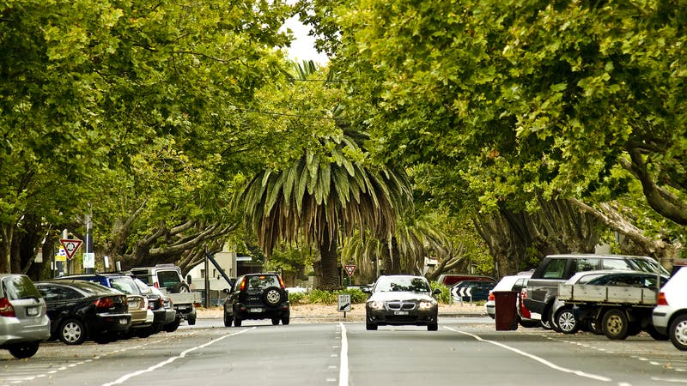

Prepared for: Jennifer Witheridge
Urban Forest Planner | Open Space, Recreation and Community Resilience
CITY OF PORT PHILLIP

Prepared by: Sarah Bishop
Director
ACTIVATE CONSULTING

Acknowledgement
Activate Consulting and its partners respectfully acknowledge the Traditional Owners of the land now known as the City of Port Phillip, the people of the Kulin Nations. We pay our respect to their Elders, past and present. We acknowledge and uphold their continuing relationship to this land.

Document title | Greening Port Phillip - Urban Forest Strategy  Stage 1B Engagement Findings Report
Version | Final
Date | 15 September 2023
Prepared by | Robyn Cochrane, CEO/Director, Cochrane Research Solutions  Sarah Bishop, Director, Activate Consulting
Approved by | Robyn Cochrane for Sarah Bishop, Director, Activate Consulting
Activate Consulting
ABN: 83 416 003 475
Telephone | 0403 214 449
Email | sarah@activatepeople.com
Web | activatepeople.com
Copyright and disclaimer
The materials presented in this report are for information purposes only. The information is provided solely on the basis that readers will be responsible for making their own assessments of the matters discussed. Readers are advised to verify all relevant representations, statements, and information and to obtain independent advice before acting on any information contained in or in connection with this report. While every effort has been made to ensure that the information is accurate, Activate Consulting will not accept any liability for any loss or damages that may be incurred by any person acting in reliance upon the information.

Partners

CONTENTS

1. EXECUTIVE SUMMARY 4
2. PROJECT BACKGROUND AND ENGAGEMENT OVERVIEW 7
2.1 Project background 7
2.2 Engagement overview 7
2.3 Insights from the recent consultations (Sustainable Environment Strategy and Climate Emergency Plan) 9
2.4 Stage 1B Engagement Program 11
3. WHO WE HEARD FROM 12
3.1 Participants 12
4. OVERVIEW OF FINDINGS – DRAFT VISION AND PRINCIPLES 16
4.1 Level of support for the draft Vision 16
4.2 Level of support for the five draft Principles 18
5. OVERVIEW OF FINDINGS – SUPPORTING A GREENER PORT PHILLIP 23
5.1 Views on the current state of greening in Port Phillip 24
5.2 Feedback on proposed Council actions to support a greener Port Phillip 24
5.3 Tree canopy in Port Phillip 27
5.4 Personal and household actions to support a greener Port Phillip 29
5.5 Visions for transforming specific locations across Port Phillip 34
5.6 Other ideas to consider for the draft Greening Port Phillip UFS 38
APPENDICES 39
1. New Urban Forest Strategy – Feedback Form (Survey) 39
2. Selection of images from place-based pop-up engagement activities 50

- EXECUTIVE SUMMARY
Port Phillip City Council (Council) is developing a new Urban Forest Strategy (UFS) which aims to build on the success of its pioneering 2011 Strategy and incorporate a more advanced contemporary understanding of urban greening best practice.
The UFS development process will occur over two stages:
- Stage 1 – Developing and adopting the Vision and Strategic Principles
- Stage 2 – Developing and adopting the Action, Implementation, and Evaluation Plan
To ensure the Strategy is locally responsive, innovative and can be delivered in partnership with the community, Council is undertaking a comprehensive engagement process throughout the two stages. This will build on the significant community feedback related to the urban forest that has already been received through other recent projects.
This report presents the findings of the second stage of engagement (Stage 1B) with the community to test support for the Draft Vision and Principles, actions for Council and households to support greening, views on increasing tree canopy, visions for transforming specific locations, and other general feedback for Council to consider when developing the UFS.
Community engagement approach
The Stage 1B engagement program was open from 10 July to 6 August 2023. Around 475 participants were engaged via the following online and three Place-based pop-up engagement activities.
- 202 voting pod votes (pop-up place-based activities)
- 119 survey responses (online and hard copy)
- 89 dotmocracy responses (pop-up place-based activities)
- 68 ideas board comments (pop-up place-based activities)
- 47 online forum submissions (online)
- 23 children’s drawing sheets (pop-up place-based activities)
- 3 email submissions.

In addition, the communication activities were effective in reaching and informing around 520 people with 948 visits by 523 visitors to the Have Your Say Port Phillip. There were also 247 downloads of project documents.
Participation profile
Most participants (96.6%) live within Port Phillip, many in the suburbs of St Kilda, Elwood, Balaclava, and St Kilda East. Low participation was recorded for Melbourne, Southbank, and Windsor.
There were more Women/Female participants (55.2%) than Men/Males (39.7%).
In relation to age, around a quarter (25.9%) of survey participants were aged 35 to 49 years. All age groups were represented with the exception of people aged 80 years and over. A low level of participation was noted for those aged 18 to 24 years (1.7%). Younger voices were represented with 12.1% aged under 18 years and around 126 children and young people under 18 years participated via place-based pop-up engagement activities.
With regard to connection(s) to Port Phillip, many participants reported being a resident (87.1%) and/or a ratepayer (34.5%). While lower numbers were recorded for other categories, there was some representation of Workers, Volunteers, Students, Visitors, and Business owners.
A total of 33 survey participants identified with diverse personal characteristics. These participants identified as LGBTI (Lesbian, Gay, Bisexual, Transgender, Intersex), being From a non-English speaking background, that they Consider themself financially disadvantaged, or as a Person with disability.
Based on the available demographic information overall, the consultation successfully engaged a broad cross-section of community members. Participants represented all suburbs, genders, connections to Port Phillip, most age groupings, and some identified with diverse personal characteristics.
Engagement findings
Level of support for the draft Vision and five Principles
Feedback from 126 survey participants and place-based pop-up (dotmocracy) participants shows strong support for the draft Vision (88.1%), draft Principle 1 (90.4%), draft Principle 2 (83.9%), draft Principle 3 (95.1%), draft Principle 4 (90.3%), and draft Principle 5 (93.6%).
Some participants indicated the draft Vision and Principles could be strengthened by adding more detail and targets, making an explicit commitment, addressing points regarded as unclear or missing, being more ambitious, considering suggestions, and targeting efforts in specific locations across the municipality.
Views on the current state of greening in Port Phillip
Feedback from 67.3% of 202 place-based pop-up (dotmocracy) participants signals Port Phillip is not green enough.
Feedback on proposed Council actions to support a greener Port Phillip
Survey participants support all proposed Council actions to support a greener Port Phillip, particularly Planting biodiverse nature strips (52.2%), Creating green spaces in new developments (47.0%), Creating new nature strips where there are currently none (46.1%), Council partnering with environment-focused community organisations and environmental experts (39.1%), and Improving parks with indigenous plants, trees, shrubs, ground cover (33.0%).
Participants also suggested a variety of ideas to increase greening which included focusing on Creating more green spaces, Greening or improving specific spaces or locations, Encouraging and enabling community members to embrace greening, and Retaining and increasing trees.
Tree canopy in Port Phillip
The majority of survey participants supported increasing tree canopy across Port Phillip. Many participants (66.4%) reported Increase to around 40% to 50% throughout the municipality. The majority of participants completely supported all proposed Council actions to influence and achieve an increase in tree canopy in relation to Council property, Private property, and Other Government property. However, mixed support was reported for Removing some street car parking spaces to accommodate street trees.
Personal and household actions to support a greener Port Phillip
Some participants (28.4%) reported they are already actively greening Port Phillip to a large or very large extent, while others (37.1%) are actively greening to some extent. Over one third of participants (34.5%) are actively greening to a small extent or not at all.
Survey participants supported all of the “at your home” actions to help green Port Phillip to varying degrees. Many participants already have a garden where they live or in their property (70.1%), growing fruit or vegetables where they live or in their property (47.0%) or have large tree/s where they live or in their property (47.0%). Many participants would consider planting vegetation on their nature strip (52.1%), installing water sensitive urban design (such as saving and using grey water) (41.0%), and incorporating greening options like a vertical garden or green roof (37.6%). The action that is not relevant or that participants are most unlikely to do is incorporating greening options like a vertical garden or green roof (42.7%).

Survey participants also supported all of the “in the community” actions to help green Port Phillip to varying degrees. Many participants are already advocating to improve biodiversity and our urban forest (44.4%) and advocating to protect trees (43.6%). Many participants would consider participating in community tree planting, ‘friends of’ group or other local community organisation (55.5%), volunteering time and expertise to support greening (community garden, bush or coast site) (51.3%) and maintaining and watering local plants and trees (58 or 49.6%). The action that is not relevant or that participants are most unlikely to do is volunteering time and expertise to support greening (community garden, bush, or coast site) (18.8%).
Participants also suggested a variety of ideas to that would help them take more action to green Port Phillip which included Offering financial incentives, subsidies, and plant giveaways, Providing a range of educational and community involvement opportunities, and facilitating initiatives, Advocacy and practical support for apartment dwellers and renters, and Providing information, guidelines, advice and communicating to raise awareness.
Visions for transforming specific locations across Port Phillip
Online forum participants outlined visions for transforming particular places in their neighbourhoods and many ideas referred to locations within St Kilda (12), Balaclava (7), St Kilda East (5), and Elwood (5).

- PROJECT BACKGROUND AND ENGAGEMENT OVERVIEW
2.1 Project background
Port Phillip City Council (Council) was one of the first councils to develop an Urban Forest Strategy in 2011, sparking recognition amongst the community of the importance of greening for people and the environment. It is now time for a new Urban Forest Strategy (UFS) to be developed, to build on the achievements so far and incorporate a more advanced contemporary understanding of urban greening best practice.
Over the 10 years since the last strategy, the following factors have emerged:
- An increase in community awareness and interest in urban greening, locally and globally
- An increased focus by the community on nature strip and ‘street’ gardening in response to COVID
- An expanded understanding of the urban forest to include all vegetation, not just street trees
- A rise in the number and influence key stakeholders championing urban forest issues
- Greater compliance focus on electrical line clearance
- Canopy loss on private property due to housing development and the need to accommodate more homes
- Loss of large canopy trees due to age and health
Council has engaged a mixed consultant team to map its current canopy and research and prepare a new UFS. Activate Consulting is engaged to plan and deliver the community and stakeholder engagement program to inform this process.
The UFS development process will occur over two stages:
- Stage 1 – Developing and adopting the Vision and Strategic Principles
- Stage 2 – Developing and adopting the Action, Implementation, and Evaluation Plan

2.2 Engagement overview
Over recent years, Council has already heard significant community feedback related to the urban forest through the development of other projects such as the Public Spaces Strategy, Nature Strip Guidelines, and Act and Adapt (Sustainability) Strategy revision.
The aim of this engagement program is to build on what has already been heard and work with the community to inform the development of an UFS that balances community needs and desires, with council’s legal requirements (e.g., accessibility, electrical line clearance), and engenders collaboration between the community, Council, and key stakeholders to implement the actions developed as part of this strategy.
To achieve this, the objectives of the engagement process are to:
- Gather feedback and input from key stakeholders and the broader community to:
  - Develop our understanding of the current context
  - Gain an understanding of their needs, desires, concerns, and ideas about the urban forest, what and where it is; and
  - Effectively harness and focus community passion and expertise positively into the strategy development.
- Create community interest in the project, bring them along the journey to develop the strategy, and generate buy-in for its implementation
- Implement a robust and transparent engagement process that properly reflects the diversity of community needs and builds confidence in the findings
- Gather, analyse, and report feedback to meaningfully inform the UFS.
Figure 2.1 outlines the key engagement stages and target timelines.

Figure 2.1 Key community and stakeholder engagement stages and target timelines

Stage |  | Timeframe |  | Inputs |  | Who we are engaging |  | Purpose
Planning |  | March 2023 |  | Background research, benchmarking, best practice, Port Phillip content, summary of previous consultation findings |  | CoPP project working group  Urban forest consultants |  | Inform Stakeholder analysis, and  Engagement and Communication Plan
Stage 1A |  | May/June |  | Background information, previous consultation findings |  | Key stakeholders  Advisory Groups |  | Inform Draft Vision and Strategic Principles
 |  |  |  | Council endorsement draft Vision and Strategic Principles for consultation (5 July)
Stage 1B |  | Early-July – early-Aug |  | Draft Vision and Strategic Principles, Background information (summary) |  | Broad community |  | Test and refine Draft Vision and Strategic Principles  Invite specific greening ideas for Stage 2
 |  |  |  | Council endorsement of Vision and Strategic Principles (October)
Stage 2A |  | Nov/Dec |  | Vision and Strategic Principles  Specific greening ideas and other input already received |  | Internal staff  Key stakeholders  Advisory Groups  Interested community |  | Inform Draft Action Plan for the UFS
 |  |  |  | Council endorsement of Draft UFS Action Plan for consultation (December)
Stage 2B |  | Feb/Mar 2024 |  | Draft Urban Forest Strategy Action Plan |  | Broad community |  | Test and refine the Draft UFS and Action Plan
 |  |  |  | Council endorsement of Final UFS and Action Plan (April 2024)

2.3 Insights from the recent consultations (Sustainable Environment Strategy and Climate Emergency Plan)
This section presents an overview of selected community feedback gathered during the recent consultation programs undertaken for the draft Act and Adapt: Sustainable Environment Strategy 2023-28 (July 2023) and draft Climate Emergency Plan 2023-28 (July 2023). Both consultation periods were open from 10 July until 10 August 2023.
The focus here is insights drawn from the feedback which relate to greening-related topics and the UFS. Insights have been themed and are presented using the five draft Principles as categories, as shown below.
Draft Principle 1: We work together to value, protect, grow and care for healthy and sustainable greening everywhere.
- Working together: More planting now to reduce the heat island effect using existing partnerships. Strengthen the partnership with the EcoCentre and consider co-application for relevant grants. The EcoCentre has a range of relevant expertise, from walks and talks to assisting with gardens for wildlife, coordinating community plantings on public/semi-private. With tangible assistance and practical support, the EcoCentre can effectively assist in activating community participation.
- Research connections: The EcoCentre conducts a range of citizen science programs that could contribute to elements of monitoring at a street or precinct level, in complement to larger technical assessments, while offering the scaffolding for conversations and education of community members.
Draft Principle 2: We retain first, respecting established character, and adapt by adding more resilient plant species where they are most needed to reduce heat and flood vulnerabilities.
- New tree planting, tree replacement, and climate ready trees: There are many deciduous (and non-native) trees such as the Plain Trees that cost a lot in terms of leaf litter blocking drains. With a concerted effort to replace green canopy with evergreen trees (such as eucalypts) there will be much cooler spaces throughout the year. Council to have accurate data to enable new plantings to be effectively carried out. For new plantings to be successful, they must be assessed in terms of soil preparation, formative pruning, and proactive monitoring and promotion of progress. Prioritise tree and understory planting in public spaces of greatest need. Use a selection of climate resilient tree species to encourage biodiversity and canopy size and time for canopy to mature.
- Depaving: Increased permeability, de-paving, increasing green spaces is good but more detail is needed such as timeframes, ambition of reach, and scalability. Progressively transition road and footpaths to permeable materials. Yes! More de-paving! Campaigns to help stop people paving their gardens. Permeable footpaths. Inserting gardens in wide roads or underutilised areas. Replace hard surfaces with plants and permeable paving will reduce the heat island effect, reduce air temperature during heat spells and improve air quality, mental health, and biodiversity. Think bigger. Undertake significant action to increase permeability in public and private spaces and report annually on progress.
- Planning improvements: Council to urgently advocate for canopy cover to be a mandatory requirement in Planning Schemes for private land. ResCode standards relating to building setbacks and site permeability in the Planning Schemes do not guarantee that sufficient space is available for canopy trees to exist or survive.
Draft Principle 3: We prioritise biodiversity, supporting healthy ecosystems and establishing wildlife corridors.
- Monitoring biodiversity: Biodiversity programs have many co-benefits for cooler cities, city character, and human wellbeing. Consider using the term “Biodiversity-rich communities” or “Biodiversity actions”. The Green Line is a significant project for Council as both a walking and biodiversity corridor. Outline the next steps will be progressed to realise the Green Line.
Draft Principle 4: We invest in thriving integrated urban greening in streetscapes, buildings and gardens.
- Open space greening and land acquisition: Recommend an action that open Spaces identified as hot locations by heat mapping should be assessed for new tree plantings and depending on size and function, as priority precincts. Areas with low levels of open space and canopy cover need to be identified and overlaid with heat mapping data to enable the development of priority precincts. Need green shaded spaces with local trees to provide safe, attractive, cool, and enjoyable public spaces. Prioritise the purchase of land to create public spaces in areas of greatest need.
- Water and storm water harvesting: Harvested storm water must impact a greener environment, creating and improving wetland areas. Storm water runoff to focus on ground level (rain gardens, storm water harvesting channels) and green surfaces on roof tops and in vertical gardens. Aim to slow water runoff from hard surfaces and trap pollutants. Need for more permeable pavements to permit water to soak into the ground rather than flowing straight to the bay. Include more and longer-term implementation examples and actions for high value opportunities for storm water harvesting, the Stormwater Asset Management Plan, and the delivery of WSUD projects. Consider nature-based solutions, such as constructed wetlands or rain gardens. This would have a lower cost, require less maintenance, and bring biodiversity and ecosystem services. More out of the box thinking regarding current and future water retention requirements.
Draft Principle 5: We value the urban forest as a long-term asset that is critical to the health and wellbeing of our community and to our city’s character and function, through quality design, construction and maintenance.
- Embracing technologies for tracking and monitoring: Key benefits of improved mapping and monitoring include enabling evidence-based planning and decision-making for urban forests, informing greening targets and tracking progress, assisting with identifying priority areas for action and investment, providing a resource for local government to develop local greening strategies, and providing a baseline for monitoring the implementation of greening strategies and regulatory responses. Use advanced data and analytics on heat mapping and tree canopy measurement to urgently increase tree canopy cover and understory planting. Recent AI programs can identify an individual tree and make a measurement around its crown area and repeat this over subsequent aerial photography. Programs such as Tree Ledger can determine whether a tree was removed, how much retained canopy grew or senesced and how newly planted trees were surviving. Prioritise updating urban heat island effect information in a readily accessible form and available on the Council website. Finalise thermal heat mapping, vulnerability mapping, canopy cover mapping and changes in canopy cover mapping, consistent with information provided by DEECA.
Other feedback relevant to the UFS.
- Support for action and more ambitious targets: Support for more ambitious targets for Council and the Community. The urban canopy targets to be strengthened and rephrased as more definite and less aspirational. It is noted that Council is awaiting legislation, however, Council can still act with urgency and priority to reduce its own emissions. Accelerate action to create the Green Line.

2.4 Stage 1B Engagement Program
This report presents the findings of Stage 1B engagement with the broad community to test support for the Draft Vision and Principles. It also explores Council and household actions to support greening, views on increasing tree canopy, visions for transforming specific locations, and other general feedback for Council to consider when developing the UFS. See Appendix 1 for a copy of the Feedback Form/Survey and Appendix 2 for a selection of images from the place-based pop-up engagement activities.
The Stage 1B engagement program was open from 10 July to 6 August 2023. As shown in Table 1.1, there were approximately 475 engaged participants.
Table 2.1 Overview of engagement methods and participation
Engagement activity | Details | Estimated number of participants
Place-based pop-up engagement | Dotmocracy, Voting pod, Ideas boards, Children’s drawing sheet  Elwood Farmers Market (22 July 2023)  South Melbourne Market (21 July 2023)  Veg Out Market in St Kilda (5 August 2023) | 315
Survey | Online and hard copy options | 119
Online forum | Online mapping activity | 38
Email submission | Email submissions to Council | 3
Estimated total participants |  | 475

In addition, the communication activities were effective in reaching and informing around 520 people with:
- 948 visits by 523 visitors to the Have Your Say Port Phillip, which has 38 total followers including 31 new followers from this consultation
- 94 downloads of the Draft Urban Forest Strategy 2040 Strategic Directions
- 60 downloads of the Executive Summary Background and Benchmarking Report
- 49 downloads of the Biodiversity Study and Action Plan Background Research Discussion Paper
- 30 downloads of the UFS timeline infographic
- 14 downloads of the Tree Ledger Report 2012-2022, and
- 108 people directed to the project page via social media posts.

- WHO WE HEARD FROM

Around 475 engaged participants provided feedback via online and in-person activities throughout the engagement period as follows:
- 202 voting pod votes (pop-up place-based activities)
- 119 survey responses (online and hard copy)
- 89 dotmocracy responses (pop-up place-based activities)
- 68 ideas board comments (pop-up place-based activities)
- 47 online forum submissions
- 23 children’s drawing sheets (pop-up place-based activities)
- 3 email submissions.
Note: Some individuals participated in more than one activity and not all children’s drawing sheets were useable.
The survey was the most comprehensive data gathering activity, capturing demographic information as well as in-depth feedback on key topics of interest. This section describes the demographic profile of the participants. Not all engagement activities captured participant demographic information or the same information, so this profile is mostly based on the survey unless stated otherwise.

3.1 Participants
As shown in Figure 3.1, most participants (96.6%) live within Port Phillip, many in the suburbs of St Kilda, Elwood, Balaclava, and St Kilda East. Low participation was recorded for Melbourne, Southbank, and Windsor.
There were more Women/Female participants (55.2%) than Men/Males (39.7%) as shown in Figure 3.2. One participant reported non-binary, and another indicated they use a different term for gender (genderfluid).
In terms of age, Figure 3.3 shows around a quarter (25.9%) of survey participants were aged 35 to 49 years. All age groups were well represented with the exception of people aged 80 years and over. A low level of participation was noted for those aged 18 to 24 years (1.7%). Younger voices were represented with 12.1% aged under 18 years. Figure 3.4 shows the place-based pop-up activities (voting pod, dotmocracy, and drawing sheet) were effective in engaging around 126 children and young people under 18 years (noting some individuals participated in more than one activity).
With regard to connection(s) to Port Phillip, Figure 3.5 shows many participants reported being a resident (87.1%) and/or a ratepayer (34.5%). While lower numbers were recorded for other categories, there was some representation of Workers, Volunteers, Students, Visitors, and Business owners.
As shown in Figure 3.6, 33 survey participants identified with diverse personal characteristics. These participants identified as LGBTI (Lesbian, Gay, Bisexual, Transgender, Intersex), being From a non-English speaking background, that they Consider themself financially disadvantaged, or as a Person with disability.
Based on the available demographic information overall, the consultation successfully engaged a broad cross-section of community members. Participants represented all suburbs, genders, connections to Port Phillip, most age groupings, and some identified with diverse personal characteristics.

Figure 3.1 Residential location
The four participants selecting ‘Other’ reported Brighton, Carnegie, Elsternwick, and Reservoir.
Figure 3.2 Gender
The one participant selecting ‘Other’ reported Genderfluid.

Figure 3.3 Age - survey participants

Figure 3.4 Age - pop-up participants
Note: Some individuals participated in more than one activity

Figure 3.5 Connection(s) to Port Phillip

Figure 3.6 Diversity and inclusion

Two stakeholder groups provided an email submission:
- Port Phillip Emergency Climate Action Network.
- Sol Green Reserve Precinct.

- OVERVIEW OF FINDINGS – DRAFT VISION AND PRINCIPLES
Feedback from 126 survey participants and place-based pop-up (dotmocracy) participants shows strong support for the draft Vision (88.1%), draft Principle 1 (90.4%), draft Principle 2 (83.9%), draft Principle 3 (90.3%), draft Principle 4 (90.3%), and draft Principle 5 (93.6%).
Some participants indicated the draft Vision and Principles could be strengthened by adding more detail and targets, making an explicit commitment, addressing points regarded as unclear or missing, being more ambitious, considering suggestions, and targeting efforts in specific locations across the municipality.
4.1 Level of support for the draft Vision
Working with key local stakeholders and urban forest consultants, a draft Vision or aspiration for the City of Port Phillip’s Urban Forest in 2040 has been developed. The following draft Vision outlines what the UFS Strategy is trying to achieve:
- In the City of Port Phillip, urban greening is healthy and abundant, biodiversity is valued and supported, and nature connects community.
Survey participants and place-based pop-up (dotmocracy) participants were asked how supportive they are of the draft Vision and presented with a range of response options.

Figure 4.1 shows the majority of participants (111 or 88.1%) support the draft Vision To a large extent or To a very large extent, with 74 (or 58.7%) reporting To a very large extent. Very few participants reported Not at all, To a small extent or To some extent (11 or 8.7%), and a small number reported No opinion/don’t know (4 or 3.2%).

Figure 4.1 Level of support for the draft Vision

Survey participants were also asked if they are not mostly supportive of the draft Vision to explain why, particularly if anything is unclear or missing. A total of 34 survey participants provided a personalised response, referring to one or more aspects.
Participants provided a variety of views which have been grouped and categorised by theme. Descriptive summaries of participant views are shown in Table 4.1 and accompanied by tally counts which signal the number of survey responses referencing each theme. Overall, the sentiment in the feedback highlights reasons why participants are supportive of the draft Vision and suggests it could be strengthened by adding more detail and targets, making an explicit commitment, addressing points regarded as unclear or missing, being more ambitious, considering suggestions, and targeting efforts in specific locations across the municipality.
Table 4.1 Themes from feedback relating to the Draft Vision
Themes with sub-themes from the feedback

Supportive of draft Vision (13 responses)
- Support the draft Vision in-principle, it is comprehensive. Support creating a beautiful and healthy neighbourhood as nature connects community, and community connects people. Clear evidence of benefits to community and mental health. Keep up the good work on our City.
- With the increase of urban sprawl, it's important to focus on urban greening, supportive of additional greening, the greening concept and increasing biodiversity. Support having more plants of different varieties in the ground and more native plants. As the climate changes trees and plants will assist with cooling and shade.
- Need green spaces to combat climate change for community welfare and enjoyment. Decreasing greenhouse gases and increasing ecological outcomes are important.

Requests for more detail, targets, and an explicit commitment (8 responses)
- Seems to be a parenthood statement, unclear what it means, seems vague, no concrete actions that are relatable. It omits inclusivity and equity in making the whole municipality equally green. Does not state landscape plan requirements for new developments (large canopy tree, weed list, proportion of plant varieties).
- The vision needs targets and funding commitments. Would like formal or greater commitment to the development of green spaces that act as cool oases, greening streets and improving tree cover.

Some topics seem unclear or missing (8 responses)
- First Nations engagement and the types of (remnant) ecosystems that are culturally significant (in addition to Flagship fauna and species).
- How to achieve the urban biodiversity goal with limited garden spaces and mostly multiuse areas.
- Haven’t seen or heard of the vision prior to this.
- Would like to know how the State Government's intention to assume more planning powers from Councils will affect this and other environmental strategies.
- Residential areas close to or at the boundaries with industrial sites and/or empty industrial sites are not considered for greening.
- Testing nonindigenous trees as 'climate ready' requires scientific study. Some private businesses are pushing species for profit over local indigenous trees (which cope with temperature extremes and provide habitat).
- What is “urban” greening? Urban Greening is not abundant in the City of Port Phillip, it's dominated by footpaths and space for cars.

Feedback and requests for specific locations within municipality (7 responses)
- Need street improvements. More vegetation in Alexandra Street in St Kilda East (between Dandenong Road and Inkerman Street); improve Grey Street (concrete with a poor choice of planting and little maintenance); focus on Beaconsfield Parade and neglected areas such as Balaclava and St Kilda East. Concerns that established foreshore plantings of salt bush are being removed.
- Appreciate the new gum trees planted in Eilden Road, and recent works off Chapel Street, Bothwell Green Corridor is good.

Requests to be more ambitious (3 responses)
- It could be more ambitious. The target for increasing tree canopy is low. 0.6 percent increase in public green canopy over a decade suggests we need some ambition.

Email submission participants support the UFS and Vision. Suggestions to consider including references to private land, shady connecting corridors for walkability, water, climate adaptation, social equity, and investing in developing a bold and innovative UFS based on robust research, analysis, and key stakeholder input.
4.2 Level of support for the five draft Principles
A set of five draft Principles was also developed to support the draft Vision. The following Principles are foundational guidelines that will inform decisions and the choice of actions:

- We work together to value, protect, grow and care for healthy and sustainable greening everywhere.

- We retain first, respecting established character, and adapt by adding more resilient plant species where they are most needed to reduce heat and flood vulnerabilities.

- We prioritise biodiversity, supporting healthy ecosystems and establishing wildlife corridors.

- We invest in thriving integrated urban greening in streetscapes, buildings and gardens.

- We value the urban forest as a long-term asset that is critical to the health and wellbeing of our community and to our city’s character and function, through quality design, construction and maintenance.”

Survey participants and place-based pop-up (dotmocracy) participants were asked how supportive they are of each of the five draft Principles and presented with a range of response options.

Draft Principle 1: We work together to value, protect, grow and care for healthy and sustainable greening everywhere

Figure 4.2 shows the majority of participants (113 or 90.4%) support draft Principle 1 To a large extent or To a very large extent, with 91 (or 72.8%) reporting To a very large extent. Very few participants reported Not at all, To a small extent or To some extent (9 or 7.2%), and a small number reported No opinion/don’t know (3 or 2.4%).

Figure 4.2 Level of support for draft Principle 1

Draft Principle 2: We retain first, respecting established character, and adapt by adding more resilient plant species where they are most needed to reduce heat and flood vulnerabilities.
Figure 4.3 shows the majority of participants (104 or 83.9%) support draft Principle 2 To a large extent or To a very large extent, with 72 (or 58.1%) reporting To a very large extent. Some participants reported Not at all, To a small extent or To some extent (18 or 14.5%), and a small number reported No opinion/don’t know (2 or 1.6%).
Figure 4.3 Level of support for draft Principle 2

Draft Principle 3: We prioritise biodiversity, supporting healthy ecosystems and establishing wildlife corridors.
Figure 4.4 shows the majority of participants (118 or 95.1%) support draft Principle 3 To a large extent or To a very large extent, with 93 (or 74.2%) reporting To a very large extent. Very few participants reported Not at all or To a small extent (4 or 6.5%), and a small number reported No opinion/don’t know (2 or 2.4%).

Figure 4.4 Level of support for draft Principle 3

Draft Principle 4: We invest thriving integrated urban greening in streetscapes, buildings and gardens.

Figure 4.5 shows the majority of participants (112 or 90.3%) support draft Principle 4 To a large extent or To a very large extent, with 92 (or 74.2%) reporting To a very large extent. Some participants reported Not at all or To a small extent (9 or 7.3%), and a small number reported No opinion/don’t know (3 or 2.4%).

Figure 4.5 Level of support for draft Principle 4

Draft Principle 5: We value the urban forest as a long-term asset that is critical to the health and wellbeing of our community and to our city’s character and function, through quality design, construction and maintenance.

Figure 4.6 shows the majority of participants (117 or 93.6%) support draft Principle 5 To a large extent or To a very large extent, with 99 (or 79.2%) reporting To a very large extent. Very few participants reported Not at all or To a small extent (6 or 4.8%), and a small number reported No opinion/don’t know (2 or 1.6%).

Figure 4.6 Level of support for draft Principle 5

Survey participants were also asked if they are not mostly supportive of the draft Principles to explain why, particularly if anything is unclear or missing, and indicate the Principle number where relevant. A total of 35 survey participants provided a personalised response, referring to one or more aspects.
Participants provided a variety of views which have been grouped for each draft Principle where applicable. Descriptive summaries of participant views are shown in Table 4.2 and accompanied by tally counts which signal the number of survey responses referencing each theme. Overall, the sentiment in the feedback suggests draft Principles could be strengthened by adding more detail and targets, clarifying key terms, considering the inclusion of points raised and suggestions, and targeting efforts in specific locations across the municipality.
Table 4.2 Themes from feedback relating to the draft Principles
Themes with sub-themes from the feedback

Draft Principle 1 (4 responses)
- Clarify who “we” refers to (is it homeowners and landholders) and clearly explain who we will be working together.
- Consider adding specific or clear actions.
- Support emphasis on greening everywhere, including areas such as St Kilda East, Balaclava, and Ripponlea that have been neglected in the past.

Draft Principle 2 (10 responses)
- Clarify which resilient plant species are acceptable and necessary to reduce heat and flood vulnerabilities as local indigenous tree species have proven very resilient and could be considered as a first option for plantings. Consider focusing on growing healthy resilient indigenous species which will protect and enhance biodiversity and decolonize the landscape back to Boonwurrung roots. Carefully consider choosing alternative species over proven indigenous species. Avoid species where tree roots affect the ground for building foundations/footings.
- Consider stating "Improving Liveability" and greening neighbourhoods in all areas beyond the Elwood canal, beachfronts, and iconic streets. Refer to the current uneven distribution of tree cover in Port Phillip. Concerns that a focus on reducing heat and floods may prioritise foreshore suburbs.
- Support for the intention to retain and preserve the character of some parts of Port Phillip, where good trees are established. Some existing trees are not supportive of biodiversity, climate change resilient, or native. Replace non-native trees known to be pests with natives and do not retain to simply improve the “green canopy”. Many native species thrive with little water. More plants equal less grass to maintain.
- Support for greening over profit and not permitting new developments to demolish existing vegetation. Support for greening of neighbourhoods, increasing pedestrian amenity and street planting at the cost of parking.
- Suggestion for trees damaged by garbage trucks to be replaced, and trees to be protected from vandalism.

Draft Principle 3 (3 responses)
- Clarify what is being prioritised over and incorporate clear actions.
- Consider including “habitats” or support for local fauna and extend to establishing greater habitat reserves beyond "corridors" (which implies limited land space).

Draft Principle 4 (9 responses)
- Clarify what “invest” means or how it will be done, and whether it implies spending money now to elicit more money at a later date (i.e., via sale).
- Support to extend and include strengthening controls to stop the removal of large trees on private land. Support to involve apartment Body Corporates in the conversation and consider supporting discounted native landscaping services for apartment buildings. Support vertical gardens on commercial buildings.
- Support to increase green spaces and "reduce imperious areas, primarily road pavement, where the road is not strictly necessary for transport function". Target the reduction of impervious area to increase green space.
- Support for new and more native trees, plantings, and vegetation in Acland Street.
- Support for making free natives available to property owners or providing lists of suitable natives for the area.
- Suggestion to review clearways in St Kilda (i.e., Princes Street) to determine if they are still required (post-COVID) and consider roadside plants at the bookends of parking areas.

Draft Principle 5 (2 responses)
- Support to extend and include strengthening controls to stop the removal of large trees on private land.
- Support setting a tree canopy target of at least 40% by 2050 (including parks, streets, and private land) and interim targets.

Requests for more detail, a commitment, and to be more ambitious (7 responses)
- Suggestion to incorporate practical examples for implementation such as how to engage renters, seed exchange initiatives, encouraging communal composting bins, discouraging lawns, encouraging car-free hours or days. Add another layer of principles which focus on what will be done.
- Requests for formal commitments, plans, and to be more ambitious for a climate emergency era.
- Request for bolded words to be clearly and precisely defined.

Feedback and requests for specific locations within municipality (6 responses)
- St Kilda has been allowed to overdevelop and has too many hard surfaces
- Acland Street needs new and more native trees, plantings, and vegetation
- Trees planted along streets in Balaclava have not been adequately protected from vandalism or are too immature to resist the damage.
- Southey Street in Elwood needs more maintenance of swales, pruning of street trees and trees in smaller parks (i.e., Clarke Reserve or Mitford Street).
- Carefully consider trees being planted as the trees in Grey Street drop debris and block the drains. The corner of Grey Street and Dalgety/Gurner needs more maintenance.
- More greenery and vegetation for Alexandra Street in East St Kilda.
- Address the dead palms and state of Beaconsfield Parade, more greening for the centre strip from Kerford Road to Port Melbourne.

Supportive and complimentary of draft Principles and UFS (4 responses)
- Supportive of draft Principles, draft Principles are great and seem to be comprehensive.
- Pleased to see a Strategy in place.

Other feedback (3 responses)
- Suggests an indigenous view and land management perspective is referenced and emphasised in the Principles.
- Asks how the strategy will be informed by locations identified as currently trapping urban heat and whether these locations could be aligned with key implementation initiatives. Also, consider whether directly combatting urban heat should be a Principle to ensure alignment with other strategic work (i.e., Public Health and Wellbeing Plan).
- Asks for more indigenous and Australian plant species to be planted and to showcase their beautiful flowers and colours, for more green connections to be created to major hubs so bees and animals can migrate without road dangers; and to rewind parks with quolls owls and other animals that balance the ecosystem, and to reduce foxes, cats, and mynas.

Email submission participants noted the lack of mention of inclusion and equity and suggested including a reference to “equitably distributed”. Other suggestions included incorporating general overarching goals related to biodiversity, community perceptions and satisfaction with the quality of the environment within the municipality.

- OVERVIEW OF FINDINGS – SUPPORTING A GREENER PORT PHILLIP
While Stage 1B engagement focused on testing the level of support for the draft Vision and five draft Principles for the UFS, there was also an opportunity to gather input and feedback on other topics that might support a greener Port Phillip. This information adds useful context to the draft Vision and Principles and will be used in Stage 2 to help inform the draft Action, Implementation and Evaluation Plan.
Feedback from 67.3% of 202 place-based pop-up (dotmocracy) participants signals Port Phillip is not green enough. Survey participants support all proposed Council actions to support a greener Port Phillip, particularly Planting biodiverse nature strips (52.2%), Creating green spaces in new developments (47.0%), Creating new nature strips where there are currently none (46.1%), Council partnering with environment-focused community organisations and environmental experts (39.1%), and Improving parks with indigenous plants, trees, shrubs, ground cover (33.0%). Participants also suggested a variety of ideas to increase greening which included focusing on Creating more green spaces, Greening or improving specific spaces or locations, Encouraging and enabling community members to embrace greening, and Retaining and increasing trees.
The majority of survey participants supported increasing tree canopy across Port Phillip. Many participants (66.4%) reported Increase to around 40% to 50% throughout the municipality. The majority of participants completely supported all proposed Council actions to influence and achieve an increase in tree canopy in relation to Council property, Private property, and Other Government property. However, mixed support was reported for Removing some street car parking spaces to accommodate street trees.
Some participants (28.4%) reported they are already actively greening Port Phillip to a large or very large extent, while others (37.1%) are actively greening to some extent. Over one third of participants (34.5%) are actively greening to a small extent or not at all. Survey participants supported all of the “at your home” actions to help green Port Phillip to varying degrees. Many participants already have a garden where they live or in their property (70.1%), growing fruit or vegetables where they live or in their property (47.0%) or have large tree/s where they live or in their property (47.0%). Many participants would consider planting vegetation on their nature strip (52.1%), installing water sensitive urban design (such as saving and using grey water) (41.0%), and incorporating greening options like a vertical garden or green roof (37.6%). The action that is not relevant or that participants are most unlikely to do is incorporating greening options like a vertical garden or green roof (42.7%).
Survey participants also supported all of the “in the community” actions to help green Port Phillip to varying degrees. Many participants are already advocating to improve biodiversity and our urban forest (44.4%) and advocating to protect trees (43.6%). Many participants would consider participating in community tree planting, ‘friends of’ group or other local community organisation (55.5%), volunteering time and expertise to support greening (community garden, bush or coast site) (51.3%) and maintaining and watering local plants and trees (58 or 49.6%). The action that is not relevant or that participants are most unlikely to do is volunteering time and expertise to support greening (community garden, bush or coast site) (18.8%). Participants also suggested a variety of ideas to that would help them take more action to green Port Phillip which included Offering financial incentives, subsidies, and plant giveaways, Providing a range of educational and community involvement opportunities, and facilitating initiatives, Advocacy and practical support for apartment dwellers and renters, and Providing information, guidelines, advice and communicating to raise awareness.
Online forum participants outlined visions for transforming particular places in their neighbourhoods and many ideas referred to locations within St Kilda (12), Balaclava (7), St Kilda East (5), and Elwood (5).

5.1 Views on the current state of greening in Port Phillip
Place-based pop-up engagement participants (voting pod) were asked whether they thought Port Phillip is green enough and presented with three response options. A total of 91 participants aged under 18 years and 111 participants aged 18 years provided a response.
As shown in Figure 5.1, mixed views were reported across both age groupings. Overall, the majority of participants (136 or 67.3%) reported No, comprising 45 (or 49.5% of) participants aged under 18 years and 91 (or 82.0% of) participants aged 18 years and over.
Figure 5.1 Views on whether Port Phillip is green enough

5.2 Feedback on proposed Council actions to support a greener Port Phillip
Preamble from survey: During Stage 1A engagement with representatives of local stakeholder groups, a range of ideas were proposed to increase greening in Port Phillip. This listing of actions was tested for support in Stage 1B engagement.

Survey participants were asked to indicate which of the 14 proposed actions they would support the most to increase greening in Port Phillip and could select up to three actions.
Figure 5.2 shows all proposed actions were supported, albeit to varying degrees. The five actions most frequently selected by participants were:
- Planting biodiverse nature strips (60 or 52.2%)
- Creating green spaces in new developments (54 or 47.0%)
- Creating new nature strips where there are currently none (53 or 46.1%)
- Council partnering with environment-focused community organisations and environmental experts (45 or 39.1%)
- Improving parks with indigenous plants, trees, shrubs, ground cover (38 or 33.0%).

Figure 5.2 Level of support for proposed actions to increase greening in Port Phillip

Survey participants and place-based pop-up participants (ideas board) were asked for big and small ideas to increase greening (trees and vegetation) and other actions that might help green Port Phillip. A total of 53 survey participants and 37 ideas board participants provided a personalized response, referring to one or more points. Participants provided a variety of ideas which have been grouped by theme. Descriptive summaries of participant views are shown in Table 5.1 and accompanied by tally counts which signal the number of participant responses referencing each theme.
Table 5.1 Themes from feedback relating to other actions to help green Port Phillip
Themes with sub-themes from the feedback

Creating more green spaces (18 responses)
- Encourage planting and ground cover plants on nature strips, widening existing nature strips, and making all nature strips biodiverse.
- Convert unnecessary road pavement to new green space, planting out road verges and median strips with diverse native species.
- Acquire additional land to increase green spaces in the community and new pockets of land for pocket parks. Create micro forests around Port Phillip.
- Greening apartments (i.e., vertical gardens) and lawn roofs.
- Greening car parks, less car parking near the marina and more foreshore vegetation/trees.
- Facilitate laneway greening with appropriate design standards.

Greening or improving specific spaces or locations (14 responses)
- More trees and biodiversity planting in Grey Street and surrounding streets, improve gutters, drainage and flowers.
- Green public corridor from Alma Park through Balaclava, following the railway line to Ripponlea.
- Create a biodiversity and fauna corridor along Raglan Street in St Kilda East.
- More native trees and shrubs especially in St Kilda shopping precincts.
- Prioritise areas such as Argyle Street Precinct, Balaclava, Ripponlea, and St Kilda East.
- More bio link corridors like Dank Street and light rails and beach/vegetation reservation areas.
- Maintain existing street gardens in Southey Street.
- Replace Acland Street trees that were removed.
- Community edible garden on the corner of Octavia Street and Robertson Avenue.
- More trees in Vale Street in St Kilda.
- More biodiversity planting at Albert Park Lake.
- More green open spaces near apartments, especially Normanby Road.

Encouraging and enabling community members to embrace greening (13 responses)
- Create more resources for residents about tree management, supporting and increasing existing greening. Provide support and advice for builders. Provide advice for owners and tenants (i.e., preventing overuse of chemical pesticides). Create urban forest skills training sessions for residents. Start a seed exchange in libraries.
- More community gardens, more communal or neighbourhood gardens for those living in units and renting.
- Introduce habitat gardening or gardens for wildlife program.
- Assist private landowners to have and install nesting boxes in backyards.
- Community education so people understand how much water we waste.
- Examine community demographics and identify how each segment can contribute to greening.
- Showcase designs of private gardens that focus on sustainability and biodiversity.

Retaining and increasing trees (7 responses)
- More street trees are needed and more biodiverse underplanting. Plant more trees in grassy areas. Trees away from power lines.
- Incorporate Plain trees which are superior street trees. Plan to replace Plane trees with other non-allergenic species.
- Retain all existing trees.
- Target for increased canopy cover needs to be higher (10% of 19%).

Collaborating with government bodies (6 responses)
- Create an urban forest the length of the train line, plant out rail corridors, more greening in Sandringham railway areas and along the Balaclava train line. Planting and mulching along railway embankments.
- Collaborate with the Department of Housing to establish a bee corridor at St Lukes.

Increasing plantings of Indigenous and native species (6 responses)
- Plant more native trees and shrubs. More indigenous and native Australian plants and fewer introduced species. Fewer plane trees and more natives and pollinating trees. Encourage native and indigenous plants.
- New property developments to have a minimum requirement for indigenous planting, not just permeable soil, to support insects, birds, and animals.

Supporting local community groups and greening initiatives (5 responses)
- Invest in, and promote, Westgate Biodiversity Nursery.
- Establish Greening Ambassadors in different locations or neighbourhoods to lead those interested in projects to green streets and backyards.
- Increase investment in local indigenous nurseries and Port Phillip EcoCentre, and Yalukit Willam Nature Association.
- Support local groups.
- Establish Gardens for Wildlife group.

Integrating edible community gardening spaces (5 responses)
- Integrate a food plan (edible plants, fruit trees). Create edible gardening spaces, community edible gardens. More fruit trees on public land.
- Incorporate permaculture techniques such as local food forests.

Using development regulations to protect and preserve greening (4 responses)
- Establish laws to preserve green spaces from over-development and minimize significant canopy loss on private land. Tighten rules to retain large trees on new developments. Make developers pay and plant offsets for vegetation removed in private developments. New housing developments to be enviro friendly. Improve greening outcomes in redevelopment / renovations by increasing permeability (i.e., no bitumen driveways).

Planning, research, and investment to support greening (4 responses)
- Council to increase investment in tree planting and maintaining new plantings. Create an action plan for growing and improving biodiverse habitats for native wildlife. Mapping trees and creating a tree maintenance schedule.

Continuing community and stakeholder consultation (3 responses)
- Consult with the traditional owners regarding native vegetation and indigenous plants, shrubs, and trees. Engage renters. Start focus groups and engage the community to actively green areas and assist with maintenance.

Doing more with storm water (2 responses)
- More storm water harvesting. Be proactive in developing sewage treatment and stormwater collection for local toilets and gardens. Proactive growth in task, grey and black water, retrofits for new developments.

Other feedback (6 responses)
- Create no-maintenance wet and dry indigenous planting (or rewilding zones), that are self-regulating.
- Cease all chemical pesticide/herbicide treatments.
- Return maintenance back to Council and Citywide or contractors.
- More wildflowers for the bees and insects.
- More colourful plants.
- Discourage lawns.

5.3 Tree canopy in Port Phillip
Preamble from survey: The overall tree canopy coverage across Port Phillip is currently 17.17% but varies from suburb to suburb. Since 2012, tree canopy has:
- increased by 0.39% on public land, averaging 26.0% on streets and 17.22% in parks
- decreased by 1.09% on private land and is currently 12.45%.
Increasing tree canopy can be challenging due to the availability of public space (i.e., space used for other purposes such as sports grounds, footpaths, roads and cycleways, parking, underground utilities, and electricity lines) and the choices that owners can make on private land (i.e., development, garden preferences and concerns about trees on private property). The more efforts are made to increase tree canopy, the greater the impact on these other factors.

Survey participants were asked to consider what increase in tree canopy should be the aim for Port Phillip presented with five response options.
Figure 5.3 shows the majority of participants (100 or 93.5%) supported increasing tree canopy across Port Phillip. Many participants (71 or 66.4%) selected Increase to around 40% to 50% throughout the municipality while others selected Increase to around 35% on public land and 20% on private land (20 or 18.7%). Participants selected Increase to around 30% on public land and 15% on private land (9 or 8.4%) and Keep it the same as now (3 or 2.8%) to a lesser degree. A small number reported No opinion/don’t know (4 or 3.7%).
Figure 5.3 Level of support for proposed tree canopy targets

Survey participants were asked if tree canopy was to increase, to what extent would they support a list of proposed Council actions intended to influence and achieve this, presented with four response options.
As shown in Figure 5.4, the majority of participants completely supported all proposed Council actions, albeit to varying degrees. In relation to Council property, the strongest support was reported for Finding space for, and planting additional biodiverse areas in parks and reserves (97 or 82.9% Completely support, 1 or 0.9% Do not support) followed by Budget spending to alter infrastructure to accommodate larger tree planting and tree growth (i.e., aerial bundling electricity lines) (86 or 73.5% Completely support, 3 or 2.6% Do not support). Mixed support was reported for Removing some street car parking spaces to accommodate street trees (63 or 53.8% Completely support, 31 or 26.5% Partly support, and 17 or 14.5% Do not support).
With regard to Private property, the strongest support was reported for Strengthening vegetation requirements in new developments (97 or 82.9% Completely support, 3 or 2.6% Do not support) followed by Offering incentives to private landowners to plant trees or alternative greening (green roofs and walls, biodiversity and habitat planting) (84 or 71.8% Completely support, 5 or 4.3% Do not support). Mixed support was reported for Strengthening tree protection regulations and compliance (75 or 64.1% Completely support, 23 or 19.7% Partly support, and 11 or 9.4% Do not support) and Offering incentives to private landowners to retain trees (72 or 61.5% Completely support, 31 or 26.5% Partly support, and 7 or 6.0% Do not support).
In relation to Other Government property, the majority of participants completely supported Advocating for, or joint projects for, tree planting and greening along state government managed roads (99 or 84.6% Completely support, 16 or 13.7% Partly support, and 0 or 0.0% Do not support).

Figure 5.4 Level of support for proposed Council actions intended to increase tree canopy

5.4 Personal and household actions to support a greener Port Phillip
Preamble from survey: Residents and landholders play an important role in greening neighbourhoods in Port Phillip. As do the many local environmental advocates and groups that partner with Council to care for green spaces for the benefit of the whole community.

Survey participants were asked to indicate the extent to which they, or their household, are actively greening Port Phillip and presented with five response options.
As shown in Figure 5.5, mixed views were reported. Some participants (33 or 28.4%) are actively greening Port Phillip To a large extent or To a very large extent. A further 43 participants (or 37.1%) reported To some extent. Other participants reported Not at all or To a small extent (40 or 34.5%).
Figure 5.5 Extent to which participants and their households are actively greening Port Phillip

Survey participants were asked to indicate which actions they are taking or likely to take to help green Port Phillip and presented with a listing of actions that could be taken at home and in the community, along with four response options.
As shown in Figure 5.6, participants supported all “at home” actions to varying degrees. The three most frequently reported actions that participants are already doing are Having a garden where they live or in their property (82 or 70.1%), Growing fruit or vegetables where they live or in their property (55 or 47.0%) and Having large tree/s where they live or in their property (55 or 47.0%). The three most frequently reported actions that participants don’t do but would consider are Planting vegetation on their nature strip (61 or 52.1%), Installing water sensitive urban design (such as saving and using grey water) (48 or 41.0%), and Incorporating greening options like a vertical garden or green roof (44 or 37.6%). The most frequently reported action that participants are unlikely to do or that is not relevant is Incorporating greening options like a vertical garden or green roof (50 or 42.7%).

Figure 5.6 Support for actions to help green Port Phillip – at home

As shown in Figure 5.7, participants supported all “in the community” actions to varying degrees. The two most frequently reported actions that participants are already doing are Advocating to improve biodiversity and our urban forest (52 or 44.4%) and Advocating to protect trees (51 or 43.6%). The three most frequently reported actions that participants don’t do but would consider are Participating in community tree planting, ‘friends of’ group or other local community organisation (65 or 55.5%), Volunteering time and expertise to support greening (community garden, bush or coast site) (60 or 51.3%) and Maintaining and watering local plants and trees (58 or 49.6%). The most frequently reported action that participants are unlikely to do or that is not relevant is Volunteering time and expertise to support greening (community garden, bush or coast site) (22 or 18.8%).

Figure 5.7 Support for actions to help green Port Phillip – in the community

Survey participants and place-based pop-up engagement participants (ideas board) were also asked what support or assistance would help them take more action to green Port Phillip. A total of 47 survey participants and 32 ideas board participants provided a personalised response, referring to one or more points.
Participants provided a variety of views which have been grouped and categorised by theme. Descriptive summaries of participant views are shown in Table 5.2 and accompanied by tally counts which signal the number of participants referencing each theme. Overall, the sentiment in the feedback ways to support more action to green Port Phillip include Offering financial incentives, subsidies, and plant giveaways, Providing a range of educational and community involvement opportunities, and facilitating initiatives, Advocacy and practical support for apartment dwellers and renters, and Providing information, guidelines, advice and communicating to raise awareness.
Table 5.2 Themes from feedback relating to support or assistance for more action to green Port Phillip (Survey and Pop-ups)
Themes with sub-themes from the feedback

Offering financial incentives, subsidies, and plant giveaways (18 responses)
- Financial incentives and funding: Grants open to all community groups to initiate and participate in greening programs, ensure continuity via multi-year or ongoing fundings. Grants to support street designs. Continued and/or increased funding and support for local community groups such as the EcoCentre.
- Subsidies: Subsidise the cost of plants for planting nature strips, encourage rewilding nature strips. Subsidised landscape designer to help with 'greening' our flats or shared property. Subsidies for solar on homes and solar initiatives for older (Art Deco) apartments. Plant subsidies for residents. Subsidise EV stations at private properties – retrofit apartments and make mandatory at new builds.
- Plant giveaways: Giveaways for resident gardens such as indigenous trees, indigenous plants, indigenous species, and more native plants. Provide plants to beautify streetscapes.

Providing a range of educational and community involvement opportunities, and facilitating initiatives (14 responses)
- Education: Community training sessions, teaching about insect hotels. Education and initiatives on growing your own food (i.e., balcony gardens), improving biodiversity, permaculture and organic. More workshops for households and families (i.e., decreasing emissions). Access to equipment and workshops about raised nature strip food gardens.
- Community involvement: More opportunities for community involvement. Bringing people together for more activities. Make it easier to identify ways to get involved (i.e., signage at local parks). Arrange very local projects, working groups, and garden clubs.
- Facilitating initiatives: Liaising for more soil to be delivered for community planters. Creating the 'space' in the nature strip or facilitating laneway planting. Assistance to encourage neighbours to consider nature strip planting. Make a bird-friendly balcony with perches and water.

Advocacy and practical support for apartment dwellers and renters (12 responses)
- Advocacy support: Assist renters to advocate to body corporates to plant more native gardens around apartment buildings. Prepare a support pack for renters to make a request without fear of a rental increase. Options are limited for renters despite talking to owners. Encourage owners’ corporations and body corporate to care better for plants and soil. Involve all body corporations.
- Practical support: More support and assistance for renters and those in apartments. More programs for renters. Assistance for people living in flats as they are often not permitted to green a property or shared property. Assist apartment renters to plant native plants that grow on balconies. Some have a big balcony but no direct garden. Consider apartment roof top gardens.

Providing information, guidelines, advice, and communicating to raise awareness (11 responses)
- Information: Provide information about Indigenous trees and plants and local native trees, flowers, and shrubs. Share information about volunteer greening groups in local communities. Information to share with the primary school community about planting more trees in the school.
- Guidelines and advice: Clear nature strip planting guidelines (which match adjacent councils so verge sides are similar and wildlife corridors are possible). Advice about increasing biodiversity (i.e., bees, insects, birds for renters through pot gardening and irrigation). Recommendations about planting natives.
- Communication: Greater communication. Use a street-by-street approach to inform residents about practical steps they can take to improve their street. Raise awareness about planting vegetation on nature strips. Promote nature strip guidelines and encourage more verge planting.

Increasing tree canopy target and planting of suitable trees and plants (7 responses)
- Increase targets for tree canopy (like City of Melbourne). More plants, wall climbing plants, grass, and trees (specifically in Havelock Street and Talbot Park). Retain Plane trees and remove non-native trees such as liquid ambers which are harmful to native fauna.

Managing domestic animal behaviours in public spaces (5 responses)
- Stop dogs digging up nature strip plantings. Cat laws need enforcement as native animals are being killed on a large scale.
- Less dogs, more dogs and puppies, more dog parks.

Strengthening tree protection regulations and reviewing regulations for maintaining large trees (4 responses)
- Support for strengthening tree protection regulations and compliance. Do not permit large established trees to be cut down for new apartment developments. Make it harder for large healthy trees to be removed.
- Less red tape for maintaining large trees.

Depaving sections of footpaths and roads (3 responses)
- Support for Council depaving sections of footpaths and roads to permit more planting, nature strip planting, and supporting of trees.

5.5 Visions for transforming specific locations across Port Phillip
Online forum participants were asked if they had a vision for transforming a particular place in their neighbourhood to show or tell what that might look like. A total of 38 participants provided 47 personalised ideas, referring to one or more points.
Participant ideas referring to the same suburb have been grouped together and are presented by the suburb in alphabetical order. Paraphrased summaries of participant views are shown in Table 5.3 and accompanied by tally counts which signal the number of participants referencing each theme.
Table 5.3 Themes from feedback relating to visions for transforming specific locations across Port Phillip (Online forum)
Themes with sub-themes from the feedback

Albert Park (2 responses)
- Opportunities for Beaconsfield Parade. Plenty of room to plant and shade the promenade. There must be opportunities for planting in areas formerly for cars and trucks. Approach Vic Rail regarding acquiring land along the tracks from Albert Park to South Melbourne Market. Fencing would create beautiful parkland adjacent to Ferrars Place and Ferrars Street, from MSAC to the South Melbourne Market
- Opportunities for Kerferd Road median: Plant shrubs and understory to support native bird population, insects, and bees. Pedestrian path winding through so people can still walk dogs through this new native park. Additional indigenous trees to be planted. Underground power connection to be mandatory in all new renovations so regular lopping of canopy declines over time. Identify a shade-giving species suitable for planting along the Beaconsfield Parade seafront.

Balaclava (7 responses)
- Opportunities for the railway corridor and Carlisle Street: The ecosystem of mature trees around Balaclava Station supported by local residents has been damaged since the expansion in 2012 and not rectified. Now it is an unavoidable eyesore. This was followed by the building of universally unpopular apartments on the Marlborough Street Council carpark, which saw more trees removed. The street trees in Carlisle Street between Chapel and Hotham (especially between Carlisle Ave and Hotham) have also suffered severe neglect and attrition. In the short 230 metres between Carlisle Ave and Hotham Street there are many empty tree cavities on the footpath. Carlisle Street is a main pedestrian thoroughfare to the Station for local commuters. But all that bitumen and a scarcity of mature trees makes walking increasingly untenable once the temperature gets above 30 degrees or so. Properly positioned trees create avenue microclimates which make footpaths useable throughout the year. Trees need to be protected from particular risks in their particular locations. In Carlisle Street this is mostly vandalism. Preserving the trees, we have is important because they represent decades of investment by Council and neighbours, established habitat for wildlife, and a minimum 20-year hole in the environment and local amenity when they are removed.
- Opportunity for collaboration with Vic Rail regarding Balaclava Station: Would like to see a strategy include an effective collaboration with Vic Rail regarding removing weeds, planting vegetation and trees. Plant more trees on Carlisle Street.
- Opportunity for collaboration with the National Trust regarding Glenfern Mansion (corner of Hotham and Inkerman Streets): Glenfern Mansion sits in the middle of an area with inadequate green space and the property has been neglected for years. This green space could become a park or community garden in an area desperate for greenery.
- Opportunity for tree canopy improvements: New canopy street trees for Gibbs Street between Nightingale and Bothwell Streets. Assistance is needed to maintain the garden strip in Bothwell Street between Gibbs Street and the railway line. Need for more planting in this entire garden strip to complement the planting adjacent to it in the new Bothwell Street central planting and cover bare soil. Need to remove dead plants, remove weeds in the rocky swathe, provide a delivery of good quality mulch. More trees and underplanting along the railway line between Balaclava and Elsternwick station.
- Opportunity to impact urban heating: Recognizing the reality of urban heating and densification we need to be able to focus on those areas of the city which are already densified and meet the needs in these areas - Balaclava/East St Kilda and South Melbourne.
- Opportunity to green Brighton Road: Maintain Brighton Road median strips to reverse the loss of trees and transform the grass verges. Green the rail corridor and prioritize greening in the heavily built-up suburbs of Balaclava and East St Kilda.

Elwood (5 responses)
- Opportunity for tree planting: Plant trees along fence lines between large apartment buildings in Elwood where there is no other space for large trees to grow, and shade is lacking.
- Opportunity to protect the Plane tree: The life span of the Plane tree is several hundred years. They are not at the end of their life span, deserve more respect, provide magnificent shade, and beautify the streets.
- Opportunity for planned removal of unsuitable street trees: Much damage has been caused by inappropriate trees planted in Elwood streets some 100 years ago that now contribute to a significant problem (Liquid Ambers and London Plane trees). These non-native trees do not attract native Australian wildlife which detracts greatly from the street scape of Elwood. We love the shade but need a change so future generations don't have the headache of these nonnative trees and their problems. The issue requires a planned removal of old trees program and replacement with suitable native trees that provide shade, and a habitat for native species.
- Opportunities to green and manage establish and protected trees: Mangroves at the mouth of Elster Creek, and rewilding and daylighting former creek beds to be undertaken at Bothwell Street. Broadway between Milton Street and Glen Huntly Road has excessive sealed bitumen for possible revegetation. Plane trees iconic avenues to remain only. Support to be provided to residents to maintain 'protected' trees and for the removal process as the case may be, as the processes are a costly burden.
- Opportunities to benefit from new plantings of native Mangroves: Investigate and instigate the planting of native Mangroves at the mouth of Elster Creek and the outflow from Albert Park lake at Cowderoy street drain. Benefits are this is a highly threatened species and action would help to redress the perilous nature of this species existence; a new habitat for wildlife would be established creating feeding opportunities for rare migratory parrots and juvenile fish; Mangroves are useful for mitigating the effects of storm damage and inundation by stabilising the shoreline; and lastly, it shouldn't be particularly expensive.

Port Melbourne (2 responses)
- Opportunities to green Rouse Street, Nott Street, and Beach Street: Plant more trees and maintain established trees. Consider establishing a volunteer program for interested people to look after one particular tree (i.e., Port Melbourne Tree Guardian Program), and providing a budget allocation to purchase, plant, and care for trees to encourage a sense of ownership. Plant more trees on the sandy part of the beach and consider re-establishing a wider "wellbeing path" for cycling, rollerblading, running and walking.
- Opportunities to improve coastal vegetation: Prioritise improvements for coastal vegetation between Port Melbourne and St Kilda West. This will prevent erosion and connect populations of birdlife.

Ripponlea (1 response)
- Opportunities to green Ripponlea shopping area: Ripponlea has a small resident group that has replanted trees and weeded gardens. The Ripponlea shops area would benefit from small planting areas.

South Melbourne (1 response)
- Opportunity to expand the Heart Garden Street gardening project: This project involves residents re-planting nature strips with bird and bee friendly plants. It could be expanded across the municipality via partnerships with schools, kinders, businesses and residents, who plant and care for natives. The Port Phillip EcoCentre could be supported to lead expanded greening programs. The Canterbury Road urban forest is a great example and beautiful stretch of forest next to a busy road.

St Kilda (12 responses)
- Opportunities to maintain established trees and green St Kilda: Established street trees could be more cared for and expanded in front of cafes to make St Kilda and surround suburbs greener. Local pets and wildlife would benefit from more green, grassy play spaces.
- Opportunities to rewild and protect native wildlife: Support greening St Kilda and rewilding to assist native wildlife at night. Hopeful that Council acts about foxes, roaming cats and feral animals decimating native wildlife at night, and Indian minors which push out and kill young magpies.
- Opportunities for more tree canopy and green areas: Inkerman Street has limited canopy and green areas and is very hot in summer which will be compounded by the heat urban island effect. A greater diversity of native species is needed on nature strips (i.e., small streets like Redan Street and Crimea Street).
- Opportunity to improve Acland Street and Fitzroy Street: Acland Street is currently uninviting with concrete slab for trams, cars, and pedestrians. Add some significant Palm trees for charm, greenery, and shade. Fitzroy Street has the potential to look cosmopolitan by removing inconsistent pavers and graffiti, providing greater space around tree stumps, and adding fountains.
- Opportunity to create green space: Convert the Cemetery car park (Alexandra Street) into a park with grass, native trees, fruit trees, and community gardens.
- Opportunity to plant more native street trees: Plant more native street trees particularly in current spaces (see Wordsworth and Cowper Streets). Encourage plantings on nature strips and pathways by providing seeds or tube stock of native plants.
- Opportunity to green Octavia Street and Octavia Crescent: Octavia Street has a rich history and lacks greenery. The corner of Octavia Street and Roberston Avenue could be converted into an edible garden space. If acquired, the land on the corner of Octavia Street and Octavia Crescent could be converted into usable edible community gardens with fruit trees and lush gardens and connect residents living in different housing forms. Clean up the area with lighting and vertical gardens on buildings, remove car barriers, and plant attractive trees and flower beds.
- Opportunity to de-pave to increase tree planting: Support for de-paving, de-paving large footpaths, and adding in-road tree planting, particularly from 181 Fitzroy Street to the St Kilda Road junction where there is no footpath dining. Plant appropriate tree replacements under the canopy of the existing plane trees so they mature before other trees die. Preferred species include Grevillea tree, Native frangipani tree, Lilly Pilly, Lemon-scented myrtle, Australian pine (beaf-wood), and Gum Tree to attract bird species and bees. Partner with Parks Victoria to plant more Australian natives in sparse and unused sections of the St Kilda junction side of Albert Park. Encourage and incentivise local homeowners and owner corporations to plant more trees in common spaces, on roof tops, and to maintain trees on nature strips. Use partnerships to plant climbing and vine species over walls and buildings covered in graffiti and advertising (i.e., corner of Barkly and St Kilda Road).
- Opportunity to green and beautify targeted streets including Grey Street: Establish a register of specific streets or avenues never considered for trees and plantings to identify priority streets, a specific design (with CPTED principles) and budget. The trees, plantings, median strips, and footpaths have been neglected in Grey Street for decades. Grey Street could become an example of showcase green footpaths, green median strips, green entry and exit points with canopies of specially chosen trees and plants.
- Opportunity for more tree shade nearby the intersection of Alma Road and St Kilda Road: Nearby the intersection of Alma Road and St Kilda Road there is a lack of tree shade in the area within a radius of 500 metres in most directions which is a linear heat island in the summer months.
- Opportunity for more street tree planting along St Leonards Avenue: Many street trees along St Leonards Avenue have been damaged or removed. The entire street has inadequate canopy coverage and there are many opportunities to plant trees possibly via a centre median planting arrangement.

St Kilda East (5 responses)
- Opportunities for St Kilda East to be a priority area for the UFS: St Kilda East has a large proportion of apartments housing families, many without gardens or trees. Further, older houses are being demolished and replaced with apartment buildings, making streets less attractive visually, removing established gardens and trees, reducing bird and insect life, and adding to the heat bank effect. Alexandra Street, adjacent streets, and the St Kilda Cemetery could be improved by planting trees, ground level cover, foresting and public seating.
- Opportunities for St Kilda East to have more green spaces, become greener, and improve amenity: There are many options to address the current lack of public open space and challenges associated planting with the footpaths and roads. These include partnering with the St Kilda Cemetery to re-green the cemetery; identifying key avenues in each 'block' to prioritise for greening and improved amenity (i.e., Argyle Street, Alexandra Street, Westbury Street, Raglan Street, Nelson Street, and William Street); converting surplus parking into nature strips and planting trees (i.e., Alexandra Street and areas around St Kilda Cemetery); implementing the Green Line nature corridor along the train line from Alma Park to Rippon Lea estate; rewilding sections of Alma Park; and acquiring properties in St Kilda East to increase public open space and urban forest.
- Opportunity to maintain and replace street trees so they are flourishing: Few street trees are flourishing around Malakoff Street as they haven’t been replaced, carefully maintained, or sufficiently watered. Flourishing trees provide cooling for pedestrians and habitat for birds and other creatures and have measurable mental health benefits.
- Opportunity to beautify Alexandra Street: Alexandra Street could be better used as a green space.

St Kilda West (1 response)
- Opportunity to create new green spaces: There is an opportunity to transform the wide nature strips into urban forests, make grassy lawn nature strips biodiverse, and create community gardens along Beaconsfield Parade from St Kilda West to Port Melbourne.

Draft Vision, Principles, tree canopy and implementing the UFS (4 responses)
- Opportunity to address urban impacts of climate change by setting targets and prioritise greening across the City: UFS needs to address urban impacts of climate change and neighborhood amenity for open space. Consider cooling, biodiversity and adopt the principle of using native species. The PECAN priorities reflecting these future issues to be included in the strategy. The Yalukit Willam nature reserve exemplifies beauty, biodiversity cooling and integrated water urban design which can be adopted in other open spaces. Set a tree canopy target of at least 40% by 2050 (including parks, streets, and private land), and interim targets. Increase investment in greening to reach the tree canopy target, prioritise greening in urban heat island hot spots and area lacking public open space, ensure greening is equitable across the City, protect trees on private land and encourage greening on private land, prioritise greening over other uses of public space.
- Opportunity to monitor outcomes through collaboration: Monitor outcomes of UFS through citizen science that combines ‘Friends of’ groups and EcoCentre, with researchers from urban ecology field. More funding for community engagement programs that support biodiversity monitoring.
- Generally supportive of the UFS: Background material provides a good basis for the Council's strategy although the Vision statements could align more closely with community feedback (i.e., realistic, and able to monitor progress). Supportive of a target of 30% canopy cover as a first step. While recognizing the reality of urban heating and densification, focus on those areas already densified such as Balaclava, East St Kilda, and South Melbourne.

An email submission participant requested the following actions be very high priority to realise a vision for Sol Green Reserve (a park of about 0.39 hectares bordered by Montague Street, Coventry Street, Nelson Road, and City Road in South Melbourne):
- Reclaim road space as parkland
- Remove non-park uses from the park
- Introduce traffic calming measures
- Manage on-street parking more efficiently
- Plant new trees in Nelson Road
- Replace Norfolk Island Hibiscus trees
- Integrate water sensitive urban design with other aims
- Upgrade park facilities.

5.6 Other ideas to consider for the draft Greening Port Phillip UFS

Survey participants were asked if there was anything else that they would like considered for the draft Greening Port Phillip UFS, looking towards 2040. A total of 62 survey participants provided a personalised response, referring to one or more points. Feedback that referred to specific topics covered in previous sections of this report has been incorporated within the relevant section.
This remaining feedback has been grouped using two categories (New suggestions and Compliments) and is presented below as descriptive statements.
Suggestions
- Broad community and government management plan that all stakeholders could buy into and support.
- Consider alternative ground coverings to grass that require less maintenance and water usage for new and existing government owned land areas such as parks and nature strips.
- Consider enhancing the marine environment.
- Convert and maximise the use of the nature strip along Beaconsfield Parade for greening (low growing urban forest or community gardens).
- Do not be intimidated by those who wish to destroy what is already green in our neighbourhood (i.e., street trees).
- Educate communities about the noxious weed Tree of Heaven that is rampant in Port Phillip.
- Elwood Ti Tree Reserve is a very important location for bird species. Any greening works (pruning, tree removal, plantings) should be done with the bird population in mind.
- Employ a dedicated tree protection officer to monitor compliance.
- Mistletoe restoration.
- Paint black bitumen white to reflect heat.
- Safer Greener Argyle Street Precinct - use this as a blueprint for Council to show what is possible.
- Seek advice from engineers and architects on green roofs that do not leak.
- Strategy to include recommendations for people living in Port Phillip who are looking for employment or education opportunities to be able to take part in plantings and maintenance.
- The Bothwell Street Urban Forest green corridor in Balaclava is a fantastic initiative to replicate.
- Work more closely with Energy Safe Victoria and power companies to better protect trees from aggressive pruning away from electrical infrastructure.
Compliments
- Great that Port Phillip is considering this Strategy. There are many willing residents who maintain and improve green areas in the municipality, so it is great to be able to work together on this.
- I wish to emphasise how important I think this is in the context of the climate emergency.
Email submission participants raised the following matters for consideration:
- Best practice planting outcomes, support of tree health through adherence to protocols in plantings, and water availability being essential to tree health.
- Equitable distribution of tree planning, greening, and Water Sensitive Urban Design installations across the City.
- Incorporating urban heat mapping and precinct plans.
- Private land protections regarding the legal and illegal removal of trees.
- Referring to technology for assessing canopy cover and developing spatially specific targets.
- The Council resuming maintenance and plantings for key boulevards.

APPENDICES
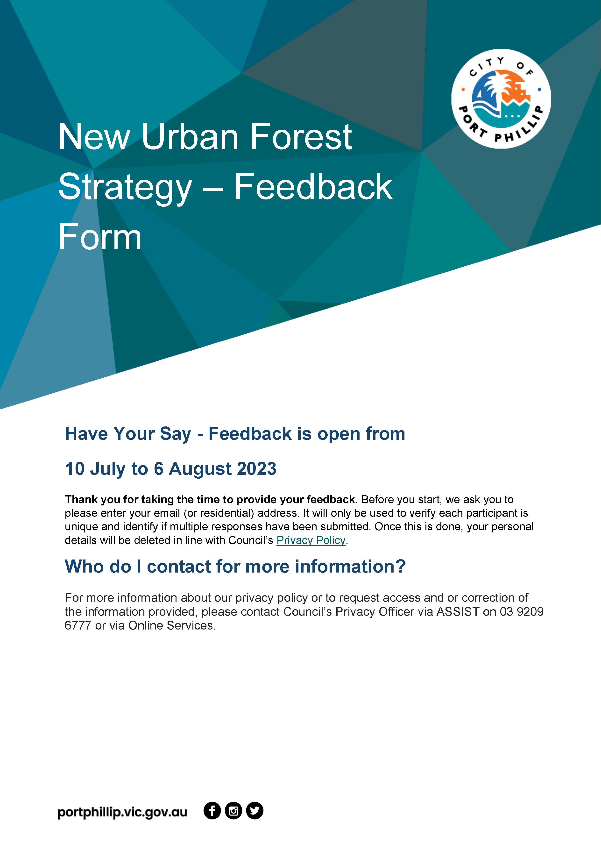
1. New Urban Forest Strategy – Feedback Form (Survey)

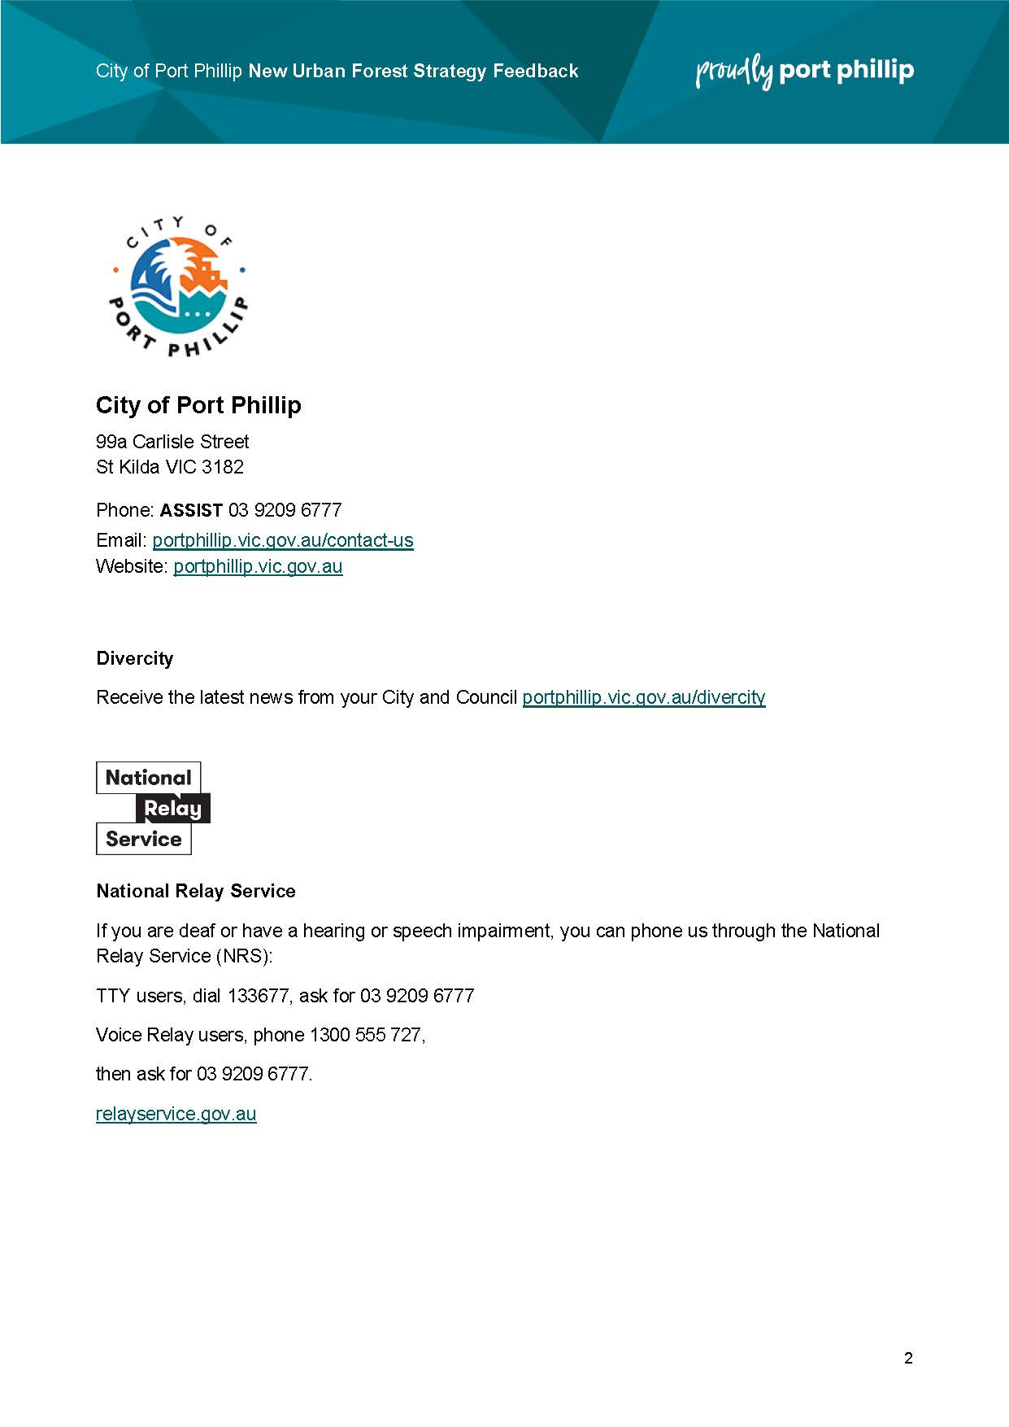
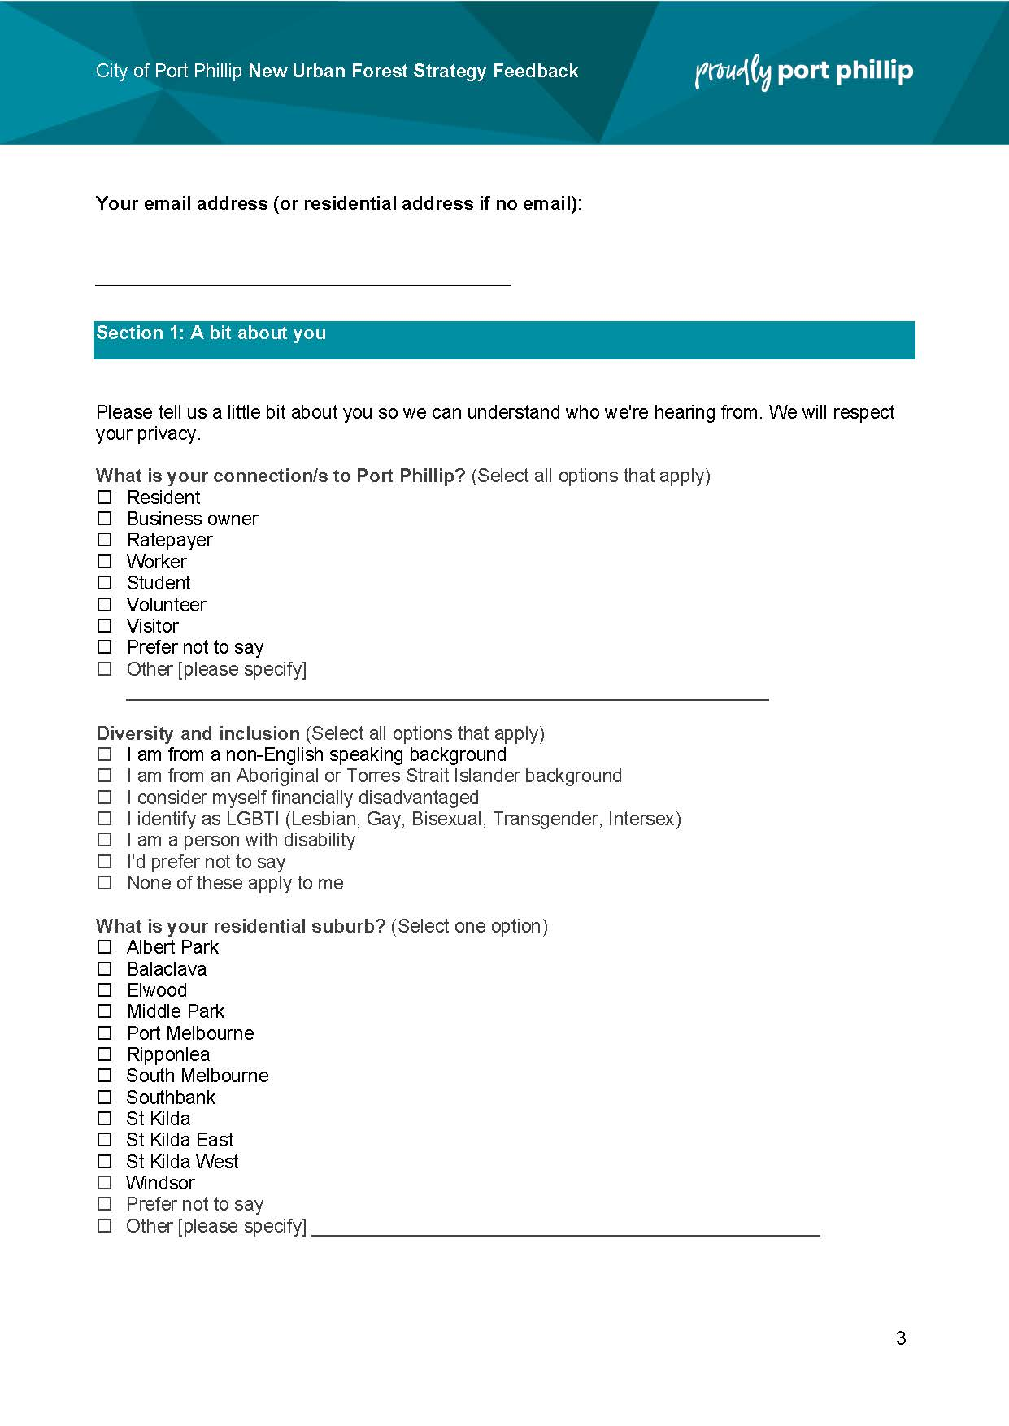

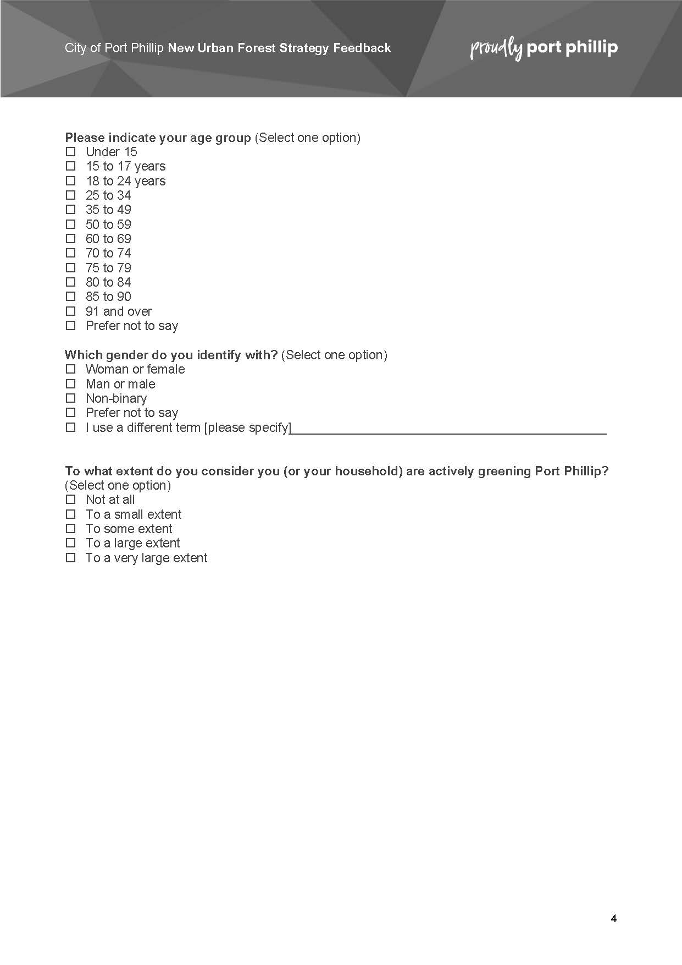

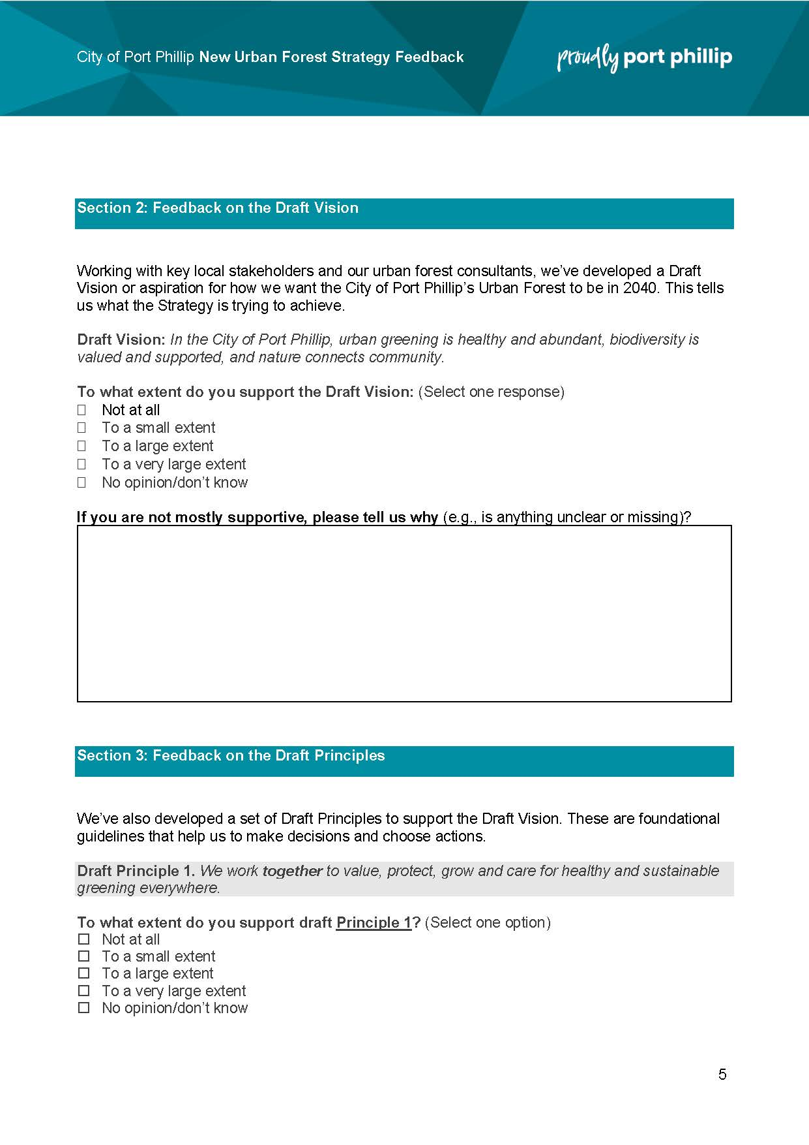

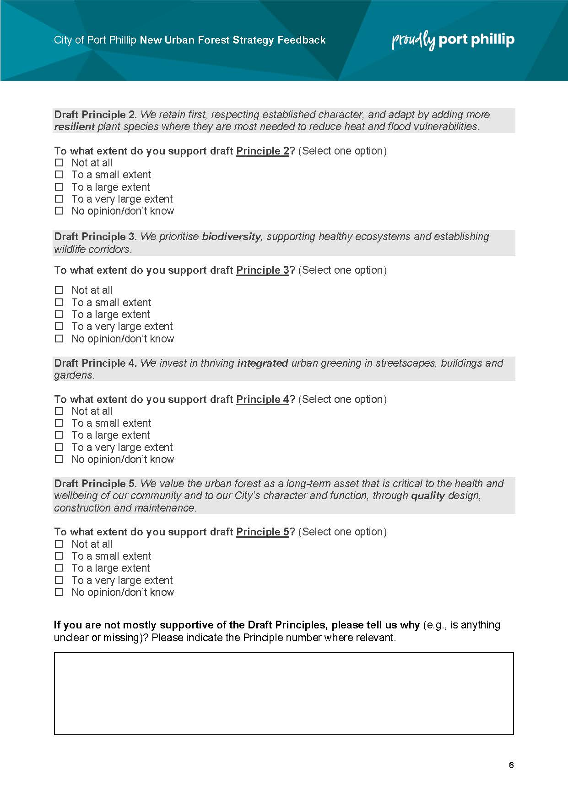
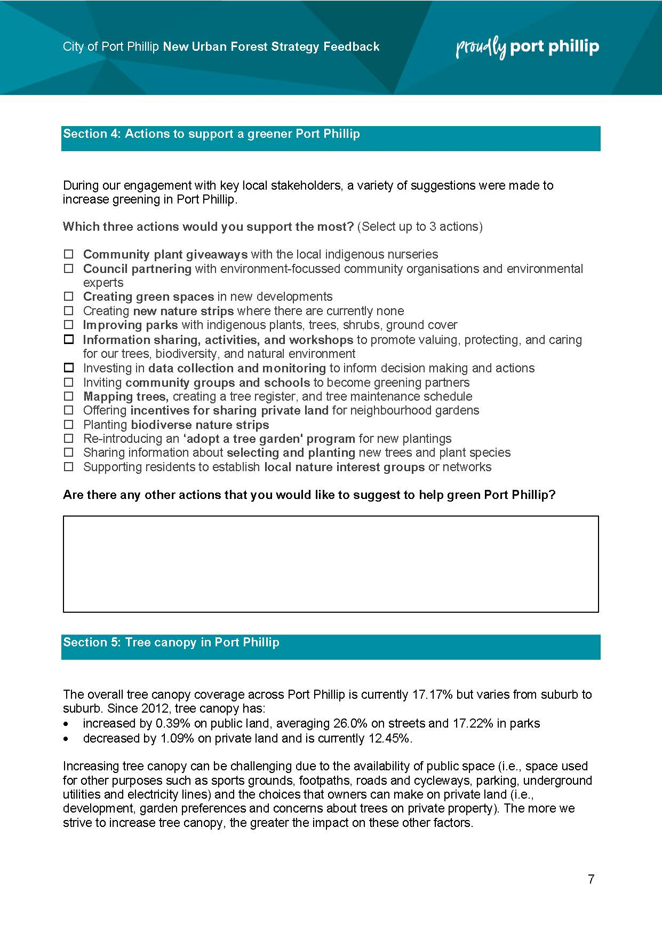
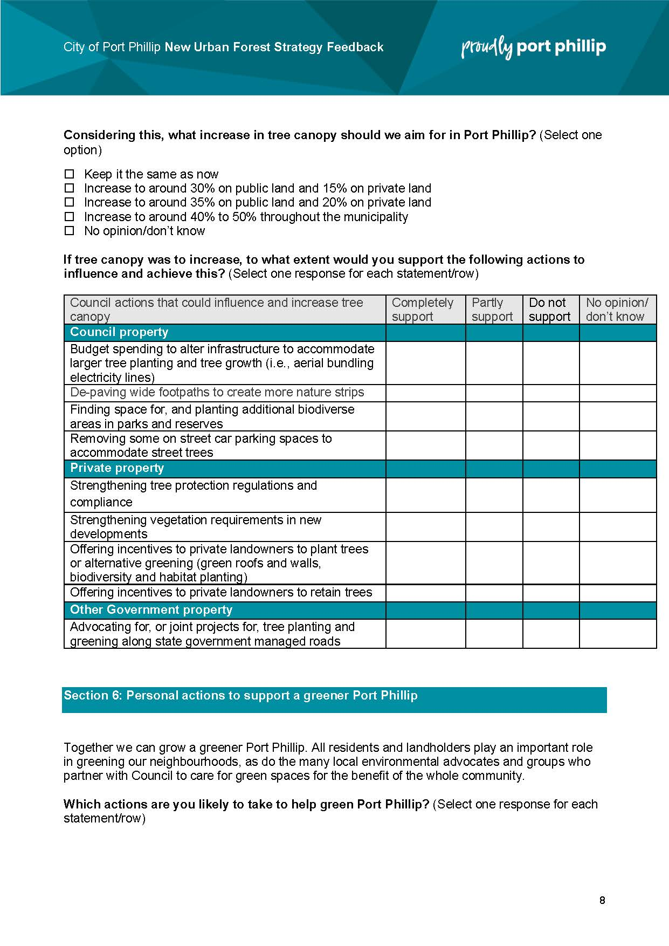
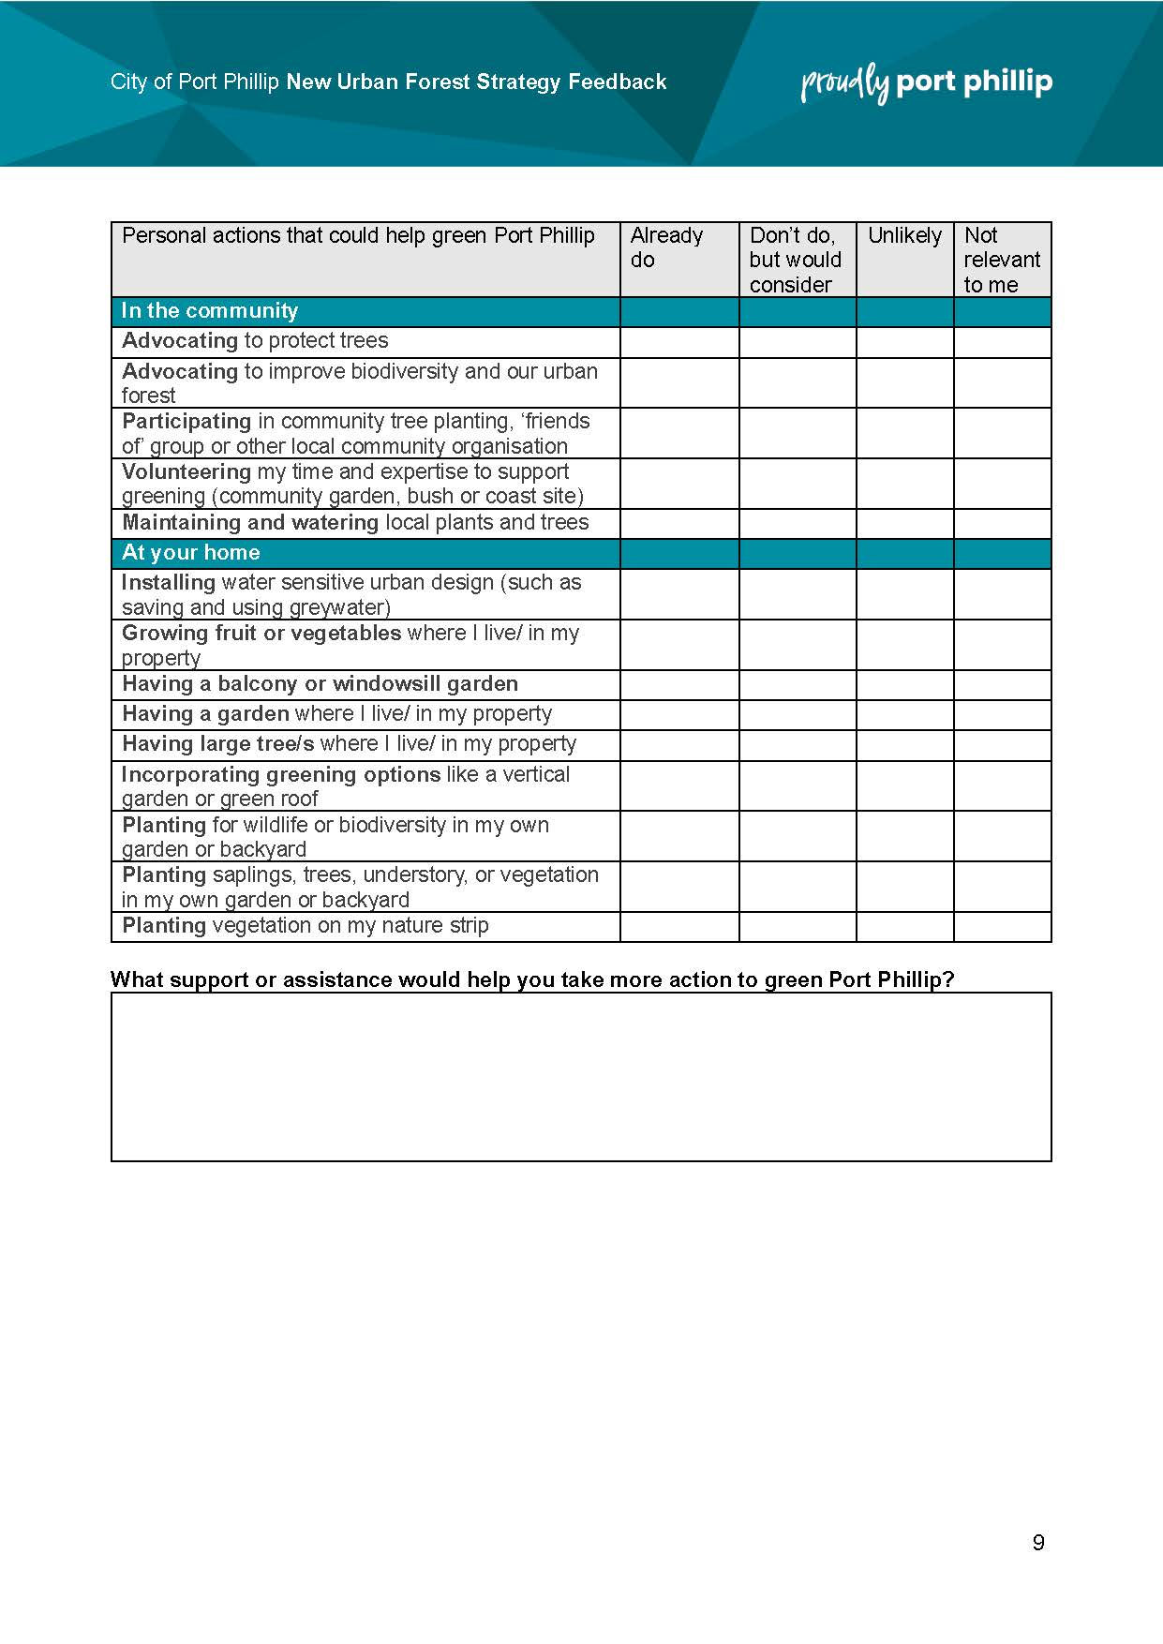

2. Selection of images from place-based pop-up engagement activities
