|  |  |  |
| --- | --- | --- |
| **Car Share Policy  2016 - 2021** | TRIM folder: | 30/09/11 |
| Approval date: | 26/07/16 |
| Approved by: | Council |
| Review Date | December 2018 |
| Responsible Officer: Kathleen Kemp | Expiry Date | 26/07/21 |
| ***Sustainable Transport Planner*** | Version No | 1 |
| Authorising Officer: Brett Walters | ***Manager Sustainability & Transport*** | |

## 1. PURPOSE

The purpose of this policy is to:

1.1 Define the benefits of car share to members, the local community and Council;

* 1. Encourage the expansion of car share across the municipality between 2016 and 2021;
  2. Provide clear targets for expanding the number of car share vehicles and members in the City of Port Phillip by 2021 to reduce the number of privately owned vehicles and create a shift to sustainable travel choices, in order to realise community benefits;
  3. Outlines the rationale for any applicable car share fees and charges;
  4. Articulate the criteria for the preferred location for on-street car share bays.
  5. Provide a clear basis for Council procedures in how Council officers increase the number of car share vehicles and the coverage across the municipality.

## 2. SCOPE

* 1. The operation of Car Share on the road network within the municipality, including expanding the network of vehicles and any changes to on-street parking controls.
  2. Supporting the provision of car share vehicles within appropriately located and designed developments through the application of the Port Phillip Planning Scheme.
  3. This policy only applies to commercial Car Share Providers. Peer-to-peer car share schemes are excluded from this policy except for the purposes of promotion and reporting.
  4. This policy does not apply to any agreement between Car Share providers and a third party entered into for the purposes of providing a car share vehicle within privately owned property.

## 3. REFERENCES

* 1. Car Share delivers on key objectives from the “Vibrant” and “Healthy” sections of the Council Plan. Specifically it addresses the following three focus areas:
* 4.4 Ensure people can travel with ease using a range of convenient, safe, accessible and sustainable travel choices, and particularly actions to:
  + Plan for, and respond to, the changing transport needs of a high density community.
  + Minimise the impacts of motor vehicles on the liveability of our City.
* 4.2 Ensure growth is well planned and managed for the future
* 2.2 Support our community to achieve improved health and wellbeing
* Council’s *Sustainable Transport Strategy* which sets Council’s vision for a connected and liveable city where residents, visitors and workers can live and travel without needing to own a car by improving the convenience, safety, accessibility and range of sustainable travel choices across the municipality. The policy supports the Strategy by supporting the realisation of the following:
  + Council’s commitment to achieve an aspirational 50% reduction in community greenhouse gas emissions per person by 2020 (based on 2006 levels) as articulated in the Toward Zero Environmental Strategy.
  + Supporting outcome: Motor Vehicles – Smarter with Less

Reduced vehicle usage and ownership by providing for sustainable modes of travel, car share schemes and encouraging the uptake of more efficient vehicle technologies and driver behaviour.

* + Council has committed to encourage households and businesses to use car share schemes.
  1. The *Port Phillip Planning Scheme*, Clause 52.06 - Car Parking.
  2. Council’s *Sustainable Transport Policy and Parking Rates 2007*.
  3. The *Local Government Act 1989,* Clause 1 of Schedule 11.

## 4. DEFINITIONS

4.1 Car share providers (CSP) are approved by Council to apply for car share bays and provide vehicles for their members to use.

4.2 On-street car share bays refer to dedicated parking spaces located on local and arterial roads, which are occupied by a vehicle provided and managed by the respective Car Share Provider.

4.3 Off-street car share bays refer to parking spaces in off-street car parks, residential or commercial buildings or properties.

## 5. COUNCIL POLICY

## Benefits of Car Share to the City of Port Phillip

* + 1. A network of easily reached and distributed car share vehicles provides benefits to the member (user), local residents (non-users) and the broader community. As such, the expansion in the ‘network coverage’ and number of car share vehicles across the municipality is encouraged, as it generates the following benefits:
  + Lowering private vehicle ownership levels;
  + Reducing local parking pressures and improving parking availability around the car share vehicle location (Research shows that one Car Share Vehicle replaces an average of 10 privately owned vehicles);
  + Supporting shifts towards more walking, bike riding and public transport trips, by being a complementary travel choice;
  + Residents and businesses who become car share members save money, by avoiding the cost of car ownership.
  + Generates a number of secondary benefits and opportunities. This includes social equity as people can access a vehicle without owning a vehicle, increased physical activity, greater local expenditure and better environmental performance through less vehicle emissions and local amenity.
    1. Independent research by Phillip Boyle & Associates indicates that investment in Car Share by Council delivers a Cost Benefit Ratio of $2.43 for every $1 spent, as shown in **Figure 1.**

**Figure 1** Annual Benefit and Cost of each Car Share Vehicle in the City of Port Phillip

**Public Benefit**

**Private Benefit**

**Public Cost**

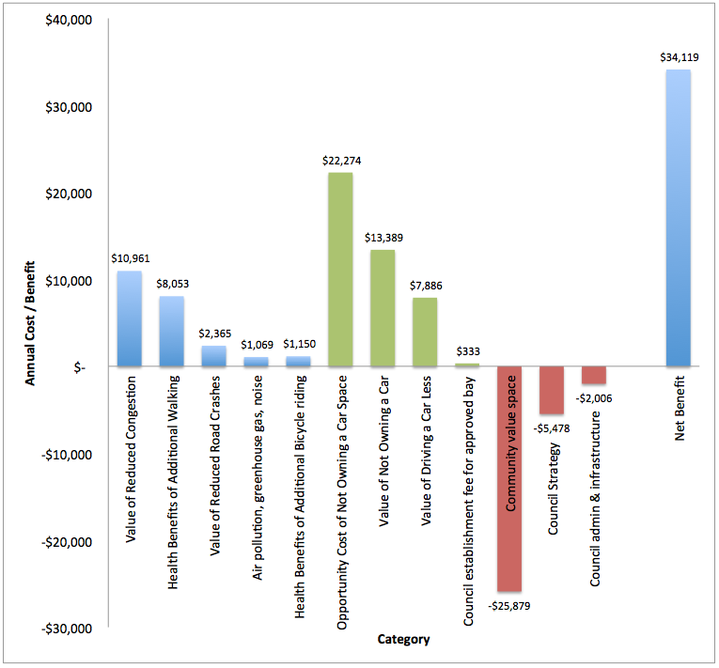

# Target for the number of car share spaces and membership in 2021

* + 1. Council seeks to realise a network of 330 car share vehicles (both on and off-street) across the municipality by 2021. Expansion targets for car share are based upon reducing the level of private vehicle ownership within the municipality. Current trends in growth are that if not addressed a further 2,904 vehicles will added to the already 51,927 privately owned vehicles located within the City of Port Phillip between 2016 and 2021.
    2. The target of 330 car share vehicles by 2021 is intended to stabilise car ownership levels at 2015 levels (52,000 privately owned vehicles). Assuming incremental expansion of on-street car share vehicles then this could follow the pattern shown in **Table 1**.

**Table 1: Proposed annual expansion of car share vehicles to reach 2021 target.**

|  |  |  |  |  |  |  |
| --- | --- | --- | --- | --- | --- | --- |
| **Financial Year** | **2016/17** | **2017/18** | **2018/19** | **2019/20** | **2020/21** | **2021/22** |
| **Number of car share vehicles in service** | 103 | 147 | 191 | 235 | 282 | 330 |
| **Number of new car share bays created per annum** | 44 | 44 | 44 | 47 | 48 |  |

* + 1. Council reserves the right to amend the target upwards, as part of a mid-policy review to be completed by December 2018. Amending the target upwards will be based upon the levels of car share utilisation, membership per vehicle and the benefits of car share quantified through monitoring and reporting data supplied by the Car Share Providers to Council, in order to affect greater reductions in private vehicle ownership to pre-2016 levels.
    2. Council will work with car share operators to promote car share and increase membership in car share schemes to 10% of the resident population.

# Fees and charges

* + 1. Council seeks cost neutrality in providing on-street car share bays, managing the implementation of the policy and monitoring performance and reporting. In determining appropriate establishment fees and any annual charges, Council takes into consideration the following factors:
  + Administration and management costs;
  + Officer time dedicated to the expansion of the network of car share bays;
  + The value of car spaces for residents;
  + Demand for on-street car share bays; and
  + The direct community benefits of car share.

# Siting and location criteria for on-street car share bays

* + 1. Council’s Sustainable Transport Strategy provides four guiding principles which help to inform the general locations and more specific siting criteria for the placement of new on-street car share bays shown in **Table 3** and **Figure 2** shows the Hierarchy of Parking Need from Council’s Sustainable Transport Strategy.
    2. Council officers and CSPs will follow these criteria in determining the ideal placement of car share bays and thus vehicles to maximise the vehicle use and as a result, the benefits of car share to our local community and members.

**Table 3: Location and siting criteria for determining car share bay placement.**

|  |  |
| --- | --- |
| **Sustainable Transport Strategy Guiding Principles** | **Criteria for Determining Car Share Bay Placement** |
| 1. ***Ensure Priority*** – The Council will give preference to, and right of way to sustainable transport modes in terms of allocating time, space and facilities, guided by Council’s Road User Hierarchy. | **Location Criteria:**  **Parking Hierarchy**   * Follows the hierarchy of parking need in determining the location, based on parking controls nearby.   **Convenient**   * Place cars outside residential or commercial properties. * Place cars where users request them or where demand is demonstrated. |
| **Siting Criteria:**  **Favourable Context**   * Near activity and community hubs, areas of high employment, residential densities or low vehicle ownership. |
| 1. ***Increased Integration*** – The Council will strive to achieve a City where places are interlinked through walking, bike riding and public transport routes that are efficient, direct, attractive and competitive. | **Location Criteria:**  **Transport Integration**   * Place near tram or bus stops or train stations. * Place on arterials and “exits” to communities. |
| **Siting Criteria:**  **Effective Catchment**   * Put cars within 300m of each other to provide ‘coverage’. * Put cars at intersections to maximise access catchment.   **Efficiency**   * Uses spaces which are no longer required and can be re-purposed (loading zones, taxi zones, and residential disabled parking bays). * Locations where works have created new space (redundant cross-overs removed, street furniture relocated). * Authorise ‘small bays for small cars’. |
| 1. ***Improve Safety and Accessibility*** – Council will work to provide conditions which allow people of all abilities to feel safer using our streets and sustainable transport options. | **Location Criteria:**  **Safety**   * Orientated so it does not block sightlines from access ways, crossovers or pedestrian crossing points (formal and informal). * Provides clearances from service covers, drainage pits and conduits.   **Mobility impaired**   * Preserves DDA accessibility such as dropped kerbs, circulation space next to disabled parking spaces, tram and bus stops. |
| **Siting Criteria:**   * Minimum setback from vehicle crossovers and intersections is maintained. |
| 1. ***Raise Profile*** – The Council will strive to raise the profile of walking, bike riding and public transport along with the benefits of these transport modes through provision of information, facilities and active promotion to drive change in travel behaviour. | **Location Criteria:**  **Visibility**   * Ideally bays are at the beginning or end of a row of parking. * A proportion of bays close to shopping strip, major attractors or areas of high pedestrian traffic. * The choice of vehicle (sedan, wagon, van) must reflect the ground floor use of adjacent buildings and the surrounding streetscape to ensure it does not obscure or be out of scale within the locations context.   **Promotion and Awareness**   * Communicates the benefits of car share on lowering parking demand and cost saving for people becoming members. * Clearly communicates the purpose of the car share bay. |

**Figure 2: Council’s Hierarchy of Parking Need**

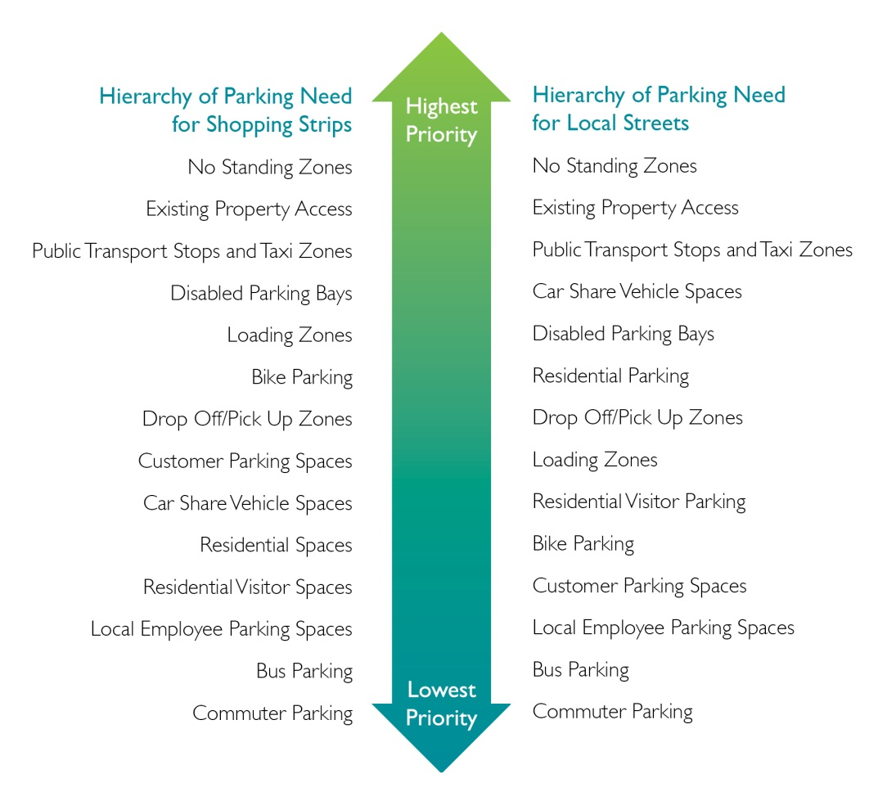

# Supporting the Provision of Car Share Vehicles within New Developments

* + 1. Council supports the provision of car share vehicles within new developments to not only reduce the need for car parking and car ownership for the specific development, and lessen the impact of this on the locality, but also to supplement the on-street network of car share in the locality of the new development.
    2. Within new developments the provision of a car share scheme operated by a Car share Provider is supported by Council along with a reduction in the number of car parking spaces provided on-site. This will be considered in conjunction with Council’s *Sustainable Transport Policy and Parking Rates 2007* and the *Port Phillip Planning Scheme* (Provision 52.06 – Car parking).
    3. Public access is required to be provided to the car share vehicle within each new development. This necessitates careful design and location of car share bays within new developments to ensure easy access to the car share vehicle and make it convenient to use. Guidance on the location and design of the car share bay within new developments is included within **Attachment 7**.

# Car Share as a Travel Choice for Our Community ’

* + 1. Council recognises that Car Share is a travel choice or ‘service’ for the local community. In order to be a viable travel choice and alternative to private vehicle ownership Council seeks to create a network of car share vehicles that provide municipality-wide coverage.
    2. The proposed distribution of car share vehicles, across each Sustainable Transport Planning Precinct between now and 2021is shown in **Figure 3.**
    3. Further details on how Council will guide the creation a network of car share vehicles is included in **Attachment 8.**

**Figure 3: Distribution of current and proposed car share vehicles by precinct**

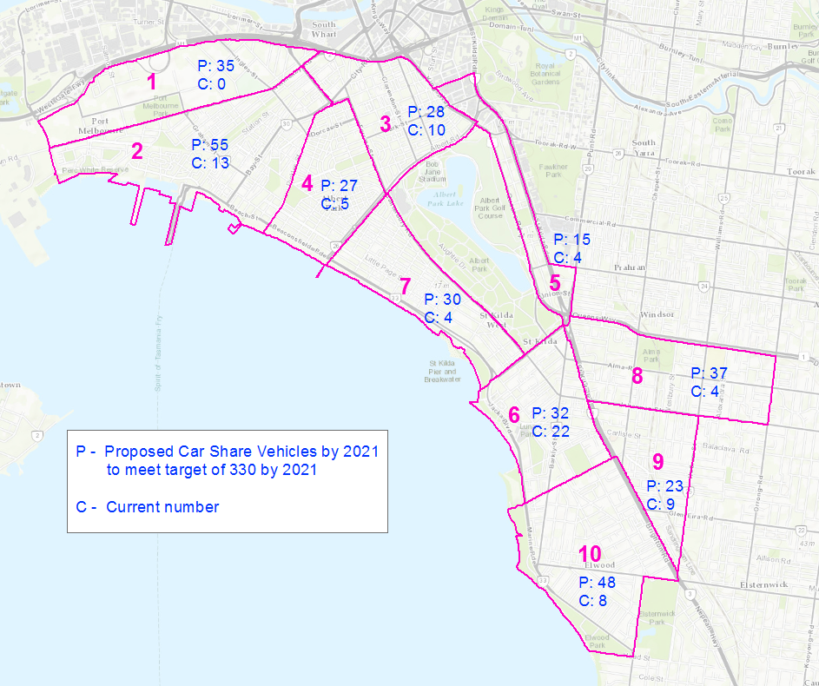

# Roles and Responsibilities

* + 1. Car Share Providers (CSP) are responsible for providing documents to become qualified, as outlined in **Attachment 1** and providing vehicles, membership and levels of service that meet requirements, providing quarterly and annual reports and maintaining vehicles as outlined in **Attachment 2.**
    2. Council is responsible for approval of car share applications, consulting adjacent properties, installation of car share bays and promoting the benefits of car share as outlined in **Attachment 3** with the Application Process for New On-Street Car Share Bays outlined in **Attachment 4** and the City of Port Phillip Car Share Enforcement Procedure described in **Attachment 5**.
    3. Developers and Body Corporates are responsible for meeting the requirements of the planning scheme, planning permits and ensuring that the operation of the development continues to comply with the planning permit and conditions relating to the car share vehicle and bay within the development.

## 6. CAR SHARE PROCEDURES

# The relevant procedures for implementing the City of Port Phillip Car Share Policy 2016 – 2021 are detailed in the supporting document and set out within the following attachments:

# Attachment 1 - Car Share Provider (CSP) Qualification Criteria

# Attachment 2 - Obligations of Car Share Providers

# Attachment 3 - Obligations of Council

# Attachment 4 - Application Process for New On-Street Car Share Bays

# Attachment 5 – City of Port Phillip Car Share Enforcement Procedure

# Attachment 6 – Car Share Bay Application Form (September 2015)

# Attachment 7 – Location and Design Criteria for Car Share Vehicles within New Developments

**Attachment 8 –** **Council’s Approach to Expanding Car Share**

# Attachment 1: Car Share Provider (CSP) Qualification Criteria

1.1 Only CSPs that are considered suitable can apply for car share bays within the City of Port Phillip. To determine whether a CSP is qualified they must demonstrate their compliance to criteria detailed below.

* 1. **Insurance:**
     1. The CSP will need to hold a current Public Liability Policy of Insurance for the sum of

10 million dollars. The CSP must provide the Council with a certificate of currency in respect of the insurance/s referred to above.

* 1. **Car Share Vehicle Requirements:**

1.3.1 Providers must supply a range of vehicles based on an assessment of local

needs, encompassing passenger vehicles, vans and utility vehicles.

* + 1. There is to be no third party advertising placed on car share vehicles unless by prior agreement for a specific purpose such as to offset the costs of wheelchair accessible vehicles. The CSP’s branding must be readily distinguishable for enforcement purposes.
    2. All passenger vehicles must have a minimum 4 star ANCAP safety rating. Average emissions for passenger vehicles of 175 grams per kilometre in 2017 reducing by 15 grams per kilometre annually to 115 in 2021.

1.3.4 In the case of vans or utility vehicles, the operator must demonstrate that the vehicle is a high environmental performer for its class.

* + 1. The vehicle must not be a caravan, box trailer and must not exceed 4.5 tonnes gross

weight.

* 1. **Car Share Membership Requirements:**
     1. There are to be no restrictions to membership based on the age of car share

members.

As defined in VicRoads’ Traffic Management Note No. 28[1]:

* A car share vehicle is for the exclusive use of car share members
* A member of a car share scheme is a person who has fulfilled membership requirements with a CSP
* Vehicles are available to car share members only. There are to be no casual memberships made available as is the case with hire car companies.
  1. **Minimum Level of Service:**
     1. Car share vehicles will be available for a minimum booking period of one hour.
     2. CSPs must ensure that no on-street space remains empty for a period greater than

five consecutive days, unless by prior written agreement.

* + 1. A CSP must ensure vehicles can be booked via both an Internet and telephone

booking service available 24 hours a day, 7 days a week.

* + 1. The CSP must provide a customer support service during business hours seven days a week.

1.5.5 The CSP must be capable of demonstrating they comply with the obligations set out

in Section **Attachment 2** of this policy.

# Attachment 2: Obligations of Car Share Providers

* 1. **Promotion**

Each Car Share Provider is solely responsible for the promotion of their service to prospective and existing members. Council will continue to promote the concept of car sharing as a travel choice that complements walking, bike riding and public transport travel and an alternative to a privately owned vehicle.

* 1. **Reporting:**

2.2.1 Council requires CSPs to collect usage information on their individual car share vehicles and bay locations as well as general membership characteristics for reporting purposes.

* + 1. CSPs will agree to report quarterly in a standardized spread sheet on the following characteristics, at a minimum, for each on-street and off-street vehicle e.g.:
* Total number of hours booked per month
* Total number of trips per month
* Utilisation rate per month (number of hours the vehicle is booked per month/time

vehicle is available per month)

* Total distance travelled per month
* Average trip distance per month
* Number of trips over 50km per month
* Number of trips undertaken on weekdays per month
* Number of trips undertaken on weekends per month.
* Average emissions of passenger vehicle fleet.
  + 1. CSPs will agree to report quarterly on the following characteristics, at a minimum, on

their members e.g.:

* Membership numbers per month
* Percentage growth in membership by month
* Breakdown of members by private or corporate membership (if applicable) by month
* Geographical location of members within the City of Port Phillip by postcode.
  + 1. In addition to submitting quarterly reports, CSPs will agree Council can request a

report at any time on the usage characteristics of any one bay if required.

* + 1. CSPs will agree to conduct an annual survey of Port Phillip members’ travel habits

and car ownership levels. Questions will be provided by the Sustainable Transport team.

* 1. **Maintaining Car Share Locations:**
     1. The CSP must supply a vehicle to the approved bay within ten working days of installation (or by prior written agreement) as per the terms of the Agreement.
     2. Council’s Transport Safety Engineering team is responsible for maintaining signage

and line marking of the car share bay, however the CSP must ensure that:

* In the course of maintaining or cleaning car share vehicles, no refuse shall be

disposed onto the street

* No existing or approved structures, fixtures or fittings shall be altered or added

to without written approval of the delegate

* Any approved fixtures, such as information panels, are kept in good condition

and the information they contain is kept up to date by the CSP.

* 1. **Enforcement Procedure:**

2.4.1 Demand for on-street parking in the City of Port Phillip is high. CSPs need to

adhere to, and inform their members of, the enforcement procedure set out in  
**Attachment 5** should a car share bay be illegally occupied by a non-car share vehicle.

* 1. **Allowing Access to Car Share Bays:**
     1. The CSP will grant Council access to the bay for necessary activities such as line marking, road works, festivals or events. Council will aim to provide advanced notice to the CSP in these situations.
  2. **Failure to Meet Obligations:**
     1. Ability to terminate an agreement is as per Council’s Register of Delegations.

2.6.2 Council can suspend the CSP’s right to use one or more of the allocated car

share spaces if they fail to meet any of the obligations listed above and can choose to reallocate bays to another CSP.

# Attachment 3: Obligations of Council

* 1. The individual responsibilities of each Council work unit are outlined below:
     1. **Car Share Officer is responsible for:**
* Assessment and approval of car share bay applications using the siting and location criteria (jointly with Transport Safety Engineering).
* Informing Councillors of the Car Share Bay locations which are being considered
* Consulting properties immediately adjacent to proposed bay locations to ascertain

whether they have any legitimate concerns or objections.

* Ensuring CSPs are set up as Debtors on Council’s financial system
* Informing Procurement via an Invoice Request Form to invoice CSPs for the required

number of approved car share bays.

* Informing the Sustainable Transport team of the proposed make and model of car

share vehicles to be supplied by CSPs for approval

* Informing the Sustainable Transport team with the locations of new bays once they

have been implemented.

* Updating the map of car share bays within the municipality on Council’s

website twice a year.

* Informing Parking and Enforcement of the location of new bays once they are

Implemented.

* Serving as the point of contact for CSPs regarding applications for car share bays and

invoicing for new car share bays..

* + 1. **Transport Safety Engineering is responsible for:**
* Assessment and approval of car share bay applications using the siting and location criteria (jointly with Car Share Officer).
* Providing referral advice to Statutory Planning about the suitability of proposed off-street car share spaces.
* Arranging contractors to install new bays (signage and line marking) and to refresh

signage and line marking of existing bays as deemed necessary by the Coordinator of Transport Safety Engineering

* Serving as the point of contact for CSPs regarding maintenance of existing car share bays.  
  + 1. **Sustainable Transport is responsible for:**
* Overseeing the CSP qualification process
* Working the Contracts, Procurement and Fleet area to develop a suitable contract with car share providers
* Approving the make and model of car share vehicles to be supplied by CSPs
* Monitoring performance of car share bays based on reports received from operators
* Designing an annual survey of car share member travel habits to provide to CSPs
* Recommending to Council appropriate fees and charges and ensuring that this is included in the Car Share Application Form.
* Working with City Strategy to progress the inclusion of car share provision, location and design requirements in the planning scheme, requisite research and planning scheme amendment preparation. This will include determining the ideal approach and mechanisms to facilitate greater car share provision within developments.
* Using Council’s communication channels to:
  + Show that car share vehicles are readily available in the City of Port Phillip and help residents identify the locations and providers that are most convenient for them.
  + Encourage residents and businesses to join and use car share services.
  + Promote car sharing as a travel choice that complements walking, bike riding and public transport travel and an alternative to a privately owned vehicle.
  + Increase the awareness of decision-makers including Councillors and Council officers, and the broader community of the benefits to the local community and ease of use of car share.
* Updating the schedule of bays in the CSP’s Contract of Agreement
  + 1. **Parking Enforcement is responsible for:**
* Maintaining the policy and procedure for the enforcement of car share

bays

* Serving as the point of contact for CSPs regarding enforcement of car share bays
* Responding to requests to issue parking infringement notices to non-car share

vehicles parked in car share bays.

* + 1. **Statutory Planning is responsible for:**
* Seek the inclusion of car share bays that are well located and designed in new developments to enable convenient access and ease of use within planning applications and providing information about car share to developers during pre-application meetings.
* Ensuring that planning permits include installation of off-street car share bays where appropriate.
  + 1. **ASSIST is responsible for:**
* Taking general enquiries from the community about the car sharing
* Serving as the point of contact for CSPs if a car share bay is found to be illegally

occupied by a non-car share vehicle. The ASSIST Centre will then transfer the call from the CSP to the Parking Enforcement team.

# Attachment 4: Application Process for New On-Street Car Share Bays

* 1. Council reserves its rights to determine the number of available car share bays prior to the application process.
  2. Applications for new car share bays will be accepted generally twice per year and Council will provide six weeks’ notice of the dates.
  3. Council will advise how many bays are available to be applied for prior to the start of the application process.
  4. Qualified CSP are encouraged to nominate at least one additional location and prioritise their applications so that if a proposed location is deemed unsuitable another can be considered.
  5. Qualifying CSPs must follow the process outlined below to apply for new bays:
     1. **Step 1:** **Submitting the Application**
* The CSP must complete an application form for each bay they wish to apply for and submit it to Council’s Car Share Officer for approval.

**4.5.2** **Step 2 Assessment of Applications:**

As part of their application, CSPs will have to demonstrate the demand for a car share bay at their chosen location. To demonstrate the demand for a bay CSPs can refer to:

* The number of existing car share members or potential new members living/working nearby
* Utilisation rates of existing car share vehicles located nearby
* Potential demand based on an assessment of relevant demographics e.g. household size, age of population etc.
* Number of requests from existing car share members or registrations of interest from potential new members.
  + 1. CSPs must consider Council’s Siting and Location Criteria including the Hierarchy of Parking Need when applying for new bay locations. The hierarchy prioritises safety and sustainability while aiming to accommodate the parking needs of residents, businesses and visitors.
    2. Consideration will be given to applications for pods with multiple vehicles if sufficient demand can be demonstrated based on the number of members and/or high usage of existing car share vehicles in the vicinity of the proposed location.
    3. In general, applications for new car share bays will not be considered where parking

or stopping is prohibited by Road Rules Victoria, such as in clearways, at the location of bus stops.

4.5.6 Each application will be assessed on its own merits in conjunction with Council policy.

* 1. **Step 2: Application Assessment**

## Council’s Car Share Officer will assess the application and the

## suitability of the proposed car share bay location and will provide fortnightly updates to CSP of progress on the application.

## If required, the Car Share Officer will undertake consultation with properties immediately adjacent to the proposed bay location and will inform Councillors of locations prior to consultation.

## Where the proposed location is deemed unsuitable by the Transport Safety Engineering team or where the consultation is unsuccessful, an effort will be made to find an alternative location for the bay nearby.

* 1. **Step 3: Payment of Establishment Fee and any annual fees**
     1. Transport Safety Engineering will require payment of the establishment fee

for each approved car share bay location. An invoice will be issued to the CSP payable within **30 days** by electronic funds transfer. If payment is not received in 30 days the allocation of the bay allocation will be cancelled.

* + 1. Any annual frees will be levied on 1 July for each financial year and must be paid in full before any new car share bays are installed.
  1. **Step 4:** **Bay Installation**
     1. Once payment has been received, Transport Safety Engineering will engage a

contractor to implement signage and line marking for the required number of bays.

* + 1. Council will endeavour to implement signage and line marking of the car share bay **within six to eight weeks** of receiving payment, subject to the contractor’s availability and weather conditions.
  1. **Step 5: Updating Council Records**

Once the bays have been installed, the Car Share Officer will update the list of locations on the Council website and inform the Sustainable Transport team of the new locations for addition to the schedule of bays in the CSP’s Contract of Agreement.

* 1. **Duration of Agreement:** 
     1. The duration of the agreement will last for a period of **five years** after which time it

will come under review by Council.

* + 1. Council reserves the right to take back bays at any time if necessary and will give the CSP a minimum of **one month’s notice** in writing should the situation arise. Council will attempt to relocate the car share bay in question at no cost to the CSP.
    2. The CSP may terminate the agreement upon giving the required amount of notice to Council as defined in the terms of the Agreement.
    3. Council’s Transport Safety Engineering team will consult the properties immediately

adjacent to the proposed bay location in writing, if applicable, to ascertain whether the

occupiers have any legitimate objections. Providing there are none, Traffic and Parking

Design will install the appropriate signs and line marking according to the timeframes specified.

* 1. **Removing or Relocating installed car share bays**
     1. Council reserves the right to remove an existing Car Share Bay at any time. In this event Council will advise the CSP of its intention and cover the costs involved. The CSP will have the opportunity to nominate a new bay for installation which will follow the standard application process.
     2. If a CSP wants to remove a car share bay and another CSP does not want to utilise the bay, the CSP will be liable for the cost of removing the car share bay.

# Attachment 5: City of Port Phillip Car Share Enforcement Procedure

* 1. Demand for on-street parking in the City of Port Phillip is high. Providers need to adhere to, and inform their members of, the following procedure should they find a car share bay to be illegally occupied by a non-car share vehicle:
  2. **Step 1:** **CSP** **Notification of an Illegally Parked Vehicle**
* Members must immediately inform the CSP if a non-car share vehicle is parked in the car share bay and provide them with the offending vehicle’s registration details.
* Members should then park the car share vehicle legally. As close as possible to its designated bay observing clearways, disabled bays and timed restrictions, and inform the CSP of its whereabouts. The car share vehicle will be exempt from paid parking charges.
  1. **Step 2:** **Council Notification of an Illegally Parked Vehicle**
* The CSP is to notify Council’s Parking Enforcement team, via the ASSIST Centre’s general contact number within 1 hour of being notified, and provide them with the location of the offending vehicle and its registration details as well as the location of where the car share vehicle was parked. The CSP must advise the member to park the vehicle within the City of Port Phillip boundaries or for car share vehicles that are located within private car parks, the vehicle should be parked within the same private car park
  1. **Step 3:** **Infringement of Illegally Parked Vehicle**
* Parking Enforcement will respond to requests to infringe illegally parked vehicles subject to the response times listed in the Parking Enforcement Procedure.
  1. **Step 4: Returning the Car Share Vehicle to the Car Share Bay**
* The CSP must ensure that the car share vehicle is returned to the car share bay within 12 hours of notification by Council.

**Attachment 6**: **Application Form for On-Street Car Share Bays (March 2016)**

Applications must be lodged with Port Phillip City Council (**Council**) Transport Safety Engineering team via email at [*transport@portphillip.vic.gov.au*](mailto:transport@portphillip.vic.gov.au) by 15 April 2016. Council reserves the right to refuse any incomplete applications, or ask for further information where required. By submitting an application, the Applicant agrees to comply with the terms and conditions of the On-Street Car Share Scheme Agreement.

All enquiries regarding the application should be addressed to Council at [*transport@portphillip.vic.gov.au*](mailto:transport@portphillip.vic.gov.au) or (03) 9209 6239.

1. **Applicant’s Details**

|  |  |
| --- | --- |
| Company name: |  |
| Company address: |  |
| ABN: |  |
| Contact Person: |  |
| Phone number: |  |
| Fax number: |  |
| Email: |  |

1. **Proposed Car Share Bay Location[2]**

Please provide the following:

* Street address
* Aerial view of showing location of proposed bay.
* Street view clearly showing proposed bay.
* Existing parking restrictions at the proposed bay location
* Land use abutting the proposed bay location
* Proximity to nearest car share vehicle(s)
* Proximity to public transport stops or train stations (if applicable)

**Figure 1: Aerial view for Proposed Car Share Bay (example only)**

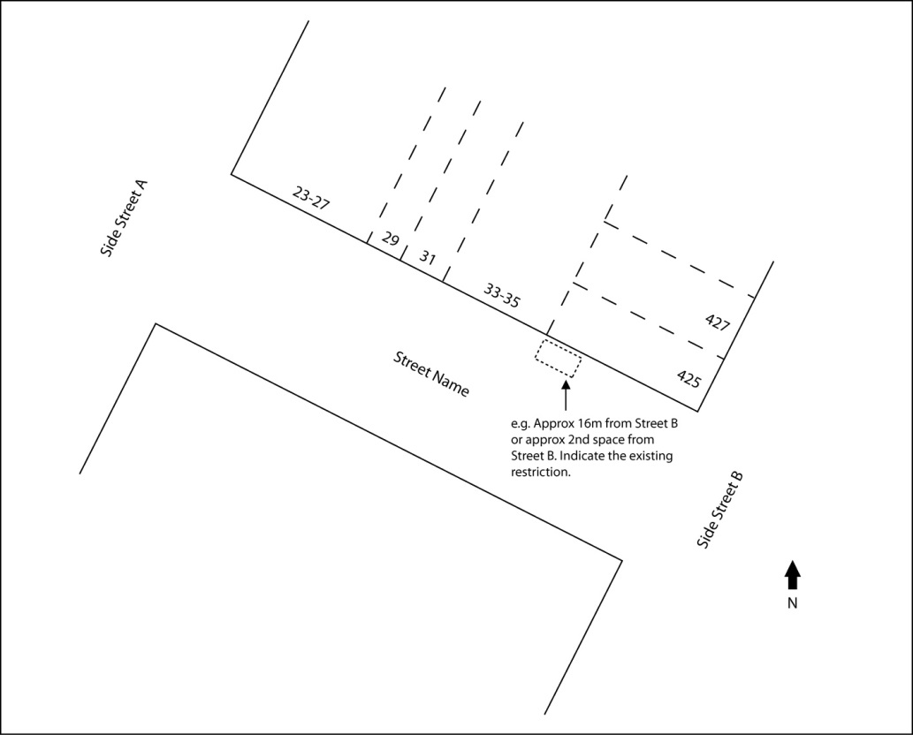

If more than 1 location is requested, please attach **additional** pages as required- Please ensure each bay is in order of preference. **Does the Applicant propose to install an information panel at the location[3]:**

No

Yes, please provide details of the dimensions of the information panel (height, width, depth) and proposed content.

1. **Basis for Demand[4]**

|  |  |
| --- | --- |
| * Number of existing car share members within a 500m radius |  |
| * Number of potential new members within a 500m radius |  |
| * Utilisation rates of existing car share vehicles within a 500m radius expressed as a ratio of car to members |  |
| * Other indicators of estimated demand: e.g. household size, age of population, growth in monthly membership etc. |  |

1. **Proposed Car Share Vehicle At Location**

|  |  |
| --- | --- |
| **Vehicle 1** | **Vehicle 2 (Alternate)** |
| Proposed make(s): | Proposed make(s): |
| Proposed model(s): | Proposed model(s): |
| ANCAP safety rating: *stars* | ANCAP safety rating: *stars* |
| Carbon emissions per vehicle: *grams/km* | Carbon emissions per vehicle: *grams/km* |

1. **Payment of Application Fee**

## Based on the information provided in the application, Council will determine the suitability of the proposed car share bay location and will undertake consultation if required.

## Council may in its discretion reject any application. In that event, Council may propose an alternative location for the Applicant.

## 

## If the Applicant is successful, the Applicant must pay Council a $1,000 bay establishment fee (Fee) by electronic funds transfer within 30 days of notification. If the Fee is not paid by the deadline, Council may reject the application. Council may in its discretion, amend the Fee.

1. **PRIVACY NOTICE**

## The *Privacy Act 1988 (Cth)* makes provisions for collecting, storing using and disclosing personal information, which has implications for the way in which Council handles personal information in its possession or control.

## Council will only use the Applicant’s personal information for the purposes provided to it. Council does not share the Applicant’s information with other organisations, or other persons without the Applicant’s permission unless it is reasonably necessary for the purpose or when Council is required or authorised by law to do so.

|  |
| --- |
| **The Applicant certifies** that all information provided under this application and the attached supporting documentation is true and correct and agrees to the Terms and Conditions of the Car Share Scheme.  Executed for and on behalf of ______________________________________________ by its Authorised Representative:  Signed: …………………………………….. Name: …….……………………………  Position: …………………………………….. Date: ……………………………………… |

**Attachment 7 –** **Car share Bays in New Developments - Location and Design Guidance**

7.1 The below criteria provide guidance to the location and design of car share bays within new developments:

* The car share space must be accessible 24 hours a day, seven days a week by any member of the car share provider, and by employees or contractors of the car share operator in order to clean, detail or service the car.
* A highly visible location from the street
  + for buildings with car parks in the front setback, in the front set back of the site adjacent to visitor car spaces.
  + for buildings with car parks at the rear, at the rear of the site adjacent to visitor car spaces or loading facilities.
* Ideally in front of boom gates
* In the first level of a multi-storey car park (be it ground level, the first level up or first level down)
* In a separate location to where other, assigned / subdivided car spaces are provided
* Where security arrangements are not required or are simple to follow (and where customers can use the same mechanism that they use to get into the vehicle)
* In a well-lit part of the site
* a short distance from an entry point, lift or staircase
* In a standard car space where manoeuvring in and out of the space is limited to no more than three movements
* On common property managed by the Owners’ Corporation
* Minimum height clearance of 2.2 m to allow a cleaning van to enter, manoeuver and exit.
* Mobile data and GPS reception
* Markings for exclusive use of the car share vehicle

**Attachment 8 –** **Council’s Approach to Expanding Car Share**

* 1. Council intends for the expansion of the network of car share vehicles to grow outward from the existing vehicle locations into other parts of the municipality to achieve coverage across the City of Port Phillip. Into the future expansion of car share will be considered through an area approach.
  2. Council may request that new car share bays will be located in specific parts of the municipality.
  3. An analysis of the capacity for expansion of the Car Share network in different areas was completed and considered the following factors:

# population forecasts;

# journey to work data;

# current car ownership levels;

# household incomes; and

# levels of parking demand across the municipality.

* 1. The proposed distribution across the Sustainable Transport Planning Precincts is detailed within **Table 1** below.

|  |  |  |  |  |  |  |  |
| --- | --- | --- | --- | --- | --- | --- | --- |
| **Table 1 Proposed distribution of car share vehicles by Sustainable Transport Planning Precinct** | | | | | | | |
| **Precinct Number** | **Sustainable Transport Planning Precinct** | **On-road car parking spaces**  (Based on Car Parking Capacity Study 2014) | **Proposed Car Share Vehicles by 2021 to meet target of 330 by 2021** | **Current number** | **Additional proposed by 2021** | **Car Share Bays as a Proportion of on-road car parking spaces** | **Comments on capacity for future growth of car share** |
| 1 | Fishermans Bend | 2,590 | 35 | 0 | 35 | 1.4% | Ensure planning requirements apply |
| 2 | Port Melbourne | 9,435 | 55 | 13 | 42 | 0.6% | Expand strongly |
| 3 | South Melbourne | 5,660 | 28 | 10 | 18 | 0.5% | Limited expansion |
| 4 | Albert Park | 6,324 | 27 | 5 | 22 | 0.4% | Expand |
| 5 | St Kilda Road | 1,456 | 15 | 4 | 11 | 1.0% | Expand strongly  (particularly off street) |
| 6 | St Kilda | 4,505 | 32 | 22 | 10 | 0.7% | Limited expansion |
| 7 | Middle Park & St Kilda West | 6,941 | 30 | 4 | 26 | 0.4% | Expand |
| 8 | St Kilda East | 4,642 | 37 | 4 | 33 | 0.8% | Expand |
| 9 | Balaclava and Ripponlea | 3,398 | 23 | 9 | 14 | 0.7% | Expand especially near apartments |
| 10 | Elwood | 5,616 | 48 | 8 | 40 | 0.9% | Expand especially near apartments |
|  | **Total** | **50,567** | **330** | **79** | **152** | **0.7%** |  |

1. VicRoads Traffic Management Note No. 28 – Guidelines for the Implementation of Car-Share Parking, November 2009.
2.
3. Council does not support the attachment of brochure holders or other temporary fixtures to signposts.
4. Applicant should provide as much details as possible and where appropriate, supply references.