Hewison Reserve

Upgrade

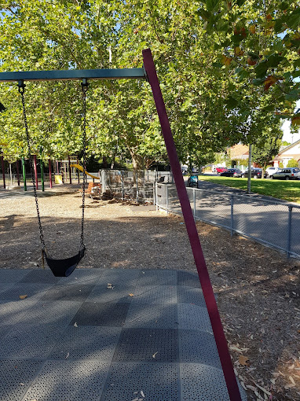
Engagement Summary Report – October 2023

Contents
Executive summary 3
Project background 4
Engagement approach 5
Engagement findings 6

Executive summary
This Engagement Report has been compiled following the conclusion of the concept phase of community engagement for the Hewison Reserve Upgrade. The engagement process included delivery of project postcards in the local area, site signage and Have Your Say website with a survey for respondents to complete.

The information received during the engagement period will be used to update the concept plan as the project moves toward detailed design in late 2023 with construction scheduled to commence in early 2024. The updated concept plan will be advertised on the project website.

Every effort has been made by the authors of this document to represent accurately participant feedback and insights.
Key findings
Of the 92 completed surveys from both the short and long survey:

- Respondents were asked ‘Do you agree with the proposed play equipment?’. Most respondents said natural timber climbing frame (89%/n=59) and pendulum basket swing (87%/n=58) followed by Tee Pee Climber with Slide (84%/n=56).
- Several respondents commented that they support the use of play equipment.
- When asked ‘Do you agree with the proposed amenities?’, most respondents (59%/n=42) supported new seating followed by accessible BBQ with accessible surface (41%/n=29).
- Extending the play area to the south to accommodate a natural play and loose parts area drew concern from many respondents due to antisocial behaviour and vandalism concerns and removing a valued area of grass from general use.
- Increasing amenities was the most prominent area that people felt needed change. This was related to providing facilities for dogs such as a fenced dog of lead area or altering the use of the park to dog off lead. Many respondents called for the installation of toilet facilities as a key aspect of park usability.

Project background
Hewison Reserve in Balaclava is located on land reclaimed from a former lagoon and is heavily used for a variety of activities which include dog walking, competitive sport (soccer and cricket), physical education classes and other passive recreation activities.

Facilities currently within the Reserve include:

- A large play area which is currently in poor condition and reach the end of its usable life
- 2 picnic table areas one to the south and the other to the north of the play area with a barbeque
- Significant native tree planting throughout the reserve
- A large open grassed area.
- A direct path network with lighting
- Extensive garden beds which contain native flora and fauna of the local area.

The play area in Hewison reserve is currently in poor condition and currently ranked 12 of 60 play spaces that require and upgrade. This is a high priority for Council to remove the existing play equipment and upgrade the play space. Through removing the equipment, the opportunity exists to upgrade the play offering within the play area to more contemporary play offerings, create more accessible equipment, and upgrade the barbeque area to an accessible area, consistent Council’s approach to ensure access for all.

Our proposed upgrade aims to benefit the surrounding community through:

- The construction of a new play space
- Protecting and enhancing the natural look and feel of the reserve through new shrub and ground cover opportunities.
- Improving accessibility through a new accessible barbeque area and more accessible play equipment opportunities
The proposed redevelopment Includes:
- Removal of all existing play equipment and installation of new equipment.
- The introduction of natural play through extending
- Upgrading the barbeque area with an accessible barbeque and more picnic tables
- New cricket nets, BBQ, and picnic facilities
- Safer and better lit pathways
A concept plan was developed by Council in late-2022. This document has been compiled following the conclusion of the first phase of community engagement for the Hewison Reserve Upgrade (May 2022) This engagement consisted of 3 on site forums with the community and opportunity to comment via the Have Your Say page. Respondents provided recommendations and comments on what they like about the existing reserve and what they would like to see in the future. Respondents also had the opportunity to provide input to new play equipment opportunities.

Following this current round of engagement in response to the concept plan, plan will be revised and advertised on the project website as the final plan for implementation.

Engagement approach
The community was informed about the engagement process in the following way:
- Signage displayed in the reserve
- Project postcard sent to nearby residents within 500m of the reserve
- Council’s ‘Have Your Say’ webpage Including an online survey for feedback
- Council’s social media pages (Facebook and Instagram)

What we did

Engagement activities
The following engagement activities were undertaken during this project:
- An online survey hosted on Council’s Have your Say project page; and
- Two (2) community place-based pop-ups held on-site,
- Feedback was sought from the broader community, as well as attendees onsite at Hewison Reserve

Participation
Participation snapshot:
The total reach of this project was 904 people.
- 543 page visits of the Have Your Say page
- 91 survey contributions were received from 92 Contributors, and
- 30 people following the project page.
- A paid social media campaign was run on Facebook, with the post seen by 835 people.

Strategies to support participation
Community participation was supported through the following initiatives:
- Communications Campaign:
  - run through the City of Port Phillip. This included promotion on Council’s corporate channels and social media as well as signage at the site.
- Dedicated Project Page:
  - a dedicated project page was created on Council’s Have Your Say, a consistent location for the community to access information and participation via the survey.
- Site activation:
  - two (2) on-site pop ups were completed
- Postcard letterbox drop:
  - to residents and businesses surrounding Hewison Reserve
- Social media posts:
  - on Council’s Facebook and Instagram pages.
- Council’s Newsletters:
  - Divercity and Have Your Say newsletters.

Engagement findings

Have Your Say Response
Information relating to the engagement was posted on Council’s Have Your Say site. The concept design was made available on the Have Your Say Page with the opportunity to complete a survey to share feedback on specific elements of the design and for general comments. A total of 91 respondents contributed.

Survey Responses
The survey asked respondents to provide responses to questions relating to the type of equipment and amenities, with an opportunity for general comments on the proposed design.

Question 1 – Do you agree with the proposed play equipment?

Figure 1. Proposed equipment level of support
Note: The graph above dose not equal 100% due to respondents being able to choose multiple options

65 respondents provided and answer to this question. Most respondents supported the proposed play equipment however many comments requested more variety of play equipment and to accommodate more equipment for younger children. With regards to specific pieces of equipment, most respondents supported natural timber climbing frame (89%/n=59) and pendulum basket swing (87%/n=58) followed by Tee Pee Climber with Slide (84%/n=56). The natural play area due to concerns that it will be used for anti-social behaviour and remove the grassed area currently used as a quiet space and cut through.

Whilst the double swing was supported, many comments related to there not being enough swings due to the baby swing being next to a swing for older children. Many respondents requested that the number of swings be increased.
Question 2 – If you do not agree with any of the play equipment above, please state the equipment and why?

37 of 91 community members provided responses to this question. A total of 15 responses were negative towards the proposed equipment whilst 11 of the respondents had mixed reviews.
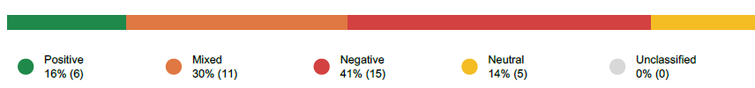
Figure 2. General level of support for equipment
In reviewing the specific comments from the respondents, only 2 comments did not support the play equipment at all, questioning the need for its replacement. Most comments centred around not supporting the natural play area to the south of the existing play area. 12 respondents were strongly against extending the play area for natural play due to anti-social behaviour concerns and concerns regarding losing a quiet area and well utilised cut through from Balston Street to Orange Grove for many residents.
19 comments were received relating to the equipment type and requested changes to the choice of equipment. In general, it was requested that a wider range of equipment be provided that would accommodate younger children and that more swings be provided.

Question 3 – Do you agree with the proposed amenities?

70 of 91 community members provided responses to this question. Most respondents (59%/n=42) supported new seating followed by an accessible BBQ with accessible surface (41%/n=29).

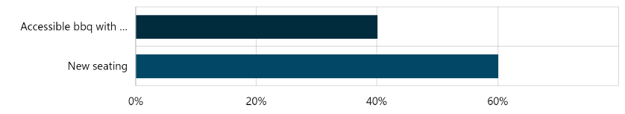
Figure 3. Proposed amenities support
No provision for comments was provided for this question, however specific comments regarding the proposed amenities are provided in Question 4.

Question 4 – If you do not agree with any of the amenities above, please state the amenity and why?

29 of 91 community members provided responses to this question.
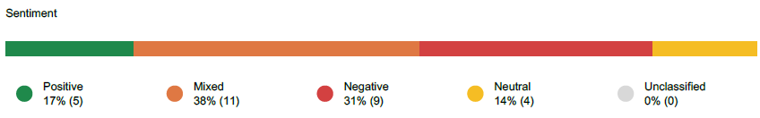
Figure 4. General level of support for amenities
9 responses did not support the proposed amenities whilst 11 respondents had mixed feelings. Most comments related to the proposed seating as it did seem to be comfortable or in adequate quantities. Comments referred to using standard park seating rather than the proposed log seating.
5 respondents requested toilets to be installed within the reserve.
Question 5 – Do you have any other feedback about the proposed design?

66 of 91 community members provided responses to this question.
These responses have been categorised into the following themes;
- Support for the proposal
- Natural play/loose parts area extended into the lawn area to the south
- Provide Public Toilets
- Park should be dog friendly
- More Shade
- Other Facilities
- Equipment type
- Objection to the proposal

Theme | Responses | % of total Responses | Comment
Support for the proposal | 11 | 17% | We live on Orange Grove and take our kids to the park most days. We love the new design and are very excited for it! Thank you!  I love it and can’t wait for our family to enjoy the new design.  I remember when this park was a blank field, so always good to see improvements.  Love it! Can't wait for my kids to play.  The timber and amount of natural material use is great! World's better than bright plastic pieces. If there isn't one there already, a drinking tap would be great.
Natural Play/Loose Parts Area | 10 | 15% | The grass at the back is the only shady spot to picnic, loosing that would be bad.  People use the area at the south end near for exercise yoga - adult exercise. It would be good to keep and support this space which is located away from the road , the dog area on the main lawn. A place for adults to use the park.  It’s a high traffic playground that gets a lot of children visiting during the day but also random people walking home from the pub. I’m concerned that some of the new concept could be mistreated and and not last long (ie nature play).  Love the idea to have open-ended natural materials for children to make and create. Would love this to be maximised in the design. Any chance of water play?  I'm 14 years old and live on Balston street. I use the pathway from Balston street laneway to Orange Grove to ride to school everyday. I also use this path when walking the dog and walking to the library. It would greatly hinder my ability to access Orange Grove. I know that I am not the only kid who lives in my area that feels this way too. I would very much appreciate if the council kept the path as it is now.
Public Toilets | 10 | 15% | A timed toilet would be very handy  The park needs a toilet. It makes little sense for the increase of capacity for children without the addition of the necessary facilities to support them.  Gated around the park which I presume it will remain and toilet needed
Dogs | 9 | 14% | Park should be dog friendly  Can there be an area for small dogs to play?  Its not safe for kids to play amongst free wheeling dogs. Can the fence be extended around some of the grassy area so kids can play on the grass and it’s not used only for animals.  Is it possible to have some small enclosure for dogs?  I really like everything that you have, but the one missing thing that I think would be welcomed would be an upgraded dog bowl to the water fountain that doesn’t allow little kids to continually place stones in and kick dirt in, along with a supply of dog poo bags.  Could we have the other lawn block in Hewison Reserve fully fenced and purpose as fenced dog park? Jus like what’s like on Eastern Reserve (in South Melbourne) So that with the upgraded amenities, family can take care of both kids and dogs in the same reserve while enjoy their own time.
Shade | 7 | 10% | Is there possibility to add more native trees for shade? (Not just on play area but wider park land). And possibly one more bike hoop.  Sunshade installed across most of the equipment  Will the playground include any sun shelter? There are large trees around the existing ground but I think it could benefit with sun shade.  I think it would be nice to consider some shading to assist with optimizing sun smart areas
Other facilities | 5 | 8% | Basketball court/concreted area with basketball ring is desirable, as it allows children of all ages (including teenagers) a space for basketball activity.  See above. A basketball ring will really suit kids from 8- 18. Parents included!  My 8-year-old daughter has the following feedback/requests:  - A metal bar for swinging and gymnastics practice, water play area such as Thomas reserve, booran reserve and webdock, mini trampoline, toilets, table tennis table, gym equipment  In addition to the play equipment, seat, and BBQ, it is important to ensure that the planting area and density is maximised to allow best outcomes for biodiversity, pollination and cooling of our environment.  Please make sure there are bicycle racks and a bicycle repair station to allow people on bikes to access the park  Good illumination is required. Presently the pathway lights are subsumed by the trees completely. Illuminating the play area will help reduce vandalism and abusive behaviour at night.
Equipment Type | 4 | 6% | There appears to be a lot of items geared towards older children - this play area is one of the few that are fenced so it would be great to see some a toddler spot.  I think the overall design and ideas are great. Just a second set of swings would be ideal as they are always popular on that playground.  I very much like the proposed changes to the reserve which give children more options to play, learn and develop their confidence. However there is no mention that accessibility will be improved for people with disabilities including those that use wheel chairs. Would like to see the gates widened to allow easier wheel chair access, and pathways that allow wheel chairs to traverse the area. Please also ensure that some of the new equipment is suitable for the use and enjoyment of less able children.  Its very silly to build a playground which doesn't cater for young children. The majority of the children who come to this playground are under 5 and none of this equipment is for them. They will fall off and break their arms.
Objection to the proposal | 1 | 2% | This play area should not be changed. It is a waste of rate payers dollars. The size of the playground services the little community that use it. The shaded and open areas are also used by our little community. I hope for a change you listen to the residents.  Maybe start with maintaining what we have. Rather than spending money on things that really don’t need to be changed.

Table 1. Summary of feedback responses

Email Responses

In addition to the Have Your Say responses to the survey, the project team received (3) email submissions.

The email submissions focused on the extension of the play area to the south of reserve removing the grassed area to accommodate a natural play area and increasing planting in the reserve. The responses were similar expressing concern over the removal of the grassed area as it is a quiet space within the reserve and is used as a cut through between Balston Street and Orange Grove. All respondents stated this would have a significant impact on how they use the park and their accessibility to other areas of Balaclava.

Who we heard from
All residents who responded to the survey were City of Port Phillip residents. The overwhelming majority were local users of the park who lived in Balaclava and St Kilda East. A small number of respondents were from Elwood and St Kilda and one respondent preferred not to provide suburb information.
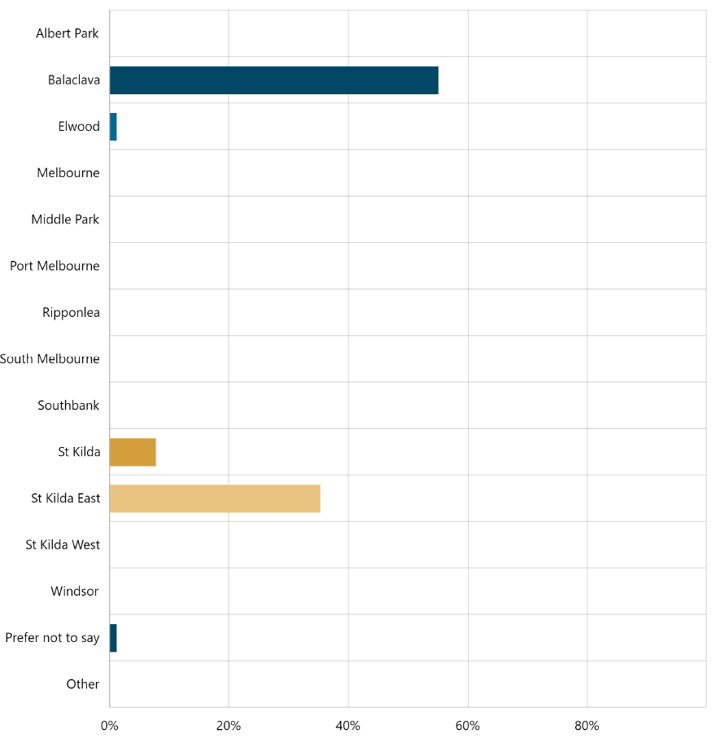
Figure 5. Respondent suburb profile

The largest representative age group was respondents aged 35 to 49 followed by respondents aged 25 to 34.
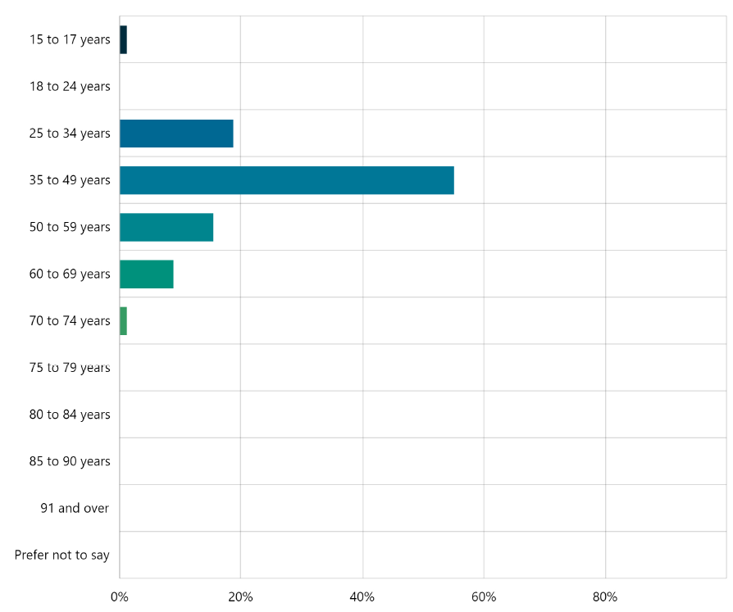
Figure 6. Respondent age profile

The largest representative gender was respondents identifying as female. 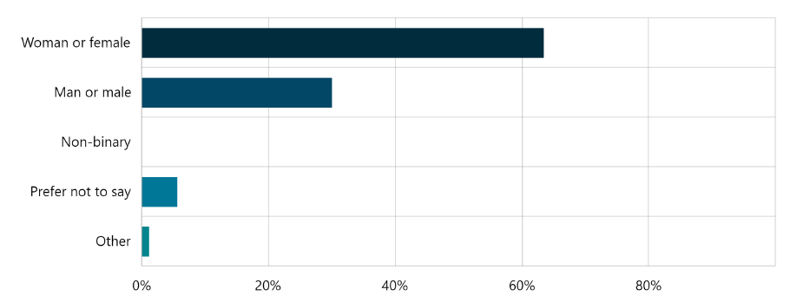

Figure 7. Respondent gender profile

